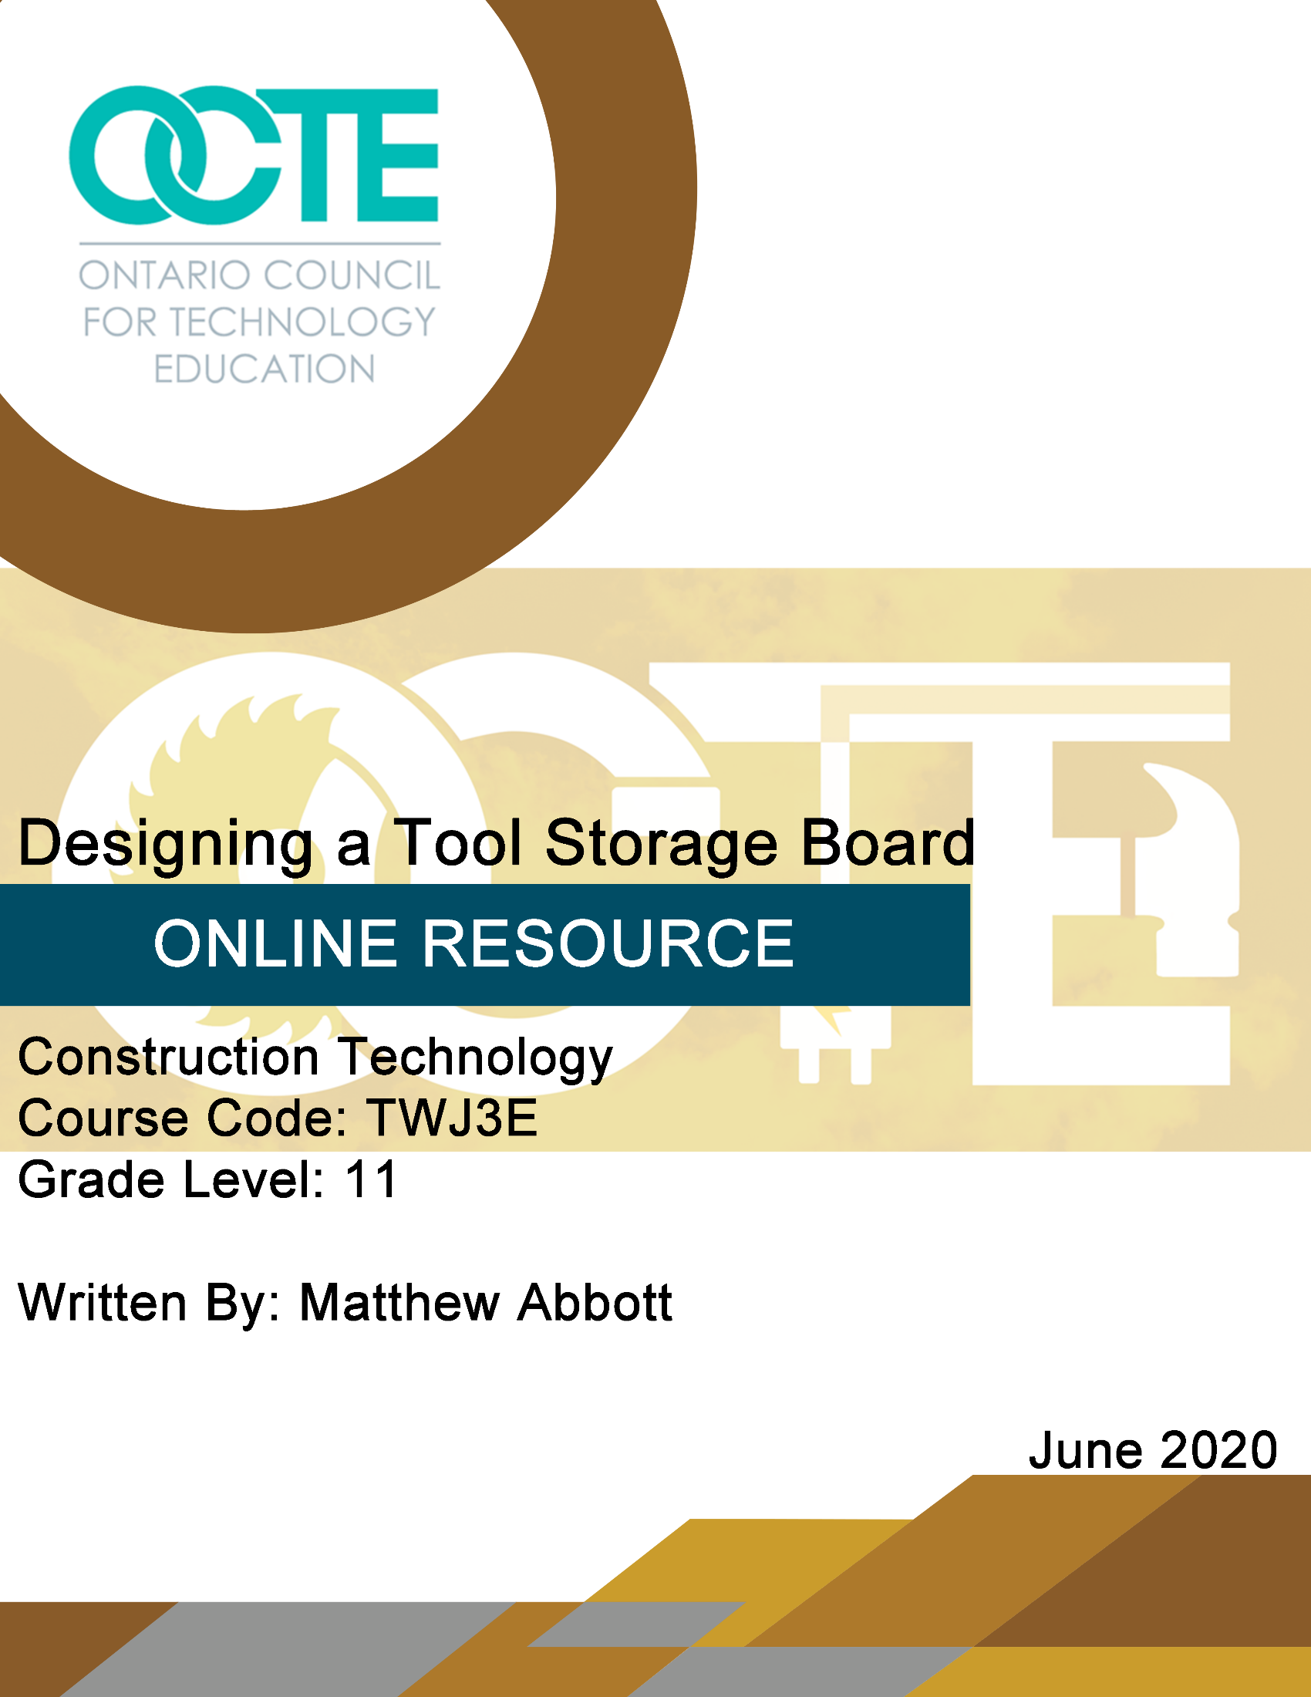

Table of Contents

Introduction 2
Project Outline 2
Prior Knowledge 2
Student Activities 3
Tool Board Assignment 3
Activity 1: Tool Inventory 4
Sample Tool Inventory Table 4
For Students without Tools or Limited Number of Tools At Home. 5
Activity 2: Your Tool Board Layout 6
Activity 3: Scale Drawing 7
Extension Activities 8
Extension Activity 1 8
Extension Activity 2 8
Extension Activity 3 8
Extension Activity 4 8
Planning Notes 9
Instructional Strategies 9
Motivational Strategies 9
Learning Goals and Success Criteria 9
Overall and Specific Expectations 10
Overall Expectations 10
Specific Expectations 10
Safety Concerns and Expectations 10
Differentiation of the Project / Activity 10
Career and Industry Extensions 11
Tool Board Rubric 12
Appendix A – Brainstorming 15
Appendix B – Material List 16
Material List 16
References 17

Introduction
Course Code: TWJ3E
Broad base Technology: Construction Technology
Destination: Workplace
Grade Level: 11
Prerequisite (if applicable) None
Online Project Name: Designing a Tool Storage Board
Writer’s Name: Matthew Abbott (SCCDSB)

Project Outline
- Students will make an inventory of hand tools at home. They may also include hand power tools in this inventory.
- They will categorize their tools and make a detailed list in a spreadsheet.
- After researching some videos on tool storage students will choose materials and a style of tool board that will work for them.
- Students will design a tool storage board that is applicable to their particular home, applies to their interests or hobbies and will fit in a particular spot in their dwelling, shed, workshop or garage.
- Students will create a basic drawing template including a title block.
- A scale drawing of their tool board will be produced.
- Students will compile all of their work and submit to teacher.

Prior Knowledge
- A basic understanding of hand tools would help but is not required.
- An understanding of Metric and Imperial systems of linear measurement.
- Basic research skills with internet search engines and YouTube.

Student Activities

Tool Board Assignment
Introduction
In the construction lab we have various sets of tools that we use to design, layout and fabricate projects. Each group of tools has its own storage area and within that storage area there are individual storage compartments or zones for smaller groups of/or individual tools.
At home, you may have a garage with tools, toolboxes, and tools in other storage areas. On the other hand, some of you may have a very limited set of tools depending on where you live and your needs however; everyone knows how frustrating it can be to search for an item such as a screwdriver that is in a drawer with fifty other various tools.
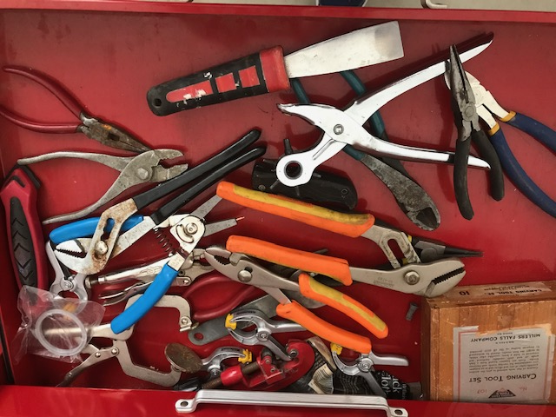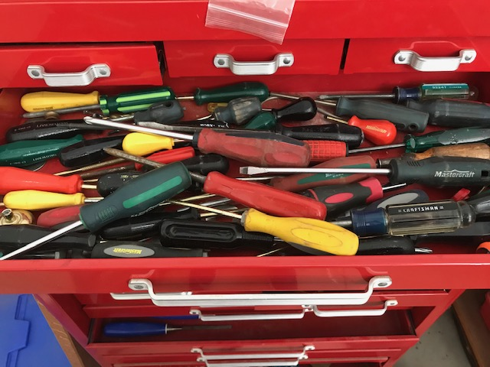
A tool board is a great way to keep your tools organized and visible so that you can keep track of your tools and save time looking for a particular item.

Activity 1: Tool Inventory
- Have a discussion with your parents/guardians about this assignment. Make sure they understand what you are doing.
- Complete an inventory of all your tools or the tools required in a specific area such as your garage or basement workshop. Try to list the tools in groups, such as pliers, measuring and layout tools, hammers, etc. You may find you have extra tools of one type and are missing some of another. Keep track of those and submit your findings to your parent or guardian. This is a great time to search for those missing items and also a great time to start your own tool kit or donate excess tools to a local charity.
- Put that inventory into a table or spreadsheet. Remember to differentiate between different types and sizes of screwdrivers, chisels, wrenches and other similar tools. This is the time to be very specific. You will be marked on how detailed your list is. For example, a pair of pliers could be locking jaw pliers, lineman’s pliers, side cutters, long nose pliers, needle nose pliers or slip-joint pliers. Be prepared to do some research on proper terminology. This may include an internet search, asking a friend or possibly consulting someone in industry.

Sample Tool Inventory Table
Tool Category
Striking Tools | 1 ball peen hammer, 1 claw hammer, 2 framing hammers
Measuring and layout tools | 1 tape measure, 1 try-square
Screwdrivers | #1,2,3 Robertson (square), #2 Phillips
Wrenches | 1 set open ended box wrenches
Knives and Scrapers
Files
Clamps
Pliers | 1 pair locking jaw (Vice Grips)

For Students without Tools or Limited Number of Tools At Home.
Task list:
- Have a discussion with your parents/guardians about this assignment. Make sure they understand what you are doing.
- Complete an inventory of all your tools or the tools you would require to complete odd jobs around your house/apartment. Think about tasks like fixing your bicycle or building some small projects. Consult with your friends, parents/guardians or teachers about what tools they think would be appropriate.
- Go to a local hardware store and check out available tools. Note specific dimensions for future reference.

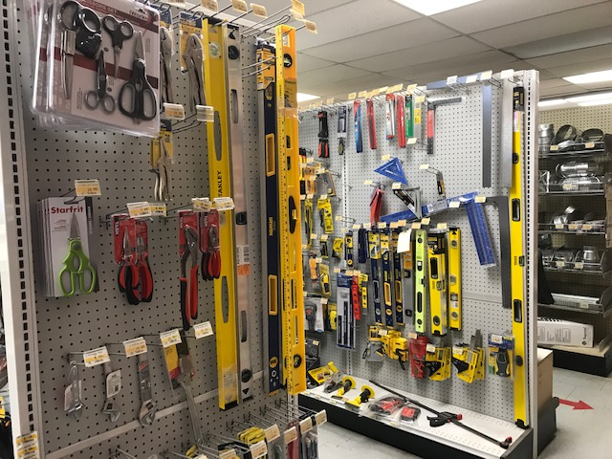

- Put that inventory into a table or spreadsheet. Remember to differentiate between different types and sizes of screwdrivers, chisels, wrenches and other similar tools. This is the time to be very specific. You will be marked on how detailed your list is. For example, a pair of pliers could be locking jaw pliers, lineman’s pliers, side cutters, long nose pliers, needle nose pliers or slip-joint pliers. Be prepared to do some research on proper terminology. This may include an internet search, asking a friend or possibly consulting someone in industry.
- Submit that spreadsheet/table to the teacher.

Activity 2: Your Tool Board Layout
- Do an internet search on tool board ideas.
- Create a list of tools that you would want on your tool board. It does not have to be the complete inventory from your home. You can also make additions.
- Have a discussion with your parents as to a potential location for a wall tool board.
- Take a picture of that location
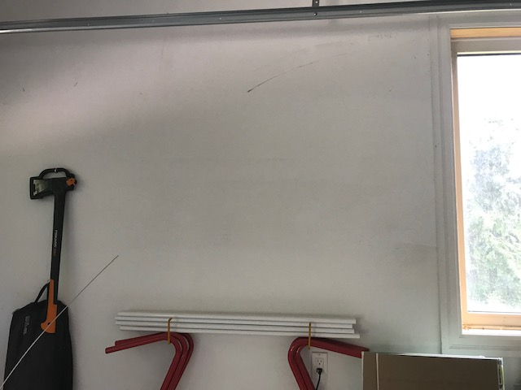
- Measure the height and width.
- Clear an area on the floor in the house or other space and measure off the same area as your tool board. Mark it off with some tape or other type of border.
- Layout your tools in the way you would like them organized. Is there enough space? Were you able to reduce the amount of wall space required?
- Have someone take a picture of you beside your tool layout. Make sure your tools are arranged in a way that they can be supported if vertical on a wall.

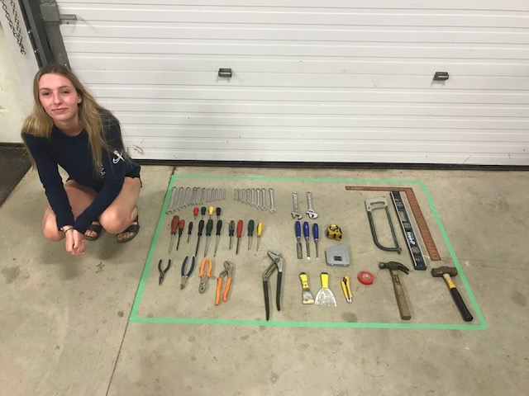

Activity 3: Scale Drawing

- View the “Technical Drawing at Home Part 1” PowerPoint (slides 1-6).
- Complete a drawing template for your tool board drawing.
- Your final drawing area will be approximately 8” x 10”. How are you going to fit your tool board accurately into a drawing that size?
- View Part 2 (slides 7–12) of the Technical Drawing at Home PowerPoint. Determine the correct scale for your drawing.
- Make a scaled drawing of your tool board indicating overall size of the board and draw in the individual tools or storage areas. Try to be as detailed as you can but keep the drawing neat. You may use symbols and a legend or you may label your diagram if you choose.

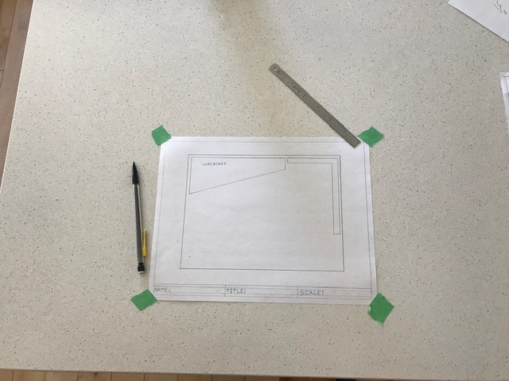

- Scan or take a picture of your drawing.
- Compile all of your documents and submit them to the teacher.

Extension Activities

Extension Activity 1
- Conduct a YouTube video search on how to find studs in walls.
- Using one or more techniques find the studs in the wall for which you have designed your tool board.
- Using that information mark on your drawing where you would install fasteners to hold your tool board on the wall.

Extension Activity 2
- Design a bracket to hold a specific tool or set of tools.
- Using the template provided sketch your bracket and provide complete dimensions. (Appendix A)

Extension Activity 3
- Think of the styles of tool boards you viewed in your research.
- Research different materials and their screw holding strength.
- Create a list of materials required to build your tool board. (Appendix B)

Extension Activity 4
- Build your tool board. (only if you have received proper training and are under qualified supervision)

Planning Notes
- This project requires little preparation by teacher.
- It can be adapted to other courses in Technological Education.
- Teachers may need to set up live video discussion with individual students to discuss tool lists.

Instructional Strategies
- This can be a fully self-deliverable at-home project.
- Independent research
- Can include live video consultation
- Working in small groups
- Presentation using a live video meeting and allowing student to present to class.

Motivational Strategies
- This project applies to the student’s current situation and is possibly an improvement for their home.
- This is a project that can involve parents and siblings.
- This is a ‘real world’ problem-solving project.
- This design can then be built at school or at home.
- Students can see a direct result that affects them personally.

Learning Goals and Success Criteria
By the end of this project students will:
- Have a better technical vocabulary with regards to hand tools.
- Will know how to find studs in their walls at home.
- Understand how to better and more safely store their personal hand tools.
- Use key words in an internet search.
- Be able to measure accurately using a tape measure.
- Be able to scale objects correctly to fit them into a drawing.
- Be able to produce a reasonably accurate technical drawing at home.

Overall and Specific Expectations in support of Ontario Curriculum Grades 11 -12 Technological Education

Overall Expectations
A2. Describe woodworking tools, equipment, and techniques, and use them safely;
A3. Use correct terminology related to woodworking and the materials, tools, equipment, and processes involved.
B2. Produce and interpret sketches and/or working drawings for a variety of woodworking projects;

Specific Expectations
A2.1 Demonstrate proficiency in using, maintaining, adjusting, and storing construction tools and equipment safely (e.g., chisels, planes, measuring instruments, table saws, drills, lathes);
A2.2 Demonstrate proficiency with commonly used measuring, layout, and assembly methods (e.g., layout and measuring: determining and marking circumference, diameter, radius, angles, and rounded corners; assembly: fasteners, glues, milled joints);
A3.3 Use correct terminology to identify and describe woodworking tools and equipment (e.g., air compressor, brad nailer, tri-square, planer, router, T-bevel);
B2.1 Prepare and/or modify sketches and working drawings (e.g., orthographic view, plan, elevation, section, detail drawing), using manual and/or computer-assisted methods and appropriate metric and/or imperial units;

Safety Concerns and Expectations
- Students should be mindful of tools with sharp edges and points.
- Students should be aware of potential hazards in storage areas such as unstable stacks of boxes, unlabeled chemicals and possible electrical hazards.

Differentiation of the Project / Activity
- Students with or without tools can complete this project.
- Teachers may allow substitutions such as gardening tools
- Teacher may allow students to work in pairs. A student with a large tool inventory could team up with a student with no tools at home.
- Students may create their drawing using CAD or graphic software. Drawing detail should increase with this option.

Career and Industry Extensions
- Cabinet maker
- Custom woodworker
- Lumber store retailer
- Hardware store manager
- Interior designer
- Carpenter
- Finish carpenter

Tool Board Rubric
Categories | Level 1 | Level 2 | Level 3 | Level 4
Knowledge and Understanding
Knowledge of content  Student demonstrates knowledge of different hand tools and their proper names. | demonstrates limited knowledge of content | demonstrate some knowledge of content | demonstrates knowledge of content | demonstrates thorough knowledge of content
Understanding of content  Student understands the concept of scaled drawings. | demonstrates limited understanding of content | demonstrates some understanding of content | demonstrates considerable understanding of content | demonstrates thorough understanding of content
Thinking
Use of planning skills  Student follows a logical order of events to complete assignment | uses planning skills with limited effectiveness | uses planning skills with some effectiveness | uses planning skills with considerable effectiveness | uses planning skills with a high degree of effectiveness
Use of processing skills  Student is able to design a tool board with an efficient layout. | uses processing skills with limited effectiveness | uses processing skills with some effectiveness | uses processing skills with considerable effectiveness | uses processing skills with a high degree of effectiveness
Use of critical/creative thinking processes  Student is able to self-evaluate his/her product, reflect on the process and suggest positive changes. | uses critical/ creative thinking processes with limited effectiveness | uses critical/ creative thinking processes with some effectiveness | uses critical/ creative thinking processes with considerable effectiveness | uses critical/ creative thinking processes with a high degree of effectiveness

Communication
Expression and organization of ideas and information  Drawing is neat and understandable. Visuals draw viewers’ attention. | expresses and organizes ideas and information with limited effectiveness | expresses and organizes ideas and information with some effectiveness | expresses and organizes ideas and information with considerable effectiveness | expresses and organizes ideas and information with considerable effectiveness
Communication for different audiences in oral, visual, and written forms  Student communicated effectively with teacher by live video.  Visuals are clear and show information clearly | communicates for different audiences and purposes with limited effectiveness | communicates for different audiences and purposes with some effectiveness | communicates for different audiences and purposes with considerable effectiveness | communicates for different audiences and purposes with a high degree of effectiveness
Use of conventions vocabulary, and terminology of the discipline in oral, visual, and written forms  Tool inventory is detailed, and contains the proper specific terminology. | uses conventions, vocabulary, and terminology of the discipline with limited effectiveness uses | uses conventions, vocabulary, and terminology of the discipline with some effectiveness | uses conventions, vocabulary, and terminology of the discipline with considerable effectiveness | uses conventions, vocabulary, and terminology of the discipline with a high degree of effectiveness

Application
Application of knowledge and skills in familiar contexts  Student was able to take previously learned math concepts and use them to solve a practical problem. | applies knowledge and skills in familiar contexts with limited effectiveness | applies knowledge and skills in familiar contexts with some effectiveness | applies knowledge and skills in familiar contexts with considerable effectiveness | applies knowledge and skills in familiar contexts with a high degree of effectiveness
Transfer of knowledge and skills to new contexts  Student was able to take basic household items and create a measuring device. | transfers knowledge and skills to new contexts with limited effectiveness | transfers knowledge and skills to new contexts with some effectiveness | transfers knowledge and skills to new contexts with considerable effectiveness | transfers knowledge and skills to new contexts with a high degree of effectiveness
Making connections within and between various contexts  Student makes the connection between angle inclination and height. | makes connections within and between various contexts with limited effectiveness | makes connections within and between various contexts with some effectiveness | makes connections within and between various contexts with considerable effectiveness | makes connections within and between various contexts with a high degree of effectiveness

Appendix A – Brainstorming
Idea:

Description:
Sketch:

Appendix B – Material List

Material List

Name: _______________________________________
Project: ____________________________ Date: ______________________________

Item # | Description | Quantity

References
21st Century Competencies: Foundation Document for Discussion. Phase 1: Towards Defining 21st Century Competencies for Ontario, Winter 2016 Edition, 2016 http://www.edugains.ca/resources21CL/About21stCentury/21CL_21stCenturyCompetencies.pdf
Course Codes for Emphasis courses in the Revised Curriculum: Technological Education, Grades 11 and 12, 2009 http://www.edu.gov.on.ca/eng/curriculum/secondary/techedemphasiscourses.pdf
Growing Success: Assessment, Evaluation, and Reporting in Ontario Schools, First Edition, Covering Grades 1 to 12, 2010 www.edu.gov.on.ca/eng/policyfunding/growSuccess.pdf
Learning for All – A Guide to Effective Assessment and Instruction for All Students, Kindergarten to Grade 12, 2013 http://www.edu.gov.on.ca/eng/general/elemsec/speced/LearningforAll2013.pdf
Technical Drawing at Home PowerPoint (PowerPoint presentation), 2020 http://www.octe.ca/application/files/1615/9247/5226/Technical_Drawing_at_Home_Autosaved.pptx
The Differentiated Instruction Scrapbook http://www.edugains.ca/resourcesDI/EducatorsPackages/DIEducatorsPackage2010/2010DIScrapbook.pdf
The Ontario Curriculum, Grades 9 and 10: Technological Education, 2009 (revised) http://www.edu.gov.on.ca/eng/curriculum/secondary/teched910curr09.pdf
The Ontario Curriculum, Grades 11 and 12: Technological Education, 2009 (revised) http://www.edu.gov.on.ca/eng/curriculum/secondary/2009teched1112curr.pdf
Tool board clipart Courtesy of Vecteezy.com, 2020 www.vecteezy.com
.

