TIJ 1O Exploring Technology – Teacher Content
Exploring Manufacturing Technology – 3D Design and Printing
Teacher Instructions for Setting Students Up on Tinkercad
Navigate to https://www.tinkercad.com/
If you don’t already have an account, create one by clicking here
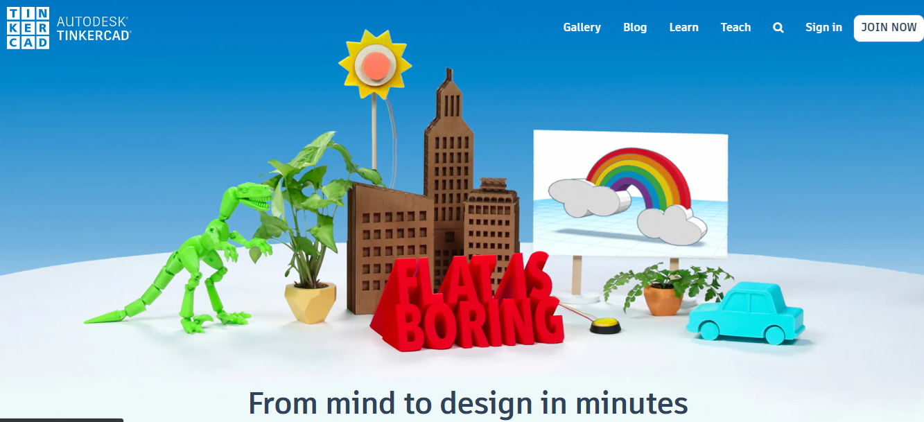

Click here to create an educator account, and click here to agree to terms
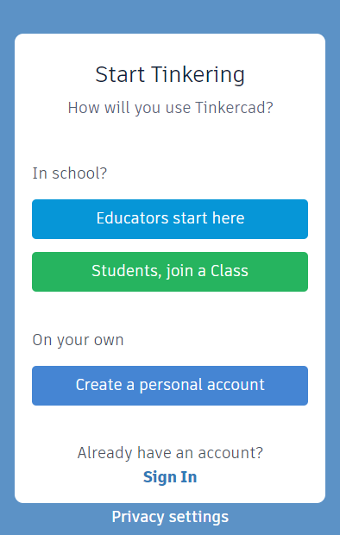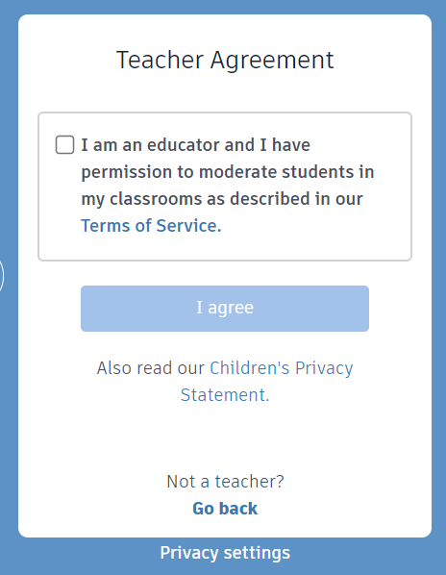

Select a method to create an account.
If you sign up with email, you’ll be asked to provide your birth date
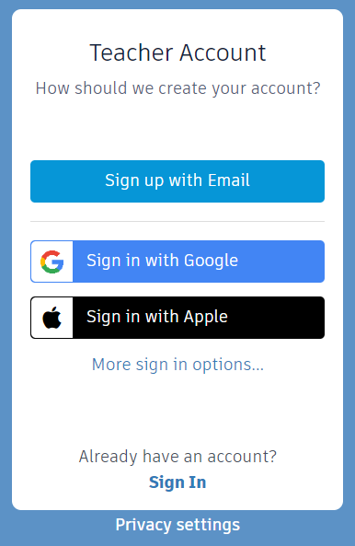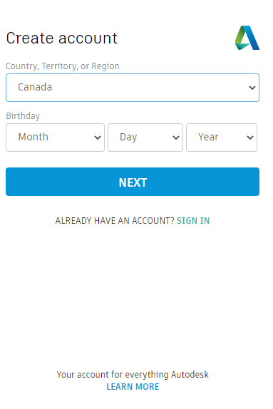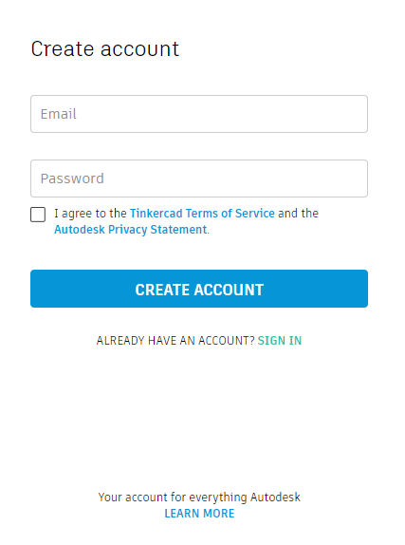

Finally!
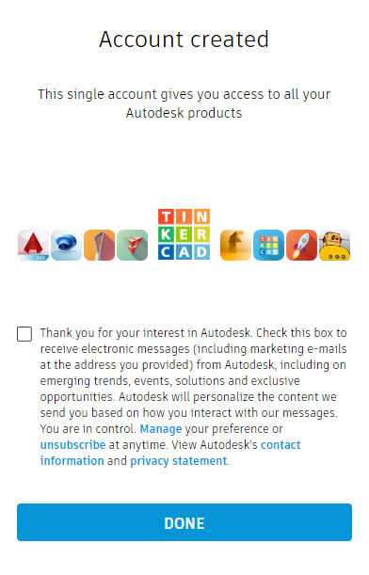

This is your home screen once you’ve logged in.
You can click on this icon at any time to return to this screen.
Click here to create a class of your students.
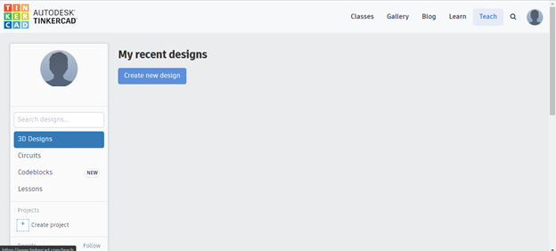

On this screen, you can create a class so that your students can log in.
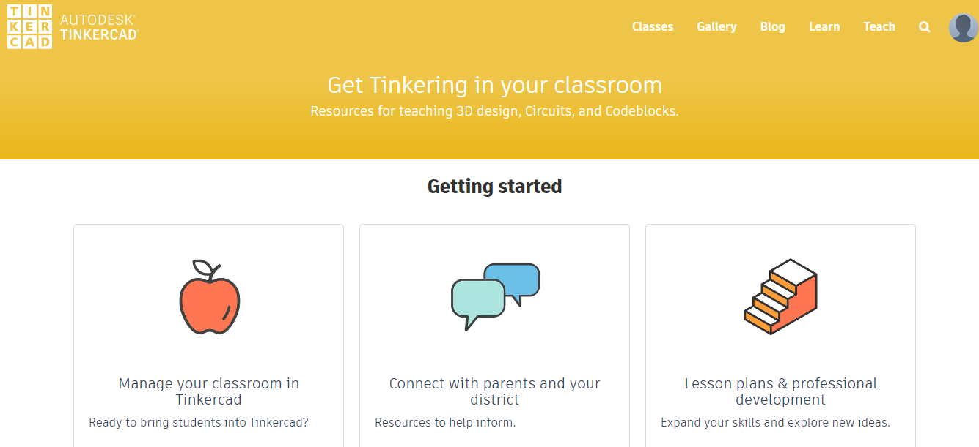

Scroll down the page and click here to build your class.
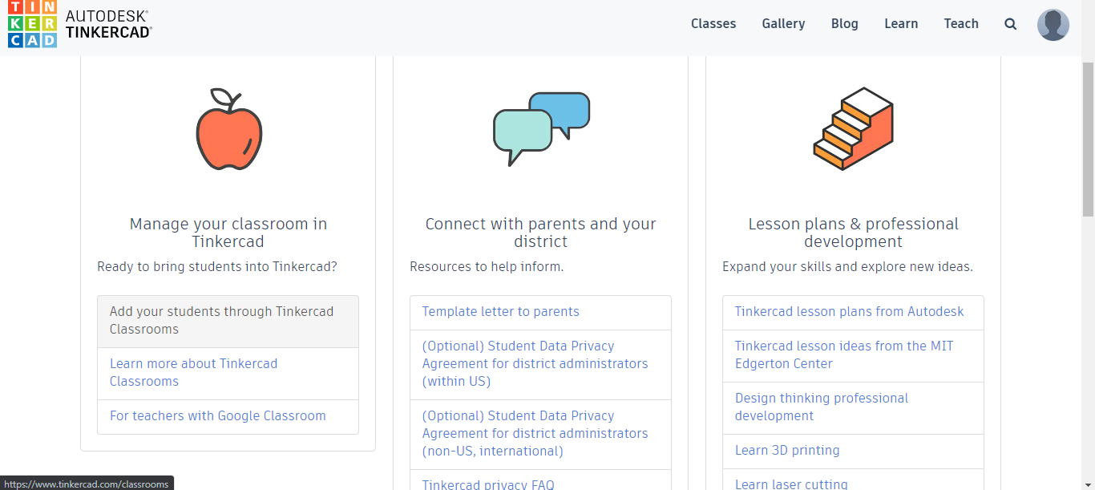

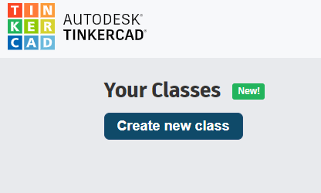
Click on the “Create new class” button.

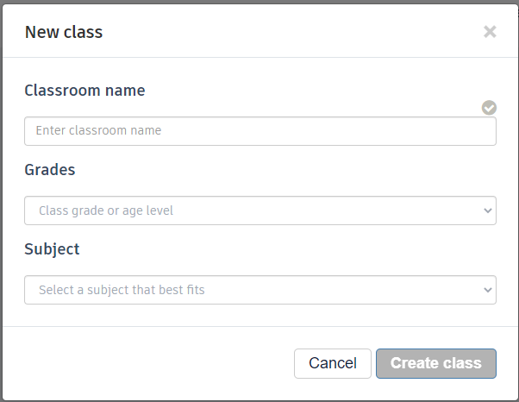
Fill in the required details

You can click on your newly created class to add students.
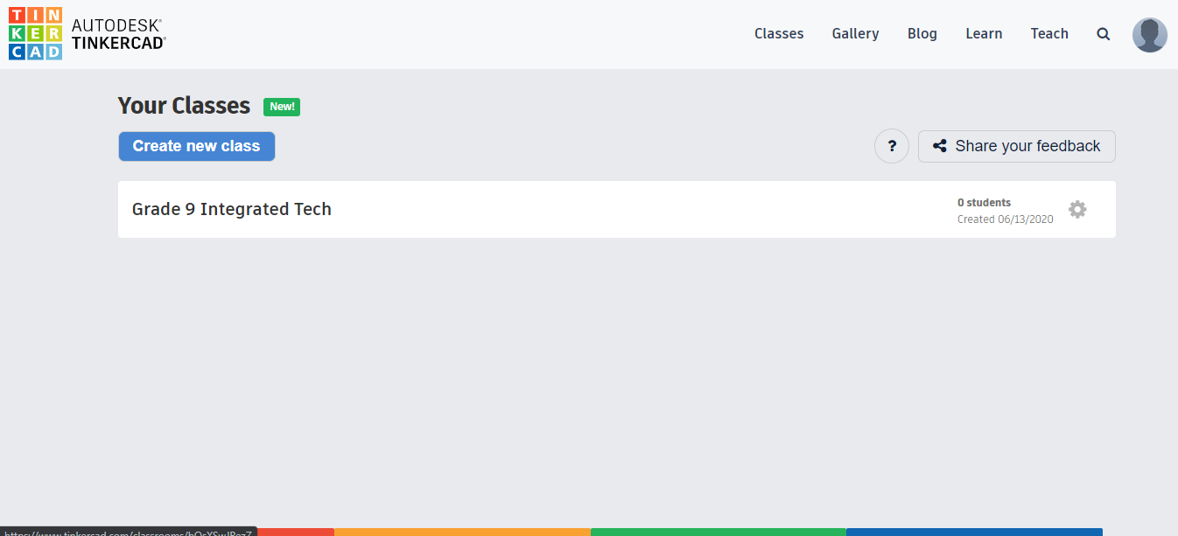
Click on Add Students to populate your class.
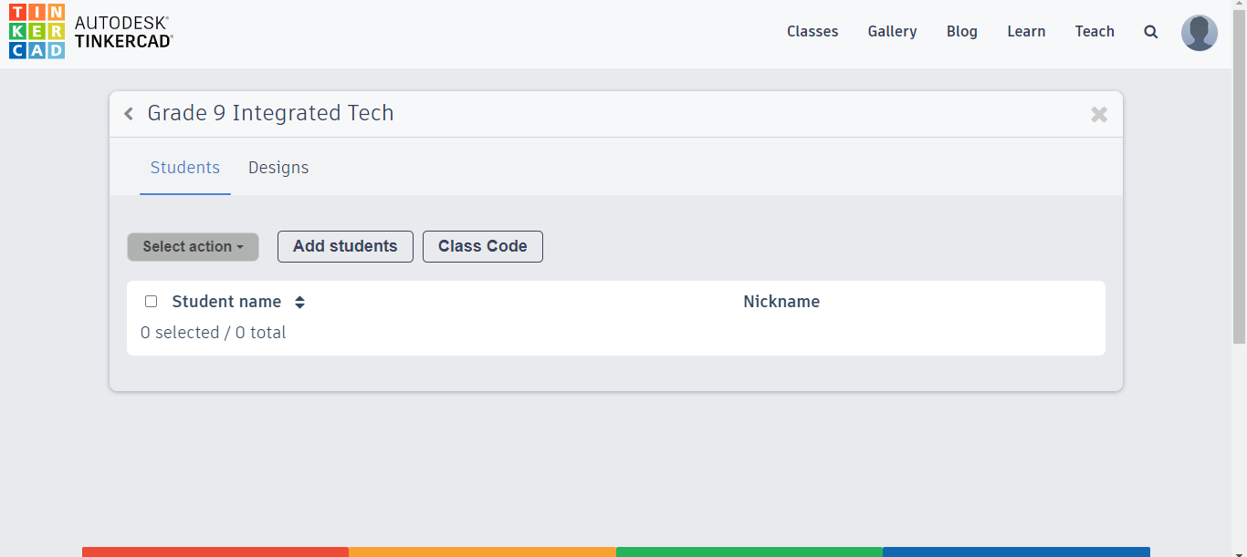
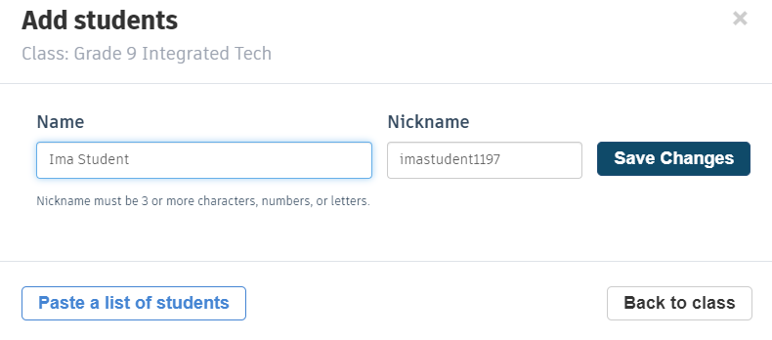

Once you’ve added all of your students, you can go back to your class.

You’ll be able to see all of the students of your class here. Once they’ve done some work, you’ll be able to click on individual students to see their progress and their created files.
At this point, you’ll need to click on Class Code to get the link to share with your students.
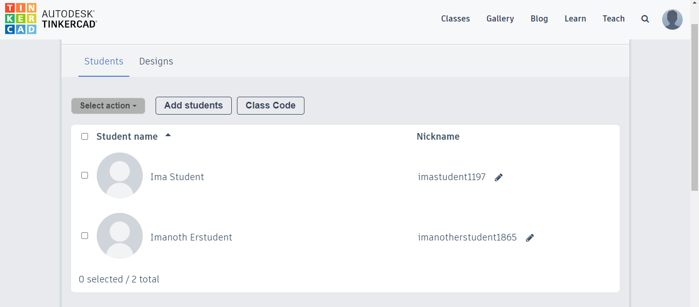

You can copy the code or the link to share with your students so that they can launch TInkercad.
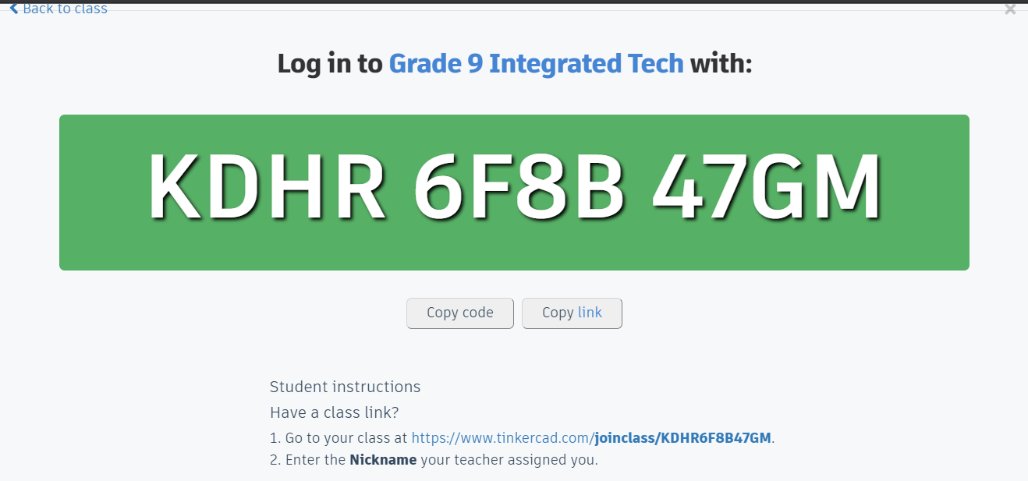

Your students will need their nicknames to login once they reach the site from the link.
To get their nicknames, go back to the list of students in your class. If you click on their nickname, it copies onto the clipboard, and can be pasted into another document (spreadsheet or table) of your student logins.
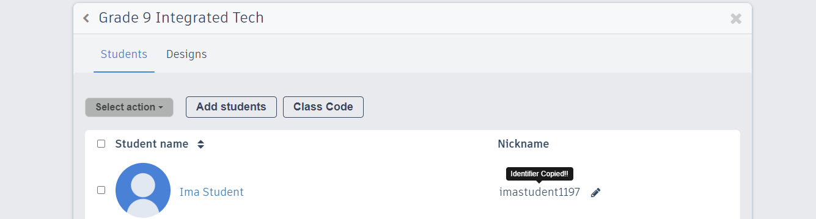

As a teacher, if you’re new to 3D Design, there are very helpful lessons that will get you up and running in this environment in no time.
For the sake of time, students working through this project are being directed to begin in the starters, going through 7 direct, step-by-step instruction modules.
For a more macro-level understanding of some of the concepts, try clicking on Projects, and then select the module Let’s Learn Tinkercad
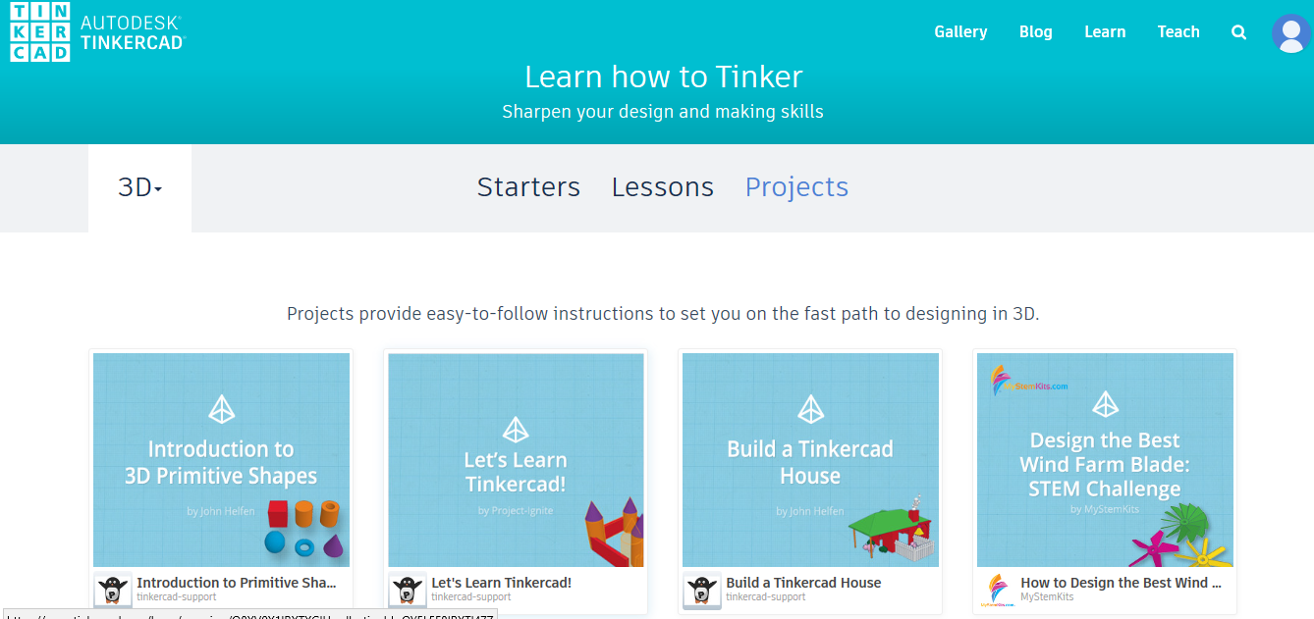

These 5 easy lessons will give you a great understanding.
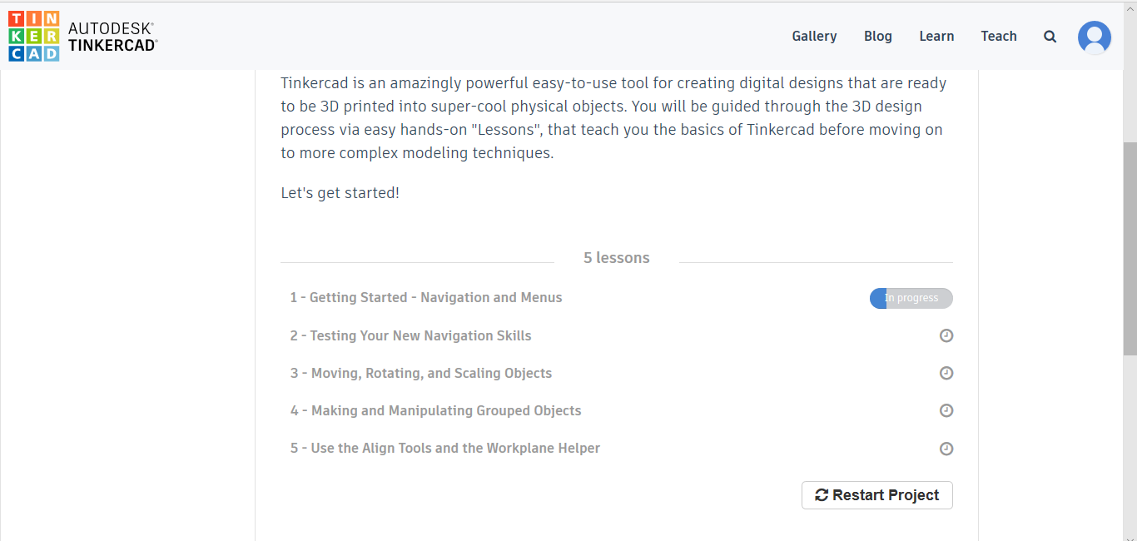

Enjoy. Be patient. Persevere. Experiment. Have fun.
Best of Luck!

