
Making “Cents” of the Skilled Trades
Exploring Financial Literacy through the Global Competencies

This resource is intended for teachers to use to explore financial literacy and the skilled trades, grounded in the global competencies. Teachers can tailor this resource to suit either a Grade 7 or 8 class (mathematics, language & career exploration), a Grade 10 Career Studies course or a senior high school course focused on the skilled trades.

Both a teacher guide and a student-facing resource are included. All student resources are available to edit to best suit the needs of your curriculum and your students. The experiential learning cycle is embedded throughout the activities, and will be highlighted in the teacher guide that follows.

Resources Include::
 | Google Version | Microsoft Version | PDF
Introduction Slide Deck | Slides | PPT | PDF
Student Exploration- Making “Cents” of the Skilled Trades | Slides | PPT | PDF
Self-Directed Learning Template | Docs | Word | PDF
Critical Thinking & Problem Solving- Your Business Finances | Sheets | Excel | PDF
Collaboration- T-SHIRT STORE REMODEL | Sheets | Excel | PDF 1  PDF 2
Collaboration- CHARITY "MAKE OVER" GARDEN PARTY | PPT | Excel | PDF 1  PDF 2

Teacher Guide-
Introducing Making “Cents” of the Skilled Trades

This unit can be used to meet curriculum expectations in Grade 7 & 8 (Language and Mathematics), Grade 10 Career Studies, and most Technology 9-12 courses, particularly those tied to the skilled trades.

Copies of student resources (slide decks, spreadsheets etc) are linked throughout the teacher guide, and copies of corresponding slides within the document for teacher’s reference.

Lesson 1: Introduction to Skilled Trades & Global Competencies

Lesson Objectives:
- Students will explore and connect to the Skilled Trades
- Students will begin to explore Global Competencies

Student Learning Goals:
We will explore the skilled trades and global competencies so we can explore career opportunities and skills necessary for the workforce.

Curriculum Connections:
Grade 7/8 - Writing- 1.3 gather information to support ideas for writing, using a variety of strategies and a wide range of print and electronic resources

Pathways to success: “In Grades 7 and 8, students are thinking about the opportunities available to them in secondary school and beyond (apprenticeship, college, community living, university, or the world of work). Educators help students see the connections between what they are learning in school and its relevance and application beyond the classroom. “ (Creating Pathways to Success, pg. 28)

Grade 10 Career Studies- B. 1.2- explain how transferable skills are developed through school, extracurricular, and/or community experiences, and analyse how they contribute to a person’s readiness for future educational, life, and work opportunities and to their career development

Technology Courses- D2. describe career opportunities in (tech course content area) and the education and training required for these careers.

Materials:
- Slide Deck- Introduction
- Computer/Projector

Considerations for Accommodations:
- Please reference your class profile and Individual Education Plans to ensure that all students have the support they need to meet their learning goals and success criteria.
- Consider what students’ needs would be prior to, during, and after the lesson.

Lesson Outline

- Students will need to be introduced to/review the skilled trades. Consider one of the following based on the age of students as well as whether the course is being taught virtually or in person:
  - Have students build a house out of lego, recyclables, or other building blocks. Using sticky notes have students label as many of the “jobs” of people who would build the house. Use prompting questions for groups such as “How would the water get into the house? What about staying warm in winter?” etc.
  - Using an interactive noteboard (such as padlet or jamboard) or large chart paper if in person, invite students to share/brainstorm all the skilled trades they can list. Then have them add a small description of the work each does. Teacher prompts could include “if I wanted to host a concert, who would I need to help with set up? If we were to renovate our school, who would we need?” Then try a similar activity, list each global competency and have students ‘graffiti’ or ‘post’ what they think each one means. Keep these to compare with global competency definitions later on.
- Use the Slide Deck Introduction- Skilled Trades & Global Competencies.
- Consolidate new learning after reviewing the slide deck. Have students fold a piece of paper in quarters. In the first two squares, have students record a “myth or misconception” about the skilled trades (not for women, ‘low paying jobs etc.) and then respond with the truth about the misconception. In the second two squares, have students record “important info to know”. Any two pieces of information they believe to be important about the skilled trades/what they learned from the intro slides.
- Explain to students that these two concepts will be the foundation for the work that will be doing in this mini-unit.

Lesson 2: Student Exploration- Making “Cents” of the Skilled Trades

In this section, teachers will introduce students to the Student Exploration of “Making ‘Cents’ of the Skilled Trades”. This student-facing document involves 4 sections. Each section is broken down into “lessons” below. Teachers can choose to introduce the entire mini-unit, or one “lesson” at a time.

Each lesson is based on one of the Global Competencies. For more resources about Global Competencies and the Skilled Trades, teachers should use OCTE’s Skilled Trades & Global Competencies Experiential Learning Resource. This resource contains breakdowns of each global competency, prompts to connect to the skilled trades, and Experiential Learning opportunities connected to the skilled trades.
All student handouts and resources are best accessed and completed digitally. Even if students are completing hard copies of any of the documents, they will require internet access to research their skilled trade, and many other prompts throughout the activity.

Students will notice some of the activities are broken down to mirror the Experiential Learning Cycle. (Participate, Reflect, Apply). For more information about Experiential Learning and Assessment please review OCTE’s Experiential Learning & Assessment

Lesson 2.1: Student Exploration- Self-Directed Learning
Lesson Objectives:
- Students will identify and explore a skilled trade of interest (or connected to TECH course content)
- Students will use self-directed learning skills to learn more about their skilled trade, education pathways as well as education costs and financing
- Students will start to explore and compare options for student loans, paid apprenticeships etc.

Student Learning Goals:
We will use self-directed learning skills so we can explore a skilled trade of interest to us.

Curriculum Connections:
Grade 7 Mathematics- F1.4 identify various societal and personal factors that may influence financial decision making, and describe the effects that each might have

F1.5 explain how interest rates can impact savings, investments, and the cost of borrowing to pay for goods and services over time

Grade 10 Career Studies- B. 1.2- explain how transferable skills are developed through school, extracurricular, and/or community experiences, and analyse how they contribute to a person’s readiness for future educational, life, and work opportunities and to their career development
B. 1.3- reflect on how the transferable skills they have developed so far have aided them in their learning and in life, and identify the skills that they may need to develop further

Technology Courses- D2. describe career opportunities in (tech course content area) and the education and training required for these careers.

Materials:
- Student Exploration- Making “Cents” of the Skilled Trades
  - Slides referenced after the lesson, refer to slide deck for interactive links
- Self-Directed Learning Template
- Computer/Internet Connection

Considerations for Accommodations:
- Please reference your class profile and Individual Education Plans to ensure that all students have the support they need to meet their learning goals.
- Consider what students’ needs would be prior to, during, and after the lesson.

Lesson Outline

- Introduce/review the Global Competency Self-Directed Learning.
  - Additional Resources: OCTE’s Skilled Trades & Global Competencies Experiential Learning Resource
- Participate: Invite students to explore skilled trades. Assist students who may need some guidance in narrowing down their choices.
  - Students who use “Trades Explorer” may not get a “match”. Encourage them to explore the related careers listed below.
- Reflect: This can be done on your Pathways Exploration Site (myBlueprint, Xello, etc.) These sites may also have more resources for exploring the skilled trades.
- Apply: Students will work through a template prompting them to record information about their skilled trade of choice. This information will be necessary for the remaining activities. Teachers should review this information with each student before they continue any of the other activities.
  - Teachers may wish to edit/add specific questions/prompts to the student handout to make sure it best meets their specific curriculum expectations.

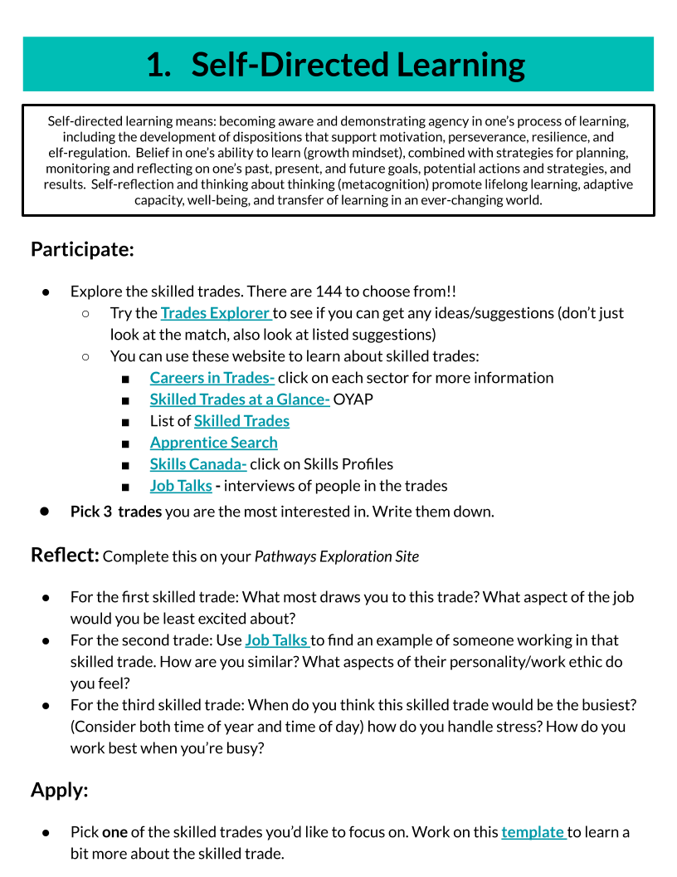

Self-Directed Learning Template
Pick a skilled trade you would be interested in pursuing. Work through the template below to explore more about the skilled trade!

Name: ____________________

Skilled Trade Chosen
Use Skilled Trades at a Glance and Apprentice Search to help you complete this section
Minimum Grade Required (Educational Prerequisites)
Length of Program- include details about hours, on the job training etc.
Certification/Red Seal-include details of what this would require to complete
Skills, Interests and Values- include at least 4 points

Future Planning- unions? Potential employers?
Wage information

Planning for my Skilled Trade Career

There are many pathways to a skilled trade. Try exploring these pathways: Pathways to Apprenticeship
What are the possible paths to your skilled trade? (list multiple options) Pre-apprenticeship programs? Apprenticeship? College? Co-op apprenticeship program?
Use Apprentice Search or Ontario College listings to find a program
Apprenticeship Program
Find at least one apprenticeship program available. Where? Include program details
Apprenticeship Costs
What are the costs associated with this apprenticeship?
College Program
Find at least one college program available. Where? Include program details
College Costs
What are the costs associated with this college program?

Starting Now!
What high school courses/programs are available in your school board to help support this skilled trade? Note: some specialty programs may not be available at your school, but may be open to all students from your board. Be sure to check out your board website and ask your guidance counsellor for more information.
OYAP- Ontario Youth Apprenticeship Program
Is your trade offered through OYAP in your board? How do you apply?
SHSM- Specialist High Skills Major
Are there SHSM programs at your school that would support your learning in this area of the trades?
Co-op
What co-op options are available? Could you get a co-op placement in your trade area, or something similar?

Supporting Courses
What high school credits are mandatory or recommended for an apprenticeship or college program in your trade?
If an OYAP program is available, what credits are necessary for application?

Looking at Finances

Loans and Finances
Investigate 3 options to help fund your education. Consider paid apprenticeships, student loans, scholarships, grants, lines of credit etc. Only list options that would be feasible for you (not a scholarship for students in rural New Brunswick if you are living in Toronto!) List the details (provider, lending rate, etc.) for each.
Websites to help: Paying for College in Ontario Apprenticeship Ontario
Option #1-
Option #2-
Option #3-

Lesson 2.2: Student Exploration- Communication OR Innovation, Creativity & Entrepreneurship

Lesson Objectives:
- Students will analyse and critique advertisements/websites/social media
- Students will use communication or innovation, creativity & entrepreneurship global competencies to create their own advertisements/websites/social media
- Students will start to explore the importance of a positive digital footprint

Student Learning Goals:
We will use communication/innovation skills so we can practice creating and curating an online presence.

Curriculum Connections:
Grade 7/8 Media Literacy- Overall Expectations: 2. identify some media forms and explain how the conventions and techniques associated with them are used to create meaning; 3. create a variety of media texts for different purposes and audiences, using appropriate forms, conventions, and techniques; 4. reflect on and identify their strengths as media interpreters and creators, areas for improvement, and the strategies they found most helpful in understanding and creating media texts.

Grade 10 Career Studies- B. 2.3- explain how digital media use and a social media presence can influence their education and career/life opportunities, while at the same time demonstrating an understanding of the importance of managing their personal information and protecting their privacy online
C1.3 use effective and appropriate forms, media, and styles to communicate their skills, experience, and achievements to prospective mentors, program administrators, employers, community organizations, scholarship funders, or investors

Technology Courses- (Examples)
Hairstyling & Aesthetics- A3.3 identify effective advertising and management strategies (e.g., appeal to new client groups, including diverse populations) and new products, tools, and equipment that can be used to support and enhance salon/spa operations;

Hospitality & Tourism- B3.3 design an advertising and/or promotional tool (e.g., picture, slogan, announcement, giveaway) that aligns with their approved marketing strategy.

Communications Technology- D2.3 demonstrate an understanding of and adhere to ethical standards relating to the creation of media products (e.g., restrictions on appropriation of content and image manipulation) and to their dissemination (e.g., honesty in advertising).

Materials:
- Student Exploration- Making Cents of the Skilled Trades
  - Slides referenced after the lesson, refer to slide deck for interactive links
- Computer/Internet Connection

Considerations for Accommodations:
- Please reference your class profile and Individual Education Plans to ensure that all students have the support they need to meet their learning goals.
- Consider what students’ needs would be prior to, during, and after the lesson.

Lesson Outline

- Introduce/review the Global Competency Communication and Innovation, Creativity & Entrepreneurship
  - Additional Resources: OCTE’s Skilled Trades & Global Competencies Experiential Learning Resource
- Students will get to choose which global competency they would like to work on and explore. There is no need for them to do both.
- Before students begin this section, it is important to introduce/review copyright, particularly in regards to image use.
  - Additional Resources: https://www.cultofpedagogy.com/online-images/
- Participate: In both competencies students are exploring advertisements/websites for people in the trade of their choice. If you have had community guests, or know of some local businesses, it would be helpful to direct students to local examples. Remind students of “offline” examples. Is there a community board at the library? Grocery store?
- This is also an important time to discuss a “digital footprint” as a class. What evidence do you see of these people/businesses online?
  - Additional Resources: https://www.commonsense.org/education/lesson-plans/whats-my-digital-footprint
- Reflect: Students will be asked to highlight their favourites, and analyse the use of colour, design, etc.
- Students will also be asked to investigate the cost of these advertisements. While there are ways to post for free online, promoted content, social media ads, influencer posts etc all cost money. Students may need some assistance navigating this information, as it is not always easy to find (or in Canadian funds!)
- Apply: Students will be creating their own advertisements, websites etc. If your board is a GAFE board students should be able to create their own google site.
  - Be aware of external website hosts that collect student information. You must abide by your school board’s privacy policy with all external websites.

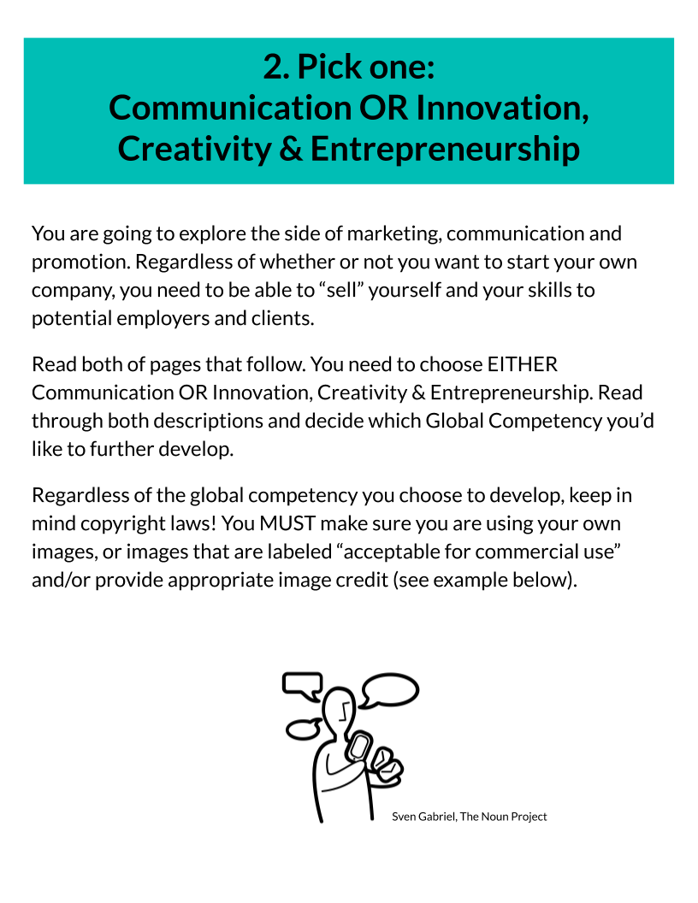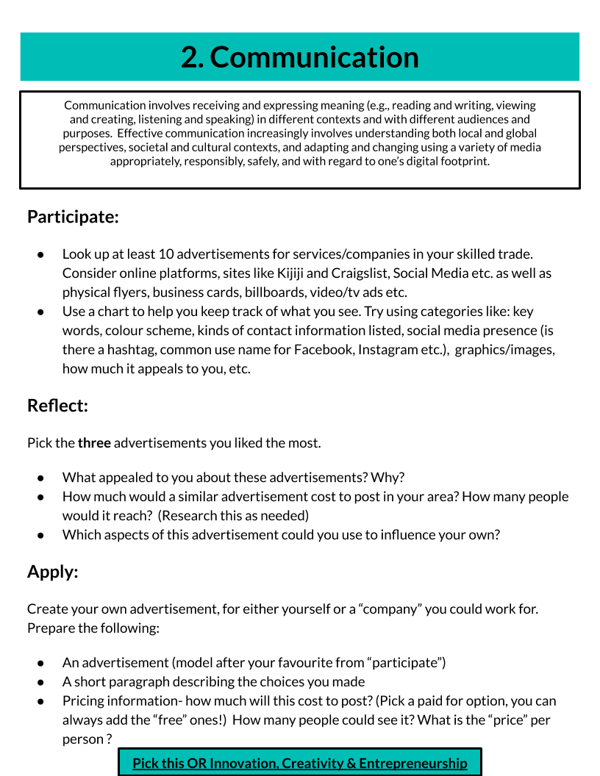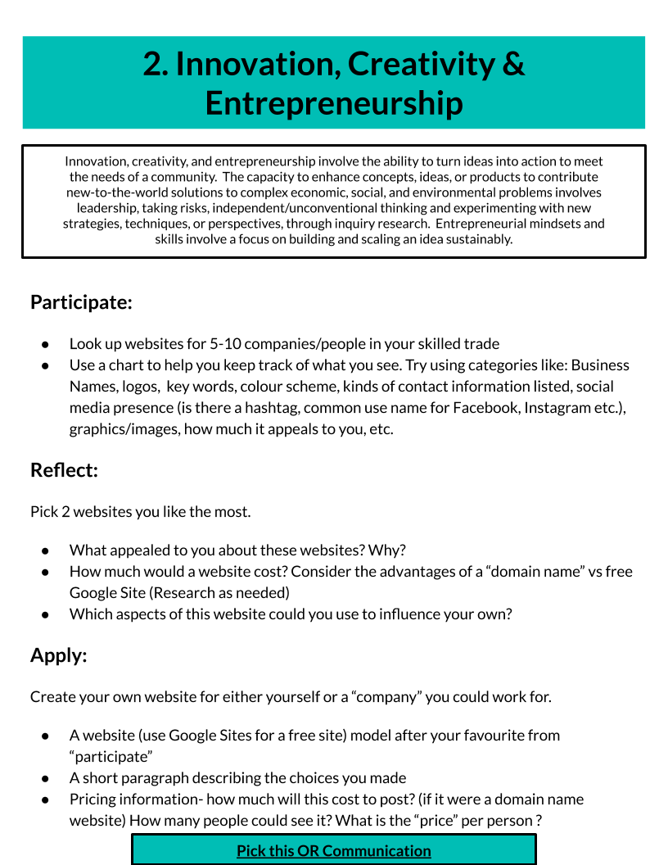

Lesson 2.3: Student Exploration- Critical Thinking & Problem Solving OR Collaboration

Lesson Objectives:
- Students will investigate the financial and logistical side of working in the trades
- Students will use critical thinking and problem solving and collaboration skills to budget, research and plan purchases/schedules
- Students will further explore Canadian loan options

Student Learning Goals:
We will use critical thinking/collaboration skills so we can make informed financial decisions.

Curriculum Connections:
Grade 7 Mathematics- F1.5 explain how interest rates can impact savings, investments, and the cost of borrowing to pay for goods and services over time

Grade 8 Mathematics- F1.4 determine the growth of simple and compound interest at various rates using digital tools, and explain the impact interest has on long-term financial planning

F1.5 compare various ways for consumers to get more value for their money when spending, including taking advantage of sales and customer loyalty and incentive programs, and determine the best choice for different scenarios

Grade 10 Career Studies- C2.2- compare different forms of borrowing and identify some of the risks and benefits associated with each

Technology Courses- (Examples)
Technological Design- A2.2 research and describe strategies for the planning, organization, and management of human, material, and financial resources for a design project (e.g., strategies for delegating tasks, selecting materials, estimating costs).

Transportation- A3.4 compare the overall cost of loans from various sources (e.g., banks, finance companies, private lenders);

Communications Technology- B2.5 use charts or hand-drawn sketches to organize sequences, clarify relationships, or compare alternatives;

Materials:
- Student Exploration- Making “Cents” of the Skilled Trades
  - Slides referenced after the lesson, refer to slide deck for interactive links
- Critical Thinking & Problem Solving- Your Business Finances
- Collaboration- T-SHIRT STORE REMODEL
- Collaboration- CHARITY “MAKE OVER” GARDEN PARTY
- Computer/Internet Connection

Considerations for Accommodations:
- Please reference your class profile and Individual Education Plans to ensure that all students have the support they need to meet their learning goals.
- Consider what students’ needs would be prior to, during, and after the lesson.

Lesson Outline

- Introduce/review the Global Competency Critical Thinking & Problem Solving and Collaboration
  - Additional Resources: OCTE’s Skilled Trades & Global Competencies Experiential Learning Resource
- Students from both groups will be asked to explore getting a loan of $100,000. This could be a small group activity followed by a full-class comparison and discussion. Where did students find some of the ‘best’ loan offers? What were the conditions? Is everyone eligible for the loan? Who is not? What other considerations are necessary?
- Critical Thinking & Problem Solving: Students are working through price comparison. It is recommended students use a digital spreadsheet to track their options. Students may also need to be introduced to digital spreadsheet functions such as Sum, averages etc.
  - Be sure to remind students to local for local offerings and make sure the prices are in Canadian Dollars.
- Collaboration: Students are creating a schedule for a team of skilled trades workers on one of two projects (renovation of a local t-shirt shop or charity event in a garden party). This will require students to research all 6 workers. If their own trade of choice is not listed for either of the projects, they should investigate how they might play a role in these projects.
  - There are two tabs on this spreadsheet document (Click the tab at the bottom to access Payroll).

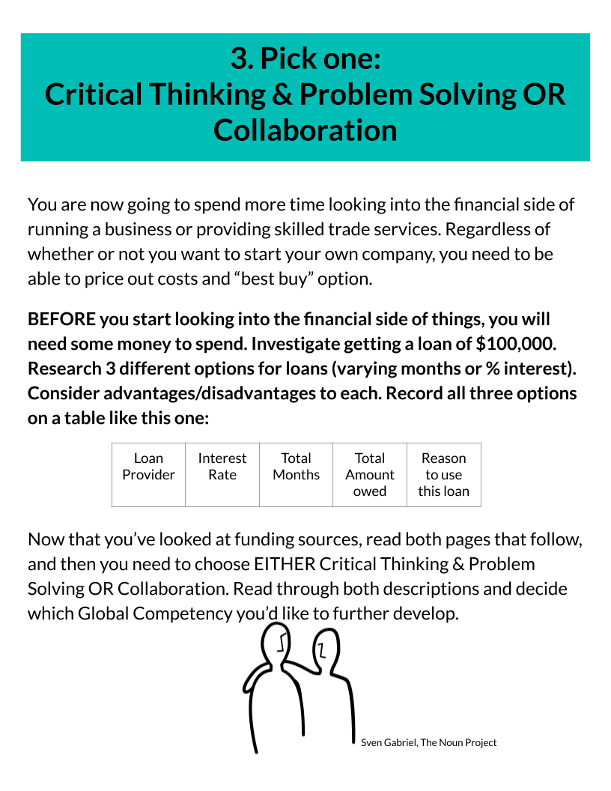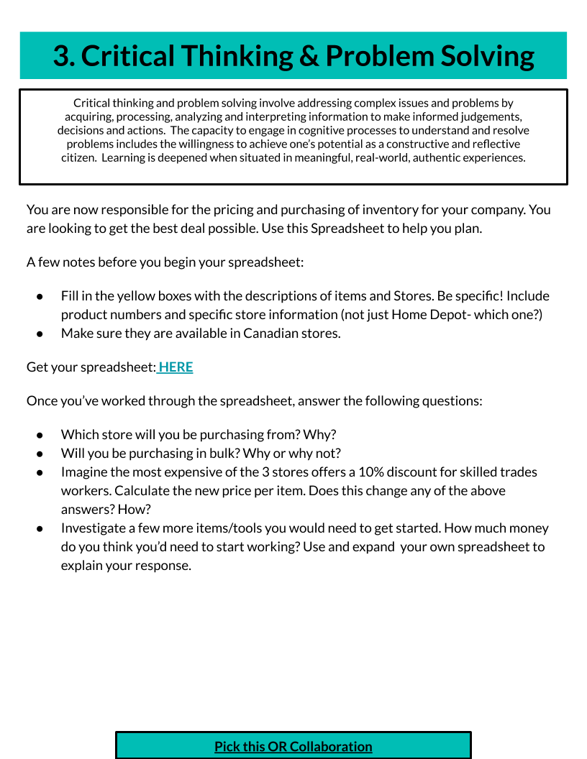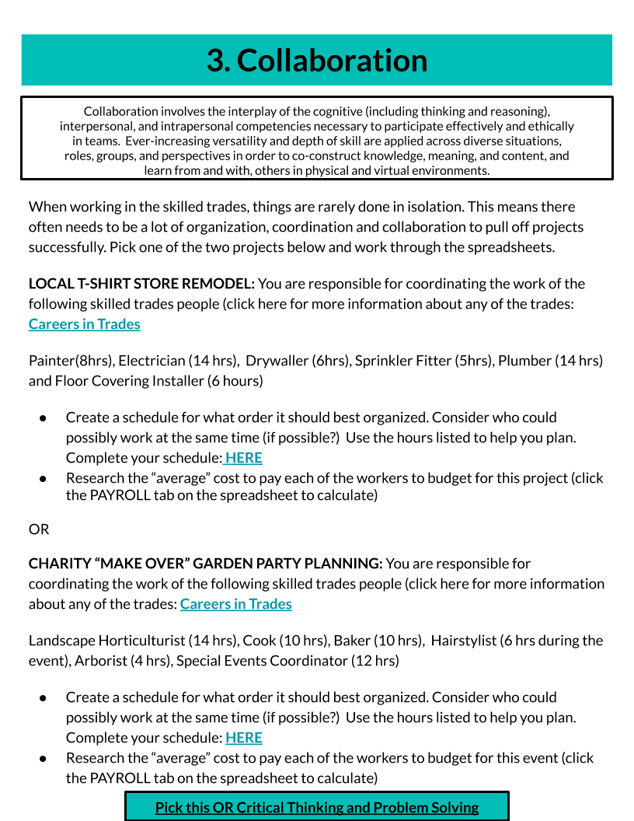

Critical Thinking & Problem Solving Spreadsheet
Your Name:
INITIAL PRICING: | Initial Pricing- Pick 3 items you will need from 3 different stores. Note their prices below
 | Store #1 | Store #2 | Store #3
Item #1
Item #2
Iterm #3
BUYING IN BULK: | Buying in bulk- Is there a discount for buying in bulk? Pick a number of items (10, 100 etc- depends on your trade) and note the total price for each, and price per item.
 | # of items | Store #1 (Bulk Total) | Store #1 (price per item) | Store #2 (Bulk Total) | Store #2 (price per item) | Store # 3 (Bulk Total) | Store #3 (price per item)
Item #1 |  |  | Bulk Total / # of items |  | Bulk Total / # of items |  | Bulk Total / # of items
Item #2 |  |  | Bulk Total / # of items |  | Bulk Total / # of items |  | Bulk Total / # of items
Iterm #3 |  |  | Bulk Total / # of items |  | Bulk Total / # of items |  | Bulk Total / # of items
T-Shirt Remodel
*Each time slot is an hour in length.  *All workers need an hour for lunch after 4 hours of work.  *No worker can work more than 7 hours per day |  |  |  |  | Painter (8 hrs)  Electrician (14 hrs)  Drywaller (6 hrs) |  | Sprinkler Fitter (5 hrs)  Plumber (14 hrs)  Floor Covering Installer (6 hrs)
 | DAY 1 | DAY 2 | DAY 3 | DAY 4 | DAY 5 | DAY 6 | DAY 7 | DAY 8
7:00 AM
8:00 AM
9:00 AM
10:00 AM
11:00 AM
12:00 PM
1:00 PM
2:00 PM
3:00 PM
4:00 PM
5:00 PM

Project: T-Shirt Store Remodel |  | Employee | Hours Worked | Hourly Cost | Total Pay
 |  | TOTAL
**There are more efficient ways to have this spreadsheet automatically calculate for you! Try using formulas.
Charity “Make Over” Garden Party Spreadsheet
*Each timeslot is an hour in length.  *All workers need an hour for lunch after 4 hours of work.  *No worker can work more than 7 hours per day  *Event itself is on the "final" day (you choose the day) from 1-4 pm |  |  |  |  | Cook (10 hrs)  Baker (10 hrs)  Hairstylist (6 hrs - 3 of which are during the event) |  | Landscape Horticulturist (14 hrs)  Arborist (4 hrs)  Special Events Coordinator (12 hrs)
 | DAY 1 | DAY 2 | DAY 3 | DAY 4 | DAY 5 | DAY 6 | DAY 7 | DAY 8
7:00 AM
8:00 AM
9:00 AM
10:00 AM
11:00 AM
12:00 PM
1:00 PM
2:00 PM
3:00 PM
4:00 PM
5:00 PM

Project: Charity "Make Over" Garden Party |  | Employee | Hours Worked | Hourly Cost | Total Pay
 |  | TOTAL
**There are more efficient ways to have this spreadsheet automatically calculate for you! Try using formulas.
Lesson 2.4: Student Exploration- Citizenship
Lesson Objectives:
- Students will examine the financial aspect of working internationally
- Students will explore the financial and long-term impact of environmentally friendly choices in the skilled trades

Student Learning Goals:
We will use citizenship skills so we can explore the short and long term impact of financial and environmental decisions.

Curriculum Connections:
Grade 7 Mathematics- F1.1 identify and compare exchange rates, and convert foreign currencies to Canadian dollars and vice versa

Grade 8 Mathematics- F1.1 describe some advantages and disadvantages of various methods of payment that can be used when dealing with multiple currencies and exchange rates

Grade 10 Career Studies- B1.1 identify some recent and evolving technological, economic, and social trends that have influenced the world of work, both locally and globally, noting their impact on the kind of work we do and how we do it as well as on workers’ rights and responsibilities, and analy

Technology Courses-
Communication Technology- C1.2 describe environmentally responsible practices that can be used to reduce the impact of communications technologies on the environment

Computer Technology- C1. describe environmental issues related to the widespread use of computer technology, and apply strategies to reduce environmental harm from computer use;

Construction- D1.3 describe the environmental effects of using natural and manufactured construction materials (e.g., energy use, release of toxic chemicals, disposal of manufacturing and construction waste, effects on water supply and quality); D1.4 describe ways of reducing and/or managing energy consumption in the home (e.g., smart meters, energy-efficient lighting, timers, heat recovery ventilators);

Green Industries- C2. analyse social, economic, and cultural relationships involving the green industries.

Materials:
- Student Exploration- Making Cents of the Skilled Trades
  - Slides referenced after the lesson, refer to slide deck for interactive links
- Computer/Internet Connection

Considerations for Accommodations:
- Please reference your class profile and Individual Education Plans to ensure that all students have the support they need to meet their learning goals.
- Consider what students’ needs would be prior to, during, and after the lesson.

Lesson Outline

- Introduce/review the Global Competency Citizenship.
  - Additional Resources: OCTE’s Skilled Trades & Global Competencies Experiential Learning Resource
- Students will be examining their work from both an international and environmental impact. They will need to refer back to their work from 2.2 and 2.3
- International Impact: students will look at currency/exchange rates for purchases in other countries
- Reflection questions can be done as a class.
- Environmental Impact: Students may need some support to find environmental concerns in their trades.
- Reflection work should be connected to their work in 2.2

Assessment

Assessment should be based on the curriculum expectations of your course. Refer to OCTE’s Assessment and Experiential Learning for other assessment supports.
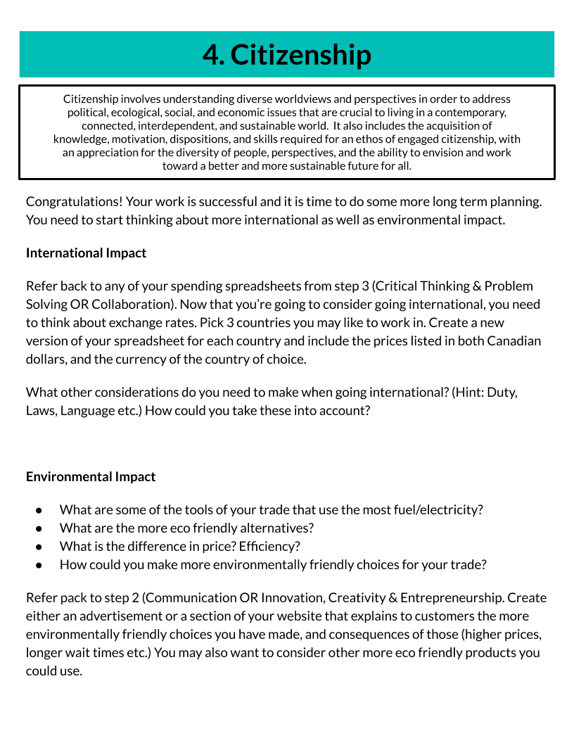

References

Common Sense Education (n.d.). What’s my digital footprint? Retrieved from https://www.commonsense.org/education/lesson-plans/whats-my-digital-footprint
Edugains. (2017). Framework of global competencies. Retrieved from:
http://www.edugains.ca/resources21CL/21stCenturyLearning/FrameworkofGlobalCompetencies_AODA.pdf
Gonzalez, J (2017, November 13). Teaching students to legally use images online. Cult of Pedagogy. Retrieved from: https://www.cultofpedagogy.com/online-images/
Ontario Ministry of Education. (2006). The Ontario curriculum grades 1‐8: Language. [Program of Studies]. Retrieved from http://www.edu.gov.on.ca/eng/curriculum/elementary/language18currb.pdf
Ontario Ministry of Education. (2009). The Ontario curriculum grades 11 & 12: Technology education. [Program of Studies]. Retrieved from http://www.edu.gov.on.ca/eng/curriculum/secondary/2009teched1112curr.pdf
Ontario Ministry of Education. (2016) Community-Connected Experiential Learning: a
Policy Framework For Ontario Schools, Kindergarten to Grade 12: Draft for
Consultation. Retrieved from
http://www.edu.gov.on.ca/eng/general/elemsec/job/passport/CommunityConnected_ExperientialLearningEng.pdf
Ontario Ministry of Education. (2019). The Ontario curriculum grades 19: Career studies. [Program of Studies]. Retrieved from http://edu.gov.on.ca/eng/curriculum/secondary/career-studies-grade10.pdf
Ontario, The Premier’s Highly Skilled Workforce Expert Panel. (2016, June). Building
the Workforce of Tomorrow: A Shared Responsibility. Retrieved from
https://files.ontario.ca/hsw_rev_engaoda_webfinal_july6.pdf

