
Connecting to Skilled Trades Through Experiential Learning
Table of Contents

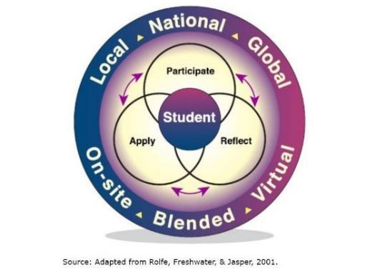

Preamble
- These resources provide a suite of Experiential Learning Opportunities related to the Skilled Trades
- The resources may be used throughout the year/semester to further engage students with respect to making connections to the Skilled Trades
- The resources may be used online or face-to-face, and may be adapted to best suit the learning of the particular subject/curriculum and/or students
- Click on the various versions to make your own copies for using and, if necessary, editing

Connecting to the Global Competencies through Skilled Trades
Title | Description | Microsoft Version | PDF Version
Lesson Plan | - Lesson Plan will outline how teachers may adapt/modify prompts for various purposes and Skilled Trades |   Word Version |   PDF Version
Handout: Understanding the Global Competencies | - This Handout defines each of the 6 Global Competencies and provides considerations for each | Word Version | PDF Version
Handout: The Global Competencies – Quick-Reference Guide | - This Handout is a one-paged, quick-reference guide of the Global Competencies | Word Version | PDF Version
Handout: EL prompts for Global Competences in the Skilled Trades | - Generic prompts relating to the Skilled Trades sector are provided for each Global Competency  - These prompts may be modified to better suit the Experiential Learning Opportunity in which the students are participating | Word Version | PDF Version
Slide Deck: The Global Competencies in the Skilled Trades | - This Slide Deck features the definitions and prompts for each Global Competency  - This Slide Deck may be modified to better suit the experience and/or Skilled Trades sector | 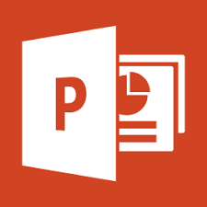  PowerPoint Version | PDF Version
Slide Deck: Activity | - This Slide Deck outlines an activity that has students make connections to the Global Competencies within the context of the Skilled Trades | PowerPoint Version | PDF Version
Rubric for Student Self-Assessment | - This rubric will allow students to determine how they are progressing towards making connections between the Skilled Trades and the Global Competencies | Word Version | PDF Version
Conference (Virtual or Face-to-Face) Related to the Skilled Trades
Title | Description | Microsoft Version | PDF Version
Lesson Plan | - Lesson Plan will outline how teachers may adapt/modify prompts for various purposes and Skilled Trades  - Specific examples of Skilled Trades Conferences will be highlighted | Word Version | PDF Version
Student Handout | - The student handout may be adapted/modified to best suit the experiences  - Teachers may also decide to take sections of this handout/worksheet and incorporate them in D2L (i.e., Discussions, etc.) | Word Version | PDF Version
Virtual or Pre-Recorded Expert Interview
Title | Description | Microsoft Version | PDF Version
Lesson Plan | - Lesson Plan will outline how teachers may adapt/modify prompts for various purposes and Skilled Trades  - Lesson Plan uses the Expert Interview videos from jobtalks.org | Word Version | PDF Version
Slide Deck | - This Slide Deck features questions and prompts for classroom lesson | PowerPoint Version | PDF Version
Student Worksheet | - This Student Worksheet may be used for students to take notes when watching the video interviews | Word Version | PDF Version
Project-/Problem-/Inquiry-Based Learning & Design Thinking
Title | Description | Microsoft Version | PDF Version
Lesson Plan | - Lesson Plan will outline how teachers may adapt/modify prompts for various activities (i.e., problem-based, project-based, or inquiry-based) | Word Version | PDF Version
Slide Deck | - This Slide Deck reviews the steps of the Design Thinking Process  - Reflection and application components are also included in the Slide Deck | PowerPoint Version | PDF Version
Design Thinking Template | - This template may be used with students as the progress through the Design Thinking Process | Word Version | PDF Version
Student Reflection & Application Worksheet | - This Worksheet has students reflect upon and apply their learning from the activity | Word Version | PDF Version
References
Title | Description | Microsoft Version | PDF Version
References | - This list of references includes all sources used to create this suite | Word Version | PDF Version

