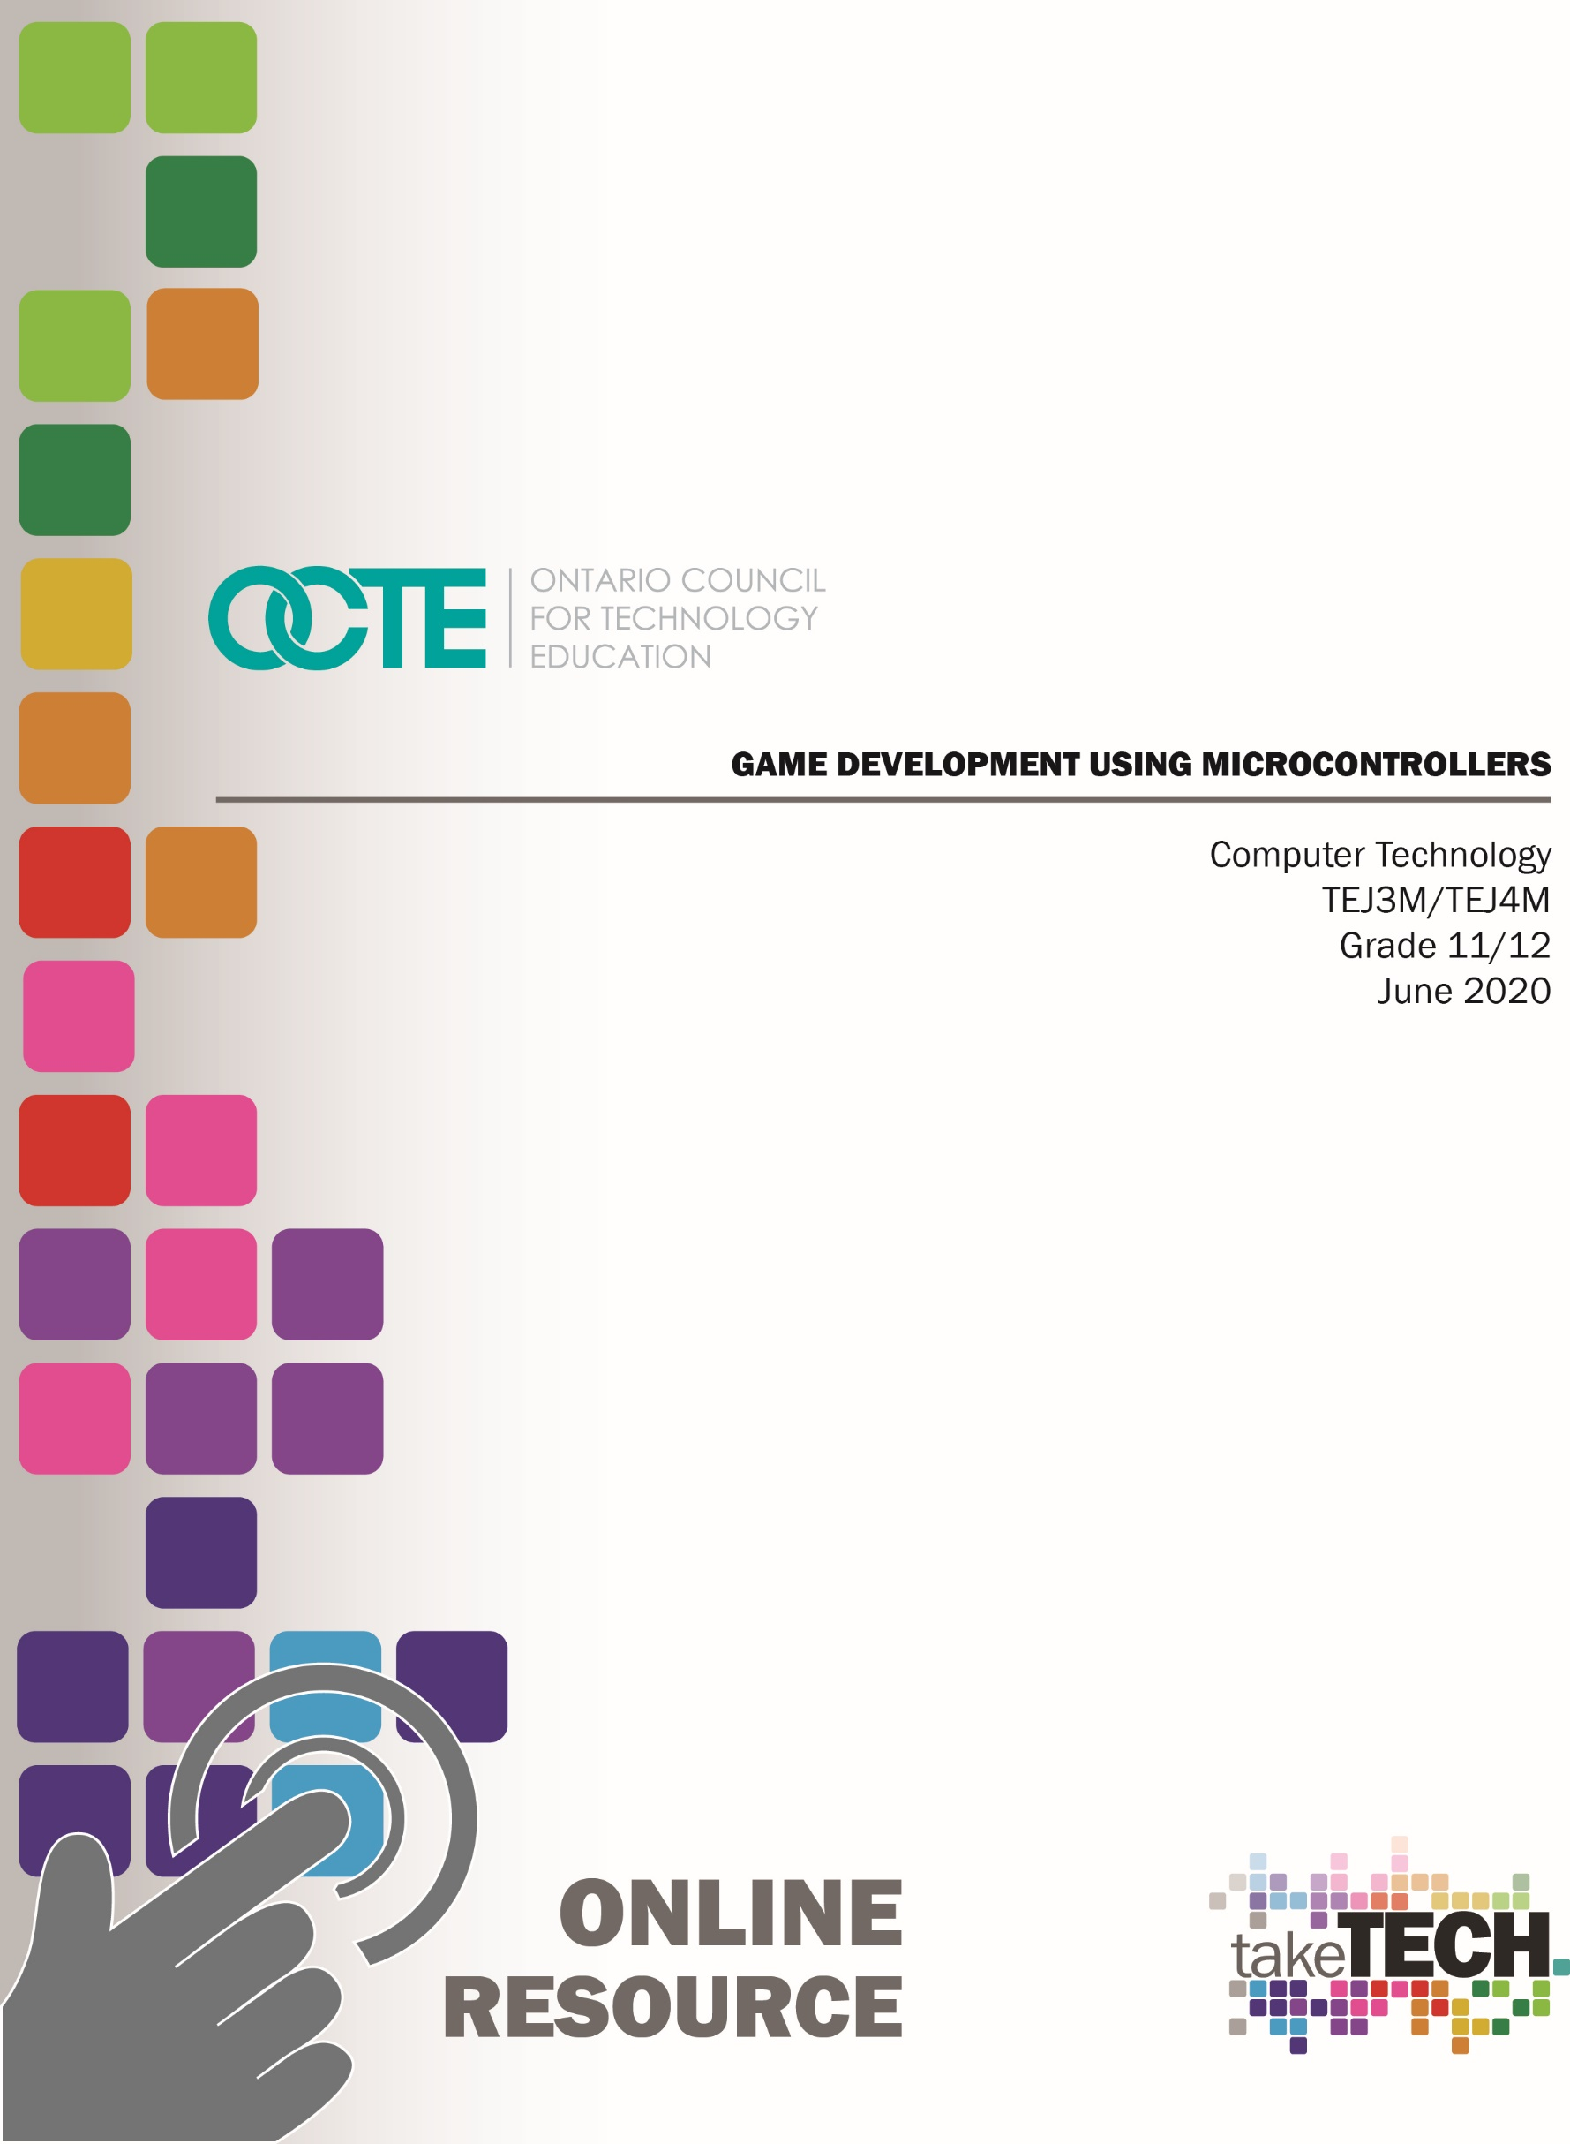

Table of Contents

Introduction 2
Project Outline 2
Prior Knowledge 2
Student Activities 3
Activity 1 – Project Introduction 3
Activity 2 – Using Digital Outputs with a Microcontroller 5
Activity 3 – Using Digital Inputs with a Microcontroller 6
Activity 4 – Using Analog Inputs with a Microcontroller 7
Activity 5 – Using FOR Loops in C++ Programming 8
Activity 6 – Using Boolean Operators in Programming 9
Activity 7 – Using a WHILE Loop in C++ Programming 10
Activity 8 - Using Arrays in C++ Programming 11
Activity 9 – Using Functions in C++ Programming 12
Activity 10 – Culminating Task 13
Resources 14
Video Links: 14
Planning Notes 15
Instructional Strategies 15
Overall and Specific Expectations 15
Overall Expectations: 15
Specific Expectations: 16
Safety Concerns and Expectations 16
Applicable SAFEDocs and ToolSAFE videos 17
Differentiation of the Project / Activity 17
Assessment and Evaluation 18
Accommodations 20
Enrichment activities 21
Reflection or Design Report 21
Appendix A – Exit card – Pull Up and Pull Down Resistors used with Pushbuttons 22
Appendix B – Quiz – Digital and Analog Inputs using a Microcontroller 24
Appendix C – Quiz – Boolean Operators 25
References 26

Introduction
Course Code: TEJ3M / TEJ4M
Broad base Technology: Computer Technology
Destination: College or University
Grade Level: 11 or 12
Prerequisite: None
Online Project Name: Game Development using Microcontrollers

Project Outline
This project involves the creation of a game using an Arduino microcontroller. Students may discuss with the teacher what game they may want to design based on difficulty and availability of parts at the school. The video series created for this project steps through the construction of a memory game. This option was chosen as a large part of this project can be completed with the online simulator at home as long as a student has a computer and access to the internet. Other game options may require more complex hardware and may not be accomplished with the online simulator. For the fall of 2020, a version of the memory game would be a good option if students have an extended “learn at home” period.

Prior Knowledge
Students who have experience with computer programming will find the project easier than those that do not. If a student has taken grade 10 Computer Studies (ISC2O) they will already be familiar with programming concepts such as variables, data types, loops, and arrays. If a student is new to programming, it is suggested that they begin with “block programming” as shown in the video and become familiar with this first. Then, as the student becomes more familiar with block programming, they may use the online simulator to convert from block to text programming (C++) which will be required for working with the real Arduino microcontroller.

Student Activities

Activity 1 – Project Introduction
The goal(s) of this activity are to introduce the students to the project of building a game using an Arduino microcontroller. Students may discuss ideas with the teacher, but the student will be limited to resources in class. It’s important that the task is not too difficult to program and/or the hardware requirements may not be achievable. The video series for this project focuses on the creation of a memory game. This is a good choice for many students as the hardware requirements are minimal and the programming can be completed at home or at school with the online simulator.
Time required: 20 minutes
In class activities:
- Teacher shall introduce project to class
- Teacher should review the design process with the students and illustrate with an example
- Students shall be introduced to video series
Materials/Equipment required if in class: For an introduction, the teacher may show Arduino UNO boards and connecting cables, Arduino software installed on class computers, pushbuttons, 10 kOhm resistors, 220 Ohm resistors, LEDs, piezo speakers, male to male connecting wires, male to female connecting wires, and LCD screens if available.
Resources: The details of this activity will be described in a video that student can watch on the OCTE website or the OCTE YouTube channel. If the student is at school, the student can watch the video in class or at home and then complete the activity using the tools and supplies in class. If the student is at home, they can begin working on the task using the web-based simulator. Supplementary resources can be used if the student is home for an extended period of time.
Web link: Video 1 – Introduction to Project Task
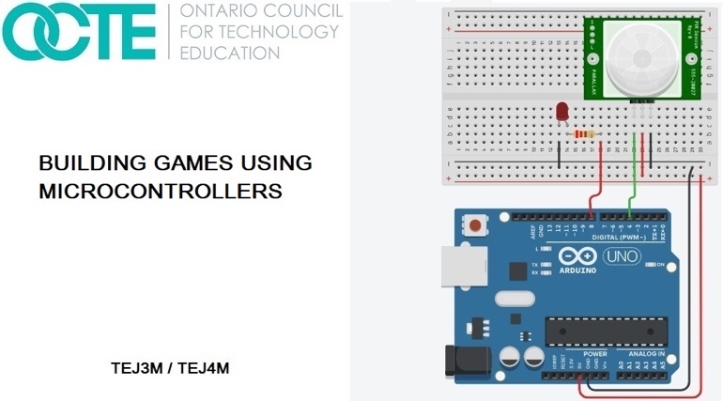
Synopsis of video: This video introduces students to the culminating task which is a game design using an Arduino microcontroller. Although the game design will be determined by the teacher and the student, the video series focuses on the creation of a memory game. The video introduces the project and goes through some keys to success for the project.
Assessment/Evaluation: Assessment/Evaluation: Informal assessment can take place in the form of providing feedback to students as they progress through this activity. Students should be encouraged to ask questions to increase their understanding and to reveal areas where they need support.

Activity 2 – Using Digital Outputs with a Microcontroller
The goal(s) of this activity are to create a digital output using the Arduino microcontroller.
Time required: 30 minutes
In class activities:
- Teacher shall show students how to create an LED output circuit using a current limiting resistor (220 Ohms). The teacher will review the operation of a diode and that this is a polarity sensitive device (anode and cathode).
- After handing out supplies, the students will create a flashing circuit using their Arduino microcontroller and a program written in C++.
- Students shall watch the next video in the series
Materials/Equipment required if in class: Arduino UNO boards and connecting cables, Arduino software installed on class computers, pushbuttons, 10 kOhm resistors, 220 Ohm resistors, LEDs, piezo speakers, male to male connecting wires, male to female connecting wires, and LCD screens if available.
Resources: The details of this activity will be described in a video that student can watch on the OCTE website or the OCTE YouTube channel. If the student is at school, the student can watch the video in class or at home and then complete the activity using the tools and supplies in class. If the student is at home, they can begin working on the task using the web-based simulator. Supplementary resources can be used if the student is home for an extended period of time.
Web link: Video 2 – Using Digital Outputs with a Microcontroller
Synopsis of video: This video introduces students to how you can create a flashing circuit using the Arduino microcontroller and the digitalWrite command in text programming. The students are shown how to set up a three LED circuit and create a flashing sequence from one LED to the next.
Assessment/Evaluation: Demonstration of working circuit to the teacher

Activity 3 – Using Digital Inputs with a Microcontroller
The goal(s) of this activity are to create a digital input to a microcontroller using a pushbutton and a pull-down resistor
Time required: 30 minutes
In class activities:
- Teacher shall show students how to create a digital input using a pushbutton and a pull-down resistor or pull up resistor.
- The students will be given supplies and create a digital input using a pull-down resistor and a pushbutton.
- Students shall watch the next video in the series
Materials/Equipment required if in class: Arduino UNO boards and connecting cables, Arduino software installed on class computers, pushbuttons, 10 kOhm resistors, 220 Ohm resistors, LEDs, piezo speakers, male to male connecting wires, male to female connecting wires, and LCD screens if available.
Resources: The details of this activity will be described in a video that student can watch on the OCTE website or the OCTE YouTube channel. If the student is at school, the student can watch the video in class or at home and then complete the activity using the tools and supplies in class. If the student is at home, they can begin working on the task using the web-based simulator. Supplementary resources can be used if the student is home for an extended period of time.
Web link: Video 3 – Using Digital Inputs with a Microcontroller
Synopsis of video: This video introduces students to creating a digital input using a pushbutton and a pull-down resistor. Students learn how to use the digitalRead command to accept the input state from the pushbutton circuit.
Assessment/Evaluation: Demonstration of working circuit to the teacher. Exit card on pull up and pull-down resistors (see Appendix A)

Activity 4 – Using Analog Inputs with a Microcontroller
The goal(s) of this activity is for students to create an analog input and send this input to a microcontroller.
Time required: 30 minutes
In class activities:
- The teacher will introduce variable resistors and how they can act as an analog input to a microcontroller. The teacher will also give examples of other devices that can act as analog inputs such as volume controls and dimmer controls for lights.
- Student will build an analog input circuit using a potentiometer
- Students shall watch next video in the video series
Materials/Equipment required if in class: Arduino UNO boards and connecting cables, Arduino software installed on class computers, pushbuttons, 10 kOhm resistors, 220 Ohm resistors, LEDs, piezo speakers, male to male connecting wires, male to female connecting wires, and LCD screens if available.
Resources: The details of this activity will be described in a video that student can watch on the OCTE website or the OCTE YouTube channel. If the student is at school, the student can watch the video in class or at home and then complete the activity using the tools and supplies in class. If the student is at home, they can begin working on the task using the web-based simulator. Supplementary resources can be used if the student is home for an extended period of time.
Web link: Video 4 – Using Analog Inputs with a Microcontroller
Synopsis of video: This video introduces students to how an analog input is used with a microcontroller. In the video, a potentiometer is used as an input device and students learn how a range of voltages from zero to 5 Volts is interpreted to a ten bit binary number by the microcontroller (0 to 1023). The students are shown the voltage change on the input using a voltmeter and how the serial monitor can be used to see the value of the ten bit binary number.
Assessment/Evaluation: Demonstration of working circuit to the teacher.

Activity 5 – Using FOR Loops in C++ Programming
The goal(s) of this activity are to learn how to create a finite loop through the use of FOR loops in C++ programming.
Time required: 30 minutes
In class activities:
- The teacher will introduce the FOR loop structure in C++.
- Student will build a flashing LED circuit using multiple FOR loops.
- Students shall watch next video in the video series.
Materials/Equipment required if in class: Arduino UNO boards and connecting cables, Arduino software installed on class computers, pushbuttons, 10 kOhm resistors, 220 Ohm resistors, LEDs, piezo speakers, male to male connecting wires, male to female connecting wires, and LCD screens if available.
Resources: The details of this activity will be described in a video that student can watch on the OCTE website or the OCTE YouTube channel. If the student is at school, the student can watch the video in class or at home and then complete the activity using the tools and supplies in class. If the student is at home, they can begin working on the task using the web based simulator. Supplementary resources can be used if the student is home for an extended period of time.
Web link: Video 5 – Use FOR Loops in C++ Programming
Synopsis of video: This video introduces students to FOR loops as a way to loop a finite number of times to accomplish some task. The video shows two separate LED circuits and how each LED is flashed a specific number of times based on the FOR loop.
Assessment/Evaluation: Demonstration of working circuit to the teacher. Quiz on digital and analog inputs (see Appendix B)

Activity 6 – Using Boolean Operators in Programming
The goal(s) of this activity are to show how to use Boolean operators for accepting multiple inputs to a microcontroller.
Time required: 30 minutes
In class activities:
- The teacher will introduce the “and” and “or” Boolean operators and the truth tables for each.
- Student will build a two digital input circuit using two pushbuttons and pull down resistors. Students will then create the code to check both input states from the pushbuttons and will turn on an LED based on the “and” and “or” Boolean operators.
- Students shall watch next video in the video series
Materials/Equipment required if in class: Arduino UNO boards and connecting cables, Arduino software installed on class computers, pushbuttons, 10 kOhm resistors, 220 Ohm resistors, LEDs, piezo speakers, male to male connecting wires, male to female connecting wires, and LCD screens if available.
Resources: The details of this activity will be described in a video that student can watch on the OCTE website or the OCTE YouTube channel. If the student is at school, the student can watch the video in class or at home and then complete the activity using the tools and supplies in class. If the student is at home, they can begin working on the task using the web based simulator. Supplementary resources can be used if the student is home for an extended period of time.
Web link: Video 6 – Using Boolean Operators in Programming
Synopsis of video: This video introduces students to the “and” and “or” Boolean operators. Students are shown the operation of two slideswitches and how the Boolean operators can be used to create an output.
Assessment/Evaluation: Demonstration of working circuit to the teacher.

Activity 7 – Using a WHILE Loop in C++ Programming
The goal(s) of this activity are to show how a WHILE loop can be used in game programming as part of the “main game play loop”.
Time required: 30 minutes
In class activities:
- The teacher will introduce WHILE loops to students.
- Student will build a pushbutton circuit along with an LED circuit. Then, the students will complete the code to turn on the LED circuit based on the WHILE loop.
- Students shall watch next video in the video series
Materials/Equipment required if in class: Arduino UNO boards and connecting cables, Arduino software installed on class computers, pushbuttons, 10 kOhm resistors, 220 Ohm resistors, LEDs, piezo speakers, male to male connecting wires, male to female connecting wires, and LCD screens if available.
Resources: The details of this activity will be described in a video that student can watch on the OCTE website or the OCTE YouTube channel. If the student is at school, the student can watch the video in class or at home and then complete the activity using the tools and supplies in class. If the student is at home, they can begin working on the task using the web based simulator. Supplementary resources can be used if the student is home for an extended period of time.
Web link: Video 7 – Using a WHILE Loop in C++ Programming
Synopsis of video: This video introduces students to how a WHILE loop can be used in game development with Arduino and C++. The students are shown that a memory game requires something like a WHILE loop so that the game will continue as long as the player is winning. As soon as the player loses, the game will be able to end due to the condition of the WHILE statement.
Assessment/Evaluation: Demonstration of working circuit to the teacher.

Activity 8 - Using Arrays in C++ Programming
The goal(s) of this activity are to introduce students to the use of arrays in C++ programming. Students will also learn how to generate random numbers for the purpose of game development.
Time required: 30 minutes
In class activities:
- The teacher will introduce students to one dimensional arrays and how they are set up in C++. The teacher shall state how arrays can be filled and by what data types.
- The students will set up three pushbutton circuits. Each pushbutton circuit will be a digital input to the microcontroller. The state of each pushbutton will be stored in a three element array. Students will display the elements of the array through the serial monitor of the Arduino.
- Students shall watch next video in the video series
Materials/Equipment required if in class: Arduino UNO boards and connecting cables, Arduino software installed on class computers, pushbuttons, 10 kOhm resistors, 220 Ohm resistors, LEDs, piezo speakers, male to male connecting wires, male to female connecting wires, and LCD screens if available.
Resources: The details of this activity will be described in a video that student can watch on the OCTE website or the OCTE YouTube channel. If the student is at school, the student can watch the video in class or at home and then complete the activity using the tools and supplies in class.
If the student is at home, they can begin working on the task using the web based simulator. Supplementary resources can be used if the student is home for an extended period of time.
Web link: Video 8 – Using Arrays in C++ Programming
Synopsis of video: This video introduces students to arrays and how they can be used in game development. The video shows how to use a random function to generate random numbers that can be used in game design (i.e.: roll of a dice). The video shows how turn on four LEDs in a random sequence through the use of an array and the random function in C++.
Assessment/Evaluation: Demonstration of working circuit to the teacher. Quiz on Boolean operators (see Appendix C)

Activity 9 – Using Functions in C++ Programming
The goal(s) of this activity are to introduce functions in C++ programming and how they can be incorporated for a more effective and efficient game design.
Time required: 30 minutes
In class activities:
- The teacher will introduce functions to students and how they can be used in C++ programming. It should be emphasized that functions can not only create a more efficient program, but it will make the code easier to debug.
- Students will set up a three LED circuit and then create the code to random generate a flashing pattern with the LEDs. Students must use an array to complete this task. The elements of the array should be shown in the serial monitor.
- Students shall watch next video in the video series
Materials/Equipment required if in class: Arduino UNO boards and connecting cables, Arduino software installed on class computers, pushbuttons, 10 kOhm resistors, 220 Ohm resistors, LEDs, piezo speakers, male to male connecting wires, male to female connecting wires, and LCD screens if available.
Resources: The details of this activity will be described in a video that student can watch on the OCTE website or the OCTE YouTube channel. If the student is at school, the student can watch the video in class or at home and then complete the activity using the tools and supplies in class. If the student is at home, they can begin working on the task using the web based simulator. Supplementary resources can be used if the student is home for an extended period of time.
Web link: Video 9 – Using Functions in C++ Programming
Synopsis of video: This video introduces students to functions and how they can be used to create a more effective and efficient design in C++ programming. Students are shown how to use a function to check the button states of four pushbuttons and then return a parameter to the main function.
Assessment/Evaluation: Demonstration of working circuit to the teacher

Activity 10 – Culminating Task
The goal(s) of this activity is to review the details of the culminating task
Time required: 60 minutes
In class activities:
- Students shall watch the final video in the video series. This reviews the task as well as the keys to success.
- Students will be given class time to complete the culminating task which is a “Building a game using a Microcontroller”. Students will be handing in a document showing the design process for this task (see Reflection or Design Report)
Materials/Equipment required if in class: Arduino UNO boards and connecting cables, Arduino software installed on class computers, pushbuttons, 10 kOhm resistors, 220 Ohm resistors, LEDs, piezo speakers, male to male connecting wires, male to female connecting wires, and LCD screens if available.
Resources: The details of this activity will be described in a video that student can watch on the OCTE website or the OCTE YouTube channel. If the student is at school, the student can watch the video in class or at home and then complete the activity using the tools and supplies in class. If the student is at home, they can begin working on the task using the web based simulator. Supplementary resources can be used if the student is home for an extended period of time.
Web link: Video 10 – Review of Culminating Task
Synopsis of video: This video reviews the project details as well as the keys to success.
Assessment/Evaluation: Demonstration of working circuit to the teacher. As well, students will include a submission of wiring diagram and connections with the microcontroller along with the project code. Students will be handing in a document showing the design process for this task (see Reflection or Design Report)

Resources
Simulation website: Autodesk Tinkercad website
Arduino website: Arduino

Video Links:
Video 1: Introduction to Project Task
http://www.octe.ca/application/files/3615/9206/2752/1._Introduction_to_project.mp4
Video 2: Using Digital Outputs with a Microcontroller
http://www.octe.ca/application/files/4815/9206/2862/2._Using_digital_outputs_with_a_microcontroller.mp4
Video 3: Using Digital Inputs with a Microcontroller
http://www.octe.ca/application/files/6715/9206/9968/3._Using_digital_inputs_with_a_microcontroller.mp4
Video 4: Using Analog Inputs with a Microcontroller
http://www.octe.ca/application/files/7515/9207/0086/4._Using_analog_inputs.mp4
Video 5: Use FOR Loops in C++ Programming
http://www.octe.ca/application/files/2515/9207/0197/5._Using_FOR_loops_.mp4
Video 6: Using Boolean Operators in Programming
http://www.octe.ca/application/files/6615/9207/0672/6._Using_Boolean_operators.mp4
Video 7: Using a WHILE Loop in C++ Programming
http://www.octe.ca/application/files/8015/9207/1939/7._Using_a_WHILE_loop.mp4
Video 8: Using Arrays in C++ Programming
http://www.octe.ca/application/files/1615/9224/6590/8.__Using_arrays.mp4
Video 9: Using Functions in C++ Programming
http://www.octe.ca/application/files/7115/9207/2706/9._Using_functions.mp4
Video 10: Review of Culminating Task
http://www.octe.ca/application/files/8815/9207/2851/10._Completion_of_project.mp4

Planning Notes
Before beginning this unit, a review of basic electricity would be beneficial. The teacher may want to review voltage, current, and resistance and how to operate a multimeter. As well, Ohm’s Law and Joule’s Law should be reviewed. This will allow students to more fully understand digital and analog inputs as well as pull up and pull down resistor circuits. As a preview to this project, the teacher may want to create some activities using the simulator in preparation for this project. This could include some simple series and parallel circuits. Also, the teacher may wish to use the block programming feature in the simulator to prepare students for programming in text format.

Instructional Strategies
Due to the situation with COVID-19 in the spring of 2020, this series was developed with the possibility that students may not be in school full time for the fall of 2020. As a result, the majority of this project can be completed with the online simulator where students can create simple electric circuits along with microcontroller circuits. Students can complete tasks at home if required and hand in a screen capture showing their circuit and code or by completing a screen recording and handing it in to their learning management system. New tasks can be created by the teacher that stem from what is shown in the video series.

Overall and Specific Expectations in Support of Ontario Curriculum Grades 11 -12 Technological Education

Overall Expectations:
A3. Describe the function of electronic components and the use of these components in control systems and other circuits, and calculate values for circuit components;
A5. Demonstrate an understanding of the use of binary numbers, hexadecimal numbers, and Boolean algebra in computer logic and data processing
B3. Design, construct, create diagrams for, and troubleshoot electronic circuits and interfaces for control systems;
B5. Demonstrate an understanding of fundamental programming concepts, and develop a program that interacts with an external device.

Specific Expectations:
A3.1 Identify and describe the functions of electronic components (e.g., resistor, capacitor, diode, LED)
A3.2 Describe the function of electrical devices used in control systems
A3.5 Compare the advantages and disadvantages of interfacing using desktop computers, microcontrollers, and programmable logic controllers
A5.1 Describe binary and hexadecimal numbers, and convert positive integers among decimal, binary, and hexadecimal number systems
A5.3 Relate Boolean algebra to the fundamental logic gates and to combinations of these gates, using symbolic, algebraic, and numeric representations
B3.1 Use a design process to design and safely construct and test interfacing or robotics circuits (e.g., for LED traffic lights, VU meter, alarm system, or motor control), using appropriate materials and techniques, including soldering
B3.2 Troubleshoot an electronic circuit using appropriate methods and test equipment (e.g., methods: isolation and substitution of components; equipment: multimeter, oscilloscope, logic probe)
B3.3 Draw and interpret diagrams that represent circuit components and functions (e.g., schematic diagram, block diagram, flow chart)
B3.4 Use computer programs to simulate circuit performance and to draw schematic diagrams and circuit layouts (e.g., circuit simulator, schematic capture software, printed circuit board layout software)
B5.1 Use constants, variables, expressions, and assignment statements correctly, taking into account the order in which operations are performed;
B5.2 Use input statements, output statements, selection structures, and repetition structures in a program
B5.3 Use a design process to write, test, and debug a computer program that controls and/or responds to the inputs from an external device (e.g., LED array, motor, relay, infrared sensor, temperature sensor)

Safety Concerns and Expectations
The majority of the activities can be completed at home using the online simulator. This portion does not require supervision by a parent. If a student has a real Arduino board at home, the project voltage is low voltage (5 Volts) and the Arduino board limits the amount of current supplied.

Applicable SAFEDocs and ToolSAFE videos
Please refer to the Computer Technology SAFEDocs located on the OCTE website.

Differentiation of the Project / Activity
Students will be given opportunities to learn using various formats including the web based circuit simulator and the actual Arduino microcontroller. Students will have the opportunity to learn through virtual circuit building as we as building circuits using breadboards and microcontrollers in class.
Students will also be able be assessed in various formats from text to oral demonstrations to screen captures and screen recordings. Screen captures and screen recordings are an excellent way for students to demonstrate their knowledge if they have “learn from home” extended periods of time. There are many free screen recording apps that student may use.

Assessment and Evaluation

Constructing Games using Microcontrollers Rubric
Categories | 50-59%  (Level 1) | 60-69%  (Level 2) | 70-79%  (Level 3) | 80-100%  (Level 4)
Knowledge and Understanding – Subject-specific content acquired in each course (knowledge), and the comprehension of its meaning and significance (understanding)
 | The student:
Knowledge of content  Student knows how to create the software and connect the hardware for the microcontroller | demonstrates  limited knowledge  of content | demonstrates  some knowledge  of content | demonstrates  considerable  knowledge of  content | demonstrates  thorough knowledge of  content
Understanding of content  Student understands different measuring units for voltage, current and resistance | demonstrates  limited understanding  of  content | demonstrates  some understanding  of  content | demonstrates  considerable  understanding  of content | demonstrates  thorough understanding  of  content
Thinking – The use of critical and creative thinking skills and/or processes

 | The student:
Use of planning skills  Student could plan the construction of the hardware circuit and software code | uses planning  skills with limited  effectiveness | uses planning  skills with some  effectiveness | uses planning  skills with  considerable  effectiveness | uses planning  skills with a  high degree of  effectiveness  while building their box
Use of processing skills  Student could identify the input and output pins for input and output devices | uses processing  skills with limited  effectiveness | uses processing  skills with some  effectiveness | uses processing  skills with  considerable  effectiveness | uses processing  skills with a  high degree of  effectiveness
Use of critical/creative  thinking processes  Student was able to use creative thinking to determine random sequences that are required in game design | uses critical/  creative thinking  processes  with limited  effectiveness | uses critical/  creative thinking  processes  with some  effectiveness | uses critical/  creative thinking  processes with  considerable  effectiveness | uses critical/  creative thinking  processes with a  high degree of  effectiveness

Categories | 50-59%  (Level 1) | 60-69%  (Level 2) | 70-79%  (Level 3) | 80-100%  (Level 4)
Communication – The conveying of meaning through various forms

 | The student:
Expression and  organization of ideas  and information  Student was able to organize their ideas and present their information clearly in a wiring diagram | expresses and  organizes ideas  and information  with limited  effectiveness | expresses and  organizes ideas  and information  with some  effectiveness | expresses and  organizes ideas  and information  with considerable  effectiveness | expresses and  organizes ideas  and information  with considerable  effectiveness  expresses and  organizes ideas  and information  with a high  degree of  effectiveness
Communication for  different audiences  in oral, visual, and written  forms  Student was able to demonstrate and describe how hardware and software work with microcontroller | communicates for  different audiences  and purposes  with limited  effectiveness | communicates for  different audiences  and purposes  with some  effectiveness | communicates for  different audiences  and purposes  with considerable  effectiveness | communicates for  different audiences  and purposes  with a high  degree of  effectiveness  uses conventions
Use of conventions  vocabulary, and terminology  of the discipline in  oral, visual, and written  forms  Student can use terminology associated with software and hardware circuits | uses conventions,  vocabulary, and  terminology of  the discipline  with limited  effectiveness  uses | conventions,  vocabulary, and  terminology of  the discipline  with some  effectiveness | uses conventions,  vocabulary, and  terminology of  the discipline  with considerable  effectiveness | uses conventions,  vocabulary, and  terminology of  the discipline with  a high degree of  effectiveness

Categories | 50-59%  (Level 1) | 60-69%  (Level 2) | 70-79%  (Level 3) | 80-100%  (Level 4)
Application – The use of knowledge and skills to make connections within and between various contexts

 | The student:
Application of knowledge  and in familiar  contexts  Student was able to create a memory game using software and hardware | applies knowledge  and skills in familiar  contexts with limited  effectiveness | applies knowledge  and skills in familiar  contexts with some  effectiveness | applies knowledge  and skills in familiar  contexts with  considerable  effectiveness | applies knowledge  and skills in familiar  contexts with a  high degree of  effectiveness
Transfer of knowledge  and skills to new  contexts  Student was able to transfer knowledge of arrays to store elements in a game design | transfers knowledge  and skills  to new contexts  with limited  effectiveness | transfers knowledge  and skills  to new contexts  with some  effectiveness | transfers knowledge  and skills  to new contexts  with considerable  effectiveness | transfers knowledge  and skills  to new contexts  with a high degree  of effectiveness
Making connections  within and between various  contexts  Student will make connections between block and text programming | makes connections  within and between  various contexts  with limited  effectiveness | makes connections  within and between  various contexts  with some  effectiveness | makes connections  within and between  various contexts  with considerable  effectiveness | makes connections  within and between  various contexts  with a high degree  of effectiveness0–

Accommodations
Each activity in this project is supported with a video. Students can watch the video a number of times as required at school or at home. If students have access to a computer and the internet at home, they can practice using the simulator as much as required. For the hearing impaired, a student may watch the videos through YouTube using close captioning.
For those students who are having difficulty programming in text form (C++) the teacher could create activities based on block programming using the simulator. This could be completed by students at school or at home if they have a computer and access to the internet.

Enrichment activities
Students who complete the task early may look at the addition of an LCD screen for their project. Students will learn about serial and parallel data transmission by doing so. The screen could indicate the beginning and end of the game as well as score or current level. There are many supports found on the internet about the Arduino LCD screen.

Reflection or Design Report
At the end of the culminating task, students will demonstrate working circuit to their teacher. As well, students will complete a design report that contains the following elements:
- The problem – Creating a memory game using the Arduino microcontroller
- Imagine – Brainstorm a solution and choose an idea
- Plan – Include a circuit drawing with connections to the microcontroller
- Create – Follow the plan and complete initial testing
- Improve – Review results and determine what can work better and repeat steps 1 to 5

Appendix A – Exit card – Pull Up and Pull Down Resistors used with Pushbuttons
- If the breadboard shown below is correctly powered from the Arduino, what is the input voltage on pin 7 when the pushbutton is not pressed? (Answer: 0 Volts)
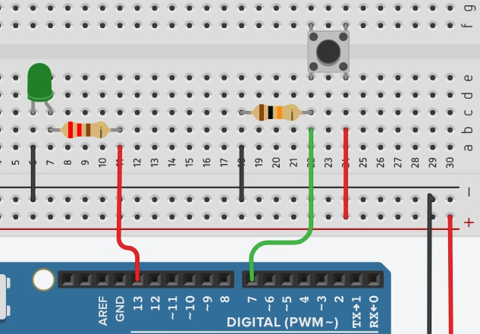
- If the breadboard shown below is correctly powered from the Arduino, what is the input voltage on pin 7 when the pushbutton is pressed? (Answer: 5 Volts)

- If the breadboard shown below is correctly powered from the Arduino, what is the input voltage on pin 7 when the pushbutton is pressed? (Answer: 0 Volts)
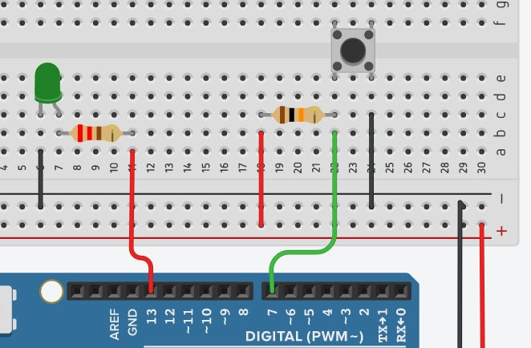

Appendix B – Quiz – Digital and Analog Inputs using a Microcontroller
- A digital input pin on the Arduino is designed to accept what voltages? (Answer: 0 V or 5 V)
- An analog input pin on the Arduino is designed to accept what voltages? (Answer: a range of voltages from 0 V or 5 V)
- What is one pin used for an analog input on the Arduino board? (Answer: A0 or A1 or A2 or A3 or A4 or A5)
- If a potentiometer is used as analog input to your Arduino board, what is displayed in the serial monitor if the wiper from the potentiometer is exactly halfway as shown in the image below? Assume the breadboard is correctly powered from the Arduino. (Answer: 511 or 512)
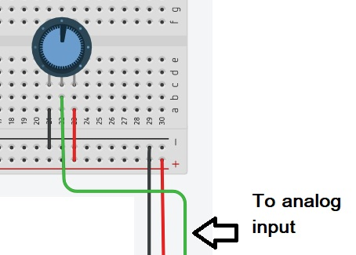

- What voltage on an analog input pin on your Arduino would be required to produce a serial monitor value equal to 767? Assume a potentiometer was used as the analog input. (Answer: approximately 3.75 Volts)

Appendix C – Quiz – Boolean Operators
- The following truth table is for what Boolean operator? (Answer: AND)
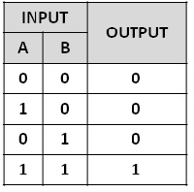
- The following truth table is for what Boolean operator? (Answer: OR )
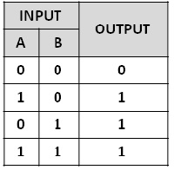
- “||” (two pipes) can be used to represent which Boolean operator? (Answer: OR)
- Which of the following is the correct syntax for an IF statement in C++? (Answer: a)
a) if (bottomSwitch == 1 or topSwitch == 1)
b) if (bottomSwitch = 1 or topSwitch = 1)
- True or false. AND & OR gates may have more than two inputs? (Answer: true)

References
21st Century Competencies: Foundation Document for Discussion. Phase 1: Towards Defining 21st Century Competencies for Ontario, Winter 2016 Edition, 2016 http://www.edugains.ca/resources21CL/About21stCentury/21CL_21stCenturyCompetencies.pdf
Arduino Website https://www.arduino.cc/
Autodesk TinkerCAD Website https://www.tinkercad.com/
Computer Technology SAFEDocs (OCTE), 2013 https://www.octe.ca/application/files/4815/3796/3124/SAFEdoc_CET.pdf
Course Codes for Emphasis courses in the Revised Curriculum: Technological Education, Grades 11 and 12, 2009 http://www.edu.gov.on.ca/eng/curriculum/secondary/techedemphasiscourses.pdf
Growing Success: Assessment, Evaluation, and Reporting in Ontario Schools, First Edition, Covering Grades 1 to 12, 2010 www.edu.gov.on.ca/eng/policyfunding/growSuccess.pdf
Learning for All – A Guide to Effective Assessment and Instruction for All Students, Kindergarten to Grade 12, 2013 http://www.edu.gov.on.ca/eng/general/elemsec/speced/LearningforAll2013.pdf
The Differentiated Instruction Scrapbook http://www.edugains.ca/resourcesDI/EducatorsPackages/DIEducatorsPackage2010/2010DIScrapbook.pdf
The Ontario Curriculum, Grades 9 and 10: Technological Education, 2009 (revised)
http://www.edu.gov.on.ca/eng/curriculum/secondary/teched910curr09.pdf
The Ontario Curriculum, Grades 11 and 12: Technological Education, 2009 (revised) http://www.edu.gov.on.ca/eng/curriculum/secondary/2009teched1112curr.pdf

