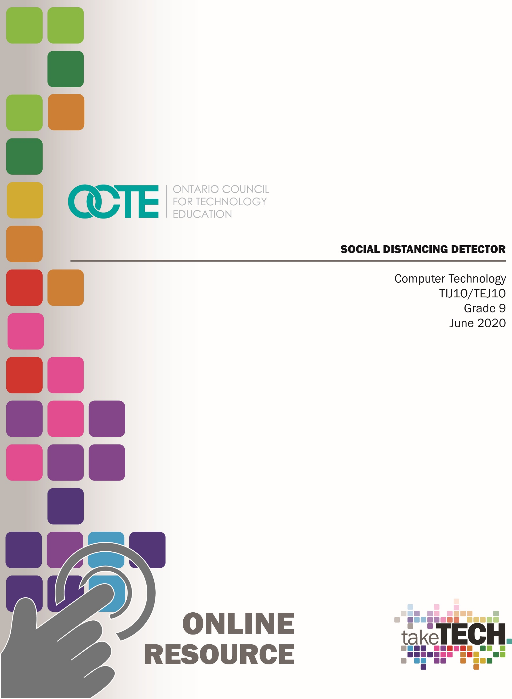

Table of Contents

Introduction 3
Project Outline 3
Prior Knowledge 3
Student Activities 4
Activity 1 – Project Introduction 4
Activity 2 – Introduction to Web Based Simulators for Circuit Building 5
Activity 3 – Introduction to Voltage, Current and Resistance in Electric Circuits 6
Activity 4 – Using a Breadboard to create Electric Circuits 7
Activity 5 – Introduction to Ohm’s Law 8
Activity 6 – Series Circuits 9
Activity 7 – Parallel Circuits 10
Activity 8 – Introduction to Microcontrollers 11
Activity 9 – Using a Digital Input with a Microcontroller 12
Activity 10 – Using a Digital Input Sensor with a Microcontroller 13
Activity 11 – Using an Analog Input with a Microcontroller 15
Activity 12 – Using an Ultrasonic Sensor with a Microcontroller 16
Activity 13 – Using Boolean Operators in Programming 17
Activity 14 – Culminating Task 18
Resources 19
Video Links: 19
Instructional Strategies 20
Overall and Specific Expectations 21
Overall Expectations: 21
Specific Expectations: 21
Safety Concerns and Expectations 22
Applicable SAFEDocs 22
Differentiation of the Project / Activity 22
Assessment and Evaluation 23
Constructing “Social Distancing” Detector Rubric 23
Accommodations 25
Enrichment Activities 26
Reflection or Design Report 26
Appendix A – Exit Card – Voltage, Current, and Resistance 27
Appendix B – Assignment – Ohm’s Law 28
Appendix C – Quiz - Ohm’s Law and Series Circuits 29
Appendix D – Quiz – Digital and Analog input devices 31
References 32

Introduction
Course Code: TIJ1O / TEJ1O
Broad base Technology: Exploring Technologies and Computer Technology
Destination: Open
Grade Level: 9
Prerequisite: None
Online Project Name: Social Distancing Detector

Project Outline
In the spring of 2020, we all became familiar with the phrase “social distancing” due to the impact of the COVID 19 virus on Canada and the rest of the world. Staying a minimum of two meters apart became something that was highly recommended to minimize the spread of the virus. In this project, our goal is to design a wearable device that can be physically mounted on the front of a person used to remind us to stay a distance of two meters from one another.

Prior Knowledge
As this is a grade 9 project, it will be assumed that students have a basic knowledge of electricity from previous grades. As for computer programming, it will be assumed that students do not have any knowledge of programming skills and concepts. It will be beneficial if the student has already been exposed to block programming using Scratch or some other block programming tool.

Student Activities

Activity 1 – Project Introduction
The goal(s) of this activity are to introduce the students to the project of building a “Social Distancing” detector using a microcontroller and output and input devices such as sensors.
Time required: 20 minutes
In class activities:
- Teacher shall introduce project to class
- Teacher should review the design process with the students and illustrate with an example
- Students shall be introduced to video series
Materials/Equipment required if in class: For an introduction, the teacher may show Arduino UNO boards and connecting cables, Arduino software installed on class computers, passive infrared sensor, ultrasonic sensor, piezo speaker, male-to-male connecting wires, male to female connecting wires
Resources: The details of this activity will be described in a video that student can watch on the OCTE website or the OCTE YouTube channel. If the student is at school, the student can watch the video in class or at home and then complete the activity using the tools and supplies in class. If the student is at home, they can begin working on the task using the web-based simulator. Supplementary resources can be used if the student is home for an extended period of time.
Web link: Video – Introduction to project task
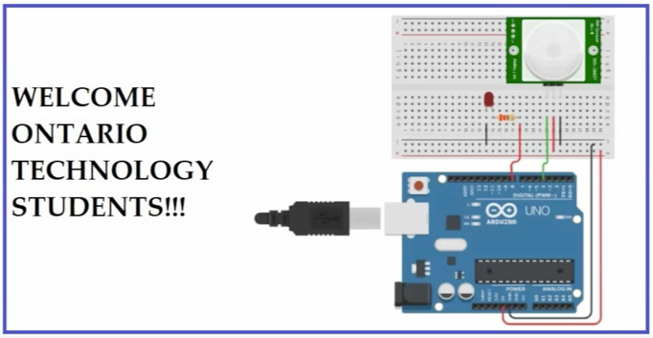
Synopsis of video: This video introduces students to the culminating task, which is a “Social Distancing” detector. Students will be shown using an illustration how the detector should work. The video shows how they are to design a wearable device using an Arduino microcontroller that will detect if another person comes with a range of two meters.
Assessment/Evaluation: Informal assessment can take place in the form of providing feedback to students as they progress through this activity. Students should be encouraged to ask questions to increase their understanding and to reveal areas where they need support.

Activity 2 – Introduction to Web Based Simulators for Circuit Building
The goal(s) of this activity are to introduce students to a web-based simulator that will help students learn how to build circuits and program a microcontroller in a virtual environment.
Time required: 30 minutes
In class activities:
- Students shall build simple DC circuits in class
- Students shall watch next video in the video series (link below)
Materials/Equipment required if in class: 9 Volts batteries, breadboards, small lightbulbs with connecting wires, 9V battery connector, connecting wires
Resources: The details of this activity will be described in a video that student can watch on the OCTE website or the OCTE YouTube channel. If the student is at school, the student can watch the video in class or at home and then complete the activity using the tools and supplies in class. If the student is at home, they can begin working on the task using the web-based simulator. Supplementary resources can be used if the student is home for an extended period of time.
Web link: Video – Introduction to web based simulator for Arduino and circuit building
Synopsis of video: This video introduces students to web based simulator that will be used throughout this project. The web-based simulator is a free online tool called Tinkercad and can be found at tinkercad.com. If a student is at home for an extended period of time, the student can be working through the video series. All the student needs at home is access to a computer, the Internet, and a browser. Using the simulator, a simple circuit using a battery, a switch, and a lightbulb is created illustrating a simple circuit design.
Assessment/Evaluation: Informal assessment can take place in the form of providing feedback to students as they progress through this activity. Students should be encouraged to ask questions to increase their understanding and to reveal areas where they need support.

Activity 3 – Introduction to Voltage, Current and Resistance in Electric Circuits
The goal(s) of this activity are to introduce students to the concepts of voltage, current, and resistance in a simple electric circuit.
Time required: 60 minutes
In class activities:
- Students shall be introduced to the concepts of voltage, current and resistance
- Students shall review metric prefixes commonly used with electricity (ie: kilo, milli)
- Students shall be introduced to fixed resistors colour codes for carbon resistors
- Students shall be shown how to use a multimeter
- Students will watch next video in the video series
- Students will be given exit card on voltage , current, and resistance
Materials/Equipment required if in class: 9 Volts batteries, breadboards, small lightbulbs with connecting wires, 9V battery connector, connecting wires, multimeters
Resources: The details of this activity will be described in a video that student can watch on the OCTE website or the OCTE YouTube channel. If the student is at school, the student can watch the video in class or at home and then complete the activity using the tools and supplies in class. If the student is at home, they can begin working on the task using the web-based simulator. Supplementary resources can be used if the student is home for an extended period of time.
Web link: Video – Introduction to voltage, current and resistance
Synopsis of video: This video introduces students to electrical theory and the concepts of voltage, current, and resistance. Students build a simple circuit with a lightbulb, 9 V battery and a slide switch. As well, students learn how to make measurements with a multimeter including measuring voltage, current, and resistance.
Assessment/Evaluation: exit card on voltage, current, and resistance (see Appendix A)

Activity 4 – Using a Breadboard to create Electric Circuits
The goal(s) of this activity is to demonstrate how to build an electric circuit using a breadboard.
Time required: 30 min
In class activities:
- Teacher will give introduction to breadboards and how they can be used
- Students shall watch next video in the video series
- Students will build various circuits in class and demonstrate to teacher. Note: The web-based simulator can be used if the supplies are not available.
Materials/Equipment required if in class: breadboards, male-to-male connecting wires, lightbulbs, 9 Volt batteries and battery connectors
Resources: The details of this activity will be described in a video that student can watch on the OCTE website or the OCTE YouTube channel. If the student is at school, the student can watch the video in class or at home and then complete the activity using the tools and supplies in class. If the student is at home, they can begin working on the task using the web-based simulator. Supplementary resources can be used if the student is home for an extended period of time.
Web link: Video – Using a breadboard to create electric circuits
Synopsis of video: This video introduces students to how you set up a breadboard to build electric circuits. This includes supplying DC voltage to the + and – power rails and how to use to the power rails to build a circuit.
Assessment/Evaluation: Demonstration of working circuit to the teacher

Activity 5 – Introduction to Ohm’s Law
The goal(s) of this activity are to introduce students to the relationship of voltage, current, and resistance using Ohm’s Law.
Time required: 40 minutes
In class activities:
- Teacher will give examples illustrating Ohm’s Law
- Students shall complete handout on Ohm’s law
- Students shall watch next video in the video series
- Students shall complete Ohm’s Law assignment for homework
Materials/Equipment required if in class: handout on Ohm’s Law, assignment on Ohm’s Law
Resources: The details of this activity will be described in a video that student can watch on the OCTE website or the OCTE YouTube channel. If the student is at school, the student can watch the video in class or at home and then complete the activity using the tools and supplies in class. If the student is at home, they can begin working on the task using the web-based simulator. Supplementary resources can be used if the student is home for an extended period of time.
Web link: Video – Introduction to Ohm’s Law
Synopsis of video: This video introduces students to Ohm’s Law and the relationship between voltage, current, and resistance. Students are shown how to calculate current given voltage and resistance.
Assessment/Evaluation: Assignment on Ohm’s Law (see Appendix B)

Activity 6 – Series Circuits
The goal(s) of this activity is to introduce students to series circuits.
Time required: 30 minutes
In class activities:
- Students will be introduced to series circuits and build a series circuit using a resistor in series with an LED.
- Students will be given the chance to build a simple circuit in class. Note: The web-based simulator can be used if the supplies are not available.
- Students will watch next video in the video series
- There will be a quiz on Ohm’s Law
Materials/Equipment required if in class: breadboards, male-to-male connecting wires, lightbulbs, 9 Volt batteries and battery connectors
Resources: The details of this activity will be described in a video that student can watch on the OCTE website or the OCTE YouTube channel. If the student is at school, the student can watch the video in class or at home and then complete the activity using the tools and supplies in class. If the student is at home, they can begin working on the task using the web-based simulator. Supplementary resources can be used if the student is home for an extended period of time.
Web link: Video – Introduction to series circuits
Synopsis of video: This video introduces students to series circuits and how to identify one. Students are shown how to set up a circuit, which includes a resistor in series with an LED.
Assessment/Evaluation: quiz on Ohm’s Law (see Appendix C)

Activity 7 – Parallel Circuits
The goal(s) of this activity is to introduce students to parallel circuits.
Time required: 30 minutes
In class activities:
- Students will be introduced to parallel circuits and will build a parallel circuit using a resistor in series with an LED
- Students will be given the opportunity to build parallel circuits in class. Note: The web-based simulator can be used if the supplies are not available.
- Students shall watch next video in the video series
Materials/Equipment required if in class: breadboards, male to male connecting wires, lightbulbs, 9 Volt batteries and battery connectors, slide switches
Resources: The details of this activity will be described in a video that student can watch on the OCTE website or the OCTE YouTube channel. If the student is at school, the student can watch the video in class or at home and then complete the activity using the tools and supplies in class. If the student is at home, they can begin working on the task using the web-based simulator. Supplementary resources can be used if the student is home for an extended period of time.
Web link: Video – Introduction to parallel circuits
Synopsis of video: This video introduces students to parallel circuits and how to identify them. They will be shown how to create a two branch series circuit using a breadboard. Students are shown that the current from the source can travel in more than one path.
Assessment/Evaluation: Demonstration of working circuit to the teacher

Activity 8 – Introduction to Microcontrollers
The goal(s) of this activity is to introduce students to a microcontroller and how it can be used.
Time required: 30 minutes
In class activities:
- The teacher will introduce microcontrollers and block programming
- Students set up a computer with their Arduino board and create a simple flashing circuit using block program and an LED circuit. Note: The web-based simulator can be used if the supplies are not available.
- Students will watch next video in the video series
- Students will be given an exit card on microcontrollers
Materials/Equipment required if in class: LEDs, 220 Ohm resistors, breadboards, male to male connecting wires, 9 Volt batteries and battery connectors, Arduino UNOs and connecting cables, computers, and Arduino programming software (WEB LINK to Arduino website)
Resources: The details of this activity will be described in a video that student can watch on the OCTE website or the OCTE YouTube channel. If the student is at school, the student can watch the video in class or at home and then complete the activity using the tools and supplies in class. If the student is at home, they can begin working on the task using the web-based simulator. Supplementary resources can be used if the student is home for an extended period of time.
Web link: Video – Introduction to microcontrollers
Synopsis of video: This video introduces students to microcontroller and specifically the Arduino microcontroller. Students learn how to build a simple flashing circuit using an Arduino UNO along with block programming. Students are also shown the text form of this program in C++.
Assessment/Evaluation: Demonstration of working circuit to the teacher

Activity 9 – Using a Digital Input with a Microcontroller
The goal(s) of this activity is to have students create a digital input using a microcontroller.
Time required: 30 minutes
In class activities:
- The teacher will introduce how to create a digital input circuit with a microcontroller. A solid understanding of pull down and pull up resistors in digital input circuits is always a challenging topic for students. A student must try to understand that when no current flows in a circuit there is no voltage drop across a resistor. This can be difficult for students to understand.
- Students set up a computer with their Arduino board and create an input with a pushbutton. Note: The web-based simulator can be used if the supplies are not available.
- Students shall watch next video in the video series
Materials/Equipment required if in class: LEDs, 220 Ohm resistors (or some value close), pushbuttons, pull down/up resistors (10 kOhm), Arduino UNOs and connecting cables, computers, and Arduino programming software (WEB LINK to Arduino website)
Resources: The details of this activity will be described in a video that student can watch on the OCTE website or the OCTE YouTube channel. If the student is at school, the student can watch the video in class or at home and then complete the activity using the tools and supplies in class. If the student is at home, they can begin working on the task using the web-based simulator. Supplementary resources can be used if the student is home for an extended period of time.
Web link: Video – Using a digital input with a microcontroller
Synopsis of video: This video introduces students to how a pushbutton is used along with a pull down/up resistor to create a digital input to a microcontroller. The video demonstrates the use of a pull down resistor with a pushbutton and how it can turn on an LED circuit.
Assessment/Evaluation Demonstration of working circuit to the teacher

Activity 10 – Using a Digital Input Sensor with a Microcontroller
The goal(s) of this activity is to have students use a digital input sensor such as a passive infrared sensor (PIR) to a microcontroller.
Time required: 30 minutes
In class activities:
- The teacher will introduce sensors as digital inputs to a microcontroller. Students will set up a PIR sensor and see how it operates. Students should be warned that this device is sensitive to infrared and may be triggered by light coming in through the class window or from the lights in the classroom. Students can search the internet to determine the function of the two potentiometers on the side of the PIR sensor. They will need a Phillips screwdriver to set these potentiometers. Students should see if they can turn on an LED when the PIR is activated.
- Students shall watch next video in the video series
- Students demonstrate use of PIR sensor to teacher using the materials listed below and their Arduino boards. Note: The web-based simulator can be used if the supplies are not available.
Materials/Equipment required if in class: LEDs, 220 Ohm resistors (or some value close), passive infrared sensor (PIR), small Phillips screwdriver (to set pots on PIR), Arduino UNOs and connecting cables, computers, and Arduino programming software (WEB LINK to Arduino website)
IMPORTANT: The passive infrared sensor (PIR) detects infrared and is sensitive to sunlight coming in through windows and lights in the classroom. Warn students of this before handing out this device. This will be a good opportunity to teach students that not all sensors will function exactly as expected and time will be needed to test this device in various environments. Note that there is a sensitivity potentiometer on the side of the device that can be set to help with this issue.
Resources: The details of this activity will be described in a video that student can watch on the OCTE website or the OCTE YouTube channel. If the student is at school, the student can watch the video in class or at home and then complete the activity using the tools and supplies in class. If the student is at home, they can begin working on the task using the web-based simulator. Supplementary resources can be used if the student is home for an extended period of time.
Web link: Video – Using digital input sensor (PIR) with a microcontroller
Synopsis of video: This video introduces students to the PIR sensor and how it functions in a virtual environment. The video demonstrates how a PIR sensor can be set up to turn on an LED when the PIR sensor is activated. The simulator uses a click of the mouse to simulate the presence of an infrared source.
Assessment/Evaluation: Demonstration of working circuit to the teacher

Activity 11 – Using an Analog Input with a Microcontroller
The goal(s) of this activity is for students to create an analog input and send this input to a microcontroller.
Time required: 30 minutes
In class activities:
- The teacher will introduce variable resistors and how they can act as an analog input to a microcontroller. The teacher will also give examples of other devices that can act as analog inputs such as volume controls and dimmer controls for lights.
- Students shall watch next video in the video series
- Students demonstrate use of analog input to teacher using the materials listed below and their Arduino boards
Materials/Equipment required if in class: potentiometers, Arduino UNOs and connecting cables, computers, and Arduino programming software (WEB LINK to Arduino website)
Resources: The details of this activity will be described in a video that student can watch on the OCTE website or the OCTE YouTube channel. If the student is at school, the student can watch the video in class or at home and then complete the activity using the tools and supplies in class. If the student is at home, they can begin working on the task using the web-based simulator. Supplementary resources can be used if the student is home for an extended period of time.
Web link: Video – Using an analog input with a microcontroller
Synopsis of video: This video introduces students to how an analog input is used with a microcontroller. In the video, a potentiometer is used as an input device and students learn how a range of voltages from zero to 5 Volts is interpreted to a ten bit binary number by the microcontroller (0 to 1023). The students are shown the voltage change on the input using a voltmeter and how the serial monitor can be used to see the value of the ten bit binary number.
Assessment/Evaluation: Demonstration of working circuit to the teacher

Activity 12 – Using an Ultrasonic Sensor with a Microcontroller
The goal(s) of this activity is to introduce students to an ultrasonic sensor and how it can be used as an analog input to a microcontroller.
Time required: 40 min
In class activities:
- The teacher will introduce ultrasonic sensors and how they function through the use of sound waves.
- Students shall watch next video in the video series
- Students demonstrate use of ultrasonic sensors to teacher using the materials listed below and their Arduino boards
Materials/Equipment required if in class: ultrasonic sensors, Arduino UNOs and connecting cables, computers, and Arduino programming software (WEB LINK to Arduino website)
Resources: The details of this activity will be described in a video that student can watch on the OCTE website or the OCTE YouTube channel. If the student is at school, the student can watch the video in class or at home and then complete the activity using the tools and supplies in class. If the student is at home, they can begin working on the task using the web-based simulator. Supplementary resources can be used if the student is home for an extended period of time.
Web link: Video – Using an ultrasonic sensor with a microcontroller
Synopsis of video: This video introduces students to how an ultrasonic device operates through the use of sound waves. Students learn how sound waves are sent out of the transmit port of the device and then bounce off an object and return and enter the receive port of the device.
Assessment/Evaluation: Quiz – Digital and Analog input devices (see Appendix D)

Activity 13 – Using Boolean Operators in Programming
The goal(s) of this activity are to show how to use Boolean operators for accepting multiple inputs to a microcontroller.
Time required: 30 minutes
In class activities:
- The teacher will introduce the “and” and “or” Boolean operators and the truth tables for each.
- Student will build a two digital input circuit using two pushbuttons and pull down resistors. Students will then create the code to check both input states from the pushbuttons and will turn on an LED based on the “and” and “or” Boolean operators.
- Students shall watch next video in the video series
Materials/Equipment required if in class: pushbuttons, 220 Ohm resistors, LEDs, Arduino UNOs and connecting cables, computers, and Arduino programming software (WEB LINK to Arduino website)
Resources: The details of this activity will be described in a video that student can watch on the OCTE website or the OCTE YouTube channel. If the student is at school, the student can watch the video in class or at home and then complete the activity using the tools and supplies in class. If the student is at home, they can begin working on the task using the web-based simulator. Supplementary resources can be used if the student is home for an extended period of time.
Web link: Video – Using Boolean Operators in Programming
Synopsis of video: This video introduces students to the “and” and “or” Boolean operators and how they can be used in conjunction with input devices.
Assessment/Evaluation: Quiz – Demonstration of working circuit to the teacher.

Activity 14 – Culminating Task
The goal(s) of this activity is to review the details of the culminating task
Time required: 60 minutes
In class activities:
- Students shall watch the final video in the video series. This reviews the task as well as the keys to success.
- Students will be given class time to complete the culminating task which is a “Social Distancing” detector. Students will be handing in a document showing the design process for this task (see Reflection or Design Report)
Materials/Equipment required if in class: passive infrared sensors, ultrasonic sensors, piezo speakers, Arduino UNOs and connecting cables, computers, and Arduino programming software (WEB LINK to Arduino website)
Resources: The details of this activity will be described in a video that student can watch on the OCTE website or the OCTE YouTube channel. If the student is at school, the student can watch the video in class or at home and then complete the activity using the tools and supplies in class. If the student is at home, they can begin working on the task using the web-based simulator. Supplementary resources can be used if the student is home for an extended period of time.
Web link: Video – Concluding video for culminating task
Synopsis of video: This video reviews the project details as well as the keys to success.
Assessment/Evaluation: Demonstration of working circuit to the teacher. As well, students will include a submission of wiring diagram and connections with the microcontroller along with the project code. Students will be handing in a document showing the design process for this task (see Reflection or Design Report)

Resources
Simulation website: Autodesk Tinkercad website
Arduino website: Arduino

Video Links:
Video 1 - Introduction to task
http://www.octe.ca/application/files/7215/9207/5726/TEJ10_-_VIDEO_1_INTRODUCTION_TO_TASK.mp4
Video 2 - Introduction to simulator
http://www.octe.ca/application/files/1715/9207/5822/TEJ10_-_VIDEO_2_INTRODUCTION_TO_SIMULATOR.mp4
Video 3 - Voltage, Current, Resistance
http://www.octe.ca/application/files/9515/9207/5940/TEJ10_-_VIDEO_3_VOLTAGE_CURRENT_RESISTANCE.mp4
Video 4 - Using a breadboard
http://www.octe.ca/application/files/6115/9207/6113/TEJ10_-_VIDEO_4_USING_A_BREADBOARD.mp4
Video 5 - OHM’s law
http://www.octe.ca/application/files/1615/9207/6203/TEJ10_-_VIDEO_5_OHMS_LAWS.mp4
Video 6 - Series circuits
http://www.octe.ca/application/files/6615/9207/6325/TEJ10_-_VIDEO_6_SERIES_CIRCUITS.mp4
Video 7 - Parallel circuits
http://www.octe.ca/application/files/9615/9207/6464/TEJ10_-_VIDEO_7_PARALLEL_CIRCUITS.mp4
Video 8 - Intro to microcontrollers
http://www.octe.ca/application/files/7115/9207/6681/TEJ10_-_VIDEO_8_INTRO_TO_MICROCONTROLLERS.mp4
Video 9 - Using a digital input
http://www.octe.ca/application/files/7315/9207/6884/TEJ10_-_VIDEO_9_USING_A_DIGITAL_INPUT.mp4
Video 10 - Using a digital input sensor
http://www.octe.ca/application/files/1215/9207/7047/TEJ10_-_VIDEO_10_USING_A_DIGITAL_INPUT_SENSOR.mp4

Video 11 - Using an analog input
http://www.octe.ca/application/files/1215/9207/7231/TEJ10_-_VIDEO_11_USING_AN_ANALOG_INPUT.mp4
Video 12 - Using an ultrasonic sensor
http://www.octe.ca/application/files/6815/9207/7391/TEJ10_-_VIDEO_12_USING_AN_ULTRASONIC_SENSOR.mp4
Video 13 - Using Boolean operators
http://www.octe.ca/application/files/1515/9218/2980/TEJ10_-_VIDEO_13_USING_BOOLEAN_OPERATORS.mp4
Video 14 - Closing video
http://www.octe.ca/application/files/8215/9207/7551/TEJ10_-_VIDEO_13_CLOSING_VIDEO.mp4

Instructional Strategies
Due to the situation with COVID-19 in the spring of 2020, this series was developed with the possibility that students may not be in school full time for the fall of 2020. As a result, the majority of this project can be completed with the online simulator where students can create simple electric circuits along with microcontroller circuits. Students can complete tasks at home if required and hand in a screen capture showing their circuit and code or by completing a screen recording and handing it in to their learning management system. New tasks can be created by the teacher that stem from what is shown in the video series. For example:
- A simple circuit showing a 900 Ohm resistor connected to a 9 Volt battery with a current meter
- A series circuit that contains two 220 Ohm resistors and two LEDs
- A parallel circuit that contains three branches with a 220 Ohm and an LED in each branch

Overall and Specific Expectations in support of Ontario Curriculum Grades 9 -10 Technological Education

Overall Expectations:
A1. Demonstrate an understanding of the fundamental concepts and skills required in the planning and development of a product or service, including the use of a design process and/or other problem-solving processes and techniques;
B1 Use problem-solving processes and project-management strategies in the planning and fabrication of a product or delivery of a service
B2. Fabricate products or deliver services, using a variety of resources.

Specific Expectations:
A1.1 Describe a design process or other problem solving process for planning and developing products and/or services
A1.2 Describe problem-solving processes and techniques for solving various kinds of problems in different technological areas;
A1.3 Apply correctly the mathematical and scientific concepts and skills required in the planning and development of a product and/or service;
B1.1 Apply the steps of a design process or other problem-solving process to plan and develop products and services
B1.2 Apply the steps and/or techniques of appropriate problem-solving processes and methods (e.g., diagnostics, reverse engineering, trial and error, divide and conquer, parts substitution, extreme cases) to solve a variety of problems in different technological areas
B1.3 Identify and discuss solutions that have been developed to address key technological problems or meet human needs in various areas of technology
B2.1 Use appropriate tools, materials, and equipment (e.g., tools: hammer, chisel, screwdrivers, soldering iron, cheese grater, sieve, seam ripper; pruning shears, hair clipper; materials: wood, aluminum, polystyrene, paper, wax, clay, textiles, electronic components, mulch, hair colour; equipment: drill press, test meter, computer, software, printer, video camera, thermometer, grill, sewing machine, autoclave, curling iron) to create products or deliver services;
B2.2 Make accurate measurements using a variety of tools (e.g., ruler, scale, tape measure, caliper, micrometer, thermometer, measuring cup), in metric or imperial units, as appropriate;
B2.3 Meet all design criteria (e.g., technical requirements, type and quality of materials, appearance, ease of use, safety, timeline, client’s expectations) in creating a product or delivering a service;
B2.4 Demonstrate the ability to use, maintain, and store tools and equipment properly and with care.

Safety Concerns and Expectations
The majority of the activities can be completed at home using the online simulator. This portion does not require supervision by a parent. If a student has a real Arduino board at home, the project voltage is low voltage (5 Volts) and the Arduino board limits the amount of current supplied.

Applicable SAFEDocs
Please refer to the Computer Technology SAFEDocs located on the OCTE website.

Differentiation of the Project / Activity
Students will be given opportunities to learn using various formats including the web based circuit simulator and the actual Arduino microcontroller. Students will have the opportunity to learn through virtual circuit building as we as building circuits using breadboards and microcontrollers in class.
Students will also be able be assessed in various formats from text to oral demonstrations to screen captures and screen recordings. Screen captures and screen recordings are an excellent way for students to demonstrate their knowledge if they have “learn from home” extended periods of time. There are many free screen recording apps that student may use.
To support access to written text, students can be encourage to use apps such as Goggle Read and Write or other text to speech apps.

Assessment and Evaluation

Constructing “Social Distancing” Detector Rubric
Categories | 50-59%  (Level 1) | 60-69%  (Level 2) | 70-79%  (Level 3) | 80-100%  (Level 4)
Knowledge and Understanding – Subject-specific content acquired in each course (knowledge), and the comprehension of its meaning and significance (understanding)
 | The student:
Knowledge of content  Student knows how to create the software and connect the hardware for the microcontroller | demonstrates  limited knowledge  of content | demonstrates  some knowledge  of content | demonstrates  considerable  knowledge of  content | demonstrates  thorough knowledge of  content
Understanding of content  Student understands different measuring units for voltage, current and resistance | demonstrates  limited understanding  of  content | demonstrates  some understanding  of  content | demonstrates  considerable  understanding  of content | demonstrates  thorough understanding  of  content
Thinking – The use of critical and creative thinking skills and/or processes

 | The student:
Use of planning skills  Student could plan the construction of the hardware circuit and software code | uses planning  skills with limited  effectiveness | uses planning  skills with some  effectiveness | uses planning  skills with  considerable  effectiveness | uses planning  skills with a  high degree of  effectiveness  while building their box
Use of processing skills  Student could identify the input and output pins for input and output devices | uses processing  skills with limited  effectiveness | uses processing  skills with some  effectiveness | uses processing  skills with  considerable  effectiveness | uses processing  skills with a  high degree of  effectiveness
Use of critical/creative  thinking processes  Student was able to use creative thinking to determine how to detect another human within two meters | uses critical/  creative thinking  processes  with limited  effectiveness | uses critical/  creative thinking  processes  with some  effectiveness | uses critical/  creative thinking  processes with  considerable  effectiveness | uses critical/  creative thinking  processes with a  high degree of  effectiveness

Categories | 50-59%  (Level 1) | 60-69%  (Level 2) | 70-79%  (Level 3) | 80-100%  (Level 4)
Communication – The conveying of meaning through various forms

 | The student:
Expression and  organization of ideas  and information  Student was able to organize their ideas and present their information clearly in a wiring diagram | expresses and  organizes ideas  and information  with limited  effectiveness | expresses and  organizes ideas  and information  with some  effectiveness | expresses and  organizes ideas  and information  with considerable  effectiveness | expresses and  organizes ideas  and information  with considerable  effectiveness  expresses and  organizes ideas  and information  with a high  degree of  effectiveness
Communication for  different audiences  in oral, visual, and written  forms  Student was able to demonstrate and describe how hardware and software work with microcontroller | communicates for  different audiences  and purposes  with limited  effectiveness | communicates for  different audiences  and purposes  with some  effectiveness | communicates for  different audiences  and purposes  with considerable  effectiveness | communicates for  different audiences  and purposes  with a high  degree of  effectiveness  uses conventions
Use of conventions  vocabulary, and terminology  of the discipline in  oral, visual, and written  forms  Student can use terminology associated with software and hardware circuits | uses conventions,  vocabulary, and  terminology of  the discipline  with limited  effectiveness  uses | conventions,  vocabulary, and  terminology of  the discipline  with some  effectiveness | uses conventions,  vocabulary, and  terminology of  the discipline  with considerable  effectiveness | uses conventions,  vocabulary, and  terminology of  the discipline with  a high degree of  effectiveness

Categories | 50-59%  (Level 1) | 60-69%  (Level 2) | 70-79%  (Level 3) | 80-100%  (Level 4)
Application – The use of knowledge and skills to make connections within and between various contexts
 | The student:
Application of knowledge  and in familiar  contexts  Student was able to create a social distancing detector using software and hardware | applies knowledge  and skills in familiar  contexts with limited  effectiveness | applies knowledge  and skills in familiar  contexts with some  effectiveness | applies knowledge  and skills in familiar  contexts with  considerable  effectiveness | applies knowledge  and skills in familiar  contexts with a  high degree of  effectiveness
Transfer of knowledge  and skills to new  contexts  Student was able to transfer knowledge of digital and analog inputs to various sensors | transfers knowledge  and skills  to new contexts  with limited  effectiveness | transfers knowledge  and skills  to new contexts  with some  effectiveness | transfers knowledge  and skills  to new contexts  with considerable  effectiveness | transfers knowledge  and skills  to new contexts  with a high degree  of effectiveness
Making connections  within and between various  contexts  Student will make connections between various input circuits for a microcontroller (ie: PIR vs ultrasonic) | makes connections  within and between  various contexts  with limited  effectiveness | makes connections  within and between  various contexts  with some  effectiveness | makes connections  within and between  various contexts  with considerable  effectiveness | makes connections  within and between  various contexts  with a high degree  of effectiveness

Accommodations
Each activity in this project is supported with a video. Students can watch the video a number of times as required at school or at home. If students have access to a computer and the internet at home, they can practice using the simulator as much as required. For the hearing impaired, a student may watch the videos through YouTube using close captioning.

Enrichment Activities
Students will begin programming using block programming in the simulator. For those who have understood block programming they may move on to text programming using C++. Student who complete the task early may look at how to program the microcontroller to limit or eliminate “false positives” as the sensors may send back incorrect or unwanted feedback to the microcontroller. Students could program the microcontroller to eliminate the outlier data that could trigger a false positive.

Reflection or Design Report
At the end of the culminating task, students will demonstrate working circuit to their teacher. As well, students will complete a design report that contains the following elements:
- The problem – Social distancing of 2 meters required
- Imagine – Brainstorm a solution and choose an idea
- Plan – Include a circuit drawing with connections to the microcontroller
- Create – Follow the plan and complete initial testing
- Improve – Review results and determine what can work better and repeat steps 1 to 5

Appendix A – Exit Card – Voltage, Current, and Resistance
1. What is the resistance of a circuit if the current is 8 A and the DC source is 16 V? (Answer: b)
a. | 0. 5 Ω | c. | 128 Ω
b. | 2 Ω | d. | 50 mΩ
2. If the current flowing in a circuit is 12.4 Amps and the resistance is 8.2 Ohms, what is the voltage of the DC source? (Answer: c)
a. | 1.51 Volts | c. | 101.68 Volts
b. | 15.1 Volts | d. | 1016.8 Volts
3. In an electric circuit if the resistance goes up and the battery voltage stays the same then: (Answer: a)
a. | the current must go down | c. | the current stays the same
b. | the current must go up

Appendix B – Assignment – Ohm’s Law
1. If a circuit had a voltage of 100 V and a resistance of 8 Ohms what would be the current in the circuit? (Answer: a)
a. | 12.5 mA | c. | 0.8 A
b. | 1.25 mA | d. | 0.08 A
2. If the voltage in a circuit is 15 Volts and the current flowing is 80 A, what is the resistance in the circuit? (Answer: d)
a. | 5.33 Ohms | c. | 0.01875 Ohms
b. | 0.533 Ohms | d. | 0.1875 Ohms
3. If the current in a circuit is 0.25 A and the resistance in the circuit is 500 Ohms, what is the voltage supplied by the DC battery in the circuit? (Answer: c)
a. | 2 kV | c. | 125 V
b. | 2 V | d. | 12.5 V
4. What is the colour code of the resistor (R1) in the electric circuit shown below when the switch is closed if A1 is 4.2 mA and the battery voltage is 92.4 Volts? (Answer: red, red, orange)
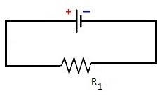
colour of first band ______ colour of second band ______ colour of third band __________
5. As you increase the resistance in a potentiometer connected in a circuit containing a DC source, the voltage drop across the potentiometer ___________ and the current in the circuit _______________. (Answer: b)
a. | goes up , goes up | c. | goes down , goes up
b. | goes up , goes down | d. | goes down , goes down

Appendix C – Quiz - Ohm’s Law and Series Circuits
1. Using the circuit diagram below, what is the value of A1 to one decimal place given the values below? Battery voltage = 18 V, R1 = 3 Ohms, R2 = 3 Ohms, R3 = 3 Ohms (Answer: c)
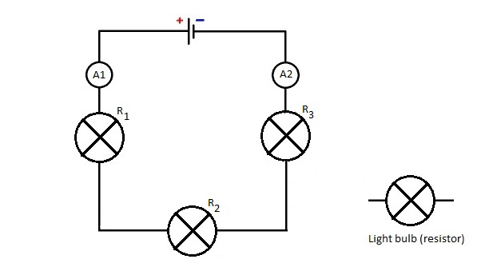
a. | 4.0 A | c. | 2.0 A
b. | 1.3 A | d. | 0.5 A

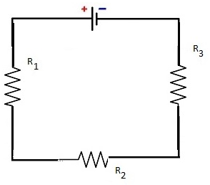
2. Using the circuit diagram below, fill out all missing values in the table below. Do not forget to show all of your work.
Battery voltage = 385.04 V
R1 colour code = brown orange brown gold
R2 colour code = yellow purple orange gold
R3 colour code = brown black red gold
Resistance | Current | Voltage
R₁ = _______ Ω | I = ____________ A  ______ Amps | V₁ = __________
R₂ = _______ Ω | I = ____________ A  ______ Amps | V₂ = __________
R₃ = _______ Ω | I = ____________ A  ______ Amps | V₃ = __________
Answers:
R1 = 130 Ω, R2 = 47 kΩ , R3 = 1 kΩ
Current = 0.008 A or 8 mA
V1 = 1.04 V, V2 = 376 V , V3 = 8 V

Appendix D – Quiz – Digital and Analog input devices
- A digital input for the Arduino microcontroller is design to accept a voltage of _______ Volts or _______ Volts.
- Inputs A0 to A5 on an Arduino UNO are referred to as ___________ inputs.
- Circle the correct answer. A passive infrared sensor is a type of _____________ (analog/digital) input sensor.
- Circle the correct answer. An ultrasonic sensor is a type of _____________ (analog/digital) input sensor.
- The range of values shown in the serial monitor for your Arduino microcontroller for the input from a potentiometer are from _____ to _____.
Answers:
- zero or 5 Volts
- analog
- digital
- analog
- zero to 1023

References
21st Century Competencies: Foundation Document for Discussion. Phase 1: Towards Defining 21st Century Competencies for Ontario, Winter 2016 Edition, 2016 http://www.edugains.ca/resources21CL/About21stCentury/21CL_21stCenturyCompetencies.pdf
Arduino Website https://www.arduino.cc/
Autodesk Tinkercad Website https://www.tinkercad.com/
Course Codes for Emphasis courses in the Revised Curriculum: Technological Education, Grades 11 and 12, 2009 http://www.edu.gov.on.ca/eng/curriculum/secondary/techedemphasiscourses.pdf
Growing Success: Assessment, Evaluation, and Reporting in Ontario Schools, First Edition, Covering Grades 1 to 12, 2010 www.edu.gov.on.ca/eng/policyfunding/growSuccess.pdf
Learning for All – A Guide to Effective Assessment and Instruction for All Students, Kindergarten to Grade 12, 2013 http://www.edu.gov.on.ca/eng/general/elemsec/speced/LearningforAll2013.pdf
The Differentiated Instruction Scrapbook http://www.edugains.ca/resourcesDI/EducatorsPackages/DIEducatorsPackage2010/2010DIScrapbook.pdf
The Ontario Curriculum, Grades 9 and 10: Technological Education, 2009 (revised) http://www.edu.gov.on.ca/eng/curriculum/secondary/teched910curr09.pdf
The Ontario Curriculum, Grades 11 and 12: Technological Education, 2009 (revised) http://www.edu.gov.on.ca/eng/curriculum/secondary/2009teched1112curr.pdf

