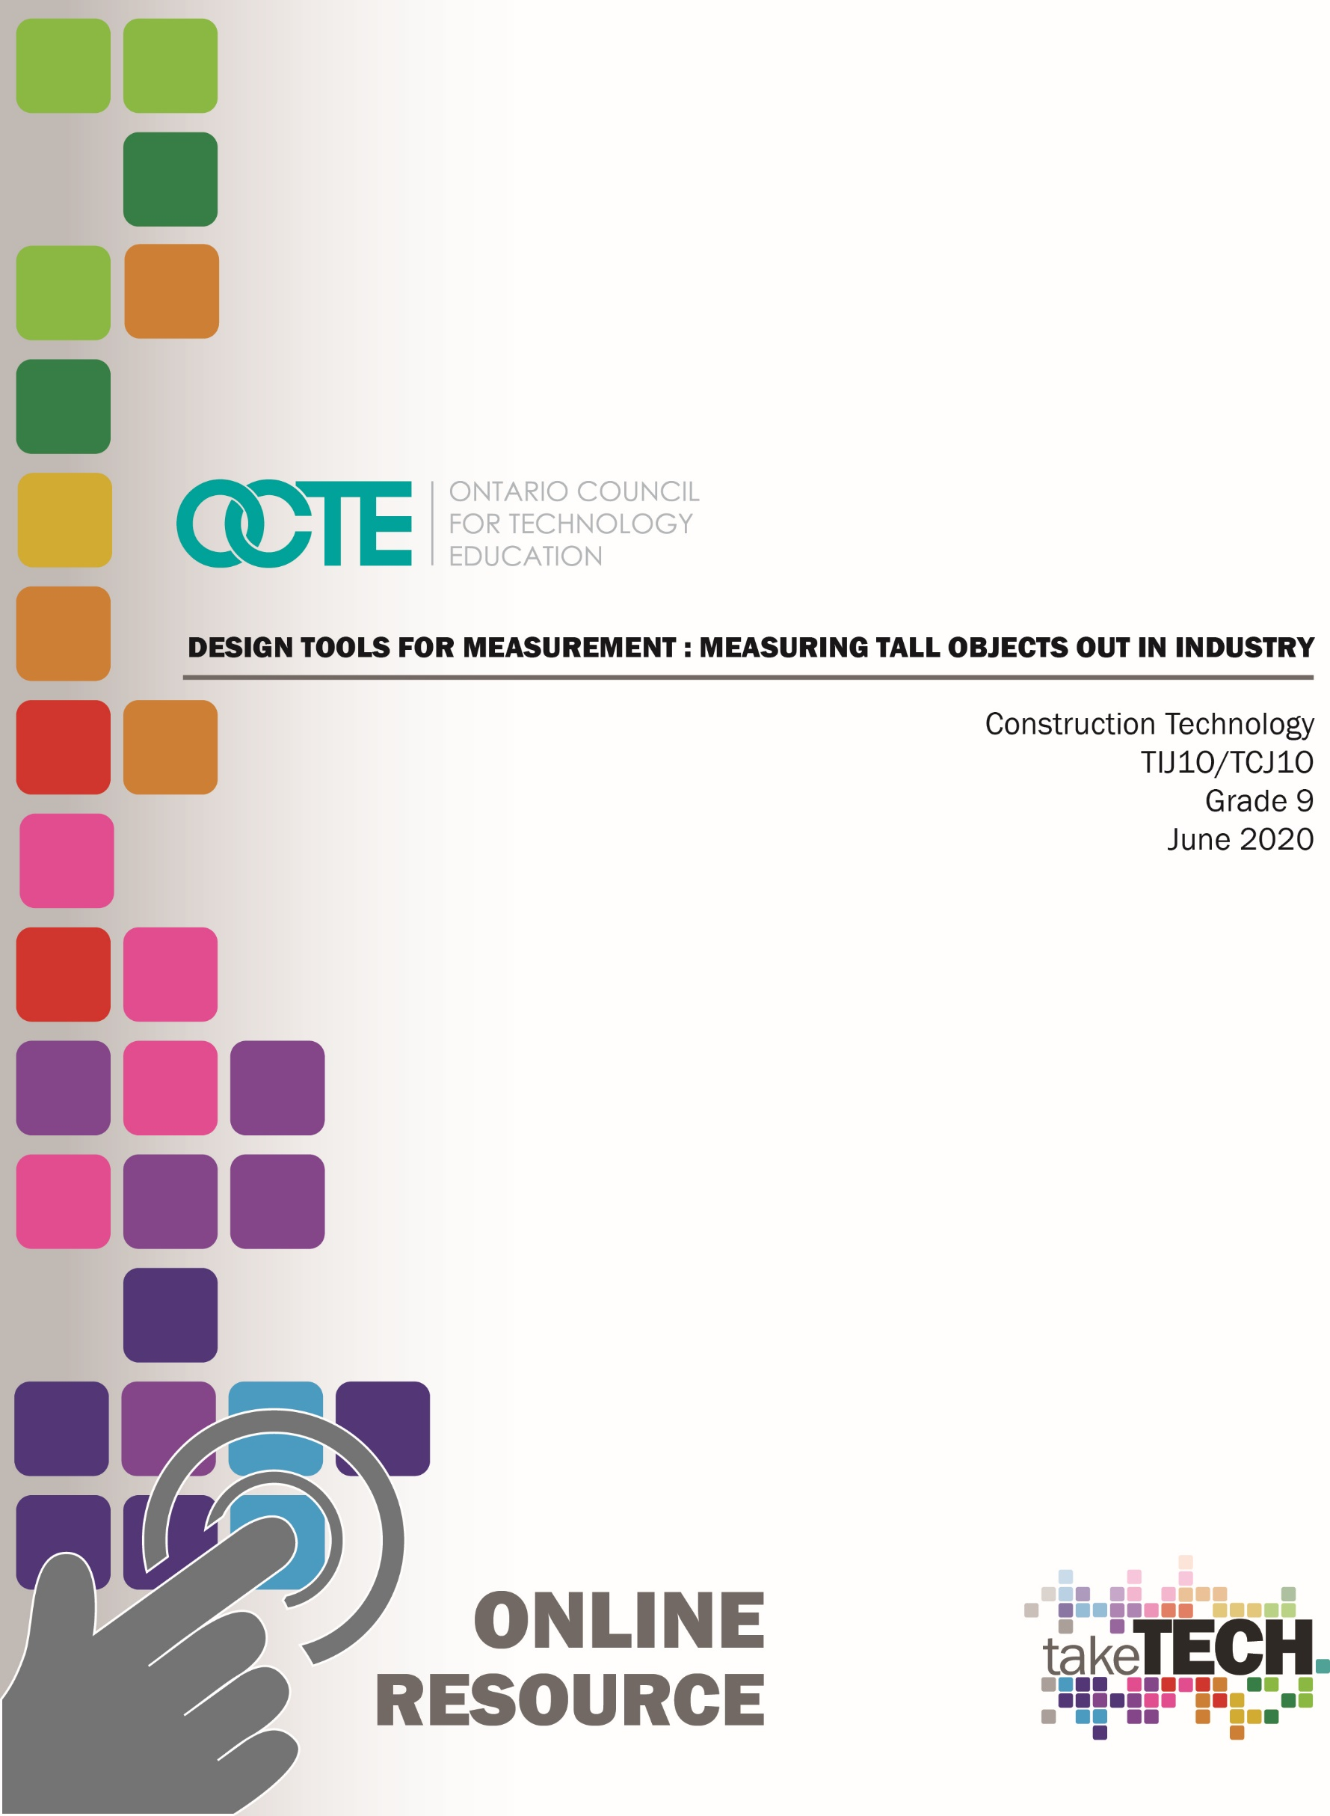

Table of Contents

Introduction 3
Project Outline 3
Prior Knowledge 3
Student Activities 3
Resources 4
Measuring the Height of Tall Objects 5
The Scenario: 5
Brainstorming 6
Find a tall object 7
Research and Sketching 9
Idea Number 1: 10
Idea Number 2: 11
Fabrication and Testing 12
Comparison Chart 13
Calculations, Reporting and Reflection 14
Extension Activity 1: Using Technology 15
Extension Activity 2 – Super Fibers 16
Super Fibers 16
Planning Notes 17
Instructional Strategies 17
Motivational Strategies 17
Learning Goals and Success Criteria 17
Overall and Specific Expectations 18
Overall Expectations 18
Specific Expectations 18
Safety Concerns and Expectations 19
Applicable SAFEDocs and ToolSAFE Videos 20
Differentiation of the Project / Activity 20
Career and Industry Extensions 20
Appendix A - Measuring the Height of an Object Student Checklist 21
Measuring the Height of an Object Student Checklist 21
Appendix B - Measuring Tall Objects Rubric 22
Appendix C – Conversion Factors 25
Appendix D – Conversion Math Worksheet 26
Appendix E – Reading Measurements ion a Protractor 28
Appendix F – Pythagorean Theorem Worksheets 30
References 36

Introduction
Course Code: TIJ1O / TCJ1O
Broad base Technology: Exploring Technologies and Construction Technology
Destination: Open
Grade Level: 9
Online Project Name: Measuring Tall Objects Out in Industry

Project Outline
- Students will be given a scenario in which they will be required to calculate the length of a guy wire.
- Students will participate in an online brainstorming session with teacher so teacher can guide students in correct direction. This can be with a live Google Doc or a live video discussion with a chat pod.
- Students will then go outside in their neighbourhood to choose their tall object
- Students will research different methods and fabricate devices to help determine angles of sight from which they can calculate the height of their object. Students will have an opportunity to check in with the teacher regarding their choice of methods/devices before they start fabrication.
- Students will produce a slide show to showcase their device and findings.
- A comparison/reflection form will then be completed by students

Prior Knowledge
- Students should understand basic geometry, Pythagorean Theorem
- Students should have basic understanding of both Metric and Imperial systems.
- Students should be able to use basic modelling tools such as scissors, modelling knives and hot glue guns.

Student Activities
- Beginning scenario and brainstorming
- Finding a tall object; estimating its height
- Research and sketching
- Fabrication and testing
- Calculations, reporting and reflection
- Extension Activity: Using Technology
- Extension Activity Super Fibers

Resources
The resources in this document include black line masters, handouts, appendices, pictures. Under the direction and premise that is activity is to be completed online, tools and equipment have been kept at a minimum and the students can utilize a tape measure, and a calculator.
All clip art files have been specifically sourced and are royalty free and are referenced in the References section of this document.

Measuring the Height of Tall Objects


The Scenario:
- Imagine you are working on a construction site at which a tower crane is being used.
- The crane has broken down and needs emergency repairs
- A special lightweight, super-strong stabilizing rope needs to be made to a specific length to go from the tip of the crane down to the ground on a 45-degree angle.
- This rope is very expensive and a loop has to be spliced onto each end to shackle onto the crane and the ground point. This needs to be done at the supplier’s location therefore, the calculation must be made on site.
- You realize that in order to calculate the length you will need to know the height of the crane at the end of the boom. You do not have any measuring equipment normally used for this purpose and you have not been given the height from the crane contractor.
- You do remember from your geometry lessons that when you have a right angle and the height and length are the same then the angle up from the bottom will be 45-degrees.
- The same holds true for the angle looking down from above. (isosceles right angle triangle)
- Due to security issues no cell phones are allowed on the construction site.
- What are you going to do?
- Let’s brainstorm.

Brainstorming
What object do I use to test my theory? | Math concepts that apply.
Safety concerns? | Possible solutions

Find a tall object
- Have fun with this.
- Go out into the neighborhood around your house with a friend and find a nice tall tree, tower, windmill or building. Try to find an object that you estimate is at least fifty feet (15m) in height.

- Remember to follow social distancing guidelines.
- Make sure you have permission to be there. Try to utilize public spaces.
- Be aware of your surroundings. Are there any safety hazards in the area? (roadways, driveways, noxious weeds, water, electrical hazards)

- Estimate the height of the object and stand that distance away from it. (Try to estimate how far the object would fall if it tipped over)
- Have your friend take your picture from a distance that will show the complete object and you standing at your height estimate distance.
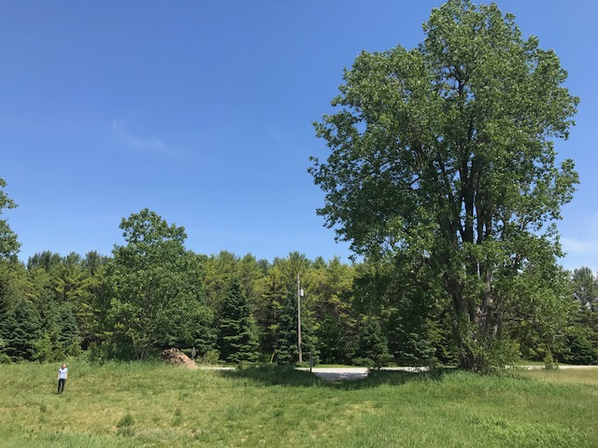

- Pace off that distance in strides. Measure your stride length, multiply your stride length by the number of strides and write down your estimate in feet and metres. (see appendix for feet–metres conversion ratio) (If you have a tape measure you can verify your distance)

Research and Sketching

- Go home and research various height measuring options. Start with a search for “How to measure tall objects” in your search engine. Focus on devices/methods for measuring angles of inclination. You will find there are many interesting ways to help you calculate the height of your tall object.
- Choose two different methods for measuring. Neither of them can include using anything electronic. At least one of them should incorporate having to fabricate a device to help you. The other method can also use a fabricated device or you can use another proven method for calculating height. Try to keep them relatively simple.
- Using the templates provided, sketch the two ideas.

STOP
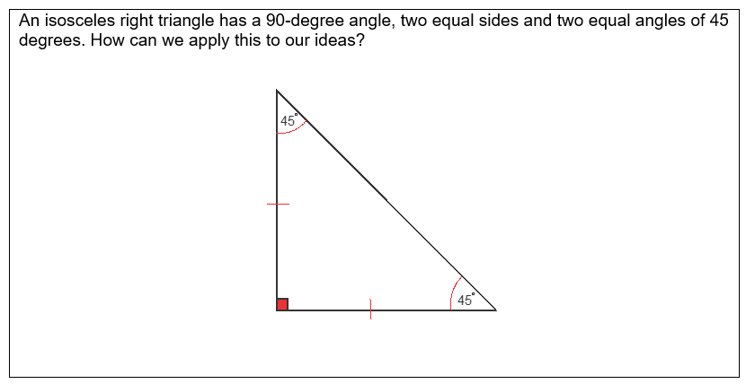

Continue

- Submit your two ideas to the teacher. Your teacher will then consult with you to make sure you are going in the right direction and to help make recommendations.

Idea Number 1:

Description:
Sketch:

Idea Number 2:

Description:
Sketch:

Fabrication and Testing
- Now it’s time to fabricate. Make sure you have everything you need. Write a list of materials and tools necessary to make your devices. Keep in mind things around the house things that will help you measure angles and help hold things level.

- Are you going to use any hand tools? Now would be a good time to consult with your teacher to discuss safety issues. Power tools are not recommended for this project. Make sure you have proper supervision and are following all safety rules necessary.

- When you are finished, take a picture of yourself with each of your measurement devices. 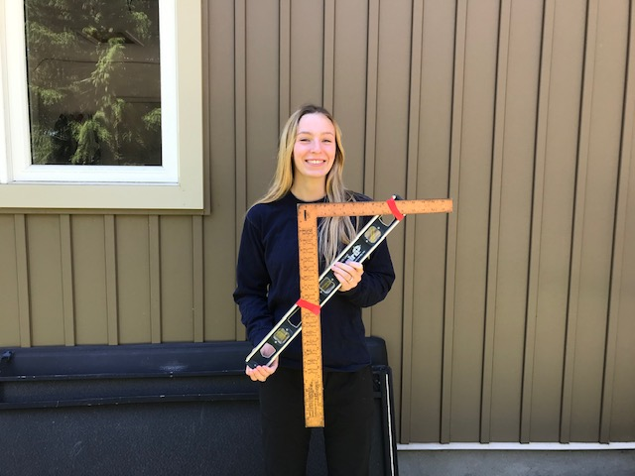
- Go back to your tall object and calculate the height with help from your two new devices.
- For each method, stand out from the object the same distance as your calculated height.
- Have your friend take pictures of you at each distance.
- Measure it in strides again, calculate your new distance in feet and metres. (If you have a tape measure you can verify your distance)

- Record your findings on the comparison chart.

Comparison Chart
Idea # | Strides | Feet | Metres | Guy Wire Length
Estimate
1
2

Calculations, Reporting and Reflection
- Finish up your comparison chart by calculating the guy wire length using Pythagorean Theorem.

- Create a slide show that has the following slides:
  - Title page
  - Your estimate picture
  - One for each of your two measuring devices with a brief description of each.
  - One for each of your device/methods on your calculated distance in front of your tall object. Use the following format.
  - Your comparison chart.
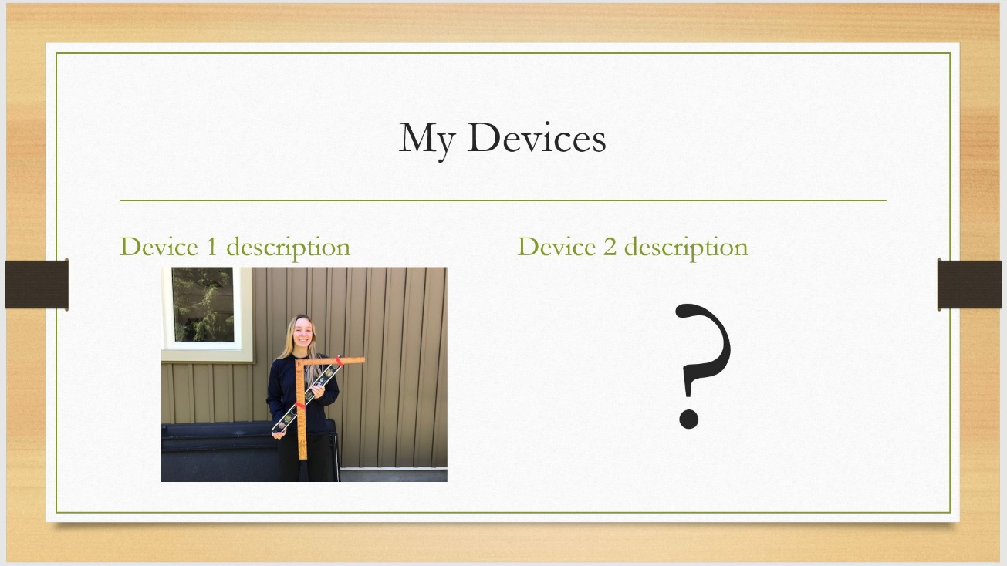

Extension Activity 1: Using Technology
- Your cell phone is a very powerful tool that may include an app to help you determine angles or calculate distance. Try an included app or download a free one and calculate the object’s height again using your app to help. How close is it to your other measurements?
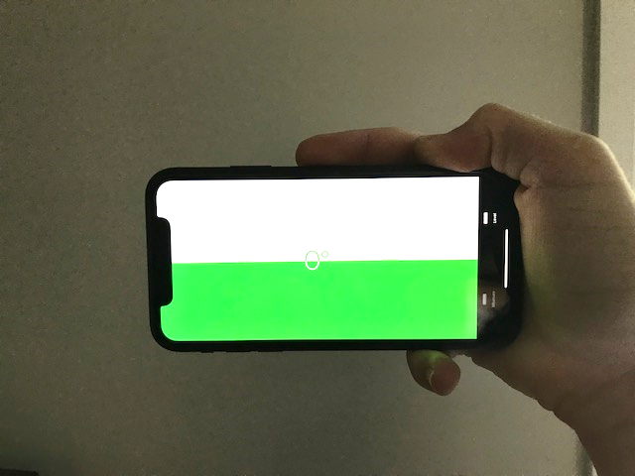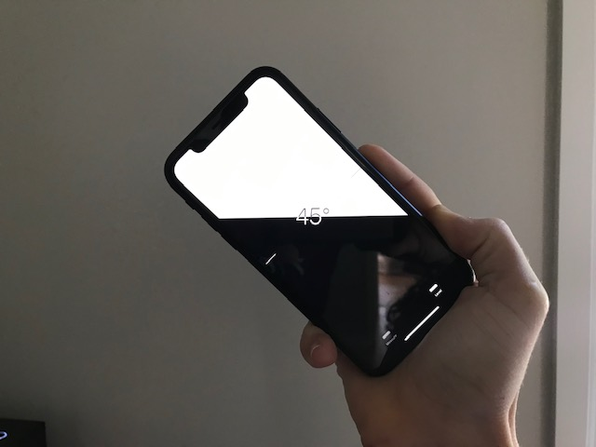

Extension Activity 2 – Super Fibers

Super Fibers
There are many new synthetic fibers being produced that are super strong and lightweight. Many of them are being used in rope, fishing line and as a replacement for steel cable. Some have been around for a few years. Others are in development right now. Below are some examples. Look them up and find the specifications for each. Compare them against wire rope and generic nylon rope. See if you can find any others.
Try to keep the diameter the same for each fiber.
Fiber | Diameter | Weight per ft./m | Breaking Strength  (tensile strength) | Popular usage | Price per metre/foot
Wire rope
Stainless steel
Nylon
Kevlar
Spectra
Dyneema
Vectran

Planning Notes
- Teachers should plan some form video meeting to consult with students twice during the activities.
- Some safety lessons could be used depending in which direction the teacher wishes the project to go.
- A review on Imperial/Metric measurements and Pythagorean Theorem may help.
- Grade nine science curriculum includes incline measuring devices as a way to help map star locations in the astronomy unit.
- Grade eight curriculum includes the introduction of Pythagorean Theorem.
- This project is producible in school or at home.

Instructional Strategies
- Independent, guided research
- Open-ended problem solving
- Live video meetings
- Brainstorming

Motivational Strategies
- This is a project which requires no tools to complete. Students can fabricate their project out of simple materials.
- A real life scenario is used to allow students to imagine they are in a specific work situation.
- Student are able to connect with a friend and get outside.

Learning Goals and Success Criteria
By the end of this project students will be able to:
- Demonstrate an understanding of the relationship between right angle triangles and heights of objects.
- Demonstrate an understanding of some safety concerns dealt with by surveyors.
- Demonstrate the ability to convert between metric and imperial dimensions.
- Demonstrate the ability to communicate ideas and information through technical sketches and presentation software.
- Demonstrate the ability to communicate to the teacher through audio or live video communications.
- Will be able to fabricate simple measurement tools from basic items at home.
- Will use keywords in an internet search.
- Will be able to apply Pythagorean Theorem to calculate the hypotenuse of a right angle triangle in a practical problem solution.
- Will demonstrate learning skills that include Responsibility, Organization, Independent Work, Initiative, and Self-Regulation.

Overall and Specific Expectations in Support of Ontario Curriculum Grades 9 - 10 Technological Education

Overall Expectations
A1 Demonstrate an understanding of the fundamental concepts and skills required in the planning and development of a product or service, including the use of a design process and/or other problem-solving processes and techniques;
A2 Demonstrate the ability to use a variety of appropriate methods to communicate ideas and solutions;
A3 Evaluate products or services in relation to specifications, user requirements, and operating conditions.
B1 Use problem-solving processes and project-management strategies in the planning and fabrication of a product or delivery of a service;
B2 Fabricate products or deliver services, using a variety of resources.
C2 Demonstrate an awareness of how various technologies affect society, as well as how society influences technological developments.
D1 Follow safe practices and procedures when using materials, tools, and equipment;

Specific Expectations
A1.3 Apply correctly the mathematical and scientific concepts and skills required in the planning and development of a product and/or service; A1.4 incorporate appropriate technological concepts (e.g., aesthetics, control, environmental sustainability/stewardship, ergonomics, fabrication/building/ creation, function, innovation, material, mechanism, power and energy, safety, structure, systems) in the design, fabrication or delivery, and evaluation of a product or service (see pp. 5-6);
A2.1 Use a variety of appropriate methods to communicate information or ideas and concepts during the planning and production stages of a project (e.g., production plans, scripts, flow charts, storyboards, sketches, technical drawings, recipes, client consultation reports, design briefs);
A2.2 Use correct terminology to identify and describe various processes, tools, and equipment used in creating products or delivering services (e.g., processes: levelling, squaring, formulating, baking, sterilizing, colouring; tools: pruning saw, wire cutter, curling iron; equipment: USB flash drive, tire balancer, camcorder, flat iron, deep fryer, magnifying lamp, ultraviolet sanitizer, solderless breadboard, measuring cup, thermometer);
A2.3 Use metric and imperial units of measurement (e.g., metric: degrees Celsius, joules, micrometres [microns], millimetres, kilohms, L/100 km, tonnes; imperial: degrees Fahrenheit, BTUs, knots, mils, inches, feet, miles per gallon, pounds per square inch, tons) and the abbreviations or symbols associated with them correctly and as appropriate to the task;
A2.4 Describe and use various forms of communication to document the progress and results of the development of a product or service (e.g., tracking sheets, production status reports, a multimedia presentation, a graphic or animated presentation, technical drawings, updates on a website, a blog, technical reports);
A3.1 Evaluate a product or service, and processes associated with its development, on the basis of a set of criteria relevant to that product or service (e.g., adherence to specifications, ease of use, attractive appearance, ruggedness, clean joints, acceptable weld bead, uniform colour, adherence to forest management plan, nutritional value);
A3.2 Suggest improvements to a product or service on the basis of a set of criteria relevant to that product or service (e.g., durability, reliability, ease of use, eco-friendliness, appearance, safety, customer satisfaction).
B1.1 Apply the steps of a design process or other problem-solving process to plan and develop products and services (e.g., define the problem or challenge, taking into account relevant contextual or background information; gather information [about criteria, materials, constraints]; generate possible solutions, using techniques such as brainstorming; choose the best solution; develop and produce a model or prototype; test the model or prototype; incorporate improvements or redesign and retest; report on results) (see pp. 16-19);
B1.3 Identify and discuss solutions that have been developed to address key technological problems or meet human needs in various areas of technology (e.g., catalytic converters, CPU heat sinks, solar cells, regenerative brake energy systems, wind turbines, convection ovens, internal defibrillators, scent-free and hypoallergenic products);
B1.4 Use a variety of sources to research technological solutions to specific problems or challenges (e.g., the Internet, reference books, journals or magazines, experts);
C2.2 Describe how society is being affected today by various new and emerging technologies (e.g., electronic messaging, Global Positioning System [GPS], wireless access, hybrid vehicles, nanotechnology, biotechnology);
D1.1 Use appropriate personal protective equipment (e.g., gloves, safety glasses or goggles, hard-hat, hearing protection, respirator mask);

Safety Concerns and Expectations
- Project should not require parental supervision unless students use hand tools.
- Students are old enough to find a tall object in their neighborhood and observe necessary safety precautions.
- Power tools should be discouraged.
- Students may use modelling tools like modelling knives and hot glue guns. Applicable safety should be covered. Proper PPE should be worn including safety glasses.

Applicable SAFEDocs and ToolSAFE Videos
- Exploring Technologies SAFEDocs (OCTE), 2013
- Construction Technology SAFEDocs (OCTE), 2013
- Technological Design SAFEDocs (OCTE), 2013
- ToolSAFE TDJ Modelling Tools, (OCTE), 2015
- ToolSAFE TDJ Hot Glue Gun (OCTE), 2015

Differentiation of the Project / Activity
There are a number of ways in which this project can be differentiated for instruction. They include,
- The number of devices the students must make may be increased or decreased if desirable.
- Teacher may use live chat, live video or a shared Google Doc for students to input their ideas.
- The presentation technique may change to video or live video discussion.
- Teachers may give a student a specific design to try.
- More advanced math concepts can be used by changing the angle of inclination or changing it to a leaning object.
- Extension activities may be used to enhance project or substitute parts of project.
- Teachers may allow students to work with partners.

Career and Industry Extensions
Industry extensions and career exploration for students to include:
- Civil engineer
- Surveyor
- Rigger
- Crane operator
- Heavy construction contractor
- Inspector
- Construction Engineering Technician

Appendix A - Measuring the Height of an Object Student Checklist

Measuring the Height of an Object Student Checklist
I have found a tall object I think is at least 15m high. __________
My tall object is in a safe, public area . __________
I have my estimate complete with a picture. __________
I have completed my research. __________
I have sketched my two measurement devices. __________
I have submitted my ideas to the teacher for review. __________
Both prototypes have been fabricated. __________
I have taken my picture with each prototype. __________
I have calculated the height of my object using my two aids. __________
I have a picture taken of me at each calculated distance. __________
I have completed my comparison chart. __________
I have completed my slideshow with all slides. __________
I have submitted the project using the format the teacher requested. __________

Appendix B - Measuring Tall Objects Rubric
Categories | Level 1 | Level 2 | Level 3 | Level 4
Knowledge and Understanding
Knowledge of content  Student demonstrates knowledge of math concepts, internet research and presentation software. | demonstrates limited knowledge of content | demonstrate some knowledge of content | demonstrates knowledge of content | demonstrates thorough knowledge of content
Understanding of content  Student understands Imperial and Metric Systems. Student understands Pythagorean Theorem and how to calculate a hypotenuse. | demonstrates limited understanding of content | demonstrates some understanding of content | demonstrates considerable understanding of content | demonstrates thorough understanding of content
Thinking
Use of planning skills  Student follows a logical order of events to complete assignment | uses planning skills with limited effectiveness | uses planning skills with some effectiveness | uses planning skills with considerable effectiveness | uses planning skills with a high degree of effectiveness
Use of processing skills  Student develops 2 measurement devices with that are highly effective. | uses processing skills with limited effectiveness | uses processing skills with some effectiveness | uses processing skills with considerable effectiveness | uses processing skills with a high degree of effectiveness
Use of critical/creative thinking processes  Student is able to self-evaluate his/her product, reflect on the process and suggest positive changes. | uses critical/ creative thinking processes with limited effectiveness | uses critical/ creative thinking processes with some effectiveness | uses critical/ creative thinking processes with considerable effectiveness | uses critical/ creative thinking processes with a high degree of effectiveness

Communication
Expression and organization of ideas and information  Slide show is well organized. Information is delivered effectively. | expresses and organizes ideas and information with limited effectiveness | expresses and organizes ideas and information with some effectiveness | expresses and organizes ideas and information with considerable effectiveness | expresses and organizes ideas and information with considerable effectiveness
Communication for different audiences in oral, visual, and written forms  Student communicated effectively with teacher by live video.  Visuals on slide show are relevant and clear. | communicates for different audiences and purposes with limited effectiveness | communicates for different audiences and purposes with some effectiveness | communicates for different audiences and purposes with considerable effectiveness | communicates for different audiences and purposes with a high degree of effectiveness
Use of conventions vocabulary, and terminology of the discipline in oral, visual, and written forms  Student produced well drawn and clear sketches. Dimensions in slide show have correct designations. | uses conventions, vocabulary, and terminology of the discipline with limited effectiveness uses | uses conventions, vocabulary, and terminology of the discipline with some effectiveness | uses conventions, vocabulary, and terminology of the discipline with considerable effectiveness | uses conventions, vocabulary, and terminology of the discipline with a high degree of effectiveness

Application

Application of knowledge and skills in familiar contexts  Student was able to take previously learned math concepts and use them to solve a practical problem. | applies knowledge and skills in familiar contexts with limited effectiveness | applies knowledge and skills in familiar contexts with some effectiveness | applies knowledge and skills in familiar contexts with considerable effectiveness | applies knowledge and skills in familiar contexts with a high degree of effectiveness
Transfer of knowledge and skills to new contexts  Student was able to take basic household items and create a measuring device. | transfers knowledge and skills to new contexts with limited effectiveness | transfers knowledge and skills to new contexts with some effectiveness | transfers knowledge and skills to new contexts with considerable effectiveness | transfers knowledge and skills to new contexts with a high degree of effectiveness
Making connections within and between various contexts  Student makes the connection between angle inclination and height. | makes connections within and between various contexts with limited effectiveness | makes connections within and between various contexts with some effectiveness | makes connections within and between various contexts with considerable effectiveness | makes connections within and between various contexts with a high degree of effectiveness0–

Appendix C – Conversion Factors
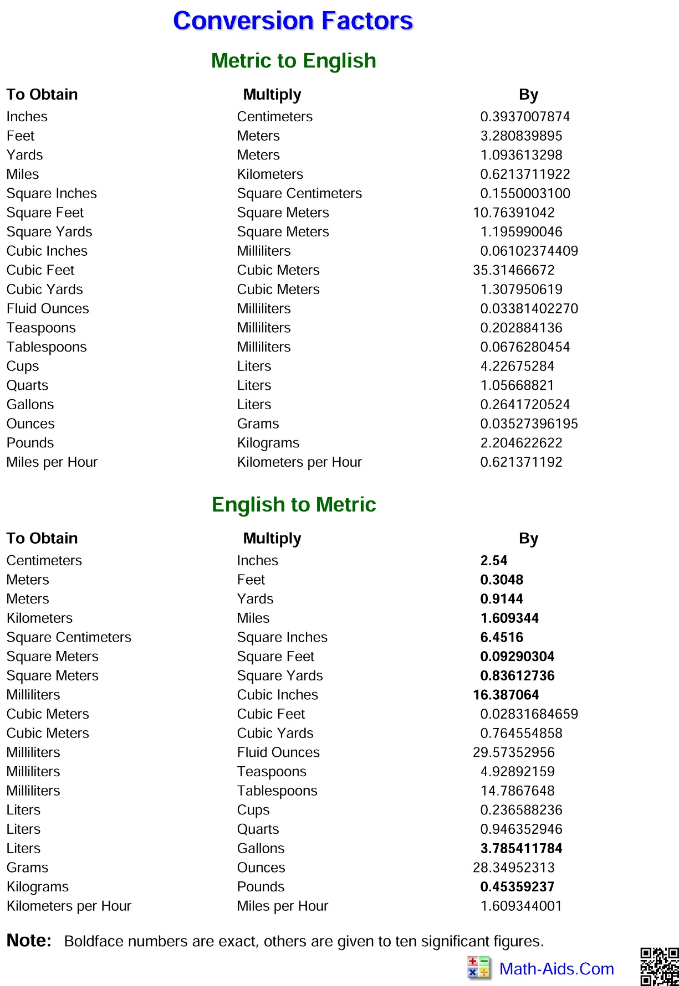

Appendix D – Conversion Math Worksheet
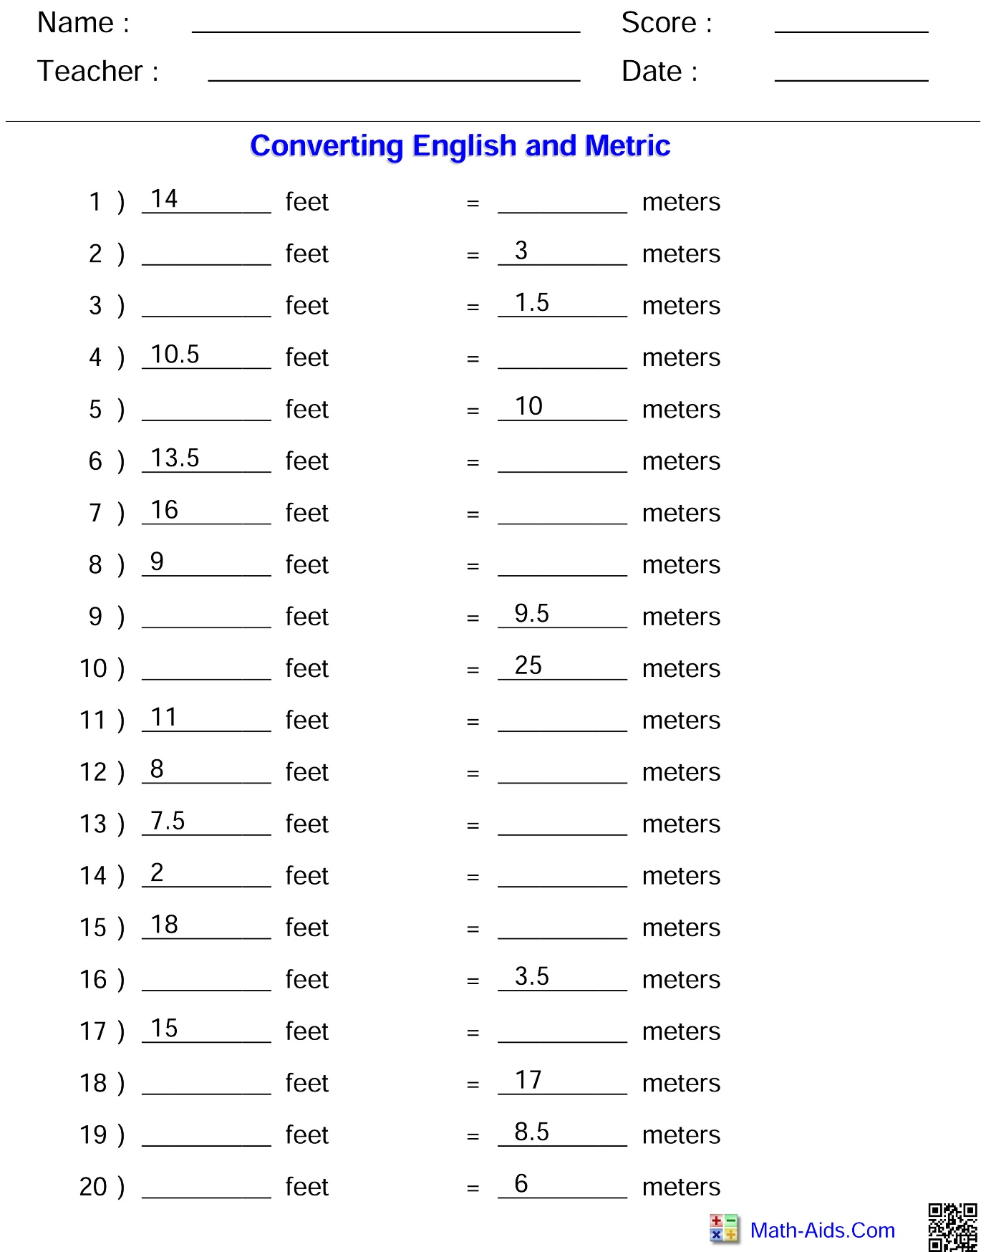
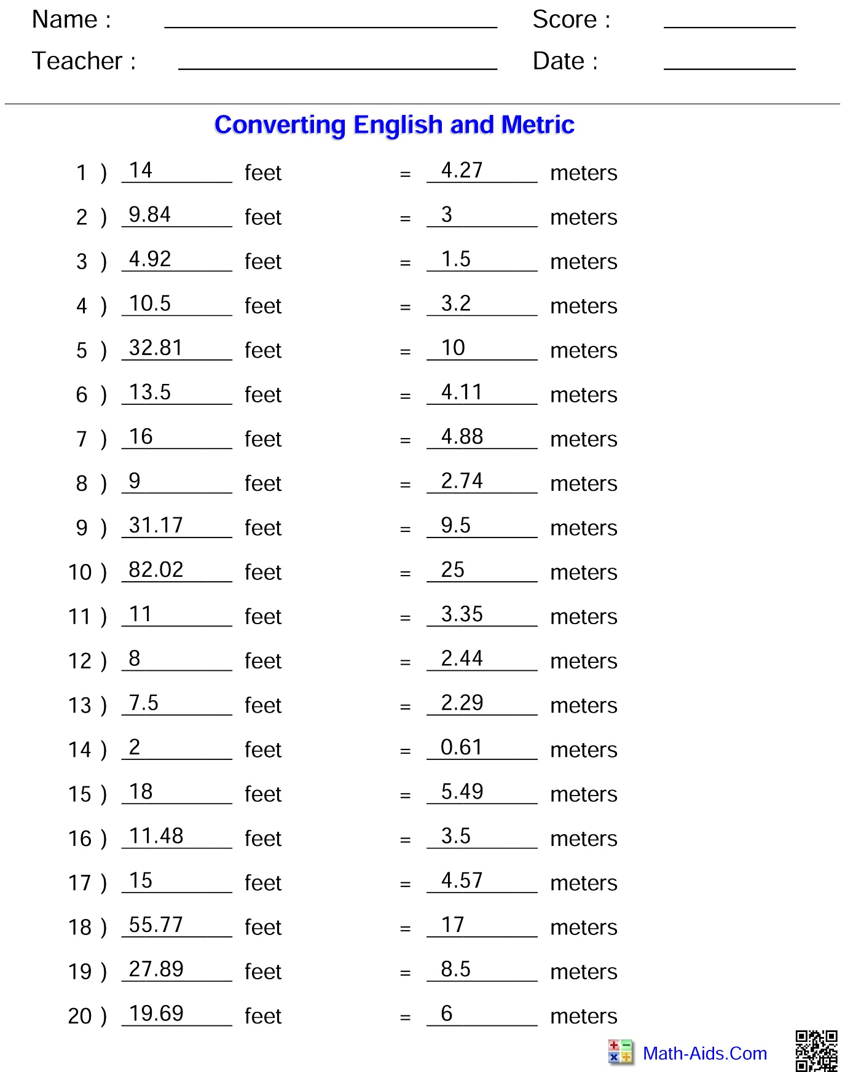

Appendix E – Reading Measurements on a Protractor
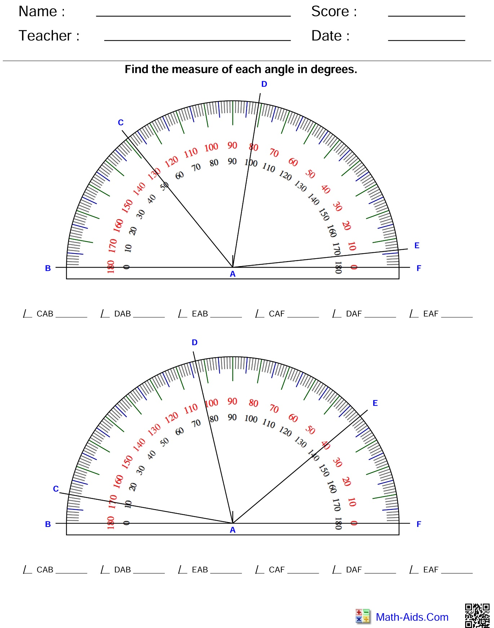
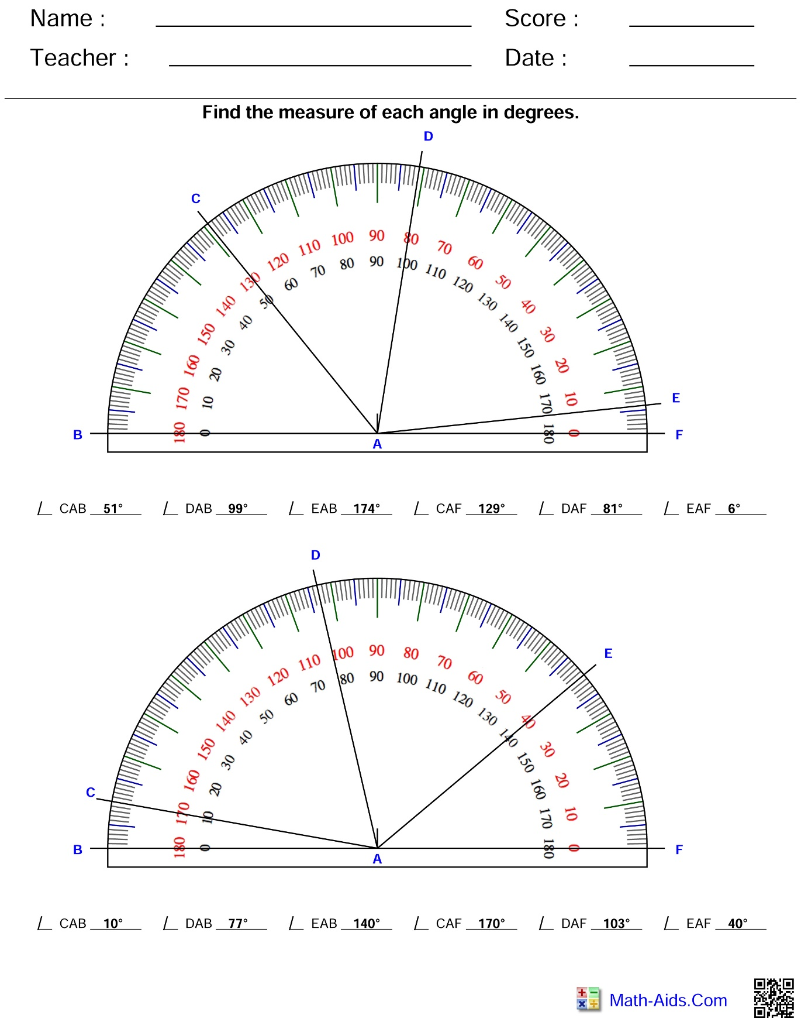

Appendix F – Pythagorean Theorem Worksheets
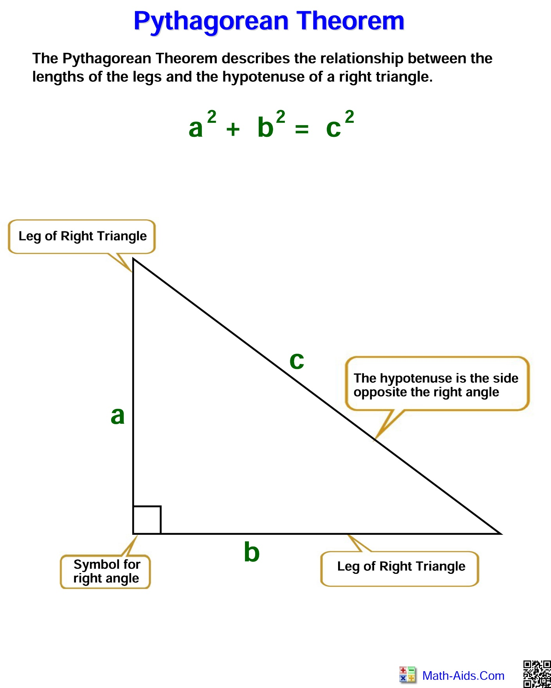
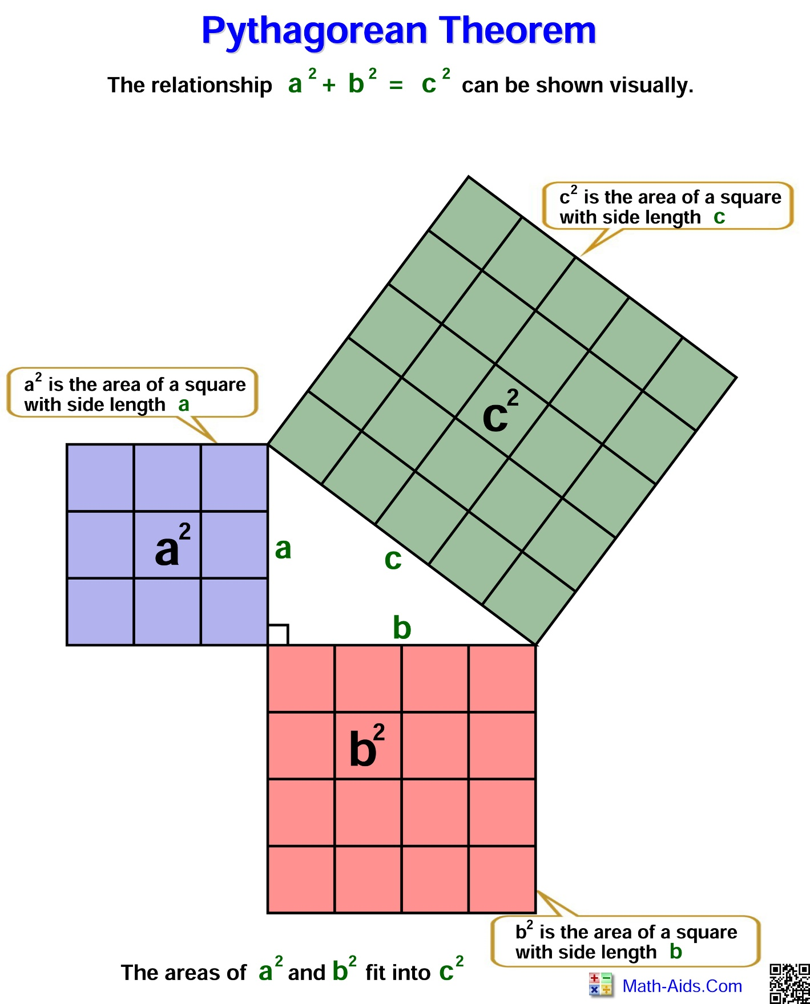

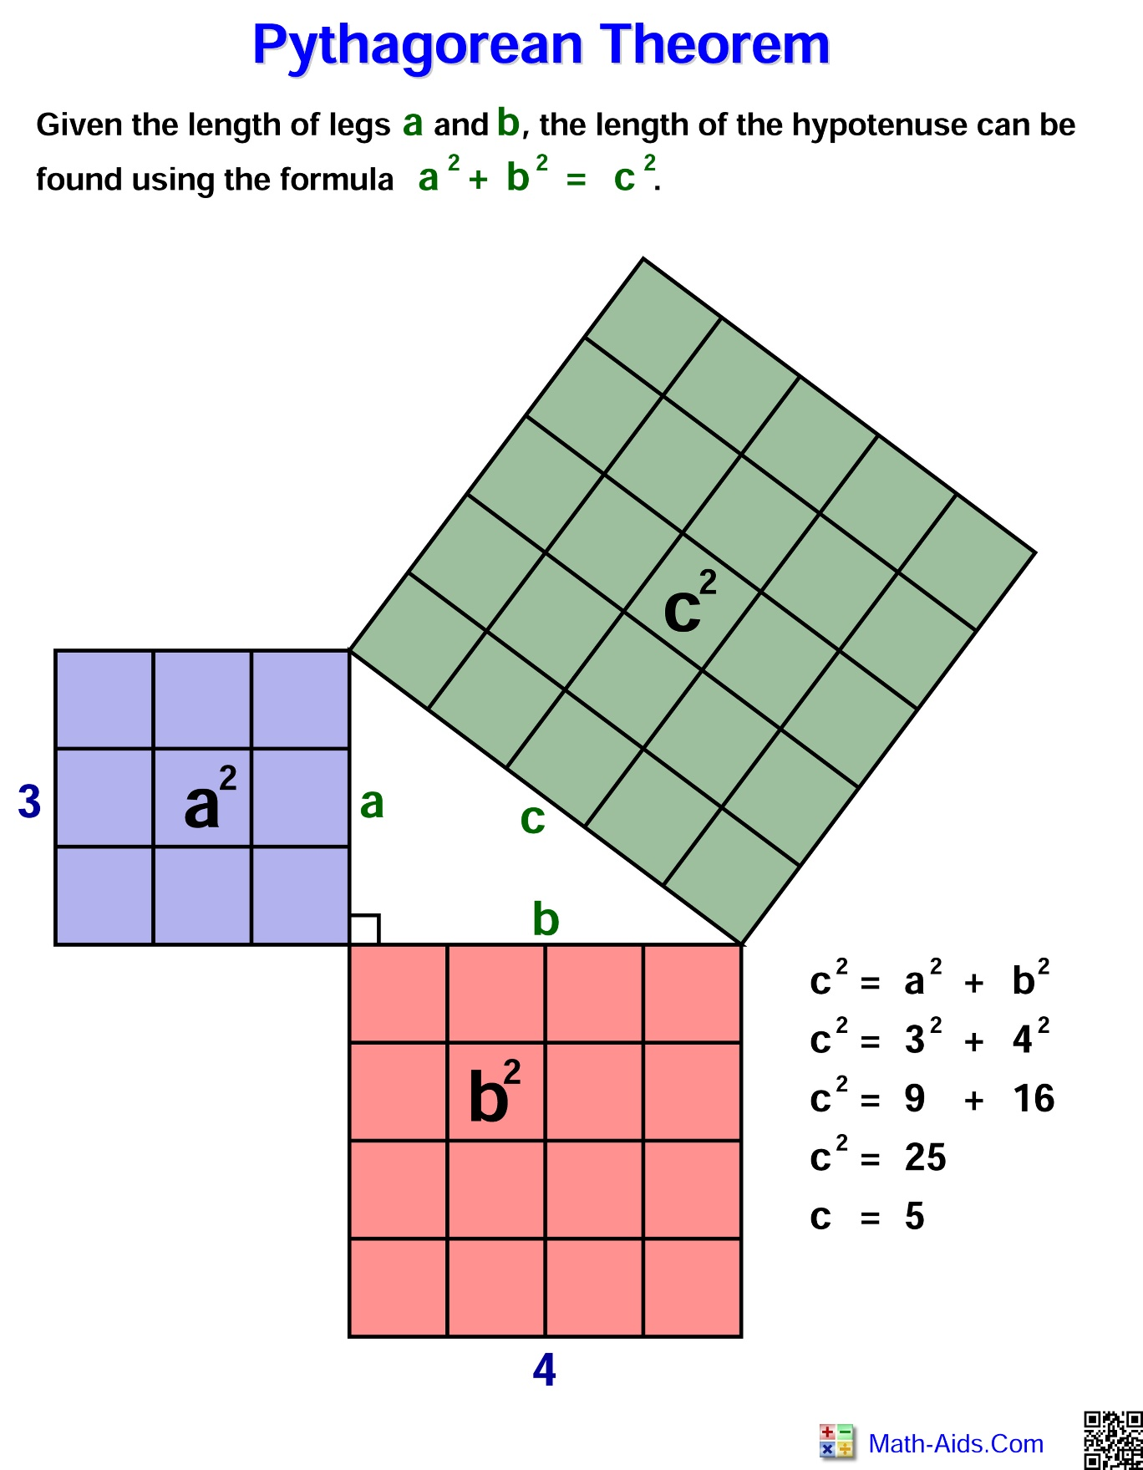

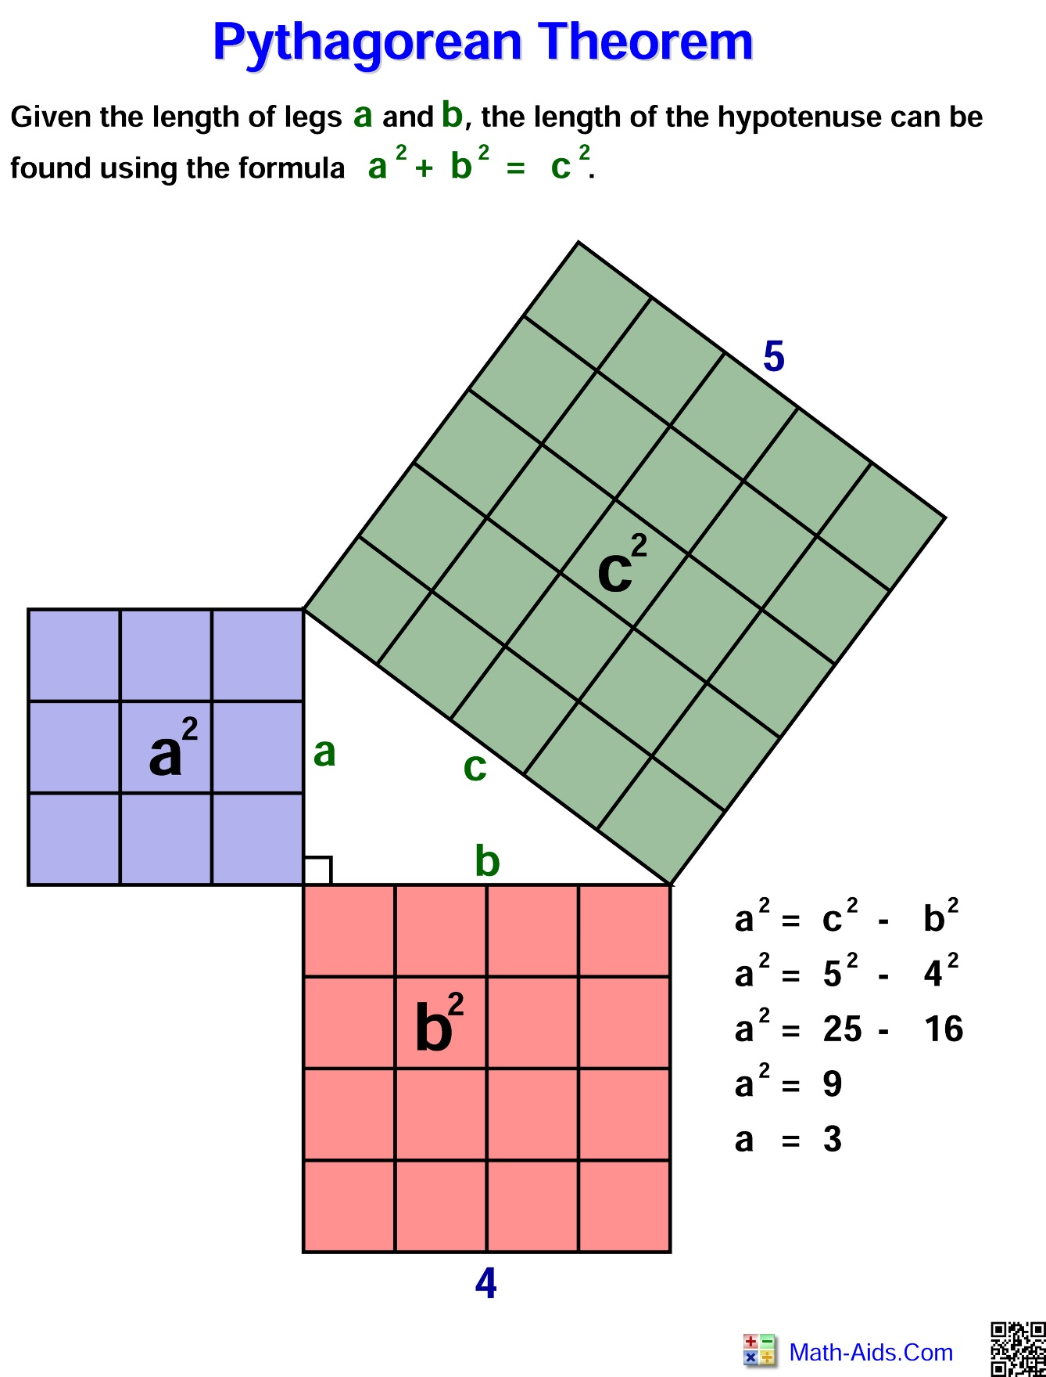
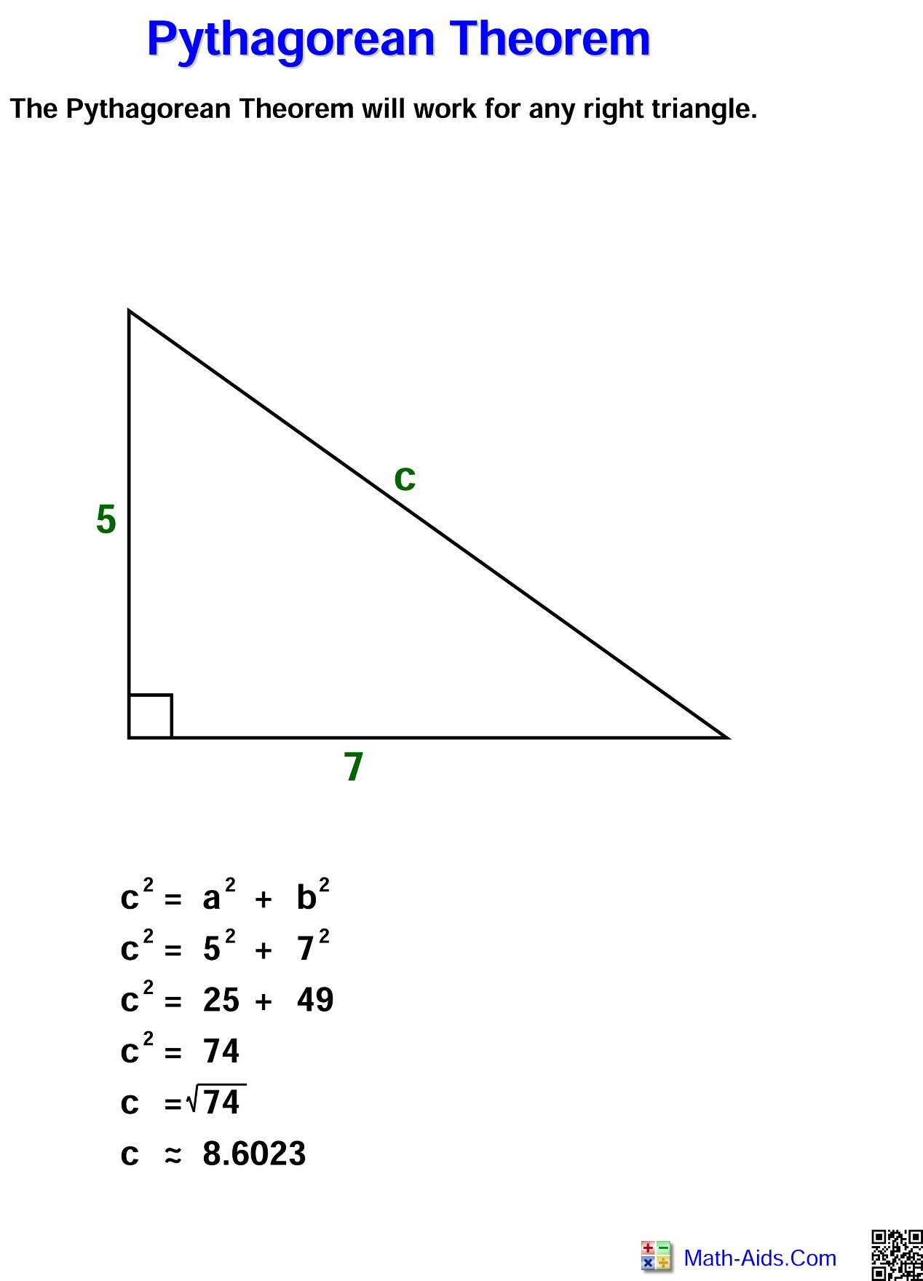
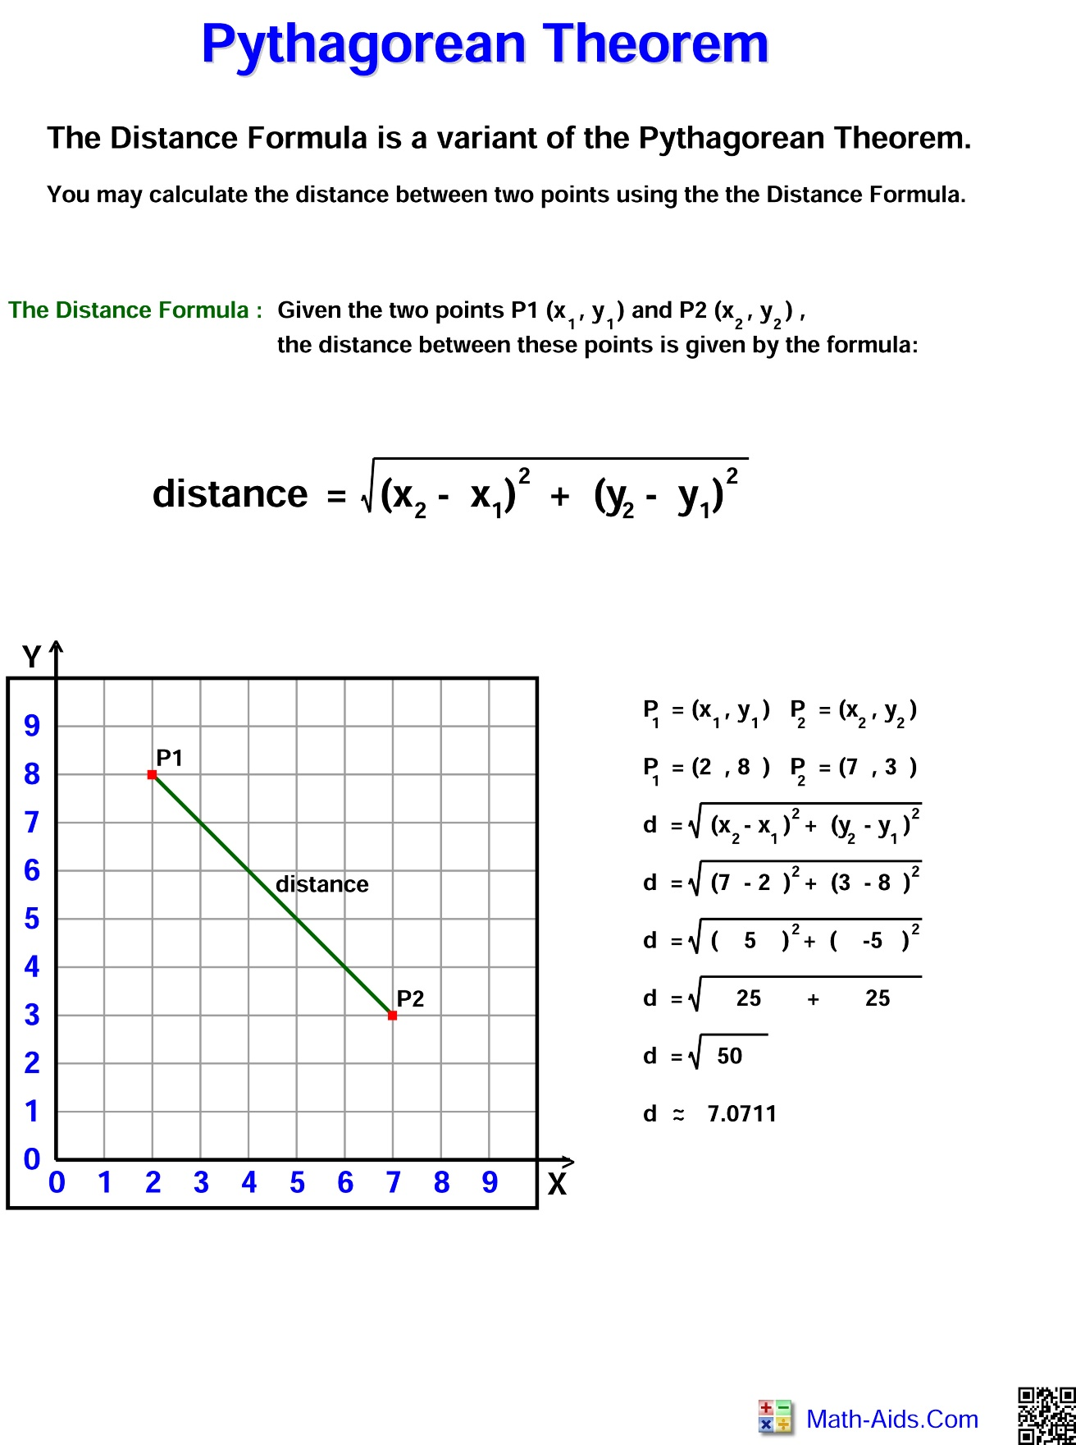

References
21st Century Competencies: Foundation Document for Discussion. Phase 1: Towards Defining 21st Century Competencies for Ontario, Winter 2016 Edition, 2016 http://www.edugains.ca/resources21CL/About21stCentury/21CL_21stCenturyCompetencies.pdf
Clipart (courtesy of Vecteezy), 2020 www.vecteezy.com
Construction Technology SAFEDocs (OCTE), 2013 https://www.octe.ca/application/files/1115/3796/3108/SAFEdoc_CON.pdf
Course Codes for Emphasis courses in the Revised Curriculum: Technological Education, Grades 11 and 12, 2009 http://www.edu.gov.on.ca/eng/curriculum/secondary/techedemphasiscourses.pdf
Exploring Technologies SAFEDocs (OCTE), 2013 https://www.octe.ca/application/files/6715/3796/3140/SAFEdoc_EXPL.pdf
Growing Success: Assessment, Evaluation, and Reporting in Ontario Schools, First Edition, Covering Grades 1 to 12, 2010
www.edu.gov.on.ca/eng/policyfunding/growSuccess.pdf
Learning for All – A Guide to Effective Assessment and Instruction for All Students, Kindergarten to Grade 12, 2013 http://www.edu.gov.on.ca/eng/general/elemsec/speced/LearningforAll2013.pdf
Pythagorean Theorem and Math Worksheets (Math-Aids), 2020 https://www.math-aids.com/
Technological Design SAFEDocs (OCTE), 2013 https://www.octe.ca/application/files/2915/3796/3174/SAFEdoc_DESIGN.pdf
The Ontario Curriculum, Grades 9 and 10: Technological Education, 2009 (revised)
http://www.edu.gov.on.ca/eng/curriculum/secondary/teched910curr09.pdf
The Ontario Curriculum, Grades 11 and 12: Technological Education, 2009 (revised) http://www.edu.gov.on.ca/eng/curriculum/secondary/2009teched1112curr.pdf
ToolSAFE TDJ Hot Glue Gun (OCTE), 2015 https://www.octe.ca/en/resources/resource-folder/toolsafe/toolsafe-tdj-hot-glue-gun
ToolSAFE TDJ Modelling Tools, (OCTE), 2015 https://www.octe.ca/en/resources/resource-folder/toolsafe/toolsafe-tdj-modelling-tools

