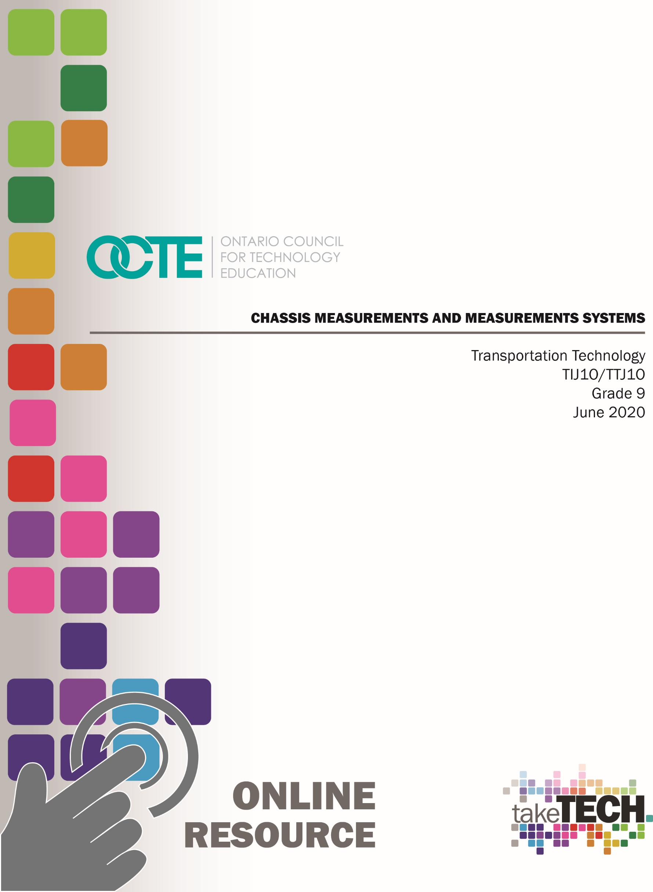

Table of Contents

Introduction 3
Project Outline 3
Prior Knowledge: 3
Student Activities 3
Planning Notes: 4
Unit #1 – Making Accurate Measurements Using a Variety of Tools 5
What Are The Two Main Systems Of Measurements? 5
Different Ways to Measure 5
Activity #1 – Measurements and Measurement Systems 5
Activity #2 - Fractions & Metric Measurements 6
Practice Makes Perfect! 8
Activity #3 – Documenting Your Time Trials 9
Activity #4 - Exploring Tools and Fastener Size 10
Activity #5 – Chassis Measurements 11
Practical Assignment 1 12
Activity #6 – Wheel Base 13
Practical Assignment 2 13
Activity #7 – Identifying Tools and Measurement Systems 14
Activity #8 – Vehicle Data Culminating Assignment - Box Assignment 15
Resources 17
Overall and Specific Expectations 17
Overall Expectations: 17
Specific Expectations: 17
Challenges with the project (online versus in class): 18
Differentiation of Project/Activity: 18
Global Extensions: 18
Assessment and Evaluation 19
Making Accurate Measurements Box Assignment Rubric 19
Appendix A - Fractions/Metric 22
Appendix B – Accurate Measurements Using a Variety of Tools Unit Plan 23
Unit #1: Accurate Measurements Using a Variety of Tools 23
Activity 1, 2 & 3 Unit Plan 23
Unit #1: Accurate Measurements Using a Variety of Tools 26
Activity 4 Unit Plan 26
Activity: Activity 5, 6, 7 & 8 Unit Plan 28
Appendix C – Answer Sheets to Blackline Masters 31
Activity #1 - Different Ways to Measure 31
Activity #2 - Fractions & Metric Measurements 32
Activity #3 - Practice Makes Perfect! 34
Activity #4 - Exploring Tools and Fastener Size 34
Activity #5 - Chassis Measurements 35
Activity #6 - Practical Assignment 1 36
Activity #7 - Practical Assignment 2 37
Activity #8 - Culminating Assignment - Box Assignment 38
References 39

Introduction
Course Code: TIJ1O / TTJ1O
Broad Base Technology: Exploring Technologies and Transportation Technology
Destination: Open
Grade Level: 9
Online Project Name: Chassis Measurements and Measurement Systems

Project Outline
By the end of this project the student will be able to measure using imperial or metric measuring systems, know how to arrange their fractions, understand common socket or wrench sizes that are similar in size, know which vehicles use which size and measuring system of tools or fasteners (metric vs imperial), know some safety procedures in handling tools, be able to demonstrate their skills by organizing tools size or by their learning skills by performing a service task that includes measuring a wheel base, wheel track and ground clearance. At the end, students will produce an artifact depicting the difference of chassis measurements between manufacturers.

Prior Knowledge:
Prior knowledge of basic math skills and units of measurement in both the Metric and Imperial systems would be an asset.

Student Activities
- With a synchronous learning time agreed upon by teachers and students, the teacher begins to lead the students by asking key questions. How much do you weigh? How tall are you? Why did some students respond by answering in Metric while others responded to answering in Imperial? How else can we measure distance? Ever travel to the USA? How do American’s post speed limits or sell their gasoline? Which province has the largest Manufacturing Sector? Who is our largest trading partner?
- Students fill in a chart with both systems of measurements including units. Students cut out squares of fractions and metric numbers. Students organize all numbers from least to greatest. Then use the cut squares to complete the diagram by labelling in the appropriate fraction.
- Students will sort numbers into 5 piles. 1/16, 1/8, ¼, ½ and metric. Then ask students to arrange these fractions from least to greatest in their appropriate group. Use this opportunity to review common denominator rule and move all 1/8, then ¼ and lastly ½ into a single row. Have students’ practice. Time students and make a game or teams to see which groups can finish first. Add metric numbers to increase difficulty.
- Students will draw lines to a teacher determined length to ensure that students understand the lesson. Other measuring handouts may be supplemented, however best way to ensure students can measure is to ask them to draw lines. Ask students to use cut out squares if they need assistance as a reference.
- As an Ice breaker, ask students to clear their workspace leaving out their zip lock bag with number cut outs inside. All at the same time (synchronous) or individually (asynchronous) ask students to empty contents and sort numbers. Award a prize if suitable to the fastest times.
- In a group activity, ask students one at a time, “What vehicles their family owns?” Make a list of all the makes and models.
- Students complete a chart dividing manufactures into two sub categories, Domestic and Import. Then subdivide the Import list into European makes and models as well. Adding as many manufactures as they can think of. Students can then add country of origin to their list.
- Ask students to make a connection between tool and fastener sizes as they apply to individual manufactures and countries. Using the chart, students are to add the correct measuring systems to each vehicle manufacturer. (Example: Older domestic vehicles and outboard small powered engines use both imperial and metric systems.) Students in groups or through synchronous learning are to sort tools by size.
- Students are provided with imperial and metric fasteners. OCTE SAFEDoc handouts can be used or teacher safety instruction on tools can be covered at this point. Ask students to try different fasteners on different tool sizes until they have matched all the tools with fasteners. Have students record their findings.
- Reviewing different manufactures and ask students to identify which vehicle models are long and which ones have short wheelbases. Have students reflect on which vehicles are more suited to highway driving vs trying to commute in larger cities. What problems do larger vehicles have when trying to get around in larger cities?
- Students complete a series of questions pertaining to chassis measurements to further develop and understand design concepts.
- Students are then asked to measure actual vehicles. Several vehicles can be set up for students to measure. Short and long wheel base models if possible. If at home (asynchronous learning) students can measure family vehicles with parental permission or measure other items such as skateboards, wagons, baby strollers etc. If available, try to set up a vehicle that has been in an accident so that students can brainstorm why the different sides of the vehicles are different?
- While half the class is measuring wheel base, the other half can be reviewing tool sizes. Students can try their tools on different car parts until they find parts that fit. If not in a classroom, (synchronize learning) then students can supplement with bicycles, lawnmower or other items that are assembled using fasteners.
- Students can cross reference their actual measurements to manufacture specifications using a service manual if possible and complete the handout for evaluation.
- Students are then to create a box that is 6 ¼” X 5 ½” X 4 ¾”. (H x W x D). On the exterior of the box, students will select 6 different makes and models and research each of their wheelbases. Leaving one side of their box open, students can choose their favourite transportation vehicle and present their research to the class.

Planning Notes:
Teachers can accommodate students by assisting them to organize their numbers and allow them to leave their numbers out while measuring during the assignments.

Unit #1 – Making Accurate Measurements Using a Variety of Tools
This unit will improve your accuracy and speed while measuring and selecting the right size of tool.

What Are The Two Main Systems Of Measurements?
We have only two systems of measurement which are Imperial (also known as standard) and Metric. Canada switched from Imperial to Metric in 1970. The majority of countries around the world use the Metric system. Our largest trading partner, the United States, uses the Imperial system and this is part of the reason why we maintain this system in Canadian society.

Different Ways to Measure
This activity will help you compare and contrast the different ways to measure.

Activity #1 – Measurements and Measurement Systems
Reflect on your society around you. How much do you weigh? How tall are you? Did you answer in metres or feet? How else can we measure distance? Have you ever travelled outside of Canada? How are speed limits posted? Kilometres per hour or miles an hour? Is gasoline sold by Gallons or by Litres? Last time you went grocery shopping with your family, how is produce sold? Pounds or kilograms?
Fill out the chart below using commonly used measurements and their appropriate units.
 | Metric | Imperial
Distance
Weight
Volume

Activity #2 - Fractions & Metric Measurements

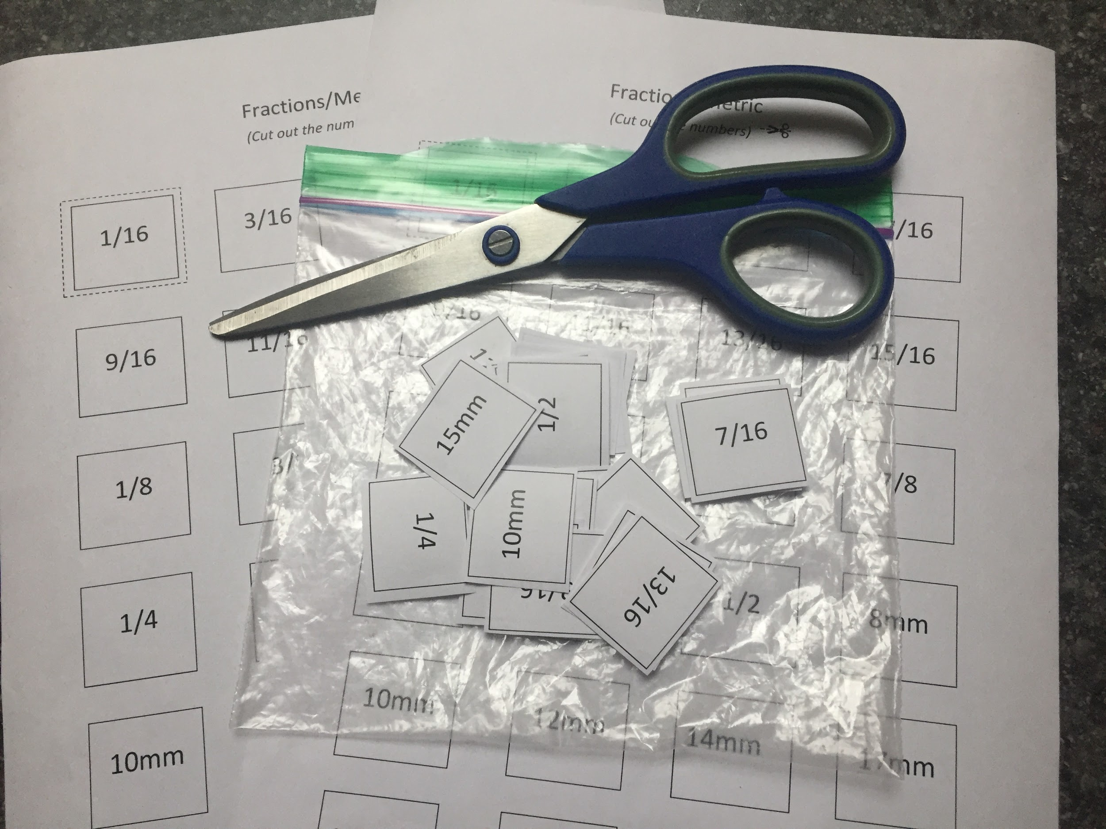
Fractions & Metric Measurements
Understanding and Organizing Fractions.
For this exercise, you will need scissors, a ruler, and a zip lock bag.
Select and print Appendix A or create your own using the numbers found on Appendix A.
- Using scissors, cut out all the squares.
- Separate the Metric numbers and Imperial (fractions) into two piles.
- Further separate the fractions into four (4) more piles. 1/16ths, 1/8ths, ¼’s and ½’s.
- Next arrange all the 1/16th in order from least to greatest in a row leaving spaces in between each 1/16th.
- Under that row, organize the 1/8ths, followed by the ¼’s and ½.
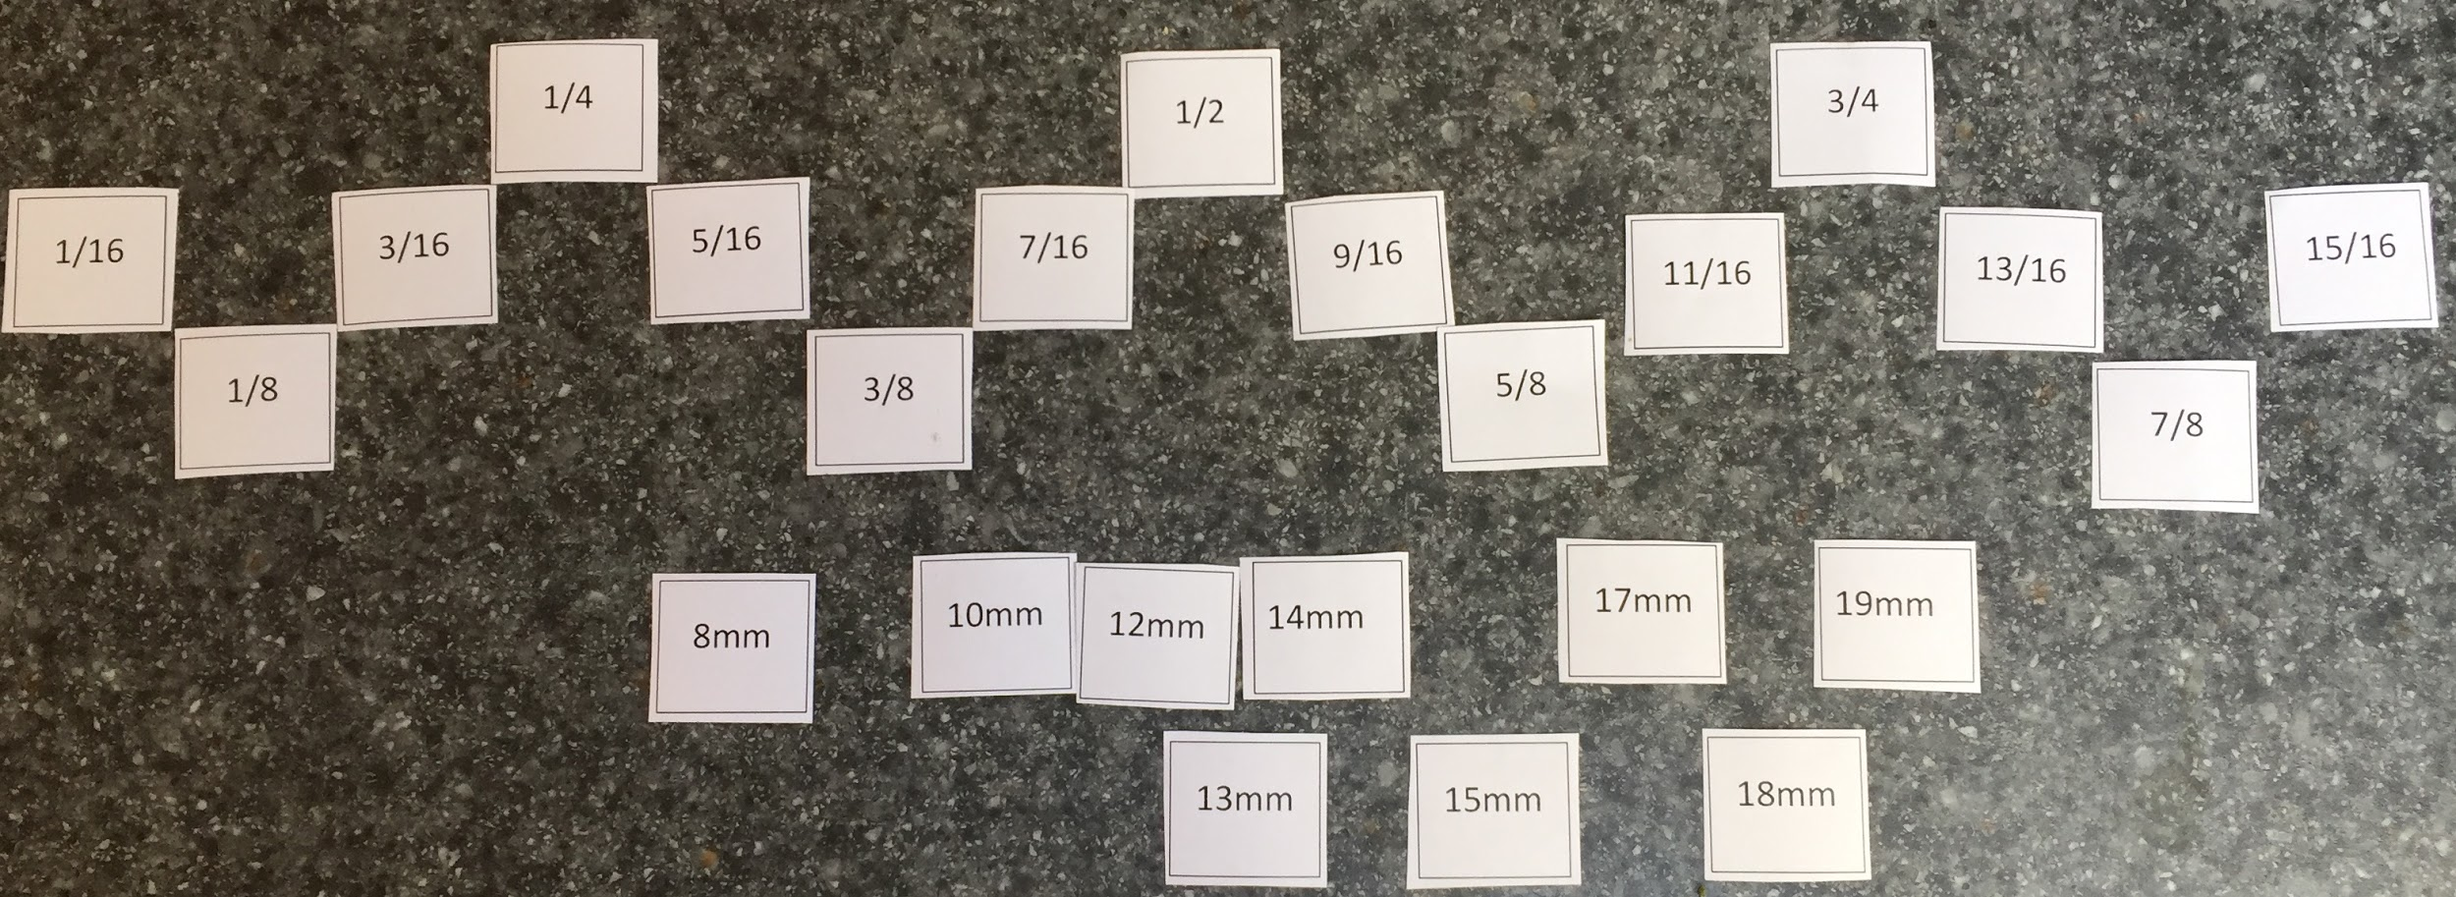
- Now, slide the 1/8th into their prospective slots. Followed by ¼’s and ½
- Complete the diagram below by labelling each unit of measure. Before you begin, is this a Metric or Imperial ruler? Hint, try counting each line.
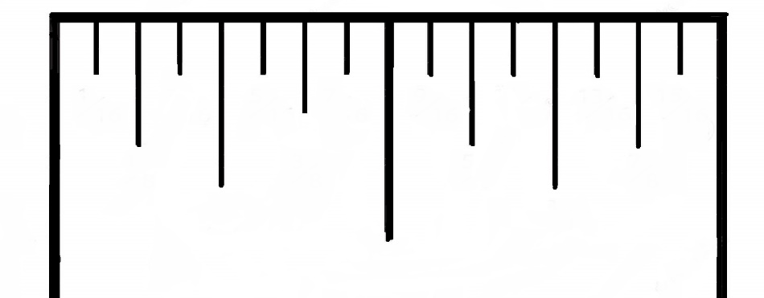
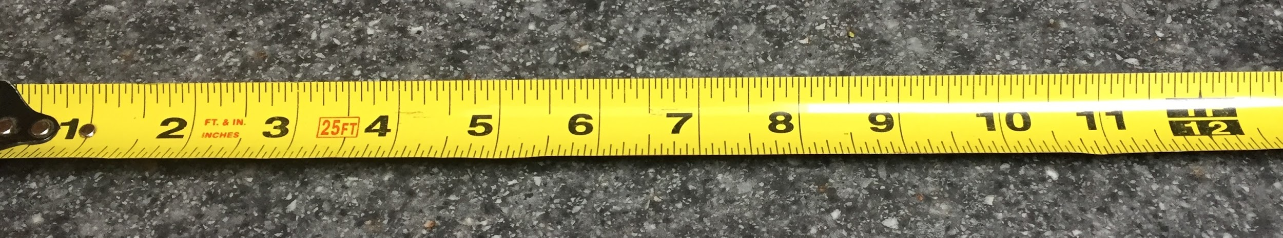
- Using a ruler with an Imperial scale, draw the following lines to the correct length.

    - 2 ¼”

    - 3 ½”

    - 5 ⅛”

    - 1 15/16”

- Using a ruler with a metric scale, draw the following lines to the correct length.

    - 30 mm

    - 45 mm

    - 55 mm

    - 3.5 cm

Practice Makes Perfect!
This activity is designed to improve your efficiency in measuring and selecting the correct size of tool.

Activity #3 – Documenting Your Time Trials
Now that you have organized your fractions and drawn a few lines, let’s apply what you have learned. Put all the Fractions and Metric numbers that you cut out into the zip lock bag. Next, give it a good shake. Using a timer, time yourself organizing your fractions from least to greatest, then add in the metric numbers. For an additional challenge, organize your numbers from greatest to least. Record your results below:
Day | Attempt 1 | Attempt 2 | Attempt 3 | Attempt 4 | Attempt 5
Monday
Tuesday
Wednesday
Thursday
Friday

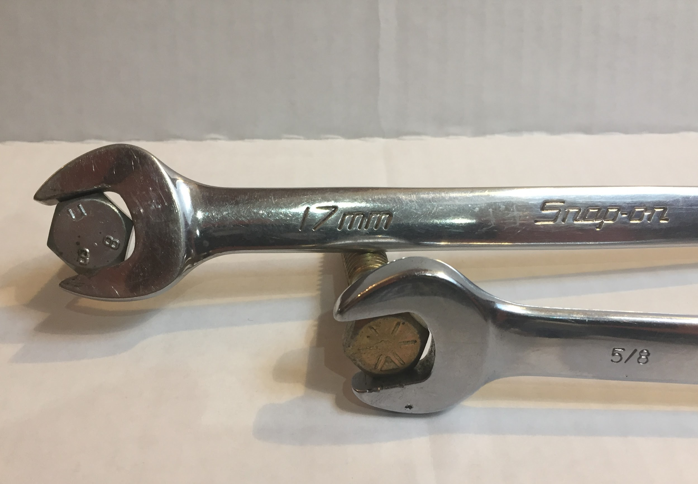
Activity #4 - Exploring Tools and Fastener Size

Exploring Tools and Fastener Size
This activity will allow you to demonstrate the ability to use, maintain, and store tools properly with care and explore the connection between the correct tool sizes to the corresponding fastener.
- With parental permission, ask an adult if you can use either some wrenches or sockets or a combination of both. Try to collect both Metric and Imperial sizes and organize your tools from least to greatest according to their size. Next, if possible, ask permission to use some fasteners (bolts and nuts) looking for a variety of sizes both metric and imperial. Try to guess the size of the tool that fits the fastener. Then try to fit the correct size until you have figured out all the sizes.

- Domestic vehicles are produced in North America, while imports and European models are made from countries in Asia and Europe. Complete the chart below with as many makes as you can. Be sure to include the country of origin.

Make
Domestic  (made in North America) | Import (Asia)  (made in Asia) | Import (European)  (made in Europe)

Activity #5 – Chassis Measurements

Chassis Measurements
This activity will introduce you to common terminology used when determining and recording vehicle dimensions.
Please answer the questions below in the spaces provided.
- What is the chassis?

- What is the body?

- Define the following terms: Wheelbase, Track and Road Clearance.

- Why are separate measurements for wheelbase, track and Road Clearance necessary?

- Complete the diagram below to show the exact points from where the chassis measurements are taken. 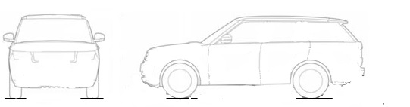
- State one advantage of a long wheel base and one advantage of a short wheelbase.

- How is the manufacturing date of the vehicle determined? Where do you find this documented on a vehicle?

- How are the sides of the chassis lengths determined?

- Which side of the vehicle is the right side?

Practical Assignment 1
Make accurate measurements and document chassis measurements.

Activity #6 – Wheel Base
- With parental approval, using a measuring tape, measure the wheelbase, track, and road clearance for two transportation vehicles. These could include a wagon and skateboard. Document the following in the chart below.
 | Vehicle # 1 |  | Vehicle #2
YEAR

MAKE

MODEL

 | Metric | Imperial | Metric | Imperial
TRACK
Wheel base (Right)
Wheel base (Left)
Road Clearance

Practical Assignment 2
This activity will assist in determining the appropriate tool size to deliver a potential service by Exploring Common fasteners and Corresponding tool sizes.

Activity #7 – Identifying Tools and Measurement Systems
Using wrenches, sockets, tape measure or ruler measure the following tool sizes that would fit a fastener and record your findings. Identify the fastener as Imperial and/or Metric.
Item | Metric (mm) Measurement | Imperial (inches) measurement | Is the fastener Metric or Imperial?
Bicycle hub nut
Bicycle seat post clamp nut/bolt
Bicycle pedal nut
Now try to locate 3 other fastener tool sizes and record your findings below: (skate board, another bicycle, roller blades or any items that you have access.
(Optional) With parental or ownership approval, locate and record the following tool sizes where available.
Lawn mower spark plug socket size
Wheel nut on passenger car

Activity #8 – Vehicle Data Culminating Assignment - Box Assignment
In this activity a box will be constructed to a specific unit of measurement in order to communicate the specifications that apply to evaluate a vehicle. You will be asked to complete a variety of tasks that will reinforce some of the skills and knowledge you have acquired.
- Make a list of the following vehicles of your choice:
- Domestic vehicle (example Ford Mustang GT)
- Import vehicle
- European vehicle
- Electric vehicle
- Supercar
- Motorcycle
- Construct a box with the following dimensions. 6 ¼” high, 5 ½” wide and 4 ¾” deep. Your box can be made from paper, bristle board or cardboard.

- On the outside of your box, decorate the sides with the different vehicles that you selected from around the world.

- Add specifications such as wheel base, wheel track and ground clearance. Write a brief description on why you choose this vehicle.

- Leave one side open. On the inside of the box, repeat the same process but leaving this space for your favorite form of transportation.

Present your box to your instructor, group or class.
- Year: 2017 Make: Ford
- Model Mustang GT350
- Wheel Base: 107” Wheel Track: 63.3”
- Ground Clearance: 137mm


This Mustang has a flat crank V8 that produces 526 Hp at 7500 RPM!

Resources
Please see all of the activities / assignments and assessment rubrics included in this document along with the appendices.

Overall and Specific Expectation in support of Ontario Curriculum Grades 9-10 Technological Education:

Overall Expectations:
A2 Demonstrate the ability to use a variety of appropriate methods to communicate ideas and solutions;
B1 Use problem-solving processes and project-management strategies in the planning and fabrication of a product or delivery of a service;
B2 Fabricate products or deliver services, using a variety of resources.

Specific Expectations:
A2.3 Use metric and imperial units of measurement (e.g., metric: degrees Celsius, joules, micrometres [microns], millimetres, kilohms, L/100 km, tonnes; imperial: degrees Fahrenheit, BTUs, knots, mils, inches, feet, miles per gallon, pounds per square inch, tons) and the abbreviations or symbols associated with them correctly and as appropriate to the task;
A2.4 Describe and use various forms of communication to document the progress and results of the development of a product or service (e.g., tracking sheets, production status reports, a multimedia presentation, a graphic or animated presentation, technical drawings, updates on a website, a blog, technical reports);
B1.1 Apply the steps of a design process or other problem-solving process to plan and develop products and services (e.g., define the problem or challenge, taking into account relevant contextual or background information; gather information [about criteria, materials, constraints]; generate possible solutions, using techniques such as brainstorming; choose the best solution; develop and produce a model or prototype; test the model or prototype; incorporate improvements or redesign and retest; report on results) (see pp. 16-19);
B1.2 Apply the steps and/or techniques of appropriate problem-solving processes and methods (e.g., diagnostics, reverse engineering, trial and error, divide and conquer, parts substitution, extreme cases) to solve a variety of problems in different technological areas (see pp. 16-19);
B1.4 Use a variety of sources to research technological solutions to specific problems or challenges (e.g., the Internet, reference books, journals or magazines, experts);

B2.1 Use appropriate tools, materials, and equipment (e.g., tools: hammer, chisel, screwdrivers, soldering iron, cheese grater, sieve, seam ripper; pruning shears, hair clipper; materials: wood, aluminum, polystyrene, paper, wax, clay, textiles, electronic components, mulch, hair colour; equipment: drill press, test meter, computer, software, printer, video camera, thermometer, grill, sewing machine, autoclave, curling iron) to create products or deliver services;
B2.2 Make accurate measurements using a variety of tools (e.g., ruler, scale, tape measure, caliper, micrometer, thermometer, measuring cup), in metric or imperial units, as appropriate;

Safety Concerns
Most of this resource involves students doing things at home. The tools and measuring devices will be limited to what students and their parents have in their possession. Please refer to the OCTE SAFEDocs for Transportation Technology and Exploring Technologies for safety documents, in order to properly address any safety concerns during instruction of this project.

Challenges with the project (online versus in class):
Parental approval may be required when using a measuring tape to measure the wheelbase, track, and road clearance for two transportation vehicles; (Optional) With parental or ownership approval may be required to locate and record the following tool sizes when locating lawn mower spark plug socket size and wheel nut on passenger vehicle.

Differentiation of Project/Activity:
Students can use squares with fractions out and visible if they need assistance as a reference while measuring.
Students practice arranging fractions at home and focus on just 1/8th or 1/16ths until they are confident in their fractions. Students can also sort from least to greatest and then greatest to least and include metric numbers to their sorting
On the exterior of the box, students will select 6 different makes and models and research each of their wheelbases. Students have the options of choosing their selections.

Global Extensions:
Students will explore the different manufacturers of vehicles from around the world. Students may not be aware of the extensive manufacturing possibilities in Ontario and our contribution to the global economy.

Assessment and Evaluation

Making Accurate Measurements Box Assignment Rubric
Categories | 50-59%  (Level 1) | 60-69%  (Level 2) | 70-79%  (Level 3) | 80-100%  (Level 4)
Knowledge and Understanding – Subject-specific content acquired in each course (knowledge), and the comprehension of its meaning and significance (understanding)
 | The student:
Knowledge of content:  Student knows how to read a ruler, determine the correct size of faster and the different chassis measurements? | demonstrates limited knowledge of content | demonstrates some knowledge of content | demonstrates considerable knowledge of content | demonstrates thorough knowledge of content
Understanding of content:  Student understands different measuring systems & units, can apply them to a specific task and understands where and how to measure a chassis. | demonstrates limited knowledge of content | demonstrates some knowledge of content | demonstrates considerable knowledge of content | demonstrates thorough knowledge of content
Thinking – The use of critical and creative thinking skills and/or processes
 | The student:
Use of planning skills:  Student could plan a box that included chassis specification, graphic and a brief description of the vehicle they choose. | uses planning skills with limited effectiveness | uses planning skills with some effectiveness | uses planning skills with considerable effectiveness | uses planning skills with a high degree of effectiveness while building their box
Use of processing skills:  Student could locate all chassis specifications for various makes and models and interpreted the data collected. | uses processing skills with limited effectiveness | uses processing skills with some effectiveness | uses processing skills with considerable effectiveness | uses processing skills with a high degree of effectiveness
Use of critical/creative  thinking processes:  Student was able to use critical thinking skills to locate 7 vehicles including chassis specification and design a creative box. | uses critical/ creative thinking processes with limited effectiveness | uses critical/ creative thinking processes with some effectiveness | uses critical/ creative thinking processes with considerable effectiveness | uses critical/ creative thinking processes with a high degree of effectiveness

Categories | 50-59%  (Level 1) | 60-69%  (Level 2) | 70-79%  (Level 3) | 80-100%  (Level 4)
Communication – The conveying of meaning through various forms

 | The student:
Expression and organization of ideas and information: Student was able to organize their ideas and present their information clearly. | expresses and organizes ideas and information with limited effectiveness | expresses and organizes ideas and information with some effectiveness | expresses and organizes ideas and information with considerable effectiveness | expresses and organizes ideas and information with considerable effectiveness expresses and organizes ideas and information with a high degree of effectiveness
Communication for different audiences in oral, visual, and written forms:  Student was able to communicate by reading a ruler correctly, communicate their ideas by building a box with 7 different vehicles and document all the necessary specifications along with producing an oral presentation. | communicates for different audiences and purposes with limited effectiveness | communicates for different audiences and purposes with some effectiveness | communicates for different audiences and purposes with considerable effectiveness | communicates for different audiences and purposes with a high degree of effectiveness
Use of conventions vocabulary, and terminology of the discipline in oral, visual, and written forms:  Student can use different systems of measurement, create a visual box to outlined dimensions and provide an oral presentation. | uses conventions, vocabulary, and terminology of the discipline with limited effectiveness | uses conventions, vocabulary, and terminology of the discipline with some effectiveness | uses conventions, vocabulary, and terminology of the discipline with considerable effectiveness | uses conventions, vocabulary, and terminology of the discipline with a high degree of effectiveness

Categories | 50-59%  (Level 1) | 60-69%  (Level 2) | 70-79%  (Level 3) | 80-100%  (Level 4)
Application – The use of knowledge and skills to make connections within and between various contexts

 | The student:
Application of knowledge and in familiar contexts:  Student was able to create a box that was decorated with 7 different vehicles and included all chassis specifications. | applies knowledge and skills in familiar contexts with limited effectiveness | applies knowledge and skills in familiar contexts with some effectiveness | applies knowledge and skills in familiar contexts with considerable effectiveness | applies knowledge and skills in familiar contexts with a high degree of effectiveness
Transfer of knowledge and skills to new contexts:  Student was able to concepts that vehicles that are manufactured in different parts of the world use different measurement systems and have different chassis specifications. | transfers knowledge and skills to new contexts with limited effectiveness | transfers knowledge and skills to new contexts with some effectiveness | transfers knowledge and skills to new contexts with considerable effectiveness | transfers knowledge and skills to new contexts with a high degree of effectiveness
Making connections within and between various contexts:  Student understand the differences between different measurement systems, vehicle manufactures as it applies to specifications. | makes connections within and between various contexts with limited effectiveness | makes connections within and between various contexts with some effectiveness | makes connections within and between various contexts with considerable effectiveness | makes connections within and between various contexts with a high degree of effectiveness

Appendix A - Fractions/Metric (Cut out the numbers) 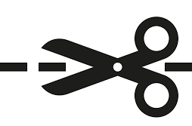
 | 1/16 |  |  | 3/16 |  |  | 5/16 |  |  | 7/16
 | 13/16 |  |  | 15/16 |  |  | 9/16 |  |  | 11/16
 | 3/8 |  |  | 1/8 |  |  | 5/8 |  |  | 3/4
 | 1/2 |  |  | 1/4 |  |  | 7/8 |  |  | 8mm
 | 10mm |  |  | 12mm |  |  | 13mm |  |  | 14mm
 | 15mm |  |  | 17mm |  |  | 18mm |  |  | 19mm

Appendix B – Accurate Measurements Using a Variety of Tools Unit Plan
Unit #1: Accurate Measurements Using a Variety of Tools  Activity: Activity 1, 2 & 3 Unit Plan |  | Grade 9
Time Bar:  90 minutes | Learning Goals  - Students will be able to measure using Imperial/Metric measuring systems.  - Students will be able to arrange fractions from least to greatest.  - Students will be able to make connections between Imperial and Metric sizes. | Materials  Ruler/Tape Measure  Scissors  Zip lock bag  Hand out (appendix A)
 | Identify Grouping 🡪 Strategy  Key Questions:  - How much do you weigh? How tall are you?  - Why did some students respond by answering in Metric while others responded to answering in Imperial?  - How else can we measure distance?  - Ever travel to the USA? How do American’s post speed limits or sell their gasoline?  - Which province has the largest Manufacturing Sector?  - Who is our largest trading partner? | Plan links between assessment and instruction:  1) Identify what will be assessed (curriculum expectations or learning skills).  2) Choose an appropriate assessment strategy.  3) Choose an appropriate assessment scoring tool.
Minds On…

 | Identify Grouping 🡪 Strategy  Students fill in a chart with both systems of measurements including units. Students cut out squares of fractions and metric numbers. Students organize all numbers from least to greatest. Then use the cut squares to complete the diagram by labelling in the appropriate fraction.  Teachers start the lesson by reviewing concepts taught previously in math. (STEM) Using Appendix A, ask students to sort numbers into 4 piles. 1/16, 1/8, ¼, ½ and metric. Then ask students to arrange these fractions from least to greatest in their appropriate group. Use this opportunity to review common denominator rule and move all 1/8, then ¼ and lastly ½ into a single row. Have students’ practice. Time students and make a game or teams to see which groups can finish first. Add metric numbers to increase difficulty. | Explicitly label:  - Assessment for learning  (inform future instruction)  - Assessment as learning  (reflection)  - Assessment of learning  (student achievement).
Action!
 | Identify Grouping 🡪 Strategy  Students will draw lines to a teacher determined length to ensure that students understand the lesson. Other measuring handouts may be supplemented, however best way to ensure students can measure is to ask them to draw lines. Ask students to use cut out squares if they need assistance as a reference.  Note: Students should be well prepared to measure after the three-part lesson. | Explicitly identify planned differentiation of content, process, or product based on readiness, interest, or learning preference in order to work in zone of proximal development; save time; give students choice, …  Provide hyperlinks to:  - Rationale/research   - Video   - Lesson artefacts   - Professional  dialogue 
Consolidate Debrief

<Choose relevant label(s)>  Application  Concept Practice  Differentiated  Exploration  Reflection  Skill Drill | Home Activity or Further Classroom Consolidation  Students practice arranging fractions. They can sort from least to greatest and then greatest to least. They can also include metric to their sorting. Students should practice and record results daily for a period of one week. Goal is to sort numbers in under 30 seconds. | Your plan should include activities that are:  - visual  - kinesthetic  - auditory

Unit #1: Accurate Measurements Using a Variety of Tools  Activity: Activity 4 Unit Plan |  | Grade 9
Time Bar:  90 minutes | Learning Goals  - Students will be able to measure using Imperial/Metric measuring systems.  - Students will be able to arrange fractions form least to greatest.  - Students will be able to make connections between Imperial and Metric sizes. | Materials  Zip lock bag  Assortment of hand tool and/or sockets  Assortment of fasteners imperial/metric.
 | Identify Grouping 🡪 Strategy  Ice breaker.  Ask students to clear their workspace leaving out their zip lock bag with number cut outs inside. All at the same time (synchronous) or individually (asynchronous) ask students to empty contents and sort numbers. Award a prize if suitable to the fastest times.  Key Questions:  In a group activity, ask students one at a time, “What vehicles their family owns?” Make a list of all the makes and models. | Plan links between assessment and instruction:  1) Identify what will be assessed (curriculum expectations or learning skills).  2) Choose an appropriate assessment strategy.  3) Choose an appropriate assessment scoring tool.
Minds On…

 | Identify Grouping 🡪 Strategy  Students complete a chart dividing manufactures into two sub categories, Domestic and Import. Then subdivide the Import list into European makes and models as well. Adding as many manufactures as they can think of. Students can then add country of origin to their list. Ask students to make a connection between tool and fastener sizes as they apply to individual manufactures and countries. Second part of the lesson is to ask students to sort tools by size.  Teachers start the lesson by reviewing concepts of sorting fractions and metric numbers. Then facilitate the discussion by guiding students to compose a list of major vehicle manufacturers. | Explicitly label:  - Assessment for learning  (inform future instruction)  - Assessment as learning  (reflection)  - Assessment of learning  (student achievement).
Action!
 | Identify Grouping 🡪 Strategy  In class, students can sort tools in groups, or individually (remote learning)  As the lesson progresses, provide students with imperial and metric fasteners and ask them to try different fasteners on different tool sizes until they have matched all the tools with fasteners. Have students record their findings.  Note: Students should be well prepared to do measuring after the three-part lesson. | Explicitly identify planned differentiation of content, process, or product based on readiness, interest, or learning preference in order to work in zone of proximal development; save time; give students choice, …  Provide hyperlinks to:  - Rationale/research  - Video  - Lesson artefacts  - Professional  dialogue
Consolidate Debrief
<Choose relevant label(s)>  Application  Concept Practice  Differentiated  Exploration  Reflection  Skill Drill | Home Activity or Further Classroom Consolidation  Students continue practicing arranging fractions. They then can organize tool sizes at home (asynchronous) with parental permission and match tools sizes with fasteners found around the home. | Your plan should include activities that are:  - visual  - kinesthetic  - auditory

Unit #1: Accurate Measurements Using a Variety of Tools  Activity: Activity 5, 6, 7 & 8 Unit Plan |  | Grade 9
Time Bar:  180 minutes | Learning Goals  - Students will be able to describe major chassis terminology.  - Students will be able to measure major chassis clearances.  - Students will be able to make connections between Imperial and Metric sizes.  - Students will be able to plan can create an artefact that communicates the difference between chassis measurements as it applies to different manufactures. | Materials  Tape measure  Assortment of hand tool and/or sockets  Assortment of parts/fasteners and/or  Vehicles

 | Identify Grouping 🡪 Strategy  Review the different manufactures and ask students to identify which vehicle models are long and which ones have short wheelbases.  Have students reflect on which vehicles are more suited to highway driving vs trying to commute in larger cities.  What problems do larger vehicles have when trying to get around in larger cities? | Plan links between assessment and instruction:  1) Identify what will be assessed (curriculum expectations or learning skills).  2) Choose an appropriate assessment strategy.  3) Choose an appropriate assessment scoring tool.
Minds On
 | Identify Grouping 🡪 Strategy  Students complete a series of questions pertaining to chassis measurements to further develop and understand design concepts.  Students are then asked to measure actual vehicles. Several vehicles can be set up for students to measure. Short and long wheel base models if possible. If at home (asynchronous) students can measure family vehicles with parental permission or measure other items such as skateboards, wagons, baby strollers etc. While half the class is measuring wheel base, the other half can be reviewing tool sizes. Ask students to try their tools on different car parts until they find parts that fit. If not in a classroom, then students can supplement with bicycles, lawnmower or other items that are assembled using fasteners.  Teacher is responsible for arranging a variety of vehicles for students to measure in groups. If available, try to set up a vehicle that has been in an accident so that students can brainstorm why the different sides of the vehicles are different? | Explicitly label:  - Assessment for learning  (inform future instruction)  - Assessment as learning  (reflection)  - Assessment of learning  (student achievement).
Action!

 | Identify Grouping 🡪 Strategy  In class, students can sort tools in groups, or individually (remote learning)  Ask students to cross reference their actual measurements to manufacture specifications if possible and complete the handout for evaluation.  As a consolidation final assignment, ask students to create a box that is 6 ¼” X 5 ½” X 4 ¾”. (H x W x D). On the exterior of the box, students will select 6 different makes and models and research each of their wheelbases. Leaving one side of their box open, students can choose their favourite transportation vehicle and present their research to the class. | Explicitly identify planned differentiation of content, process, or product based on readiness, interest, or learning preference in order to work in zone of proximal development; save time; give students choice, …  Provide hyperlinks to:  - Rationale/research  - Video  - Lesson artefacts  - Professional  dialogue
Consolidate Debrief
<Choose relevant label(s)>  Application  Concept Practice  Differentiated  Exploration  Reflection  Skill Drill | Home Activity or Further Classroom Consolidation  Students can measure their family vehicles and compare actual measurements to manufacture specifications.  Beyond the classroom activity, students can include why they chose each of their vehicles. | Your plan should include activities that are:  - visual  - kinesthetic  - auditory

Appendix C – Answer Sheets to Blackline Masters

Activity #1 - Different Ways to Measure
Fill out the chart below using commonly used measurements and their appropriate units.
 | Metric | Imperial
Distance | metres (mm, cm, m, km) | inches, feet, yards, miles
Weight | grams (g, kg, tonne) | ounces, pounds, tons
Volume | litres (mL, L) | ounces, pint, gallons

Total Score 6/6

Activity #2 - Fractions & Metric Measurements
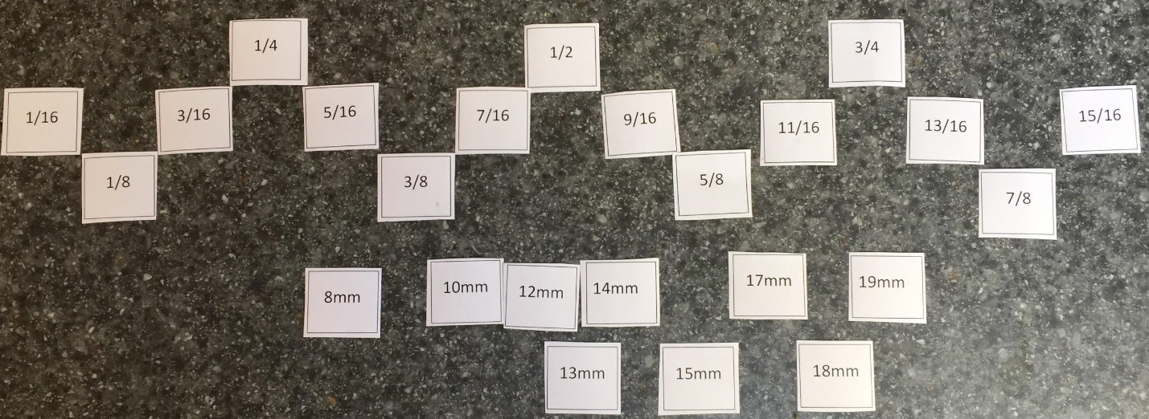Total Score 5/5
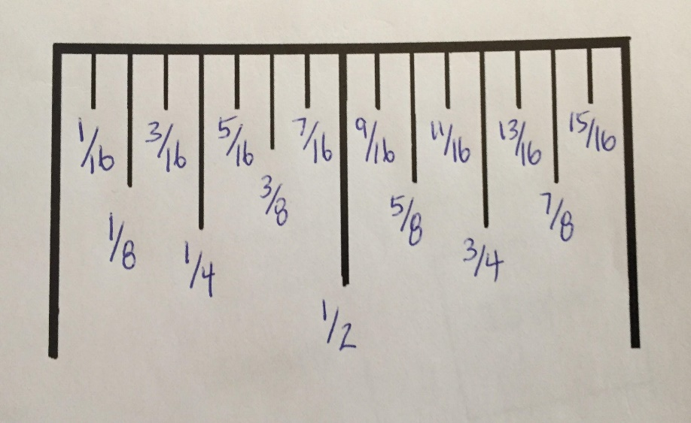
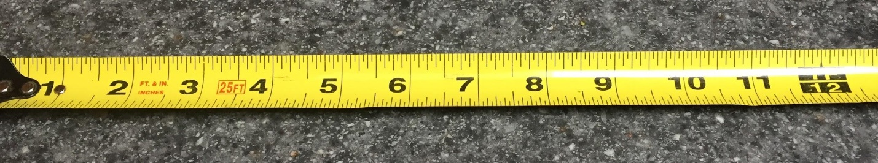
Total Score 5/5

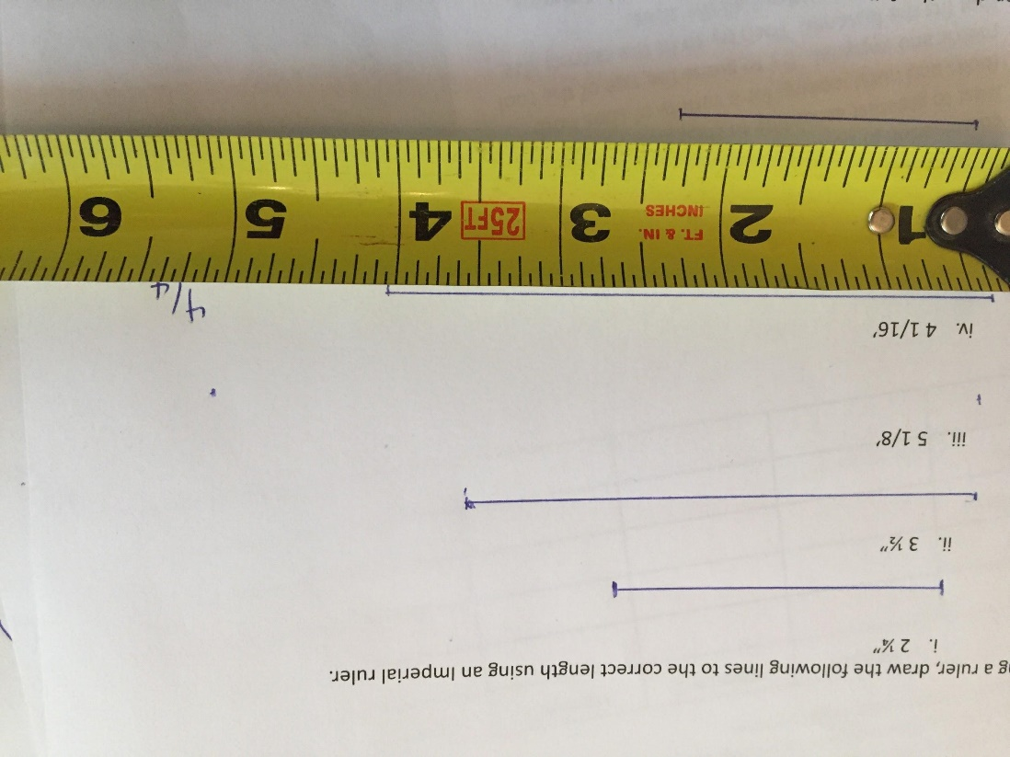
Using a ruler with an Imperial scale, draw the following lines to the correct length.

Using a Ruler with a metric scale, draw the following lines to correct length.
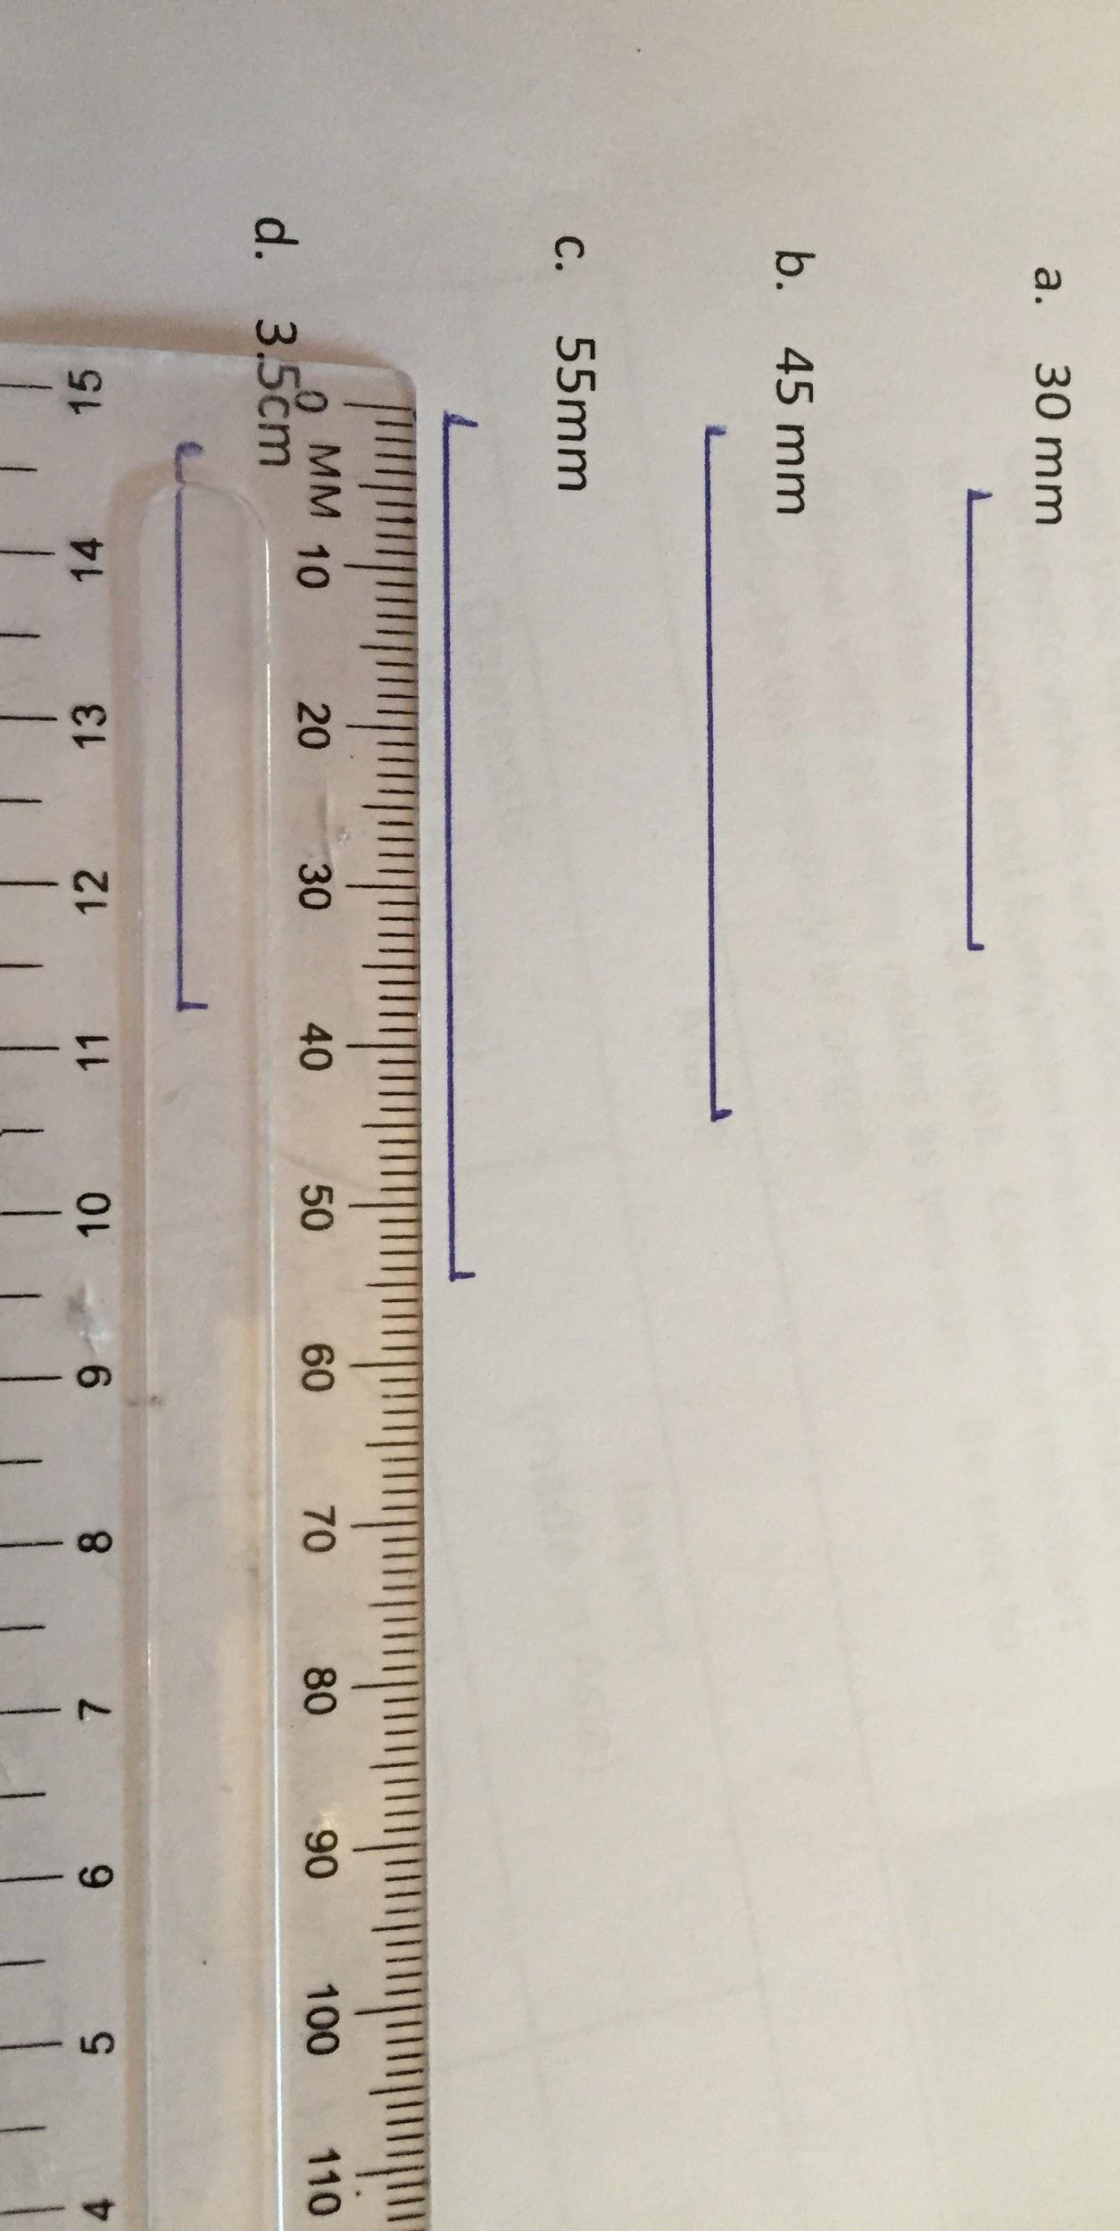
Total Score 4/4

Activity #3 - Practice Makes Perfect!

Day | Attempt 1 | Attempt 2 | Attempt 3 | Attempt 4 | Attempt 5
Monday
Tuesday
Wednesday
Thursday
Friday |  |  |  |  | Less than 30 seconds
Total Score 5/5

Activity #4 - Exploring Tools and Fastener Size

Make
Domestic  (made in North America) | Import (Asia)  (made in Asia) | Import (European)  (made in Europe)
Ford, Lincoln, Mercury  GM - Chevrolet, Buick, GMC, Cadillac Chrysler, Dodge, Jeep, Ram | Honda (Acura), Toyota (Lexus), Nissan (Infiniti), Mazda, Subaru – All Japanese  Kia, Hyundai - Korean | Volkswagen, BMW, Mercedes, Audi, Porsche - German  Fiat, Alpha Romeo, Maserati, Ferrari - Italian  Austin Martin, Bentley, Jaguar – England/UK
Total Score 6/6

Activity #5 - Chassis Measurements
Please answer the questions below in the spaces provided. Answers are in blue Total Scores are at the end of each question:
- What is the chassis?
Frame, suspension, steering, engine and drivetrain of a vehicle. 2/2
- What is the body?
Outside shape of the vehicle. Fenders, hood, trunk, roof and panels. 2/2
- Define the following terms: Wheelbase, Track and Road Clearance.
Wheelbase-distance from the center of front wheels to center of rear wheels
Wheel Track (Tread) - Distance between the center of wheels on the same axle.
Road Clearance - Minimum distance between the ground and lowest part of vehicle. 6/6
- Why are separate measurements for wheelbase, track and Road Clearance necessary?
Vehicles are manufactured to “Build Tolerances”. Verify a vehicle is within manufacturer's specifications and a means to make comparisons between different manufactures. 2/2
- Complete the diagram below to show the exact points from where the chassis measurements are taken. 6/6
- State one advantage of a long wheel base and one advantage of a short wheelbase.
Provides better stability and ride. 2/2
- How is the manufacturing date of the vehicle determined? Where do you find this documented on a vehicle?
Provides better maneuverability. 2/2
- How are the sides of the chassis lengths determined?
There are two sides. Drivers and Passenger side. 2/2
- Which side of the vehicle is the right side?
The right side is the Passenger side. 2/2

Activity #6 - Practical Assignment 1
 | Vehicle # 1 |  | Vehicle #2
YEAR | 2015
MAKE | Ford
MODEL | Edge
 | Metric | Imperial | Metric | Imperial
TRACK | 1645 mm | 64.75”
Wheel base (Right) | 2851 mm | 112.25”
Wheel base (Left) | 2851 mm | 112.25”
Road Clearance | 200 mm | 7.75”
Total Score 10/10

Activity #7 - Practical Assignment 2
Item | Metric (mm) Measurement | Imperial (inches) measurement | Is the fastener Metric or Imperial?
Bicycle hub nut | 15 mm | 5/8” | Metric
Bicycle seat post clamp nut/bolt | 13 mm | ½” | Metric
Bicycle pedal nut | 15 mm | 5/8” | Metric
Now try to locate 3 other fastener tool sizes and record your findings below: (skate board, another bicycle, roller blades or any items that you have access.
(Optional) With parental or ownership approval, locate and record the following tool sizes where available.
Lawn mower spark plug socket size | 16mm | 5/8” | Imperial
Wheel nut on passenger car | 19mm | ¾” | Metric
Total Score 10/10

Activity #8 - Culminating Assignment - Box Assignment
In this activity a box will be constructed to a specific unit of measurement in order to communicate the specifications that apply to evaluate a vehicle.
Year: 2017 Make: Ford
Model Mustang GT350
Wheel Base: 107” Wheel Track: 63.3”
Ground Clearance: 137mm

This Mustang has a flat crank V8 that produces 526 Hp at 7500 RPM!

Please see rubric located in Assessment and Evaluation on pages 19 - 21.

References
21st Century Competencies: Foundation Document for Discussion. Phase 1: Towards Defining 21st Century Competencies for Ontario, Winter 2016 Edition, 2016 http://www.edugains.ca/resources21CL/About21stCentury/21CL_21stCenturyCompetencies.pdf
Course Codes for Emphasis courses in the Revised Curriculum: Technological Education, Grades 11 and 12, 2009 http://www.edu.gov.on.ca/eng/curriculum/secondary/techedemphasiscourses.pdf
Growing Success: Assessment, Evaluation, and Reporting in Ontario Schools, First Edition, Covering Grades 1 to 12, 2010 www.edu.gov.on.ca/eng/policyfunding/growSuccess.pdf
Learning for All – A Guide to Effective Assessment and Instruction for All Students, Kindergarten to Grade 12, 2013 http://www.edu.gov.on.ca/eng/general/elemsec/speced/LearningforAll2013.pdf
The Differentiated Instruction Scrapbook http://www.edugains.ca/resourcesDI/EducatorsPackages/DIEducatorsPackage2010/2010DIScrapbook.pdf
The Ontario Curriculum, Grades 9 and 10: Technological Education, 2009 (revised) http://www.edu.gov.on.ca/eng/curriculum/secondary/teched910curr09.pdf
The Ontario Curriculum, Grades 11 and 12: Technological Education, 2009 (revised) http://www.edu.gov.on.ca/eng/curriculum/secondary/2009teched1112curr.pdf

