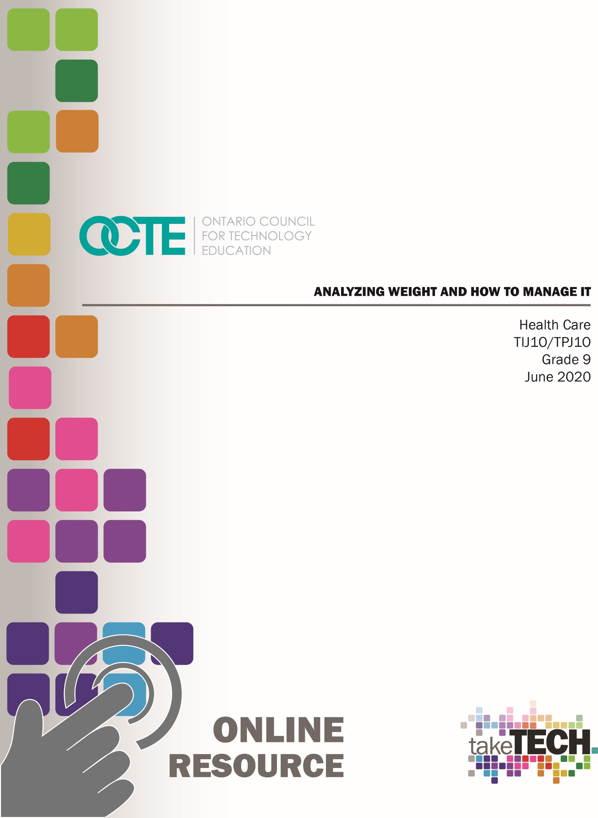

Table of Contents

Introduction 2
Project Outline 2
Prior Knowledge 2
Student Activities 2
Planning Notes 3
Resources 4
Instructional Strategies 4
The Hook/Motivational Strategies 4
Learning Goals and Success Criteria 5
Overall and Specific Expectations 5
Overall Expectations 5
Specific Expectations 5
Challenges Implementing the Project (Online Versus In Class) 6
Differentiation of Project/Activity 6
Assessment and Evaluation 6
Religious Considerations 7
Industry Extensions/Career Exploration 7
Global Extensions 7
Ethical Considerations 7
Environment Considerations 7
Reflection or Design Report 8
Appendix A – BMI Chart 9
Appendix B - BMI Reflection 10
Appendix C - Article Discussion 11
Appendix D – Food Journal 12
Appendix E – Analyzing Trendy Diets 13
Appendix F – New Diet 14
Appendix G – Career Exploration 15
References 16

Introduction
Course Code: TIJ1O / TPJ1O
Broad base Technology: Exploring Technologies and Health Care
Destination: Open
Grade Level: 9
Online Project Name: Analyzing Weight and How To Manage It

Project Outline
Students will demonstrate learning skills that include measuring weight and height using common equipment, to determine an individual’s Body Mass Index (BMI). They will learn about the different categories within the BMI chart that can be used as a health determinant. Students will evaluate and compare several people, and write a reflection on whether this chart is accurate and reasonable. Students will gain understanding of Canada’s Food Guide and their dietary suggestions, and how it can be used to obtain or maintain a healthy body weight. After reading newspaper articles, the students can engage in online dialogue regarding their thoughts on the articles. A 2-day tracking of their food intake will allow for reflection on whether their personal habits align with Canada’s Food Guide. Students will then assess a diet of their choice to determine its advantages and disadvantages, and suggest ways to improve the diet as presented. Students then combine all their learnings to create their own diet.

Prior Knowledge:
Students have a fundamental understanding of how to take their weight, and may have prior exposure to the new Canada’s Food Guide.
Most students will be aware of some of the common diets, and may have even tried them.

Student Activities:
  - With a synchronous learning time agreed upon by teacher and students, the teacher will lead the students in determining their understanding of how to take weight and height. It is to be done in metric as per Canadian hospital standards. Students can be shown how to use a scale, and the ideal time to take an accurate weight (in the morning, after voiding). Students are then shown how to take an accurate height measurement – no shoes, participant against a wall with measuring tape. A BMI chart is shown to the students, and they are shown how to use it to determine a person’s health category.

  - In the provided chart (Appendix A), students are to take weight and height on various family members (try to include as many as possible from different ages).
  - Students use this data, and refer to a BMI chart from the internet, or use the equation: BMI=kg/m² . Based on height and weight measurements, they are to fill in the category for all of their participants.
  - Students then analyze the results on the chart and complete a reflective paper (Appendix B). Both chart and paper are submitted for evaluation.
  - Students watch a video on Canada’s Food Guide, and go to the website to view the current guide. This guide is used for the final project in this unit.
  - In a synchronous learning style, the teacher can guide the students through Canada’s Food guide to point out a few features: food groups, eating habits and lifestyle patterns associated with food.
  - Students can choose one (or more) newspaper/magazine article(s) that relate to eating patterns and its effect. After reading the article, in a synchronous learning style, the teacher will lead the class to take turns discussing the article(s), and reflect on the points discussed. Some questions to consider are posted in Appendix C.
  - Students are asked to complete a 2-day journal of what they ate (Appendix D). Once completed, they can analyze their intake as it relates to Canada’s Food Guide. The last column can be filled in with alternatives/additions that would align their eating with the suggested servings according to the guide.
  - Students are then to complete an assignment that analyzes diets and how they can be used to obtain or maintain a BMI within the healthy range (Appendix E).
  - Students are asked to create a new “diet” that combines all they have learned about BMI, Canada’s Food Guide and diets to construct one that appeals to adolescents. (Appendix F)
  - Students are to explore various careers and extensions to career paths related to eating habits, Canada’s Food Guide, and lifestyle patterns. (Appendix G)

Planning Notes:
Teachers can determine the level of student understanding to increase or decrease the synchronous learning. Plan a synchronous lesson in advance to encourage involvement. Ensure that students have watched the video on Canada’s Food Guide prior to the synchronous lesson on how to “read” the guide.
Articles on healthy eating, unhealthy food habits, and eating styles of adolescents can be changed and adapted to incorporate current issues, local newspapers, religious events, etc. A few Canadian and current sources are listed. Students who choose the same article can be placed in groups to discuss and share their reflections prior to the synchronous lesson.

Resources:
1. YouTube video on Canada’s Guide by TVO Kids (3:10)
2. Canada’s Food Guide by Government of Canada
3. BMI Chart
- News articles:
Global News article titled, “Confused-by-Fad-Diets: Registered-Holistic-Nutritionist-has-Advice”
A Canadian Grocer Study on “Healthy eating becoming increasingly important to Canadians”
CBC News article on “Canadian school kids' diet changes are 'definitely good news’”
Verywell Health article titled, “4 Bad Food Habits Teens Have and How to Fix Them”
5. Students will need scale and measuring tape

Instructional Strategies:
For the initial lesson on measuring height and weight, the teacher may choose to video tape themselves using the scale and measuring height. A teddy bear/doll or other inanimate object can be used to maintain privacy. This video can be displayed in the first lesson.
A whiteboard or other teaching method can be used to demonstrate the use of the BMI chart. Students need to understand how to use the weight and height to determine a category. This is important for activities 3 and 4. Use an example of a weight and height to determine the level of understanding.
Teachers may also use any of the following instructional strategies; 3-Part lesson, lecture, storyboard, word wall, think-pair-share, placemat activity, rapid write, K-W-L, anticipation chart, ABC taxonomy, think aloud, analyzing text, Cornell note taking, exit ticket/ticket out the door, plus/minus/delta, to get their students engaged in the learning.

The Hook/Motivational Strategies:
Students who are interested in athletics or competitive sports will appreciate the knowledge about nutrition and how weight can affect some sports, such as swimming and long-distance running. It is interesting that some very athletic people are, in fact, not in the “healthy” category according to the BMI.

Canada’s Food Guide was recently changed in 2019, making it very current. Students can look at these changes and consider if they are adhering to the new guide. Adolescents face many opportunities to be their own person and make their own choices, and this can include the food they eat.
Understanding the link between nutrition and diseases may be a motivation to improve eating habits and reduce the likelihood of hereditary diseases.

Learning Goals and Success Criteria:
Students will be able to understand how nutrition affects their health status as indicated on the BMI chart. They will be able to understand how diets can play a role in maintain overall health and understand how their current eating patterns can affect their health in the future.

Overall and Specific Expectations in Support of Ontario Curriculum Grades 9 - 10 Technological Education

Overall Expectations:
A3 Evaluate products or services in relation to specifications, user requirements, and operating conditions
D2 Identify careers in various technological fields, and describe the educational requirements for them.

Specific Expectations:
A3.1 Evaluate a product or service, and processes associated with its development, on the basis of a set of criteria relevant to that product or service (e.g., adherence to specifications, ease of use, attractive appearance, ruggedness, clean joints, acceptable weld bead, uniform colour, adherence to forest management plan, nutritional value)
A3.2 Suggest improvements to a product or service on the basis of a set of criteria relevant to that product or service (e.g., durability, reliability, ease of use, eco-friendliness, appearance, safety, customer satisfaction)
D2.1 Describe secondary and postsecondary education pathways (i.e., selection of courses, programs, experiential learning opportunities, and other learning opportunities at the secondary and postsecondary levels, including apprenticeship training, certificate programs, college programs, and/or university programs) leading to a variety of careers in technological fields

Challenges Implementing the Project (Online Versus In Class):
Students may not have the required equipment, either the scale or measuring tape. The methods of measuring may not be in metric, leading to possible frustration in converting the data from imperial to metric.
In some cases, there may be limited participants to fill out the BMI chart if the family unit is small. This will limit the interpretation of data, as a larger sample size will lead to more conclusions.

Differentiation of Project/Activity:
Using the BMI chart may be difficult for some students. For this situation, the teacher can provide some examples of weight and height during the lesson, or privately afterwards, and have the students give an answer before doing the assignment (Activity 4).
Teachers and students can determine how many participants to involve in Activity 3 and 4. A larger number will provide more accurate data for evaluation, and students who want to challenge themselves can get data on 10 people of varied ages.
If a student is reluctant to provide their 2-day food eating journal, an example can be provided. This example can be assigned to the whole class if there are students in the class who have eating issues (anorexia nervosa, bulimia or obesity).
If students have reading difficulties, a video can be used instead. Ensure the video relates to eating patterns and how it can affect health. The aim is to focus on adolescent nutritional patterns and their implications.
For additional learning, students can further explore the Canada’s Food Guide website by the Government of Canada.

Assessment and Evaluation
Assessment As Learning
- BMI Chart
Assessment Of Learning
- BMI Reflection
- Dietary evaluation
- New diet

Religious Considerations:
Some religions and ethnic groups have certain food guidelines and limitations. These may have some implications to adherence to Canada’s Food Guide. Students are encouraged to use their knowledge to explore and incorporate any food guidelines with Canada’s Food Guide.

Industry Extensions/Career Exploration:
Industry extensions and career exploration for students include the following areas,
- Dietician
- Nutritionist (personal, sports, oncology, diabetes)
- Sports therapist
- Food safety auditor
- Health/personal coach
- Corporate wellness consultant
- Homeopathy
- Food manufacturing industry
- Chef

Global Extensions:
Food availability and financial implications regarding dietary needs exist in many parts of the world. Even within Ontario, there are many families who are not able to adhere to Canada’s Food Guide due to monetary concerns. In addition, the large food processing plants, and large farms operated by conglomerates may be of concern.

Ethical Considerations:
Food availability varies significantly throughout the world. Whereas some people have food difficulties, such as anorexia nervosa, bulimia or obesity, others have no access to food. In addition, dietary choices such as the vegetarian and vegan options play a role in how animals are used for human consumption.

Environment Considerations:
The trend towards locally grown food products has made impact on many people’s food buying choices. With limited finances, this is not always possible. In addition, not all foods can be grown locally, so many products are transported long distances. There is always concern about pests, pesticides and herbicides used in mass food production. A trend is to eat what is in season, allowing for greater fruit and vegetable consumption during the summer and early autumn months, but fresh food is shipped in during the off-season.

Reflection or Design Report
Teachers may wish to have the students complete a design report, reflection or create a foldable to consolidate their learning. This would be a nice way to capture the student’s understanding in a summative format and be used in preparation for their examination or entering the workforce.

Appendix A – BMI Chart

BMI Chart

Initials | Age | Male or Female | Height (cm) | Weight (kg) | BMI

Appendix B - BMI Reflection

BMI Reflection
BMI can be a quick and universal way of determining whether a person is within a healthy range based on weight and height. It is commonly used in health care as a quick reference. However, there are some limitations for its use.
Based on the people you evaluated, write a reflection on your thoughts about how valuable the BMI is in providing a means of determining a person’s health. Some things to consider:
- Is the sex of the individual a factor?
- Is the age of the individual important?
- Does muscle composition affect BMI?
- What are some other factors that can affect BMI?
Your reflection is your opinion based on your survey. You can research some more data on this subject to validate your opinion.
All work is to be in proper paragraphs, use good grammar and sentence structure.
 | Level 1  (50-59%) | Level 2  (60-69%) | Level 3  (70-79%) | Level 4  (80-100%)
Thinking:  -uses data obtained from participants | -uses very little data from participants | -uses some data from participants | -uses several data from participants | -many examples of data from participants is used
- answers questions | -only one of the questions is answered with reasoning | -two of the questions are answered with reasoning | -three of the questions are answered with reasoning | -all of the questions are answered with reasoning
-provides conclusions and thoughts about BMI | -provides limited conclusions and thoughts about BMI | -provides a few conclusions and thoughts about BMI | -provides some conclusions and thoughts about BMI | -provides many conclusions and thoughts about BMI
Communication:  -written component contains appropriate grammar, spelling, and sentence structure | -written component contains good grammar, spelling, and sentence structure, but there are several mistakes | -written component contains good grammar, spelling, and sentence structure with limited mistakes | -written component contains very good grammar, spelling, and sentence structure | -written component contains excellent grammar, spelling, and sentence structure

Appendix C - Article Discussion

Article Discussion
Questions to consider when reflecting on the newspaper/journal article:
Not every article is the same, so you do not need to answer every question. Pick one or two to discuss.
    - What is the writer trying to convey?
    - How is nutrition viewed – positive or negative?
    - Is the writer advising certain eating habits/foods?
    - Are there any risks outlined due to eating habits?
    - Does the article have an effect on your attitudes towards what you eat?
    - Do you think the article is relevant to you or other teenagers?
    - Does the writer provide any data to substantiate their point?

Appendix D – Food Journal

Food Journal

Name: _______________________
My 2 day Food Record
Dates ________________________
Time/place | What you ate and how much | Which category in Canada’s Food Guide | Does your food follow the guide? | Some alternative (healthier) food choices

Appendix E – Analyzing Trendy Diets

Analyzing Trendy Diets
1. Choose a diet that you have seen advertised:
Bernstein Jenny Craig Weight Watchers South Beach another
2. Research the diet on internet. List the basic premise (ideas) of how the diet works. ( /2)
3. Evaluate the diet based on Canada’s Food Guide. Justify your answer. ( /10)
- Are all the food groups met?
- Are the proportion sizes appropriate?
- Is there the right number of servings per day?
- How would you improve the diet to make it healthier?
- Does it involve or advocate physical activity?

Appendix F – New Diet

New Diet
Now that you have studied the BMI chart, have a good understanding of Canada’s Food Guide, and critiqued a diet, it is your turn to create a diet.
Some considerations:
- must follow the pattern of Canada’s Food Guide
- geared toward an adolescent audience
- include any suggestions/improvements you had when analyzing a trendy diet
- have a name that will attract adolescents to your diet
- incorporate exercise or activities
- provide a one day meal plan (breakfast, snack, lunch, snack, dinner, snack).
Rubric
 | Level 1  (50-59%) | Level 2  (60-69%) | Level 3  (70-79%) | Level 4  (80-100%)
Knowledge: demonstrates an understanding of Canada’s Food Guide | demonstrates limited understanding of Canada’s Food Guide | demonstrates some understanding of Canada’s Food Guide | demonstrates considerable understanding of Canada’s Food Guide | demonstrates thorough understanding of Canada’s Food Guide
Application: applies knowledge of adolescent eating patterns | applies limited knowledge of adolescent eating patterns | applies some knowledge of adolescent eating patterns | applies considerable knowledge of adolescent eating patterns | applies thorough knowledge of adolescent eating patterns
-makes connection with nutrition and exercise | makes limited connection with nutrition and exercise | makes some connection with nutrition and exercise | makes considerable connection with nutrition and exercise | makes thorough connection with nutrition and exercise
Communication:  -outlines one day menu plan | outlines one day menu plan with limited effectiveness | outlines one day menu plan with some effectiveness | outlines one day menu plan with considerable effectiveness | outlines one day menu plan with thorough effectiveness
-communicates ideas and strategies of diet | communicates ideas and strategies of diet with limited effectiveness | communicates ideas and strategies of diet with some effectiveness | communicates ideas and strategies of diet with considerable effectiveness | communicates ideas and strategies of diet with thorough effectiveness

Appendix G – Career Exploration

Career Exploration

Students are to perform research and explore careers related to health and nutrition, healthy eating habits, Canada’s Food Guide and lifestyle.

- Leveraging the lessons that have already be discussed, research a career that deals with the topics of health eating habits, Canada’s Food Guide and lifestyle. Sample careers include,
- Dietician
- Nutritionist (personal, sports, oncology, diabetes)
- Sports therapist
- Food safety auditor
- Health/personal coach
- Corporate wellness consultant
- Homeopathy
- Food manufacturing industry
- Chef

- Create an overview of the career including the following topics,
          - Career title,
          - Working conditions,
          - Typical work responsibilities/duties,
          - Rate of pay,
          - Places of work,
          - Secondary courses/post-secondary path,
          - Professional requirements of the job

- Post your career exploration assignment in your class / learning management system.

- Comment on two peer career exploration assignments or create a short video response highlighting components that you liked or learned a lot about the career and a thought-provoking question of what you would like to know more about.

References
21st Century Competencies: Foundation Document for Discussion. Phase 1: Towards Defining 21st Century Competencies for Ontario, Winter 2016 Edition, 2016 http://www.edugains.ca/resources21CL/About21stCentury/21CL_21stCenturyCompetencies.pdf
4 Bad Food Habits Teens Have and How to Fix Them”, (Verywell Health) 2020 https://www.verywellhealth.com/teens-bad-food-habits-2610256
BMI Calculator Canada https://bmicalculatorcanada.com/
Canada’s Food Guide (Government of Canada), https://food-guide.canada.ca/en/
Canadian school kids' diet changes are 'definitely good news’”, (CBC News), 2019 https://www.cbc.ca/news/health/school-children-teen-nutrition-1.5259999
Confused-by-Fad-Diets: Registered-Holistic-Nutritionist-has-Advice (Global News Article), 2020 https://globalnews.ca/news/6386026/confused-by-fad-diets-registered-holistic-nutritionist-has-advice/
Course Codes for Emphasis courses in the Revised Curriculum: Technological Education, Grades 11 and 12, 2009 http://www.edu.gov.on.ca/eng/curriculum/secondary/techedemphasiscourses.pdf
Growing Success: Assessment, Evaluation, and Reporting in Ontario Schools, First Edition, Covering Grades 1 to 12, 2010 www.edu.gov.on.ca/eng/policyfunding/growSuccess.pdf
Healthy eating becoming increasingly important to Canadians, (Canadian Grocer Study), 2017 http://www.canadiangrocer.com/research/healthy-eating-becoming-increasingly-important-to-canadians-study-71343
Learning for All – A Guide to Effective Assessment and Instruction for All Students, Kindergarten to Grade 12, 2013 http://www.edu.gov.on.ca/eng/general/elemsec/speced/LearningforAll2013.pdf
The Differentiated Instruction Scrapbook http://www.edugains.ca/resourcesDI/EducatorsPackages/DIEducatorsPackage2010/2010DIScrapbook.pdf
The Ontario Curriculum, Grades 9 and 10: Technological Education, 2009 (revised) http://www.edu.gov.on.ca/eng/curriculum/secondary/teched910curr09.pdf
The Ontario Curriculum, Grades 11 and 12: Technological Education, 2009 (revised) http://www.edu.gov.on.ca/eng/curriculum/secondary/2009teched1112curr.pdf
TVO Kids New Canada’s Food Guide Video https://www.youtube.com/watch?v=CsvBBfRDjbg

