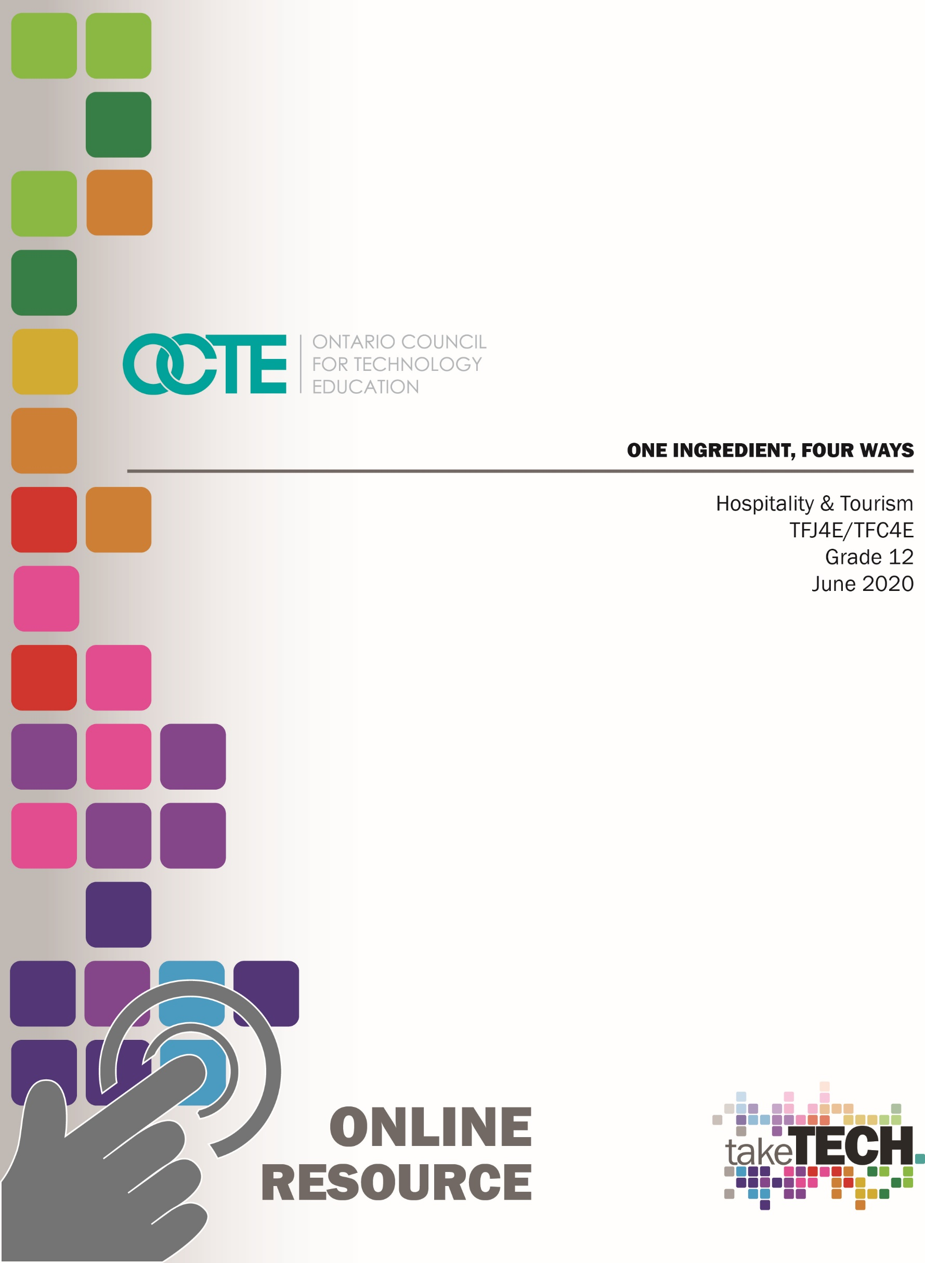

Table of Contents
Introduction 2
Project Outline 2
Prior Knowledge Helpful for Performing the Task 3
Planning Notes/Organization 3
Resources 3
Instructional Strategies 4
The Hook/Motivational Strategies 4
Learning Goals and Success Criteria 4
Overall and Specific Expectations 4
Overall Expectations 4
Specific Expectations 5
Safety Concerns and Expectations 5
Personal Protective Equipment 5
Applicable SAFEDocs 5
Identify Challenges with the Project 6
Differentiation of the Project 6
Assessment and Evaluation Practices 6
Religious Considerations 6
Industry Extensions/Career Exploration 6
Student Activities - Introduction 1 Ingredient, 4 Ways Project 7
Part 1 Exploration of Ingredients Chart 8
Part 2 Brainstorming Graphic Organizer (Top 4 Ingredients) 9
Part 3 Brainstorming and Research Chart 10
Part 4 Recipe Charts in Kitchen Format 11
Part 5 Menu Item Descriptions 12
Part 6 Finished Restaurant Menu 13
Part 7 Kitchen Action Plan 14
Part 8 Final Practical Evaluation 15
Appendix A - Blank Recipe Form 16
Appendix B - Recipe Writing Kitchen Format PowerPoint 17
Appendix C - Exit Card 18
References 19

Introduction
Course Code: TFJ4E / TFC4E
Broad base Technology: Hospitality and Tourism
Destination: Workplace
Grade Level: 12
Prerequisite: TFJ3E / TFC3E
Online Project Name: One Ingredient, Four Ways

Project Outline
By the end of this project the student will plan and prepare menus, demonstrate a level of competence in food handling, preparation, and presentation that meets professional standards (B2). Students will demonstrate an understanding of appropriate procedures to follow in the planning and delivery of an event or activity (B3). Students will demonstrate technical proficiency in the use and maintenance of tools and equipment related to the food and beverage services sector of the tourism industry (B1). Students will demonstrate learning skills that include responsibility, organization, independent work, initiative and self-regulation.
This Project Outline includes the following components,
Project Introduction
Part 1 Exploration of Ingredient Chart
Part 2 Brainstorming Graphic Organizer
Part 3 Brainstorming and Research Chart
Part 4 Recipe Chart in Kitchen Format
Part 5 Menu Item Descriptions
Part 6 Finished Restaurant Menu
Part 7 Kitchen Action Plan
Part 8 Final Practical Evaluation
Part 9 Exit Card

Prior Knowledge Helpful for Performing the Task
Prior to this lesson, students will have:
- Knowledge of how to handle and store foods in compliance with the Health Protection and Promotion Act (HPPA) (A3)
- Demonstrated the use of safe food handling and proper sanitation practices (e.g., prevent cross-contamination of foods, keep their person and uniform clean, wear hair nets, observe good housekeeping practices (A3.1)
- Applied provincial standards for safe food handling when preparing food (e.g., wear gloves, use different-coloured cutting boards for different foods) (A3.2)
- Demonstrated professional food storage practices (e.g., label containers; apply the “first in , first out” method when selecting food products for use (A3.3)
- Identified the causes of food-borne illness and methods for prevention (e.g., store, handle and cook food appropriately (A3.5)

Planning Notes/Organization
No prior planning required. All student activities have been divided into nine different parts to help organize student projects and to provide multiple sources to provide evidence of student learning. Each activity builds on the project to help overall student success.

Resources
Please see Appendix 1 Project Introduction
Please see Appendix 2 Part 1 Exploration of Ingredient Chart
Please see Appendix 3 Part 2 Brainstorming Graphic Organizer
Please see Appendix 4 Part 3 Brainstorming and Research Chart
Please see Appendix 5 Part 4 Recipe Chart in Kitchen Format
Please see Appendix 6 Part 5 Menu Item Descriptions
Please see Appendix 7 Part 6 Finished Restaurant Menu
Please see Appendix 8 Part 7 Kitchen Action Plan
Please see Appendix 9 Part 8 Final Practical Evaluation
Please see Appendix 10 Blank Recipe Form
Please see Appendix 11 PowerPoint for Recipe Writing Kitchen Format
Please see Appendix 12 Part 9 Exit Card

Instructional Strategies
Instructional strategies include project-based, problem-based approach, student profiles, exit card, and graphic organizers.

The Hook/Motivational Strategies
It is time to show your creativity by becoming an expert with one ingredient and transforming that ingredient into an exciting menu featuring your ingredient four ways. You will need to research four delicious recipes that will be original, exciting and versatile. We live in budget conscious times so remember to take into consideration the importance of cooking, preparing and using your ingredient to its full potential. You will have the responsibility of transforming a menu with one ingredient to create a variety of interesting ways to present your “star” ingredient. There are many things to consider… will you make a cold appetizer, a hot appetizer, a soup, a side dish, a main entrée, or even a dessert? It will be important to consider your options carefully while giving great consideration to the organization of your menu. Executive chefs I cannot wait to see your menus!

Learning Goals and Success Criteria
By the end of this project the student will plan and prepare menus, demonstrate a level of competence in food handling, preparation, and presentation that meets professional standards (B2). Students will demonstrate an understanding of appropriate procedures to follow in the planning and delivery of an event or activity (B3). Students will demonstrate technical proficiency in the use and maintenance of tools and equipment related to the food and beverage services sector of the tourism industry (B1).

Overall and Specific Expectations in Support of Ontario Grades 11-12 Technological Education

Overall Expectations
B1 Demonstrate technical proficiency in the use and maintenance of tools and equipment related to the food and beverage services sector of the tourism industry;
B2 Plan and prepare menus, demonstrating a level of competence in food handling, preparation, and presentation that meets professional standards;
B3 Demonstrate an understanding of appropriate procedures to follow in the planning and delivery of an event or activity.

Specific Expectations
B1.1 Demonstrate proficiency when using a variety of tools and equipment related to the food and beverage services sector (e.g., electric mixers, ovens, knives);
B1.2 Use a variety of measuring tools to accurately determine, in metric, US customary, or British imperial units as appropriate, the weight and/or volume of ingredients for meal preparation and, in degrees Celsius or Fahrenheit, the cooking temperature required;
B1.3 Maintain tools and equipment related to the food and beverage services sector in a professional manner (e.g., keep knives sharp, keep workstations clean and organized, store tools properly).
B2.1 Apply Health Protection and Promotion Act (HPPA) standards in handling, storing, and preparing food products (e.g., cook and/or store food at the proper temperature; apply the “first in, first out” [FIFO] method in selecting ingredients);
B2.4 Prepare a variety of food products (e.g., appetizer, main course, dessert) according to recipe specification;
B2.6 Prepare complex recipes accurately using readily available ingredients
B3.1 Create an action plan for an event or activity
B3.3 Coordinate and stage an event or activity individually or as part of a team;
B3.4 Use teamwork and organizational skills to complete a variety of tasks in the coordination and/or staging of an event or activity;
B3.5 Analyse the success of an event or activity in relation to its action plan

Safety Concerns and Expectations
The only safety concerns for Part # 1-7 would be computer internet safety. The safety concerns for Part # 8 would be dependent on the availability of a commercial school kitchen which would require standard kitchen safety practices.

Personal Protective Equipment
Part # 8 would require standard kitchen safety practices (hairnet, chef’s coat and apron, proper footwear).

Applicable SAFEDocs
Please see the OCTE SAFEDocs for Hospitality for safety documents in order to properly address and instruct for the completion of Part # 8.

Identify Challenges with the Project
Part 1-7 are available for online learning. All student activities have been divided into nine different parts to help organize student projects. Each activity builds on the project to help overall student success. Part 8 can be added when and where in-school learning in a commercial tech kitchen is available.

Differentiation of the Project
Differentiation can be achieved by providing choice with project, graphic organizer, learning preference, VAK inventory, and exit card strategies.

Assessment and Evaluation Practices
Evidence of student achievement for evaluation is collected through this project from different sources using multiple sources to evaluate student learning. Student products will be in the form of assignments for evaluation. Assignments for evaluation include rich performance tasks, demonstration, research, project based on real world setting. Assessment will include the categories of knowledge/understanding, thinking, communication and application.

Religious Considerations
With the One Ingredient, Four Ways project it is structured to consider any religious and/or cultural considerations. Student’s preferences or student’s interests in structuring the project to coincide with a menu that represents a particular religion and/or culture will support and enhance the overall finished project.

Industry Extensions/Career Exploration
This project does not include any industry extensions/career exploration; however, the project could lead to further reach ahead activities to support a SHSM hospitality program.

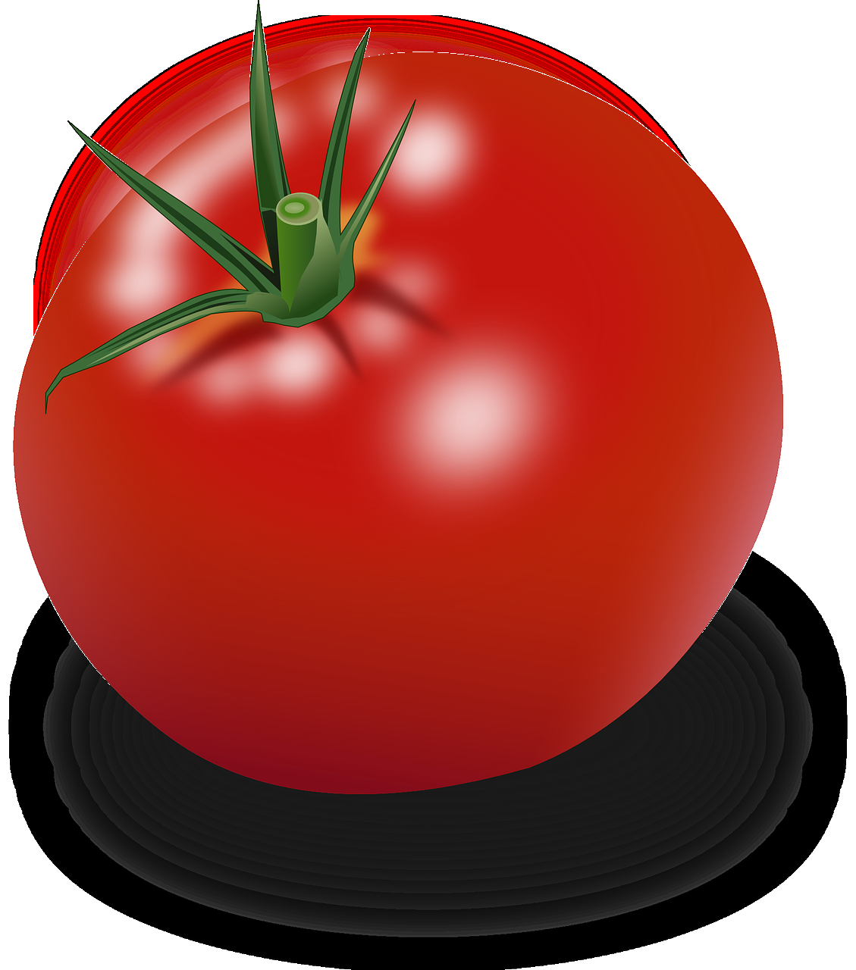
Introduction 1 Ingredient, 4 Ways Project
It is time to show your creativity by becoming an expert with one ingredient and transforming that ingredient into an exciting menu featuring your ingredient four ways. You will need to research four delicious recipes that will be original, exciting and versatile. We live in budget conscious times so remember to take into consideration the importance of cooking, preparing and using your ingredient to its full potential. You will have the responsibility of transforming a menu with one ingredient to create a variety of interesting ways to present your “star” ingredient. There are many things to consider… will you make a cold appetizer, a hot appetizer, a soup, a side dish, a main entrée, or even a dessert? It will be important to consider your options carefully while giving great consideration to the organization of your menu. Executive chefs I cannot wait to see your menus!
As the executive chef and for the completion of your project you will be responsible for the following:
Part 1 Exploration of Ingredients Chart (C) /30
Part 2 Brainstorming Graphic Organizer (Top 4 Ingredients) (T) /45
Part 3 Brainstorming and Research Chart (1 Ingredient, 4 Ways) (T) /50
Part 4 Recipe Charts in Kitchen Format (4 Recipes for Ingredient) (K) /40
Part 5 Menu Item Description (T) /20
Part 6 Finished Restaurant Menu (A) /50
Part 7 Kitchen Action Plan (A) /30
*Parts 1 – 7 Total /265

Part 8 Practical Evaluation (A) /100
*Parts – 8 Total /100
Part 1 Exploration of Ingredients Chart /30
Name: _____________________
Complete the following chart to start exploring potential ingredients for your project. The options are endless so make sure to put some thought into the potential of all of these ingredients.
Ingredient Options | I would like to use this ingredient because…. | I would not like to use this ingredient because.... | Rank in order of preference
Rice

Tomato

Potato

Butternut Squash

Sweet Potato

Mushrooms

Broccoli

Quinoa

Black Beans

Kidney Beans

I wish this ingredient was on the list __________________________________

Part 2 Brainstorming Graphic Organizer (Top 4 Ingredients) /45
Name: _____________________
Complete the graphic organizer to narrow down your potential ingredient for your project. The recipes will help to start the formation of your menu moving forward.
My top four ingredients that I would like to brainstorm are
1)_______________________________  3)_______________________________ | 2) _______________________________  4) _______________________________
For each ingredient come up with 10 different recipe options for moving forward.
  Ingredient
  _________
  Ingredient
  _________
  Ingredient
  _________
  Ingredient
  _________

Part 3 Brainstorming and Research Chart /50

Name: _____________________
Complete the brainstorming and research chart to narrow down your menu selections for your project. These are the recipes that you will narrow down from your one ingredient.
Ingredient Chosen for Project __________________________

Recipe Name | Recipe found at  (Website link, recipe book, magazine, etc.) | Pros (2 each)  (Two reasons why this recipe would be a great choice) | Cons (2 each)  (Two reasons why this recipe might not be a good choice) | “Wow factor” possibilities  (Reasons why this recipe will excite potential customers)
Put an asterisk * beside the four items you will be using on your menu.

Part 4 Recipe Charts in Kitchen Format /40
Name: _____________________
Use the blank recipe form provided with resources and type out your four recipes in kitchen format. Remember you are the executive chef so your recipes must be clear and easily understood so that your kitchen brigade can complete your recipes. Each recipe will be marked out of ten (4 recipes x 10 marks = 40 marks) based on the seven parts of a recipe format. Please make sure to complete all seven areas of your recipes for complete marks. Refer to the PowerPoint in resources if you need to review the seven areas for your final recipes.
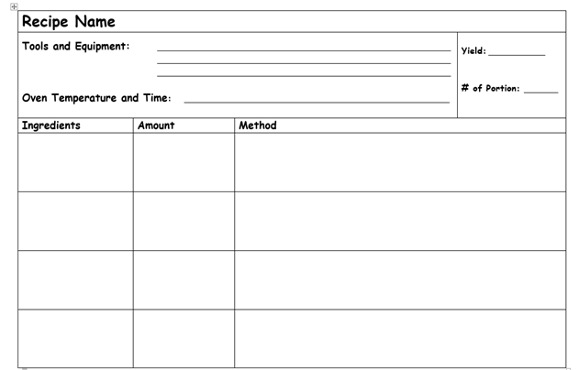

Part 5 Menu Item Descriptions /20
Name: _____________________
Use the space below to create your menu descriptions. Remember these descriptions will be used to sell your menu items on your menu. Make sure to use great detail and descriptive words to entice and sell your menu to your customers. They should be professional and free of spelling and grammatical errors.
Menu Item # 1 Description /5
________________________________________________________________________________________________________________________________________________________________________________________________________________________________________________________________________________________________________________
Menu Item # 2 Description /5
________________________________________________________________________________________________________________________________________________________________________________________________________________________________________________________________________________________________________________
Menu Item # 3 Description /5
________________________________________________________________________________________________________________________________________________________________________________________________________________________________________________________________________________________________________________
Menu Item #4 Description /5
________________________________________________________________________________________________________________________________________________________________________________________________________________________________________________________________________________________________________________

Part 6 Finished Restaurant Menu /50
Name: _____________________
Create a menu on an 8 ½ by 11” piece of paper by hand or using the computer that reflects your 1 Ingredient, 4 Ways Menu. The menu will use your descriptions from Part 5. The menu should be professional and free of spelling and grammatical errors. Please print the menu in colour and make sure to add pictures to add visual interest. Executive chefs I cannot wait to see your menus!
Criteria | Level 0 0-49% | Level 1 50-59% | Level 2 60-69% | Level 3 70-79% | Level 4 80-100%
Content  Knowledge  /10 | Menu not developed for the 1 Ingredient, 4 Ways project; and has not met the requirements for this assignment. | Student has a very limited grasp of 1 Ingredient, 4 Ways Menu; and has started to develop a very limited menu. | Student has a limited grasp of 1 Ingredient, 4 Ways Menu; and has started to develop a menu. | Student has a considerable grasp of 1 Ingredient, 4 Ways Menu; and has developed a great menu. | Student has an excellent grasp of 1 Ingredient, 4 Ways Menu; and has developed an excellent menu.
Requirements and “Must Haves”  /10 | Menu is incomplete, missing detailed information and many components (ex: missing 3 or more menu items) and significant consideration is needed to enhance the overall menu. | Menu is incomplete or missing components and missing detailed information. Menu is incomplete or missing components (ex: missing 2 or more menu items) and further consideration is needed to enhance the overall menu. | Menu has most of the necessary components but some requirements are missing. Menu is incomplete or missing components (ex: missing 1 or more menu items) and some further consideration is needed to enhance the overall menu. | All requirements are met and thoughtfully laid out. All 4 menu items are included but further consideration needed to enhance the overall menu. | All requirements are met and thoughtfully laid out. All menu requirements are complete. All 4 menu items are included and completed with additional consideration added to enhance the overall menu.
Creativity  /10 | Colour, pictures and visual interest have not been added to the menu. Significant consideration needed to enhance the overall menu. | Little to no creative thought put into menu design. Very plain and no effort to be creative is present. Menu does not include colour, pictures and has limited visual interest. | Moderately creative. Menu has some thought put into the layout of menu design. Menu has some visually interesting components including elements that relate to the menu. | Menu has elements of creativity that enhances the information on the overall menu. Menu has many visually interesting components that relate well to the menu. | Excellent attention to creative detail. Menu is above and beyond average presentation. Menu has many excellent visually interesting components that relate well to the menu.
Communication of Theme  /10 | Information and theme not communicated well and with no relation to the theme. Star ingredient not evident throughout the menu. | Communicates information and ideas with limited clarity in relation to the theme. Star ingredient evident but in a limited amount on the menu. | Communicates information and ideas with some clarity in relation to the theme. Star ingredient somewhat evident throughout the menu. | Communicates information and ideas with considerable clarity in relation to the theme. Star ingredient evident throughout the menu. | Communicates information and ideas with a high degree of clarity in relation to the theme. Star ingredient strongly evident throughout the menu.
Use of Preparation and Research Time  /10 | Did not use preparation time to research and complete the menu. | Uses preparation and research time with limited focus to complete the menu. | Uses preparation and research time with some focus to complete the menu. | Uses preparation and research time with considerable focus to complete the menu. | Uses preparation and research time with a high degree of focus to complete the menu.

Part 7 Kitchen Action Plan /30
Name: ___________________
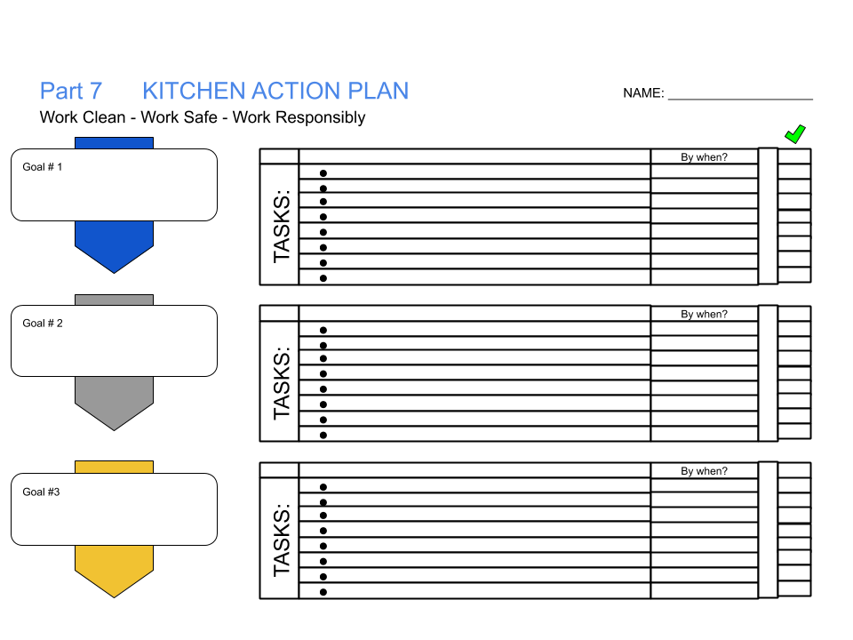

Part 8 Final Practical Evaluation /100
Materials Required to Complete this Practical Evaluation:
Hairnet, chef’s coat and apron, proper footwear, printed recipe

As the executive chef and for the completion of your final evaluation you will be responsible for preparing one of your recipes from your 1 Ingredient, 4 Ways Menu.
The following factors should be considered prior to your final evaluation:
- Independently prepare 1 of your recipes from your 1 Ingredient, 4 Ways Menu
- Selected menu item to demonstrate skills developed over the semester focusing on sanitation, food safety, knife skills, cooking methods, garnishing and plating
- Recipe to be completed and plated in a 90 minute time period
- Four identical portions served to your customers
- Garnish used to enhance your overall menu item
- Visually attractive restaurant quality plate
Kitchen Lab Rubric
Criteria | Level 0 0-49% | Level 1 50-59% | Level 2 60-69% | Level 3 70-79% | Level 4 80-100%
Sanitation  Appearance/ Uniform  /10 | Should not participate due to improper attire and/or shoes for kitchen, poor hygiene-dirty fingernails etc. | Dressed improperly; needed to make major modification to hair, clothing, footwear, and/or hands before participating. | Dressed properly for lab, minor modifications to hair, clothing, footwear, and/or hands needed before beginning work. | Dressed properly, hair restrained, proper footwear, and hands washed – no adjustments needed before beginning work. | Exceptionally neat, clean and arrived ready to begin work.
Workstation  /10 | Poorly maintained work space during lab, needed repeated teacher intervention to correct cross-contamination and/or unsanitary conditions. | Work space not well-maintained during lab, needed coaching to remedy cross-contamination and/or unsanitary conditions. | Maintained moderately-clean work space; little threat of cross-contamination during kitchen lab. | Maintained clean work-space; avoided cross-contamination throughout kitchen lab | Maintained exceptionally clean and sanitary work space throughout lab; no cross-contamination or unsanitary conditions.
Work Habits  /10 | Frequent touching of face, hair, unclean surfaces, little concern for cleanliness, no visible handwashing. | Poor handwashing technique and/or frequency; no visible concern for cleanliness. | Adequate handwashing technique and/or frequency; adequate concern for general cleanliness. | Frequent proper handwashing; minimal touching of face, hair or unclean work surfaces; noticeable concern for cleanliness. | Extreme care with cleanliness and keeping hands clean; no touching of face, hair, or unclean surfaces.
Clean Up  /10 | Station, tools and equipment were not given any consideration following production. | Station, tools and equipment were given little sanitation consideration following production. | Station, tools and equipment were given some sanitation consideration following production. | Station, tools and equipment were given sanitation consideration following production. | Station, tools and equipment were given exceptional sanitation consideration following production.
Prep  Time Management  /10 | Large amount of wasted time and/or inactivity, activity not completed. | Did not complete in time allotted due to inefficient use of time. | Adequate organization completed activity relatively on time. | Completed activity and all clean-up tasks on time. | Exceptionally organized; completed activities ahead of time and moved on to new tasks.
Results  Tools and Equipment  /10 | Improper use of tools and equipment requiring repeated teacher intervention. | Improper use of tools and equipment requiring some teacher intervention. | Adequate use of tools and equipment requiring little teacher intervention. | Uses tools and equipment without teacher intervention. | Uses tools and equipment with extreme care.
Skill Level  (Knife skills, cooking methods) /20 | Does not meet minimum requirements at this time. | Needs practice and coaching to meet average skill level. | Properly demonstrated skill with some prompting. | Proficient at skill without supervision. | Exemplary demonstration of skill level beyond expectations.
Final Product  (plating, garnishing)  /20 | Final product does not meet minimum requirements | Product needs a variety of adjustments to further develop and increase overall final product. | Product needs moderate adjustments to further develop and increase overall final product. | Product needs minimal adjustments to further develop and increase overall final product. | No adjustments are required for the final product.

Appendix A - Blank Recipe Form
Recipe Name
Tools and Equipment:  Oven Temperature and Time: |  |  | Yield:  # of Portions:
Ingredients | Amount | Method

Appendix B - Recipe Writing Kitchen Format PowerPoint
Recipe Writing Kitchen Format PowerPoint
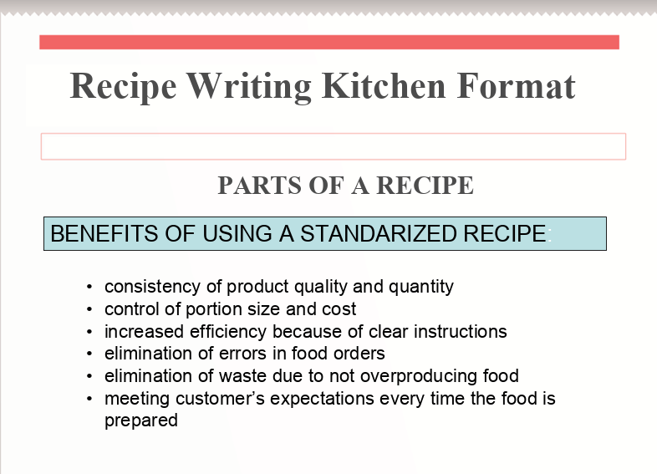
http://www.octe.ca/application/files/9415/9296/3677/Appendix_11_Recipe_Writing_Kitchen_Format.ppt

Appendix C - Exit Card
1 Ingredient, 4 Ways Project
Exit Card
Name: ________________________

Explain what you LIKED, and DISLIKED about this project. Why?

Are there any changes that you would’ve made to the kitchen action plan?
Why or why not?
________________________________________________________________________________________________________________________________________________________________________________________________________________________________________________
How did the success of your final project relate to the kitchen action plan that you created?
________________________________________________________________________________________________________________________________________________________________________________________________________________________________________________

References
21st Century Competencies: Foundation Document for Discussion. Phase 1: Towards Defining 21st Century Competencies for Ontario, Winter 2016 Edition, 2016 http://www.edugains.ca/resources21CL/About21stCentury/21CL_21stCenturyCompetencies.pdf
Course Codes for Emphasis courses in the Revised Curriculum: Technological Education, Grades 11 and 12, 2009 http://www.edu.gov.on.ca/eng/curriculum/secondary/techedemphasiscourses.pdf
Growing Success: Assessment, Evaluation, and Reporting in Ontario Schools, First Edition, Covering Grades 1 to 12, 2010
www.edu.gov.on.ca/eng/policyfunding/growSuccess.pdf
Learning for All – A Guide to Effective Assessment and Instruction for All Students, Kindergarten to Grade 12, 2013 http://www.edu.gov.on.ca/eng/general/elemsec/speced/LearningforAll2013.pdf
OCTE SAFEDocs for Hospitality, 2013 https://www.octe.ca/application/files/6215/3796/3180/SAFEdoc_HOST.pdf
Recipe Writing Kitchen Format PowerPoint, 2020 http://www.octe.ca/application/files/3715/9247/3871/Appendix_11_OCTE_Writing_Project_Recipe_Writing_Kitch
The Ontario Curriculum, Grades 9 and 10: Technological Education, 2009 (revised)
http://www.edu.gov.on.ca/eng/curriculum/secondary/teched910curr09.pdf
The Ontario Curriculum, Grades 11 and 12: Technological Education, 2009 (revised) http://www.edu.gov.on.ca/eng/curriculum/secondary/2009teched1112curr.pdf
Tomato clip art https://pixabay.com/static/uploads/photo/2013/07/12/18/19/tomato-153272_640.png

