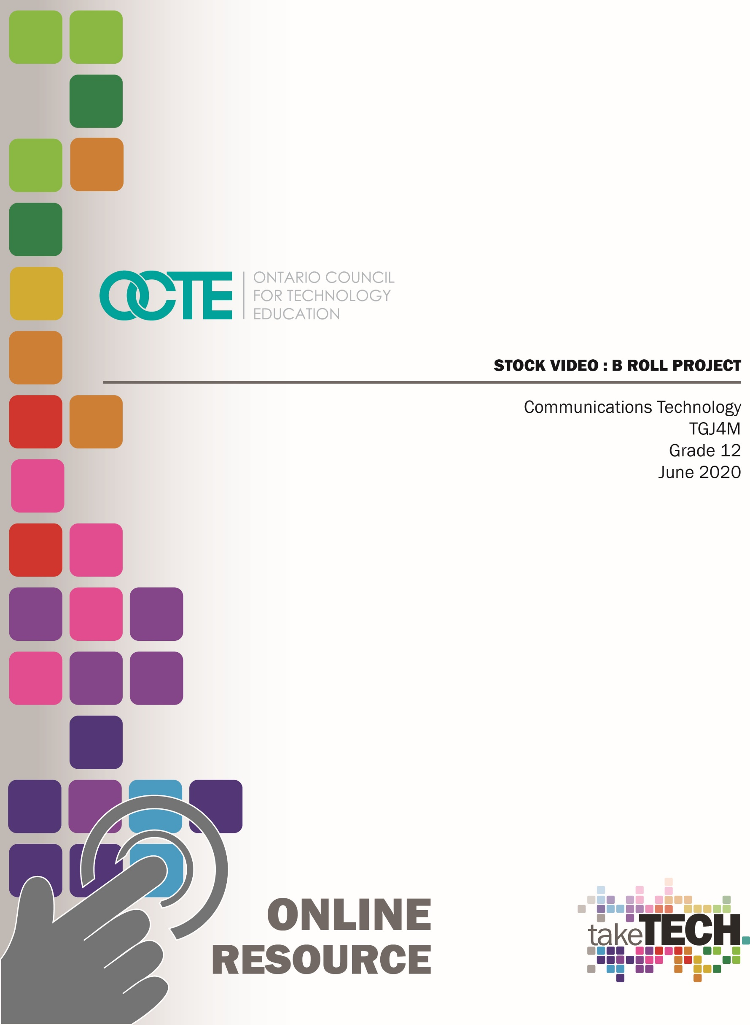

Table of Contents
Introduction 2
Project Outline 2
Prior Knowledge 2
Student Activities 3
Activities and Assignment Worksheet 3
Activity 1 – Understanding Canadian Copyright Laws 3
Activity 2 – Recognizing the importance of good B-Roll/Stock 3
Activity 3 – Settings for success 3
Activity 4 – Ingesting, Editing, and Exporting 3
Activity 5 – Create Stock Video Footage 3
Resources 4
PowerPoint Presentation Files 4
Worksheets and Links 4
Planning Notes 4
Tools/Equipment (optional) 5
Software 5
Journals/Magazines: 5
Videos 5
Websites for Teachers 5
Instructional Strategies 5
Motivational Strategies 6
Learning Goals and Success Criteria 6
Overall and Specific Expectations 6
Overall Expectations: 6
Safety Concerns and Expectations 6
Applicable SAFEDocs and ToolSAFE videos 7
Differentiation of the Project / Activity 7
Assessment and Evaluation Practices, Rubrics, Test and Quiz Resources 7
Career and Industry Extensions 7
Reflection or Design Report 7
Shooting Stock Video Project 8
Activity 1 – Understanding Canadian Copyright Laws 8
Activity 2 – The Importance of Good B-Roll 9
Activity 3 – Setting The Stage for Success 9
Activity 4 – Ingesting, Editing and Exporting 10
Assignment 1 – Create Stock Video/B-Roll 10
Appendix A – Activities and Assignment Worksheet 11
Overview: 11
Overall Expectations: 11
Activities: 11
Questions: 11
Appendix B – Activity 1: Understanding Canadian Copyright Laws 12
Question 1.1 12
Question 1.2 12
Question 1.3 12
Appendix C – Activity 2: The Importance of Good B-Roll/Stock 13
Question 2.1 13
Question 2.2 13
Question 2.3 14
Question 2.4 14
Question 2.5 14
Appendix D – Activity 3: Setting the Stage for Success 15
Question 3.1 15
Question 3.2 15
Question 3.3 16
Question 3.4 16
Appendix E – Activity 4: Ingesting Editing and Exporting 17
Appendix F – Assignment 1 – Create Stock Video/B-Roll 18
Overview 18
Considerations: 18
Evidence Of Learning & Skill Development 18
Rubric Description 19
Assignment 1 – Create Stock Video/B-Roll Rubric 20
Appendix G – TGJ4M Video Production: Watch & Learn Links and Read & Learn Links 21
Activity 1 – Understanding Canadian Copyright Laws 21
Activity 2 – The Importance of Good B-Roll 23
Activity 3 – Setting the Stage for Success 23
Activity 4 – Videos 24
Activity 4 – Ingesting, Editing, and Exporting Links 25
References 26

Introduction
Course Code: TGJ4M
Broad base Technology: Communications Technology
Destination: College or University
Grade Level: 12
Prerequisite: TGJ3M
Online Project Name: Stock Video / B Roll Project

Project Outline
This assignment will provide the learner with an opportunity to understand the role of a stock videographer.
The learner will analyze concepts and terms associated with aspect ratio, resolution, color correction, and file type.
The learner will demonstrate their knowledge by creating stock video footage that could be uploaded to their collaborative classroom site or stock video site.

Prior Knowledge
Prior Knowledge Helpful for performing the Project:
The learner will have demonstrated prior knowledge of types of shots, composition, lighting, ingesting video, and basic editing techniques in the TGJ 3M course.
Teachers are encouraged to review copyright laws in Canada prior to starting this lesson and assignment. Examples of royalty-free and creative commons image sites that can be used in student work are:
- Pexels
- Pixabay
- Videezy
- Videvo
- Vidsplay
It may be helpful for students to understand how to download images from the internet or create screen captures:
- Windows: Snipping Tool or Snip and Sketch
- macOS: Command+Shift+3 or Command+Shift+4
- Android: Power + Volume Down
- iPhone OS: Side Button + Volume Up Button
Students would benefit from:
- an understanding of linear measurement,
- some experience accessing online resources, creating and downloading files, and submitting such files to a destination according to their teacher’s direction

Student Activities

Activities and Assignment Worksheet

Activity 1 – Understanding Canadian Copyright Laws
- Prior understanding of Copyright
- Works that should be protected by Copyright
- Communicating Copyright to your peers

Activity 2 – Recognizing the importance of good B-Roll/Stock
- Finding examples of stock in a short video
- Tools to create good stock video
- Accessing footage in the public domain
- Out of Ontario stock footage
- Types of shots (e.g., ES-establishing shot)

Activity 3 – Settings for success
- Image resolution
- Determining the frame rate
- Defining what are visual distractions
- Free/Creative Commons vs. Paid stock sites
- Exporting

Activity 4 – Ingesting, Editing, and Exporting
- Using only stock footage to create a short video

Activity 5 – Create Stock Video Footage
- Shoot your own stock/B-Roll footage

Resources

PowerPoint Presentation Files
- 1 Creating Stock Video – Understanding Canadian Copyright Laws
- 2 Creating Stock Video – The Importance of Good B-Roll/Stock
- 3 Creating Stock Video – Setting the Stage for Success
- 4 Creating Stock Video – Ingesting Editing and Exporting

Worksheets and Links
- Appendix A – Activities and Assignment Worksheet
- Appendix B – Activity 1: Understanding Canadian Copyright Laws
- Appendix C – Activity 2: The Importance of Good B-Roll/Stock
- Appendix D – Activity 3: Setting the Stage for Success
- Appendix E – Activity 4: Ingesting Editing and Exporting
- Appendix F – Assignment 1 – Create Stock Video/B-Roll
- Appendix G – TGJ4M Video Production: Watch & Learn Links and Read & Learn Links

Planning Notes
The combination of lessons, activities, and assignments will take learners 1.5 weeks of 60-minute periods to complete. Accommodation of extra time may be required for some learners.
Note: These lessons, activities, and assignment has been structured in a way that permits a “deep dive” into video/video editing in Grade 12 in case the school has a focus program or SHSM
- Create a digital space for each learner to submit and receive the material (e.g., Microsoft One Drive, Google Drive, Dropbox, etc.)
- Provide each learner with the TGJ4M Stock Video worksheet. The teacher may convert to a format most familiar to their learners (e.g., convert from .docx to Google Doc) Note: This is a living document, for the teacher to provide ongoing feedback, and opportunities for the learner to revise their work
- Post or provide the learners with the materials at timed intervals or all at once.
- Provide timely feedback to learners. The work has been scaffolded
- Review all links prior to the start of this project, in many cases; additional learning options were posted allowing for one link to be removed if needed
- Teachers may choose to limit the options available for video editing; please review carefully beforehand.
Note: In a disrupted learning environment, it may be best to allow learners will have the opportunity to choose the tool that best suits their needs.

Tools/Equipment (optional)
- Mobile Device
- DSLR
- Camcorder
- Laptop
- Desktop
- Chromebook
- Tablet

Software
- Hitfilm Express
- Filmic Pro
- DaVinci Resolve
- OpenShot Video Editor

Journals/Magazines:
- Adobe Create Digital Magazine

Videos
- Orange83
- Epic Tutorials for iOS & Android Filmmaking
- Cinecom.net
- Adobe for Education
- RocketJump Film School
- Richard Lackey
- iPhoneographers
- FiLMiCPro

Websites for Teachers
- Social Media Video Course Trailer | Adobe Social Media Video Course
- Adobe Education Exchange

Instructional Strategies
- The lessons, activities, and assignment have been scaffolded
- The lessons, activities, and assignment have been created using different forms of media and are multidevice supported
- The learner is encouraged to revise their work using a living (collaborative) document shared with the teacher

Motivational Strategies
We are all creators! The lessons, activities, and assignments have been created to allow learners of all abilities to build on their understanding of video and create a meaningful product.
In Grade 11, students become familiar with the basics of video and video editing; this builds upon their existing knowledge allowing the learner to discover opportunities to create and potentially generate a passive income from selling stock video.

Learning Goals and Success Criteria
- Identify how stock video is used to enhance or convey a message
- Recognize the impact that stock video has in the creation of a finished product
- Discover opportunities to create stock video
- Compare different types of programs and applications, choosing the best tool for their device
- Design an original work that can be used in their school, or on a stock video site

Overall and Specific Expectations in support of Ontario Curriculum Grades 11 -12 Technological Education

Overall Expectations:
A1. Demonstrate an understanding of advanced concepts, techniques, and skills required to produce a range of communications media products and services
A3. Demonstrate an understanding of technical terminology, scientific concepts, and mathematical concepts used in communications technology, and apply them to the creation of media products
B3. Create products or productions that demonstrate competence in the application of creative and technical skills and incorporate current and evolving standards, processes, formats, and technologies.
D2. Demonstrate an understanding of and adhere to legal requirements and ethical practices relating to the communications technology industry

Safety Concerns and Expectations
Grade 12 students are to follow school protocols when creating stock video footage.

Applicable SAFEDocs and ToolSAFE videos
OCTE Safe Activity Foundations in Education Document for Communications Technology.

Differentiation of the Project / Activity
Lessons include visual, written, and video-based instruction. Some YouTube videos support Closed Captioning
Students may choose to complete activities using the Google Read & Write Extension
- Support for Google Read&Write
- Quick Reference Guide
Teachers may also refer to the Differentiation Scrapbook to further take into account for learner ability, multiple intelligences, exceptional students, and ESL learners.

Assessment and Evaluation
- Open-ended questions
- Living document (learner teacher collaboration and feedback)
- Assignment Rubric (see page 20)

Career and Industry Extensions
Activities 2 – 4 The learner builds on their knowledge of skills necessary to be a stock video content creator, in Assignment 1, students are encouraged to submit their work to a stock site. Industry feedback will be provided for students who choose this option.

Reflection or Design Report
Upon the conclusion of these lessons, activities, and assignment, the teacher is encouraged to reflect with their learners about:
- What went well?
- What area’s need to be improved?
- At what stage were you most engaged?
- How could these lessons, activities, and assignments better next time?
- What advice would you give to someone before starting this work?
- Provide one example of something that you learned.

Shooting Stock Video Project
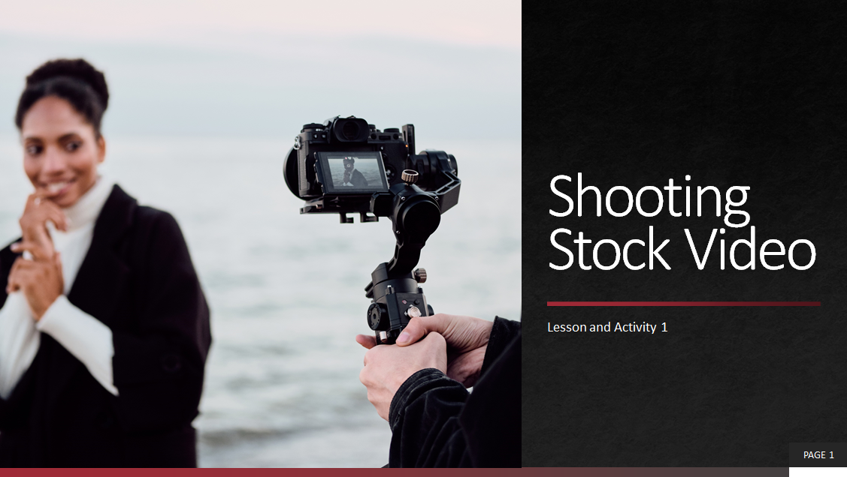

Activity 1 – Understanding Canadian Copyright Laws
Teacher presents visual content, videos and other examples to students, using the PowerPoint presentation and worksheets in the appendices:
1 Creating Stock Video – Understanding Canadian Copyright Laws
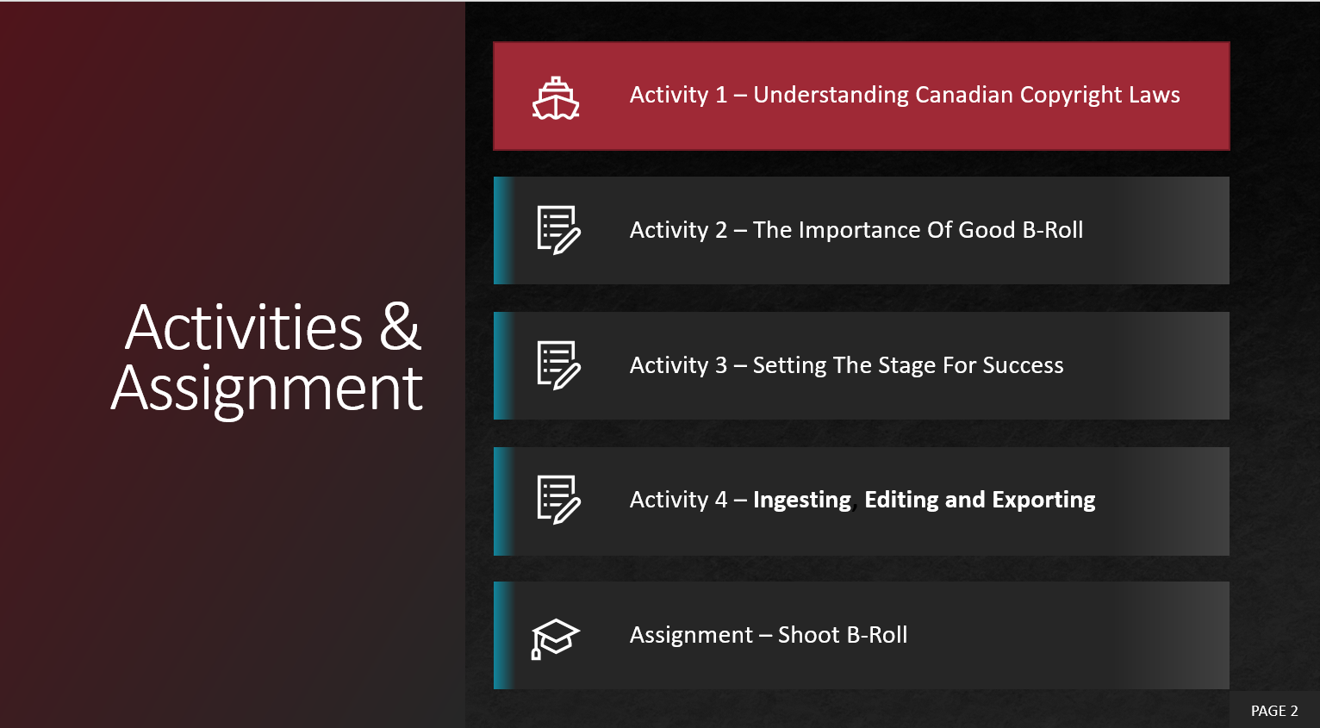
- Why Should I Care About Copyright Laws?
- Intellectual Property or Copyright, is there a difference?
- Your role in protecting Copyright
- What is Creative Commons?
Use Appendix B – Activity 1: Understanding Canadian Copyright Laws with the PowerPoint

Activity 2 – The Importance of Good B-Roll
Teacher presents visual content, videos and other examples to students, using the PowerPoint presentation and worksheets in the appendices:
2 Creating Stock Video – The Importance of Good B-Roll/Stock
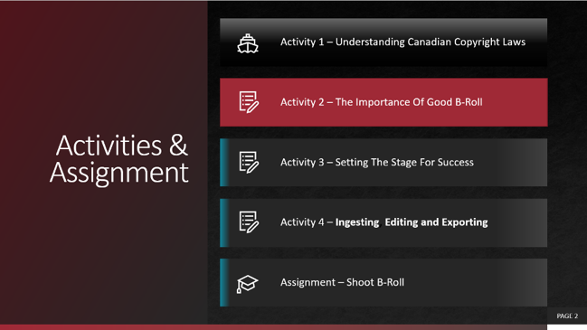
- What is stock footage?
- Importance of stock footage
Use Appendix C – Activity 2: The Importance of Good B-Roll/Stock with the PowerPoint

Activity 3 – Setting the Stage for Success
Teacher presents visual content, videos and other examples to students, using the PowerPoint presentation and worksheets in the appendices:
3 Creating Stock Video – Setting the Stage for Success
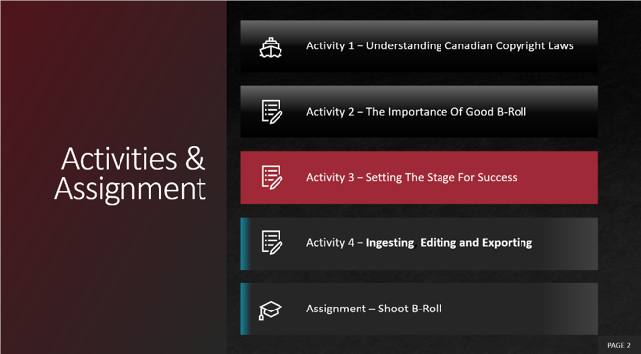
- Resolution, Aspect Ratio and Frame Rate
- Audio
Use Appendix D – Activity 3: Setting the Stage for Success with the PowerPoint

Activity 4 – Ingesting, Editing and Exporting
Teacher presents visual content, videos and other examples to students, using the PowerPoint presentation and worksheets in the appendices:
4 Creating Stock Video – Ingesting Editing and Exporting
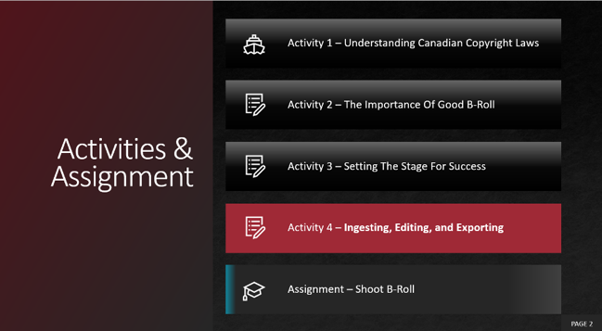
- Video Editing
- Exporting
Use Appendix E – Activity 4: Ingesting Editing and Exporting with the PowerPoint

Assignment 1 – Create Stock Video/B-Roll
Upon completion of the activities, students will plan and create their own stock footage. Details and rubric of this assignment are available in Appendix F – Assignment 1 – Create Stock Video/B-Roll

Appendix A – Activities and Assignment Worksheet

Overview:
This worksheet has been designed as a collaborative document to be shared with your teacher. As you work your way through these activities and assignments, your teacher will provide feedback that you may choose to use in revising your work. Pay careful attention to the rubric at the bottom of this sheet, and the teacher comments as you go along.
*Helpful tip, make a backup of your work

Overall Expectations:
A1 Demonstrate an understanding of advanced concepts, techniques, and skills required to produce a range of communications media products and services
A3 Demonstrate an understanding of technical terminology, scientific concepts, and mathematical concepts used in communications technology, and apply them to the creation of media products
B3 Create products or productions that demonstrate competence in the application of creative and technical skills and incorporate current and evolving standards, processes, formats, and technologies.
D2 Demonstrate an understanding of and adhere to legal requirements and ethical practices relating to the communications technology industry

Activities:
When starting each activity, complete all readings and watch all videos before beginning.

Questions:
Depending on your previous experiences, some of the material that is covered may be a review, and for others, it may be brand new. It is expected that you will have questions as you work your way through this; ask your teacher for more direction.

Appendix B – Activity 1: Understanding Canadian Copyright Laws

Question 1.1
Prior to starting this lesson, describe your understanding of what Copyright meant to you? Post one piece of work that you have completed in the past that you are proud of and would not want someone to use without your permission.
Answer Here

Post an Image or Work Here

Question 1.2
Name six different works that should be protected by Copyright
e.g., House Music - Martin Garrix - Animals

Question 1.3
Think about what you have learned since the start of this activity. As a senior student, others look up to you, and your peers' value your opinion. How would you communicate what you have learned about Copyright and or intellectual property to others? Choose one method of communicating this knowledge to other students; this could be through a flyer, podcast, or video once you have created something that is significant include it below.

Include your work here

Appendix C – Activity 2: The Importance of Good B-Roll/Stock

Question 2.1
Visit the website Vimeo and choose any short video that is of interest to you.
Name of video and link here
What shots you feel could have been substituted with or were created using stock video
Shot | Time
Sunrise, over the city | e.g., 1:21

Question 2.2
Using your previous knowledge of the tools needed to create a video, list the tools that you feel would be necessary to shoot the provided examples.
e.g., Dolly

Question 2.3
What are two sites that you can use to access footage that was released into the public domain?
Answer here

Question 2.4
Put yourself into the position of a person creating stock video; where are some places that you could shoot images, which typically would not be found in Ontario.
Answer here

Question 2.5
Although the video you just watch promoted specific companies' stock footage, it provided some valuable insight into the importance of good stock. Think back to grade 11 Comm Tech class, when you learned about types of shots, what are eight types of shots that you can obtain or shoot.
e.g., establishing shot

Appendix D – Activity 3: Setting the Stage for Success

Question 3.1
The resolutions presented, have specific formats that they refer to research and provide the information for the following
4096x2304 (example) | 4K 16:9 (example)
4096x2160
3840x2160
2048x1080
1920x1080
 | 8K
 | 8K 16:9

Question 3.2
The individual creating stock video must choose the appropriate frame rate, research some considerations that would go into this decision, and explain your choices for the following.
24 FPS Answer here
30 FPS Answer here
240 FPS Answer here

Question 3.3
What are some movies, TV shows, or videos that you have seen that have contained visual distractions?
Movie, TV, or Video | Visual distraction (provide context)

Question 3.4
There are hundreds of stock video sites out there that someone like you could be creating and contributing to. Research three stock video sites, two paid, and one creative commons and answer the following questions for each.
- What is the name of the site?
- What is the process for submitting content?
- What type of content do they accept?
- What are the aspect ratios they are looking for?
- If paid the stock site pays, how much per video can you earn?
- What are the legal requirements?

Appendix E – Activity 4: Ingesting Editing and Exporting
In TGJ3M you learned about scriptwriting and storyboarding, now you have the opportunity to use those skills to create a short video of your choice using nothing but stock video.
Task: Tell a short story using only stock video. Your account must have a definite beginning, middle, and end and can include sound effects and audio.
Criteria:
Time: 2 – 5 minutes
Types of Cuts: Jump Cut, Standard Cut, J-Cut, L-Cut, Cutaway, Match Cut or Montage
Format: 1080 or 720p h.264
Example: Awake by Lovelast - Music Video Created Entirely From Stock Video Footage
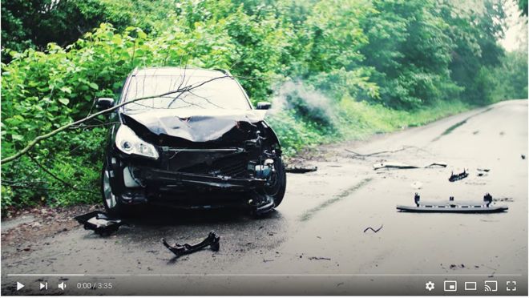
https://www.youtube.com/watch?v=HLrh5XXHj7U

Appendix F – Assignment 1 – Create Stock Video/B-Roll

Overview
Find Inspiration from the digital world, research, and learn from online tutorials that work well for you, demonstrate evidence of your knowledge/skill development resulting in original video work. Stock video is licensed for specific uses. In this assignment, you will assume the role of a stock videographer. The subject and equipment you choose are up to you. The format and length are predetermined for submission; however, you are encouraged to test out your skills by submitting your work to a stock site. Alternatively, you will want to contribute to your school’s stock site

Considerations:
- Project planning and time management is important
- Creative problem-solving to a specific target audience and technical issues encouraged
- Storyboarding with sketched diagrams and creators' notes is strongly recommended
- Location, Time of day, Lighting, Equipment (e.g., tripod), Props, Models (note: model release needed)

Evidence of Learning & Skill Development
Include any relevant links below
Vector or Graphic Design Project Components | Check | Link to evidence of completion
Inspiration(s) | ✔️ | Functional link(s)
Tutorial(s) | ✔️ | Functional link(s) to tutorials used for knowledge & Skill development.
Copy of Final Product exported .mp4, .mov, AVI | ✔️ | Functional link to the final product! THANK YOU!

Time to complete: 3 hours
Number of clips: 6 (or more)
Types of Shots: variety (e.g., wide)
Storyboard/Preplanning – submit a written concept of the kind of stock video you will produce using a Google or Word Document. Submit a simple shot that describes the type of stock video to be created.
Length of clips: 20 – 60 seconds
Format: MP4
Colour Space: Flat or Neutral
Sound: None
Time-lapse: permitted (optional)
Resolution: 720p
Submission Stock Videos: Upload to online drive, share link
Safety: No video may be shot if there is any chance of injury to yourself or others. No exceptions
Note: Revision based on feedback is encouraged

Rubric Description
Description of Rubric provided on next page for final product
- The final product is an accumulation of your planning, filming, and editing skills and decisions
- Demonstrating skills developed through your tutorial work and relating to your Inspiration
- Understanding of stock video market
- The final product illustrates a clear, reliable connection to the topic and has the clarity of purpose
- Composition and technical operation of camera should display a strong understanding of tools used
- Editing should be done with an understanding and intent of needs
- Lighting should be suitable for the scene being shot. The video should not be underexposed or overexposed

Assignment 1 – Create Stock Video/B-Roll Rubric
Expectation | Level 4 | Level 3 | Level 2 | Level 1 | R
Communication: define project objectives and performance criteria precisely.
Overall Expectation: A1
Written documentation about the type of stock that is about to be produced | Defines and explains project objectives, process & reflection with profound detail. | Defines and explains project objectives process & reflection with considerable detail. | Defines and explains project objectives, process & reflection with some detail. | Did not define or explain project objectives, process & reflection. | Did not submit prior to execution of stock video
Thinking: Use a variety of planning techniques and tools when creating plans for communications technology projects.
Overall Expectation: A3
Create storyboard for each stock shot | Uses a variety of planning techniques and tools when creating plans for communications technology projects with a high degree of logic. | Uses a variety of planning techniques and tools when creating plans for communications technology projects with considerable logic. | Uses a variety of planning techniques and tools when creating plans for communications technology projects with some logic. | Uses a variety of planning techniques and tools when creating plans for communications technology projects with limited logic. | Did not submit prior to stock video submission
Application: Produce rich media products that conform to evolving industry standards and formats. Apply software skills to integrate components for a media production.
Overall Expectation: B3
Completed stock videos, industry standards and formats. | Produces rich media products that conform to evolving industry standards and formats with a high degree of fluency. | Produces rich media products that conform to evolving industry standards and formats with considerable fluency | Produces rich media products that conform to evolving industry standards and formats with some fluency. | Produces rich media products that conform to evolving industry standards and formats with limited fluency. | Does not meet the minimum requirements, please redo, and resubmit
Completed stock videos | Applies software skills to integrate components for a media production with profound relevance. | Applies software skills to integrate components for a media production with considerable relevance. | Applies software skills to integrate components for a media production with some relevance. | Applies software skills to integrate components for a media production with limited relevance.

Appendix G – TGJ4M Video Production: Watch & Learn Links and Read & Learn Links

Activity 1 – Understanding Canadian Copyright Laws
Watch & Learn – IP Peter’s Path  Protect Peter’s Innovation  https://www.ic.gc.ca/eic/site/cipointernet-internetopic.nsf/vwapj/peter-comic-eng.pdf/$file/peter-comic-eng.pdf | 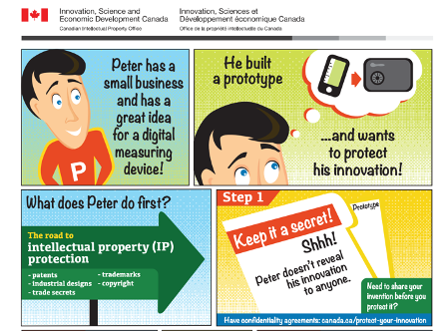
Watch & Learn – ISEDC  What is copyright? Canada  https://www.youtube.com/watch?v=ljNS5p3cqls | 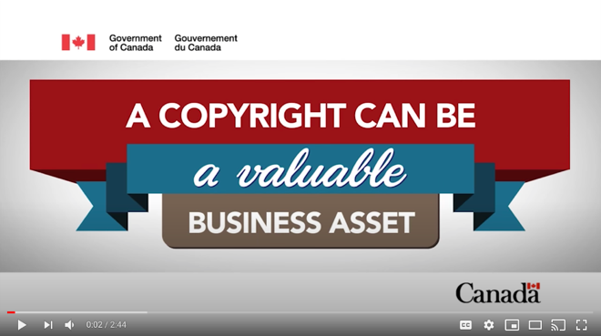
Watch & Learn – Copyright  Copyright and Creativity  https://vimeo.com/70184320 | 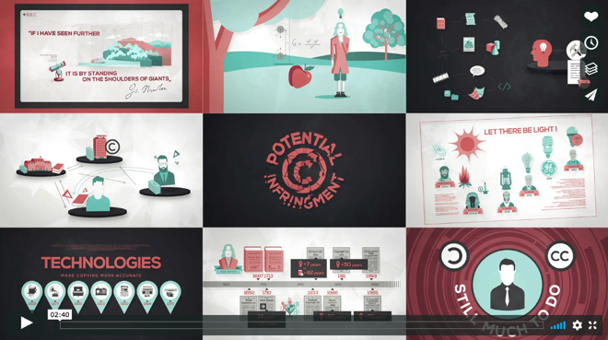
Watch & Learn – Wanna Work Together  Creative Commons  https://vimeo.com/13590841 | 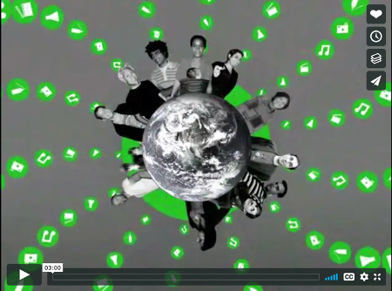
Read & Learn – Wanna Work Together  Copyright Act January 9, 2020  https://www.copibec.ca/en/nouvelle/274/what-is-the-public-domain- | 
Watch & Learn – YouTube Creators  Fair Use  https://www.youtube.com/watch?v=1PvjRIkwIl8&list=PLpjK416fmKwRnRbv72ksHRYEknNSaAFkd&index=2&t=181s | 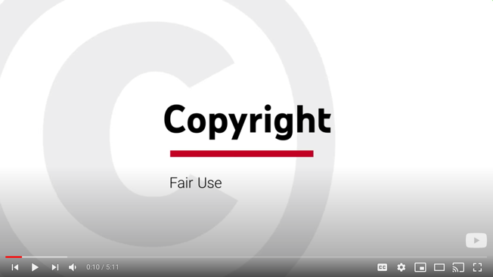
Watch & Learn – YouTube Creators  Music and Copyright  https://www.youtube.com/watch?v=qe17meaudTI&list=PLpjK416fmKwRnRbv72ksHRYEknNSaAFkd&index=3&t=0s | 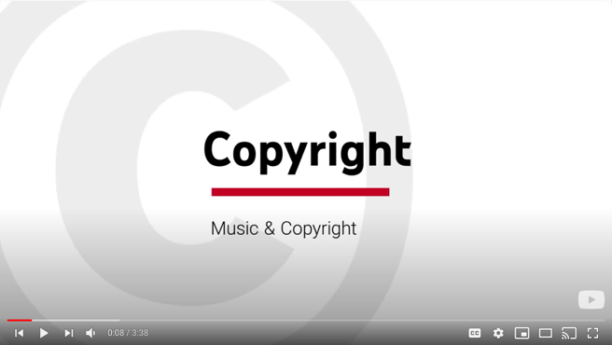
Watch & Learn – YouTube Creators  Copyright Permissions  https://www.youtube.com/watch?v=6pgMtJHg9gg&list=PLpjK416fmKwRnRbv72ksHRYEknNSaAFkd&index=4&t=0s | 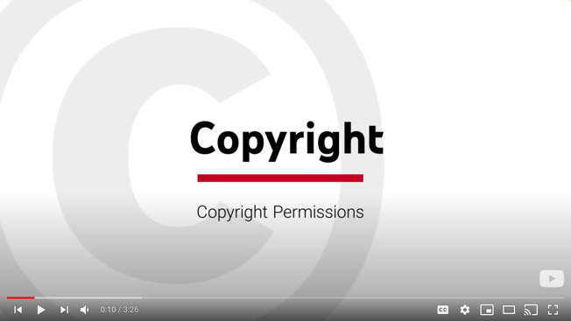
Watch & Learn – YouTube Creators  Copyright FAQ  https://www.youtube.com/watch?v=_rdUXBad_LU&list=PLpjK416fmKwRnRbv72ksHRYEknNSaAFkd&index=9&t=0s | 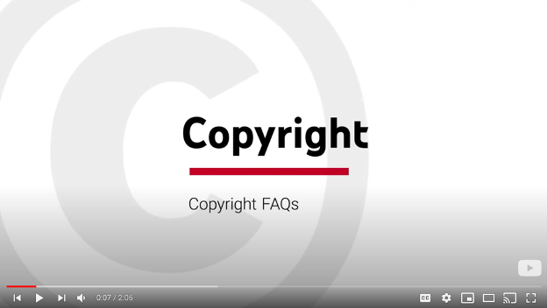

Activity 2 – The Importance of Good B-Roll
Watch & Learn – Adobe Creative Cloud  Why Consider Stock  https://www.youtube.com/watch?v=ghlNzMqSbtM | 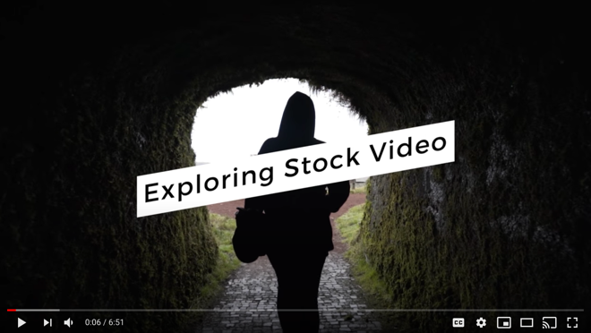

Activity 3 – Setting the Stage for Success
Watch & Learn – Adobe Creative Cloud  How to Shoot Stock Video  https://www.youtube.com/watch?v=DzS-yEn40eA&t=293s | 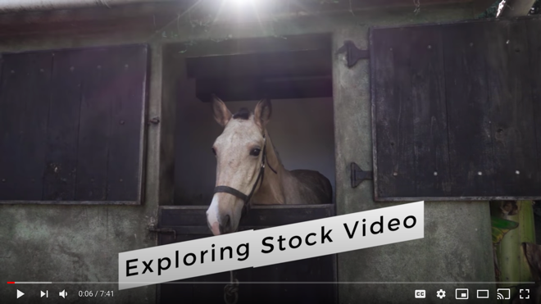
Watch & Learn – Adobe Creative Cloud  Make Passive Income with Stock  https://www.youtube.com/watch?v=wAJrCKWG14E | 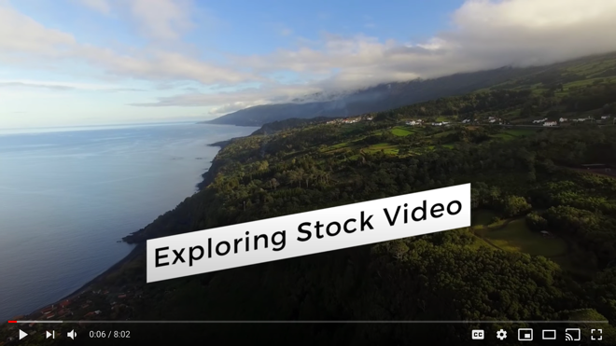

Activity 4 – Videos
Example of Video Created from Stock Footage  Awake by Lovelast  https://www.youtube.com/watch?v=HLrh5XXHj7U | 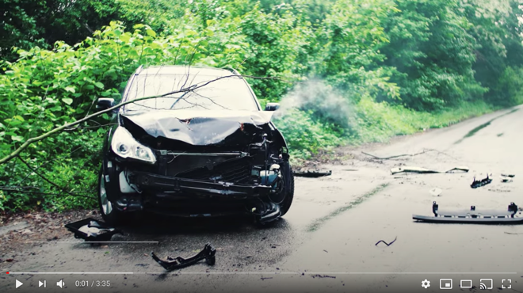
Watch & Learn – TechGumbo  Top 5 Best FREE STOCK VIDEO  https://www.youtube.com/watch?v=RFimmzu8nTw | 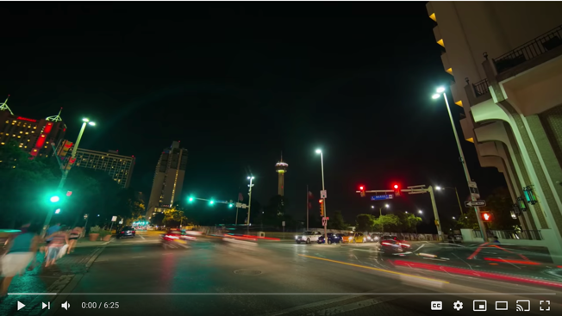

Activity 4 – Ingesting, Editing, and Exporting Links

Applications and Tutorials
Hitfilm Express
https://fxhome.com/express
Hitfilm Express Tutorials
https://fxhome.com/video-tutorials
DaVinci Resolve
https://www.blackmagicdesign.com/products/davinciresolve/
DaVinci Resolve Tutorials
https://www.blackmagicdesign.com/products/davinciresolve/training
OpenShot Video Editor
https://www.openshot.org
OpenShot Video Editor User Guide
https://www.openshot.org/user-guide
Adobe Spark
https://spark.adobe.com/
Creating and Editing Adobe Spark
https://adobespark.zendesk.com/hc/en-us/sections/204145698-Creating-and-Editing

Free Stock Sites
Pexels
https://www.pexels.com/videos/
Pixabay
https://pixabay.com/videos/
Videezy
https://www.videezy.com/
Videvo
https://www.videvo.net/
Vidsplay
https://www.vidsplay.com/

References
21st Century Competencies: Foundation Document for Discussion. Phase 1: Towards Defining 21st Century Competencies for Ontario, Winter 2016 Edition, 2016
http://www.edugains.ca/resources21CL/About21stCentury/21CL_21stCenturyCompetencies.pdf
Copybec Copyright Specialists, What is the Public Domain? https://www.copibec.ca/en/nouvelle/274/what-is-the-public-domain-
Copyright Information for Teachers, Council of Ministers of Education, Canada website.
https://www.cmec.ca/466/Copyright_Information_for_Teachers.html
Course Codes for Emphasis courses in the Revised Curriculum: Technological Education, Grades 11 and 12, 2009 http://www.edu.gov.on.ca/eng/curriculum/secondary/techedemphasiscourses.pdf
The Differentiated Instruction Scrapbook
http://www.edugains.ca/resourcesDI/EducatorsPackages/DIEducatorsPackage2010/2010DIScrapbook.pdf
Growing Success: Assessment, Evaluation, and Reporting in Ontario Schools, First Edition, Covering Grades 1 to 12, 2010 www.edu.gov.on.ca/eng/policyfunding/growSuccess.pdf
Innovation, Science and Economic Development Canada, Intellectual property and copyright.
https://www.ic.gc.ca/eic/site/cipointernet-internetopic.nsf/vwapj/peter-comic-eng.pdf/$file/peter-comic-eng.pdf
Learning for All – A Guide to Effective Assessment and Instruction for All Students, Kindergarten to Grade 12, 2013 http://www.edu.gov.on.ca/eng/general/elemsec/speced/LearningforAll2013.pdf
OCTE Safe Activity Foundations in Education Document for Communications Technology.
https://www.octe.ca/application/files/5515/3796/3096/SAFEdoc_COM.pdf
The Ontario Curriculum, Grades 9 and 10: Technological Education, 2009 (revised) http://www.edu.gov.on.ca/eng/curriculum/secondary/teched910curr09.pdf
The Ontario Curriculum, Grades 11 and 12: Technological Education, 2009 (revised) http://www.edu.gov.on.ca/eng/curriculum/secondary/2009teched1112curr.pdf

