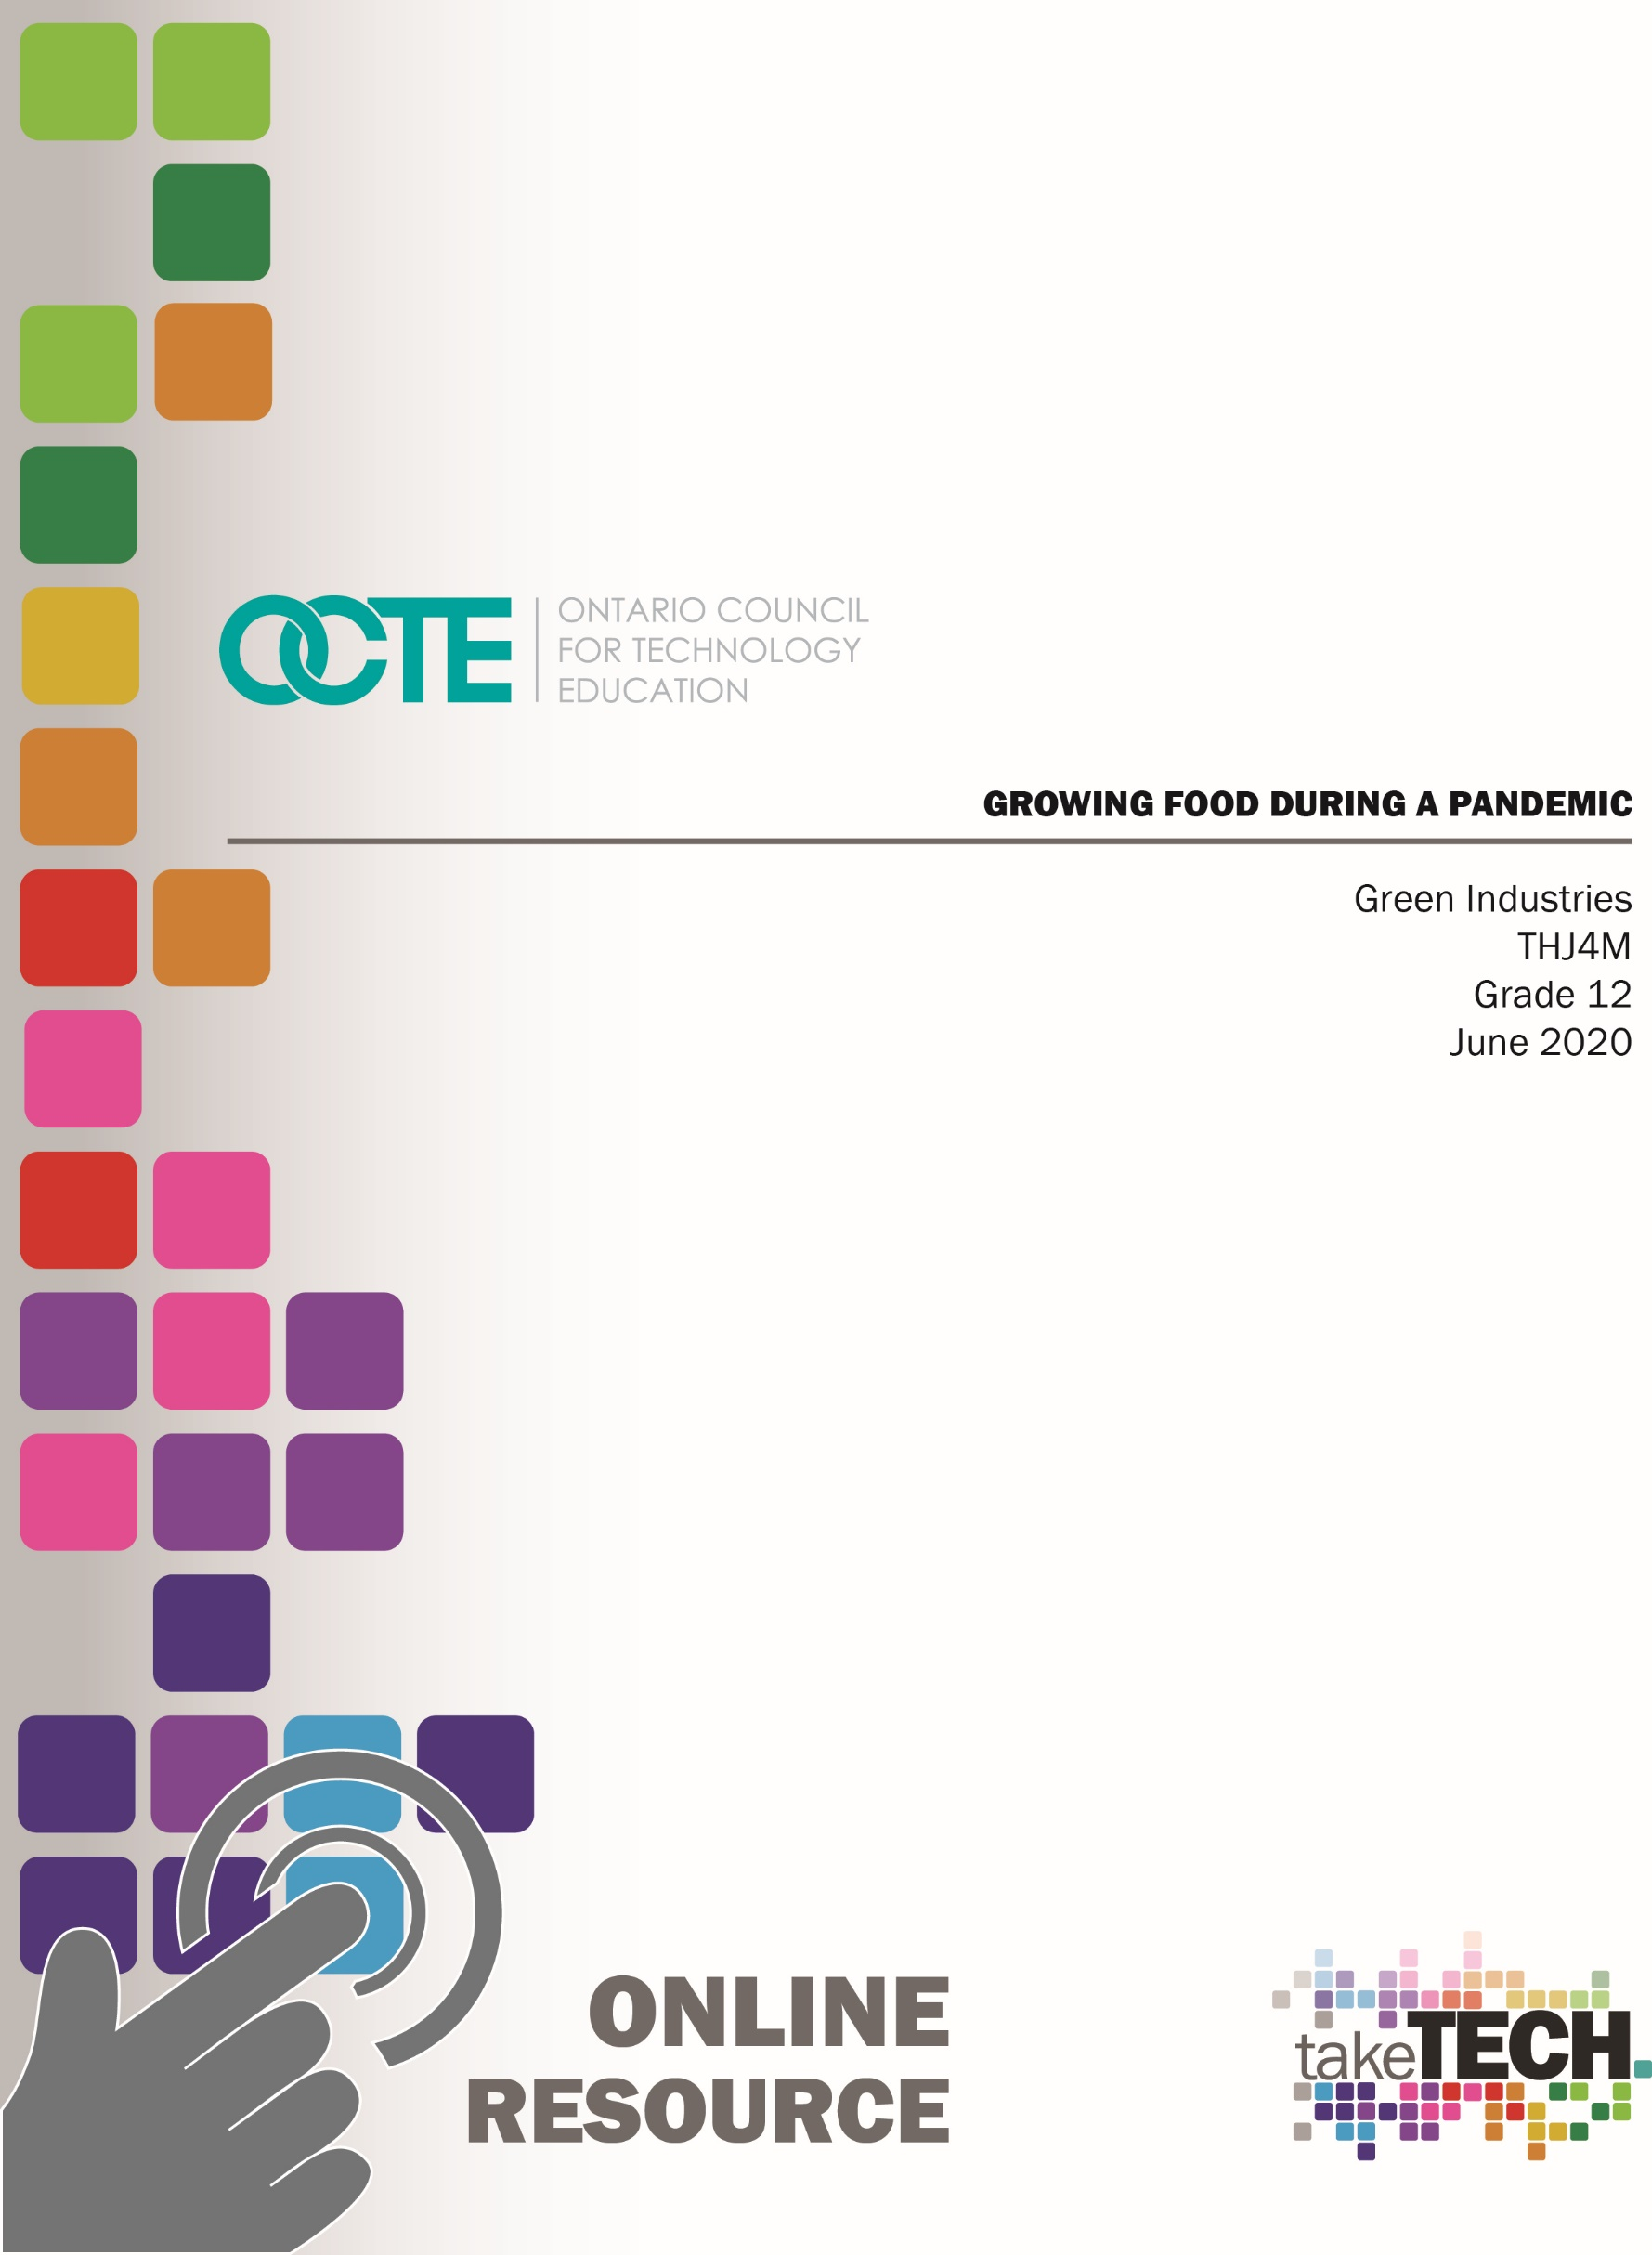

Table of Contents

Introduction 2
Project Outline 2
Prior Knowledge 2
Student Activities 3
Planning Notes 3
Resources 3
Tools/Equipment 4
Instructional Strategies 4
The Hook/Motivational Strategies 5
Learning Goals and Success Criteria Goals 5
Learning Goals 5
Success Criteria 5
Overall and Specific Expectations 6
Overall Expectations 6
Specific Expectations 6
Safety Concerns and Expectations 6
PPE Required: 6
Applicable SAFEDocs for Project 7
Differentiation of the Project/Activity 7
Assessment and Evaluation 7
Ethical/Environmental Considerations 8
Reflection 8
Introduction – PowerPoint Presentation 9
Appendix A - Create a Google Sites Webpage: 10
Appendix B - Questions and Research 11
Appendix C - Designing an Upcycled Garden Feature 12
Appendix D – Design Process 13
Appendix E - Answer Key: Growing Plants in a Pandemic 14
Appendix F – Assessment Rubric 17
Appendix G - Exit Card 19
References 20

Introduction
Course Code: THJ4M
Broad base Technology: Green Industries
Destination: University/College
Grade Level: 12
Prerequisite: THJ3M
Online Project Name: Growing Food During a Pandemic

Project Outline
In this project, students will describe how living during this COVID pandemic has changed their lives, the lives of others and the world. We will look at lessons to be learned and explore concepts like, upcycling, repurposing, reusing and growing our own food. We will explore how these concepts have become more relevant than ever. Students will be asked to upcycle (find a new purpose for something that was heading for the trash) material(s), and to build something useful for gardening or any other useful purpose in the garden.
The Project Outline will be as follows:
- Introduction - Slide Presentation
- Activity # 1 Create a Google Sites Webpage
- Activity # 2 Questions (Research on growing during a pandemic and Upcycling)
- Activity # 3 Designing an Upcycled Garden Feature
By the end of this project, the student will:
- Explain the concept of upcycling
- Problem solve using Steps in the Design Process
- Design a project using recycled materials or material(s) ready to go to a landfill
- Create an item using repurposed material

Prior Knowledge
The students require a basic understanding of growing plants.

Student Activities
Presentation (by Teacher) - Growing Food during a Pandemic
Activity 1 – Create a Google Sites Webpage
Activity 2 – Questions and Research
Activity 3 – Designing an Upcycled Garden Feature

Planning Notes
Teachers:
- Are to deliver the prepared slide presentation remotely synchronously (in “real time”) with their students.
- Should review resources in advance and expand on themes to enhance the presentation.
All student activities have been included in the slide presentation (Research Assignment, an Upcycle Garden Project and the Website Creation).
Each activity located in this resource is linked to the slide presentation, and can be assigned by teachers (with deadlines), as they see fit.

Resources
The resources for this project include the following,
- Create a Google Sites Web Page - please see Appendix A
- Questions & Research - please see Appendix B
- Designing an Upcycled Garden Feature - please see Appendix C
- Design Process – please see Appendix D
- Answer Key: Growing Plants in a Pandemic - please see Appendix E
- Assessment Rubric - please see Appendix F
- Exit Card - please see Appendix G

Articles and handouts for students:
- Garden Upcycling Ideas: Learn About Upcycling In The Garden
- 9 Creative DIY Upcycle Ideas For The Garden
- Recycle Nation - 17 Upcycled Garden Ideas
Pictures
- Unsplash
- Pixabay
- Pexels
Materials
- Rounded up individually by students depending on their design.
Video Links / Guides
- YouTube Google Sites Tutorial
- Upcycling YouTube video

Tools/Equipment
Some tools may be required depending on individual student designs. Students must create their upcycle project using the resources they have available to them.

Instructional Strategies
The following strategy techniques will be used:
- 3-Part Lesson
- Lecture
- Questions and Research
- Design/Build Project

The Hook/Motivational Strategies
Now that we have been living our lives during the COVID-19 pandemic we are all aware of the changes we are experiencing in our daily lives. During this time, it is essential that we are resourceful and use creative thinking to help us make the most of our resources, as few as they may be. Using an Upcycling approach to gardening, put on your thinking caps and design an item to use in a garden made entirely from stuff lying around and ready to be thrown away.

Learning Goals and Success Criteria Goals

Learning Goals
- Students will recognize issues that caused by COVID 19 relating to growing and the food supply chain;
- Students will explain some of the lessons learned from the pandemic;
- Students will explore the concepts of reusing, repurposing and upcycling material;
- Students will apply the steps in the design process to upcycle an item;
- Students will discover and use Google sites to create a website.

Success Criteria
- Students will describe the effects that COVID 19 has had on the world's food supply and related issues;
- Students will demonstrate the steps in the design process;
- Students will upcycle material(s) and repurpose it into a useful “green” item;
- Students will create a Google sites personal webpage.

Overall and Specific Expectations in Support of Ontario Curriculum Grades 11 -12 Technological Education

Overall Expectations
A3 Develop and evaluate designs or processes for a variety of applications in the green industries;
B3 Demonstrate competence in technical skills relating to specific applications and tasks within the green industries;
C1 Assess options for achieving environmental sustainability in green industry operations;
D1 Demonstrate an understanding of and apply safe working practices as they relate to the green industries.

Specific Expectations
A3.1 Explain the steps required to create designs or plans for a variety of applications in the green industries (e.g., timber cruising, surveying, perennial gardens, farms, environmental assessments);
B3.2 Build a variety of structures that are commonly used in the green industries (e.g., roads, skid trails, pens, pergolas, retaining walls, brick pavements);
C1.2 Analyze ways of reducing negative or enhancing positive environmental consequences through the use of particular materials, products, processes, and disposal methods (e.g., nutrient recycling, spot spraying for insects and fungus, using organic fertilizer, composting, xeriscaping);
D1.4 Demonstrate an understanding of and apply safe procedures for using and maintaining materials, tools, and equipment (e.g., avoid moving parts and pinch points; perform a circle check of vehicles and equipment; check condition of materials, hydraulic systems, and protective equipment; check oil and fuel levels).
Safety Concerns and Expectations
Safety concerns arise if a student requires wood or other materials to be cut. Cutting must be completed using handsaws only. Please refer to the SAFEDocs for Green Industries located on the OCTE website.

PPE Required:
- Safety Glasses
- Gloves
Applicable SAFEDocs for Project
Please refer to the SAFEDocs for Green Industries located on the OCTE website.

Differentiation of the Project/Activity
This project can be differentiated by:
- the use of more specialized software;
- the research assignments could be assisted by an EA;
- the Upcycle activity could be observations of the teacher’s Upcycling project;
- the teacher could ask verbal questions to a student while an EA scribes during a synchronous interaction.

Assessment and Evaluation
Evidence of student achievement for evaluation is collected through this project using multiple sources to assess and evaluate student learning. Student projects are in the form of assignments, design/build and website creation. Assignments for evaluation include rich performance tasks, demonstration, research, project based on real world setting. Assessment will include the categories of knowledge/understanding, thinking, communication and application linked directly to course expectations.

As/For/Of Learning (Growing Success)
For Learning
- Ask questions about student’s experience working with repurposing materials;
- Ask questions regarding experience working on other projects;
- Find out about students’ interests;
- Review recent report cards;
- Reflect on instructional next steps/modifications/accommodations.

As Learning
- Read and review Google sites daily;
- Make comments/suggestions as required;
- Provide timely/descriptive feedback;
- Keep students motivated and on track to be successful in the learning outcomes;
- Reflect on instructional next steps/modifications/accommodations.
Of Learning:
- Review Google site entries;
- Review and evaluate each project.

Ethical/Environmental Considerations
- Using recycled materials saves our natural resources and reduces the consumption and need for industries that specialize in refining and processing raw materials. By reducing the need for these processes and conserving our natural resources, it reduces air and water pollution.
- Recycling materials saves energy and reduces greenhouse gas emissions.
- Growing organically may reduce the use and exposure of pesticides, herbicides, and fertilizers.

Reflection
Teachers will ask the students to answer the following questions after the completion of all activities:
- Explain what you liked and disliked about this project. Why?
- Did you learn something new? What stands out?
- Based on the learning that has taken place, specifically on where and how food is produced, has your outlook and understanding changed?
- Please provide any feedback you may have for improving this lesson.

Introduction – PowerPoint Presentation
The introduction to this project is to be presented through the following PowerPoint presentation. Please utilize and refer to the picture and link below.
Growing Plants During a Pandemic
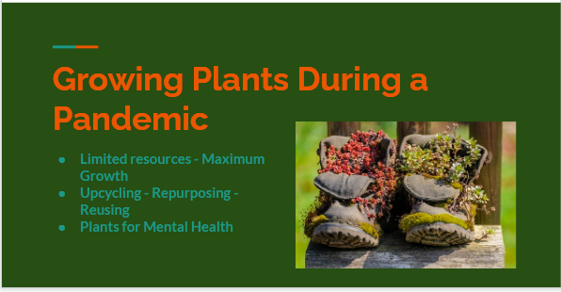

http://www.octe.ca/application/files/3115/9256/9461/Growing_Plants_During_a_Pandemic.pptx

Appendix A - Create a Google Sites Webpage:
- Google Sites Tutorial
- Use your name, class code and teachers name;
- Google Sites is how the presentation for your project will be share your teacher.
YouTube Google Sites Tutorial
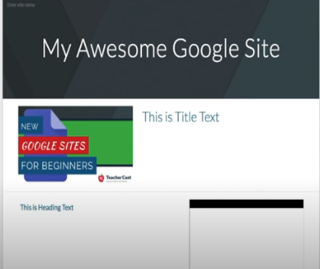
https://www.youtube.com/watch?v=w05NIgHNzWs

Appendix B - Questions and Research
- Answer these questions and add them to your Google sites webpage:
- What are some of the challenges we face while gardening during a pandemic?
- What are some lessons we could learn from this pandemic?
- What is sustainable gardening?
- Taking into account the concept of gardening at home, answer the question, where does most of our food come from?
- What is Upcycle gardening?

Appendix C - Designing an Upcycled Garden Feature
Upcycling: The Design Process
Several examples of “Upcycling” in the garden were shown in the introductory slide presentation titled, “Growing Plants During a Pandemic”. Using this information, along with additional research on the internet, create your own unique design/build upcycling project for the garden. While thinking of an item that you would like to build, follow the steps in the Design Process – define the problem or challenge, conduct research, generate ideas or solutions, build a prototype, test and reflect (see Appendix D). This process should be reflected and documented, as well as illustrated, in your Google slides webpage. It should clearly demonstrate what your item is, a description of how it works, and a reflection on how you might improve on it after testing.
Upcycling
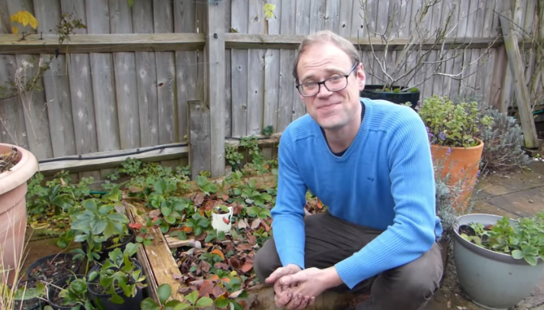
https://www.youtube.com/watch?v=7ZYlN5C0aVM

Appendix D – Design Process
While thinking of an item that you would like to build, follow the steps in the Design Process and illustrate each step into your Google sites webpage. Your creation should be an item that can be reimagined and used for growing or somehow used in a garden. Include pictures, descriptions and/or sketches. Follow the sample Design Process below.

Design Process
Define a problem or challenge
- I only have a balcony for gardening
- I would like to grow something small
- I would also like to use something that I might be throwing out.
Conduct research
- Google balcony gardening, so many ideas
- Some really creative projects out there
Generate ideas/solutions
- Reuse cans, coffee cups, small planter for railing
- Create a feature that climbs up a sunny wall
Choose best solution
- I have coffee cans and that is a great place to start for this project
Build a prototype
- Drill/poke holes in bottom of your container/can/cup for drainage
- Add potting mix
- Plant some basil
- Water as needed
Test and evaluate
- Cans work as planters
- Basil is growing!
Reflect of the process
- Coffee cans make great containers for gardening
- Next time I will use more cans / planters and slightly offset each one to maximize sunlight
- I can grow other herbs as well
- I am starting to explore the world of herbs in my foods; cilantro is next!

Appendix E - Answer Key: Growing Plants in a Pandemic
- What are some of the challenges we face while gardening during a pandemic? (5 marks)
- Not having material, pots, containers, soil, etc….
- Not having space;
- Not having a garden;
- Living in an apartment;
- Not having a balcony;
- Not having any seeds to plant;
- No knowing where to start.

- What are some lessons we could learn from this pandemic? (5 marks)
  - We have learned how reliant we are on the current food supply chain;
  - Our reliability on trucks that ship our food;
  - How some people stock pile in the early stages of the pandemic;
  - The importance of hygiene;
  - Rethinking how we can ruse items and travel less to buy new items;
  - New appreciation for our families;
  - Sitting down as a families to eat our meals;
  - Home cooked meals vs. fast food;
  - How important it is for people to support those less fortunate (i.e. donating to a food bank).

- What is sustainable gardening? (5 marks)
- Saving seeds to replant;
- Creating bio diverse gardens that attract beneficial insects;
- Using less/no pesticides;
- Rethink how we can repurpose items to use in the garden;
- Composting;
- Succession planting;
- Growing what you eat, having to buy less food that is being shipped across the country;
- Thinking about future generations when planning garden designs and ideas
- Harvesting rainwater.

- Where does most of our food come from? Re-thinking gardening at home. (3 marks)
- Most of the food we buy at a grocery store is shipped from other countries;
- Delivery from far-away places requires transportation to and from which continuously adds to the carbon footprint;
- Huge chain of events, from the farmer that grows the food, to the processing plant, to the transportation of the food, to delivering at retail stores.

- What is Upcycling gardening? (2 marks)
- It is being resourceful and creative about using items that might be otherwise thrown away and added to the local landfill;
- Repurposing items and materials for use in gardening in new and unique ways.

- How does growing plants help our mental health (5 marks)
- It becomes a form of meditation;
- It gives someone a sense of purpose and accomplishment;
- Allows the mind to wander in to the world of gardening, wondering about endless possibilities of what to grow and what you can create;
- Allows you to connect with nature;
- It is exercise and exposure to fresh air and sunshine;
- Great way to escape and be immersed in green;
- Provides an outlet to share ideas about growing experiences with others.

Total of 25 Marks

Appendix F – Assessment Rubric
Grows  (Not Yet Met)  Areas of Continued Growth Level 1&2  50 - 69 % | Criteria  Standards for This Evaluation Level 3  70 - 79 % | Glows  (Met)  Evidence of Exceeding Standards Level 4  80 - 100 %
Knowledge/Understanding /5  Listens to teacher instruction, requires constant repetition of the exercise;  Does not use class time effectively and efficiently and requires constant prompting;  The student requires constant reminder to understand what the lesson plan is about;  The student does not gather information related to the lesson plan effectively and efficiently, requires constant prompting;  The student does not or is limited in identify the needs and steps involved in the design process. | Knowledge/Understanding /5  Listens to teacher instruction, requires minimal repetition of the exercise;  Uses class time effectively and efficiently with minimal disturbances;  The student understands what the lesson plan is about;  The student gathers information related to the lesson plan with minimal assistance;  The student identifies the steps in the design process with minimal assistance. | Knowledge/Understanding /5  Listens to teacher instruction;  Uses class time effectively and efficiently;  The student understands what the lesson plan is about;  The student gathers information related to the lesson plan, is capable of doing related research thoroughly and on time.  The students identify the steps in the design process and show a great deal of open mindedness, creativeness and ability to be patient and persistent.
Thinking /5  Uses planning skills with some/limited effectiveness.  Uses processing skill with some/limited effectiveness.  Uses critical/creative thinking processes with some/limited effectiveness. | Thinking /5  Uses planning skills with considerable effectiveness.  Uses processing skill with considerable effectiveness.  Uses critical/creative thinking processes with considerable effectiveness. | Thinking /5  Uses planning skills with a high degree of effectiveness.  Uses processing skill with a high degree of effectiveness.  Uses critical/creative thinking processes with a high degree of effectiveness.

Communication /5  The student has difficulty listening to the examples introduced by the teacher;  The student requires constant clarification on tasks related to the lesson plan;  The student rarely participates in the open discussion and requires much prompting to do so;  Does not communicate clearly with teacher/students;  Does not report problems and requires prompting to do so. | Communication /5  The student listens to the examples introduced by the teacher;  The student asks for clarification on tasks related to the lesson plan;  The student participates in the open discussion;  Communicates clearly with teacher/students;  Reports problems with minimal assistance. | Communication /5  The student listens to the examples introduced by the teacher;  The student rarely requires clarification of tasks related to the lesson plan;  The student participates in the open discussion, shows leadership skills and directs the flow of conversation;  Communicates clearly with teacher/students;  Reports problems and helps other students to identify and report problems.
Application /5  Demonstrates very little competency with new skills;  Does not perform routine tasks, unless prompted on a continual basis;  Does not develop a confidence with tools applies proper techniques with plenty of guidance;  selects the right tool for the job with plenty of guidance;  applies knowledge from the lessons to practical tasks, requires plenty of guidance tasks are not completed in the time allotted work area is not clean, requires prompting to do so;  Little effort is made to work efficiently Demonstrates little to no problem-solving skills. | Application /5  Demonstrates competency with new skills;  Performs routine tasks with minimal assistance;  Develops a confidence with tools;  Applies proper techniques with minimal guidance;  Selects the right tool for the job with minimal guidance;  Applies knowledge from the lessons to practical tasks, requires minimal guidance;  Tasks are completed in the time allotted and work area is clean;  Effort is made to work efficiently;  Tools/materials put away;  Demonstrates a level of problem-solving skills. | Application /5  Demonstrates advanced competency with new skills;  Performs routine tasks without prompting;  Develops a confidence with tools and helps others;  Applies proper techniques;  Selects the right tool for the job;  Applies knowledge from the lessons to practical tasks;  Tasks are completed in the time allotted;  Work area is clean;  Work Safely and efficiently;  Tools/materials put away at the end of the class, visually inspected, clear reports are made on condition of tools;  Demonstrates a high level of problem-solving skills.

Appendix G - Exit Card
- Explain what you liked and disliked about this project. Why?
- Did you learn something new? What stands out?
- Has your outlook on where and how food is produced had an impact on you?
- Please provide any feedback you may have for improving this lesson.

References
21st Century Competencies: Foundation Document for Discussion. Phase 1: Towards Defining 21st Century Competencies for Ontario, Winter 2016 Edition, 2016 http://www.edugains.ca/resources21CL/About21stCentury/21CL_21stCenturyCompetencies.pdf
9 Creative DIY Upcycle Ideas For The Garden
https://balconygardenweb.com/creative-diy-upcycle-ideas-for-the-garden/
Course Codes for Emphasis courses in the Revised Curriculum: Technological Education, Grades 11 and 12, 2009 http://www.edu.gov.on.ca/eng/curriculum/secondary/techedemphasiscourses.pdf
Garden Upcycling Ideas: Learn About Upcycling In The Garden
https://www.gardeningknowhow.com/garden-how-to/projects/garden-upcycling-ideas.htm
Growing Success: Assessment, Evaluation, and Reporting in Ontario Schools, First Edition, Covering Grades 1 to 12, 2010 www.edu.gov.on.ca/eng/policyfunding/growSuccess.pdf
Learning for All – A Guide to Effective Assessment and Instruction for All Students, Kindergarten to Grade 12, 2013 http://www.edu.gov.on.ca/eng/general/elemsec/speced/LearningforAll2013.pdf
New Google Sites for Beginners Tutorial – 2018, YouTube video, 2018 https://www.youtube.com/watch?v=w05NIgHNzWs
Pexels - https://www.pexels.com/
Pixabay - https://pixabay.com/
Recycle Nation - 17 Upcycled Garden Ideas
https://recyclenation.com/2015/05/17-upcycled-garden-ideas/
The Differentiated Instruction Scrapbook http://www.edugains.ca/resourcesDI/EducatorsPackages/DIEducatorsPackage2010/2010DIScrapbook.pdf
The Ontario Curriculum, Grades 9 and 10: Technological Education, 2009 (revised) http://www.edu.gov.on.ca/eng/curriculum/secondary/teched910curr09.pdf
The Ontario Curriculum, Grades 11 and 12: Technological Education, 2009 (revised) http://www.edu.gov.on.ca/eng/curriculum/secondary/2009teched1112curr.pdf
Unsplash - https://unsplash.com/
Upcycling Projects: Turn Your Trash into Garden Treasures!, YouTube video, 2017 https://www.youtube.com/watch?v=7ZYlN5C0aVM

