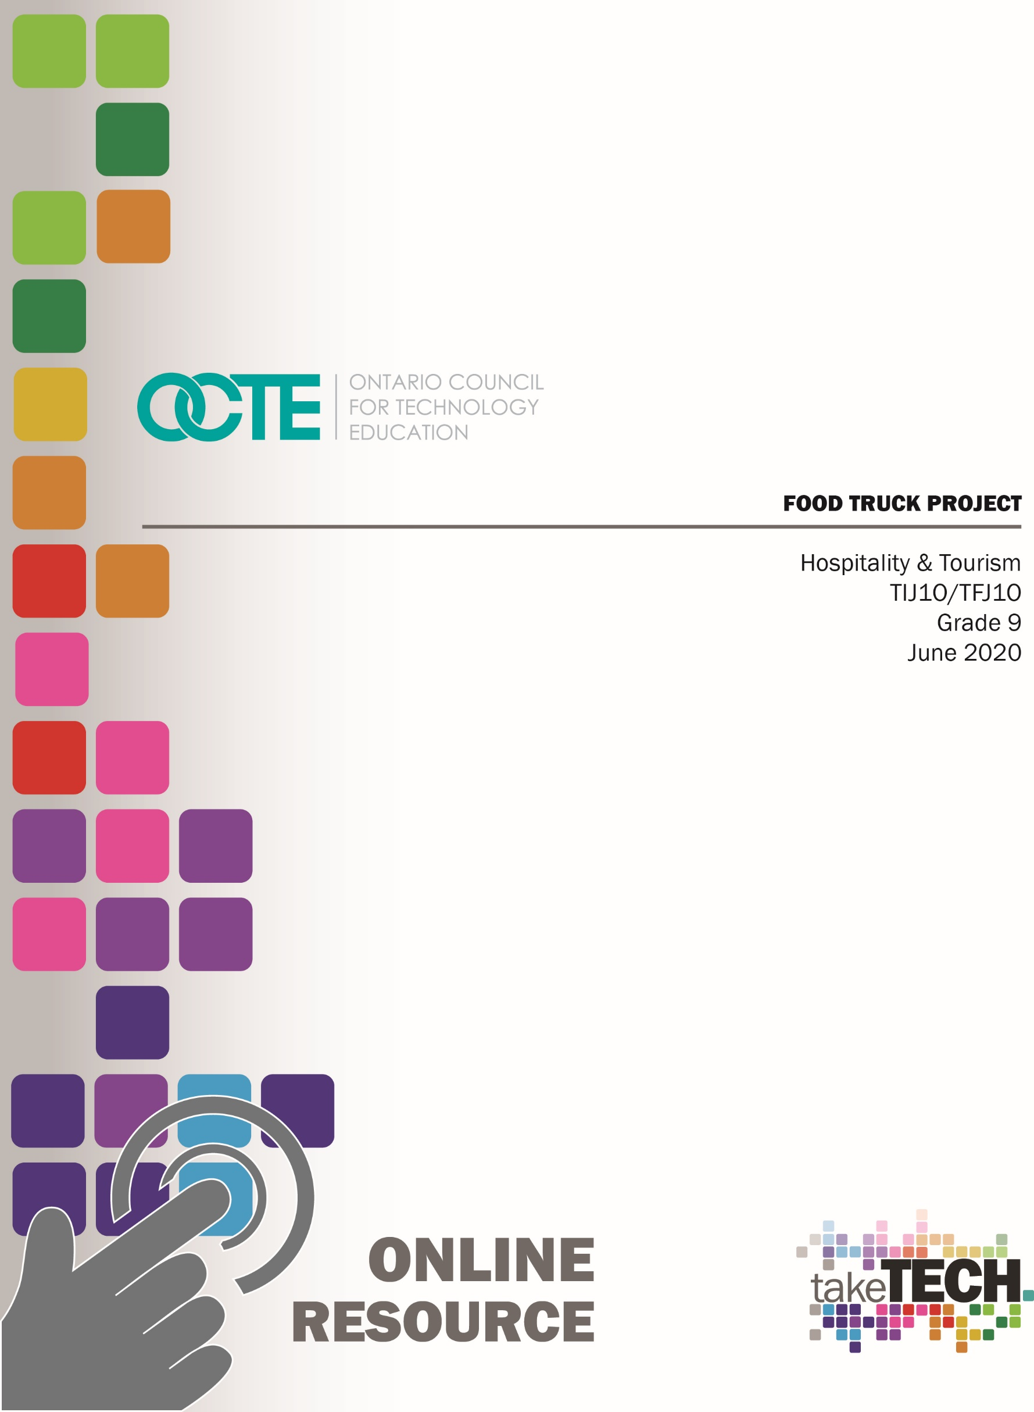

Table of Contents

Introduction 2
Project Outline 2
Planning Notes/Organization 3
Resources 3
Instructional Strategies 3
The Hook/Motivational Strategies 4
Learning Goals and Success Criteria 4
Overall and Specific Expectations 4
Overall Expectations 4
Specific Expectations 5
Safety Concerns and Expectations 6
Personal Protective Equipment 6
Applicable SAFEDocs 6
Identify Challenges with the Project 6
Differentiation of the Project 6
Assessment and Evaluation Practices 6
Religious Considerations 7
Industry Extensions/Career Exploration 7
Introduction Food Truck Project 8
Part 1 Food Truck Research and Development 9
Part 2 Food Truck Theme Brainstorming 10
Part 3 Food Truck Theme Development 11
Food Truck Theme Examples 11
Part 4 Business Logo Analysis 12
Part 5 Create a Logo and Name Your Food Truck 15
Part 6 Brainstorming Your Menu 19
Part 7 Designing Your Food Truck Menu 20
Part 8 Social Media Campaign 21
Part 9 Building Your Food Truck 23
Part 10 Food Truck Cook off Challenge 24
References 26

Introduction
Course Code: TIJ1O / TFJ1O
Broad base Technology: Exploring Technologies and Hospitality & Tourism
Destination: Open
Grade Level: 9
Online Project Name: Food Truck Project

Project Outline
By the end of this project, the student will demonstrate an understanding of the fundamental concepts and skills required in the planning and development of a product or service, such as a food truck, including the use of design process and/or other problem-solving processes and techniques (A1). Students will demonstrate the ability to use a variety of appropriate methods to communicate ideas and solutions (A2). Students will evaluate products or services such as ingredients, meals, beverages, etc. in relation to specifications, user requirements, and operating conditions (A3). Students will use problem-solving processes and project-management strategies in the planning and fabrication of a product or delivery of a food truck service (B1). Students will fabricate products or deliver services, using a variety of resources. Students will demonstrate learning skills that include responsibility, organization, independent work, initiative and self-regulation.
This Project Outline includes the following components,
Introduction Food Truck Project
Part 1 Food Truck Research and Development
Part 2 Food Truck Theme Brainstorming
Part 3 Food Truck Theme Development
Part 4 Business Logo Analysis
Part 5 Create a Logo and Name Your Food Truck
Part 6 Brainstorm Your Menu
Part 7 Design Your Food Truck Menu
Part 8 Social Media Campaign
Part 9 Building Your Food Truck
Part 10 Food Truck Cook off Challenge

Planning Notes/Organization
No prior planning required. All student activities have been divided into ten different parts to help organize student projects and to provide multiple sources to provide evidence of student learning. Each activity builds on the project to help overall student success.

Resources
Introduction Food Truck Project
Please see Part 1 Food Truck Research and Development
Please see Part 2 Food Truck Theme Brainstorming
Please see Part 3 Food Truck Theme Development
Please see Part 4 Business Logo Analysis
Please see Part 5 Create a Logo and Name Your Food Truck
Please see Part 6 Brainstorm Your Menu
Please see Part 7 Design Your Food Truck Menu
Please see Part 8 Social Media Campaign
Please see Part 9 Building Your Food Truck
Please see Part 10 Food Truck Cook off Challenge

Instructional Strategies
The specific instructional strategies used include, project based, problem-based approach, student profiles, exit card, graphic organizers. Teachers may use any of the additional instructional strategies; 3-Part lesson, lecture, storyboard, word wall, think-pair-share, placemat activity, rapid write, K-W-L, anticipation chart, ABC taxonomy, think aloud, analyzing text, Cornell note taking, ticket out the door, or plus/minus/delta.

The Hook/Motivational Strategies
It is time to show your creativity and generate ideas for the next best food truck. Food trucks are a great way to build your business from the ground up or truck up. You will be challenged to conduct research, generate ideas and choose the best solution for your food truck project. You will research, analyze and brainstorm your way to creating a trendy new food truck to be enjoyed by your customers. Your menu will need to be as exciting as the creative and innovative ideas that you will explore as you create a theme for your food truck. You will build a food truck model to display your ideas and project for all to see. The food truck cook off challenge will be your opportunity to showcase your talents and launch your new food truck. Get ready, get set, start your food truck project.

Learning Goals and Success Criteria
By the end of this project, the student will demonstrate an understanding of the fundamental concepts and skills required in the planning and development of a product or service, including the use of design process and/or other problem-solving processes and techniques (A1). Students will demonstrate the ability to use a variety of appropriate methods to communicate ideas and solutions (A2). Students will evaluate products or services in relation to specifications, user requirements, and operating conditions (A3). Students will use problem-solving processes and project-management strategies in the planning and fabrication of a product or delivery of a service (B1).

Overall and Specific Expectations in Support of Ontario Grades 9 - 10 Technological Education

Overall Expectations
A1 Demonstrate an understanding of the fundamental concepts and skills required in the planning and development of a product or service, including the use of a design process and/or other problem-solving processes and techniques;
A2 Demonstrate the ability to use a variety of appropriate methods to communicate ideas and solutions;
A3 Evaluate products or services in relation to specifications, user requirements, and operating conditions;
B1 Use problem-solving processes and project-management strategies in the planning and fabrication of a product or delivery of a service;
B2 Fabricate products or deliver services, using a variety of resources.

Specific Expectations
A1.1 Describe a design process or other problem solving process for planning and developing products and/or services;
A1.2 Describe problem-solving processes and techniques for solving various kinds of problems in different technological areas;
A1.3 Apply correctly the mathematical and scientific concepts and skills required in the planning and development of a product and/or service;
A1.4 Incorporate appropriate technological concepts (e.g., aesthetics, control, environmental sustainability/ stewardship, ergonomics, fabrication/building/ creation, function, innovation, material, mechanism, power and energy, safety, structure, systems) in the design, fabrication or delivery, and evaluation of a product or service;
A2.1 Use a variety of appropriate methods to communicate information or ideas and concepts during the planning and production stages of a project (e.g., production plans, scripts, flow charts, storyboards, sketches, technical drawings, recipes, client consultation reports, design briefs);
A2.4 Describe and use various forms of communication to document the progress and results of the development of a product or service (e.g., tracking sheets, production status reports, a multimedia presentation, a graphic or animated presentation, technical drawings, updates on a website, a blog, technical reports);
A3.1 Evaluate a product or service, and processes associated with its development, on the basis of a set of criteria relevant to that product or service (e.g., adherence to specifications, ease of use, attractive appearance, ruggedness, clean joints, acceptable weld bead, uniform colour, adherence to forest management plan, nutritional value);
A3.2 Suggest improvements to a product or service on the basis of a set of criteria relevant to that product or service (e.g., durability, reliability, ease of use, eco-friendliness, appearance, safety, customer satisfaction);
B1.1 Apply the steps of a design process or other problem-solving process to plan and develop products and services (e.g., define the problem or challenge, taking into account relevant contextual or background information; gather information [about criteria, materials, constraints]; generate possible solutions, using techniques such as brainstorming; choose the best solution; develop and produce a model or prototype; test the model or prototype; incorporate improvements or redesign and retest; report on results);
B1.2 Apply the steps and/or techniques of appropriate problem-solving processes and methods (e.g., diagnostics, reverse engineering, trial and error, divide and conquer, parts substitution, extreme cases) to solve a variety of problems in different technological areas;
B1.4 Use a variety of sources to research technological solutions to specific problems or challenges (e.g., the Internet, reference books, journals or magazines, experts);
B1.6 Use appropriate communication, time management, and organizational strategies (e.g., active listening, scheduling, flow charts, meal plans) to facilitate the process of developing a product or service;
B2.3 Meet all design criteria (e.g., technical requirements, type and quality of materials, appearance, ease of use, safety, timeline, client’s expectations) in creating a product or delivering a service.

Safety Concerns and Expectations
The only safety concerns for Part # 1-9 would be computer internet safety. The safety concerns for Part # 10 would be dependent on the availability of a commercial school kitchen, which would require standard kitchen safety practices.

Personal Protective Equipment
Part # 10 would require standard kitchen safety practices (hairnet, chef’s coat and apron, proper footwear).

Applicable SAFEDocs
Please see the OCTE SAFEDocs for Hospitality for safety documents in order to properly address and instruct for the completion of Part # 10.

Identify Challenges with the Project
Part 1-9 are available for online learning. All student activities have been divided into ten different parts to help organize student projects. Each activity builds on the project to help overall student success. Part 10 can be added when and where in-school learning in a commercial tech kitchen is available.

Differentiation of the Project
Differentiation can be achieved by providing choice with project, graphic organizer, learning preference, VAK inventory, and exit card strategies.

Assessment and Evaluation Practices
Evidence of student achievement for evaluation is collected through this project from different sources using multiple sources to evaluate student learning. Student products will be in the form of assignments for evaluation. Assignments for evaluation include rich performance tasks, demonstration, research, project based on real world setting. Assessment will include the categories of knowledge/understanding, thinking, communication and application.

Religious Considerations
With the Food Truck Project, it is structured to consider any religious and/or cultural considerations. Student’s preferences or student’s interests in structuring the project to coincide with a menu that represents a particular religion and/or culture will support and enhance the overall finished project.

Industry Extensions/Career Exploration
This project does not include any industry extensions/career exploration; however, the project could lead to further engagement for students to register for grade 10 technological education courses. This project could also increase student engagement by introducing and teaching students about future SHSM technological education programs.

Introduction Food Truck Project
It is time to show your creativity and generate ideas for the next best food truck. Food trucks are a great way to build your business from the ground up or truck up. You will be challenged to conduct research, generate ideas and choose the best solution for your food truck project. You will research, analyze and brainstorm your way to creating a trendy new food truck to be enjoyed by your customers. Your menu will need to be as exciting as the creative and innovative ideas that you will explore as you create a theme for your food truck. You will build a food truck model to display your ideas and project for all to see. The food truck cook off challenge will be your opportunity to showcase your talents and launch your new food truck. Get ready, get set, start your food truck project.
Introduction Food Truck Project
Please see Part 1 Food Truck Research and Development
Please see Part 2 Food Truck Theme Brainstorming
Please see Part 3 Food Truck Theme Development
Please see Part 4 Business Logo Analysis
Please see Part 5 Create a Logo and Name Your Food Truck
Please see Part 6 Brainstorm Your Menu
Please see Part 7 Design Your Food Truck Menu
Please see Part 8 Social Media Campaign
Please see Part 9 Building Your Food Truck
Please see Part 10 Food Truck Cook off Challenge

Part 1 Food Truck Research and Development /30
Research three different types of food trucks and fill in the information in the chart. This information will help you to research your own food truck
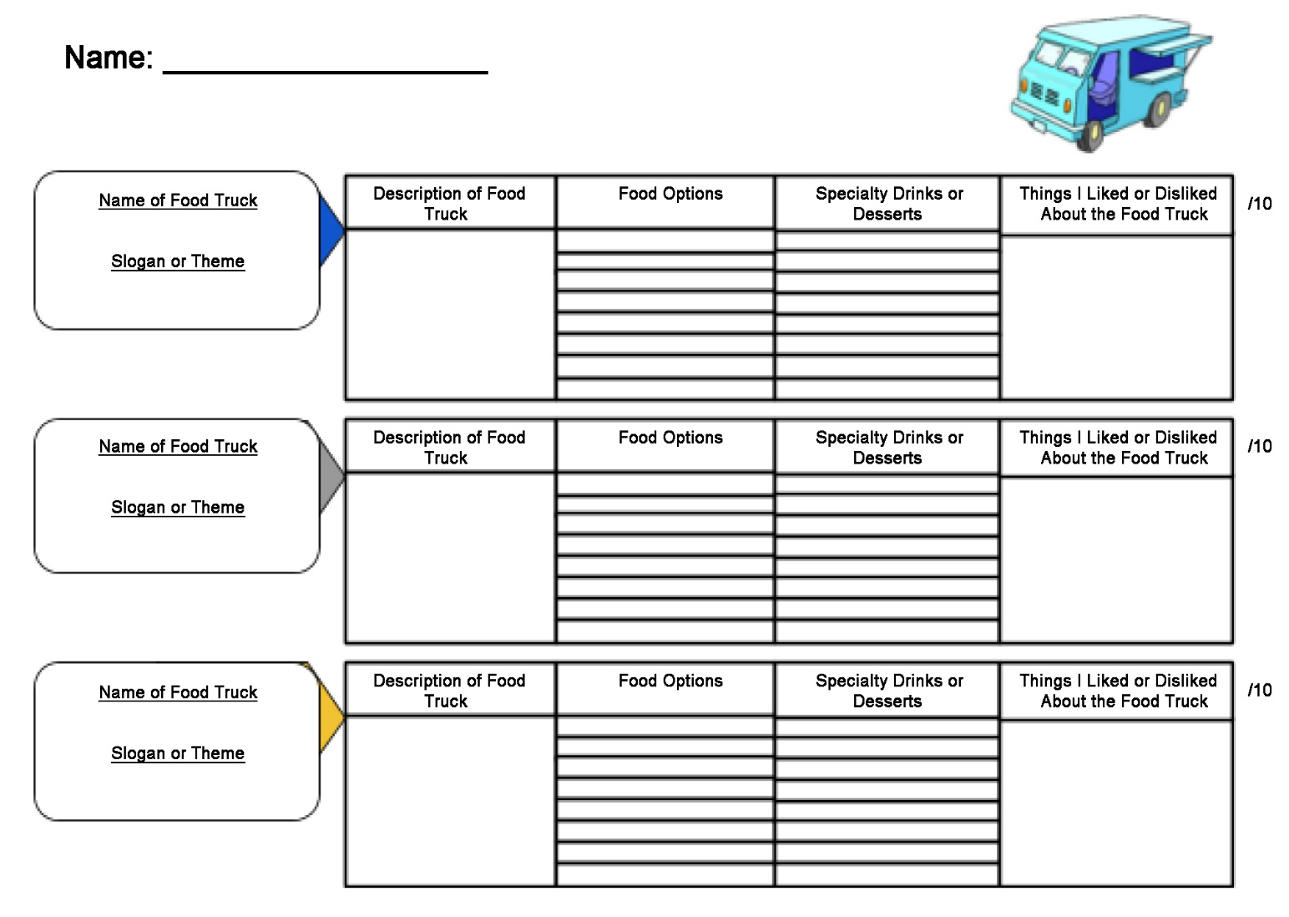

Part 2 Food Truck Theme Brainstorming /30
It is time to start planning your food truck. Setting up a plan to develop your theme will be important to increase your overall success. A good business needs a great deal of planning to help create an interesting product that people will want to spend their hard earned money on.
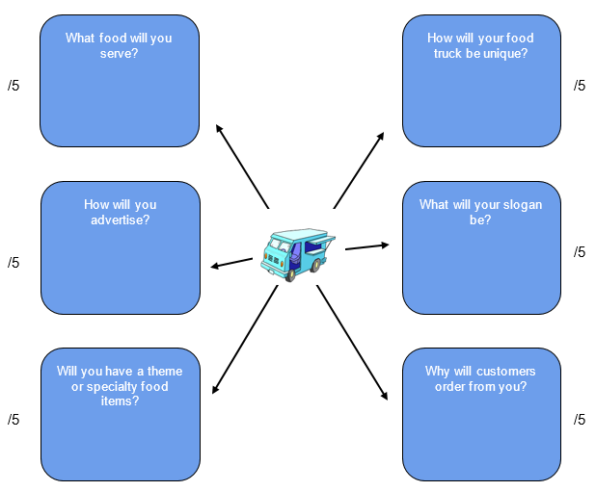

Part 3 Food Truck Theme Development /24
It is important to choose one solid food theme for your food truck. Remember you will not be able to offer a full dining room experience. Your food truck will need to specialize in one concept to be successful. You will need to make a great impression in a short amount of time so you will need to deliver amazing food that will keep customers coming back. It will be important to think about who your customers are going to be. The theme for your food truck will be the foundation for all other decisions relating to your food truck business.

Food Truck Theme Examples
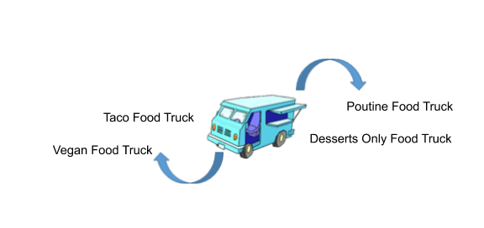
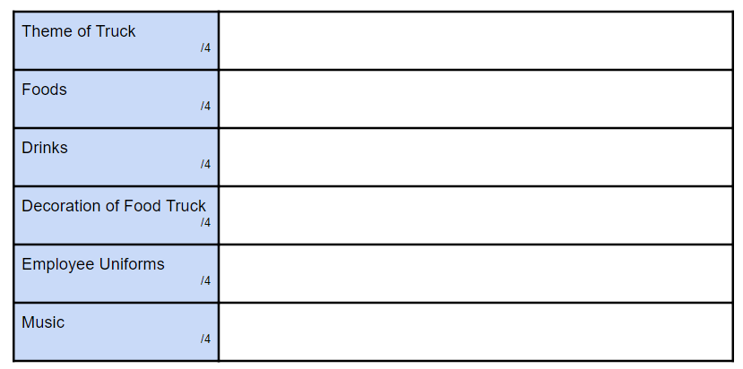

Part 4 Business Logo Analysis /60
It is important to build upon your theme with a logo that will be exciting and interesting. If you think about some of the ways successful companies have created logos you can immediately associate the business just by seeing the logo. For example if you see the “swoosh” or the “golden arches” you can immediately think of the businesses that have branded their companies by a simple symbol. It is time to look at some well-known logos and start looking at the logos so you can plan your logo to help market your food truck.
Complete the form for three well known logos.

Part 5 Create a Logo and Name Your Food Truck /40
It is time to create a logo and name your food truck. Create three logos for your food truck and draw them below. Pick one you like the best and would like to use for your food truck moving forward. Remember your logo should be creative and colourful so that it stands out and represents your business. Your logo should also have a design that connects to your theme or the foods you will be selling.

/10 /10 /10
The logo that I would like to use for my business moving forward is ______________________ /1
List four ideas for a business name for your food truck. /4

- ______________________________

- ______________________________
- ______________________________

- ______________________________
My business food truck name is ____________________________________ /1
This is why I chose this name for my business
____________________________________________________________________________
____________________________________________________________________________
____________________________________________________________________________ /4

Part 6 Brainstorming Your Menu /25
You have a theme, a logo and a name for your food truck. Now it is time to start putting these ideas together to build your menu. Your menu needs to be exciting and delicious so your customers will support your business and also tell all their friends.
Name of Food Truck _________________________________ /1
Theme of Food Truck _________________________________ /1
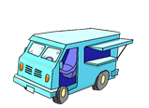

Part 7 Designing Your Food Truck Menu /50
Create a one page food truck menu that uses a variety of colours, shapes, fonts and pictures to create interest for potential customers. This menu could be used on various different social media platforms or posters. Make sure the theme is evident in your menu. The finished menu should have the name of your food truck, the logo, menu items with descriptions and prices and be overall visually appealing. Make sure to double check for spelling and grammatical errors. Your overall finished menu should be neat and professional.
Criteria | Level 0 0-49% | Level 1 50-59% | Level 2 60-69% | Level 3 70-79% | Level 4 80-100%
Communication of Information & Ideas  /10 | Does not meet the minimum expectations for communication of information and ideas. | Communicates information and ideas with limited clarity and significant steps needed to provide clarity to the title and topics required. | Communicates information and ideas with some clarity. More focus on adding clarity to the title and topics are required. | Communicates information and ideas with considerable clarity and the title and topics are clear. | Communicates information and ideas with a high degree of clarity and the title and topics stand out and are very clear.
Creativity  /10 | Does not meet the minimum expectations for creativity for this assignment. | Little to no creative thought put into assignment. Very plain and no effort to be creative is present. | Moderately creative. Has some thought put into the layout of the assignment. No extras are added. | Assignment has elements of creativity that enhance the information on the finished menu. | Excellent attention to detail. Above and beyond average presentation. Very creative finished menu.
Checklist and “Must Haves”:  *Food Truck Name  *Main options  *Toppings/Drinks  *Desserts  *Theme  /10 | Does not meet the minimum expectations on the checklist for this assignment. | Assignment is incomplete or missing components and missing significant checklist information. | Assignment has most of the necessary checklist components but some requirements are missing. | All requirements are met and thoughtfully laid out. All checklist components are complete. | Additional material has been provided to enhance the overall information on the menu.
Visual  *use of pictures  *design  *colour  /10 | Little to no visual details given to enhance the overall menu. | Very little visual details given to enhance the overall menu. | Some visual detail given to enhance the overall menu. | Great visual detail given to enhance the overall menu. | Excellent detail given to enhance the overall menu.
Menu Description  /10 | Does not meet the minimum expectation for description provided for menu items. | Very little information provided for menu items with significant spelling and/or grammar mistakes. | Some information provided for menu items with some spelling and/or grammar mistakes. With main options, toppings, drinks and desserts. | Great information provided for menu items with few spelling and/or grammar mistakes. With main options, toppings, drinks and desserts. | Excellent information provided for menu items with proper spelling and grammar. With main options, toppings, drinks and desserts.

Part 8 Social Media Campaign /30
You have the theme, the name, the logo and the menu for your food truck. Now it is time to generate some customers to come and experience your amazing food truck. Now it is time to start your social media campaign. For this section of the project you will create an Instagram and a Twitter post to advertise your food truck in order to reach as many customers as possible.
/25

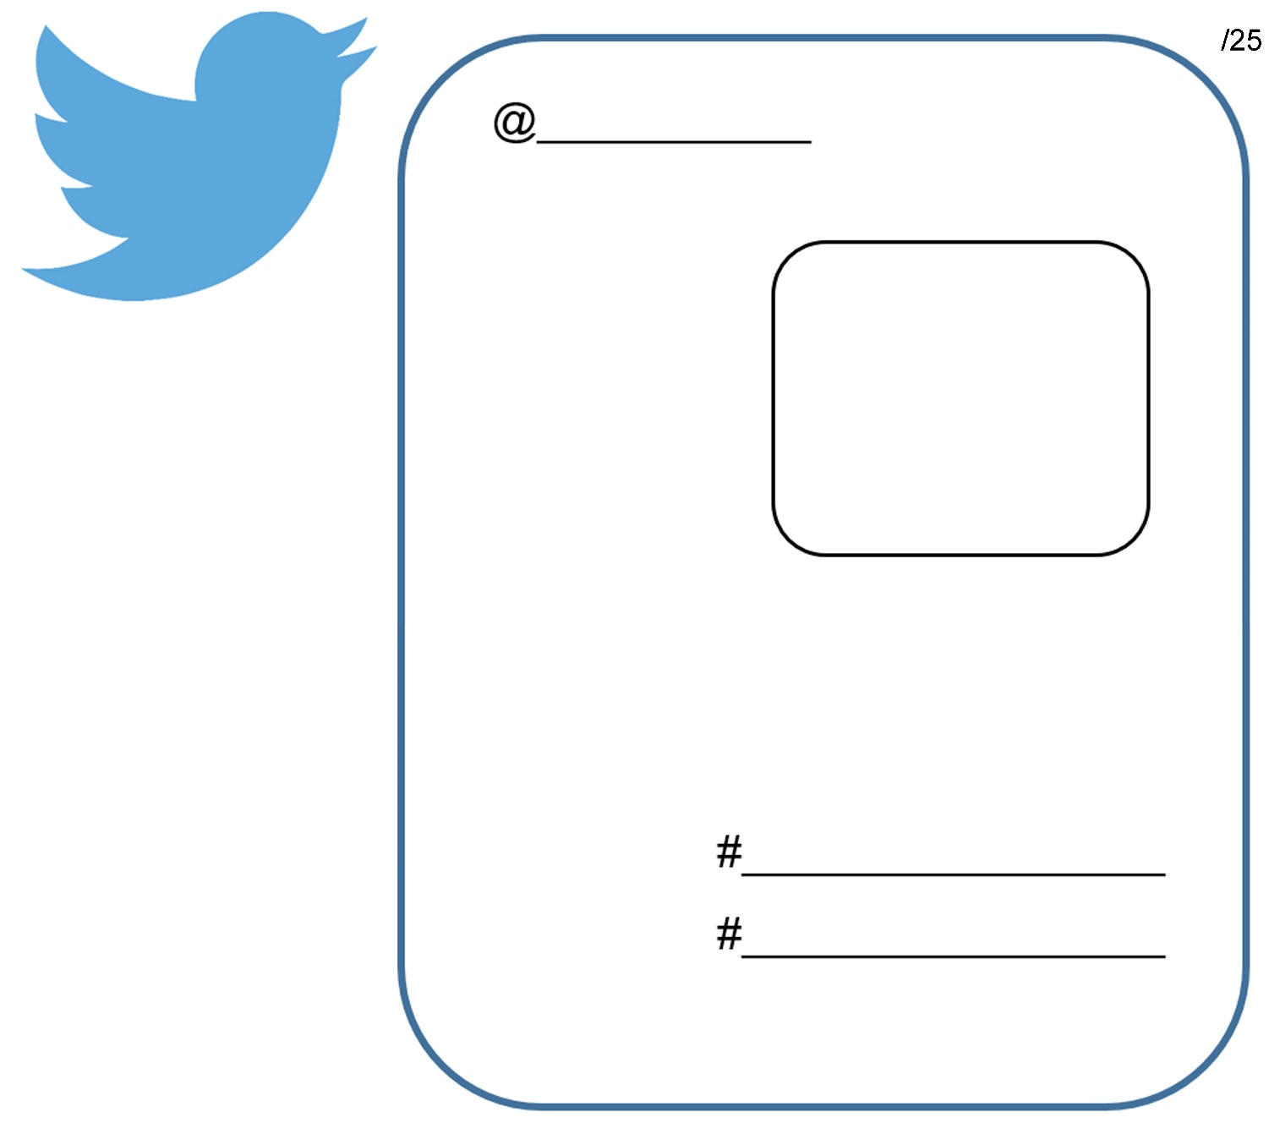

Part 9 Building Your Food Truck /60
Now it is time to build and design your three dimensional food truck. A shoe box or any other box should help get you started. You will want to include your food truck’s name and logo as part of your design plans. Your food truck should tie into your theme and be creative, colourful and interesting to attract the attention of your customers. Your overall food truck should be neat and professional. The food truck will reflect your business and remember this will be your restaurant on wheels so it must be impressive. If your truck isn’t appealing and interesting enough to intrigue your customers then you won’t have any customers. Without customers you won’t make money and your business will suffer and may even have to close. I can’t wait to see your food trucks!
Criteria | Level 0 0-49% | Level 1 50-59% | Level 2 60-69% | Level 3 70-79% | Level 4 80-100%
Planning  /10 | Does not meet the minimum expectations for planning skills. | Uses planning skills with limited effectiveness. | Uses planning skills with some effectiveness. | Uses planning skills with considerable effectiveness. | Uses planning skills with a high degree of effectiveness.
Creativity  /10 | Does not meet the minimum expectations for creativity. | Little to no creative thought put into assignment. Very plain and no effort to be creative is present. | Moderately creative. Has some thought put into the layout of the food truck. No extras are added. | Assignment has elements of creativity that enhance the overall finished food truck. | Excellent attention to detail. Above and beyond average presentation. Very creative finished food truck.
Neatness and Professional  /10 | Does not meet the minimum expectations for neatness and professionalism. | Food truck is lacking in neatness and does not look professional at this stage. | Food truck is somewhat neat and professional. The food truck needs a little more work. | Food truck is neat and professional. The food truck represents a great potential business. | Food truck is very neat and professional. The food truck represents an excellent potential business.
Visual  *use of pictures  *design  *colour  *logo  *theme  /14 | Little to no visual details given to enhance the overall food truck. | Very little visual details given to enhance the overall food truck. | Some visual detail given to enhance the overall food truck. | Great visual detail given to enhance the overall food truck. | Excellent detail given to enhance the overall food truck.
Required Elements  /16 | Does not meet minimum required elements. | Food truck is missing many required elements and needs significant further adjustments. | Food truck includes some of the required elements and further adjustments required. | Food truck includes most required elements. | Food truck includes all required elements and goes above and beyond.

Part 10 Food Truck Cook off Challenge /100
Now it is time to try some of these fantastic food truck foods. You will choose one of your main dishes from your menu to make for the judges. You will have two classes to make your food. The first day will be to prepare your food and the second day will be to cook or bake your food and present to the judges.
Criteria | Level 0 0-49% | Level 1 50-59% | Level 2 60-69% | Level 3 70-79% | Level 480-100%
Sanitation  Appearance/ Uniform  /10 | Should not participate due to improper attire and/or shoes for kitchen, poor hygiene-dirty fingernails etc. | Dressed improperly; needed to make major modification to hair, clothing, footwear, and/or hands before participating. | Dressed properly for lab, minor modifications to hair, clothing, footwear, and/or hands needed before beginning work. | Dressed properly, hair restrained, proper footwear, and hands washed – no adjustments needed before beginning work. | Exceptionally neat, clean and arrived ready to begin work.
Workstation  /10 | Poorly maintained work space during lab, needed repeated teacher intervention to correct cross-contamination and/or unsanitary conditions. | Work space not well-maintained during lab, needed coaching to remedy cross-contamination and/or unsanitary conditions. | Maintained moderately-clean work space; little threat of cross-contamination during kitchen lab. | Maintained clean work-space; avoided cross-contamination throughout kitchen lab | Maintained exceptionally clean and sanitary work space throughout lab; no cross-contamination or unsanitary conditions.
Work Habits  /10 | Frequent touching of face, hair, unclean surfaces, little concern for cleanliness, no visible handwashing. | Poor handwashing technique and/or frequency; no visible concern for cleanliness. | Adequate handwashing technique and/or frequency; adequate concern for general cleanliness. | Frequent proper handwashing; minimal touching of face, hair or unclean work surfaces; noticeable concern for cleanliness. | Extreme care with cleanliness and keeping hands clean; no touching of face, hair, or unclean surfaces.
Clean Up  /10 | Station, tools and equipment were not given any consideration following production. | Station, tools and equipment were given little sanitation consideration following production. | Station, tools and equipment were given some sanitation consideration following production. | Station, tools and equipment were given sanitation consideration following production. | Station, tools and equipment were given exceptional sanitation consideration following production.

Criteria | Level 0 0-49% | Level 1 50-59% | Level 2 60-69% | Level 3 70-79% | Level 480-100%
Prep  Time Management  /10 | Large amount of wasted time and/or inactivity, activity not completed. | Did not complete in time allotted due to inefficient use of time. | Adequate organization completed activity relatively on time. | Completed activity and all clean-up tasks on time. | Exceptionally organized; completed activities ahead of time and moved on to new tasks.
Results  Tools and Equipment  /10 | Improper use of tools and equipment requiring repeated teacher intervention. | Improper use of tools and equipment requiring some teacher intervention. | Adequate use of tools and equipment requiring little teacher intervention. | Uses tools and equipment without teacher intervention. | Uses tools and equipment with extreme care.
Skill Level  (Knife skills, measurement skills, cooking methods)  /20 | Does not meet minimum requirements at this time. | Needs practice and coaching to meet average skill level. | Properly demonstrated skill with some prompting. | Proficient at skill without supervision. | Exemplary demonstration of skill level beyond expectations.
Final Product  (plating, garnishing)  /20 | Final product does not meet minimum requirements | Product needs a variety of adjustments to further develop and increase overall final product. | Product needs moderate adjustments to further develop and increase overall final product. | Product needs minimal adjustments to further develop and increase overall final product. | No adjustments are required for the final product.

References
21st Century Competencies: Foundation Document for Discussion. Phase 1: Towards Defining 21st Century Competencies for Ontario, Winter 2016 Edition, 2016 http://www.edugains.ca/resources21CL/About21stCentury/21CL_21stCenturyCompetencies.pdf
Course Codes for Emphasis courses in the Revised Curriculum: Technological Education, Grades 11 and 12, 2009 http://www.edu.gov.on.ca/eng/curriculum/secondary/techedemphasiscourses.pdf
Food Truck ClipArt (Creative Commons) https://www.maxpixels.net/static/photo/640/Car-Van-Ice-Cream-Truck-Truck-Food-Truck-3409599.jpg
Growing Success: Assessment, Evaluation, and Reporting in Ontario Schools, First Edition, Covering Grades 1 to 12, 2010 www.edu.gov.on.ca/eng/policyfunding/growSuccess.pdf
Instagram logo, 2020 https://en.instagram-brand.com/#general
Learning for All – A Guide to Effective Assessment and Instruction for All Students, Kindergarten to Grade 12, 2013 http://www.edu.gov.on.ca/eng/general/elemsec/speced/LearningforAll2013.pdf
OCTE SAFEDocs for Hospitality, 2013 https://www.octe.ca/application/files/6215/3796/3180/SAFEdoc_HOST.pdf
The Differentiated Instruction Scrapbook http://www.edugains.ca/resourcesDI/EducatorsPackages/DIEducatorsPackage2010/2010DIScrapbook.pdf
The Ontario Curriculum, Grades 9 and 10: Technological Education, 2009 (revised) http://www.edu.gov.on.ca/eng/curriculum/secondary/teched910curr09.pdf
The Ontario Curriculum, Grades 11 and 12: Technological Education, 2009 (revised) http://www.edu.gov.on.ca/eng/curriculum/secondary/2009teched1112curr.pdf
Twitter logo social icon, 2020 https://about.twitter.com/content/dam/about-twitter/company/brand-resources/en_us/Twitter_Brand_Guidelines_V2_0.pdf

