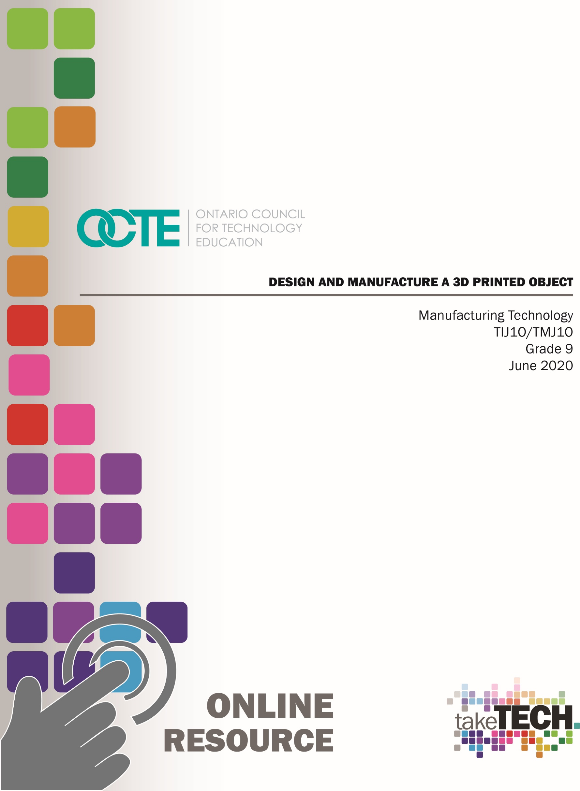

Table of Contents

Introduction 2
Project Outline 2
Prior Knowledge 2
Student Activities 3
Resources 3
Planning Notes 3
Instructional Strategies 4
Motivational Strategies 4
Learning Goals and Success Criteria 4
Overall and Specific Expectations 5
Overall Expectations: 5
Specific Expectations: 5
Safety Concerns and Expectations 6
Applicable SAFEDocs and ToolSAFE videos 6
Differentiation of the Project / Activity 7
Career and Industry Extensions 7
Reflection or Design Report 7
Consolidation: (20 Minutes) 7
Appendix A – Student Assignment Document 9
Appendix B – Teacher Support Document 10
References 11

Introduction
Course Code: TIJ1O / TMJ1O
Broad base Technology: Exploring Technologies and Manufacturing Technology
Destination: Open
Grade Level: 9
Online Project Name: Design and Manufacture a 3D Printed Object

Project Outline
For this project, students will design and produce a small series of products using a 3D printer.
As an example, students could design game pieces for a unique board game of their own design as part of a larger project that could incorporate connections to a graphic design module to introduce students to Communications Technology.


Prior Knowledge
Students would benefit from:
- an understanding of linear measurement,
- some experience accessing online resources, creating and downloading files, and submitting such files to a destination according to their teacher’s direction

Student Activities
Go through the module “TIJ1O Exploring Technology – Student Assignment Exploring Manufacturing Technology – 3D Design and Printing”
In this module, students will:
- Design 3D shapes in an Online CAD (Computer Aided Design) environment,
- Create 3D printer compatible files to create real 3D objects that you designed on the computer.
- Perform a post-production assessment and evaluation of the product and process
Teachers should go through the help document “TIJ1O Exploring Technology – Teacher Content Manufacturing Technology – 3D Design and Printing”

Resources
Completion of this module will require the student to have the following resources:
- Paper, pencil, ruler
- Internet access
- A computer, smart phone, or tablet
- Capacity to share files – email or cloud drive
Completion of this module will require the teacher to have the following resources:
- Internet access
- A computer, smart phone, or tablet
- Capacity to receive shared files – email or cloud drive
- Access to a 3D printer
- Various colours of filament spools of PLA for 3D printer

Planning Notes
This 6-hour module requires no specialized software to be installed on any devices. It can be completed entirely online using browser-based apps.
The student information package includes:
- Minds On activity
- Activity – including:
  - online 3D design training modules
  - online design of student’s unique project
  - exporting 3D printer files and sending them to the teacher
- Consolidation – post-production assessment and evaluation of the product and process
The teacher information package includes:
- Instructions on setting up and managing class and student accounts on a web-based 3D design system (Tinkercad)
- Instructions on accessing 3D Printing Basics instruction

Instructional Strategies
This learning package is meant to be student-led, designed to be used in a Learning from Home scenario, minimizing the need for specialized devices and software.
It is broken up into several manageable online mini-lessons that prompt and follow student progress.

Motivational Strategies
Students’ intrinsic motivators include:
- Progress through this unit provides students with opportunities intrinsic motivation including:
  - autonomy,
  - development of competence,
  - determining relatedness to their life, interests,
  - relevance to their lives and career opportunities
- Learning in manageable chunks for relatively gratifying progress checkpoints

Learning Goals and Success Criteria
Learning Goals - Student can:
- use online resources to design and produce an artifact in a 3D CAD environment for output on a 3D printer
- reflect on and identify strengths and next steps for improvement in online 3D model design
- identify and explain the concepts of:
  - Object Placement
  - Manipulating the View
  - Moving Objects
  - Rotating Objects
  - Resizing Objects
  - Grouping Objects
  - Aligning Objects
- use a problem-solving model
- identify appropriate file type of 3D printing
- identify file type conventions
- describe 3D printing materials and their environmental impacts

Success Criteria – Student has:
- completed online training modules
- completed online lesson for a task similar to their assignment
- completed their unique 3D design
- downloaded and submitted their STL file to the teacher for production
- reflected on the process and product

Overall and Specific Expectations in Support of Ontario Curriculum Grades 9 - 10 Technological Education

Overall Expectations:
A1. Demonstrate an understanding of the fundamental concepts and skills required in the planning and development of a product or service, including the use of a design process and/or other problem-solving processes and techniques;
A2. Demonstrate the ability to use a variety of appropriate methods to communicate ideas and solutions;
A3. Evaluate products or services in relation to specifications, user requirements, and operating conditions
B2. Fabricate products or deliver services, using a variety of resources.
C1. Demonstrate an awareness of the effects of various technologies on the environment;
D2. Identify careers in various technological fields, and describe the educational requirements for them.

Specific Expectations:
A1.4 Incorporate appropriate technological concepts (e.g., aesthetics, control, environmental sustainability/stewardship, ergonomics, fabrication/building/ creation, function, innovation, material, mechanism, power and energy, safety, structure, systems) in the design, fabrication or delivery, and evaluation of a product or service (see pp. 5–6);
A1.5 Describe the characteristics of a variety of materials used in the fabrication of a product or the delivery of a service (e.g., strength, durability, possible toxicity, lifespan, density, nutritional value, flavour, asepsis) and identify other relevant considerations to be made in relation to those materials (e.g., cost, availability);
A2.2 Use correct terminology to identify and describe various processes, tools, and equipment used in creating products or delivering services
A3.1 Evaluate a product or service, and processes associated with its development, on the basis of a set of criteria relevant to that product or service (e.g., adherence to specifications, ease of use, attractive appearance, ruggedness, clean joints, acceptable weld bead, uniform colour, adherence to forest management plan, nutritional value);
A3.2 Suggest improvements to a product or service on the basis of a set of criteria relevant to that product or service;
B2.1 Use appropriate tools, materials, and equipment (e.g., tools: hammer, chisel, screwdrivers, soldering iron, cheese grater, sieve, seam ripper; pruning shears, hair clipper; materials: wood, aluminum, polystyrene, paper, wax, clay, textiles, electronic components, mulch, hair colour; equipment: drill press, test meter, computer, software, printer, video camera, thermometer, grill, sewing machine, autoclave, curling iron) to create products or deliver services;
C1.2 Identify technological solutions that have been designed in response to environmental concerns (e.g., catalytic converter, wind turbines, solar-powered signs, biofuels, non-toxic and hypoallergenic products, recyclable and reusable packaging);
D2.1 Describe secondary and postsecondary education pathways (i.e., selection of courses, programs, experiential learning opportunities, and other learning opportunities at the secondary and postsecondary levels, including apprenticeship training, certificate programs, college programs, and/or university programs) leading to a variety of careers in technological fields;
D2.6 Develop and/or select pieces of work and other materials that provide evidence of their skills and achievements in technology, for inclusion in a portfolio (e.g., Passport to Safety certificate, project photographs, sketches, drawings, skills checklist, work logs).

Safety Concerns and Expectations
No parent supervision is required for this assignment. This project is almost entirely computer based, and can be engrossing, so an ergonomically designed workspace is recommended, with suggested reminders for body breaks.

Applicable SAFEDocs and ToolSAFE videos
These ToolSAFE resources are applicable in the event that the student has physical access to 3D printing equipment:
3D Printer Safety Video
3D Printer Safety Lesson Plan
PLA Filament MSDS Sheet (Makerbot)
ABS Filament MSDS Sheet (Makerbot)

Differentiation of the Project / Activity
This project can be differentiated by:
- the use of more specialized software,
- the design challenge can be modified to have the student determine a need for a small object within their home environment that they could design and produce
- the project can be extended to have students design all of the pieces to actually produce a full, working version of a board game of their design

Career and Industry Extensions
Students can explore career connections and opportunities in the following fields:
- MakerSpace Coach
- 3D programmer
- video game designer
- graphic designer
- CNC machine operator
- CAD/CAM programmer/technician
- Mechanical engineering

Reflection or Design Report
Refer to Page 12 of the TIJ1O Exploring Technology – Student Assignment - Exploring Manufacturing Technology – 3D Design and Printing

Consolidation: (20 Minutes)
Once your project is printed, examine it.
- Are you happy with the overall product?
- Did it turn out at the right size?
- Are you happy with the smoothness and detail?
- What changes would you make to the design of this piece?
- What are the steps required to make the changes?
- Did you try designing any other parts?
- If so, did the process get quicker and/or easier?
- How could you make use of a 3D printer in the future?

Appendix A – Student Assignment Document
View the complete Student Assignment Document
TIJ 1O Exploring Technology – Student Assignment
Exploring Manufacturing Technology – 3D Design and Printing
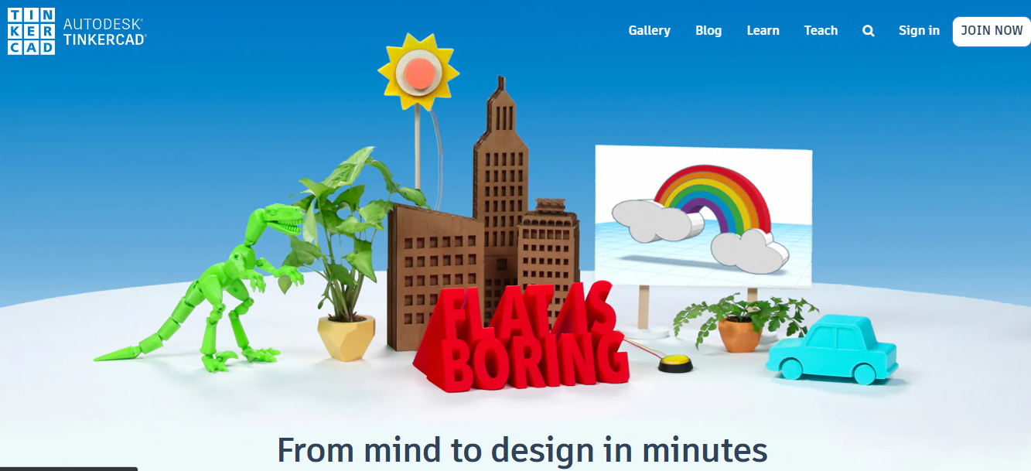

Appendix B – Teacher Support Document
View the complete Teacher Support Document
TIJ 1O Exploring Technology – Teacher Content
Exploring Manufacturing Technology – 3D Design and Printing
Teacher Instructions for Setting Students Up on Tinkercad
Navigate to https://www.tinkercad.com/
If you don’t already have an account, create one by clicking here

References
3d Printing Cartoon 3d Printer Clipart by Pinclipart https://www.pinclipart.com/downpngs/xwRbRJ_3d-printing-cartoon-3d-printer-clipart/
21st Century Competencies: Foundation Document for Discussion. Phase 1: Towards Defining 21st Century Competencies for Ontario, Winter 2016 Edition, 2016 http://www.edugains.ca/resources21CL/About21stCentury/21CL_21stCenturyCompetencies.pdf
ABS Filament SDS Sheet for Technological Design (Makerbot), 2013 https://www.octe.ca/download_file/force/340/301
AutoDesk Tinkercad Graphics https://www.tinkercad.com/
Course Codes for Emphasis courses in the Revised Curriculum: Technological Education, Grades 11 and 12, 2009 http://www.edu.gov.on.ca/eng/curriculum/secondary/techedemphasiscourses.pdf
Growing Success: Assessment, Evaluation, and Reporting in Ontario Schools, First Edition, Covering Grades 1 to 12, 2010 www.edu.gov.on.ca/eng/policyfunding/growSuccess.pdf
Learning for All – A Guide to Effective Assessment and Instruction for All Students, Kindergarten to Grade 12, 2013 http://www.edu.gov.on.ca/eng/general/elemsec/speced/LearningforAll2013.pdf
OCTE 3-D Printer Lesson Plan for Technological Design (OCTE), 2013 https://www.octe.ca/download_file/force/339/301
OCTE 3-D Printer ToolSAFE Video (YouTube), 2016 https://youtu.be/q9OHdmwkUXM
Manufacturing Tech Module - Student assignment (PDF), 2020 http://www.octe.ca/application/files/5115/9295/8015/MFG_Tech_Module_-_Student_Assignment_.pdf
Manufacturing Tech Module - Teacher content (PDF), 2020 http://www.octe.ca/application/files/3415/9295/7896/MFG_Tech_Module_-_Teacher_Content_.pdf
Monopoly Car Piece Photo by Suzy Hazelwood from Pexels - https://www.pexels.com/photo/monopoly-car-piece-1634213/
PLA Filament SDS Sheet for Technological Design (Makerbot), 2013 https://www.octe.ca/download_file/force/341/301
Technological Design SAFEDocs (OCTE), 2013 https://www.octe.ca/application/files/2915/3796/3174/SAFEdoc_DESIGN.pdf
The Differentiated Instruction Scrapbook http://www.edugains.ca/resourcesDI/EducatorsPackages/DIEducatorsPackage2010/2010DIScrapbook.pdf
The Ontario Curriculum, Grades 9 and 10: Technological Education, 2009 (revised) http://www.edu.gov.on.ca/eng/curriculum/secondary/teched910curr09.pdf
The Ontario Curriculum, Grades 11 and 12: Technological Education, 2009 (revised) http://www.edu.gov.on.ca/eng/curriculum/secondary/2009teched1112curr.pdf

