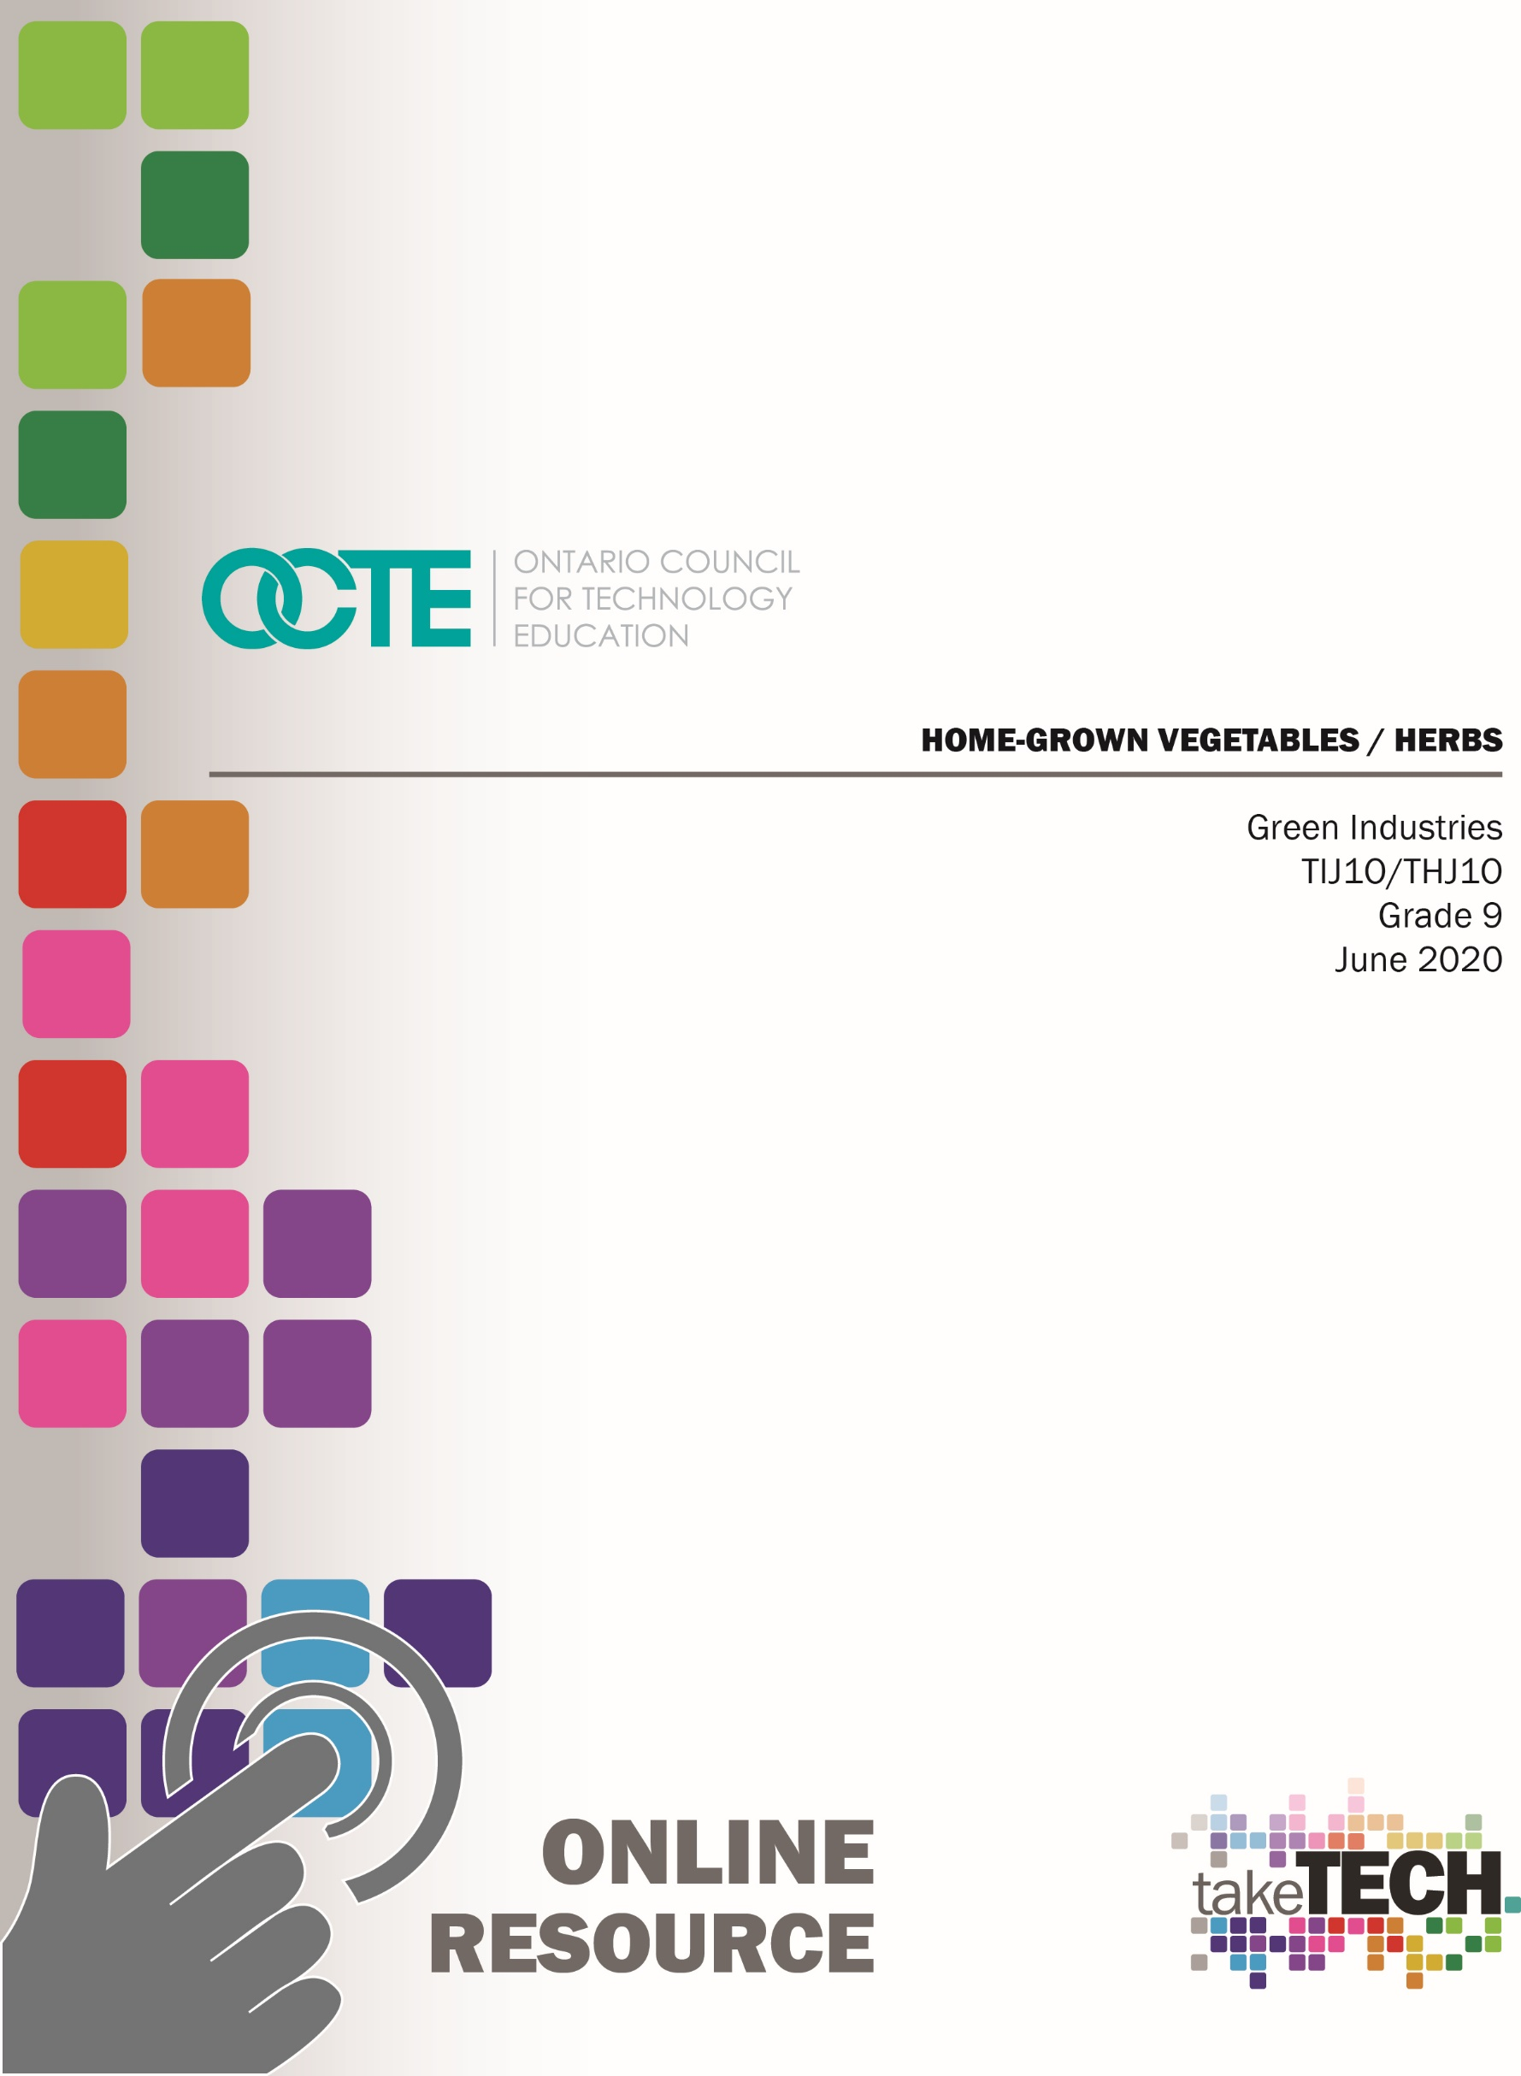

Table of Contents

Introduction 2
Project Outline 2
Prior Knowledge 2
Planning Notes 2
Resources 3
Introduction – PowerPoint Presentation 4
Activity #1: How Growing Crops Changed the World? 5
Activity #2: The Importance of Growing Your own Food. 5
Activity #3: Understanding Soil Basics and Plant Nutrition 6
Activity #4: Seed Germination and Plant Care 7
Activity #5 Culminating Activity 8
The Hook/Motivational Strategies 9
Learning Goals and Success Criteria 9
Overall and Specific Expectations 10
Overall Expectations 10
Specific Expectations 10
Safety Concerns 11
Challenges with the Project. Online Verse Home 12
Differentiation 12
Assessment 12
Industry Extensions/Careers 12
Ethical/Environmental Considerations 12
Student Reflections 13
Appendix A - Answer Keys 14
ACTIVITY #1: HOW GROWING CROPS CHANGED THE WORLD 14
ACTIVITY #2: THE IMPORTANCE OF GROWING OUR OWN FOOD 15
ACTIVITY #3: UNDERSTANDING SOIL BASICS AND PLANT NUTRITION 16
ACTIVITY #4: SEED GERMINATION AND PLANT CARE 17
Appendix B - GOOGLE SLIDE RUBRIC: 18
GROWING PLANTS DURING A PANDEMIC 18
References 20

Introduction
Course Code: TIJ1O / THG1O
Broad base Technology: Exploring Technologies and Green Industries
Destination: Open
Grade Level: 9
Online Project Name: Home-grown Vegetables / Herbs

Project Outline
By the end of this project, the student will identify and explain the impact that growing our own food crops had on civilization. Students will demonstrate an understanding of where food comes from and the importance of growing our own food. Students will demonstrate an understanding of soil basics, plant nutrition, seed germination and plant care. Students will demonstrate learning skills that include responsibility, organization, independent work, initiative and self-regulation.

Project Outline
Introduction - Slide Presentation
Activity # 1 - How Growing Crops Changed the World
Activity # 2 - The Importance of Growing Our Own Crops
Activity # 3 - Understanding Soil Basics & Plant Nutrition
Activity # 4 - Seed Germination and Plant Care
Culminating Activity - Homegrown Windowsill Herbs & Vegetables (option A & B)

Prior Knowledge
Prior knowledge of basic gardening, planting techniques, gardening tools, types of soils (N-P-K) is helpful but nor required. Prior knowledge in using Google slides would also be a benefit to the teacher and students.

Planning Notes
Teachers are to deliver the prepared slide presentation remotely in “real time” synchronously.
Teachers should review resources in advance and expand on themes to enhance the presentation.
All student activities have been divided into 4 assignments and 1 culminating activity (with option A or B)
Each activity located in this resource is linked to the slide presentation, and can be assigned by teachers (with deadlines), as they see fit.
Students are to include research acquired from the guiding questions in the activities in their slide presentations.
Teacher will prepare packages to be sent out to students that will include potting mix, herb seeds or vegetable seeds and instructions pertaining to seed variety.
Teachers who are unable to send seeds due to budgetary constraints should prepare and grow seedlings and share progress through images and synchronous sessions.

Resources
Resources in this document include embedded links to articles, websites, links to gardening resources and a rubric. As a convenience, a number of the resources have been compiled in this section.
Websites
- Canadian Centre for Occupational Health and Safety
- CODE
- Landscape Ontario
- Master Gardeners of Ontario
- Ministry of Labour
- National Geographic Education
- Ontario College of Trades (OCT)
Articles
Beaker Life: The Evolution of Agriculture
Food Secure Canada: What Is Behind The Trend Of Local Food?
Gardeners: How to Start Seeds
Gardening Know How: Soilless Potting Mix – What Is A Soilless Mixture And Making Homemade Soilless Mix
Growing Tomatoes from Seed to Harvest, Gardeners Supply Company
How important is it for Canada to produce its own food?
McGill University Food Services: Sustainability
The New York Times: How the First Farmers Changed History
The Spruce: Soilless Potting Mix
West Coast Seeds: What the Heck is N-P-K ?

Introduction – PowerPoint Presentation
The introduction to the project is presented in a PowerPoint presentation. Please utilize and refer to the picture and link below.
Home Grown Vegetables & Herbs
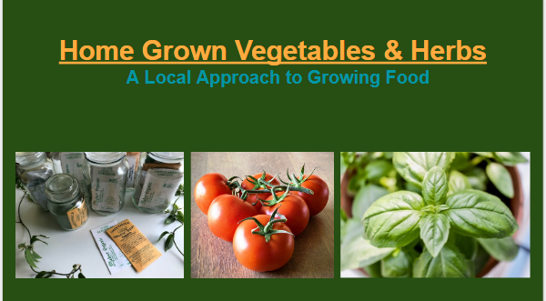
http://www.octe.ca/application/files/9015/9268/8113/Home-Grown_Vegetables_Herbs.pptx

Activity #1: How Growing Crops Changed the World?
Students will gather information on the question - How did growing crops change the world? The fact is that civilization, as we know it was born when we became farmers! Take some time to gather information through student research on the question, “How did growing crops change the world?” using the resources provided below:
- National Geographic Education website
- The New York Times article titled How the First Farmers Changed History
- Beaker Life article titled The Evolution of Agriculture
Students will answer the following questions after they have research the topic in question:
- When and where did humans start to grow/farm their own crops for food? What were some early crops?
- What changes in society resulted from farming? How did it impact where and how people lived? How did it affect human health & longevity?
- We were nomadic people before this revolution happened, what does that mean? How did we get our food before we began growing crops? What kind of house would people have lived in back then?

Activity #2: The Importance of Growing Your own Food.
Students will use the following resources provided to research the importance of growing their own food.
Resources:
- Google
- McGill University Food Services website on Sustainability
- CBC article on How important is it for Canada to produce its own food?
- Food Secure Canada: What Is Behind The Trend Of Local Food?
Once they have researched the topic the students will be asked to answer the following questions:
- Where do some foods (produce) originally grow and how does it travel before arriving at our grocery stores?
- What kind of carbon footprint are we leaving behind with the current practice of food delivery?
- Describe how a typical head of lettuce starts in California and makes its way to our grocery store.
- How can we change the way we farm in order to eat more locally and sustainably?
Clue: Farm to Table (home gardens, community gardens, local farms, food share)
- What are the benefits of growing food in your backyard compared to imported produce from your grocery store?

Activity #3: Understanding Soil Basics and Plant Nutrition
Students will use the resources provided to research information on basic soil knowledge and plant nutrition.
Resources:
- Gardening Know How: Soilless Potting Mix – What Is A Soilless Mixture And Making Homemade Soilless Mix
- The Spruce: Soilless Potting Mix
- Master Gardeners of Ontario website
- West Coast Seeds: What the Heck is N-P-K ?
Students will then be required to answer the following questions:
- What is a soilless potting mix used for and what are its benefits?
- What ingredients make up a soilless potting mix?
- What can you do to improve soil in your garden? Ie: adding organic compounds…
- NPK are nutrients required for plants to grow and succeed. What does each letter stand for and what are the benefits of each nutrient. (ie: N= Nitrogen: excellent for the growth of healthy leaves and shoots)

Activity #4: Seed Germination and Plant Care
Students will use the resources provided to research information on seed germination and plant care
Resources:
- Gardening Know How article on caring for seedlings after germination
- The Spruce article on when should I feed plant seedlings
- Gardeners article on how to start seeds
- Gardeners article on Growing Tomatoes from Seed to Harvest
Students will then be required to answer the following questions:
- What is a viable seed?
- What is required to encourage seed germination? (requirements/conditions)
- Explain the difference between a cotyledon and true leaves?
- What does damping off mean and what causes it to occur?
- What does it mean to transplant your seedlings?
- What does hardening off mean?
- Describe the steps involved in starting and caring for a tomato from seed to fruit.

Activity #5 Culminating Activity

Home Grown Windowsill Vegetables and Herbs

Can we grow food at our own homes?
The fact is that with a little knowledge and very limited resources we can grow vegetables and herbs almost anywhere. Using the resources provided, students need to research basic gardening skills and information that will assist the students to complete the options available in this cumulative activity.

Resources:
- Gardening Know How article on Caring For Seedlings After Germination
- The Spruce article on How to Care for Plant Seedlings
- Gardeners article on how to start seeds
- Gardeners article on Growing Tomatoes from Seed to Harvest
OPTION A - Growing Seedlings at Home
A package will be mailed out to students by the teacher and will contain the following,
- Potting mix
- Seeds (Herbs or Vegetables)
Teachers please note: if this activity is taking place in the fall semester it is best to grow herb seeds which can continue to grow on a windowsill. If it occurs in spring, a vegetable growing option also works well so seedlings can be transplanted outdoors when ready.
Students will be resourceful and use any suitable container available to start their own seeds by creating a mini-greenhouse. (There are many examples on the internet using items such as coffee cups or egg cartons with plastic wrap)
Students will research their seeds requirements for optimum germination and survival
Students will sow their seeds into their homemade mini-greenhouses
Students will use Google slides to document their progress from beginning to end.

OPTION B - Observation of Growing Seedlings
Teachers who may not have a budget allowance to send seeds and potting soil to all students can use this option.
The teacher will grow a few different seed varieties (herbs and/or vegetables) and post images in real time to all students of the process from beginning to end
Students will research how they could create their own mini-greenhouse from household items. (There are many examples on the internet using items such as coffee cups or egg cartons with plastic wrap)
Students will research the seed varieties (chosen by the teacher) requirements for optimum germination and survival
Students will use Google slides to summarize their research and to document progress from sowing seeds to germination from observing the instructor’s images

The Hook/Motivational Strategies
Plants are essential to life on earth and play a vital role in our food chain. When humans first discovered how to cultivate plants it created a cultural revolution that changed humankind and the world, as we know it forever. This project will bring together the history of growing plants to modern day production. It will culminate with an opportunity to grow your own food - a great way to save money and enjoy healthy eating as well as reduce your carbon footprint.

Learning Goals and Success Criteria
Learning Goals
- Students will describe the history of growing food
- Students will recognize the importance of growing our own food
- Students will describe the basics of soil characteristics and plant nutrition
- Students will grow a plant from seed
Success Criteria
- Students will create a Google slides presentation, including description and pictures
- Students will successfully grow a plant from seed
- Students will identify what went right/wrong with the seed starting project

Overall and Specific Expectations in Support of Ontario Curriculum Grades 9 -10 Technological Education

Overall Expectations
A1. Demonstrate an understanding of the fundamental concepts and skills required in the planning and development of a product or service, including the use of a design process and/or other problem-solving processes and techniques;
A2. Demonstrate the ability to use a variety of appropriate methods to communicate ideas and solutions;
B1. Use problem-solving processes and project-management strategies in the planning and fabrication of a product or delivery of a service;
C1. Demonstrate an awareness of the effects of various technologies on the environment;

Specific Expectations
A1.2 Describe problem-solving processes and techniques for solving various kinds of problems in different technological areas;
A2.2 Use correct terminology to identify and describe various processes, tools, and equipment used in creating products or delivering services (e.g., processes: levelling, squaring, formulating, baking, sterilizing, colouring; tools: pruning saw, wire cutter, curling iron; equipment: USB flash drive, tire balancer, camcorder, flat iron, deep fryer, magnifying lamp, ultraviolet sanitizer, solderless breadboard, measuring cup, thermometer);
A2.4 Describe and use various forms of communication to document the progress and results of the development of a product or service (e.g., tracking sheets, production status reports, a multimedia presentation, a graphic or animated presentation, technical drawings, updates on a website, a blog, technical reports);
B1.2 Apply the steps and/or techniques of appropriate problem-solving processes and methods (e.g., diagnostics, reverse engineering, trial and error, divide and conquer, parts substitution, extreme cases) to solve a variety of problems in different technological areas;
B1.4 Use a variety of sources to research technological solutions to specific problems or challenges (e.g., the Internet, reference books, journals or magazines, experts);
B1.6 Use appropriate communication, time management, and organizational strategies (e.g., active listening, scheduling, flow charts, meal plans) to facilitate the process of developing a product or service.

C1.1 Describe how various technologies (e.g., integrated pest management, water purification, mass transit, agricultural technologies, resource extraction) affect the environment, and identify important environmental considerations associated with different areas of technology (e.g., how to deal with ozone-depleting chemicals or hazardous wastes; how to increase opportunities for recycling, conservation, use of sustainable methods or materials);

Safety Concerns
There are minimal concerns with safety in this project. Using a knife may be required when poking holes into containers and should be addressed. Reviewing the following documents would be beneficial and help address any concerns applicable to safety
Review of “Knife Handling” ToolSAFE Video
Green Industries SAFEDocs (particularly page 31)
Green Industries workers handle knives frequently to cut plant material and flowers. Workers should know how to use them correctly in order to avoid cuts. Cuts often result from the improper use of knives. A sharp knife is safer than a dull one because it will cut materials more easily and with less pressure.
- Always use the correct knife.
- Always use a sharp knife. You are more likely to cut yourself with a dull knife because you will need to use more force.

- Always cut with the blade facing away from your body.
- Never let the knife’s blade or handle hang over the edge of a table.
- When carrying a knife, hold it by the handle with the point of the blade facing down at your side. Make sure that the sharp edge is facing behind you.

- Do not try to catch a falling knife. Step away and let it fall.
- When you are passing a knife to someone, lay the knife down on the work surface or pass it by carefully holding the dull side of the blade with the handle facing toward the other person.

- Never use a knife to perform inappropriate tasks, such as opening soil bags or prying something apart. These tasks could damage or even break the blade

- Carefully wipe the blade from its dull side.
- Always wash, sanitize, and wipe knives before putting them away.
AT ALL TIMES – IF IN DOUBT, SEE YOUR INSTRUCTOR

Challenges with the Project. Online Verse Home
This entire project can be completed with online learning. All student activities have been divided into five different parts. Each activity creates learning opportunities to support the culminating activity to help overall student success. The culminating activity can be executed and posted synchronously by the teacher where funding for seeds/soil/postage may be limited.

Differentiation
This project can be differentiated by:
- the use of more specialized software
- the research assignments could be assisted by an EA
- the culminating activity could be observation of the teacher’s seedlings
- the teacher could ask verbal questions to a student while an EA scribes during a synchronous interaction
You may also refer to the Differentiation Scrapbook to take into account for learner ability, multiple intelligences, exceptional students, ESL learners.

Assessment
Evidence of student achievement for evaluation is collected through this project from different sources using multiple sources to evaluate student learning. Student products will be in the form of assignments for evaluation. Assignments for evaluation include rich performance tasks, demonstration, research, project based on real world setting. Assessment will include the categories of knowledge/understanding, thinking, communication and application.

Industry Extensions/Careers
This project does not include any industry extensions/career exploration; however, the project incorporates basic fundamental principles of Green Industries that can be built on may lead to greater student engagement and interest in this field.

Ethical/Environmental Considerations
- Using recycled materials
- Growing local reducing carbon footprints
- Growing organically, reducing pesticides/herbicides/fertilizers

Student Reflections
Teachers will ask the students to answer the following questions after the completion of all activities that conclude the student’s presentation:
- Explain what you liked and disliked about this project. Why?
- Did you learn something new? What stands out?
- Has your outlook on where food is produced had an impact on your diet?
- Please provide any feedback you may have for improving this lesson.

Appendix A - Answer Keys

ACTIVITY #1: HOW GROWING CROPS CHANGED THE WORLD
- Humans began growing wheat 10,000 years ago in the “Fertile Crescent” of the Middle East. Other early crops include rice in Asia and potatoes in Central America. (4 marks)
- The farming of these staple crops allowed people to establish roots in one place, transitioning from a nomadic hunter/gatherer existence to more stable and permanent communities. A bountiful crop meant a steady diet and better health and a longer lifespan. People could now live in permanent dwellings, houses that would comprise the first permanent villages. (5 marks)
- Before we learned to be farmers, we had to follow game to hunt and gather roots and berries along the way. It was a harsh existence where people would have lived in tents and when food became scarce, there was hunger and disease. (3 marks)
(Total 12 marks)

ACTIVITY #2: THE IMPORTANCE OF GROWING OUR OWN FOOD
- Some food, especially produce, can travel vast distances to get to our table. Some tropical crops like bananas and oranges require a warm climate to grow and those industries are set up in semi-tropical and tropical areas. Iceberg lettuce comes almost exclusively from California; strawberries are often shipped from Florida and other southern states to reach our tables. (3 marks)
- Trucking food such long distances impacts our environment. Vehicles produce greenhouse gases, which contribute to global warming. This can be measured by a carbon footprint that calculates energy consumption and pollution rates.
(3 marks)
- California has ideal growing conditions for many crops, especially lettuce. Iceberg lettuce is famous for its long shelf life and travels easily in trucks and train cars. As a side note, Iceberg lettuce is packed with many nutrients and is highly nutritious! (2 marks)
- If we change our approach to farming and buying produce, we can help reduce our collective carbon footprints. Farm to Table is a concept where farmers grow locally and we the consumer by directly from them. This shortens the distance of delivery and reduces the distribution chain. (3 marks)
- We can also grow many fruits and vegetables ourselves in our own backyards and community gardens. If we do this, we know if the produce is clean, spray free and organic where we may not know exactly what supermarket produce may contain. (3 marks)
(Total 14 marks)

ACTIVITY #3: UNDERSTANDING SOIL BASICS AND PLANT NUTRITION
- Soilless mix, also known as potting mix is a medium used to grow plants in pots. It can be used in greenhouses or at home. (2 marks)
- Soilless mix does not contain topsoil, it is a mix of shredded peat moss, perlite and composted bark (may vary and contain other ingredients) (3 marks)
- Soilless mix has ideal properties for growing plants. It allows ideal drainage yet maintains good water holding capacity. (2 marks)
- You can improve soil in your garden by adding compost to enrich it. You can add peat moss to help its water holding capacity. You can grow a cover crop to revitalize nitrogen levels. (3 marks)
- NPK
N = Nitrogen - helps plants with green growth
P = Phosphorus - helps with plant rooting
K = Potassium - helps with general plant health (6 marks)
(Total 16 marks)

ACTIVITY #4: SEED GERMINATION AND PLANT CARE
- A viable seed is a seed capable of growing under suitable environmental conditions. Some seeds have a dormancy which must be broken in order for them to germinate ie; providing a stratification period to prepare seed (2 marks)
- Most seeds require water and a continuously humid environment and sunlight to germinate (3 marks)
- Cotyledons refer to the first (embryonic leaves) which appear first on a germinating plant. They differ from the true leaves of the plant which follow and are unique to a species (2 marks)
- Damping Off is a fungal disease that causes seedlings and young plants to wilt and die. It is caused by pathogens in the soil that thrive in wet and cool conditions. (2 marks)
- Transplanting seedlings is required once they begin to grow. They may be transplanted into larger pots and grown on or directly into the garden (2 marks)
- Before seedlings can be transplanted, they need to be hardened off. This is a process acclimatizing the plants to outdoor conditions, placing them in a shady, protected area outdoors first and gradually introducing them to bright sunlight so they don’t get burned (3 marks)
Starting a Tomato
- Place two or three tomato seeds in a small container containing a soilless mix
- Cover the seed slightly with about 2-3 millimeters of mix and firm it over seeds
- Water gently with a soft rose or spray bottle so as not to disrupt seed
- Place potted seeds in a warm windowsill or somewhere with a sufficient light source for growing
- Fertilize using 20-20-20 fertilizer mixed at prescribed rates once a week
- Transplant outdoors after last threat of frost after hardening off the plants (6 marks)
(Total 20 marks)

Appendix B - GOOGLE SLIDE RUBRIC:

GROWING PLANTS DURING A PANDEMIC
(Grows)  Not Yet Met  Areas of Continued Growth  Level 1&2  (50-69 %) | Criteria  Standards for This Evaluation  Level 3  (70-79 %) | (Glows)  Met  Evidence of Exceeding Standards  Level 4  (80-100 %)
Knowledge/Understanding /5  - Listens to teacher instruction, requires constant repetition of the exercise  - Does not use class time effectively and efficiently and requires constant prompting  - The student requires constant reminder to understand what the lesson plan is about  - The student does not gather information related to the lesson plan effectively and efficiently, requires constant prompting | Knowledge/Understanding /5  - Listens to teacher instruction, requires minimal repetition of the exercise  - Uses class time effectively and efficiently with minimal disturbances  - The student understands what the lesson plan is about  - The student gathers information related to the lesson plan with minimal assistance | Knowledge/Understanding /5  - Listens to teacher instruction  - Uses class time effectively and efficiently  - The student understands what the lesson plan is about,  - The student gathers information related to the lesson plan is capable of doing related research thoroughly and on time.
Thinking /5  - Uses planning skills with some/limited effectiveness  - Uses processing skill with some/limited effectiveness  - Uses critical/creative thinking processes with some/limited effectiveness | Thinking /5  - Uses planning skills with considerable effectiveness  - Uses processing skill with considerable effectiveness  - Uses critical/creative thinking processes with considerable effectiveness | Thinking /5  - Uses planning skills with a high degree of effectiveness  - Uses processing skill with a high degree of effectiveness  - Uses critical/creative thinking processes with a high degree of effectiveness

Communication /5  - The student has difficulty listening to the examples introduced by the teacher  - The students requires constant clarification on tasks related to the lesson plan  - The student rarely participates in the open discussion and requires much prompting to do so  - Does not communicate clearly with teacher/students  - Does not report problems and requires prompting to do so | Communication /5  - The student listens to the examples introduced by the teacher  - The students asks for clarification on tasks related to the lesson plan  - The student participates in the open discussion  - Communicates clearly with teacher/students  - Reports problems with minimal assistance | Communication /5  - The student listens to the examples introduced by the teacher  - The students rarely requires clarification on tasks related to the lesson plan  - The student participates in the open discussion, shows leadership skills and directs the flow of conversation  - Communicates clearly with teacher/students  - Reports problems and helps other students to identify and report problems
Application /10  - Demonstrates very little competency with new skills  - Does not perform routine tasks, unless prompted on a continual basis  - Does not develop a confidence with tools  - Applies proper technique under guidance  - Selects the right tool for the job with plenty of guidance  - Requires plenty of guidance  - Tasks are not completed in the time allotted  - Work area is not clean, requires prompting to do so  - Little effort is made to work efficiently  - Tools/materials are rarely put away at the end of the class, visually inspections require plenty of prompting | Application /10  - Demonstrates competency with new skill  - Performs routine tasks with minimal assistance  - Develops a confidence with tools  - Applies proper techniques with minimal guidance  - Selects the right tool for the job with minimal guidance  - Applies knowledge from the lessons to practical tasks, requires minimal guidance  - Tasks are completed in the time allotted  - Work area is clean  - Effort is made to work efficiently  - Tools/materials put away at the end of the class, visually inspected | Application /10  - Demonstrates advanced competency with new skills  - Performs routine tasks without prompting  - Develops a confidence with tools and helps others  - Applies proper techniques  - Selects the right tool for the job  - Applies knowledge from the lessons to practical tasks  - Tasks are completed in the time allotted  - Work area is clean  - Work Safely and efficiently  - Tools/materials put away at the end of the class, visually inspected, clear reports are made on condition of tools

References
21st Century Competencies: Foundation Document for Discussion. Phase 1: Towards Defining 21st Century Competencies for Ontario, Winter 2016 Edition, 2016 http://www.edugains.ca/resources21CL/About21stCentury/21CL_21stCenturyCompetencies.pdf
Caring for Seedlings after Germination, Gardening Know How (article), 2020 https://www.gardeningknowhow.com/garden-how-to/propagation/seeds/seedlings-after-germination.htm
Course Codes for Emphasis courses in the Revised Curriculum: Technological Education, Grades 11 and 12, 2009 http://www.edu.gov.on.ca/eng/curriculum/secondary/techedemphasiscourses.pdf
Education, National Geographic (website), https://www.nationalgeographic.org/education/
Google (search engine), 2020 https://www.google.com/
Green Industries SAFEDocs (OCTE), 2013 https://www.octe.ca/application/files/8115/3823/5630/SAFEdoc_GREEN.pdf
Growing Success: Assessment, Evaluation, and Reporting in Ontario Schools, First Edition, Covering Grades 1 to 12, 2010 www.edu.gov.on.ca/eng/policyfunding/growSuccess.pdf
Growing Tomatoes from Seed to Harvest, Gardeners Supply Company (article), 2020 https://www.gardeners.com/how-to/video-slideshow-growing-tomatoes/7902.html
Home Grown Vegetables & Herbs (PowerPoint), 2020 http://www.octe.ca/application/files/9015/9268/8113/Home-Grown_Vegetables_Herbs.pptx
How important is it for Canada to produce its own food? (CBC), 2016 https://www.cbc.ca/news/canada/forum-produce-1.3499711
How the First Farmers Changed History, The New York Times (article), 2016 https://www.nytimes.com/2016/10/18/science/ancient-farmers-archaeology-dna.html
How to Care for Plant Seedlings, The Spruce (article), 2020 https://www.thespruce.com/when-should-i-feed-plant-seedlings-1403093
How to Start Seeds, Gardeners (article), 2020 https://www.gardeners.com/how-to/how-to-start-seeds/5062.html
Learning for All – A Guide to Effective Assessment and Instruction for All Students, Kindergarten to Grade 12, 2013 http://www.edu.gov.on.ca/eng/general/elemsec/speced/LearningforAll2013.pdf
Master Gardeners of Ontario (website), 2020 https://www.mgoi.ca/
Review of “Knife Handling” ToolSAFE Video (OCTE), https://www.octe.ca/en/resources/resource-folder/toolsafe/toolsafe-tfj-knife-handling
Soilless Potting Mix, The Spruce (article), 2019 https://www.thespruce.com/what-is-a-soilless-potting-mix-1403085
Soilless Potting Mix – What Is A Soilless Mixture And Making Homemade Soilless Mix, Gardening Know How, (article), 2020 https://www.gardeningknowhow.com/garden-how-to/soil-fertilizers/soilless-growing-mediums.htm
Sustainability, McGill University Food Services, 2020 https://www.mcgill.ca/foodservices/sustainability/green/local
The Differentiated Instruction Scrapbook http://www.edugains.ca/resourcesDI/EducatorsPackages/DIEducatorsPackage2010/2010DIScrapbook.pdf
The Evolution of Agriculture, Beaker Life (article), 2018 https://thebeakerlife.com/the-evolution-of-agriculture-ebc10bf664ae
The Ontario Curriculum, Grades 9 and 10: Technological Education, 2009 (revised) http://www.edu.gov.on.ca/eng/curriculum/secondary/teched910curr09.pdf
The Ontario Curriculum, Grades 11 and 12: Technological Education, 2009 (revised) http://www.edu.gov.on.ca/eng/curriculum/secondary/2009teched1112curr.pdf
What Is Behind The Trend Of Local Food?, Food Secure Canada (article), 2016 https://foodsecurecanada.org/resources-news/news-media/buying-local-food-products
What the Heck is N-P-K ?, West Coast Seeds (article), 2015 https://www.westcoastseeds.com/blogs/garden-wisdom/what-the-heck-is-n-p-k

