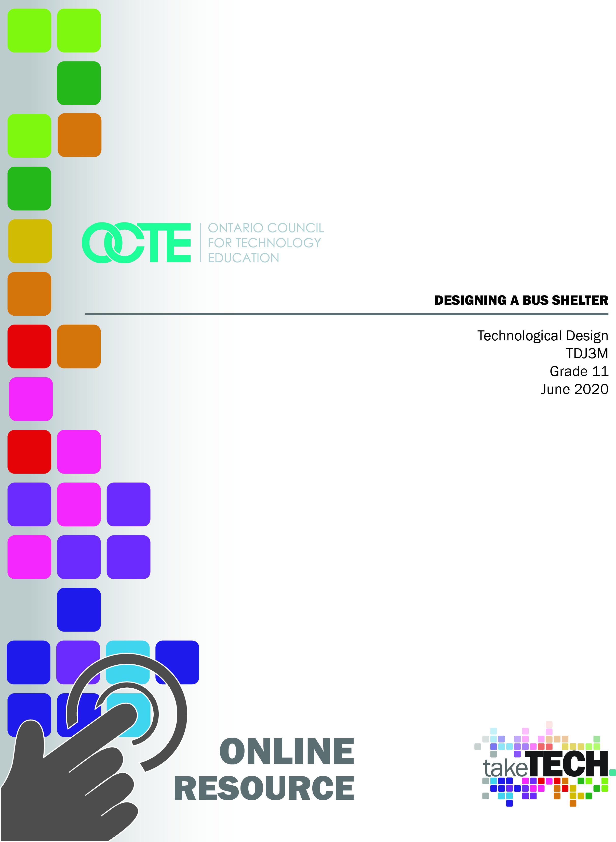

Table of Contents

Introduction 3
Project Outline 3
Prior Knowledge 3
Student Activities 3
Planning Notes / Organization / Procedure to carry out project 4
Resources/Lesson Plans 5
Activity One Lesson Plans: The Design Process 5
Design is a progressive process that follows a general course of 4 stages: 5
Thinking During The Design Process 5
Activity Two Lesson Plan: Design Brief and Researching 6
Project Design Brief 6
Activity Two Lesson Plan: Researching and Thinking 7
Activity Three Lesson Plan: Concept Sketches and Development 8
Scaled Floorplan Sketches (Possible Extension) 9
Bus Shelter Project: Student Exemplars 10
Getting Started with SketchUp for Web 11
SketchUp for Web Interface 11
Using SketchUp Instructor 12
Introducing Drawing Basics and Concepts in SketchUp 12
Activity Four and Lesson: Final Design 14
A Checklist 14
Orthographic Projection (Extension Design Principle) 14
Using SketchUp for Accuracy 15
Activity Five Lesson Plan: Career Exploration 16
Career Exploration: How to Become an Architect 16
Important Qualities 17
Canadian Universities with Architecture Programs 17
Other Programs related to Architecture 17
Career Exploration: Architects and Their Designs 18
Activity Six Lesson Plan: Reflection on your learning 19
Bus Shelter Project: A Reflection 19
Resources 20
Instructional Strategies 20
The Hook/Motivational Strategies 20
Learning Goals and Success Criteria 20
Overall and Specific Expectations 21
Overall Expectations 21
Specific Expectations 21
Challenges with the project (online versus in class) 21
Differentiation of the Project / Activity 22
Assessment & Evaluation 22
Religious Considerations / Links 21
Industry Extensions / Careers Exploration 23
Environmental Considerations 23
Reflection or Design Report 23
References 24

Introduction
Course Code: TDJ3M
Broad base Technology: Technological Design
Destination: University/College Preparation
Grade Level: 11
Prerequisite None
Online Project Name: Designing a Bus Shelter

Project Outline
By the end of this project, the student will be able to understand and work through the stages of the design process, assess and develop design criteria when creating concept and scaled sketches, and use computer design software (SketchUp 2020) to develop and refine a final product. As well, the student will become familiar with SketchUp 2020, and its capacity to produce a 3D CAD model that is accurate, precise and reflective of the intended design.

Prior Knowledge
Prior knowledge of basic math skills, units of measurement (Metric) and pencil sketching would be an asset.

Student Activities
- Students will be introduced to the Design Process and begin to understand it as a series of steps or stages necessary to complete a design project. Students will be asked to complete preliminary research for the purpose of analyzing existing designs.
- By thinking through the design process, students will understand the factors that are critical to making design decisions, which include marketing, ergonomics, manufacturing and aesthetics.
- Students will research and assess existing designs with these factors in mind, and brainstorm and innovate potential design features.
- Students will produce and develop concept sketches to explore their initial ideas for designs. They will learn, refine and practice the fundamentals of concept sketching.
- Students will specifically produce a series of pencil concept sketches to develop and transfer their ideas to paper, understanding that these concept sketches are a means of exploring possible solutions to design problem.
- Students will decide on a final design from their series of concept sketches, and formalize the chosen design by developing and refining formal characteristics. Potential Extension: Often, designers create models and prototypes of their final design to further explore and reconsider the design. Models and prototypes provide validation of design thinking, and if possible, students should be offered the opportunity to create a working model.
- Students will learn the difference between concept sketching and scaled sketching.
- Students will demonstrate their understanding of measurement, accuracy and precision by producing a scaled sketch of their chosen design on graph paper (preferably).
- Students will incorporate form, function and ergonomics into their design, as well as consider materials to be used and colour choices.
- Environmental consideration will be incorporated into students’ final designs.
- Students will use SketchUp Web 2020 to create the 3D CAD model of their design.
- Students will work through a practice SketchUp drawing task to learn the fundamentals of computer-assisted drawing, and understand the capabilities of SketchUp Web.
- Working from their concept and scaled sketches, students will produce their final design using SketchUp.
- Students will continue to refine the final design by referring to the design criteria as outlined in the design brief.
- Students will reference Student Exemplars and Checklists to assess, develop and refine their own work.
- Students will explore and research the career requirements of an Architect, and understand the educational and training pathways related to this design field.

Planning Notes / Organization / Procedure to carry out project
Today’s Technological Programs are exploring different instructional models that are more focused on the student. These instructional models, including project-based learning, are changing both the way students use class time and the way classrooms are designed. Increasingly, teachers are exploring inquiry models of learning which help students develop higher-order thinking and communication skills so important in today’s digitally interconnected world.
The strengths of project-based learning that is student-centered are well documented. Engaging and investing in this kind of learning empowers students to become better collaborators, communicators, critical thinkers and problem solvers. Most importantly, students who are given the opportunity to become self-directed take ownership of their learning.
The Bus Shelter Project, outlined in this document, is rooted in project-based learning and offers a holistic, student-centered instructional strategy for engaging students in this process.

Resources/Lesson Plans

Activity One Lesson Plans: The Design Process
The Design Process is an approach for breaking down a large project into manageable parts. Many professionals in design related fields use this process or one very similar to define the stages needed to work through each project. Like professional designers, you will also work through the Design Process to accomplish this task. The chart below shows the stages of the Design Process that you will be following.

Design is a progressive process that follows a general course of 4 stages:
Stages | Description
Research | Learning from previous research and analysis
Concept | Exploring for solutions to design problems
Development | Developing formal characteristics
Formalization | Completing working drawings, models and prototypes

Thinking During the Design Process
While working through the Design Process, you will not only be thinking about your design criteria, but also factors that may be critical when making design decisions. Consider the following factors:
Factors | Description
Marketing | This is knowledge of the company, the competitors,  the marketplace, the customers and pricing.
Ergonomics | This is the study of how humans behave in relation to  particular environments and products.
Manufacturing | Will the product be mass-produced? From which  materials? What manufacturing process will be used?
Aesthetics | Aesthetics refer to the visual attractiveness and  appeal of a product.

Activity Two Lesson Plan: Design Brief and Researching
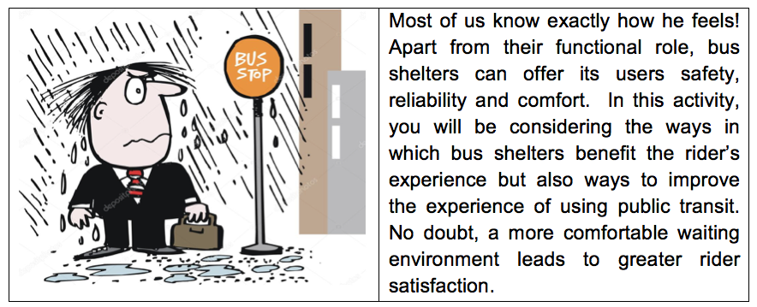

Project Design Brief
Objective: You will design and create a 3d CAD model of a bus shelter
Your Bus Shelter design must include the follow criteria:
Design Criteria | Specifications
Size | Consideration should be given to location and  population density
Seating | Proportional to size
Accessibility | Accommodate mobility issues
Materials to be used | Consider materials that are durable and cost  effective
Environmental | Solar panels, green roof options, etc.
Route Information | Schedule information, consider connectivity and  Wi-Fi options
Lighting | Interior and exterior, safety
Waste disposal | Garbage and recycling bins

In addition to the design criteria listed above, your finished 3D CAD model will include the following:
- Concrete base/pad
- Adjacent sidewalk
- Nearby streets
- People
- Cars
- Trees/planter
- Buildings

Activity Two Lesson Plan: Researching and Thinking
Internet searches are a great way of collecting information and/or possible design ideas. Search and explore different design structures and features that you could possibly include in your own design. While researching, think about the factors that make for a good design.
As you research for design ideas, consider the following questions:
- Does the design satisfy aspects of safety? (Visibility, lighting, weather protection, route schedules/information, etc.)
- Does the design provide for accessibility? (Seating, shared space, space for wheelchair, safe surfaces, pedestrian infrastructure, etc.)
- Does the design address environmental factors?
- Does the design integrate well with surroundings?
- Does the design offer unique features? (Bicycle infrastructure, amenities, etc.)

Activity Three Lesson Plan: Concept Sketches and Development
Concept sketches are freehand drawings that are used by designers as a quick and simple way of exploring initial ideas for designs. Consider the following requirements for these concept sketches:
- You should have a minimum of 7 - 10 sketches of possible designs.
- Concept Sketches are drawn freehand.
- These can be completed in pencil or marker (not pen).
- Concept Sketches are not drawn to scale.
- Include any notes of functions or features not evident by the sketch.
From your concept sketches, select one that will become your final design. Consider the following requirements for your chosen concept sketch:
- Work to develop and enhance this concept sketch.  - Colour the chosen sketch.  - Colours in the sketch should reflect the final design as much as possible, including the actual materials (ie) wood, plastics, metals.  - Again, you may use markers or pencil crayons.  - Consider student exemplars for further ideas.  - Consider your own concept sketches for further ideas. | Sample Concept Sketches of Bus Shelter Designs  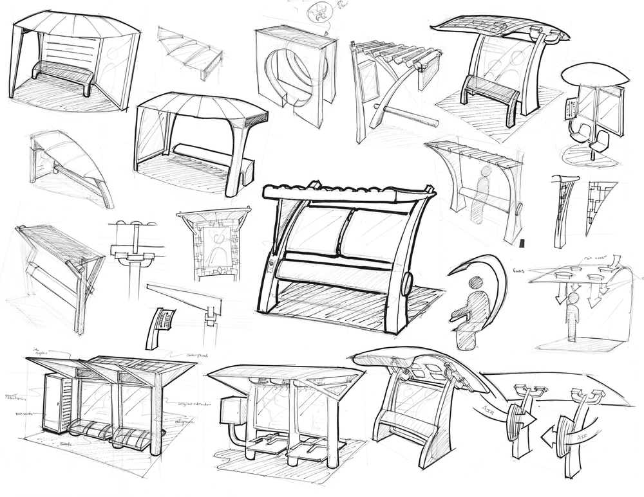

Scaled Floorplan Sketches (Possible Extension)
A scaled drawing or floorplan is a representation of an actual object or space drawn in two-dimensions. For a floorplan, you can imagine that you are directly above the building looking down. The lines represent the walls of the building, and the space in between the lines represents the floor.
- All scaled floorplan sketches are to be completed on graph paper (supplied).
- Each scaled sketch will be drawn at ½”= 1 ft. scale.
- Scale, set square, circle/ellipse templates, French curve and compass should be used to produce an accurate and precise floorplan sketch.
- The sketches will also include the overall dimensions.
- Scaled sketches are produced in pencil only.
The image on the left is an example of a scaled sketch of a bus shelter floorplan. This scaled sketch was then used to produce the SketchUp drawing, shown on the right.
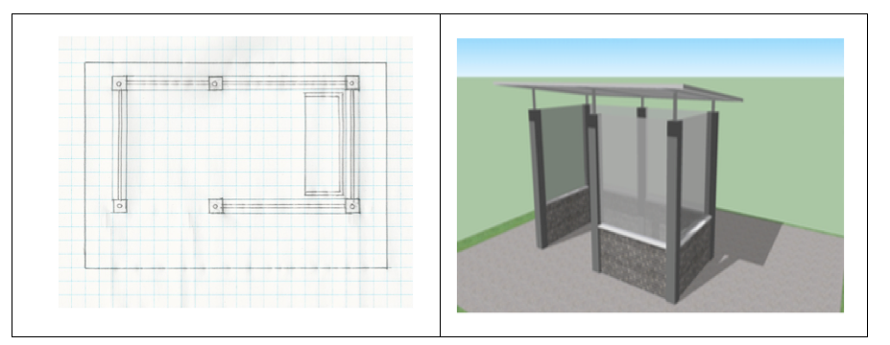

Bus Shelter Project: Student Exemplars
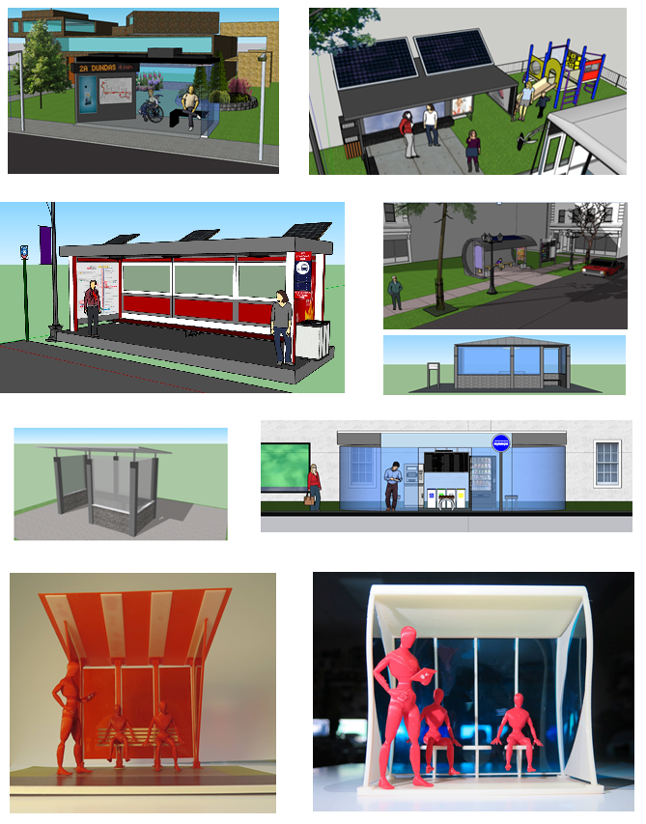
A Possible Extension: 3D Printed Project

Getting Started with SketchUp for Web
Ready to start creating, editing and viewing models in SketchUp for Web? Let us look at what you will need in order to start using SketchUp for Web, including the web-browser and devices-support details.
To start using SketchUp for Web, you need the following:
- A SketchUp ID for signing in
- An Internet connection
- A computer or Chromebook
Tip: SketchUp is best suited for mouse and keyboard interaction. Use a three-button, scroll-wheel mouse for easy orbiting, zooming, and precision positioning while modeling.

SketchUp for Web Interface
In the following figure, you can see what SketchUp for Web looks like when you first open the program in your web browser. The numbers in the figure correspond to the numbers in the following list:
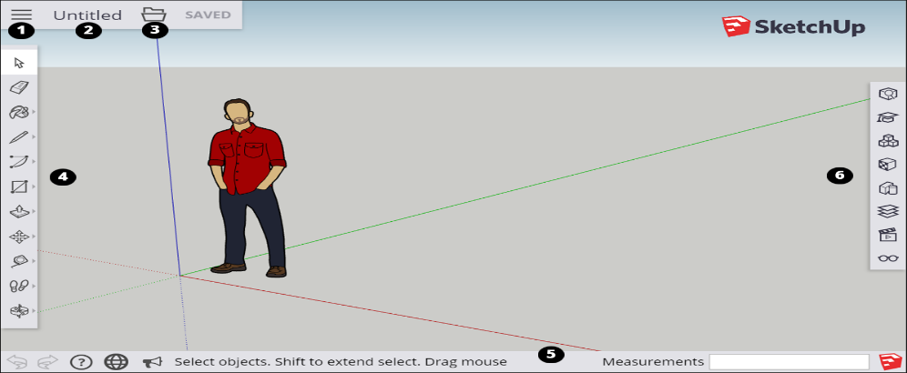
- Open/Model Preferences Icon: When you click this icon in the upper-left, a sidebar opens where you find an About SketchUp section, your account information, templates for creating new models, and a link to upload your model to 3D Warehouse.
- Model Name: Click Untitled to save your model to Trimble Connect.
- File Operations Icon: Click this icon to open a new or existing file or save your model as a new file.
- Toolbar: This toolbar contains the tools you need to create 3D models.
- Status Bar: From left to right, you find the Uno/Redo buttons, a link to the Help Center, a language menu, a link to the SketchUp Forums, tips and options for the selected tool, and the Measurements box for modeling accurately.
- Panels: Click these icons to access panels for entity information, the Instructor, components, materials, styles, layers, views, and display. Tip: If you are not certain what a tool is, hover over the tool and a ScreenTip appears. When you select a tool, a brief note about what it does or the options available for that tool appear in the status bar. You can also find help by opening the Instructor panel.

Using SketchUp Instructor
If you are new to SketchUp, then the SketchUp Instructor is a great resource for mastering this software.
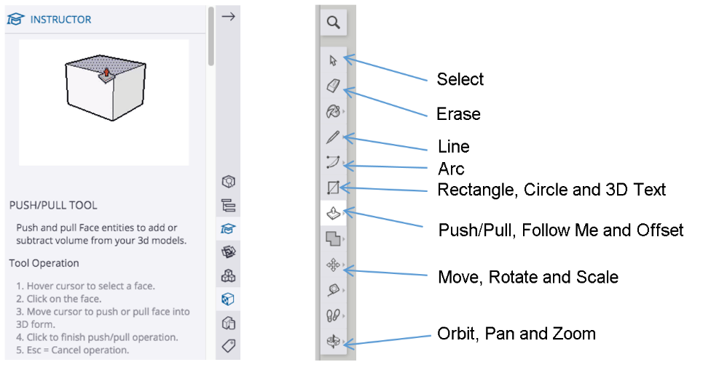

Introducing Drawing Basics and Concepts in SketchUp
Introducing drawing basics to students using SketchUp for the first time can be achieved by using the link to Introducing Drawing Basic and Concepts

SketchUp Practice Drawing Task
In this next task, you will work on your practice drawing to improve your skills. This task will allow you to try out a range of different ideas that will help lead to your final design. In this stage, designers express and get as many initial ideas down on paper – however in a much simpler form. Practice the drawing below to reinforce and master the fundamental tools that you will be using to create your bus shelter.

Tip: SketchUp provides a “Reference Card” that highlights important tools you will use while completing this project.
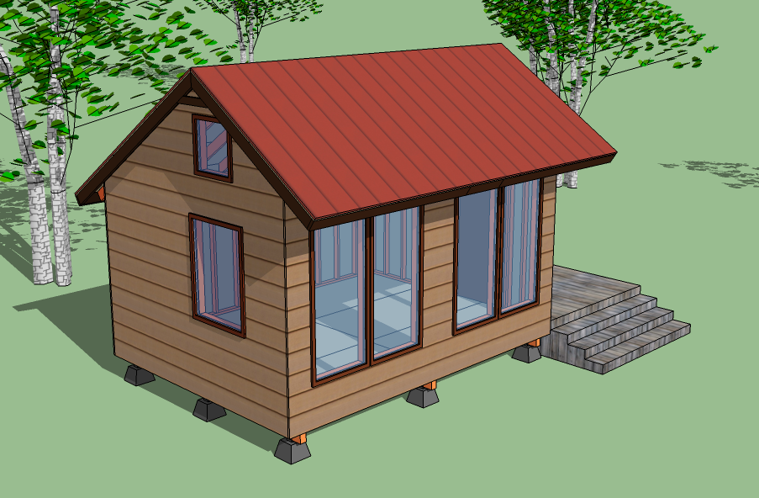
The Reference Card looks somethings like this,
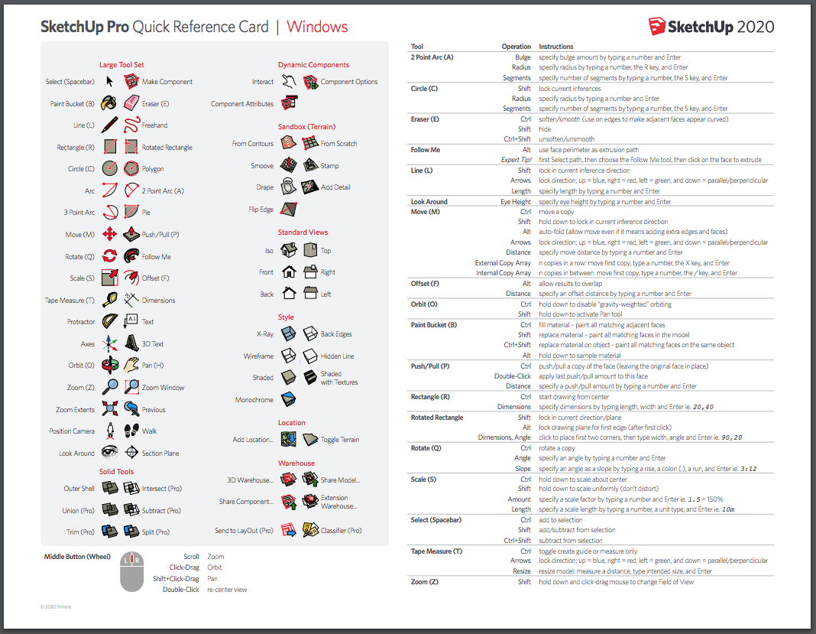

Activity Four and Lesson: Final Design
Once the research, concept pencil sketches and practice SketchUp drawing are completed, you are now ready to enter the final stage of designing your bus shelter. At this stage, you will work to refine your final SketchUp drawing. The ability to refine and improve the final product often determines the success of designers and their designs. The following checklist may help you develop your design choices, which may help you execute your best ideas.

A Checklist
- Does your final design fulfill the criteria as outlined in the design brief? Be sure to check the design brief often during this stage.
- Consider and assess the aesthetic choices that you have made to your final design. Do these choices work or might you have to explore other options?
- Return to your original concept sketches. Are there any design elements that can be included to enhance your overall design?
- Have you altered features that do not serve the design?
- Have you highlighted features that absolutely work in your design?

Orthographic Projection (Extension Design Principle)
Orthographic projection is a means of representing a three-dimensional (3D) object in two dimensions (2D). It projects multiple views of the object by rotating the object about its center through increments of 90°. An orthographic view describes an object completely and helps designers create orthographic drawings.
An orthographic drawing is a clear, detailed way to represent the image of an object. Engineers, designers, architects, and technical artists use orthographic drawings to help a manufacturer understand the specifics of a product.
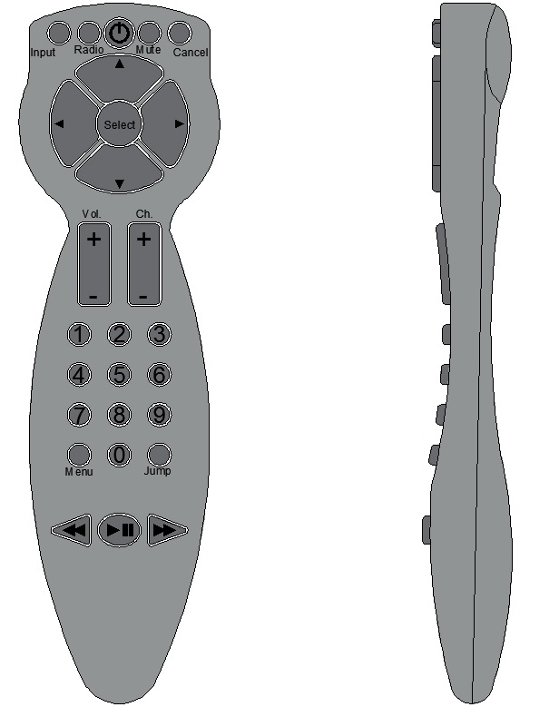
Front View Right Side View

Using SketchUp for Accuracy
Whenever you are drawing or creating geometry, SketchUp gives you the opportunity to be as accurate as you need to be. SketchUp has the capability of drawing your bus shelter to your specific measurements. For example, if you choose to have a 3D rectangle that is 150 mm long and 60 mm wide, and with a thickness of 15 mm, you can be produced in SketchUp. You can draw a line in SketchUp; determine the length of that line, simply by typing in the dimension on your keyboard, and pressing enter.
To see this in action, refer to this SketchUp video link.
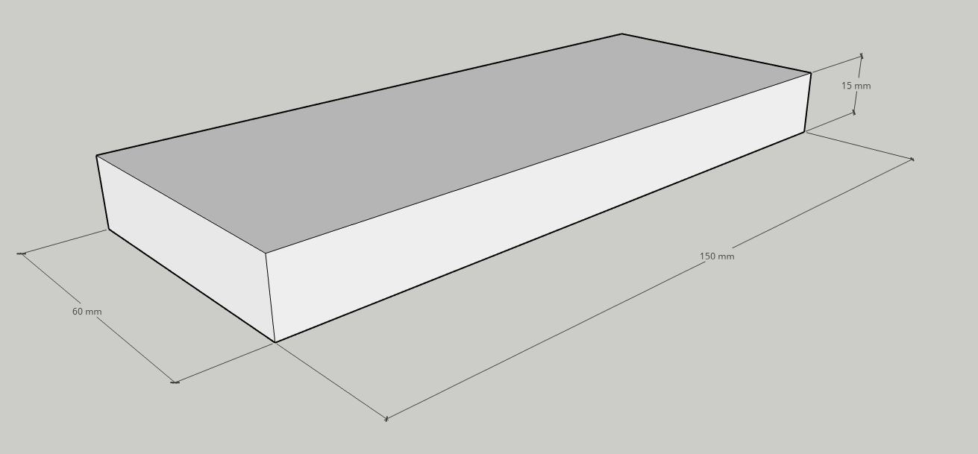
The above image illustrates SketchUp’s capacity to include measurements and dimensions for accuracy.

Activity Five Lesson Plan: Career Exploration

Career Exploration: How to Become an Architect
What Architects Do?
Architects plan and design houses, office buildings, and other structures.
Work Environment
Architects spend much of their time in offices, where they meet with clients, and consult with engineers and other architects. They also visit construction sites to review the progress of projects.
How to Become an Architect
There are typically three main steps to becoming a licensed architect: completing a professional degree in architecture, gaining relevant experience through a paid internship, and passing the Architect Registration Exam.
Education
Earning a professional degree in architecture is the typical path to becoming an architect. Most architects earn their professional degree through a 5-year Bachelor of Architecture degree program, intended for students with no previous architectural training. Many earn a master’s degree in architecture, which can take 1 to 5 years to complete, depending on the extent of the student’s previous training in architecture.
A typical program includes courses in architectural history and theory, building design with an emphasis on computer-aided design and drafting (CAD), structures, technology, construction methods, professional practices, math, physical sciences, and liberal arts. Central to most architectural programs is the design studio, where students apply the skills and concepts learned in the classroom to create drawings and three-dimensional models of their designs.
Training
Most new graduates complete their training period by working at architectural firms —before they may sit for the Architect Registration Exam.
Interns in architectural firms may help design part of a project. They may help prepare architectural documents and drawings, build models, and prepare construction drawings on CAD. Interns may also research building codes and write specifications for building materials, installation criteria, the quality of finishes, and other related details.
Licenses, Certifications, and Registrations
Architects are required to be licensed. Licensing requirements typically include completing a professional degree in architecture, gaining relevant experience through a paid internship, and passing the Architect Registration Exam.

Important Qualities
Analytical skills. Architects must understand the content of designs and the context in which they were created. For example, architects must understand the locations of mechanical systems and how those systems affect building operations.
Communication skills. Architects share their ideas; both in oral presentations and in writing, with clients, other architects, and workers who help prepare drawings. Many also give presentations to explain their designs.
Creativity. Architects design the overall look of houses, buildings, and other structures. Therefore, the final product should be attractive and functional.
Organizational skills. Architects often manage contracts. Therefore, they must keep records related to the details of a project, including total cost, materials used, and progress.
Technical skills. Architects use computer-aided design and drafting (CAD) technology to create plans as part of integrated building information modeling.
Visualization skills. Architects must be able to see how the parts of a structure relate to each other. They also must be able to visualize how the overall building will look once completed.

Canadian Universities with Architecture Programs
- University of British Columbia
- University of Calgary
- University of Manitoba
- University of Toronto
- Ryerson University
- Carleton University
- Laurentian University
- McGill University
- University de Montreal
- Laval University
- Dalhousie University

Other Programs related to Architecture
- Industrial Design
- Interior Design Programs
- Landscape Architecture
- Urban Planning Programs
- Architectural History/Heritage/Conservation Programs
- Art History Departments (with Design or Architectural History)
- Architectural Technology

Career Exploration: Architects and Their Designs
Students will be asked to research a famous structure or building anywhere in the world. The teacher may begin the class by inviting students to brainstorm and list famous structures around the world. This will pique the interest of students. Students will be asked to research a building of choice, and explore the significance of the structure. The teacher will determine how the student will present the information to classmates. To facilitate students in their research, they will be asked to work through the following prompts:
(Possible List: CN Tower, Parliament Buildings of Canada, Empire State Building, Golding Gate Bridge, London Bridge, Eiffel Tower, Sydney Opera House, The Blue Mosque, Leaning Tower of Pisa, Angkor Wat, etc.)
- Identify the building. (name, location, and year in which it was built)
- Offer a brief history of the building. How have history, trends, culture and geography contributed to its design?

- Who was the architect? Offer a brief background.
- What other buildings or structures is this architect known for?
- How does the structure and geometric shape of this building contribute to its overall aesthetics?
- Identify the materials used in the construction of the building that make it so unique. Where did these materials come from?

- In what ways do the people who live in the same community use the building?

Activity Six Lesson Plan: Reflection on your learning

Bus Shelter Project: A Reflection
Reflecting on your learning allows you to understand your strengths as a student, and the connections that you are making to assignments, like this Bus Shelter Project. Use the following prompts to reflect on your Bus Shelter Project experience (and what you have learned from it).
- Identify two ideas that you discovered or acquired during the bus shelter project that you did not know before.
- Identify two skills that you acquired during this project that may assist you in your future.
- Do you think learning new technologies, like SketchUp, are important? Offer two reasons to support your response.
- What did you do really well on this assignment?
- What might have you done differently on this assignment?
- What is your best suggestion for improving this project?

Resources
Resources such as handouts, pictures, blueprints, etc., are embedded throughout this document. Additional resources include,
Tools/Equipment - Pencils, graph paper, ruler
Software - SketchUp 2020 Web
Videos
Best Way to Learn SketchUp from Scratch
SketchUp Tutorial for Beginners

Websites for Teachers:
ArchDaily
Azure Magazine
Project for Public Spaces – Bus Shelters

Instructional Strategies
Teachers may use any of the following instructional strategies as they see fit; 3-Part lesson, lecture, storyboard, word wall, think-pair-share, placemat activity, rapid write, K-W-L, anticipation chart, ABC taxonomy, think aloud, analyzing text, Cornell note taking, exit ticket/ticket out the door, plus/minus/delta,

The Hook/Motivational Strategies
Apart from their functional role, bus shelters can offer its users safety, reliability and comfort. In this activity, you will be considering the ways in which bus shelters benefit the rider’s experience but also ways to improve the experience of using public transit. No doubt, a more comfortable waiting environment leads to greater rider satisfaction.

Learning Goals and Success Criteria
By moving through the design process, students will think critically about design, develop and refine design concepts, demonstrate technical literacy by using computer design software, produce an original product and assess their own learning.

Overall and Specific Expectations in Support of Ontario Curriculum Grades 11 -12 Technological Education

Overall Expectations
A1 Demonstrate an understanding of factors and relationships that affect technological design and the design process;
B2 Apply appropriate methods for generating and graphically representing design ideas and solutions;
D2. Identify career opportunities in fields related to technological design, and describe the training and education required for these careers.

Specific Expectations
A1.2 Identify the steps in the design process (e.g., define the problem or challenge, taking into account relevant contextual or background information; gather information about criteria, constraints, and available materials; generate possible solutions, using techniques such as brainstorming; choose the best solution; develop and produce a model or prototype; test the model or prototype; incorporate improvements or redesign and retest; report results) (see pp. 22–23), and demonstrate an understanding of the relationships among the steps (e.g., prototype testing can show that more idea development is needed);
B2.1 Use freehand sketches to help brainstorm initial design concepts for a project;
B2.5 Apply principles and elements of graphic design to enhance design ideas in concept drawings and/or presentation-quality drawings.
D2.2 Describe the educational and training pathways (i.e., selection of secondary and postsecondary courses, programs, and learning experiences) and entry requirements (e.g., portfolio, internship) for careers related to technological design;

Challenges with the project (online versus in class)
- Students who use Chromebooks may have some issues with the reliability of SketchUp 2020 Web.
- Students may lack some of the necessary drawing instruments and graph paper.

Differentiation of the Project / Activity
Accommodations do not change the content of the learning expectations, but they should take into account the student’s preferred learning modality and areas of strength and need, and should provide students with appropriate opportunities to demonstrate their learning. Some accommodations may include modifying the project requirements, replacing the computer design component with pencil drawings, providing a quiet work space, having a tutor or a teacher-assistant facilitate project work, and scribing and recording the student’s verbatim responses should be considered. (Refer to the Differentiation Scrapbook to take into account for learner ability, multiple intelligences, exceptional students, ESL learners)

Assessment & Evaluation

Technological Design SketchUp Assessment Rubric
Criteria | Level 1  (50-59%) | Level 2  (60-69%) | Level 3  (70-79%) | Level 4  (80-100%)
Knowledge/  Understanding  Design criteria | Demonstrates a limited understanding of design criteria | Demonstrates some understanding of design criteria | Demonstrates considerable understanding of design criteria | Demonstrates high degree of understanding of design criteria
Thinking  Level of detail in final design | Uses thinking skills to demonstrate level of detail in final design with limited effectiveness | Uses thinking skills to demonstrate level of detail in final design with some effectiveness | Uses thinking skills to demonstrate level of detail in final design with considerable effectiveness | Uses thinking skills to demonstrate level of detail in final design with a high degree of effectiveness
Communication  Aesthetics and appearance of final design (materials, colour choice, amenities, etc.) | Communicates overall aesthetics and appearance of final design with limited effectiveness | Communicates overall aesthetics and appearance of final design with some effectiveness | Communicates overall aesthetics and appearance of final design with considerable effectiveness | Communicates overall aesthetics and appearance of final design with a high degree of effectiveness
Application  Use and application of SketchUp in final design | Uses and applies SketchUp with limited effectiveness in final design | Uses and applies SketchUp with some effectiveness in final design | Uses and applies SketchUp with considerable effectiveness in final design | Uses and applies SketchUp with a high degree of effectiveness in final design
Comments:

Religious Considerations / Links

Working toward Catholic Graduate Expectations:
3. A Reflective, Creative and Holistic Thinker Who:
(c) Thinks reflectively and creatively to evaluate situations and solve problems.
4. A Self-Directed, Responsible, Lifelong Learner Who:
(b) Demonstrates flexibility and adaptability.
(f) Applies effective communication, decision-making, problem-solving, time and resource management skills.
7. A Responsible Citizen Who:
(i) Respects the environment and uses resources wisely.

Industry Extensions / Careers Exploration
Industry and career exploration is incorporated in Activity Five: Career Exploration.

Environmental Considerations
Consideration for the end product and utilization of recycled materials should be incorporated into the design elements. Teachers may make it a project requirement of each bus shelter if they wish.

Reflection or Design Report
Teachers may wish to have the students complete a design report, reflection or create a foldable to consolidate their learning. This would be a nice way to capture the student’s understanding in a summative format and be used in preparation for their examination, entering post-secondary education or the workforce. See Activity Six: A Reflection, for more information.

References
21st Century Competencies: Foundation Document for Discussion. Phase 1: Towards Defining 21st Century Competencies for Ontario, Winter 2016 Edition, 2016 http://www.edugains.ca/resources21CL/About21stCentury/21CL_21stCenturyCompetencies.pdf
ArchDaily (website), 2020 https://www.archdaily.com/
Azure Magazine (website), 2020 https://www.azuremagazine.com/
Best Way to Learn SketchUp from Scratch (video), https://forums.sketchup.com/t/best-way-to-learn-sketchup-from-scratch/52391
Business Executive Waiting Rain (image) https://www.shutterstock.com/image-vector/vector-cartoon-business-executive-waiting-rain-247961005
Course Codes for Emphasis courses in the Revised Curriculum: Technological Education, Grades 11 and 12, 2009 http://www.edu.gov.on.ca/eng/curriculum/secondary/techedemphasiscourses.pdf
Drawing accurately SketchUp video (video), https://mastersketchup.com/drawing-accurately-sketchup
Getting Started, SketchUp (image), 2020 https://help.sketchup.com/en/sketchup-web/getting-started-sketchup-web
Growing Success: Assessment, Evaluation, and Reporting in Ontario Schools, First Edition, Covering Grades 1 to 12, 2010 www.edu.gov.on.ca/eng/policyfunding/growSuccess.pdf
Introducing Drawing Basics and Concepts https://help.sketchup.com/en/sketchup/introducing-drawing-basics-and-concepts
Learning for All – A Guide to Effective Assessment and Instruction for All Students, Kindergarten to Grade 12, 2013 http://www.edu.gov.on.ca/eng/general/elemsec/speced/LearningforAll2013.pdf
Project for Public Spaces: Bus Shelters (webpage), 2008 https://www.pps.org/article/busshelters
SketchUp Pro Quick Reference Card, SketchUp, 2020 https://download.flexnetoperations.com/439214/1540/57/15473057/HC-QRC2020-SU-W-v01.pdf?ftpRequestID=7818752907&server=download.flexnetoperations.com&dtm=DTM20200623012529NjYxODkxNjU5&authparam=1592900729_ff900b05539cf50522cece55c688c882&ext=.pdf
SketchUp Tutorial for Beginners (video), https://www.youtube.com/watch?v=UsHRGDvN4sM
The Ontario Curriculum, Grades 9 and 10: Technological Education, 2009 (revised) http://www.edu.gov.on.ca/eng/curriculum/secondary/teched910curr09.pdf
The Ontario Curriculum, Grades 11 and 12: Technological Education, 2009 (revised) http://www.edu.gov.on.ca/eng/curriculum/secondary/2009teched1112curr.pdf
Tiny house (image) https://senaterace2012.com/26-spectacular-google-house-plans/google-sketchup-archives-tiny-house-design/

