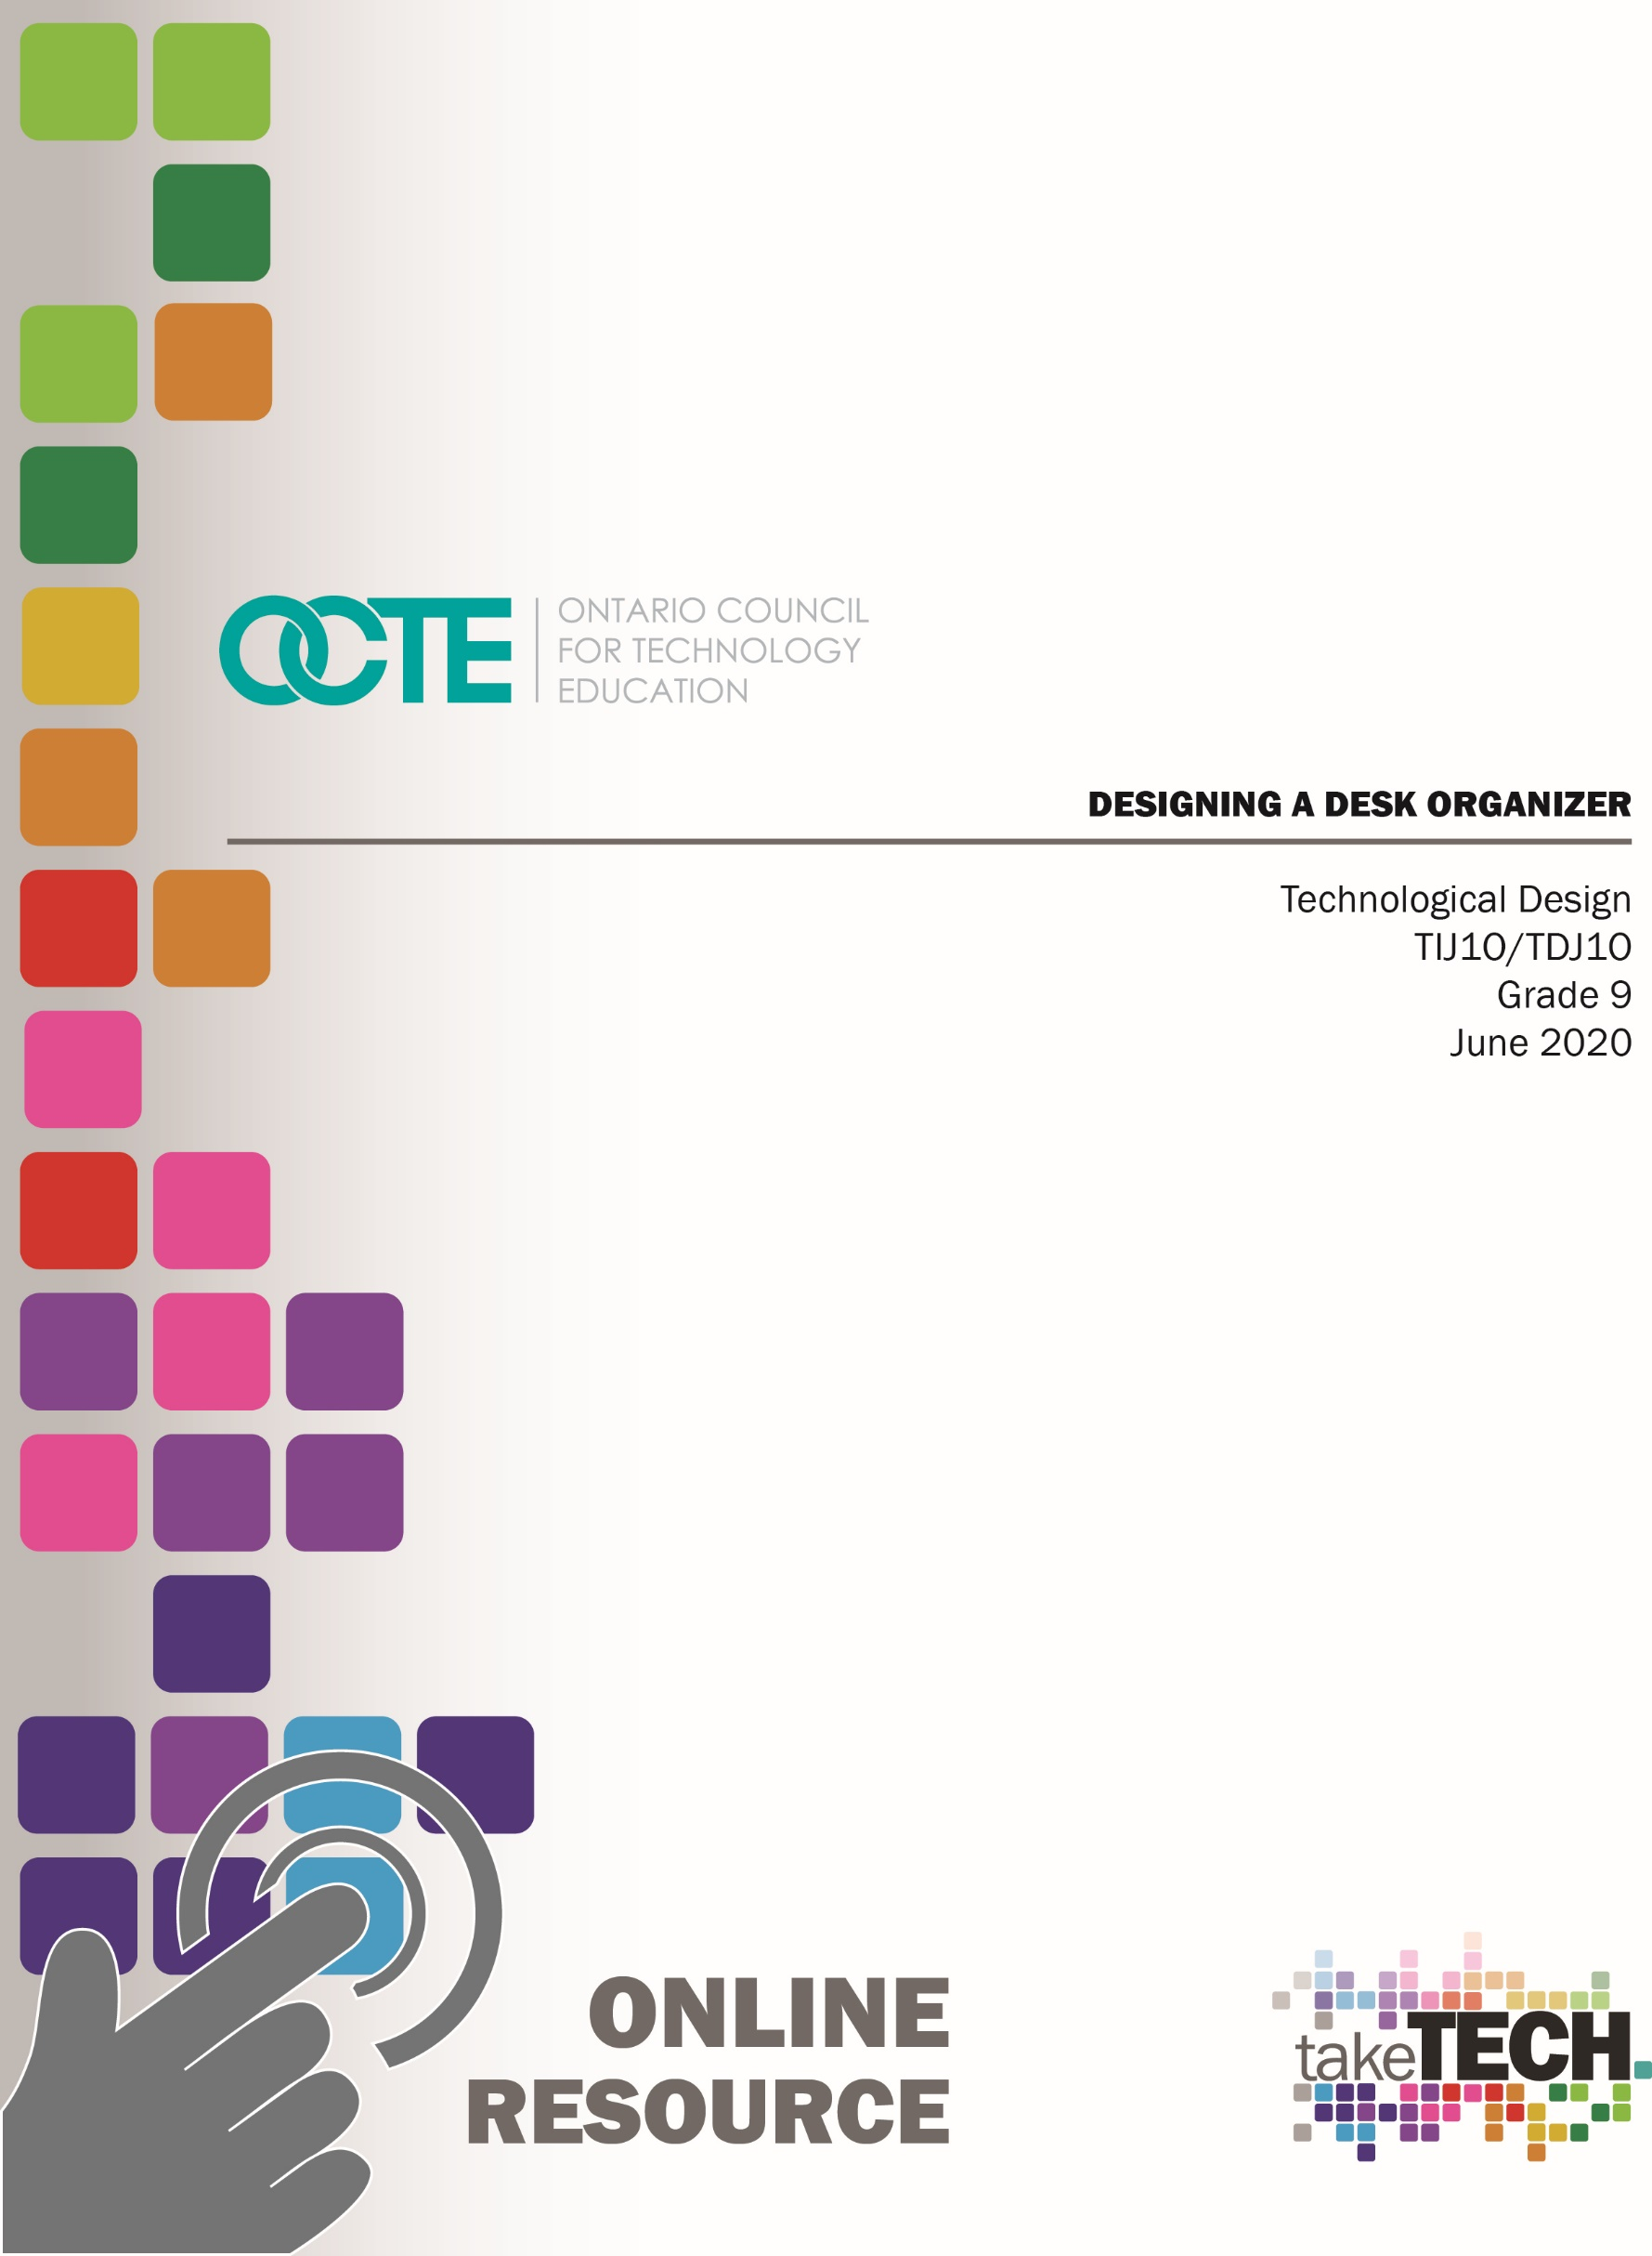

Table of Contents

Introduction 3
Project Outline 3
Prior Knowledge 3
Student Activities 3
Planning Notes 4
Resources/Lesson Plans 5
Activity 1 – The Design Process 5
Thinking During the Design Process 5
Activity 2 – Design Brief, Researching and Brainstorming 6
The Design Brief 6
Activity 3 – Concept Sketches and Development 8
Desk Organizer Project: Student Exemplars 9
A Possible Extension: 3D Printed Project 9
Getting Started with SketchUp for Web 10
SketchUp for Web Interface 10
Using SketchUp Instructor 11
SketchUp Practice Drawing Task 11
The Reference Card for Google Sketchup 12
Activity 4 – Final Design 14
Using SketchUp for Accuracy 14
Activity 5 – Career Exploration 15
Career Exploration Task 18
Activity 6 – Reflection on your learning 20
Desk Organizer Project: A Reflection 20
Resources 21
Motivational Strategies 21
Learning Goals and Success Criteria 21
Overall and Specific Expectations 22
Overall Expectations: 22
Specific Expectations: 22
Safety Concerns and Expectations 24

Applicable SAFEDocs and ToolSAFE videos 24
Differentiation of the Project / Activity 24
Career and Industry Extensions 24
Environmental Considerations 24
Reflection / Design Report 24
References 25

Introduction
Course Code: TIJ1O / TDJ1O
Broad base Technology: Exploring Technologies and Technological Design
Destination: Open
Grade Level: 9
Online Project Name: Designing a Desk Organizer

Project Outline
By the end of this project the student will be able to understand and work through the stages of the design process, assess and develop design criteria when creating concept and scaled sketches, and use computer design software (SketchUp 2020) to develop and refine a final product. As well, the student will become familiar with SketchUp 2020, and its capacity to produce a 3D CAD model that is accurate, precise and reflective of the intended design

Prior Knowledge
Prior knowledge of basic math skills, units of measurement in the Metric system and pencil sketching would be an asset.

Student Activities
- Students will be introduced to the design process and begin to understand it as a series of steps or stages necessary to complete a design project. Students will be asked to complete preliminary research for the purpose of analyzing existing designs.
- By thinking through the design process, students will understand the factors that are critical to making design decisions, which include marketing, ergonomics, manufacturing and aesthetics.
- Students will research and assess existing designs with these factors in mind, and brainstorm and innovate potential design features.
- Students will produce and develop concept sketches to explore their initial ideas for designs. They will learn and practice the fundamentals of concept sketching.
- Students will specifically produce a series of pencil concept sketches to develop and transfer their ideas to paper, understanding that these concept sketches are a means of exploring possible solutions to design problem.
- Students will decide on a final design from their series of concept sketches, and formalize the chosen design by developing and refining formal characteristics.
Potential Extension: Often, designers create models and prototypes of their final design to further explore and reconsider the design. Models and prototypes provide validation of design thinking, and if possible, students should be offered the opportunity to create a working model.
- Students will learn the difference between concept sketching and scaled sketching.
- Students will demonstrate their understanding of measurement, accuracy and precision by producing a scaled sketch of their chosen design on graph paper (preferably).
- Students will use SketchUp Web 2020 to create the 3D CAD model of their design.
- Students will work through a practice SketchUp drawing task to learn the fundamentals of computer-assisted drawing, and understand the capabilities of SketchUp Web.
- Working from their concept and scaled sketches, students will produce their final design using SketchUp.
- Students will continue to refine the final design by referring to the design criteria as outlined in the design brief.
- Students will reference Student Exemplars to assess, develop and refine their work.
- Students will reference Student Exemplars and Checklists to assess, develop and refine their own work.
- Students will use Checklists to assess, develop and refine their own work.
- Students will explore and research the career requirements of an Industrial Designer, and understand the skills required for such a career.
- Students will complete a Reflection, which will allow them to understand their strengths as a student, and the connections that they have made to the project. They will use prompts and questions to reflect on this experience and what they have learned from it.

Planning Notes
Today’s Technological Programs are exploring different instructional models that are more focused on the student. These instructional models, including project-based learning, are changing both the way students use class time and the way classrooms are designed. Increasingly, teachers are exploring inquiry models of learning which help students develop higher-order thinking and communication skills so important in today’s digitally interconnected world.
The strengths of project-based learning that is student-centered are well documented. Engaging and investing in this kind of learning empowers students to become better collaborators, communicators, critical thinkers and problem solvers. Most importantly, students who are given the opportunity to become self-directed take ownership of their learning.
The Desk Organizer Project, outlined in this document, is rooted in project-based learning and offers a holistic, student-centered instructional strategy for engaging students in this process.

Resources/Lesson Plans

Activity 1 – The Design Process
The Design Process is an approach for breaking down a large project into manageable parts. Many professionals in design related fields use this process or one very similar to define the stages needed to work through each project. Like professional designers you will also work though the Design Process to accomplish this task. The chart below shows the stages of the Design Process that you will be following.
Design is a progressive process that follows a general course of 4 stages:
Stages | Description
Research | Learning from previous research and analysis
Concept | Exploring for solutions to design problems
Development | Developing formal characteristics
Formalization | Completing working drawings, models and prototypes

Thinking During the Design Process
While working through the Design Process, you will not only be thinking about your design criteria, but also factors that may be critical when making design decisions. Consider the following factors:
Factors | Description
Marketing | This is knowledge of the company, the competitors, the marketplace, the customers and pricing.
Ergonomics | This is the study of how humans behave in relation to particular environments and products.
Manufacturing | Will the product be mass-produced? From which materials? What manufacturing process will be used?
Aesthetics | Aesthetics refer to the visual attractiveness and appeal of a product.

Activity 2 – Design Brief, Researching and Brainstorming
With so many of us studying and working from home, who doesn’t need a little help with organizing and storing our desk tools and essentials? Keeping a workstation clean and clear of any unnecessary clutter is possible with the help of desk organizers. Desk organizers are important storage caddies that store and display what you need at a moment’s notice, like post-it-notes, writing utensils, USBs and other electronic devices. Remember what Ben Franklin said – For every minute spent in organizing, an hour is earned!
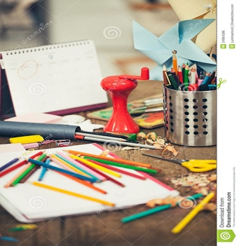

The Design Brief

Objective:
You will design and create a 3D CAD model of a desk organizer.

Design Criteria
Your desk organizer design must include the following:
- A base organizer that should not exceed 200 mm (length) x 100 mm (width) x 10 mm (thickness)
- Designated areas for at least five different items of your choice
- You may consider including your name or a logo in 3D text

Project Requirements:
- Research existing desk organizers
- Brainstorming and listing of possible desk items to be included in design
- Concept Sketching – developing different ideas
- Scaled Sketching SketchUp 3D drawing of final design

CAD Software:
- SketchUp App 2020

Researching
Internet searches are a great way of collecting information and/or possible design ideas. Search and explore different design structures and features that you could possibly include in your own design. While researching, think about the factors that make for a good design.

Brainstorming
Brainstorm a list of possible items that can customize your desk organizer. Work toward a list of ten to twelve items. Here are some examples that you can consider for your desk organizer:
- Electronic devices
- Writing tools and art supplies
- Personal items like a wallet, keys, glasses etc.

Activity 3 – Concept Sketches and Development
Concept sketches are freehand drawings that are used by designers as a quick and simple way of exploring initial ideas for designs. Consider the following requirements for these concept sketches:
- You should have a minimum of 7 - 10 sketches of possible designs.
- Concept Sketches are drawn freehand.
- These can be completed in pencil or marker (not pen).
- Concept Sketches are not drawn to scale.
- Include any notes of functions or features not evident by the sketch.
From your concept sketches, select one that will become your final design. Consider the following requirements for your chosen concept sketch:
- Work to develop and enhance this concept sketch.
- Colour the chosen sketch.
- The colours in the sketch should reflect the final design as much as possible including the actual materials i.e. Wood/Plastics/Metals.
- Again, you may use markers or pencil crayons.
- Consider student exemplars for further ideas.
Below is an example of concept sketches, which explore desk organizer design possibilities:
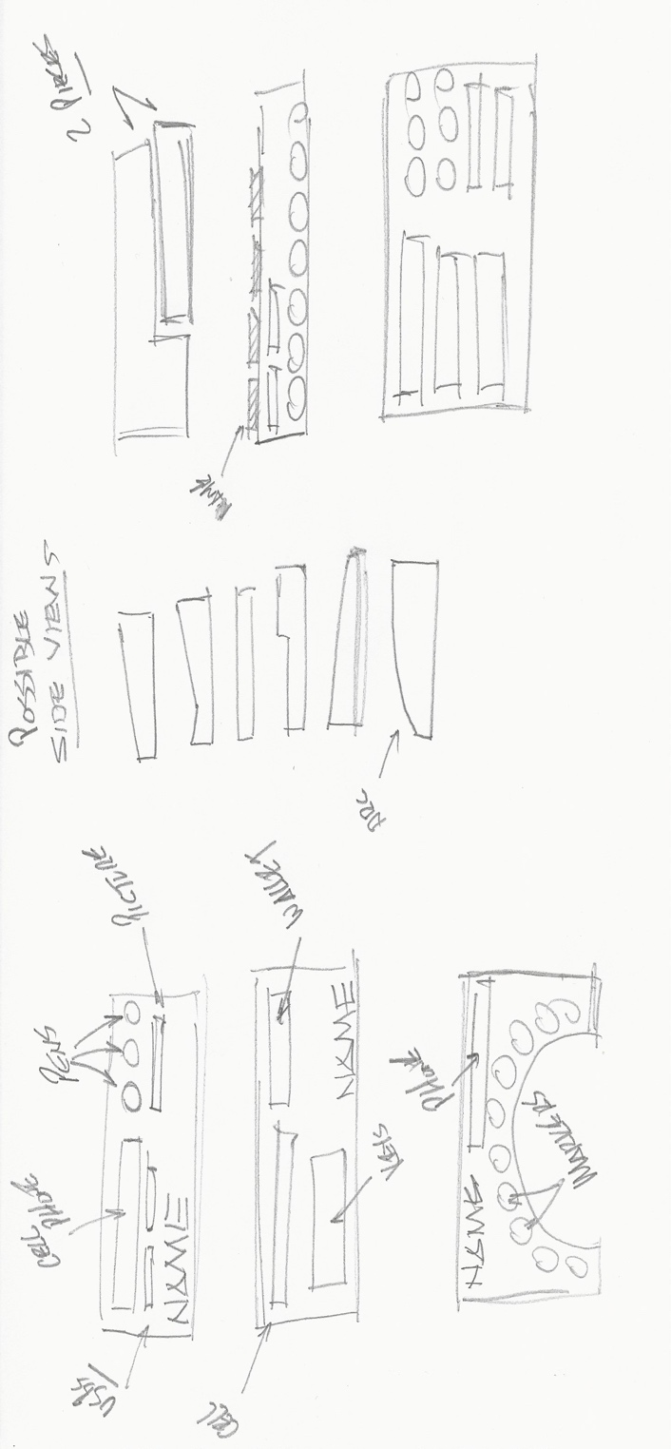

Desk Organizer Project: Student Exemplars
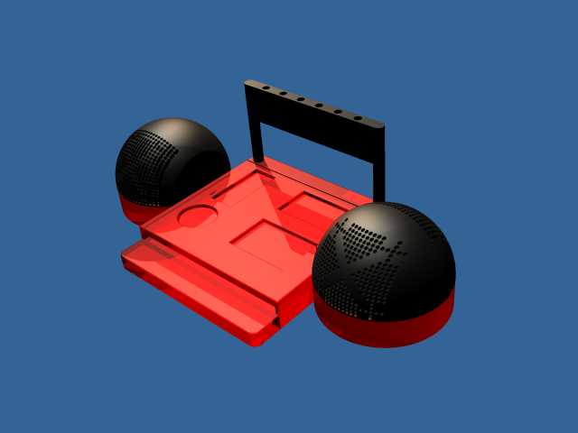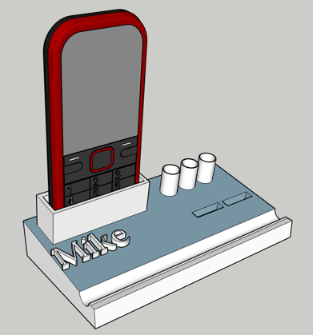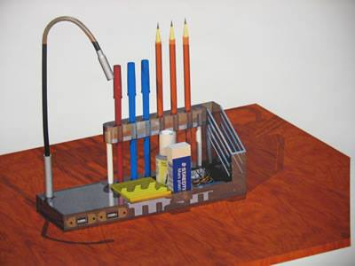
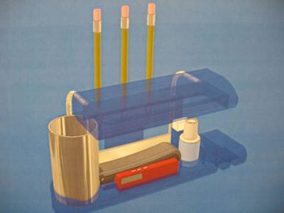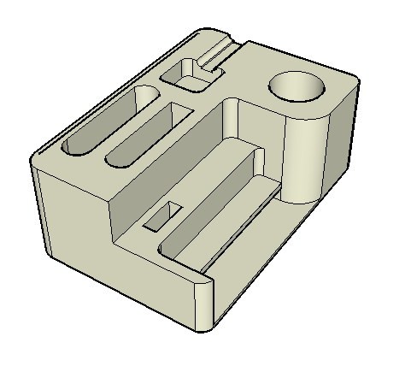

A Possible Extension: 3D Printed Project
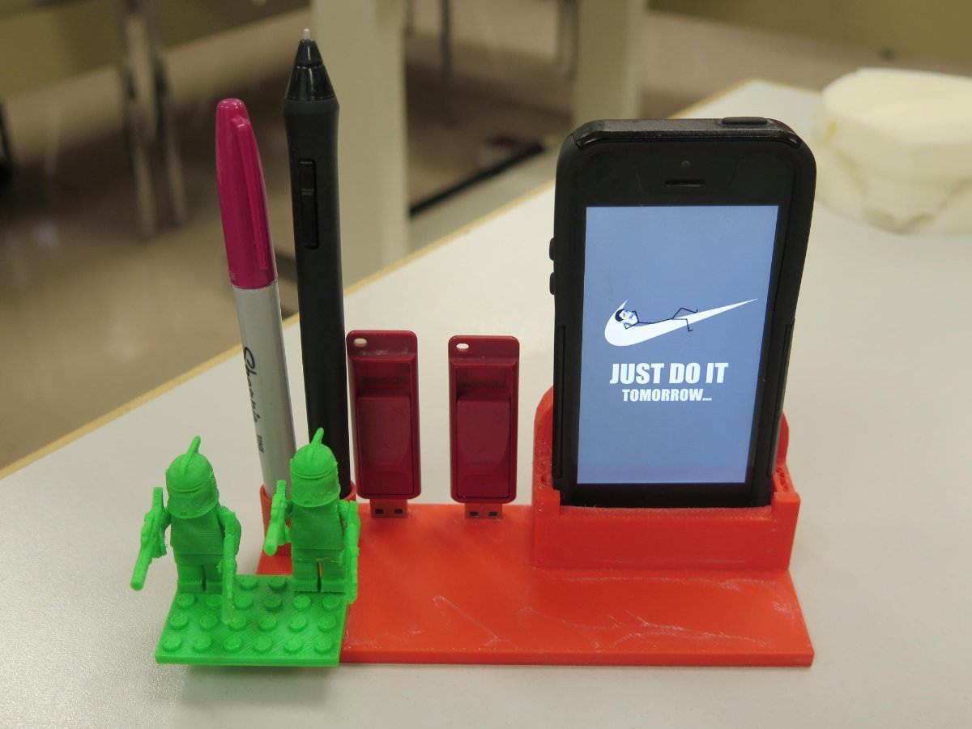

Getting Started with SketchUp for Web
Ready to start creating, editing and viewing models in SketchUp for Web? Let’s take a look at what you will need in order to start using SketchUp for Web, including the web-browser and devices-support details.
To start using SketchUp for Web, you need the following:
- A SketchUp ID for signing in
- An Internet connection
- A computer or Chromebook
Tip: SketchUp is best suited for mouse and keyboard interaction. Use a three-button, scroll-wheel mouse for easy orbiting, zooming, and precision positioning while modeling.

SketchUp for Web Interface
In the following figure, you can see what SketchUp for Web looks like when you first open the program in your web browser. The numbers in the figure correspond to the numbers in the following list:
- Open/Model Preferences Icon: When you click this icon in the upper-left, a sidebar opens where you find an About SketchUp section, your account information, templates for creating new models, and a link to upload your model to 3D Warehouse.
- Model Name: Click Untitled to save your model to Trimble Connect.
- File Operations Icon: Click this icon to open a new or existing file or save your model as a new file.
- Toolbar: This toolbar contains the tools you need to create 3D models.
- Status Bar: From left to right, you find the Uno/Redo buttons, a link to the Help Center, a language menu, a link to the SketchUp Forums, tips and options for the selected tool, and the Measurements box for modeling accurately.
- Panels: Click these icons to access panels for entity information, the Instructor, components, materials, styles, layers, views, and display. Tip: If you’re not certain what a tool is, hover over the tool and a ScreenTip appears. When you select a tool, a brief note about what it does or the options available for that tool appear in the status bar. You can also find help by opening the Instructor panel.
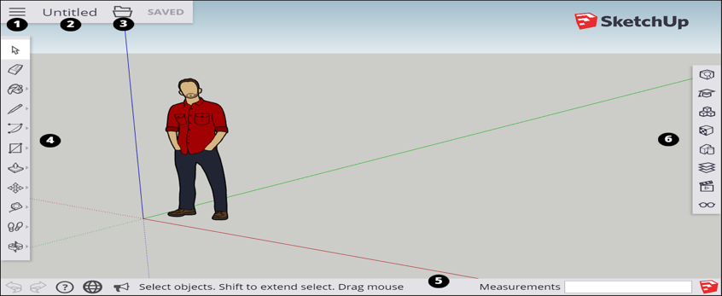

Using SketchUp Instructor
If you are new to SketchUp, then the SketchUp Instructor is a great resource for mastering this software.
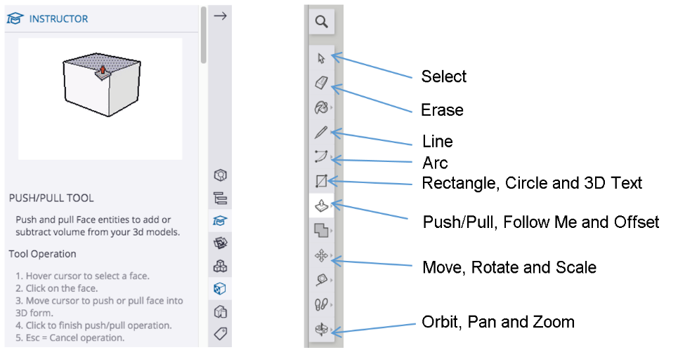
Introducing Drawing Basics and Concepts

SketchUp Practice Drawing Task
In this next task, you will work on your practice drawing to improve your skills. This task will allow you to try out a range of different ideas that will help lead to your final design. In this stage, designers express and get as many initial ideas down on paper – however in a much simpler form. Practice the drawing below to reinforce and master the fundamental tools that you will be using to create your desk organizer.
Tip: SketchUp provides a “Reference Card” that highlights important tools you will use while completing this project.
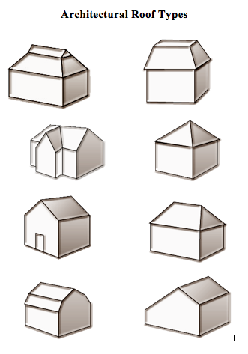

The Reference Card for Google SketchUp
The Reference Card link
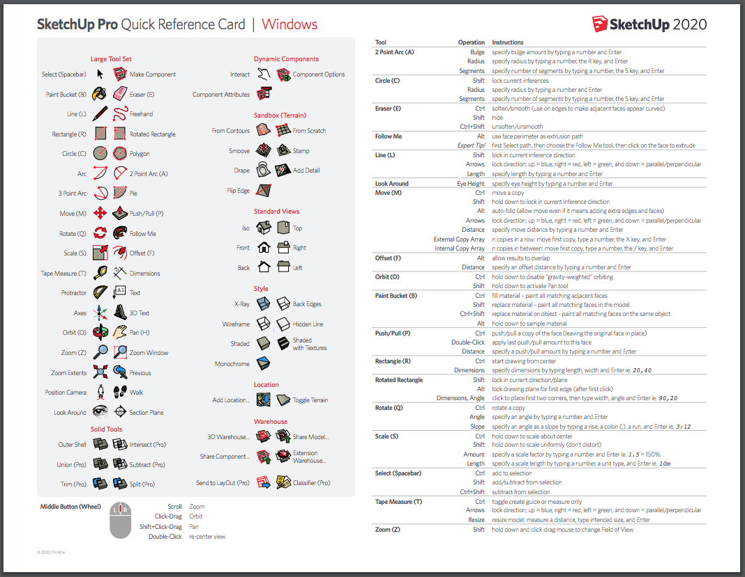

Example of a desk organizer scaled sketch, which includes overall dimensions.
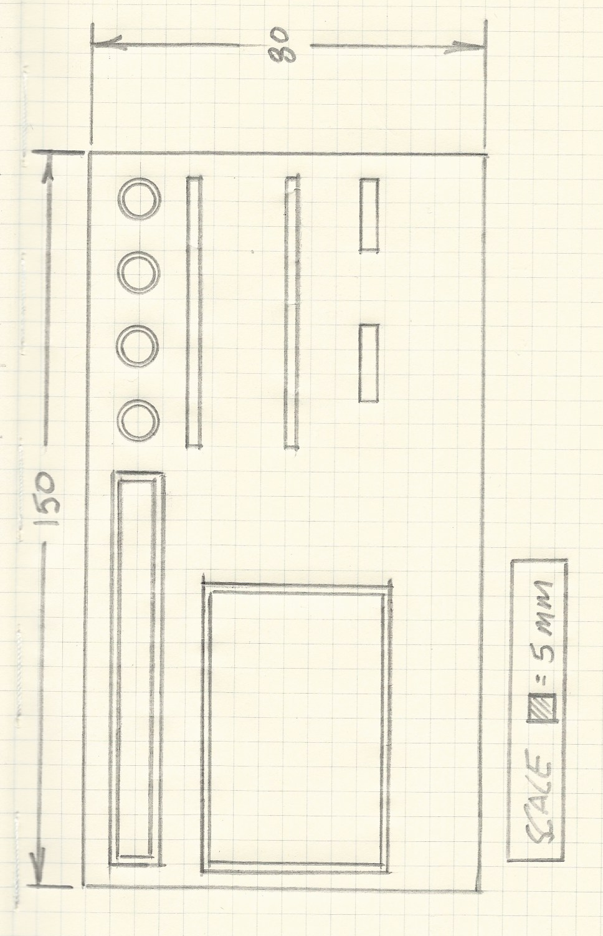

Activity 4 – Final Design
Once the research, brainstorming, concept pencil sketches and practice SketchUp drawing are completed, you are now ready to enter the final stage of designing your desk organizer. At this stage, you will work to refine your final SketchUp drawing. The ability to refine and improve the final product often determines the success of designers and their designs. The following checklist may help you develop your design choices, which may help you execute your best ideas.
A Checklist:
- Does your final design fulfill the criteria as outlined in the design brief? Be sure to check the design brief often during this stage.
- Consider and assess the aesthetic choices that you have made to your final design. Do these choices work, or might you have to explore other options?
- Return to your original concept sketches. Are there any design elements that can be included to enhance your overall design?

Using SketchUp for Accuracy
Whenever you are drawing or creating geometry, SketchUp gives you the opportunity to be as accurate as you need to be. SketchUp has the capability of drawing your desk organizer to your specific measurements. For example, if you choose to have a base that is 150 mm long and 60 mm wide, and with a thickness of 15 mm, you can be produced in SketchUp. You can draw a line in SketchUp, determine the length of that line, simply by typing in the dimension on your keyboard, and pressing enter.
To see this in action, watch this SketchUp video.
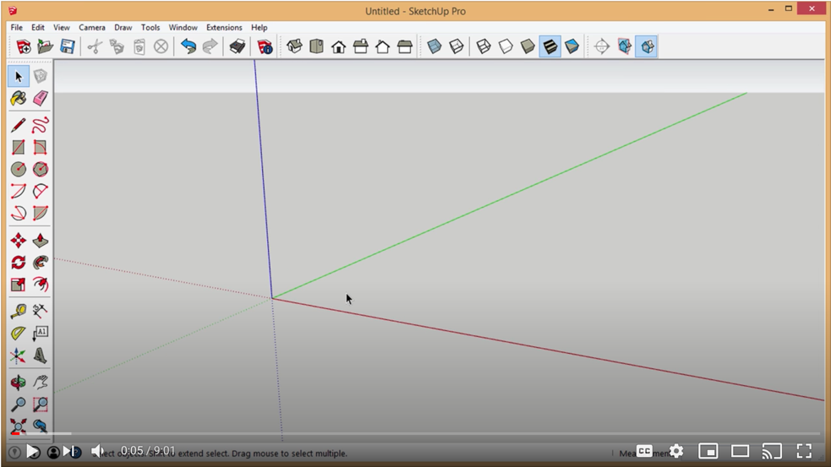
https://mastersketchup.com/drawing-accurately-sketchup/

Activity 5 – Career Exploration

Do you want to become an Industrial Designer?
Although there are other paths to take, here is a brief overview of what it takes to become an industrial designer:
- Excel in fine arts, visual arts, design studies and physics while in high school
- Make sure you have the right personal traits for this work
- Pursue an undergraduate industrial design degree
- Get work experience as a student via internship and co-op opportunities
- Get an entry-level job after graduation
- Advance into roles of greater responsibility and pay, or into roles in related fields

An Insight into the Industrial Design Field
The field of industrial design combines visual arts and technology and requires knowledge and skills in a variety of fields. For this reason, industrial designers can come from a variety of educational backgrounds. Many have bachelor’s degrees in industrial design, fine arts, engineering or architecture, or a background in graphic design.

What is an Industrial Designer?
Industrial designers use technical and design training, in combination with the collection and analysis of requirements from clients and manufacturers, to create models and drawings on how to make products easier to use, better to use, and better to look at. They aren’t usually tasked with coming up with an overall design; instead, they are concerned with impacting the technical aspects of the overall design by considering the usability and aesthetics of the design. The designs they work on are a wide variety of products and systems, ranging from furniture, electronics and appliances, to automobiles, sporting goods, toys, and much more.

What do they do?
Although their duties can vary from job to job, industrials designers are generally responsible for the following:
- Consulting with clients or manufacturers to establish requirements for the product or system to be designed
- Analyzing the intended function and aesthetics of the product or system in order to create product specifications
- Researching production specifications, costs of production materials and methods of manufacturing
- Preparing formal presentations and reports for client or management approval
- Preparing concepts, drafts, and initial prototypes of product or system
- Working closely and consulting with other members or development team, such as engineers, marketers and managers

How can I gain experience as a student?
A great way to gain relevant and valuable experience for this career is to obtain an internship or co-op position while you are a student. Speak with your teachers and counsellors in your school’s Guidance Office, as they will be able to help.

How can I prepare in high school?
Developing your skills in the areas of visual arts and technology while you’re still a high school student is a great way to get a head start in this profession. Excelling in coursework related to technological design programs, fine arts, visual arts, and physics will serve as excellent preparation for this career and help you qualify for post-secondary programs.

Traits of Successful Industrial Designers
If you have the following personal traits, you’ll not only be well suited for work as an industrial designer, you’ll be a standout:
- You’re the kind of person who enjoys taking things apart and fixing them
- The shape and design of everyday items catches your eye
- Trying to figure out how a product goes from concept to store shelves intrigues you
- You enjoy conceptualizing problems in new ways to fin innovative and practical solutions
- A career that combines design and technology appeals to you
- Working well with others in a multidisciplinary environment won’t be a challenge for you
- You enjoy conducting product research and experimenting with different design approaches and materials. You’re ambitious to work in a pioneering industry that’s still trying to carve out brand value (businesses looking to an industrial designer for help with a product is still a novel idea)

What kinds of employers hire Industrial Designers?
The following types of organizations often employ industrial designers, either on a full-time or contractual basis:
- Small, medium and large design firms
- Engineering and architecture firms
- Fashion and clothing design companies
- Manufacturers of commercial, industrial or institutional goods
- Technology companies
- Recreational and not-for-profit groups, such as sports teams and leagues
- Media outlets
- Self-employment

Careers Similar to Industrial Design
Listed below are careers that may be in the same field, or they may involve many of the same skills, competencies and/or responsibilities as an industrial designer:
- Design Engineer
- Graphic Designer Toy Designer
- Drafting Technician
- Mechanical Engineer
- Web Designer
- Ergonomist
- Industrial Engineer
- Artist
- Furniture Designer

Schools in Canada that offer Industrial Design Courses
- Fanshawe College
- St. Clair College
- Centennial College
- Humber College
- Cambrian College
- Conestoga College
- Niagara College
- Loyalist College
- Georgian College
- Sheridan College
- Herzing College
- University of Guelph
- OCAD University
- Carleton University
- McMaster University
- University of Alberta
- Southern Alberta Institute of Technology (SAIT)
- Northern Alberta Institute of Technology (NAIT)
- Saskatchewan Polytechnic
- University of the Fraser Valley
- Simon Fraser University
- Emily Carr University of Art and Design
- The University of British Columbia
- University of Prince Edward Island
- Memorial University of Newfoundland
- University of Waterloo
- Kwantlen Polytechnic University

Career Exploration Task
An important facet to finding a career that is most suitable for you in the Technological Field, like Industrial Design, is to research the career that best matches your interests. Career exploration helps connect your education to a career by identifying and exploring potentially satisfying occupations. This assignment is designed to familiarize you with the field of Industrial Design, and specifically, the resources that can help answer important questions that you may be considering. In addition, it will invite you to assess how well a career in the Industrial Design field “fits” your interests, values, skills and personality style. This assignment can help you consider a pathway or at least begin to explore possibilities.

Criteria | Include research and responses below
In the Industrial Design field, which area of study and career choice appeals to you? (Design Engineer, Drafting Technician, Ergonomist, Furniture Designer, Graphic Designer, Mechanical Engineer, Industrial Engineer, Toy Designer, Web Designer or Artist?)
Describe in detail the tasks/duties a person in this occupation would perform. (Job Description)
Identify the possible employment settings. (Where you might work)
Describe the working conditions of a person employed in this occupation. (hours, work environment, salary, etc.).
What education and training are needed? Identify the specific courses that will prepare you for this career.
What aptitudes/abilities/interests/values should a person in this occupation possess and why?
What have you learned during this career exploration? Are you still interested in this possible career choice? Why?

Resources:
www.onetonline.org
www.bis.gov
https://www.jobserachintelligence.com/etc/jobseekers
http://acinet.org/
http://www.quintcareers.com/career-exploration/
www.whatcanidowiththismajor.com/major

Activity 6 – Reflection on your learning

Desk Organizer Project: A Reflection
Reflecting on your learning allows you to understand your strengths as a student, and the connections that you are making to assignments, like this Desk Organizer Project. Use the following prompts to reflect on your Desk Organizer Project experience and what you have learned from it.
- Identify two ideas that you discovered or acquired during this desk organizer project that you did not know before.
- Identify two skills that you acquired during this desk organizer project that may assist you in your future.
- Do you think learning new technologies, like SketchUp, are important? Offer two reasons to support your response.
- What did you do really well on this assignment?
- What might have you done differently on this assignment?
- What’s your best suggestion for improving this project?

Resources

Tools/Equipment
- Pencils
- Graph Paper
- Ruler

Software
- SketchUp 2020 Web

Videos
- Best Way to Learn SketchUp from Scratch
- SketchUp Tutorial for Beginners

Websites for Teachers
- Azure
- Dezeen
- Core 77
- Designboom

Motivational Strategies
With so many of us studying and working from home, who doesn’t need a little help with organizing and storing our desk tools and essentials? Keeping a workstation clean and clear of any unnecessary clutter is possible with the help of desk organizers. Desk organizers are important storage caddies that store and display what you need at a moment’s notice, like post-it-notes, writing utensils, USBs and other electronic devices. Remember what Ben Franklin said – For every minute spent in organizing, an hour is earned!

Learning Goals and Success Criteria
By moving through the design process, students will think critically about design, develop and refine design concepts, demonstrate technical literacy by using computer design software, produce an original product and assess and reflect on their own learning.

Overall and Specific Expectations in Support of Ontario Curriculum Grades 9 -10 Technological Education

Overall Expectations:
A1 Demonstrate an understanding of the fundamental concepts and skills required in the planning and development of a product or service, including the use of a design process and/or other problem-solving processes and techniques;
A2 Demonstrate the ability to use a variety of appropriate methods to communicate ideas and solutions;
A3 Evaluate products or services in relation to specifications, user requirements, and operating conditions;
B1 Use problem-solving processes and project-management strategies in the planning and fabrication of a product or delivery of a service;
B2 Fabricate products or deliver services, using a variety of resources;
D2 Identify careers in various technological fields, and describe the educational requirements for them.

Specific Expectations:
A1.1 Describe a design process or other problem-solving process for planning and developing products and/or services (see pp. 16–19)
A1.2 Describe problem-solving processes and techniques for solving various kinds of problems in different technological areas;
A1.3 Apply correctly the mathematical and scientific concepts and skills required in the planning and development of a product and/or service;
A2.1 Use a variety of appropriate methods to communicate information or ideas and concepts during the planning and production stages of a project (e.g., production plans, scripts, flow charts, storyboards, sketches, technical drawings, recipes, client consultation reports, design briefs);
A2.3 Use metric and imperial units of measurement (e.g., metric: degrees Celsius, joules, micrometres [microns], millimetres, kilohms, L/100 km, tonnes; imperial: degrees Fahrenheit, BTUs, knots, mils, inches, feet, miles per gallon, pounds per square inch, tons) and the abbreviations or symbols associated with them correctly and as appropriate to the task;
A3.1 Evaluate a product or service, and processes associated with its development, on the basis of a set of criteria relevant to that product or service (e.g., adherence to specifications, ease of use, attractive appearance, ruggedness, clean joints, acceptable weld bead, uniform colour, adherence to forest management plan, nutritional value);
A3.2 Suggest improvements to a product or service on the basis of a set of criteria relevant to that product or service (e.g., durability, reliability, ease of use, eco-friendliness, appearance, safety, customer satisfaction).
B1.1 Apply the steps of a design process or other problem-solving process to plan and develop products and services (e.g., define the problem or challenge, taking into account relevant contextual or background information; gather information [about criteria, materials, constraints]; generate possible solutions, using techniques such as brainstorming; choose the best solution; develop and produce a model or prototype; test the model or prototype; incorporate improvements or redesign and retest; report on results) (see pp. 16–19);
B1.2 Apply the steps and/or techniques of appropriate problem-solving processes and methods (e.g., diagnostics, reverse engineering, trial and error, divide and conquer, parts substitution, extreme cases) to solve a variety of problems in different technological areas (see pp. 16–19);
B1.3 Identify and discuss solutions that have been developed to address key technological problems or meet human needs in various areas of technology (e.g., catalytic converters, CPU heat sinks, solar cells, regenerative brake energy systems, wind turbines, convection ovens, internal defibrillators, scent-free and hypoallergenic products);
B1.4 Use a variety of sources to research technological solutions to specific problems or challenges (e.g., the Internet, reference books, journals or magazines, experts);
B2.1 Use appropriate tools, materials, and equipment (e.g., tools: hammer, chisel, screwdrivers, soldering iron, cheese grater, sieve, seam ripper; pruning shears, hair clipper; materials: wood, aluminum, polystyrene, paper, wax, clay, textiles, electronic components, mulch, hair colour; equipment: drill press, test meter, computer, software, printer, video camera, thermometer, grill, sewing machine, autoclave, curling iron) to create products or deliver services;
B2.2 Make accurate measurements using a variety of tools (e.g., ruler, scale, tape measure, caliper, micrometer, thermometer, measuring cup), in metric or imperial units, as appropriate;
B2.3 Meet all design criteria (e.g., technical requirements, type and quality of materials, appearance, ease of use, safety, timeline, client’s expectations) in creating a product or delivering a service;
B2.4 Demonstrate the ability to use, maintain, and store tools and equipment properly and with care
D2.1 Describe secondary and postsecondary education pathways (i.e., selection of courses, programs, experiential learning opportunities, and other learning opportunities at the secondary and postsecondary levels, including apprenticeship training, certificate programs, college programs, and/or university programs) leading to a variety of careers in technological fields;
D2.4 Demonstrate an understanding of the Essential Skills that are important for success in the technology industries, as identified in the Ontario Skills Passport (e.g., reading text, writing, document use, computer use, oral communication, numeracy, thinking skills).

Safety Concerns and Expectations
Learners may need to practice physical distancing, and the school board adopted cleaning processes for shared tools. (e.g., shared tablets, keyboard, mice, etc.)

Applicable SAFEDocs and ToolSAFE videos
OCTE Safe Activity Foundations in Education Document for Technological Design.

Differentiation of the Project / Activity
Accommodations do not change the content of the learning expectations, but they should take into account the student’s preferred learning modality and areas of strength and need, and should provide students with appropriate opportunities to demonstrate their learning. Some accommodations may include modifying the project requirements, replacing the computer design component with pencil drawings, providing a quiet workspace, having a tutor or a teacher-assistant facilitate project work, and scribing and recording the student’s verbatim responses should be considered.
Teachers may refer to the Differentiation Scrapbook to take into account for learner ability, multiple intelligences, exceptional students, and ESL learners.

Career and Industry Extensions
See Activity 5 – Career Exploration

Environmental Considerations
Environmental considerations should be embedded into activities. For example, try to have students use recycled materials.

Reflection / Design Report
See Activity 6 – Reflection on your learning

References
21st Century Competencies: Foundation Document for Discussion. Phase 1: Towards Defining 21st Century Competencies for Ontario, Winter 2016 Edition, 2016 http://www.edugains.ca/resources21CL/About21stCentury/21CL_21stCenturyCompetencies.pdf
Azure Magazine (website), 2020 https://www.azuremagazine.com/
Best Way to Learn SketchUp from Scratch (video), https://forums.sketchup.com/t/best-way-to-learn-sketchup-from-scratch/52391
Core 77 (website), 2020 https://www.core77.com/
Course Codes for Emphasis courses in the Revised Curriculum: Technological Education, Grades 11 and 12, 2009 http://www.edu.gov.on.ca/eng/curriculum/secondary/techedemphasiscourses.pdf
Designboom (website), 2020 https://www.designboom.com/
Dezeen (website), 2020 https://www.dezeen.com/
Getting Started, SketchUp (image), 2020 https://help.sketchup.com/en/sketchup-web/getting-started-sketchup-web
Growing Success: Assessment, Evaluation, and Reporting in Ontario Schools, First Edition, Covering Grades 1 to 12, 2010 www.edu.gov.on.ca/eng/policyfunding/growSuccess.pdf
Introducing Drawing Basics and Concepts https://help.sketchup.com/en/sketchup/introducing-drawing-basics-and-concepts
Learning for All – A Guide to Effective Assessment and Instruction for All Students, Kindergarten to Grade 12, 2013 http://www.edu.gov.on.ca/eng/general/elemsec/speced/LearningforAll2013.pdf
Messy Desk, Dreamstime stock photos (image)
https://www.dreamstime.com/royalty-free-stock-image-messy-student-s-desk-primary-school-image34864386
OCTE Safe Activity Foundations in Education Document for Technological Design https://www.octe.ca/application/files/2915/3796/3174/SAFEdoc_DESIGN.pdf
SketchUp Quick Reference Cards 2020
https://www.sketchup.com/quick-reference-cards/sketchup-2020/en
SketchUp Tutorial for Beginners (video), https://www.youtube.com/watch?v=UsHRGDvN4sM
The Ontario Curriculum, Grades 9 and 10: Technological Education, 2009 (revised) http://www.edu.gov.on.ca/eng/curriculum/secondary/teched910curr09.pdf
The Ontario Curriculum, Grades 11 and 12: Technological Education, 2009 (revised) http://www.edu.gov.on.ca/eng/curriculum/secondary/2009teched1112curr.pdf

