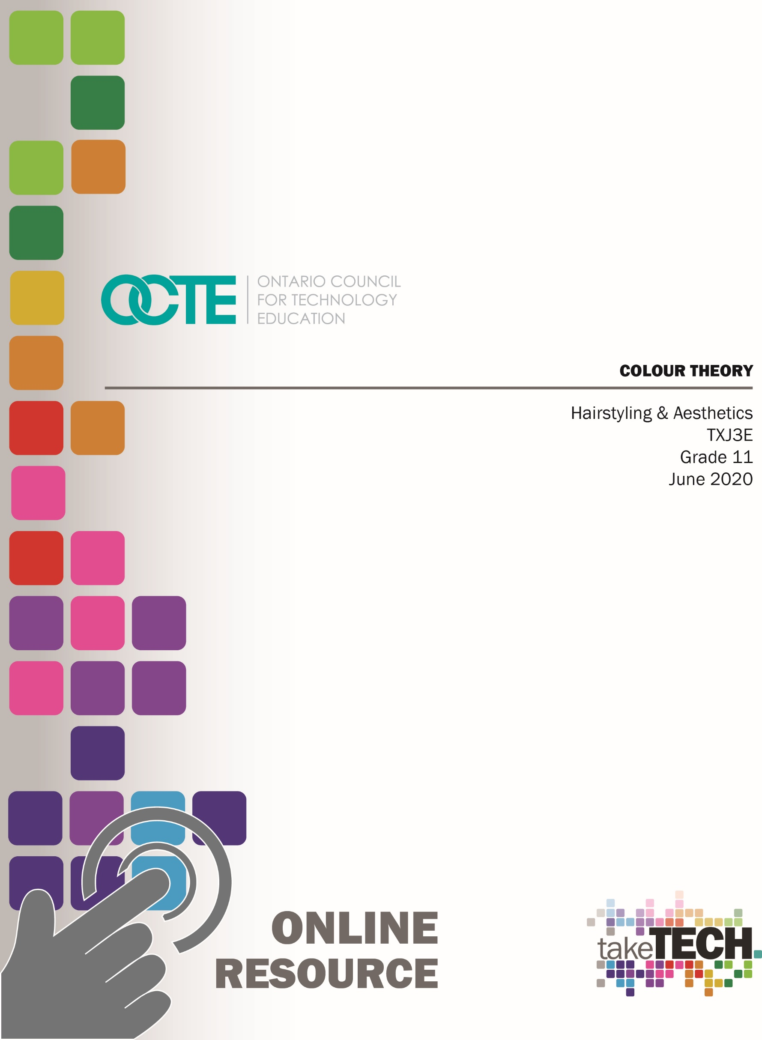

Table of Contents

Introduction 3
Project Outline 3
Prior Knowledge 3
Student Activities 4
Activity 1 – Colour Theory 4
Colour Theory Worksheet 5
Activity 2 – Understanding Levels and Tones 7
From Level 10 to Level 1 Poster Activity 7
From Level 10 to Level 1 Poster Rubric 8
Activity 3- How to do a Tint Retouch and Scalp Treatment 9
Activity 4 - Independent Study for Hairstyling and Aesthetics Assignment 10
Activity 4.1 - Inquiry Questions for Hairstyling and Aesthetics Student Handout 11
Activity 4.2 - Summarizing Interests in Hairstyling and Aesthetics 13
Activity 4.3 – Answering to Your Top Three 13
Activity 4.4 – The Focus of Your Independent Study 14
Activity 4.5 – Mid-Assignment Interview 16
Activity 4.6 – Student Articles 16
Planning Notes 17
Resources 18
Handouts 18
PowerPoint Presentations 18
Rubrics 18
From Level 10 to Level 1 Poster Rubric 18
Websites for Teachers 18
Videos 18
Instructional Strategies 19
The Hook / Motivational Strategies 19
Learning Goals and Success Criteria 20

Overall and Specific Expectations 20
Overall Expectations 20
Specific Expectations 21
Safety Concerns 22
Applicable SAFEDocs and ToolSAFE videos 22
Project Challenges 23
Differentiation of the Project / Activity 23
Assessment and Evaluation 24
Reflection or Design Report 26
Appendix A - Teacher’s Notes for Planning 27
Appendix B – Teacher’s Colour Theory Answer Sheet 29
References 31

Introduction
Course Code: TXJ3E
Broad base Technology: Hairstyling and Aesthetics
Destination: Open
Grade Level: 11
Prerequisite: No
Online Project Name: Colour Theory and Independent Study

Project Outline
This resource has 3 components or activities,

Activity 1
Students will develop an understanding of the law of colour, levels and tones and how it pertains to hair colour.

Activity 2
Students will do a tint retouch with conditioner followed by a scalp treatment and style.

Activity 3
Students will investigate various services and practices in the Hairstyling and Aesthetic Industry. They will then do an independent study on one or two overall expectations from the curriculum.

Prior Knowledge
It would benefit the students if they have taken the TXJ2O course prior to the TXJ3E. The TXJ3E however, is an open destination course and has no prerequisite.
Part B of this activity is best suited for the middle of the semester where students will have had some experience working with hair to section and style. Part C, on the other hand, can be used as a culminating activity or as an assignment to further explore the industry.

Student Activities

Activity 1 – Colour Theory
Students will view the PowerPoint presentation and the Hydrogen Peroxide video and then answer questions on Handout for Colour Theory.

Colour Theory PowerPoint presentation
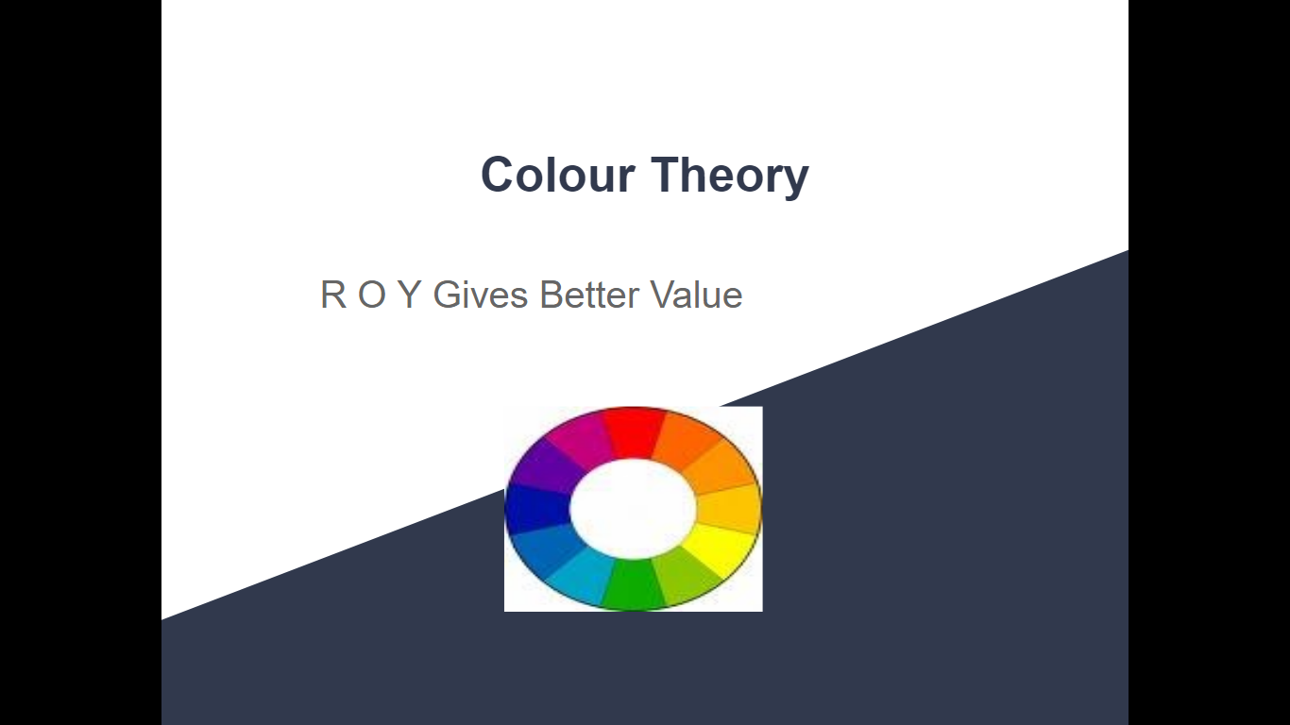
https://www.octe.ca/application/files/8415/9727/4780/Colour.PPT__Part_A.pptx

Hydrogen Peroxide Video
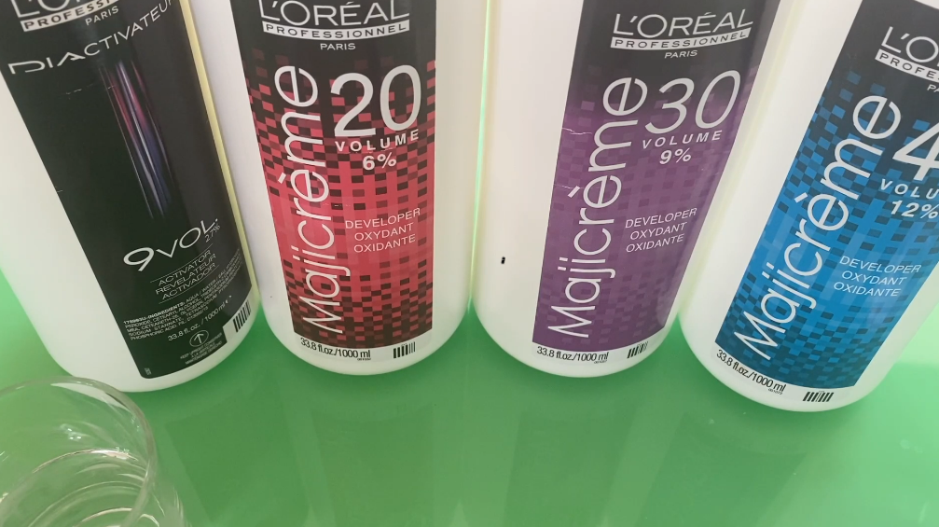
https://www.octe.ca/application/files/4315/9840/2730/Hydrogen_peroxide.mp4

Colour Theory Worksheet Student Name: _______________________
Using the colour theory slides and the Internet, answer the following questions. Please use a different colour font to help in marking this.

- All colour lines have an International Levelling system. This is ___________________ to darkness minus the tone. /2 marks
- What is tone? /2 marks
- What does level 6 stand for? ________________________________ /2 marks
- There are four categories of hair colour. The first category is temporary. This colour has large colour molecules that are _____________________ charged and attach themselves onto the cuticle. /2 marks
- How long does temporary hair colour last? /2 marks
- The next colour is called a semi-permanent colour. It is very similar to the temporary but some of the molecules are slightly smaller allowing them to imbed themselves slightly under the cuticle. Both temporary and semi-permanent hair colours do not have a developer. How long does a semi-permanent hair colour last? /2 marks
- The next category is a demi permanent hair colour. List 5 characteristics for this hair colour.

/5 marks
- Permanent is the last category of hair colour. It is an oxidative colour that can lift natural pigment and deposit permanent colour molecules into the cortex. What is the name of natural pigments found in the hair? (Hint starts with an M”) /2 marks
- Hair lightener or (Bleach) lifts the natural pigment and artificial pigment from the hair. It is the only product that can lift artificial colour. No question to answer but remember this as it is important.

- In the video for hydrogen peroxide, what did you learn or understand on,
A) Rolaids fizz up in vinegar
B) The higher the volume of developer, the faster it works /2 marks
- Henna is a natural hair colour. It more or less stains the hair. What is another name of this hair colour? (starts with a “V”) /2 marks
- What is an example of a metallic hair colourant? (Historically marketed to men and starts with “G”) /2 marks
- What are two uses of hair lighteners? (slide 14) /4 marks
- What are the three primary colours? /3marks
- What does blue and red make? /2 marks
- What does blue and yellow make? /2 marks
- What does red and yellow make? /2 marks
- Are all the secondary colours made from equal parts of two primary colours?
Answer: Yes or No ______________ /2 marks
- How do you make a tertiary colour? /2 marks
- What are opposites also called on the colour wheel? /2 marks
- What do the colours across from each other do? /2 marks

Activity 2 – Understanding Levels and Tones
Students will need access to technology to create a guide to levels and tones or magazines to cut and paste. Please find the handout with instructions is posted below.

From Level 10 to Level 1 Poster Activity Student Name:_____________
You have already learned about levels and tones from the Colour Theory PowerPoint and Worksheet. To further demonstrate your understanding of levels do a poster of pictures of hair colour going from a level 10 to a level 1. Under each picture put below the level and the tone. The tone can be warm, neutral or cool.
Below is L’Oréal’s level system and underlying pigment. Some manufacturers recognize slightly different underlying pigments in levels 5 to 8.

International Leveling System Underlying pigment
10(Lightest Blonde) Palest yellow
9 (Very Light Blonde) Pale yellow
8 (Light Blonde) Yellow
7 (Blonde) Gold
6 (Dark Blonde) Orange
5 (Light Brown) Orange- Red
4 (Medium Brown) Red
3 (Dark Brown) Dark Red
2 (Darkest Brown) Dark Red
1 (Black) Dark Red

One of the hardest tasks is to “level” a red head. This is a rule of thumb used in salons. Look at your client and try to identify if their red hair is:
- Dark Auburn (kind of a browny-red) - then they are a level 4 or 5
- Copper penny or an Irish setter- then they are a level 6
- Carrot top- then they are a level 7
- Strawberry blonde then they are a level 8

From Level 10 to Level 1 Poster Rubric
Level 4 | Level 3 | Level 2 | Level 1 | Level R
Student is able to demonstrate an exceptional understanding of levels and tones by posting all pictures in a correct order and identifying the tones. Student has used multiple tones | Student is able to demonstrate a considerable understanding of levels and tones by posting all pictures in a correct order and correctly identifying the tones. | Student is able to demonstrate some understanding of levels by posting all pictures in the correct order. Student has identified most of the tones correctly. | Student has demonstrated limited understanding of levels. Not all pictures are in the correct order for levels or tones. Mostly just in between levels 6-8 are incorrect. | Student has not demonstrated sufficient evidence of understanding of levels or tones. More review is needed.

Activity 3- How to do a Tint Retouch and Scalp Treatment
Students will need a peer, family member or mannequin to work with. There are handouts and videos to instruct students on how to do a tint retouch and scalp treatment. This is formative assessment only.
Step 1 - First you will need:
- A model if you don’t have a person who wants to be pampered then maybe you can try doing it on yourself.
- Some conditioner (If we were in class we would have access to different products as some treatments are better than others depending on your client’s texture and scalp condition)
- A bowl
- A brush. Any brush will do, you can use a paint brush, a toothbrush, be creative.
- Take a picture of your tools
Step 2 - Watch this video on how to do a tint re-touch
Step 3 - Then do your conditioner application to practice a tint re-touch. Take a picture of the finished product
Step 4 - Watch this video on how to do a scalp massage on a client
Step 5 - Do your scalp massage, don’t be afraid to use a bit of pressure and don’t worry about getting lost in each step. If you are massaging someone’s head, you are doing it right.
Step 6 - Lastly your client can shampoo the conditioner out and you can style their hair. You will now be the most popular person in the house because this is a treat. We did scalp massages in hairdressing school and we begged our teachers to let us do them. Take a picture of your client!

Activity 4 - Independent Study for Hairstyling and Aesthetics Assignment
This activity is an independent assignment with various activities. Planning notes for the teacher are included in Appendix A as well as additional activities and resources for the students.
For this assignment you are going to do an Independent Study. We are going to look at all the different topics in Hairstyling and Aesthetics as well as your interests. Then you and your teacher will come up with a way to demonstrate your knowledge and skills in this topic. Suggestions will be provided but feel free to present other options to your teacher.

Activity 4.1 - Inquiry Questions for Hairstyling and Aesthetics Student Handout
This is to help students to discover some likes and dislikes about the Hairstyling and Aesthetic Industry.
- Rate the following services to which you are most interested in, enjoy doing or just want to learn more about it. Use this guide to rate the following.
1- Love it 2- Interested 3- Just okay 4 -Hope to avoid this
- Up-do’s/Styles ________ I am always on Instagram looking at Up-dos and styles
- Haircutting ________ I really want to learn how to cut hair! Cut my hair, change my life...
- Manicures ________ I love nails and am always looking at Nail designs
- Pedicures ________ Love beautiful feet
- Hair colour _________ Love hair colour, balayage, highlights etc
- Make-up ________ I am always experimenting and love make-up
- Gel Nails ________ I want to learn and do extensions and gels
- Eyelashes _________ I would love to learn more, extensions, lifts, tinting
- Salon/Spa Marketing _________ Social media and marketing interests me
- Skin care ________ I want to look 25 when I am 40! Hate acne!
- Environmental Effects ________ I am concerned about the environment. How is our industry impacting the ecosystem?
- Social Impacts _________ Look good, feel good! Are hairdressers and aestheticians social workers?
- Business Practices _________ I want to understand how to run my own business some day
- Hair removal __________ Waxing, electrolysis, laser
- Eyebrows _________ Shaping, microblading, tinting!
- Theatrical make-up ____________ Special Effects, Aging make-up, etc
- Disinfection and Sanitation _______ Keeping people safe, organisms, viruses, etc. is really cool. I love to clean!
- Organization and stock _______ I love to organize and plan

Answer the following questions in proper sentence form
- Why did you take this course?
- What is your biggest struggle in school?
- What motivates you?
- Do you have trouble asking for help?
- If you get stuck or don’t understand, what do you do?
- What describes you best?
a) I am a self-starter
b) I have trouble getting started but once I am going, I am good to go
c) I am always distracted and need a lot of help to stay on task.
- Do you prefer to work alone or in a group?
- If you have to present a project, how do you like to do this?
- State something about yourself that you are proud of?

Student Name: _______________________ Date: ________________

Activity 4.2 - Summarizing Interests in Hairstyling and Aesthetics
Now that you have rated some topics and answered some questions I would like you to look over your answers and write a statement that describes what you think this information gives insight to?

Activity 4.3 – Answering to Your Top Three
You are going to answer four questions to three of your favourite topics from the list of “Inquiry Questions for Hairstyling and Aesthetics”. You should have given this topic a “1” or at least a “2”
Answer the four following questions for each chosen subject/topic.
- What do I know about this subject/topic?
- What do I wonder about this subject/topic?
- What do I like about this subject/topic?
- What do I dislike about this subject/topic or kind of scares me?

Activity 4.4 – The Focus of Your Independent Study
Out of the three subjects/topics you chose, present two ideas to your teacher on what you think you could do as an independent study? Here are some ideas.
Portfolio
- Create a professional Instagram/ Twitter using your school email.
- Create hairstyles, nail art, make-up etc. and post to your platform. This would require you to do your own services, have family members to work on or have a mannequin.
Written Presentations
- Research and do a presentation on chosen subject (google slides, Prezi and etc.)

Oral or Video Presentations
- Create a Video about your subject on iMovie, Adobe Spark or YouTube
Create
- Design a Salon and Create Inventory for a salon/spa
Community Partners
Could you collaborate with a Salon or Spa
Do the Social Media for a Salon
Interview a couple different hairstylists and or aestheticians
An example of what a student could do for an Independent Study from Community Partners:
“I would like to work with a Salon or Spa and do their Social Media. I will partner with a Salon or Spa and work with the owner on marketing their salon/spa. This could also just be a made up Salon/Spa if a Salon/Spa is not available or there is reason for Salon/Spas to be shut down. I will post at least once daily, do promotional videos and promote this business using Instagram. I will gather followers, collect likes, shares, contests etc. I will then reflect on my performance and what I have learned.”

Success Criteria
Here are some “I can… or I will …” statements that match up with Overall Expectations from the TXJ3E Curriculum. This might be helpful for students to match up their independent study with one or more expectations.

Success Criteria | Overall Expectations
- By the end of the semester I can..or I will...  - I will be able to identify and diagnose porosity, texture, density and elasticity in their peers and clients. I have an understanding of how bonds are broken, how hair grows and matures[A1]  - I understand how different chemicals affect the hair and can make changes in colours and textures. [A2]  - I will market myself by doing different clients on Salon Days. I will visit other places of businesses to see how a successful salon/spa should be run. I will demonstrate an understanding of business practices. [A3]  - I will be able to perform a manicure and identify the anatomy of the nail including; cuticle, free edge, hyponychium, eponychium and when it is safe to perform a manicure. I can/will be able to perform the following services: [B1/B3]  - Flat Iron straightening and curls  - Spiral curls  - Winding curls  - Braiding  - Basic up-do  - Crimping  - Manicures/Gel colour  - Scalp treatments  - Shampooing and conditioning  - Recommend products to clients depending on their needs and wishes  - Colour and highlight hair  - Etc... | Fundamentals  A1. Students will demonstrate an understanding of the functions of hair, skin and nails  A2. Students will demonstrate an understanding of issues related to chemicals components found in hairstyling and aesthetic products  A3. Students will demonstrate an understanding of business practices and strategies used in the hairstyling and aesthetics industry  Skills  B1. Students will perform a variety of salon/spa services that meet industry standards, using appropriate materials, techniques, and equipment safely and correctly.  B3. Students will apply methods for identifying, analysing, and meeting the needs of a diverse clientele.

Success criteria | Overall Expectations
By the end of the semester I can...  - I will be able to apply or to design a hairstyle or makeup to accentuate facial shapes as well as hair structures. [B.2]  - I will partner up with different clients on Salon Days. I will study or research different cultures, present and reflect on how the beauty industry impacts society. [C.2]  - I will do my daily job every day. I will follow all health and safety standards as set out by the Health Unit and Ontario Health and Safety Standards. I will make a safety book on professional best practices. [D.1]  - I will participate on Field trips and with workshops that are offered to learn about the industry. Possibly do a job shadow. Research hairdressing or aesthetic schools.  [D.2] | Skills  B2. Students will create designs for a variety of hairstyling and aesthetics purposes and contexts.  Technology, Environment and Society  C2. Students explain why hairstyling and aesthetics services are important to society, and identify ways in which social and cultural factors affect the industry.  Professional Practice and Career Opportunities  D1.Students will apply health and safety standards related to the use of hairstyling and aesthetics equipment, materials, and techniques and the maintenance of a safe work environment.  D2. Students will identify and describe a variety of career opportunities and related training and education requirements in the hairstyling and aesthetics industry.

Activity 4.5 – Mid-Assignment Interview
Around the halfway mark you will have an interview or questionnaire to do with your teacher. If you need help before that reach out!

Activity 4.6 – Student Articles
Present or hand in your article for evaluation.

Planning Notes
I would consider this project for a two to three week time frame. Here is a checklist but you may need to adjust to suit your program.

Checklist

Day One
- Fill it out Inquiry Questionnaire for Hairstyling and Aesthetics (Activity #1)
- Write out your statement of summarizing your answers (Activity #2)
Day Two
- Answer four questions to three of your favourite topics (Activity #3)
- Start to brainstorm your ideas
Day Three
- Pitch two ideas to your teacher on what you could do as a project and try to match it up with overall expectations
Day Four to Seven
- Implement Project
Day Seven
- Check in time for Interview with your teacher (this could be done online, in a small group, or with a form)
Day Fourteen
- Submit product- This could either be a portfolio, presentation, chosen and agreed upon with your teacher back on day three to four.

Resources

Handouts
Colour Theory Activity 1
From Level 10 to Level 1 Poster Activity
How to do a Tint Retouch and Scalp Treatment
Inquiry Questions for Hairstyling and Aesthetics Student Handout (Activity 4.1)
Summarizing Interests in Hairstyling and Aesthetics (Activity 4.2)
Answering to Your Top Three (Activity 4.3)
The Focus of Your Independent Study (Activity 4.4)

PowerPoint Presentations
Colour Theory PowerPoint presentation

https://www.octe.ca/application/files/8415/9727/4780/Colour.PPT__Part_A.pptx

Rubrics
From Level 10 to Level 1 Poster Rubric
Rubric for Overall Expectations from the Ministry of Education

Websites for Teachers
L’Oréal Professionnel Hair Colour Numbering System
L’Oréal Terms of Use
OCTE SAFEDocs for Hairstyling and Aesthetics
OCTE ToolSAFE videos for Hairstyling and Aesthetics

Videos
Hydrogen Peroxide Video (Activity 1)

https://www.octe.ca/application/files/4315/9840/2730/Hydrogen_peroxide.mp4

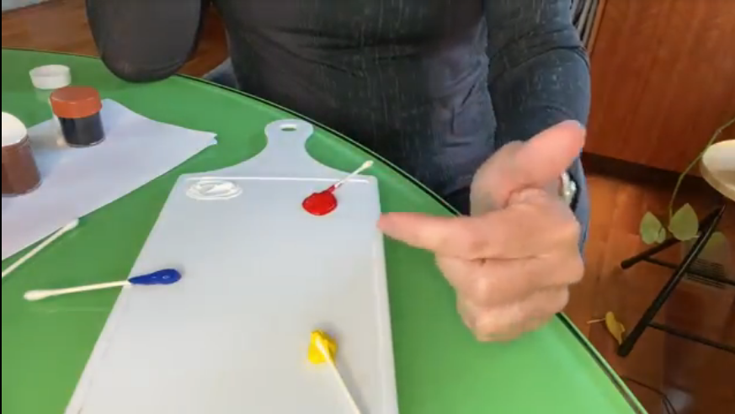 | Colour Wheel (Activity 1)  https://www.octe.ca/application/files/5415/9651/0565/Colour_Wheel_1.mp4
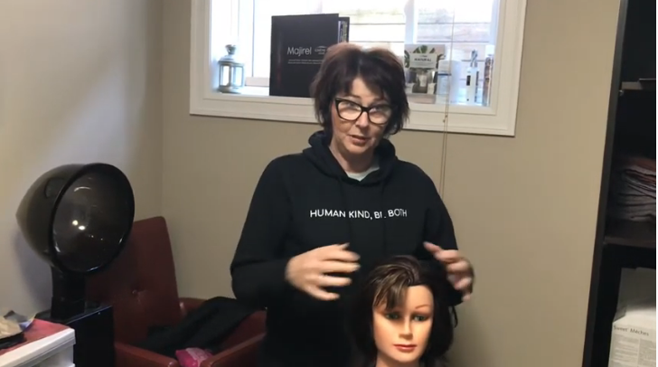 | Scalp Massage (Activity 3)  https://youtu.be/fSVgPGNmXM8
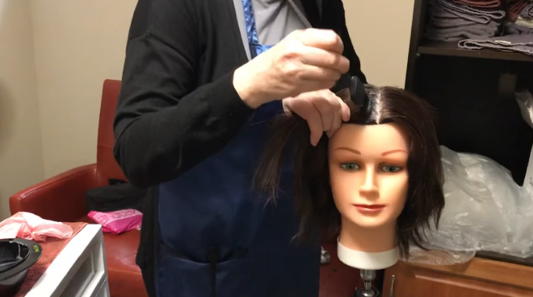 | Tint re-touch (Activity 3)  https://youtu.be/e6VzlZdlW9s

Instructional Strategies
Teachers may use any of the following instructional strategies; 3-Part lesson, lecture, storyboard, word wall, think-pair-share, placemat activity, rapid write, K-W-L, anticipation chart, ABC taxonomy, think aloud, analyzing text, Cornell note taking, exit ticket/ticket out the door, plus/minus/delta, etc. to best meet the needs of their students.

The Hook / Motivational Strategies
Students in Activity 4 are to discover more about what excites them in the industry and then have student choice to learn about it. The questionnaire above will give teachers the insight to how their students learn and what they are interested in. Students then can share their projects by different platforms and have all students learn from each other.

Learning Goals and Success Criteria
Learning goals are brief statements that describe what students should be able to do, know, and understand by the end of a project or of class. While each activity can be broken down and have individual learning goals, this resource project is set up for a time period of approximately two weeks, and the success criteria stated in Activity 4.4 provides direct links to the course overall expectations.

Overall and Specific Expectations in Support of Ontario Curriculum Grades 11 - 12 Technological Education

Overall Expectations
A1 Students will demonstrate an understanding of the functions of hair, skin and nails
A2 Students will demonstrate an understanding of how chemicals affect hairstyling and aesthetic products
A3 Students will demonstrate business practices and strategies used in the hairstyling and aesthetics industry.
B1 Students will perform a variety of salon/spa services that meet industry standards, using appropriate materials, techniques, and equipment safely and correctly.
B3 Students will apply methods for identifying, analysing, and meeting the needs of a diverse clientele.
C2 Students will explain why hairstyling and aesthetics services are important to society, and identify ways in which social and cultural factors affect the industry.
D1 Students will apply health and safety standards related to the use of hairstyling and aesthetics equipment, materials, and techniques and the maintenance of a safe work environment.
D2 Students will identify and describe a variety of career opportunities and related training and education requirements in the hairstyling and aesthetics industry.

Specific Expectations
A1.1 Describe the physiological properties of hair, skin, and nails (e.g., density, elasticity, porosity, texture, cycles of growth);
A2.1 Explain the role of pH values in hair care, skin care, and nail care products (e.g., hair products: shampoo, conditioners, chemical relaxers, permanent wave solutions, peroxide, neutralizers; skin products: moisturizers, cleansing creams, toners; nail products: acrylic overlays, UV gels, liquid nail wraps, primers);
A3.1 Identify and describe behaviours, attitudes, and skills that are important for successful employment in the hairstyling and aesthetics industry (e.g., commitment to the job and to a high standard of performance, professional appearance and dress, task management skills, interpersonal skills, respect for confidentiality, commitment to antidiscriminatory practices, conflict-resolution skills);
A3.2 Use a variety of teamwork and interpersonal skills to communicate and interact successfully with clients and co-workers (e.g., understand and accommodate cultural differences in body language and communication style – for instance, many First Nations people show respect by not looking into the eyes of the person they are speaking to);
A3.3 Identify effective advertising and management strategies (e.g., appeal to new client groups, including diverse populations) and new products, tools, and equipment that can be used to support and enhance salon/spa operations;
B1.1 Select and use appropriate materials, tools, and products to perform professional salon/spa services (e.g., hair colouring, hair cutting, hairstyling, chemical texturizing, make-up applications, nail care and skin care treatments);
B1.2 Demonstrate a working knowledge of products, techniques, and tools used to perform hairstyling and aesthetics services (e.g., products: gel, pomade, mousse, wax, hairspray, lightener, neutralizer, milk cleanser, toner, peel, serum, creams, oils; techniques: for cutting, colouring, and styling hair; tools: thermal irons, hair brushes/combs, scissors, texture shears, razors, clippers, highfrequency machines, nail files, cuticle pushers, nail buffers, comedone extractors);
B1.4 Perform hairstyling and aesthetics services (e.g., hair cutting, hairstyling, make-up, nail care, skin care) to meet the needs of individuals and groups in school and community contexts (e.g., special event occasions, musicals, plays, productions, fashion shows, nursing homes, hospitals).
B3.2 Develop and analyse a profile of a client (e.g., condition of scalp, hair, skin, and nails; skin type; facial shape; body type) in order to recommend appropriate hairstyling and aesthetics services;

C2.1 Describe the role that the hairstyling and aesthetics industry plays in increasing people’s self-esteem and well-being (e.g., fostering a positive body image, good personal grooming and hygiene, and self-confidence; reducing stress; identifying health issues) at the various life stages (e.g., child, preteen, teenager, young/middle-aged adult, senior);
D1.2 Use safe and sanitary work practices to prevent the spread of pathogens and protect their own and others’ health (e.g., sanitize, disinfect, and/or sterilize implements and equipment; work in a well-ventilated space; wear safety glasses and appropriate clothing; handle products correctly; practise good posture and apply ergonomic principles; wash hands frequently; use deodorant regularly);
D1.3 Demonstrate an understanding of procedures to ensure safe and productive work practices in the hairstyling and aesthetics workplace (e.g., using a checklist to keep track of tools and equipment; developing and following routines/protocols for the correct use of scissors, curling irons, electric cords, waxing heaters, autoclave, glass bead sterilizer, steamer, chemicals);
D2.2 Use a career-planning process to research, identify, and describe secondary and postsecondary goals, plans, and pathways related to the hairstyling and aesthetics industry (e.g., identify personal interests and attributes; investigate education and career opportunities in the school, community, and workplace; decide which opportunities to select and plan the transitions between stages);

Safety Concerns
When students are working on a peer, family member or themselves teachers and school boards may wish to obtain parental consent and provide parental supervision if completed at home. Personal Protective Equipment such as gloves, aprons, masks, face shields, are also required in order to perform tasks and services on clients. Proper safety training is required on any of the tools and equipment. Please refer to the OCTE SAFEDocs for Hairstyling and Aesthetics on the OCTE website.

Applicable SAFEDocs and ToolSAFE videos
Please refer to the OCTE SAFEDocs for Hairstyling and Aesthetics for safety documents and OCTE ToolSAFE videos for Hairstyling and Aesthetics in order to properly address instruct this project.

Project Challenges
The biggest challenge in Activity 4 will be keeping students on task. The inquiry questions to identify students' challenges, the checklist and mid assignment check in (interview or questionnaire) should help with this.

Differentiation of the Project / Activity
Teachers can also refer to the Differentiation Scrapbook to take into account for learner ability, multiple intelligences, exceptional students, and ESL learners.
Suggestions for Differentiated Instruction include,
Activity 1
Teachers can adjust the amount of questions, have students answer orally or have them only watch the video.
Activity 2
Students can make a collage of different hair colours but not have to identify their tone or level
Activity 3
Students could just do the massage on a mannequin or peer/family member and watch the videos.
Activity 4
Students can modify this project to best suit their identified learning goals, abilities and to what students have access to during remote learning.

Assessment and Evaluation

Rubric for Overall Expectations from the Ministry of Education

 | Level 4  80-100% | Level 3  70-79% | Level 2  60-69% | Level 1  50-59%
Knowledge and Understanding Knowledge of subject specific content and the comprehension of its meaning and it’s significance.  *Facts  *Equipment  *Terminology  *Processes  *Procedures  *Industry Standards | Demonstrates thorough knowledge of content.  Demonstrates thorough under- standing of content | Demonstrates considerable knowledge of content.  Demonstrates considerable understanding of content | Demonstrates some knowledge of content.  Demonstrates some understanding of content | Demonstrates limited knowledge of content.  Demonstrates limited understanding of content
Thinking  The use of critical and creative thinking skills and/or processes.  *Use of planning skills  *Strategize  *Problem solve  *Processing skills  *Use of creative/critical thinking processes | Expresses and organizes and information with a high degree of effectiveness  Communicates for different audiences and purposes with a high degree of effectiveness  Uses vocabulary and terminology with a high degree of effectiveness | Expresses and organizes and information with considerable effectiveness  Communicates for different audiences and purposes with considerable effectiveness  Uses vocabulary and terminology with considerable effectiveness | Expresses and organizes and information with some effectiveness  Communicates for different audiences and purposes with some effectiveness  Uses vocabulary and terminology with some effectiveness | Expresses and organizes and information with limited effectiveness  Communicates for different audiences and purposes with limited effectiveness  Uses vocabulary and terminology with limited effectiveness
Communication  Expresses and organizes ideas in oral or written form.  *Terminology  *Vocabulary | Applies knowledge and skills with a high degree of effectiveness  Transfers knowledge and skills to new contexts.  Makes connections within and between various contexts with a high degree of effectiveness | Applies knowledge and skills with considerable effectiveness  Transfers knowledge and skills to new contexts.  Makes connections within and between various contexts with considerable effectiveness | Applies knowledge and skills with some effectiveness  Transfers knowledge and skills to new contexts.  Makes connections within and between various contexts with some effectiveness | Applies knowledge and skills with limited effectiveness  Transfers knowledge and skills to new contexts.  Makes connections within and between various contexts with limited effectiveness
Application  Application of knowledge and skills  *Transfers concepts, processes, use of equipment and technology to new contexts. | Student applies and transfers knowledge and skill with a high degree of effectiveness  Makes connections between various contexts with a high degree of effectiveness | Student applies and transfers knowledge and skill with considerable effectiveness  Makes connections between various contexts with considerable effectiveness | Student applies and transfers knowledge and skill with some effectiveness  Makes connections between various contexts with some effectiveness | Student applies and transfers knowledge and skill with limited effectiveness  Makes connections between various contexts with limited effectiveness

Triangulation of student work through conversations, observations, data collected and product are all considerations for evaluation.
A second rubric is also used in Activity 2, From Level 10 to Level 1 to assess the poster created in that activity.
Assessment As Learning - Activity 1
Assessment For Learning - Activity 2 and 3
Assessment Of Learning - Activity 4

Reflection or Design Report
Teachers may wish to have the students complete a design report, reflection or create a foldable to consolidate their learning. This would be a nice way to capture the student’s understanding in a summative format and be used in preparation for their examination, entering post-secondary education or the workforce.

Appendix A - Teacher’s Notes for Planning

Independent Study
Over the past two years, New Pedagogies for Deeper Learning has been a focus with my school board. The pedagogy to this is to increase student’s creativity, critical thinking, communication, collaboration, citizenship and character. This pedagogy also blends with a number of books on “inquiry learning”. It is the intent that you are able to use this framework as an independent study for your students. The methodology is to ask questions, research, reflect, experiment, ask more questions, reflect, present and finally evaluate.
The activities provided in this resource are general. As the students start their project, you will have to personalize some of your questions and provide personal feedback in the formative part of their learning. The rubric is very general so you can look more at the descriptive words to evaluate on the overall competencies. (ie: Has the student developed thorough knowledge and understanding of this overall competency?)
Students will pick topics that interest them. Hopefully the key to engagement is that it is something they are passionate or at least interested in. This assignment is designed for independent study but if there is a compelling reason for students to work together that could be considered.
After the student has picked the topic, they will be asked to submit a plan, they will then match with the help of their teacher what expectations they think they can demonstrate. The “I can statements with overall expectations will hopefully help with this.
Next comes the research and experimenting. Some students will have access to more equipment, tools, products, etc. than others, so this will be a great way of accommodating all levels of accessibility as well as modifying for all levels of learners.
Once students have developed a plan and have started. I would suggest a half way point check in. This could be done by an interview or with a questionnaire or form. Here are some examples of questions. It is recommended to do a few general questions along with a couple of personalized questions as well.
- What is your favourite thing so far?
- Do you feel that being a woman/man in this profession makes a difference?
- Who would you say is a role model for you and why?
- What advice would you give yourself before starting this course/assignment?
- What is the most annoying thing about this assignment?
- Rate yourself between 1 and 10 so far and why do you give yourself that number?
- If you had to describe your assignment in one word. What would that be?
- What has been the biggest surprise so far on this assignment?
- What skills were you good at when you started this assignment and what have you improved at so far?
- If tomorrow you walked in and were the teacher, what would you change?
- How well do you take feedback?
- What new skills have you learned this semester?

Depending on a class situation, teachers could use this assignment as a Culminating Activity.

Appendix B – Teacher’s Colour Theory Answer Sheet
Colour Theory
Using the colour theory slides, your brain and possibly the Internet, answer the following questions. Please use a different colour font to help in marking this.

- All colour lines have an International Levelling system. This is lightness to darkness minus the tone. /2 marks
- What is tone? Tone is the warmthness or coolness of a colour
/2 marks
- What does level 6 stand for? Dark Blonde /2 marks
- There are four categories of hair colour. The first category is temporary. This colour has large colour molecules that are positively charged and attach themselves onto the cuticle. /2 marks
- How long does temporary hair colour last? One to two shampoos
/2 marks
- The next colour is called a semi permanent colour. It is very similar to the temporary but some of the molecules are slightly smaller allowing them to imbed themselves slightly under the cuticle. Both temporary and semi permanent hair colours do not have a developer. How long does a semi-permanent hair colour last? Four to six shampoos /2 marks
- The next category is a demi permanent hair colour. List 5 characteristics for this hair colour.
- Small molecules the same size as permanent
- Oxidizing hair colour
- Developer needed
- Deposit only
- Lasts approximately 28 shampoos
/5 marks
- Permanent is the last category of hair colour. It is an oxidative colour that can lift natural pigment and deposit permanent colour molecules into the cortex. What is the name of natural pigments found in the hair? (Hint starts with an M”)
Melanin /2 marks
- Hair lightener or (Bleach) lifts the natural pigment and artificial pigment from the hair. It is the only product that can lift artificial colour. No question to answer but remember this as it is important.
- In the video for hydrogen peroxide, what did you understand from that? A) Rolaids fizz up in vinegar B) The higher the volume of developer, the faster it works. ___A__ /2 marks
- Henna is a natural hair colour. It more or less stains the hair. What is another name of this hair colour? (starts with a “V”) Vegetable haircolours /2 marks
- What is an example of a metallic hair colourant? (Historically marketed to men and starts with “G) Gradual /2 marks
- What are two uses of hair lighteners? (slide 14) Diffuses/lightens/lifts artificial hair colour and natural hair colour /4 marks
- What are the three primary colours? Red, blue and yellow /3marks
- What does blue and red make? Violet/purple /2 marks
- What does blue and yellow make? Green /2 marks
- What does red and yellow make? Orange /2 marks
- Are all the secondary colours made from equal parts of two primary colours?
Answer: Yes or No __Yes____________ /2 marks
- How do you make a tertiary colour? Equal parts of primary colours /2 marks
- What are opposites also called on the colour wheel? Complimentary colour /2 marks
- What do the colours across from each other do? Neutralize or mute each other /2 marks

References
21st Century Competencies: Foundation Document for Discussion. Phase 1: Towards Defining 21st Century Competencies for Ontario, Winter 2016 Edition, 2016 http://www.edugains.ca/resources21CL/About21stCentury/21CL_21stCenturyCompetencies.pdf
Colour Theory PowerPoint (Presentation), 2020 https://www.octe.ca/application/files/8415/9727/4780/Colour.PPT__Part_A.pptx
Course Codes for Emphasis courses in the Revised Curriculum: Technological Education, Grades 11 and 12, 2009 http://www.edu.gov.on.ca/eng/curriculum/secondary/techedemphasiscourses.pdf
Growing Success: Assessment, Evaluation, and Reporting in Ontario Schools, First Edition, Covering Grades 1 to 12, 2010 www.edu.gov.on.ca/eng/policyfunding/growSuccess.pdf
Hydrogen Peroxide video (OCTE Video), 2020
https://www.octe.ca/application/files/4315/9840/2730/Hydrogen_peroxide.mp4
Learning for All – A Guide to Effective Assessment and Instruction for All Students, Kindergarten to Grade 12, 2013 http://www.edu.gov.on.ca/eng/general/elemsec/speced/LearningforAll2013.pdf
L’Oréal Professionnel Hair Colour Numbering System (website), 2020 https://www.lorealprofessionnel.co.uk/hair-advice/hair-colour-advice/what-do-the-numbers-in-hair-colour-mean
L’Oréal Terms of Use (website), 2020 https://www.loreal.com/en/group/global-terms-of-use/
OCTE SAFEDocs for Hairstyling and Aesthetics (Document), 2017 https://www.octe.ca/download_file/view/4844/1201
OCTE ToolSAFE videos for Hairstyling and Aesthetics (Website), 2020 https://www.octe.ca/en/search-results?search_paths%5B%5D=%2Fen&query=toolsafe+txj&submit=Search
Scalp Massage (YouTube video), 2020 https://youtu.be/fSVgPGNmXM8
The Differentiated Instruction Scrapbook http://www.edugains.ca/resourcesDI/EducatorsPackages/DIEducatorsPackage2010/2010DIScrapbook.pdf
The Ontario Curriculum, Grades 9 and 10: Technological Education, 2009 (revised) http://www.edu.gov.on.ca/eng/curriculum/secondary/teched910curr09.pdf
The Ontario Curriculum, Grades 11 and 12: Technological Education, 2009 (revised) http://www.edu.gov.on.ca/eng/curriculum/secondary/2009teched1112curr.pdf
Tint re-touch (YouTube video), 2020 https://youtu.be/e6VzlZdlW9s

