

Table of Contents

Introduction 3
Project Outline 3
Prior Knowledge 3
Student Activities 4
Activity 1 – Simple Machines Diagnostic 4
Activity 2– Simple Machines Lesson 5
Activity 3 – Complex Machines 7
Activity 4 – Scavenger Hunt 8
Activity 5 – Evolution of Machines Timeline 9
Evolution of a Machine Exemplar 10
Activity 6 – Design Challenge - Build and Test Your Own Crane. 11
Reflection Questions – These are to be typed up and handed in 13
Teacher Notes: 14
Planning Notes 16
Resources 17
Files 17
Lesson Plans 17
Handouts 17
Tools/Equipment 17
Materials 17
Videos 18
Websites for Teachers 18
Instructional Strategies 18
The Hook / Motivational Strategies 18
Learning Goals and Success Criteria 19
Overall and Specific Expectations 19
Overall Expectations 19
Specific Expectations 20
Safety Concerns 20
Applicable SAFEDocs and ToolSAFE videos 20
Project Challenges 21
Differentiation of the Project / Activity 21
Assessment and Evaluation 21
Career and Industry Extensions 22
Environmental Considerations 22
Reflection or Design Report 22
Appendix A - Design Project - Self and Peer Assessment 23
Appendix B - Design Project Rubric 24
Appendix C - Simple and Complex Machine worksheet for Activity 1. 25
Appendix D - Simple and Complex Machine worksheet for Activity 3 26
Appendix E - Simple and Complex Machine worksheets for Activity 4 27
Appendix F – Simple Machines PowerPoint (Activity 2) 29
Appendix G –Evolution of Machines Timeline Assignment PowerPoint (Activity 5) 30
References 31

Introduction
Course Code: TDJ20
Broad base Technology: Technological Design
Destination: Open
Grade Level: 10
Online Project Name: Designing and Testing a Crane

Project Outline
By the end of this project students will be familiar with the 6 different simple machines and will be able to identify how these machines are used in products and tools they use on a daily basis. They will investigate how mechanical advantage is achieved using a lever by completing hands on experiments. Students will develop their problem solving skills by working through the design process to design, build and test a crane that meets specified criteria and constraints.

Prior Knowledge
- Students should be familiar with some simple machines from elementary Science and Technology and Exploring Technologies in grade 9.
- Students should be familiar with the design process steps. (Research, brainstorm, concept sketch, choose the best design, build a prototype, test your prototype.)
- Students should have completed isometric and orthographic drawings sketching and drawings.
- Students will have basic understanding of math skills (measuring, units, multiplication)
- Students will have basic research skills.

Student Activities

Activity 1 – Simple Machines Diagnostic
Students will complete a diagnostic worksheet. The task is to try to recall the 6 simple machines and explain how they might work. Using terms like force, load, direction, magnification or multiplication. This will allow teachers to know if they need to spend more time reviewing.
Students can then discuss their answers in small groups before taking up the work as a class.
Below is a thumbnail of the actual worksheet, found in Appendix C and downloadable as full page presentation format.

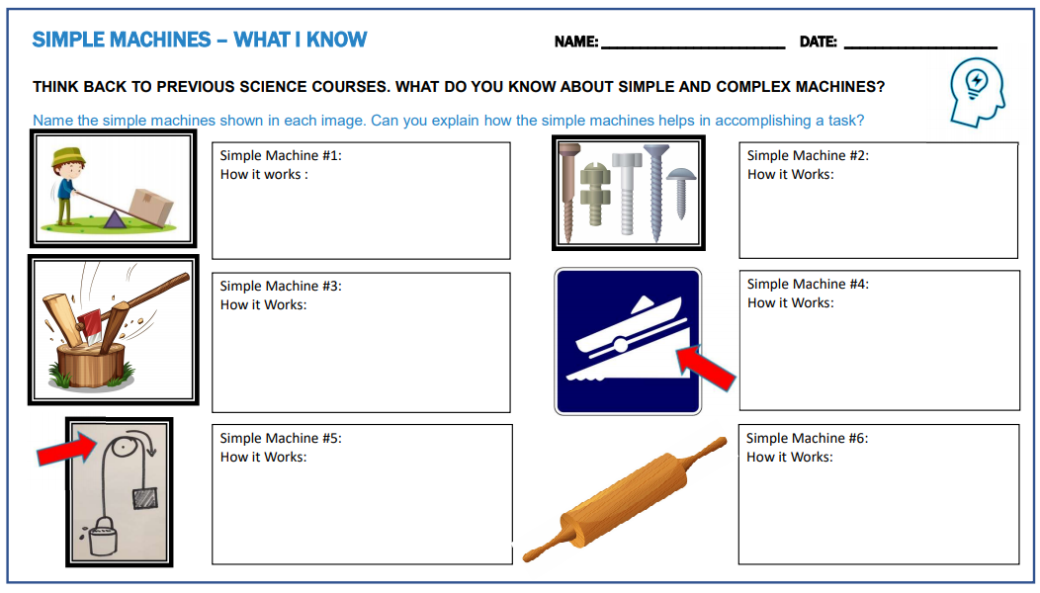

Activity 2– Simple Machines Lesson
This short lesson goes over the fundamentals of simple machines and focuses specifically on levers. It includes the 3 classes of levers and diagrams of how the forces (of the load and effort) are applied relative to the fulcrum.
The lesson includes an opportunity for students to work in pairs to come up with examples of the various tools and products used every day that are examples of the 3 classes of levers, then share their knowledge with the class. This lesson also has students apply their knowledge by sketching one of the items / tools they listed and labelling the sketch. This allows them to develop their sketching and communication skills while learning about simple machines.
Below are several sample slides taken out of the PowerPoint presentation that accompanies this activity. Please utilize the entire presentation for all three classes of levers.
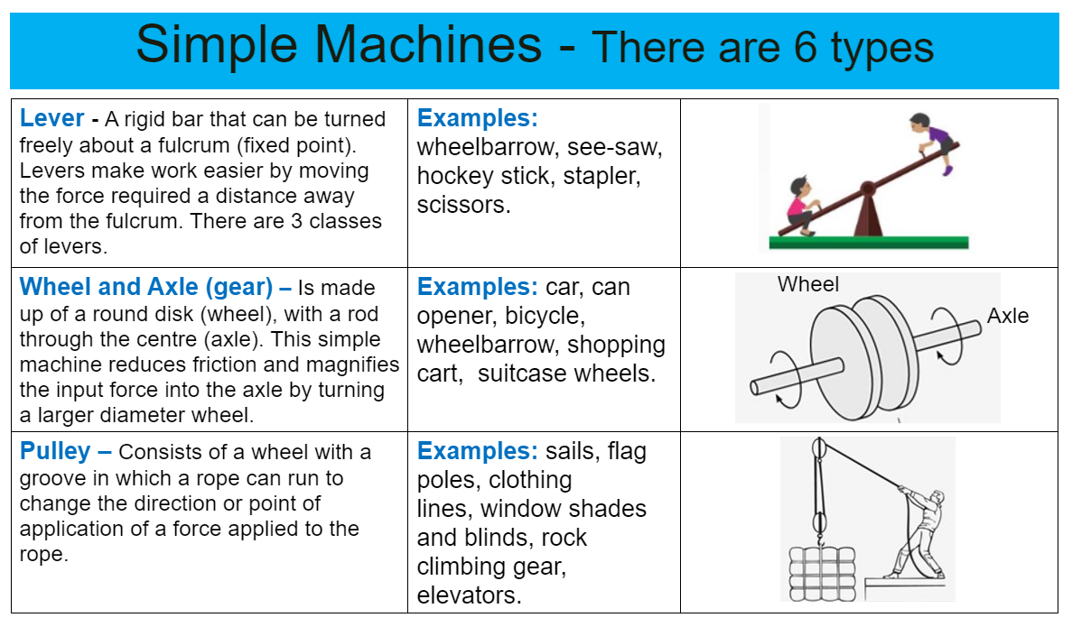
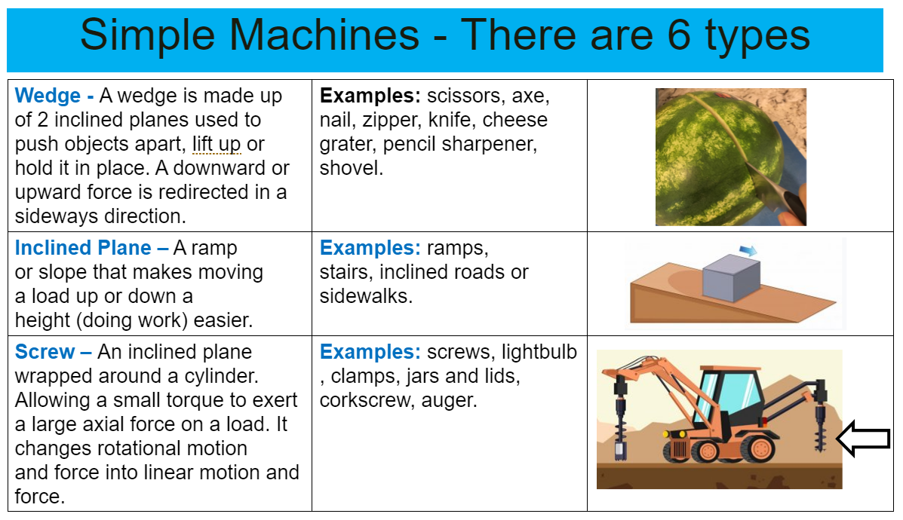
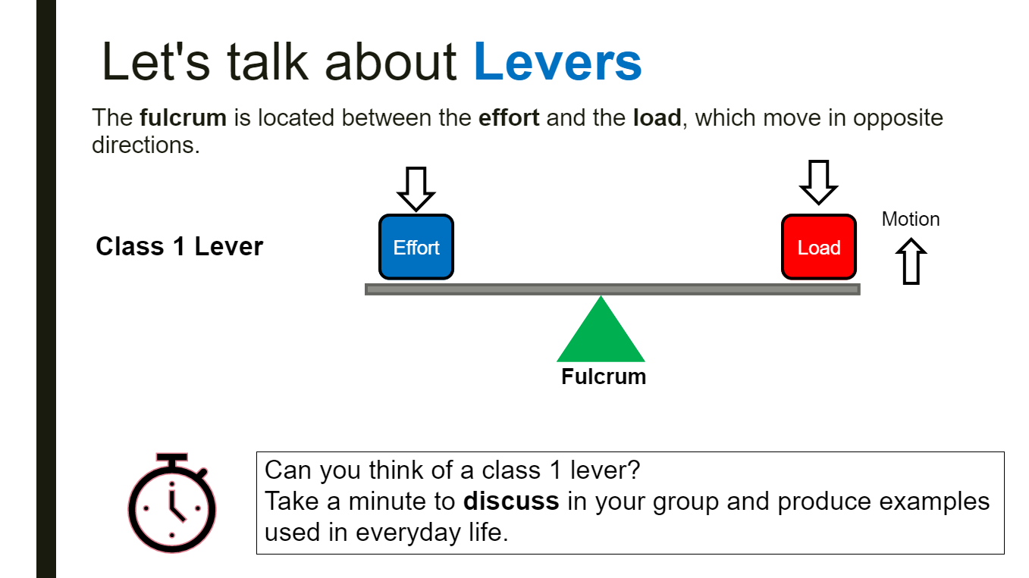

Activity 3 – Complex Machines
In this activity students will analyze images of products on the worksheet to understand how many simple machines are incorporated in the various complex machines. They can work in groups of 2 or 3 to complete the task or do the work at home. This activity allows students to apply their understanding and evaluate the function of machines or tools they may use on a daily basis.
Developing the ability to determine which parts are critical in the design and analyze how products work is essential for students to develop design solutions. These are skills required for the culminating crane design challenge.
The “Simple Machines – Make Up Complex Machines” worksheet, similar to the thumbnail below, can be found in Appendix D and downloadable as full page presentation format.

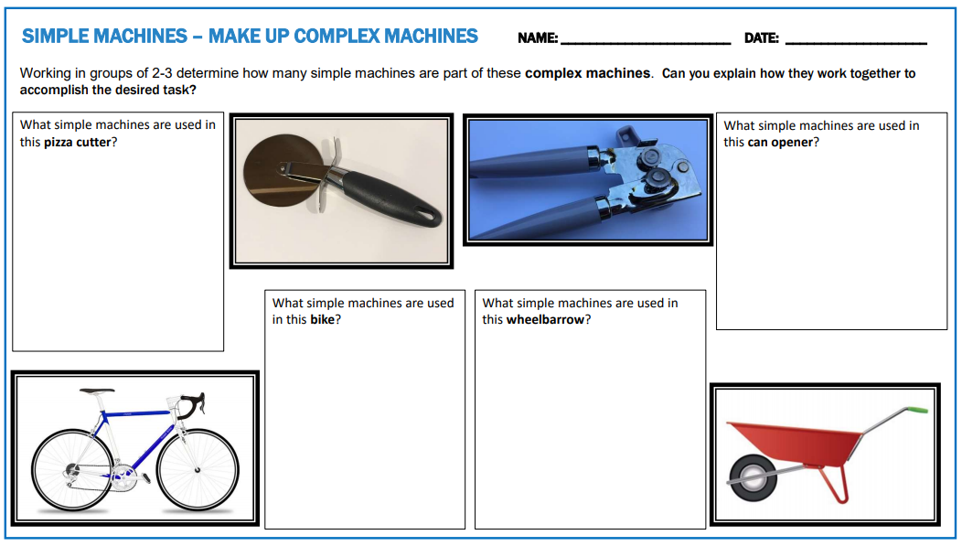

Activity 4 – Scavenger Hunt
In this activity students will search around their home/classroom/workshop to find, photograph and sketch simple machines.
Students will work on critical thinking skills by allowing them to apply their knowledge of simple machines as well as develop sketching skills. The task allows students to continue developing their sketching skills for assessment of learning. They will be required to sketch and label their design concepts for the final design challenge. This is an opportunity for teachers to provide students with feedback in preparation for the final culminating activity.
Full size Scavenger Hunt student activity worksheets, similar to the thumbnails below, can be found in Appendix E and downloadable as full page presentation format.
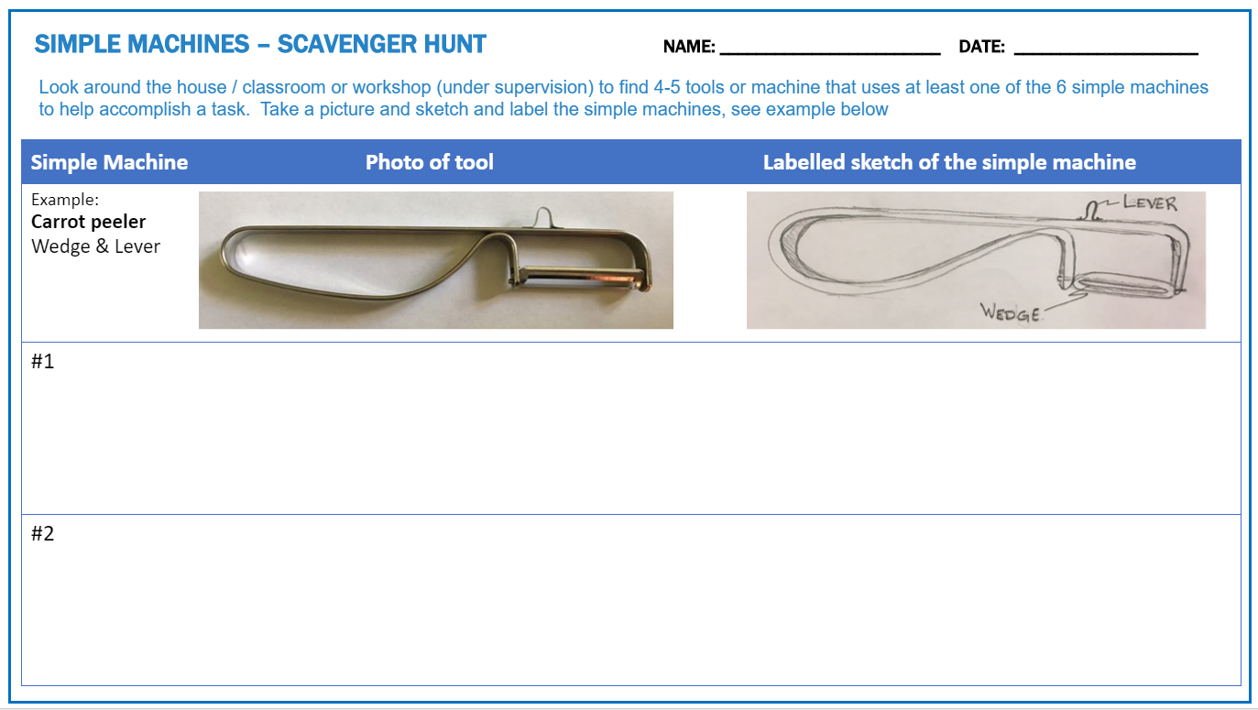
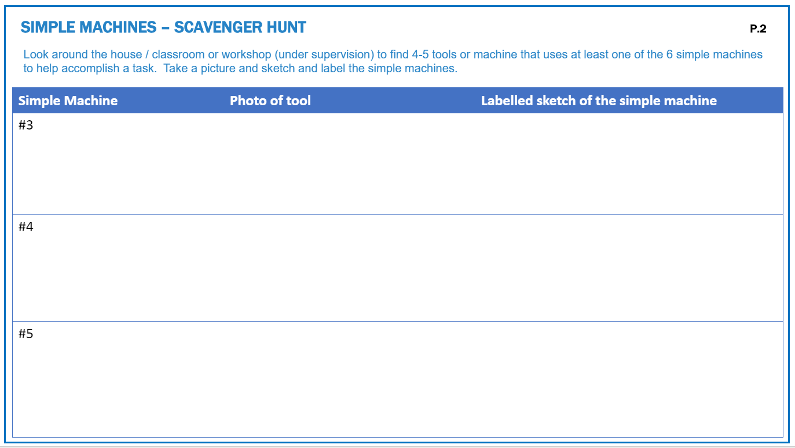

Activity 5 – Evolution of Machines Timeline
In this activity, students will conduct research on how a machine or tool has evolved over time and how society has benefited from the technology. By completing this activity students will develop their research and communication skills, while learning about how society influences technological innovation and how technology affects society. This task can be done in class or entirely online. A PowerPoint presentation is also available, see Appendix G.

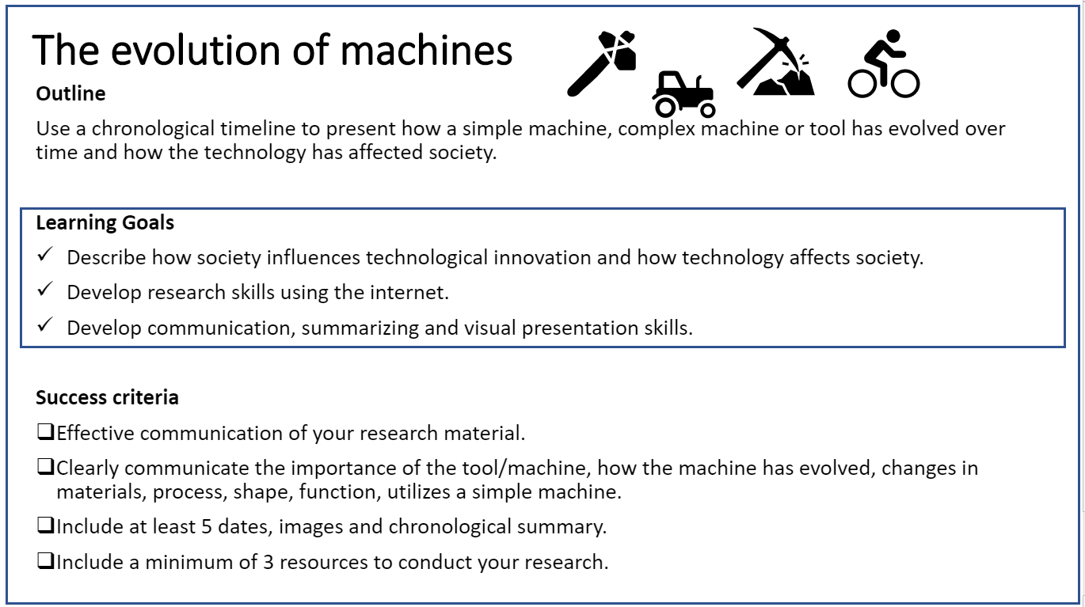

The suggested method for this activity is to create a chronological timeline of a tool or machine. The timeline would include dates, images, inventors and societies that created/utilized or benefited from the technology. There are many possibilities as a medium to communicate this information. An oral presentation is also possible. An exemplar has been included on the following page.

Evolution of a Machine Exemplar
Below is an exemplar is shown below
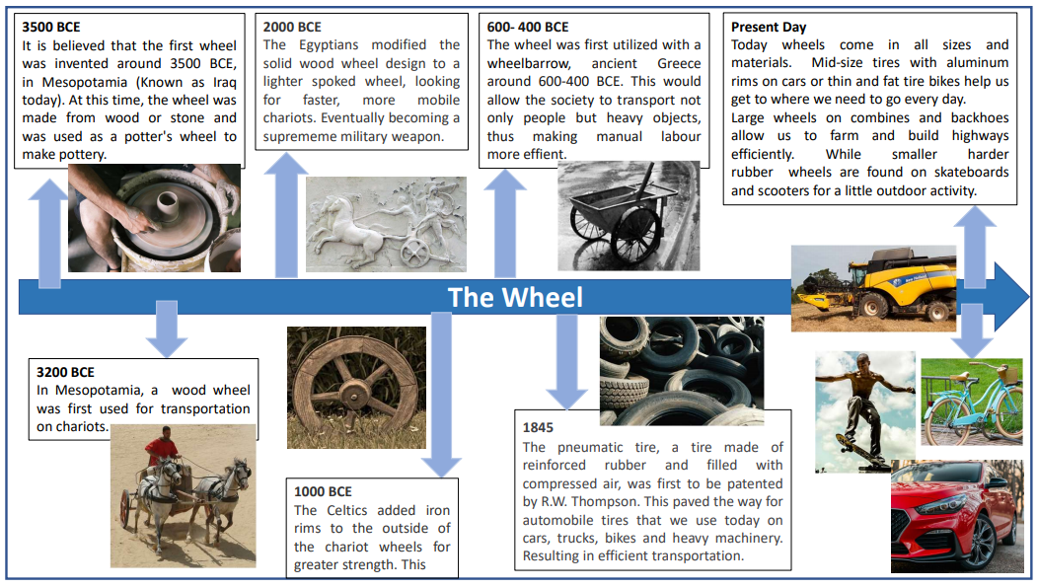

Activity 6 – Design Challenge - Build and Test Your Own Crane.
This culminating activity will have students apply their knowledge from the previous activities, while working through the design cycle steps. They will work in teams, to design, build and test a crane that meets the design criteria and constraints. There are many videos available to demonstrate the primary function of a crane and this is a great way to introduce the challenge.
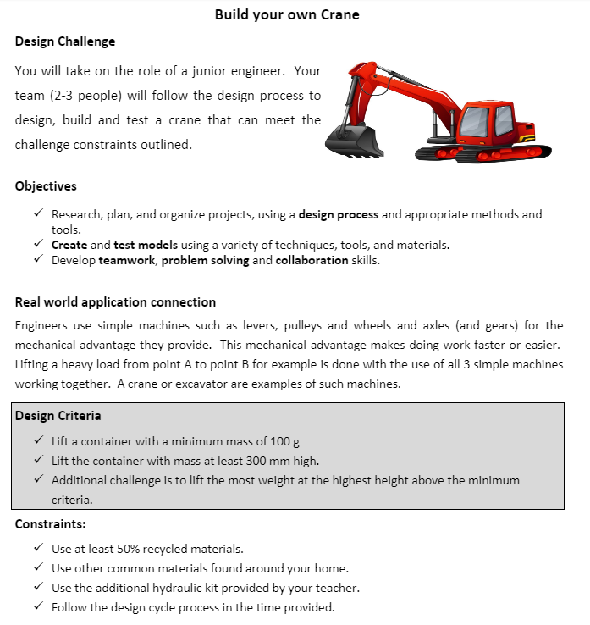
Materials:
Required: | Ideas for additional material:
- Cardboard  - Syringes (1-2)  - Vinyl tubing  - Adhesive (glue, tape, hot glue)  - Dowel – (For pivot) | - Popsicle Sticks  - Rope or string  - Paper clips  - Elastic Band  - Plastic bottle (recycled)

Required Tools:
- Engineering Journal – Take notes throughout the design process (electronic or paper)
- Ruler
- Pencil
- Hot glue gun (if you choose)
- Scissors or utility knife (if working under teacher or parent supervision)
Design Process:
- Get into your team and conduct research. This can be a search on different types of crane designs and how they work, or a review of the previous simple machine activities completed in the unit
- Brainstorm ideas of possible solutions that meet the design criteria and constraints.
- Each student is to sketch 2 possible solutions. Remember to include enough detail and notes in your sketch to effectively communicate your ideas.
- Choose the best solution as a team, using a pros and cons list to evaluate each design against the constraints.
- Create a technical drawing of your final solution - Technical Drawing: provide a two-dimensional scale drawing of your design. It should include dimensions and labelled parts/information.
- Build a prototype. Take notes of any issues that you encountered during the build.
- Test your prototype. Make any necessary changes to ensure the design meets the criteria. Note all changes in your journal and mark up your sketch.
- Finalize your design and test.
- Write a reflection on the design process by answer questions provided.

Reflection Questions – These are to be typed up and handed in.

- Did your design meet the criteria outlined in the design challenge? Explain why or why not.
- What part of the prototype do you think was the most critical? Why?
- Evaluate your design. What changes would you make to your original design? Why?
- Name at least 2 benefits to working in a team. Name 1 drawback? Be specific.
- What skills do you think are the most valuable for a team to be successful in designing a solution to a challenge? Why? (Ex; Collaboration, communication, organization, responsibility, initiative, independent work.)
- Reflecting on the design process steps, which one do you think is the most critical and why? (Research, brainstorm, concept ideas, choose the best solution, build a prototype, test the prototype, re-evaluate).

Teacher Notes:
Here is a sample of a simple crane.
- First two images below show the crane fully extended and fully retracted.
- This design is basic and uses 2 syringes. More complex designs that mimic an excavator boom (crane) is another option depending on availability of syringes.
- The maximum weight the crane can lift will depend on the size of syringes available.
- The lesson and activities focused on the advantages of simple machines. This crane design also incorporates structures, which is covered in intermediate science. Additional lessons could be added to ensure student understand how to design a rigid enough crane arm that won’t buckle. The design shown below has 2 pieces of cardboard hot glued together with the structural members in the vertical direction.
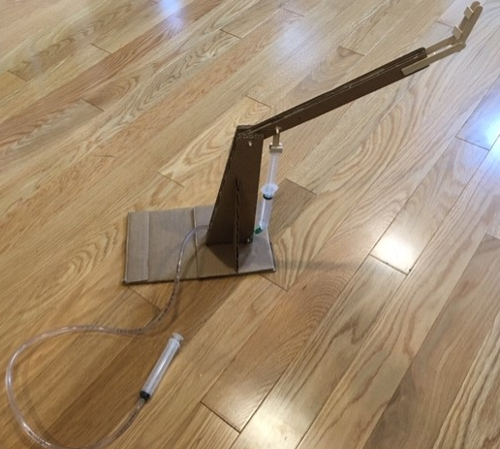
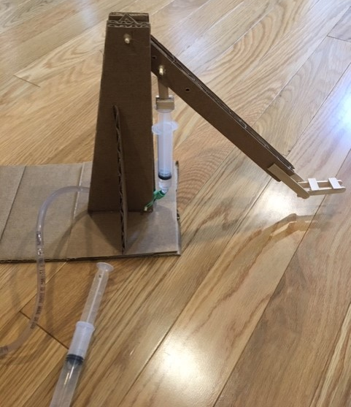

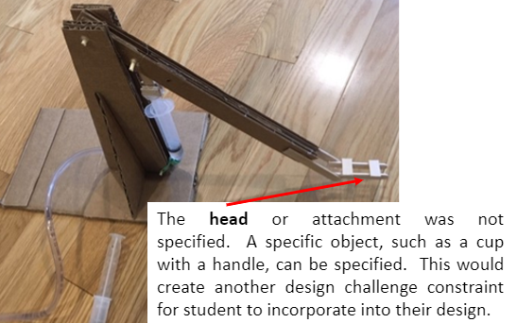

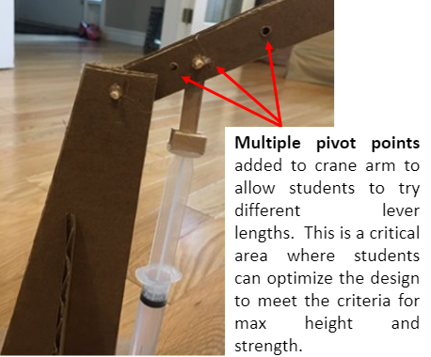

Planning Notes
- Review slides and handouts in advance.
- Review utility knife and hot glue gun safety procedures with the class in advance.
- Order syringes and vinyl tubing, as most students won’t have access to this material.

Resources

Files
There are six activities incorporating handouts, PowerPoint presentations, and lesson plans. Please see each activity as well as the appendices for all associated files.

Lesson Plans
Activity 2 is a lesson plan on simple and complex machines. It also goes into more detail about levers.

Handouts
Self and Peer Assessment for design project (Appendix A)
Simple and Complex Machine worksheet for Activity 1 (Appendix C)
Simple and Complex Machine worksheet for Activity 3 (Appendix D)
Simple and Complex Machine worksheet for Activity 4 (Appendix E)
Design Challenge - Build and Test Your Own Crane. (Activity 6)

Tools/Equipment
Tools required to carry out these activities include a pencil and paper (Activities 1,2,3,4,6); a computer with internet access (Activity 1,3,5); and scissors, utility knife, glue gun or tape, syringes and tubing (Activity 6)

Materials
For Activity 6, at least two syringes and lengths of vinyl tubing are to be provided by the teacher. Cardboard and tape or glue are the minimum materials required. Other materials can be used if available, and as determined by the teacher. The complete materials list is detailed in the handout.

Videos
Ted Ed video on the mighty mathematics of the lever
PBS video about simple machine inventions
PBS Learning Media video on Mechanical Advantage
PBS Learning Media video on Levers: Raising the Moai on Easter Island
PBS Learning Media video on Solving Complex Problems with Simple Machines
PBS Kids video on how levers work

Websites for Teachers
Interactive Lever simulation: Phet Simulation - Levers
Interactive Gear simulation: Gear generator simulation
Teachengineering.org - simple machines
Tryengineering.org

Instructional Strategies
The introduction of this unit can include a video of simple machines along with heavy machinery. Some video links have been included.
The activities can be for online, hybrid or in class learning. For hybrid or in class learning, students can complete the activities in pairs or small groups.
The culminating task is completed through broad based learning.

The Hook / Motivational Strategies
An introduction of a video of heavy machinery can be used to show students how simple machines are utilized to essentially move mountains. From small kitchen appliances, to bikes, trains, cranes and excavators, the mechanical advantage of simple machines can be found everywhere. Students will be working with a team of other junior engineers to apply their knowledge of simple machines to solve a real world problem.

Learning Goals and Success Criteria
Learning goals and success criteria are the foundation on which students base their ability to monitor their learning and determine next steps. Applicable learning goals may include any of the following,
- Students will identify simple machines in items they have in their house
- Students will sketch and make labeled drawings
- Students will develop communication using technological terminology
- By the end of the project, students will learn the steps of the design process
- By the end of the project, students will develop a set of designs to create a crane
- Students will use team work skills in order to build and test a crane
- By the end of the first five activities students will demonstrate sketching, research and presentation skills.
- Working on the design challenge (Activity 6), students will demonstrate an understanding of the design process and problem solving skills, specifically as it relates to building and testing a prototype.
Success criteria may include any of the following,
- I will be able to identify simple machines
- I will be able to correctly identify levers and their class of lever
- I will accurately sketch and make labeled drawings
- I will communicate effectively using technological terminology
- I will apply my knowledge to meet the design challenge
- I will follow the steps of the design process
- I will develop a set of designs to create a crane
- I will develop team work skills to build and test a crane
- I will incorporate recyclable materials in the design of my crane

Overall and Specific Expectations in Support of Ontario Curriculum Grades 9 - 10 Technological Education

Overall Expectations
B2. Apply appropriate methods for generating and graphically representing design ideas and solutions;
B3. Create and test models using a variety of techniques, tools, and materials;
C2. Describe how society influences technological innovation and how technology affects society

Specific Expectations
B2.1 Create freehand sketches of brainstormed design ideas, emphasizing key features (e.g., shapes, texture, materials, protrusions, unusual features).
B3.1 Use appropriate tools, equipment, and materials to create design models and/or prototypes.
B3.2 Use appropriate measuring methods and scales (e.g., metric: 1:10, 1 cm:1 m or 1:100, 1:500; imperial: 1 /2":1’ or 1:24) when creating models and prototypes;
B3.3 Assess models and/or prototypes on the basis of prescribed criteria.
C2.1 Describe how society influences the development and use of technology.

Safety Concerns
The most effective way to cut cardboard for the culminating project is to use a utility knife. This can be substituted with scissors if there are any safety concerns around using such a tool.
A hot glue gun is an effective way to put all the pieces together. A bowl of ice water should be nearby and all long hair should be tied back. Masking or duct tape are both good alternatives to using a hot glue fun if there are any safety concerns.

Applicable SAFEDocs and ToolSAFE videos
Please refer to the OCTE SAFEDocs for Technological Design for safety documents in order to properly address any tool safety concerns when instructing this project.
You may also refer to the following ToolSAFE videos,
ToolSAFE video for Hot Glue Guns
ToolSAFE video for Modeling Tools

Project Challenges
The prototype build is most effective if completed in class with team members. However, it could be modified to be completed at home independently.

Differentiation of the Project / Activity
The unit begins with a diagnostic activity to be completed alone or with a partner. Allowing students to review what they have learned from previous sciences classes.
Activities are hands-on and in small groups, to allow for collaboration of ideas.
The lesson includes images and text along with think-pair-share activity to support various learning styles. The teacher will bring student ideas together to allow for deeper understanding of content.
Activity 5 and 6 submissions can be submitted as a video or presented orally.

Assessment and Evaluation
Assessment As Learning
Activity 1 can be used as a diagnostic tool to create a baseline of students’ previous knowledge of simple machines.
Activity 2 is a lesson that includes opportunities for students to collaborate and share their ideas. This allows the teacher to assess their knowledge and observe how they apply that knowledge.
Assessment For Learning
Activity 3 and 4 provide students with the opportunity to apply their knowledge and get feedback relative to the theory of simple machines as well as on their sketching skills
Assessment Of Learning
Activity 5 can be used as assessment of learning or for learning, depending on when in the course the project is assigned. Students will demonstrate research and communication skills. Both of which are assessed in the final culminating project, Activity 6.
Activity 6 - Allows students to demonstrate their understanding of the theory and apply their research and sketching skills that they worked on in previous activities. Students will also demonstrate their understanding of the design process through broad based learning.

Career and Industry Extensions
Applying knowledge in real world applications. Students can investigate how simple machines can be utilized to help the elderly or someone with a disability accomplish an otherwise simple task. (Ex, getting out of bed or the car, opening a jar or a door, etc.).
Review videos that explore related careers and create a Venn Diagram to compare necessary skills in 2-3 of the career choices. Career opportunities in fields that use the design process and simple machines.
Example of some videos are:
- Hot Jobs on PBS – Explanation from a Computer, Biomedical and Electrical Engineering students and their final design project. PBSLearning- Engineering Student Projects Video
- PBS Learning - Interview with a mechanical engineer designing bicycles
- Edge factor has spotlight videos on many different careers in trades and tech fields. Edge factor - careers

Environmental Considerations
Students will use at least 50% of recycled materials required for the culminating project.

Reflection or Design Report
Students will reflect on the design process by answering and submitting questions after the build challenge is complete (Activity 6). An extension of the project could be to add a final design report submission.

Appendix A - Design Project - Self and Peer Assessment
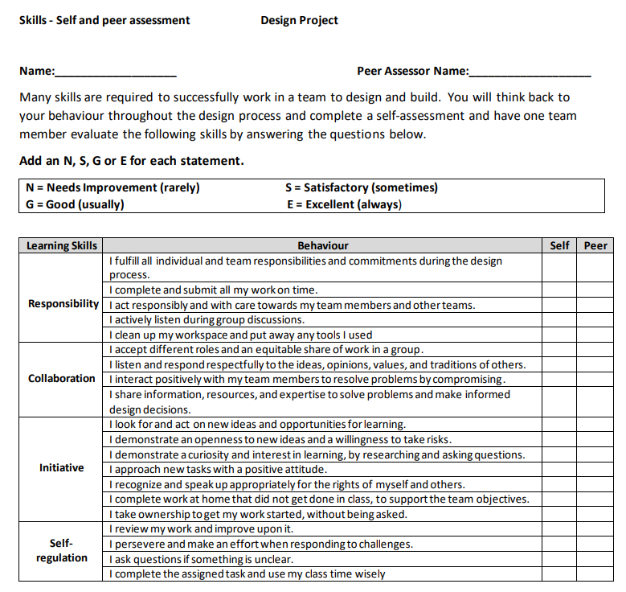

Appendix B - Design Project Rubric
This is a single point rubric. The criteria for a level 3 is defined. If the students’ work is above or below the expected level 3 criteria, notes can be added to provide students with specific feedback.
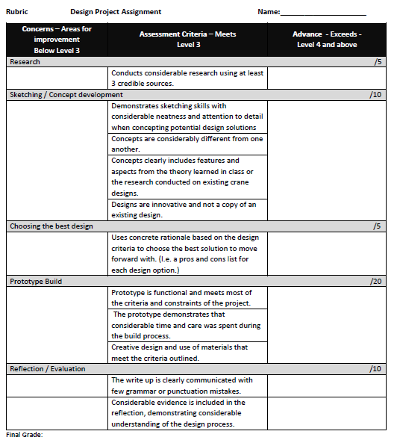

Appendix C - Simple and Complex Machine worksheet for Activity 1.
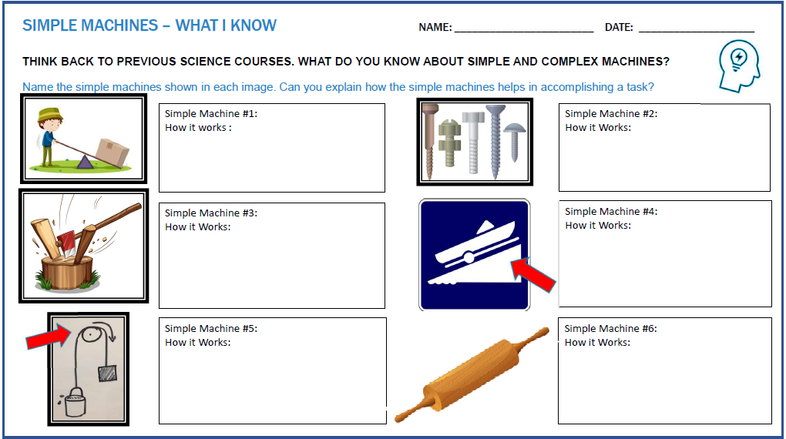

Appendix D - Simple and Complex Machine worksheet for Activity 3
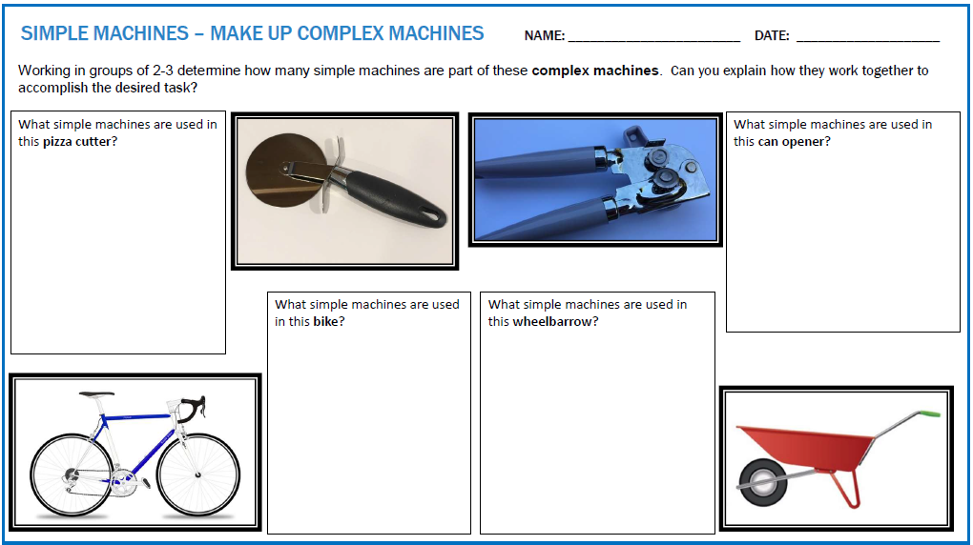

Appendix E - Simple and Complex Machine worksheets for Activity 4
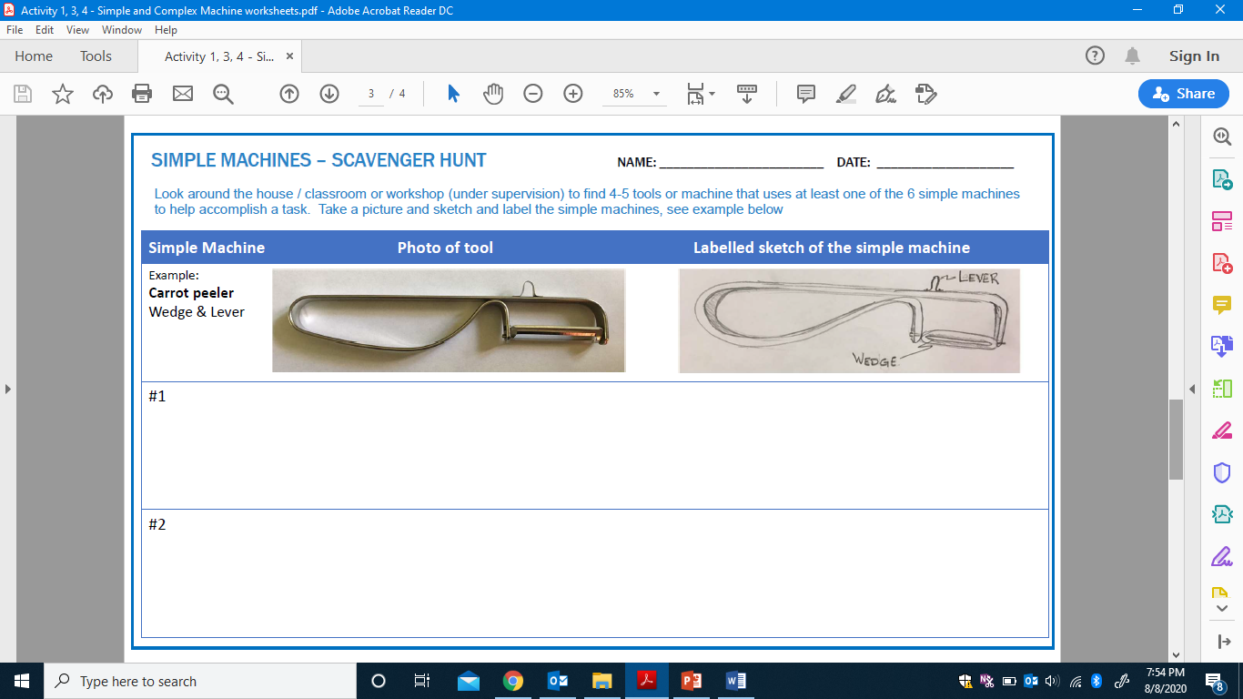

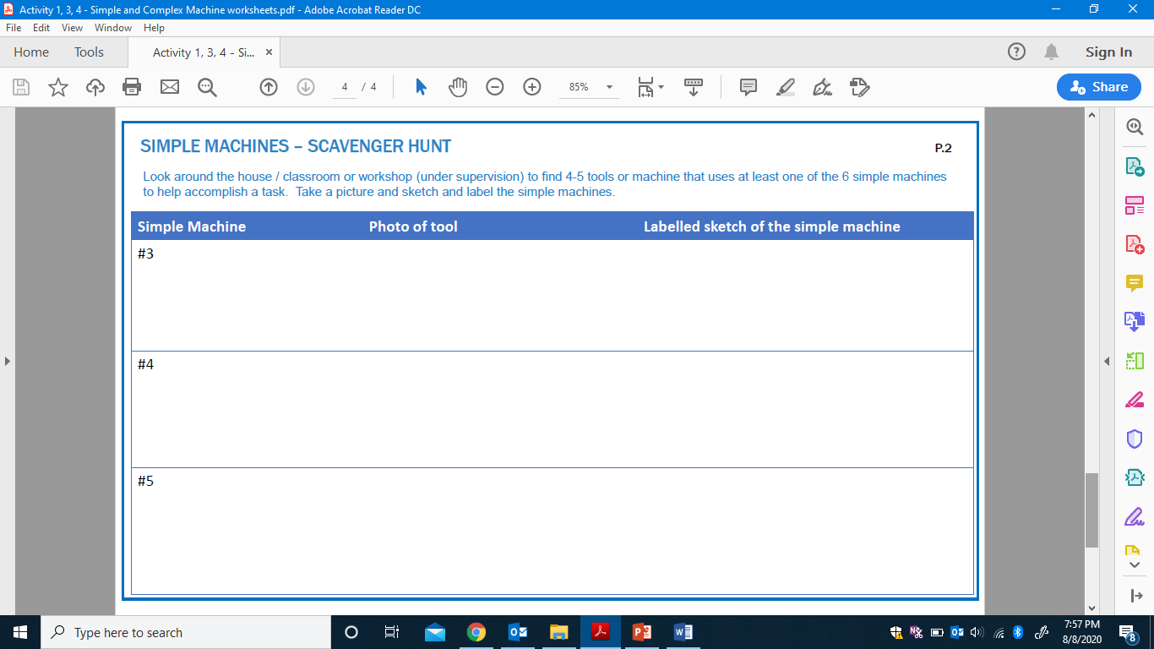

Appendix F – Simple Machines PowerPoint (Activity 2)
Simple Machines PowerPoint presentation
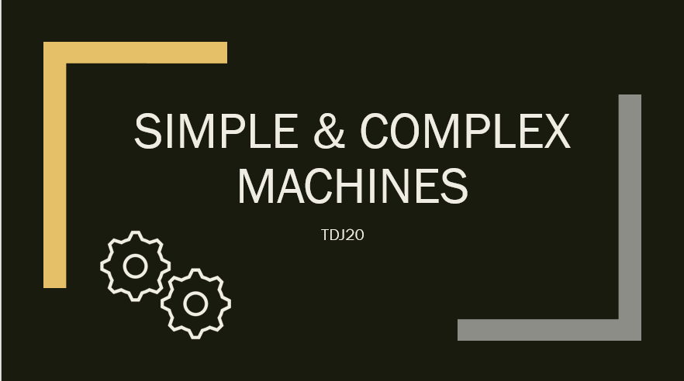
https://www.octe.ca/application/files/3115/9745/6853/Activity_2_-_Simple_Machines.pptx

Teacher are invited to use this PowerPoint presentation during Activity 2. The presentation outlines the 6 types of simple machines and covers the 3 classes of levers.
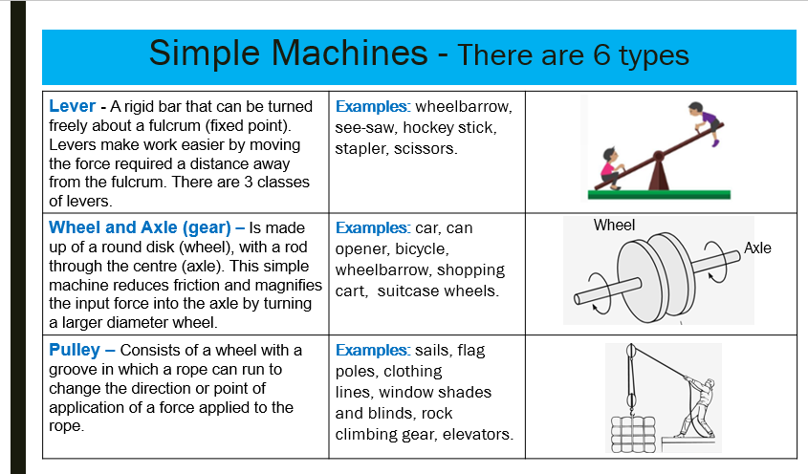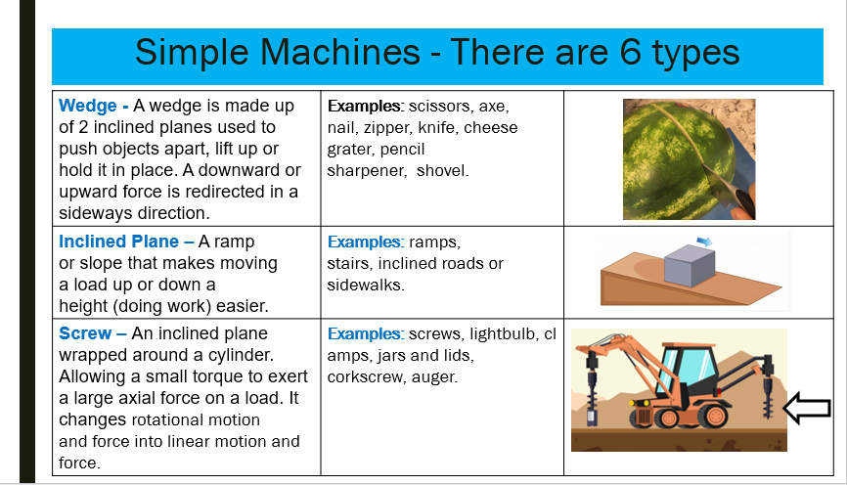
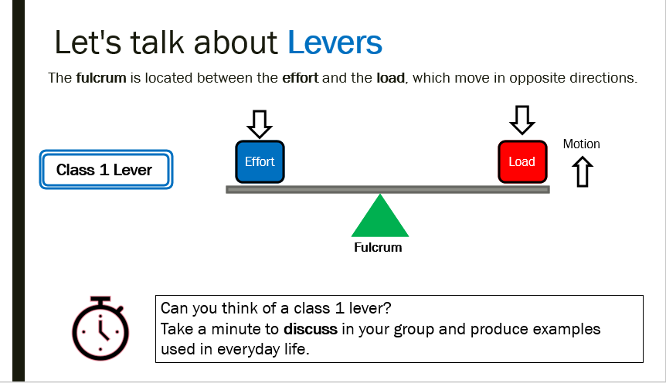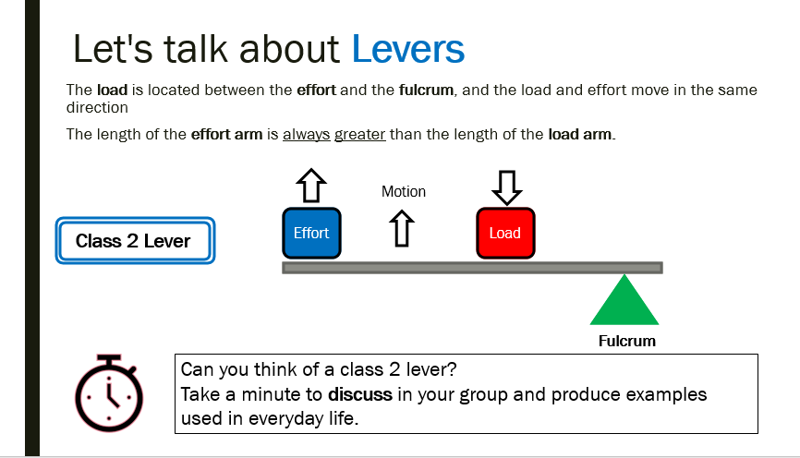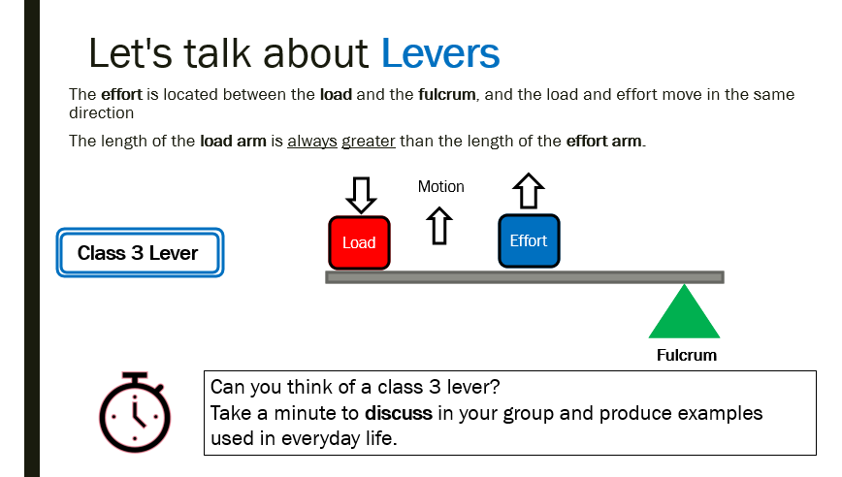

Appendix G –Evolution of Machines Timeline Assignment PowerPoint (Activity 5)

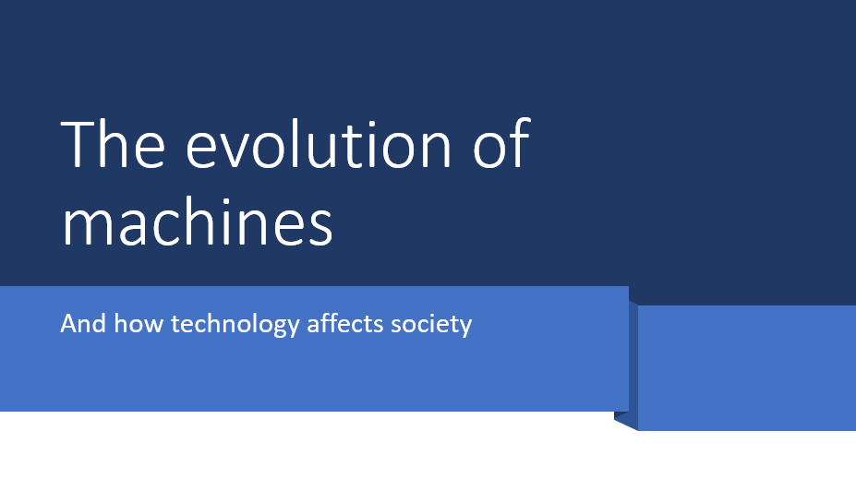
https://www.octe.ca/application/files/3615/9701/6505/The_Evolution_of_Machines_-_Activity_5.pptx

References
21st Century Competencies: Foundation Document for Discussion. Phase 1: Towards Defining 21st Century Competencies for Ontario, Winter 2016 Edition, 2016 http://www.edugains.ca/resources21CL/About21stCentury/21CL_21stCenturyCompetencies.pdf
Ancient Wheelbarrow- black and white (Image), 2020 https://ccsearch.creativecommons.org/photos/d61f8e36-dc4e-4c9b-a869-6a908761621c
Axe splitting wood (Image), 2020 https://www.vecteezy.com/vector-art/445134-a-set-of-cutting-tree
Baby Blue bicycle (Image), 2020 https://ccsearch.creativecommons.org/photos/1066022b-52b2-4526-9b51-1042c84b788f
Backhoe with auger (Image), 2020 https://www.vecteezy.com/vector-art/174040- tractor-backhoe-earth-auger-system-free-vector
Block-and-tackle-in-use.svg (Image), 2020 https://ccsearch.creativecommons.org/photos/9bed7bda-552d-422f-995c-5dadda561aa7
Blue Bike (Image), 2020 https://pixabay.com/images/search/bike/
Boat Ramp sign (Image), 2020 https://ccsearch.creativecommons.org/photos/1d88940b-02a7-40ce-83d5-d1f47bc8741c
Course Codes for Emphasis courses in the Revised Curriculum: Technological Education, Grades 11 and 12, 2009 http://www.edu.gov.on.ca/eng/curriculum/secondary/techedemphasiscourses.pdf
Different type of screws and nails (Image), 2020 https://www.vecteezy.com/vector-art/120124-free-nail-head-icons-vector
Evolution of Machines - Activity 5 (PowerPoint presentation), 2020 https://www.octe.ca/application/files/3615/9701/6505/The_Evolution_of_Machines_-_Activity_5.pptx
Excavator (Image), 2020 https://www.vecteezy.com/vector-art/413578-excavator
Ferris Wheel (Image), 2020 https://www.pexels.com/search/ferris%20wheel/
Growing Success: Assessment, Evaluation, and Reporting in Ontario Schools, First Edition, Covering Grades 1 to 12, 2010 www.edu.gov.on.ca/eng/policyfunding/growSuccess.pdf
Horses with Chariot décor (Image), 2020 https://ccsearch.creativecommons.org/photos/045e9c89-b8b6-452c-8e2b-04e110939dbd
Image of tire wheel and rim assembly (Image), 2020 https://www.pexels.com/photo/automobile-automotive-car-rim-244553/
Learning for All – A Guide to Effective Assessment and Instruction for All Students, Kindergarten to Grade 12, 2013 http://www.edu.gov.on.ca/eng/general/elemsec/speced/LearningforAll2013.pdf
Man lifting a box with a lever (Image), 2020 https://www.vecteezy.com/vector-art/366457-boys-playing-seesaw-and-man-lifting-box-with-beam
OCTE SAFEDocs for Technological Design, 2013 https://www.octe.ca/download_file/view/4840/1201
Old bicycle (Image), 2020 https://ccsearch.creativecommons.org/photos/800de876-a36a-4473-a343-aa3b2c3cc0ee
Old wooden wheel with metal rim (Image), 2020 https://www.pexels.com/photo/brown-wooden-wheel-on-top-of-green-grass-161921/
Person fly fishing (Image), 2020 https://www.vecteezy.com/vector-art/211511-young-fisherman-fly-fishing-in-mountain-river
Person riding chariot with 2 horses (Image), 2020 https://ccsearch.creativecommons.org/photos/53e54061-2b30-4cad-9962-48617e36ff79
Pile of old tires (Image), 2020 https://ccsearch.creativecommons.org/photos/a763c4b3-a6fc-41b3-a244-34887ffe8da4
Pottery Wheel (Image), 2020 https://unsplash.com/s/photos/pottery-wheel
Red Car (Image), 2020 https://unsplash.com/photos/hdMSxGizchk
Red Excavator (Image), 2020 https://www.vecteezy.com/vector-art/413578-excavator
Rolling Pin (Image), 2020 https://www.vecteezy.com/vector-art/539030-roller-pin-made-of-wood
See-Saw Vectors with Kids (Image), 2020 https://www.vecteezy.com/vector-art/88697-see-saw-vectors-with-kids
Schematic drawing of a simple clutch.svg (Image), 2020 https://ccsearch.creativecommons.org/photos/7271ec5f-178b-480a-8332-d382e84f849b
Simple and Complex Machines (Worksheets in PowerPoint presentation) https://www.octe.ca/application/files/4615/9701/6595/Simple_and_Complex_Machine_Worksheets_-_Activity_134.pptx
Simple and Complex Machine Worksheets (Handouts), 2020 https://www.octe.ca/application/files/1215/9761/9910/Simple_and_Complex_Machine_worksheets.pdf
Simple Machines (PowerPoint presentation), 2020 https://www.octe.ca/application/files/3115/9745/6853/Activity_2_-_Simple_Machines.pptx
Skateboard with close up of feet (Image), 2020 https://unsplash.com/s/photos/wheels
Skateboarder (Image), 2020 https://ccsearch.creativecommons.org/photos/b495a82a-3fb7-4098-bfd3-9292705d2bc3
Slope with box (Image), 2020 https://www.freepik.com/free-vector/two-objects-rolling-slope_6655874.htm#page=1&query=slope&position=0
The Differentiated Instruction Scrapbook http://www.edugains.ca/resourcesDI/EducatorsPackages/DIEducatorsPackage2010/2010DIScrapbook.pdf
The Ontario Curriculum, Grades 1-8 Science and Technology, 2007 (revised): http://www.edu.gov.on.ca/eng/Curriculum/elementary/scientec18currb.pdf
The Ontario Curriculum, Grades 9 and 10: Technological Education, 2009 (revised) http://www.edu.gov.on.ca/eng/curriculum/secondary/teched910curr09.pdf
The Ontario Curriculum, Grades 11 and 12: Technological Education, 2009 (revised) http://www.edu.gov.on.ca/eng/curriculum/secondary/2009teched1112curr.pdf
ToolSAFE video for Hot Glue Guns (Video), 2015 https://www.octe.ca/en/resources/resource-folder/toolsafe/toolsafe-tdj-hot-glue-gun
ToolSAFE video for Modeling Tools (Video), 2015 https://www.octe.ca/en/resources/resource-folder/toolsafe/toolsafe-tdj-modelling-tools
Two object rolling slope (Image), 2020 https://www.freepik.com/free-vector/two-objects-rolling-slope_6655874.htm#page=1&query=slope&position=0
Two people rowing (Image), 2020 https://www.vecteezy.com/vector-art/366592-two-men-rowing-kayak
Wheel Barrow (Image), 2020 https://www.vecteezy.com/vector-art/223245-realistic-gardening-tools-colorful-set
Yellow Combine (Image), 2020 https://ccsearch.creativecommons.org/photos/b2ce6023-3cf1-4e29-9e84-bebb2abff979

