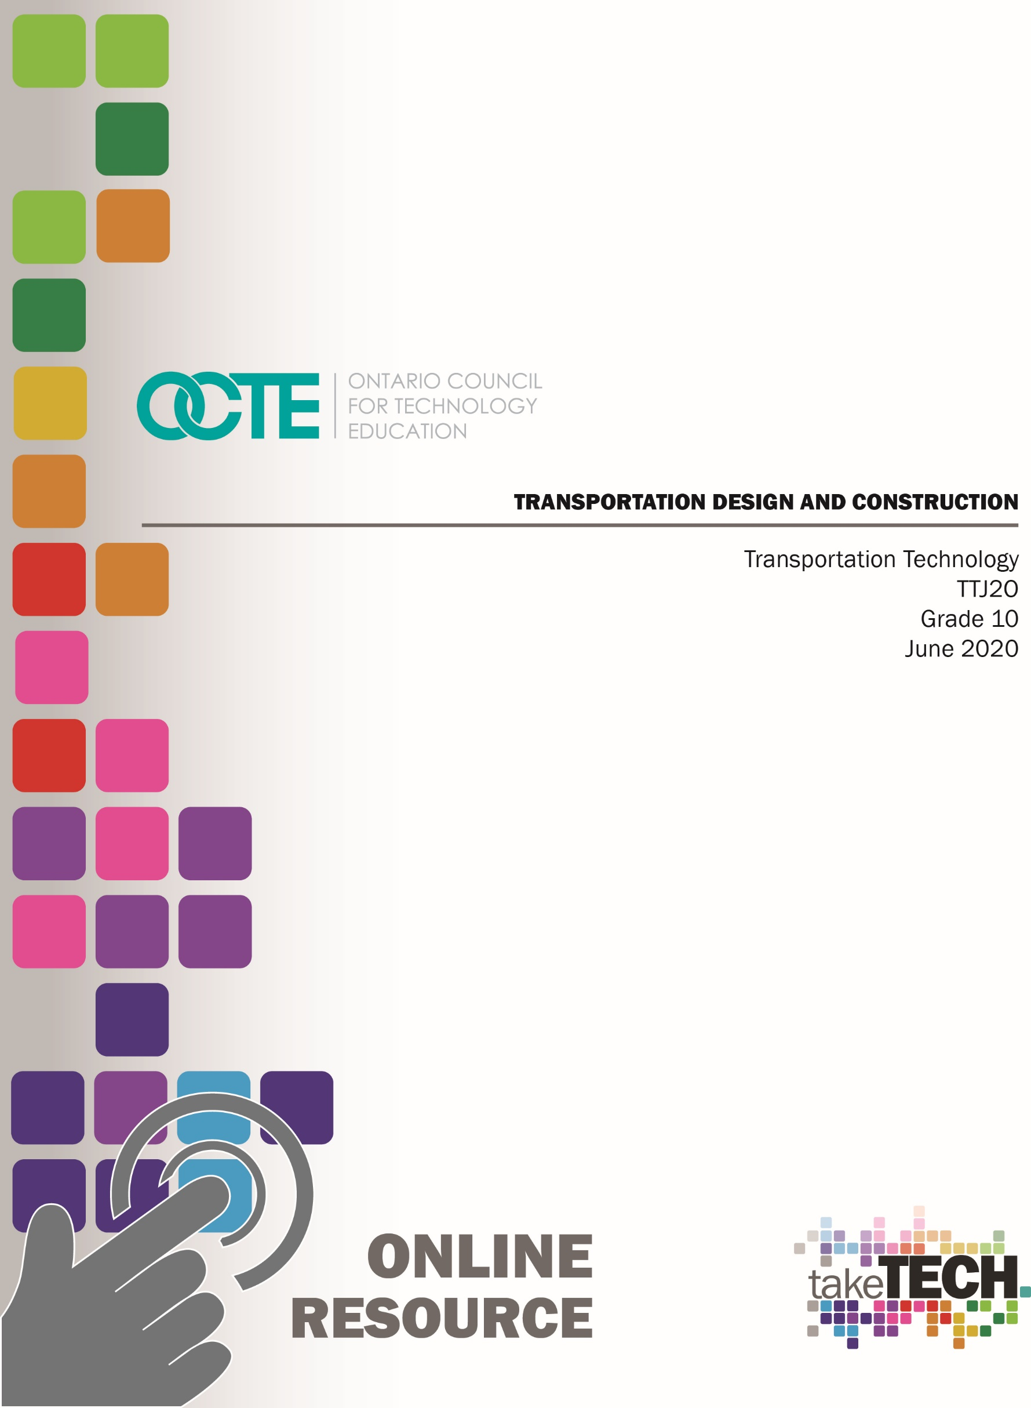
OCTE TDJ2O Online Resource cover page titled "Designing and Testing a Crane"

Table of Contents

Introduction 3
Project Outline 3
Prior Knowledge 3
Student Activities 3
Planning Notes 4
Notes on Activity 1 – Transportation Design & Construction (Aerodynamics) 4
Notes on Activity 2 – Transportation Design & Construction (Land & Air) 6
Notes on Activity 3 – Transportation Design & Construction (Sea) 7
Resources 8
Lesson Plans 8
Handouts 8
Tools/Equipment 9
Materials 10
Videos for Teachers 8
Activity 1 – Transportation Design & Construction (Aerodynamics) 11
Activity 2 – Transportation Design & Construction (Land & Air) 13
Culminating Task 15
Activity 3 – Transportation Design & Construction (Sea) 16
Final Evaluation 18
Instructional Strategies 19
The Hook / Motivational Strategies 19
Learning Goals and Success Criteria 19
Overall and Specific Expectations 20
Overall Expectations 20
Specific Expectations 20
Applicable SAFEDocs and ToolSAFE videos 20
Project Challenges 21
Differentiation of the Project / Activity 21
Assessment and Evaluation 22
Career and Industry Extensions 25
Environmental Considerations 25
Reflection or Design Report 25
Appendix A – Lesson Plans 26
Lesson Plan - Activity 1 Aerodynamics 26
Lesson Plan - Activity 2 Land & Air 28
Lesson Plan - Activity 3 - Sea 30
References 32

Introduction
Course Code: TTJ2O
Broad base Technology: Transportation Technology
Destination: Open
Grade Level: 10
Prerequisite: None
Online Project Name: Transportation Design & Construction

Project Outline
In this unit, students will develop knowledge and skills related to the construction of vehicle/craft systems. Students will identify and describe the major systems and components of vehicles, aircraft, and/or watercraft such as body, hull, and/or fuselage system components. Students will use a problem-solving process to design and fabricate a component of a vehicle and a scaled watercraft. At the end of this unit students will be expected to prepare a report on their work throughout the process using appropriate documentation.

Prior Knowledge
Students will use prior knowledge from Science and Technology programming (grade 3 to grade 9). Exploring Technologies (TIJ1O) or Transportation Technology (TTJ1O) would be an asset.

Student Activities
This resource has been broken into 3 activities or assignments that focus on Design and Construction as they apply to different modes of transportation. Activity 1 focuses on aerodynamics, while Activity 2 focuses on land and air modes of transportation. Activity 3 takes a look at modes of transportation that take place on water or the sea. Have fun and explore what’s available for you and your students.

Planning Notes
Here are a few notes in planning out this resource and its activities.

Notes on Activity 1 – Transportation Design & Construction (Aerodynamics)
- With a synchronous learning time agreed upon by teachers and students, the teacher begins to lead the students by asking key questions. Have you ever thought about how airplanes fly? Why are boats shaped to a point at the bow? Why do cars have wings or spoilers?
- Ask the students to collect the following materials from their home. Empty water bottle, pencil, tape, scissors, paper, and a house hold fan.
- Ask the students to use their scissors and cut their paper into 6 to 12 equal strips of 6mm (1/4”) X 100 mm (4”).
- Ask the students to carefully tape four (4) to six (6) the strips onto their water bottle closer to the neck of the water bottle.
- For best results, ask students to secure a pencil using tape to their water bottle towards the neck of the bottle.
- With the fan on high, ask the students to manipulate the bottle in front of the fan.
Aerodynamics Video
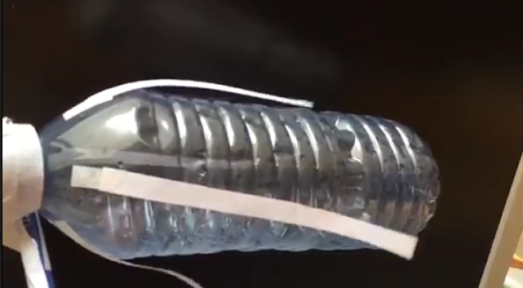

https://www.octe.ca/application/files/8715/9771/3214/Video.mp4

- Ask the students to record their findings by carefully observing the paper strips. Then ask the students to repeat the process but this time moving the paper strips towards the bottom of the water bottle. Finally, ask students to tape the strips on the bottom of the water bottle. Ask students to reflect on what happens to the strips as the air rushed over the water bottle.
Aerodynamics Video_1
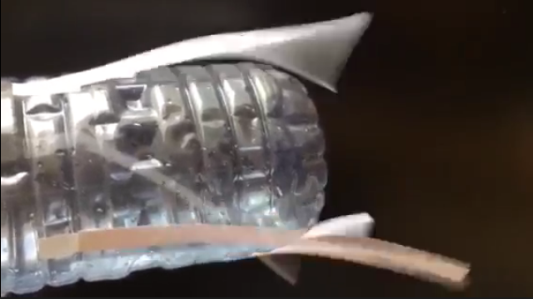

https://www.octe.ca/application/files/1515/9771/3362/Video_1.mp4

Aerodynamics Video_2
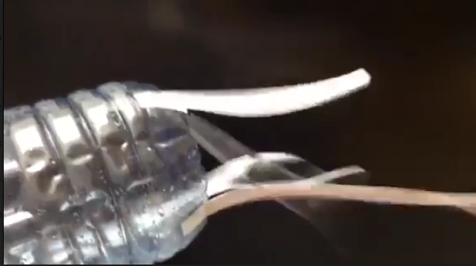

https://www.octe.ca/application/files/9315/9771/3484/Video_2.mp4

Notes on Activity 2 – Transportation Design & Construction (Land & Air)
- Students are then asked to answer a series of questions regarding aerodynamics. Terms such as drag, lift, gravity, thrust, and weight.
- Students can then explore different objects from their household. Toy car(s) are preferred for this activity however toy boats, rocket, and planes or any household object will suffice. Ask students to then record their findings and reflect on which items had superior results.
Aerodynamics Video_4
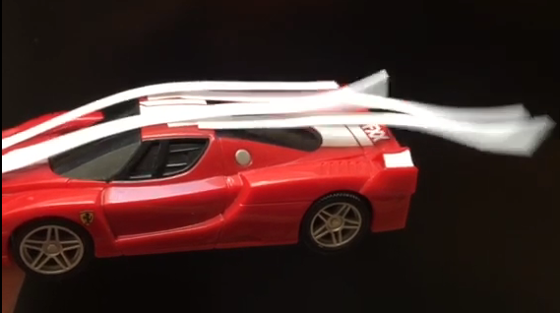
https://www.octe.ca/application/files/3215/9771/3660/Video_4.mp4
- Students can then experiment with various shapes and objects from around their home or can use this as an opportunity to build an air plane wing.
Aerodynamics Video_3
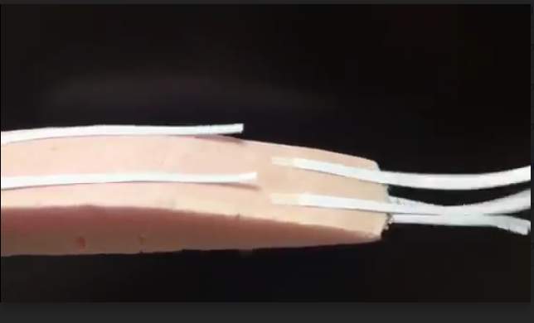
https://www.octe.ca/application/files/6715/9771/3569/Video_3.mp4
- For the culminating task, ask students to add a shape onto their water bottle to change the air flow. They can add a splitter, wing, spoiler or fin. Students are expected to document all their findings in a SPICE report that will be submitted for evaluation.

Notes on Activity 3 – Transportation Design & Construction (Sea)
- For the next activity, students are to apply the concepts they have learned into the construction of a scaled boat.
- Ask students to gather the following materials from their homes. Paper, cereal boxes or bristle board, tape or glue, and a soup can (284mL or larger).
- Ask students to create three (3) prototype boats from two (2) sheets of 7” X 10” pieces of paper by folding, cutting and taping the paper together. Each prototype should test a different hull design.
- Using the same principles explored in the previous activity, ask students to test their boat designs using a fan and strips of paper.
- Ask students to reflect and document on how their shapes impacted the overall aerodynamics of their design and why? How does aerodynamics play a factor in how a boat moves through the water?
- Students will then be directed to choose one boat design and create their prototype from a cereal box or bristle board. Their material are limited to two (2) 7” X 10 “sheets and tape or glue. Students are only allowed to tape or glue their seams.
- Direct students to fill a sink, basin or bucket with water.
- Carefully placing their scale boat in water with the soup can inside, ask students to time how long their boat can float before taking in water. Students’ video record their boats and submit for evaluation.
- At the end of this activity, students are directed to submit a spice report for evaluation.
- Students can research career opportunities available.

Resources

Lesson Plans
See Appendix A

Handouts
Activity 1 – Transportation Design & Construction (Aerodynamics)
Activity 2 – Transportation Design & Construction (Land & Air)
Activity 3 – Transportation Design & Construction (Sea)

Videos for Teachers
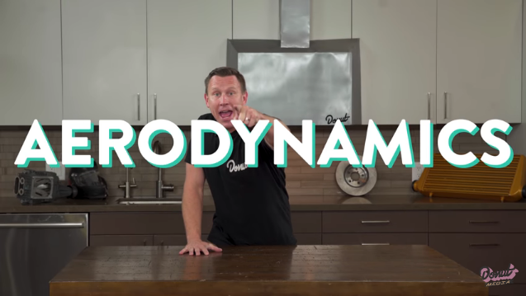 | Wings and Spoilers; Lift and Drag | How It Works (YouTube video)  https://www.youtube.com/watch?v=AXjiThF1LXU
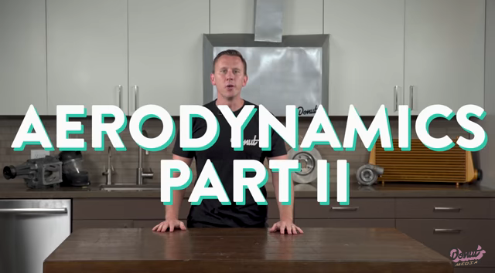 | Side Skirts, Diffusers, and Air Dams | How It Works | Science Garage (YouTube video)  https://www.youtube.com/watch?v=Woq-nl9QyfQ
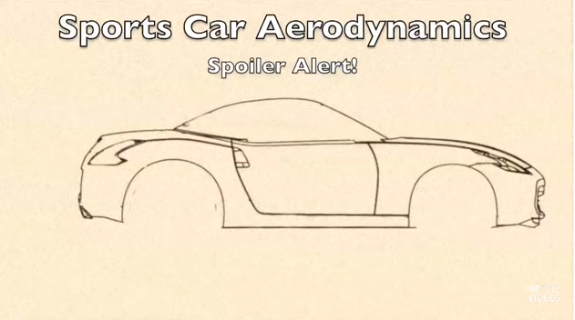 | Sports Car Aerodynamics: Spoiler Alert!  https://www.youtube.com/watch?v=TKH1DyV9vNU
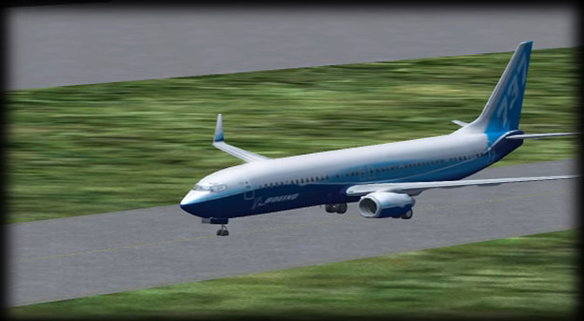 | The Aerodynamics of Flight (YouTube), 2009  https://www.youtube.com/watch?v=5ltjFEei3AI

Aerodynamics Video
https://www.octe.ca/application/files/8715/9771/3214/Video.mp4

Aerodynamics Video_1
https://www.octe.ca/application/files/1515/9771/3362/Video_1.mp4

Aerodynamics Video_2
https://www.octe.ca/application/files/9315/9771/3484/Video_2.mp4

Aerodynamics Video_3
https://www.octe.ca/application/files/6715/9771/3569/Video_3.mp4

Aerodynamics Video_4
https://www.octe.ca/application/files/3215/9771/3660/Video_4.mp4

Tools/Equipment
Scissors
Ruler
Tape

Materials
Pop bottle
Paper
Cardboard
Glue
Tape

Activity 1 – Transportation Design & Construction (Aerodynamics)

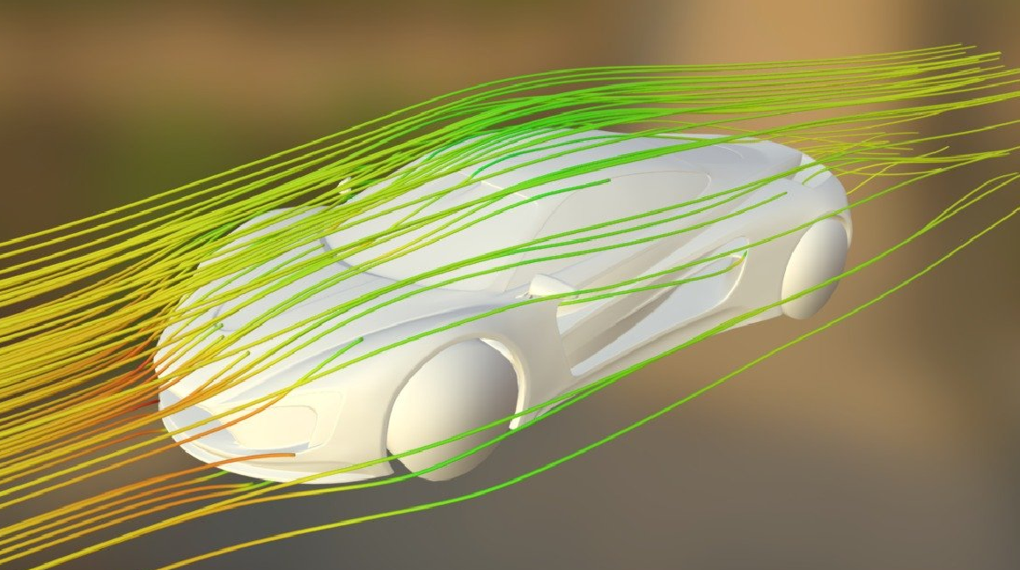

- Look around your house and collect the following materials. An empty water bottle, pencil, tape, scissors, paper, and a household fan.

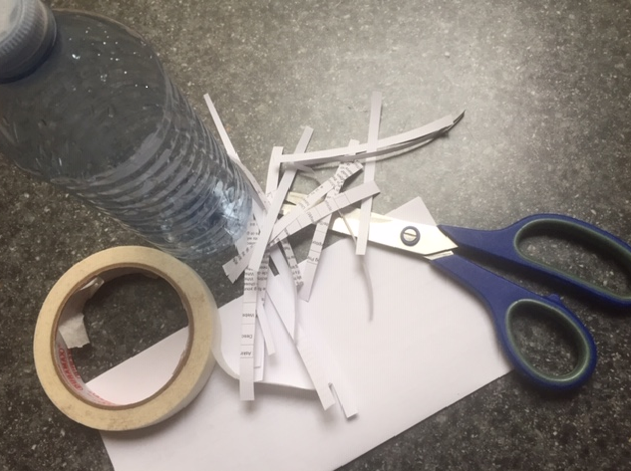
- Using your scissors, cut your paper into 6 to 12 equal strips of 6mm (1/4”) X 100 mm (4”).
- Carefully tape four 4 to 6 strips onto your water bottle as close to the neck of the bottle as possible.

- For best results, tape a pencil to the cap of the water bottle and secure water bottle towards the neck. (4 marks)

- With the fan on high, manipulate the bottle in front of the fan.

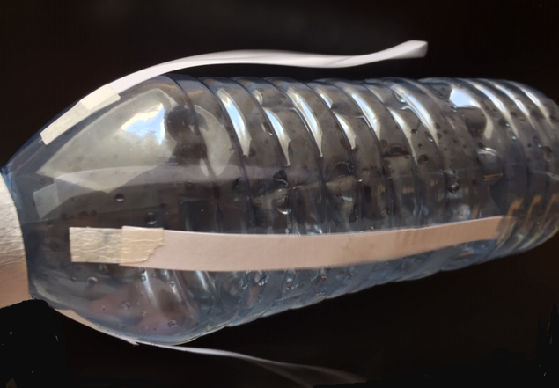
- What did you observe? If possible, use your phone and record your results in slow motion. (2 marks)

- Repeat the process, this time moving the strips towards the middle of the water bottle. What did you observe now? If possible, use your phone again and record your results in slow motion. Did anything change? (2 marks)

- Lastly, move your strips to the bottom of the water bottle and repeat the process. What happens to the paper strips? (2 marks)

/10 marks

Activity 2 – Transportation Design & Construction (Land & Air)

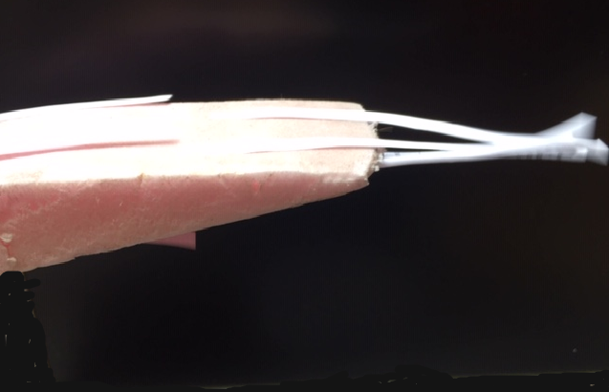
Answer the following questions. (2 marks each)
- What is an airplane?
- How are airplanes powered?
- At what speeds can an airplane travel?
- What are the five major parts of a fixed wing airplane?
- How does a splitter, wing, spoiler or fin improve a vehicle’s efficiency?
- How have auto manufacturers included these concepts into their vehicles in recent years? Provide at least two examples for full marks.
- What does the term aerodynamics mean?

- Define the following terms: (2 marks each)
  - Lift
  - Gravity
  - Drag
  - Trust
  - Weight
- In the image below, label how Lift, Gravity, Drag, Thrust and Weight affect an airplane wing. (1 mark)
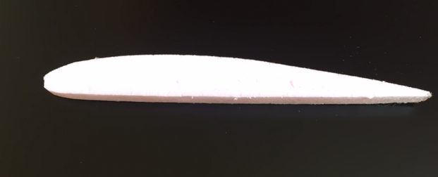
- How might friction affect an object travelling through the air?
- Search around your home for differently shaped objects to study. Toy cars, boats and planes would work best, however any object will suffice.
- Repeating the process with a fan and paper strips, test all your objects.
- For full marks, attach pictures or short videos to this assignment.
- How do these objects perform compared to the water bottle you first tested?

Culminating Task
Your task is to add a shape or wing onto your water bottle to improve air flow. You can add a splitter, wing, spoiler or fin. Document all your findings on the chart below.

S | What is the challenge? | /2
P | What problems do you think you will need to overcome in order for your airflow to improve? | /4
I | Include your research. Attach pictures, diagrams, scientific calculation and prototypes to this sheet. | /6
C | Make your product. List all your problems you needed to overcome while building your object. Keep record, log or journal. Take lots of pictures. | /12
E | Reflect on your challenge. Did your splitter, wing, spoiler or fin meet your expectations? | /6

Activity 3 – Transportation Design & Construction (Sea)

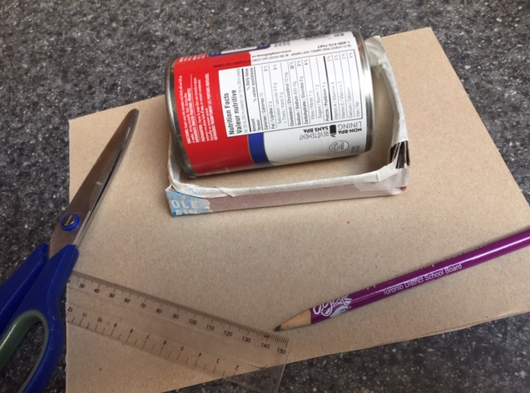

Answer the following questions. (2 marks each)
- How were the first sea vessels made to transport goods?
- What types of products or materials are transported by water vessels?
- Define the following terms:
- Buoyancy
- Hull
- Draft
- How will a ship sink?
- Define the following terms:
- Round Hull
- Flat Hull
- V-Hull
- Catamaran
- Tri-Hull
- Pontoon
- Gather the following materials from your home. Paper, cereal box(s) or bristle board, tape or glue, and a soup can (284mL or larger).
- Create three (3) prototype boats (Reverse Engineering) from two (2) sheets of 7” X 10” pieces of paper by folding, cutting and taping the paper together. Each prototype should test a different hull design.
- Using your paper strips from activity 1 and 2, test your (3) boat designs using a fan and strips of paper.
- Which design has the best air flow? Reflect and document how each shape impacted the overall aerodynamics. Take pictures of all three designs.
- Choose one boat design and create a working scaled prototype from a cereal box or bristle board. Your materials are limited to two (2) 7” X 10“ sheets and tape or glue. Note: Students are only allowed to tape or glue their seams. You cannot cover your entire boat with tape or glue.
- Please ensure to take pictures of your final project.
- Using a sink or bucket full of water, carefully place your scale boat in the bucket of water with the soup can inside. Video record your boat and time how long your boat can float carrying the soup can before taking in 3 mm of water. Note: Video and pictures must be submitted as part as your evaluation.

Final Evaluation

S | What is the challenge? | /2
P | What problems do you think you will need to overcome in order for your airflow to improve? | /4
I | Include your research. Attach pictures, diagrams, scientific calculation and prototypes to this sheet. | /6
C | Make your product. List all your problems you needed to overcome while building your object. Keep record, log or journal. Take lots of pictures. | /12
E | Reflect on your challenge. Did your splitter, wing, spoiler or fin meet your expectations? | /6

Instructional Strategies
Teachers may use any of the following instructional strategies; 3-Part lesson, lecture, storyboard, word wall, think-pair-share, placemat activity, rapid write, K-W-L, anticipation chart, ABC taxonomy, think aloud, analyzing text, Cornell note taking, exit ticket/ticket out the door, plus/minus/delta, etc.

The Hook / Motivational Strategies
There are many movies and videos that compare one vehicle or manufacturer to another. Movies “Ford vs Ferrari” and “The Fast and the Furious” are good examples. Utilizing excerpts out of movies draws the student’s attention to the project and want to learn more.

Learning Goals and Success Criteria
Learning goals and success criteria are the foundation on which students base their ability to monitor their learning and determine next steps. Applicable learning goals may include any of the following,
- Students will identify vehicle components related to aerodynamics
- Students will use problem-solving processes to design and fabricate projects related to vehicles or craft;
- Students will demonstrate an understanding of aerodynamics and the relationship it has between various aspects of the transportation industry and society.
Success criteria may include any of the following,
- I will be able to identify key elements of aerodynamics in different modes of transportation
- I will be able to identify and describe major body components
- I will use problem-solving to process designs and fabricate a more aerodynamic project
- I will use various problem-solving processes and techniques appropriately to solve problems related to vehicles or craft;
- I will be able to describe technological innovations (e.g., related to performance) in vehicles and/or a craft

Overall and Specific Expectations in Support of Ontario Curriculum Grades 9 - 10 Technological Education

Overall Expectations
A3 Identify and describe the major systems and components of vehicles, aircraft, and/or watercraft;
B1 Use problem-solving processes to design and fabricate a project that converts and uses energy, and to address various problems or challenges related to vehicles or craft;
C2 Demonstrate an understanding of the relationship between various aspects of the transportation industry and society.

Specific Expectations
A3.5 Identify and describe major body, hull, and/or fuselage system components (e.g., fender, keel, fairing).
B1.1 Use a problem-solving process to design and fabricate a project (e.g., a self-propelled vehicle or craft) that demonstrates conversion and use of energy under varying conditions (e.g., application of mechanical advantage, varying torque and speed);
B1.2 Use various problem-solving processes and techniques appropriately to solve problems or address challenges related to vehicles or craft;
B1.3 Apply relevant technological concepts (e.g., concepts related to materials, power and energy, mechanisms) appropriately as they work through problem-solving processes related to vehicles or craft;
B1.4 Report on the end result of the project and identify possible improvements.
C2.2 Describe recent technological innovations (e.g., related to performance, comfort, drivability, fuel economy, recycling of parts) in vehicles and/or craft;

Applicable SAFEDocs and ToolSAFE videos
Please refer to the OCTE SAFEDocs for Broad-Base Technologies for safety documents in order to properly address and instruct this project. You may require the use of various broad-based technologies (and not just Transportation Technology) if you design, fabricate, construct and install transportation related products on vehicles and/or crafts.

Project Challenges
Challenges with this resource can be the number of resources available to the students if they are at home and do not have access the school or workshop. Should teachers make extensions to the lessons within this resource and develop a project like manufacturing or installing a spoiler (on a vehicle), the necessary safety instruction and protocols must be followed in order to keep the students safe and meet transportation standards, laws and regulations.

Differentiation of the Project / Activity
Teachers can also refer to the Differentiation Scrapbook to take into account for learner ability, multiple intelligences, exceptional students, and ESL learners.

Assessment and Evaluation
Categories | 50-59% (Level 1) | 60-69% (Level 2) | 70-79% (Level 3) | 80-100% (Level 4)
Knowledge and Understanding – Subject-specific content acquired in each course (knowledge), and the comprehension of its meaning and significance (understanding)
 | The student:
Understanding of Content:  Students demonstrate an understanding of the relationship between various aspects of the transportation industry and society. | demonstrates limited knowledge of content | demonstrates some knowledge of content | demonstrates considerable knowledge of content | demonstrates considerable thorough of content
Understanding of content:  Students understand and apply relevant technological concepts appropriately as they work through problem-solving processes related to vehicles or craft. | demonstrates limited knowledge of content | demonstrates some knowledge of content | demonstrates considerable knowledge of content | demonstrates considerable thorough of content

Thinking – The use of critical and creative thinking skills and/or processes
 | The student:
Use of planning skills: use various problem-solving processes and techniques appropriately to solve problems or address challenges related to vehicles or craft; | uses planning skills with limited effectiveness | uses planning skills with some effectiveness | uses planning skills with considerable effectiveness | uses planning skills with a high degree of effectiveness
Use of processing skills: Student could use problem-solving processes to design and fabricate a project that converts and uses energy, and to address various problems or challenges related to vehicles or craft; | uses processing skills with limited effectiveness | uses processing skills with some effectiveness | uses processing skills with considerable effectiveness | uses processing skills with a high degree of effectiveness
Use of critical/creative thinking processes: Student was able to describe recent technological innovations) in vehicles and/or craft. | uses critical/creative thinking process skills with limited effectiveness | uses critical/creative thinking process skills with some effectiveness | uses critical/creative thinking process skills with considerable effectiveness | uses critical/creative thinking process skills with a high degree of effectiveness

Communication – The conveying of meaning through various forms
 | The student:
Expression and organization of ideas and information: Student was able to report on the end result of the project and identify possible improvements. | expresses and organizes ideas and information with limited effectiveness | expresses and organizes ideas and information with some effectiveness | expresses and organizes ideas and information with considerable effectiveness | expresses and organizes ideas and information with a high degree of effectiveness
Use of communication for different audiences in oral, visual, and written forms: Student could identify and describe major body, hull, and/or fuselage system components. | communicates for different audiences and purposes with limited effectiveness | communicates for different audiences and purposes with some effectiveness | communicates for different audiences and purposes with considerable effectiveness | communicates for different audiences and purposes with a high degree of effectiveness
Use of conventions vocabulary, and terminology of the discipline in oral, visual, and written forms: Student could identify and describe the major systems and components of vehicles, aircraft, and/or watercraft. | uses conventions, vocabulary, and terminology of the discipline with limited effectiveness | uses conventions, vocabulary, and terminology of the discipline with some effectiveness | uses conventions, vocabulary, and terminology of the discipline with considerable effectiveness | uses conventions, vocabulary, and terminology of the discipline with a high degree of effectiveness

Career and Industry Extensions
Aerodynamics lends itself to all of modes of transportation and can generate a number of career opportunities such as mechanical engineering, technological design, research and development. Industry extensions can be explored and viewed in automotive and aerospace manufacturing, boat building, power sport and racing industries. You can also find the properties of aerodynamics in golf club design, darts, Frisbee, and many more sports.

Environmental Considerations
By using recyclable materials students have the opportunity to reuse materials for learning purposes before being recycled.

Reflection or Design Report
Teachers may wish to have the students complete a design report, reflection or create a foldable to consolidate their learning. This would be a nice way to capture the student’s understanding in a summative format and be used in preparation for their examination,

Appendix A – Lesson Plans
Unit: Transportation Design & Construction (Aerodynamics)  Activity 1 Aerodynamics |  | Grade 10
Time Bar:  90 minutes | Learning Goals  Students will develop knowledge and skills related to the construction and operation of vehicle/craft systems and learn maintenance and repair techniques by fabricating a test piece to examine air flow over an object(s). | Materials  Empty water bottle, pencil, tape, scissors, paper, and household fan.
 | Identify Grouping 🡪 Strategy  Key Questions:  How you ever thought about how airplanes fly? Why are boats shaped to a point at the bow? Why do cars have wings or spoilers? | Plan links between assessment and instruction:  1) Identify what will be assessed (curriculum expectations or learning skills).  2) Choose an appropriate assessment strategy.  3) Choose an appropriate assessment scoring tool.
Minds On…

 | Identify Grouping 🡪 Strategy  Students gather empty water bottle, pencil, tape, scissors, paper, and household fan. Students cut strips of paper to size as outline in the assignment. Students attach the strips to the water bottle as three different positions and observe air flow while placing water bottle in front of a household fan. | Explicitly label:  Assessment for learning  (inform future instruction)  Assessment as learning  (reflection)  Assessment of learning  (student achievement).
Action!
 | Identify Grouping 🡪 Strategy  Students will write a reflection on what happened to the strips of paper as air was passing over the bottle. Ask students to pay particular attention to what happens when the strips are attached to the bottom of the bottle.  Students will take pictures and/or video their results. | Explicitly identify planned differentiation of content, process, or product based on readiness, interest, or learning preference in order to work in zone of proximal development; save time; give students choice, …  Provide hyperlinks to:  Rationale/research   Video   Lesson artefacts   Professional  dialogue 
Consolidate Debrief
<Choose relevant label(s)>  Application  Concept Practice  Differentiated  Exploration  Reflection  Skill Drill | Home Activity or Further Classroom Consolidation  Students can research on-line videos on aerodynamics and test more than one shape as well as add more strips of paper. | Your plan should include activities that are:  visual  kinesthetic  auditory

Unit: Transportation Design & Construction (Land & Air)  Activity 2 Land & Air |  | Grade 10
Time Bar:  90 minutes | Learning Goals  Students will relevant technology concepts appropriately to solve problems or address challenges related to vehicles and crafts. Students will identify a major component sur as a splitter, wing, spoiler and fin to improve air flow. At the end of this activity, students will use problem solving process and report on different shapes or components affect the aerodynamics of a vehicle. | Materials  Bristle board or cereal box, ruler, scissors, tape, glue, water bottle, toy car, and household fan.
 | Identify Grouping 🡪 Strategy  Key Questions:  Have you ever observed the back of a bus in the winter? Why is the back always so dirty?  What is Drag, Lift, Gravity, Thrust and weight? | Plan links between assessment and instruction:  1) Identify what will be assessed (curriculum expectations or learning skills).  2) Choose an appropriate assessment strategy.  3) Choose an appropriate assessment scoring tool.
Minds On…

 | Identify Grouping 🡪 Strategy  Students will be asked to answer a series of questions pertaining to aerodynamics. Students will then define major body components for both airplanes and vehicles. Students will define the terms; lift, gravity, dray, trust, and weight and label a diagram. Students with then have to test a toy car or other objects for their aerodynamics using strips of paper and a fan. | Explicitly label:  - Assessment for learning  (inform future instruction)  - Assessment as learning  (reflection)  - Assessment of learning  (student achievement).
Action!
 | Identify Grouping 🡪 Strategy  After testing their toy cars or objects, students will be expected to document their findings in a design report following the SPICE model.  Note: Students can test as many objects as they wish and record their observations using the slow motion feather on their cell phones. | Explicitly identify planned differentiation of content, process, or product based on readiness, interest, or learning preference in order to work in zone of proximal development; save time; give students choice, …  Provide hyperlinks to:  - Rationale/research  - Video  - Lesson artefacts  - Professional  dialogue
Consolidate Debrief
<Choose relevant label(s)>  Application  Concept Practice  Differentiated  Exploration  Reflection  Skill Drill | Home Activity or Further Classroom Consolidation  Students can continue to test as many objects as they wish and review on-line videos on aerodynamics. | Your plan should include activities that are:  - visual  - kinesthetic  - auditory

Unit: Transportation Design & Construction (Sea)  Activity 3 - Sea |  | Grade 10
Time Bar:  120 minutes | Learning Goals  Students will develop knowledge and skills related to the construction and operation of vehicle/craft systems and learn maintenance and repair techniques as they apply to watercraft vessels. During this lesson, students describe major components, fabricate a scaled water craft addressing various problems, apply relevant technology concepts, describe recent innovations and create a design report as part as a reflection. | Materials  Bristle board or cereal box, ruler, scissors, tape, glue, household fan, and soup can. (284mL)
 | Identify Grouping 🡪 Strategy  Key Questions:  How were the first transportation systems made?  What types of products are transported in water vessels?  What do the terms buoyancy, hull and draft mean?  How will a ship sink?  What is the difference between round, flat, V, catamaran, Tri and Pontoon Hulls? | Plan links between assessment and instruction:  1) Identify what will be assessed (curriculum expectations or learning skills).  2) Choose an appropriate assessment strategy.  3) Choose an appropriate assessment scoring tool.
Minds On…

 | Identify Grouping 🡪 Strategy  Students will gather the materials from their house. Students will test hull prototypes of scaled water vessels for air flow. They will then build one prototype to hold a 284mL soup can. | Explicitly label:  - Assessment for learning  (inform future instruction)  - Assessment as learning  (reflection)  - Assessment of learning  (student achievement).
Action!
 | Identify Grouping 🡪 Strategy  Students will document all their work. Students are expected to take pictures and video their boat holding a soup can in a container of water.  Note: Students can compete all at the same time as an “in-class” competition or work in pairs during the design process. | Explicitly identify planned differentiation of content, process, or product based on readiness, interest, or learning preference in order to work in zone of proximal development; save time; give students choice, …  Provide hyperlinks to:  - Rationale/research  - Video  - Lesson artefacts  - Professional  dialogue
Consolidate Debrief
<Choose relevant label(s)>  Application  Concept Practice  Differentiated  Exploration  Reflection  Skill Drill | Home Activity or Further Classroom Consolidation  Students can research career opportunities. | Your plan should include activities that are:  - visual  - kinesthetic  - auditory

References
21st Century Competencies: Foundation Document for Discussion. Phase 1: Towards Defining 21st Century Competencies for Ontario, Winter 2016 Edition, 2016 http://www.edugains.ca/resources21CL/About21stCentury/21CL_21stCenturyCompetencies.pdf
Aerodynamics Video (Video), 2020 https://www.octe.ca/application/files/8715/9771/3214/Video.mp4
Aerodynamics Video_1 (Video), 2020
https://www.octe.ca/application/files/1515/9771/3362/Video_1.mp4
Aerodynamics Video_2 (Video), 2020
https://www.octe.ca/application/files/9315/9771/3484/Video_2.mp4
Aerodynamics Video_3 (Video), 2020
https://www.octe.ca/application/files/6715/9771/3569/Video_3.mp4
Aerodynamics Video_4 (Video), 2020
https://www.octe.ca/application/files/3215/9771/3660/Video_4.mp4
AirShaper demo (beta) - 3D streamlines (image), 2016 https://sketchfab.com/3d-models/airshaper-demo-beta-3d-streamlines-fe837aab4587425aaefa93d7cd9a9fd8
Course Codes for Emphasis courses in the Revised Curriculum: Technological Education, Grades 11 and 12, 2009 http://www.edu.gov.on.ca/eng/curriculum/secondary/techedemphasiscourses.pdf
Growing Success: Assessment, Evaluation, and Reporting in Ontario Schools, First Edition, Covering Grades 1 to 12, 2010 www.edu.gov.on.ca/eng/policyfunding/growSuccess.pdf
Learning for All – A Guide to Effective Assessment and Instruction for All Students, Kindergarten to Grade 12, 2013 http://www.edu.gov.on.ca/eng/general/elemsec/speced/LearningforAll2013.pdf
Side Skirts, Diffusers, and Air Dams | How It Works | Science Garage (YouTube video), 2018 https://www.youtube.com/watch?v=Woq-nl9QyfQ
Sports Car Aerodynamics: Spoiler Alert! (YouTube video) 2012 https://www.youtube.com/watch?v=TKH1DyV9vNU
The Aerodynamics of Flight (YouTube video), 2009 https://www.youtube.com/watch?v=5ltjFEei3AI
The Differentiated Instruction Scrapbook http://www.edugains.ca/resourcesDI/EducatorsPackages/DIEducatorsPackage2010/2010DIScrapbook.pdf
The Ontario Curriculum, Grades 9 and 10: Technological Education, 2009 (revised) http://www.edu.gov.on.ca/eng/curriculum/secondary/teched910curr09.pdf
The Ontario Curriculum, Grades 11 and 12: Technological Education, 2009 (revised) http://www.edu.gov.on.ca/eng/curriculum/secondary/2009teched1112curr.pdf
Wings and Spoilers; Lift and Drag | How It Works (YouTube video), 2018 https://www.youtube.com/watch?v=AXjiThF1LXU

