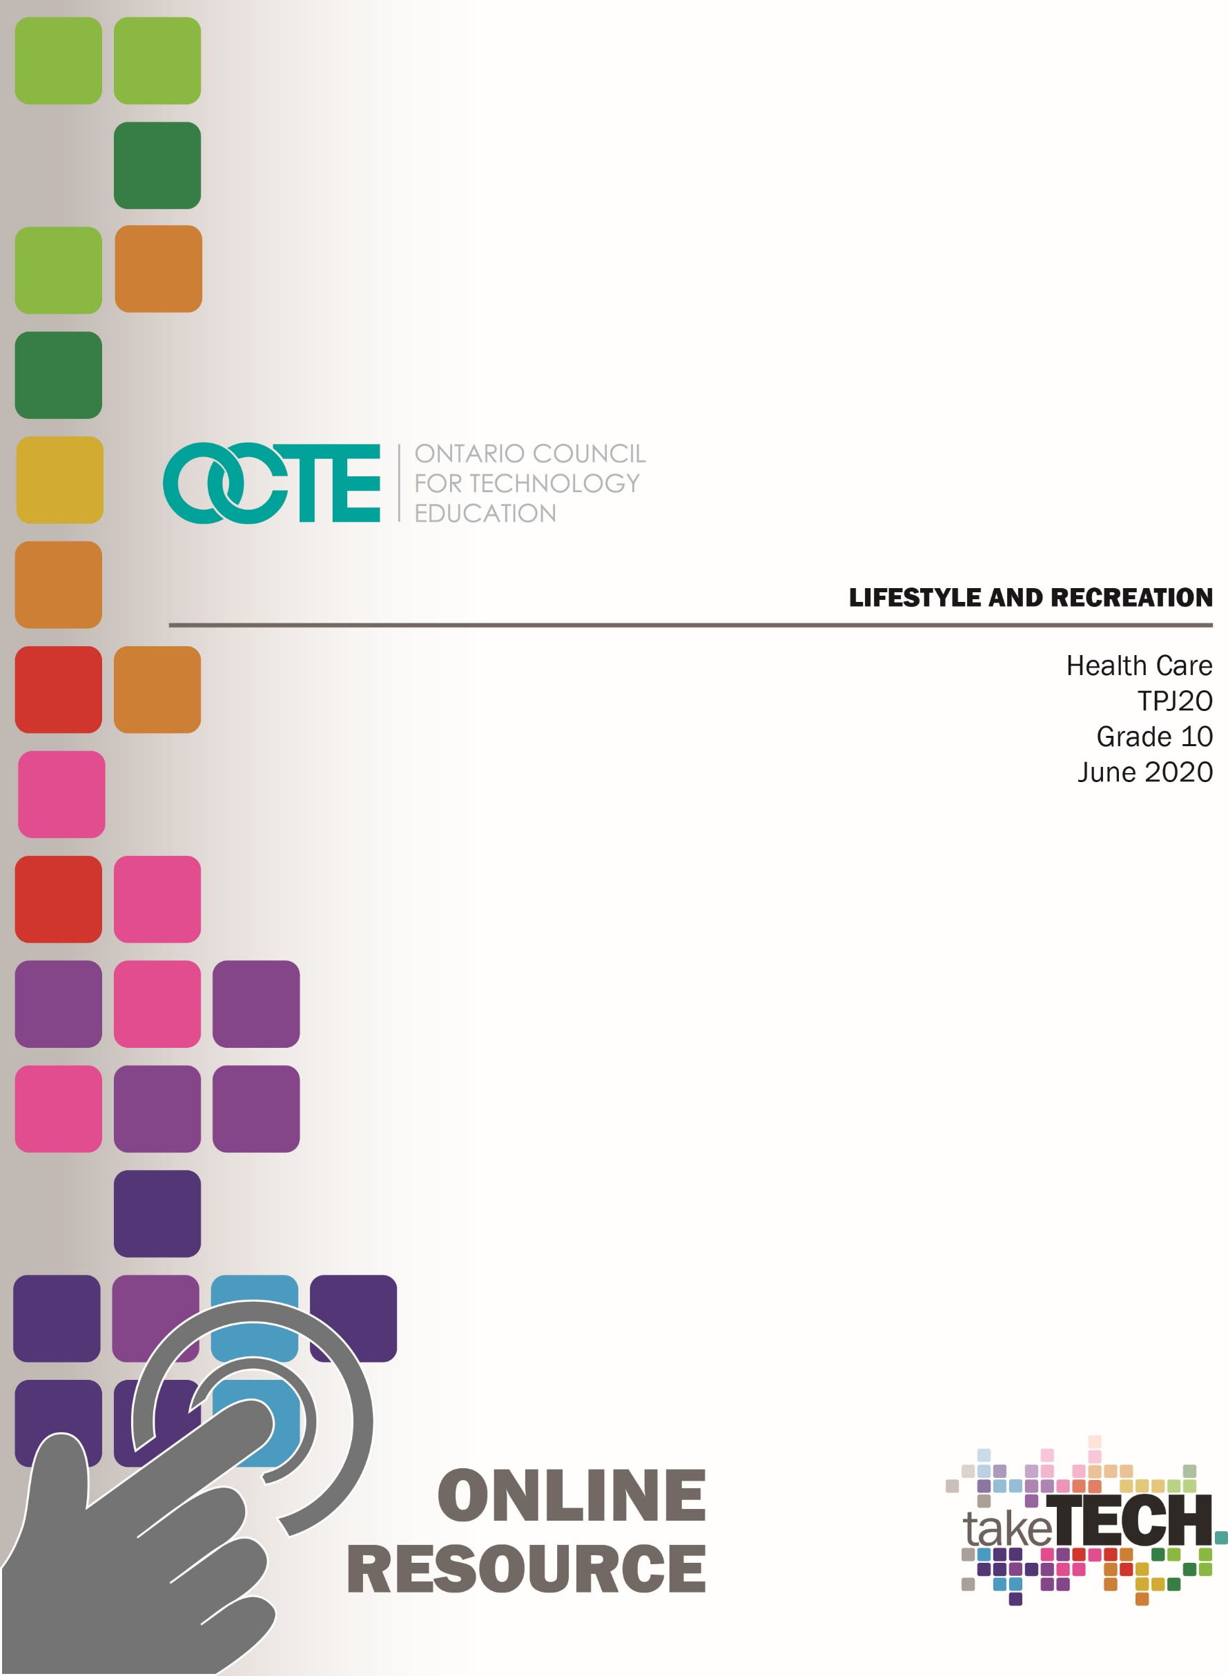
OCTE TDJ2O Online Resource cover page titled "Designing and Testing a Crane"

Table of Contents

Introduction 3
Project Outline 3
Prior Knowledge 3
Student Activities 3
Activity 1 – Then and Now 4
Activity 2 – Reflective Paper Based on the Then and Now Discussion 5
Activity 3 – I Told My Kids I Ate All Their Halloween Candy 6
Activity 4 – Playground Safety 7
Activity 5 – Play day 7
Activity 6 – Summer Camp Assignment 8
Planning Notes 8
Resources 8
Instructional Strategies 9
The Hook / Motivational Strategies 9
Learning Goals and Success Criteria 10
Overall and Specific Expectations 10
Overall Expectations 10
Specific Expectations 11
Applicable SAFEDocs and ToolSAFE videos 11
Project Challenges 11
Differentiation of the Project / Activity 12
Assessment and Evaluation 12
Religious Considerations 12
Career and Industry Extensions 13
Ethical Considerations 13
Environmental Considerations 13
Reflection or Design Report 13
Appendix A – Ideal Family 14
Appendix B – Are Canadian Children Getting Enough Sleep? 16
Appendix C – Playground Images 17
Appendix D – Rubrics 18
Rubric for students and peer assessment 18
Rubric for teacher evaluation 19
Appendix E - Summer Camp 20
Summer Camp Daily Schedule 21
Summer Camp Assignment Rubric 22
References 23

Introduction
Course Code: TPJ2O
Broad base Technology: Health Care
Destination: Open
Grade Level: 10
Prerequisite: None
Online Project Name: Lifestyle and Recreation

Project Outline
Students will examine the multitude of factors that affect personal health, including nutrition, exercise, sleep and life balance. They will examine their personal habits and propose ways to improve their lifestyle. This knowledge will become the foundation for development of a recreational schedule that incorporates these requirements.

Prior Knowledge
Students have participated in learning the many aspects of healthy lifestyle choices throughout their school years. The focus is now to examine their adolescent life, and how it has changed from childhood choices, especially given the new freedoms experienced. They can examine their attitudes and further build on activities or groups that they have participated in – whether that is swimming lessons or playing a musical instrument.
Some students may have participated in a summer camp program, either as a participant or a camp leader. They can draw on this experience to provide the framework for the summer camp project.

Student Activities

Activity 1 – Then and Now
The teacher will arrange a suitable time to meet online, in synchronous learning style, with all students. Students are asked to have a chalkboard, whiteboard or blank sheets of paper (can use good-on-one-side or scrap paper). In the meeting, students can write down answers and turn so all can see their response.
The teacher is to ask the following questions (one at a time):
What was your favourite toy as a child?
What is your favourite “toy” now?
What was your favourite activity as a child (bicycling, swimming lessons, soccer team)?
What is your favourite activity now?
What was your sleep routine as a child?
What is your sleep routine now (what time is bed-time/wake up time)?
What was your favourite food as a child?
What is your favourite food now?
Following each question, a discussion can ensue. The teacher can guide the discussion and ask individual students to explain their answers – choose different students for a variety of answers. If possible, encourage cultural diversity, and ask students to provide examples of cultural foods/activities/toys that they experienced.
Discussion themes include,
Why was/is it your favourite toy/activity/food/sleep pattern?
What was/is a benefit for the toy/activity/food/sleep pattern?
Divide the students into 4 focus groups. Being aware and respectful of what they wish to share (personal information) with other students, they are to meet together online (later date or following this meeting) to discuss one of the above topics (toy, activity, sleep routine, food) in further detail. Some points to consider in their discussion:
What was the basis for this toy/activity/food/sleep routine?
Was/is there social, financial, cultural or other factors that played a role? (Students can confer with parents regarding this answer)
What are the pros and cons of this toy/activity/food/sleep pattern?
Would you consider this a positive or negative factor to health?
All students are to make notes of the discussion(s).
The students are then divided into teams so that one member of each of the 4 focus groups is present in each group. In this second group, students are to meet online and discuss what their focus group had discussed without sharing names (ie; participant #1). The discussion should remain on the topic and not on any one person/participant. Each person that leads their topic is to ask for input from the other group members regarding their topic. All members of this second group are to make notes of this discussion for their class notes. One member from each group is asked to post the discussion notes (include team members) to their teacher so that it may be correlated and posted on the classroom platform (ie. Google classroom, Brightspace, etc.).
[Note: If done in the classroom, this lesson can be done with discussions occurring in the present time, preferably with one topic at a time. Discussions within each group can be written on whiteboard, presentation paper]

Activity 2 – Reflective Paper Based on the Then and Now Discussion
Students are asked to write a reflective paper that asks them to consider the previous lesson and the discussion notes to outline their ideal family life. See Appendix A.
This is to be submitted in a time frame suitable for the students learning goals. For example, one week can be given for submission deadline. Teachers can have the option to allow students to work in pairs.
[This activity can be used in a hybrid school model for students to do online]

Activity 3 – I Told My Kids I Ate All Their Halloween Candy
Students are to watch a YouTube video titled, “I Told My kids I ate all their Halloween Candy on their own time.
In a synchronous learning manner, all students are to meet on an online platform and discuss their responses to this video. Students are encouraged to share what they used to find frustrating/stressful when they were younger (this can be talked about within the family – maybe compare their frustration responses to their siblings, or discuss things that the parents found frustrating when they were younger). This can be discussed further as students reflect on their experiences. After the discussion, each student is to create 2 columns on a piece of paper– first column is what they find stresses them out now (as an adolescent), and in the second column, list what they currently do to decrease their stress. Once completed, in an open conversation format, they can share some stressors and their stress relievers. Students are to compare their two columns and determine which is longer. Some questions to consider in an online sharing manner:
Is the stress ongoing or sporadic?
Are the stressors controllable or not?
Do some stressors impact their ability to cope day-to-day?
What stress relief activities are the most helpful?
Who helps you in times of stress?
Are some of the stress relievers helpful or harmful?
Students can break off into smaller groups to share some of their stress relievers. This may provide others with additional ways of coping with hardships. Ask students to add to some new ideas to their stress reliever list. These should be relievers that they can reasonably incorporate into their daily lives. Ask students to reflect on stressors that they can modify to help ease their daily lives.
[Note: If done in the classroom, this lesson can be done with discussions occurring in the present time, breaking up into groups or sharing with the classroom. Stressors and stress relief ideas can be written on the board.]
As the discussion progresses, if any students participate in physical activities (sports teams, regular fitness routine), ask them to share with the class how they feel it aids them in their health and well-being. Encourage an open dialogue. Teacher can ask how many students walk/bicycle to school; how many take a bus; how many can walk/bicycle but are driven instead? This can generate ideas on how walking/bicycling to and from school can aid in adding physical activity to their day. This walk can also be used as a time to “wind down”, reflect on the day, and act as a stress reliever.

Activity 4 – Playground Safety
Students are to look at a few pictures of play environments and identify any safety hazards that they feel would be dangerous to a) children and b) adolescents. See Appendix B. This can be done at home (online) or in a classroom discussion.
Students read the following Canadian Safety Council article on playground safety:
Discussion can continue in an online platform. Do students ever look at any of these factors when they approach a play structure (maybe with younger siblings or when babysitting)?

Activity 5 – Play day
Teacher and students are to meet in synchronous learning fashion at a previously arranged time. Students can work in pairs or groups of 3 (teacher can choose most appropriate method).
Scenario: Your class has been asked by the local elementary school to assist in designing the end of the year (or Halloween, or spring, etc.) “playday”. The preferred day would allow for the activities to take part mostly outdoors, but some games could take place in the school. In your group, you are to come up with one activity that the elementary students (teams comprised of 8-10 students from grades 1-7) can partake in. Once you submit your plans, they will be evaluated by the principal and school council who will then decide which activities they will use. There is a prize for the 3 games that they feel are most suited for “playday”.
The principal has a few requirements:
- Must include a sign to advertise the event (the sign will be posted at the activity station)
- Must be fun and involve some physical component
- Must not be too competitive (consider the grade 1s and physical limitations)
- Includes how it is beneficial (ie. promotes balance, aids in hand-eye coordination)
- Must be varied (no 2 activities the same)
- Must be inclusive to all abilities and grades (the team of students is to work together as a group to achieve the goal)
Each group is to work together (online or in classroom) to come up with ideas. Once a firm activity is decided, each group will post their idea on the class learning platform (ie: Google classroom) so that other groups do not design a similar activity. Each group is to work together to ensure all requirements of the assignment are met.
[Note: This can be altered if in a classroom environment. When all the activities are completed at the due date, each group of students can explain their activity, and have the rest of the class play that activity. This can be done before the peer evaluation].
Students are then asked to “grade” 2 other events. See Appendix C for sample rubrics – one for the students and one for the teacher.

Activity 6 – Summer Camp Assignment
Please see Appendix D for the Summer Camp Assignment.

Planning Notes
Some of the components can be adjusted or altered based on whether the activity is done in the classroom or online. Work submission deadlines are to be determined by the teacher according to their student profiles. Teachers can provide examples of toys that can lead to further discussion. The teacher may choose to provide recent articles that outline the sleep requirements for infants, children and adolescents (this can be displayed in the classroom).

Resources

Activities
Activity 1 – Then and Now
Activity 2 – Reflective Paper Based on the Then and Now Discussion
Activity 3 – I Told My kids I ate all their Halloween Candy
Activity 4 – Playground Safety
Activity 5 – Play day

Software
Learning Management System

Materials
Canadian-children-getting-enough-sleep-infographic

Videos
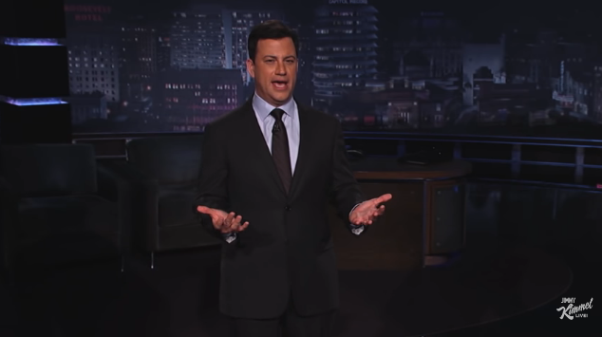 | YouTube video titled, “I Told My Kids I Ate All Their Halloween Candy”  https://www.youtube.com/watch?v=_YQpbzQ6gzs

Websites for Teachers
Canadian Safety Council article on playground safety:

Instructional Strategies
Teachers may use any of the following instructional strategies; 3-Part lesson, lecture, storyboard, word wall, think-pair-share, placemat activity, rapid write, K-W-L, anticipation chart, ABC taxonomy, think aloud, analyzing text, Cornell note taking, exit ticket/ticket out the door, plus/minus/delta, etc.

The Hook / Motivational Strategies
As the student ages, they have greater input into how they spend their time. If the student understands how lifestyle choices impact their health on a long-term basis, they can choose to make some adjustments now. With the challenges of balancing school, part-time work and teenage responsibilities, having a good plan to maintain personal health can assist them on a healthy path.
Students may have participated in summer camps, or are interested in applying to be a camp counselor. This camp project allows them to build some insight into developing a recreational schedule that meets the criteria for a well-developed camp experience which may assist them in getting this job.

Learning Goals and Success Criteria
Learning goals include describing factors that affect personal health and well-being and developing and using a variety of age-appropriate recreational activities to promote safe and healthy play for children and adolescents
Students are encouraged to share in the discussions so that teachers may assess their understanding and knowledge through their communication skills. Assessment can also take place through the student participation in synchronous learning discussions and activities. Rubrics are used for evaluation and the “playday” project can be marked by teacher or used as an opportunity for students to reflect on the creation of new activities for this day.
Success is evident in the sharing of information and honest reflection of lifestyle choices. Success criteria for components of this project will look like,
- I can use my communication skills to describe factors that affect a person’s health
- I can describe factors of well-being
- I can identify factors to improve a person’s health
- By researching, I can develop and use age-appropriate activities
- I can promote safe and healthy play for children
- I can use my skills to assess safe playgrounds and playscapes
- I develop teamwork skills when working with others
- I learn to respect others when working in teams

Overall and Specific Expectations in Support of Ontario Curriculum Grades 9 -10 Technological Education

Overall Expectations
A2: Describe factors that affect personal health and well-being;
B2: Develop and use a variety of age-appropriate recreational activities to promote safe and healthy play for children and adolescents.

Specific Expectations
A2.1 Identify factors that affect the personal health and well-being of children and adolescents (e.g., environmental conditions, diet, food safety, food security, adequate shelter, amount of daily exercise, amount of daily rest, recreation opportunities, work/life balance, stress);
A2.3 Describe the benefits of different types of exercise (e.g., aerobic versus strength conditioning) and/or sports, and explain how a regular fitness or sports program can promote good health;
A2.8 Explain how lifestyle choices can have an impact on an individual’s health and well-being (e.g., sleep habits; nutrition; work/life balance; use of tobacco, alcohol, prescription and illegal drugs);
A2.10 Develop a personal health plan that promotes healthier lifestyle choices and habits;
B2.1 Create a recreational activity for either a child or an adolescent that is age appropriate and safe and that promotes a health, fitness, or social objective (e.g., a fitness program using resistance bands or balloon volleyball for a child or adolescent with a disability, a music performance by students for an elementary school or day care centre);
B2.2 Identify common play space hazards, and design a safe play space for children of a specific age group;
B2.3 Design a game or entertainment activity that is appropriate to a specific culture and age or stage of development (e.g., activity centre–based games for children, purposeful storytelling for multicultural celebrations).

Applicable SAFEDocs and ToolSAFE videos
Please refer to the OCTE SAFEDocs for Health Care for safety documents in order to properly address and instruct this project.

Project Challenges
Sometimes students may not be willing to share their childhood or adolescent experiences based on their family history (abuse, neglect, mental health concerns, etc.). Allow some flexibility to allow some students to limit their involvement. Discussions can get lively as students reflect on favourite toys/activities – try to encourage dialogue but maintain time limitations.
Ensure all communication and explanations are given in enough detail so that students can work on them with a good understanding of expectations.

Differentiation of the Project / Activity
In Activity 1, all students are invited to participate. Students who are reluctant to answer initially may be encouraged as toys/activities are being discussed, and may choose to include themselves with another student’s toys/activities. This can be further explored and advanced students can make a daily schedule that compares what they currently do with a new schedule that better incorporates some of the healthier lifestyle choices.
In Activity 2, students who have difficulty writing can be asked to submit a PowerPoint (or Google slides, etc.) assignment that offers pictures for the toys, house style, activities. Some written explanations for their choice can be provided. If suitable, the student can provide pictures only, then explain verbally to the teacher about the choices made.
In Activity 4, students are encouraged to work in groups. The teacher can form groups in advance to allow for some students to work together for success (pair a stronger student with a weaker one).
In Activity 5, the students are provided with a framework for the day that could include guidance of timelines for the day (ie. wake up, meal times, activity times, bed time). The teacher can provide the students with some suggestions for camps (ie. if the student is a soccer player, the camp could be a soccer camp).
Teachers can also refer to the Differentiation Scrapbook to take into account for learner ability, multiple intelligences, exceptional students, and ESL learners.

Assessment and Evaluation
Assessment As Learning –Activity 1, 3
Assessment For Learning –Activity 2, 4
Assessment Of Learning –Activity 2, 5, 6

Religious Considerations
Teachers may provide some consideration on the type and selection of activities and toys in order to carry out this project.

Career and Industry Extensions
The health and well-being of children and adolescents can fall into a diverse group of careers.
- Child and Youth Development Worker
- Recreational Therapist
- Child and Adolescent Psychologist
- Early Childhood Educator
- Teacher
- Pediatric Dietician or Nutritionist
- Art Therapist
- Coach
- Camp Director or Leader
- Nanny
- Social Worker

Ethical Considerations
The exposure to toys and activities can be economically and culturally sensitive. Although many children do take part in organized sports, not all children attend summer camp, which can limit their full ability to provide a comprehensive activity schedule.

Environmental Considerations
When toys are produced, they are often made cheaply, and discarded into waste. Students can consider toys, games, activities that do not require many items in order to play (ie. tag) as they design the “playday”. In discussing the ride/bike or drive to school, teachers can incorporate the environmental benefit of walking and bicycling to school. When designing the camp schedule, students may be asked to consider the environmental impact of the activity.

Reflection or Design Report
Teachers may wish to have the students complete a design report, reflection or create a foldable to consolidate their learning. This would be a nice way to capture the student’s understanding in a summative format and be used in preparation for their examination, entering post-secondary education or the workforce.

Appendix A–Ideal Family
After the discussion about toys, activities, sleep pattern and food preferences, write a reflective paper on what your ideal family life would be like if you were a parent with children. Remember that this is all make-belief, but you are not a millionaire.
Here is your family make-up:
Parent or single parent
3 children (YES, 3)
1 – age 13
2 – age 8
3 – age 4
You can choose genders of your 3 children. Provide them with a name to use throughout your paper.
In addition to previous discussion topics, include where you would like to live. Pick a country (if not Canada), and a city/town. You may choose a rural or urban setting. Give a brief summary of your house – one-story / two-story, # of bedrooms, # of bathrooms, size of yard, etc.).
Your paper will include what toys and activities your children have/participate in. Explain why you made these choices – how is it benefitting your children?
What would the night time routine be like? Is there a different approach to each one?
What foods would you be sure to include or exclude from their diets? Why?
Does the environment in which you live impact your family? How?
How does your house affect the health of you and your family?

 | Level 1 | Level 2 | Level 3 | Level 4
Thinking  Toy suitability  Exercise needs  Activity goals  Sleep routines  Food choices | -little linkage of toys to ages  -recognizes and explains little of the exercise needs of the children  -little consideration or explanation of the activity goals of the children  -provides little explanation of sleep routines for the children  -minimal details are provided for foods chosen for the children | -some linkage of toys to ages  -recognizes and explains some of the exercise needs of the children  -some consideration and explanation of the activity goals of the children  -provides some explanation of sleep routines for the children  -some details are provided for foods chosen for the children | -good linkage of toys to ages  -recognizes and explains most of the exercise needs of the children  -many examples of consideration and explanation of the activity goals of the children  -provides good explanation of sleep routines for the children  -many details are provided for foods chosen for the children | -accurate linkage of linkage of toys to ages  -recognizes and explains the exercise needs of the children  -specific consideration and explanation of the activity goals of the children  -provides thorough explanation of sleep routines for the children  -significant details are provided for foods chosen for the children
Application  Location and type of home | -provides minimal explanation for the choice of house type and location | -provides some explanation for the choice of house type and location | -provides good explanation for the choice of house type and location | -provides thorough explanation for the choice of house type and location
Communication  Paper contains appropriate grammar, sentence structure and paragraphs | -paper has many mistakes regarding appropriate grammar, sentence structure and paragraphs | -paper has lots of mistakes regarding appropriate grammar, sentence structure and paragraphs | -paper has a few mistakes regarding appropriate grammar, sentence structure and paragraphs | -paper has no mistakes regarding appropriate grammar, sentence structure and paragraphs

Appendix B – Are Canadian Children Getting Enough Sleep?
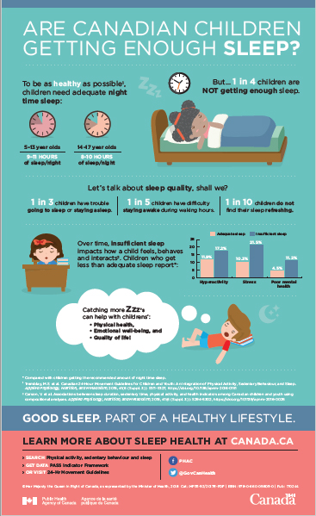

Appendix C–Playground Images
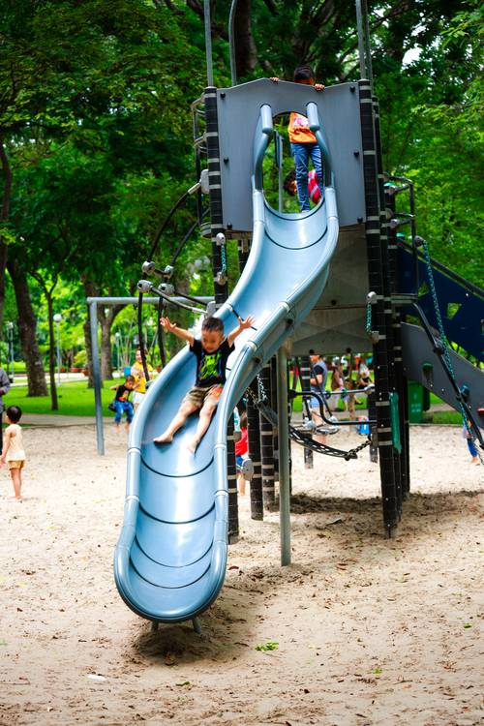
https://www.pexels.com/photo/boy-playing-on-slide-in-playground-2143761/
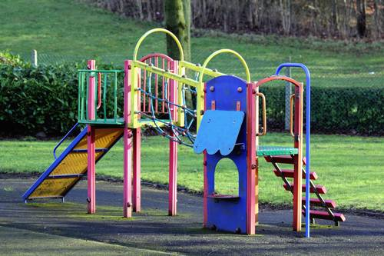
https://www.pexels.com/photo/colors-empty-equipment-grass-133458/

Appendix D–Rubrics

Rubric for students and peer assessment

Name: ____________________ activity being evaluated: ______________________
 | Level 1 | Level 2 | Level 3 | Level 4
Does the sign make this activity appealing? | Limited or somewhat | approaching but needs more information or aesthetics | Meets the standard, considerable design and information | absolutely, competed to a high degree
Does this activity look like a lot of fun? | Limited or somewhat | approaching but needs more information | Meets the standard, considerable design and information | absolutely, I can’t wait to try it
Does this activity have a physical component? | Limited or somewhat | approaching but needs more information on the physical component | Meets the standard, physical component clearly stated | absolutely, competed to a high degree
Is the activity new and creative? | Limited or somewhat | approaching but needs more information on the activity | Meets the standard, considerable creativity and information | absolutely, competed to a high degree
Does the activity include all team members? | this activity seems geared towards a certain age group | this activity seems to include quite a few of the team members | this activity seems to include most of the team members | absolutely, all team members play a role

What are some things you would want to tell the group that could improve their activity?
(for example, make it more fun, make it more inclusive, or include the whole team)

Rubric for teacher evaluation

Activity being evaluated: ______________________
Group members: _________________________________________________
 | Level 1 | Level 2 | Level 3 | Level 4
Does the sign make this activity appealing? | thought is put into the sign but it is not as appealing visually as it could be | the sign offers some appeal but can be further improved | the sign is visually appealing but not very neat or colorful | The sign is visually appealing to elementary students
Does this activity look like a lot of fun? | this activity looks like it could be fun, but more organization is needed | maybe – would want more information about the activity | this activity seems like it might be fun to some students | absolutely, I can’t wait to try it!
Does this activity have a physical component? | this activity uses limited physical components | approaching but needs more information about how physical (length of time – is there a target?) | this activity does use some physical components | this activity uses many physical components without being too difficult to do
Is the activity new and creative? | somewhat creative, but it is a lot like…… | somewhat creative – it’s an adaptation of….. | this activity seems to be new and creative | I have never heard of this game, shall we give it a try?
Does the activity include all team members? | this activity seems geared towards a certain age group | this activity seems to include quite a few of the team members | this activity seems to include most of the team members | absolutely, all team members play a role

Appendix E - Summer Camp
Congratulations! You got the job!
You are so excited to be a part of the camp leadership team at Rockwoods Summer Camp. You have fond memories of being a camper there one summer when you were 13. Some of the memories include the fun afternoons, swimming, and trying so hard to fall asleep with that mosquito buzzing around.
Now you are going to attend a group meeting on (due date) to begin planning for the summer. You have been tasked to come up with one day’s activities, and the other members are doing the same. The goal for the meeting is to have a preliminary 14-day schedule that the camp can use on a rotating basis.
This is an overnight camp for approximately 90 campers ranging in age from 10 -16. Some campers remain for 2-3 weeks, but most are only there for one week. The camp is located on Lake Rockwoods, and has a large property in a natural setting located quite a distance from town.
Use the chart provided to fill in a full day’s schedule.
Be sure to provide specific information regarding:
- Times (for example – when is wake-up, when is supper, how long is the activity/game)
- Nutrition (are there any specific requirements due to heat, activity levels)
- Sleep schedule (when is lights out or quiet time)
- What learning is going to take place (canoeing, orienteering, archery)
- What safety considerations need to be in place for the activities
- Does the day allow for rest, socialization, quiet time, busy time

Summer Camp Daily Schedule
Time | Activity | Equipment | Purpose | Considerations  (Safety, inclusivity)

Summer Camp Assignment Rubric

 | Level 1 | Level 2 | Level 3 | Level 4
Knowledge:  Nutritional components | -limited nutritional consideration is given | -nutritional components have some alignment with activities | -nutritional components have good alignment with activities | -nutritional components have alignment with activities
Application:  Activities are varied throughout day  Activities are appropriate for age group  Activities have necessary details and procedures  Activities are well designed to be fun and active | -activities are repeated throughout the day  -activities are not very appropriate for age group  -activities have few of the necessary details and procedures  -activities have limited ability to be fun and active  (campers may be bored) | -activities have some variety throughout day  -activities are somewhat appropriate for age group  -activities have some of the necessary details and procedures  -activities have some designs to be fun and active | -most activities are varied throughout day  -activities are appropriate for age group  -activities have most of the necessary details and procedures  -activities are well designed to be fun and active | -activities are varied throughout day  -activities are appropriate for age group and provide some learning opportunities  -activities have all necessary details and procedures  -activities are very well designed to be fun and active
Communication:  Daily chart is done  Each activity is well explained | -daily chart is not thorough and missing some components to be complete | -daily chart has most of the information, but is not thorough and complete | -daily chart is mostly thorough and complete; some activities need more details | -daily chart is very thorough and complete, and all activities are well explained

References
21st Century Competencies: Foundation Document for Discussion. Phase 1: Towards Defining 21st Century Competencies for Ontario, Winter 2016 Edition, 2016 http://www.edugains.ca/resources21CL/About21stCentury/21CL_21stCenturyCompetencies.pdf
Boy Playing On Slide –Playground Photograph (Pexels image), 2020 https://www.pexels.com/photo/boy-playing-on-slide-in-playground-2143761/
Canada Safety Council, Playground Safety (article), 2020 https://canadasafetycouncil.org/playground-safety/
Course Codes for Emphasis courses in the Revised Curriculum: Technological Education, Grades 11 and 12, 2009 http://www.edu.gov.on.ca/eng/curriculum/secondary/techedemphasiscourses.pdf
Growing Success: Assessment, Evaluation, and Reporting in Ontario Schools, First Edition, Covering Grades 1 to 12, 2010 www.edu.gov.on.ca/eng/policyfunding/growSuccess.pdf
I Told My Kids I Ate All Their Halloween Candy (YouTube video), 2011 https://www.youtube.com/watch?v=_YQpbzQ6gzs
Learning for All – A Guide to Effective Assessment and Instruction for All Students, Kindergarten to Grade 12, 2013 http://www.edu.gov.on.ca/eng/general/elemsec/speced/LearningforAll2013.pdf
Colourful Playground Structure with Grass Photograph (Pexels image), 2020 https://www.pexels.com/photo/colors-empty-equipment-grass-133458/
Public Health Agency of Canada, Are Canadian Children Getting Enough Sleep? (Infographic), 2018 https://www.canada.ca/en/public-health/services/publications/healthy-living/canadian-children-getting-enough-sleep-infographic.html
The Differentiated Instruction Scrapbook http://www.edugains.ca/resourcesDI/EducatorsPackages/DIEducatorsPackage2010/2010DIScrapbook.pdf
The Ontario Curriculum, Grades 9 and 10: Technological Education, 2009 (revised) http://www.edu.gov.on.ca/eng/curriculum/secondary/teched910curr09.pdf
The Ontario Curriculum, Grades 11 and 12: Technological Education, 2009 (revised) http://www.edu.gov.on.ca/eng/curriculum/secondary/2009teched1112curr.pdf

