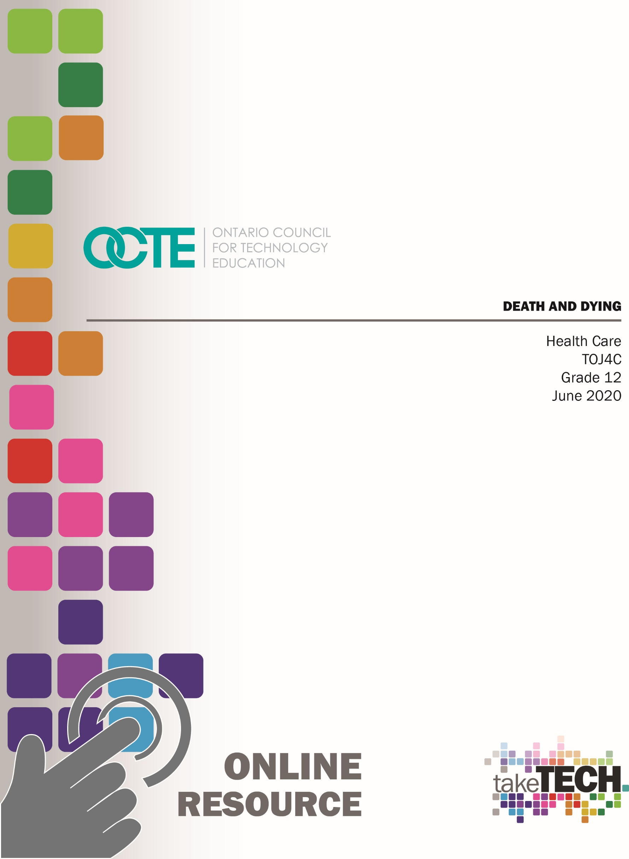

Table of Contents

Introduction 3
Project Outline 3
Prior Knowledge 3
Student Activities 3
Activity 1 – Personal Reflections on Death 4
Activity 2 – Kübler-Ross Stages of Grief 5
Activity 3 – Physical Signs of Death 6
Activity 4 – Clinical Indicators of Death 6
Activity 5 – Cultural and Religious Death Practices 6
Activity 6 – Experiencing and Dealing with Loss 6
Planning Notes 7
Resources 7
Articles 7
Handouts 7
Textbooks/ Books 7
Videos 8
Websites for Teachers 8
Instructional Strategies 9
The Hook / Motivational Strategies 9
Learning Goals and Success Criteria 9
Overall and Specific Expectations 10
Overall Expectations 10
Specific Expectations 10
Safety Concerns 10
Applicable SAFEDocs and ToolSAFE videos 11
Project Challenges 11
Differentiation of the Project / Activity 11
Assessment and Evaluation 11
Religious Considerations 12
Career and Industry Extensions 12
Ethical Considerations 12
Environmental Considerations 13
Reflection or Design Report 13
Appendix A – Death and Dying 14
Appendix B – Physical Signs of Impending Death 15
Appendix C – Requirements and Regulations 16
Appendix D - Scenarios 17
Scenario 1 17
Scenario 2 17
Scenario 3 17
Scenario 4 18
Scenario 5 18
Scenario 6 18
Scenario 7 19
Appendix E – Reflective Paper 20
Reflective Paper Rubric 21
References 22

Introduction
Course Code: TOJ4C
Broad base Technology: Health Care
Destination: College
Grade Level: 12
Prerequisite: None
Online Project Name: Dealing with Death and Dying

Project Outline
Students will explore the final phase of life – dying. They can reflect on their personal experiences with death and how it shapes their view of dealing with patients and their families. Student will explore theories about death and the physiological process of dying. With group discussions, they can explore how different cultures view death and common practices that are associated with dealing with the grieving process. Students will work in small groups to examine case studies that involve dealing with patients and families during the death process and explore some careers that assist during this process.

Prior Knowledge
Most students have faced a loss or death, some closer, with family/friends, while others with more distant relatives or people. Although they have gone through the process of dealing with death, their knowledge of the physiological components may be limited.

Student Activities
Prior to engaging in this unit, the teacher should provide some notice to the students that this topic is upcoming. This can prepare some students for this difficult discussion, especially any students who have recently dealt with a loss. Students should be encouraged to send an email or otherwise notify the teacher of any difficulties they may face when dealing with this topic.

Activity 1 – Personal Reflections on Death
In an online group format, the teacher can ask students if they have dealt with a death. Students can indicate yes with a nod of their heads or a thumbs up (if faces are displayed). The teacher can ask if any students are comfortable talking about their experiences (ie: who died, how you managed or grieved?). If students feel comfortable, they can also talk about how others around them dealt with the death (for examples their parents or grandparent).
Students are then asked to complete the following sentences (see Appendix A). Each student is asked to give their honest answer (teacher can allow some students to refrain from answering as this can be emotionally difficult). Discussion can continue as students listen and understand feelings experienced (themselves and others) regarding each sentence.
[If this lesson occurs in class, ask all students to be respectful as the discussion takes part. Teacher is to provide the opportunity for a student (and friend if necessary) to leave the room briefly to deal with their emotions].
Students can be reminded that death can also include a pet, a relationship (ie: a divorce), or a loss of a body part (amputation) or function (paralysis).
Prior to the next synchronous learning meeting, students are to write down as many emotions/feelings/behaviours that are commonly displayed when someone is dealing with a death.

Activity 2 – Kübler-Ross Stages of Grief
In a synchronous lesson, students can share some of the emotions/feelings/behaviours that they had previously written down. Once many results are shared, a general tally can be made of the most common words used (ie. crying, reduced eating, wanting to be alone). Students are asked to explore other behaviours that may not have been mentioned – behaviours that may not be evident.
The teacher can lead the discussion that all of these behaviours can appear immediately after death, before death, or in months and years following the death (ie: 5 year anniversary of death, a birthday missed).
Students are asked to read an article on the stages of grieving as conceived by Dr. Kübler-Ross, as an individual work assignment (some suggestions are provided under “Planning Notes”).
Students are asked to make personal notes from the reading. They are to list and define the 5 stages. Once complete, they are to create a chart with the 5 stages for each column, and list the emotions/feelings/behaviours previously discussed into the appropriate column. They can add other behaviours into the column as determined in their readings.
denial | anger | bargaining | depression | acceptance

Following the assigned work, the teacher can have a synchronous learning time to answer any questions the students may have on this topic. One discussion should include the fact that the stages do not happen in a particular order. Some of these stages can happen all in one day; some people can remain in the anger phase for many days; some people experience a return to denial weeks after death has occurred. The teacher can also explain that there is no timeline to experiencing these feelings. As an example, even though acceptance may have occurred in the “brain”, the heart may still feel “broken”.
An additional learning experience can be to read articles that question these 5 stages (the initial publication by Kübler-Ross was in 1969). Students can ask:
Does this apply to today’s generation?
Is this represented in different religions and cultures?
What if a person does not experience one of these stages?
Is there a way to adjust this model that keeps it current to all situations?

Activity 3 – Physical Signs of Death
Students are encouraged to watch a video on the physical signs of death.
A YouTube video on the 10 Signs of Death and Signs Death is Near
A YouTube video on how long is the active dying process
Teacher can lead a lesson using Appendix B, while students take notes. Once notes are completed, for homework, students are assigned the handout – Caring for the Dying Patient
As a follow-up, teacher can post the End of life: Caring for someone who is dying article from the Mayo Clinic so students can review their answers:

Activity 4 – Clinical Indicators of Death
Refer to Appendix C for independent student work.

Activity 5 – Cultural and Religious Death Practices
The teacher is to arrange for a synchronous lesson via online platform. Prior to this lesson, the students are asked to find pictures of various practices of funeral or ceremonial proceedings. These may be related to their culture/religion, or be new to them. Each student is asked to display their picture, and explain how that culture celebrates the deceased. If possible, they can include any personal experiences they may have. In addition, the students are asked to identify some of the careers that are associated with the care of the dead or the religious death practices.

Activity 6 – Experiencing and Dealing with Loss
The teacher is to divide the class into 7 equal groups. Each group is to have one scenario as outlined in Appendix D. In an online forum, students are to meet as a group and understand their scenario. Each group is to answer the following questions:
What are some of the factors that make this situation difficult?
What are some factors (if any) that make this situation easier to deal with?
What is an empathetic approach that would aid the family member(s)?
Are there special considerations based on age/understanding?
Do you think this is an easy or difficult death? Explain your answers.

Following the group discussion, students are to write a reflective paper that addresses these questions and summarizes their understanding of dealing with death. Appendix E outlines this assignment and the rubric is provided.

Planning Notes
Ensure all students are made aware of this topic in advance.
For Activity 4, the teacher can follow up with an online meeting to discuss answers and ensure all students have the correct answers.
The topic on clinical indicators of death can be expanded on. If desired, the teacher can expand to discussions about brain death vs. vital signs absent. This can continue into discussions regarding organ donation. The legal implications of death can also be explored – ie. Who decides to cease life support?

Resources

Articles
End of life: Caring for someone who is dying article from the Mayo Clinic

Handouts
Caring for the Dying Patient

 | Signs of impending death | Caring for the needs
GI system
Circulatory system
Nervous system
Muscular system
Respiratory system

Textbooks/ Books
If used in classroom: Mosby’s Canadian Textbook for the Support Worker by S.A. Sorrentino and L. Remmert, published by Elsevier is a textbook that is available.

Videos
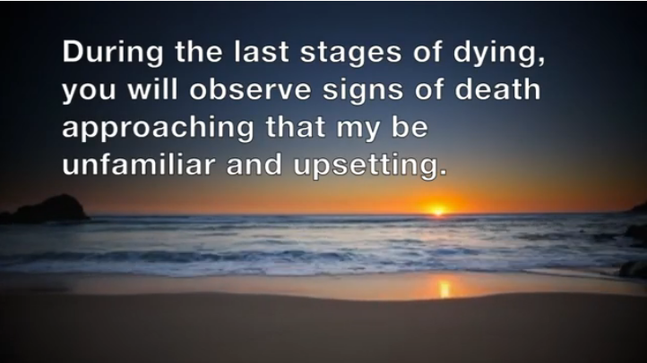 |  | 10 Signs of Death I Signs Death is Near  https://www.youtube.com/watch?v=53QhpMvnLtc
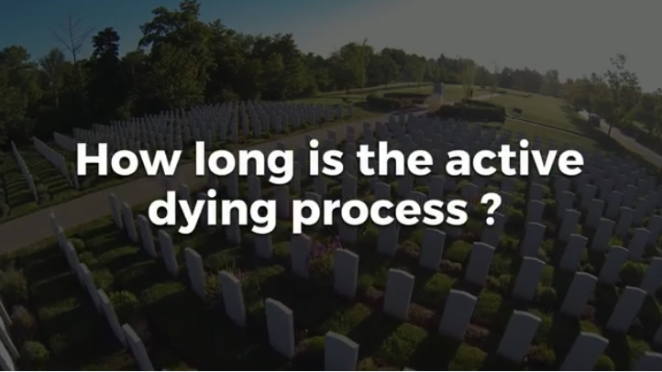 |  | How long is the active dying process?  https://www.youtube.com/watch?v=FjHLlE-aDyQ
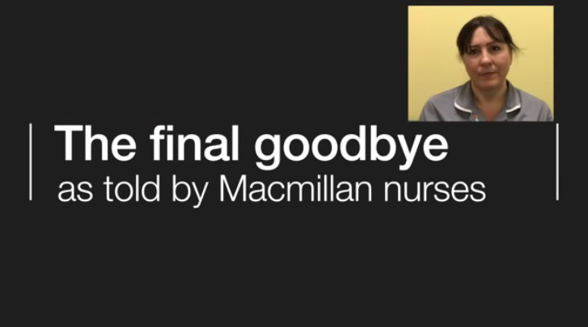 | The final goodbye as told by Macmilan nurses  https://www.youtube.com/watch?v=Tw3OP5GXbCo

Websites for Teachers
Some internet sources for Kübler -Ross stages of grieving:
https://www.psycom.net/depression.central.grief.html
https://www.verywellmind.com/five-stages-of-grief-4175361
https://psychcentral.com/lib/the-5-stages-of-loss-and-grief/
Internet source that gives ways of dealing with death to adolescents:
https://kidshealth.org/en/teens/someone-died.html?ref=search#catbody-basics

Instructional Strategies
Teachers may use any of the following instructional strategies; 3-Part lesson, lecture, storyboard, word wall, think-pair-share, placemat activity, rapid write, K-W-L, anticipation chart, ABC taxonomy, think aloud, analyzing text, Cornell note taking, exit ticket/ticket out the door, plus/minus/delta, etc.

The Hook / Motivational Strategies
If the student plans on entering the health care field, dealing with death is a certainty. By understanding the process, and coming to terms with their personal emotions, they can understand how to deal with these circumstances in a professional manner.
Students who have their driver’s license have been faced with the question regarding their consent for organ donation. By understanding “brain death”, they will have a greater awareness of how the deceased body can be a time of joy for the patients who are awaiting an organ donor.
Students who have not experienced a death may increase their awareness of the feelings that arise at this time. In the group discussions, they can understand the emotions that fellow students are expressing, and potentially be able to help a friend deal with the death of a person close to them.

Learning Goals and Success Criteria
Learning goals include developing an understanding of death and how the patient, family and health care team deal with death.
Students are encouraged to share in the discussions so that teachers may assess their understanding and knowledge through their communication skills. Assessment can also take place through the student participation in synchronous learning discussions and activities. A rubric is used for evaluation of the student’s reflection on the various topics covered.
Success is evident in the sharing of information and honest reflection of experiences with death. Success criteria for components of this project will look like,
- I can use my communication skills to describe the final stages of life
- I can describe how different people deal with death
- I can identify the stages of grief and how they relate to behaviours of survivors
- I can describe the physiological indicators of death
- I can reflect on my experience with death and how it can impact my behaviour
- I can view a death scenario and develop a plan to deal with it
- I develop teamwork skills when working with others
- I learn to respect others when working in teams

Overall and Specific Expectations in Support of Ontario Curriculum Grades 11 - 12 Technological Education

Overall Expectations
A5. Describe the final stages of life, grieving, and the ways in which children and older adults may experience loss.

Specific Expectations
A5.1 Demonstrate an understanding of the concept of death and describe the five-stage process of coming to terms with death and dying, as conceived by Elisabeth Kübler-Ross (i.e., denial, anger, bargaining, depression, acceptance);
A5.2 Describe the physical signs of approaching death (e.g., decreased circulation, apnea, CheyneStokes respiration);
A5.3 Describe the clinical indicators of death (e.g., absent vital signs, fixed and dilated pupils);
A5.4 Describe some of the different religious and cultural beliefs and practices related to death and dying, the arrangements that typically need to be made in connection with funeral or other ceremonial proceedings, and how financial considerations may affect these practices;
A5.5 Describe various types of loss and how they may be experienced by children at different stages of development and by older adults (e.g., loss of a pet, separation from a parent as a result of divorce, loss of a body part, loss of peers at an increasing rate in old age).

Safety Concerns
Students who have experienced a death may still be dealing with the grieving process. It may be necessary to determine the best way to aid them in learning while honouring their emotional needs. The teacher needs to reach out to all students prior to this topic to determine their ability to manage through this lesson, and adjust teaching strategies accordingly. Parents of children with mental health issues or previous suicide ideation may need to be notified prior to this lesson to engage their assistance in dealing with their child.

Applicable SAFEDocs and ToolSAFE videos
Although this resource does not utilize a lot of tools and equipment, please refer to the OCTE SAFEDocs for Health Care and the ToolSAFE videos for any safety documents and resources should you add a module or assignment.

Project Challenges
The biggest challenge is the sensitivity of the subject. Whereas students who plan to enter the healthcare field will deal with death, this topic is still a very emotional one. It is important to maintain a level of caring while dealing with the facts of death. This may aid some students in understanding the inevitable prospective of dealing with death.

Differentiation of the Project / Activity
Teachers can also refer to the Differentiation Scrapbook to take into account for learner ability, multiple intelligences, exceptional students, and ESL learners.
Consideration must be made for a student who has had a recent death, or is dealing with the palliative nature of a person close to them.
Further work into legal matters can occur if time permits, or if students express interest in this topic. In addition, exploring the new Canadian law pertaining to the right to die can be an option for any students who wish to further their knowledge.

Assessment and Evaluation
Assessment As Learning –all group discussions are assessment, as students can share what they have experienced
Assessment For Learning – Activity 2, 3 and 5
Assessment Of Learning –Activity 6

Religious Considerations
This topic lends itself to religious perspectives on dealing with the dying patients and their family. All students are encouraged to respect that religions deal with this period in different ways, and as healthcare professionals, the right of the family to practice their faith is a component of religious freedom.
If the right to die topic is explored, this has very strong religious considerations, and may open up discussions regarding the health care workers legal obligation to their patient. Some students may feel strongly about this issue.

Career and Industry Extensions
- Coroner
- Grief counselor
- Psychologist
- Psychiatrist
- Palliative care nurse
- Funeral service manager
- Hospice aid
- Mental health counselor
- Social worker
- Chaplain or religious leader
- Personal support worker
- Geriatrician

Ethical Considerations
Although this topic is sensitive, there is the new law in Canada regarding the right to die. This is personal and holds religious meaning, yet the patient and their family can be given this option in their end-of-life care plan.

Environmental Considerations
There are limited considerations regarding the environment. Students may consider the issue of burial vs. cremation as a way of conserving space, costs associated with both methods. Cremation followed by dispersing of the ashes is a consideration to the environment, and many municipalities have rules regarding where the ashes can be disposed.

Reflection or Design Report
Teachers may wish to have the students complete a design report, reflection or create a foldable to consolidate their learning. This would be a nice way to capture the student’s understanding in a summative format and be used in preparation for their examination, entering post-secondary education or the workforce.

Appendix A – Death and Dying

Death and Dying

Reflections: Personal Feelings about Death

Please complete the following sentences:
- Palliative care is…
- Death is…
- A good death is…
- What frightens me about death is…
- A corpse makes me feel…
- Mourning is…
- Cemeteries are…
- I could accept death when/if…
- Beliefs about life after death…
- Beliefs about heaven…

Appendix B – Physical Signs of Impending Death
Often times, when faced with a palliative situation, family members want to know how long their loved one has. It is very difficult to accurately predict the time of death. However, it is important to acknowledge the emotional strain this situation has on the family. Therefore, it is important to know what signs indicate impending death and allow family members to make decisions. This can be true if some family members are located far away, and have expressed a wish to come when death is near.
Here are some signs that death is near:
- Slowing of digestive system
-refusal to drink or eat
-refusing to eat favourite foods
-craving of unusual foods
-patient may have fecal incontinence
-abdomen is distended or firm
-nausea or vomiting

- Excessive fatigue or sleeping
-sleeping for longer periods of time
-disoriented
-loss of interest to their surroundings
-may be difficult to awaken
-loss of consciousness

- Circulatory abnormalities
-pulse can be fast, weak and irregular
-extremities are cool and have mottled colour
-blood pressure is decreased
-dryness around eyes and mouth
-pale skin

- Decreased movement
-often noticed in feet and legs
-mouth may relax; often breathing with open mouth

- Respiratory abnormalities
-decrease in respirations
-Cheyne-Stokes breathing
-increased mucus in airway causing gurgling sound

Appendix C – Requirements and Regulations
Answer the following questions using the internet or textbook (if there is a classroom text).
Focus on local rules/regulations. For example – is there information about a local hospice regarding their procedures for care at time of death?
- What are some of the physical indicators of death?
- Who pronounces a person to be dead (legally)?
- When is it necessary to call a coroner?
- What are the rules in home care regarding care of the body?
- What are the rules in a hospital regarding care of the body?

There are regulations regarding necessary actions if someone is very ill.
- What does “advanced directives” mean?
- What are “powers of attorney”?
- What does DNR mean?

When someone in your care dies, you may be required to care for the body.
- What does care for the body after death require?
- What is necessary to do if the coroner is investigating the death?

Appendix D - Scenarios

Scenario 1
James Stands has been admitted to the hospice where you work. He is only 56, but has terminal brain cancer. He has a wife – Judy, but no children. His father passed away years ago, and his mother is alive, but has early onset Alzheimer’s. James has a large group of friends who plan to visit regularly, so he was placed in the largest room in the hospice. He is estranged from his only sister, Brenda, and at the request of James and Judy, the sister is not to be allowed to visit.
Brenda Stands does arrive at the hospice 2 days after his admission, and is having a hard time dealing with the directive banning her from visiting. In your role as hospice director, you invite her into your office for a long discussion.
Within the week, James does succumb to the cancer and dies surrounded by his wife and friends. Brenda hears about the death, and visits you again the following morning.

Scenario 2
7 year old Li Ying disappeared from school 2 weeks ago, and the police have been unable to locate her. There is very little information, and the search seems to have stalled. The situation is dire, and it is unlikely that Li will be found alive.
You have been working with the police as a mental health worker, and specialize in pediatrics. You have been called in to assist with Li’s older brother, Khang, who is 11. Both parents (Bo and Cheng) have been unable to work or function as normal, and have asked for help in supporting Khang.
While it is important to remain positive, your role is to assist Khang in developing an understanding that his sister may not be found alive.

Scenario 3
You are the emergency room physician on night shift when a quiet night takes a turn. Seven MVC victims come in and the pressure begins. The most critical of the patients is 31 year old Ekon Kanumba. He was a pedestrian hit by a speeding car, and has sustained multiple injuries. The most severe is a head injury that has left Ekon in a coma (Glasgow Coma Scale – 3). After he returns from the CT, you realize that the damage to the brain is severe, and he is likely to be pronounced brain-dead. You are on your way to notify his wife, 29 year old Aaliyah. She was also injured, but her injuries are minor – contusions and abrasions to her left arm and shoulder. Fortunately, there has been no trauma to the 4 month fetus, and her pregnancy is not at risk. She has been waiting for an update on Ekon.

Scenario 4
94 year old Prisha Patel has been in the nursing home for just over 5 months. She has suffered several strokes, and has limited ability to move her right arm and leg. In the past few days, she has declined most of her food, and is declining physically. She has been on bedrest for the past 2 days, as she is too weak to sit up. Her husband Arjun has faithfully visited her every afternoon, but has come down with a respiratory infection, and has been asked not to visit.
As a PSW, you have been communicating with Arjun for the past few days. He is asking if she is going to “make it”.

Scenario 5
You have recently accepted a job for the city as a social worker. On your first week, you are called into the hospital to deal with a “John Doe”. On arrival, you are escorted to a room, where “John” lays on the stretcher with a blanket over his whole body. You are not certain what is going on, and ask to speak to the nurse.
When a nurse finally arrives, he tells you that the patient is deceased, but they have no name, no next of kin, and are leaving the tracing and further details to you.

Scenario 6
You are working your regular evening shift in the operating room when the patient who was undergoing a routine hip repair suffers a heart attack and attempts to revive her are unsuccessful. You are asked to go with the surgeon to talk to the family.
Thea Alexopoulous is a 59 year old, otherwise healthy female. You had a great conversation with her prior to the surgery, and she reminds you so much of your own mother, who is also 59.
In the waiting room, her husband Nico, and son are awaiting news of the surgery.

Scenario 7
Since you are on call this evening, you are not surprised to get a phone call from the local trauma centre. A 17 year old boy was skateboarding with his friends and suffered a severe head injury that has a poor prognosis. He is currently on life support, and his family and some friends are in the ICU waiting room.
Once you arrived at the hospital, you go to visit Garth Johnson, and the physicians have told you that he has been declared brain-dead. They have asked for your assistance to speak to the family regarding the donation of organs. As a worker for Trillium Gift of Life, you prepare yourself to talk to the family. The physician lets you know that the parents are separated, and the mother is upset with the father for allowing Garth to skateboard without a helmet.

Appendix E – Reflective Paper
In your group, discuss the scenario, and use the questions to direct your conversation. Continue to explore the scenario with additional topics as the conversation develops.
What are some of the factors that make this situation difficult?
What are some factors (if any) that make this situation easier to deal with?
What is an empathetic approach that would aid the family member(s)?
Are there special considerations based on age/understanding?
Do you think this is an easy or difficult death? Explain your answers.

Write a reflective paper that addresses these questions, and your personal perspective on this scenario. This is meant to summarize your understanding of physiological death, but with the psychological components that accompany this stage of life.
Ensure that your paper is at least 2 pages long and is grammatically correct.

Reflective Paper Rubric

Student Name: ____________________________ Date: _______________________

Criteria/Categories | Level 1  (2/5) | Level 2  (3/5) | Level 3  (4/5) | Level 4  (5/5)
Knowledge /  Understanding Addresses all of the questions asked in the assignment  Identifies understanding of the process of grieving  Demonstrates understanding of the factors in the scenario | - limited use of the questions asked in the assignment  - provides limited understanding of the process of grieving  -has limited understanding of the factors in the scenario | - some use of the questions asked in the assignment  - provides some understanding of the process of grieving  -has good understanding of the factors in the scenario | - considerable use of the questions asked in the assignment  - provides good understanding of the process of grieving  -has very good understanding of the factors in the scenario | - thorough use of the questions asked in the assignment  - provides considerable understanding of the process of grieving  -has complete understanding of the factors in the scenario
Application  Applies knowledge of the communication techniques in dealing with the family members  Reflects on how they are affected by the death and the scenario | - limited ability to use communication techniques in dealing with the family members  - limited reflection of how they are affected by the death and the scenario | - some ability to use communication techniques in dealing with the family members  - some good reflection of how they are affected by the death and the scenario | - considerable ability to use communication techniques in dealing with the family members  - good reflection of how they are affected by the death and the scenario | - excellent ability to use communication techniques in dealing with the family members  - great reflection of how they are affected by the death and the scenario
Communication
Demonstrates proper literacy skills, including grammar and sentence structure | - demonstrates limited literacy skills, including grammar and sentence structure | -demonstrates some literacy skills, including grammar and sentence structure | - demonstrates considerable literacy skills, including grammar and sentence structure | - demonstrates a high degree of literacy skills, including grammar and sentence structure

References
10 Signs of Death | Signs Death is Near (YouTube video by Love Lives On), 2019 https://www.youtube.com/watch?v=53QhpMvnLtc
21st Century Competencies: Foundation Document for Discussion. Phase 1: Towards Defining 21st Century Competencies for Ontario, Winter 2016 Edition, 2016 http://www.edugains.ca/resources21CL/About21stCentury/21CL_21stCenturyCompetencies.pdf
Death and Grief (article), 2020 https://kidshealth.org/en/teens/someone-died.html?ref=search#catbody-basics
Course Codes for Emphasis courses in the Revised Curriculum: Technological Education, Grades 11 and 12, 2009 http://www.edu.gov.on.ca/eng/curriculum/secondary/techedemphasiscourses.pdf
End of life: Caring for someone who is dying (article by Mayo Clinic staff), 2020 https://www.mayoclinic.org/healthy-lifestyle/end-of-life/in-depth/cancer/art-20047600
Growing Success: Assessment, Evaluation, and Reporting in Ontario Schools, First Edition, Covering Grades 1 to 12, 2010 www.edu.gov.on.ca/eng/policyfunding/growSuccess.pdf
How long is the active dying process ?, (YouTube video by Best Health), 2019
https://www.youtube.com/watch?v=FjHLlE-aDyQ
Learning for All – A Guide to Effective Assessment and Instruction for All Students, Kindergarten to Grade 12, 2013 http://www.edu.gov.on.ca/eng/general/elemsec/speced/LearningforAll2013.pdf
The 5 Stages of Grief & Loss (article), 2020 https://psychcentral.com/lib/the-5-stages-of-loss-and-grief/
The Differentiated Instruction Scrapbook http://www.edugains.ca/resourcesDI/EducatorsPackages/DIEducatorsPackage2010/2010DIScrapbook.pdf
The final goodbye as told by Macmilan nurses (YouTube video), 2020 https://www.youtube.com/watch?v=Tw3OP5GXbCo
The Five Stages of Grief: An Examination of the Kübler-Ross Model (article), 2020 https://www.psycom.net/depression.central.grief.html
The Five Stages of Grief: Learning about emotions after loss can help us heal (article), 2020 https://www.verywellmind.com/five-stages-of-grief-4175361
The Ontario Curriculum, Grades 9 and 10: Technological Education, 2009 (revised) http://www.edu.gov.on.ca/eng/curriculum/secondary/teched910curr09.pdf
The Ontario Curriculum, Grades 11 and 12: Technological Education, 2009 (revised) http://www.edu.gov.on.ca/eng/curriculum/secondary/2009teched1112curr.pdf

