

Table of Contents

Introduction 3
Project Outline 3
Prior Knowledge 3
Student Activities 4
Activity 1 – The 4 Designations of Drill Sizes 4
Activity 2 – Tap Identification 4
Activity 3 – Reading a Tap Drill Chart 4
Activity 4 – Project: Drill and Tap Block 5
Planning Notes 5
Resources 6
Handouts 6
Pictures/Blueprints 6
Tools/Equipment 6
Materials 6
Videos 6
Websites 6
Instructional Strategies 7
The Hook / Motivational Strategies 7
Learning Goals and Success Criteria 7
Overall and Specific Expectations 8
Overall Expectations 8
Specific Expectations 8
Safety Concerns 9
Applicable SAFEDocs and ToolSAFE videos 9
Project Challenges 9
Differentiation of the Project / Activity 10
Assessment and Evaluation 10
Assessment As Learning 10
Assessment For Learning 10
Assessment Of Learning 10
Career and Industry Extensions 11
Reflection or Design Report 11
Appendix A – Hand Taps Handout 12
Appendix B – Tap Drill Chart 13
Appendix C – Tap and Drill Sizes Quiz 15
Appendix D – Twist Drill Comparison Placemat 16
Appendix E – Drill and Tap Block Rubric 17
Appendix F – Project Drawing/Blueprint 18
Appendix G – Project Reference Pictures 19
References 20

Introduction
Course Code: TMJ2O
Broad base Technology: Manufacturing
Destination: Open
Grade Level: 10
Prerequisite: None
Online Project Name: Drill and Tap Block

Project Outline
This project will teach students how to drill and tap various size holes on a milling machine. They will be required to cut a piece of rough stock aluminum and mill the ends of the block square. They will then layout 3 different hole positions on the block using the height gauge and surface plate. The student will finish the project by use the milling machine to drill and tap 3 different size holes.
By the end of this project the student will…
- Learn the various designations of drill sizes
- Learn how taps are identified
- Be able to read a tap drill chart
- Understand the importance of proper drill size selection when tapping
- Demonstrate how to drill and tap a hole properly

Prior Knowledge
Students should have some basic knowledge from the grade 9 TIJ1O Exploring Technologies course which is suggested but not mandatory. This includes,
- General shop safety
- Layout techniques using height gauge
- Band saw operation
- Milling machine operation

Student Activities

Activity 1 – The 4 Designations of Drill Sizes
The goal of this activity is for students to learn the ways in which drill sizes are designated. Students will be able to identify the 4 different designations (fraction, letter, number, metric) and be able to locate the drills in a standard drill set.
Time required: 30 minutes
Materials/equipment needed: Standard drill set, various drills to pass around to students

Activity 2 – Tap Identification
The goal of this activity is for students to understand how taps are identified. They will learn about different types of taps and why it is important to choose the right tap for the job required.
Time required: 30 minutes
Material/equipment needed: Tap set, various taps to pass around to students
Resources: Hand Tap Handout (Appendix A)
Video #1 - Tapping Essentials (13:20)

Activity 3 – Reading a Tap Drill Chart
The goal of this activity is for students to learn how to read a tap drill chart. They will learn how to select the proper size drill depending on the tap size required. The students will complete a quiz to assess their understanding form Activities 1, 2 and 3.
Time required: 90 minutes
Material/equipment needed: Tap drill chart
Resources: Tap Drill Chart (Appendix B)
Tap Drill Quiz (Appendix C)
Video #2 - Tap Drill Chart (4:10)
Twist Drill Comparison Placemat

Activity 4 – Project: Drill and Tap Block
This project will allow the students to use their knowledge of drilling and tapping to manufacture an aluminum block with various sized tapped holes.
The students are required to cut a piece of rough stock aluminum (size can vary depending on available material) and mill the ends square. They will then layout out 3 different hole positions spaced out equally on their material. The students are then tasked with selecting 3 different size taps (tap sizes can vary depending on available tooling) and, using the provided tap drill chart (Appendix B), select the proper size drill for each tap.
The students will use the milling machine to drill and tap the 3 different size holes in their piece of material. They will hand in their project for evaluation using a rubric (Appendix D)
Time required: 180 minutes
Material/equipment needed: Aluminum stock, center drills, drills, taps, end mill, height gauge, surface plate, band saw, milling machine
Resources: Drill and Tap Block Rubric (Appendix D)

Planning Notes
The following are suggestions when planning to perform this project,
- Prepare lessons for drill designation, tap identification and tap drill chart reading
- Set-up projector to show videos
- Make copies of all handouts for students or have them available on online learning management system for students
- Prepare all materials for demonstration prior to class or prior to videotaping
- Have various drills and taps placed around the room for students to look at and socially distance
- Have all machines and tools set up to use safely, ensuring guarding is in place
- Prepare material for students to cut

Resources

Handouts
Hand Taps Handout (Appendix A),
Tap Drill Chart (Appendix B)
Tap Drill Quiz (Appendix C)
Twist Drill Comparison Placemat (Appendix D)

Pictures/Blueprints
Hand Taps picture (Appendix A)
Starrett Inch/Metric Tap Drill Sizes & Decimal Equivalents (Appendix B)
Project Drawing/Blueprint (Appendix F)
Project Reference Pictures (Appendix G)

Tools/Equipment
End mills, center drills, drill set, various taps, height gauge, surface plate, band saw, milling machine

Materials
Aluminum stock

Videos
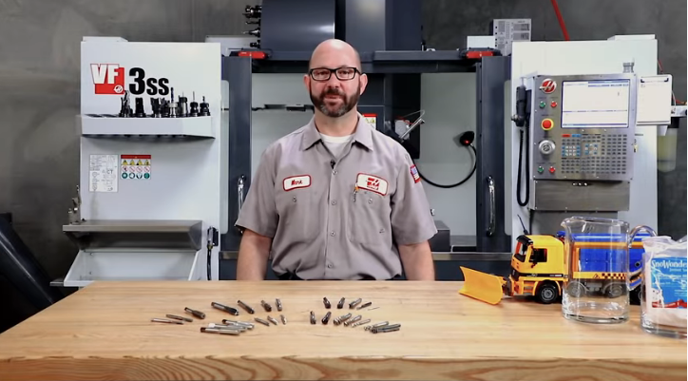 | Video #1 – Tapping Essentials (13:20)  This video explains different types of taps and the uses of each.  https://www.youtube.com/watch?v=bkrUzGooA9k
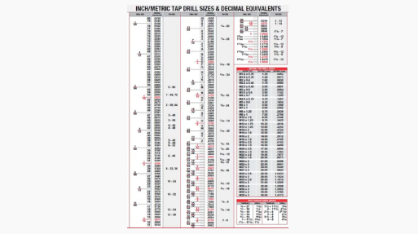 | Video #2 – Tap Drill Chart (4:10)  This is a short video explaining how to properly read a tap drill chart.  https://www.youtube.com/watch?v=68U_ONuLVKk

Websites
NC Cutting Tools - 7 Differences between HSS and Cobalt Drill Bits
Powertool Addict - Cobalt Drill Bits vs Titanium Drill Bits: What Material is the Better Choice?
RD Barrett - The Difference Between HSS and Cobalt Drill Bits
Regal Cutting Tools on Twist Drills
Vermont AmericanTwist Drill Bit Types – How to Choose the Right Twist Drill Bit

Instructional Strategies
Teachers may use any of the following instructional strategies; 3-Part lesson, lecture, storyboard, word wall, think-pair-share, placemat activity, rapid write, K-W-L, anticipation chart, ABC taxonomy, think aloud, analyzing text, Cornell note taking, exit ticket/ticket out the door, plus/minus/delta, etc. to effectively introduce an activity or teach their students.

The Hook / Motivational Strategies
Start the class with a discussion about threads (what are they, how do they work, where are they used etc.). Ask the students to think of some places that threads are used and have them share their thoughts. Talk about the importance of having international standards when it comes to manufacturing threads and why it is necessary. Explain how threads are made and introduce the students to taps, demonstrating how they are used the create threads.

Learning Goals and Success Criteria
Learning goals and success criteria are the foundation on which students base their ability to monitor their learning and determine next steps. Applicable learning goals may include any of the following,
- Students will learn about the various designations of drill sizes
- Students will understand how taps are identified
- Students will discover the importance of proper drill size selection when tapping
Success criteria may include any of the following,
- I will demonstrate their ability to read a tap drill chart correctly
- I will be able to identify taps and dies
- I will accurately machine to a specification
- I will accurately machine to within a tolerance
- I will demonstrate how to drill and tap a hole on the milling machine
- I will be able to identify and explain how various materials, tools, and equipment are used in the manufacture of products
- I will develop and use a manufacturing process to produce a product
- I will safely use the correct machines and tools to manufacture a product

Overall and Specific Expectations in Support of Ontario Curriculum Grades 9 - 10 Technological Education

Overall Expectations
A3 Identify and explain how various materials, tools, and equipment are used in the manufacture of products;
B2. Develop and use a manufacturing process plan to produce a product;
B3. Use hand tools, machine tools, power tools, materials, and equipment safely and correctly in the manufacture of a product;
B4. Demonstrate the use of metrology skills to measure, lay out, and inspect a product.

Specific Expectations
A3.1 Identify and describe the hand tools, machine tools, power tools, and equipment (e.g., saw, drill, engine lathe, vacuum forming machine, computer hardware and software) used in the design and fabrication of a variety of projects (e.g., robotic challenge, design challenge, fabrication project);
B2.1 Identify and select appropriate materials required to manufacture a product;
B2.3 Use correct procedures to prepare materials for the manufacture of a product (e.g., layout, cutting to rough length, squaring, drilling, weld preparation, deburring);
B3.1 Set up hand tools, machine tools, power tools, and equipment (e.g., jigs and fixtures, clamps, engine lathe, welding equipment, milling machine, drill press, injection-moulding machine) properly in preparation for the manufacture of a product (e.g., robotic challenge, design challenge, fabrication project);
B3.2 Use various hand tools, power tools, machine tools, and related equipment (e.g., saws, grinders, milling machine, engine lathe, welding equipment, vacuum-forming machine) safely and correctly to manufacture a product;
B3.4 Demonstrate safe workplace practices and behaviours (e.g., follow instructions, keep work area clean and dry, don’t distract other workers) when using materials, tools, and equipment to manufacture a product;
B4.2 Perform proper layout procedures.

Safety Concerns
Students must follow previous instruction and learned machine safety instructions while operating the band saw and milling machine. Safety passports or equipment instruction, testing and demonstration signoffs maybe utilized to track student training on pieces of equipment. Students must also wear proper PPE (safety glasses, proper footwear, etc.) while completing this project.

Applicable SAFEDocs and ToolSAFE videos
Please refer to the SAFEDocs for Manufacturing Technology on the OCTE website for safety documents in order to properly address and instruct this project.

Project Challenges
Challenges that may arise during this project may include:
- Students not understanding how to read a tap drill chart properly
- More one on one time may be needed to support students learning
- Additional worksheets may be provided for practice
- Students will break taps while completing the project
- Teach students how to remove a broken tap
- Have extra taps ready to use if needed
- The machines may get backed up by students needing to work
- Have half of the students work on quiz while other half uses machines
- Have them switch places when they are complete
- Students may have difficulty completing the project
- Have students partner with a more knowledgeable classmate
- Spend more one on one time with students who require it

Differentiation of the Project / Activity
This project can be differentiated by:
- Using various size material, depending on availability
- Using various size taps, depending on availability
- Assigning students specific size holes to tap or having them choose their own sizes
- The quiz could be completed as a fill-in-the-blank worksheet with the entire class
- This projected could be completed entirely in class over 2 or 3 days or it could also be a combination of online and in person work.
- The project could also be completed entirely online if needed, with the exception of Activity #4
Teachers can also refer to the Differentiation Scrapbook to take into account for learner ability, multiple intelligences, exceptional students, and ESL learners.

Assessment and Evaluation

Assessment As Learning
- Ask questions and make suggestions based on daily observation
- Assess students’ cognition about their learning
- Students monitor their own learning and ask questions as needed

Assessment For Learning
- Provide feedback to students about their learning and how to improve
- Create differentiated teaching strategies and learning opportunities
- Identify particular learning needs of students

Assessment Of Learning
- Students will complete a quiz to assess their understanding of the lessons
- Evaluate each project according to the rubric

Career and Industry Extensions
Students can explore career opportunities in the Manufacturing Industry including:
- General Machinist
- Millwright
- Welder
- CNC Operator
- Engineer
- Ironworker
- Metal Fabricator

Reflection or Design Report
Teachers may wish to have the students complete a design report, reflection or create a foldable to consolidate their learning. This would be a nice way to capture the student’s understanding in a summative format and be used in preparation for their examination, entering post-secondary education or the workforce.

Appendix A – Hand Taps Handout
Hand Taps
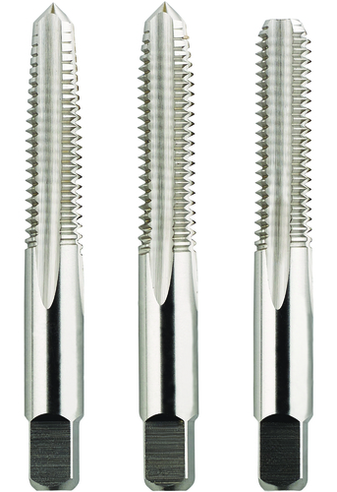
- Used to cut internal threads.
- The top end of the shank is square so a tap wrench or tap handle can be used to turn the tap into a hole which then produces a thread.
- When cutting, use cutting oil to lubricate the metal as it cuts.
- After a full complete turn, back the handle half a turn to break chips.
- Keep the tap straight and parallel with the workpiece.

Preparing Workpiece for Internal Threads
- A hole must be drilled first. The drill bit must be smaller than the size of the tap so there is room for the threads to be cut. Use a “Tap Drill Chart” to find the right drill size.
- Add a chamfer to the end of the workpiece. This is to help start the tap.
- Use cutting oil to help cut and to keep the metal from heating up.

Appendix B – Tap Drill Chart
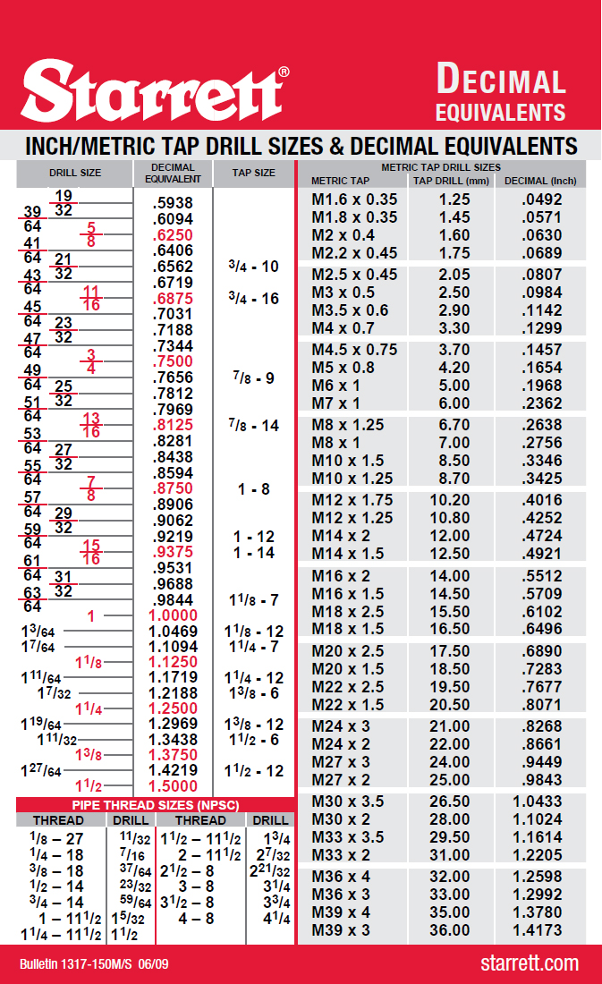
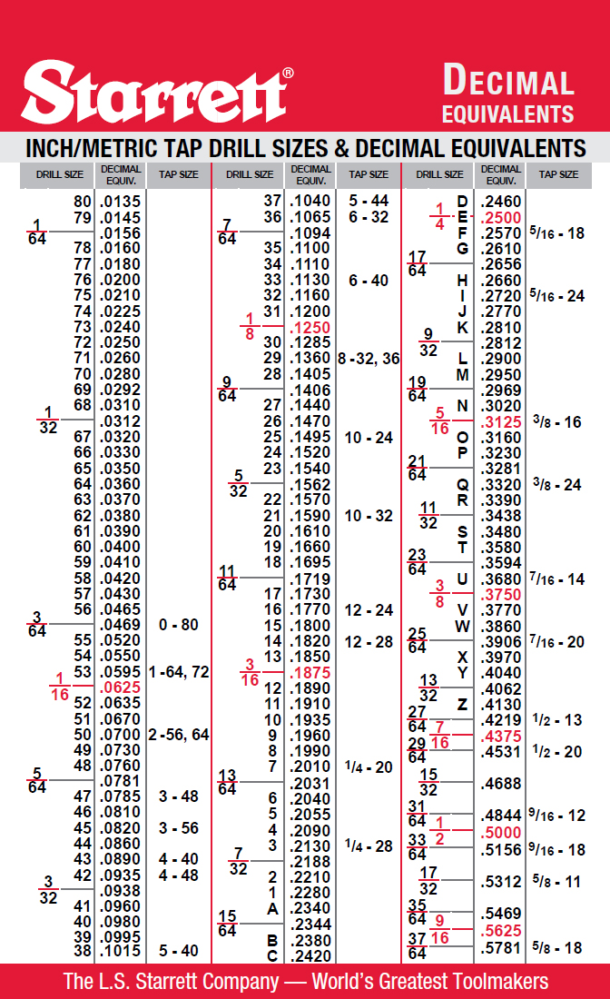

Appendix C – Tap and Drill Sizes Quiz
Name: ___________________________ Total: /17 marks
1. List the 4 ways that drills are designated: /4 marks
________________________________________________________________________
2. 1/4 x 20 U.N.C. thread, 20 represents the________________? /1 mark
- major diameter c) tap drill size
- number of threads per inch d) hole size
3. 3/8 x 24 U.N.F thread, 3/8 represents the________________? /1 mark
- major diameter c) tap drill size
- number of threads per inch d) hole size
4. For a 1/2 x 13 U.N.C thread, the term U.N.C. stands for? /1 mark
- unified national colour c) universal number code
- under no condition d) unified national course
Using the tap drill chart provided, answer the following questions: /1 mark each
5. What size drill is needed to make a ¼-28 thread? _______________
6. Give the drill size for a 5/8-18 thread. _______________
7. Name the drill size to produce a 10-32 thread. ________________
8. A 5/16-24 thread needs what size drill? ____________________
9. What size drill is required for a 7/8-9 tap? _______________
10. Give the drill size needed for a ¾-16 tap? ________________
11. What drill size is needed to make a 5/8-11 thread? _______________
12. Name the drill size for a 3/8-16 thread. ________________
13. What is the proper size drill to make a M6 x 1.00 thread? _________________
14. Name the drill size for a M10 x 1.25 tap. ______________ Total /10

Appendix D – Twist Drill Comparison Placemat
Using your class textbook for Manufacturing Technology or the Internet, research high speed steel, black oxide, titanium nitride and cobalt twit drills. State the properties of each twist drill and on what materials you would use each one.

High Speed Steel (HSS) | Cobalt
Black Oxide | Titanium Nitride

Bonus: Research Carbide twist drills and cutting tools, and compare them to the list above

Appendix E – Drill and Tap Block Rubric
Category | Level 4 | Level 3 | Level 2 | Level 1
Manufacturing | Student uses manufacturing processes to efficiently produce a product | Student uses manufacturing processes to produce a product | Student uses some of the manufacturing processes to produce a product | Student uses minimal manufacturing processes to produce a product
Layout | The layout of all three holes are in the correct position | The layout of two holes are in the correct position | The layout of one hole is in the correct position | All three holes are laid out but not one hole is correct
Tap Drill Sizes | All three tap drills are the correct size | Two of the tap drills are the correct size | One of the tap drills is the correct size | None of the tap drills are the correct size
Tools and equipment | Student uses tools (hand and machine), and equipment safely and to a high degree of accuracy to manufacture a product | Student uses tools (hand and machine), and equipment safely and correctly to manufacture a product | Student uses some of the tools (hand and machine), and equipment safely with assistance to manufacture a product | Student uses a limited number of the tools (hand and machine), and equipment under supervision and with assistance to manufacture a product
Overall Appearance | Project has been deburred, has no machining marks, and is accurate to 0.001” of specification | Project has been deburred, has very few machining marks to considerable accuracy (with –in tolerance) | Project has been deburred with moderate effectiveness. A few machining marks and/or rough edges are present | Project has burrs and sharp edges. Many machining marks and/or rough edges are present and is not accurate
Time Management | Class time was used wisely every day. Much time and effort went into the project | Class time was used wisely most days. Considerable time and effort went into project | Class time was used some days. The time and effort spent on the project could have been better | Class time was not used wisely. Little effort went into the project but the project was completed by due date
Comments

Appendix F – Project Drawing/Blueprint
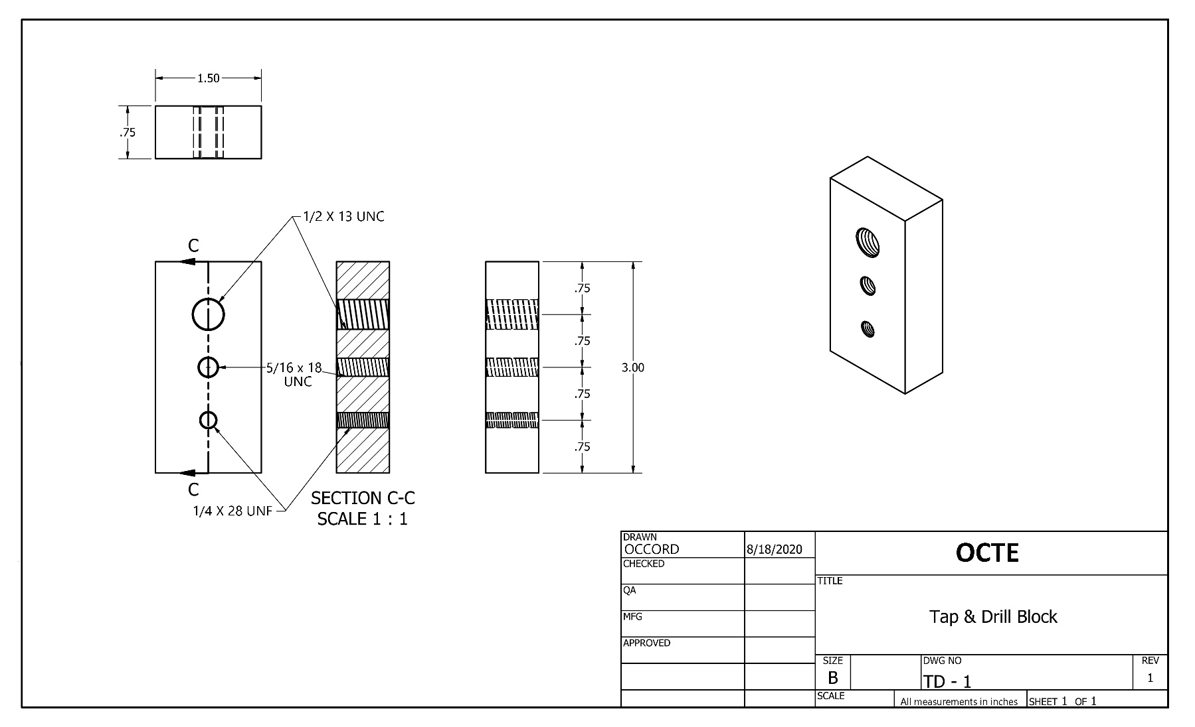

Appendix G – Project Reference Pictures
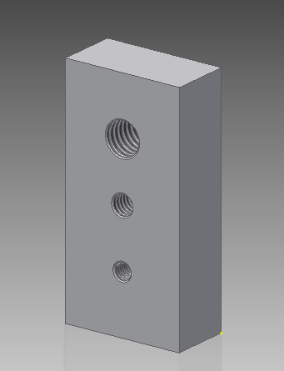
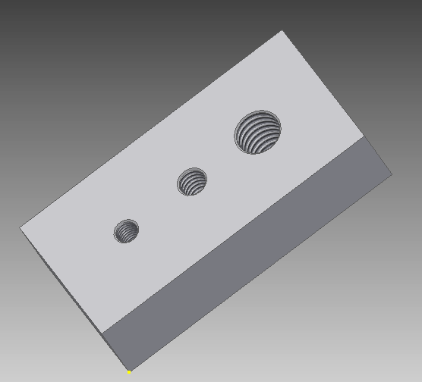

References
7 Differences between HSS and Cobalt Drill Bits (Article), 2020 https://www.nccuttingtools.com/7-differences-between-hss-and-cobalt-drill-bits.html
21st Century Competencies: Foundation Document for Discussion. Phase 1: Towards Defining 21st Century Competencies for Ontario, Winter 2016 Edition, 2016 http://www.edugains.ca/resources21CL/About21stCentury/21CL_21stCenturyCompetencies.pdf
Cobalt Drill Bits vs Titanium Drill Bits: What Material is the Better Choice? (Article), 2020 https://powertooladdict.com/cobalt-drill-bits-vs-titanium-drill-bits-what-material-is-the-better-choice/
Course Codes for Emphasis courses in the Revised Curriculum: Technological Education, Grades 11 and 12, 2009 http://www.edu.gov.on.ca/eng/curriculum/secondary/techedemphasiscourses.pdf
Growing Success: Assessment, Evaluation, and Reporting in Ontario Schools, First Edition, Covering Grades 1 to 12, 2010 www.edu.gov.on.ca/eng/policyfunding/growSuccess.pdf
Learning for All – A Guide to Effective Assessment and Instruction for All Students, Kindergarten to Grade 12, 2013 http://www.edu.gov.on.ca/eng/general/elemsec/speced/LearningforAll2013.pdf
SAFEDocs for Manufacturing Technology (OCTE), 2017
https://www.octe.ca/application/files/7115/3796/3174/SAFEdoc_MANU.pdf
Starrett Inch/Metric Tap Drill Sizes & Decimal Equivalents (Chart), 2009
https://www.starrett.com/docs/educational/decimal-equivalent-card---bulletin-1317.pdf
Tap Drill Chart (YouTube video), 2018 https://www.youtube.com/watch?v=68U_ONuLVKk
Tapping Essentials – Every Machinist Needs to Watch This – Haas Automation Tip of the Day (YouTube video) 2019 https://www.youtube.com/watch?v=bkrUzGooA9k
The Difference Between HSS and Cobalt Drill Bits (Article), 2019 https://rdbarrett.co.uk/blog/the-difference-between-hss-and-cobalt-drill-bits/
The Differentiated Instruction Scrapbook http://www.edugains.ca/resourcesDI/EducatorsPackages/DIEducatorsPackage2010/2010DIScrapbook.pdf
The Ontario Curriculum, Grades 9 and 10: Technological Education, 2009 (revised) http://www.edu.gov.on.ca/eng/curriculum/secondary/teched910curr09.pdf
The Ontario Curriculum, Grades 11 and 12: Technological Education, 2009 (revised) http://www.edu.gov.on.ca/eng/curriculum/secondary/2009teched1112curr.pdf
Three Taps (Image), 2020 https://www.morsecuttingtools.com/catalogue/product/1075080
Twist Drills (Resource), 2020 https://www.regalcuttingtools.com/products/twist-drills
Twist Drill Bit Types – How to Choose the Right Twist Drill Bit (Article), 2020 https://vermontamerican.com/twist-drill-bit-types-choose-right-twist-drill-bit/

