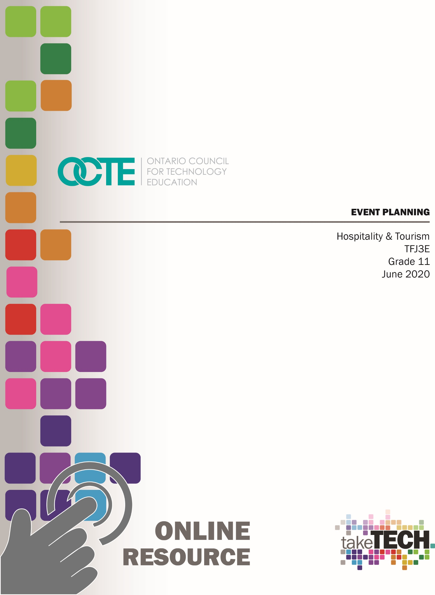

Table of Contents

Introduction 3
Project Outline 3
Prior Knowledge 4
Planning Notes 4
Resources 4
Presentations 4
Tools/Equipment 4
Software 4
Assignments 5
Charts and Tables 5
Graphic Organizers 5
Rubrics 5
Instructional Strategies 5
The Hook / Motivational Strategies 6
Learning Goals and Success Criteria 6
Overall and Specific Expectations 6
Overall Expectations 6
Specific Expectations 7
Safety Concerns 7
Applicable SAFEDocs and ToolSAFE videos 7
Project Challenges 7
Differentiation of the Project / Activity 7
Assessment and Evaluation 8
Religious Considerations 8
Career and Industry Extensions 8
Reflection or Design Report 8
Introduction to Project – Event Planning 9
Activity 1 - Event Planning Research Slideshow 10
Event Planning Chart 11
Event Planning Research Slideshow Rubric 12
Activity 2 - Learning More about Ontario Tourism 13
Part 1 - Post Slideshow for Class to Review 13
Part 2 - Success Criteria for Events Chart 13
Activity 3 - Social Media Platform Assignment 14
Social Media Graphic Organizer 15
Activity 4 - Event Planning Checklist 15
Activity 5 - Event Types 17
Design an Event Pros and Cons Chart 17
Activity 6 - Objective and Timeline of the Event 18
Activity 7 - Event Venue Assignment 19
Event Venue Graphic Organizer 19
Event Venue Evaluation Assignment 20
Activity 8 - Menu Planning 21
Menu Brainstorming and Graphic Organizer 21
Menu Brainstorming and Research Chart 22
Recipe Chart in Kitchen Format 25
Menu Item Descriptions 26
Finished Event Menu 27
Finished Event Menu Rubric 27
Kitchen Production Schedule 28
Equipment Requirements 29
Teamwork Assignment 30
Activity 9 - Final Touches Event Planning Assignment 31
Activity 10 - Event Invitation Assignment 32
Event Invitation Rubric 32
Appendix A - Blank Recipe Form 33
Appendix B - Recipe Writing Kitchen Format PowerPoint 34
References 35

Introduction
Course Code: TFJ3E
Broad base Technology: Hospitality and Tourism
Destination: Workplace
Grade Level: 11
Prerequisite: None
Online Project Name: Event Planning

Project Outline
By the end of this unit the student will demonstrate an understanding of appropriate procedures to follow in planning an event or activity. (B3) Students will research and report on a local and/or provincial tourism event or activity (e.g., music festival, sporting event, product show, cultural event) and identify the components that made the event or activity successful. Students will use computer software to prepare and present a variety of documents related to an event or activity and explain the importance of teamwork. Students will design an event or activity and complete the appropriate preparations for the event or activity.
The Project Outline includes the following components,
Activity 1 Event Planning Research Slideshow
Event Planning Chart
Event Planning Research Slideshow Rubric
Activity 2 Learning More about Ontario Tourism
Part 1 Post Slideshow for Class to Review
Part 2 Success Criteria for Event Chart
Activity 3 Social Media Platform Assignment
Social Media Graphic Organizer
Activity 4 Event Planning Checklist
Activity 5 Event Types
Design an Event Pros and Cons Chart
Activity 6 Objective and Timeline of the Event Chart
Activity 7 Event Venue Assignment
Event Venue Graphic Organizer
Event Venue Evaluation

Activity 8 Menu Planning
Menu Brainstorming and Graphic Organizer
Menu Brainstorming and Research Chart
Recipe Chart in Kitchen Format
Recipe Chart PowerPoint
Menu Item Descriptions
Finished Event Menu
Finished Event Menu Rubric
Kitchen Production Schedule
Equipment Requirements
Teamwork Assignment
Activity 9 Final Touches Event Planning Assignment
Activity 10 Event Invitation
Event Invitation Rubric

Prior Knowledge
This resource is for the TFJ3E course which does not have any prerequisites. Good literacy, communication and computer skills are an asset.

Planning Notes
All student activities have been divided into 10 activities to help organize student projects and to provide multiple sources to provide evidence of student learning. Each activity builds on the Event Planning project to help cover curriculum expectations and increase overall student success.

Resources
As stated in the Project Outline, the activities for this project includes PowerPoint presentations, digital notes, research tasks, assignments, tables, charts, graphic organizers and student reviews. Below is a comprehensive list of resources integrated in this entire project.

Presentations
Recipe Writing Kitchen Format (PowerPoint)

Tools/Equipment
Computer / Tablet
Internet

Software
Students will need training on acceptable computer use set by your school board.

Assignments
Learning More about Ontario Tourism
Event Planning Research Slideshow
Event Venue Assignment
Event Venue Evaluation Assignment
Menu Item Descriptions
Finished Event Menu
Kitchen Production Schedule
Equipment Requirement
Teamwork Assignment
Final Touches Event Planning Assignment
Event Invitation Assignment

Charts and Tables
Event Planning Chart
Success Criteria for Events Chart
Event Planning Checklist
Design an Event Pros and Cons Chart
Menu Brainstorming and Research Chart
Recipe Chart

Graphic Organizers
Social Media Graphic Organizer
Objective and Timeline of the Event Graphic Organizer
Event Venue Graphic Organizer
Menu Brainstorming Graphic Organizer

Rubrics
Event Planning Research Slideshow Rubric
Finished Event Menu Rubric
Event Invitation Rubric

Instructional Strategies
Instructional strategies include project-based, problem-based approach, student profiles, exit card, and graphic organizers.

The Hook / Motivational Strategies
It is time to learn about all of the great things that Ontario has to offer. You will start this unit by researching and reporting on a local and/or provincial tourism event or activity like a music festival, sporting event, product show or cultural event happening in your neighbourhood or a neighbourhood in our great province. Working with your classmates to examine what helps to make these events a success will help you as you explore how to create your very own successful event. As you continue through the unit, you will explore and create your own event that will be an exciting and spectacular event for your guests. You will be responsible for creating the atmosphere by creating an event that focuses on the venue, location, decorations and menu to complement the theme of your event. The importance of teamwork will be demonstrated by creating a kitchen production schedule that will ensure all of your menu creations are executed to enhance the overall experience of your amazing event.

Learning Goals and Success Criteria
By the end of this unit the student will demonstrate an understanding of appropriate procedures to follow in planning an event or activity. (B3) Students will research and report on a local and/or provincial tourism event or activity (e.g., music festival, sporting event, product show, cultural event) and identify the components that made the event or activity successful. Students will use computer software to prepare and present a variety of documents related to an event or activity and explain the importance of teamwork. Students will design an event or activity and complete the appropriate preparations for the event or activity.

Overall and Specific Expectations in Support of Ontario Curriculum Grades 11 - 12 Technological Education

Overall Expectations
B3. Demonstrate an understanding of appropriate procedures to follow in planning an event or activity.
D2. Demonstrate an understanding of the importance of customer service in the food and beverage services sector of the tourism industry;

Specific Expectations
B3.1 Research and report on a local and/or provincial tourism event or activity (e.g., music festival, sporting event, product show, cultural event) and identify the components that made the event or activity successful;
B3.2 Design an event or activity and complete the appropriate preparations for the event or activity (e.g., mise en place, trip itinerary, production schedule);
B3.3 Identify the equipment required for an event or activity (e.g., chafing dishes for buffet service, insulated carrier for offsite catering, tables and tent for outside reception) and identify the cost of purchasing or renting the equipment;
B3.4 Apply principles of advertising in promoting a school event or community activity (e.g., create a marketing campaign for a local tourism event);
B3.5 Use computer software to prepare and present a variety of documents related to an event or activity (e.g., menu, brochure, advertisement).
D2.6 Explain the importance of teamwork in providing high-quality customer service in the food and beverage services sector.

Safety Concerns
Computer use and internet safety would be the only safety concerns related to this project.

Applicable SAFEDocs and ToolSAFE videos
Please refer to the OCTE SAFEDocs for Hospitality for safety documents in order to properly address and instruct any safety concerns.

Project Challenges
All student activities have been divided into ten different activities to help organize student projects and assignments. Each activity builds on the project to cover the Event Planning curriculum expectations. Each activity can also be used independent of the other activities. Students would need electronic devices as well as internet to complete most if not all of these online activities.

Differentiation of the Project / Activity
Teachers can also refer to the Differentiation Scrapbook to take into account for learner ability, multiple intelligences, exceptional students, and ESL learners. Differentiation can be achieved by providing choice with project, graphic organizer, learning preference, VAK inventory, and exit card strategies.

Assessment and Evaluation
Evidence of student achievement for evaluation is collected throughout this project from different sources using multiple sources to evaluate student learning. Student products will be in the form of assignments for evaluation. Assignments for evaluation include rich performance tasks, demonstration, research, project based on real world setting. Assessment will include the categories of knowledge/understanding, thinking, communication and application.

Religious Considerations
With the Event Planning activities it is structured to consider any religious and/or cultural considerations. Student’s preferences or student’s interests in structuring the project to coincide with the planning of an event that represents a particular religion and/or culture will support and enhance the overall finished project.

Career and Industry Extensions
This project does not include any industry extensions/career exploration; however, the project could lead to further reach ahead activities to support a SHSM hospitality program.

Reflection or Design Report
Teachers may wish to have the students complete a design report, reflection or create a foldable to consolidate their learning. This would be a nice way to capture the student’s understanding in a summative format and be used in preparation for their examination, entering post-secondary education or the workforce.

Introduction to Project – Event Planning
It is time to learn about all of the great things that Ontario has to offer. You will start this unit by researching and reporting on a local and/or provincial tourism event or activity like a music festival, sporting event, product show or cultural event happening in your neighbourhood or a neighbourhood in our great province. Working with your classmates to examine what helps to make these events a success will help you as you explore how to create your very own successful event. As you continue through the unit, you will explore and create your own event that will be an exciting and spectacular event for your guests. You will be responsible for creating the atmosphere by creating an event that focuses on the venue, location, decorations and menu to complement the theme of your event. The importance of teamwork will be demonstrated by creating a kitchen production schedule that will ensure all of your menu creations are executed to enhance the overall experience of your amazing event. Your event will be trending in no time at all. #can’twaitformyinvite

Activity 1 - Event Planning Research Slideshow
Research and report on a local and/or provincial tourism event or activity (e.g., music festival, sporting event, product show, cultural event). Create a slideshow presentation that presents your research findings on your local and/or provincial tourism event or activity.
Your slideshow presentation should be creative and include visuals such as images, charts or graphs to illustrate ideas. Contain information that will help your fellow classmates learn about all of the great things that Ontario has to offer. Your slideshow should be easily understood and contain valuable information on your event or activity. Use the graphic organizer on the following page to assist with pulling together your information as you begin your research.
Your slide show should be divided into the following slides:
Slide 1 Introduction Slide (with your title and your name)
Slide 2 Description of Event
Slide 3 Location of Event (city, location, date, and season)
Slide 4 Financial Impact of Event (cost to attend, number of people expected to attend)
Slide 5 Why is the Event Taking Place (charity, fun, community building or advertising product)?
Slide 6 Who is the Target Audience? How is the Event Marketed to the Public (social media presence, advertising locally, etc.)?
Slide 7 Food and Beverage Served at the Event
Slide 8 Five Reasons to Attend this Event
Slide 9 Identify the Components that Made the Event Successful
Slide 10 Resources (all websites used for your research, copy the URL into the slide, even for pictures used)

Event Planning Chart
Name: ________________
Slide # 1
Event name:
Your name:
Slide # 2  Description of Event | Slide # 3  Location of Event (city, location, date, season) | Slide # 4  Financial Impact of Event (cost to attend, number of people expected to attend)
Slide # 5  Why is the Event Taking Place? (charity, fun, community building, advertising product) | Slide # 6  Who is the Target Audience? How is the Event Marketed to the Public (social media presence, advertising locally, etc.)? | Slide # 7  Food and Beverage Served at the Event
Slide # 8  Five Reasons to Attend this Event | Slide # 9  Identify the Components that Made the Event Successful (minimum 10 points) | Slide # 10  Resources (all websites used for your research, copy the urn into the slide, even for pictures used)

Event Planning Research Slideshow Rubric
Name: __________________
Criteria | Level 0  0-49% | Level 1  50-59% | Level 2  60-69% | Level 3  70-79% | Level 4  80-100%
Communication of Information & Ideas  /10 | Does not meet minimum expectations for communication of information and ideas. | Communicates information and ideas with limited clarity and significant steps needed to provide clarity to the topic required. | Communicates information and ideas with some clarity more focus on adding clarity to the topic required. | Communicates information and ideas with considerable clarity and the topics are clear. | Communicates information and ideas with a high degree of clarity and the topics stand out and are very clear.
Creativity  /10 | Does not meet the minimum expectations for creativity for this assignment. | Little to no creative thought put into assignment. Very plain and no effort to be creative is present. | Moderately creative. Has some thought put into layout of assignment. Few extras are added. | Assignment has elements of creativity that enhance the information on the finished product. | Excellent attention to detail. Above and beyond average presentation. Very creative finished product.
Presentation Requirements  See assignment layout and requirements for slides 1-10  /10 | Does not meet the minimum expectations for the layout and requirements for slides 1-10. | Assignment is incomplete or missing components for the layout and missing requirements for slides 1-10. | Assignment has most of the necessary components for the layout, some require-ments are missing from slides 1-10. | Assignment has all of the necessary components for the layout, a few require-ments are missing from slides 1-10. | Assignment has all of the necessary components for the layout, a few requirements are missing from slides 1-10.
Event Planning Graphic Organizer  /10 | Graphic organizer is not complete and does not meet the minimum expectations. | Graphic organizer is incomplete or missing many components with very little detail covering topics. | Graphic organizer complete with some detail and with some of the topics covered. | Graphic organizer complete with great detail with most to all topics covered. | Graphic organizer complete with excellent detail with all topics covered.
Content Knowledge  Identify the components that made the event successful  /10 | Does not meet the minimum expectations for identifying the components that made the event successful. | Student has a limited grasp and can identify 5-6 components that made the event successful. | Student has some grasp and can identify 6-7 components that made the event successful. | Student has a considerable grasp and can identify 7-8 components that made the event successful. | Student has an excellent grasp and can identify 8-10 components that made the event successful.

Activity 2 - Learning More about Ontario Tourism

Part 1 - Post Slideshow for Class to Review
Now that you have had a chance to research and report on a local and/or provincial tourism event or activity it is time to learn more about the great things happening in Ontario. Post your slideshow presentation to the online classroom. View all other student’s slideshows and comment on each slideshow about something you found interesting about their event. Remember to be respectful and supportive when responding to your classmates.

Part 2 - Success Criteria for Events Chart
Using the chart below discover the components that made all of these other events or activities successful. Remember your classmates have included their finding in their slideshows on slide # 9. Remember the focus is what made these events successful so that when you create your own event you will include many of these ideas to increase the success of your event.
Success Criteria for Events Chart
Name: ______________
Event or Activity Name  Location of Event  Student’s Name From Slideshow | Components that Made the Event Successful  (bullet points)

Activity 3 - Social Media Platform Assignment
Social media can have a positive or negative effect on any event. Social media plays a big part in how we receive information on a daily basis. Using the local and/or provincial tourism event or activity that you researched when you created your slideshow find the social media platforms that were used by the organizers. Once you have found two of these platforms you will need to choose one and read and review what people had to say about the event. Using this information will continue to help you identify the factors that made the event successful or unsuccessful. Use the graphic organizer below to continue your learning.
Name: ____________________
Social Media Graphic Organizer
Add Event Name and Event Location

Add Social Media Platform




Factors that I will use when I create my event based on social media information

Positive Comments about Event

Negative Comments about Event

Activity 4 - Event Planning Checklist
Planning an event can present many challenges along the way. It is important to do your research and planning in an organized way in order to have a successful event. This Event Planning Checklist will help to organize all of your ideas and assignments to keep you on track towards your amazing event. Please fill out the information after you complete your assignments for each of these sections. This chart will be a working document to use as you work through each assignment while you plan your event
Event Planning Checklist
 | When  Complete Mark Here  X | Use this section to include notes of your planning as you work through each assignment and activity towards your event.
Event Name

Type of Event

Activity 5
- Design an Event Pros and Cons Chart
Objective and Timeline of Event
What is the purpose of the event?

Activity 6
- Objective and Timeline of Event Graphic Organizer
Event Venue
Where will you host this event?
Do you have specific venue requirements?

Activity 7
- Event and Venue Graphic Organizer
- Event and Venue Evaluation Assignment

Menu Planning

Activity 8
- Menu Brainstorming and Graphic Organizer

- Menu Brainstorming and Research Chart

- Recipe Charts (5) in Kitchen Format

- Menu Item Descriptions

- Finished Event Menu

- Kitchen Production Schedule

- Equipment Requirements

- Teamwork Assignment
Final Touches for Event

Activity 9
- Final Touches Event Planning Assignment

Event Invitation

Activity 9
- Event Invitation Assignment

Activity 5 - Event Types
The main categories of events can be classified under private, corporate and charity events.
Examples of Events
Private events  - Wedding receptions  - Birthday party  - Festival gatherings  - Prom  - Baby showers | Corporate events  - Business dinners  - Conferences  - Seminars  - Product launches  - Meetings | Charity events  - Sports events  - Fundraisers  - Charitable auctions

You will be responsible for creating an event for 50 people. The first step will be to brainstorm the three different types of events to decide how to move forward with your event.
Name: ____________________

Design an Event Pros and Cons Chart
Private Event
Description of Possible Event:
Pros | Cons
Corporate Event
Description of Possible Event:
Pros | Cons
Charity Event
Description of Possible Event:
Pros | Cons

After brainstorming the pros and the cons for an event, which event have you decided to move forward with for your event planning? _____________________________________

Activity 6 - Objective and Timeline of the Event
Now that you have decided whether you will have a private, corporate or charity event it is time to determine the objective of the event. At the end of the day, events and parties are all about bringing people together and having fun. Figuring out and determining the why you are planning an event will set the plans in motion to creating a successful event. Include the name of your event in the text box below. In the ‘Description of Event’ and ‘Objective of Event’ text box include detailed and specific information.
Name: ___________________ /26

Now that you have a description and objective for your event it is time to plan the timeline. Will this be a morning, afternoon or evening event? How many hours will this event take place? Is there a specific time of year that you would like to plan this event?
Write a short paragraph to outline the timeline for your event. /5

Activity 7 - Event Venue Assignment
Now it is time to secure your venue for your event. The location will be the next important item to consider while preparing for your event.
Venue: the venue for an event or activity is the place where it will happen.

Things to Consider While Looking for a Venue for your Event
- Do you prefer indoor or outdoor venues?
- What time of day and/or year will you be hosting your event?
- Will you want a park, hall, hotel, restaurant etc.?
- How big of a space will you need based on what you have planned?
- Transportation concerns for the guests?
- Does your venue have parking?
- Is there a kitchen on site?
- Is the venue have the décor and look for your event?
- Will this venue accommodate 50 people?

Event Venue Graphic Organizer
Name: __________________
Fill in the graphic organizer for four different venue options for your event. /20

Event Venue Evaluation Assignment
Name: __________________ /25
After completing the graphic organizer with four different options for a venue, you will need to decide which venue to move forward with for your event. Answer the following questions in full sentence about the venue that you plan to use for your event.
- What is the name and address of your venue? /2
- List the type of functions held at this venue? /2
- What does the venue have to set the décor for the venue? /3
- List the Pros about using this venue. /2
- Lis the Cons about using this venue. /2
- What is the cost of renting this venue? /1
- Is there a security deposit at this venue? /1
- Does this venue have a catering menu? /1
- If this venue has a catering menu list some of the interesting options? /5
- If this venue does not have a catering menu does it have a kitchen for outside caters to use for your event? /2
- What equipment or things will you need to bring with you for the event that are not found at this venue? /3
- Does this venue allow off site caterers, staff, DJ’s? /1

Activity 8 - Menu Planning
Menu planning is key to success for any event. It is important to have food available for your guests that will add to the experience. The food that you will be serving should complement the venue, the theme and the overall presentation of your event.
Here are some points to consider when planning a menu for your event.
Menus Should Reflect Variety
Be sure that your menu reflects variety in the following areas:
- Colour
- Texture
- Flavour
- Shape
- Cooking methods
Create a menu for your event for 50 people.
Menu must include:
- 1 plated appetizer | - 1 plated entrée | - 1 plated dessert

Menu Brainstorming and Graphic Organizer
Name: ________________ /40
For each course come up with 10 different recipe options for moving forward.
Appetizers  ____________ |  | Entrées  ____________
Desserts  ____________ |  | Beverage Options  ____________

Menu Brainstorming and Research Chart
Name: ________________ /150
Complete the brainstorming and research chart to narrow down your menu course selections for your event. Research 5 different options for each course. These are the recipes that you will narrow down from your graphic organizer ingredient.
Appetizer Course /50
Recipe Name and Source  (Website link, recipe book, magazine, etc.)  /10 | How Does This Recipe Add to your Theme  (Website link, recipe book, magazine, etc.)  /15 | Pros  (Two reasons why this recipe would be a great choice)  /10 | Cons  (Two reasons why this recipe might not be a good choice)  /10 | Ranking (1-5 for your preference)  /5

This is the plated appetizer that I have chosen for my event _______________________.
Entrée Course /50
Recipe Name and Source  (Website link, recipe book, magazine, etc.)  /10 | How Does This Recipe Add to your Theme  (Website link, recipe book, magazine, etc.)  /15 | Pros  (Two reasons why this recipe would be a great choice)  /10 | Cons  (Two reasons why this recipe might not be a good choice)  /10 | Ranking (1-5 for your preference)  /5

This is the plated entree that I have chosen for my event __________________________.

Dessert Course /50
Recipe Name and Source  (Website link, recipe book, magazine, etc.)  /10 | How Does This Recipe Add to your Theme  (Website link, recipe book, magazine, etc.)  /15 | Pros  (Two reasons why this recipe would be a great choice)  /10 | Cons  (Two reasons why this recipe might not be a good choice)  /10 | Ranking (1-5 for your preference)  /5

This is the plated dessert that I have chosen for my event _________________________.

Recipe Chart in Kitchen Format
Name: ________________ /50
Use the blank recipe form, provided as Appendix A, and type out your recipes in kitchen format. Remember you are the chef so your recipes must be clear and easily understood so that your kitchen brigade can complete your recipes. Each recipe will be marked out of ten (5 recipes x 10 marks = 50 marks) based on the seven parts of a recipe format. You will need to include a recipe for your plated appetizer, your entrée (which will include a protein, starch and a vegetable side) and a plated dessert. Please make sure to complete all seven areas of your recipes for complete marks. Refer to the Recipe Writing Kitchen Format PowerPoint (Appendix B) if you need to review the seven areas for your final recipes.
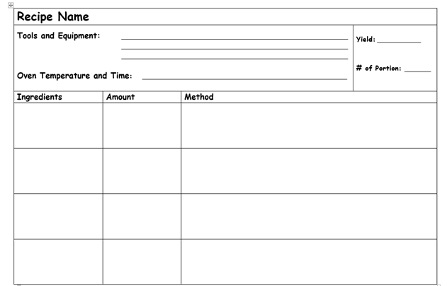
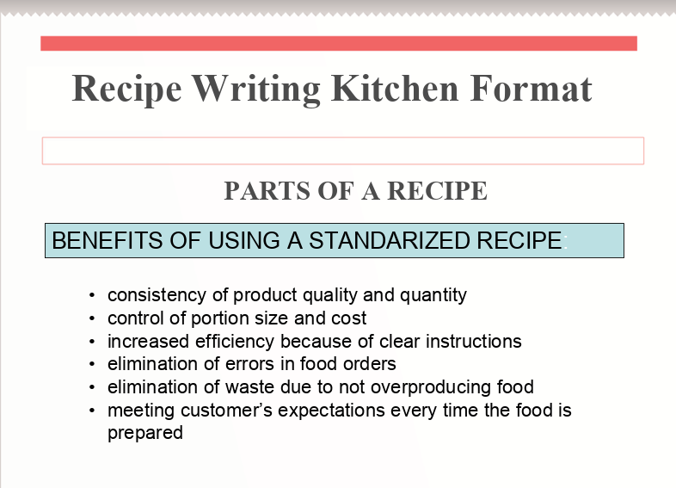

Menu Item Descriptions
Name: _________________ /15

Use the space below to create your menu descriptions. Remember these descriptions will be used to advertise your food selections on your menu. Make sure to use great detail and descriptive words to entice and sell your menu to your customers. They should be professional and free of spelling and grammatical errors.
Plated Appetizer Description /5
________________________________________________________________________________________________________________________________________________________________________________________________________________________________________________________________________________________

Plated Entrée Description /5
________________________________________________________________________________________________________________________________________________________________________________________________________________________________________________________________________________________

Plated Dessert Description /5
________________________________________________________________________________________________________________________________________________________________________________________________________________________________________________________________________________________

Finished Event Menu
Name: _________________ /50
Create a menu on an 8 ½ by 11” piece of paper by hand or using the computer that reflects your Event Menu. The menu will use your descriptions from the previous assignment. The menu should be professional and free of spelling and grammatical errors. Please print the menu in colour and make sure to add pictures to add visual interest. Chefs, I cannot wait to see your Event Menus!

Finished Event Menu Rubric
Criteria | Level 0 0-49% | Level 1 50-59% | Level 2 60-69% | Level 3 70-79% | Level 4 80-100%
Content  Knowledge  /10 | Menu not developed for the Event Menu; and has not met the requirements for this assignment. | Student has a very limited grasp of the Event Menu; and has started to develop a very limited menu. | Student has a limited grasp of the Event Menu; and has started to develop a menu. | Student has a considerable grasp of the Event Menu; and has developed a great menu. | Student has an excellent grasp of the Event Menu; and has developed an excellent menu.
Requirements and “Must Haves”  /10 | Menu is incomplete, missing detailed information and many components (ex: missing 2 or more menu items) and significant consideration is needed to enhance the overall menu. | Menu is incomplete or missing components and missing detailed information. Menu is incomplete or missing components (ex: missing 1 or more menu items) and further consideration is needed to enhance the overall menu. | Menu has most of the necessary components but some requirements are missing. Menu is incomplete or missing components (ex: missing 1 or more menu items) and some further consideration is needed to enhance the overall menu. | All requirements are met and thoughtfully laid out. All 3 menu items are included but further consideration needed to enhance the overall menu. | All requirements are met and thoughtfully laid out. All menu requirements are complete. All 3 menu items are included and completed with additional consideration added to enhance the overall menu.
Creativity  /10 | Colour, pictures and visual interest have not been added to the menu. Significant consideration needed to enhance the overall menu. | Little to no creative thought put into menu design. Very plain and no effort to be creative is present. Menu does not include colour, pictures and has limited visual interest. | Moderately creative. Menu has some thought put into the layout of menu design. Menu has some visually interesting components including elements that relate to the menu. | Menu has elements of creativity that enhances the information on the overall menu. Menu has many visually interesting components that relate well to the menu. | Excellent attention to creative detail. Menu is above and beyond average presentation. Menu has many excellent visually interesting components that relate well to the menu.
Communication of Theme  /10 | Information and theme not communicated well and with no relation to the theme of event. | Communicates information and ideas with limited clarity in relation to the theme of event. | Communicates information and ideas with some clarity in relation to the theme of event. | Communicates information and ideas with considerable clarity in relation to the theme of event. | Communicates information and ideas with a high degree of clarity in relation to the theme of event.
Use of Preparation and Research Time  /10 | Did not use preparation time to research and complete the menu. | Uses preparation and research time with limited focus to complete the menu. | Uses preparation and research time with some focus to complete the menu. | Uses preparation and research time with considerable focus to complete the menu. | Uses preparation and research time with a high degree of focus to complete the menu.

Kitchen Production Schedule
Name: ________________ /50
This chart is to organize the preparation for the event. You are required to include your plated appetizer and dessert only. Your entrée does not need to be included with your kitchen production schedule. This chart should include mise en place, production schedule and all required work that needs to be done before and during your event. You will have five classes to complete your menu items. The importance of planning and teamwork cannot be stressed enough. You will need to have a detailed production schedule for your team to complete all your assigned tasks in order to be successful.
Class One  /10 | Class Two  /10 | Class Three  /10
Class Four  /10 | Class Five  /10 | Additional Production Concerns  All kitchen recipes typed in kitchen format

Equipment Requirements
Name: ________________ /30
After completing your Kitchen Production Schedule the next requirement will be to complete the list of equipment required. Using your Kitchen Production Schedule go through and add all the tools and equipment that you will require to complete the food for your event. Remember to list all of the tools and equipment required.
After you have gone through and added the tools and equipment from the Kitchen Production Schedule it is time to add any other equipment that you will require for the event (e.g., chafing dishes for buffet service, insulated carriers for offsite catering, tables and tents for outside reception). The tools and equipment required will vary depending on the type of event you are hosting and the location in which you are hosting the event.
Tools and Equipment Needed from the Kitchen Production Schedule
(Add addition rows as needed)
/20
All Other Equipment Needed for Event
(Add addition rows as needed)
/10

Teamwork Assignment
Name: ________________
The importance of teamwork in providing high-quality customer service in the hospitality sector is critical for any successful event. It is important to have a positive work environment to help motivate employees. The best way to help employees is to make them feel like they are part of a team.
For this next assignment you will create a wordle. A wordle is a piece of text which has been rearranged into a visual pattern of words. You will come up with as many words that will describe teamwork to demonstrate your understanding of the importance of teamwork.
Don’t forget to type the word teamwork several times so that it will stand out in your wordle. For example when I think about teamwork some of the words that come to my mind are respect, organization and trust. There are several free wordle apps that can be used. Here is one that works well and can be saved as a .png file. Go to www.wordle.net and use words or phrases that emphasize your understanding of teamwork.



Activity 9 - Final Touches Event Planning Assignment
Decorations can add the additional “wow” factor when guests arrive to your event. Using the internet find six different pictures that you would use to create your event. Copy and paste your pictures into the chart below. Include how you would use the decorations in the picture for your event.
Decorations for Event
Picture # 1 | Picture # 2 | Picture # 3
Description of how you would use picture # 1 | Description of how you would use picture # 2 | Description of how you would use picture # 3
Picture # 4 | Picture # 5 | Picture # 6
Description of how you would use picture # 4 | Description of how you would use picture # 5 | Description of how you would use picture # 6
Resources (Website Links)

Activity 10 - Event Invitation Assignment
Name: ________________ /50
Design an invitation with all of the information for the party. You can create the invitation by hand or on the computer. Your invitation should be creative, easy to read, free of spelling errors, colourful and reflect the type of event you are hosting.
Remember to include:
- The name of the event | - Any information important to the theme of the event
- The reason for the event | - Any special requests
- The location date and time | - Who to respond to (RSVP)

Event Invitation Rubric
Criteria | Level 0 0-49% | Level 1 50-59% | Level 2 60-69% | Level 3 70-79% | Level 4 80-100%
Content Requirements and “Must Haves”  - Name of event  - Reason for event  - Location, date time  - Important information  - Special requests  - Who to RSVP to  /10 | Invitation is incomplete, missing detailed information and many components (ex: missing 5 or more items) and significant consideration is needed to enhance the overall invitation. | Invitation is incomplete or missing components and missing detailed information. Invitation is incomplete or missing components (ex: missing 3-4 or more items) and further consideration is needed to enhance the overall invitation. | Invitation has most of the necessary components but some requirements are missing. Invitation is missing components (ex: missing 2 or more items) and some further consideration is needed to enhance the overall invitation. | All requirements are met and thoughtfully laid out. All invitation items are included but further consideration needed to enhance the overall invitation. | All requirements are met and thoughtfully laid out. All invitation menu requirements are complete. All items are included and completed with additional consideration added to enhance the overall invitation.
Neatness/ Organization  /10 | Invitation not developed for the event; and has not met the requirements for this assignment. | Invitation is not neat or organized and needs further consideration for this assignment. | Invitation is somewhat neat and organized and needs some consideration for this assignment. | Invitation is neat and organized and needs very little consideration for this assignment. | Invitation is extremely neat and organized and has gone above expectations for this assignment.
Design/ Creativity  /10 | Colour, pictures and visual interest have not been added to the invitation. Significant consideration needed to enhance the overall invitation. | Little to no creative thought put into invitation design. Very plain and no effort to be creative is present. Invitation does not include colour, pictures and has limited visual interest relating to the event. | Moderately creative. Invitation has some thought put into the layout and design. Invitation has some visually interesting components including elements that relate to the event. | Invitation has elements of creativity that enhances the information on the overall presentation; many visually interesting components that relate well to the event. | Excellent attention to creative detail. Invitation is above and beyond average presentation; many excellent visually interesting components that relate well to the event.
Communication of Theme  /10 | Information and theme not communicated well and with no relation to the theme of event. | Communicates information and ideas with limited clarity in relation to the theme of event. | Communicates information and ideas with some clarity in relation to the theme of event. | Communicates information and ideas with considerable clarity in relation to the theme of event. | Communicates information and ideas with a high degree of clarity in relation to the theme of event.
Use of Preparation and Research Time  /10 | Did not use preparation time to research and complete the invitation. | Uses preparation and research time with limited focus to complete the invitation. | Uses preparation and research time with some focus to complete the invitation. | Uses preparation and research time with considerable focus to complete the invitation. | Uses preparation and research time with a high degree of focus to complete the invitation.

Appendix A - Blank Recipe Form
Recipe Name
Tools and Equipment:  Oven Temperature and Time: |  |  | Yield:  # of Portions:
Ingredients | Amount | Method

Appendix B - Recipe Writing Kitchen Format PowerPoint

http://www.octe.ca/application/files/9415/9296/3677/Appendix_11_Recipe_Writing_Kitchen_Format.ppt

References
21st Century Competencies: Foundation Document for Discussion. Phase 1: Towards Defining 21st Century Competencies for Ontario, Winter 2016 Edition, 2016 http://www.edugains.ca/resources21CL/About21stCentury/21CL_21stCenturyCompetencies.pdf
Clipart and Pictures (Pixabay), 2020 www.pixabay.com
Course Codes for Emphasis courses in the Revised Curriculum: Technological Education, Grades 11 and 12, 2009 http://www.edu.gov.on.ca/eng/curriculum/secondary/techedemphasiscourses.pdf
Event Type Classifications http://hndeventmanagement.weebly.com/
Growing Success: Assessment, Evaluation, and Reporting in Ontario Schools, First Edition, Covering Grades 1 to 12, 2010 www.edu.gov.on.ca/eng/policyfunding/growSuccess.pdf
Instagram logo, 2020 https://en.instagram-brand.com/#general
Learning for All – A Guide to Effective Assessment and Instruction for All Students, Kindergarten to Grade 12, 2013 http://www.edu.gov.on.ca/eng/general/elemsec/speced/LearningforAll2013.pdf
Marketing Social Media Advertising Wordle (image), 2016 https://pixabay.com/illustrations/marketing-social-media-advertising-1573711/
Recipe Writing Kitchen Format (PowerPoint presentation), 2020 http://www.octe.ca/application/files/9415/9296/3677/Appendix_11_Recipe_Writing_Kitchen_Format.ppt
The Differentiated Instruction Scrapbook http://www.edugains.ca/resourcesDI/EducatorsPackages/DIEducatorsPackage2010/2010DIScrapbook.pdf
The Ontario Curriculum, Grades 9 and 10: Technological Education, 2009 (revised) http://www.edu.gov.on.ca/eng/curriculum/secondary/teched910curr09.pdf
The Ontario Curriculum, Grades 11 and 12: Technological Education, 2009 (revised) http://www.edu.gov.on.ca/eng/curriculum/secondary/2009teched1112curr.pdf
Twitter logo social icon, 2020 https://about.twitter.com/content/dam/about-twitter/company/brand-resources/en_us/Twitter_Brand_Guidelines_V2_0.pdf
Venue (Definition), 2020 https://www.collinsdictionary.com/dictionary/english/venue
Wordle (Definition), 2020 https://www.macmillandictionary.com/dictionary/british/wordle
Wordle (Free App), 2020 www.wordle.net

