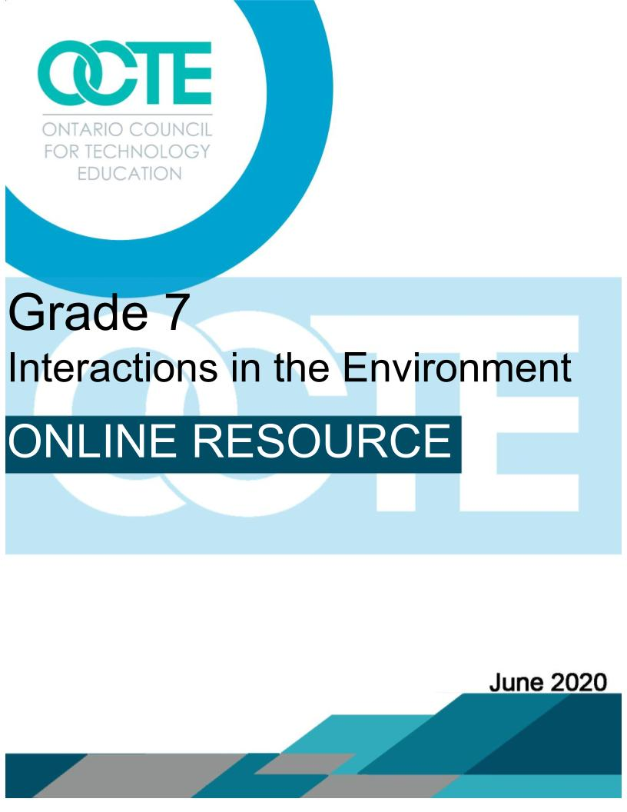

Activity 1
Development of Curiosity and Wonder
Scientific and Technological Concepts:
The Ontario Science and Technology Curriculum Grades 1-8 describes an ecosystem as being, “A complex system that comprises living organisms and their environment, which interact as a unit.” As long as it’s connected parts remain in balance, the living organisms and nonliving components within the complex system will interact in a manner that is sustainable. Human actions that affect components of an ecosystem can promote its sustainability, or can alter it in a negative manner.

The Assembly of First Nations describes honouring the Earth (the sustainability of ecosystems) as follows: “Indigenous peoples are caretakers of Mother Earth and realize and respect her gifts of water, air and fire... Everything is taken and used with the understanding that we take only what we need, and we must use great care and be aware of how we take and how much of it so that future generations will not be put in peril.”

An ecosystem is an area where a community of organisms that interact with each other and their environment.

An abiotic element is a non-living component of an ecosystem (e.g., soil, sunlight, water, temperature, etc.).

A biotic element is a living component of an ecosystem (e.g., plants, animals, insects, microbes, etc.).

Learning Goals
Students will:
- research and understand the interactions between living organisms (biotic elements), and non-living (abiotic elements) in an ecosystem;
- explore relationships in an ecosystem by designing, creating, and operating an ecosystem connection board that contains separate lists of abiotic and biotic elements found in the ecosystem being studied;
- communicate their findings for feedback and/or evaluation.

Expectations
Overall Expectations:
- Investigate interactions within the environment, and identify factors that affect the balance between different components of an ecosystem.
- Demonstrate an understanding of interactions between and among biotic and abiotic elements in the environment.
Specific Expectations:
2.4 Use appropriate science and technology vocabulary, including sustainability, biotic,ecosystem,
community, population, and producer, in oral and written communication.
2.5 Use a variety of forms (e.g., oral, written, graphic, multimedia) to communicate with different
audiences and for a variety of purposes (e.g., design a multimedia presentation explaining the
interrelationships between biotic and abiotic components in a specific ecosystem).
3.1 Demonstrate an understanding of an ecosystem (e.g., a log, a pond, a forest) as a system of
interactions between living organisms and their environment.
3.2 Identify biotic and abiotic elements in an ecosystem, and describe the interactions between
them (e.g., between hours of sunlight and the growth of plants in a pond; between a termite
colony and a decaying log; between the soil, plants, and animals in a forest).

Equipment & Materials | Personal Protective Equipment (PPE)
Depending on their design, students may use some or all of the following items:  - any one of the following: cardboard, bristol board, cereal boxes, or packaging from purchased items,  - any one of the following: string, yarn, fishing line, or thread,  - any one of the following: brass split pin fasteners, paper clips, thumb tacks, push pins, or straight pins; these may be optional, depending on the design chosen;  - scissors,  - paper,  - tape and/or glue,  - items not listed above may be used if approved by a student’s parent/guardian, and their teacher;  - Student Handouts,  - Appendix A, Ecosystem Connections Board - Research Sheet,  - Appendix B, Ecosystem Connections Board - Description of Hands-On Task.  - Appendix C, Ecosystem Connections Board - Hands-On Task Planning Sheet,  - Appendix D, Ecosystem Connections Board - Communicating Your Learning,  - Appendix E, Assessment, Success Criteria,  - Teacher Resources,  - Appendix E, Assessment - Success Criteria,  - Appendix F, Ecosystem Connections Board - Research Sheet, Example for Appendix A,  - Appendix G, A Simple Example of an Ecosystem Connections Board (example for Appendix C),  - Appendix H, Technological Problem Solving and Communicating Assessment Rubric  - Appendix I, Full Assessment Rubric. | - N/A.

Safety Considerations:
- depending on the circumstances under which this unit is delivered, students are to follow applicable directives issued by their local Public Health Units when participating in these activities;
- students will ensure that any found, reused, or recycled items are sanitized as needed before use;
- students will need to be cautious when cutting materials, especially thicker material like cardboard;
- students will need to be cautious and aware of what they are using to poke holes through materials;
- students will tie back long/loose hair;
- if a student wishes to use materials that do not appear in the “Equipment & Materials” list above, they must have their choices approved by a parent/guardian, and submit a list of the items to their teacher; if the teacher determines that the materials are safe to use, permission will be granted to use them.

What does the teacher do? | What do the students do based on the Skills Continuums?
Connect with your students, distribute materials, and collect materials using your Board’s chosen means of communication.  Initiating and Planning/Introduction  Introduce Activity 1 through synchronous and/or asynchronous video, or by phone - if applicable. Use  the Ecosystem Connections Board - Research Sheet, Example (see Appendix F). This is the teacher’s example sheet for the student handout, Ecosystem Connections Board - Research Sheet (see Appendix A). Discuss ecosystems, environments, and examples of biotic elements, and abiotic elements that interact within them (e.g., a flower box) to illustrate the definitions listed on the sheet.  Inform students that a flower box can be used to illustrate a very small, simple ecosystem. Explain how this ecosystem’s environment supports life through interactions between and within its biotic and abiotic elements. Review biotic elements such as flowers, pollinating bees and hummingbirds, microbes (e.g., decomposers), and insects. Then review the abiotic elements such as the flower box, soil, fertilizer and/or compost, water, sunlight, and warmth.  Move on from the flower box example to discuss ecosystems of various sizes such as a log, wetlands (e.g., ponds, swamps), a forest, a yard or park, oceans, deserts, the tundra, rainforests, etc.  Distribute the Ecosystem Connections Board - Research Sheet (see Appendix A) either electronically, or in a package (as per your Board’s directives at the time the activity is being addressed). Connect with your students through synchronous and/or asynchronous video, or by phone - if applicable. Address applicable sections of the Assessment - Success Criteria (see Appendix E). Discuss the content in Appendix A. Have your students research a variety of ecosystems, and select one to study in depth. Assign the Ecosystem Connections Board - Research Sheet (see Appendix A). A completed sheet is needed for the Hands-on Task and Demonstration of Learning assignments. Have students submit their research sheets for feedback and/or evaluation.  Performing and Recording/Analysing and Interpreting  Distribute the Ecosystem Connections Board - Description of Hands-On Task (see Appendix B) and the Ecosystem Connections Board - Hands-On Task Planning Sheet (see Appendix F) either electronically, or in a package, as per your Board’s directives at the time the activity is being addressed). Connect with your students through synchronous and/or asynchronous video, or by phone - if applicable. Address relevant sections of Assessment, Success Criteria (see Appendix E). Discuss the content listed in Appendices C and D. You may see, or want to encourage, more challenging designs such as rotating disks mounted behind viewing windows, or two stacks of elements mounted on the board, with a pivot point at one end of each stack that allows interacting elements to be fanned out and displayed, like tools on a Swiss Army knife. Have students submit their Hands-On Task Planning Sheet for feedback and/or evaluation.  Communicating  Review Ecosystem Connections Board - Communicating Your Learning (see Appendix D) prior to beginning this activity. Modify the document, if needed, so that it meets your specific assessment needs. Connect with your students through synchronous and/or asynchronous video, or by phone - if applicable. Address applicable sections of Assessment - Success Criteria (see Appendix E). Discuss the content listed in Ecosystem Connections Board - Communicating Your Learning (see Appendix D). Ensure your students clearly understand what is required to meet your success criteria.  Sample accommodations:  - Provide instruction and/or material by email or phone, for students who do not have adequate bandwidth in their homes for video.  - Students who cannot access the required building materials may complete the task on paper, or electronically.  - For students with special needs, refer to your students’ IEPs for additional specific accommodations and/or modifications that must be provided to promote success.  Sample Troubleshooting:  - Students who do not have adequate access to electronic devices and/or the internet can be contacted by phone for support, and they can mail in work that was completed on paper. | Scientific Inquiry/Research Skills  Initiating and Planning:  - Students will plan an organizational system for gathering and organizing information, about ecosystems and elements that make up their environment using a variety of strategies and organizational patterns.  - Students will independently select print, multimedia, and/or electronic resources that provide information on ecosystems and the elements that make up their environment.  Performing and Recording:  - Students will select information from print, multimedia, and electronic resources that they have found independently. The materials selected will address the information needed to complete Appendix A.  - Students will record information gathered, using the specific sections listed on Appendix A.  - Students will select sources of information, showing awareness of currency and bias to ensure that their information on ecosystems is from reliable and credible sources.  Analysing and Interpreting:  - Students will verify the validity of and compare information gathered from research.  - Students will summarize relevant information, using Appendix A.  Communicating:  - Students will refer to Appendix D and use this to guide the development of their research presentation. The presentation will use the prescribed form(s) selected by the teacher. It will address a student selected ecosystem, and will describe its abiotic elements, biotic elements, and their interactions within the ecosystem’s environment.  Technological Problem-Solving Skills  Initiating and Planning:  - Students will use Appendices B and C to guide their identification of possible designs that can be used to create an Ecosystem Connections Board. They will prioritize them with regard to their potential for solving the problem.  - Using Appendix C, students will select a possible solution, and provide reasons for the choice that take into account considerations such as function, aesthetics, environmental impact.  - Students will complete technical drawings and/or diagrams that illustrate their selected design, and its components.  Performing and Recording:  - Students will carry out their selected plan.  - Students will design, build, and test their Ecosystem Connections Board to determine if it adequately displays connections between and within biotic and abiotic components.  Analysing and Interpreting:  - Students will use Appendix C to record the effects of their Ecosystem Connections Board on themselves, others, and/or the environment, considering things such as cost, materials, time, and/or space, and suggest ways in which undesirable effects could be lessened or eliminated.  Communicating:  - Students will use grade-appropriate science and technology vocabulary correctly (e.g., ecosystem, environment, biotic, and abiotic) when completing their assignments, and in their culminating Communication of Learning.

Appendix A
Ecosystem Connections Board - Research Sheet

Name:_________________________________ Class: _______ Date: __________________________

The Ontario Curriculum Grades 1-8: Science and Technology, 2007, provides the following definitions. Use these to assist you as you complete your research sheet below.
- An ecosystem is “A complex system that comprises living organisms and their environment, which interact as a unit.”
- An environment is “All the biotic and abiotic elements that surround and affect organisms or groups of organisms and influence their survival and development.”
- An abiotic element is “A physical but non-living feature of an ecosystem, such as climate, rocks, soils, ice, topography, and non-living organic matter.”
- Biotic elements are “ The living parts of an organism’s environment.”

Assignment

Select an ecosystem to study, and complete the items listed below.

- My ecosystem is ___________________________________ .

- The environment in my selected ecosystem includes the following biotic and abiotic elements.
Elements Found in My Ecosystem’s Environment
The biotic elements are as follows: | The abiotic elements are as follows:

Appendix A (continued)

- Describe some interactions that take place between the biotic and abiotic elements that make up the environment in your ecosystem.
- Describe some interactions that take place between biotic elements that make up the environment in your ecosystem.
- Describe some interactions that take place between abiotic elements that make up the environment in your ecosystem.

Appendix B

The Ecosystem Connections Board - Description of Hands-On Task

Name:_________________________________ Class: _______ Date: __________________________

Design and build an Ecosystem Connections Board that meets the following requirements:
- Refer to the Hands-On Task Planning Sheet (see Appendix C), select materials from the list your teacher has provided, brainstorm and sketch out possible connections board designs, select what you believe will be your best design, build it, and report on the pros and cons of your chosen design.

- Include a correctly punctuated title on your board that names the ecosystem you have chosen to study.

- Make a list on one side of your board that includes the biotic elements found in the environment of your ecosystem.

- Make a list on the other side of your board that includes the abiotic elements found in the environment of your ecosystem.

- Build a connecting system that is used to show an interaction takes place between two elements.

- The connections must be temporary so that one set of interactions is displayed at a time (e.g., first, connect a flower to sunlight, warmth, water, soil, and nutrients; second, connect decomposers to the flower).

Appendix C
The Ecosystem Connections Board - Hands-On Task Planning Sheet

Name:_________________________________ Class: ________ Date: __________________________

Safety

Adhere to the following items:
- depending on the circumstances under which this unit is delivered, you are to follow applicable directives issued by your local Public Health Units when participating in these activities;
- ensure that any found, reused, or recycled items are sanitized as needed before use;
- be cautious when cutting materials, especially thicker material like cardboard;
- be cautious and aware of what you are using to poke holes through materials;
- tie back long/loose hair.

Equipment & Materials

Depending on your design, you may use some or all of the following items:
- any one of the following: cardboard, bristol board, cereal boxes, or packaging from purchased items,
- any one of the following: string, yarn, fishing line, or thread.
- any one of the following: brass split pin fasteners, paper clips, thumb tacks, push pins, or straight pins (may be optional, depending on the design chosen),
- scissors,
- paper,
- tape and/or glue,
- items not listed above may be used if approved by your parent/guardian, and your teacher.

Appendix C (continued)

The Ecosystem Connections Board - Hands-On Task Planning Sheet
Assignment

Complete two sketches, with labels, of possible designs you can use. Deliberate the pros and cons of each design, then select the idea you believe is your best choice. Proceed with building your connections board.

Ecosystem Connections Board
Design Idea 1

Appendix C (continued)

The Ecosystem Connections Board - Hands-On Task Planning Sheet

Ecosystem Connections Board
Design Idea 2

Appendix C (continued)

The Ecosystem Connections Board - Hands-On Task, Planning Sheet
Assignment

Analyse the potential life cycle of the product (the connections board) you have created. Start with your materials and how they are gathered. Then consider each step in your product’s life cycle through to its eventual disposal, and how those waste products will be managed.

In the area below, describe the effects of your chosen solution on you, others, and/or the environment. Consider things such as the cost, materials, time, and/or space used to create your connections board. Suggest ways in which undesirable effects could be lessened or eliminated.

- Considering the topics listed above, the following are the pros, or benefits, of my chosen design.

- Considering the topics listed above, the following are the cons, or undesirable effects, of my chosen design.

- The following steps and/or changes can be implemented to lessen or eliminate the cons, or undesirable effects, of my chosen design.

Appendix D
The Ecosystem Connections Board - Communicating Your Learning

Name:_________________________________ Class: ________ Date: __________________________

- Refer to the information you have listed in Appendix A, Ecosystem Connections Board - Research Sheet.

- Create a report using the option(s) your teacher has selected.

  - Your report must include a formal communication of the information (numbers 1 to 5) listed in your copy of Appendix A, the Ecosystem Connections Board - Research Sheet. Some potential choices are as follows.

    - Create a video where you display and describe individual sets of interactions (connections) illustrated on your board.

    - Create a narrated video of still images. Take a picture of each set of interactions (connections) you illustrated on your board. Import the pictures into a video app or program, then add narration that describes the interactions in each picture.

    - Create a slideshow that includes images of the connections you illustrated on your board, and compose passages that describe each slide’s connections in the box below the slide, where speaker’s notes are recorded.

    - Take a picture of each set of connections illustrated on your board. Follow each of these images with a picture of a description, recorded on paper (either written by hand or printed out), of each set of connections.

- Submit your report for feedback, and turn it in for your final evaluation.

Appendix E
Assessment - Success Criteria

Name:_________________________________ Class: ________ Date: __________________________

Criteria | Met | Not there yet
The student demonstrated an understanding of interactions between and among biotic and abiotic elements in the environment, and describe the interactions between them (e.g., between hours of sunlight and the growth of plants in a pond; between a termite colony and a decaying log; between the soil, plants, and animals in a forest).

The student used appropriate science and technology vocabulary (e.g., biotic, abiotic, ecosystem, environment) in oral and/or written communication.

The student used one of a variety of forms (e.g., oral, written, graphic, multimedia) to communicate their learning to their teacher and/or peers regarding the interrelationships between biotic and abiotic components in a specific ecosystem.

The student demonstrated an understanding of an ecosystem (e.g., a log, a pond, a forest) as a system of interactions between living organisms and their environment.

Strengths

Next Steps

Appendix F

Ecosystem Connections Board - Research Sheet, Example for Appendix A

Name:_________________________________ Class: ________ Date: __________________________

The Ontario Curriculum Grades 1-8: Science and Technology, 2007, provides the following definitions. Use these to assist you as you complete your research sheet below.
- An ecosystem is “A complex system that comprises living organisms and their environment, which interact as a unit.”
- An environment is “All the biotic and abiotic elements that surround and affect organisms or groups of organisms and influence their survival and development.”
- An abiotic element is “A physical but non-living feature of an ecosystem, such as climate, rocks, soils, ice, topography, and non-living organic matter.
- Biotic elements are “ The living parts of an organism’s environment.”

Assignment

Select an ecosystem to study, and complete the items listed below.

- My ecosystem is a flower box (a micro-ecosystem).

- The environment in my selected ecosystem includes the following biotic and abiotic elements.

Elements Found in My Ecosystem’s Environment
The biotic elements are as follows:  - flowers,  - pollinating bees and hummingbirds,  - microbes (e.g., decomposers) in the soil,  - insects (some harmful ones include beetles, aphids, earwigs, and slugs). | The abiotic elements are as follows:  - flower box,  - soil,  - fertilizer and/or compost,  - water,  - sunlight,  - warmth.

Appendix F (continued)

- Describe some interactions that take place between the biotic and abiotic elements that make up the environment in your ecosystem.
- The seeds need warmth and moisture to germinate.
- The flower uses warmth, water, and nutrients stored in the soil to grow.
- The flower uses sunlight to carry out photosynthesis and create food from the nutrients and water it absorbs from the soil.
- Roots spread out in the soil and use it to support the plant and keep it upright.

- Describe some interactions that take place between biotic elements that make up the environment in your ecosystem.
- Pollinators (e.g., bees and hummingbirds) collect pollen and nectar from flowers to use as food. During the collection of pollen, pollinators fertilize plants so they can grow seeds and reproduce.
- Parasites such as earwigs and beetles eat parts of plants that are specific to their diets. In doing so, they survive, but they do damage to the plant.
- Describe some interactions that take place between abiotic elements that make up the environment in your ecosystem.
- The flower box contains the soil and keeps it from being eroded by the wind and rain.
- Warmth causes water to evaporate from the soil.

Appendix G
A Simple Example of an Ecosystem Connections Board
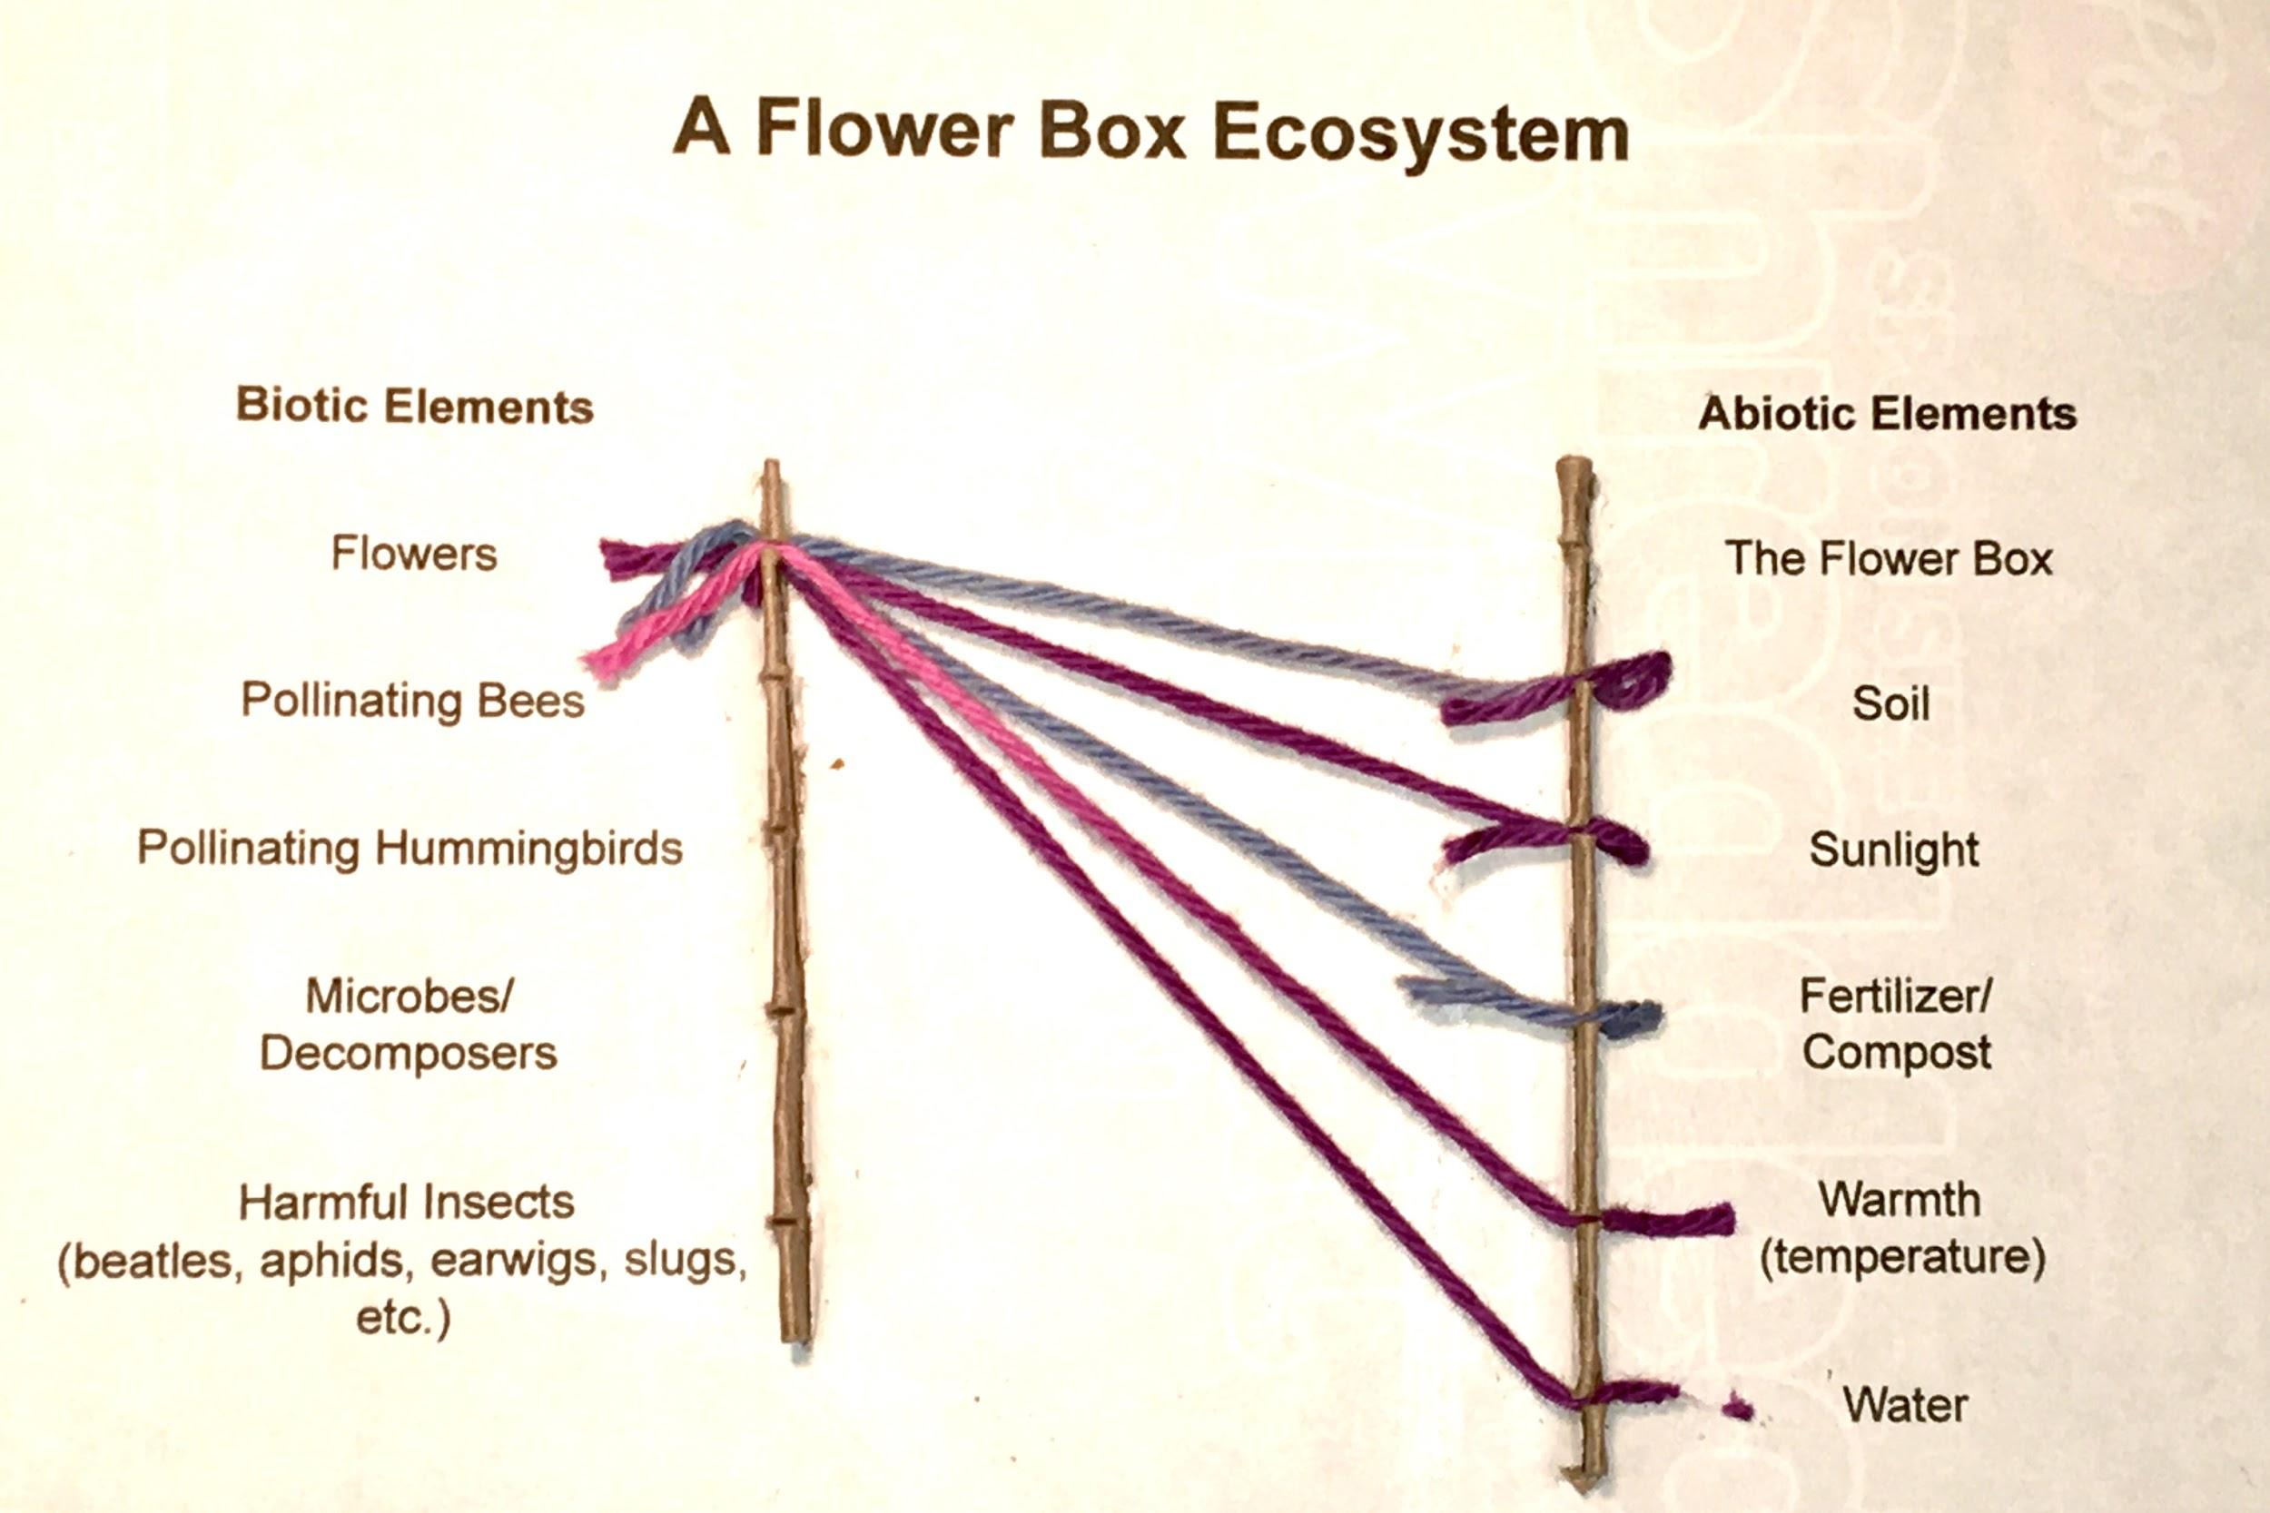  This is an example of connections between biotic (a flower) and abiotic elements in the environment of an ecosystem. The board is a printed piece of paper glued to a cereal box panel. If needed, students can print directly on the cereal box panel by hand. | 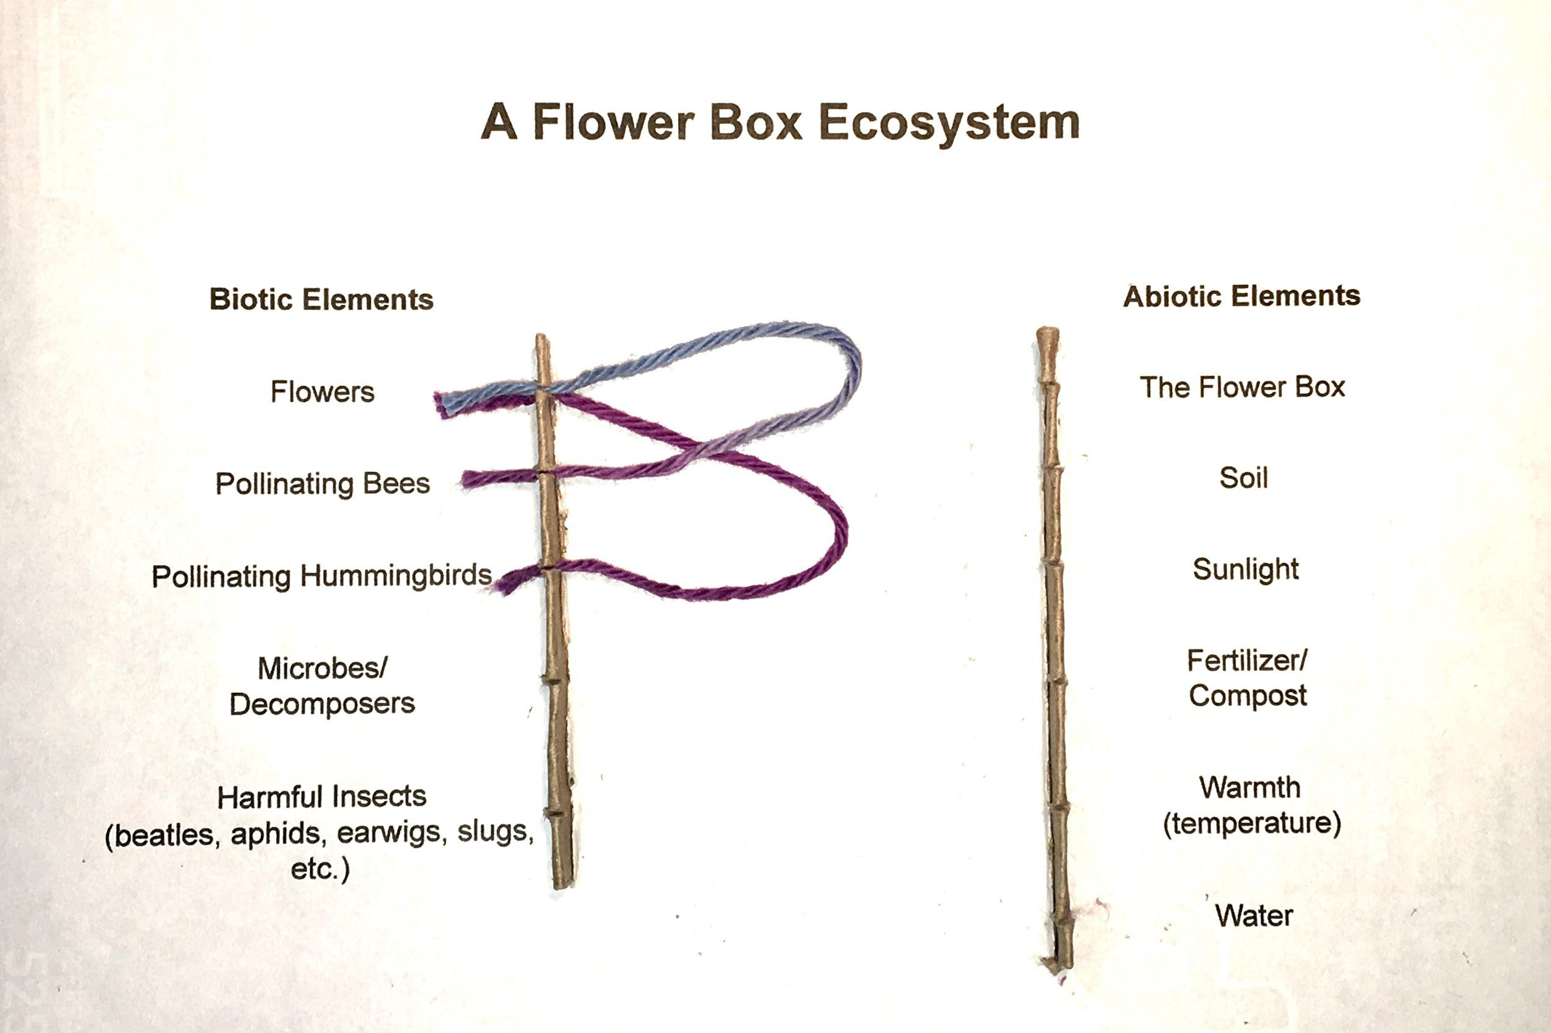  This is an example of connections between biotic elements in the environment of an ecosystem. The same can be done for abiotic elements.
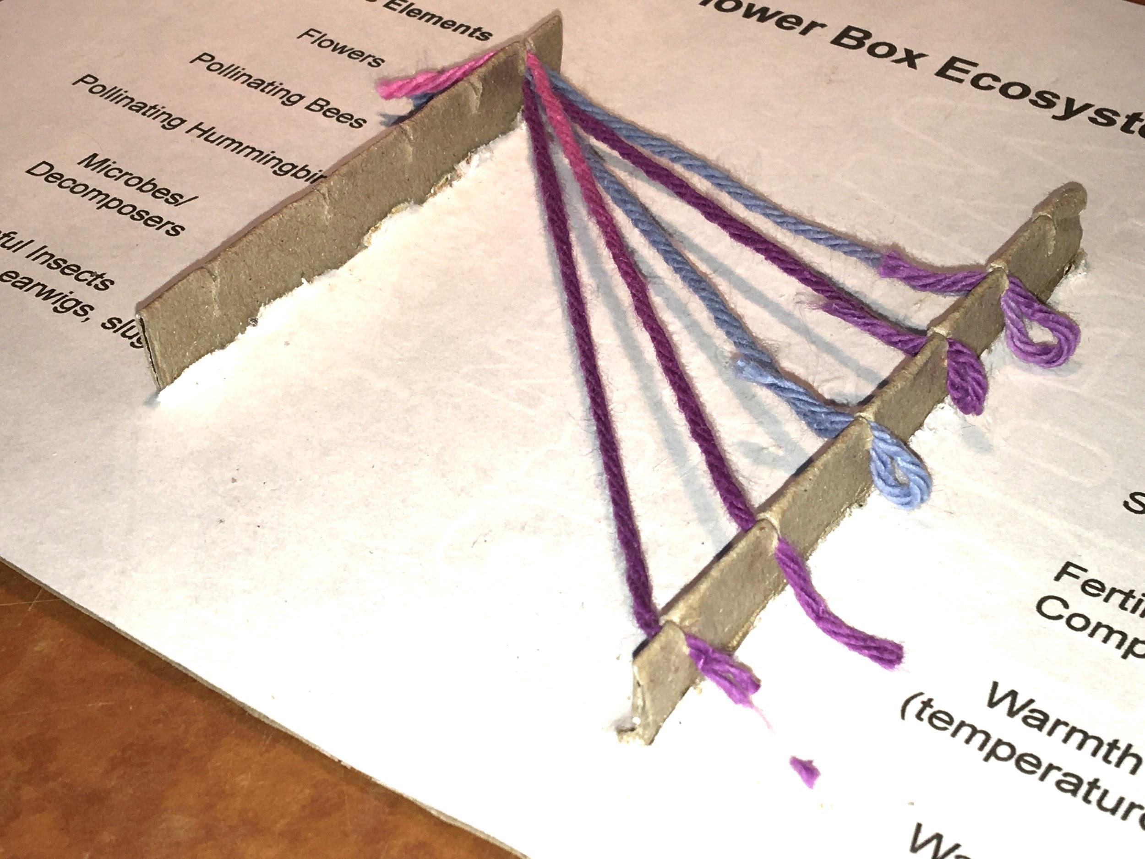  This illustrates the structure of the connecting ribs. They are made by using folded pieces of a cereal box, glue sticks, and yarn that is friction fit into the slots. | 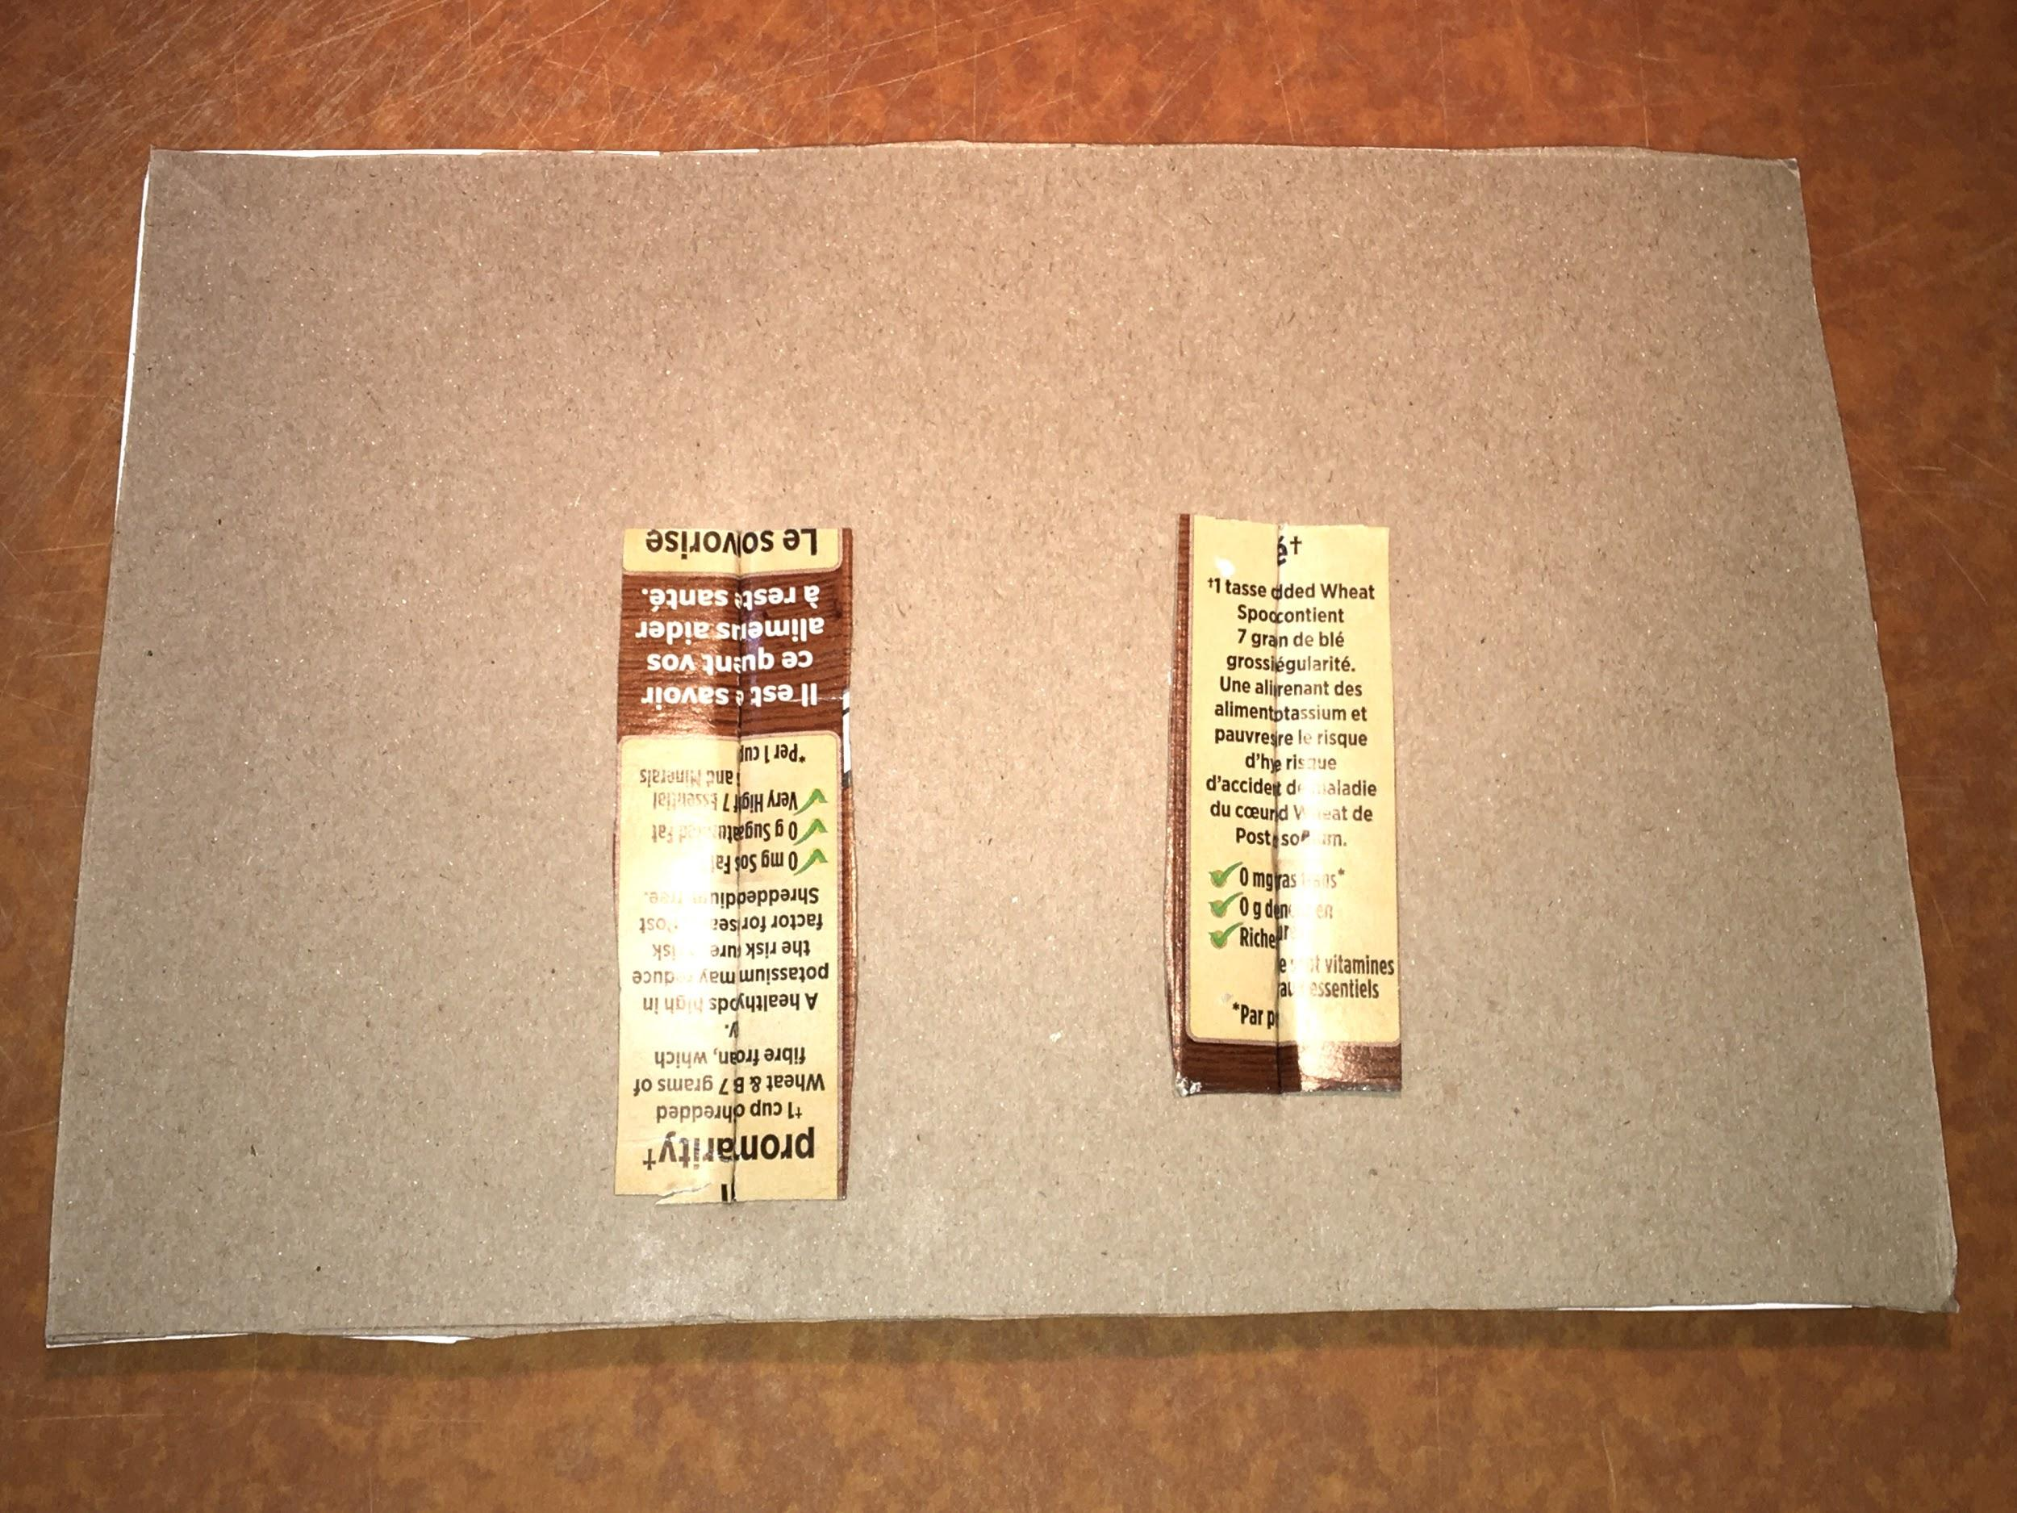  Folded connecting ribs are pushed through from the back, and the flanges are glued in place.

Appendix H
Technological Problem Solving and Communicating Assessment Rubric

CRITERIA | LEVEL 1 | LEVEL 2 | LEVEL 3 | LEVEL 4
Design Process  Plan  Students will draw at least two designs, or at least two different views of their model, will include measurements, and will choose appropriate materials. | The student developed an unfinished plan with various considerations missing.  The student demonstrated a limited use of the design process (plan, build, test, evaluate, communicate). | The student developed a workable plan with some steps missing.  The student demonstrated some use of the design process (plan, build, test, evaluate, communicate). | The student developed a clear workable plan using appropriate materials.  The student used the design process (plan, build, test, evaluate, communicate) as expected. | The student developed a workable plan, and modified the plan as necessary.  The student used the design process (plan, build, test, evaluate, communicate) very effectively.
Model  Students will translate their plan into a model. | The student’s design plans did not translate into a working model. | The student translated their design plans into a somewhat working model based on some of the stated criteria.  The student created a model that occasionally functioned according to specifications.  The student used a predictable design and materials. | The student adequately translated their design plans into a working model based on the stated criteria.  The student created a model that successfully functioned according to specifications.  The student used a predictable design and materials. | The student successfully translated their design plans into a working model based on the stated criteria.  The student created a model that successfully functioned according to specifications.  Care was taken during the student’s construction process.  The student produced a unique and creative design.
Communication and Reflection  Students will use Grade 7 level science and technology terminology, and their communication will make their knowledge of interactions within ecosystems, as well as the design process, evident. | The student used limited grade level terminology.  The student did not communicate a basic understanding of the concepts.  The student reflected on the design process and made limited suggestions for improvement. | The student used some grade level terminology.  The student communicated some understanding of the concepts.  The student reflected on the design process and made some suggestions for improvement. | The student used an adequate amount of grade level terminology.  The student communicated an understanding of most of the concepts.  The student reflected on the design process and made necessary suggestions for improvement. | The student used all required grade level terminology.  The student communicated an understanding of all concepts.  The student reflected on the design process and made all necessary suggestions for improvement.

Appendix I

Full Assessment Rubric

This rubric was developed from the Ontario Curriculum Grades 1-8 Science and Technology, Revised 2007 document.

 | Level 1 | Level 2 | Level 3 | Level 4
Knowledge and Understanding – Subject-specific content acquired in each grade (knowledge), and the comprehension of its meaning and significance (understanding).

 | The Student:
1. Knowledge of content (e.g., facts and terminology related to ecosystems and their biotic and abiotic components). | demonstrates  limited  knowledge  of content. | demonstrates  some knowledge  of content. | demonstrates  considerable  knowledge of  content. | demonstrates  thorough  knowledge  of content.
2. Understanding of content (e.g., concepts, ideas, and processes involving ecosystems and their biotic and abiotic components). | demonstrates  limited  understanding  of content. | demonstrates  some understanding  of content. | demonstrates  considerable  understanding of content. | demonstrates  thorough  understanding  of content.
Thinking and Investigation – The use of critical and creative thinking skills and inquiry problem solving skills and/or processes.

 | The Student:
3. Use of initiating and planning skills and strategies (identify appropriate items to research, and locate resources that are relevant to the study of ecosystems and their components). | uses initiating  and planning  skills and  strategies  with limited  effectiveness. | uses initiating  and planning  skills and  strategies  with some  effectiveness. | uses initiating  and planning  skills and  strategies with  considerable  effectiveness, | uses initiating  and planning  skills and  strategies with  a high degree  of effectiveness.
4. Use of processing skills and strategies (e.g., performing and recording, gathering evidence and data, observing, manipulating materials and using equipment safely, ... proving) to design and fabricate an Ecosystem Connections Board. | uses processing skills and strategies with limited  effectiveness. | uses processing skills and strategies with some  effectiveness. | uses processing skills and strategies with  considerable  effectiveness. | uses processing skills and strategies with  a high degree  of effectiveness.
 | The student:
5. Use of critical/creative thinking processes, skills, and strategies (e.g., analysing, interpreting, problem solving, evaluating, forming and justifying conclusions on the basis of evidence) to determine if the Ecosystem Connections Board prototype meets the design requirements for this task. | uses critical/creative thinking processes, skills, and strategies with limited  effectiveness. | uses critical/creative thinking processes, skills, and strategies with some  effectiveness. | uses critical/creative thinking processes, skills, and strategies with  considerable  effectiveness. | uses critical/creative thinking processes, skills, and strategies with  a high degree  of effectiveness.
Communication – The conveying of meaning through various forms
 | The student:
6. Expression and organization of ideas and information in oral, visual, and/or written forms (e.g., complete an oral or written report, video, or slideshow that is organized in a clear, logical manner and includes the use of an Ecosystem Connections Board to demonstrate connections between and within elements in an ecosystem’s environment). | expresses and organizes ideas and information with limited effectiveness. | expresses and organizes ideas and information with some effectiveness. | expresses and organizes ideas and information with considerable effectiveness. | expresses and organizes ideas and information with a high degree of effectiveness.
7. Communication for different audiences and purposes in oral, visual, and/or written forms. | communicates for different audiences and purposes with limited effectiveness. | communicates for different audiences and purposes with some effectiveness. | communicates for different audiences and purposes with considerable effectiveness. | communicates for different audiences and purposes with a high degree of effectiveness.
8. Use of conventions, vocabulary, and terminology (e.g., ecosystem, environment, biotic, abiotic) in oral, visual, and/or written forms. | uses conventions, vocabulary, and terminology with limited  effectiveness. | uses conventions, vocabulary, and terminology with some  effectiveness. | uses conventions, vocabulary, and terminology with considerable  effectiveness. | uses conventions, vocabulary, and terminology with a high degree of  effectiveness.
Application – The use of knowledge and skills to make connections within and between various contexts
 | The student:
9. Application of knowledge and skills (e.g., concepts and processes, use of equipment and technology, investigation skills) in familiar contexts. | applies knowledge and skills in familiar contexts with limited effectiveness. | applies knowledge and skills in familiar contexts with some effectiveness. | applies knowledge and skills in familiar contexts with considerable effectiveness. | applies knowledge and skills in familiar contexts with a high degree of effectiveness.
 | The student:
10. Making connections between society, science, technology, and the environment regarding the design solution selected, and its impacts on people, other living things, and the environment. | connects science, technology, society, and the environment with limited effectiveness. | connects science, technology, society, and the environment with some effectiveness. | connects science, technology, society, and the environment with considerable effectiveness. | connects science, technology, society, and the environment with a high degree of effectiveness.
11. Proposing courses of practical action to deal with problems relating to science, technology, society, and the environment through the understanding of interactions within ecosystems and how balance between the elements is maintained. | proposes courses of practical action of limited effectiveness. | proposes courses of practical action of some effectiveness. | proposes courses of practical action of considerable effectiveness. | proposes highly  effective courses of practical action.

Opportunities for assessment (Links to assessment pieces, organizers):
- Assess student responses to items 1-5 on Appendix A.
- Assess the sketches and responses to items 1-3 on Appendix C.
- Assess the final report developed under the direction of Appendix D.
- Use Appendix E to provide ongoing feedback and a summative evaluation to your students.
- Record a condensed assessment of your student’s progress using the Technological Problem Solving and Communicating Assessment Rubric (see Appendix H)
- Record an in depth assessment or your student’s progress using the Full Assessment Rubric (see Appendix I).

Cross Curricular Opportunities:
- The Arts: Grade 7 Dance (this expectation can be incorporated into the video assignment where students can interpret, through dance, interactions between and within biotic and abiotic elements in an ecosystem),
  - A1.2 use dance as a language to communicate ideas from their own writing or media works (e.g., create a dance piece inspired by a student authored poem or media work about relationships with the natural world...).
- The Arts: Grade 7 Visual Arts (this expectation can be addressed by turning the Ecosystems Connections Board into a work of art that addresses the content listed below),
  - D1.1 create art works, using a variety of traditional forms and current media technologies, that express feelings, ideas, and issues (e.g., … art or an installation that portrays both sides of the struggle between humankind and nature...) Teacher prompts: “How will your artwork convey... perspectives on an issue that you have chosen to explore... “How does your installation communicate the benefits and challenges of environmental stewardship?”
- Language: Grade 7 Oral Communication (if your students are to submit oral reports, either in person or by video, you may choose to integrate instruction and assessment of some or all of the Oral Communication expectations listed below).
  - Purpose 2.1, identify a range of purposes for speaking and explain how the purpose and intended audience might influence the choice of speaking strategies (e.g., to present conclusions about a research project...).
  - Interactive Strategies 2.2, demonstrate an understanding of appropriate speaking behaviour in most situations… (e.g., … use language and forms of address that are appropriate to the formality or informality of the situation).
  - Clarity and Coherence 2.3, communicate orally in a clear, coherent manner, using a structure and style appropriate to both the topic and the intended audience.
  - Appropriate Language 2.4, use appropriate words, phrases, and terminology from the full range of their vocabulary, including inclusive and non-discriminatory language, and a range of stylistic devices, to communicate their meaning accurately and engage the interest of their intended audience.
  - Vocal Skills and Strategies 2.5, identify a range of vocal effects, including tone, pace, pitch, volume, and a variety of sound effects, and use them appropriately and with sensitivity towards cultural differences to communicate their meaning.
  - Non-Verbal Cues 2.6, identify a variety of non-verbal cues, including facial expression, gestures, and eye contact, and use them in oral communications, appropriately and with sensitivity towards cultural differences, to help convey their meaning.
  - Visual Aids 2.7, use a variety of appropriate visual aids (e.g., charts, videos, props, multimedia) to support and enhance oral presentations.
- Language: Grade 7 Writing (if your students are to submit written reports, you may choose to integrate instruction and assessment of some or all of the Writing expectations listed below).
  - Research 1.3, gather information to support ideas for writing, using a variety of strategies and a wide range of print and electronic resources (e.g., ... record sources used and information gathered in a form that makes it easy to understand and retrieve).
  - Review 1.6, determine whether the ideas and information they have gathered are relevant, appropriate, and sufficiently specific for the purpose, and do more research if necessary.
  - Revision 2.7, make revisions to improve the content, clarity, and interest of their written work, using a variety of strategies.
  - Producing Drafts 2.8 produce revised draft pieces of writing to meet identified criteria based on the expectations (e.g., adequate development of information and ideas, logical organization, appropriate use of form and style, appropriate use of conventions).
  - Spelling Familiar Words 3.1, spell familiar words correctly.
  - Vocabulary 3.3, confirm spellings and word meanings or word choice using a variety of resources appropriate for the purpose.
  - Punctuation 3.4, use punctuation appropriately to communicate their intended meaning in more complex writing forms, including forms specific to different subject areas, with a focus on the use of: periods after initials, in abbreviations, and in decimal numbers; parentheses; punctuation to indicate intonation, pauses, or gestures.
  - Grammar 3.5, use parts of speech correctly to communicate their meaning clearly, with a focus on the use of: relative pronouns (e.g., who, whose, which, that); prepositions, including prepositional phrases; adjectives; conjunctions; adverbs; present, past, and future verb tenses; present and past participles (e.g., I am reading, I have read).
  - Proofreading 3.6, proofread and correct their writing using guidelines developed with peers and the teacher (e.g., an editing checklist specific to the writing task).
  - Producing Finished Works 3.8, produce pieces of published work to meet identified criteria based on the expectations (e.g., adequacy of information and ideas, logic and effectiveness of organization, effective use of form and stylistic elements, appropriate use of conventions, effective presentation).
- Language: Grade 7 Media Literacy (if your students are to submit a media text to demonstrate their learning, you may choose to integrate instruction and assessment of some or all of the Media Literacy expectations listed below).
  - Form 3.2, identify an appropriate form to suit the specific purpose and audience for a media text they plan to create (e.g., a website or multimedia presentation about a unit of study to present research findings to the class).
  - Producing Media Texts 3.4 produce a variety of media texts of some technical complexity for specific purposes and audiences, using appropriate forms, conventions, and techniques.

References:
- The Assembly of First Nations, “Honouring Earth,” by Angie Turner, October 16, 2013, http://www.afn.ca/honoring-earth/

Activity 2
Structured to develop technological problem solving skills
Scientific and Technological Concepts

The food chain includes producers, consumers, and decomposers. Decomposers are an essential part of ecosystems. They prevent organic material from accumulating in the world around us, and they are essential to the ongoing function of the food chain. According to The Ontario Science and Technology Curriculum Grades 1-8:
“... Bacteria and fungi are decomposers. They help to maintain healthy soil by breaking
down organic materials such as manure, bone, spider silk, and bark. Earthworms then
ingest the decaying matter, take needed nutrients from it, and return those nutrients to
the soil through their castings.”

Decomposers can help us manage some of our organic waste through composting. Composting activities can range from small in-home composters, to city-wide collection of organic waste. As studied above, interactions between and within biotic elements and abiotic elements are also essential to the function of a composter’s mico-ecosystem.

Learning Goals
Students will:
- research and understand the role of decomposers in the food chain;
- research the design and operation of an in-home composter;
- explore the role of decomposers in the food chain by designing, creating, and operating an in-home composter;
- conduct an experiment that answers a student generated question about the operation of their composter;
- explore connections between composting and Indigenous perspectives on the environment;
- communicate their findings for feedback and/or evaluation.

Expectations

Overall Expectations:
- Investigate interactions within the environment, and identify factors that affect the balance between different components of an ecosystem.
- Demonstrate an understanding of interactions between and among biotic and abiotic elements in the environment.

Specific Expectations:
2.1 Follow established safety procedures for investigating ecosystems (e.g., stay with a partner,
wash hands after investigating an ecosystem).
2.2 Design and construct a model ecosystem (e.g., a composter, a classroom terrarium, a greenhouse),
and use it to investigate interactions between the biotic and abiotic components in an ecosystem.
2.4 Use appropriate science and technology vocabulary, including sustainability, biotic, ecosystem,
community, population, and producer, in oral and written communication.
2.5 Use a variety of forms (e.g., oral, written, graphic, multimedia) to communicate with different
audiences and for a variety of purposes (e.g., design a multimedia presentation explaining the
3.3 Describe the roles and interactions of producers, consumers, and decomposers within
an ecosystem.
3.9 Describe Aboriginal perspectives on sustainability and describe ways in which they can be used
in habitat... management.

Equipment & Materials | Personal Protective Equipment (PPE)
Depending on their design, students may use some or all of the following items:  - a plastic or metal container, with a large plastic lid (e.g., items about the size of a coffee tin),  - a drip tray (e.g., a styrofoam produce tray, a plate, a paper plate covered in plastic wrap or the inner bag from a cereal box, a baking sheet, a shallow cardboard box lined with a garbage bag, etc.),  - scissors, a knife, or a punch,  - a knife,  - tape,  - glue or glue sticks,  - a glue gun (low heat), and glue sticks,  - a hammer and nail (if using a metal container),  - if using a hammer and nail, pliers or a piece of cardboard that can be used to hold the nail (helps avoid striking fingers with the hammer),  - pieces of screen or cloth to cover holes and prevent insects, especially fruit flies, from getting into the composter,  - newsprint (e.g., newspaper, flyers, etc.),  - soil,  - organic waste, see Indoor Composter Design Challenge - What Goes Into Your Composter? (Appendix E),  - a magnifying glass or electronic device that can zoom in on an object,  - items not listed above may be used if approved by a student’s parent/guardian, and their teacher;  - Student Handouts,  - Appendix A, An Overview of Student Tasks for Activity 2, the Indoor Composter Design Challenge,  - Appendix B, Indoor Composter Design Challenge - Safety,  - Appendix C, Indoor Composter Design Challenge - Equipment and Materials,  - Appendix D, Indoor Composter Design Challenge - Research on Composter Designs and Operation,  - Appendix E, Indoor Composter Design Challenge - Technical Drawings and Design Analysis,  - Appendix F, Indoor Composter Design Challenge - What Goes Into Your Composter?,  - Appendix G, Indoor Composter Design Challenge - A General Guide for Making and Running an Indoor Composter,  - Appendix H, Indoor Composter Design Challenge - Research Assignment,  - Appendix I, Indoor Composter Design Challenge - Experimental Data,  - Appendix J, Communicating Your Learning,  - Appendix K, Assessment - Success Criteria,  - Teacher Resources,  - Appendix K, Assessment - Success Criteria,  - Appendix L, Indoor Composter Design Challenge - Research Assignment, Appendix H Examples,  - Appendix M, A Simple Example of an Indoor Compost Bin, Made With Limited Resources,  - Appendix N, Technological Problem Solving and Communicating Assessment Rubric  - Appendix O, Full Assessment Rubric. | The following items are recommended for this activity:  - gloves and/or hand soap,  - garden trowel, mixing spoon, or stick  - CSA approved safety glasses, goggles, or face shields (if using a hammer and nail, or a glue gun).

Safety Considerations:
- depending on the circumstances under which this unit is delivered, students are to follow applicable directives issued by their local Public Health Units when participating in these activities;
- students will ensure that any found, reused, or recycled items are sanitized as needed before use;
- students will need to be cautious when cutting materials, especially thicker material like cardboard;
- students will need to be cautious and aware of what they are using to poke holes through materials;
- students will tie back long/loose hair;
- if students use a hammer and nail, they must wear CSA approved safety glasses, safety goggles, or a CSA approved face shield;
- Students will not have one person hold the nail while another person hits it with a hammer;
- Students are encouraged to keep their fingers safe by using pliers to hold the nail, or by punching the nail through a piece of cardboard that can be used as a holder that creates distance between their fingers and the nail.
- If using a hammer and nail, students must roll up and tuck in all loose clothing, and remove jewelry (earrings in particular are susceptible to being hooked by the claws on the hammer);
- students will use gloves and/or handwashing whenever they handle compost material (including liquid that accumulates in the drip tray beneath the composter);
- if a student wishes to use materials that do not appear in the “Equipment & Materials” list above, they must have their choices approved by a parent/guardian, and submit a list of the items to their teacher; if the teacher determines that the materials are safe to use, permission will be granted to use them.

What does the teacher do? | What do the students do based on the Skills Continuums?
There are a wide variety of resources listed for this activity. Read through them to determine which ones meet your instructional needs for this strand.  Connect with your students, distribute materials, and collect materials using your Board’s chosen means of communication.  Initiating and Planning/Introduction  Before you begin, review A Simple Example of an Indoor Compost Bin, Made With Limited Resources (see Appendix M). This will give you a base to work from if you need to assist students who may not have access to more extensive resources and tools.  Introduce Activity 2 through synchronous and/or asynchronous video, or by phone - if applicable. Distribute Appendices A and J (either electronically, or in a package, as per your Board’s directives at the time the activity is being addressed). Connect with your students through synchronous and/or asynchronous video, or by phone - if applicable. Use An Overview of Student Tasks for Activity 2, the Indoor Composter Design Challenge sheet (see Appendix A) to inform students about the scope of activities that will be addressed as they complete this unit.. Use the Indoor Composter Design Challenge - A General Guide for Making and Running an Indoor Composter resource (see Appendix G) to provide a brief overview of composter design and operation. Inform students that they will be participating in an indoor composter design challenge that will require research, design, fabrication, operation, and observation of an indoor composting bin. At this time, do not distribute Appendix G to your students. Review the Communicating Your Learning assignment (see Appendix J), so your students will be aware that documentation is required throughout this activity in order to properly complete their final report.  Distribute Appendices B-D either electronically, or in a package (as per your Board’s directives at the time the activity is being addressed). Connect with your students through synchronous and/or asynchronous video, or by phone - if applicable. Address applicable sections of the Assessment - Success Criteria sheet (see Appendix K). Discuss the content in Appendices B and C (safety, tools, and materials). Ensure your students understand the safety requirements, and the restrictions placed on tools and materials for this activity. Discuss the content of the Indoor Composter Design Challenge - Research on Composter Designs and Operation sheet (see Appendix D), and assign the sheet. Have students submit their research sheets for feedback and/or evaluation.  Performing and Recording/Analysing and Interpreting  Distribute the Indoor Composter Design Challenge - Technical Drawings and Design Analysis assignment (see Appendix E) either electronically, or in a package, as per your Board’s directives at the time the activity is being addressed. Connect with your students through synchronous and/or asynchronous video, or by phone - if applicable. Address relevant sections of the Assessment - Success Criteria sheet (see Appendix K). Have students submit their Indoor Composter Design Challenge - Technical Drawings and Design Analysis assignment (see Appendix E) for feedback and/or evaluation.  Return Appendix E and Distribute Indoor Composter Design Challenge - What Goes Into Your Composter? (see Appendix F), and the Indoor Composter Design Challenge - A General Guide for Making and Running an Indoor Composter resource (see Appendix G) either electronically, or in a package, as per your Board’s directives at the time the activity is being addressed. Connect with your students through synchronous and/or asynchronous video, or by phone - if applicable. Address relevant sections of the Assessment - Success Criteria sheet (see Appendix K). Have students compare their research and designs to the information listed in Appendices F and G. Inform students that they may update their designs and procedures for operating their composter, if needed.  At this point, have your students build and begin operating their composter. Discuss the Communicating Your Learning assignment (see Appendix J) that was distributed previously. Ensure that students record the process using a variety of methods, such as video, pictures, drawings, and journals. They will use this material to complete their final report.  Distribute the Indoor Composter Design Challenge - Experimental Data sheet (see Appendix I) either electronically, or in a package, as per your Board’s directives at the time the activity is being addressed. Connect with your students through synchronous and/or asynchronous video, or by phone - if applicable. Discuss Appendix I with your students. Use the example of “Which foods decompose the fastest?” as a sample question that can be addressed by a composting experiment. Other questions such as “Can I prevent strong odours from developing in my compost?” or “Can I prevent fruit flies from growing in my composter?” may stimulate ideas in students who experience difficulty creating a testable question. Ensure your students have an understanding of what is required for each section of the assignment. This assignment will be completed over a number of weeks. Address relevant sections of the Assessment - Success Criteria sheet (see Appendix K). Have students submit their completed experiment sheets for feedback and/or evaluation.  While students are conducting their experiment, distribute the Indoor Composter Design Challenge - Research Assignment (see Appendix H) either electronically, or in a package, as per your Board’s directives at the time the activity is being addressed. Connect with your students through synchronous and/or asynchronous video, or by phone - if applicable. Discuss Appendix H, and ensure students understand what is required of them to complete the assignment. Use Appendix L, Indoor Composter Design Challenge - Research Assignment, Appendix G Examples for your reference. It contains sample responses to the research tasks. Address relevant sections of the Assessment - Success Criteria sheet (see Appendix K). Have students submit their completed research sheets for feedback and/or evaluation.  Communicating  Review the Communicating Your Learning assignment (see Appendix J), prior to beginning this activity. Modify the document, if needed, so that it meets your specific assessment needs. Connect with your students through synchronous and/or asynchronous video, or by phone - if applicable. Address applicable sections of Assessment -Success Criteria (see Appendix K). Ensure your students clearly understand what is required to meet your success criteria. Have students submit their completed reports for feedback and/or evaluation.  Sample accommodations:  - Provide instruction and/or material by email or phone, for students who do not have adequate bandwidth in their homes for video.  - Students who cannot access the required building materials may complete the task on paper, or electronically.  - For students with special needs, refer to your students’ IEPs for additional specific accommodations and/or modifications that must be provided to promote success.  Sample Troubleshooting:  - Students who do not have adequate access to electronic devices and/or the internet can be contacted by phone for support, and they can mail in work that was completed on paper. | Scientific Inquiry/Research Skills  Initiating and Planning:  - Students will plan an organizational system for gathering and organizing information about building and operating a composter, and Indegenous perspectives on the environment using a variety of strategies and organizational patterns.  - Students will independently select print, multimedia, and/or electronic resources that provide information on building and operating a composter, and Indegenous perspectives on the environment.  Performing and Recording:  - Students will select information from print, multimedia, and electronic resources that they have found independently. The materials selected will address the information needed to complete Appendices D and H.  - Students will record information gathered, using the specific sections listed on Appendices D and H.  - Students will select sources of information, showing awareness of currency and bias to ensure that their information on homebuilt composters is from reliable and credible sources.  Analysing and Interpreting:  - Students will verify the validity of and compare information gathered from research.  - Students will summarize relevant information, using Appendices D and H.  Communicating:  - Students will refer to Appendix J and use this to guide the development of their research presentation. The presentation will use the prescribed form(s) selected by the teacher. It will address the processes students used, and the learning students achieved, to complete Activity 2.  Scientific Inquiry/Experimentation Skills  Initiating and Planning:  - Students will use Appendix I to ask questions that arise from practical problems and issues, and formulate a specific question to investigate.  - Students will use Appendix I to make predictions, based on prior knowledge from explorations and investigations, about the results of the investigation.  Performing and Recording:  - Students will use Appendix I to record and organize data using standard measurements in simple tables, graphs, or charts, or in labelled diagrams.  Analysing and Interpreting:  - Students will use Appendix I to draw conclusions on the basis of data gathered.  Communicating:  - Students will use Appendix I to present results of an experimental procedure.  Technological Problem-Solving Skills  Initiating and Planning:  - Students will use Appendix D to guide their identification of possible designs that can be used to create an indoor composting bin. They will prioritize them with regard to their potential for solving the problem.  - Using Appendix E, students will select a possible solution, and provide reasons for the choice that take into account considerations such as function, aesthetics, environmental impact.  - Using Appendix E, students will complete technical drawings and/or diagrams that illustrate their selected design, and its components.  Performing and Recording:  - Students will carry out their selected plan.  - Students will design, build, and test their indoor composting bin and use it to complete a composting experiment.  Analysing and Interpreting:  - Students will use Appendix E to record the effects of their Ecosystem Connections Board on themselves, others, and/or the environment, considering things such as cost, materials, time, and/or space, and suggest ways in which undesirable effects could be lessened or eliminated.  Communicating:  - Students will use grade-appropriate science and technology vocabulary correctly (e.g., sustainability, producer, consumer, and decomposer) when completing their assignments, and in their culminating report.

Appendix A

An Overview of Student Tasks for Activity 2, the Indoor Composter Design Challenge

- Discuss safety, materials, and tools that will be used to complete the Indoor Composter Design Challenge.

- Complete a research assignment on the design and operation of indoor composters, and submit your work for feedback and/or evaluation.

- Design and build an indoor composter. Record your work using video, pictures, or drawings, and keep notes on what each segment is about. You will use this material for your final report.

- Conduct and record an experiment using your indoor composter, and submit your work for feedback and/or evaluation.

- Complete additional research on the micro-ecosystem within your composter, and composting’s support of Indigenous perspectives on the environment, and submit your work for feedback and/or evaluation.

- Complete a final formal report on your Indoor Composter Design Challenge, and submit your work for feedback and/or evaluation.

Appendix B
Indoor Composter Design Challenge - Safety

Safety

Adhere to the following items:
- depending on the circumstances under which this unit is delivered, students are to follow applicable directives issued by their local Public Health Units when participating in these activities;
- ensure that any found, reused, or recycled items are sanitized as needed before use;
- be cautious when cutting materials, especially thicker material like cardboard;
- be cautious and aware of what they are using to poke holes through materials;
- tie back long/loose hair;
- if using a hammer and nail, wear CSA approved safety glasses, safety goggles, or a CSA approved face shield;
- do not have one person hold the nail while another person hits it with a hammer;
- keep their fingers safe by using pliers to hold the nail, or by punching the nail through a piece of cardboard that can be used as a holder that creates distance between your fingers and the nail.
- If using a hammer and nail, roll up and tuck in all loose clothing, and remove jewelry (earrings in particular are susceptible to being hooked by the claws on the hammer);
- use gloves and/or hand washing whenever you handle compost material (including liquid that accumulates in the drip tray beneath the composter);
- if you wish to use materials that do not appear in the “Equipment & Materials” list below, you must have your choices approved by a parent/guardian, and submit a list of the items to your teacher; if the teacher determines that the materials are safe to use, permission will be granted to use them.

Appendix C
Indoor Composter Design Challenge - Equipment and Materials

Equipment & Materials

Depending on your design, you may use some or all of the following items:
- a plastic or metal container, with a large plastic lid (e.g., items about the size of a coffee tin),
- a drip tray (e.g., a styrofoam produce tray, a plate, a paper plate covered in plastic wrap or the inner bag from a cereal box, a baking sheet, a shallow cardboard box lined with a garbage bag, etc.),
- scissors, a knife, or a punch,
- a knife,
- a hammer and nail (if using a metal container),
- if using a hammer and nail, pliers or a piece of cardboard that can be used to hold the nail (helps avoid striking fingers with the hammer),
- pieces of screen or cloth to cover holes and prevent insects, especially fruit flies, from getting into the composter,
- newsprint (e.g., newspaper, flyers, etc.),
- soil,
- organic waste (see Appendix E, Indoor Composter Design Challenge - What Goes Into Your Composter?)
- a magnifying glass or electronic device that can zoom in on an object,
- items not listed above may be used if approved by a student’s parent/guardian, and their teacher.
Appendix D
Indoor Composter Design Challenge - Research on Composter Designs and Operation

Name:_________________________________ Class: _______ Date: __________________________

Research information on the design and operation of homemade/DIY indoor composters. Record your jot notes below. Remember, do not include information on vermicomposting (composting with worms). Refer back to your safety and materials sheets (Appendices A & B) as you decide what to include in your jot notes.

Information I can use to design and build my indoor composter safely:

Information I can use to operate my indoor composter safely.

Appendix E
Indoor Composter Design Challenge - Technical Drawings and Design Analysis

Name:_________________________________ Class: _______ Date: __________________________

Complete two sketches, with labels, of possible designs you can use. Deliberate the pros and cons of each design, then select the idea you believe is your best choice.

Indoor Composter
Design Idea 1

Appendix E (continued)

Indoor Composter Design Challenge - Technical Drawings and Design Analysis

Indoor Composter
Design Idea 2
Appendix E (continued)

Indoor Composter Design Challenge - Technical Drawings and Design Analysis

Name:_________________________________ Class: _______ Date: __________________________

Complete your final technical drawings. Draw at least two views (e.g., front, side, top, bottom) of your composter design, and include dimensions (measurements) and labels where applicable. When your drawings are done, complete the final analysis section on the last page of Appendix E.
Front View
Appendix E (continued)

Indoor Composter Design Challenge - Technical Drawings and Design Analysis

Side View
Appendix E (continued)

Indoor Composter Design Challenge - Technical Drawings and Design Analysis

Top View
Appendix E (continued)

Indoor Composter Design Challenge - Technical Drawings and Design Analysis

Bottom View
Appendix E (continued)

Indoor Composter Design Challenge - Technical Drawings and Design Analysis

Assignment

Analyse the potential life cycle of the indoor composter you have created. Start with your materials and how they are gathered. Then consider each step in your product’s life cycle, through to its eventual disposal and how those waste products will be managed.

In the area below, describe the effects of your chosen solution on you, others, and/or the environment. Consider things such as the cost, materials, time, and/or space used to create your indoor composter. Suggest ways in which undesirable effects could be lessened or eliminated.

- Considering the topics listed above, the following are the pros, or benefits, of my chosen design.

- Considering the topics listed above, the following are the cons, or undesirable effects, of my chosen design.

- The following steps and/or changes can be implemented to lessen or eliminate the cons, or undesirable effects, of my chosen design.

Appendix F
Indoor Composter Design Challenge - What Goes Into Your Composter?

According to the Sagamok Anishnawbek web article, “Composting in your backyard is easy, fun and useful,” and the Global News article, “How to Compost if You Live in an Apartment or Condo,” there are some do’s and don’ts when it comes to adding waste to your composter.

Items that can be composted fall into two categories. One is called Green items; they are rich in nitrogen. The other is called Brown items; they are rich in carbon.
Examples of some Green items you can compost are as follows:  - fruit scraps,  - vegetable scraps,  - coffee grounds and filters,  - tea bags,  - fresh leaves and plants,  - grass clippings,  - clover,  - feathers,  - seaweed.  Examples of some Brown items you can compost are as follows:  - corn cobs,  - bread and grains,  - nut shells, egg shells,  - shredded newspaper,  - food-soiled paper towels,  - dead leaves plants, pine needles, and cones,  - small wood chips twigs,sawdust, and wood shavings,  - dryer lint,  - potting soil,  - dried flowers,  - hair. | Examples of some items that should not go into your composter are as follows:  - weeds with seeds,  - diseased plants,  - sand,  - coal or charcoal ashes,  - coloured or glossy paper,  - meat and fish scraps,  - cheese and dairy products,  - fats, oils, and grease,  - pet feces, and cat litter,  - dead animals,  - large branches,  - pressure treated wood,  - metal and aluminum products.

Appendix G
Indoor Composter Design Challenge - A General Guide for Making and Running an Indoor Composter

According to the Sagamok Anishnawbek web article, “Composting in your backyard is easy, fun and useful,” the Bob Vila web article, “Composting 101…,” and the Apartment Therapy web article “How To Make Your Own Indoor Compost Bin,” there some general guidelines for building and running an indoor composter safely.

Keep the following items in mind when building your composter:
- Follow all safety rules.
- Use a container that won’t rot or decompose along with your compost. Plastic, tin, or steel containers are best.
- Make sure the lid fits securely. This will keep pests and insects out of your composter.
- Drill, cut, or punch air holes in the lid of your container, proper composting requires air circulation. You may also add holes to the bottom and sides of your container if additional air circulation is required.
- Cover the air holes with nylon screen or cloth. This will allow air to circulate, while keeping insects (especially fruit flies) from entering your composter.
- Place a drip tray under your composter. Place items such as scraps of wood, plastic bottle caps, etc., under your composter. This will raise it up a bit and keep it out of the liquid that pools in your drip tray.

Keep the following items in mind when running your composter:
- Follow all safety rules.
- Be careful to ensure only proper items get placed in your composter (see Appendix E, Indoor Composter Design Challenge - What Goes Into Your Composter?).
- When your composter is done, start by placing some shredded newsprint at the bottom of your bin.
- Cover the newsprint with a layer of soil (2-3cm deep).
- Add another layer of shredded newsprint.
- Add some water. Your compost should be about as wet as a sponge that has been wrung out. You can adjust the moisture level by adding newsprint or dry leaves to dry it, or by adding water if it is too dry.
- When adding compost material, maintain a 3:1 Brown to Green ratio. See “Appendix E, ... - What Goes Into Your Composter?” for more information on Green and Brown compostable material.
- When possible, chop the Brown and Green matter into small pieces before adding it to your bin.
- Monitor the drip tray. Dump the liquid out when necessary.
- Stir your compost at least once a week. If you like, add a small scoop of soil weekly as well.
- If odour becomes a problem, aerate the mixture (stir it up to get air into the mixture) more frequently, and add more newsprint or dry leaves to reduce the moisture.
- Give it time. It takes quite a while for the decomposers to break down the waste in your composter.

Appendix H
Indoor Composter Design Challenge - Research Assignment

Name:_________________________________ Class: _______ Date: __________________________

- The food cycle has three main levels. Define the three levels listed below.

  - Producer:

  - Consumer:

  - Decomposer:

- What are the three main categories of bacteria that are active in compost, and what is the effective temperature range for each category?

- In addition to bacteria, name and describe two other categories of decomposers that are found in compost.

- Describe how First Nations’ perspectives on sustainability support the composting of organic waste.

Appendix I
Indoor Composter Design Challenge - Experimental Data

Name:_________________________________ Class: _______ Date: __________________________

- Ask a question about composting that can be answered through building and operating your indoor composting bin as an experiment. What do you want to find out?

Question:

- Create a hypothesis, based on your research and background knowledge, that states your expected answer to the question you created above. What do you expect will happen?

Hypothesis:

- Start running your composter and record your observations in the charts below. In addition to written descriptions of your items, you may include links to pictures of the items as well.

Observations at Startup
Compost Item | Observations

Appendix I (continued)

Week One
Compost Item | Observations

Week Two
Compost Item | Observations

Appendix I (continued)

Week Three
Compost Item | Observations

Week Four
Compost Item | Observations

Appendix I (continued)

- What did you find out? Complete your analysis by reviewing your observations and reporting on what happened. Determine if your data confirms your hypothesis.

Analysis:

- List your conclusion in this next section. What did you learn about composting by performing this experiment? Are there items that compost more quickly than others? Were there any difficulties you had to deal with?

Conclusion:

- Was there anything you could change or do to make your composter run better? If you were to do this again, how would you improve your composting bin. What are some next steps for improvement?

Next Steps:

Appendix J
Communicating Your Learning

Name:_________________________________ Class: ________ Date: __________________________

- Create a final summary report on your Composter Design Challenge, using the option(s) your teacher has selected.

  - Your report will include a formal communication of the information you found through your research, your process of solving the Indoor Composter Design Challenge, and the results of your composting experiment.

    - Record pictures and video throughout the process of completing this activity. Use the pictures and video you compiled to make a complete video that addresses the requirements listed above in section 1. a. You may use a combination of narration, text, and commentary to support your visuals. Be sure to include a bibliography at the end of your video.

    - Create a narrated video of still images that addresses the requirements listed above in section 1. a. Be sure to include a bibliography at the end of your video.

    - Create a slideshow that That addresses the requirements listed above in section 1. a., and compose passages that describe the contents of each slide in the box below it, where the speaker’s notes are recorded. Be sure to include a bibliography at the end of your slideshow.

    - Complete your report on paper (either written by hand or printed out), that includes visuals to support the text (pictures that have been either inserted in the document digitally, or drawn by hand). Be sure to include a cover page, table of contents, and a bibliography.

- Submit your report for feedback, and turn it in for your final evaluation.
Appendix K
Assessment - Success Criteria

Name:_________________________________ Class: ________ Date: __________________________

Success Criteria | Met | Not yet
The student designed, constructed, and ran a model ecosystem (working composter), and used it to investigate components in an ecosystem.
The student used appropriate science and technology vocabulary, including sustainability, producer, consumer, and decomposer in oral and/or written communication.
The student used one of a variety of forms (e.g., oral, written, graphic, multimedia) to communicate their findings with their teacher (e.g., design a multimedia presentation explaining the design, function, and components of a composter).
The student described the roles and interactions of producers, consumers, and decomposers within an ecosystem.
The student described Aboriginal perspectives on sustainability and described ways in which composting connects with, and supports, some of these perspectives.
Strengths

Next Steps

Appendix L
Indoor Composter Design Challenge - Research Assignment, APPENDIX G EXAMPLES

- The food cycle has three main levels. Define the three levels listed below.
  - Producer: According to The Ontario Curriculum Grades 1-8: Science and Technology, 2007, “An organism that produces new organic material from inorganic material with the aid of sunlight.” A producer generates its own food.
  - Consumer: According to The Ontario Curriculum Grades 1-8: Science and Technology, 2007, “Organisms that feed on other organisms. Organisms that feed on green plants or decaying matter are called primary consumers. Carnivores are called secondary consumers, while those that feed on other carnivores are called tertiary consumers.”
  - Decomposer: According to The Ontario Curriculum Grades 1-8: Science and Technology, 2007, “An organism that breaks down the bodies or parts of dead plant or animal matter into smaller pieces (decay). Decomposers, such as mushrooms, bacteria, and earthworms, are very important in food webs.”
- What are the three main categories of bacteria that are active in compost, and what is the effective temperature range for each category?
  - Psychrophilic Bacteria is one category. They are the most active at around 13ºC (55ºF).
  - Mesophilic Bacteria is the next category. They are the most active at a range of 21ºC to 38ºC (70ºF to 100ºF)
  - Thermophilic Bacteria is the third category. They are the most active at a range of 45ºC to 71ºC (113ºF to 160ºF).
- In addition to bacteria, name and describe two other categories of decomposers that are found in compost.
  - Actinomycetes, fungi-like bacteria that spread filaments throughout the compost, like spiderwebs. They break down cellulose, lignin, chitin, and proteins, as well as tough debris such as woody stems, bark, or newspaper.
  - Fungi, includes molds and yeasts that can be found within and on top of the compost. They are responsible for breaking down cellulose and many complex plant polymers.
- Describe how First Nations’ perspectives on sustainability support the composting of organic waste.
Indigenous perspectives on the environment involve honouring and being caretakers of Mother Earth, taking only what is needed, and being aware of how, and how much is taken, so future generations will not be put in peril. Composting is being embraced as supporting these beliefs. The indegenous way of life has changed. Consumption is different now, and managing the resulting change in waste requires new actions (such as composting) to enhance stewardship of the land.

Appendix M
A Simple Example of an Indoor Compost Bin, Made With Limited Resources
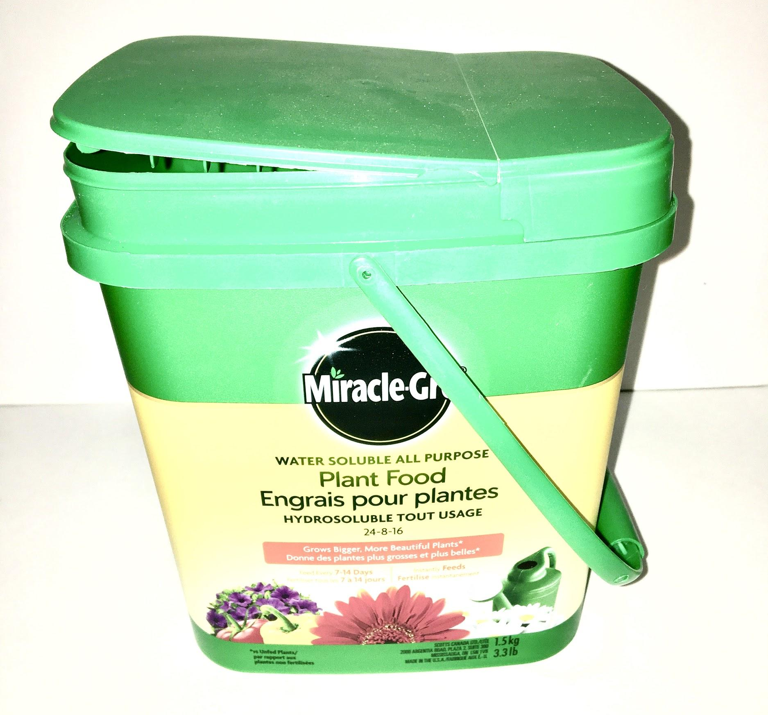  For students who may have limited resources, any plastic container will do. | 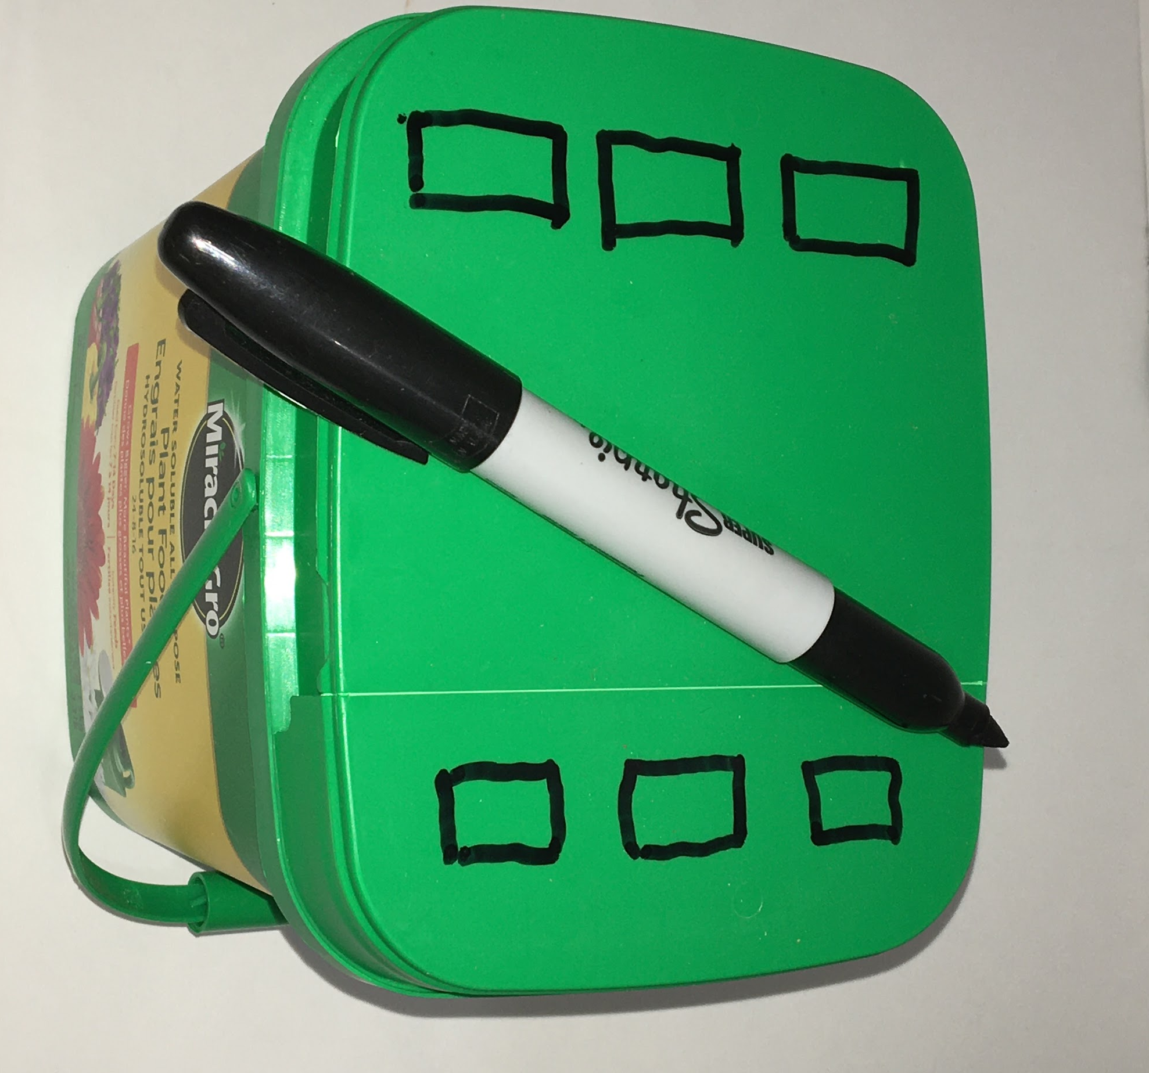  Mark out your ventilation holes.. Not everyone will have a drill, so this example was completed with scissors. Rectangles were used instead of circles because they are easier to cut out with scissors or a knife.
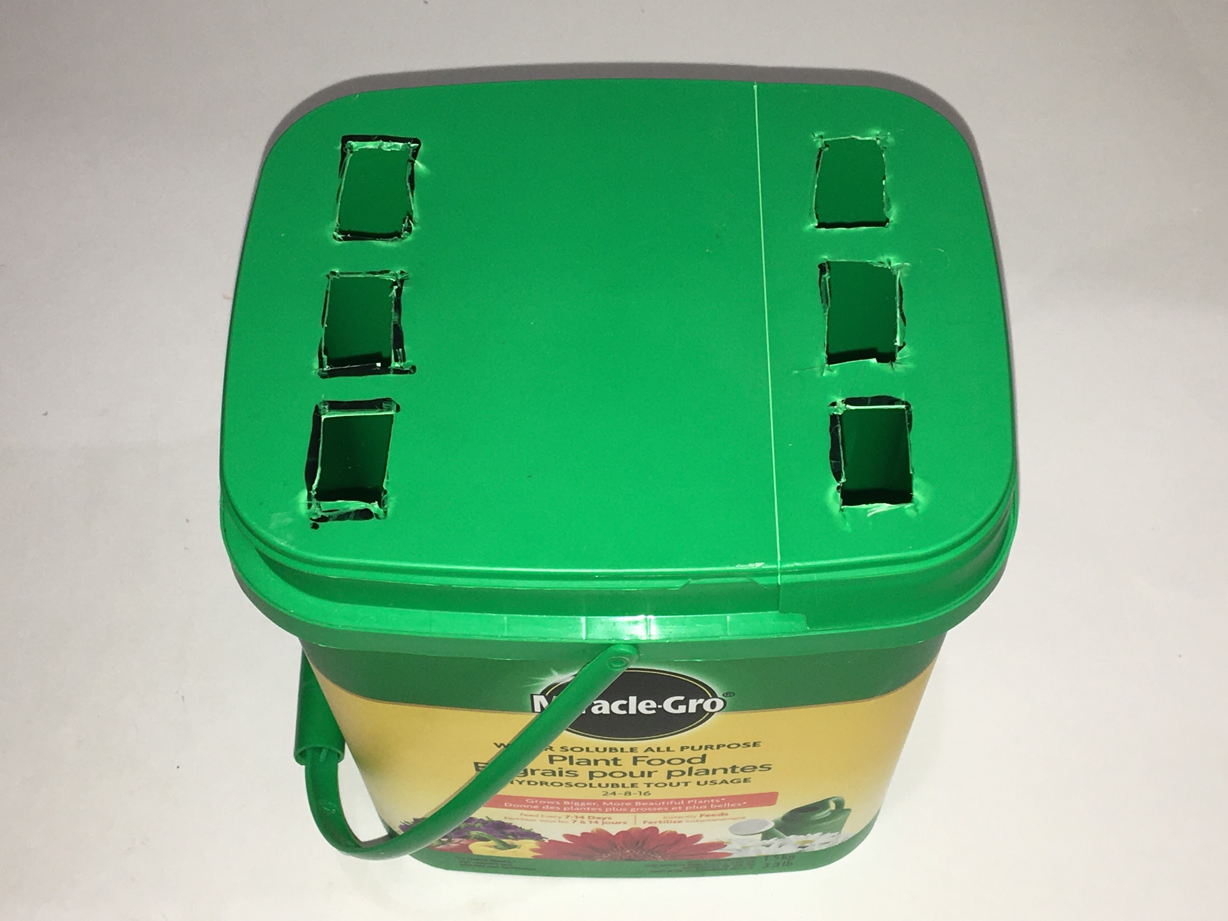  Cut ventilation holes out of the top. If desired, ventilation holes can be added to the sides as well. | 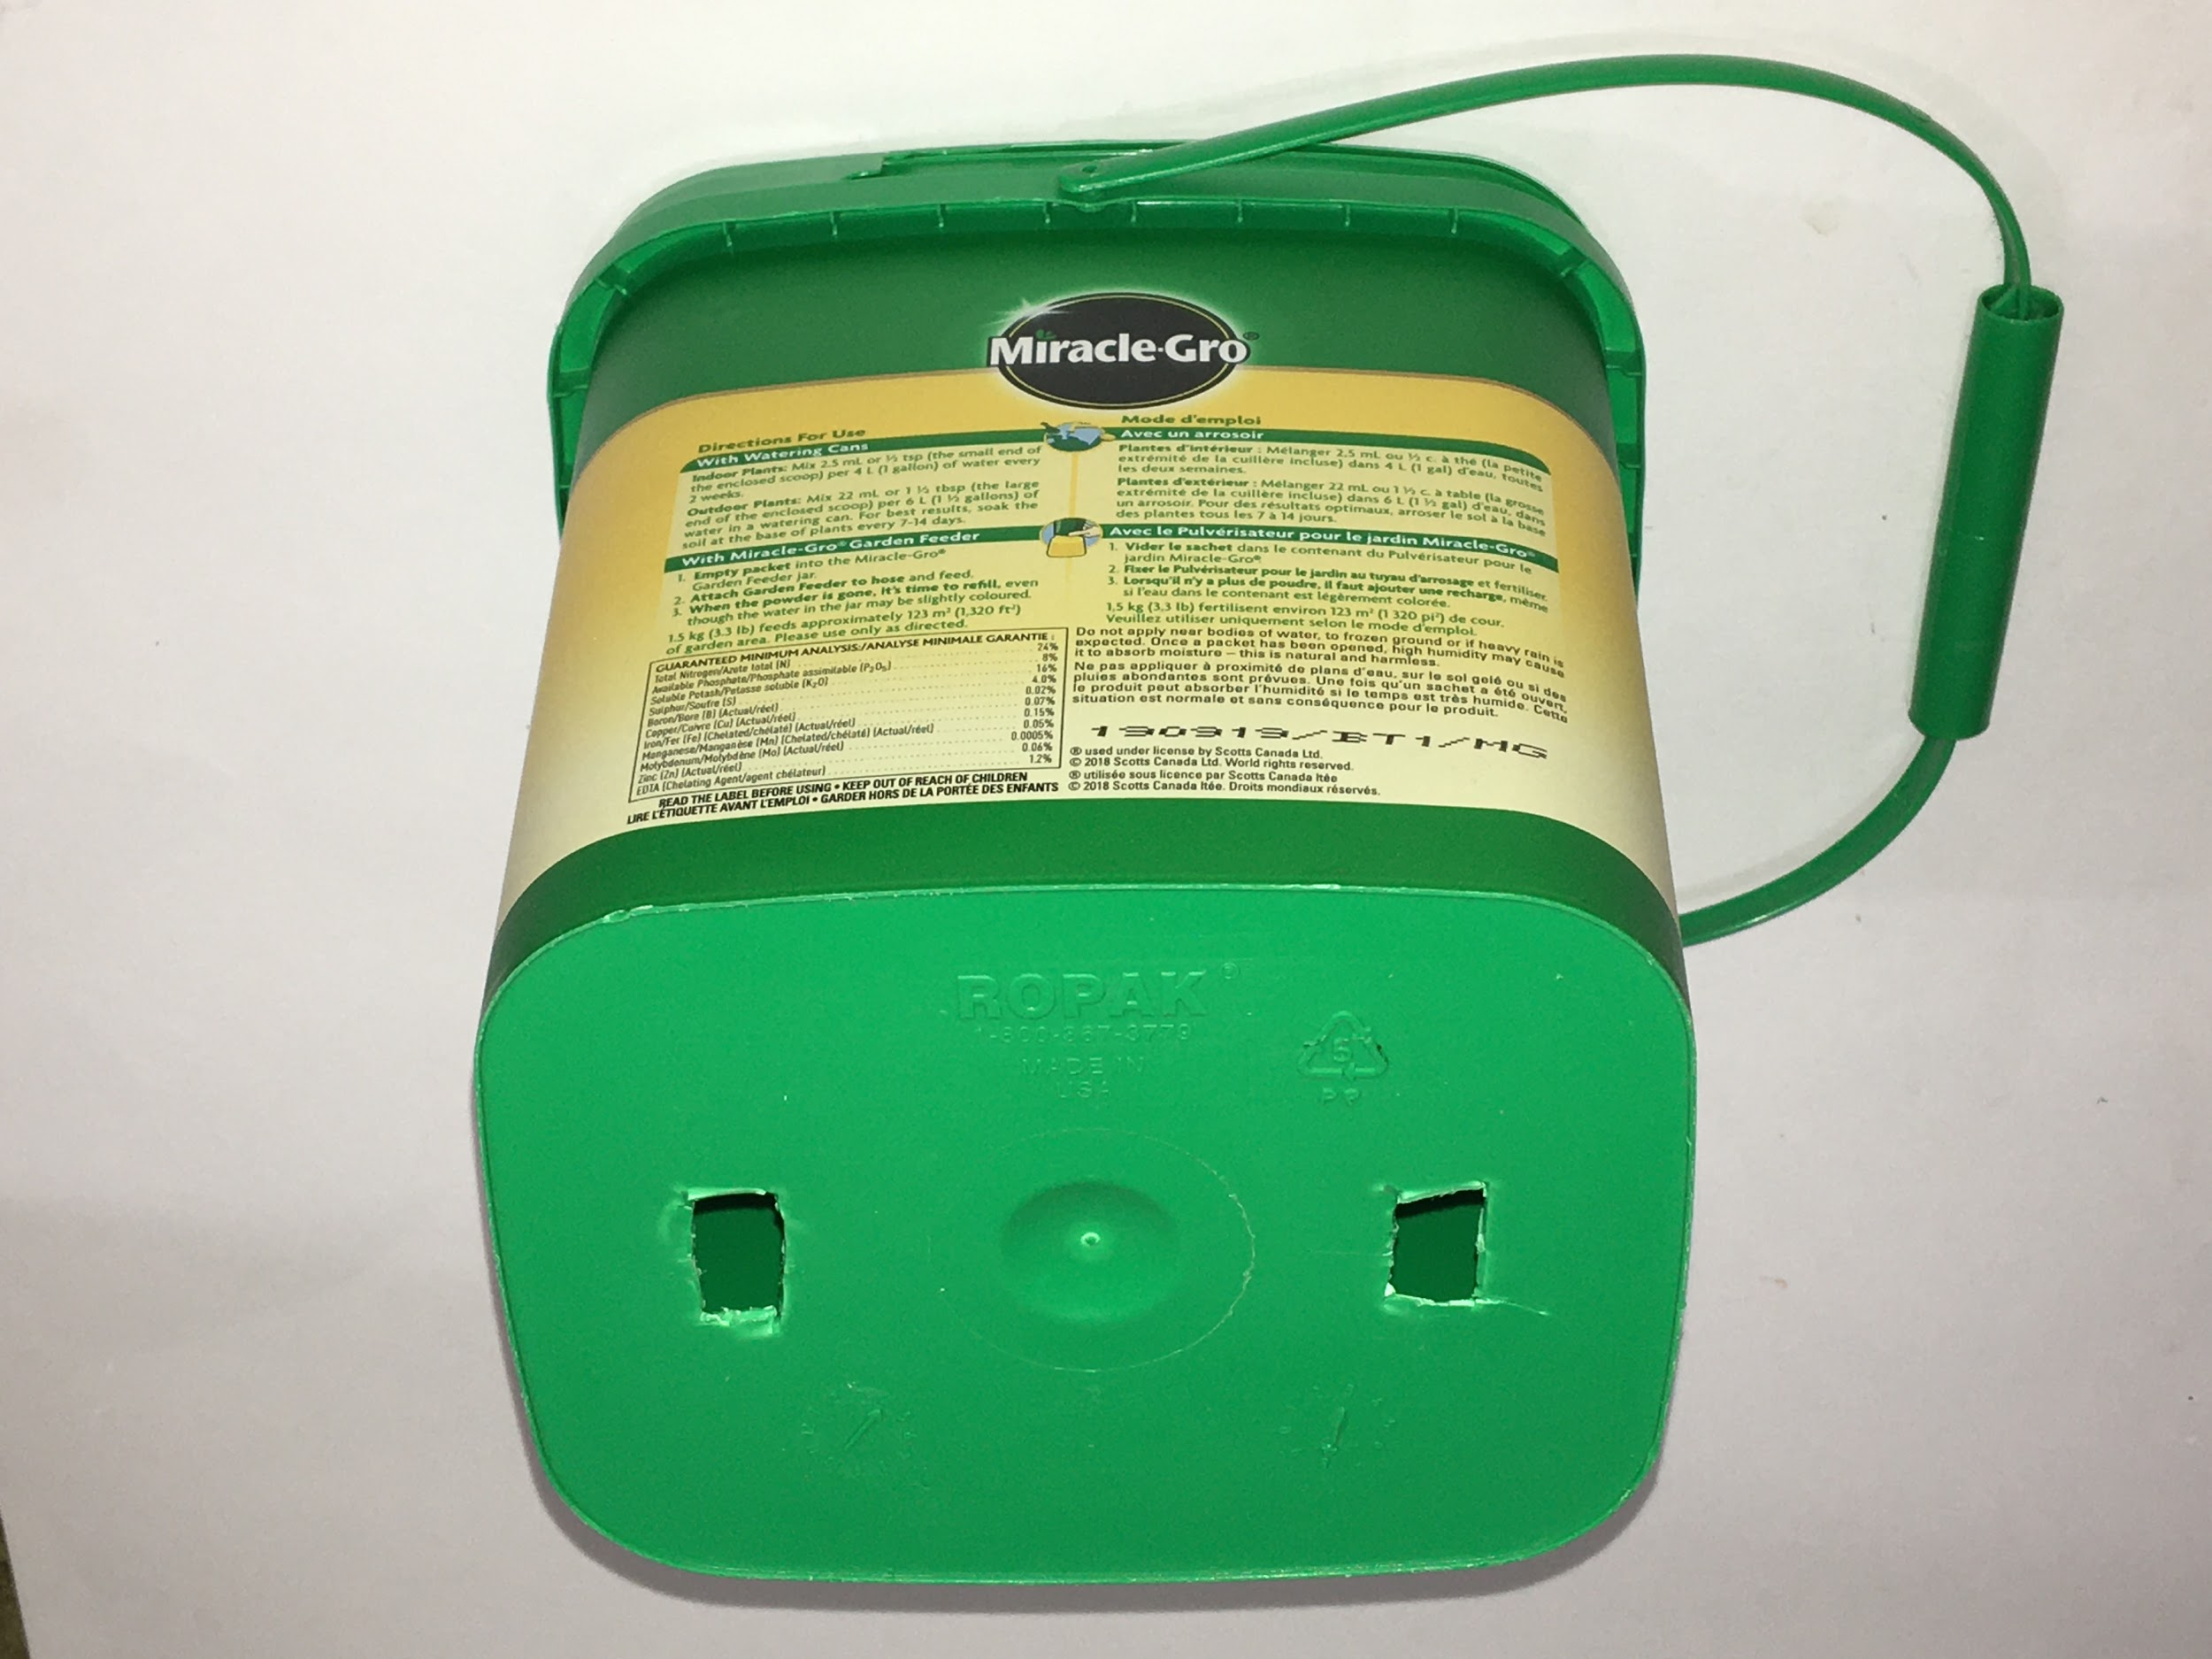  Cut drainage holes in the bottom.

Appendix M (continued)

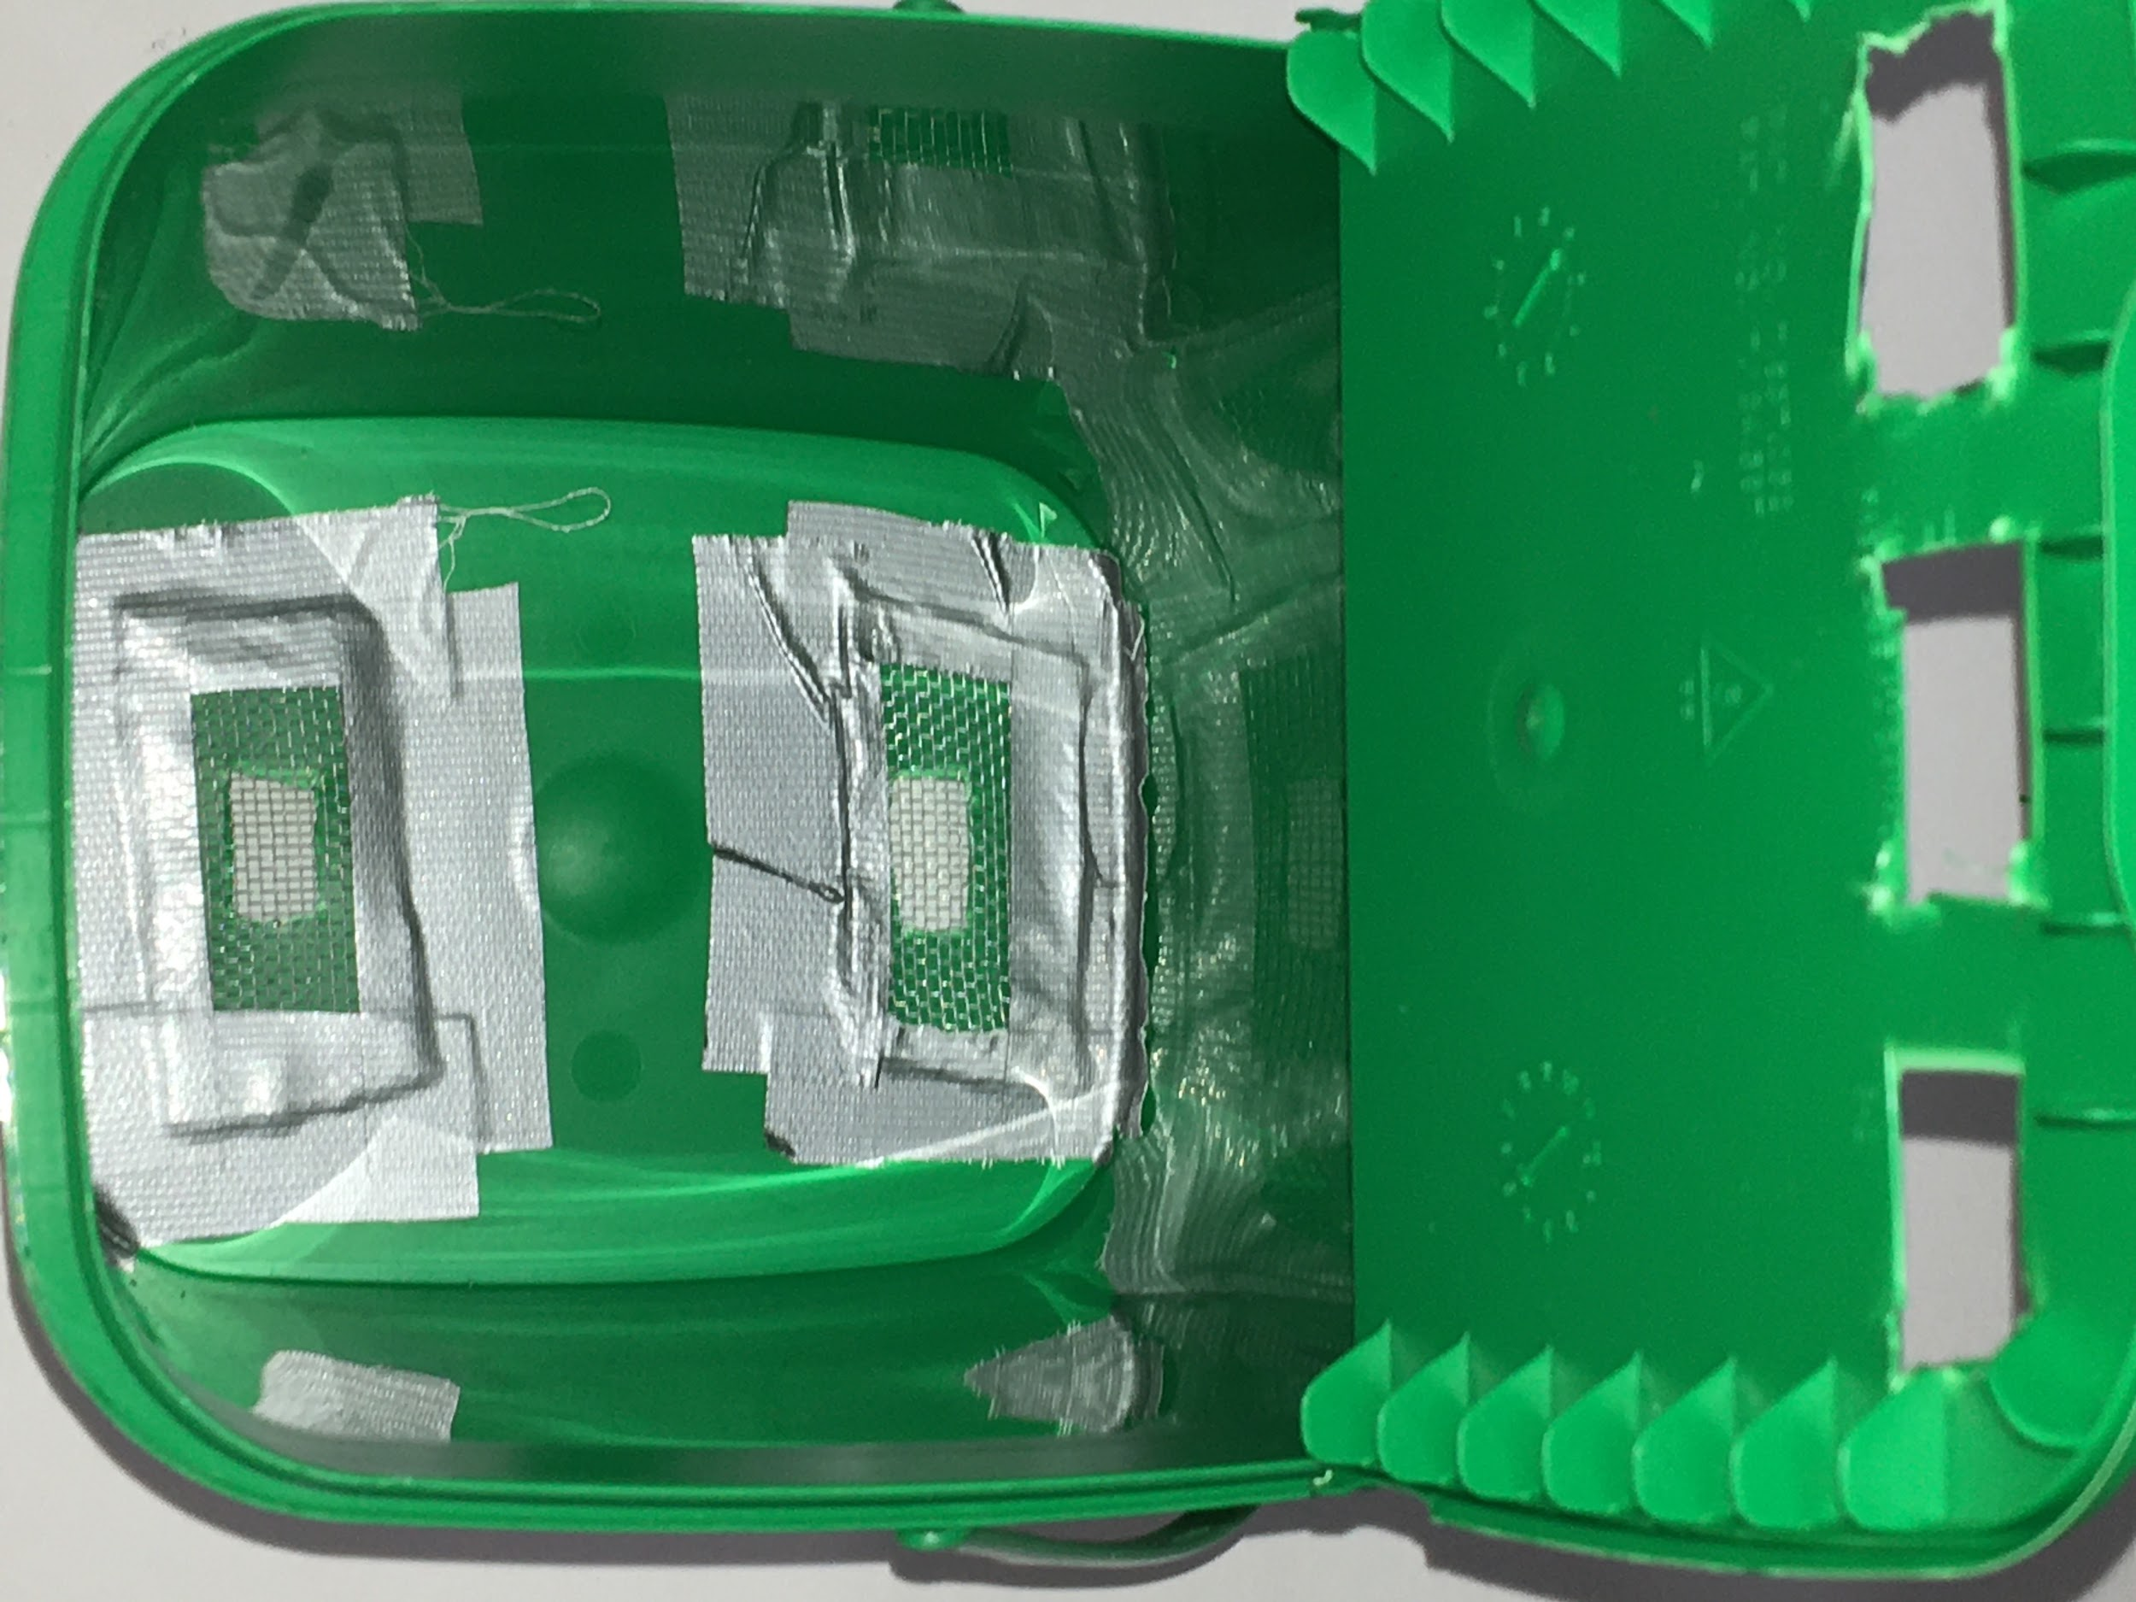  Pieces of screen were taped over the holes on the bottom, from the inside. Nylon material or simply cloth can be used instead. | 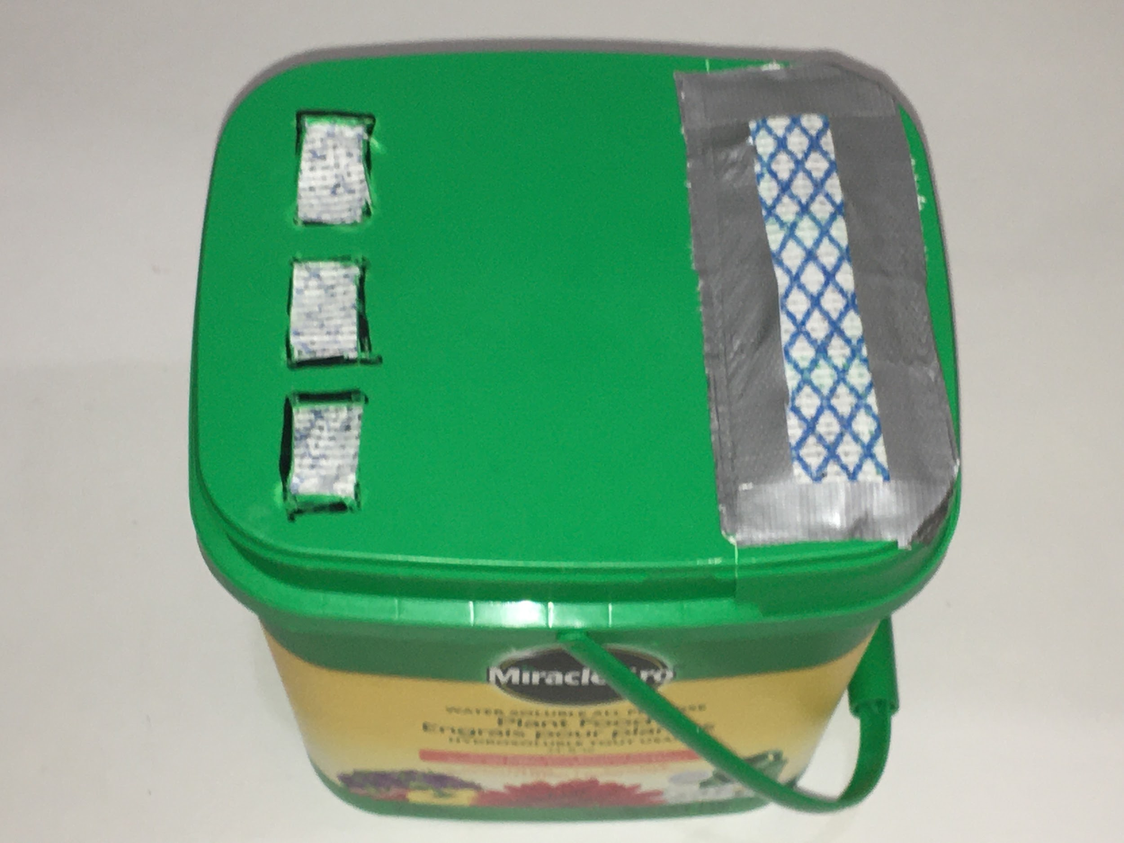  Not everyone will have pieces of screen available. These holes have been blocked by cloth. For demonstration purposes, one set of holes has been blocked from the inside, and the other from the outside.
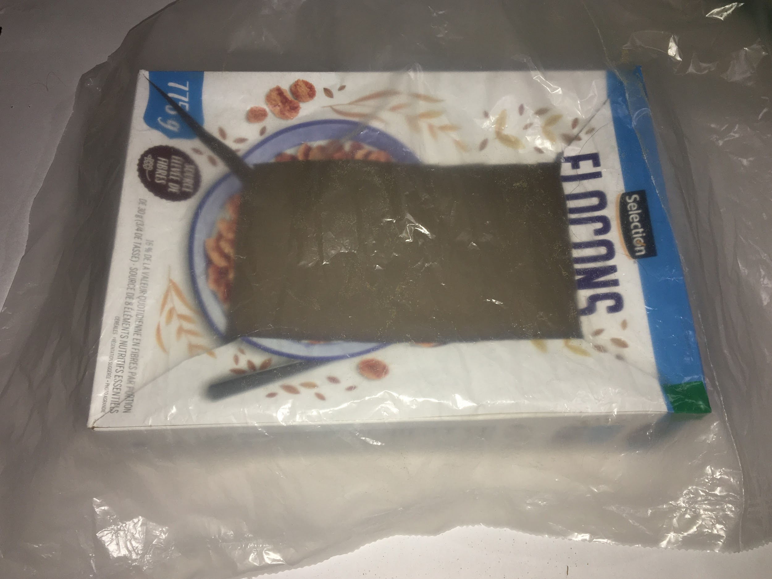  A cereal box and its inner bag can be cut up to make a drip tray. | 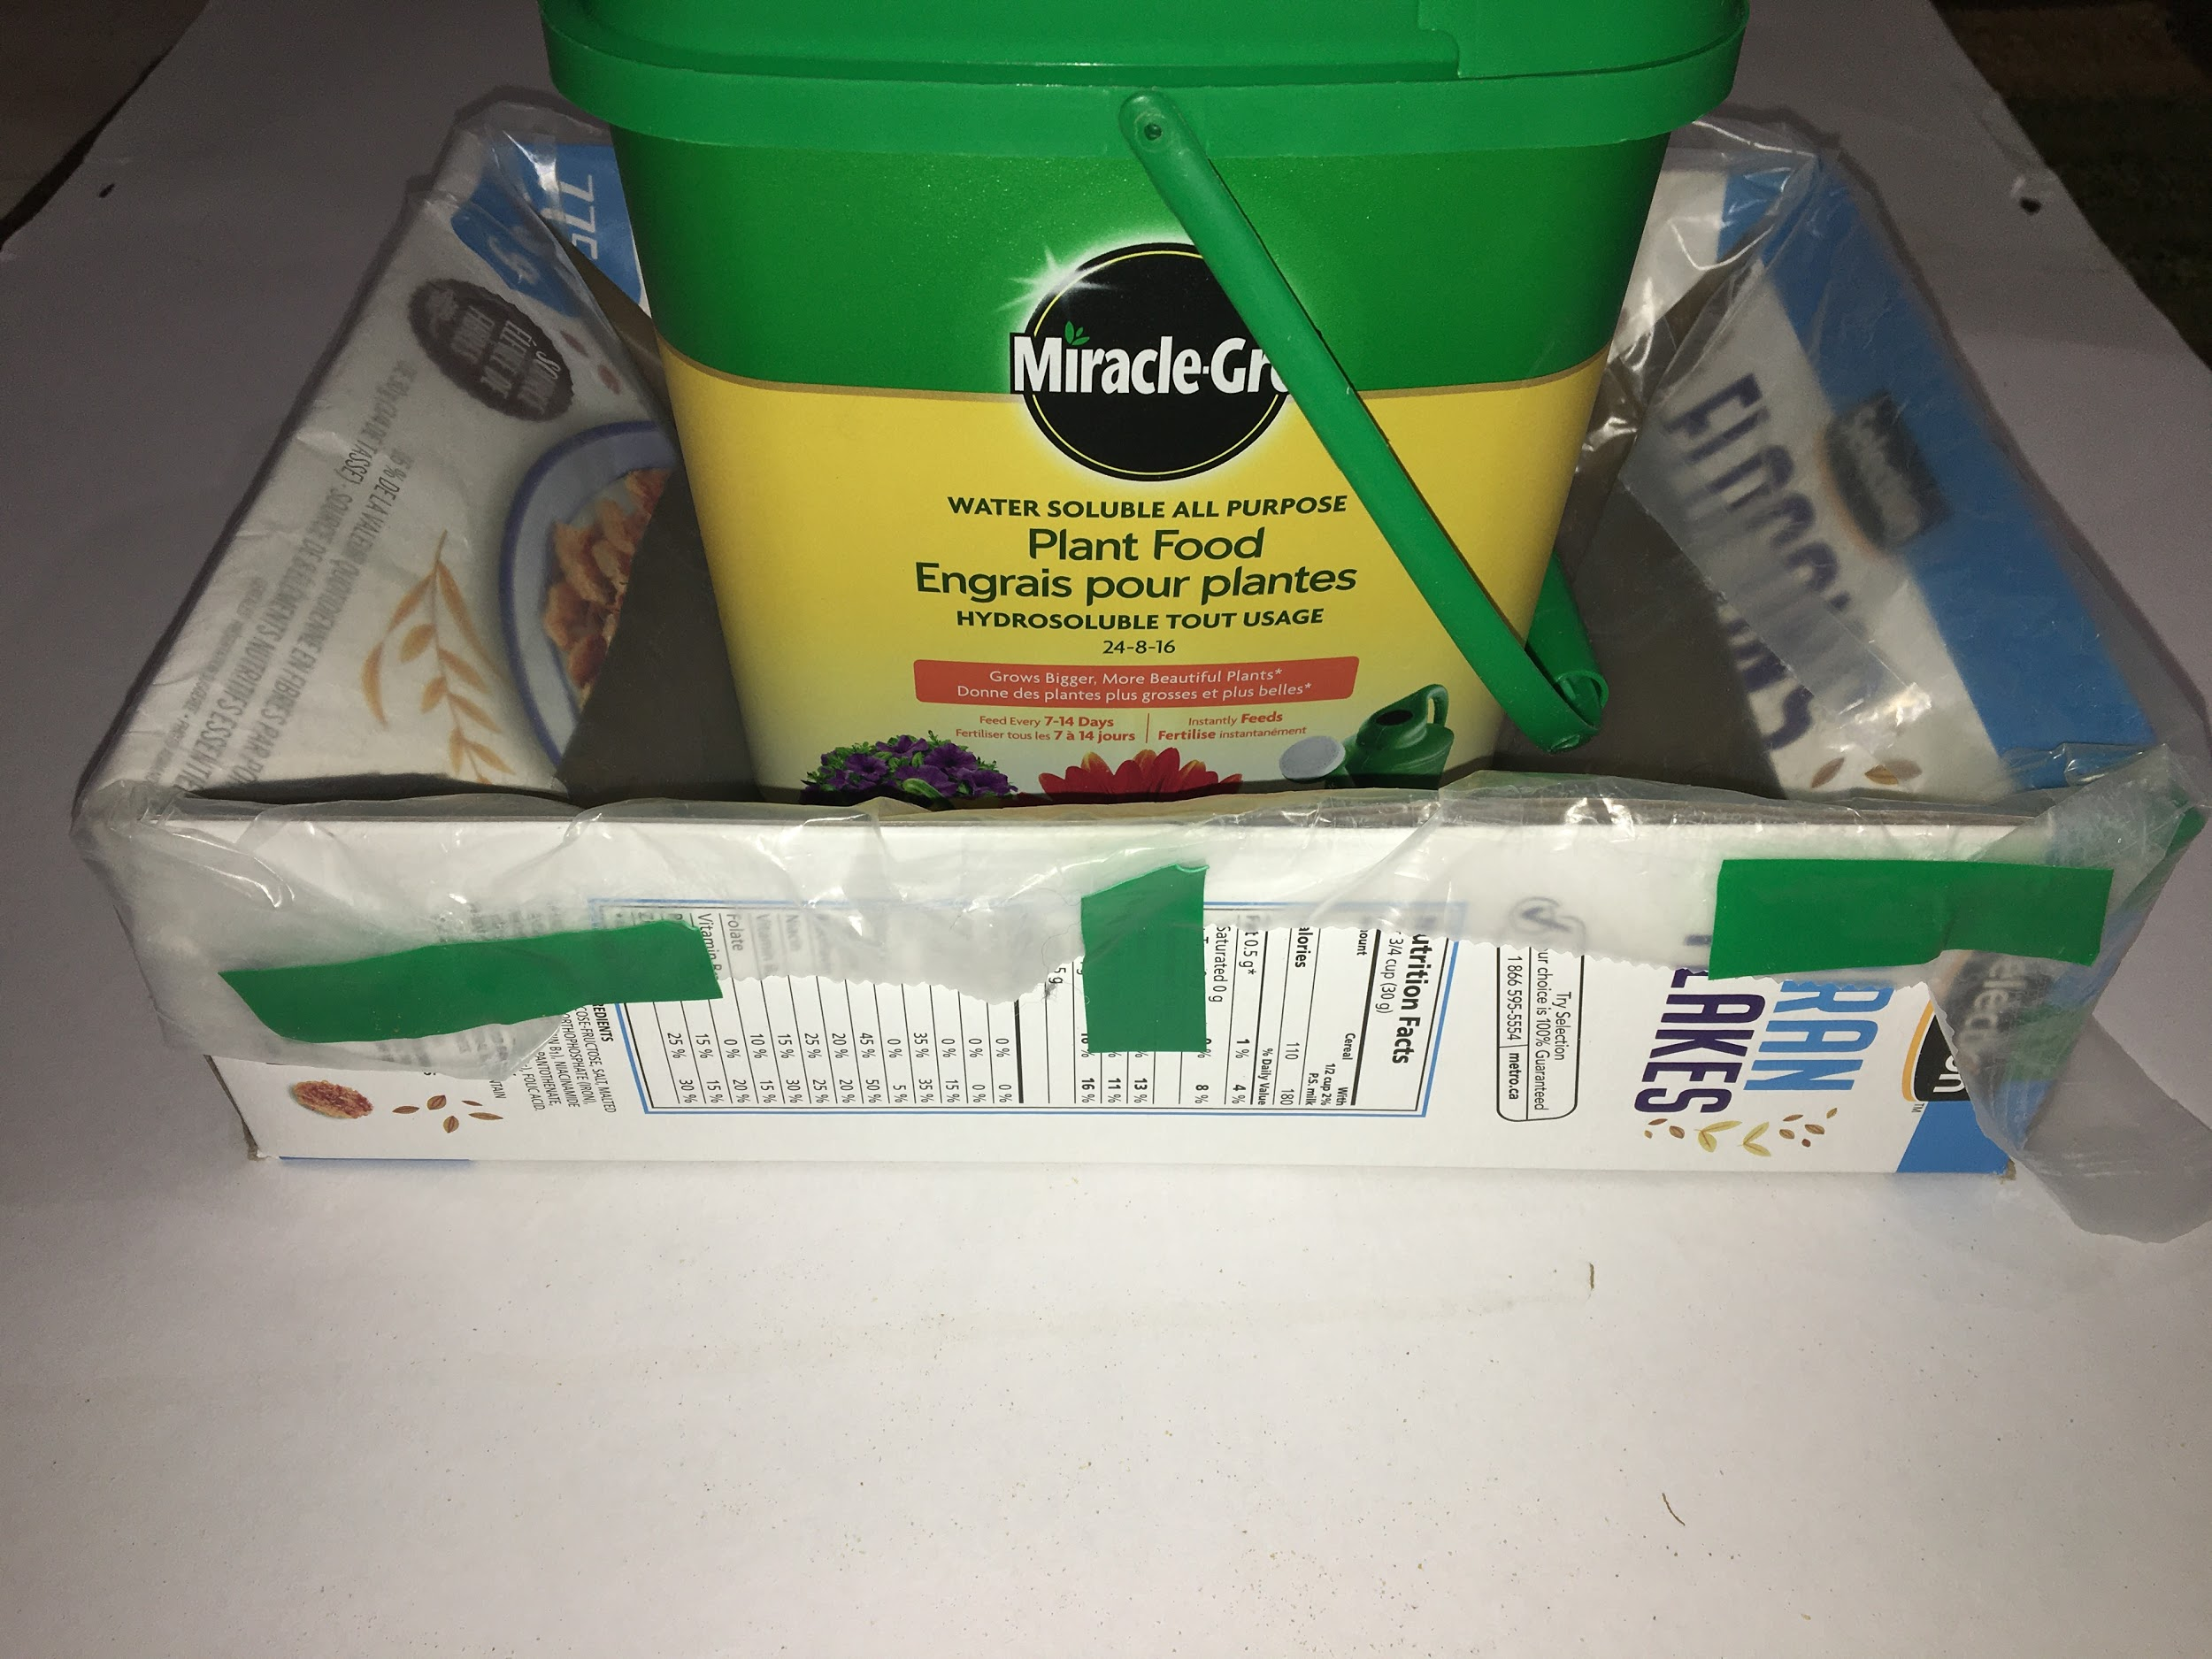  Set the composter in the drip tray, adjust the edges of the cereal bag, fold the corners, and tape the edges in place.

Appendix M (continued)

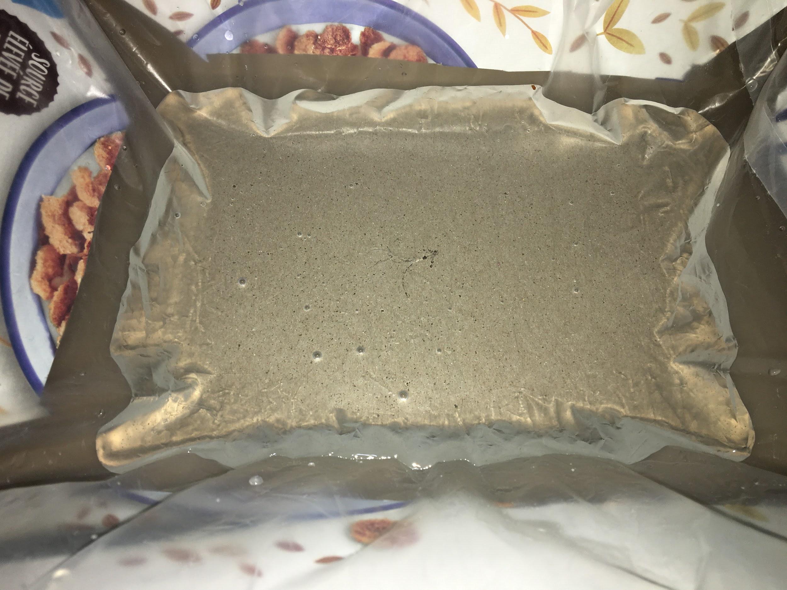  You will end up with a watertight liner for the cereal box drip tray. | 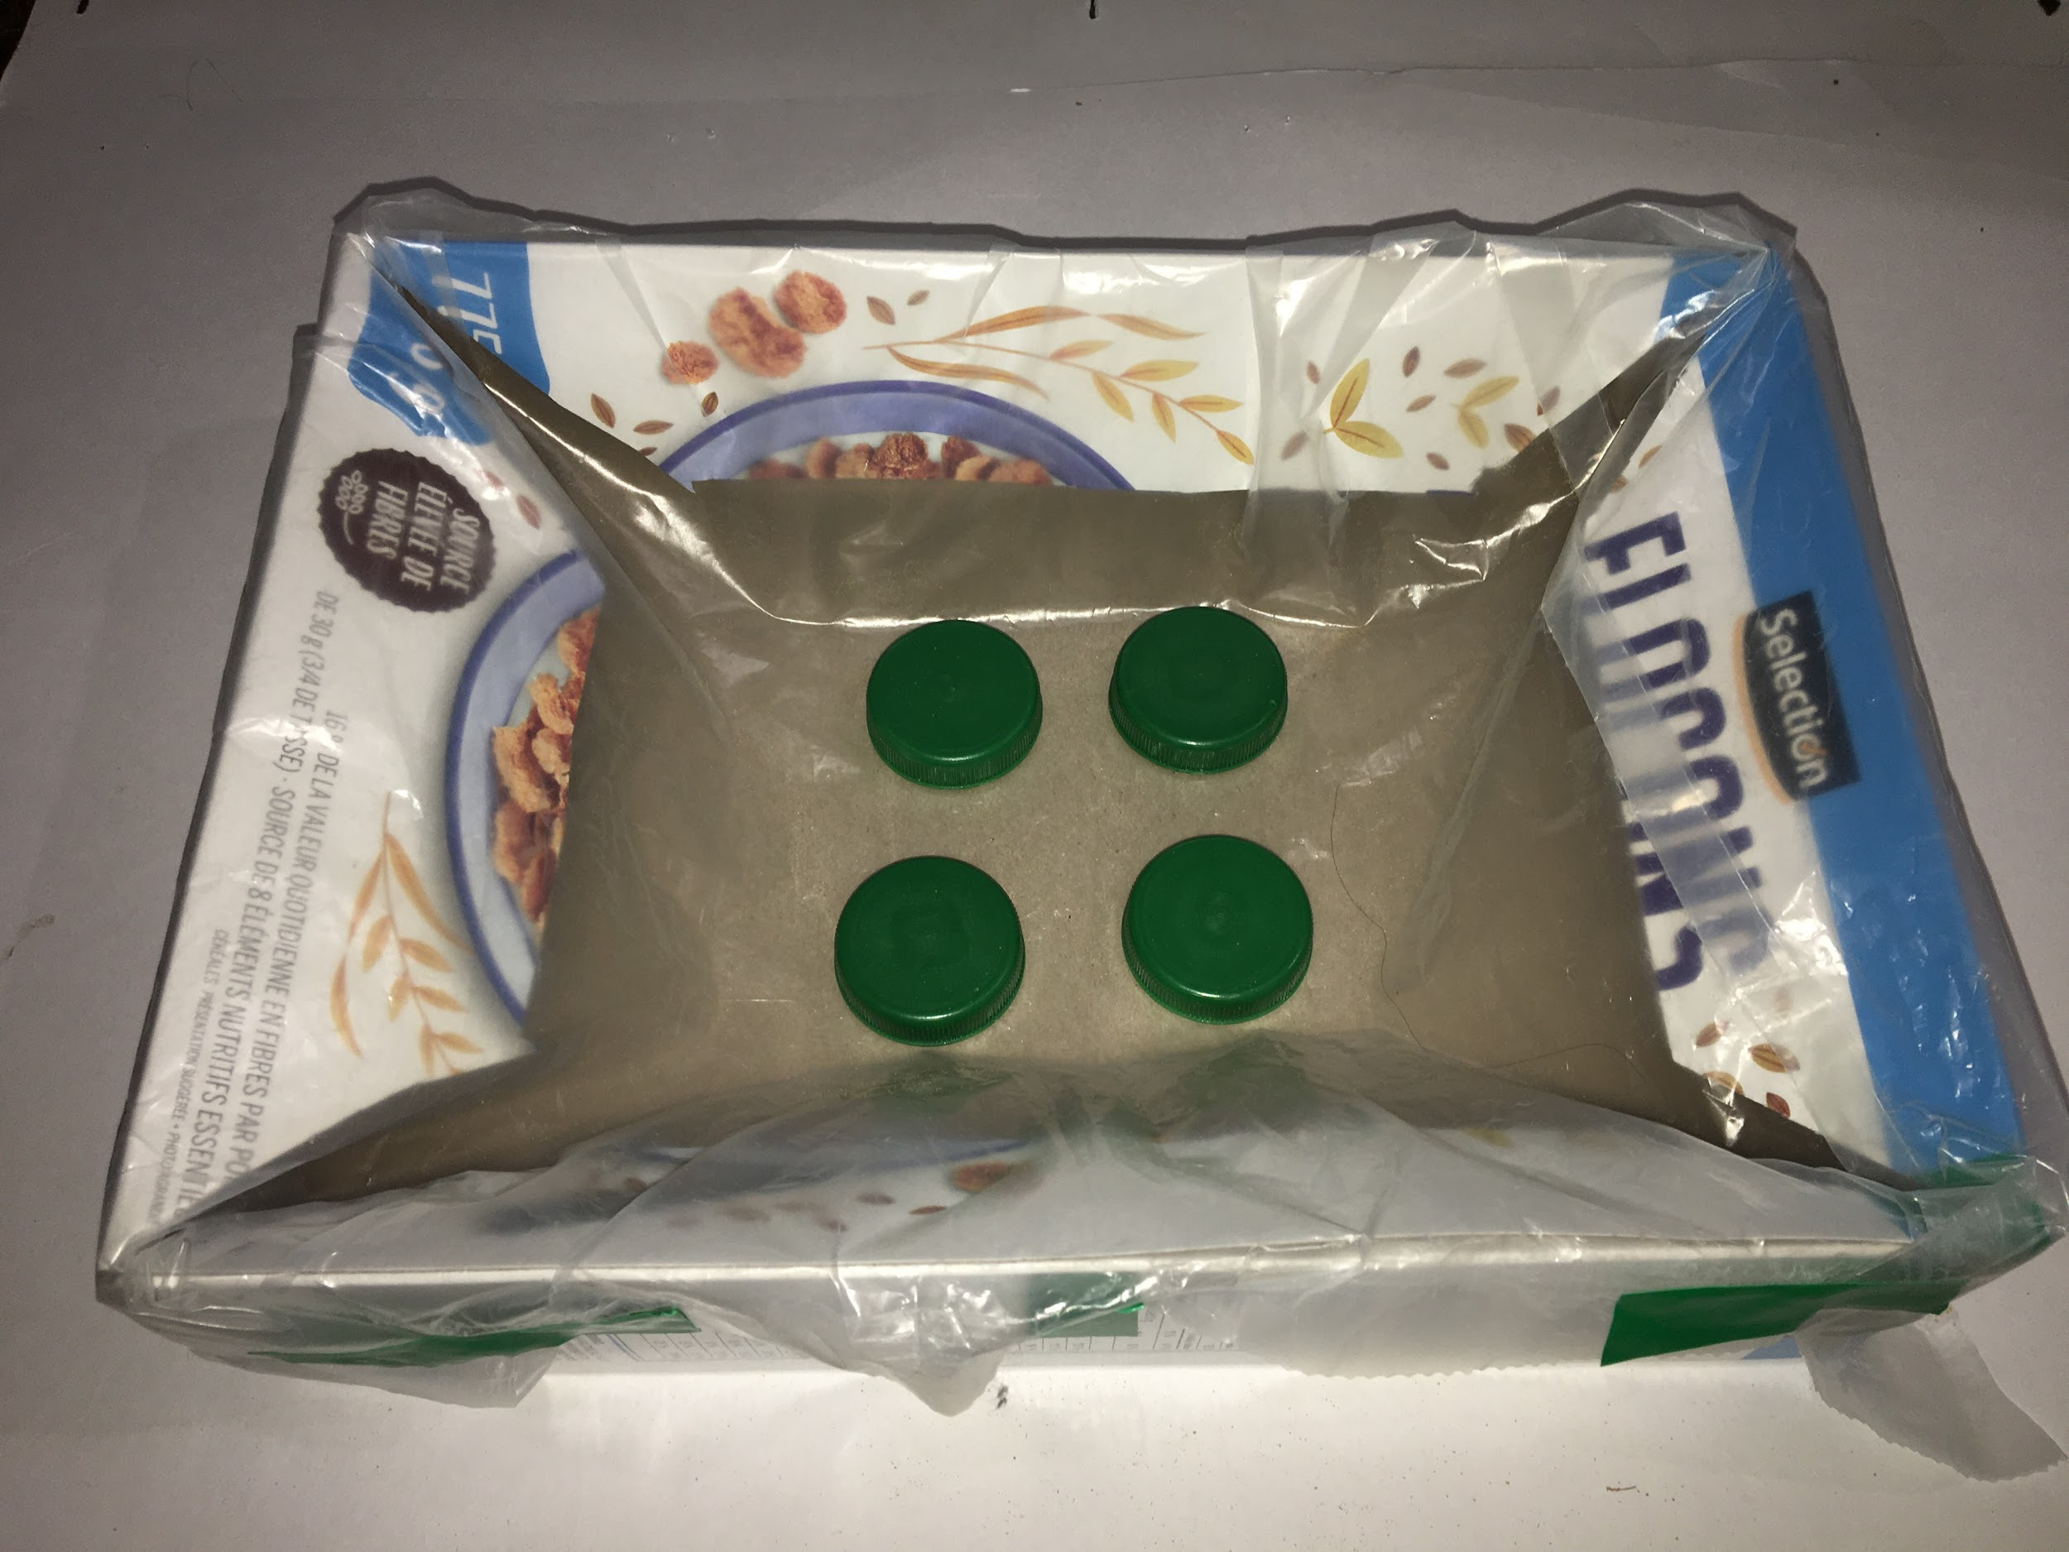  Juice bottle caps, or any other symmetrical items that won’t absorb liquid, may be used as a platform. The platform will allow drainage, and will keep the bottom of the composter out of the liquid.
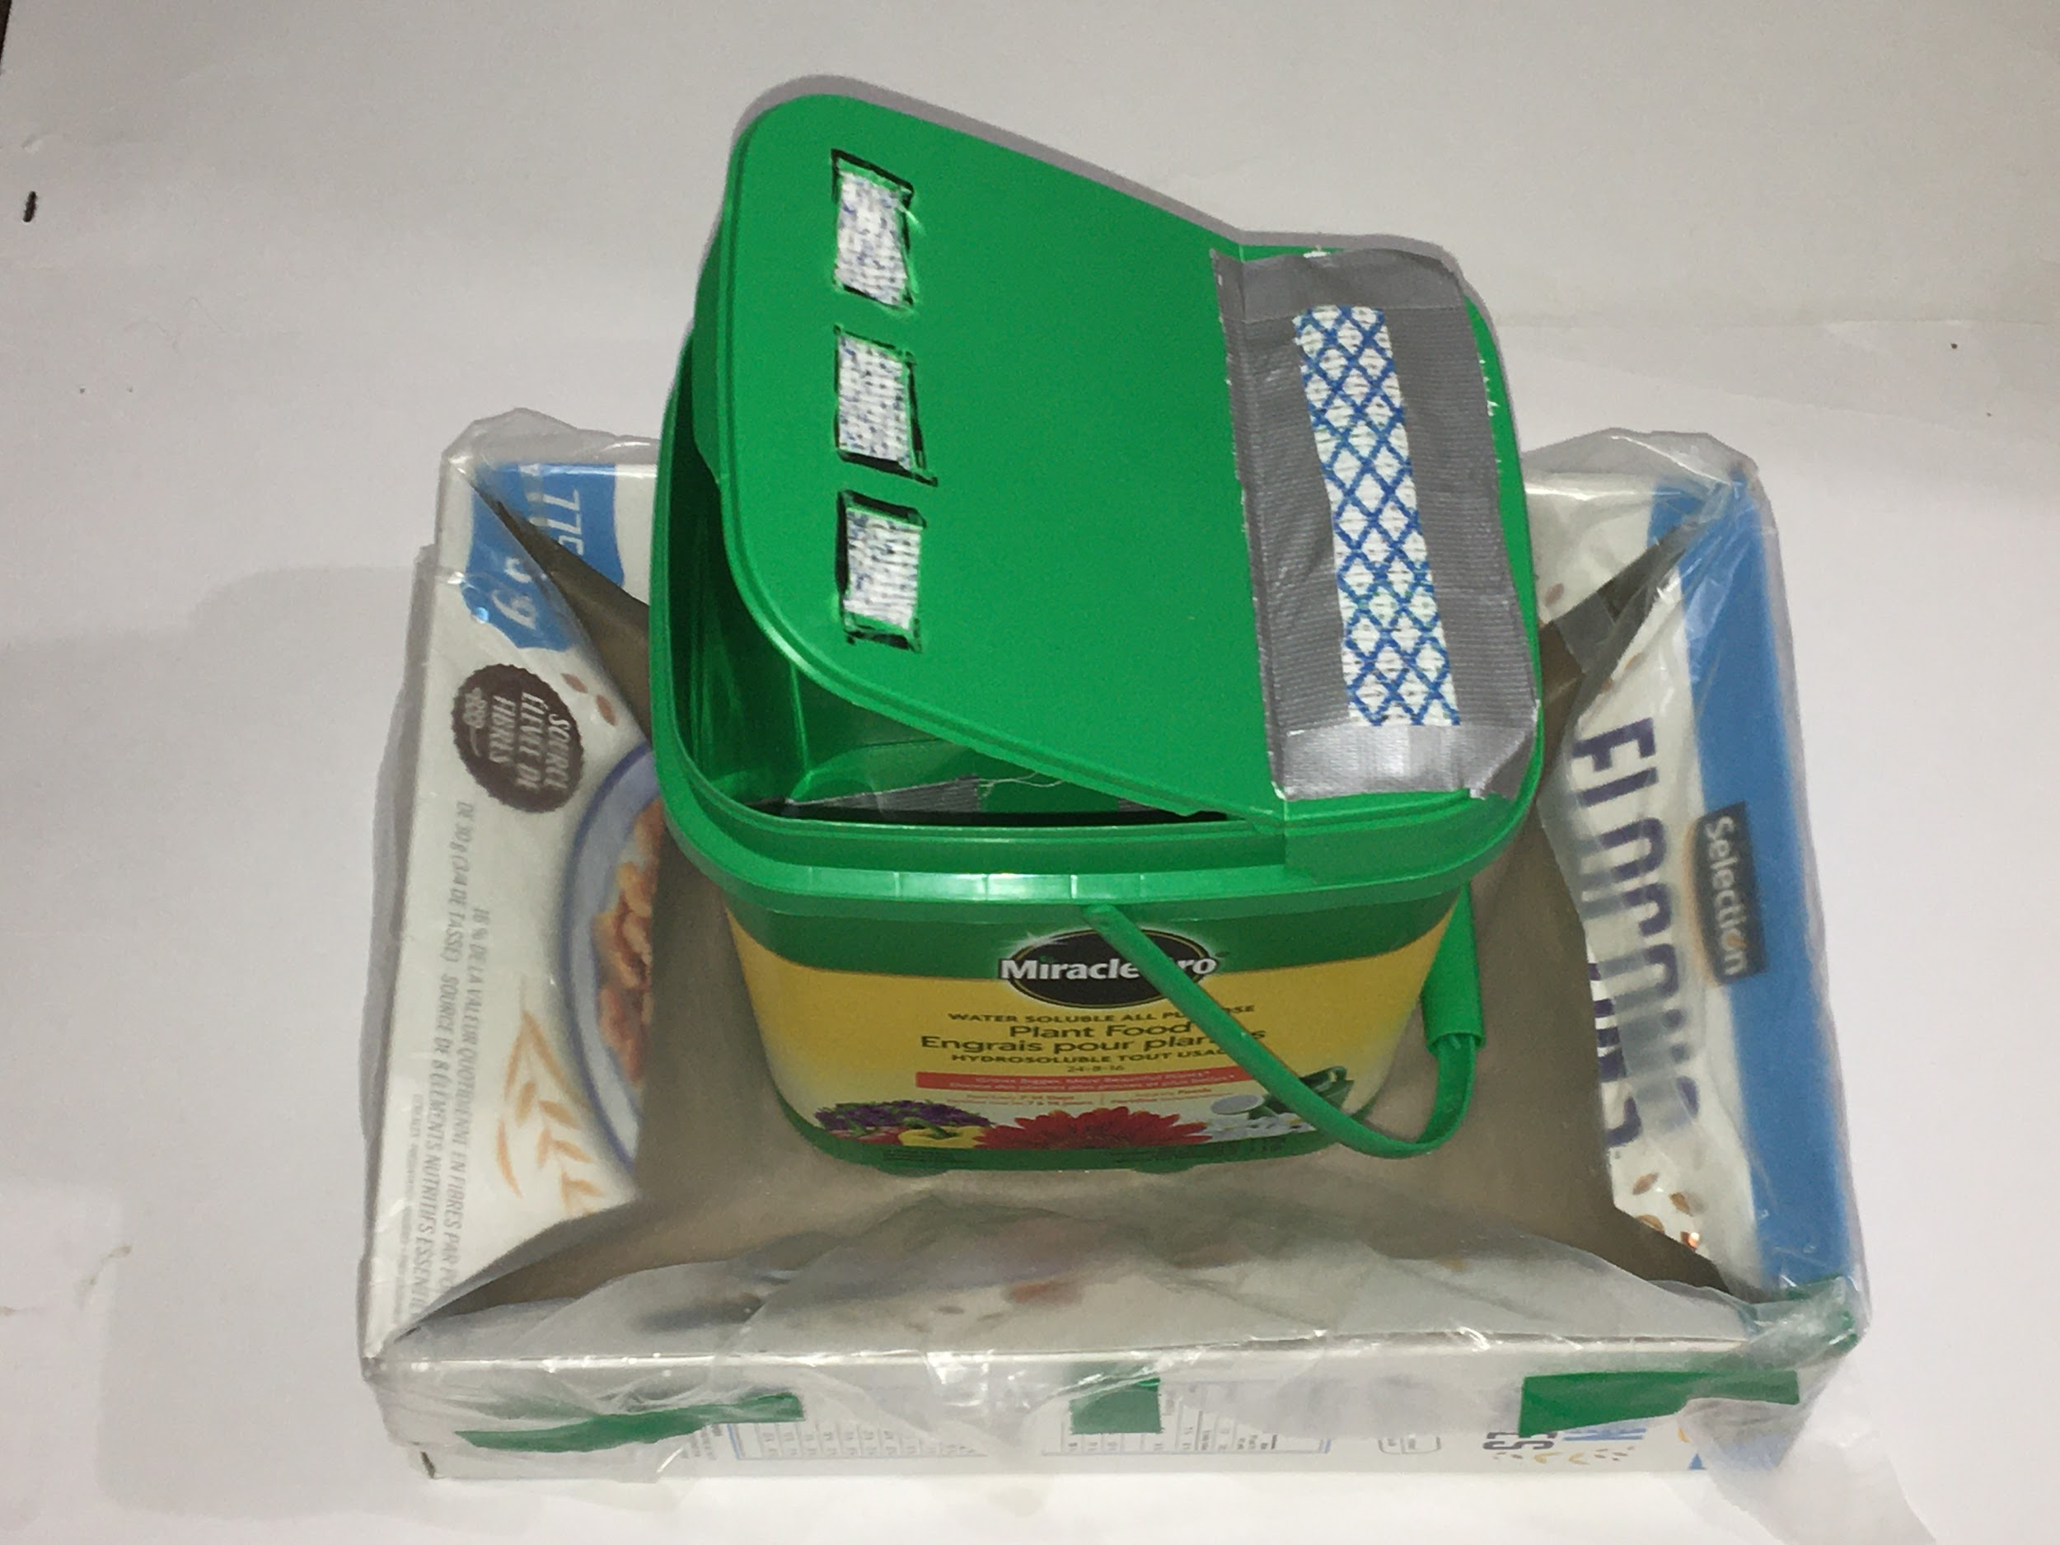
Now the indoor compost bin is ready for soil, newspaper, and organic waste.

Appendix N

Technological Problem Solving and Communicating Assessment Rubric

CRITERIA | LEVEL 1 | LEVEL 2 | LEVEL 3 | LEVEL 4
Design Process  Plan  Students will draw at least two designs, or at least two different views of their model, will include measurements, and will choose appropriate materials. | The student developed an unfinished plan with various considerations missing.  The student demonstrated a limited use of the design process (plan, build, test, evaluate, communicate). | The student developed a workable plan with some steps missing.  The student demonstrated some use of the design process (plan, build, test, evaluate, communicate). | The student developed a clear workable plan using appropriate materials.  The student used the design process (plan, build, test, evaluate, communicate) as expected. | The student developed a workable plan, and modified the plan as necessary.  The student used the design process (plan, build, test, evaluate, communicate) very effectively.
Model  Students will translate their plan into a model. | The student’s design plans did not translate into a working model. | The student translated their design plans into a somewhat working model based on some of the stated criteria.  The student created a model that occasionally functioned according to specifications.  The student used a predictable design and materials. | The student adequately translated their design plans into a working model based on the stated criteria.  The student created a model that successfully functioned according to specifications.  The student used a predictable design and materials. | The student successfully translated their design plans into a working model based on the stated criteria.  The student created a model that successfully functioned according to specifications.  Care was taken during the student’s construction process.  The student produced a unique and creative design.
Communication and Reflection  Students will use Grade 7 level science and technology terminology, and their communication will make their knowledge of indoor composter design and operation (and the design process) evident. | The student used limited grade level terminology.  The student did not communicate a basic understanding of the concepts.  The student reflected on the design process and made limited suggestions for improvement. | The student used some grade level terminology.  The student communicated some understanding of the concepts.  The student reflected on the design process and made some suggestions for improvement. | The student used an adequate amount of grade level terminology.  The student communicated an understanding of most of the concepts.  The student reflected on the design process and made necessary suggestions for improvement. | The student used all required grade level terminology.  The student communicated an understanding of all concepts.  The student reflected on the design process and made all necessary suggestions for improvement.

Appendix O
Full Assessment Rubric

This rubric was developed from the Ontario Curriculum Grades 1-8 Science and Technology, Revised 2007 document.

 | Level 1 | Level 2 | Level 3 | Level 4
Knowledge and Understanding – Subject-specific content acquired in each grade (knowledge), and the comprehension of its meaning and significance (understanding).

 | The Student:
1. Knowledge of content (e.g., facts and terminology related to composters and their components). | demonstrates  limited  knowledge  of content. | demonstrates  some knowledge  of content. | demonstrates  considerable  knowledge of  content. | demonstrates  thorough  knowledge  of content.
2. Understanding of content (e.g., concepts, ideas, and processes involving composters and components). | demonstrates  limited  understanding  of content. | demonstrates  some understanding  of content. | demonstrates  considerable  understanding of content. | demonstrates  thorough  understanding  of content.
Thinking and Investigation – The use of critical and creative thinking skills and inquiry problem solving skills and/or processes.

 | The Student:
3. Use of initiating and planning skills and strategies (identify appropriate items to research, and locate resources that are relevant to the study of composters, their design, and their function). | uses initiating  and planning  skills and  strategies  with limited  effectiveness. | uses initiating  and planning  skills and  strategies  with some  effectiveness. | uses initiating  and planning  skills and  strategies with  considerable  effectiveness, | uses initiating  and planning  skills and  strategies with  a high degree  of effectiveness.
4. Use of processing skills and strategies (e.g., performing and recording, gathering evidence and data, observing, manipulating materials and using equipment safely, ... proving) to design, fabricate, and run a functioning indoor composting bin. | uses processing skills and strategies with limited  effectiveness. | uses processing skills and strategies with some  effectiveness. | uses processing skills and strategies with  considerable  effectiveness. | uses processing skills and strategies with  a high degree  of effectiveness.
 | The student:
5. Use of critical/creative thinking processes, skills, and strategies (e.g., analysing, interpreting, problem solving, evaluating, forming and justifying conclusions on the basis of evidence) to determine if the indoor composting bin prototype meets the design requirements for this task. | uses critical/creative thinking processes, skills, and strategies with limited  effectiveness. | uses critical/creative thinking processes, skills, and strategies with some  effectiveness. | uses critical/creative thinking processes, skills, and strategies with considerable effectiveness. | uses critical/creative thinking processes, skills, and strategies with a high degree of effectiveness.
Communication – The conveying of meaning through various forms
 | The student:
6. Expression and organization of ideas and information in oral, visual, and/or written forms (e.g., complete an oral or written report, video, or slideshow that is organized in a clear, logical manner and communicates the design, fabrication, and operation of a composting bin). | expresses and organizes ideas and information with limited effectiveness. | expresses and organizes ideas and information with some effectiveness. | expresses and organizes ideas and information with considerable effectiveness. | expresses and organizes ideas and information with a high degree of effectiveness.
7. Communication for different audiences and purposes in oral, visual, and/or written forms (formally communicate the process used to complete the Indoor Composting Bin Design Challenge to the student’s teacher for evaluation). | communicates for different audiences and purposes with limited effectiveness. | communicates for different audiences and purposes with some effectiveness. | communicates for different audiences and purposes with considerable effectiveness. | communicates for different audiences and purposes with a high degree of effectiveness.
8. Use of conventions, vocabulary, and terminology (e.g., sustainability, producer, consumer, and decomposer) in oral, visual, and/or written forms. | uses conventions, vocabulary, and terminology with limited  effectiveness. | uses conventions, vocabulary, and terminology with some  effectiveness. | uses conventions, vocabulary, and terminology with considerable  effectiveness. | uses conventions, vocabulary, and terminology with a high degree of  effectiveness.
Application – The use of knowledge and skills to make connections within and between various contexts
 | The student:
9. Application of knowledge and skills (e.g., concepts and processes, use of equipment and technology, investigation skills) in familiar contexts. | applies knowledge and skills in familiar contexts with limited effectiveness. | applies knowledge and skills in familiar contexts with some effectiveness. | applies knowledge and skills in familiar contexts with considerable effectiveness. | applies knowledge and skills in familiar contexts with a high degree of effectiveness.
 | The student:
10. Making connections between society, science, technology, and the environment regarding the design solution selected, and its impacts on people, other living things, and the environment. | connects science, technology, society, and the environment with limited effectiveness. | connects science, technology, society, and the environment with some effectiveness. | connects science, technology, society, and the environment with considerable effectiveness. | connects science, technology, society, and the environment with a high degree of effectiveness.
11. Proposing courses of practical action to deal with problems relating to science, technology, society, and the environment through the understanding of interactions within ecosystems and how balance between the elements is maintained. | proposes courses of practical action of limited effectiveness. | proposes courses of practical action of some effectiveness. | proposes courses of practical action of considerable effectiveness. | proposes highly  effective courses of practical action.

Opportunities for assessment (Links to assessment pieces, organizers):
- Assess student responses recorded in the Indoor Composter Design
Challenge - Research on Composter Designs and Operation page (see Appendix D).
- Assess the sketches and responses to items 1-3 on the Indoor Composter Design Challenge - Technical Drawings and Design Analysis assignment (see Appendix E).
- Assess the student’s responses to items 1-4 on the Indoor Composter Design Challenge - Research Assignment (see Appendix H).
- Assess the student’s responses to items 1-6 on the Indoor Composter Design Challenge - Experimental Data assignment (see Appendix I).
- Assess the final report developed under the direction of the Communicating Your Learning assignment (see Appendix J).
- Use Assessment -Success Criteria (see Appendix K) to provide ongoing feedback and a summative evaluation to your students.
- Record a condensed assessment of your student’s progress using the Technological Problem Solving and Communicating Assessment Rubric (see Appendix N)
- Record an in depth assessment or your student’s progress using the Full Assessment Rubric (see Appendix O).

Cross Curricular Opportunities:
- The Arts: Grade 7 Dance (this expectation can be incorporated into the video assignment where students can interpret, through dance, the function of a composter and the interactions between the elements within it),
  - A1.2 use dance as a language to communicate ideas from their own writing or media works (e.g., create a dance piece inspired by a student authored poem or media work about relationships with the natural world...)
    - Teacher prompts: “What are some interactions from your assignment that you could represent in dance? How would you do so?” “What elements of dance (e.g., movements, levels, pathways) would best communicate the relationships, between and within biotic and abiotic elements from your ecosystem, presented in your writing or media presentation?”
- The Arts: Grade 7 Visual Arts (this expectation can be addressed by turning the indoor composting bin into a work of art that addresses the content listed below),
  - D1.1 create art works, using a variety of traditional forms and current media technologies, that express feelings, ideas, and issues (e.g., … art or an installation that portrays both sides of the struggle between humankind and nature...) Teacher prompts: “How will your artwork convey... perspectives on an issue that you have chosen to explore... “How does your installation communicate the benefits and challenges of environmental stewardship?”
- Language: Grade 7 Oral Communication (if your students are to submit oral reports, either in person or by video, you may choose to integrate instruction and assessment of some or all of the Oral Communication expectations listed below).
  - Purpose 2.1, identify a range of purposes for speaking and explain how the purpose and intended audience might influence the choice of speaking strategies (e.g., to present conclusions about a research project...).
  - Interactive Strategies 2.2, demonstrate an understanding of appropriate speaking behaviour in most situations… (e.g., … use language and forms of address that are appropriate to the formality or informality of the situation).
  - Clarity and Coherence 2.3, communicate orally in a clear, coherent manner, using a structure and style appropriate to both the topic and the intended audience.
  - Appropriate Language 2.4, use appropriate words, phrases, and terminology from the full range of their vocabulary, including inclusive and non-discriminatory language, and a range of stylistic devices, to communicate their meaning accurately and engage the interest of their intended audience.
  - Vocal Skills and Strategies 2.5, identify a range of vocal effects, including tone, pace, pitch, volume, and a variety of sound effects, and use them appropriately and with sensitivity towards cultural differences to communicate their meaning.
  - Non-Verbal Cues 2.6, identify a variety of non-verbal cues, including facial expression, gestures, and eye contact, and use them in oral communications, appropriately and with sensitivity towards cultural differences, to help convey their meaning.
  - Visual Aids 2.7, use a variety of appropriate visual aids (e.g., charts, videos, props, multimedia) to support and enhance oral presentations.
- Language: Grade 7 Writing (if your students are to submit written reports, you may choose to integrate instruction and assessment of some or all of the Writing expectations listed below).
  - Research 1.3, gather information to support ideas for writing, using a variety of strategies and a wide range of print and electronic resources (e.g., ... record sources used and information gathered in a form that makes it easy to understand and retrieve).
  - Review 1.6, determine whether the ideas and information they have gathered are relevant, appropriate, and sufficiently specific for the purpose, and do more research if necessary.
  - Revision 2.7, make revisions to improve the content, clarity, and interest of their written work, using a variety of strategies.
  - Producing Drafts 2.8 produce revised draft pieces of writing to meet identified criteria based on the expectations (e.g., adequate development of information and ideas, logical organization, appropriate use of form and style, appropriate use of conventions).
  - Spelling Familiar Words 3.1, spell familiar words correctly.
  - Vocabulary 3.3, confirm spellings and word meanings or word choice using a variety of resources appropriate for the purpose.
  - Punctuation 3.4, use punctuation appropriately to communicate their intended meaning in more complex writing forms, including forms specific to different subject areas, with a focus on the use of: periods after initials, in abbreviations, and in decimal numbers; parentheses; punctuation to indicate intonation, pauses, or gestures.
  - Grammar 3.5, use parts of speech correctly to communicate their meaning clearly, with a focus on the use of: relative pronouns (e.g., who, whose, which, that); prepositions, including prepositional phrases; adjectives; conjunctions; adverbs; present, past, and future verb tenses; present and past participles (e.g., I am reading, I have read).
  - Proofreading 3.6, proofread and correct their writing using guidelines developed with peers and the teacher (e.g., an editing checklist specific to the writing task).
  - Producing Finished Works 3.8, produce pieces of published work to meet identified criteria based on the expectations (e.g., adequacy of information and ideas, logic and effectiveness of organization, effective use of form and stylistic elements, appropriate use of conventions, effective presentation).
- Language: Grade 7 Media Literacy (if your students are to submit a media text to demonstrate their learning, you may choose to integrate instruction and assessment of some or all of the Media Literacy expectations listed below).
  - Form 3.2, identify an appropriate form to suit the specific purpose and audience for a media text they plan to create (e.g., a website or multimedia presentation about a unit of study to present research findings to the class).
  - Producing Media Texts 3.4 produce a variety of media texts of some technical complexity for specific purposes and audiences, using appropriate forms, conventions, and techniques.

References:
- Khan Academy https://www.khanacademy.org/science/biology/ecology/intro-to-ecosystems/a/food-
chains-food-webs, accessed 2020 07 08,
- Sagamok Anishnawbek, “Composting in your backyard is easy, fun and useful,” https://sagamok.ca/programs-services/planning-infrastructure-technical-services/waste-management/composting/, accessed 2020 07 08,
- Global News, “How to compost if you live in an apartment or condo,” by Heather Loney, updated July 18, 2014, https://globalnews.ca/news/1450180/how-to-compost-if-you-live-in-an-apartment-or-condo/,
- Apartment Therapy, “How To Make Your Own Indoor Compost Bin,” by Sarah Starkey, published February 7, 2011, https://www.apartmenttherapy.com/how-to-make-your-own-indoor-compost-bin-
138645,
- Bob Vila,” All You Need to Know About Indoor Composting,” by Manasa Reddigari, https://www.bobvila.com/articles/indoor-composting/, accessed 2020 07 08,
- Bob Vila, “Composting 101: What You Should and Shouldn’t Compost,” by Jennifer Noonan, https://www.bobvila.com/articles/composting-101/, accessed 2020 08 09,
- Better Homes and Gardens, “How to Make Your Own Indoor Composting Bin,” by Morgan Noll, https://www.bhg.com/gardening/yard/compost/diy-indoor-compost-bin/, Updated February 26, 2019,
- Better Homes and Gardens, “Make This Super-Easy DIY Compost Bin in a Flash,“ https://www.bhg.com/gardening/yard/compost/diy-compost-bin/, by Better Homes and Gardens’ Garden Editors, Updated February 20, 2020,
- The Official Homepage of the State of California, CalRecycle, Organic Materials Management, “Compost Pile Microbes,” updated December 7, 2018, https://www.calrecycle.ca.gov/organics/
homecompost/microbes#:~:text=However%2C%20micro%2Dorganisms%20such%20as,to%20break%20down%20organic%20matter.
- Cornell University, Cornell Waste Management Institute ©1996, Compost Microorganisms, http://compost.css.cornell.edu/microorg.html, by Nancy Trautmann and Elaina Olynciw
- The Assembly of First Nations, “Honouring Earth,” by Angie Turner, October 16, 2013, http://www.afn.ca/honoring-earth/
- The California Academy of Science, “Compost, A Scientific Investigation,” https://www.calacademy
.org/sites/default/files/assets/docs/pdf/064s1_compostworkbook_ke.pdf, accessed 2020 07 10.

Activity 3
Guided development of technological problem solving skills
Scientific and Technological Concepts:

A greenhouse’s micro-ecosystem functions through the interactions of biotic and abiotic elements. Part of this includes the absorption, conversion, and retention of the Sun’s radiation by the greenhouse’s living and nonliving components.

According to NASA’s web article, “Energy: The Driver of Climate, The Greenhouse Effect” a greenhouse is warmer than the outside temperature and retains heat due to the following. The transparent/translucent enclosure allows the Sun’s radiation to pass through into the greenhouse, the structures, plants, and soil inside absorb and are warmed by this radiation. When these items are warmed, they give off heat energy in the form of longwave radiation from the infrared end of the spectrum. Some of this radiation is absorbed by the enclosure and is retained as heat that warms the space inside. Further, the enclosure acts as a barrier that contains the warmed air and prevents it from mixing with the cooler air outside.

Global warming is caused by large scale processes which are similar to some of the processes that keep a greenhouse warm. Instead of an enclosure absorbing and retaining the heat, greenhouse gasses in our atmosphere (gasses that absorb longwave infrared radiation) capture heat energy radiated by the Earth. This retained heat warms the atmosphere and results in an overall increase in the Earth’s average temperature.

Learning Goals

Students will:
- research and understand how a greenhouse maintains suitable growing temperatures when the temperature outdoors is too low for plant growth;
- research the design and operation of a model greenhouse;
- design, build, and test a model greenhouse;
- conduct an experiment that answers a student or teacher generated question about the function of their greenhouse;
- explore connections between the processes that warm a greenhouse and the processes that cause global warming;
- communicate their findings for feedback and/or evaluation.

Expectations (Overall & specific)

Overall Expectations
By the end of Grade 7 students will:
2. investigate interactions within the environment, and identify factors that affect the balance
between different components of an ecosystem;
3. demonstrate an understanding of interactions between and among biotic and abiotic elements in
the environment.

Specific Expectations
By the end of Grade 7 students will:
2.1 follow established safety procedures for investigating ecosystems,
2.2 design and construct a model ecosystem (e.g., ... a greenhouse), and use it to investigate
interactions between the biotic and abiotic components in an ecosystem,
2.4 use appropriate science and technology vocabulary, including sustainability, biotic, ecosystem,
community, population, and producer, in oral and written communication,
2.5 use a variety of forms (e.g., oral, written, graphic, multimedia) to communicate with different
audiences and for a variety of purposes (e.g., design a multimedia presentation explaining the
interrelationships between biotic and abiotic components in a specific ecosystem).

Equipment & Materials | Personal Protective Equipment (PPE)
Depending on their design, students may use some or all of the following items:  - please note, glass items are not permitted;  - sanitized structural materials recovered from household recycling and/or disposal that can be used to build the base or frame of a small model greenhouse (e.g., produce trays, clear plastic juice or beverage bottles, boxes, styrofoam packing material, etc.),  - sanitized enclosure materials that can be used to build a clear and/or translucent cover over the model greenhouse’s frame (e.g., cellophane viewing windows from packaging, clear plastic beverage bottles, cellophane gift basket covers, cellophane wrapping paper, translucent or clear cereal box bags, etc.),  - clear plastic wrap,  - scissors,  - a knife,  - tape,  - glue or a glue stick,  - a glue gun (low heat), safety glasses, and glue sticks,  - plastic wrap (cling wrap),  - vapour barrier remnants,  - a thermometer (most cooking or air temperature thermometers will do; however, no glass thermometers containing the silver liquid, mercury, are permitted),  - small potted plants if available), either purchased, or student created and planted, that will fit inside the model greenhouse (plants must not be toxic to people or pets),  - items not listed above may be used if approved by a student’s parent/guardian, and their teacher;  - Student Handouts,  - Appendix A, The Model Greenhouse Design Challenge - An Overview of Student Tasks for Activity 3,  - Appendix B, The Model Greenhouse Design Challenge - Safety,  - Appendix C, The Model Greenhouse Design Challenge - Equipment and Materials,  - Appendix D, The Model Greenhouse Design Challenge - Research Assignment,  - Appendix E, The Model Greenhouse Design Challenge - Technical Drawings and Design Analysis,  - Appendix F, The Model Greenhouse Design Challenge - Testing Your Greenhouse,  - Appendix G, The Model Greenhouse Design Challenge - Final Report,  - Appendix H, The Model Greenhouse Design Challenge - Greenhouse Experiment,  - Appendix I, Assessment - Success Criteria,  - Teacher Resources,  - Appendix I, Assessment - Success Criteria,  - Appendix J, Sample Answers for Appendix D, The Model Greenhouse Design Challenge - Research Assignment,  - Appendix K, An Example of a Greenhouse Made With Limited Resources,  - Appendix L, Sample Double Line Graphs for Appendix G,  - Appendix M, Technological Problem Solving and Communicating Assessment Rubric  - Appendix N, Full Assessment Rubric. | The following items are recommended for this activity:  - CSA approved safety glasses, goggles, or face shields if using a glue gun.

Safety Considerations:
- depending on the circumstances under which this unit is delivered, students are to follow applicable directives issued by their local Public Health Units when participating in these activities;
- students will ensure that any found, reused, or recycled items are sanitized as needed before use;
- students will need to be cautious when cutting materials, especially thicker material like cardboard;
- students will need to be cautious and aware of what they are using to poke holes through materials;
- students will tie back long/loose hair;
- if students use a glue gun, they must wear CSA approved safety glasses, safety goggles, or a CSA approved face shield, and secure loose clothing;
- students will use gloves and/or handwashing whenever they handle plant or soil material;
- if a student wishes to use materials that do not appear in the “Equipment & Materials” list above, they must have their choices approved by a parent/guardian, and submit a list of the items to their teacher; if the teacher determines that the materials are safe to use, permission will be granted to use them.

What does the teacher do? | What do the students do based on the Skills Continuums?
There are a wide variety of resources listed for this activity. Read through them to determine which ones meet your instructional needs for this strand.  Connect with your students, distribute materials, and collect materials using your Board’s chosen means of communication.  Initiating and Planning/Introduction  Before you begin, review An Example of a Greenhouse Made With Limited Resources (see Appendix K). This will give you a base to work from if you need to assist students who may not have access to more extensive resources and tools.  Introduce Activity 3 through synchronous and/or asynchronous video, or by phone - if applicable. Distribute Appendices A and I (either electronically, or in a package, as per your Board’s directives at the time the activity is being addressed).  Use The Model Greenhouse Design Challenge - An Overview of Student Tasks for Activity 3 (see Appendix A) to inform students about the scope of activities that will be addressed as they complete this unit. Discuss the Assessment - Success Criteria sheet (see Appendix I) to clarify what the students will be assessed on during this activity.  Review The Model Greenhouse Design Challenge - Final Report (see Appendix G), and  The Model Greenhouse Design Challenge - Greenhouse Experiment (see Appendix H), so your students will be aware that documentation is required throughout this activity in order to properly complete their final report(s).  Distribute Appendices B-D either electronically, or in a package (as per your Board’s directives at the time the activity is being addressed). Connect with your students through synchronous and/or asynchronous video, or by phone - if applicable. Discuss applicable sections of the Assessment - Success Criteria sheet (see Appendix J). Address the content in Appendices B and C (safety, tools, and materials). Ensure your students understand the safety requirements, and the restrictions placed on tools and materials for this activity. Discuss the content of The Model Greenhouse Design Challenge - Research Assignment (see Appendix D), and assign the sheet. Have students submit their completed work on Appendix D for feedback and/or evaluation.  Performing and Recording/Analysing and Interpreting  Distribute The Model Greenhouse Design Challenge - Technical Drawings and Design Analysis assignment (see Appendix E) and The Model Greenhouse Design Challenge - Testing Your Greenhouse assignment (see Appendix F) either electronically, or in a package, as per your Board’s directives at the time the activity is being addressed. Connect with your students through synchronous and/or asynchronous video, or by phone - if applicable. Review Appendices E and F, to ensure that students understand the requirements of each activity. Address relevant sections of the Assessment - Success Criteria sheet (see Appendix J). Assign Appendix E. When it is complete, have students submit The Model Greenhouse Design Challenge - Technical Drawings and Design Analysis (see Appendix E) for feedback and/or evaluation.  Return Appendix E, and direct your students to build their greenhouse and begin The Model Greenhouse Design Challenge - Testing Your Greenhouse activity (see Appendix F).  After Appendix F has been completed, you may wish to distribute and assign The Model Greenhouse Design Challenge - Greenhouse Experiment (see Appendix H) either electronically, or in a package, as per your Board’s directives at the time the activity is being addressed. Connect with your students through synchronous and/or asynchronous video, or by phone - if applicable. Review the experiment requirements to ensure students understand the task. Assign numbers 1 to 5, from Appendix H.  Communicating  After Appendix F has been completed, distribute The Model Greenhouse Design Challenge - Final Report (see Appendix G) as described above. Connect with your students through synchronous and/or asynchronous video, or by phone - if applicable. Review Appendix G to ensure your students understand what is required of them to complete this task. When the task is understood, assign The Model Greenhouse Design Challenge - Final Report (see Appendix G). When the reports are finished, collect them for assessment.  If you have assigned The Model Greenhouse Design Challenge - Greenhouse Experiment (see Appendix H), conference with your students to provide feedback on their progress in addressing numbers 1 to 5. When this is complete assign number 6, creating a final report. At the due date, collect the reports for assessment.  Sample accommodations:  - Provide instruction and/or material by email or phone, for students who do not have adequate bandwidth in their homes for video.  - Students who cannot access the required building materials may complete the task on paper, or electronically.  - For students with special needs, refer to your students’ IEPs for additional specific accommodations and/or modifications that must be provided to promote success.  Sample Troubleshooting:  - Students who do not have adequate access to electronic devices and/or the internet can be contacted by phone for support, and they can mail in work that was completed on paper. | Scientific Inquiry/Research Skills  Initiating and Planning:  - Students will plan an organizational system for gathering and organizing information about building and operating a model greenhouse.  - Students will independently select print, multimedia, and/or electronic resources that provide information on building and operating model greenhouse.  Performing and Recording:  - Students will select information from print, multimedia, and electronic resources that they have found independently. The materials selected will address the information needed to complete Appendices D and H.  - Students will record information gathered, using the specific sections listed on Appendices D and H.  - Students will select sources of information, showing awareness of currency and bias to ensure that their information on model greenhouses is from reliable and credible sources.  Analysing and Interpreting:  - Students will verify the validity of and compare information gathered from research.  - Students will summarize relevant information, using Appendices D and H.  Communicating:  - Students will refer to Appendix H and use this to guide the development of their research report. The presentation will use the prescribed form(s) selected by the teacher. It will address the processes students used, and the learning students achieved, to complete Activity 3.  Scientific Inquiry/Experimentation Skills  Initiating and Planning:  - Students will use Appendix H to ask questions that arise from practical problems and issues, and formulate a specific question to investigate.  - Students will use Appendix H to make predictions, based on prior knowledge from explorations and investigations, about the results of the investigation.  Performing and Recording:  - Students will use Appendix H to record and organize data using standard measurements in simple tables, graphs, or charts, or in labelled diagrams.  Analysing and Interpreting:  - Students will use Appendix H to draw conclusions on the basis of data gathered.  Communicating:  - Students will use Appendix H to report the results of their experimental procedure.  Technological Problem-Solving Skills  Initiating and Planning:  - Students will use Appendix D to guide their identification of possible designs that can be used to create a model greenhouse. They will prioritize them with regard to their potential for solving the problem.  - Using Appendix E, students will select a possible solution, and provide reasons for the choice that take into account considerations such as function, aesthetics, environmental impact.  - Using Appendix E, students will complete technical drawings and/or diagrams that illustrate their selected design, and its components.  Performing and Recording:  - Students will carry out their selected plan.  - Students will design, build, and test their model greenhouse.  Analysing and Interpreting:  - Students will use Appendix E to record the effects of their model greenhouse on themselves, others, and/or the environment, considering things such as cost, materials, time, and/or space, and suggest ways in which undesirable effects could be lessened or eliminated.  Communicating:  - Students will use grade-appropriate science and technology vocabulary correctly (e.g., greenhouse, greenhouse gas, global warming, infrared) when completing their assignments, and in their culminating report(s).

Appendix A

The Model Greenhouse Design Challenge - An Overview of Student Tasks for Activity 3

- Discuss safety, materials, and tools that will be used to complete the Model Greenhouse Design Challenge.

- Complete research that addresses how a greenhouse maintains temperatures that are warmer than the air outside, how a simple greenhouse (uses passive heating and ventilation only) is designed, and how a simple greenhouse is operated. Then submit your work for feedback and/or evaluation.

- Design and build a model greenhouse. Record your work using video, pictures, or drawings, and keep notes on what each segment is about. You will use this material for your final report.

- Conduct and record an experiment using your model greenhouse, and submit your work for feedback and/or evaluation.

- Complete a final formal report on your Model Greenhouse Design Challenge, and submit your work for feedback and/or evaluation.

Appendix B
The Model Greenhouse Design Challenge - Safety

Safety

Adhere to the following items:
- depending on the circumstances under which this unit is delivered, students are to follow applicable directives issued by their local Public Health Units when participating in these activities;
- students will ensure that any found, reused, or recycled items are sanitized as needed before use;
- students will need to be cautious when cutting materials, especially thicker material like cardboard;
- students will need to be cautious and aware of what they are using to poke holes through materials;
- students will tie back long/loose hair;
- if students use a glue gun, they must wear CSA approved safety glasses, safety goggles, or a CSA approved face shield;
- students will use gloves and/or handwashing whenever they handle plant or soil material;
- if a student wishes to use materials that do not appear in the “Equipment & Materials” list above, they must have their choices approved by a parent/guardian, and submit a list of the items to their teacher; if the teacher determines that the materials are safe to use, permission will be granted to use them.

Appendix C
The Model Greenhouse Design Challenge - Equipment and Materials

Equipment & Materials

Depending on your design, you may use some or all of the following items:
- please note, glass items are not permitted;
- sanitized structural materials recovered from household recycling and/or disposal that can be used to build the base and a frame of a small model greenhouse (e.g., produce trays, clear plastic juice or beverage bottles, boxes, styrofoam packing material, etc.),
- sanitized enclosure materials that can be used to build a clear and/or translucent cover over the model greenhouse’s frame (e.g., cellophane viewing windows from packaging, clear plastic beverage bottles, cellophane gift basket covers, cellophane wrapping paper, translucent or clear cereal box bags, etc.),
- clear plastic wrap,
- scissors,
- a knife,
- tape,
- glue or a glue stick,
- plastic wrap (cling wrap),
- vapour barrier remnants,
- a glue gun, safety glasses, and glue sticks,
- a thermometer (most cooking or air temperature thermometers will do; however, no glass thermometers containing a silver liquid, mercury, are permitted),
- small potted plants (if available) either purchased, or student created and planted, that will fit inside the model greenhouse (plants must not be toxic to people or pets),
- items not listed above may be used if approved by a student’s parent/guardian, and their teacher.

Appendix D
The Model Greenhouse Design Challenge - Research Assignment

Name:_________________________________ Class: _______ Date: __________________________

- How does a simple greenhouse, one that is only heated by sunlight (passive heating), convert the Sun’s energy to heat energy, and how does this process result in temperatures that are higher inside the greenhouse than temperatures outside of it?

- What are the main components of a simple greenhouse (uses passive heating and ventilation only)? You may use a list, or a labeled diagram to illustrate your answer.

Appendix D (continued)

The Model Greenhouse Design Challenge - Research Assignment

- How is a simple greenhouse operated (e.g., moisture regulation, temperature regulation, ventilation)? You may use a written description, or labeled diagrams with captions to answer this question.

- Research, compare, and contrast the processes that warm a greenhouse with the processes that cause global warming. Discuss your findings below.
Appendix E
The Model Greenhouse Design Challenge - Technical Drawings and Design Analysis

Name:_________________________________ Class: _______ Date: __________________________

Complete two sketches, with labels, of possible designs you can use. Deliberate the pros and cons of each design, then select the idea you believe is your best choice.

Model Greenhouse
Design Idea 1
Appendix E (continued)

The Model Greenhouse Design Challenge - Technical Drawings and Design Analysis

Model Greenhouse
Design Idea 2
Appendix E (continued)

The Model Greenhouse Design Challenge - Technical Drawings and Design Analysis

- Complete your final technical drawings. Draw at least two views (e.g., front, top, side, or bottom) of your greenhouse design, and include dimensions (measurements) and labels where applicable.
- When your drawings are done, complete the final analysis assignment on the last page of Appendix E.
- When your final analysis assignment is done, build your model greenhouse.

Front View
Appendix E (continued)

The Model Greenhouse Design Challenge - Technical Drawings and Design Analysis

Side View
Appendix E (continued)

The Model Greenhouse Design Challenge - Technical Drawings and Design Analysis

Top View
Appendix E (continued)

The Model Greenhouse Design Challenge - Technical Drawings and Design Analysis

Bottom View
Appendix E (continued)

The Model Greenhouse Design Challenge - Technical Drawings and Design Analysis

Assignment

Analyse the potential life cycle of the model greenhouse you have created. Start with your materials and how they are gathered. Then consider each step in your product’s life cycle, through to its eventual disposal and how those waste products will be managed.

In the area below, describe the effects of your chosen solution on you, others, and/or the environment. Consider things such as the cost, materials, time, and/or space used to create your model greenhouse. Suggest ways in which undesirable effects could be lessened or eliminated.

- Considering the topics listed above, the following are the pros, or benefits, of my chosen design.

- Considering the topics listed above, the following are the cons, or undesirable effects, of my chosen design.

- The following steps and/or changes can be implemented to lessen or eliminate the cons, or undesirable effects, of my chosen design.

Appendix F
The Model Greenhouse Design Challenge - Testing Your Greenhouse

Name:_________________________________ Class: _______ Date: __________________________

Run your greenhouse and monitor its performance to see if it works as expected.

You will need the following items:
- your greenhouse,
- a plant, in a container with soil, that fits inside your greenhouse,
- a thermometer to test air temperature inside and outside your greenhouse,
- digital photography equipment (e.g., a phone with a camera app,or a digital camera) to record pictures of your greenhouse and the testing process,
- a table to record your data and notes (included in this package).

Troubleshooting and Problem Solving Notes:
- The plant referred to in the list above should be expendable, in case it does not survive your greenhouse performance test.
- If you do not have a plant that you can use to test your greenhouse, use bulky material that will absorb the Sun's energy and give off radiant heat energy (e.g., preferably dark cloth, paper, cardboard, soil, or sponge material).
- Do not use thermometers that contain a silver coloured liquid. They may contain mercury and should be avoided.
- If you do not have a thermometer use your sense of touch to determine if it is warmer, cooler, or about the same temperature inside your greenhouse as compared to the temperature outside your greenhouse.

Procedure:
- Set up your greenhouse in an area where it will receive direct sunlight.
- Put your plant (or substitute materials) inside your greenhouse. Do not forget to water your plant as needed.
- Record the temperature inside and outside your greenhouse over a number of days. Use the same times every day to make sure observations from each day can be compared fairly.
- Record notes about the general conditions experienced during your observations (e.g., cloudy or sunny, humid or dry, rainy or clear, the condition of the plant).
- Record notes about the function of your greenhouse, its condition, and any upgrades you feel would improve a second iteration of your prototype.
Appendix F (continued)

The Model Greenhouse Design Challenge - Testing Your Greenhouse

Date and Time | Temperature Inside the Greenhouse ºC | Temperature Outside the Greenhouse ºC | Observations (e.g., weather conditions; greenhouse condition, functions, possible improvements; plant condition; was a picture taken?)

Appendix G
The Model Greenhouse Design Challenge - Final Report

Name:_________________________________ Class: _______ Date: __________________________

Complete the following report and submit it for feedback and/or assessment. Please note, a fellow student should be able to create an exact duplicate of your greenhouse by using your list of materials, building steps, and final technical drawings.

Materials and Equipment Needed (add or delete points as needed):

Safety Notes (add or delete points as needed):

Building Instructions (add or delete numbered steps as needed):

Appendix G (continued)

The Model Greenhouse Design Challenge - Final Report

Technical Drawings

If no changes were made, instead of completing new drawings, you may insert your technical drawings from The Model Greenhouse Design Challenge - Technical Drawings and Design Analysis sheets (see Appendix E). If you made changes or improvements to your design as you completed your building process, include updated technical drawings in the spaces below. Be sure to include labels and dimensions (measurements).

Front View of Greenhouse

Appendix G (continued)

The Model Greenhouse Design Challenge - Final Report

Technical Drawings

Side View of Greenhouse

Appendix G (continued)

The Model Greenhouse Design Challenge - Design Challenge Report

Analysis

- Create and attach a double line graph that shows how the temperature inside your greenhouse compared with the temperature outside your greenhouse, over the time period you recorded your observations and data. Remember to include a title for your graph, appropriate increments for the temperatures on your y axis, and labels for your x and y axises.

- At what times of day were the temperatures the closest, and at what times of the day were the temperatures the furthest apart? What do you think caused these results?

- Under what conditions (e.g., cloudy vs sunny days) were the temperatures inside and outside your greenhouse the closest, and under what conditions were they the furthest apart? What do you think caused these results?

- Explain how and why your greenhouse did (or did not) function as expected.

Appendix G (continued)

The Model Greenhouse Design Challenge - Final Report

Analysis

- What do you want me to notice about your design?

- Consider what you have learned by building and testing your greenhouse. If you could build your greenhouse again, describe two (or more) items you would change or improve.

Appendix H
The Model Greenhouse Design Challenge - Greenhouse Experiment

Name:_________________________________ Class: _______ Date: __________________________

Use a separate document, or sheets of paper for this task. Complete the following steps to carry out an experiment using the model greenhouse you have designed and built.

- Ask a question. Consider the research you have completed and the model greenhouse you built. Think of a question you can answer by using your greenhouse to carry out an experiment. Examples include, but are not limited to questions such as the following.
- How does the temperature inside my greenhouse compare with the temperature outside of my greenhouse at different times throughout the day?
- Does the temperature in my greenhouse stay warmer overnight than the temperature outside my greenhouse?
- Can I control the temperature inside my greenhouse?
- Using two similar sized plants in identical containers, with identical soil, will the plant inside my greenhouse need more water than the plant outside my greenhouse?
- If the option of creating your own testable question is offered, submit it to your teacher for approval before you start designing your experiment.
- Create a hypothesis. Consider the research you have completed, formulate an answer to your question that seems reasonable, include a cause and effect where applicable.
- Design your experiment.
  - Plan out what you need and what you will do.
    - List the materials and equipment you will need.
    - List your variables.
      - Controlled Variables are all the items that are kept the same throughout your experiment.
      - The Independent Variable is the ONE thing that is changed by the person doing the experiment to see if it makes a difference.
      - The Dependent Variable is what the experimenter is looking for when recording observations, it is any change or an effect that may be caused by the Independent Variable.
    - Write out the steps you will take (your procedures) as you complete your experiment safely. Use labeled diagrams where helpful.
    - Sketch out ideas for tables, charts, and graphs you can use to record, analyse, and report on your observations.
- Carry out your experiment.
  - Follow your procedures, while observing all safety rules and precautions.
  - Record your measurements/data, and your observations.
    - Use tables to record numeric data.
    - Use written notes or voice recordings to document your observations.

Appendix H (continued)

The Model Greenhouse Design Challenge - Greenhouse Experiment

- Analyse your results.
  - Study the information you have recorded in your observations and measurements.
    - Are there any patterns or trends?
  - Make graphs out of the data you have recorded in your tables. Again, look for patterns or trends in your graphs. Select appropriate styles of graphs for your data (e.g., bar graphs are good for making comparisons, line graphs are good for showing changes over time).
  - Decide if your results from 5.a. and 5.b. prove that your hypothesis is correct or incorrect.
    - Use this information to come up with an explanation you can use in your conclusion (the explanation of your results and what you learned). In your conclusion also discuss which people, or groups, will find your results and conclusion useful. Describe who they are, and how they will benefit from having your information.
  - What are your next steps? Were there any errors? Is there anything you would improve on if you were to repeat your experiment?
- Create a report on your experiment and your findings, and turn it in for feedback and/or assessment. Another experimenter should be able to take your report and use it to carry out your experiment exactly as you did. Copy and paste these headings into a separate document, or copy them onto your sheets of paper, to help you keep the sections of your report organized.
Question
Hypothesis
Procedures and Equipment
Observations
Analysis
Conclusions
Next Steps

Appendix I
Assessment - Success Criteria

Name:_________________________________ Class: ________ Date: __________________________

Success Criteria | Met | Not yet
The student researched and recorded information that addresses how a greenhouse maintains temperatures that are warmer than the air outside, how a simple greenhouse is designed, and how a simple greenhouse is operated.
The student completed research on global warming and compared the processes that generate heat in a greenhouse with the processes that are raising the average temperature of our planet.
The student designed, built, and tested a model greenhouse.
The student completed a report on their model greenhouse design challenge. Their report included accurate information and thoroughly developed content that addressed the required tasks.
The student conducted an experiment, using the scientific method, with their model greenhouse. A final report was submitted that addressed the required content.
Strengths

Next Steps

Appendix J

Sample Answers for Appendix D
The Model Greenhouse Design Challenge - Research Assignment
- How does a simple greenhouse, one that is only heated by sunlight, convert the Sun’s energy to heat energy, and how does this process result in temperatures that are higher inside the greenhouse than temperatures outside of it?
The sun emits shortwave radiation that carries a lot of energy. It passes through the clear or translucent greenhouse enclosure and is absorbed by the plants, soil, and objects inside. This absorbed energy heats up the plants and objects. The items radiate heat in the form of longwave radiation at the infrared end of the spectrum. The infrared radiation heats the air and enclosure inside the green house, in turn the temperature increases and surpasses the temperature outside the greenhouse. Further, the enclosure prevents cooler air on the outside from mixing with warm air on the inside, and this also helps to maintain a warmer temperature on the inside of the greenhouse.

- What are the main components of a simple greenhouse? You may use a list, or a labeled diagram to illustrate your answer.
The main components of a simple greenhouse are a floor, a frame that supports a transparent or translucent enclosure, a door, and vents. If the greenhouse is large enough, there may also be shelves inside to increase the number of plants it can hold.

- How is a simple greenhouse operated (e.g., moisture regulation, temperature regulation, ventilation)? You may use a written description, or labeled diagrams with captions to answer this question.
- Moisture and humidity are controlled by vents, and the amount of water the plants receive.
- Temperature is regulated by the greenhouse’s orientation to direct sunlight, as well as vents and doors that allow air flow through the greenhouse.
- Ventilation is controlled by strategically placed vents in the enclosure. They can be located on the sides, where fresh air is let in, and on the roof (or on the peaks of end walls) where stale or hot air is released.
- Plants should be arranged so that there is good access to sunlight for all.

- Research, compare, and contrast the processes that warm a greenhouse with the processes that cause global warming. Discuss your findings below.
  - Students should refer briefly to content they included in question one for the greenhouse components of this answer.
  - Both the greenhouse and the Earth absorb shortwave radiation from the Sun.
  - The items in the greenhouse are heated by the radiation they absorb, as is the surface of the Earth and items that are on it.
  - Heat from the Earth and items in the greenhouse both radiate infrared heat waves.
  - The air and enclosure are heated by the infrared waves inside the greenhouse; however, there is no enclosure around the Earth. Greenhouse gasses (gasses that absorb infrared radiation) in the Earth’s atmosphere absorb and reflect heat energy transmitted by infrared radiation back to the Earth. This absorption of heat energy leaving the earth, and the reflection of this heat energy back to the earth has resulted in global warming (an increase in the Earth’s average temperature).

Appendix K
An Example of a Greenhouse Made With Limited Resources
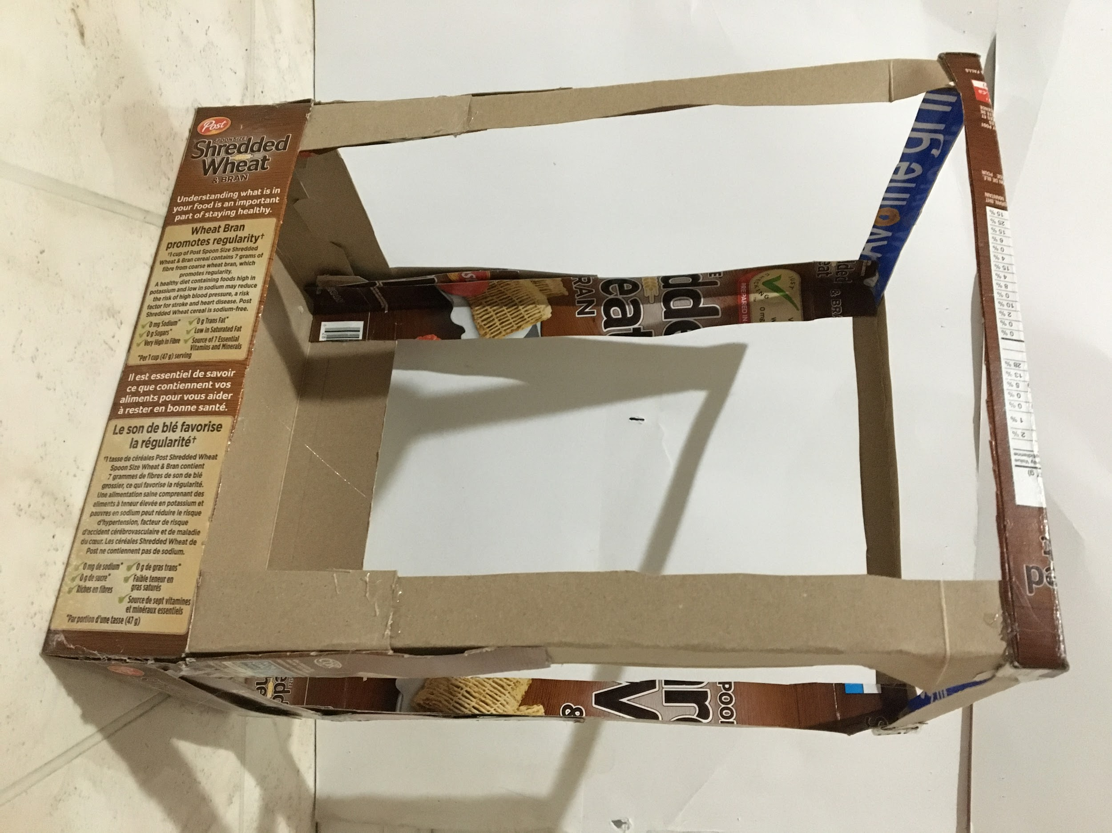  - Create a simple frame out of cereal box material. | 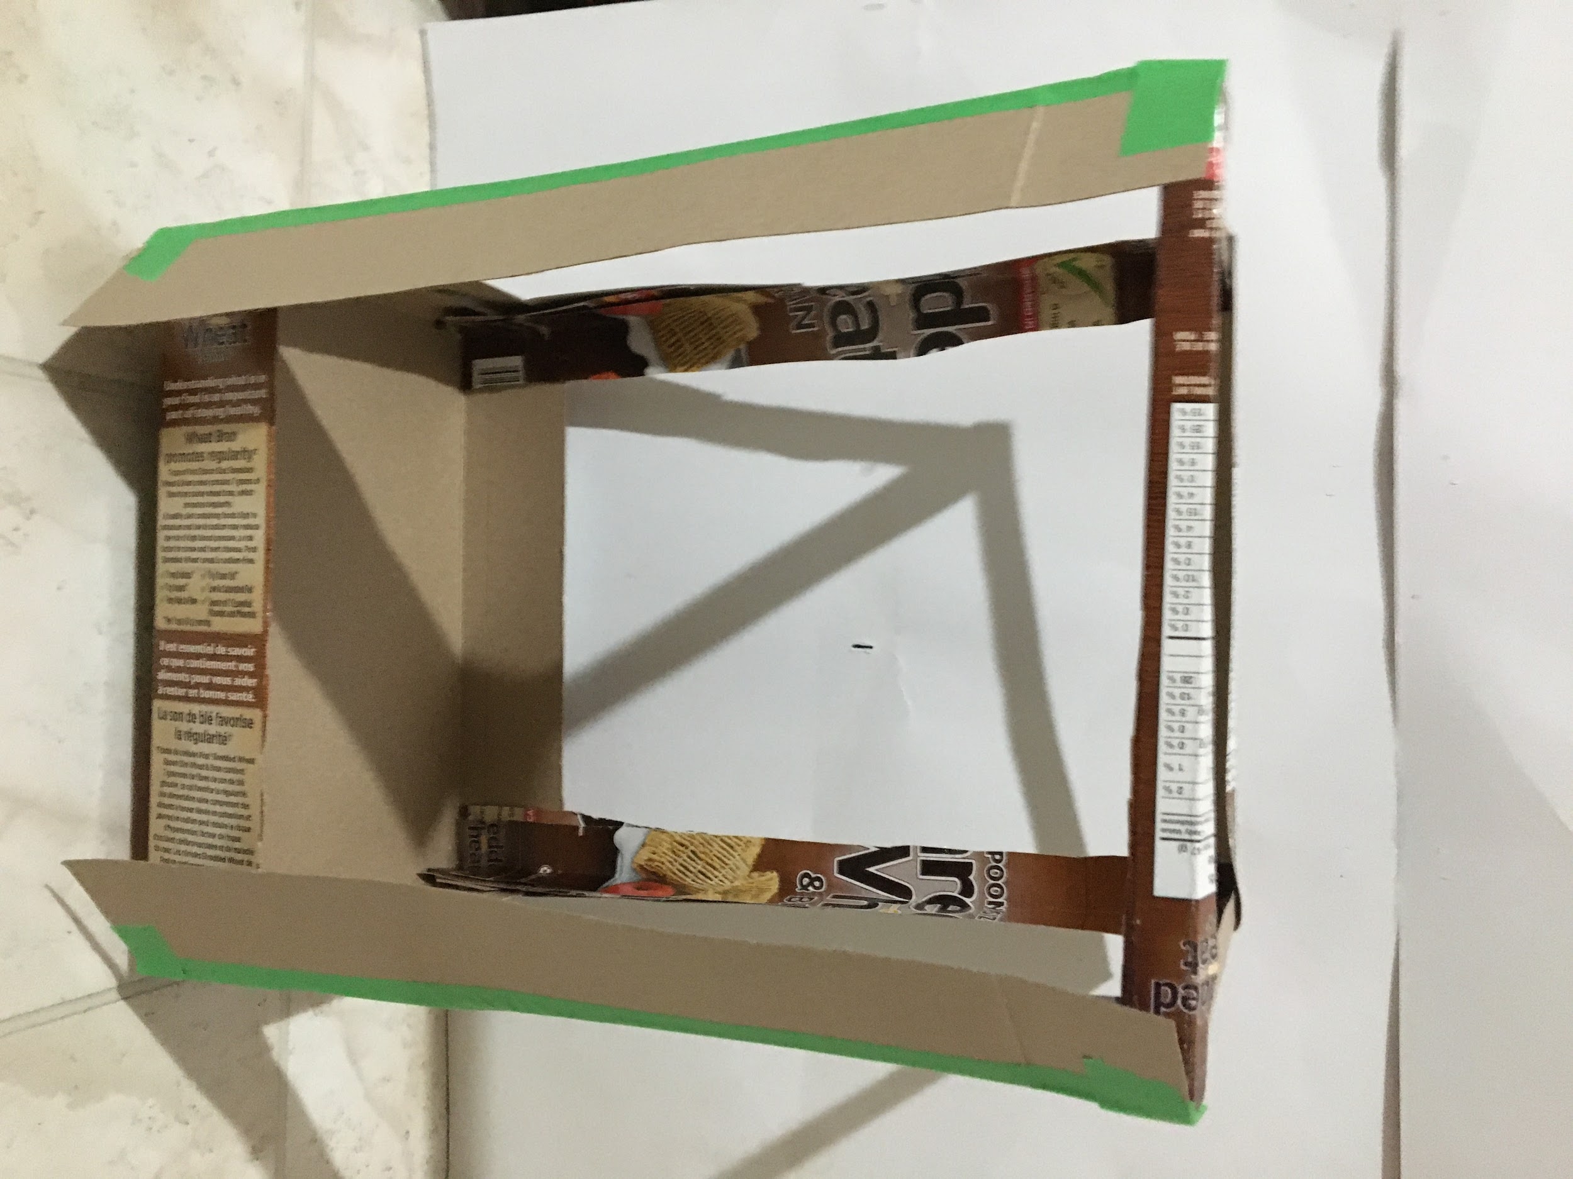  - Install flaps on one side to create a pocket for a sliding door.
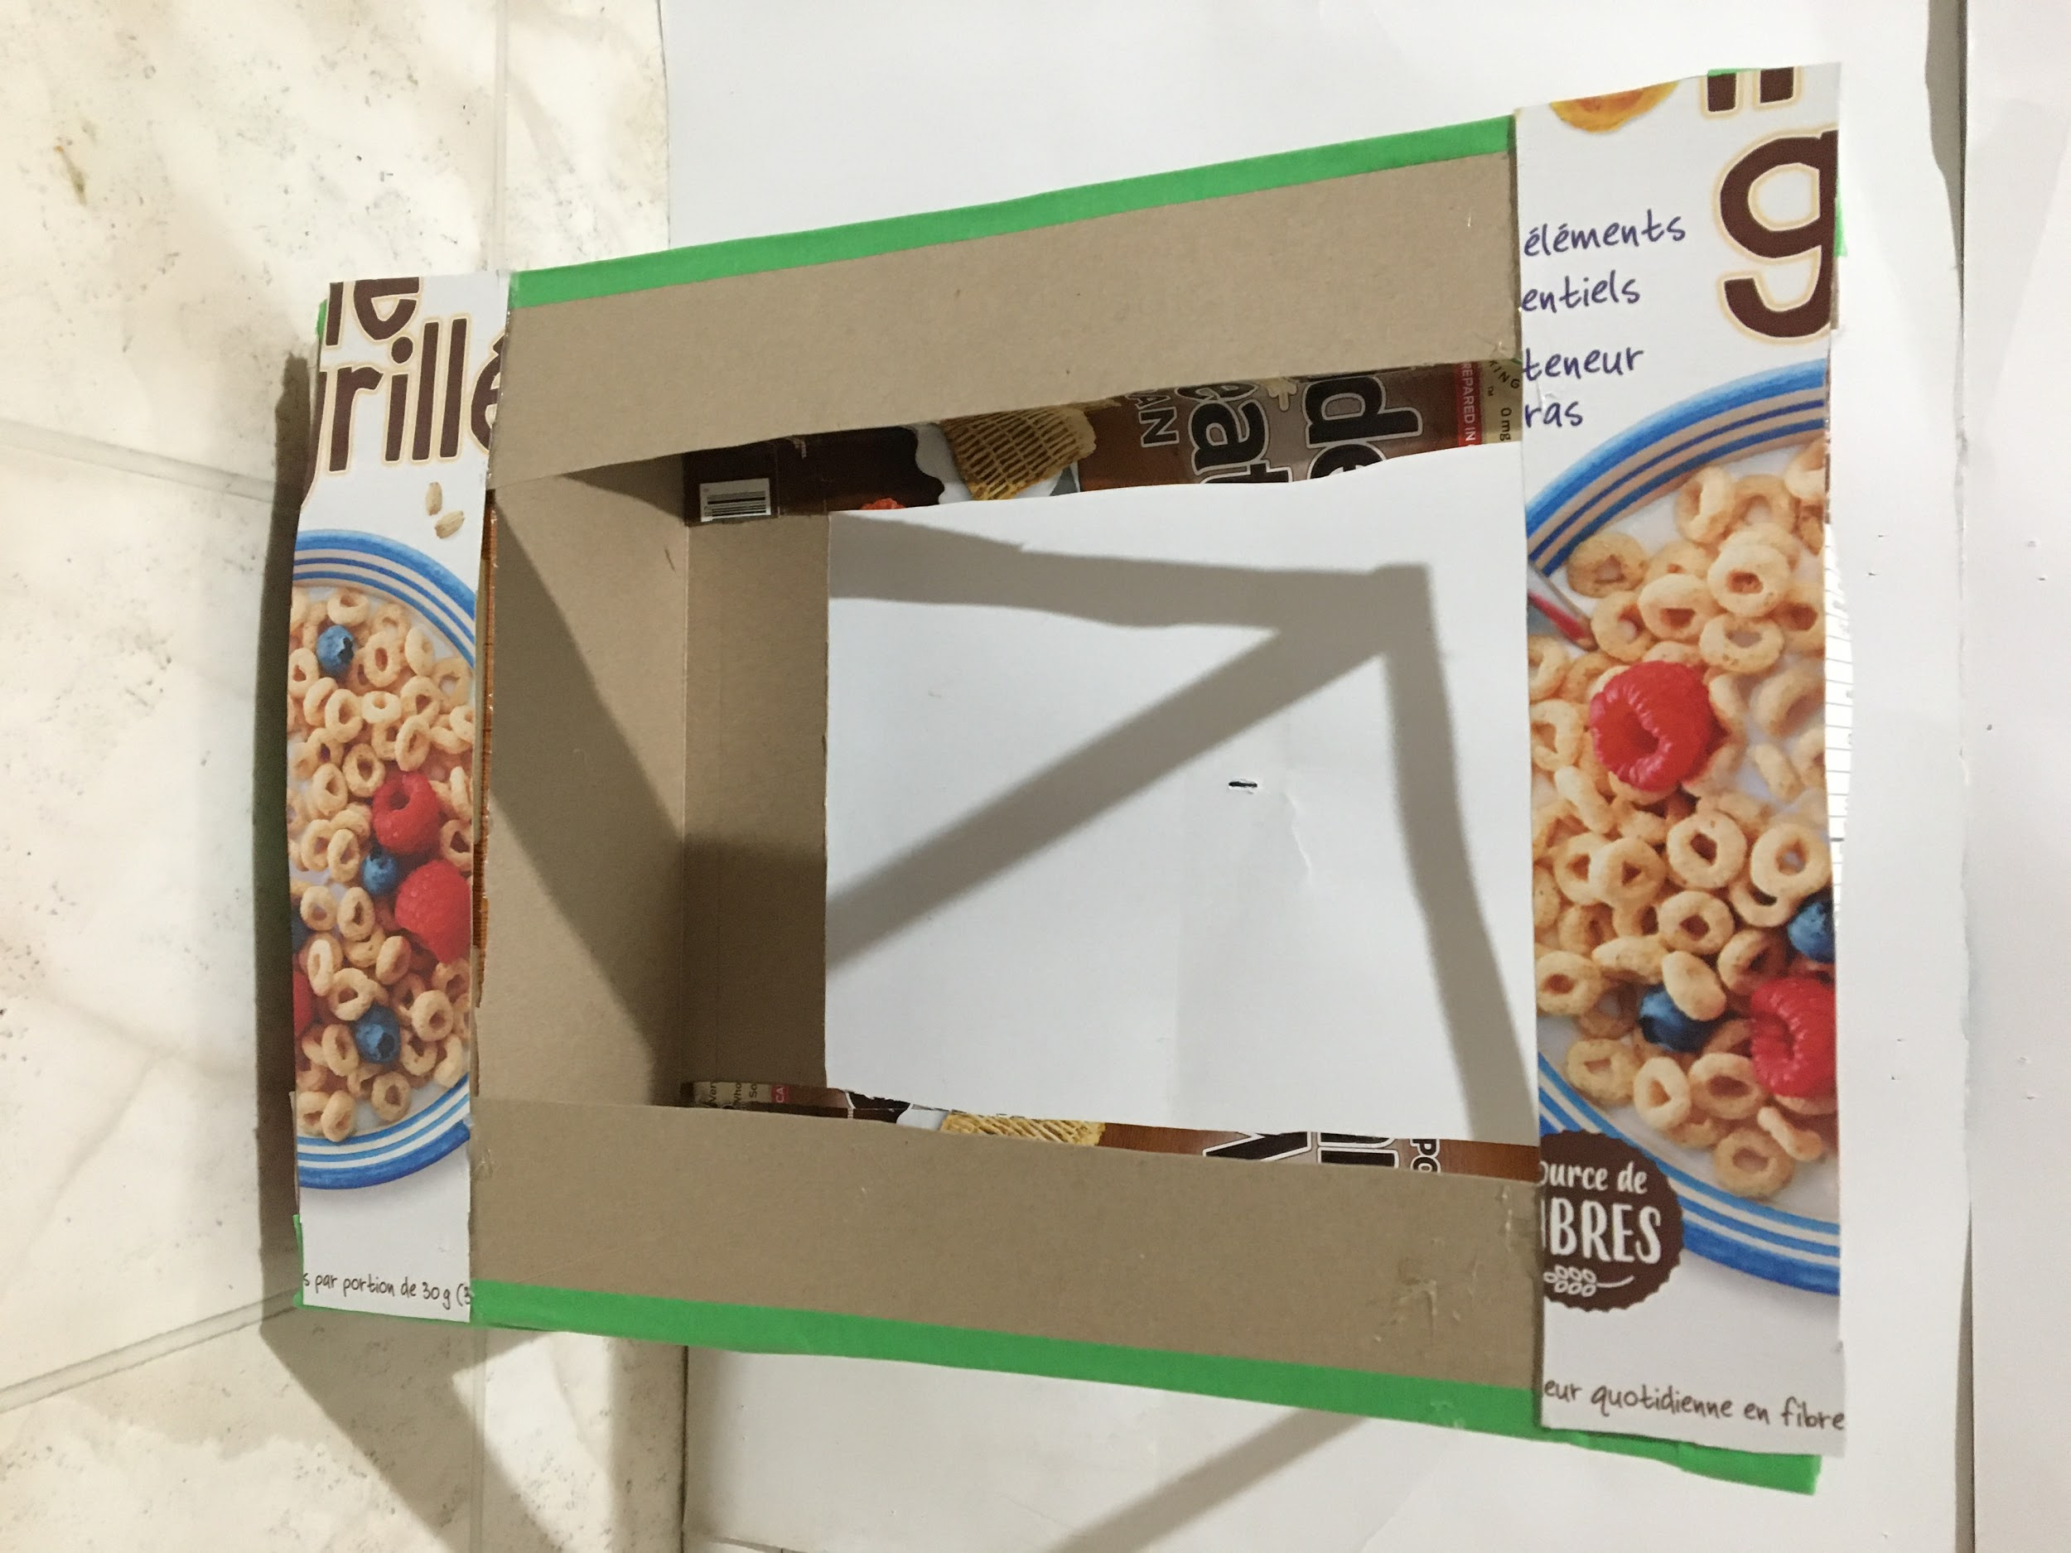  - Install cross piece to hold the pocket flaps in place. | 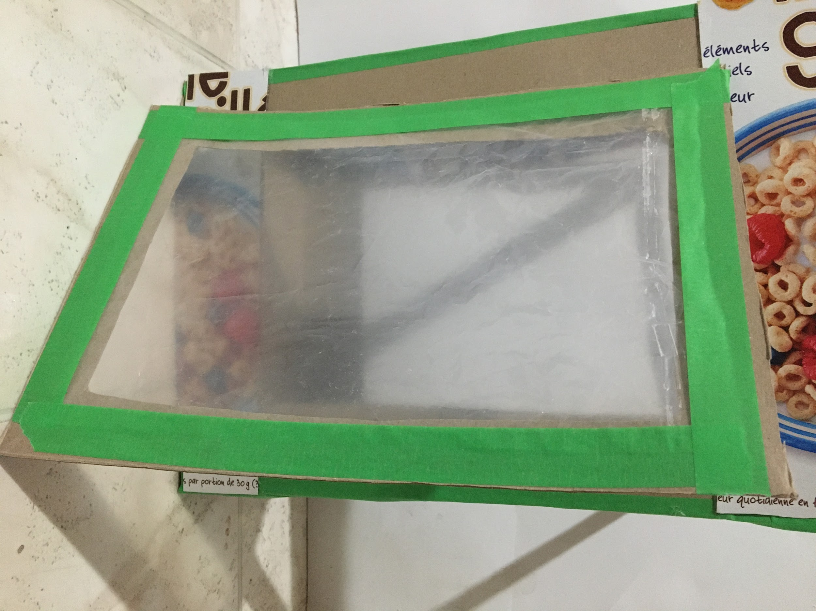  - Cut a frame for the door panel out of cereal box material and install a clear/translucent panel. This panel was cut from the bag that contained the cereal.

Appendix K (continued)
An Example of a Greenhouse Made With Limited Resources

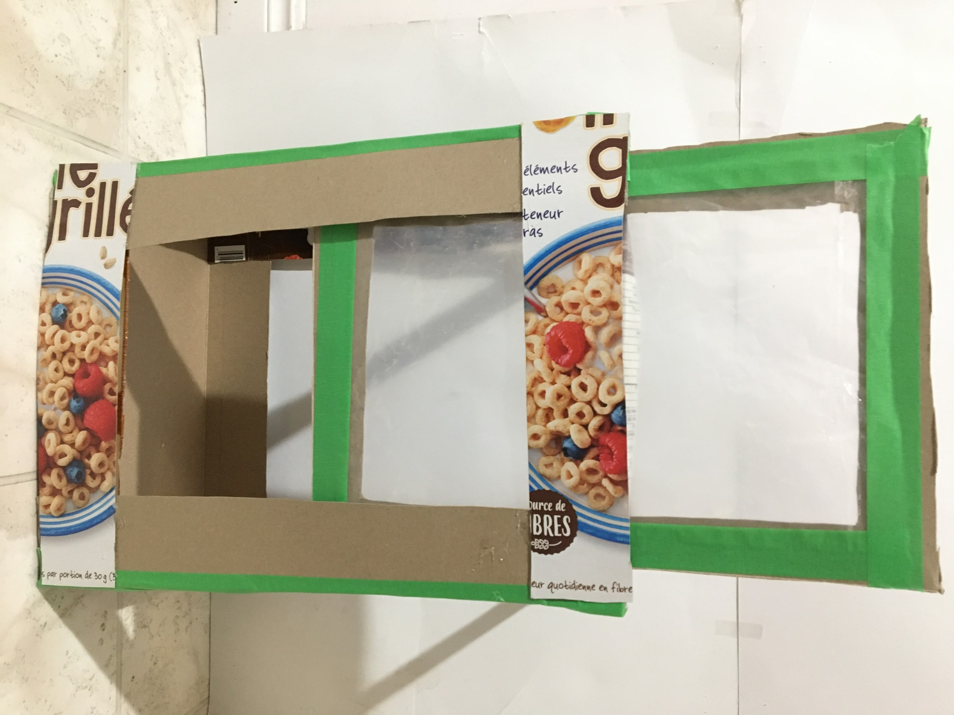  - Install the door by sliding it into the pocket. | 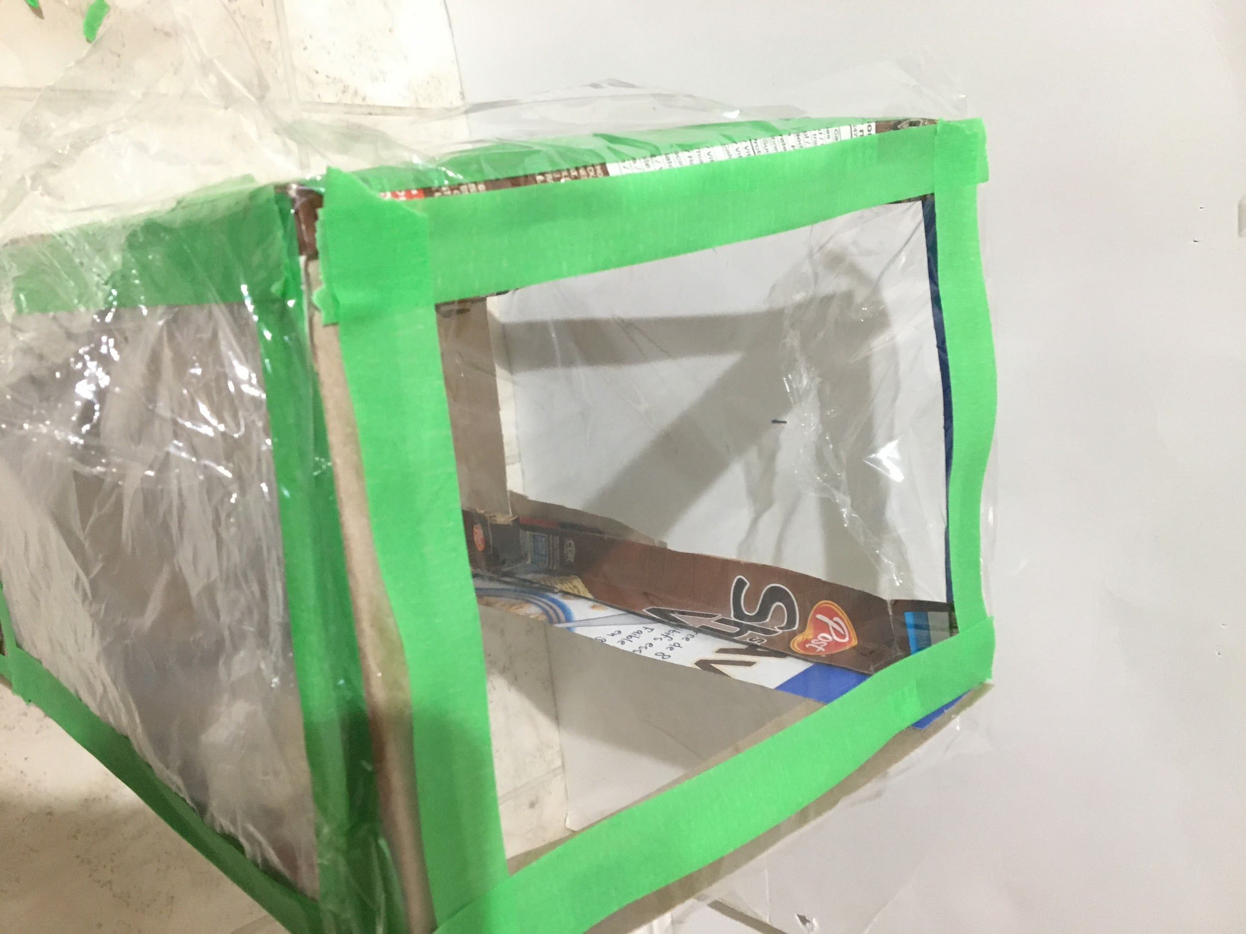  - Place cellophane over a panel. Place tape along the profile edges of the box. Trim the cellophane and tape to size.
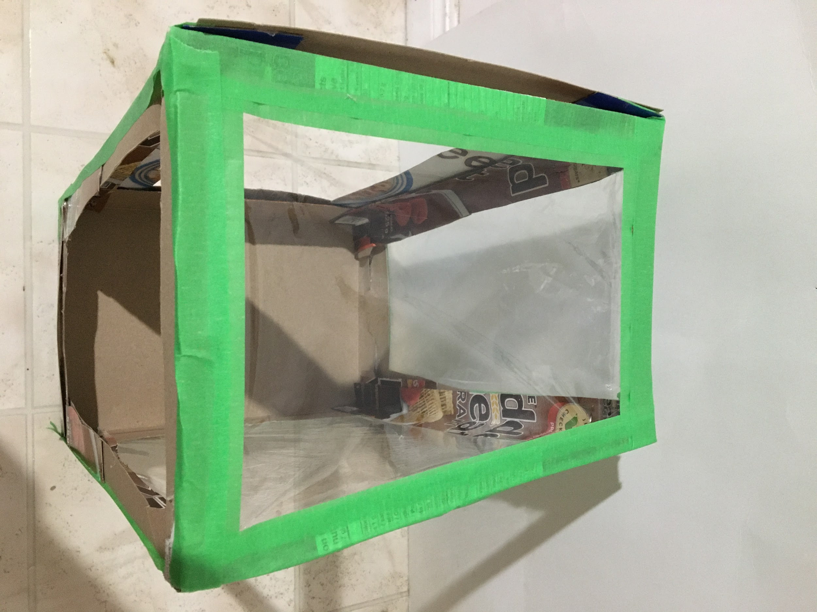  - Tape the trimmed cellophane panel into place. | 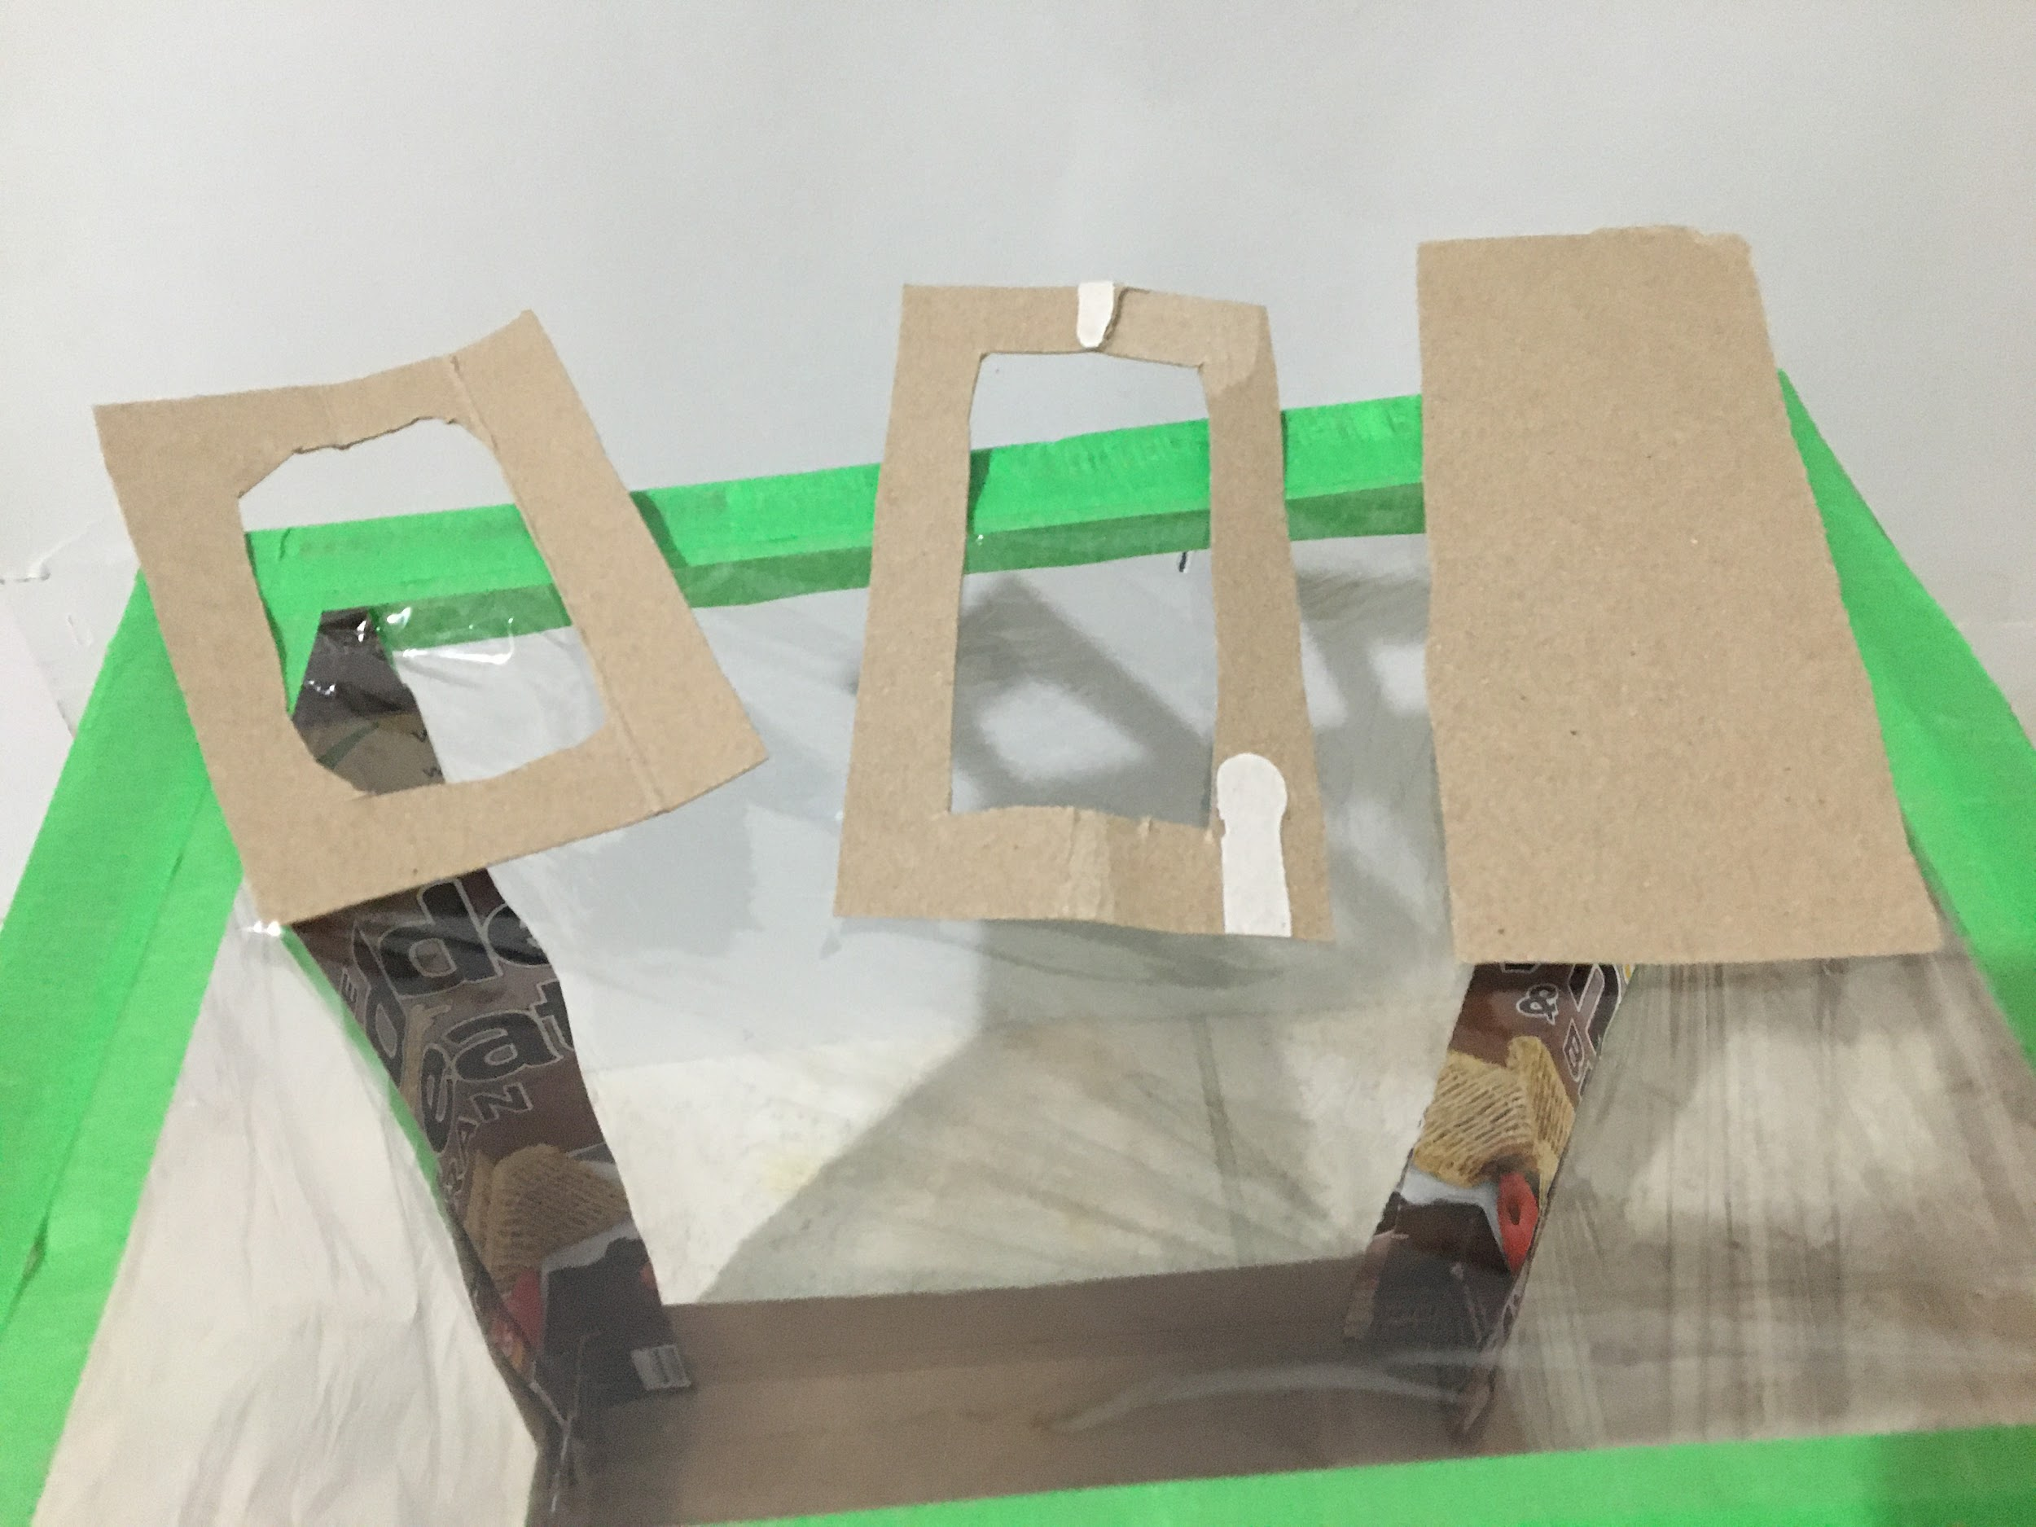  - Cut the pieces required to create a roof vent. This will be a pocket with a sliding gate to adjust the airflow.

Appendix K (continued)
An Example of a Greenhouse Made With Limited Resources

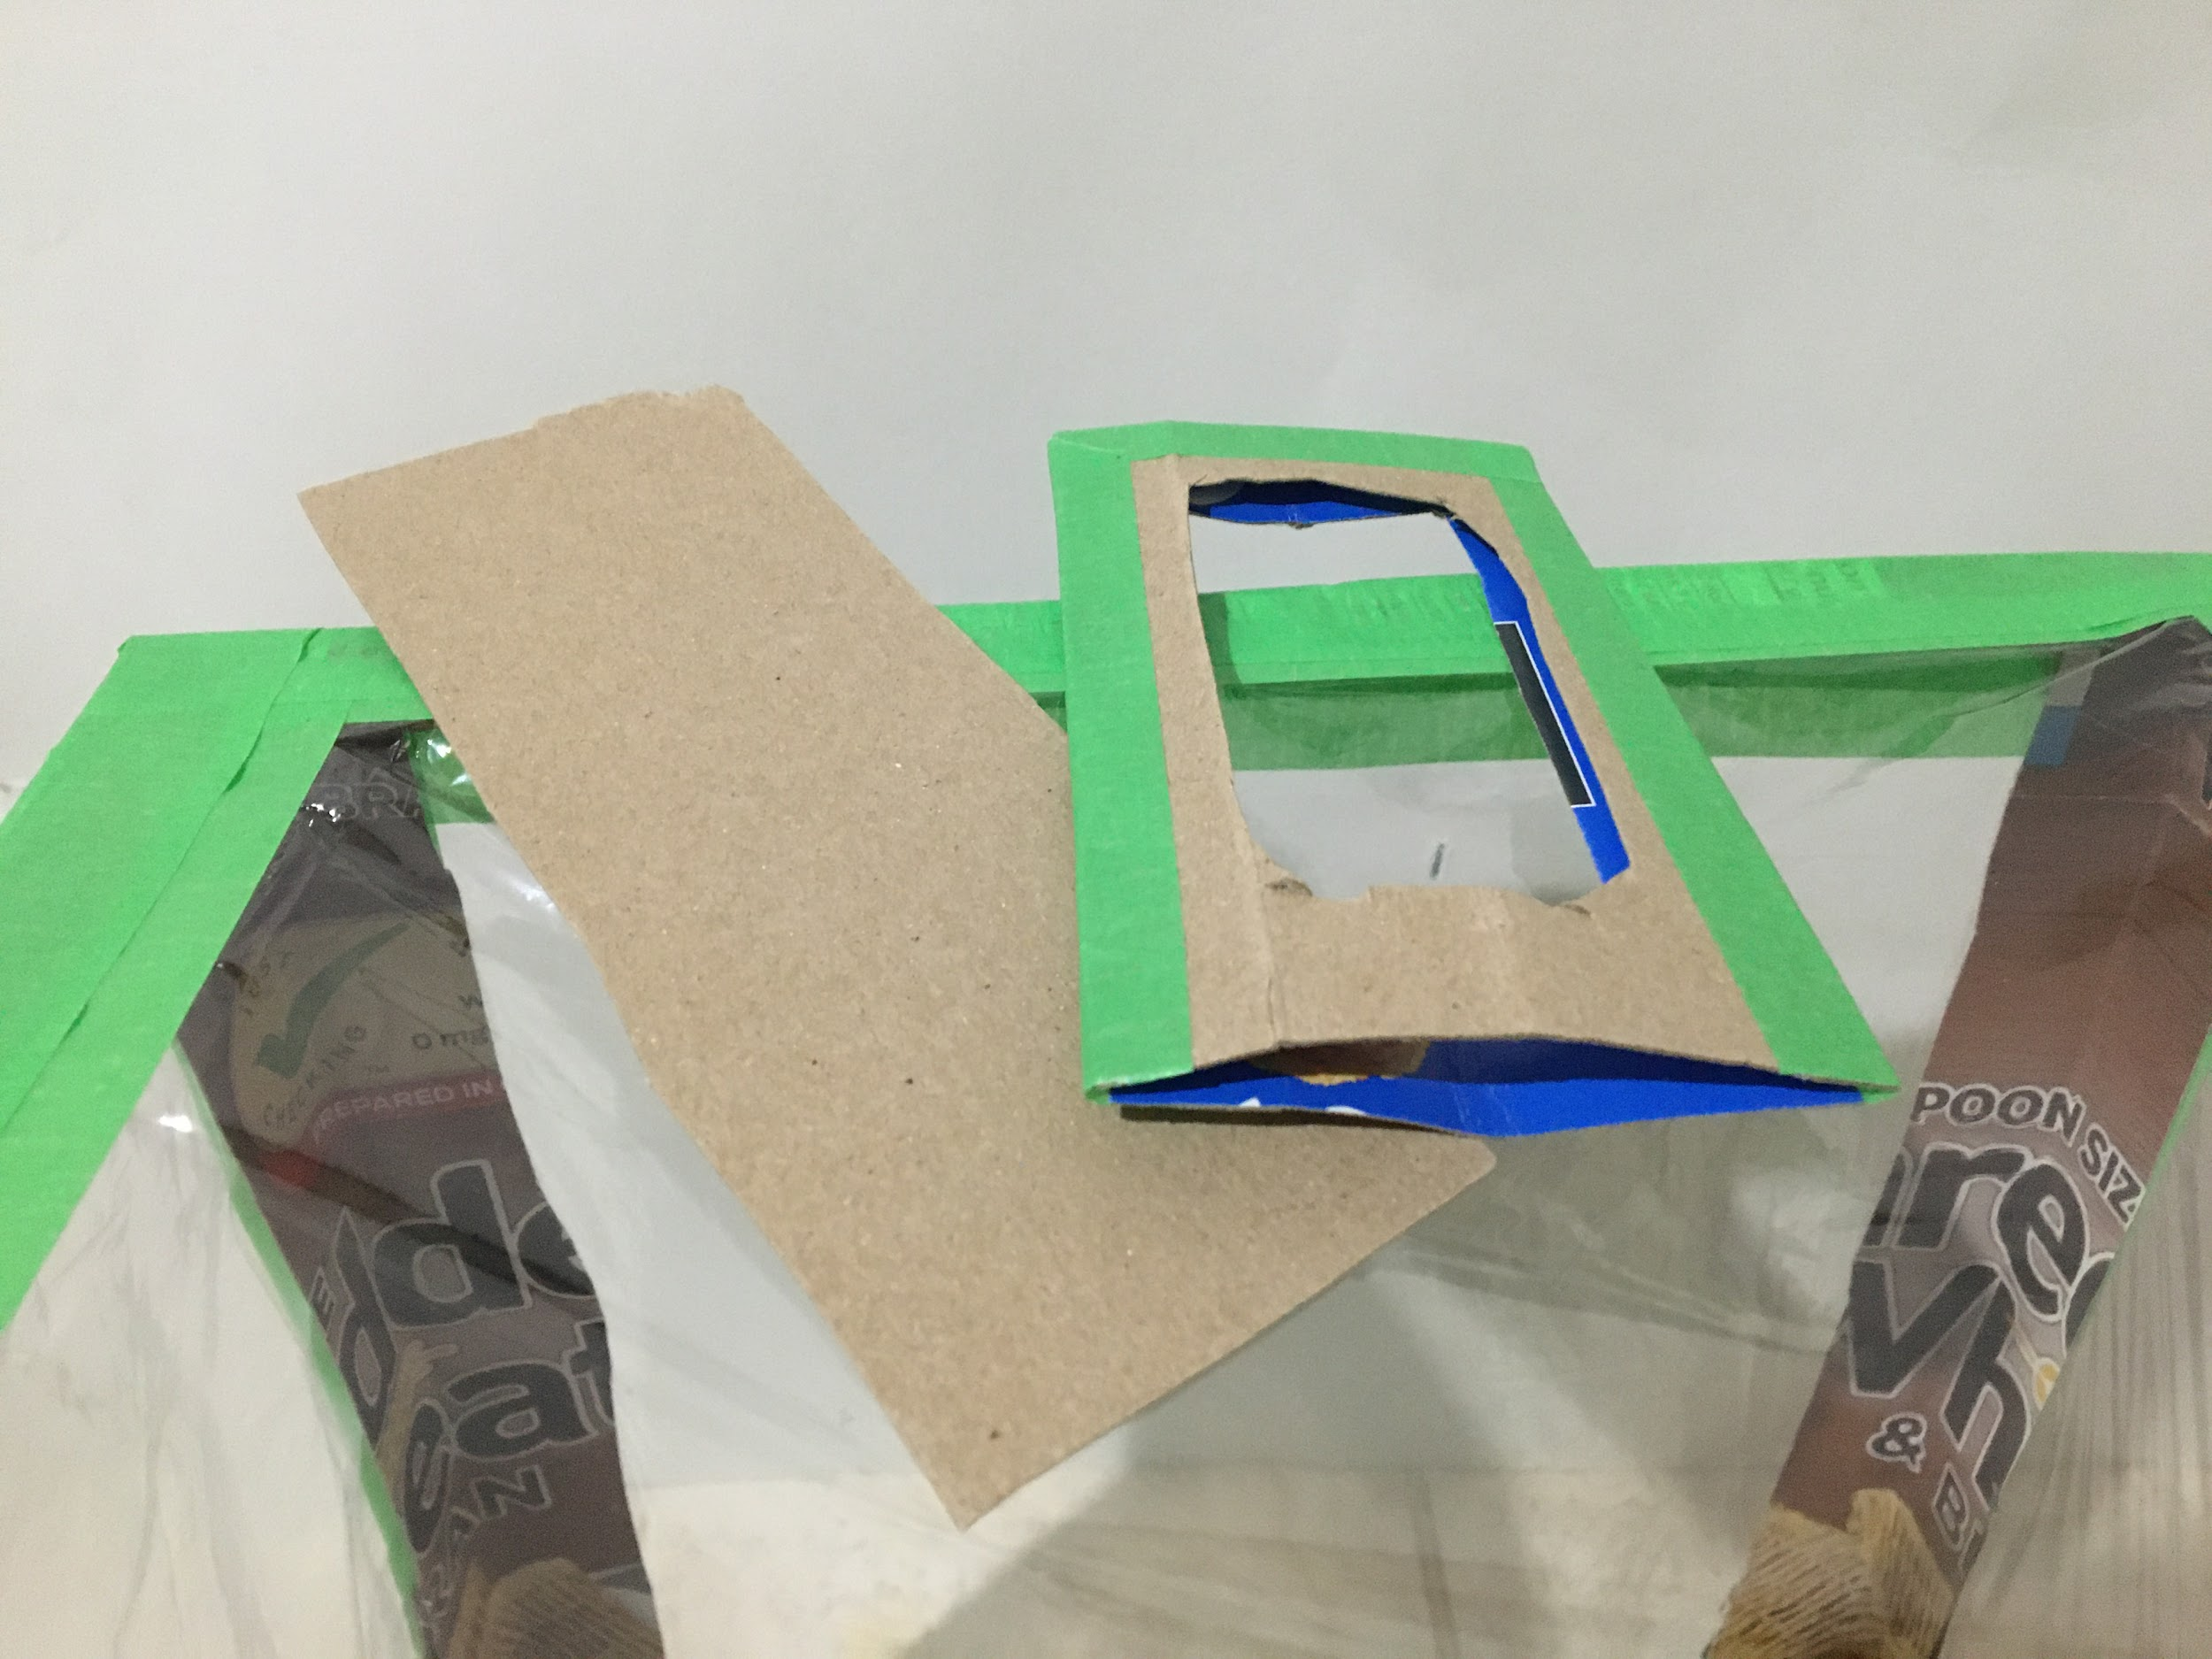  - Tape the pocket together to form your ventilation gate. | 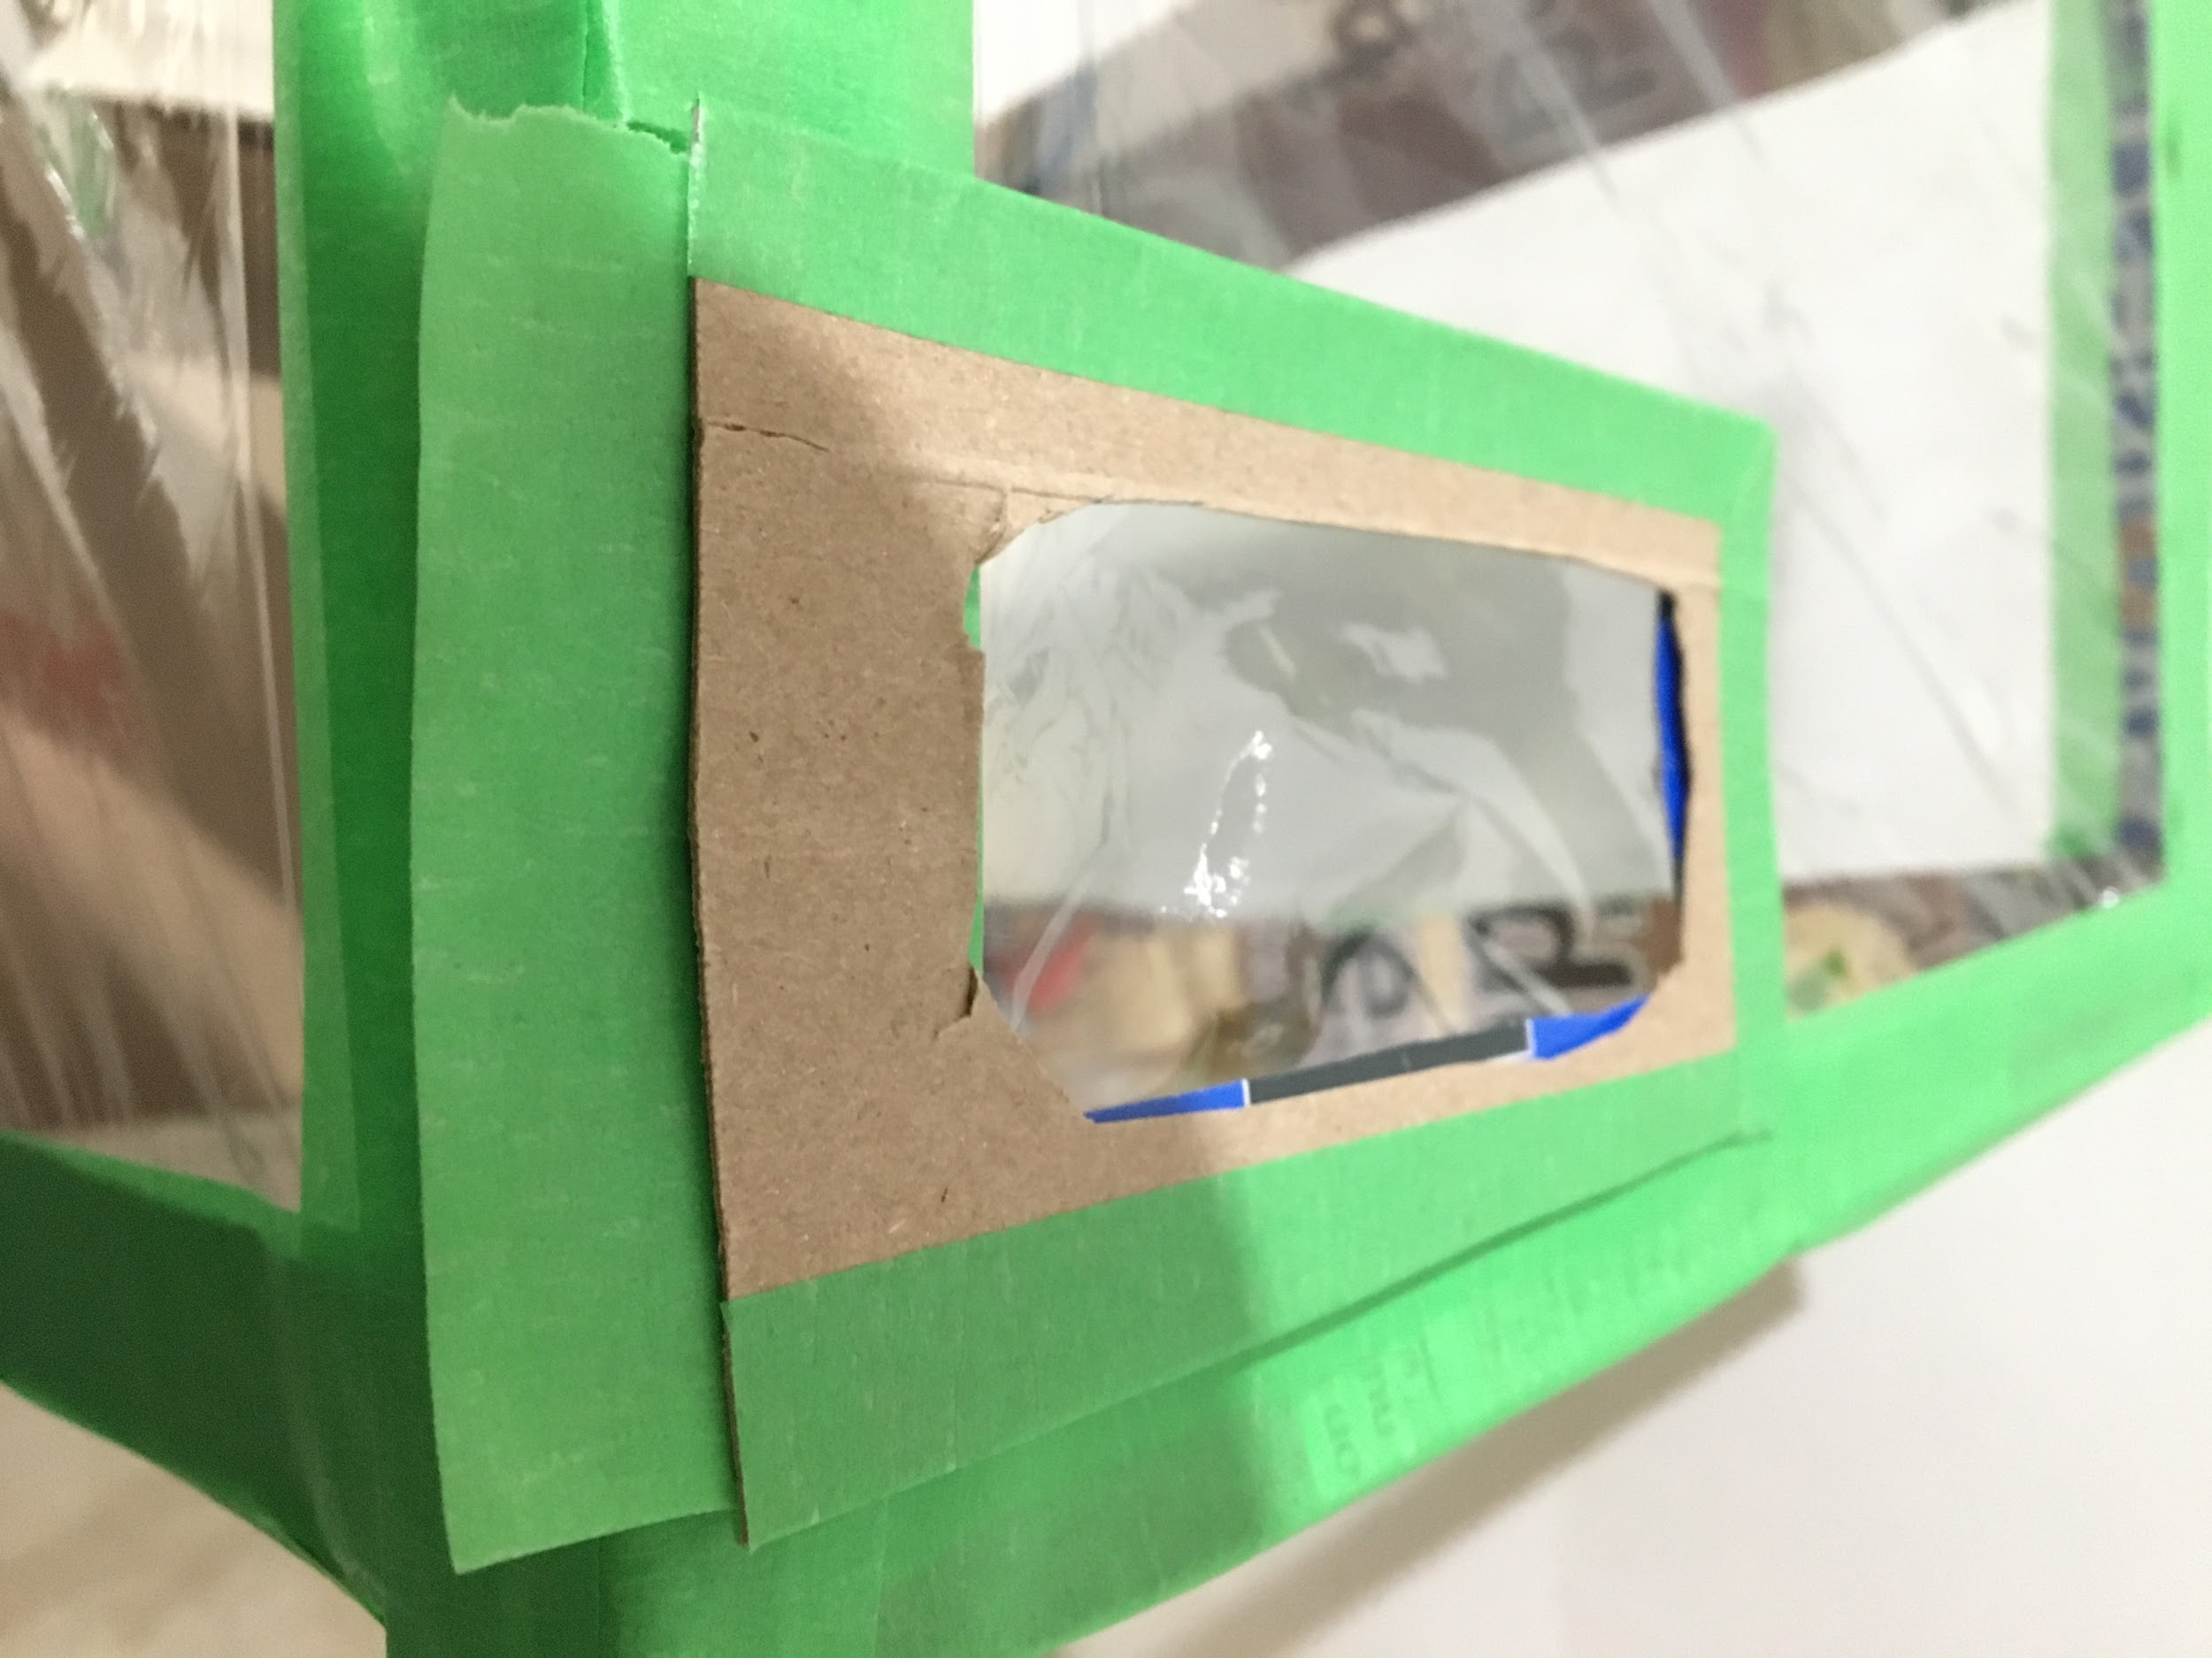  - Tape the pocket to a corner on the roof. Use two sides of the frame to provide support for the ventilation gate holder.
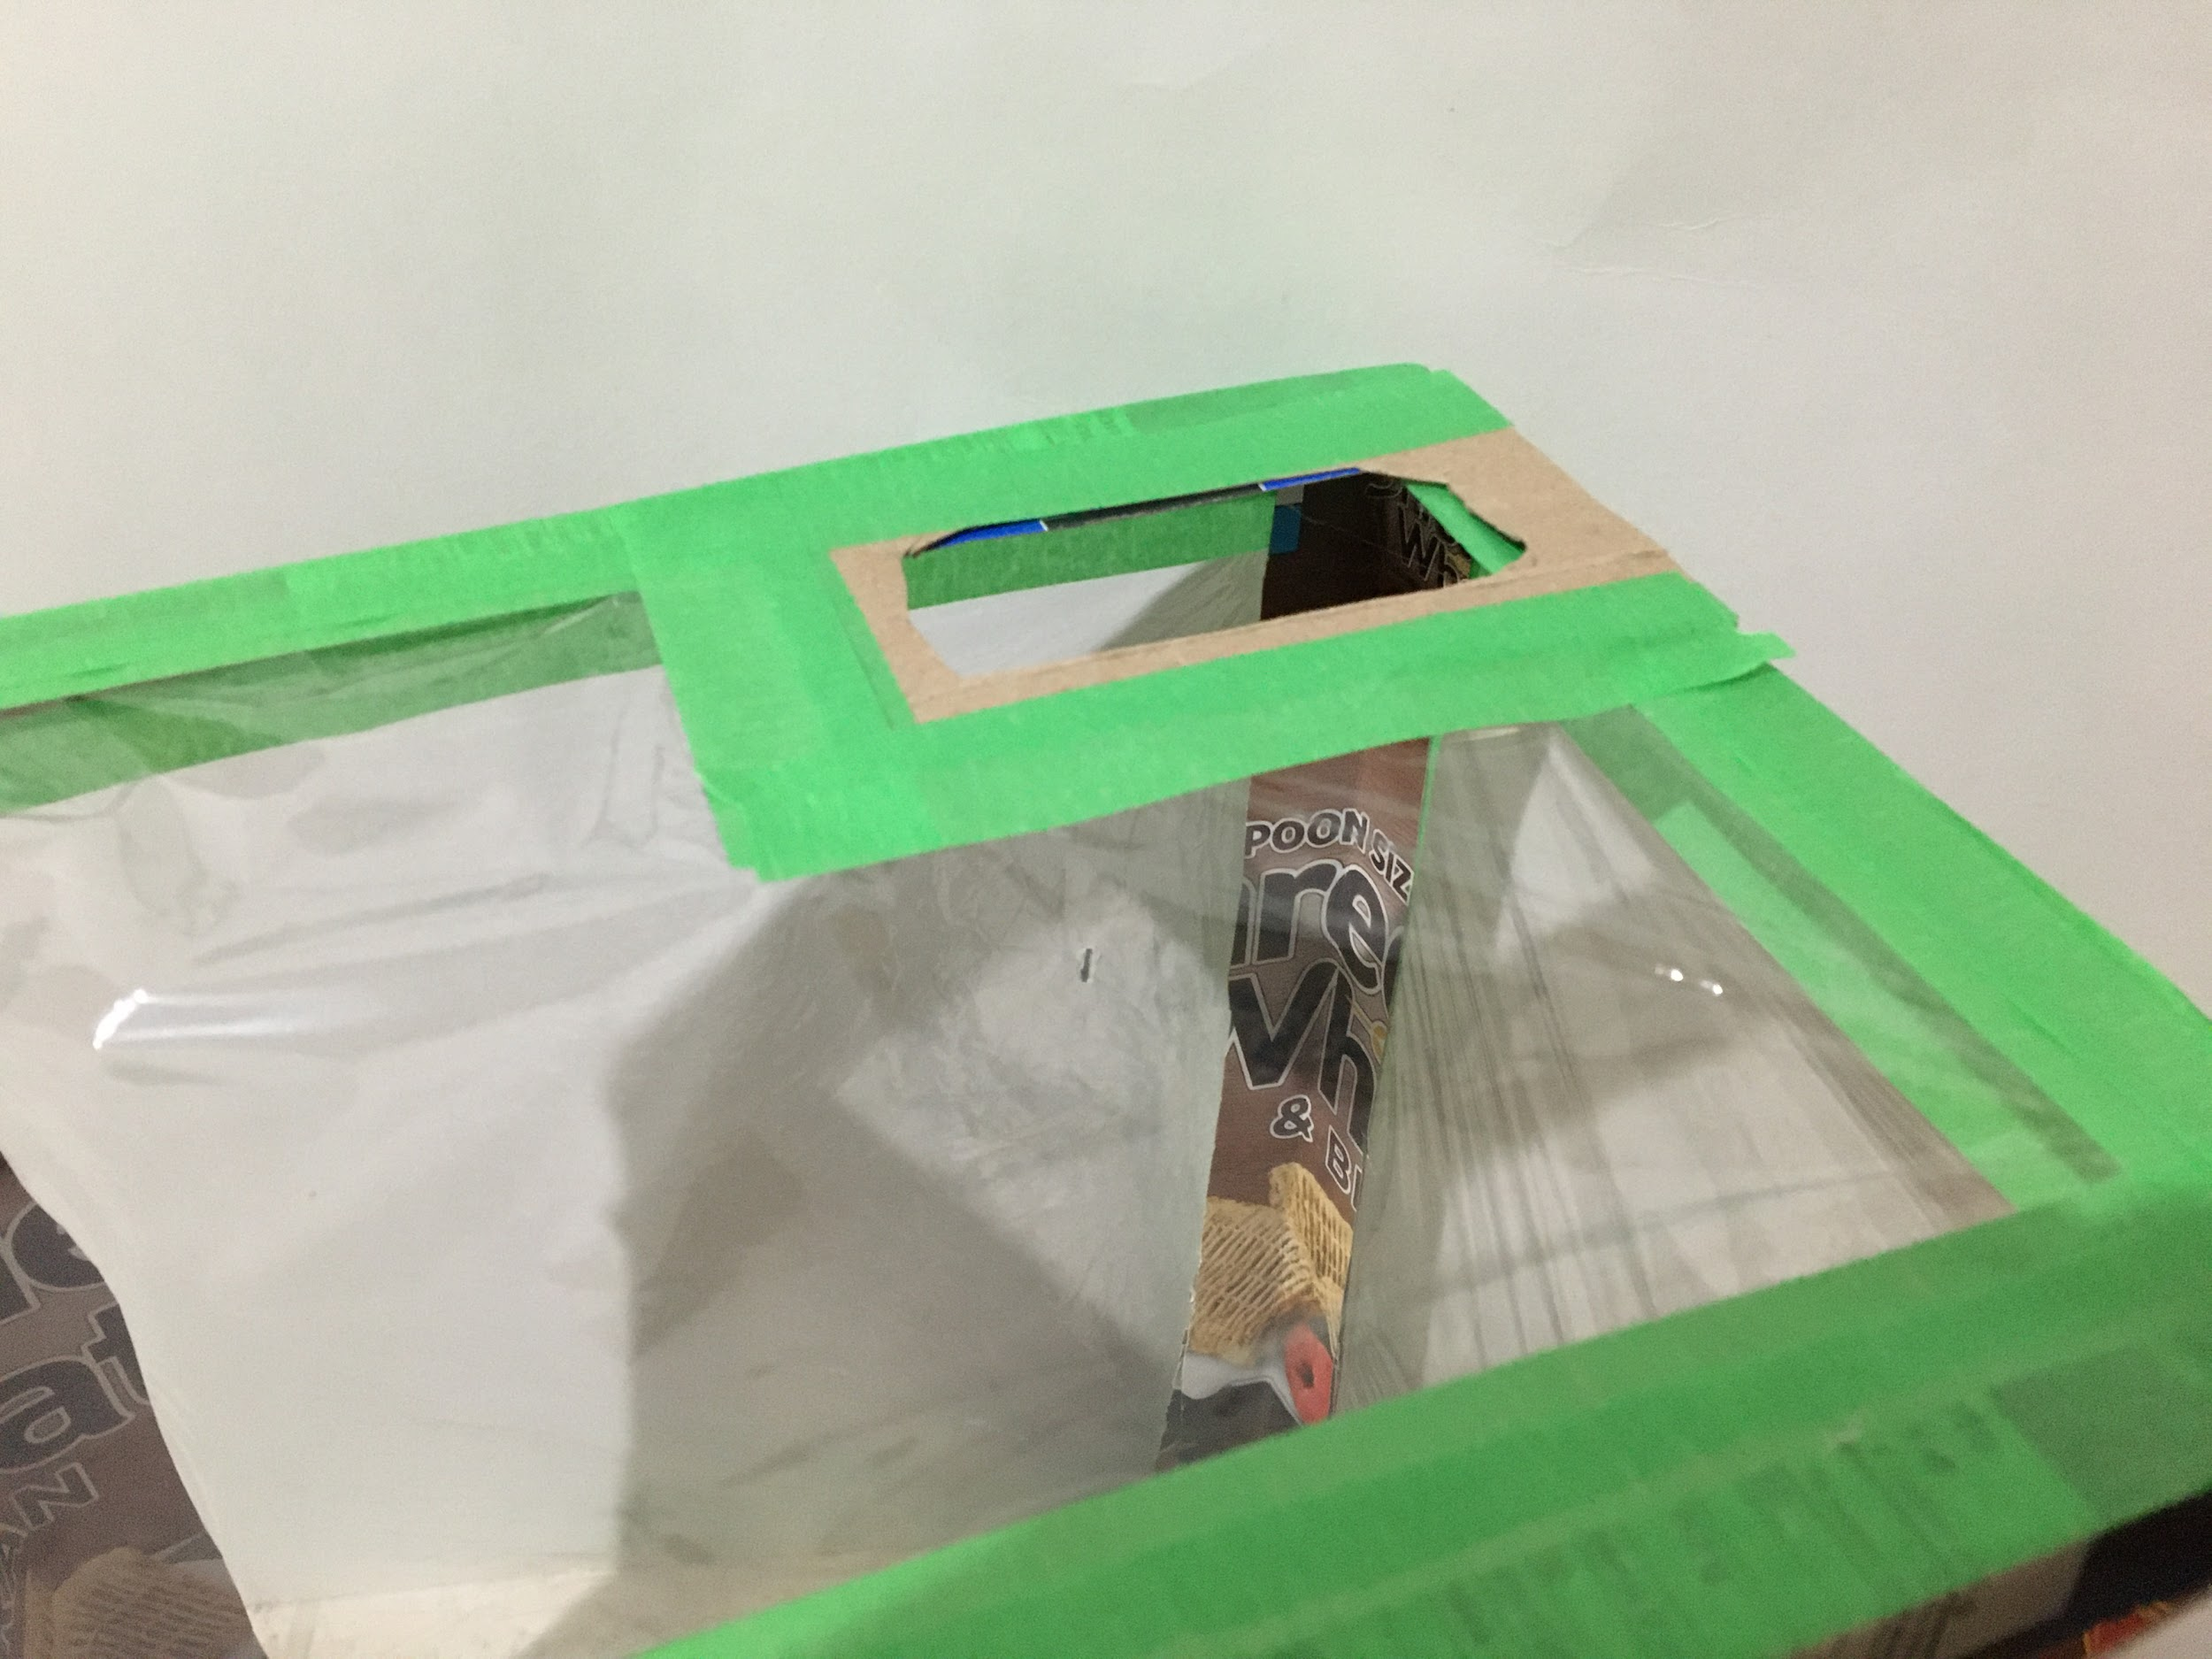  - After the ventilation gate holder is in place, remove the cellophane that is blocking the hole. | 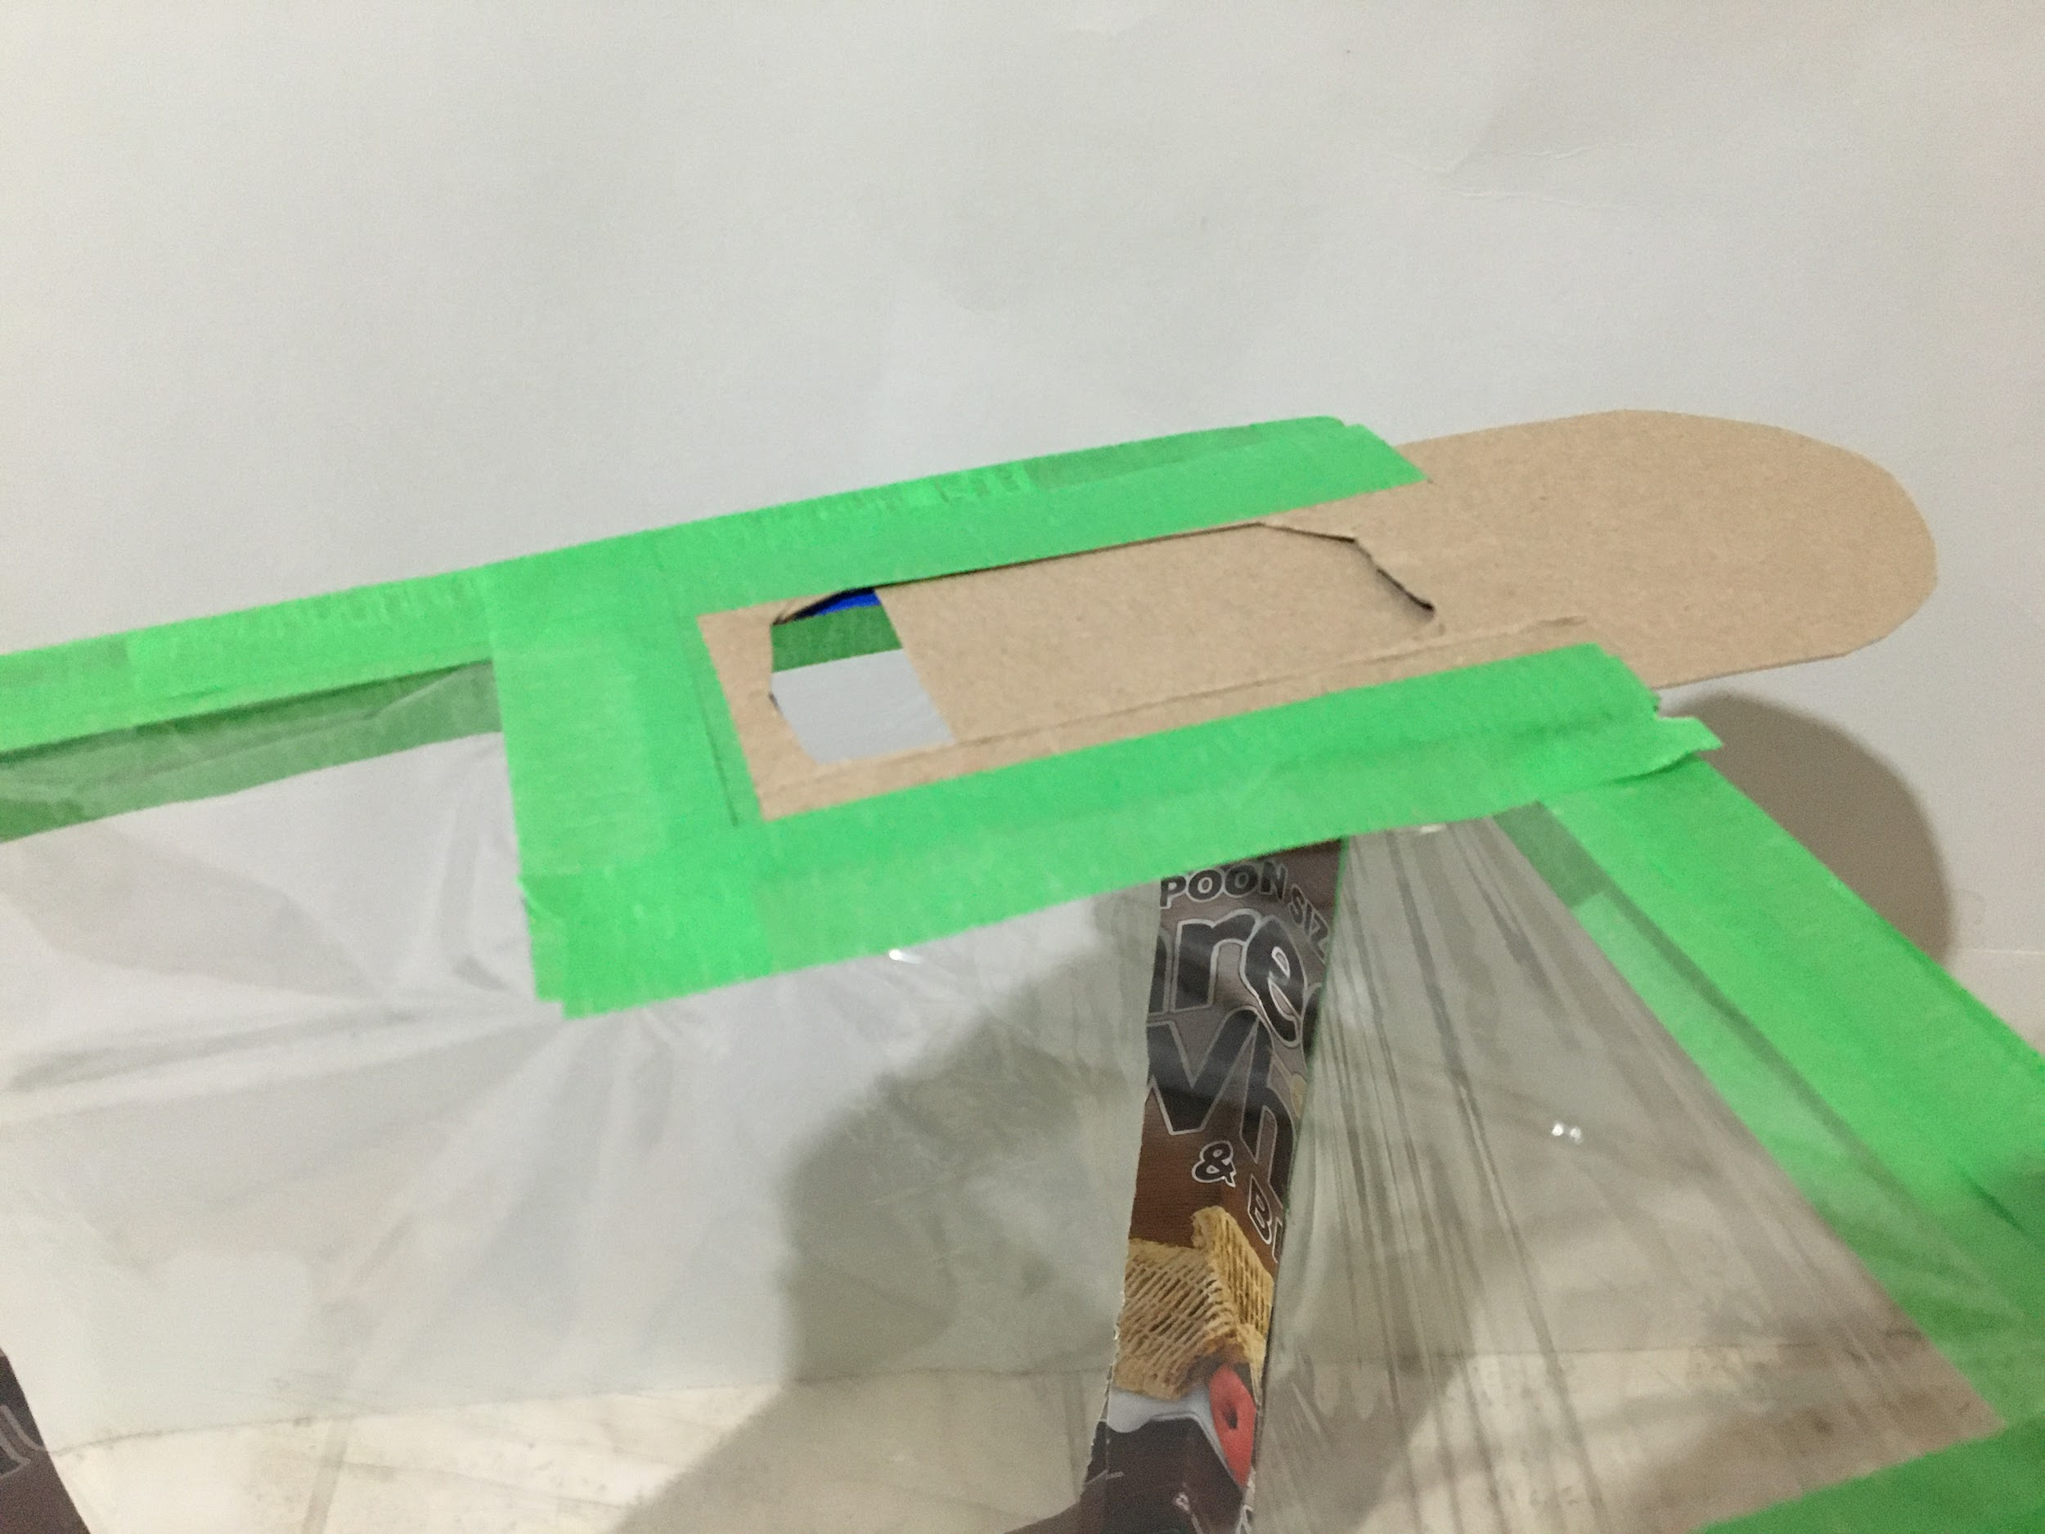  - Install the sliding ventilation gate.

Appendix K (continued)
An Example of a Greenhouse Made With Limited Resources

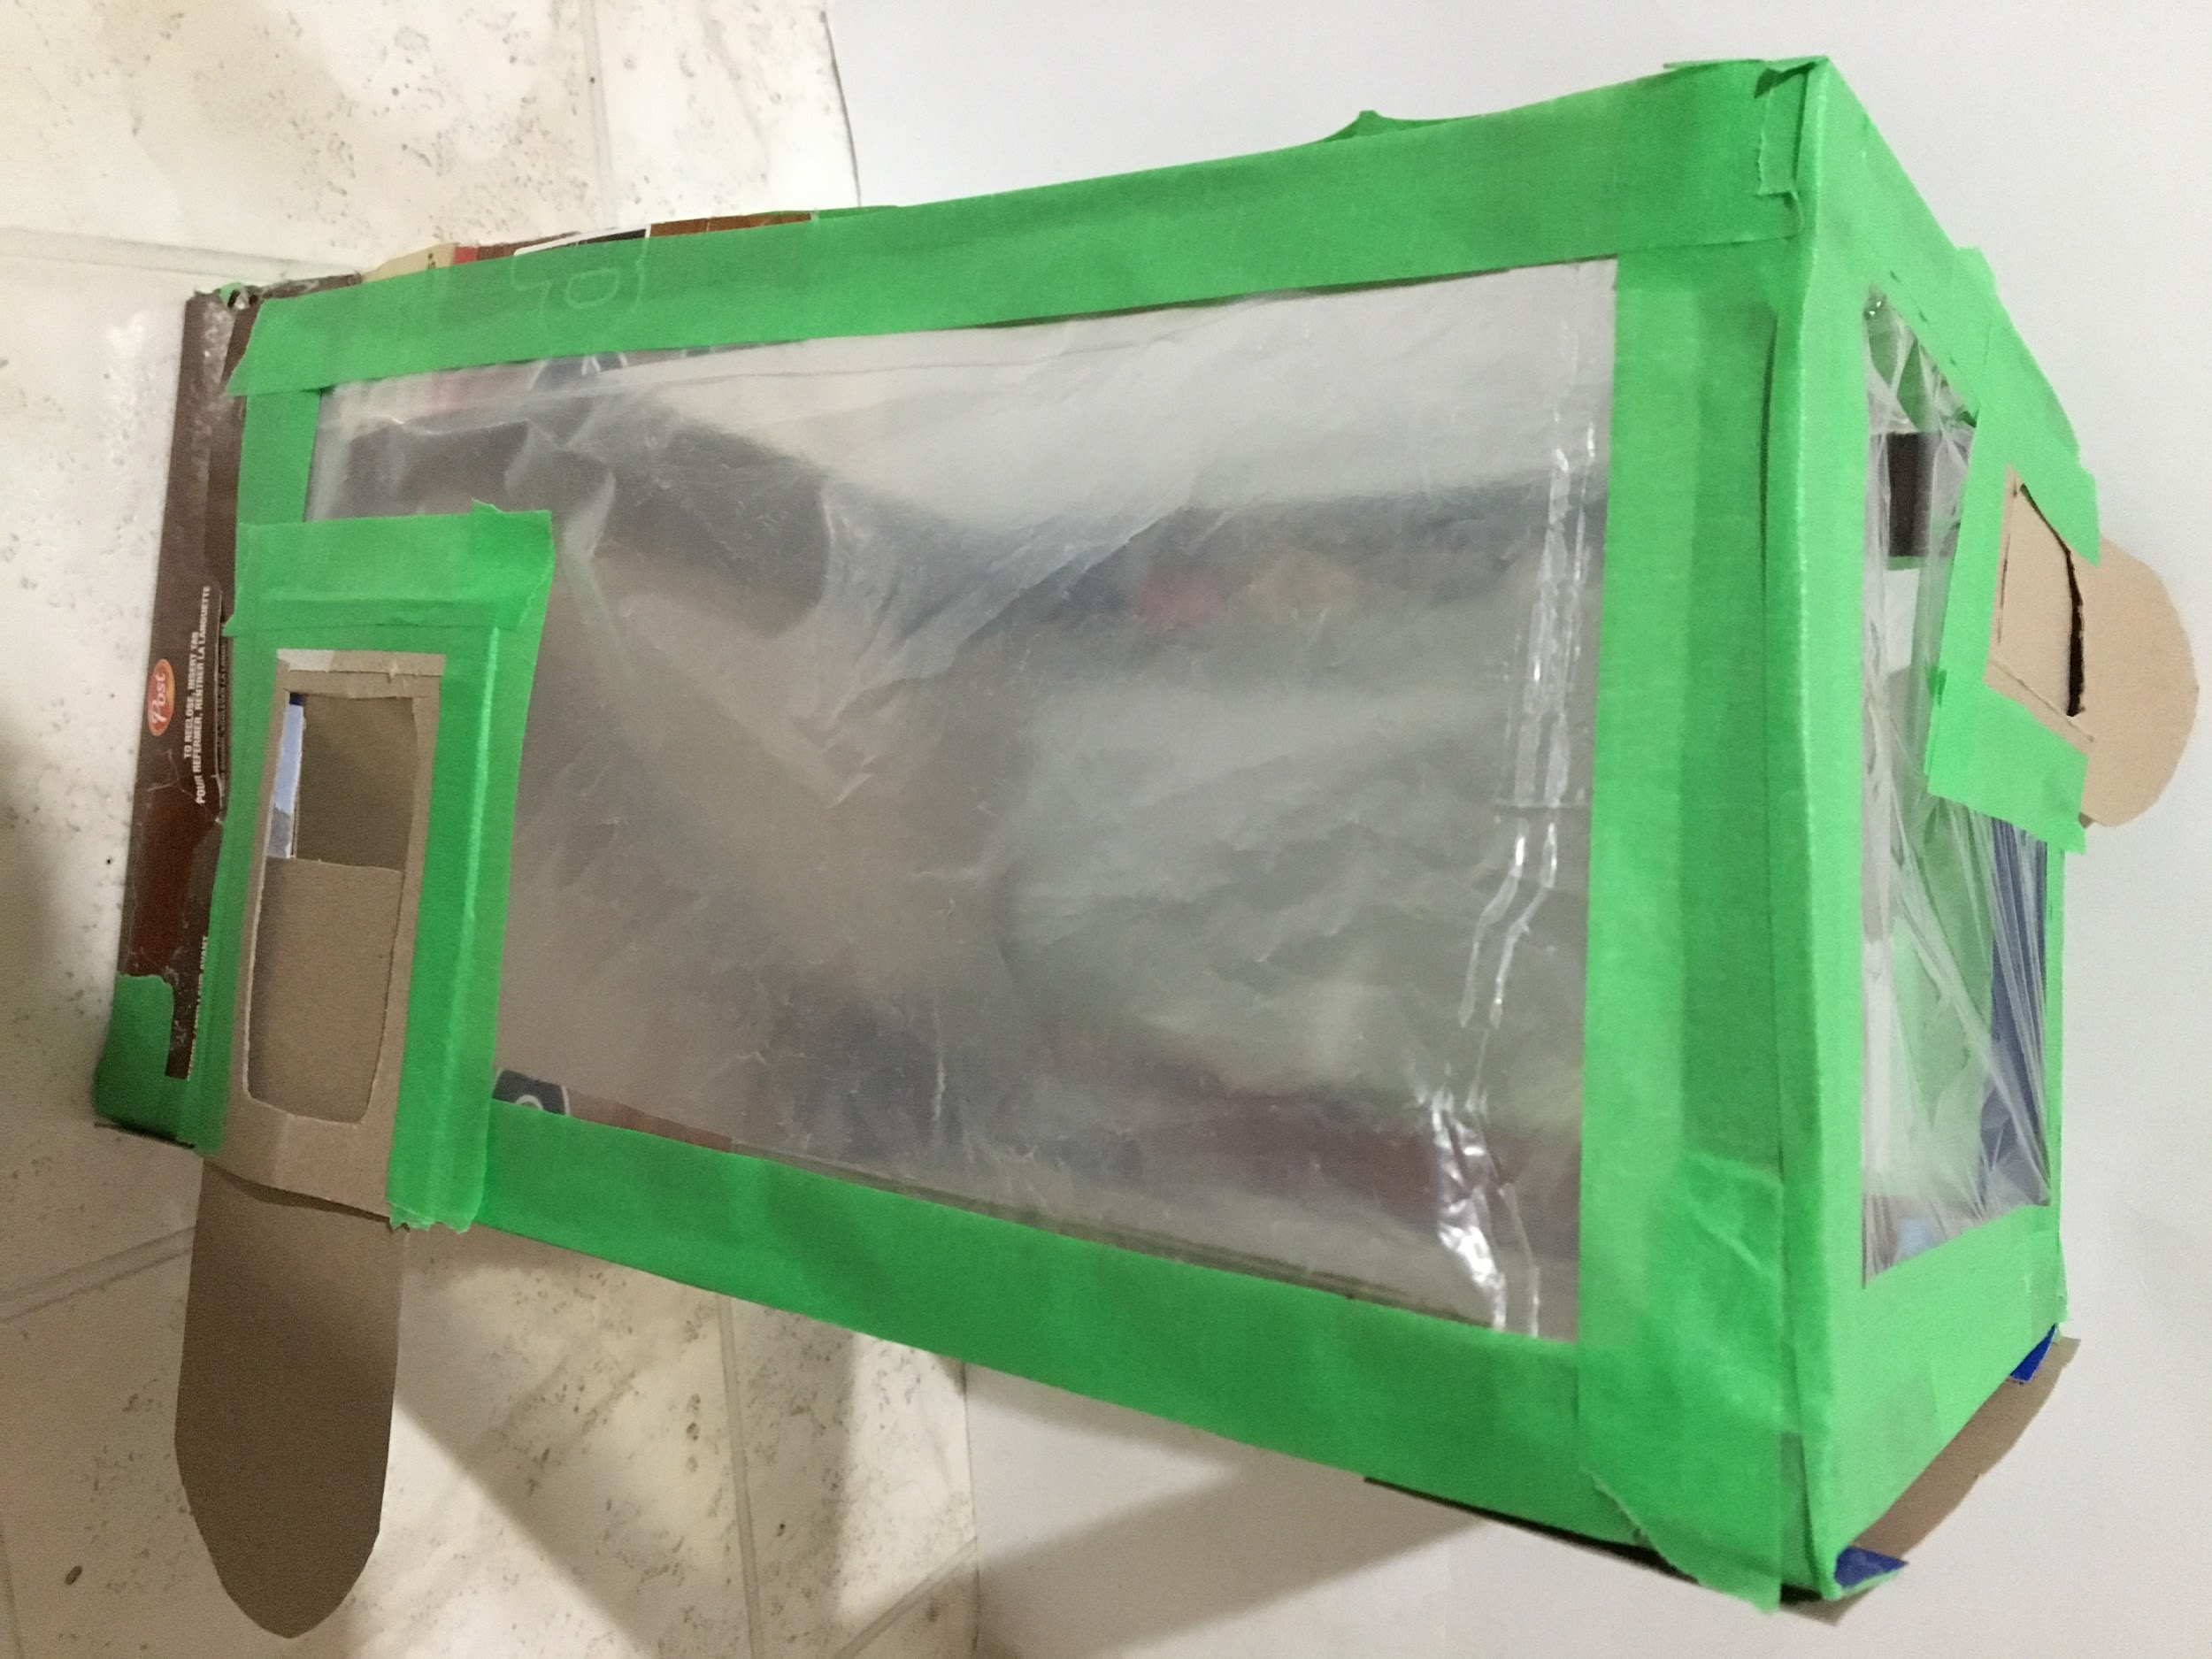  - Fabricate and install a second ventilation gate at the bottom corner, opposite from the ventilation gate on the roof. | 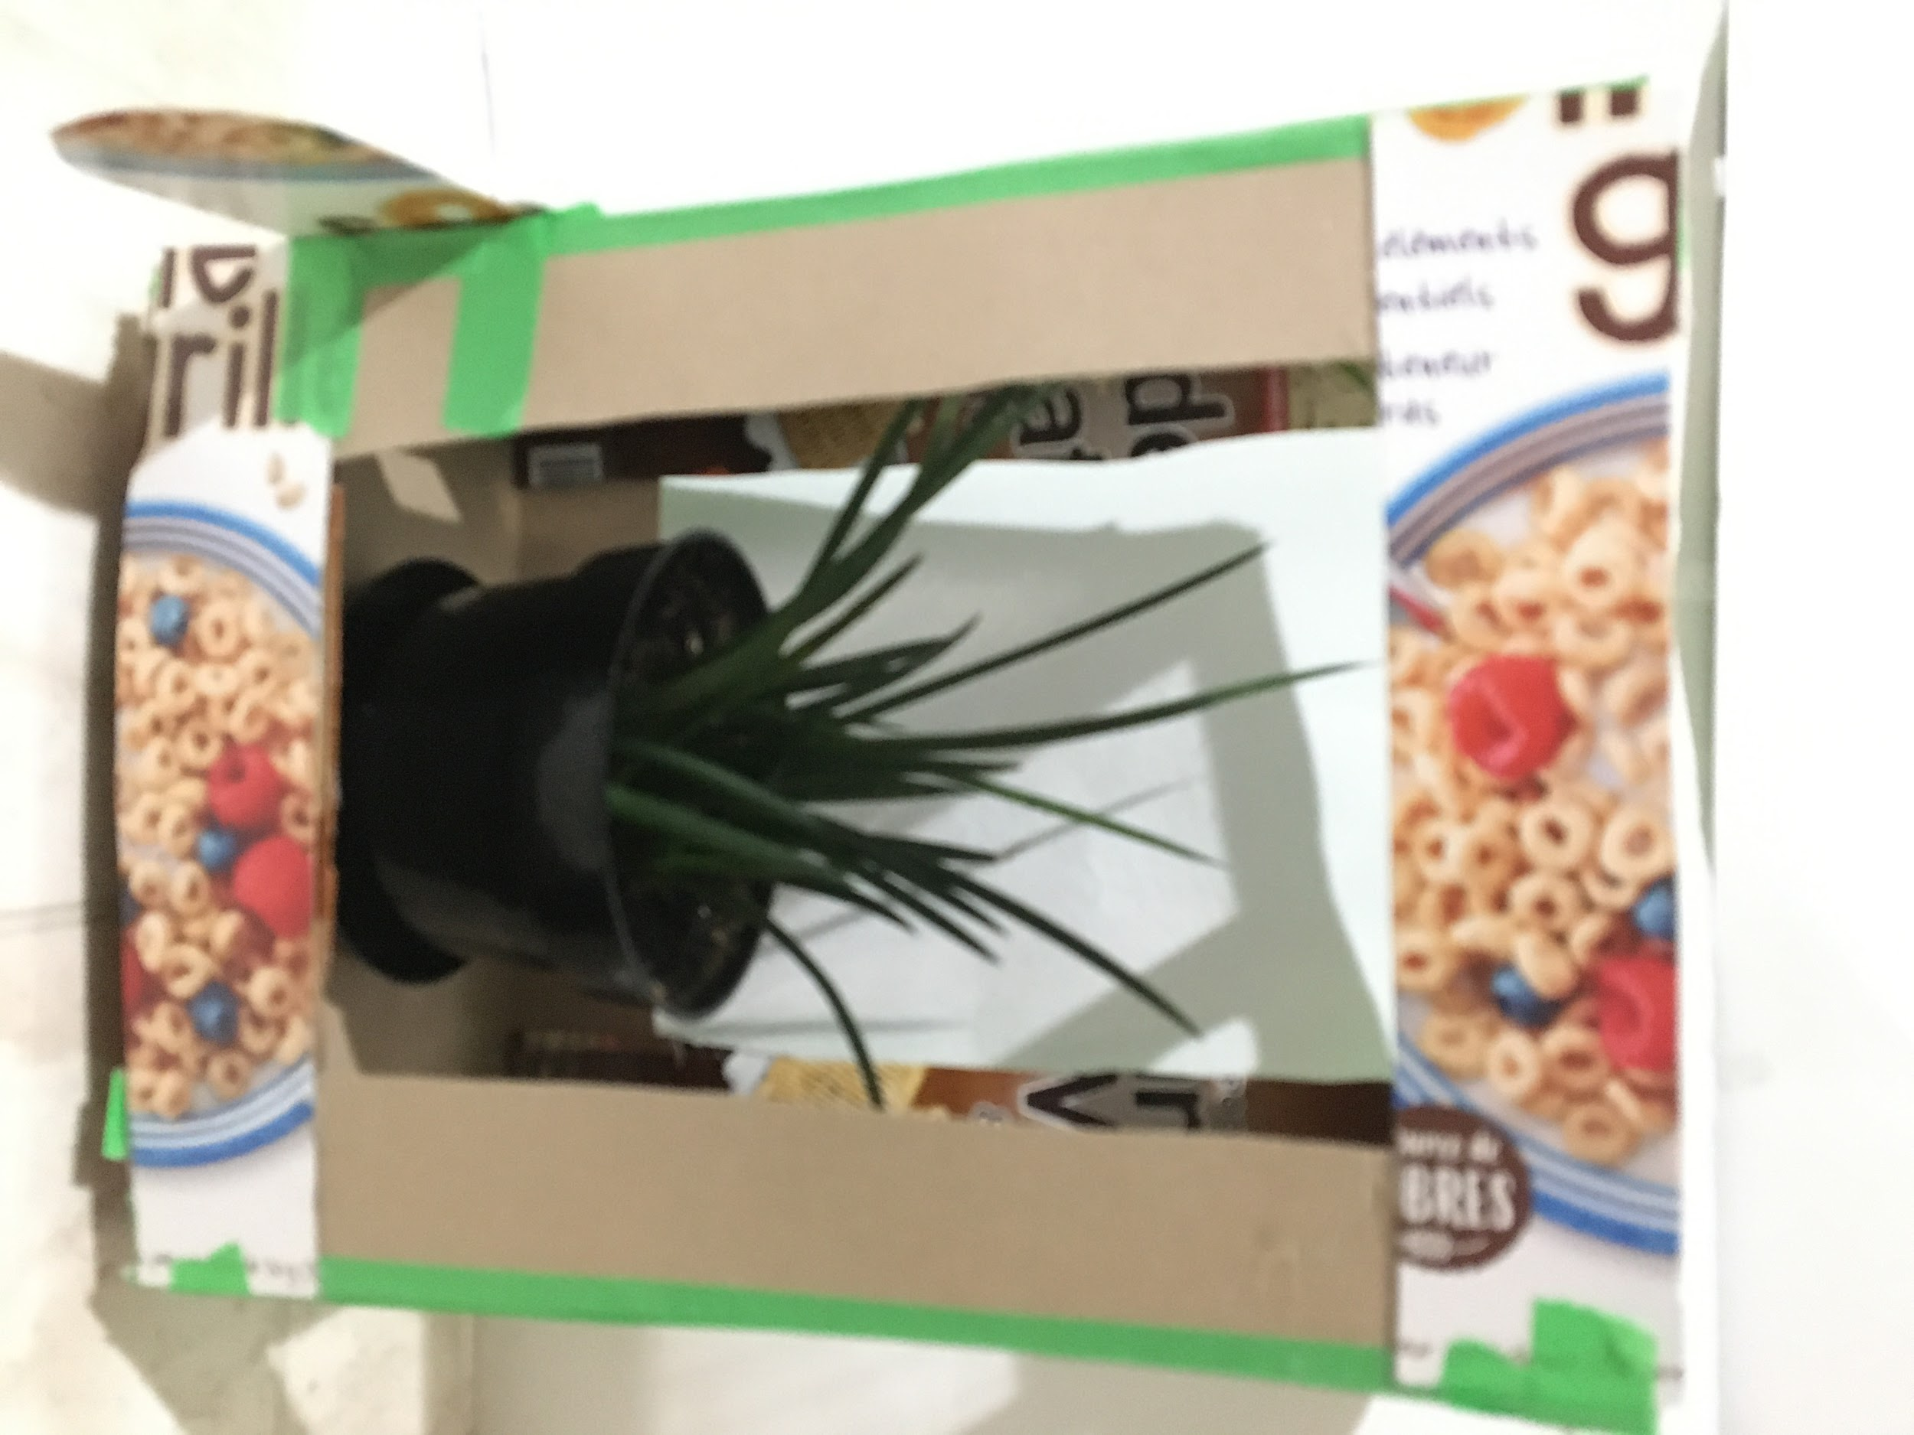  - Place a plant inside your greenhouse.
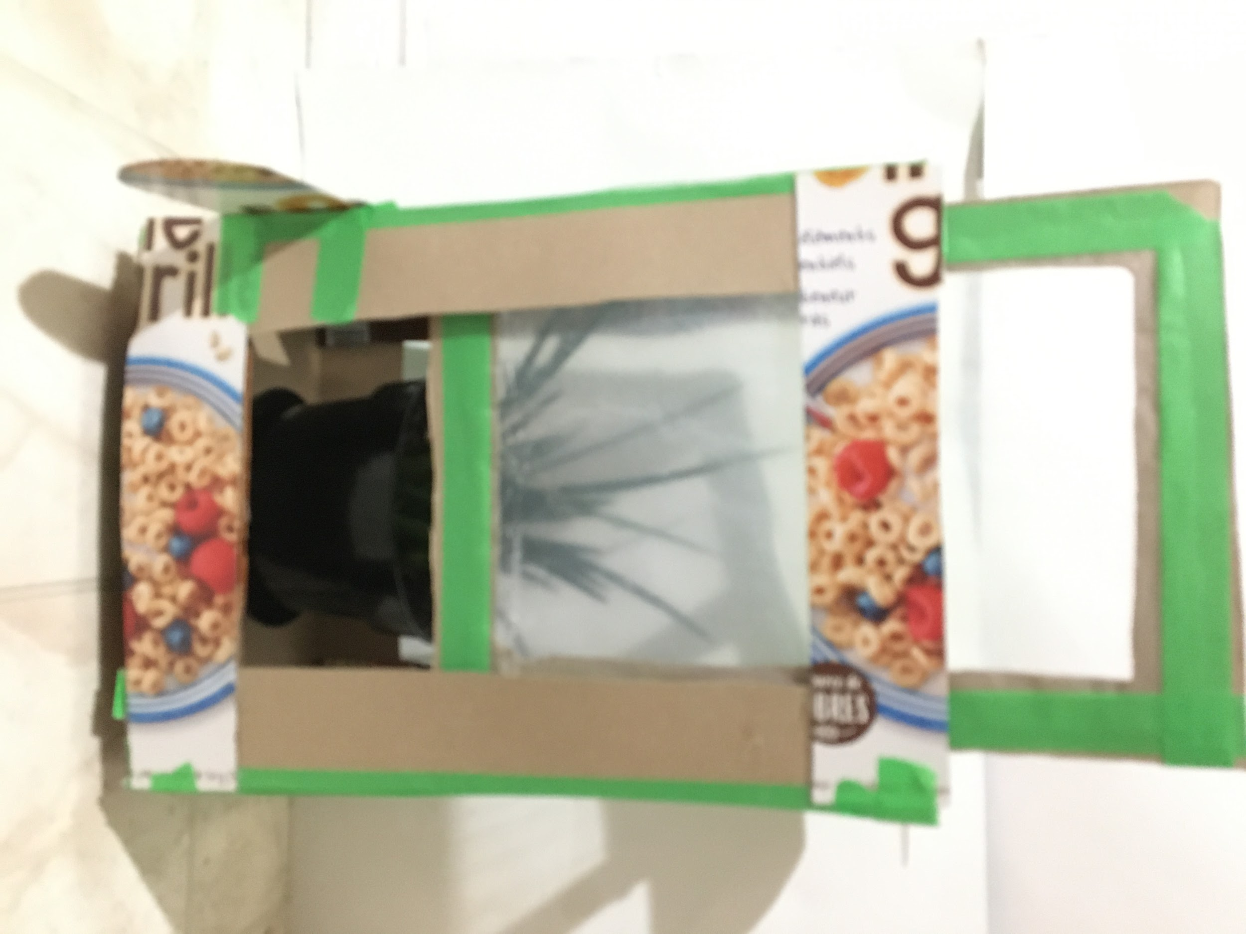  - Close the door. | 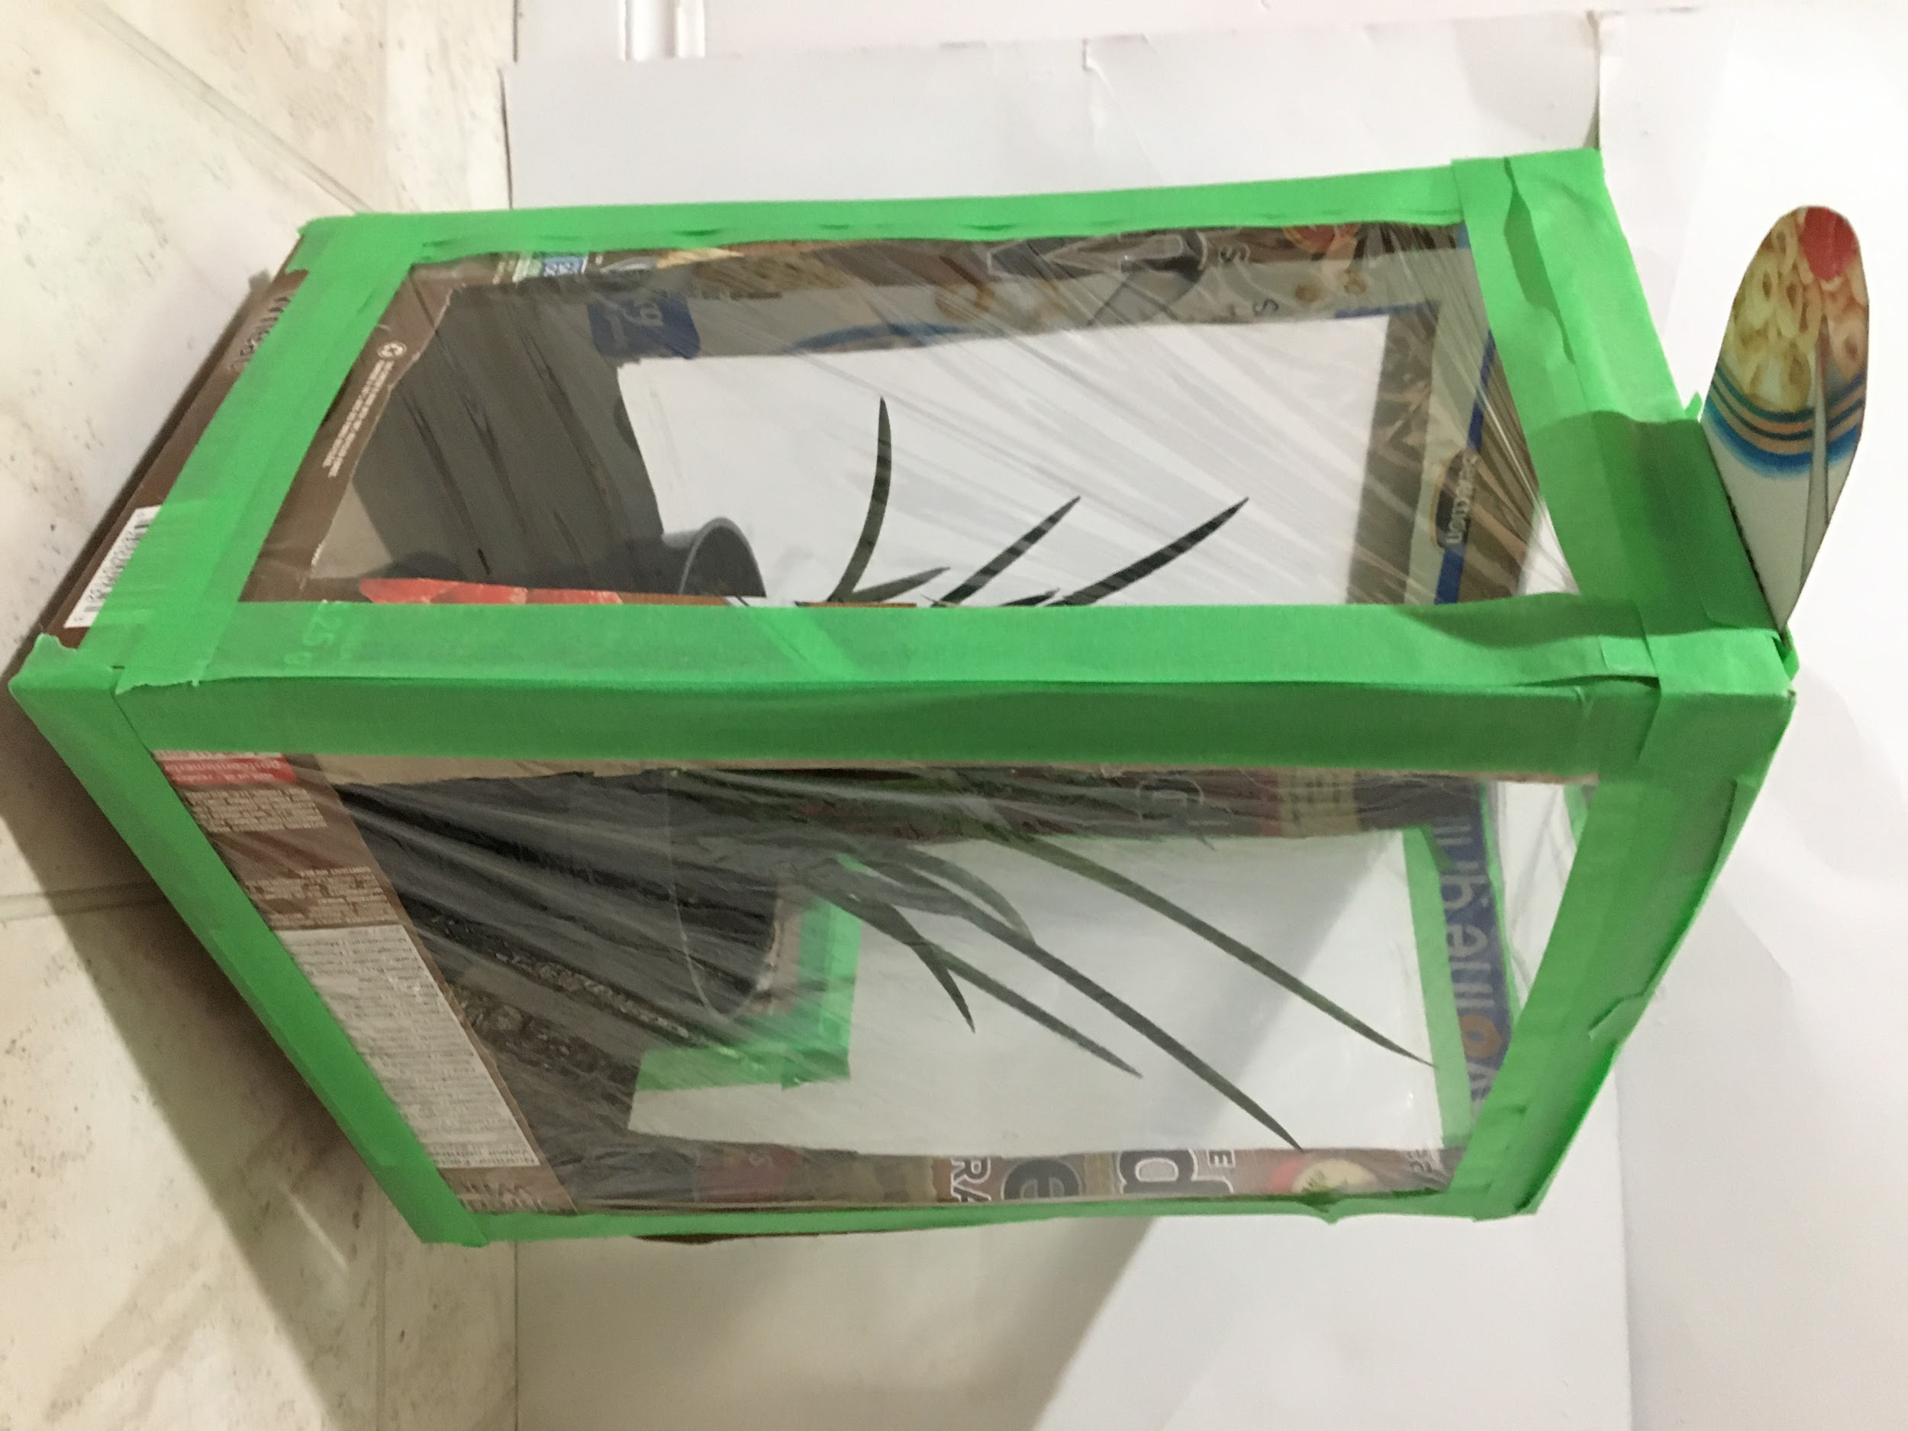  - Begin your tests and/or experiment.

Appendix L
Sample Double Line Graphs for Appendix G

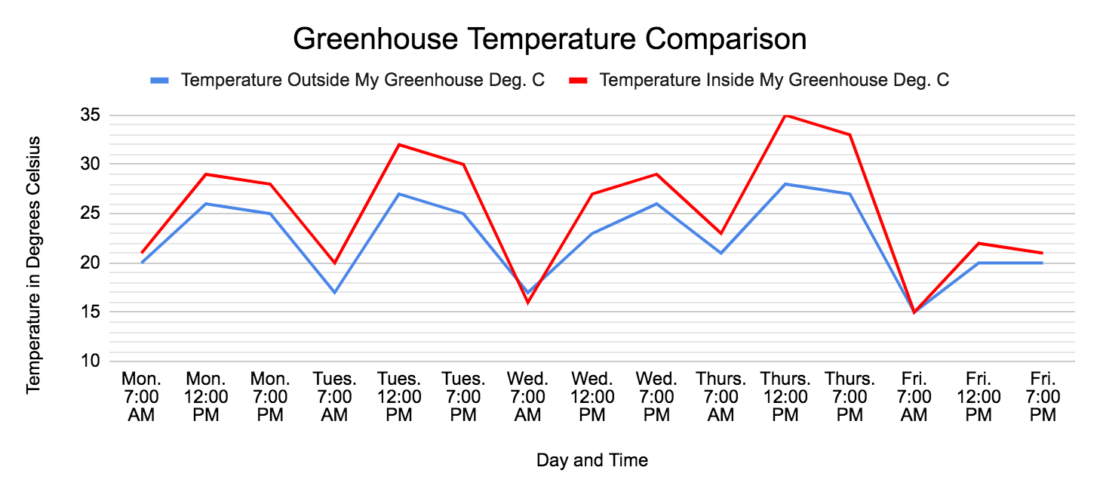
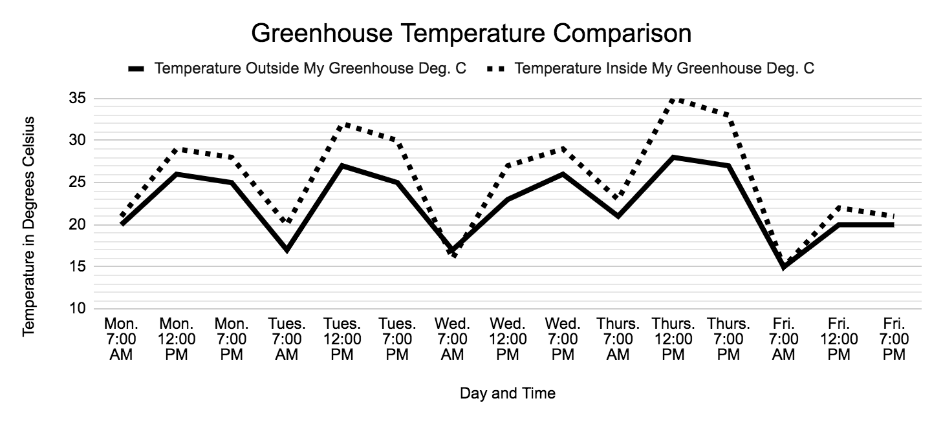

Appendix M
Technological Problem Solving and Communicating Assessment Rubric

CRITERIA | LEVEL 1 | LEVEL 2 | LEVEL 3 | LEVEL 4
Design Process  Plan  Students will draw at least two designs, or at least two different views of their model, will include measurements, and will choose appropriate materials. | The student developed an unfinished plan with various considerations missing.  The student demonstrated a limited use of the design process (plan, build, test, evaluate, communicate). | The student developed a workable plan with some steps missing.  The student demonstrated some use of the design process (plan, build, test, evaluate, communicate). | The student developed a clear workable plan using appropriate materials.  The student used the design process (plan, build, test, evaluate, communicate) as expected. | The student developed a workable plan, and modified the plan as necessary.  The student used the design process (plan, build, test, evaluate, communicate) very effectively.
Model  Students will translate their plan into a model. | The student’s design plans did not translate into a working model. | The student translated their design plans into a somewhat working model based on some of the stated criteria.  The student created a model that occasionally functioned according to specifications.  The student used a predictable design and materials. | The student adequately translated their design plans into a working model based on the stated criteria.  The student created a model that successfully functioned according to specifications.  The student used a predictable design and materials. | The student successfully translated their design plans into a working model based on the stated criteria.  The student created a model that successfully functioned according to specifications.  Care was taken during the student’s construction process.  The student produced a unique and creative design.
Communication and Reflection  Students will use Grade 7 level science and technology terminology, and their communication will make their knowledge of greenhouse design and operation (and the design process) evident. | The student used limited grade level terminology.  The student did not communicate a basic understanding of the concepts.  The student reflected on the design process and made limited suggestions for improvement. | The student used some grade level terminology.  The student communicated some understanding of the concepts.  The student reflected on the design process and made some suggestions for improvement. | The student used an adequate amount of grade level terminology.  The student communicated an understanding of most of the concepts.  The student reflected on the design process and made necessary suggestions for improvement. | The student used all required grade level terminology.  The student communicated an understanding of all concepts.  The student reflected on the design process and made all necessary suggestions for improvement.

Appendix N

Full Assessment Rubric

This rubric was developed from the Ontario Curriculum Grades 1-8 Science and Technology, Revised 2007 document.

 | Level 1 | Level 2 | Level 3 | Level 4
Knowledge and Understanding – Subject-specific content acquired in each grade (knowledge), and the comprehension of its meaning and significance (understanding).

 | The Student:
1. Knowledge of content (e.g., facts and terminology related to the function and operation of a model greenhouse). | demonstrates  limited  knowledge  of content. | demonstrates  some knowledge  of content. | demonstrates  considerable  knowledge of  content. | demonstrates  thorough  knowledge  of content.
2. Understanding of content (e.g., concepts, ideas, and processes involving the function and operation of a model greenhouse). | demonstrates  limited  understanding  of content. | demonstrates  some understanding  of content. | demonstrates  considerable  understanding of content. | demonstrates  thorough  understanding  of content.
Thinking and Investigation – The use of critical and creative thinking skills and inquiry problem solving skills and/or processes.

 | The Student:
3. Use of initiating and planning skills and strategies (identify appropriate items to research, and locate resources that are relevant to design and operation of a model greenhouse). | uses initiating  and planning  skills and  strategies  with limited  effectiveness. | uses initiating  and planning  skills and  strategies  with some  effectiveness. | uses initiating  and planning  skills and  strategies with  considerable  effectiveness, | uses initiating  and planning  skills and  strategies with  a high degree  of effectiveness.
4. Use of processing skills and strategies (e.g., performing and recording, gathering evidence and data, observing, manipulating materials and using equipment safely, ... proving) to design, fabricate, and operate a model greenhouse. | uses processing skills and strategies with limited  effectiveness. | uses processing skills and strategies with some  effectiveness. | uses processing skills and strategies with  considerable  effectiveness. | uses processing skills and strategies with  a high degree  of effectiveness.
 | The student:
5. Use of critical/creative thinking processes, skills, and strategies (e.g., analysing, interpreting, problem solving, evaluating, forming and justifying conclusions on the basis of evidence) to determine if the model greenhouse meets the design requirements for this task. | uses critical/creative thinking processes, skills, and strategies with limited  effectiveness. | uses critical/creative thinking processes, skills, and strategies with some  effectiveness. | uses critical/creative thinking processes, skills, and strategies with  considerable  effectiveness. | uses critical/creative thinking processes, skills, and strategies with  a high degree  of effectiveness.
Communication – The conveying of meaning through various forms
 | The student:
6. Expression and organization of ideas and information in oral, visual, and/or written forms (e.g., complete an oral or written report, video, or slideshow that is organized in a clear, logical manner and includes the design, fabrication, and operation of a model greenhouse). | expresses and organizes ideas and information with limited effectiveness. | expresses and organizes ideas and information with some effectiveness. | expresses and organizes ideas and information with considerable effectiveness. | expresses and organizes ideas and information with a high degree of effectiveness.
7. Communication for different audiences and purposes in oral, visual, and/or written forms. | communicates for different audiences and purposes with limited effectiveness. | communicates for different audiences and purposes with some effectiveness. | communicates for different audiences and purposes with considerable effectiveness. | communicates for different audiences and purposes with a high degree of effectiveness.
8. Use of conventions, vocabulary, and terminology (e.g., ecosystem, environment, biotic, abiotic) in oral, visual, and/or written forms. | uses conventions, vocabulary, and terminology with limited  effectiveness. | uses conventions, vocabulary, and terminology with some  effectiveness. | uses conventions, vocabulary, and terminology with considerable  effectiveness. | uses conventions, vocabulary, and terminology with a high degree of  effectiveness.
Application – The use of knowledge and skills to make connections within and between various contexts
 | The student:
9. Application of knowledge and skills (e.g., concepts and processes, use of equipment and technology, investigation skills) in familiar contexts. | applies knowledge and skills in familiar contexts with limited effectiveness. | applies knowledge and skills in familiar contexts with some effectiveness. | applies knowledge and skills in familiar contexts with considerable effectiveness. | applies knowledge and skills in familiar contexts with a high degree of effectiveness.
 | The student:
10. Making connections between society, science, technology, and the environment regarding the design solution selected, and its impacts on people, other living things, and the environment. | connects science, technology, society, and the environment with limited effectiveness. | connects science, technology, society, and the environment with some effectiveness. | connects science, technology, society, and the environment with considerable effectiveness. | connects science, technology, society, and the environment with a high degree of effectiveness.
11. Proposing courses of practical action to deal with problems relating to science, technology, society, and the environment through the understanding of interactions within ecosystems and how balance between the elements is maintained. | proposes courses of practical action of limited effectiveness. | proposes courses of practical action of some effectiveness. | proposes courses of practical action of considerable effectiveness. | proposes highly  effective courses of practical action.

Opportunities for assessment (Links to assessment pieces, organizers):
- Assess student responses to The Model Greenhouse Design Challenge - Research Assignment (see Appendix D).
- Assess student responses to The Model Greenhouse Design Challenge - Technical Drawings and Design Analysis assignment (see Appendix E).
- Assess student responses to The Model Greenhouse Design Challenge - Final Report (see Appendix G).
- Assess student responses to The Model Greenhouse Design Challenge - Greenhouse Experiment (see Appendix H).
- Provide feedback and assessment results using the Assessment - Success Criteria resource (see Appendix I).
- Record a condensed assessment of your student’s progress using the Technological Problem Solving and Communicating Assessment Rubric (see Appendix M)
- Record an in depth assessment or your student’s progress using the Full Assessment Rubric (see Appendix N).

Cross Curricular Opportunities:
- Science and Technology - Grade 7: Understanding Earth and Space Systems, Heat in the Environment
  - Overall Expectations,
By the end of Grade 7, the students will,
2. investigate ways in which heat changes substances, and describe how heat is
transferred;
3. demonstrate an understanding of heat as a form of energy that is associated with the
movement of particles and is essential to many processes within the Earth’s systems.
  - Specific Expectations,
By the end of Grade 7, the students will:
2.1 follow established safety procedures for using heating appliances and handling hot
materials (e.g., use protective gloves when removing items from hot plates),
2.3 use technological problem-solving skills (see page 16) to identify ways to minimize heat
loss,
2.4 use scientific inquiry/experimentation skills (see page 12) to investigate heat transfer
through conduction, convection, and radiation,
2.5 use appropriate science and technology vocabulary, including heat, temperature,
conduction, convection, and radiation, in oral and written communication,
2.6 use a variety of forms (e.g., oral, written, graphic, multimedia) to communicate with
different audiences and for a variety of purposes.
- The Arts: Grade 7 Dance (this expectation can be incorporated into the video assignment where students can interpret, through dance, the transformation of shortwave radiant energy from the sun into longwave radiant heat energy within their greenhouse; it can also be extended to interpret the global warming that takes place when greenhouse gasses trap the same radiant heat energy from the Earth and cause an increase in the Earth’s average temperature),
A1.2 use dance as a language to communicate ideas from their own writing or media works (e.g., create a dance piece inspired by a student authored poem or media work about relationships with the natural world...) Teacher prompts: “What are some interactions from your assignment that you could represent in dance? How would you do so?” “What elements of dance (e.g., movements, levels, pathways) would best communicate the information presented in your writing or media presentation?”
- The Arts: Grade 7 Visual Arts (this expectation can be addressed by turning the model greenhouse into a work of art that addresses the content listed below),
D1.1 create art works, using a variety of traditional forms and current media technologies, that express feelings, ideas, and issues (e.g., … art or an installation that portrays both sides of the struggle between humankind and nature...) Teacher prompts: “How will your artwork convey... perspectives on an issue that you have chosen to explore... “How does your installation communicate the benefits and challenges of environmental stewardship?”
- Language: Grade 7 Oral Communication (if your students are to submit oral reports, either in person or by video, you may choose to integrate instruction and assessment of some or all of the Oral Communication expectations listed below).
  - Purpose 2.1, identify a range of purposes for speaking and explain how the purpose and intended audience might influence the choice of speaking strategies (e.g., to present conclusions about a research project...).
  - Interactive Strategies 2.2, demonstrate an understanding of appropriate speaking behaviour in most situations… (e.g., … use language and forms of address that are appropriate to the formality or informality of the situation).
  - Clarity and Coherence 2.3, communicate orally in a clear, coherent manner, using a structure and style appropriate to both the topic and the intended audience.
  - Appropriate Language 2.4, use appropriate words, phrases, and terminology from the full range of their vocabulary, including inclusive and non-discriminatory language, and a range of stylistic devices, to communicate their meaning accurately and engage the interest of their intended audience.
  - Vocal Skills and Strategies 2.5, identify a range of vocal effects, including tone, pace, pitch, volume, and a variety of sound effects, and use them appropriately and with sensitivity towards cultural differences to communicate their meaning.
  - Non-Verbal Cues 2.6, identify a variety of non-verbal cues, including facial expression, gestures, and eye contact, and use them in oral communications, appropriately and with sensitivity towards cultural differences, to help convey their meaning.
  - Visual Aids 2.7, use a variety of appropriate visual aids (e.g., charts, videos, props, multimedia) to support and enhance oral presentations.
- Language: Grade 7 Writing (if your students are to submit written reports, you may choose to integrate instruction and assessment of some or all of the Writing expectations listed below).
  - Research 1.3, gather information to support ideas for writing, using a variety of strategies and a wide range of print and electronic resources (e.g., ... record sources used and information gathered in a form that makes it easy to understand and retrieve).
  - Review 1.6, determine whether the ideas and information they have gathered are relevant, appropriate, and sufficiently specific for the purpose, and do more research if necessary.
  - Revision 2.7, make revisions to improve the content, clarity, and interest of their written work, using a variety of strategies.
  - Producing Drafts 2.8 produce revised draft pieces of writing to meet identified criteria based on the expectations (e.g., adequate development of information and ideas, logical organization, appropriate use of form and style, appropriate use of conventions).
  - Spelling Familiar Words 3.1, spell familiar words correctly.
  - Vocabulary 3.3, confirm spellings and word meanings or word choice using a variety of resources appropriate for the purpose.
  - Punctuation 3.4, use punctuation appropriately to communicate their intended meaning in more complex writing forms, including forms specific to different subject areas, with a focus on the use of: periods after initials, in abbreviations, and in decimal numbers; parentheses; punctuation to indicate intonation, pauses, or gestures.
  - Grammar 3.5, use parts of speech correctly to communicate their meaning clearly, with a focus on the use of: relative pronouns (e.g., who, whose, which, that); prepositions, including prepositional phrases; adjectives; conjunctions; adverbs; present, past, and future verb tenses; present and past participles (e.g., I am reading, I have read).
  - Proofreading 3.6, proofread and correct their writing using guidelines developed with peers and the teacher (e.g., an editing checklist specific to the writing task).
  - Producing Finished Works 3.8, produce pieces of published work to meet identified criteria based on the expectations (e.g., adequacy of information and ideas, logic and effectiveness of organization, effective use of form and stylistic elements, appropriate use of conventions, effective presentation).
- Language: Grade 7 Media Literacy (if your students are to submit a media text to demonstrate their learning, you may choose to integrate instruction and assessment of some or all of the Media Literacy expectations listed below).
  - Form 3.2, identify an appropriate form to suit the specific purpose and audience for a media text they plan to create (e.g., a website or multimedia presentation about a unit of study to present research findings to the class).
  - Producing Media Texts 3.4 produce a variety of media texts of some technical complexity for specific purposes and audiences, using appropriate forms, conventions, and techniques.

References:
- NASA, Climate Science Investigations, “Energy: The Driver of Climate, The Greenhouse Effect”, updated December 2, 2019, http://www.ces.fau.edu/nasa/module-2/how-greenhouse-effect-works.php#:~:text=The%20plants%20and%20soil%20then,the%20temperature%20outside%20is%20lower.,
- E-Learning Ontario, “SNC1P, The Scientific Method - Solving Scientific Problems”, accessed Saturday, August 15, 2020, https://lah.elearningontario.ca/CMS/public/exported_courses/SNC1P/exported/SNC1PU01/SNC1PU01/SNC1PU01A02/_content.html.

