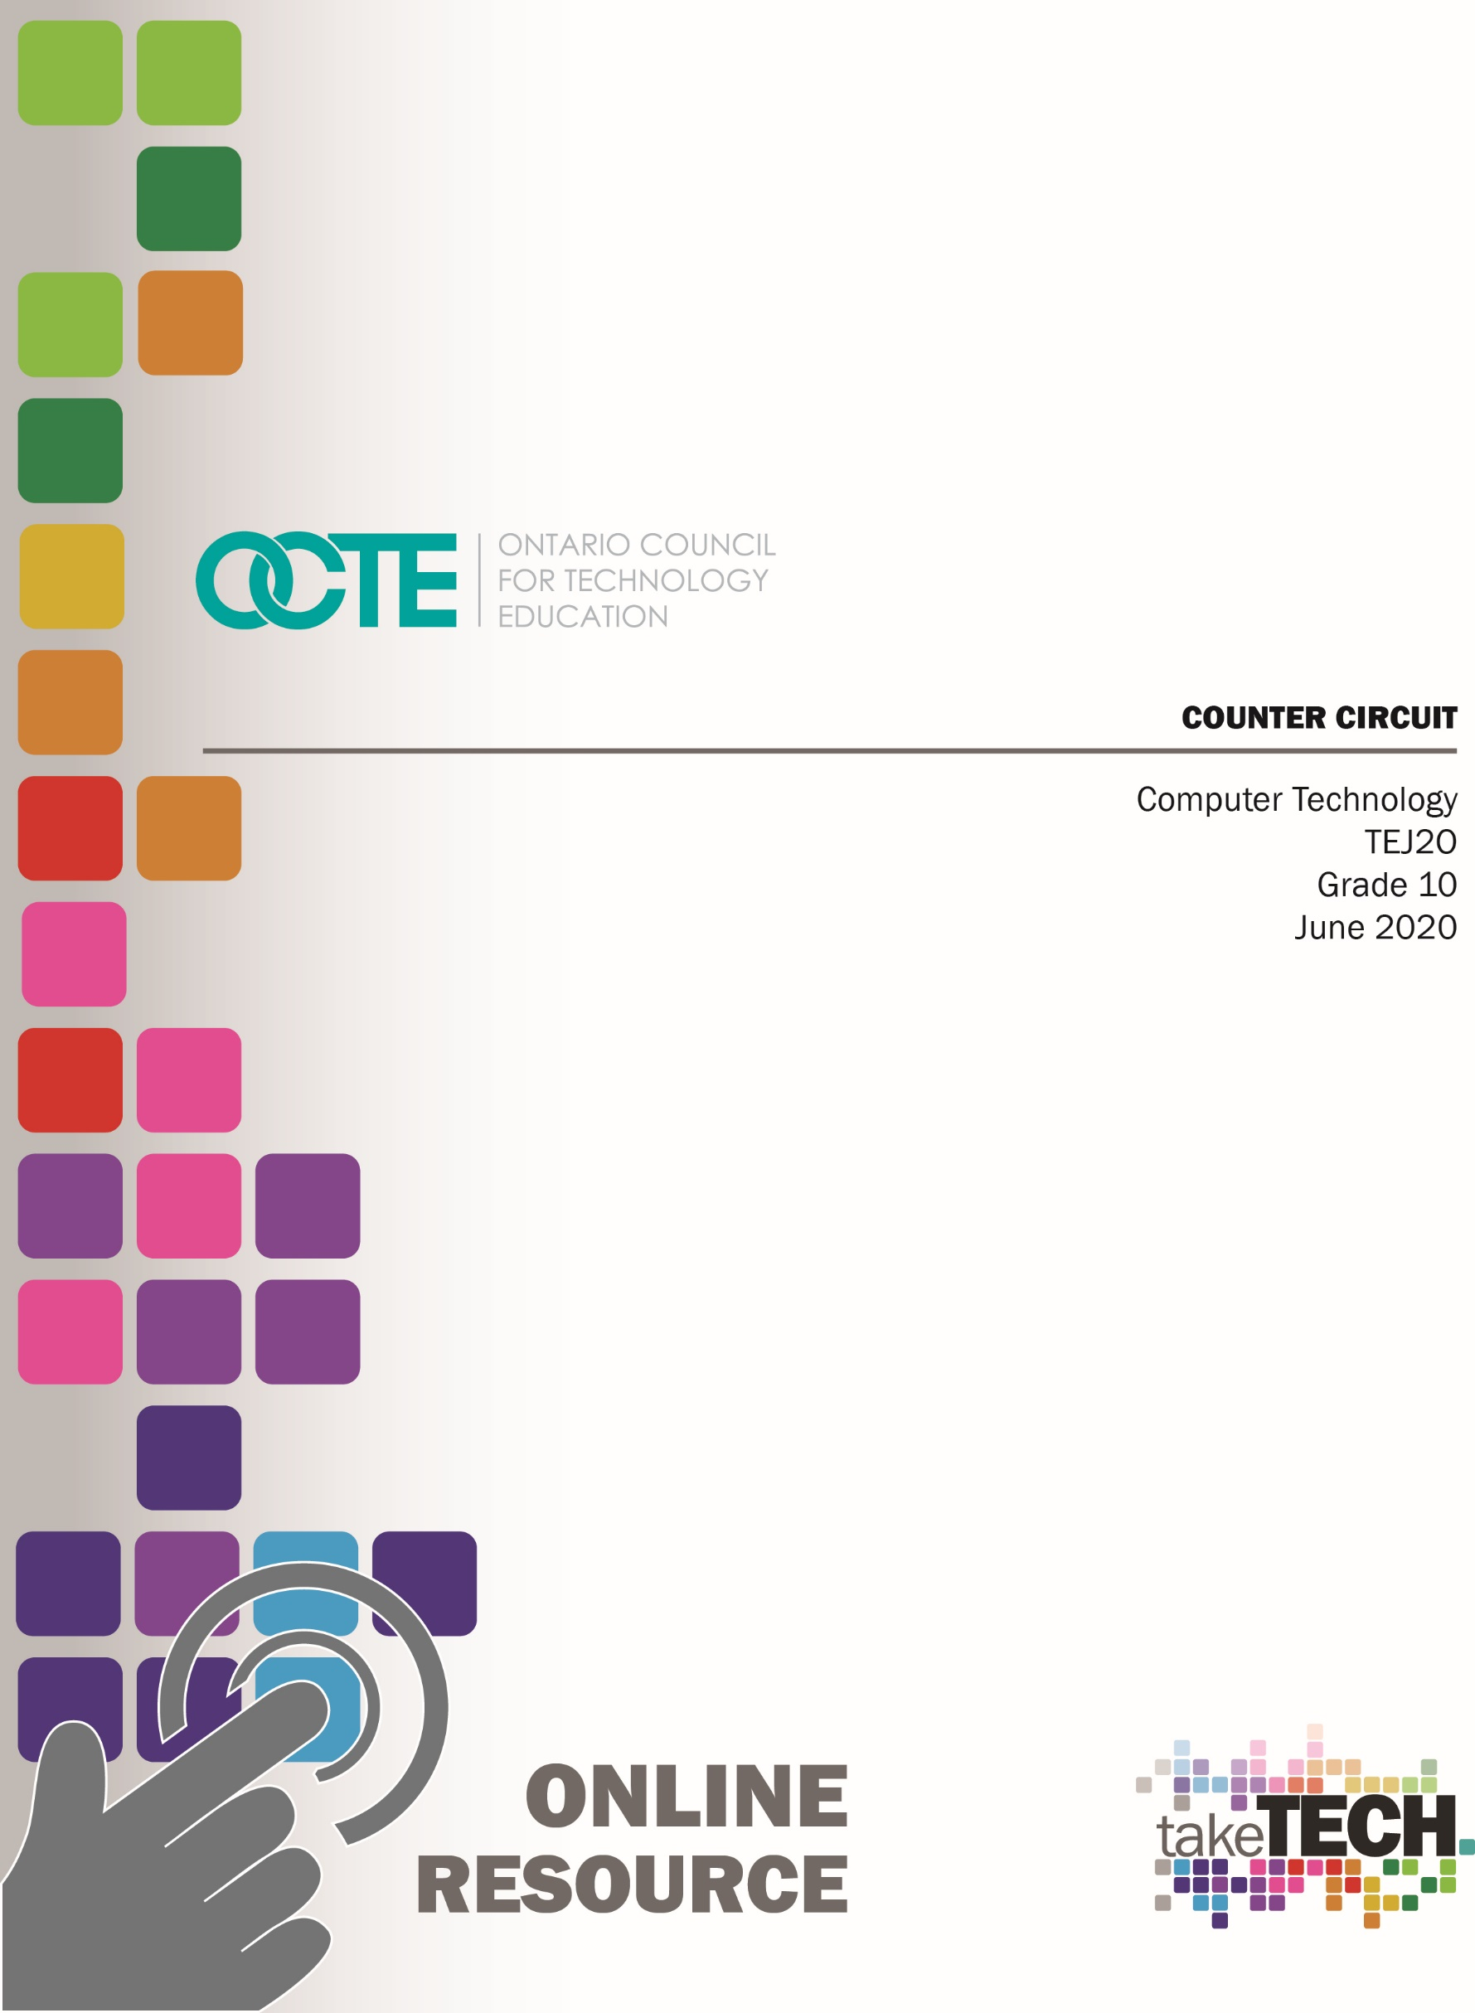

Table of Contents
Introduction 2
Project Outline 2
Prior Knowledge 2
Student Activities 2
Activity 1 – Intro to Electronics 2
Activity 2 – Introduction to Breadboarding 3
Activity 3 – Intro to Boolean Logic and Integrated Circuit Chips 4
Activity 4 – 555 Timer Circuit 5
Activity 5 – Seven Segment Display and Decoder Chip 5
Activity 6 – Counter Circuit Project 7
Instructional Strategies 7
The Hook / Motivational Strategies 7
Overall and Specific Expectations 8
Overall Expectations 8
Specific Expectations 8
Safety Concerns (including PPE if required) 8
Applicable SAFEDocs and ToolSAFE videos 8
Differentiation of the Project / Activity 9
Assessment and Evaluation 9
Reflection 9
Appendix A – Instructions for Using Classes on Tinkercad 10
Appendix B – Activity 1 Resources - Intro to Electronics 13
Activity 1: Introduction to Electronics – Completed Note 13
Activity 1: Introduction to Electronics – TEJ2O Student Note 14
Appendix C – Activity 2 Resources – Intro to Breadboarding 15
Section A: Create Basic Circuits on a Breadboard 16
Section B: Draw the Circuit Schematics for Circuits in Section A 17
Appendix D – Activity 3 Resources - Intro to Boolean Logic and Integrated Circuit Chips 18
Boolean Logic – TEJ2O Student Note and Worksheet 20
Basic Logic IC Chip Layouts – TEJ2O Student Note 23
Experimenting with Logic Gates on Logic.ly – TEJ2O 24
Integrated Circuits: Tinkercad Activity 25
Integrated Circuits: Tinkercad Activity Worksheet 26
Extension: Advanced Circuit 28
Logic Gates and Integrated Circuits - TEJ2O Quiz 29
Appendix E – Activity 4 Resources – 555 Timer Circuit 31
Building a 555 Timer Circuit – TEJ2O 31
Pinout for 555 Chip 33
Appendix F – Activity 5 Resources – Seven Segment Display and Decoder Chip 34
Labelled 7 Segment Pinout for teacher 34
Exploring a 7 Segment Display and Decoder Chip – TEJ2O 35
Appendix G – Activity 6 Resources – Counter Circuit Project 38
Activity #6 Building a Counter Circuit – TEJ2O 38
Counter Circuit Project Solutions 40
References 41

Introduction
Course Code: TEJ2O
Broad base Technology: Computer Technology
Destination: Workplace/ College / University
Grade Level: 10
Prerequisite: None
Online Project Name: Counter Circuit

Project Outline
The goal of this project is to build a counter circuit with a breadboard and various Integrated Circuit Chips which can be done in class (part list will be provided) or online with TinkerCAD (Autodesk’s Web Based Simulator). The counter circuit will only use electronic devices to help students focus on wiring and troubleshooting circuits. Throughout the module activities students will learn about a variety of electronic devices (resistors, LEDs, capacitors, breadboards, Boolean logic chips, 555 Timer chip, and the 7 segment display and decoder chips).

Prior Knowledge
This project assumes no prior knowledge but there will be some basic electronics/electricity concepts they may have learned in Grade 9 science.

Student Activities

Activity 1 – Intro to Electronics
The goal of this activity is to introduce students to basic electronic components that can be used in electronics projects and activities. Students will be able to identify the components, schematic symbols, and describe the functions of the components.
Time required: 30 minutes
Materials/Equipment required if in class: resistors, wires, LEDs, capacitors, diodes, DIP Switch, buttons, breadboard, power supply, etc. for in class experiential learning. Teachers can also use the Tinkercad.com simulator and projector to introduce these items. The teacher should also draw some basic circuits to show schematic symbols. (i.e.: battery, buttons, resistor, and LED)
Resources: Teacher can use the student handout (Appendix B) as a guide for providing important details for basic components. The completed example has been included to support the teacher as well.

Activity 2 – Introduction to Breadboarding
The goal of this activity is to build some basic breadboard circuits using the components introduced in activity #1. The teacher will need to introduce the Tinkercad.com platform. Teachers are encouraged to explore the “Class” feature of Tinkercad.com (See Appendix A – Instructions for Using Classes on Tinkercad). It will allow the teacher to remotely view students’ circuits they build making it easier to provide detailed feedback on their work using any school board’s messaging platform.
Time required: 45 minutes
Materials/Equipment required if in class: Breadboards kits with power supplies, resistors (ideally a few different values – 220 Ohm, 1K Ohm, 10K Ohm, etc.), male to male jumper wires, LEDs, and buttons. Teacher can also use the Tinkercad.com simulator and projector to introduce these circuits. Try to avoid giving the students a power cable at first and have them come to you or you go around to them to test their first set of circuits.
Resources: The video lesson “TEJ2O A2 - Introduction to Breadboards and Basic Circuits on Tinkercad” is provided to give a basic overview of the Tinkercad Simulator and how to use breadboards and basic components. A Student Activity Sheet is also provided to accompany the video.
Web link: Video – Introduction to Breadboards and Basic Circuits on Tinkercad

https://www.octe.ca/application/files/9215/9624/2124/TEJ2O_A2_-_Introduction_to_Breadboards_and_Basic_Circuits_on_Tinkercad.mp4
Assessment and Evaluation: Students should complete the activity sheet and the teacher can provide feedback on their circuits for formative assessment.

Activity 3 – Intro to Boolean Logic and Integrated Circuit Chips
The goal of this activity is to explore the six basic Boolean Logic operators (AND, OR, NOT, NAND, NOR, XOR) and the associated integrated circuit chips. Students will learn the theory behind Boolean Algebra (Logic) and will test these concepts with integrated circuit chips, breadboards, wires, LEDs, and resistors. There will be an opportunity for scaffolding and enrichment activities.
Time required: 120 minutes
Materials/Equipment Required in class: Breadboard kits with power supplies, resistors, male to male jumper wires, LEDs, and the following integrated circuit chips (74HC08, 74HC32, 74HC04, 74HC00, 74HC02, and 74HC86). The teacher can also use the Tinkercad.com simulator and projector to introduce these circuit chips. Avoid giving the students a power cable at first and have them come to you or you go around to them to test their first set of circuits to avoid damaging chips.
Resources:
- Intro to Boolean Logic (Teacher PowerPoint Presentation)
- Intro to Boolean Logic (Student Note and Worksheet)
- Intro to Logic Chips Exploration Activity (Teacher PowerPoint Presentation)
- Basic Logic IC Chip Layouts (Student Note and Worksheet)
- LogicLY Boolean Assignment (Scaffolding Activity)
- Integrated Circuits on Tinkercad Activity (Student Worksheet)
- Logic Gates and Integrated Circuits Quiz
- Introduction to Breadboards and Basic Circuits on Tinkercad (Video Activity)
- AND Integrated Circuit on Tinkercad (Video Activity)
Web link: Video – Introduction to Breadboards and Basic Circuits on Tinkercad
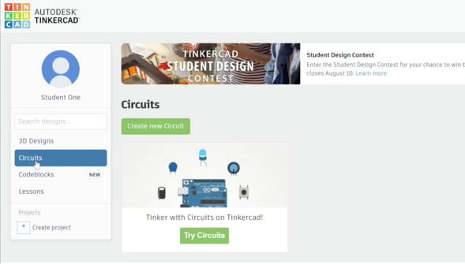
https://www.octe.ca/application/files/9215/9624/2124/TEJ2O_A2_-_Introduction_to_Breadboards_and_Basic_Circuits_on_Tinkercad.mp4

Web link: Video – AND Integrated Circuit on Tinkercad
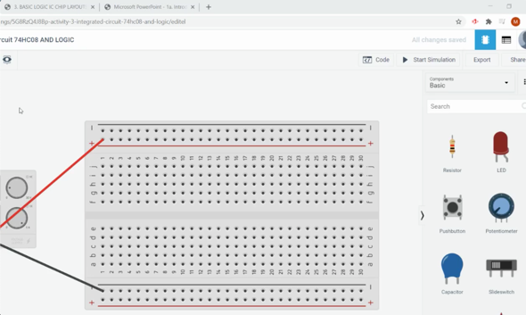
https://www.octe.ca/application/files/5515/9624/2225/TEJ2O_A3_-_AND_Integrated_Circuit_on_Tinkercad.mp4
Assessment and Evaluation: Students will complete a topic quiz.

Activity 4 – 555 Timer Circuit
The goal of this activity is to continue exploring electronics components and introducing the 555 Timer integrated circuit chip, capacitors, how resistor values affect the circuit, and how electronic components (not code) can keep track of time.
Time required: 30 minutes
Materials/Equipment required in class: Breadboards kits with power supplies, resistors (2K, 10K, 100K, 560K, 1.5M), male to male jumper wires, LEDs, 555 Timer Chip, and a capacitor (2.2uF). The teacher can also use the Tinkercad.com simulator and projector to introduce these circuit chips.
Resources: A student activity sheet is provided.
Assessment and Evaluation: Students will complete a circuit activity and submit their completed circuit to their teacher (through a Tinkercad class or image). The teacher will provide feedback and suggestions for troubleshooting.

Activity 5 – Seven Segment Display and Decoder Chip
The goal of this activity is to explore seven segment displays (digital number readout similar to an alarm clock), CD4511 seven segment decoder integrated circuit chip, capacitors, how resistor values affect the circuit, and how electronic components (not code) can keep track of time. The idea of common cathode vs. common anode will be introduced. The Binary number system will be reviewed to understand how a 4 digit binary number can produce a decimal value on the seven segment display.
Time required: 45 minutes

Materials/Equipment required in class: Breadboards kits with power supplies, resistor, male to male jumper wires, seven segment display (example: MAN72A) and decoder chip (example: 7447). The teacher can also use the Tinkercad.com simulator and projector to introduce these circuit chips.
Resources: A student activity sheet is provided. There are also two instructional videos provided.
Web link: Video – 7 Segment Intro on Tinkercad
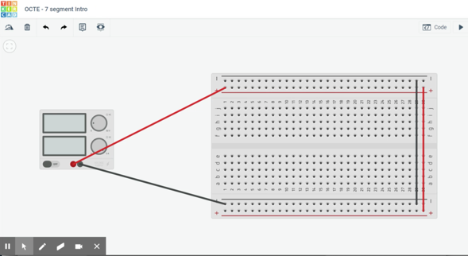
https://www.octe.ca/application/files/3515/9624/2309/TEJ2O_A5a_-_7_Segment_Intro_on_Tinkercad.mp4
Web link: Video – 7 segment with decoder on Tinkercad
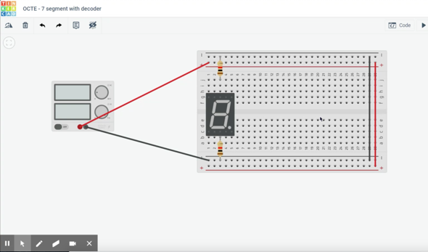
https://www.octe.ca/application/files/6715/9624/2418/TEJ2O_A5b_-_7_segment_with_decoder_on_Tinkercad.mp4
Assessment and Evaluation: Students will complete a circuit activity and submit their completed circuit to their teacher (through Tinkercad class or image). The teacher will provide feedback and suggestions for troubleshooting.

Activity 6 – Counter Circuit Project
The goal of this activity is to combine the learning from previous activities to make a Counter Circuit. The student will have the option to create one of the following (or both as enrichment):
OPTION 1: Automated Counter Circuit using 555 Timer
OPTION 2: Button Driven Counter Circuit
Both options will require students to build a complex circuit with a new integrated circuit chip (74HC93). They will use previous feedback and activities to troubleshoot and build the circuit of their choice.
Time required: 60 minutes
Materials/Equipment required in class: Breadboards kits with power supplies, resistors (220, 2K, 1.5M), male to male jumper wires, seven segment display (example: MAN72A) and decoder chip (example: 7447), 2 buttons, 555 timer, capacitor (2.2 uF). The teacher can also use the Tinkercad.com simulator and projector to introduce these circuit chips.
Resources: A student activity sheet is provided.
Assessment and Evaluation: Students will complete a Counter Circuit and the teacher will evaluate the submitted circuit with the provided rubric. Students will also complete a KWL Chart (Knew/Wanted/Learned) and a Troubleshooting Log.

Instructional Strategies
Students can complete all of the activities from home with teacher support. There are a variety of lessons, exploratory activities, and tasks that can be completed from home using an online simulator. All activities (lessons, assignments, quizzes, etc.) can be easily completed and shared through an online learning system. Students can also submit all work done on the simulator online by “sharing” an image of their circuit. Instructions for teachers have been provided to setup a class on the Tinkercad website. Teachers can view live versions of students’ circuits and can complete assessment and evaluations by observing their work through the website.

The Hook / Motivational Strategies
Students will really enjoy building these circuits online as they can safely build, test, and troubleshoot their circuits with immediate feedback in the simulator.

Overall and Specific Expectations in Support of Ontario Curriculum Grades 9 - 10 Technological Education

Overall Expectations
A1. Identify and describe the functions of, as well as important advances related to, electronic and computer components;
A3. Demonstrate a basic understanding of binary numbers and digital logic.
B2. Construct and test simple interfaces and other electronic circuits;

Specific Expectations
A1.1 Identify basic electronic components and describe their functions (e.g., resistors limit current; capacitors store charge, pass high frequencies, and block DC; diodes restrict current in one direction; LEDs indicate current flow; transistors act as amplifiers or switches);
A3.3 Derive the truth tables of the fundamental logic gates (e.g., AND, OR, NOT, NOR, NAND, XOR);
A3.4 Write Boolean equations for the fundamental logic gates (e.g., for AND, the output is Y = A • B; for OR, Y = A + B).
B2.1 Safely construct and test electronic circuits (e.g., LED circuit, flasher, timer), using both breadboard and soldering techniques to connect discrete components and/or integrated circuits;

Safety Concerns
All hands on work can be completed with an online simulator so there is little concern for safety. If activities are completed in class, the concerns may include overheating components that aren’t wired properly. Teachers should supervise actively and encourage students to use safety glasses.

Applicable SAFEDocs and ToolSAFE videos
Please refer to the Computer Technology SAFEDocs located on the OCTE website.

Differentiation of the Project / Activity
Many supporting documents for students and teachers have been provided to ensure all types of learners are given the supports they need. All circuit activities are provided with graphical guides to follow and major concepts have corresponding video lessons with screen capture instructions.

Assessment and Evaluation
Assessment For Learning
Students will be given descriptive feedback for the variety of circuit activities they complete
Assessment Of Learning
- Logic Gate and Integrated Circuits Quiz
- Rubric used for Final Counter Circuit

Reflection
Teachers may wish to have the students complete a trouble shooting log and reflection to consolidate their learning. This would be a nice way to capture the student’s understanding in a summative format and be used in preparation for their examination, entering post-secondary education or to the workforce.

Appendix A – Instructions for Using Classes on Tinkercad
Step 1: Click on “Classes”

Step 2: Create a New class by choosing a name, grade, and subject
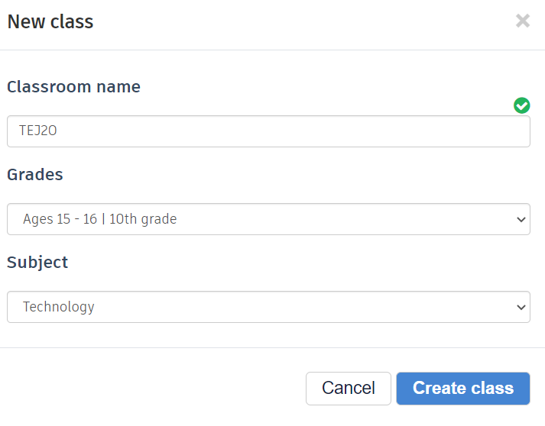
Step 3: Click on the newly created class to add students/users

Step 4: Adding Students, you can add one student at a time OR click “Paste a list of students”.
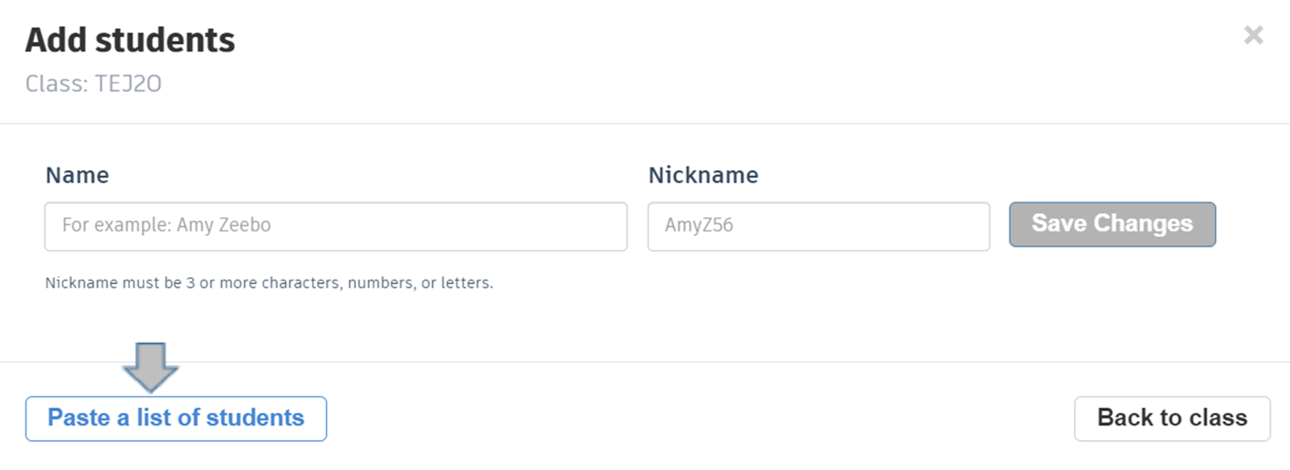
Step 5: Type of Copy the names of students then click “Add # students”.
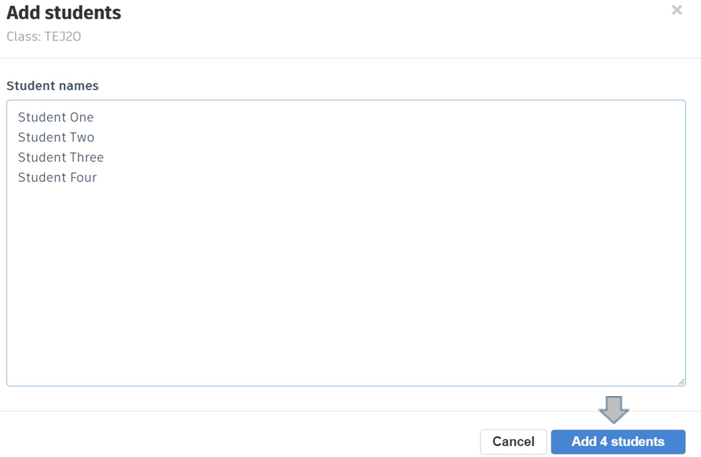

Step 6: Give each student a unique nickname. This past year I used last name and first initial. Example: Bill Gates would be “gatesb” to make it easy to inform all students.
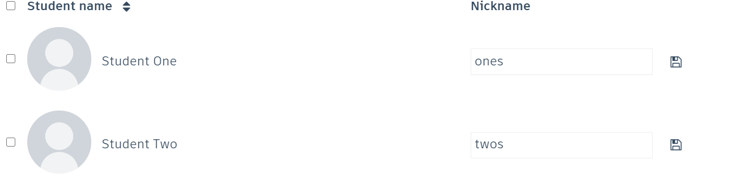
Step 7: Now you will need to share the “Class Code” with your students.
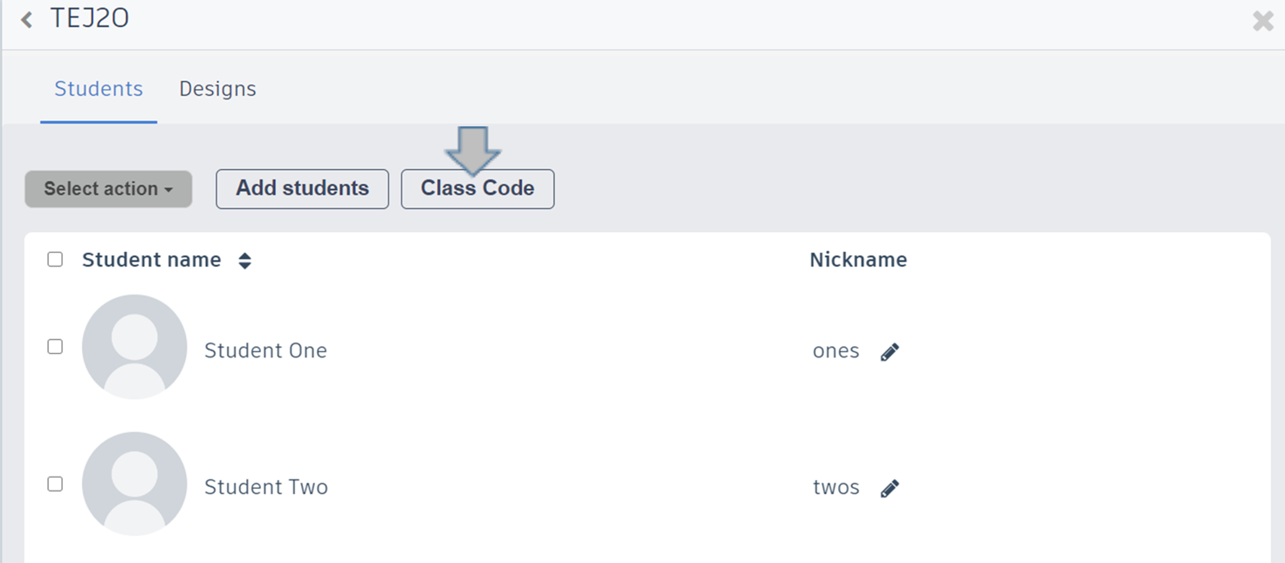
Step 8: Use the given class code and share the join link to your students.


Appendix B – Activity 1 Resources - Intro to Electronics

Activity 1: Introduction to Electronics – Completed Note

Electricity Basics
Name | Description (point form) | Unit of Measurement
Voltage | - the force motivating electrons to flow  - considered the potential energy in the circuit  - you need to refer to two points to calculate voltage | Volts
Current | - how much charge is in a circuit during a given time  - the current produced by the flow of one coulomb per second | Amps
Resistance | - this refers to the opposition of flow of electrons  - again, this must be related to two points in a circuit | Ohms (Ω)

Electronics Components
Below are some items and symbols that will be important for working with electronics.
Component Picture | Draw Schematic | Component Name | Brief Description
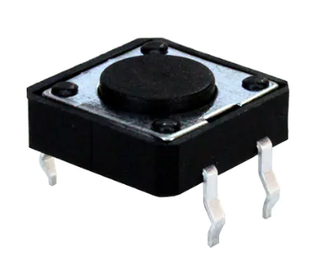 | 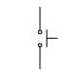 | Push Button  (can be normally open or normally closed)  *Teacher should show examples of each | This button needs to be pushed to allow flow in circuit.
 | 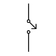 | Switch | ON / OFF Switch flows while ON, no flow when OFF.
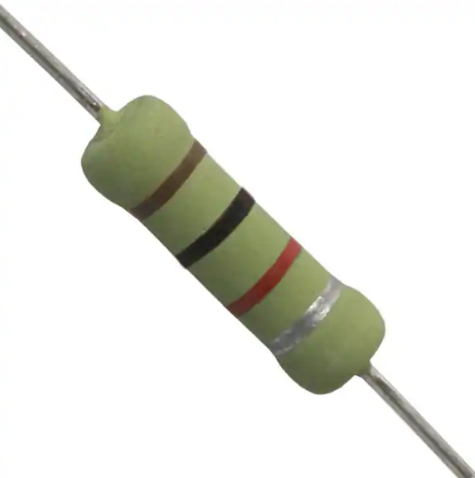 | 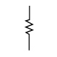 | Resistor | Slows the follow of current in a circuit  (which also lowers voltage based on Ohm’s law).
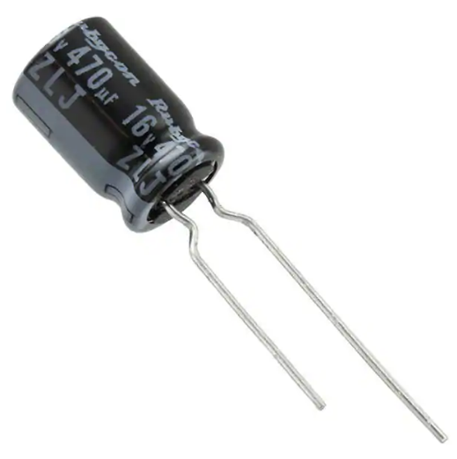 | 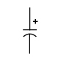 | Capacitor  (polarized capacitor) | Temporarily stores electric charge.  It acts like a bucket (with a hole in the bottom)…it fills then dumps the full amount. If not “filled” the electrons will drain.
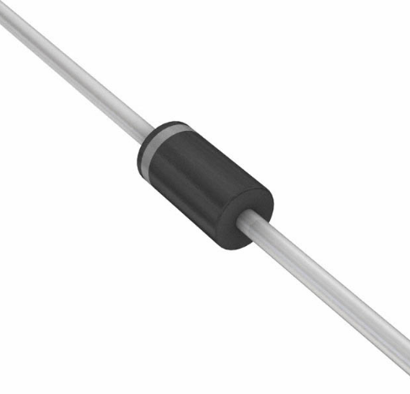 | 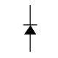 | Diode | Only allows flow in one direction (with arrow).  Can compare to a plumbing check valve.
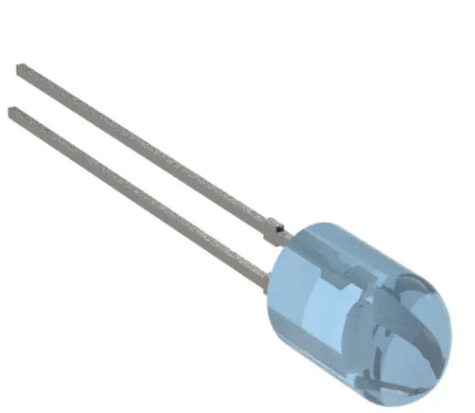 | 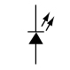 | Light Emitting Diode  (LED) | Only allows flow in one direction and also gives off light

Activity 1: Introduction to Electronics – TEJ2O Student Note

Electricity Basics
Name | Description (point form) | Unit of Measurement
Voltage
Current
Resistance

Electronics Components
Below are some items and symbols that will be important for working with electronics.
Component Picture | Draw Schematic | Component Name | Brief Description

Appendix C – Activity 2 Resources – Intro to Breadboarding
Resources: The video lesson “TEJ2O A2 - Introduction to Breadboards and Basic Circuits on Tinkercad” is provided to give a basic overview of the Tinkercad Simulator and how to use breadboards and basic components.
Web link: Video – Introduction to Breadboards and Basic Circuits on Tinkercad
https://www.octe.ca/application/files/9215/9624/2124/TEJ2O_A2_-_Introduction_to_Breadboards_and_Basic_Circuits_on_Tinkercad.mp4
A Student Activity Sheet follows to accompany this video.

Section A: Create Basic Circuits on a Breadboard

Circuit #1 – LED and Resistor
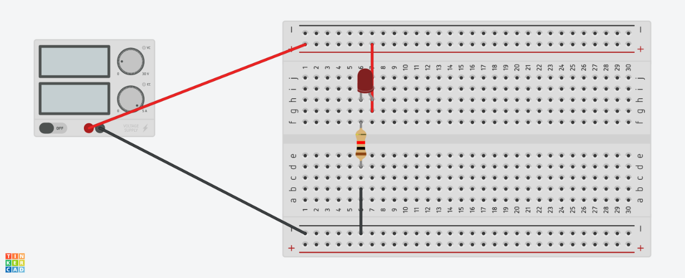

Circuit #2 – Button, LED and Resistor
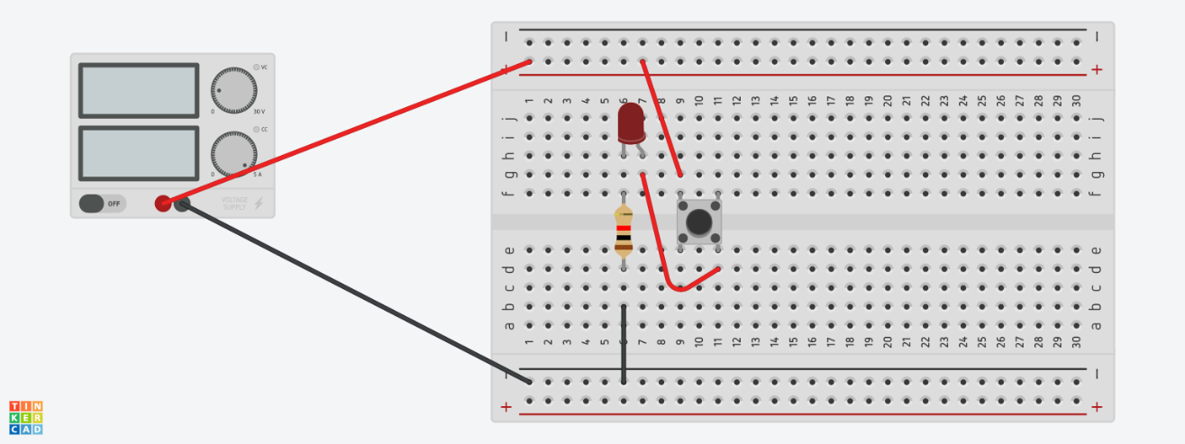

Circuit #3 – Switch, LED and Resistor
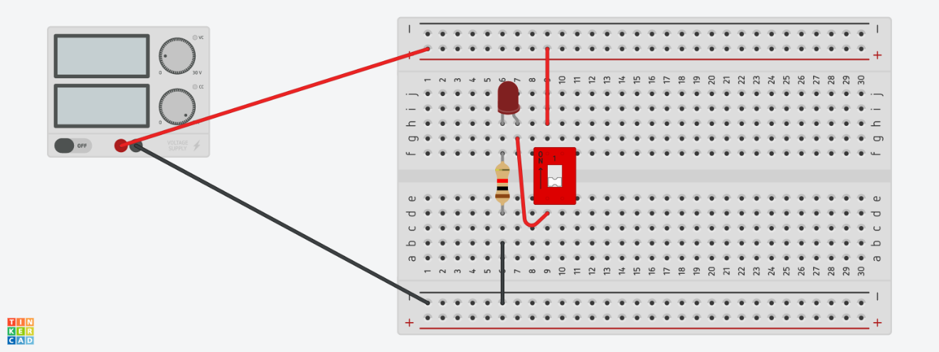

Section B: Draw the Circuit Schematics for Circuits in Section A

Completed Example - Circuit #1:
*Notice that we are only showing the electronics components not the breadboard we are using for testing.
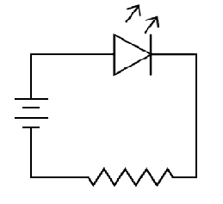

Circuit #2:

Circuit #3:

Appendix D – Activity 3 Resources - Intro to Boolean Logic and Integrated Circuit Chips
Resources Included:
3a: TEJ2O Activity 3a Intro to Boolean Logic - Teacher.pptx
Web link: (Teacher PowerPoint Presentation)

https://www.octe.ca/application/files/6615/9624/1658/TEJ2O_Activity_3a_Intro_to_Boolean_Logic_-_Teacher.pptx
3b: Intro to Boolean Logic (Student Note and Worksheet on following pages)
3d: TEJ2O Activity 3d Intro to Logic Chips Exploration.pptx
Web link: (Teacher PowerPoint Presentation)
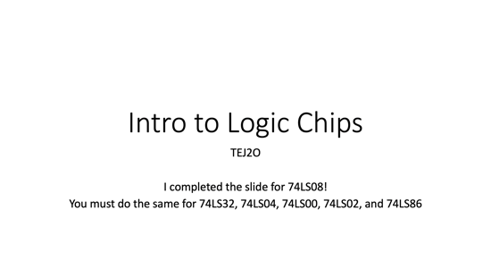
https://www.octe.ca/application/files/4915/9624/1744/TEJ2O_Activity_3d_Intro_to_Logic_Chips_Exploration.pptx
3e: Basic Logic IC Chip Layouts (Student Note and Worksheet on following pages)
3f: LogicLY Boolean Assignment (Scaffolding Activity on following pages)
3g: Integrated Circuits on Tinkercad Activity (Student Worksheet on following pages)
3h: Logic Gates and Integrated Circuits Quiz (on following pages)
3i: TEJ2O A3 - AND Integrated Circuit on Tinkercad.mp4
Web link: (Video)
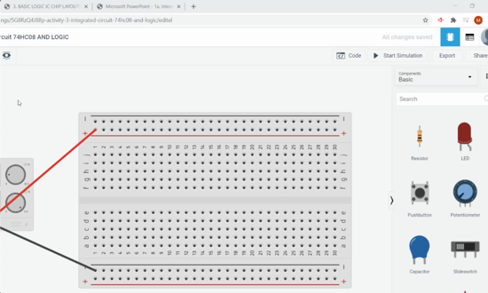
https://www.octe.ca/application/files/5515/9624/2225/TEJ2O_A3_-_AND_Integrated_Circuit_on_Tinkercad.mp4

Boolean Logic – TEJ2O Student Note and Worksheet

Student Note
Remember that: 1 = _____ or _____ 0 = _____ or _____
Boolean logic is used in almost every aspect of ______________ ________________.
In the ____________, George _________________ developed a new form of algebra, now called Boolean algebra in his honour.
Boolean equations use the ___________ number system to provide a very precise way of illustrating the logic of _____________ ___________.
Interesting fact: Boolean equations were used _________________________________ _____________________________________________________________________!
A gate is where ________________ (or ________________ ) flows through. The gate takes the ________________ (usually A and/or B) and gives an ________________ (Y and/or X).
Schematic | Gate | Symbol | Boolean Equation
 | AND
 | OR
 | NOT
 | NOR
 | XOR (EOR)
 | NAND

Truth Tables
AND |  |  |  | OR
A (Input) | B (Input) | Y (Output) |  | A (Input) | B (Input) | Y (Output)
0 | 0 |  |  | 0 | 0
0 | 1 |  |  | 0 | 1
1 | 0 |  |  | 1 | 0
NOT |  |  |  | NOR
A (Input) | B (Input) | Y (Output) |  | A (Input) | B (Input) | Y (Output)
0 | 0 |  |  | 0 | 0
0 | 1 |  |  | 0 | 1
1 | 0 |  |  | 1 | 0
XOR (EOR) |  |  |  | NAND
A (Input) | B (Input) | Y (Output) |  | A (Input) | B (Input) | Y (Output)
0 | 0 |  |  | 0 | 0
0 | 1 |  |  | 0 | 1
1 | 0 |  |  | 1 | 0

Boolean Logic – Worksheet
- Identify each of these logic gates by name, and complete their respective truth tables:
*Note: 3 of the gates are NOT in the note but you should be able to use your knowledge to extend your thinking.
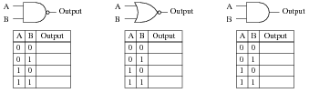
Name: _________________ | Name: _________________ | Name: _________________
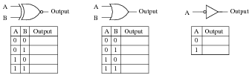
Name: _________________ | Name: _________________ | Name: _________________
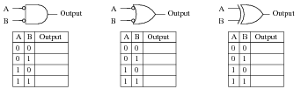
Acts Like: _________________ | Acts Like: _________________ | Acts Like: _________________

Basic Logic IC Chip Layouts – TEJ2O Student Note
74LS08 (AND CHIP) *aka 74HC08 | 74LS32 (OR CHIP) *aka 74HC32
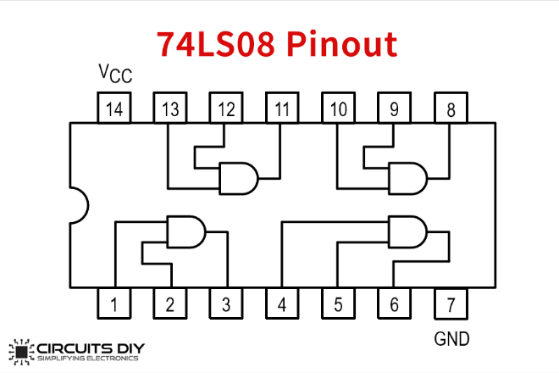 | 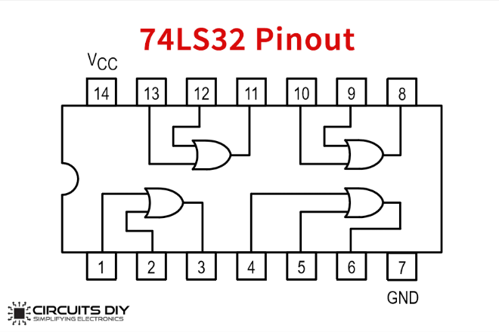
74LS04 (NOT CHIP) *aka 74HC04 | 74LS00 (NAND CHIP) *aka 74HC00
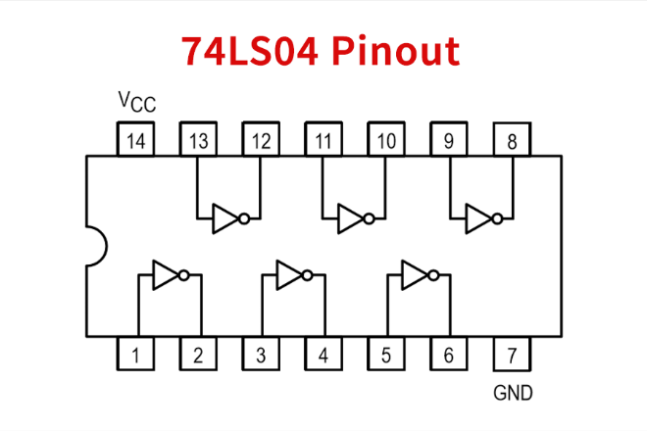 | 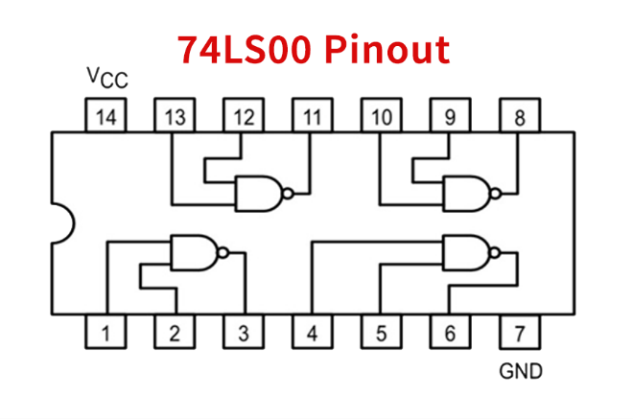
74LS02 (NOR CHIP) *aka 74HC02 | 74LS86 (XOR CHIP) *aka 74HC86
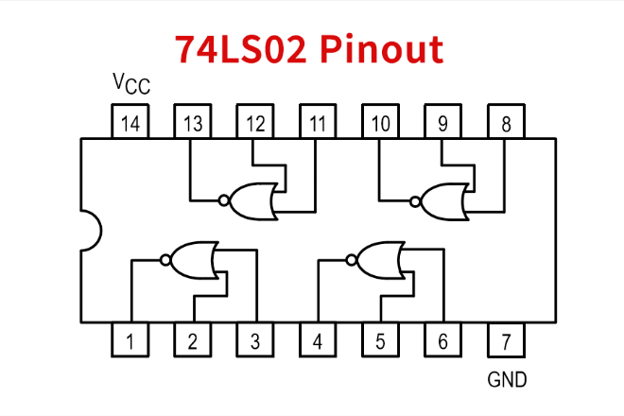 | 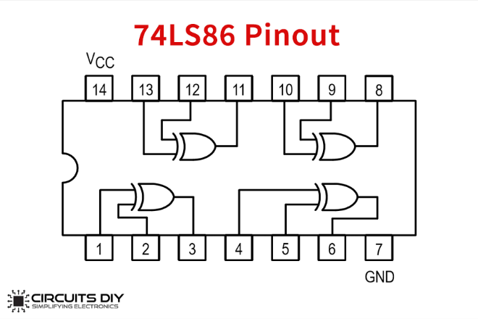
Please note:
1) All chips use pin 14 (top left) for power
2) All chips use pin 7 (bottom right) for ground
3) All the chips (except NOT) have 4 gates on the chip (*NOT has 6 gates on the chip)
4) The NOR chip is reversed (output, input, input)

Experimenting with Logic Gates on Logic.ly – TEJ2O
Today we are going to use Logic.ly to experiment with the logic gates we discussed with Boolean Logic. Use the instructions below to create a standard test circuit. You will be removing and adding new GATES for each test circuit.
Step #1 – Go to https://logic.ly/demo
Step #2 – Add two toggle switches, a light bulb, and the first gate “AND”. Connect the wires as indicated in the diagram.
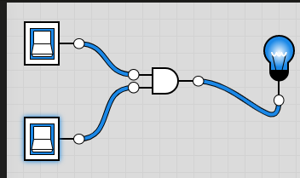
Step #3. Click the switch(es) to see the effect on the OUTPUT LIGHT.
Step #4. Take a screen shot (snipping tool works well) and SAVE IT as “AND”. Repeat for OR, NAND, NOR, XOR, and NOT (*only one switch needed for NOT) (6 x 2 marks each = 12 marks)
Step #5 – Complete the table below with all the results as you are doing them. (3 marks)
Gate Type | Sw1 | Sw2 | Output (On/Off) |  | Gate Type | Sw1 | Sw2 | Output (On/Off)
AND | Off | Off |  |  | NOR | Off | Off
 | Off | On |  |  |  | Off | On
 | On | Off |  |  |  | On | Off
 | On | On |  |  |  | On | On
OR | Off | Off |  |  | XOR | Off | Off
 | Off | On |  |  |  | Off | On
 | On | Off |  |  |  | On | Off
 | On | On |  |  |  | On | On
NAND | Off | Off |  |  | NOT | Off | N/A
 | Off | On |  |  |  | On | N/A
 | On | Off
 | On | On
Extension #1: Do the same for XNOR.
Extension #2: Create the following logic gate. Y = [(A x B) + C] x D

Integrated Circuits: Tinkercad Activity
Step #1: Go to www.tinkercad.com – Login using your course code and nickname
Step #2: Go to CIRCUITS (as indicated in screenshot below)


CHIP #1 – SAMPLE CIRCUIT
Your screenshots should look like this. *NOTE: This shows a value of 1 and 0 in an “AND Gate” so if it was running the LED it should be OFF
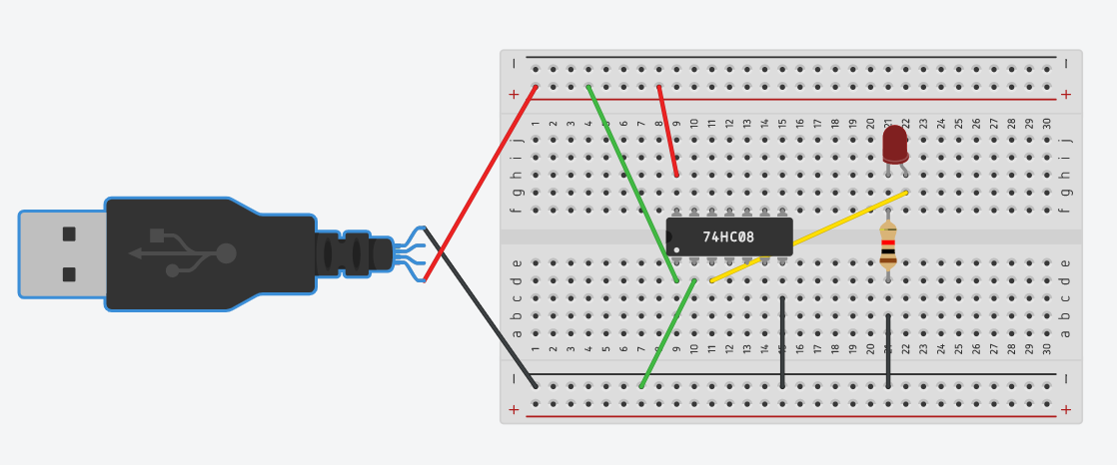

Integrated Circuits: Tinkercad Activity Worksheet Student: ____________

CHIP #1 - 74HC08 (we will also refer to it as 74LS08)
Gate Type: _______________
Results: | A | B | Y
To complete the circuit, take a screen shot (or use snipping tool), paste it into your software of choice and crop it accordingly. Save the image as 74LS08.png

CHIP #2 - 74HC32 (we will also refer to it as 74LS32)
Gate Type: _______________
Results: | A | B | Y
To complete the circuit, take a screen shot (or use snipping tool), paste it into your software of choice and crop it accordingly. Save the image as 74LS32.png

CHIP #3 - 74HC04 (we will also refer to it as 74LS04)
*Note that this chip is different
Gate Type: _______________
Results: | A | Y
To complete the circuit, take a screen shot (or use snipping tool), paste it into your software of choice and crop it accordingly. Save the image as 74LS04.png

CHIP #4 - 74HC00 (we will also refer to it as 74LS00)
Gate Type: _______________
Results: | A | B | Y
To complete the circuit, take a screen shot (or use snipping tool), paste it into your software of choice and crop it accordingly. Save the image as 74LS00.png

CHIP #5 - 74HC02 (we will also refer to it as 74LS02)
*Note that NOR is backwards
Gate Type: _______________
Results: | A | B | Y
To complete the circuit, take a screen shot (or use snipping tool), paste it into your software of choice and crop it accordingly. Save the image as 74LS02.png

CHIP #6 - 74HC86 (we will also refer to it as 74LS86)
Gate Type: _______________
Results: | A | B | Y
To complete the circuit, take a screen shot (or use snipping tool), paste it into your software of choice and crop it accordingly. Save the image as 74LS86.png

Extension: Advanced Circuit
Results: | A | B | Y | Z

Circuit:
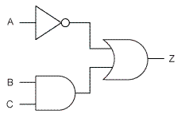
To complete the circuit, take a screen shot (or use snipping tool), paste it into your software of choice and crop it accordingly. Save the image as ADVANCED.png

Advanced Circuit Review Questions:
- Which circuit CHIPS do I need?
- How many input wires are there in total?
- What is the final output (Z) if all inputs are HIGH (1)?
- What is the final output (Z) if all inputs are LOW (0)?
- Can you confirm the final output (Z) if input A = 1, B = 1 and C is unknown?
- Can you confirm the final output (Z) if input A = 0, B is unknown, and C is unknown?

Logic Gates and Integrated Circuits - TEJ2O Quiz
Learning Goal: Derive the truth tables of the fundamental logic gates (e.g., AND, OR, NOT, NOR, NAND, XOR);
Student: _________________ Total: ___ / 26

- Complete the truth table for the following gates: /6
  - 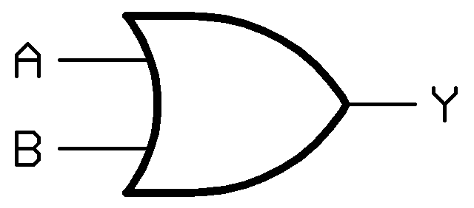
  - 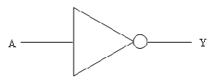
  - 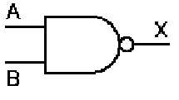

- Integrated Circuit Chips
  - Identify the 14 pins on the IC below (place number inside the “leg”) /1

  - Identify: POWER Pin #____ , GROUND Pin #____ /2
  - Choose one of the chips (circle it) AND, OR, NAND, NOR, NOT, or XOR.
Draw all the gates in the chip above (chip layout) /4
  - What is the chip number of the chip you chose? 74LS______ /1
- For each of the following logic gate circuits you must identify the outputs and the number of Integrated Circuit Chips required to create it on an experimenter breadboard. /12

  - A = 1, B = 0 x = ____ , y = ____, z = ____
# of ICs required __________
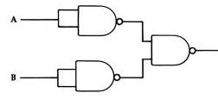
  - A = 1, B = 1, C = 1, D = 0 x = ____ , y = ____, z = ____
# of ICs required __________
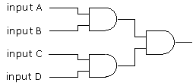
  - A = 1, B = 0, C = 1 x = ____ , y = ____, z = ____
# of ICs required __________
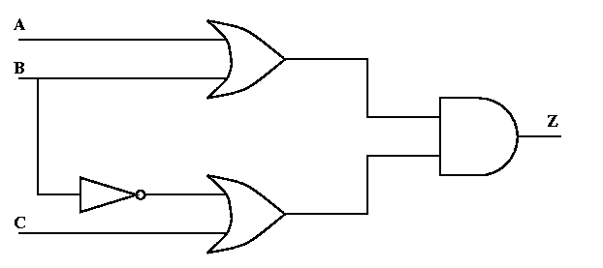

Appendix E – Activity 4 Resources – 555 Timer Circuit

Building a 555 Timer Circuit – TEJ2O
In this activity you will be building a circuit that blinks an LED using a polarized capacitor, 555 Timer Chip, and 2 Resistors (R1 = 2K Ohm and R2 = varies see table below).
555 Timer
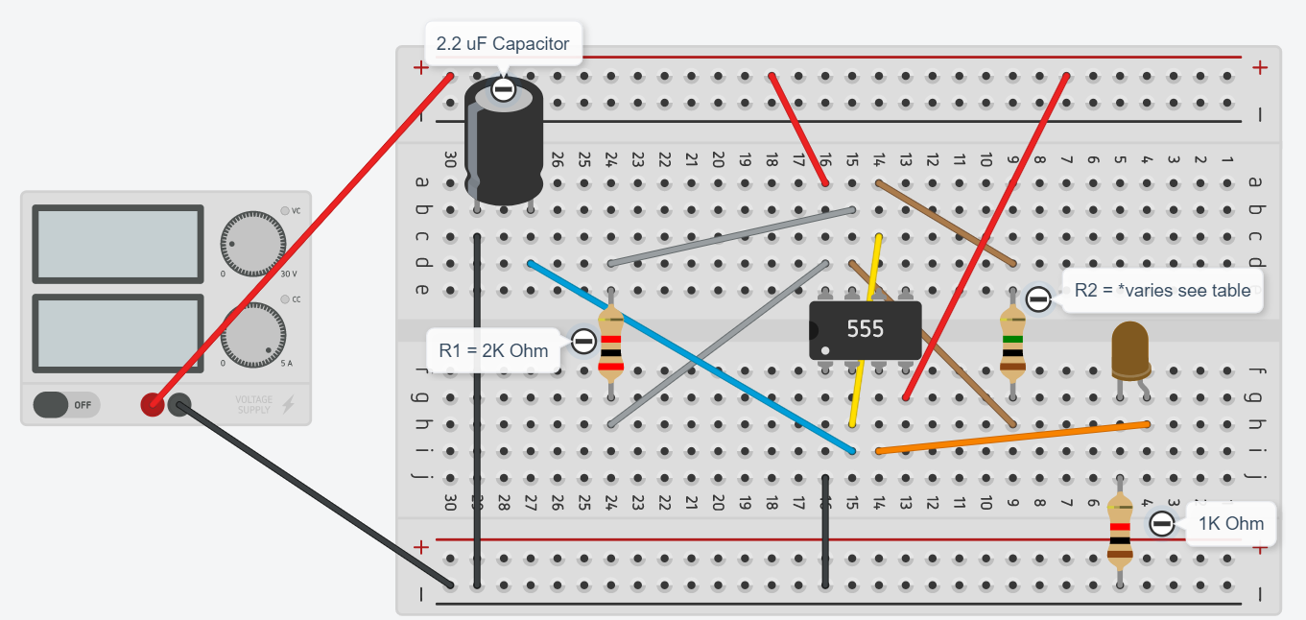
To review reading resistor band values, you can use this online resource:
https://www.digikey.ca/en/resources/conversion-calculators/conversion-calculator-resistor-color-code-4-band
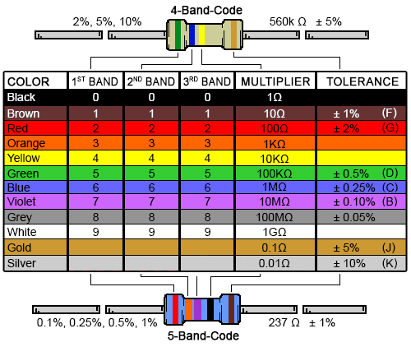
Note: Default Resistor Value on TinkerCAD is 1K ohm. You can change the value using a dropdown menu after clicking on the resistor in your circuit.
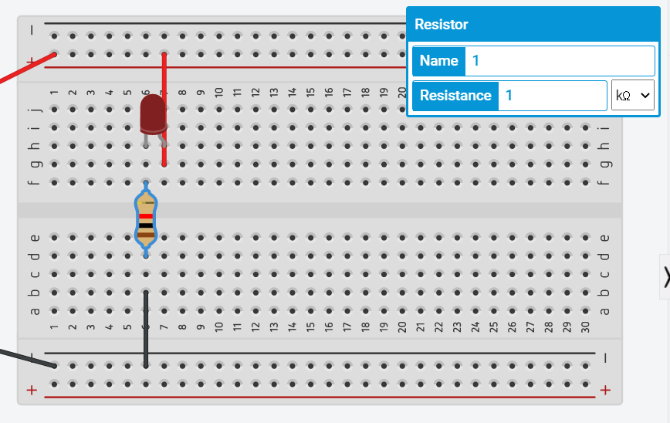
Try the changing resistor values for R2 in your 555 Timer Circuit (Resistor #2)
R2 Values | 4 Band Colour | Speed of Blinking
10K Ohm | brown black orange gold
100K Ohm | brown black yellow gold
510K Ohm (first one) | green brown yellow gold
1M Ohm | brown black green gold
1.5M Ohm | brown green green gold
Reflection Questions:
- What do you notice about the rate of blinking as it relates to the value of R2?
- If you tried to get your LED to blink ON every 1 second which R2 Value would be best?
- If you tried to get your LED to blink ON every 5 seconds which R2 Value would be best?
- If you tried to get your LED to blink ON every 10 seconds which R2 Value would be best?
- Try changing the value of the Capacitor to 1uF. Notice any change? Why does this change occur?

Pinout for 555 Chip
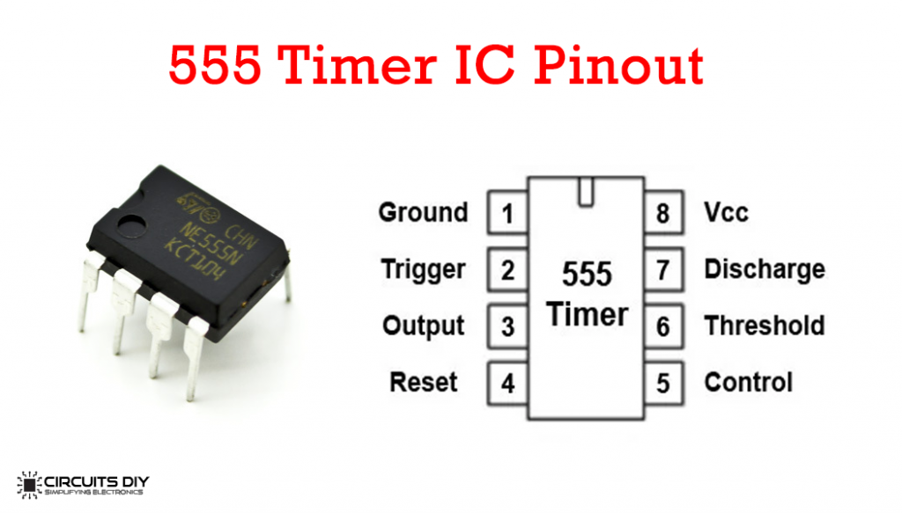

Appendix F – Activity 5 Resources – Seven Segment Display and Decoder Chip

Labelled 7 Segment Pinout for teacher
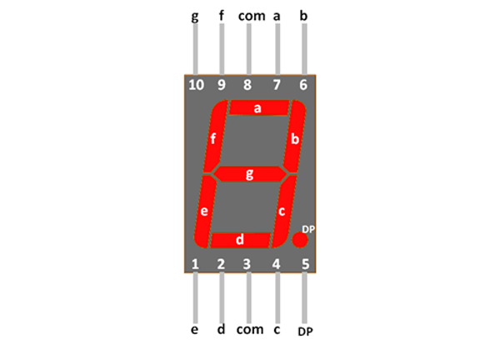
Web link: Video – 7 Segment Intro on Tinkercad
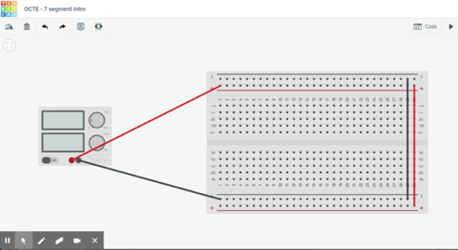
https://www.octe.ca/application/files/3515/9624/2309/TEJ2O_A5a_-_7_Segment_Intro_on_Tinkercad.mp4
Web link: Video – 7 segment with decoder on Tinkercad
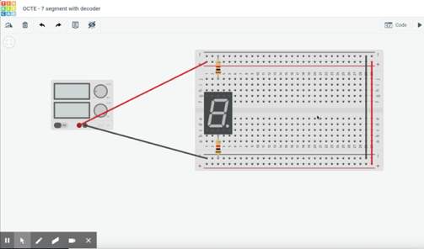
https://www.octe.ca/application/files/6715/9624/2418/TEJ2O_A5b_-_7_segment_with_decoder_on_Tinkercad.mp4

Exploring a 7 Segment Display and Decoder Chip – TEJ2O
In this activity you will be exploring the 7 Segment Display. These electronic components are made up of 7 “segments” or LEDs which can be used to display digits on an Alarm clock or messages on a scrolling display.
The 7 segments are labeled A through G. The two COMMON pins are #3 and #8. These pins receive power (common anode) or ground (common cathode) depending on the type of 7 segment display. As the segments are tiny LEDs you will use resistors to connect the COM pins to PWR or GND rails.
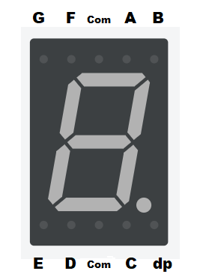Label the other 6 segments after completing the circuit below*

Exercise #1 – Wiring a COMMON CATHODE 7 Segment Display
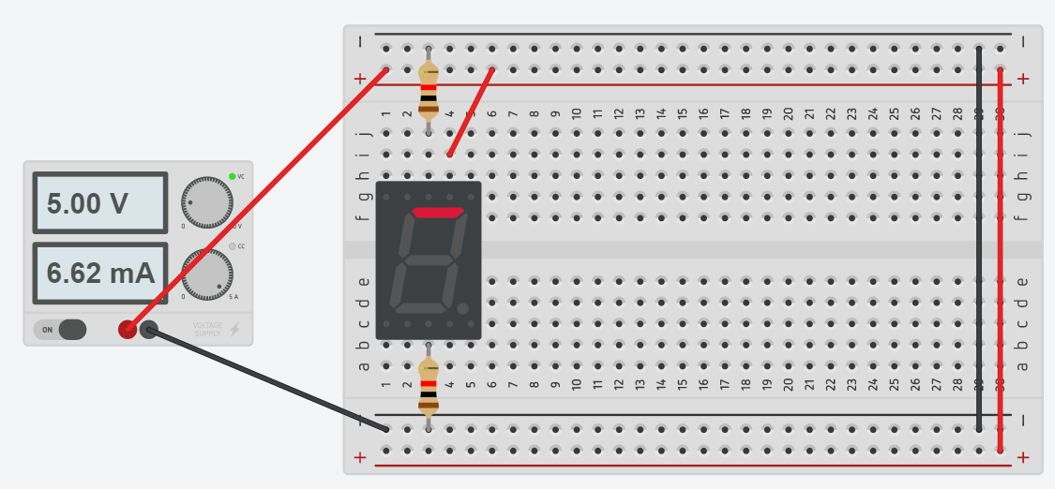
*Notice that the Resistors are connected to GROUND (Common Cathode). In this example “A” PIN is connected to POWER so the “A” Segment is ON. Please label the segments (A through G on the 7 segment above.
Reflection Questions:
- Which segments (A through G) need to be ON (PWR) to produce the number ZERO?
- Which segments (A through G) need to be ON (PWR) to produce the number FIVE?
- Which segments (A through G) need to be ON (PWR) to produce the number EIGHT?
- What could the DOT PIN be used for?

Exercise #2 – 7 Segment and Decoder
Now you will drive the 7 segment display with a decoder chip:
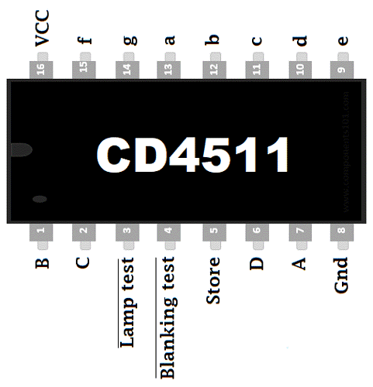
Note: While testing this chip we will give PWR to pins #16, #3 and #4 and GND to pin #8 and #5
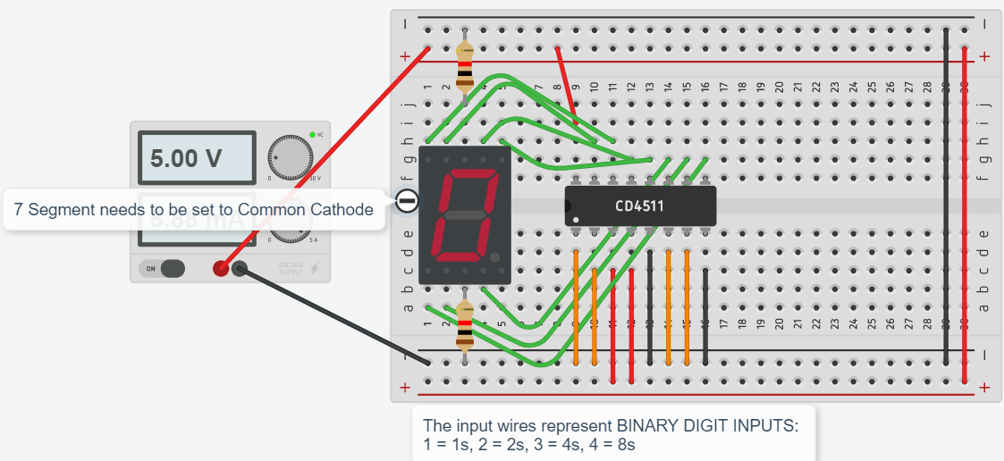
Use the table below to record the values on 7 segment display based on the input values:
INPUT 4  (2³ = 8s) | INPUT 3  (2² = 4s) | INPUT 2  (2¹ = 2s) | INPUT 1  (2⁰ = 1s) | 7 SEGMENT OUTPUT (DECIMAL DIGIT)
0 | 0 | 0 | 0
0 | 0 | 0 | 1
0 | 0 | 1 | 0
0 | 0 | 1 | 1
0 | 1 | 0 | 0
0 | 1 | 0 | 1
0 | 1 | 1 | 0
0 | 1 | 1 | 1
1 | 0 | 0 | 0
1 | 0 | 0 | 1
1 | 0 | 1 | 0
1 | 0 | 1 | 1
1 | 1 | 0 | 0
1 | 1 | 0 | 1
1 | 1 | 1 | 0
1 | 1 | 1 | 1
Reflection Questions:
- What do you notice about the "DECIMAL DIGITS" after 1 0 0 1?
- What should be the DECIMAL VALUE for 1 1 1 1?

Extension:
Try to build this “COMPLEX 7 Segment Display and Decoder”
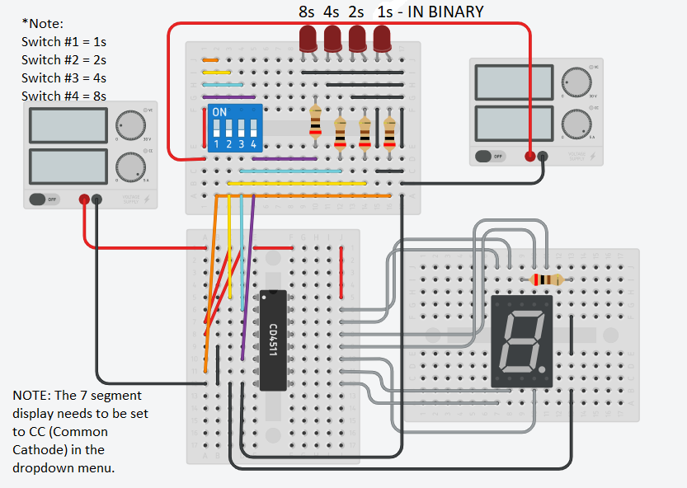

Appendix G – Activity 6 Resources – Counter Circuit Project

Activity #6 Building a Counter Circuit – TEJ2O
In this activity you will be combining all the components to date and creating a counter circuit.
Counter Chip (7493): 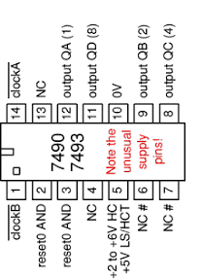

OPTION 1: Button Driven Counter Circuit with Reset Button
- Review Activity #2 to see how a button is wired. This button will “DRIVE” the counter chip (7493) on PIN #14.
- QA is connected to “INPUT 1” on CD4511, QB is connected to “INPUT 2”, QC is connected to “INPUT 3”, QD is connected to “INPUT 4”.
- PIN 5 is POWER and PIN 10 is GROUND
- Another button will reset counter to ZERO (both PIN 2 and 3)

OPTION 2: Automated Counter Circuit using 555 Timer
- Review Activity #4 to see how the 555 timer circuit is wired. This circuit will “DRIVE” the counter chip (7493) on PIN #14 (use same pin that blinks the LED in Activity #4)
- Choose an appropriate value for R2 in 555 timer circuit so the blinking is roughly 1 second (accurate time counter).
- QA is connected to “INPUT 1” on CD4511, QB is connected to “INPUT 2”, QC is connected to “INPUT 3”, QD is connected to “INPUT 4”.
- PIN 5 is POWER and PIN 10 is GROUND
- You can add a reset button that will reset counter to ZERO (both PIN 2 and 3)

Counter Circuit Rubric
Learning Goal: safely construct and test electronic circuits (e.g., LED circuit, flasher, timer) using a breadboard to connect discrete components and integrated circuits
Level 1 | Level 2 | Level 3 | Level 4
Counter circuit design does not incorporate all required components | Counter circuit design includes most required components | Counter circuit design is good with minor errors. | Counter circuit design incorporates all required components and complete the task of counting (either automated with 555 or using 2 buttons)

Counter Circuit Troubleshooting Log:
Issues/Problem | Attempted Solutions | Final Solution
Example: 7 Segment Not Lighting up | *Checked Common Ground Connections, watched teacher video a second time | *Realized that I didn’t change 7 segment to “Common Cathode”

Counter Circuit Project Reflection
What I Knew about Electronics  (PRE-PROJECT) | What I Want(ed) to Know  (DURING) | What I Learned  (POST-PROJECT)

Counter Circuit Project Solutions

OPTION 1: Button Driven Counter Circuit with Reset Button
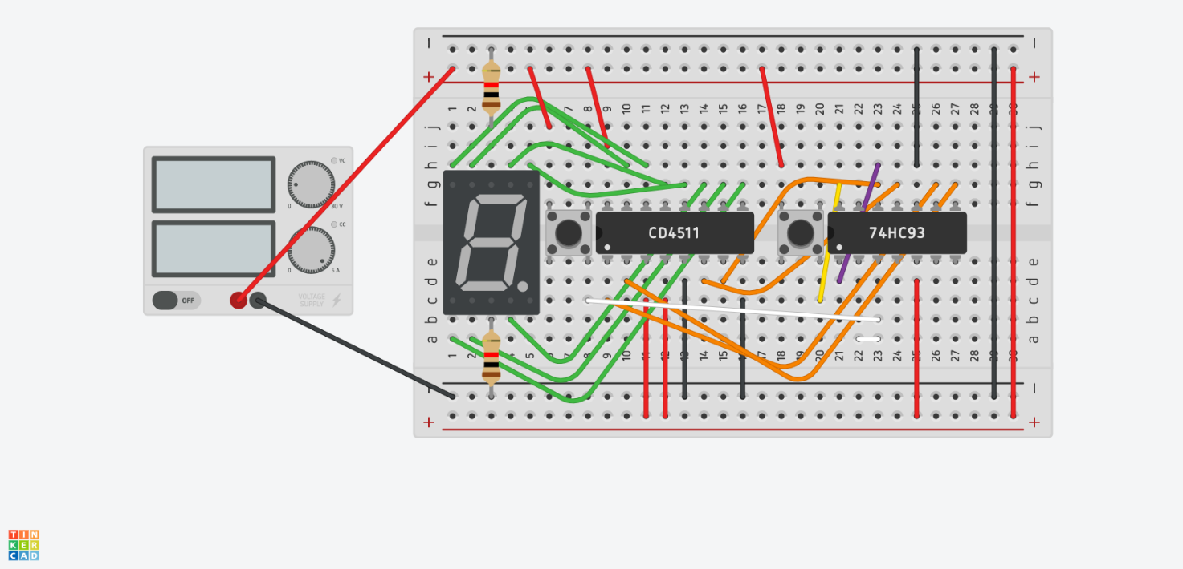

OPTION 2: Automated Counter Circuit using 555 Timer
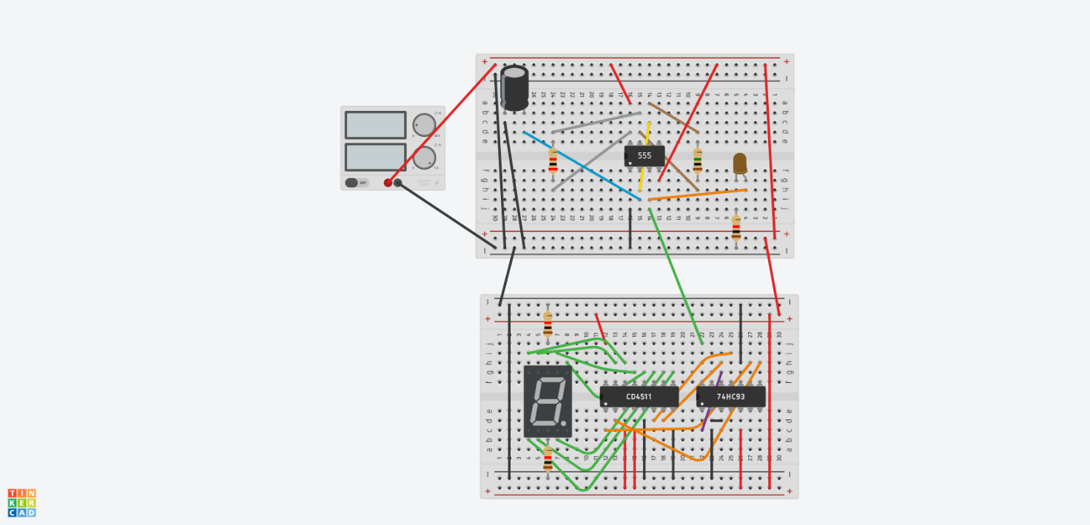

References
4 Band Resistor Color Code Calculator Chart (Image), 2020 https://www.digikey.ca/en/resources/conversion-calculators/conversion-calculator-resistor-color-code-4-band
7 Segment Display Pinout (Image), 2020 https://components101.com/7-segment-display-pinout-working-datasheet
7 Segment Intro on Tinkercad (Video), 2020 https://www.octe.ca/application/files/3515/9624/2309/TEJ2O_A5a_-_7_Segment_Intro_on_Tinkercad.mp4
7 Segment with Decoder on Tinkercad (Video), 2020 https://www.octe.ca/application/files/6715/9624/2418/TEJ2O_A5b_-_7_segment_with_decoder_on_Tinkercad.mp4
21st Century Competencies: Foundation Document for Discussion. Phase 1: Towards Defining 21st Century Competencies for Ontario, Winter 2016 Edition, 2016 http://www.edugains.ca/resources21CL/About21stCentury/21CL_21stCenturyCompetencies.pdf
74LS00 Chip Pinout (Image), 2020 https://circuits-diy.com/74ls00-quad-two-input-nand-gate-datasheet/
74LS02 Chip Pinout (Image), 2020 https://circuits-diy.com/74ls02-quad-two-input-nor-gate-datasheet/
74LS04 Chip Pinout (Image), 2020 https://circuits-diy.com/74ls04-hex-inverter-ic-not-gate-ic-datasheet/
74LS08 Chip Pinout (Image), 2020 https://circuits-diy.com/74ls08-quadruple-two-input-and-gate-datasheet/
74LS32 Chip Pinout (Image), 2020 https://circuits-diy.com/74ls32-quad-2-input-or-logic-gate-ic-datasheet/
74LS86 Chip Pinout (Image), 2020 https://circuits-diy.com/74ls86-quad-2-input-exclusive-or-xor-gate-ic-datasheet/
555 Timer IC Chip Pinout (Image), 2020 https://circuits-diy.com/dark-detector-circuit-using-ldr-and-555-timer/
AND Integrated Circuit on Tinkercad (Video), 2020 https://www.octe.ca/application/files/5515/9624/2225/TEJ2O_A3_-_AND_Integrated_Circuit_on_Tinkercad.mp4
Capacitor (Image), 2020 https://www.digikey.com/product-detail/en/rubycon/16ZLJ470MTA8X11-5/1189-1549-1-ND/3134505
Course Codes for Emphasis courses in the Revised Curriculum: Technological Education, Grades 11 and 12, 2009 http://www.edu.gov.on.ca/eng/curriculum/secondary/techedemphasiscourses.pdf
Diode (Image), 2020 https://www.digikey.com/product-detail/en/smc-diode-solutions/1N4004TA/1N4004TASMC-ND/5992911
DIP Switch (Image), 2020 https://www.digikey.com/product-detail/en/cui-devices/DS01-254-S-01BE/2223-DS01-254-S-01BE-ND/11310868
Growing Success: Assessment, Evaluation, and Reporting in Ontario Schools, First Edition, Covering Grades 1 to 12, 2010 www.edu.gov.on.ca/eng/policyfunding/growSuccess.pdf
Intro to Boolean Logic (PowerPoint Presentation), 2020 https://www.octe.ca/application/files/6615/9624/1658/TEJ2O_Activity_3a_Intro_to_Boolean_Logic_-_Teacher.pptx
Intro to Logic Chips (PowerPoint Presentation), 2020 https://www.octe.ca/application/files/4915/9624/1744/TEJ2O_Activity_3d_Intro_to_Logic_Chips_Exploration.pptx
Introduction to Breadboards and Basic Circuits on Tinkercad (Video), 2020 https://www.octe.ca/application/files/9215/9624/2124/TEJ2O_A2_-_Introduction_to_Breadboards_and_Basic_Circuits_on_Tinkercad.mp4
Learning for All – A Guide to Effective Assessment and Instruction for All Students, Kindergarten to Grade 12, 2013 http://www.edu.gov.on.ca/eng/general/elemsec/speced/LearningforAll2013.pdf
LED (Image), 2020 https://www.digikey.com/product-detail/en/broadcom-limited/HLMP-AB75-WXBDD/516-3974-3-ND/2756797
Logicly Digital Logic Simulator (Website), 2020 https://logic.ly/demo
Momentary Button (Image), 2020 https://www.digikey.com/product-detail/en/cit-relay-and-switch/CT1103AF180/2449-CT1103AF180-ND/12502982
Resistor (Image), 2020 https://www.digikey.com/product-detail/en/ohmite/OX102KE/OX102KE-ND/823904
The Differentiated Instruction Scrapbook http://www.edugains.ca/resourcesDI/EducatorsPackages/DIEducatorsPackage2010/2010DIScrapbook.pdf
The Ontario Curriculum, Grades 9 and 10: Technological Education, 2009 (revised) http://www.edu.gov.on.ca/eng/curriculum/secondary/teched910curr09.pdf
The Ontario Curriculum, Grades 11 and 12: Technological Education, 2009 (revised) http://www.edu.gov.on.ca/eng/curriculum/secondary/2009teched1112curr.pdf
Tinkercad (Website), 2020 https://www.tinkercad.com/

