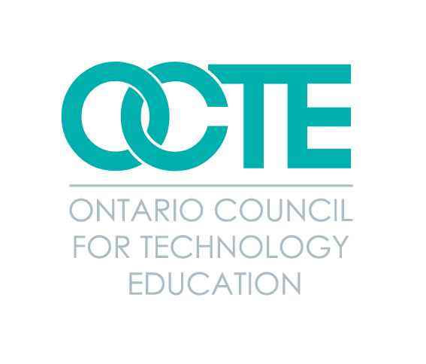
Broad Based Technology 3D Tours and
Supporting Resources for Grade 8 Students
Table of Contents
Resource Section | Page | PDF Version | Microsoft Version
Introduction | 2
Pre-Learning Phase
Overview | 10
What are the 10 BBTs? | 11
What is STEM? | 12
What are the Skilled Trades? | 13
Participation Phase
Overview | 14
Reflection Phase
Overview | 15
Image Response Reflection | 17
Take Tech Quiz and Reflective Questions | 20
3D Tour Wheel of Reflection | 21
Elevator Pitch - Sell Your Favourite BBT! | 22
Digital Portfolio - Document Your Reflections | 23
Application Phase
Overview | 24
BBT, STEM and Skilled Trades Connections Case Studies | 26
Me and the BBTs: Researching A Career of Interest | 27
Interview Assignment ‘Tech Talk’ With A Community Partner | 28
Next Stop: My Future! High School Options Scavenger Hunt | 31
Being Smart About My Future Goal Setting Activity | 32
References | 33
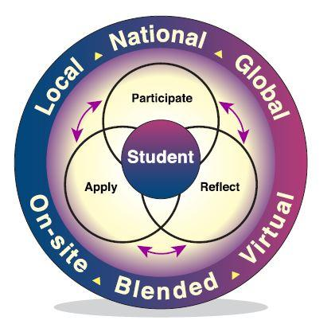
Broad Based Technology 3D Tours and Supporting Resources for
Grade 8 Students
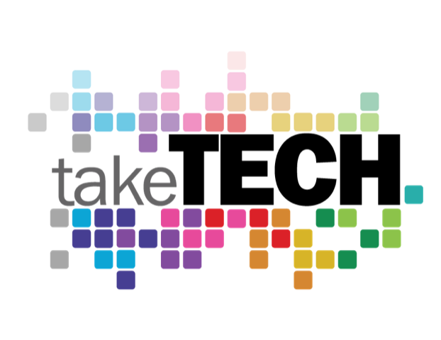
Introduction - Connecting the BBTs, Skilled Trades, and STEM related Careers

It is increasingly clear that we are living in an age where technological advancement is occurring much faster than we can even imagine what the latest device, machine or process might be able to do and what its impact will be on our day to day lives. Those that have technological skills and can apply those skill sets with ease and proficiency in their desired career area will undoubtedly have an advantage in a competitive local and global labour market. The development and refinement of technological knowledge and skills implies so much about the learner - that they possess strong literacy and numeracy skills, are critical thinkers, can successfully problem solve, have transferable skills that will serve them well in both school and work settings, and in this day and age, collaborate with others to design, fix, implement and improve technological innovations effectively.

The Broad Based Technologies (BBTs)

Broad-based technologies are groupings of technological education areas defined by common characteristics - the equipment and materials used, the ultimate purpose of the technological application, and the cluster of careers to which study in the area leads.
There are ten key broad based technological areas in which students can explore their interests, develop their skills for future application to careers of interest:

Communications: TV, Video, Audio, the Internet….Communications Technology courses are project-based and provide students with opportunities to acquire the knowledge and skills required to design, use, and manage electronic, live, recorded, and graphics, specifically in the areas of TV, video, and movie production; radio and audio production; print and graphic communications; photography; digital imaging; broadcast journalism; and interactive new media and animation.

Computer Technology: Computer hardware, game systems, 3D printing….Computer Technology students learn about hardware and software; computer interfacing, programming and networking; analog and digital electronics and robotics. They learn about the components of a computer and other electronics. These courses provide opportunities to assemble, repair, and configure computers with various types of operating systems and application software. Students learn about electronic circuits and how to write computer programs to control peripheral devices or robots.

Construction: House building, electrical work, woodworking….In construction technology courses, students get to learn about designing, constructing, and maintaining a variety of buildings and structures, and gain experience with the tools, equipment, and processes commonly used in the field. Students also learn about health and safety standards in the construction industry, building codes and regulations. Some schools also offer woodworking courses which allow students to concentrate on furniture building or cabinet making.

Hairstyling and Aesthetics: Cutting and styling hair, designing nails, working on movie sets, research and development of new products, creative make up skills….In Hairstyling and Aesthetics students learn hairstyling, make up, and nail care techniques from a salon or spa perspective. Using materials, processes, and current techniques used in the industry, students learn fundamental skills in the hairstyling and aesthetics industry. Students use professional terminology related to hairstyling and aesthetics, acquire transferable problem-solving skills, and learn about the essential skills and work habits that are important for success in these fields.

Health Care: Doctor, nurse, dentist….Health Care courses offer students an opportunity to investigate factors contributing to personal health and, at the same time, gain an introduction to a range of careers in the healthcare industry. These careers include, but are not limited to, medical doctor, child care worker, dentist, laboratory technician/technologist, nurse assistant/nurse, pharmacy assistant/pharmacist, and personal support worker.

In these courses, students gain hands-on experience using industry-standard instruments, equipment, and materials and practising current techniques. They also learn the professional terminology of the field, acquire transferable problem-solving skills, and expand their communication and interpersonal skills as they interact with their peers and clients in a variety of simulated care scenarios, like a hospital emergency room, or a medical facility!
Hospitality and Tourism: Cooking, travelling, restaurants...Hospitality and Tourism courses provide both a hands-on and a theoretical approach to learning about the various sectors in the field. Students have opportunities to develop essential food preparation and presentation skills; learn about event planning and marketing, customer relations, human resource management, inventory management, and tourism administration and management; and examine the cultural and economic forces that drive tourism trends. They also gain experience with equipment and procedures commonly used in their particular sectors of interest, and comply with health and safety regulations and standards that govern the various sectors in the tourism industry.

Green Industries: Horticulture, landscaping, floristry...In Green Industries students explore a variety of areas, including agriculture. Through hands-on projects, students learn how to use a variety of materials, processes, and techniques commonly employed in the growing and maintenance of flowers and crops as well as the ways in which they are aesthetically and functionally organized. Students get opportunities to plan, design and create finished projects all while learning the safety and healthy working practices needed to perform these tasks.

Manufacturing: Machinist, metal work, welding….Manufacturing Technology is the transformation of materials into products to meet human needs and wants. Manufacturing technology courses provide students with hands-on opportunities to acquire knowledge and skills in the areas of mechanical engineering, robotics and control systems, computer-aided manufacturing, industrial maintenance, precision machining, welding, and sheet metal. Through these hands-on projects, students learn how to design and fabricate their own projects using the various new tools and equipment skills they have acquired.

Technological Design: 3D design, architecture, robotics…Technological Design courses provide students with a variety of learning experiences that focus on the practical application of the principles of engineering, architecture, and design. These activity-based courses emphasize problem solving to meet design challenges in a wide range of areas, which may include apparel and textile design, architectural design, interior design, mechanical and industrial design, and robotics and control systems.

Students learn to apply knowledge of research, historical trends, design, materials, fabrication methods, and testing criteria to develop innovative and environmentally sustainable products, processes, and/or services. The technologies and processes used to create design solutions may include both traditional and computer-based drafting methods, scale models, working prototypes, animations and simulations, displays, portfolios, and presentations.
Transportation: Cars, boats, airplanes…Transportation Technology courses provide students with opportunities to understand transportation systems from the perspective of either the consumer or the service provider. The range of courses enables students to study both vehicle ownership and vehicle maintenance, and to develop skills and prepare for careers in the servicing and repair of vehicles, aircraft, and/or watercraft.

The broad based technology area descriptions above were adapted from the OCTE Take Tech Web page.

Connecting the BBTs to Careers in the Skilled Trades

Technological skills serve students well no matter which first or ultimate post-secondary destination they may choose to pursue. Whether it be apprenticeship, college, community, university or the workplace, tomorrow’s workforce will require proficiency in a variety of technological areas in order to compete and thrive in an increasingly technologically-driven world.

The skilled trades provide young people with a diverse range of rewarding, challenging and in demand career opportunities that require daily application of these technological skills. As defined by the Ontario.ca/skilled trades website:

“A skilled trade is a career path that requires hands-on work and specialty knowledge. Skilled trades workers build and maintain infrastructure like our homes, schools, hospitals, roads, farms and parks. They keep industries running and perform many services we rely on every day, like hairstyling, food preparation or social services.
Benefits of a career in the skilled trades include:
- in-demand jobs and great earning potential
- using cutting-edge technology
- being paid while you learn on-the-job
- many paths to advance
- “transferable skills”

There are multiple pathways to enter the skilled trades and no right or wrong way to go about doing so, whether apprenticeship is chosen voluntarily or as a compulsory component. Data suggests that the need to replace retiring workers is greater for skilled trades workers than for other occupations, underscoring the demand that exists in these fields. In 2016, nearly 1 in 3 journeypersons were aged 55 years or older. This has been supported by a recent investment of almost $440,000 (Spring 2021) to support student understanding and exploration of the skilled trades pathways.

“There are exciting skilled trades and technology careers waiting for young people today and will be even more as current workers retire in the years to come,” said Minister Monte McNaughton in a June 3, 2021 news release. “This investment is part of our strategy to break the stigma that still surrounds working in the skilled trades. We need to show students and their parents that becoming a tradesperson – a carpenter, a plumber, or an electrician – can be as fulfilling as becoming a doctor, lawyer or an engineer.”

The ten broad based technological areas connect directly to the 144 apprenticeable skilled trades in Canada as well as the hundreds of additional non-apprenticeable trades available to tomorrow’s workforce.

Connecting the BBTs and Skilled Trades to STEM Skills

One does not have to look far to find connections to the Skilled Trades and Science, Technology, Engineering and Mathematics (STEM) related fields. It is predicted that approximately 70% of Canada’s top jobs now require some level of STEM and it’s known that students that pursue science, technology, engineering and math-based courses leave open many more post-secondary opportunities for themselves than those that do not.

The Council of Canadian Academies has identified three types of STEM skills:
- Fundamental skills – includes reasoning, mathematics, problem-solving and technological literacy, all of which are important regardless of occupation.
- Practical skills – developed through training in technologies, applied sciences and the trades.
- Advanced skills – these enable engagement in discovery or applied research, including the development of new technologies.
Young people don’t always equate STEM with the skilled trades and technologies, yet these are among the most varied career opportunities that are accessible with a STEM foundation. All skilled trades programs require STEM courses for entrance and/or utilize STEM knowledge/skills in their practice. STEM and the skilled trades are intimately connected and the acquisition of the knowledge and skills required for success in both is a truly powerful combination as a young person seeks employment opportunities.

Education and Program Consultant at Let’s Talk Science Craig White has suggested that “Many skilled trades programs require a high level of math and/or science for entrance. Like all career sectors, the skilled trades workplace is being changed by technology. Careers in skilled trades require problem-solving skills, critical thinking abilities, and a lifelong learning perspective. STEM courses and programs help provide youth with these skills and abilities.”
What Does This Resource Include?
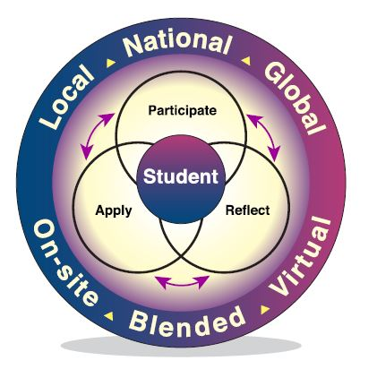
This resource provides educators with a complete package of experiential learning opportunities tied to student exploration of 3D Tours linked to the 10 broad based technology areas. These tours provide students with the opportunity to view technological education facilities and learn more about the equipment and resources within them and the opportunities they hold for further learning and career exploration.

What is Experiential Learning?
Experiential learning involves a 3-phase cycle of
Participate-Reflect-Apply.

When students participate, they actively engage in hands-on in person or virtual activities that help them bring authenticity to classroom/school learning. Often a ‘pre’ phase precedes the participation phase to ensure students have the base level understanding needed to reap the most from this experience.

When students reflect, they derive meaning from their experiences and start to make connections to themselves and their understanding of the world around them.

When students apply, they use their new understandings to create goals, make decisions, or take on new challenges with the confidence of experience behind them.

Experiential learning can take place locally, nationally, or globally or occur on-site, virtually, or through a blended model. These experiences can include field trips, industry tours, simulations, post-secondary visits, project mentorship from community partners, design challenges, service and project-based learning, job shadowing and co-operative education placements, and much more.
The following three sections are included in this experiential learning resource:
Participation: links to the ten 3D tours of technological education facilities
Reflection: a variety of different reflective activities for whole class, small group and individual reflection to support student processing of their 3D tour experiences
Application: a variety of options for students to extend their learning to their individual pathway plan (IPP) and to their understanding of the demands of the current workforce beyond the walls of their classrooms

Who Is This Resource Intended For?
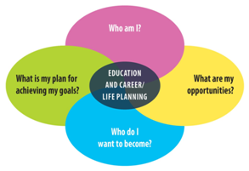
This resource was created for Grade 8 students as they prepare for a critical transition in their educational career - the transition to high school. As part of the Education and Career/Life Planning program of all students from grades 7-12, Grade 8s should be given opportunities to explore the four inquiry questions outlined below:

Source: Creating Pathways to Success, 2013

A critical piece that allows students to answer these questions requires their knowledge and awareness of the high school and career opportunities that exist for them. By becoming more aware of who they are and what interests them (Who Am I?), the range of high school, post-secondary and career opportunities that exist (What are my opportunities?), students can increasingly determine a career path that is the best fit for them (Who do I want to become?) and a clear plan to help them achieve it (What is my plan for achieving my goals?)

It is consistently reported that students know the least about the apprenticeship/skilled trades pathway and the many opportunities they can explore to consider this equitably against other initial post-secondary destinations. This resource will provide students with opportunities to explore areas of study within the ten broad based technology areas they can potentially pursue in high school and consider these areas of interest when making their high school course selections. It is important to note that not every high school (and in some cases, boards) will offer programming within every BBT area. Students will also have the opportunity to consider career options that connect to the skilled trades and STEM-related fields and the next steps they can take to help them get there. Exploration of technological areas, the skilled trades and STEM-related fields may also allow students to make connections to their learning in Science and Technology studies, specifically within the unit of Understanding Structures and Mechanisms: Systems in Action.

THE PRE-LEARNING PHASE:
Minds On Activation of Learning
What do students need to know about the 10 broad based technology areas, STEM and the skilled trades to ensure they get the most from their engagement with the 3D Tours?

Students will benefit from having a base level understanding of each of these concepts. The activities below have been designed to help students explore these areas to ensure they can effectively reflect and make connections following their 3D tour experience.

The following activities have been designed to help support these next steps for student activation of learning:

What are the 10 BBTs? - A Slide Deck with accompanying Matching Activity that allows students to learn more about the 10 BBTs and what they include.

What is STEM?- Students watch two videos and complete a mindmap to help them process their learning about what STEM is all about afterwards.

What are the Skilled Trades?- An activity for students to listen to a video about the skilled trades and complete a pre and post activity to capture their knowledge, learnings and wonderings.

What are the 10 BBTs?

Students will benefit from receiving an overview of the 10 Broad Based Technology areas before they engage in the 3D tours. This will allow them to better understand what each area includes to determine which areas may be of particular interest, and potentially, a focus for a future career.

Broad-based technologies are groupings of technological education areas defined by common characteristics - the equipment and materials used, the ultimate purpose of the technological application, and the cluster of careers to which study in the area leads.
There are ten key broad based technological areas in which students can explore their interests, develop their skills for future application to careers of interest.

The slide deck linked HERE provides an overview of the 10 BBT areas as well as a follow up matching activity for students to test their understanding of each. Slides are also linked to the BBT area posters developed by OCTE to give students additional insight into what the BBT area includes.

Educators can encourage students to make a copy of the slide deck in order to complete the matching activity and submit it.

What is STEM?

Students may have heard the term ‘STEM’ before and even know what it stands for, but do they really know what it means to have STEM skills or to work in a STEM-related field? The intention of these activities is to help them develop an appreciation of both.

Watch the two videos found at the links included below.

Video 1: STEM-What is it and why is it important? (3:06)

Video 2: STEM Careers - Inspire the Next Generation of Innovators (2:57)

Note: This infographic of the 8 STEM Thinking Dispositions, produced by Global Education STEM is a useful resource for students to refer to when thinking about the many skills and attitudes connected to learning and working with a STEM mindset.

Students are to complete the mind map below after watching the videos. There are no right or wrong answers to the prompts in the mind map - this is a way for them to make connections between the videos and how STEM relates to various aspects of their life.

How STEM relates to my INTERESTS | How STEM relates to my  LEARNING AT SCHOOL
What is STEM?

How STEM relates to my  ACTIVITIES WITH FAMILY AND FRIENDS | How STEM relates to my  UNDERSTANDING OF THE WORLD
A full page version of this mind map can be found HERE.
What are the SKILLED TRADES?

The skilled trades are an exciting, rewarding, and challenging career pathway. They are also the most misunderstood post-secondary pathway option which means that sometimes people have an inaccurate perception of what they are really all about and what they have to offer.

It’s time for students to assess what they Know, Wonder about and will Learn about the Skilled Trades in this next activity.

Step 1: Students should fill in the first column in the KWL chart to capture what they already believe they know to be true about the Skilled Trades. They should also complete the second column to indicate what wonderings they still have about the Skilled Trades as a career pathway.

Step 2: Watch the videos about the Skilled Trades:
Video 1: Consider a Career In the Skilled Trades (1:59)
Video 2: Opportunities In the Skilled Trades andTechnologies (4:34)

Step 3: Complete the remaining sections of the KWL chart. Share with a partner.
What I Think I Already Know | What I Wonder | What I Learned From the Videos
What I’m Still Wondering About

THE PARTICIPATION PHASE:
Exploring the Broad-Based Technology 3D Tours

Students will have the opportunity to explore all 10 of the web-based 3D tours featuring technological education facilities that highlight the broad based technology areas. Again, depending on availability of programming, courses in every BBT area may not be available in every secondary school.

Students should be encouraged to:
- Explore at least 5 tours of interest to them, and ideally, explore all of them
- Take their time exploring all areas within the tour, reading all of the bulletins that come up and listening to the information shared.
- Imagine that they are ‘walking’ the tour themselves.
Broad-Based Technology Area 3D Tour Link
Communications Technology
Computer Technology
Construction Technology
Green Industries
Hairstyling and Aesthetics
Health Care Technology
Hospitality and Tourism
Manufacturing Technology
Technological Design
Transportation Technology
Some questions to ponder while students complete each tour:
- What interests you about what you see during the tour?
- What is one thing you learned that surprised you?
- Is there a particular kind of project you’d be interested in doing in this space?
- Could you see yourself taking a high school course in this kind of classroom?
- What connections can you see between the tech area you are exploring and careers in the skilled trades? Could you see yourself working in these kinds of careers?
- What connections can you make between the tech area you are exploring and the skills needed for success in STEM-related careers?
- What do you still have questions about following the tour?
THE REFLECTION PHASE:
Processing the Learning and Extracting Meaning

A critical piece of any experiential learning cycle is giving students the opportunity to reflect meaningfully on what they have learned. In the absence of reflection, learning can remain at a superficial level and likely will not be retained. When students reflect deeply and thoughtfully, they describe, interpret and generalize their experience in preparation for the application phase of the experiential learning cycle.

Describe → reviewing with learners details, perspectives, and feelings associated with an event, such as:
- What just happened?
- What did you notice?
- How do you feel?

Interpret → guiding learners to process an experience, starting with questions such as, “Why?” and “What makes you say that?”

Generalize → identifying and putting into words what new learning happened, with prompts such as:
- What is important that you/we remember?
- When might you use this information?
- How does this connect to real life?

Reflection activities for students to complete following their engagement with the 3D tours can be done through:

Whole class activities
Small group/pair activities
Individual Reflections

Educators can decide which activities are best suited to each format based on the needs of their learners. Please note that the activities below are offered as suggested ways for students to reflect and build upon their learning from the 3D tours and do not all have to be completed. Educators may choose those activities that they feel will best support the reflective process of their learners.
The activities included for student reflection are:

- Image Response Reflection - students examine images representing the 10 broad based technology areas and answer reflective questions that require them to select images based on various criteria.

- Take Tech Quiz and Reflective Questions - students take a brief quiz that helps identify cluster areas within the broad based technologies that are areas of interest and then reflect on the commonalities between those areas.

- 3D Tour Wheel of Reflection - a wheel of nine reflective questions that students can answer based on their experiences with the 3D tours.

- Elevator Pitch - Sell Your Favourite BBT! An activity for students to ‘pitch’ their favourite BBT and try to convince others as to why it’s the most interesting and useful in terms of skill building and preparation for a range of important career fields.

- Digital Portfolio - Document Your Reflections (Strongly Suggested) - all Ontario school boards use a digital tool such as myBlueprint or Xello for students to document their Individual Pathways Plan. Portfolios serve as excellent ways for students to document their learning and experiences and record their reflections in a variety of ways. This activity provides students with options to create an audio, video, photographic or written reflection related to answering two of the four inquiry questions of the education and career life planning cycle. Specifically,

Who Am I?
What Are My Opportunities?

Image Response Reflection

Students are to be given the images below presented as a handout, deck of cards or as a Google Slide Deck.

Following exploration of the 3D tours, ask students to examine each of the images representing one of the ten broad-based technology areas. Students should answer the questions that follow:

- Which picture most represents a learning/career activity that interests you? Explain why.

- Which picture most represents a learning/career activity that you feel is already a strength for you? Explain why.

- Which picture most represents a learning/career activity in which you have no interest or feel is not a strength for you? Explain why.

- Which picture represents a learning/career activity in which you have limited knowledge or experience but are interested in trying? Explain why.

- Are there any particular images to which you make a strong connection to STEM skills? Are there any particular cards to which you identify a strong connection to the skilled trades? Explain your reasoning.

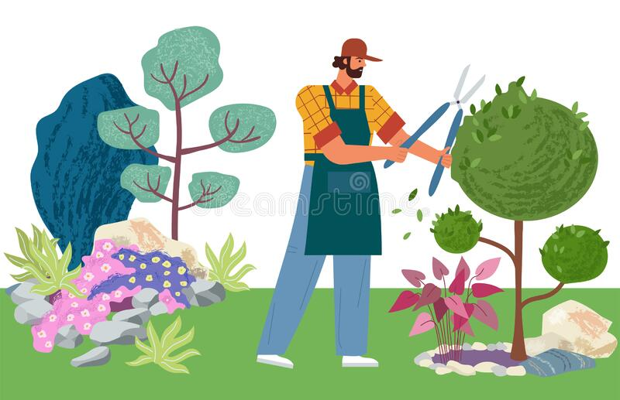 | 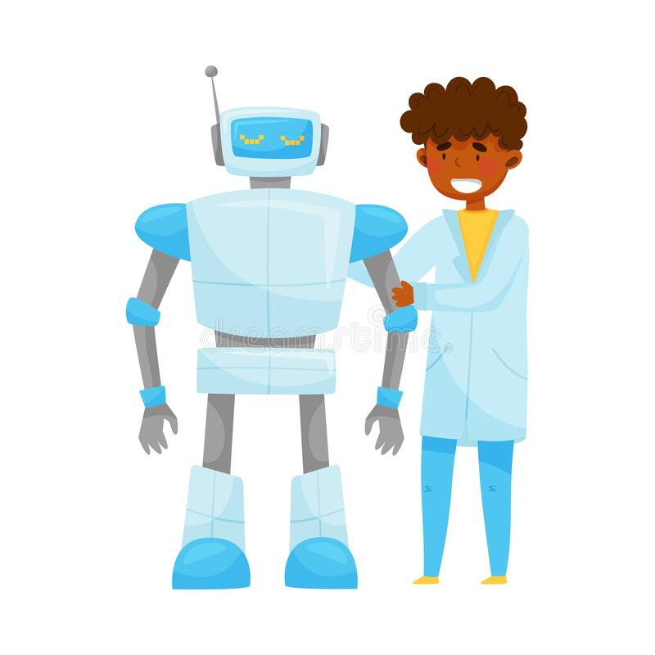
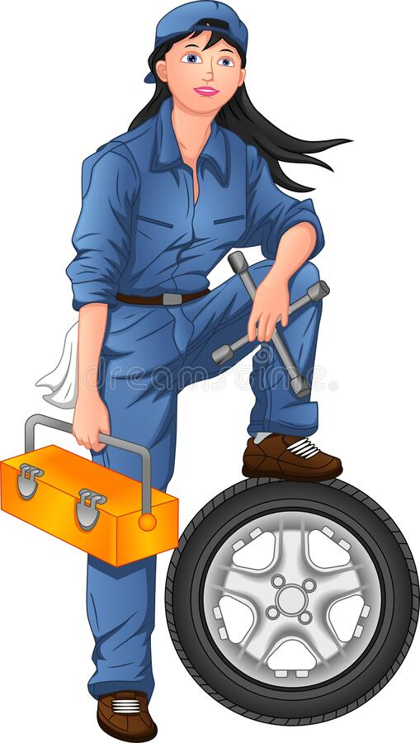 | 
 | 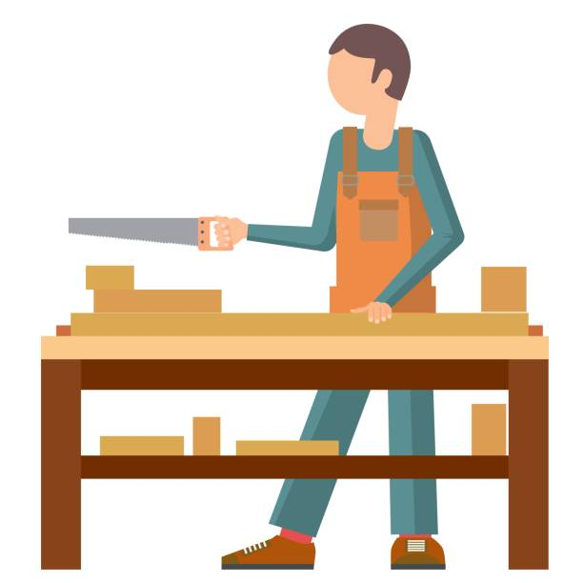
 | 
 | 

Take Tech Quiz and Reflective Questions

Now that students have viewed the 3D tours, they are encouraged to reflect further on areas within the ten broad-based technologies that are of particular interest to them.

Step 1: Students answer the five quiz questions found HERE.

Step 2: Students review the results of their quiz found at the end of the quiz document. They can read more about their identified strongest area using the BBT descriptions found HERE. Students can access these descriptions by clicking on the BBT poster images.

Step 3: Students reflect on the results of their quiz using the following prompts. These reflections can be provided orally or in a written format.

- Which BBT area (i.e. which colour) was identified as being the strongest for you?

- Did this result match with the 3D tours that you found to be of the greatest interest? Why do you think it did or didn’t match?

- What knowledge, skills and interests do you see as being common to the cluster of broad based technologies within the colour area that emerged as the strongest area of interest for you based on the quiz results?

Knowledge | Skills | Interests

What do you think this tells you about the knowledge, skills and interest you already possess and/or are interested in developing?

- Did you learn anything more about your strongest areas of interest from reading over the poster descriptions found HERE (that was different from what you learned through the 3D tours)? If so, what else did you learn?

3D Tour Wheel of Reflection

A fun and interactive way for students to reflect following their participation in the 3D tours is the use of a reflection wheel. A digital reflection wheel can be found at www.wheelofnames.com that allows educators to create their own reflective questions and then spin the wheel for students to randomly answer questions that the spinner lands on. Please note that because this website uses pop-up ads, please check with your school board’s policy around whether it is appropriate for educator use, student use, or both.

A reflective wheel of eight questions related to the 3D tours has been created HERE. Please note that educators can make a copy of the wheel to edit these questions as they see fit for their learners.

The questions included on the wheel are:

Which 3D tour interested you the most? Why?

Which 3D tour surprised you the most with what you saw and learned about? Why?

Which 3D tour included hands-on activities that you think you would find challenging? Why?

Choose one 3D tour and share something you think you would like about learning and working in that tech space.

Which tech area courses would you like to take in high school based on the 3D tours?

Identify a skill or ability you already have that you think would make you successful working in one of the tech spaces you explored in the tour.

Choose one tech area and identify a skilled trades career you think would connect to that area and explain why.

Choose one tech area and identify a STEM-related career you think would connect to that area and explain why.

Elevator Pitch - Sell Your Favourite BBT!

Students will have had multiple ways to determine which broad based technology areas speak most to their interests - their engagement with the 3D tours, their completion of the Take Tech Quiz and the results of the Image Response Activity. There should be one or two clear BBT areas that emerge as being their greatest area of interest….and now it’s time for them to sell it to the rest of their class!

Students are required to create a 2-minute ‘elevator pitch’ that allows them to share why their BBT of interest is the best. This may take the form of a ‘rant’ similar to those done by Canadian comedian Rick Mercer (you can find an example HERE). Content in the ramp should include but not be limited to:

- The BBT that the student has identified as being ‘the best’
- An overview of what the BBT is all about and has to offer in terms of student learning and experiences
- The kinds of equipment students use when engaged in work within this BBT
- The connection of this BBT to STEM skills and STEM-related careers
- The connection of this BBT to careers in the skilled trades

Note: students may need to do some additional research on this topic and may find the following websites useful
- www.apprenticesearch.com
- www.jobtalks.org
- https://careersintrades.ca/what-are-the-skilled-trades/discover-and-explore-the-trades/

Students can share their elevator pitch live or record it through a digital tool such as Flipgrid (if board-approved) to share with their class. This allows the entire class to collectively benefit from the sharing of information about each of the 10 broad based technology areas.

Digital Portfolio - Document Your Reflections

As part of the Individual Pathways Plan that every student in grades 7-12 develops over the course of their educational career, students can create a digital portfolio that documents their reflections about the 10 broad based technology areas and their connections to the skilled trades and STEM related careers.

Depending on the tool approved by your board, students may use myBlueprint, Xello, or another web-based platform. These tools allow students to create reflections in a variety of formats:
- Written
- Photographic
- Audio
- Video

...and then upload them to their portfolio.

Students can be encouraged to create a “BBT, STEM and SKILLED TRADES” portfolio and to create a reflection that answers the following questions:
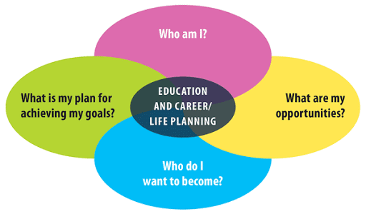
1. What is the broad-based technology area(s) that interest you most?

2. How does this area connect to careers in the skilled trades?

3. How does this area connect to careers in STEM-related fields and the development of STEM skills?

4. How did completing the 3D tours of the 10 BBTs help you answer the following questions of the Education and Career/Life Planning Cycle?
- Who Am I?
- What are my opportunities?

Students can share these portfolio submissions with their teacher and/or their classmates if they are comfortable doing so.
THE APPLICATION PHASE:
Making Connections and Taking Next Steps

Now that students have had the opportunity to meaningfully reflect upon their learning from the 3D tours when it comes to their understanding of the 10 broad based Technology areas and their connections to Skilled Trade and STEM related skills and careers, it’s time to support them in taking the next steps with their learning.

In the application phase, we want to help students make connections between what they have learned and their own life as well as their understanding of the world around them. This often takes the form of:

- Goal Setting and Decision Making
- Connecting their learning to classroom and community opportunities….and beyond
- Sharing their newfound knowledge and understanding with others
- Being challenged to extend their learning to new situations and related problems

The following activities have been designed to help support these next steps for student application of learning.

- BBT, STEM and Skilled Trade Connection Case Studies - students will read a series of six case studies about community members working in technological fields. They will answer four questions about each case study that help them to identify the BBT to which the partner’s job is connected, applications to STEM and the skilled trades, and additional related careers.

- Me and the BBTs: Researching A Career of Interest- students will use a variety of web-based resources to explore a broad-based technology area of interest in greater depth and research a career of interest that connects to this area (use IPP tool for their board but also provide additional websites)

- Interview Assignment - ‘Tech Talk’ With A Community Partner-interview a member of your local community who works in a technological-education related field. Interview questions to be provided.

- Next Stop: My Future! - students will navigate their future high school’s website, course guide and any other relevant resources to learn more about the technological education offerings available in that school as well as the range of Pathways Programs (SHSM, OYAP, Specialty Programs) available to them within their board/region.

- Being SMART about My Future- as a concluding activity, students can use a Google Form template to create SMART goals around their ongoing exploration of the broad-based technology areas, the development of their STEM skills, and their understanding of what the skilled trades have to offer.

Note: Students are strongly encouraged to add any and all of the above application activities to the digital portfolio they created during the Reflection phase.

BBT, STEM and Skilled Trades Connections Case Studies

As students form a more solid understanding of the ten broad based technology areas and their connections to STEM and opportunities within the skilled trades, they can be challenged to apply their understanding to case studies that feature a variety of community partners working in technology-focused fields.

Students will be provided with the slide deck found HERE to review six broad based technology case studies. For each case study they review (featuring six different community partners working within various skilled trade areas) they are asked to apply their understanding to answer the following four questions:

- Which BBT area did they likely study in high school?
- Why would this career be considered to be related to STEM based on what you have learned?
- Why would this career be considered as a skilled trade based on what you have learned?
- What is another related career that you can think of that would be connected to this BBT? Would it require similar or different post-secondary education as the job featured in the case study?

Note: Educators may choose to have students select a certain number of case studies to complete (eg. three) rather than all six based on what they feel is appropriate for their learners. Students may also be divided into smaller groups and each analyze one case study collectively.

The analysis of these case studies will support students in seeing the connection between their exploration of the broad based technology areas and the pursuit of careers within STEM and Skilled trade related fields. It will also illustrate that a wide range of technology-focused careers support the development of competencies within both STEM and the skilled trades by learning about ‘real people’ who took their interest in technology and developed those interests into a rewarding and challenging career.

Me and the BBTs: Researching A Career of Interest

An important next step in having students make connections between what they have learned about the broad based technology areas, STEM and the potential opportunities of the skilled trades is to give them the opportunity to learn more about a career of interest that connects to these three themes.

Depending on your board, students may have a variety of different career exploration /Individual Pathway Plan tools at their disposal such as myBlueprint or Xello. These tools will be very helpful in the completion of this activity in addition to other skilled trades and technologies career exploration websites such as:

www.apprenticesearch.com
www.Jobtalks.org
https://www.jobbank.gc.ca/career-planning
www.careersintrades.ca
https://www.ontario.ca/page/explore-trades-ontario
www.careertrekbc.ca/

Students will be asked to gather information about a career of interest that incorporates the use of the knowledge and skills of a broad based technology and has an application to STEM and/or the skilled trades. A guiding framework for the collection of their research can be found HERE.

The completion of this activity allows students to take next steps to address another question of the education and career/life planning process, specifically Who Do I Want to Become?

Students may be asked to upload this assignment to their digital portfolio as part of their Individual Pathways Plan, to present their findings orally, or to share in another creative format (slide deck or video presentation).

Interview Assignment - ‘Tech Talk’ With A Community Partner

Students have had a chance to learn more about the broad-based technology areas, see them first hand (virtually) and expand upon their understanding of the technological education opportunities that await. Now it’s time for them to make a real-world connection to someone in their community that uses technology and the application of STEM skills on a daily basis in their career.

Students may seek out a family member, neighbour, family friend, or other trusted community member who works in a technology-related field. Where appropriate, a parent or guardian may also wish to be present during the interview.

Here are some sample questions students may wish to ask of their interviewee:

- Can you share more about the work that you do day to day and how it involves the use of technology?

- When you were my age, did you know you wanted to go into this career? Please share more about the journey (education, work, and personal experiences) you took to get here.

- STEM (or Science, Technology, Engineering and Math) skills require literacy, numeracy, collaboration, critical thinking and problem solving. How do you use these skills in your job on a daily basis?

- Is your job a skilled trade? If not, can you provide some examples of occupations related to your job that would be considered to be a skilled trade?

- Do you think that students need to have technological skills to be successful in today’s workforce, whether in your job or any job for that matter?

- What advice would you give to someone looking to get into the same career that you have?

A student-friendly recording sheet for interview responses can be found on the next page.

Interview Assignment - ‘Tech Talk’ With A Community Partner
INTERVIEW RECORDING SHEET

Use the suggested questions below as a guide when you interview a community partner that works in a technology-related field. There is also space at the end to add any of your own additional questions that you would like to ask.
- Can you share more about the work that you do day to day and how it involves the use of technology?
- When you were my age, did you know you wanted to go into this career? Please share more about the journey (education, work, and personal experiences) you took to get here.
- STEM (Science, Technology, Engineering and Math) skills require literacy, numeracy, collaboration, critical thinking and problem solving. How do you use these skills in your job on a daily basis?
- Is your job a skilled trade? If not, can you provide some examples of occupations related to your job that would be classified as a skilled trade?
- Do you think that students need to have technological skills to be successful in today’s workforce, whether in your job or any job for that matter?
- What advice would you give to someone looking to get into the same career that you have?
- Your Question:

- Your Question:

Next Stop: My Future!
High School Options Scavenger Hunt

In this activity, students are invited to start to apply their understanding of the 10 BBTs to the high school options which will await them through both technological education courses as well as Pathways Programs such as Specialist High Skills Major (SHSM) and Ontario Youth Apprenticeship (OYAP). These options will be specific to the high school the students will be attending as well as the variety of SHSM and OYAP programs available within their board. As a result, the activity has been designed in such a way that it can be used in any board regardless of differences between program offerings.

An interactive slide deck for students to answer the scavenger hunt questions can be found HERE. Educators are encouraged to add in specific resources on slide 3 that students can access to find the information they need about the high school(s) they will be attending as well as board information about Pathway Program offerings.

Being SMART About My Future:
Goal Setting Activity

This goal-setting activity will allow students to set SMART goals that help them to move forward in their pursuit of knowledge and skills within the broad-based technology areas, STEM and the skilled trades.

The video found HERE allows students to reflect on what they have learned about technology and the skilled trades, and to consider ways in which they can continue to move that learning forward, both in elementary school and beyond. This is a helpful video for students to view before engaging in the goal-setting activity.

Following the video, students can complete the Google Form found HERE to create personal SMART goals to ensure they take further steps to enhance their understanding of the 10 BBTs, STEM skills and the skilled trades. A copy of this form is automatically generated so that educators can edit the form as they see fit for their learners.
This activity is specifically directed toward the task of answering the fourth inquiry question of the Education and Career/Life Planning Cycle: ‘What is my plan to achieve my goals?’

References
2 Minute Classroom. [2 Minute Classroom]. (December 31, 2020). How to Set SMART Goals - Goal Setting for Students. [Video]. You Tube. Retrieved July 17, 2021 from https://www.youtube.com/watch?v=i0QfCZjASX8

8 STEM Thinking Dispositions (Global Education STEM). Retrieved July 18, 2021 from https://drive.google.com/file/d/19uIO6eIAUNKj51fN1bRkp14dCC3vAxwv/view?usp=sharing.

Canadian Apprenticeship Forum [Canadian Apprenticeship Forum]. (2014, March 25). Consider a Career In the Skilled Trades. You Tube. https://www.youtube.com/watch?v=I0w3CbUMg7U.

Earth Science Western Australia [ESWA]. (June 4, 2019). STEM - What is it and why is it important? [Video]. You Tube. Retrieved July 8, 2021 from https://www.youtube.com/watch?v=fH5iLx_jCUk&t=1s

Government of Ontario (2013). Creating Pathways to Success. Retrieved July 7, 2021 from the Ontario Ministry of Education. http://www.edu.gov.on.ca/eng/document/policy/cps/CreatingPathwaysSuccess.pdf

Meng, Monica. Next Steps - Joining the Skilled Trades [Video]. Retrieved July 14, 2021 from OCTE.ca at https://drive.google.com/file/d/1wPh44hE2lSEOrP5Gm29cc8ZqIrWLf39Z/view?usp=sharing

McGraw Hill. [McGraw Hill PreK-12]. Stem Careers - Inspire the Next Generation of Innovators. (January 4, 2019). Retrieved July 7, 2021 at https://www.youtube.com/watch?v=XZvU_FASw7E

OCTE Take Tech Quiz (July 31, 2020). Retrieved July 12, 2021 from https://docs.google.com/document/d/12fug2k3iSHMQRTAbqMK3hzSg40oZr0JCm_cVYvvg7pQ/edit?usp=sharing

Ontario Preparing Students for Skilled Trades and Technology Careers
https://news.ontario.ca/en/release/1000257/ontario-preparing-students-for-skilled-trades-and-technology-careers

Mercer, Rick. [Rick Mercer Report]. (January 17, 2018). Rick’s Rant -. Tim Hortons. [Video]. You Tube. Retrieved July 17, 2021 from https://www.youtube.com/watch?v=UqVfbu6cJWo.

OYAP Canada [OYAP Canada]. (February 19, 2013). Ontario Youth Apprenticeship Program - OYAP Live the Skilled Life! [Video]. You Tube. Retrieved July 18, 2021 from https://www.youtube.com/watch?v=7DzbqAZ2zgU&t=24s

Peel District School Board [Peel Schools]. (September 6, 2013). Specialist High Skills Major (SHSM) Program. [Video]. You Tube. Retrieved July 16, 2021 from
https://www.youtube.com/watch?v=sipmg11YVTU

Skills Ontario. [Skills Ontario]. (February 4, 2016). Opportunities in the Skilled Trades and Technologies. [Video]. You Tube. Retrieved July 13, 2021 from https://www.youtube.com/watch?v=SNNT8r7G6mE

Smart Goals Definition and Examples. [Indeed Career Guide]. (November 23, 2020). Retrieved July 14, 2021 from Indeed Career Guide at https://www.indeed.com/career-advice/career-development/smart-goals

Referenced Websites:

Apprentice Search: www.apprenticesearch.com

Job Talks: www.jobtalks.org

Careers In Trades: https://careersintrades.ca/what-are-the-skilled-trades/discover-and-explore-the-trades/

Council of Canadian Academies:
https://www.scienceadvice.ca/wp-content/uploads/2018/10/stemfullreporten.pdf

Government of Canada Job Bank: https://www.jobbank.gc.ca/career-planning

Government of Ontario Explore the Trades:
https://www.ontario.ca/page/explore-trades-ontario

myBlueprint Educational Planner:
www.myblueprint.ca

Ontario Council for Technology Education Take Tech Website:
https://www.octe.ca/en/take-tech/about-tech

Work BC’s Career Trek:
www.careertrekbc.ca/

Xello Educational Planner:
https://xello.world/en/home-ca/

