

Table of Contents

Introduction 2
Project Outline 2
Prior Knowledge 3
Student Activities 3
Activity 1 – Skill Identification 3
Activity 2 – Cut List 3
Activity 3 – Wood Joint Box 3
Activity 4 – Skill Acquisition 3
Planning Notes 4
Skilled Trades and Apprenticeship Opportunities 4
Career and Industry Extensions 5
Continuum of Influence 5
Continuum of Skills 6
Resources 10
Lesson Plans 10
Handouts 14
Teacher Tracking Sheet 14
Instructions 14
Blueprints 19
Tools/Equipment 27
Materials 27
Websites for Teachers 27
Instructional Strategies 28
The Hook / Motivational Strategies 28
Learning Goals and Success Criteria 28
Overall and Specific Expectations in Support of Ontario Curriculum Grades 9 - 12 Technological Education 29
Overall Expectations 29
Specific Expectations 29
Safety Concerns (including PPE if required) 31
Applicable SAFEDocs and ToolSAFE videos 32
Project Challenges 32
Differentiation of the Project / Activity 32
Assessment and Evaluation 32
Assessment For Learning 32
Assessment As Learning 33
Assessment Of Learning 33
Ethical Considerations 37
Environmental Considerations 37
Reflection or Design Report 37
Appendix A - Teacher Resources 38
Appendix B - PREVIOUS EXPERIENCE CHECKLIST 39
Appendix C - ROUGH CUT CUTTING LIST ASSIGNMENT 41
Appendix D – Post Project Checklist 42
References 44

Introduction
Course Code: TCJ2O
Broad base Technology: Construction Technology
Destination: Open
Grade Level: 9 and/or 10
Prerequisite (if applicable) None
Resource/Project Name: Making a Wood Joint Box

Project Outline
Construction Technology encompasses many trades under the construction umbrella, including carpentry, heating and cooling, electrical and network cabling, masonry, plumbing and woodworking. Each of these subjects lead to careers in the various fields of construction.
This project focuses on the trades of cabinetmaking and carpentry. In both fields, basic level apprenticeship training requires the development of proficient hand tool techniques. This project focuses solely on hand tools in order to learn about and layout and cut four different wood joints.
The project is comprised of three parts:
- Pre-Activity Skill Checklist
- Activity: Making a Wood Joint Box
- Post-Activity Skill Checklist.
The first part has students reflect on their current abilities before beginning the project. No experience is necessary, and this should be explained to students so they do not feel that the project is too intimidating. This is a reflection piece so they are made aware of their personal growth from start to finish of the project.
The second part develops some basic skills that directly translate to those required for a level 1 apprentice. These skills focus on cutting with a saw, chiseling, assembling, checking for square, and sanding. They will learn about some basic wood joints in the process.
The third part allows students to reflect and acknowledge how many more skills they have acquired and how set up they are becoming for the next steps of their potential careers.

Prior Knowledge
This project will expose students to future opportunities within the Construction field. Some students may enter the course with some understanding of construction, while others may be learning about construction for the first time. Due to the broad umbrella that Construction Technology covers, regardless of the student’s prior exposure, this project will allow them to explore new information, theory, materials, tools, and skills. No prior knowledge is necessary for this project.

Student Activities

Activity 1 – Skill Identification
Prior to starting this activity, students will reflect on their skills and abilities they have entering the classroom. They are to identify and articulate their current abilities so they can be made aware of their own progress. It also allows them to recognize their improvement as it happens.

Activity 2 – Cut List
Students will learn how to make a cut list of their pieces.

Activity 3 – Wood Joint Box
Students will be working in their tech classes, building a wood frame box. Students will need to plan a cutting list, time manage, clean up and keep their spaces clean and safe. They will need to layout their pieces, use various tools safely, and develop an eye to detail as they cut and assemble their boxes. Students will have the opportunity to apply a finish as well.

Activity 4 – Skill Acquisition
Students are to fill out a checklist and reflect on the skills they learned while doing this project. They will be made aware of the skills that not only align with the curriculum, but also the first year apprenticeship program.

Planning Notes
Prior to starting, the teacher should ensure they have an adequate supply of lumber. Assume students will make some mistakes, or will waste some wood, or there may even be some unusable pieces delivered. Students will need 4’ of 1x6 lumber to do this project.
Before the class begins, the teacher should ensure the tools are in working order, put away, and that the space is clean and ready for students.
Depending on the available space, the teacher can set out the wood and tools ahead of the class beginning.
During the project, the teacher should do a layout check before any cuts are made. This prevents wasted material, and allows teachers to assess students as they are learning.
Try to avoid teaching too much at one time. Allow the students to apply the information right after it has been taught.
Remind students to clean up as they go. This will prevent clutter, potential accidents, and potential tool damage.
Teachers can adapt this project if they need, based on the materials or tools available for each individual shop. They are able to make this a power-tool project if they wish. Additionally, teachers can add to the project by incorporating a lid for the box.

Skilled Trades and Apprenticeship Opportunities
The skills and knowledge gained by completing this project will benefit students who are considering pursuing a career in the construction industry. The following is a list of trades within the construction industry where students can directly apply this knowledge:
- General Carpenter (403A)
- Cabinetmaker (438A)
- Construction Craft Worker (450A)
- Native Residential Construction Worker (296A)

Career and Industry Extensions
The skills and knowledge learned by completing this project will be of great benefit to students when pursuing a career in multiple areas in the Construction industry as well as other industries. Some additional examples of these careers are listed below:
- Floor finisher
- Window and door installer
- Roofer
- Trim carpenter
- Woodworker
- Painter
- Custom furniture builder
- Deck builder
- Fence builder

Continuum of Influence
Students who wish to begin an apprenticeship immediately should be told about OYAP or steps to enter the trade directly out of high school. Explain to the class that the average age to begin an apprenticeship in Ontario is 27 years old. Therefore, they should also be aware of the process to start an apprenticeship, in case they chose to later.
We all have different moments in our lives where we are affected by an experience like taking a technology class. This can include learning a new concept or skill, experiencing something for the first time, taking a new course, developing a talent through practice and hard work, or even calling upon a skilled tradesperson to fix, repair, design, construct, maintain, build, bake, and create innovative solutions. A continuum of influence is a graphic representation of how those experiences can lead to developing a passion and talents in areas such as Construction trades. One of the benefits is that you can see the buildings, furniture or cabinets that you have crafted.
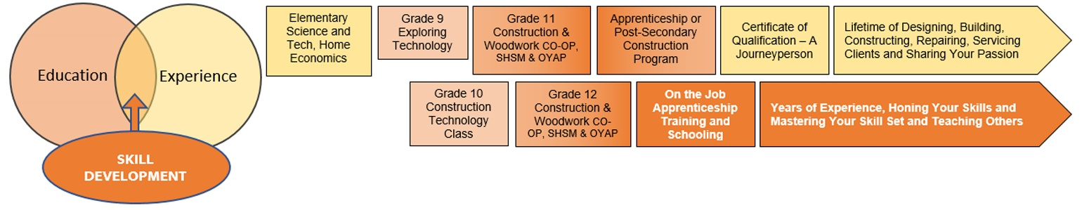

Continuum of Skills
The course curriculum and expectations of TCJ2O can prepare you for a career in the Construction Trades. Below you will find your TCJ2O Construction Technology expectations and how they link directly to the Level 1 Training Standards for a Carpenter, Cabinetmaker and Native Residential Construction Worker.
A1.6 Describe various processes and materials used to finish surfaces in construction projects;
Alignment with Apprenticeship Training Standards:
- Aligns with section 1.3.2 Level 1 Apprenticeship in School Curriculum for General Carpenter 403A
- Aligns with section S1464.5 sub section 5.2, S1467.4 sub sections 4.1, 4.2 Level 1 Apprenticeship in School Curriculum for Cabinetmaker 438A

A2.1 Explain how to correctly and safely use, maintain, and store construction tools and equipment (e.g., hammers, measuring instruments, table saws, mitre saws, drills, lathes, cordless drills);
Alignment with Apprenticeship Training Standards:
- Aligns with section 1.6.1,1.6.2 Level 1 Apprenticeship in School Curriculum for General Carpenter 403A
- Aligns with section S1465.1 sub sections 1.4. 1.5 Level 1 Apprenticeship in School Curriculum for Cabinetmaker 438A
- Aligns with performance objective 4180.05 for Native Residential Construction Worker 296A

A2.2 Select the most appropriate tools or equipment for specific tasks (e.g., wooden mallet versus framing hammer, crosscut saw versus rip saw, combination square versus framing square);
Alignment with Apprenticeship Training Standards:
- Aligns with section 1.6.2 Level 1 Apprenticeship in School Curriculum for General Carpenter 403A
- Aligns with section S1465.1 1.4. 1.5 Level 1 Apprenticeship in School Curriculum for Cabinetmaker 438A

A2.3 Describe commonly used layout, measuring, and tracing techniques (e.g., determining and marking circumference, diameter, radius, angles, rounded corners);
Alignment with Apprenticeship Training Standards:
- Aligns with section 2.1.2, 2.2.1, 2.2.2 Level 1 Apprenticeship in School Curriculum for General Carpenter 403A
- Aligns with section S1463.3 sub section 2.2 Level 1 Apprenticeship in School Curriculum for Cabinetmaker 438A
A2.4 Describe commonly used temporary and permanent assembly techniques (e.g., temporary: using screws or double-headed nails; permanent: gluing with butt, mortise and tenon, dovetail, or mitre joints);
Alignment with Apprenticeship Training Standards:
- Aligns with section 1.3.1, 1.5.2 Level 1 Apprenticeship in School Curriculum for General Carpenter 403A
- Aligns with section 1464.5 sub section 5.1, S1476.2 sub sections 2.1, 2.2, 2.3, 2.6 Level 1 Apprenticeship in School Curriculum for Cabinetmaker 438A
B2.2 Identify basic drawing conventions used in construction drawings (e.g., scales, metric and imperial dimensioning, notes, views, line types, symbols, abbreviations);
Alignment with Apprenticeship Training Standards:
- Aligns with section 2.1.2, 2.2.1, 2.2.2 Level 1 Apprenticeship in School Curriculum for General Carpenter 403A
- Aligns with section S1463.1 sub section 1.1 Level 1 Apprenticeship in School Curriculum for Cabinetmaker 438A
B2.3 Interpret technical drawings accurately when working on construction projects (e.g., determine dimensions and materials from a drawing);
Alignment with Apprenticeship Training Standards:
- Aligns with section 2.1.2, 2.2.1, 2.2.2 Level 1 Apprenticeship in School Curriculum for General Carpenter 403A
- Aligns with section S1463.1 sub section 1.1 Level 1 Apprenticeship in School Curriculum for Cabinetmaker 438A
B3.1 Apply relevant mathematical concepts and formulas when preparing components of a construction project (e.g., determine dimensions, shapes, quantities, areas, and angles);
Alignment with Apprenticeship Training Standards:
- Aligns with section 3.1.1, 3.1.3, 3.1.4 Level 1 Apprenticeship in School Curriculum for General Carpenter 403A
- Aligns with section S1462.1 sub section 1.2 Level 1 Apprenticeship in School Curriculum for Cabinetmaker 438A

C1.1 Use tools, equipment, and techniques in a correct, efficient, and safe manner to prepare project materials (e.g., dress raw lumber; measure, cut, and square stock; drill; fasten and join);
Alignment with Apprenticeship Training Standards:
- Aligns with section 1.6.1,1.6.2 Level 1 Apprenticeship in School Curriculum for General Carpenter 403A
- Aligns with section S1465.1 sub sections 1.4. 1.5 Level 1 Apprenticeship in School Curriculum for Cabinetmaker 438A
C1.2 Perform the various measurements required in the fabrication and assembly of a project, using appropriate metric and imperial units;
Alignment with Apprenticeship Training Standards:
- Aligns with section 1.5.3 Level 1 Apprenticeship in School Curriculum for General Carpenter 403A
C2.1 Construct projects in accordance with specifications (e.g., sketches, working drawings, lists of materials);
Alignment with Apprenticeship Training Standards:
- Aligns with section 2.1.2, 2.2.1, 2.2.2 Level 1 Apprenticeship in School Curriculum for General Carpenter 403A
E1.2 Identify hazards related to materials, processes, and equipment used in construction (e.g., flammable solvents, toxic chemicals, sharp blades, moving parts in machinery), as well as resources and methods for reducing these hazards (e.g., Workplace Hazardous Materials Information System [WHMIS], safe handling and operating practices, personal protective equipment);
Alignment with Apprenticeship Training Standards:
- Aligns with section 1.2.3, 1.2.4 Level 1 Apprenticeship in School Curriculum for General Carpenter 403A
- Aligns with section S1461.2 sub sections 2.2, 2.5, 2.6, 2.7, 3.1 Level 1 Apprenticeship in School Curriculum for Cabinetmaker 438A
- Aligns with section 1.0.2 Level 1 Apprenticeship in School Curriculum for Construction Craft Worker 450A
- Aligns with performance objective 4180.01 for Native Residential Construction Worker 296A
E1.3 Demonstrate an understanding of and adhere to safety practices and procedures for facilities, processes, materials, tools, and equipment used in construction (e.g., use of tool and equipment guards);
Alignment with Apprenticeship Training Standards:
- Aligns with section 1.2.5 Level 1 Apprenticeship in School Curriculum for General Carpenter 403A
- Aligns with section S1461.2 sub sections 2.2, 2.3 Level 1 Apprenticeship in School Curriculum for Cabinetmaker 438A
- Aligns with performance objective 4180.05 for Native Residential Construction Worker 296A
E1.5 Use protective clothing, gear, and equipment appropriately (e.g., dust mask, safety glasses).
Alignment with Apprenticeship Training Standards:
- Aligns with section 1.2.3 Level 1 Apprenticeship in School Curriculum for General Carpenter 403A
- Aligns with section S1461.2 sub section 2.12 Level 1 Apprenticeship in School Curriculum for Cabinetmaker 438A
- Aligns with section 1.0.3 Level 1 Apprenticeship in School Curriculum for Construction Craft Worker 450A
- Aligns with performance objective 4180.02 for Native Residential Construction Worker 296A

Resources

Lesson Plans
 Apprenticeship Resource Lesson Plan 
Topic: Wood Joint Box

Student Activity |  | Content | Teacher Activity
Pre-Activity Checklist.  Students are to fill out the checklist provided to them by their teacher.  Drawing Lesson.  Students are to be guided through reading the given drawings. They are to try to make sense of each of the cuts they will be making and laying out.  Cut List  Based on the drawings, students will then make a cutting list to help organize the information.  Lesson 1: Layout  Students start laying out the lengths of their individual pieces cuts.  Lesson 2: Cutting  Students will listen to the lesson given by their instructor, then cut their lengths.  Lessons 3-7  Students will listen to the lesson provided for each joint, then cut their joints accordingly.  Lesson 8  Students will assemble their wood joints, first as a dry fit (without glue) to ensure proper fit. They may need to adjust or re-cut some parts to help with the assembly. When completed, they can apply glue and assemble their box. Note: start by inserting the bottom piece into one side, then build the sides around it.  Finish  Students are to sand their pieces beginning with a grit 60 sandpaper and moving up to a 220 grit. They must use sanding blocks. They are to use the finish provided by their teacher, if the teacher gives this option.  Wrap-Up  Students will fill out the final Skill Checklist and reflection to indicate the new skills they have developed. They will be made aware of how they align with the apprenticeship standards for both cabinetmaking and carpentry.  Safety Concerns  Housekeeping: always keep your area safe and free of clutter or unused tools.  Tool use: Keep hands away from the path of the blade or chisel. Ensure no other students can be injured by your tool use either.  Finish material: listen to your teacher about hazards of any finish material being used. | Prior to starting the activity  5 – 10 min.  20 min  20 min.  20 min  40 min  3-5 classes, depending on the ability  1 class  2-3 classes  15 min | OCTE SAFEDocs  WHMIS  Activity 1: Pre-Activity Checklist.  Drawings Handout.  Activity 2: Cutting List handout.  Written instructions provided to help clarify.  Optional videos or OCTE docs.  Drawings and written instruction  Drawings and written instruction  WHMIS or MSDS sheets  Activity 3: Post-Activity Skill Checklist. | Before beginning the lesson, teachers should have already taught the safety required for the project. Students should have been taught and trained on hand tools.  Teachers handout the checklists. Ask students to check off all the points that apply to their current knowledge and experience.  Teachers handout the drawings and give students a few minutes to look them all over. They then explain what to look for, and how the different drawings explain different aspects of their project. Answer any questions students may have.  After students have been given enough time to review and understand the drawing, they are to write a cutting list of all their cuts. It is suggested that teachers tell students to leave an extra ⅛” to a full ¼” in case there are errors in their cuts.  Teacher gives a lesson and demonstration on how to properly layout pieces based on the drawings. Students should be taught the most accurate way to measure, draw, and use a square. Teachers should also explain the kerf of the blade, and how much room should be left between each piece. Note: with beginners, it is better to leave slightly more than you would normally think in case their cuts veer drastically from their pencil marks. As a starting point, you can tell students to leave an extra ½”.  Teachers are to demonstrate how to hold and use a hand saw safely and effectively. Notes should be made about how tightly to grip the handle, how to point one finger along the direction of the blade, how to use your other hand to ensure the blade is perpendicular to the cut, how to sight two sides of your piece as you are cutting (and cut on the diagonal along the two planes), how to cut on the offcut side, how to start the cut, how to constantly cut and check, then lastly, how to finish the cut so there is minimal to no tear out.  Before each new joint, the teacher is to demonstrate how to layout and cut each joint. Focus is to be give on proper layout, as well as the specific cuts (hammer or chisel) that need to be made.  Teacher should circulate and assist students as they need help or as their boxes are not fitting, as they would like.  Teacher will dictate what finish material will be used, and whether the sanding is completed to allow for the application of the finish material.  Teacher will hand out the final Skill Checklist assignment. They will also verbalize how many apprenticeships skills the students have developed by doing this project.  Teacher draws upon their experience and explains to students’ skill sets required for various Construction and Building skilled trades and careers. Links are to be drawn between Level 1 Training Standards and this course. Optional assignment is to have students create a continuum of influence based on their own experiences.

Expected Outcomes | Assessment of Outcomes
The student will:  Learn new woodworking techniques and tools.  Learn about, and how to layout and cut wood joints.  Learn how high school programs link directly to an apprenticeship. | Teacher is to identify students' ability and improvement in measurement accuracy, layout (straight and square lines that are on the measurement marks), cuts (how close to their pencil marks the cuts are, and how straight, square and accurate they are).  Assess the quality of the joints by how well they line up, how few gaps there are, and how straight and square they are.  Students accurately reflect on their skill development through the checklists.

Motivation | Curriculum Expectations
If students become discouraged, the final fitting of each joint will provide a great deal of satisfaction to students. Some may need extra guidance or assistance to get to that point.  Encourage students along the way, or adapt the plans so students only do one or a few wood joints.  Continually link their skills to that of an apprentice.  Continually encourage and congratulate improvement. Continually motivate students through earned compliments. Acknowledge accuracy and ability, as well as improvement or work ethic. | A2. Demonstrate an understanding of the safe and correct use of construction tools, equipment, and techniques;  A3. Use correct terminology to describe building components and construction materials, tools, equipment, and processes.  B2. Use drawings to represent design ideas and solutions to technological challenges, and interpret drawings accurately when working on construction projects;  B3. Apply the mathematical skills required in the planning and building of construction projects.  C1. Use tools, equipment, and techniques correctly and safely when preparing materials for a project;  C2. Use fabrication and assembly techniques safely, accurately, and in the correct sequence;  C3. Prepare surfaces and apply finishing products, trim, and hardware correctly and safely.  E1. Identify and follow health and safety regulations, standards, and procedures related to the construction industry;  E2. Identify career opportunities in the construction industry, and describe the training required for these careers.

Reflections | Instructional Materials
The two checklists are guides to allow students to reflect. More questions can be added at the discretion of the teacher. | Activity 1: Pre-Activity checklist  Activity 2: Cutting List  Activity 3: Post-Activity checklist  Drawings  Written Instructions

Handouts
Previous Experience Checklist (see Appendix B)
Rough Cut Cutting List Assignment (see Appendix C)
Post-Project Checklist (see Appendix D)

Teacher Tracking Sheet
Teacher’s Resource (see Appendix A)

Instructions
Written Instructions
Steps:
Part 1: Rough Cuts
- Look over the provided drawing.
- Write a cutting list of your cuts. Look at the notes on each drawing to help determine the lengths of the cuts.
- Layout the rough cuts on your given lumber. Use a tape measure, and break an inch for accuracy. Use the tri square to square your mark on all four sides.
- Tip: write an X on all offcut pieces.
- Use a vice to hold your piece while you cut. Use your saw, and ensure that you can sight the square pencil mark on two sides while you cut. This will ensure that you can keep your cuts straight.
- Once your pieces have been cut to their rough length, start laying out your joints, based on the drawings provided by your teacher.

Part 2: Wood Joints
Mortise and tenon
- On the tenon, measure the distance indicated from the end of your stock. Note: the distance between the shoulder of your mortise and the shoulder of your box joint should be exactly 8 ¾” long, while the distance between the shoulder of your mortise and the shoulder of your dovetail should be 5”. Ensure the shoulder-to-shoulder measurement is exact, as this will create assembly problems in the future. If the tenon or box joints are longer than ½” or ¾”, they can be cut down accordingly. Note: Box joints can be assembled with pins longer than ¾” and can be planed or sanded down to size after assembly. Tenons will need to be 1/16” shorter than the mortise prior to assembly.
- Use a trisquare to mark the length of your tenon (½”).
- From the top and bottom edge, measure up and down ¾”. Use your scribe or combination square to mark this around the face and edge.
  - Note:
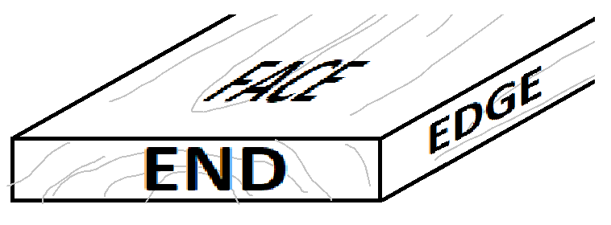
How to mark it:
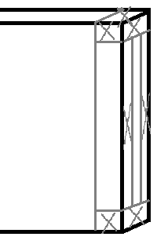
- Use your hand saw to cut out the tenon.

- Mark out the mortise.
- Use a hammer and ¼” chisel to go the required depth. Make sure you are chiseling down on the top and bottom ends of the mortise first to break the grain before chiseling the channel. Continue chiseling until your required depth of 9/16”.

Dovetail
- Mark out the length of the dovetails using a tape measure. Note: the distance between the shoulder of your dovetail pins and the shoulder of your rabbit or mortise joint should be exactly 8 ½” long. Similarly, the shoulder of your dovetail tails and the shoulder of your tenon should be exactly 5”. Ensure the shoulder-to-shoulder measurement is exact, as this will create assembly problems in the future. If your tails or pins are longer than ¾” that is not bad, and can actually be good for having nice dovetails after assembly. They can be cut or sanded after the joint has been assembled. Ideally, mark out ¾” plus 1/16” - ⅛”.
- Starting with the tails, measure the indicated distances along the end of your back piece. Use a tri square to square them across the end of the wood.
- Advice: put an X on the parts you wish to remove, so you do not accidentally remove the wrong parts.
- Set your sliding t-bevel to 1:6. To do this, you can measure on a known square piece of wood (or workspace, or other) 1” across and 6” down. Set your sliding T-bevel along your marks to create a roughly 80.5º angle.
- Alternating the direction of the T-bevel, draw in your tails on both sides of your piece of wood.
- Measure back from the end ¾” and square off your mark on all sides of your piece.
- Put your piece in a vice and use a saw to cut the tail marks.
- Use a sharp chisel to cut out between the tails, along your ¾” mark. Tip: chisel straight down, perpendicular to the direction of the grain, to break the grain. Do this on both sides. Then chisel from the end toward your chisel marks, only going the depth of your initial strikes. Repeat until the tails are all cleaned out.
Note: if you are not precise with the shoulder cuts (the chisel cuts perpendicular to the grain between the two tails, or the hand saw cuts at both ends), you will see gaps after assembly. Be very careful to be precise with your cuts and chiseling!
- For your pins, mark your end with the measurements provided.
- Use your pre-set sliding T-bevel to mark out the appropriate angles.
- Before cutting, and after marking out the pins on the end of your piece, put your cut out tails along your marks. See if they line up. Adjust as necessary to create a tight joint.
- Once you have adjusted your pencil marks on the end of your piece, use a tri-square to square your marks down along the face, parallel to the grain.
- From the end, measure down, in the same direction, ¾”. Use your square to square off that mark.
- Because the pins are angled on the end, rather than on the side with the tails, cut along the end with your hand saw.
- Set your piece on the table, so that the shorter side of the pins are facing up. Be delicate when chiseling out between your pins. Break the grain on both sides, but do the majority of your chiseling with the shorter side facing up. This will prevent major tear out on the other side.

Box Joint
- Mark out the length of the box joints using a tape measure. Note: the distance between the shoulder of your box joints and the end of your rabbit should be exactly 5 ¼” long. Similarly, the shoulder of your box joint and the shoulder of your mortise should be exactly 8 ¾”. Ensure the shoulder-to-shoulder measurement is exact, as this will create assembly problems in the future. If your pins are longer than ¾”, that is not bad, they can be cut or sanded after the joint has been assembled. Ideally, mark out ¾” plus 1/16” - ⅛”.
- Measure the given distances along the end of your piece.
- Use a tri square to square off your marks.
- Use a tri square to transfer your lines along both faces.
- Measure from the end in, along your face ¾”. Use a square to transfer this line around all faces and edges.
- Advice: put an X on the parts you wish to remove, so you do not accidentally remove the wrong parts.
- Use your saw to cut down your pencil marks, along the grain. You can cut across the grain for the end mark that needs to be removed.
- Use a sharp chisel to cut out between the marks, along your ¾” mark. Tip: chisel straight down, perpendicular to the direction of the grain, to break the grain. Do this on both sides. Then chisel from the end toward your chisel marks, only going the depth of your initial strikes. Repeat until the area is all cleaned out.
Note: if you are not precise with the shoulder cuts, you will see gaps after assembly. Be very careful to be precise with your cuts and chiseling!
- Repeat with the other piece, ensuring that you are keeping or getting rid of the opposite parts.

Rabbet and Dado Joint
- First, start by laying out the rabbet joint on the front piece.
- From the left edge, measure back ¼”.
- Using a tri square, square your mark on the face and two sides.
- Along the top and bottom edge, measure back from either face ⅜” so that the thickness is split in half.
- Repeat step 4 along the entire end.
- Using a handsaw, cut out the rabbet joint.
- On the left side piece, measure in from the end ¼”, then ⅜” on the side that will face inward of the box.
- Along the top and bottom edges, measure back from the marked face ¼”.
- Using a handsaw to cut the lengths of your dad cut, cut down ¼” depth on the left and right of your dado cut. Ensure your saw is on the inside of each line.
- Use your ¼” wide chisel to remove the material inside your dado cut. This will leave a ¼” deep and ⅜” wide dado for your rabbet to fit into.
Base
- On each of the four side pieces, measure up from the bottom ⅜”, then again 1 ⅛”. Use a scribe or combination square to transfer the line parallel to the edge of your piece.
- Continue and transfer the line across both ends.
- On each end, measure down ¼” from your pencil marks.
- Use a hand saw to cut your pencil marks to a depth of ¼”.
- Use the ¾” wide chisel to chisel out your dado.
- Your base piece should fit perfectly into the dado cuts of all four sides.

Part 3: Assembly:
- Before gluing, do a dry test of all your joints and adjust by filing, cutting, sanding or chiseling any joint that is not fitting properly.
- Put glue along all areas of your wood joints that will be making contact, right before assembling that joint.
- Start by inserting your base into one of the sides. Assemble the two joints on either side of your first piece.
- Finish with the last piece.
- Your joints should be very tight. If they are not, you may need to use clamps to secure your pieces together while they dry. Do not forget to use squish blocks if you are using metal clamps!

Part 4: Finish:
- After the glue has dried (approximately one hour), you can start sanding your finish piece.
- Begin by delicately scraping excess glue. Remember to try not to gouge your wood.
- Start sanding using a sand block, starting with grit 60, 80, 100, 120, 150, and then 220.
- Your teacher will give you options for finishes. Follow all instructions your teacher provides, as is outlined on the container and/or on the MSDS sheets.

Blueprints
BOX OUTER DIMENSIONS

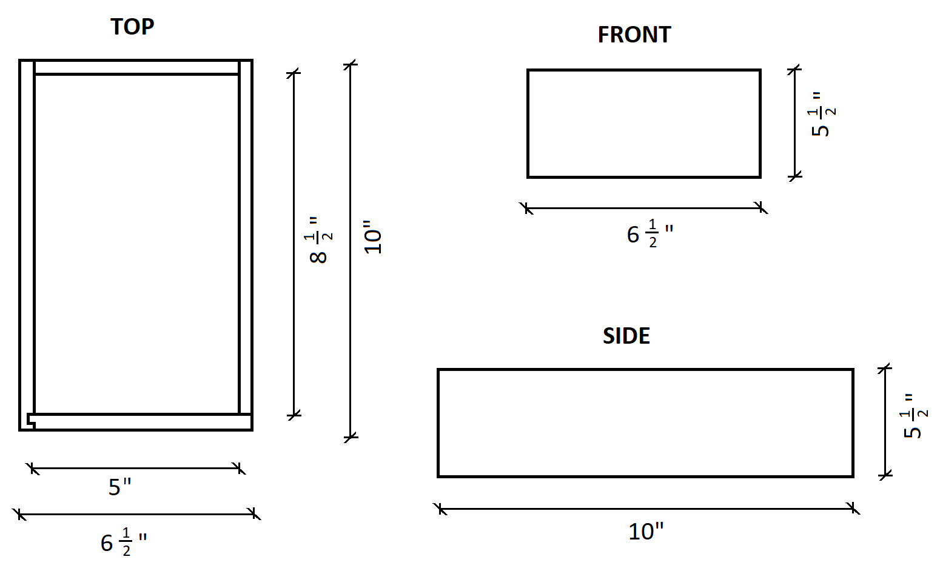

Notes:
*Individual joint details are provided below and are not indicated on the above front and side views.
*No hidden lines are indicated above.

OBLIQUE DRAWINGS

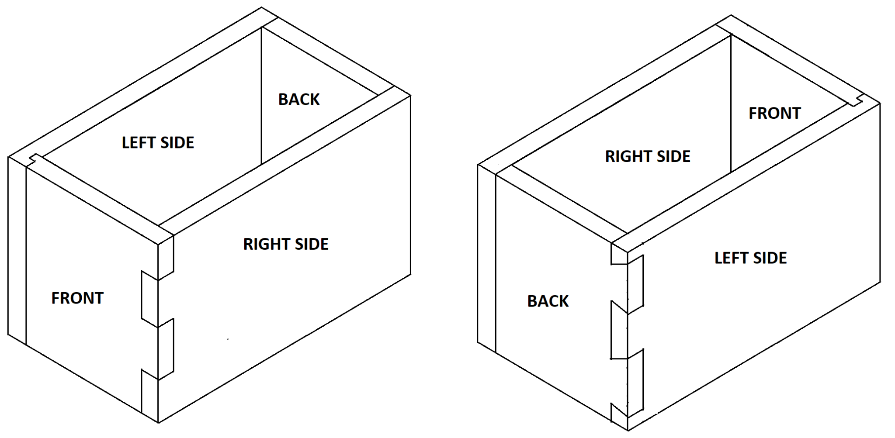

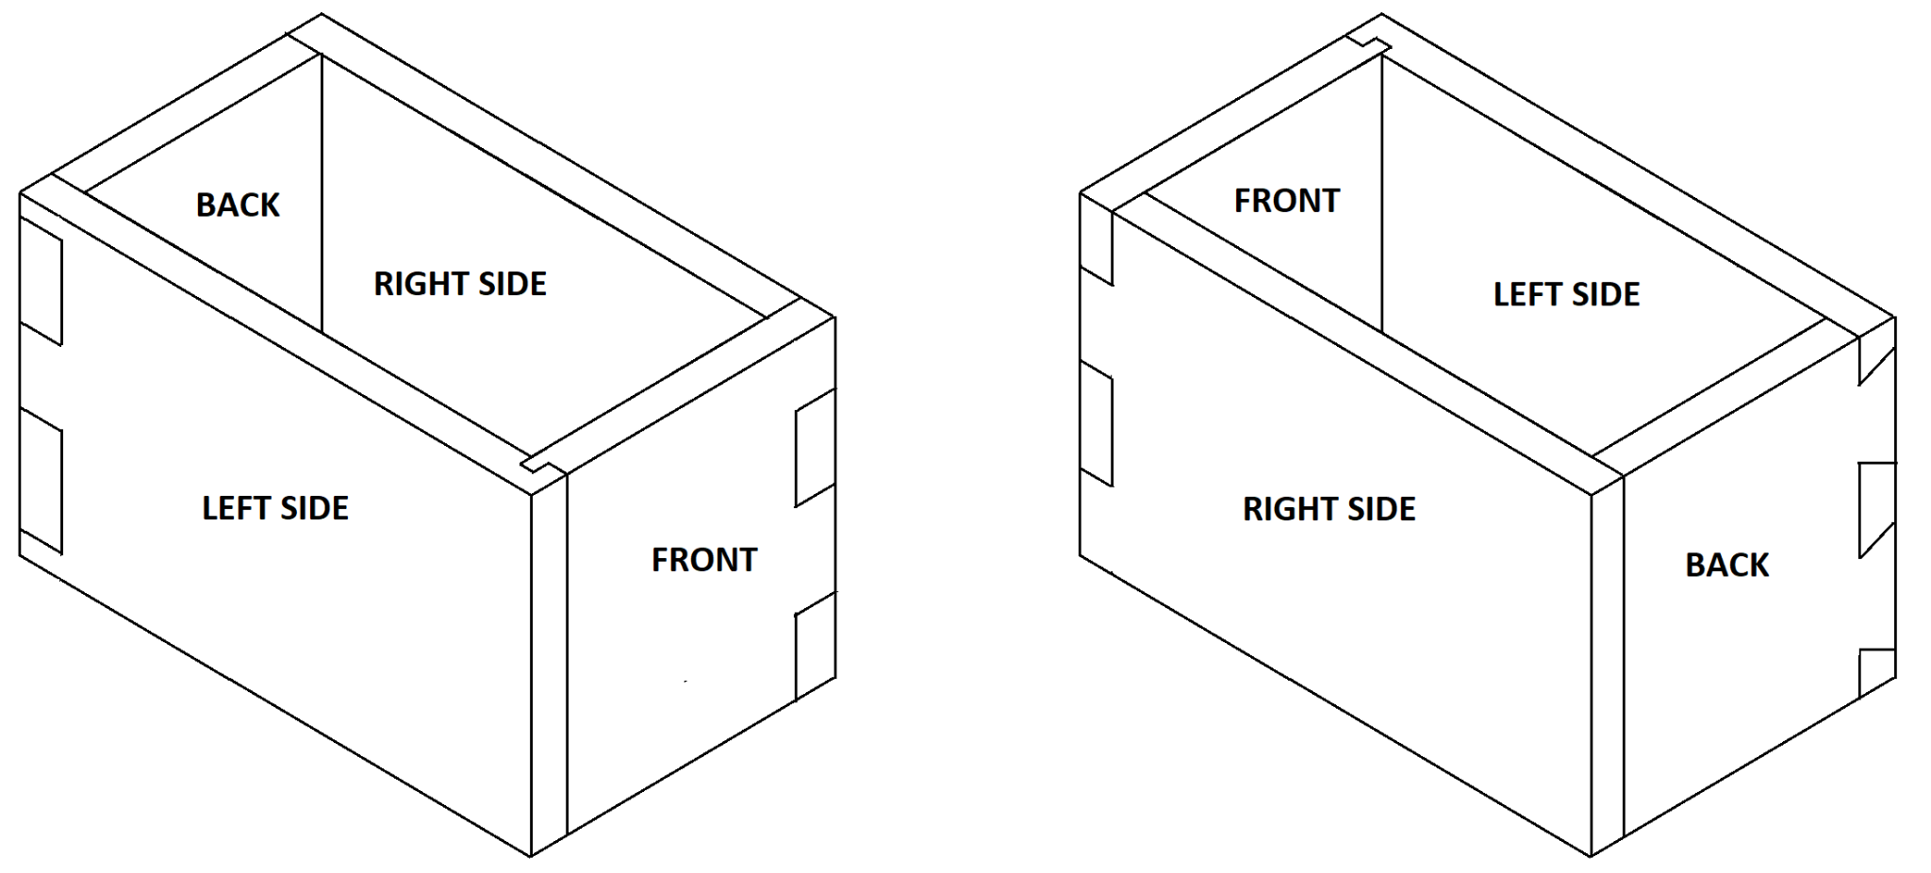

Notes:
*No hidden lines are indicated above.

Component Details
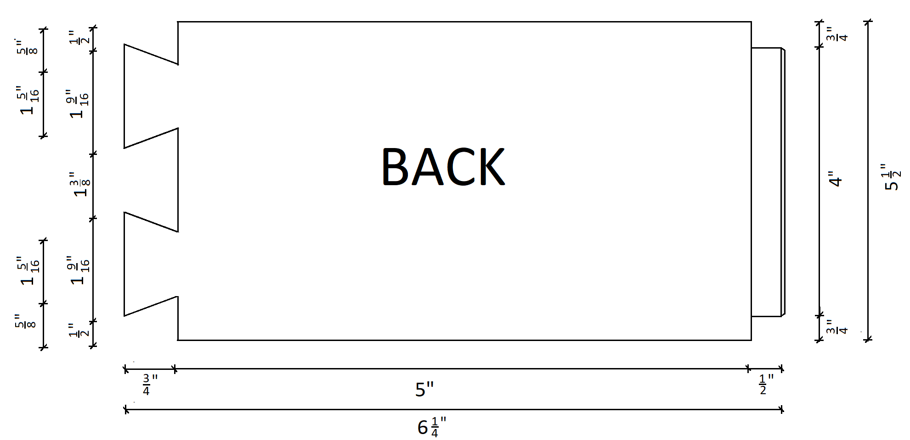
Dovetail Joint Mortise and Tenon Joint

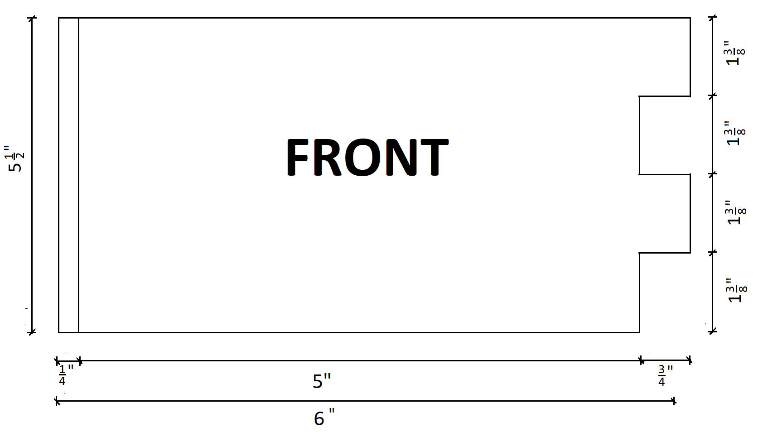
Rabbit and Dado Joint Box Joint

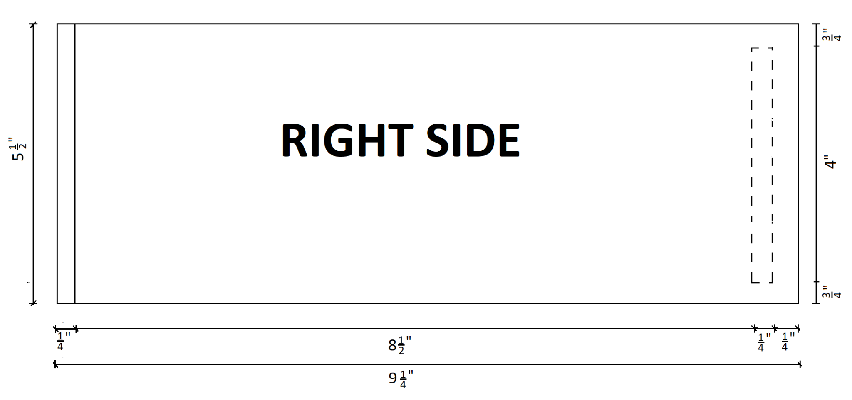
Rabbet and Dado Joint Mortise and Tenon Joint

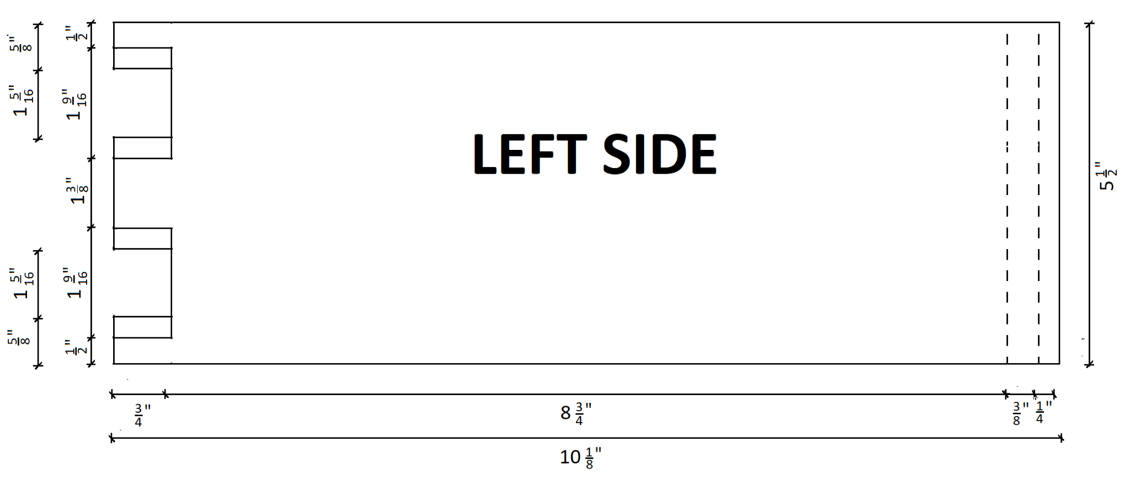
Dovetail Joint Rabbet and Dado Joint

Mortise and Tenon Joint Detail
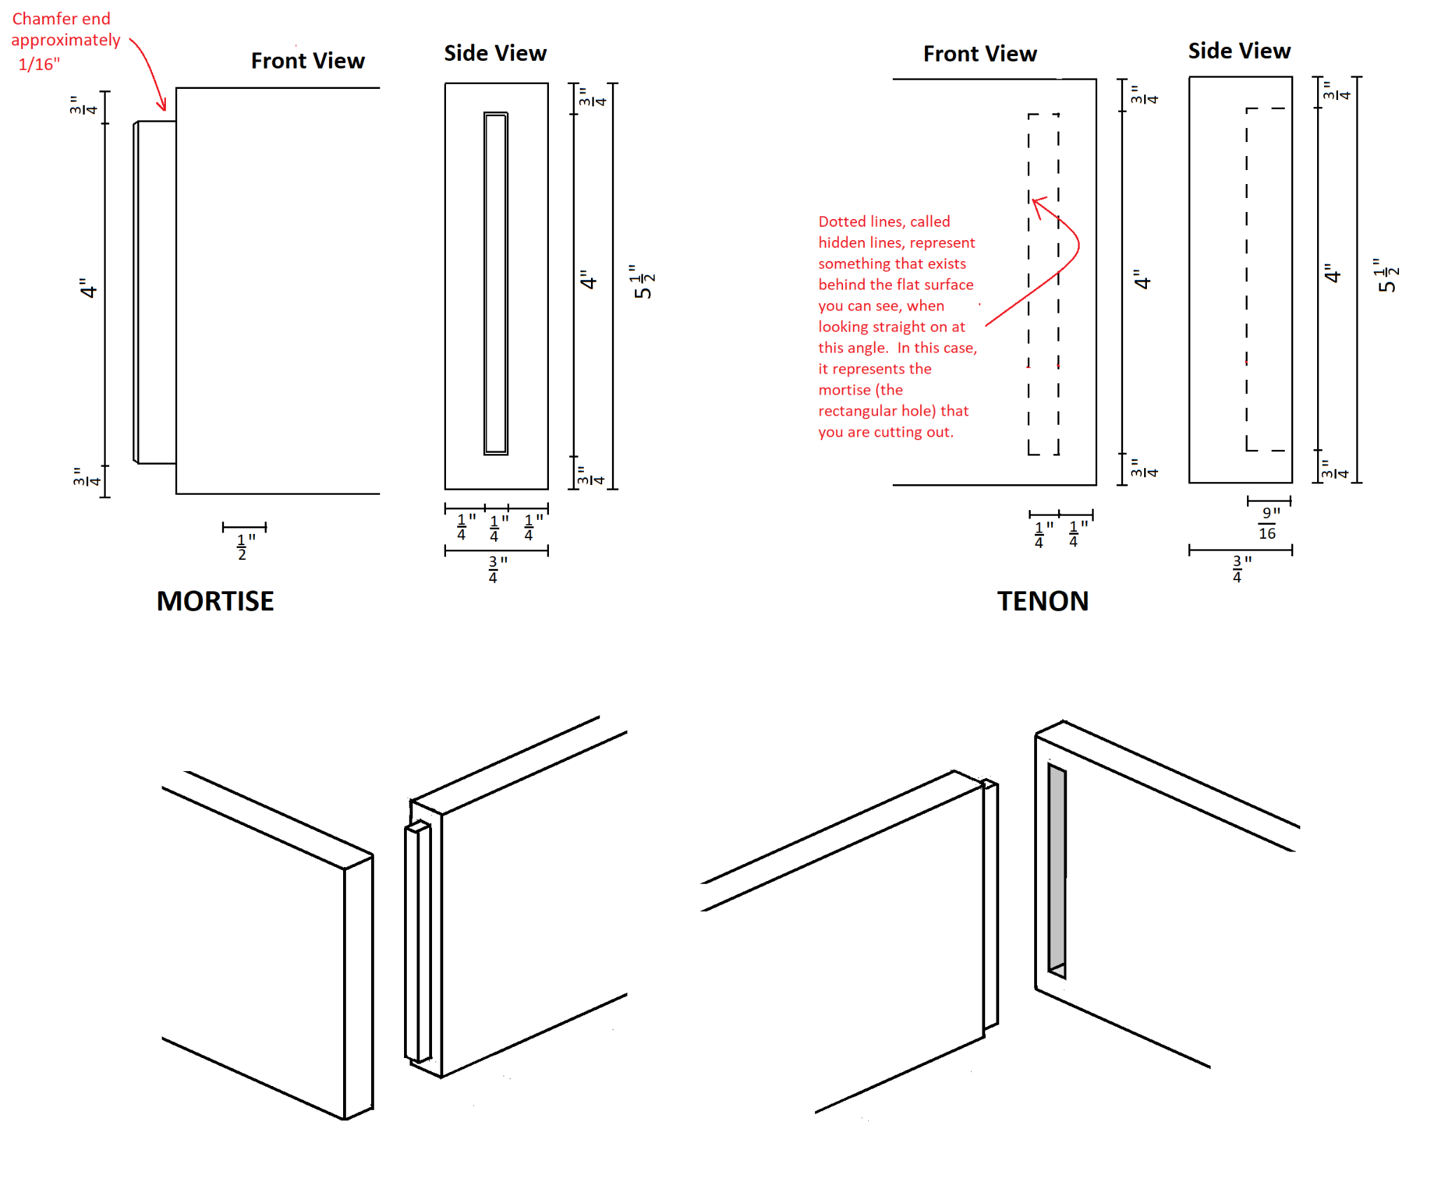

Dovetail Joint Detail
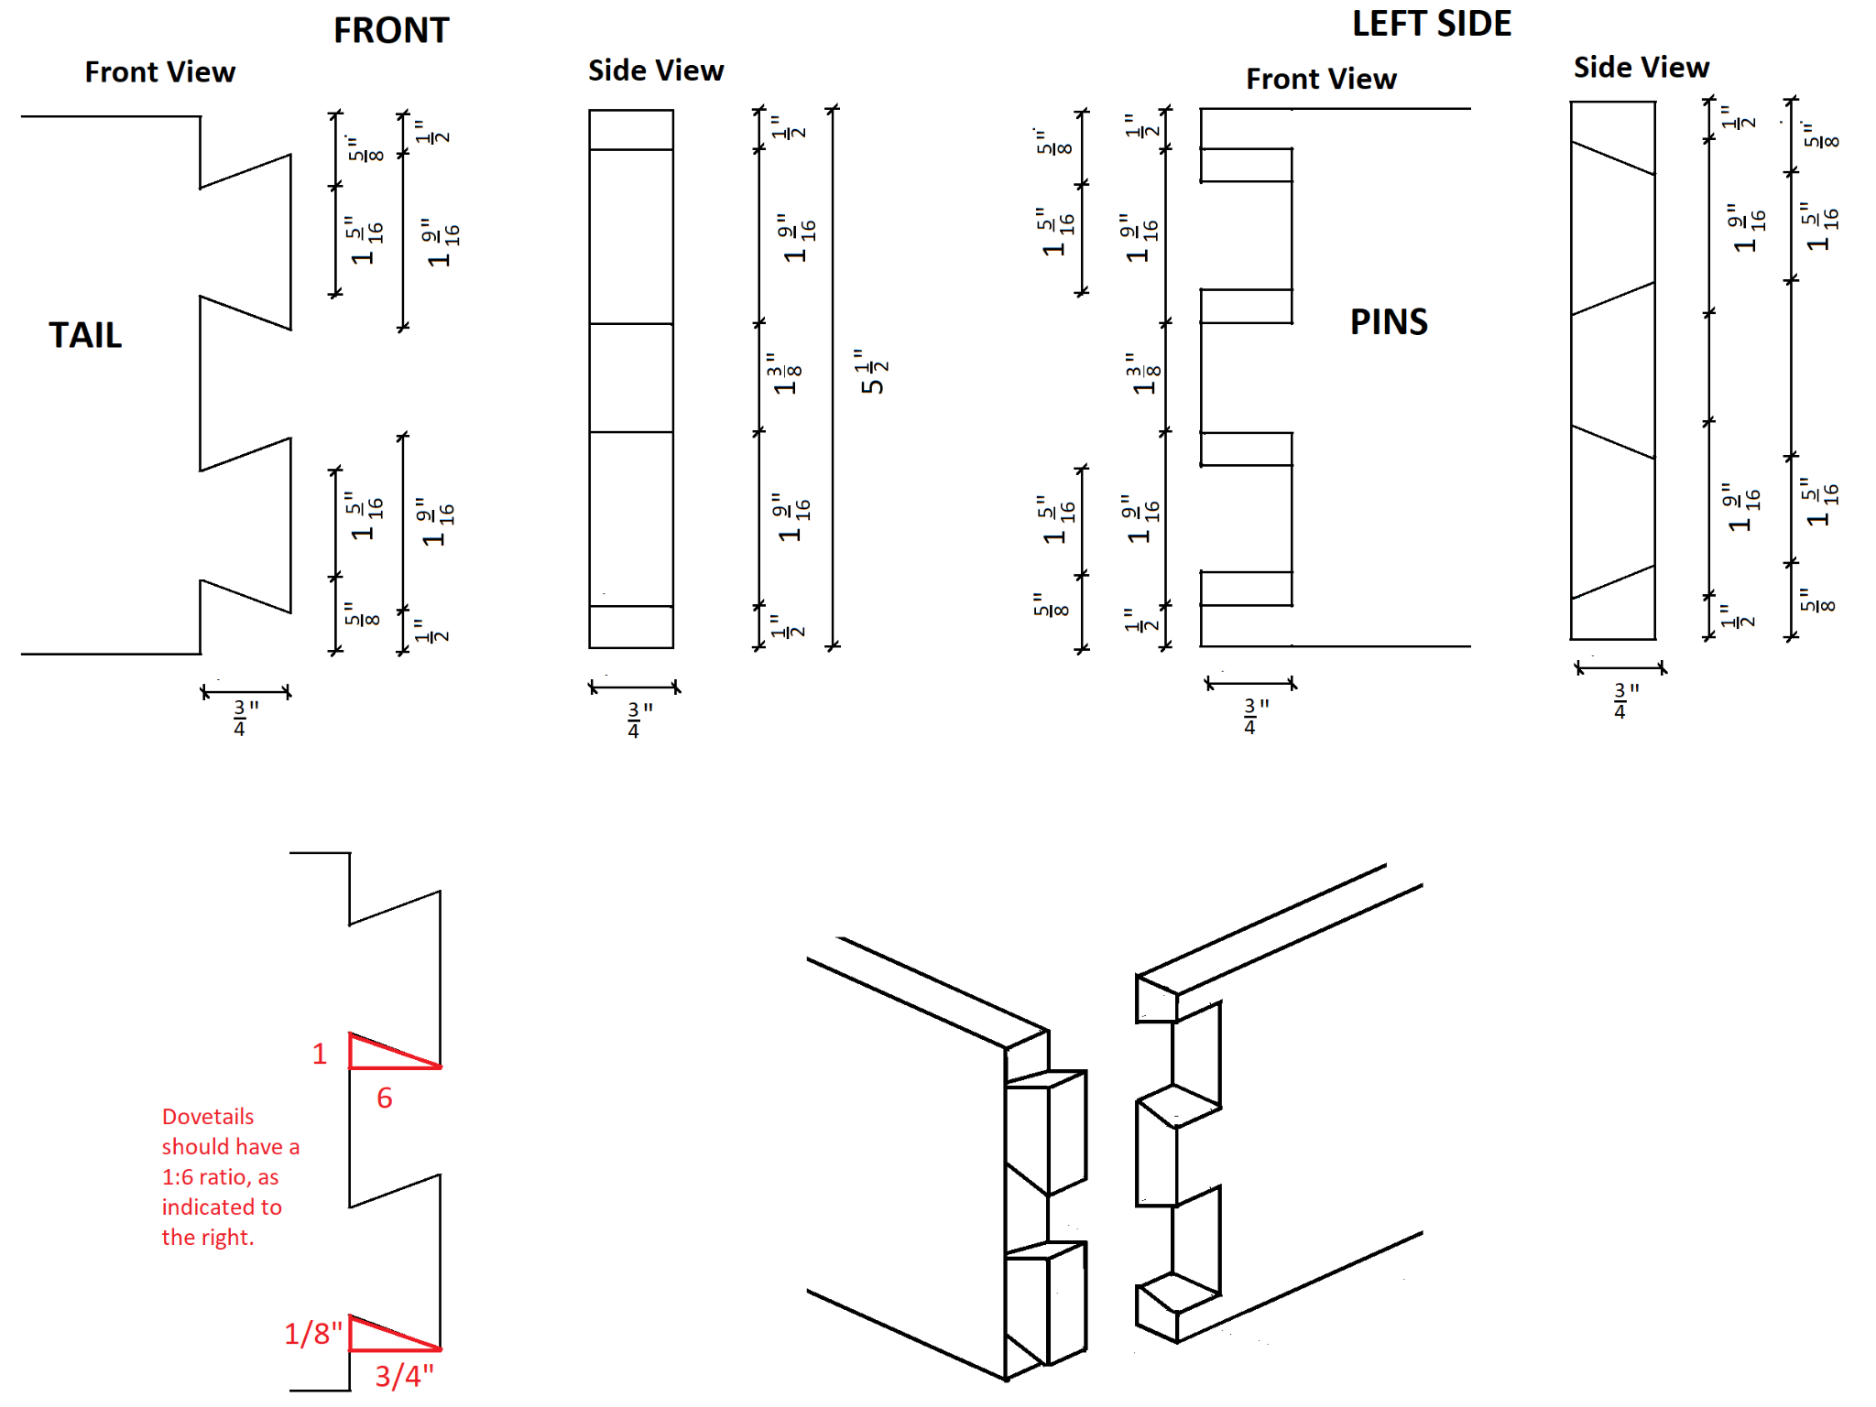

Box Joint Detail
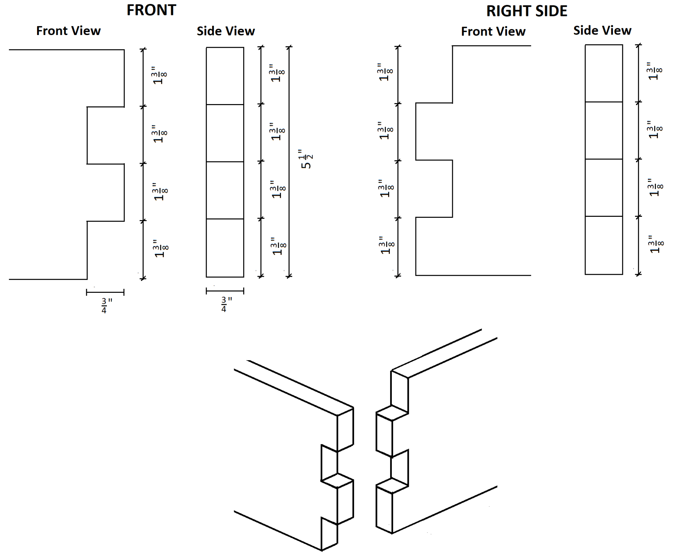

Rabbet and Dado Joint Detail
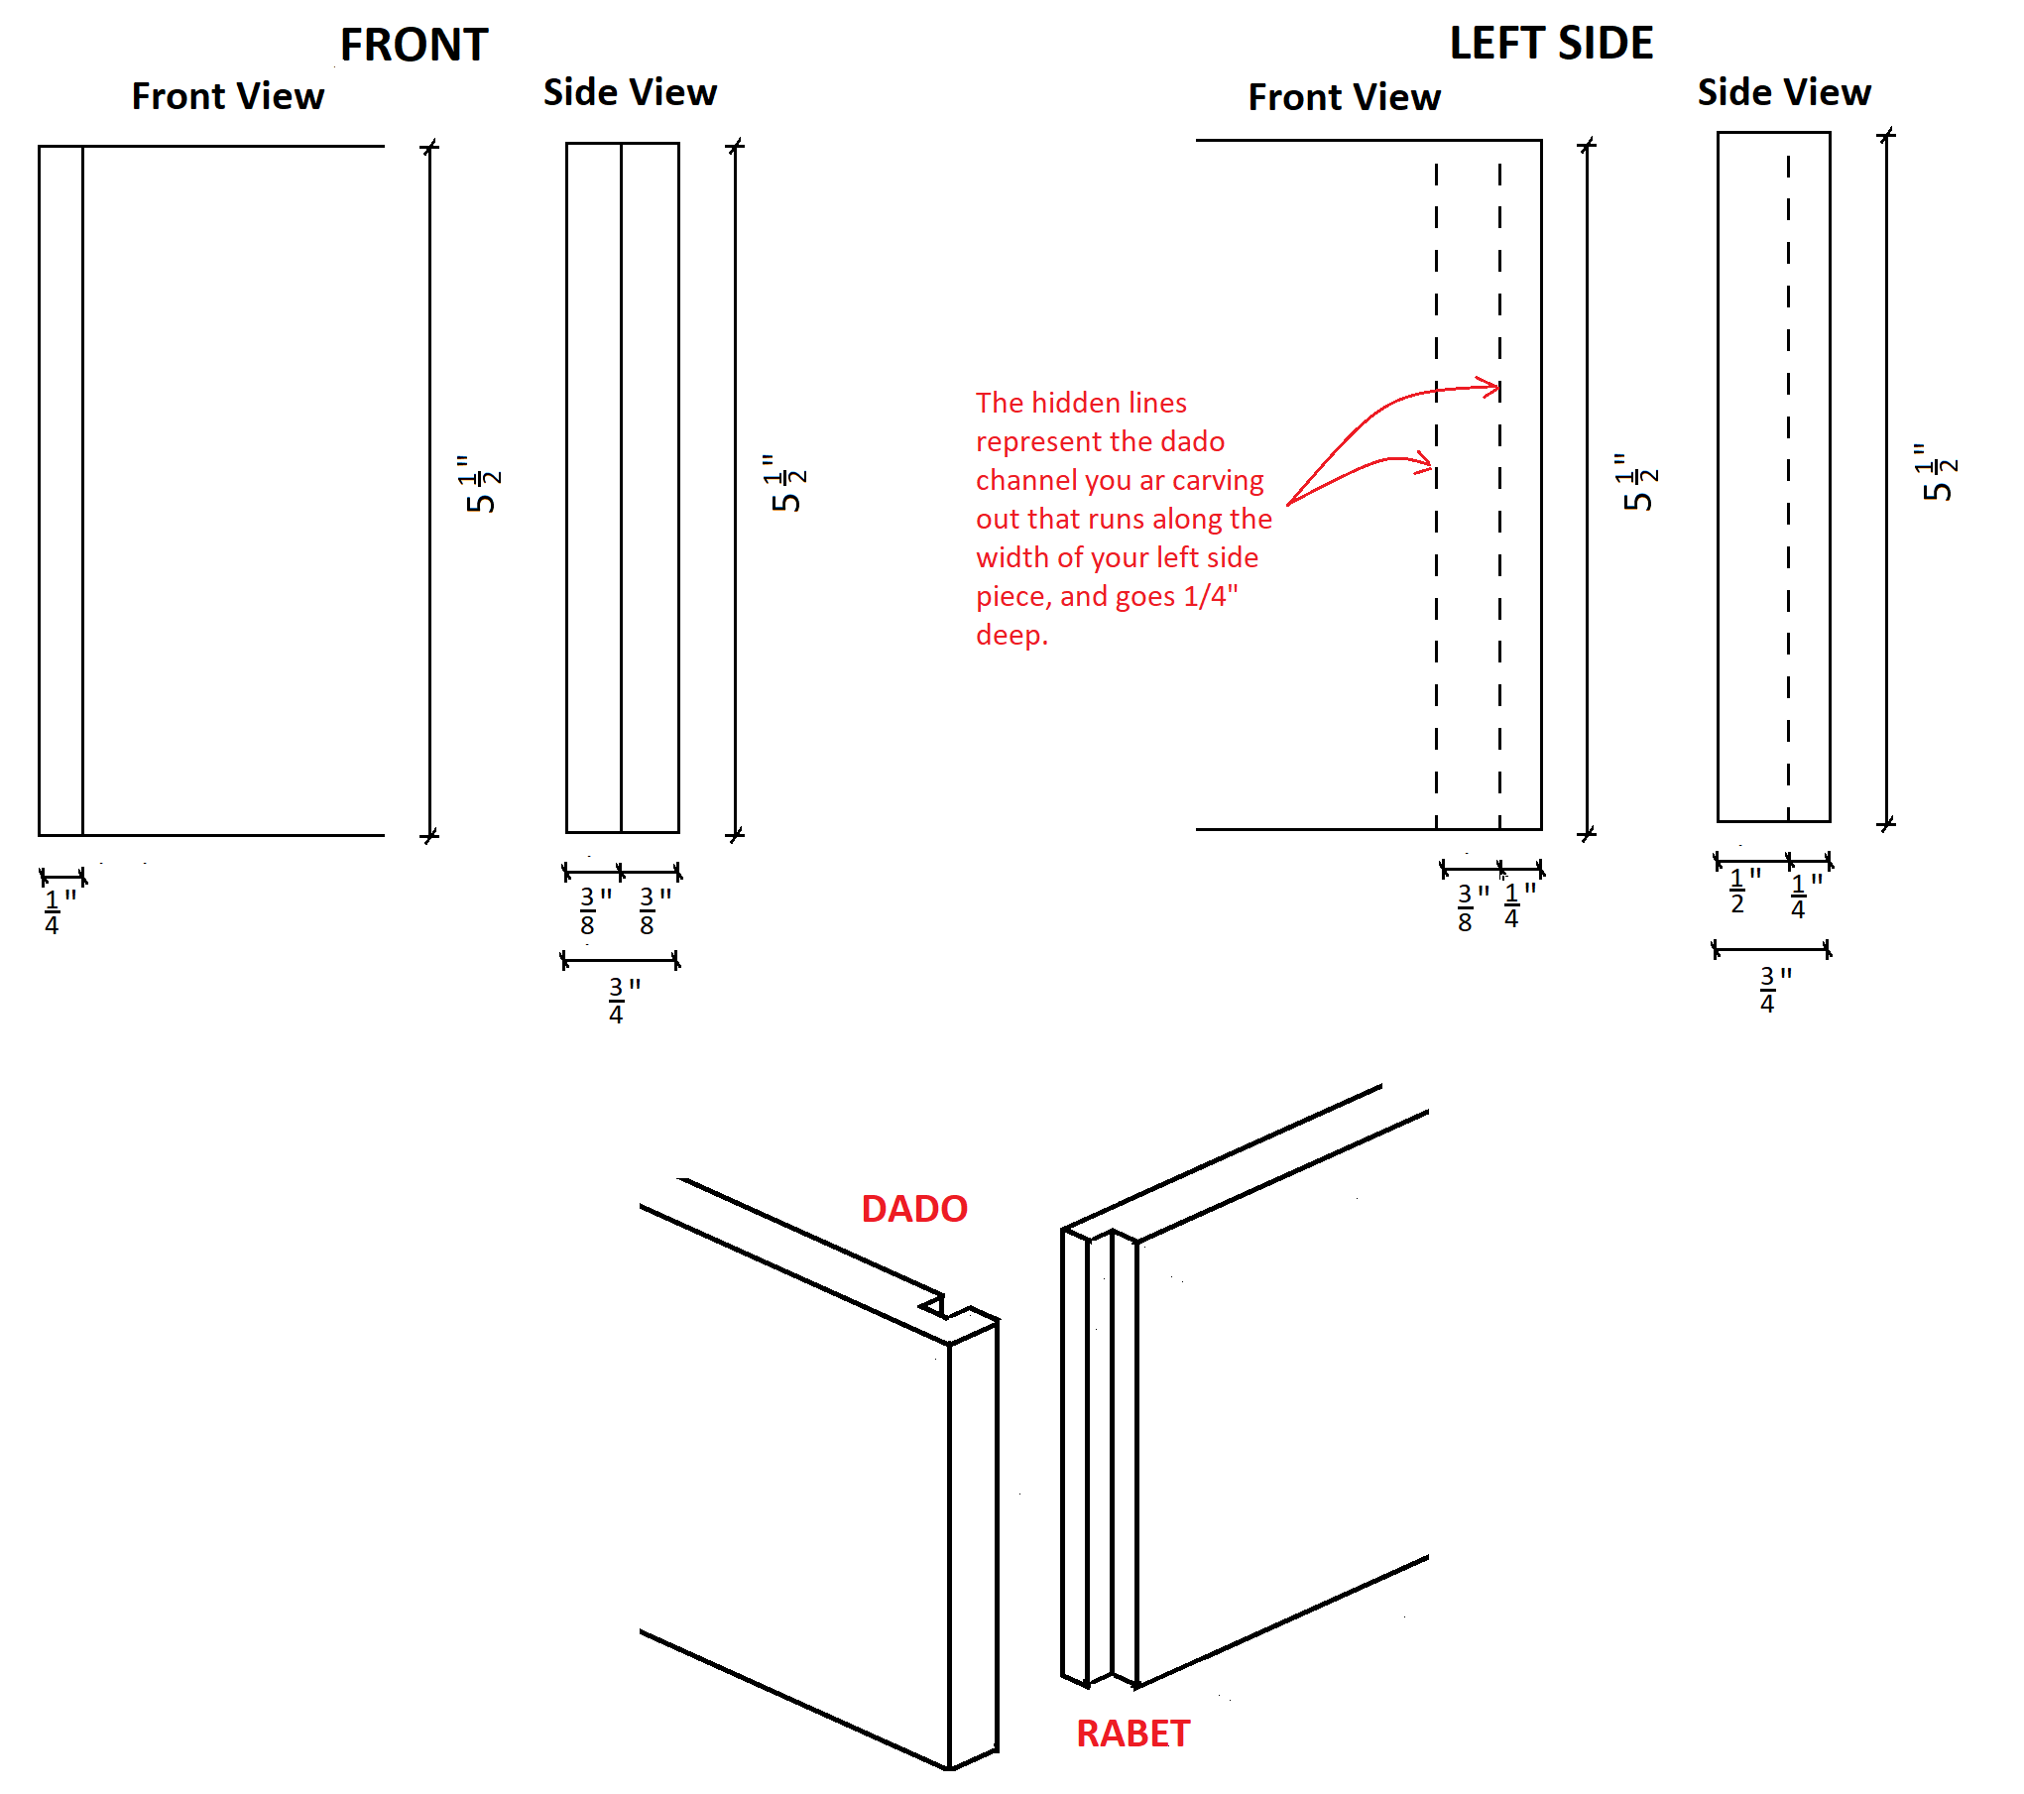

Base Dado Detail
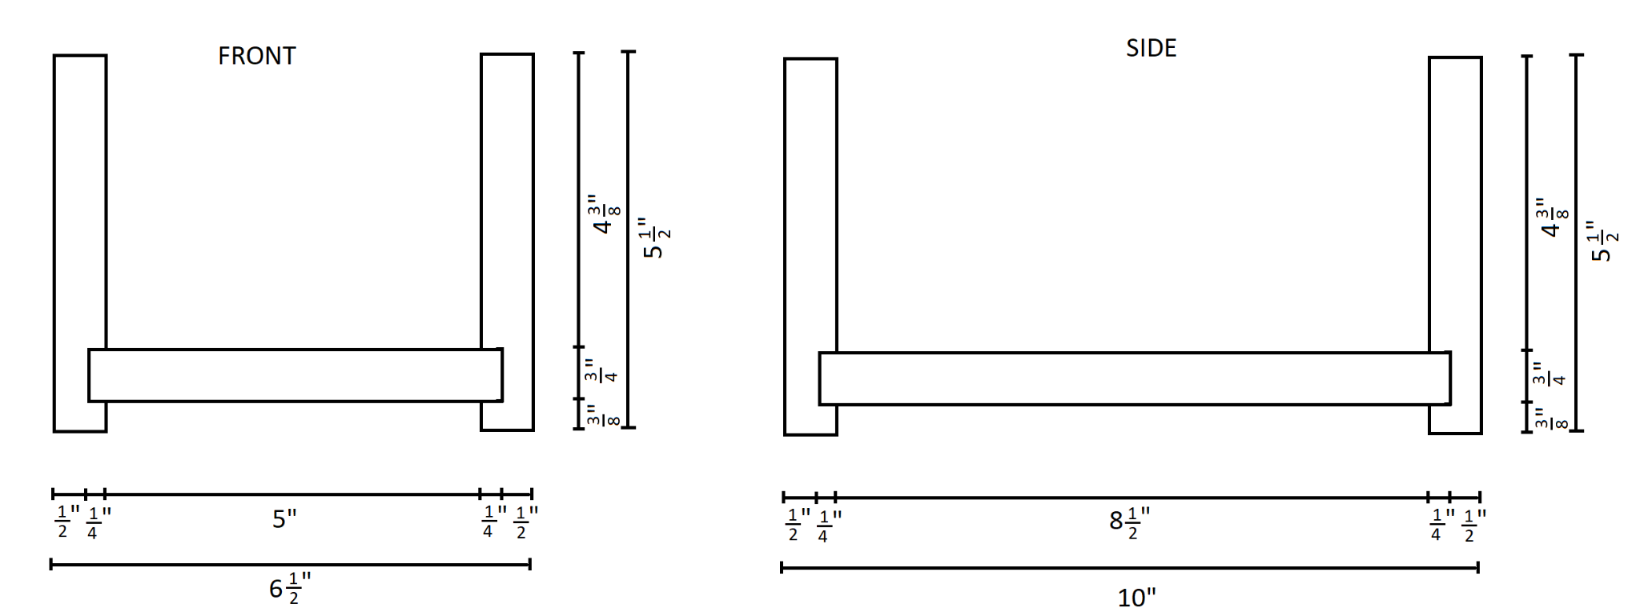

Tools/Equipment
- sharp pencil
- utility knife
- tape measure
- metal rule
- tri square
- combination square or scribe
- fine tooth saw (ideally a dozuki saw)
- sharp chisel (¼ ” and ¾ ”)
- hammer or mallet
- file and/or sandpaper with a sanding block (grit 60 through 220)
- hand plane (optional)
- sliding t-bevel
- vice
- clamps
- block plane
- finish material and application

Materials
- 1” x 6” x 4’ pine per student
- wood glue
- sandpaper (grit 60 through 220)
- finish material

Websites for Teachers
OCTE SAFEDocs for the appropriate tools being used.

Instructional Strategies
Teachers may use any of the following instructional strategies; 3-Part lesson, lecture, storyboard, word wall, think-pair-share, placemat activity, rapid write, K-W-L, anticipation chart, ABC taxonomy, think aloud, analyzing text, Cornell note taking, exit ticket/ticket out the door, plus/minus/delta, etc.

The Hook / Motivational Strategies
Helping students gain skills that directly link to industry and an apprenticeship.
Allowing students to personalize their box (painting it, wood-burning designs, adding a lid with a hand-made handle, etc.).

Learning Goals and Success Criteria
Through this project, students will become more familiar with layout, construction math, hand tools, and woodworking techniques. Students will improve their eye to detail and their fine motor skills. They will gain valuable trade knowledge useful to starting an apprenticeship in the carpentry and cabinetmaking trades.
Successful projects will have:
- Accurate measured and cut distances between joints (so the left and right side have identical interior dimensions, while front and back inside dimensions are also identical).
- Goal is to hand cut directly along your pencil mark. Try to split the pencil mark in half.
- Joints should fit tight enough so there are no visible gaps, and some effort is needed to assemble the joints (by hand). If joints are too large to fit, it will break the cut joints. This should be avoided.
- The box should be square (measured diagonals should be identical)
- Students should be given a chance to go above and beyond the project (whether in final design, adding a lid, etc.).
- Visually, the box should look aesthetically pleasing. A strong eye to detail should be evident, and a progression of improvement with each new joint should be seen.

Overall and Specific Expectations in Support of Ontario Curriculum Grades 9 - 12 Technological Education

Overall Expectations
A2. Demonstrate an understanding of the safe and correct use of construction tools, equipment, and techniques;
A3. Use correct terminology to describe building components and construction materials, tools, equipment, and processes;
B2. Use drawings to represent design ideas and solutions to technological challenges, and interpret drawings accurately when working on construction projects;
B3. Apply the mathematical skills required in the planning and building of construction projects;
C1. Use tools, equipment, and techniques correctly and safely when preparing materials for a project;
C2. Use fabrication and assembly techniques safely, accurately, and in the correct sequence;
C3. Prepare surfaces and apply finishing products, trim, and hardware correctly and safely;
E1. Identify and follow health and safety regulations, standards, and procedures related to the construction industry;
E2. Identify career opportunities in the construction industry, and describe the training required for these careers.

Specific Expectations
A1.5 List the steps of the processes used in a construction project (e.g., woodworking: planing, shaping, and sanding);
A1.6 Describe various processes and materials used to finish surfaces in construction projects;
A2.1 Explain how to correctly and safely use, maintain, and store construction tools and equipment (e.g., hammers, measuring instruments, table saws, mitre saws, drills, lathes, cordless drills);

A2.2 Select the most appropriate tools or equipment for specific tasks (e.g., wooden mallet versus framing hammer, crosscut saw versus rip saw, combination square versus framing square);
A2.3 Describe commonly used layout, measuring, and tracing techniques (e.g., determining and marking circumference, diameter, radius, angles, rounded corners);
A2.4 Describe commonly used temporary and permanent assembly techniques (e.g., temporary: using screws or double-headed nails; permanent: gluing with butt, mortise and tenon, dovetail, or mitre joints);
A3.1 Use correct terminology for the names, characteristics, and functions of construction materials, tools, and equipment in oral and written communication (e.g., reports, lists of tools and materials, schedules, design presentations);
B2.2 Identify basic drawing conventions used in construction drawings (e.g., scales, metric and imperial dimensioning, notes, views, line types, symbols, abbreviations);
B2.3 Interpret technical drawings accurately when working on construction projects (e.g., determine dimensions and materials from a drawing);
B3.1 Apply relevant mathematical concepts and formulas when preparing components of a construction project (e.g., determine dimensions, shapes, quantities, areas, and angles);
C1.1 Use tools, equipment, and techniques in a correct, efficient, and safe manner to prepare project materials (e.g., dress raw lumber; measure, cut, and square stock; drill; fasten and join);
C1.2 Perform the various measurements required in the fabrication and assembly of a project, using appropriate metric and imperial units;
C2.1 Construct projects in accordance with specifications (e.g., sketches, working drawings, lists of materials);
C2.2 Fabricate and/or assemble project components in a logical and efficient sequence (e.g., select appropriate materials and tools, follow step-by-step instructions);
C2.3 Apply appropriate quality-control measures to ensure precise dimensions and correct assembly (e.g., accurate cuts, clean joints, true edges);
C3.1 Prepare surfaces correctly for finish application according to type of material, desired finish, and intended use of the project (e.g., wood species used, smooth or textured surface, environment to which surface is exposed);
C3.2 Apply suitable finishes (e.g., stain, paint, varnish, oil, wax), taking into account the type of material to be finished, the function of the finish, and the intended use of the project, and use appropriate methods to apply these finishes correctly (e.g., brush, spray, roller);
E1.2 Identify hazards related to materials, processes, and equipment used in construction (e.g., flammable solvents, toxic chemicals, sharp blades, moving parts in machinery), as well as resources and methods for reducing these hazards (e.g., Workplace Hazardous Materials Information System [WHMIS], safe handling and operating practices, personal protective equipment);
E1.3 Demonstrate an understanding of and adhere to safety practices and procedures for facilities, processes, materials, tools, and equipment used in construction (e.g., use of tool and equipment guards);
E1.5 Use protective clothing, gear, and equipment appropriately (e.g., dust mask, safety glasses);
E2.2 Identify different careers in the construction industry (e.g., cabinet maker, mason, electrician, plumber, project manager, estimator, developer, architect), and describe the secondary school pathways (e.g., courses, programs, experiential learning opportunities) that provide preparation for these careers;
E2.4 Demonstrate an understanding of the Essential Skills that are important for success in the construction industry, as identified in the Ontario Skills Passport (e.g., reading text, document use, measurement and calculation);
E2.5 Demonstrate an understanding of the work habits that are important for success in the construction industry, as identified in the Ontario Skills Passport (e.g., working safely, reliability, teamwork);
E2.6 Develop and/or select pieces of work and other materials that provide evidence of their skills and achievements in the construction industry, for inclusion in a portfolio (e.g., work logs, skills checklist, drawings and/or photographs of projects).

Safety Concerns (including PPE if required)
Students must wear safety glasses when using any tools that could result in anything going into a student’s eyes. This includes, but is not limited to, chisel and sandpaper use.
Students are instructed to cut away from themselves. NEVER put your hand in the path of a chisel.
It is the understanding that students have already been taught the necessary safety lessons before beginning this project. If not, prior to beginning, have students read the OCTE SAFEDocs of all the tools they will be using. Students are to successfully complete the OCTE SAFEDocs tool quizzes for these tools. If using finishing products, ensure that students are WHMIS trained and know how to read the appropriate SDS sheets. Personal Protective Equipment (PPE) shall be worn with the equipment and according to SDS.

Applicable SAFEDocs and ToolSAFE videos
Please refer to the OCTE SAFEDocs for BBT Technology for safety documents in order to properly address and instruct this project.

Project Challenges
- Cost: Material cost, or the cost of new tools, if necessary, may need to be factored before beginning the project.
- Funding: In order to buy material and/or tools, funding may be sourced from the school, from specialized programs or grants.
- Tool availability: Tools listed in the project may not be available at all schools. Substitutions may need to be made, or adjustments to the project to match what exists in the classroom.
- Skill level of the teacher: Teachers may have different backgrounds and strengths, and may find wood joinery to be challenging to demonstrate.
- Skill level of the student: Students may have varying skill levels based on previous experiences in the school or at home. Some may find the kinesthetic or visuospatial learning more difficult than other forms of learning. Teachers may need to spend extra time explaining the drawings, or techniques for layout or using tools.

Differentiation of the Project / Activity
Teachers can also refer to the Differentiation Scrapbook to take into account learner ability, multiple intelligences, exceptional students, and ESL learners.

Assessment and Evaluation

Assessment For Learning
As you are giving the lesson(s):
- Ask students if they have done something similar, or used the tools described in each lesson you give. Determine their prior knowledge or their lack of experience.
- Ask students second order questions while delivering your lesson such as “why do you think I am using a tri square instead of a combination square?” Or “when cutting, should I put the blade of the saw on the left of, right of, or on the line?”
- Always ask them to identify the safety concerns, or identify how to be safe while doing these steps.
- Ask students what the next step might be before it happens.

Assessment As Learning
Throughout the project, teachers must constantly circulate to look at the following:
- Students are adhering to safe use of tools
- Students are cleaning as they work
- Students are measuring the appropriate measurements in the appropriate places.
- Students are using squares instead of rulers to square off marks.
- Students are selecting the appropriate tools for the job
- Students are cutting on the waste side of their marks.
- Students are lining up the appropriate ends of each piece.
- Students are always double-checking their measurements, or that their joints line up.

Assessment Of Learning
Please see the Rubric on the next page.

Assessment of Learning Rubric
 | 50–59% (Level 1) | 60–69% (Level 2) | 70–79% (Level 3) | 80–100% (Level 4)
Safety | Applies safety knowledge and skills throughout the project, with limited effectiveness. This includes proper housekeeping, safe tool use, and keeping peers safe as well. | Applies safety knowledge and skills throughout the project, with some effectiveness. This includes proper housekeeping, safe tool use, and keeping peers safe as well. | Applies safety knowledge and skills throughout the project, with considerable effectiveness. This includes proper housekeeping, safe tool use, and keeping peers safe as well. | Applies safety knowledge and skills throughout the project, with a high degree of effectiveness. This includes proper housekeeping, safe tool use, and keeping peers safe as well.
Tool Use | Uses tools, as shown by the teacher, with limited effectiveness and improper techniques. | Uses tools, as shown by the teacher, with some effectiveness and some proper techniques. | Uses tools, as shown by the teacher, with considerable effectiveness and proper techniques. | Uses tools, as shown by the teacher, with high degree of effectiveness and proper techniques.
Layout | Follows the instructions provided by the teacher, matching the provided measurements on the drawings and matching them to the work piece with limited effectiveness | Follows the instructions provided by the teacher, matching the provided measurements on the drawings and matching them to the work piece with some effectiveness | Follows the instructions provided by the teacher, matching the provided measurements on the drawings and matching them to the work piece with considerable effectiveness | Follows the instructions provided by the teacher, matching the provided measurements on the drawings and matching them to the work piece with a high degree of effectiveness
Cuts | Cuts are to be clean, straight, and splitting the pencil marks, with the blade on the offcut side of the marks. Student achieves these criteria with limited effectiveness | Cuts are to be clean, straight, and splitting the pencil marks, with the blade on the offcut side of the marks. Student achieves these criteria with some effectiveness | Cuts are to be clean, straight, and splitting the pencil marks, with the blade on the offcut side of the marks. Student achieves these criteria with considerable effectiveness | Cuts are to be clean, straight, and splitting the pencil marks, with the blade on the offcut side of the marks. Student achieves these criteria with a high degree of effectiveness
Wood Joints | Joints should be drawn and cut such that joints are tight, with no gaps. Student completed their joints with limited effectiveness | Joints should be drawn and cut such that joints are tight, with no gaps. Student completed their joints with some effectiveness | Joints should be drawn and cut such that joints are tight, with no gaps. Student completed their joints with considerable effectiveness | Joints should be drawn and cut such that joints are tight, with no gaps. Student completed their joints with a high degree of effectiveness
Assembly | The final box should be square, with tight fitting, aesthetically pleasing joints. Student accomplished these goals with limited effectiveness | The final box should be square, with tight fitting, aesthetically pleasing joints. Student accomplished these goals with some effectiveness | The final box should be square, with tight fitting, aesthetically pleasing joints. Student accomplished these goals with considerable effectiveness | The final box should be square, with tight fitting, aesthetically pleasing joints. Student accomplished these goals with a high degree of effectiveness
Finish | The project was sanded with the appropriate sanding techniques then finished as explained by the teacher. Final finish should be smooth and professional looking. The student met this criteria with limited effectiveness | The project was sanded with the appropriate sanding techniques then finished as explained by the teacher. Final finish should be smooth and professional looking. The student met this criteria with some effectiveness | The project was sanded with the appropriate sanding techniques then finished as explained by the teacher. Final finish should be smooth and professional looking. The student met this criteria with considerable effectiveness | The project was sanded with the appropriate sanding techniques then finished as explained by the teacher. Final finish should be smooth and professional looking. The student met this criteria with a high degree of effectiveness

Ethical Considerations
When selecting materials, environmental considerations should be taken. Ethically sourced companies, finishes and glues that are less hazardous to the environment, species of lumber and minimizing waste are some factors to consider or address with the class.

Environmental Considerations
Students should be given enough space to work, ideally at a workbench. The appropriate space will allow students to work without restricting or altering their techniques or movements. Students should be far enough away that tool use from one student cannot affect their neighbor.
Students must continually clean up their area. Clutter can become hazardous, particularly if anything falls on the floor. Unreturned tools can lead to clutter and may prevent other students the ability to access what they need to work. Material that is not properly organized can lead to dangerous work environments or can damage projects or tools.
There must be a first aid kit, an eyewash station, available PPE, cleaning supplies, and any other safety measures necessary for the space and the project.

Reflection or Design Report
Teachers may wish to have the students complete a design report, reflection or create a foldable to consolidate their learning. This would be a nice way to capture the student’s understanding in a summative format and be used in preparation for their examination, entering post-secondary education or the workforce.

Appendix A - Teacher Resources
Piece | QTY @ thickness (t) x width (w) x length (l) | Check Off When Cut
Front | 1 @ ¾” x 5 ½” x 6“
Back | 1 @ ¾” x 5 ½” x 6 ¼“
Right Side | 1 @ ¾” x 5 ½” x 9 ¼“
Left Side | 1 @ ¾” x 5 ½” x 10 ⅛“
Bottom | 1 @ ¾” x 5 ½” x 9“

Appendix B - PREVIOUS EXPERIENCE CHECKLIST

Before we begin
You will be building a Wood Joint Tray. You may have done some woodworking with your parents, in school, or in another environment. Alternatively, you may be completely new to this subject. We will start by identifying what you have done before.
Interestingly, the skills you will learn align with some of the expectations of a first year apprentice in Carpentry and Cabinetmaking! For those interested, beside each item, the carpentry and cabinetmaking training standards are written in brackets. The carpentry training standards begin with 14, while the cabinetmaking training standards begin with 61.

What to do
Prior to starting this project, you will identify the experience, skills, and abilities you have now. Check off all the boxes that apply to you, and what you have done before.

Checklist
Safety:
- Use personal protective equipment
- Practice safe work habits.
- Practice good housekeeping.
Tools:
- Select and use hand tools
- Select and operate portable power tools
- Select and operate stationary power tools and equipment
- Sand pieces with sandpaper or sanding machines.
- Used the following tools:
  - Hand saw
  - Pencil
  - Square
  - Chisel
  - Hammer
Procedure:
- Read and interpret technical drawings/plans/sketches
- Apply trade-related written and spoken information
- Perform trade-related calculations
- Use wood glue or other adhesives
- Select and use nails or screws
- Prepare the project for applying finishes, which includes but is not limited to sanding, filing, etc.
- Select, apply and polish finish material.

Student Name: ______________________

Appendix C - ROUGH CUT CUTTING LIST ASSIGNMENT
Name: __________________________________ Date: ____________________________________
ROUGH CUT CUTTING LIST ASSIGNMENT
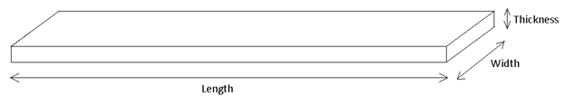
Write your list as:
QTY @ thickness (t) x width (w) x length (l)
Example:
2 @ 2” x 4” x 8’ means that you need two 8 foot long lengths of 2x4 material.
Fill in the following chart:
In the chart below, put the rough lengths that you will be cutting your four sides, and the bottom piece. Use the information from each joint to determine the final lengths.
Piece | QTY @ thickness (t) x width (w) x length (l) | Check Off When Cut
Front | ______ @ ________ x __________ x __________
Back | ______ @ ________ x __________ x __________
Right Side | ______ @ ________ x __________ x __________
Left Side | ______ @ ________ x __________ x __________
Bottom | ______ @ ________ x __________ x __________

Appendix D – Post Project Checklist
Checklist
Now that you completed the Wood Joint Tray, complete the checklist as before, and answer the questions below.
Relevant apprenticeship and trade training standards that align with this checklist include, Carpenter, Cabinetmaker, Construction Craft Worker and Native Residential Construction Worker.
Safety:
- Use personal protective equipment
- Practice safe work habits
- Practice good housekeeping
Tools:
- Select and use hand tools
- Select and operate portable power tools
- Select and operate stationary power tools and equipment
- Sand pieces with sandpaper or sanding machines
Procedure:
- Read and interpret technical drawings/plans/sketches
- Apply trade-related written and spoken information
- Perform trade-related calculations
- Use wood glue or other adhesives
- Select and use nails or screws
- Prepare the project for applying finishes, which includes but is not limited to sanding, filing, etc.
- Select, apply and polish finish material

Questions: Student Name: ____________________________
- How many new skills did you develop doing this project? Compare the number of checks you put above compared to the start of the project.

- Which skills do you feel are your strengths? Explain.

- Which skills did you find difficult to perform? Explain.

- What did you enjoy in doing this project? Explain.

- What did you not enjoy? Explain.

- Which of the following applies to you?
  - I am interested in beginning an apprenticeship
  - I am considering doing an apprenticeship
  - I plan on doing some trade-related projects or jobs, but not as a career path
  - I plan on doing some hobby projects
  - I do not intend to do trade-related projects ever again.

- The apprenticeship training standards for Carpenter, Cabinetmaker, Construction Craft Worker and Native Residential Construction Worker were all included in this assignment. Are you surprised to see how this project aligns with apprenticeship standards? Do you think this may give you a head start? Explain.

References
21st Century Competencies: Foundation Document for Discussion. Phase 1: Towards Defining 21st Century Competencies for Ontario, Winter 2016 Edition, 2016 http://www.edugains.ca/resources21CL/About21stCentury/21CL_21stCenturyCompetencies.pdf
College of Trades Training Standards https://www.collegeoftrades.ca/training-standards
Course Codes for Emphasis courses in the Revised Curriculum: Technological Education, Grades 11 and 12, 2009 http://www.edu.gov.on.ca/eng/curriculum/secondary/techedemphasiscourses.pdf
Growing Success: Assessment, Evaluation, and Reporting in Ontario Schools, First Edition, Covering Grades 1 to 12, 2010 www.edu.gov.on.ca/eng/policyfunding/growSuccess.pdf
Learning for All – A Guide to Effective Assessment and Instruction for All Students, Kindergarten to Grade 12, 2013 http://www.edu.gov.on.ca/eng/general/elemsec/speced/LearningforAll2013.pdf
﻿Ministry News https://news.ontario.ca/en/release/1000078/ontario-to-modernize-and-streamline-apprenticeship-training
OCTE SAFEDocs for Construction https://www.octe.ca/application/files/1115/3796/3108/SAFEdoc_CON.pdf
Resources, Ontario College of Trades, 2020 https://www.collegeoftrades.ca/resources
Red SEAL – Sceau Rouge, 2018 http://www.red-seal.ca/trades/tr.1d.2s_l.3st-eng.html
Skilled Trades Identified in Ontario https://www.collegeoftrades.ca/wp-content/uploads/Sector_Brochure_One_Pager_web.pdf
Skilled Trades Ontario https://www.ontario.ca/page/skilled-trades
The Apprenticeship Advantage, Ontario College of Trades, 2020 https://www.collegeoftrades.ca/wp-content/uploads/ApprenticeshipAdvantage_English_web.pdf
The Differentiated Instruction Scrapbook http://www.edugains.ca/resourcesDI/EducatorsPackages/DIEducatorsPackage2010/2010DIScrapbook.pdf
The Ontario Curriculum, Grades 9 and 10: Technological Education, 2009 (revised) http://www.edu.gov.on.ca/eng/curriculum/secondary/teched910curr09.pdf
The Ontario Curriculum, Grades 11 and 12: Technological Education, 2009 (revised) http://www.edu.gov.on.ca/eng/curriculum/secondary/2009teched1112curr.pdf

