

Table of Contents

Introduction 3
Project Outline 3
Prior Knowledge 4
Student Activities 4
Activity 1 – Review for Prior Knowledge Assessment 4
Activity 2 – Research and Planning 6
Activity 3 – Practical Demonstration of Chosen Updo 6
Activity 4 – Final Product and Write Up 6
Planning Notes 7
Skilled Trades and Apprenticeship Opportunities 7
Career and Industry Extensions 8
Continuum of Influence 8
Resources 13
Lesson Plans 13
Tools/Equipment 26
Handouts 26
Materials 26
Textbooks/ Books 26
Presentations 26
Videos 26
Sound files 27
Exemplars 27
Websites for Teachers 27
Instructional Strategies 27
The Hook / Motivational Strategies 27
Learning Goals and Success Criteria 28
Overall and Specific Expectations in Support of Ontario Curriculum Grades 9 - 12 Technological Education 29
Overall Expectations 29
Specific Expectations 29
Safety Concerns 31
Project Challenges 31
Applicable SAFEDocs and ToolSAFE videos 32
Differentiation of the Project / Activity 32
Assessment and Evaluation 33
Assessment For Learning 37
Assessment As Learning 37
Assessment Of Learning 37
Religious Considerations 37
Ethical Considerations 38
Environmental Considerations 38
Reflection or Design Report 38
Appendix A - African Culture - Global Updo 39
Braided Updo Exemplar 1 39
Braided Updo Exemplar 2 42
Appendix B - Review and Prior Knowledge Checklist and Slip 43
Appendix C - KWL Chart 44
Appendix D – Safe Use of Thermal Irons 45
Appendix E - Checklist 47
Appendix F - Global Updo Rubric 48
References 49

Introduction
Course Code: TXJ20
Broad base Technology: Hairstyling and Aesthetics
Destination: Open
Grade Level: 10
Prerequisite (if applicable) None
Project Name: Global Updo’s
Writer’s Name: Jenny Millar

This course presents hairstyling, make-up, and nail care techniques from a salon/spa perspective. Using materials, processes, and techniques used in the industry, students learn fundamental skills in hairstyling, giving manicures and facials, and providing hair/scalp analyses and treatments. Students will also consider related environmental and societal issues, and will explore secondary and postsecondary pathways leading to careers in the field of hairstyling and aesthetics.

Project Outline
Hairstyling and Aesthetics involves a lot of creativity. Around the world, people in different countries style their hair in updo’s that share similarities but also demonstrate differences. Some of their styles come alive from their cultural heritage. Embracing one’s culture or cultural heritage is going to give students the opportunity to see a variety of different style skills, and learn how each culture or cultural background does their hair in an updo.
Updo have been around for centuries and have evolved over time. Updos are used for many different occasions, like special events/celebrations or as an easy everyday style for evening and/or work.
For the global updo project, students will be focusing on creating an updo from either their ancestry heritage, or a cultural heritage that they are interested in.
Buy in: Students will develop and enhance their skills in creating hairstyles while learning about the importance of hair throughout time and across cultures. They will develop an appreciation of the variety and similarities of hairstyles from around the world. They can also utilize their skills at special events such as proms, ceremonies, graduations, and weddings.

Prior Knowledge
This Hairstyling and Aesthetics’ project has been designed for a grade 10 level and has no prerequisite course or prior learning requirement. It would be beneficial for students to have some prior knowledge before attempting this project in the following areas,
- Health and Safety in thermal applications
- Roller-sets
- Thermal Safety PowerPoint
- How to use thermal irons safely
- Curling and flat iron applications
- Principles of hair design
- Properties of the Hair and scalp
- Hairstyling fundamentals
Note: If you are using the Milady Standard Cosmetology (13th Edition) as your textbook, there is no requirement to do so, you may find Thermal Safety on page 460, Roller-sets on pages 442 - 456, Principles of Hair Design on pages 294 - 317, and Properties of the Hair and Scalp on pages 222 - 242.

Student Activities

Activity 1 – Review for Prior Knowledge Assessment
Students will use the KWL chart before we do the review. The K and W will be filled out before the review begins and the L after the review. A class review will be done through a Kahoot. Have a class discussion about previous topics covered to check for understanding before proceeding with the other lesson. Students should then be asked to start researching updos within their family or ancestry, or an ancestry that is of interest to them.

Kahoot
Prior Knowledge Assessment
KWL Chart
KWL Chart

Discussion Questions
How is volume achieved with thermal curl?
Volume is achieved with thermal curls by placing the curl very high on its base by holding the curl strand at a 135-degree angle and wrapping with medium tension. (MSC p. 465)
What are the two basic hairstyles considered the foundation of every updo and long hairstyling?
The two basic hairstyles considered the foundation of every updo and long hairstyling are:
- Ponytail
- French Pleat (MSC p. 473)
Describe a half updo? What length is it designed for?
A half updo is where half of the hair is pulled back off the face and pinned at or below the crown. The half updo is designed for long and very long hair. (MSC p. 472)
Name the five key points you must consider before beginning an updo.
The five key points to consider before beginning an updo are:
- Preparation
- Sectioning
- Pinning (MSC pgs. 472-473)
- Balance
- Texture

What is the purpose of backcombing and backbrushing?
Backcombing and backbrushing help lift and increase volume, as well as to remove indentations caused by roller setting. Backcombing involves combing small sections of hair from the ends towards the scalp causing shorter hair to mat at the scalp and form a cushion or base. Backbrushing is used to build a soft cushion or to mesh two or more curl patterns together for a uniform and smooth comb out. (MSC p. 454)
Students will complete Checklist Twitter Instagram Slip

Activity 2 – Research and Planning

After students have reviewed and refreshed their memories on hairstyling, have them look at ways they can incorporate updos using their family background (or a culture of their choosing) to showcase how an updo is done, and how they were done in the past. Once students complete their research, they will choose the updo hairstyle that they are most comfortable displaying to the class. They will explain their chosen style and how to achieve it. For this assignment, a rubric will be provided along with a checklist. The checklist will be used to ensure they are meeting the criteria and for the next stage of the assignment. The rubric will be used on the final product.
Buy in: Students will develop and enhance their skills in creating hairstyles while learning about the importance of hair throughout time and cultures, and will develop an appreciation of the variety and similarities from hairstyles around the world.
Tools needed:
- Wireless device
- Internet
- Pen and paper
- Read and write
- Google Translate

Activity 3 – Practical Demonstration of Chosen Updo

Students will demonstrate their practical updo chosen from their cultural heritage background or a culture of their choosing. Students will gather the necessary tools, equipment, supplies, and products needed to demonstrate this skill set. The learning goals and success criteria should be posted on an online platform or the board. Students will choose the style and level of difficulty that they are most comfortable demonstrating.
Assessment method: Checklist

Activity 4 – Final Product and Write Up

Students will demonstrate their cultural updo and complete the write up from the research they conducted.
For this final piece, you can demonstrate your final product in a variety of ways. You can do it through a presentation, live demonstration, pre-recorded, drawings, and oral presentation by describing the updo.
Assessment Method: Rubric

Planning Notes
Prior to starting, the teacher should ensure they have an adequate supply of tools and materials. Assume students will make some mistakes, or will waste some product
Before the class begins, the teacher should ensure the tools are in working order, put away, and that the space is clean and ready for students.
Try to avoid teaching too much at one time. Allow the students to apply the information after it has been taught.
Remind students to clean up as they go. This will prevent clutter, potential accidents, and potential tool damage.
Teachers can adapt this project if they need, based on cultural requirements and student needs. To help assess what accommodations may be required teachers may:
- Conduct a student survey at the beginning of the school year
- Consider students feedback
- Consider different learning styles
- Utilize differentiated instruction
- Consider accommodation / modification of project

Skilled Trades and Apprenticeship Opportunities
The skills and knowledge learned by completing this project will benefit students who are considering pursuing a career in the Hairstyling, Aesthetics, and Cosmetology industry. Students can directly apply this knowledge if they choose to enter the Hairstylist (332A) trade.
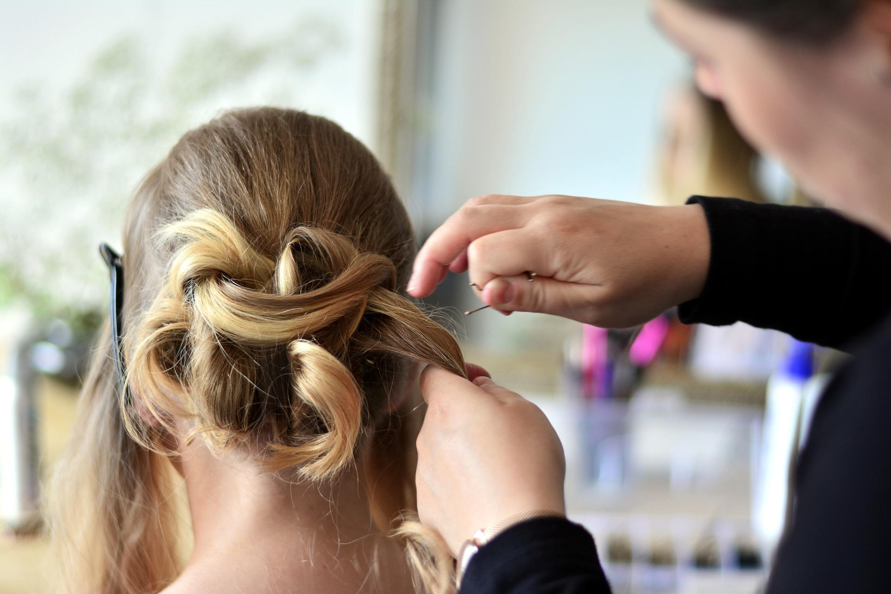

Career and Industry Extensions
The skills and knowledge learned by completing this project will be of great benefit to students when pursuing a career in multiple areas of the service industry as well as other industries. Some additional examples of these careers are listed below:
- Cosmetologist
- Hair Colourist
- Wedding and Event Stylist
- Salon or Spa Manager / Owner
- Desairology
- Teacher
- Extensionist
- Barber
- Makeup Artist
- Nail Technician
- Massage Therapist
- Beautician

Continuum of Influence
We all have different moments in our lives where we are affected by an experience. This can include learning a new concept or skill, experiencing something for the first time, taking a new course, developing a talent through practice and hard work, or even calling upon a skilled tradesperson to fix, repair, design, construct, maintain, build, bake, and create innovative solutions. The continuum of influence is a graphic representation of how those experiences can lead to developing a passion and talents in areas like Hairstyling & Aesthetics.
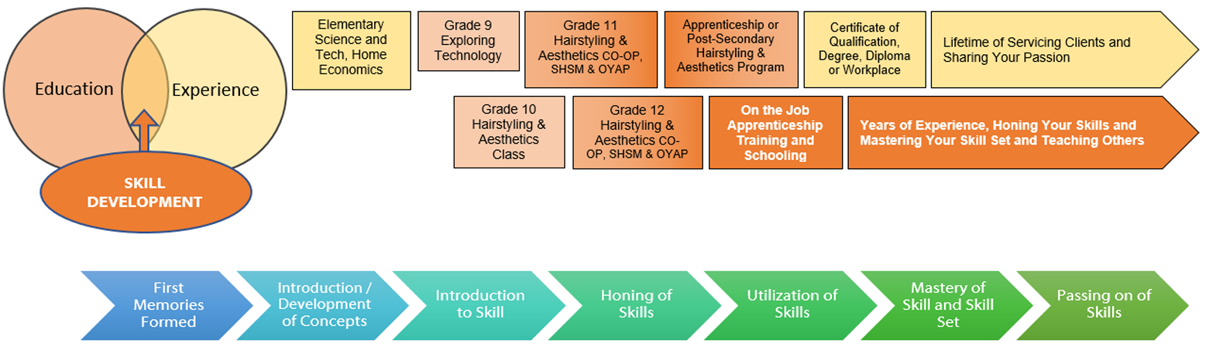

Continuum of Skills
Hairstyling and Aesthetics Curriculum College Pathway (“C” Courses)
Course | Grade 10 Open - TXJ20 | Level 1
Strand
Fundamentals | Demonstrate an understanding of the structure and characteristics of hair
A1.1 | Describe the structure of the hair  (e.g., medulla, cortex, papilla) | 5.3 Describe the properties of the  hair and scalp.
A1.2 | Describe the different characteristics of hair that affect styling and treatment needs and options (e.g., texture, density, growth patterns, protection) | 5.3 Describe the properties of the  hair and scalp.  8.3 Define the foundational elements of design.
Fundamentals | Describe a variety of common products, tools, and procedures that are used in the care of hair
A2.1 | Describe common hairstyling products and their uses (e.g., styling agents) | 8.4 Select and use hair styling products for wet, thermal and dry styling.
A2.2 | Describe various processes and equipment that are used in the hairstyling industry (e.g., spiral curl ironing, updos, flat iron, hair dryer) | 2.5 Assess and demonstrate the fundamentals of electrical safety within the workplace
A2.3 | Apply literacy skills (e.g., to read manufacturers’ instructions) and mathematical skills (e., to measure volume and/or proportions) to ensure safe and appropriate use of hairstyling techniques, tools, and products. | 1.2 Comply with Occupational Health and Safety Act (OHSA) and Workplace Hazardous Material Information Systems (WHMIS) regulations, Safety Data Sheets (SDS) information and manufacturer's safe use specifications

Course | Grade 10 Open - TXJ20 | Level 1
Hairstyling and Aesthetics Skills | Perform a variety of salon services, using appropriate tools and products in a professional and safe manner
B1.1 | Select safe and appropriate materials, tools, and products and use them correctly to perform professional salon services (e.g., thermal irons, hairspray) | 2.8 Operate and maintain equipment in accordance with manufacturers’ specifications.
B1.2 | Identify appropriate sterilization and sanitation products and equipment and use them correctly when providing salon services (e.g., disinfectants, hand sanitizers) | 2.3 Implement methods of sanitation, disinfection, infection control and materials disposal to maintain a safe, organized and sanitary workplace.
B1.3 | Comply with workplace health and safety regulations in handling salon products and equipment (e.g., regulations for handling and storing chemicals, preventing harm from spills and vapour emissions, wearing personal protective equipment) | 1.2 Comply with Occupational Health and Safety Act (OHSA) and Workplace Hazardous Material Information Systems (WHMIS) regulations, Safety Data Sheets (SDS) information and manufacturer's safe use specifications
B1.4 | Apply appropriate ergonomic principles in the workplace by adjusting equipment and tools properly to maintain good posture while working (e.g., using a mannequin stand extension) | 2.7 Maintain effective body posture and position during service.
B1.5 | Perform a variety of hairstyling procedures (e.g., thermal styling, wet setting) for a variety of purposes/occasions (e.g., cultural ceremonies, drama production, client days, fashion shows, musicals, charity events) | 8.5 Determine and demonstrate base control of tool placement for desired outcome.  8.6 Style wet hair using blow dryers, brushes, hood dryer, rollers, pin curls, braiding and finger waves.  8.7 Thermal -set hair using blow dryers, hood dryer, curling irons, flat irons, and rollers.  8.8 Perform formal hair styling service on medium to long hair.

Course | Grade 10 Open - TXJ20 | Level 1
Hairstyling and Aesthetics Skills | Use knowledge of design elements and principles in the contexts of hairstyling services and marketing
B2.1 | Use knowledge elements of design (e.g., space, line, direction, colour) to plan hairstyling strategies | 8.3 Define the foundational elements of design
B2.2 | Use knowledge of design principles (e.g., proportion, balance, emphasis) to sketch, create, and produce a variety of pleasing/interesting salon styles and effects (e.g., hairstyles) | 8.1 Interpret consultation results to determine type of styling design to be performed.
B2.3 | Use design knowledge and skills creatively in a variety of hairstyling marketing contexts (e.g., use of different cultural heritage designs to market to the different community) | 4.6 Research, recognize, and reproduce current trends for styling hair service.
Hairstyling and Aesthetics Skills | Apply methods for meeting the needs of the salon clientele
B3.1 | Communicate and interact effectively with clients (e.g., use active listening and questioning observe rules of conversational and professional etiquette) | 1.1 & 3.5 Adhere to professional ethics in the workplace
B3.2 | Conduct service and product consultations to identify the hairstyling serves to be provided (e.g., interview potential clients and record their information) | 3.3 Apply effective communication skills to establish professional rapport with client and co-workers  5.1 Conduct an efficient and effective client consultation

Course | Grade 10 Open - TXJ20 | Level 1
Professional Practices and Career Opportunities | Comply with Occupational health and safety standards in performing salon services
D1.1 | Use safe and sanitary work practices in performing hairstyling services (e.g., safety checklist for tools and equipment, always wash your hands, keep floor swept and tidy) and identify potential problems related to working in an unsanitary or unsafe work environment (e.g., danger of slipping on the floor) | 2.3 Implement methods of sanitation, disinfection, infection control and materials disposal to maintain a safe, organized and sanitary workplace
D1.3 | Identify laws, regulations, and regulatory/oversight organizations that govern the hairstyling industry (e.g., WHMIS, OHSA, Apprenticeship and Certification Act) | 1.2 & 2.1 Comply with Occupational Health and Safety Act (OHSA) and Workplace Hazardous Material Information Systems (WHMIS) regulations, Safety Data Sheets (SDS) information and manufacturer's safe use specifications
Professional Practices and Career Opportunities | Career Opportunities
D2.4 | Demonstrate an understanding of the Essential Skills that are important for success in the hairstyling industry, as identified in the Ontario Skills Passport (e.g., job task planning and organizing, decision making, problem solving) | 3.4 Apply effective time management and organizational skills

Resources

Lesson Plans
 Apprenticeship Resource Lesson Plan 
Topic: Review and Prior Knowledge Assessment
Student Activity | Curr | Content | Teacher Activity
Students will review previous lessons/topics using a Kahoot.  Kahoot Review  Students will use the KWL chart to assess their learning.  KWL Chart  Students will have classroom discussions about previous topics covered on; health and safety in thermal applications, roller-sets, How to use thermal irons, curling and flat iron applications, principles of hair design, properties of the hair and scalp, and hairstyling.  Students will fill out a checklist, twitter and/or Instagram slip.  Students will ensure their digital portfolio is shared with the teacher, so the teacher can see their demonstration of practical work skills.  Students will research about updos within their family and/or ancestry or a cultural heritage of their choice to perform/present an updo on.  Students will complete the checklist and Twitter and/or Instagram Slip.  Checklist Twitter Instagram Slip  Safety Concerns  Thermal tools safety tips | A1.1  A1.2  A2.2  B1.2  B3.1  D1.3 | Kahoot Review  KWL Chart  Discussion Questions  How is volume achieved with thermal curling?  Volume is achieved with thermal curls by placing the curl very high on its base by holding the curl strand at a 135-degree angle and wrapping with medium tension. (pg. 465 of Milady Standard Cosmetology)  What two basic hairstyles are considered the foundation of every updo and long hairstyling?  The two basic hairstyles considered the foundation of every updo and long hairstyling are:  - Ponytail  - French Pleat  (pg. 473 of Milady Standard Cosmetology)  Describe a half updo? What length is it designed for?  A half updo is where half of the hair is pulled back off the face and pinned at or below the crown. The half updo is designed for long and very long hair. (pg. 472 of Milady Standard Cosmetology)  Name the five key points you must consider before beginning an updo.  The five key points to consider before beginning an updo are:  - Preparation  - Sectioning  - Pinning  - Balance  - Texture  (pg. 472-473 of Milady Standard Cosmetology)  What is the purpose of backcombing and backbrushing?  Backcombing and backbrushing help lift and increase volume, as well as to remove indentations caused by roller setting. Backcombing involves combing small sections of hair from the ends towards the scalp causing shorter hair to mat at the scalp and form a cushion or base. Backbrushing is used to build a soft cushion or to mesh two or more curl patterns together for a uniform and smooth comb out. (pg. 454 of Milady Standard Cosmetology)  Checklist and Twitter/Instagram Slip  Checklist Twitter Instagram Slip | Teacher will write learning goals and success criteria on a whiteboard and online platform.  Teacher will have a lesson agenda on the board/online platform for students to follow throughout the lesson.  Teacher will use Kahoot to check students’ prior knowledge of previously covered topics.  Teacher will ensure Kahoot is available for students.  Teacher will ensure students use KWL chart to assess student learning. Chart for K and W should be filled out before the review and the L after the review.  Teacher will remind students to ensure their ongoing digital portfolios are shared to see practical work skills on previous units as it correlates with the lesson.  Teacher will ensure students are participating in the Kahoot and classroom discussions/reviews.  Teacher will view students completed work from their digital portfolio on thermal application, and roller set.  Teacher will have students fill out the checklist and Twitter/Instagram slip before the end of the class.  Teacher will ask students to perform research on updo hairstyles using their family or ancestry/heritage or a cultural heritage that is of interest to them.

Expected Outcomes | Assessment of Outcomes
The student will:  Describe the structure of the hair.  Describe various processes and equipment that are used in the hairstyling industry.  Identify appropriate sterilization and sanitation products and equipment and use them correctly when providing salon services.  Communicate and interact effectively and use active listening skills.  Identify laws, regulations, and regulatory/oversight organizations that govern the hairstyling industry. | Assessment FOR Learning  Discussion to gather information.  Discussion to provide information  T chart Learning goals and success criteria to explain where they are going and how they are going to get there.  Agenda of lesson on board/online platform for students to follow throughout lesson  Assessment AS Learning  Kahoot Review  KWL Chart  Discussion to assess knowledge and understanding at the beginning, middle and end of lesson  Twitter and/or Instagram Slip  Demonstration  Checklist  Assessment OF Learning  Checklist, students will explain strengths and areas of improvement.  KWL Chart, What you know, what you want to know, and what you have learned.  Twitter slip/Instagram, to reflect on what they learned.  Triangulated assessment  Conversation. Ask questions to assess their communication of application  Observe. Participation in classroom discussion, prior knowledge of thermal application and safety.  Product. View student previous finished applications.

Motivation | Curriculum Expectations
“Gorgeous hair is the Best Revenge” Ivana Trump | Growing Success:  Shares information, resources, and expertise and promotes critical thinking to solve problems and make decisions.  Demonstrate curiosity and interest in learning.  Approaches new tasks with a positive attitude.  Assesses and reflects critically on own strengths, needs, and interests.  Curriculum Expectations: A1.1, A1.2, A2.2, B1.2, B3.1, D1.3

Reflections | Instructional Materials
KWL chart  Kahoot  Classroom discussion  Twitter and/or Instagram Slip  Written reflection | Internet  Wireless device  Whiteboard  Pen and paper  Google Read and Write  Google Translate

 Apprenticeship Resource Lesson Plan 
Topic: Research and Planning
Student Activity | Curr | Content | Teacher Activity
Students will research about their cultural heritage updo styles for different ceremonies.  Students will start writing up their findings on the research.  Students will print/draw/sketch, their chosen updo from the cultural heritage.  Students will plan how they will finish the assigned task.  Students will tell the teacher how they will present their findings for the “Global Updo” project.  Students will use proper punctuation and grammar to demonstrate their understanding of the research content.  Students will use the checklist as a guide while completing the assignment.  Students will share something they learned on the Jamboard link provided.  Checklist  Jamboard Ancestry Heritage Findings  Safety Concerns  NONE | B2.1  B2.2  D2.4 | Checklist  Jamboard Ancestry Heritage Findings  Differentiated Instructions: Students can work with a partner (groups of 2’s) | Teacher will write learning goals and success criteria on a whiteboard and online platform.  Teacher will have a lesson agenda on the board/online platform for students to follow throughout the lesson.  Teacher will ask students to perform updo hairstyles research using their family or ancestry or a cultural heritage that is of interest to them.  Teacher will show students exemplars of the project “Global Updo” so they can see what the expectations are.  Teacher will check in with students to see how the research is going while they are conducting their research for the final project.  Teacher will check and ensure students are on track with the assignment.  Teacher will ensure that the instructions and assignments are differentiated to meet the needs of each student.  Teacher will remind students to use the checklist provided.  Teacher will remind students to share something they learned on the Jamboard Ancestry/Heritage Finding
Expected Outcomes | Assessment of Outcomes
The student will:  Conduct research of their family or chosen heritage updo style used for ceremonies.  Gather information on their ancestry or chosen heritage.  Demonstrate an understanding of the Essential Skills that are important for success in hairstyling.  Use knowledge elements of design to plan the hairstyling strategies for their chosen updo.  Use knowledge of design principles to sketch, create, and produce an updo style. | Assessment FOR Learning  Discussion to gather information.  Discussion to provide information  T chart Learning goals and success criteria to explain where they are going and how they are going to get there.  Agenda of lesson on board/online platform for students to follow throughout lesson  Assessment AS Learning  Exemplar  Discussion to assess knowledge and understanding at the beginning, middle and end of lesson  Notes - Jamboard  Demonstration  Checklist  Assessment OF Learning  Checklist, students will use to ensure they are on track  Jamboard, to share something they’ve learned  Triangulated assessment  Conversation. Ask questions to assess their communication of application  Observe. Participation in research, draft, and Jamboard.  Product. View sketch and/or photo ideas of the final product.

Motivation | Curriculum Expectations
“If you want to understand today, you have to search yesterday” Pearl S. Buck  Buy in: Students will develop and enhance their skills in creating hairstyles while learning about the importance of hair throughout time and cultures. They will develop an appreciation of the variety and similarities of hairstyles from around the world. They can also utilize their skills at special events like; prom, ceremonies, graduation and weddings. | Growing Success:  Responsibility  Fulfils responsibilities and commitments within the learning environment,  Complete and submit classwork, and assignments according to agreed upon timelines.  Takes responsibility for and manages own behaviour.  Collaboration  Build healthy peer-to-peer relationships through personal and media-assisted interactions.  Respond positively to the ideas, opinions, values, and traditions of others.  Shares information, resources, and expertise and promotes critical thinking to solve problems and make decisions.  Organization  Devises and follows a plan and process for completing work and tasks.  Establishes priorities and manages time to complete tasks and achieve goals.  Use class time appropriately to complete tasks.  Identifies, gathers, evaluates, and uses information, technology, and resources to complete tasks.  Initiative  Demonstrate curiosity and interest in learning.  Approaches new tasks with a positive attitude.  Looks for and acts on new ideas and opportunities for learning.  Assesses and reflects critically on own strengths, needs, and interests.  Independent Work  Use class time appropriately to complete tasks.  Independently monitors, assesses, and revises plans to complete tasks and meet goals.  Follows instructions with minimal supervision.  Self-regulation  Set own individual goals and monitors progress towards achieving them.  Seeks clarification or assistance when needed  Perseveres and makes an effort when responding to challenges.  Curriculum Expectations: B2.1, B2.2, D2.4

Reflections | Instructional Materials
Checklist  Jamboard  Written reflection | Internet  Wireless device  Whiteboard  Pen and paper  Google Read and Write  Speech to text  Google Translate

 Apprenticeship Resource Lesson Plan 
Topic: Practical Demonstration of Chosen Updo
Student Activity | Curr | Content | Teacher Activity
Students will complete chosen “Global updo” while following proper techniques, safety, and sanitation practices.  Students will plan how they will finish the assigned task.  Students will tell the teacher how they will present their findings for the “Global Updo” project.  Students will use the checklist as a guide while completing the assignment.  Students will use rubric provided to ensure they are meeting the expectations set out.  Checklist  Rubric  Safety Concerns  Burns, electric shock, ergonomic, trips, falls, etc. | A2.1  A2.2  A2.3  B1.1  B1.2  B1.3  B1.4  B1.5  B2.1  B2.2  B2.3  D1.1  D2.4 | Checklist  Rubric  Differentiated Options  Differentiated Instructions: Students can work with a partner (groups of 2’s)  If student does not feel comfortable doing the updo they can choose to:  *Complete some artwork of the updo they researched.  *Do an audio recording of what they learned and describe the updo they will perform, what products they will use, and how they will sanitize after.  *Choose the style and explain how they will achieve the style, products they will use, how they will sanitize and what they learned during the research. | Teacher will write learning goals and success criteria on board and online platform.  Teacher will have a lesson agenda on the board/online platform for students to follow throughout the lesson.  Teacher will ask students to perform a chosen updo on a mannequin, peer or family member.  Teacher will go over the rubric with students.  Teacher will go over expectations  with students.  Teacher will check and ensure students are on track with the assignment.  Teacher will ensure that the instructions and assignment is differentiated to meet the needs of each student.  Teacher will have students fill out the checklist as they have each task completed to ensure they are meeting the expectations set out.  Teacher will remind students to use rubric as they perform their practical updo.

Expected Outcomes | Assessment of Outcomes
The student will:  Describe common hairstyling products and their uses while completing updo or describing their chosen updo  Describe the processes and equipment that are used in the updo styling.  Apply literacy skills to ensure safe and appropriate use of hairstyling techniques, tools, and products.  Select safe and appropriate materials, tools, and products and use them correctly to perform professional salon services (e.g., thermal irons, hairspray)  Identify and use appropriate sanitation products and equipment and use them correctly when completing their updo practical task.  Comply with workplace health and safety regulations in handling salon products and equipment.  Apply appropriate ergonomic principles in the workplace by adjusting equipment and tools properly to maintain good posture while working.  Perform an updo style from their ancestry or another culture.  Use knowledge of design principles when creating and/or sketching their updo style.  Use design knowledge and skills creatively when completing the updo style of the different cultural designs to market to different communities.  Use safe and sanitary work practices in performing hairstyling services.  Demonstrate an understanding of planning, organizing, decision making, problem solving, and job tasks that are important for success in the hairstyling industry. | Assessment FOR Learning  Discussion to gather information.  Discussion to provide information  T chart Learning goals and success criteria to explain where they are going and how they are going to get there.  Agenda of lesson on board/online platform for students to follow throughout lesson  Assessment AS Learning  Exemplar  Discussion to assess knowledge and understanding at the beginning, middle and end of lesson  Sticky Notes - Timely Constructive Feedback  Demonstration  Checklist  Rubric  Assessment OF Learning  Checklist, students will use to ensure they are on track  Sticky Notes - Feedback on how they are doing  Triangulated assessment  Conversation. Ask questions to assess their communication of application  Observe. Updo of chosen style  Product. Final Updo practical demonstration

Motivation | Curriculum Expectations
“Hair design starts with having a vision. The philosophy of design gathers inspiration from many sources: movies, TV, magazines, videos, even a person on the street, anywhere-can spark the creative process.” Milady Standard Cosmetology | Growing Success:  Responsibility  Fulfils responsibilities and commitments within the learning environment,  Completes and submits classwork, and assignments according to agreed upon timelines.  Takes responsibility for and manages own behaviour.  Collaboration  Responds positively to the ideas, opinions, values, and traditions of others.  Shares information, resources, and expertise and promotes critical thinking to solve problems and make decisions.  Organization  Devises and follows a plan and process for completing work and tasks.  Establishes priorities and manages time to complete tasks and achieve goals.  Use class time appropriately to complete tasks.  Identifies, gathers, evaluates, and uses information, technology, and resources to complete tasks.  Initiative  Demonstrate curiosity and interest in learning.  Approaches new tasks with a positive attitude.  Looks for and acts on new ideas and opportunities for learning.  Assesses and reflects critically on own strengths, needs, and interests.  Independent Work  Use class time appropriately to complete tasks.  Independently monitors, assesses, and revises plans to complete tasks and meet goals.  Follows instructions with minimal supervision.  Self-regulation  Set own individual goals and monitors progress towards achieving them.  Seeks clarification or assistance when needed  Perseveres and makes an effort when responding to challenges.  Curriculum Expectations: A2.1, A2.2, A2.3, B1.1, B1.2, B1.3, B1.4, B1.5, B2.1, B2.2, B2.3, D1.1, D2.4

Reflections | Instructional Materials
Checklist  Written reflection  Sketch  Audio recording | Mannequin  Hair product  Thermal tools  Rollers  Hair pins  Elastics  Internet  Wireless device  Whiteboard  Pen and paper  Speech to text  Google Read and Write  Google Translate
 Apprenticeship Resource Lesson Plan 
Topic: Final Product and Write Up
Student Activity | Curr | Content | Teacher Activity
Students will put the written write up and photos of their chosen updo in their presentation form chosen.  Students will hand in assignment before the end of the class.  Students will use the checklist as a guide while completing the assignment.  Students will use rubric provided to ensure they are meeting the expectations set out.  Checklist  Rubric  Safety Concerns  None | B2.2  B2.3  D2.4 | Checklist  Rubric  Differentiated Options  Differentiated Instructions: Students can work with a partner (groups of 2’s)  Students can choose a variety of ways to demonstrate what they have learned. This can be through:  *PowerPoint Presentation  *Audio recording presentation with photos  *Sketches/drawings (visual arts)  *Oral presentation with photos or mannequin style  Accommodation/  Modification  Oral presentation or audio recorded presentation about what they learned on the chosen global updo. Along with describing how and what product to use to achieve chosen style. | Teacher will write learning goals and success criteria on board and online platform.  Teacher will have a lesson agenda on the board/online platform for students to follow throughout the lesson.  Teacher will ask students to finish the project in their chosen form and submit it to be marked.  Teacher will go over the rubric with students.  Teacher will go over expectations with students.  Teacher will check and ensure students are on track with the assignment.  Teacher will ensure that the instructions and assignments are differentiated to meet the needs of each student.  Teacher will ensure the checklist is completed and handed in with the success criteria expectations.

Expected Outcomes | Assessment of Outcomes
The student will:  Use knowledge of design principles when creating and/or sketching their updo style.  Use design knowledge and skills creatively when completing the updo style of the different cultural heritage designs to market to different communities.  Demonstrate an understanding of planning, organizing, decision making, problem solving, and job tasks that are important for success in the hairstyling industry. | Assessment FOR Learning  Discussion to gather information.  Discussion to provide information  T chart Learning goals and success criteria to explain where they are going and how they are going to get there.  Agenda of lesson on board/online platform for students to follow throughout lesson  Assessment AS Learning  Exemplar  Discussion to assess knowledge and understanding at the beginning, middle and end of lesson  Sticky Notes - Timely Constructive Feedback  Demonstration  Checklist  Rubric  Assessment OF Learning  Checklist, students will use to ensure they are on track  Sticky Notes - Feedback on how they are doing  Triangulated assessment  Conversation. Ask questions to assess their communication of final task  Observe. Chosen method to present their findings  Product. Final presentation

Motivation | Curriculum Expectations
“Hair is a canvas to showcase your personality and style. Be creative, have fun, and celebrate the uniqueness that is you!” - Adam Millar | Growing Success:  Responsibility  Fulfils responsibilities and commitments within the learning environment,  Complete and submit classwork, and assignments according to timelines that are agreed upon.  Takes responsibility for and manages own behaviour.  Collaboration  Respond positively to the ideas, opinions, values, and traditions of others.  Shares information, resources, and expertise and promotes critical thinking to solve problems and make decisions.  Organization  Devises and follows a plan and process for completing work and tasks.  Establishes priorities and manages time to complete tasks and achieve goals.  Use class time appropriately to complete tasks.  Identifies, gathers, evaluates, and uses information, technology, and resources to complete tasks.  Initiative  Demonstrate curiosity and interest in learning.  Approaches new tasks with a positive attitude.  Looks for and acts on new ideas and opportunities for learning.  Assesses and reflects critically on own strengths, needs, and interests.  Independent Work  Use class time appropriately to complete tasks.  Independently monitors, assesses, and revises plans to complete tasks and meet goals.  Follows instructions with minimal supervision.  Self-regulation  Set own individual goals and monitor progress towards achieving them.  Seeks clarification or assistance when needed  Perseveres and makes an effort when responding to challenges.  Curriculum Expectations: B2.2, B2.3, D2.4

Reflections | Instructional Materials
Checklist  Written reflection  Sketch  Audio recording  PowerPoint Presentation  Oral presentation | Internet  Wireless device  Whiteboard  PowerPoint  Word  Pen and paper  Speech to text  Google Read and Write  Google Translate

Tools/Equipment
Thermal tools, rollers, hair dryer, hot rollers, hair dryer

Handouts
Safe Use of Thermal Irons (see Appendix D)

Materials
Lesson 1: Kahoot Review, Review and Prior Knowledge Twitter - Instagram Slip
Lesson 2: Jamboard Ancestry Heritage Findings

Textbooks/ Books
The Milady Standard Cosmetology, 13th Edition (if available through your school board)

Presentations
Thermal Hairstyling PowerPoint Presentation on Flat Irons  https://www.octe.ca/application/files/2216/3016/2986/TXJ2O_Thermal_Hairstyling-Flat_Iron_Lesson_1.pptx | 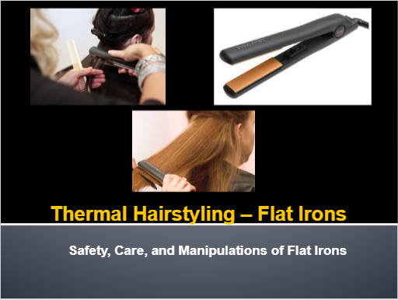
Cosmetology: Roller-set PowerPoint  https://www.octe.ca/application/files/4316/3016/2860/TXJ2O_Roller-set_Activity_1.pptx | 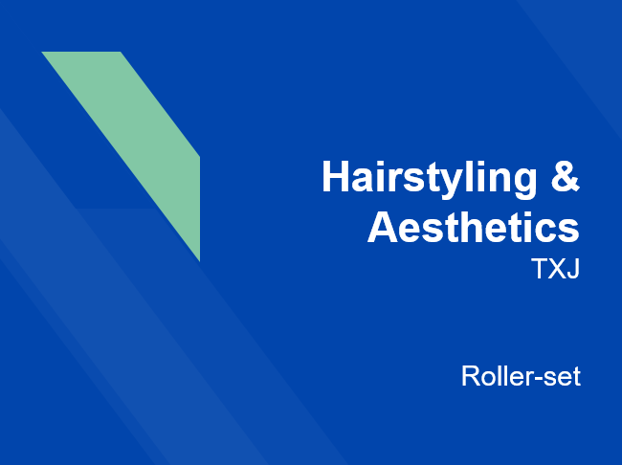

Videos
Global Updo Exemplar Video  https://www.octe.ca/application/files/7416/3321/8666/Global_Updo_Exemplar_with_copyright_free_sound.mp4 | 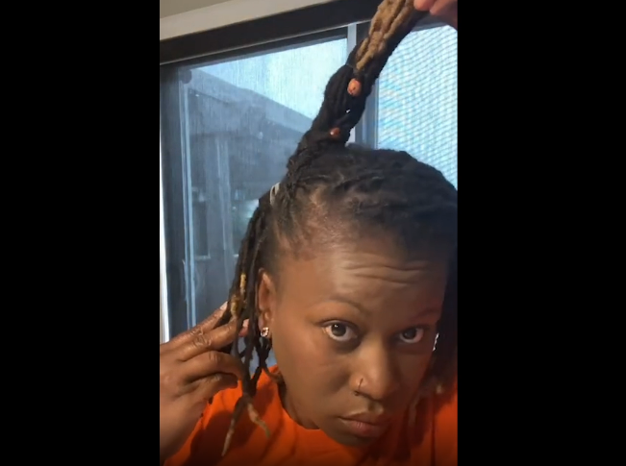

Sound files
Global Updo (mp3 soundtrack), 2021 https://www.octe.ca/application/files/8416/3016/3121/Global_Updo.mp3

Exemplars
African Culture - Global Updo (see Appendix A)

Websites for Teachers
Jamboard

Instructional Strategies
Teachers may use any of the following instructional strategies; 3-Part lesson, lecture, storyboard, word wall, think-pair-share, placemat activity, rapid write, K-W-L, anticipation chart, ABC taxonomy, think aloud, analyzing text, Cornell note taking, exit ticket/ticket out the door, plus/minus/delta, etc.

The Hook / Motivational Strategies
Buy in: Students will develop and enhance their skills in creating hairstyles while learning about the importance of hair throughout time and cultures. Students will develop an appreciation of the variety and similarities of hairstyles from around the world.
Notable quotes:
“Gorgeous hair is the Best Revenge” - Ivana Trump

“If you want to understand today, you have to search yesterday” - Pearl S. Buck

“Hair design starts with having a vision. The philosophy of design gathers inspiration from many sources: movies, TV, magazines, videos, even a person on the street, anywhere-can spark the creative process.” - Milady Standard Cosmetology

“Hair is a canvas to showcase your personality and style. Be creative, have fun, and celebrate the uniqueness that is you!” - Adam Millar

Learning Goals and Success Criteria
Through this project, students will become more familiar with the tools and techniques used in performing updos. Students will improve their eye to detail and their fine motor skills. They will gain valuable trade knowledge, which will be useful in starting an apprenticeship in the Hairstyling trade.
Students that have successfully completed this project should be able to:
- Describe the structure of the hair.
- Describe various processes and equipment that are used in the hairstyling industry.
- Identify appropriate sterilization and sanitation products and equipment and use them correctly when providing salon services.
- Communicate and interact effectively and use active listening skills.
- Identify laws, regulations, and regulatory/oversight organizations that govern the hairstyling industry.
- Conduct research of their family or chosen heritage updo style used for ceremonies.
- Gather information on their ancestry or chosen heritage.
- Demonstrate an understanding of the Essential Skills that are important for success in hairstyling.
- Use knowledge elements of design to plan the hairstyling strategies for their chosen updo.
- Use knowledge of design principles to sketch, create, and produce an updo style.
- Describe common hairstyling products and their uses while completing updo or describing their chosen updo
- Describe the processes and equipment that are used in the updo styling.
- Apply literacy skills to ensure safe and appropriate use of hairstyling techniques, tools, and products.
- Select safe and appropriate materials, tools, and products and use them correctly to perform professional salon services (e.g., thermal irons, hairspray)
- Identify and use appropriate sanitation products and equipment and use them correctly when completing their updo practical task.
- Comply with workplace health and safety regulations in handling salon products and equipment.
- Apply appropriate ergonomic principles in the workplace by adjusting equipment and tools properly to maintain good posture while working.
- Perform an updo style from their ancestry or another culture.
- Use knowledge of design principles when creating and/or sketching their updo style.
- Use design knowledge and skills creatively when completing the updo style of the different cultural designs to market to different communities.
- Use safe and sanitary work practices in performing hairstyling services.
- Demonstrate an understanding of planning, organizing, decision making, problem solving, and job tasks that are important for success in the hairstyling industry.

Overall and Specific Expectations in Support of Ontario Curriculum Grades 9 - 12 Technological Education

Overall Expectations
A1. Demonstrate an understanding of the structure and characteristics of hair, skin, and nails;
A2. Describe a variety of common products, tools, and procedures that are used in the care of hair, skin, and nails;
A3. Demonstrate an understanding of lifestyle choices, attitudes, and behaviours that are important for personal and professional success in the hairstyling and aesthetics workplace;
B1. Perform a variety of salon/spa services, using appropriate tools and products in a professional and safe manner;
B2. Use knowledge of design elements and principles in the contexts of hairstyling and aesthetics services and marketing;
B3. Apply methods for meeting the needs of the salon/spa clientele;
D1. Comply with occupational health and safety standards in performing salon/spa services;
D2. Describe career opportunities in hairstyling and aesthetics, including relevant secondary and postsecondary educational pathways, and identify key knowledge, skills, attitudes, and habits that are important for success in the industry.

Specific Expectations
A1.1 Describe the structure of the hair (e.g., medulla, cortex, papilla);
A1.2 Describe the different characteristics of hair that affect styling and treatment needs and options (e.g., texture, density, growth patterns, protection);
A2.1 Describe common hairstyling products and their uses (e.g., styling agents);
A2.2 Describe various processes and equipment that are used in the hairstyling industry (e.g., spiral curl ironing, updos, flat iron, hair dryer);
A2.3 Apply literacy skills (e., to read manufacturers’ instructions) and mathematical skills (e., to measure volume and/or proportions) to ensure safe and appropriate use of hairstyling techniques, tools, and products;
B1.1 Select safe and appropriate materials, tools, and products and use them correctly to perform professional salon services (e.g., thermal irons, hairspray);
B1.2 Identify appropriate sterilization and sanitation products and equipment and use them correctly when providing salon services (e.g., disinfectants, hand sanitizers);
B1.3 Comply with workplace health and safety regulations in handling salon products and equipment (e.g., regulations for handling and storing chemicals, preventing harm from spills and vapour emissions, wearing personal protective equipment);
B1.4 Apply appropriate ergonomic principles in the workplace by adjusting equipment and tools properly to maintain good posture while working (e.g., using a mannequin stand extension);
B1.5 Perform a variety of hairstyling procedures (e.g., thermal styling, wet setting) for a variety of purposes/occasions (e.g., cultural ceremonies, drama production, client days, fashion shows, musicals, charity events);
B2.1 Use knowledge elements of design (e.g., space, line, direction, colour) to plan hairstyling strategies;
B2.2 Use knowledge of design principles (e.g., proportion, balance, emphasis) to sketch, create, and produce a variety of pleasing/interesting salon styles and effects (e.g., hairstyles);
B2.3 Use design knowledge and skills creatively in a variety of hairstyling marketing contexts (e.g., use of different cultural heritage designs to market to the different community);
B3.1 Communicate and interact effectively with clients (e.g., use active listening and questioning observe rules of conversational and professional etiquette);
B3.2 Conduct service and product consultations to identify the hairstyling serves to be provided (e.g., interview potential clients and record their information);
D1.1 Use safe and sanitary work practices in performing hairstyling services (e.g., safety checklist for tools and equipment, always wash your hands, keep floor swept and tidy) and identify potential problems related to working in an unsanitary or unsafe work environment (e.g., danger of slipping on the floor);
D1.3 Identify laws, regulations, and regulatory/oversight organizations that govern the hairstyling industry (e.g., WHMIS, OHSA, Apprenticeship and Certification Act);
D2.4 Demonstrate an understanding of the Essential Skills that are important for success in the hairstyling industry, as identified in the Ontario Skills Passport (e.g., job task planning and organizing, decision making, problem solving).

Safety Concerns
Students completing this project will need to be properly trained in safe salon practices, etiquette, tools, and equipment. Students will be required to wear proper personal protective equipment such as aprons, gloves, and/or safety glasses and masks. Specific safety concerns include, but are not limited to, thermal applications, burns, pinch, entanglement, struck-by, ergonomics, electrical appliance use and the potential for electrical shock.

Project Challenges
Some challenges that a student or a teacher could be faced with in completing this project include,
- COVID protocols being implemented affecting normal instruction of class
- Sharing or not enough tools for everyone in the class
- Not enough chairs or workstations or mannequins for students
- Increased room temperature with thermal applications and hot tools turned on
- If person has lice or personal hygiene issues
- Time constraints
- Lack of knowledge and/or skill

Applicable SAFEDocs and ToolSAFE videos
Please refer to the OCTE Hairstyling and Aesthetics safety document in order to properly address and instruct this project.
Flat Iron ToolSAFE Video  https://youtu.be/UkzHMP0Z-R0 | 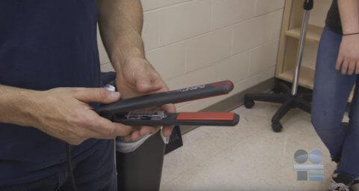
Curling Iron ToolSAFE Video  https://youtu.be/DgswGaJ88Uk | 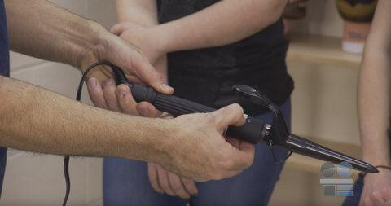

Differentiation of the Project / Activity
Students had a variety of ways to demonstrate their learning. For example:
- Students can work with a partner (groups of 2’s)
- Students can work on mannequin
Students can choose a variety of ways to demonstrate what they have learned. This can be through:
- PowerPoint Presentation
- Audio recording presentation with photos
- Sketches/drawings (visual arts)
- Oral presentation with photos or mannequin style
Accommodation/Modification
Oral presentation or audio-recorded presentation about what they learned on the chosen global updo. Along with describing how and what product to use to achieve chosen style.

Assessment and Evaluation
Review and Prior Knowledge Checklist and Slip
Task | Strength | Areas of Improvement
Identify appropriate sanitation products and use them correctly
Select safe and appropriate materials, tools, and products and use them correctly to perform salon services.
Comply with workplace health and safety regulations.
Can describe the structure of the hair.
Can describe the characteristics of the hair.
Can perform a variety of hairstyling procedures using rollers, and/or thermal irons.
Twitter Slip/Instagram
Reflect on what you’ve learned and use the hashtag #Prior knowledge

If you do not have Twitter or Instagram you can write your reflection here, or you can do an oral response on what you have learned or remembered from the units covered.

See Appendix B
KWL Chart
K-W-L Chart

Reflect on what you know before and then after learning about a particular topic. Begin by filling in the columns below with what you Know about the topic, what you Want to know, and finally, what you have Learned.

What do you Know about the topic? | What do you Want to know? | What have you Learned?

See Appendix C

Checklist
Checklist
Success Criteria | Complete | Incomplete
Student has conducted research on culture and/or heritage updo
Student has completed write-up on selected updo
Student was sensitive to others culture and/or heritage
Student presented the name of the ancestry/ cultural heritage
Student presented their findings and updo as a video presentation, or oral presentation, or visual arts, or live presentation, or photo documentation.
Student completed Jamboard activity.
Student provided references of sites/sources for their updo
Notes:

See Appendix E

Rubric
Global Updo Rubric

Criteria | Level 4  (80-100%) | Level 3  (70-79%) | Level 2  (60-69%) | Level 1  (50-59%)
Knowledge/Understanding /20
Demonstrates the ability to use tools and products accurately | Demonstrates thorough ability to use tools and products accurately | Demonstrates considerable ability to use tools and products accurately | Demonstrates some ability to use tools and products accurately | Demonstrates limited ability to use tools and products accurately
Communication /20
Communicates information clearly  Describes steps accurately  Communicates information accurately | Communicates information with a high degree of clarity  Describes steps with a high degree of accuracy  Communicates information with a high level of accuracy | Communicates information with a considerable clarity  Describes steps with a considerable accuracy  Communicates information with a considerable accuracy | Communicates information with some clarity  Describes steps with some accuracy  Communicates with some accuracy | Communicates information with limited clarity  Describes steps with limited accuracy  Communicates with limited accuracy
Thinking/Inquiry /20
Demonstrates proper use of tools, techniques and safety procedures | Demonstrates proper use of tools, techniques and safety procedures | Demonstrates considerable use of tools, techniques and safety procedures | Demonstrates some use of tools, techniques and safety procedures | Demonstrates limited use of tools, techniques and safety procedures
Application /40
Demonstrates proper techniques of updo style  Demonstrates proper use of tools and products | Demonstrates a thorough technique of updo style.  Demonstrates thorough use of tools and products | Demonstrates a considerable technique of updo style.  Demonstrates considerable use of tools and products | Demonstrates some technique of updo style.  Demonstrates some use of tools and products | Demonstrates limited technique of updo style.  Demonstrates limited use of tools and products

See Appendix F

Assessment For Learning

- Discussion to gather and provide information.
- T chart Learning goals and success criteria to explain where they are going and how they are going to get there.
- Agenda of lessons on board/online platform for students to follow throughout the unit.

Assessment As Learning

- Kahoot Review
- KWL Chart
- Discussion to assess knowledge and understanding at the beginning, middle and end of the lesson.
- Twitter and/or Instagram Slip
- Exemplar
- Notes - Jamboard
- Demonstration
- Sticky Notes - Timely Constructive Feedback
- Checklist
- Rubric

Assessment Of Learning

- Checklist, students will explain strengths and areas of improvement.
- KWL Chart, What you know, what you want to know, and what you have learned.
- Twitter slip/Instagram, to reflect on what they learned.
- Checklist, students will use to ensure they are on track.
- Jamboard, to share something they have learned.
- Sticky Notes - Feedback on how they are doing.

Religious Considerations
Some cultures and religions use head coverings when they are out in public so they might not be able to perform the updo on themselves or family members. Students might require a mannequin to complete the chosen updo style.
This reinforced why it is important to offer an updo from multiple cultural backgrounds.

Ethical Considerations
Be sensitive to culture and heritage to ensure that whatever we are doing we are doing it shows the utmost respect and care.
Teachers and students should also take into consideration the feelings of our peers when selecting cultural heritage that is outside of our own.

Environmental Considerations
Salon products can be very harmful to the environment. Consider using eco-friendly products or no products to complete the updo.

Reflection or Design Report
Teachers may wish to have the students complete a design report, reflection, or create a foldable to consolidate their learning. This would be a nice way to capture the students’ understanding in a summative format and be used in preparation for their examination, entering post-secondary education, or the workforce.
Students will reflect on what they have learned throughout their research and upbringing and share with the class during their presentation.

Appendix A - African Culture - Global Updo

Braided Updo Exemplar 1
Throughout centuries, my ancestors have used braids as a way to bind us together. Braids are part of my cultural heritage, in the past, present, and will be in the future. Ancient stone paintings were discovered that date back thousands of years depicting hairstyles. Centuries ago, braids meant different things. For example, they were fashionable and upheld societal customs. Depending on how you wore your hair, it could indicate your marital status, age, and/or the clan you belonged to. According to an article by Siraad Dirshe, “a traditional style symbolizing heritage for the Fula women of the Sahel region consisted of long braids down the back with a small tuft of hair gathered at the top of the crown.” They also adorned their hair with amber and silver disc accessorized their hair at shoulder length.
An example of the Fula hairstyle
“These styles were like neat headpieces, worn down the middle of the forehead—regal-like,” says Tamara Albertini, owner of the braid studio Ancestral Strands in Brooklyn.
Growing up, braiding has always been a big part of my world and it is something we did at a very young age. For instance, going to a wedding or event we will braid our hair so it will look neat and presentable for the occasion. Braiding is definitely still a big part of my culture and is done in a variety of ways.
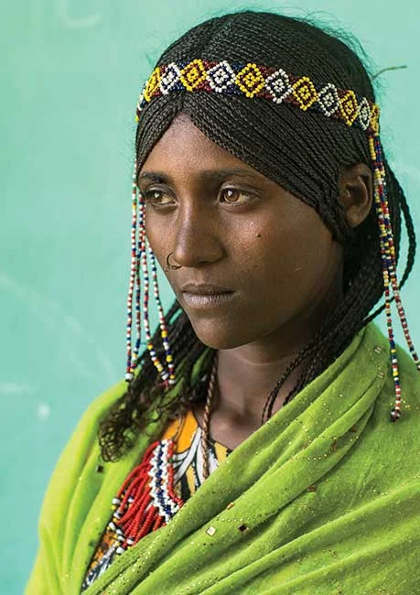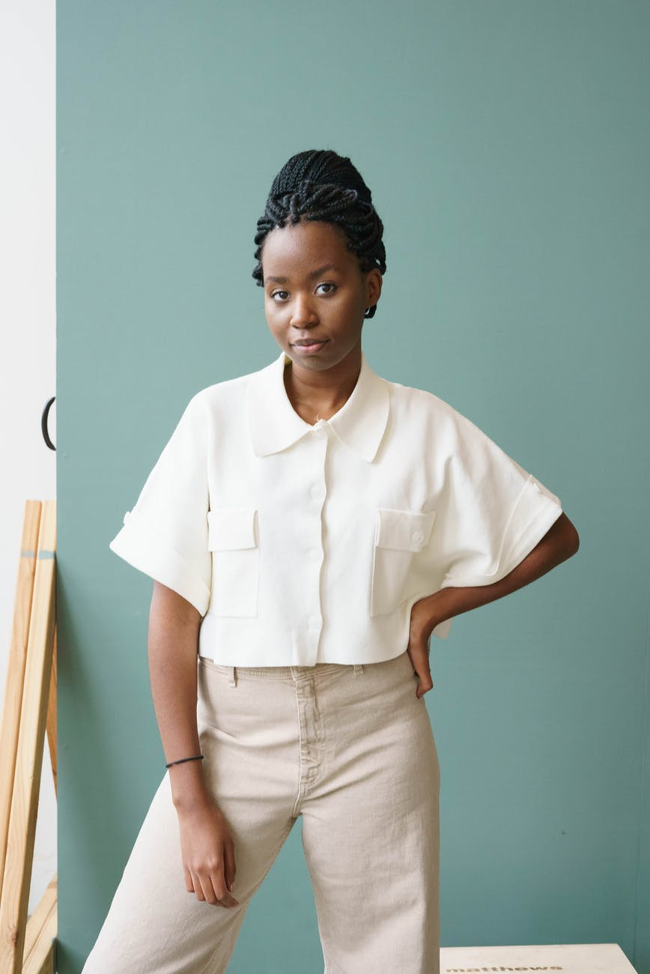

African cultural examples of braided updo.
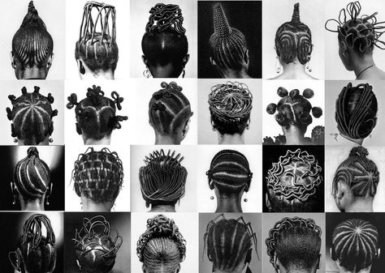

I will be completing a braided updo for my Global updo project. Please see the video showing my updo along with photos of the process.
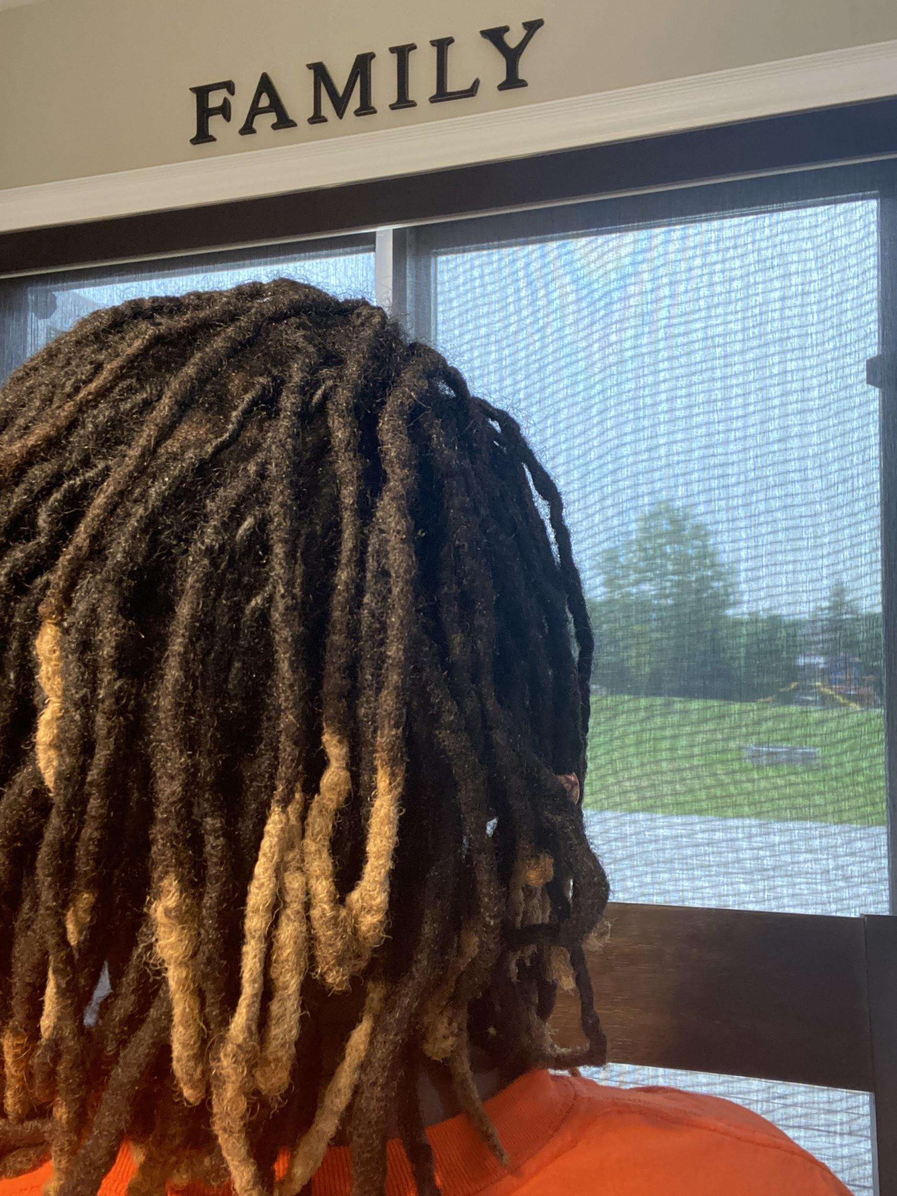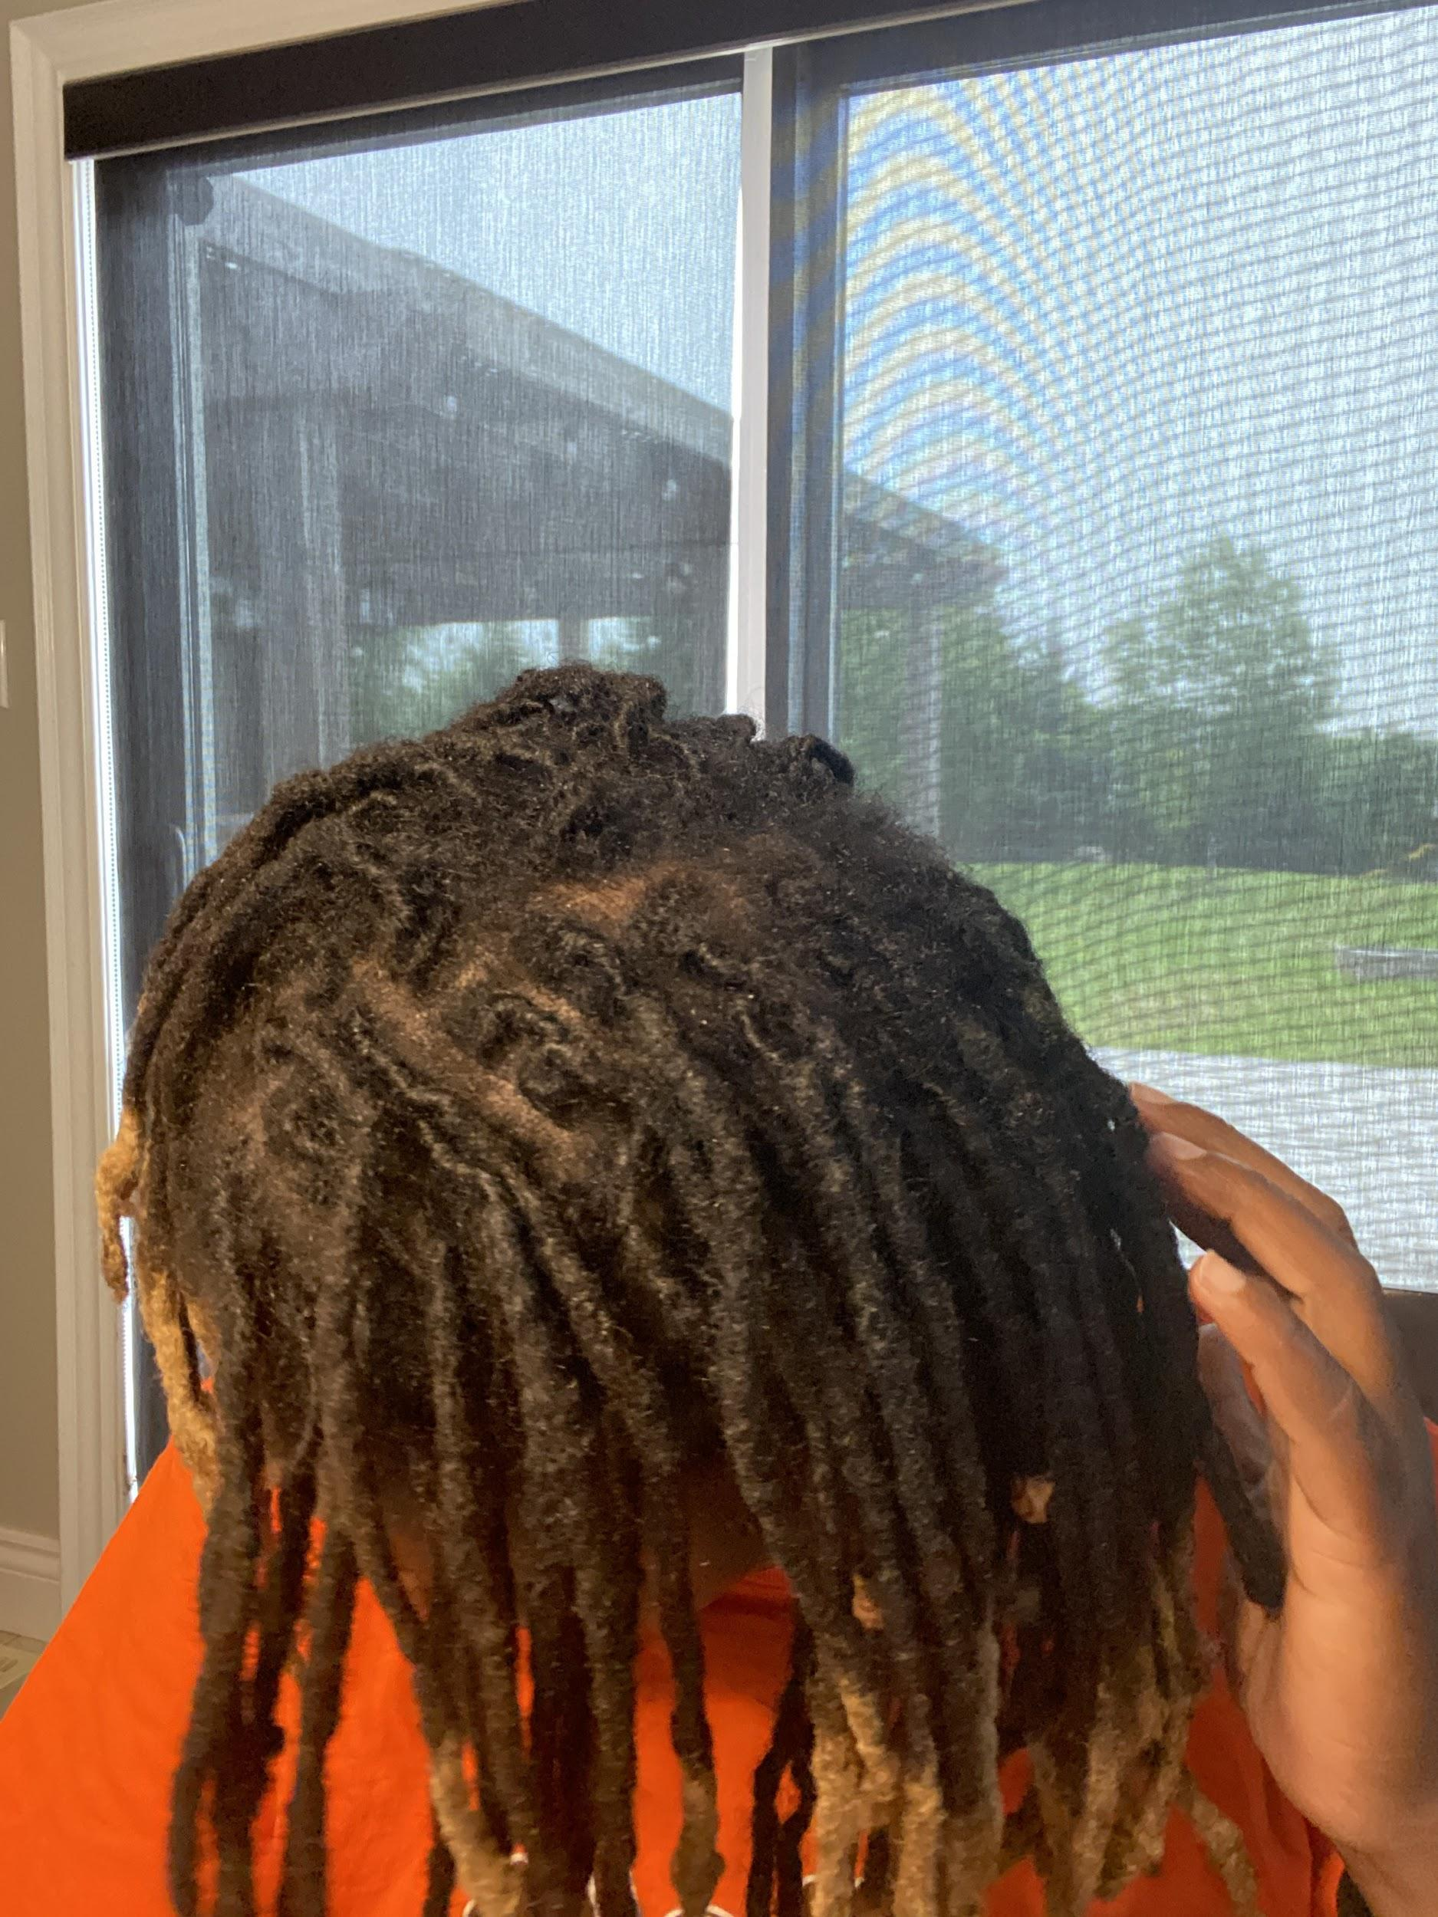

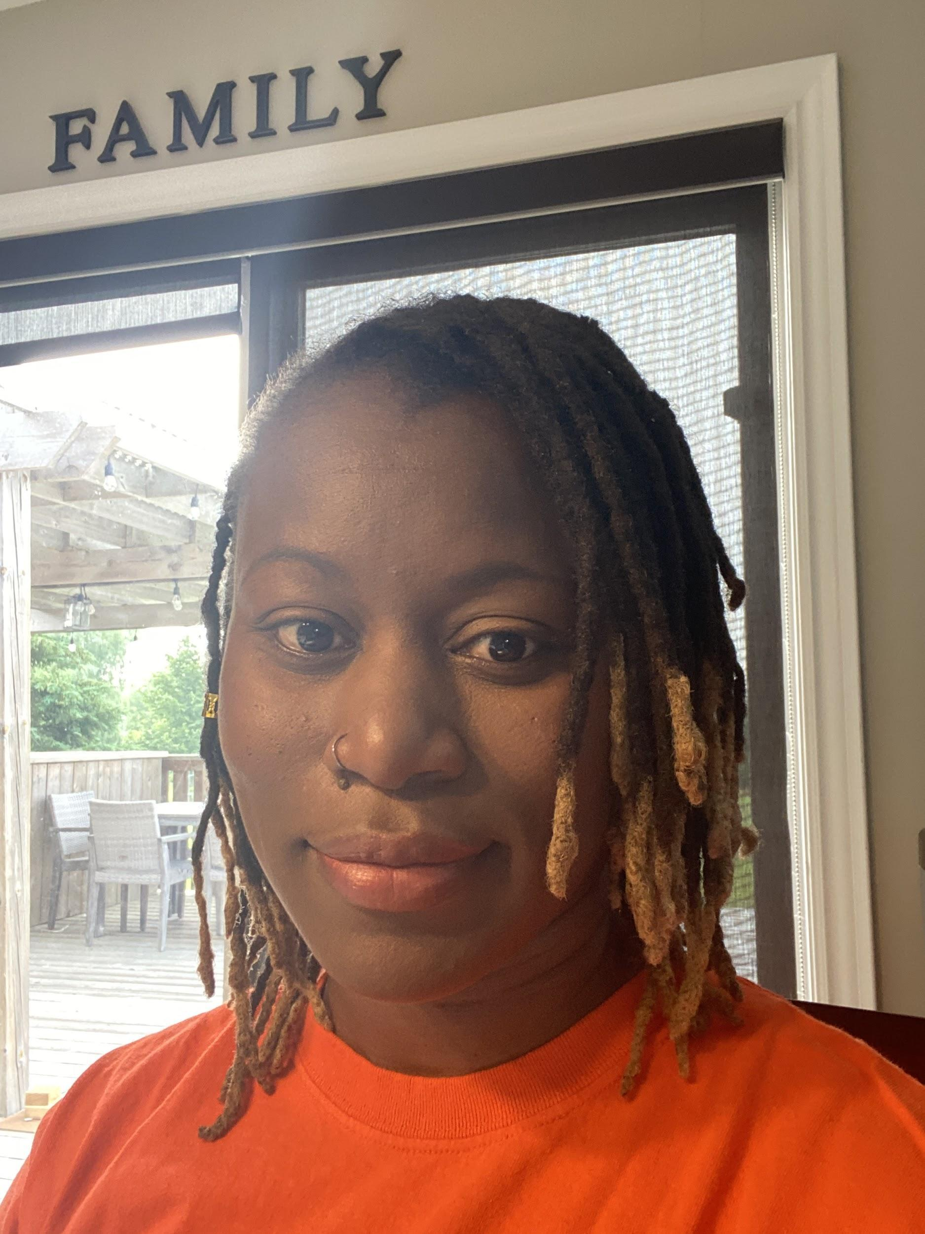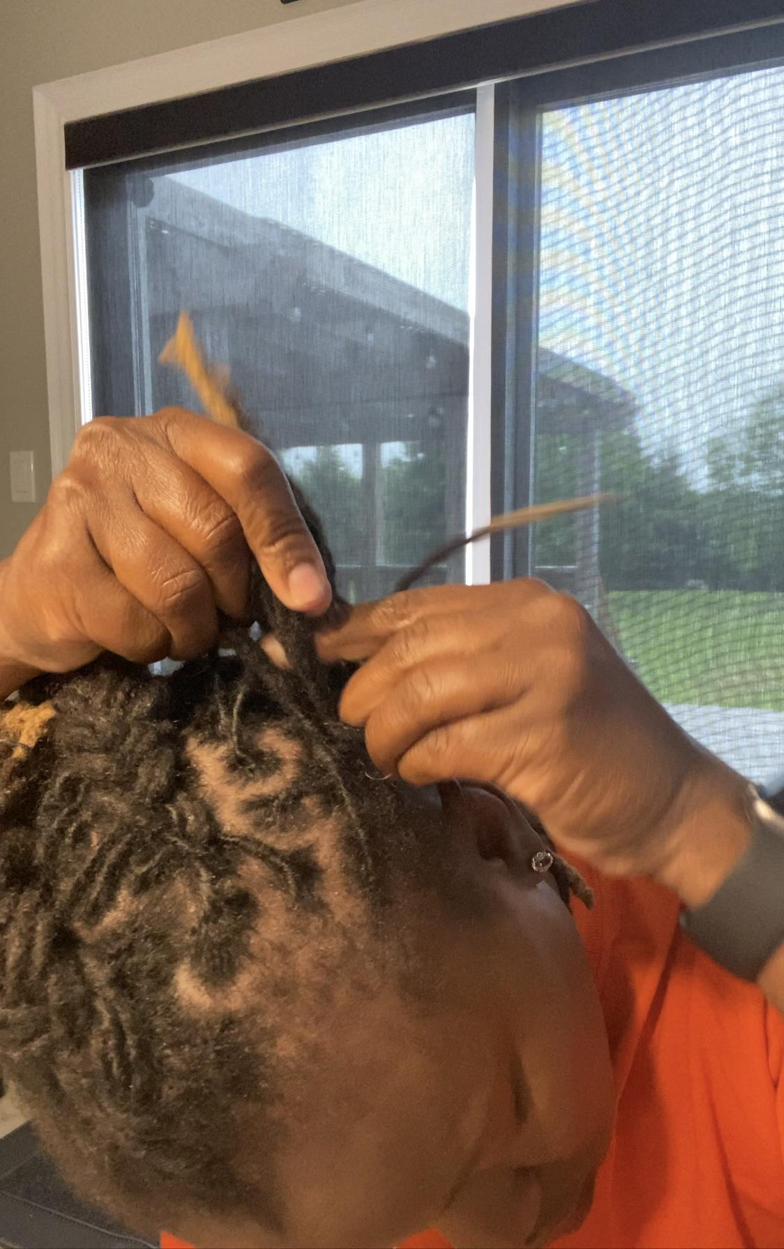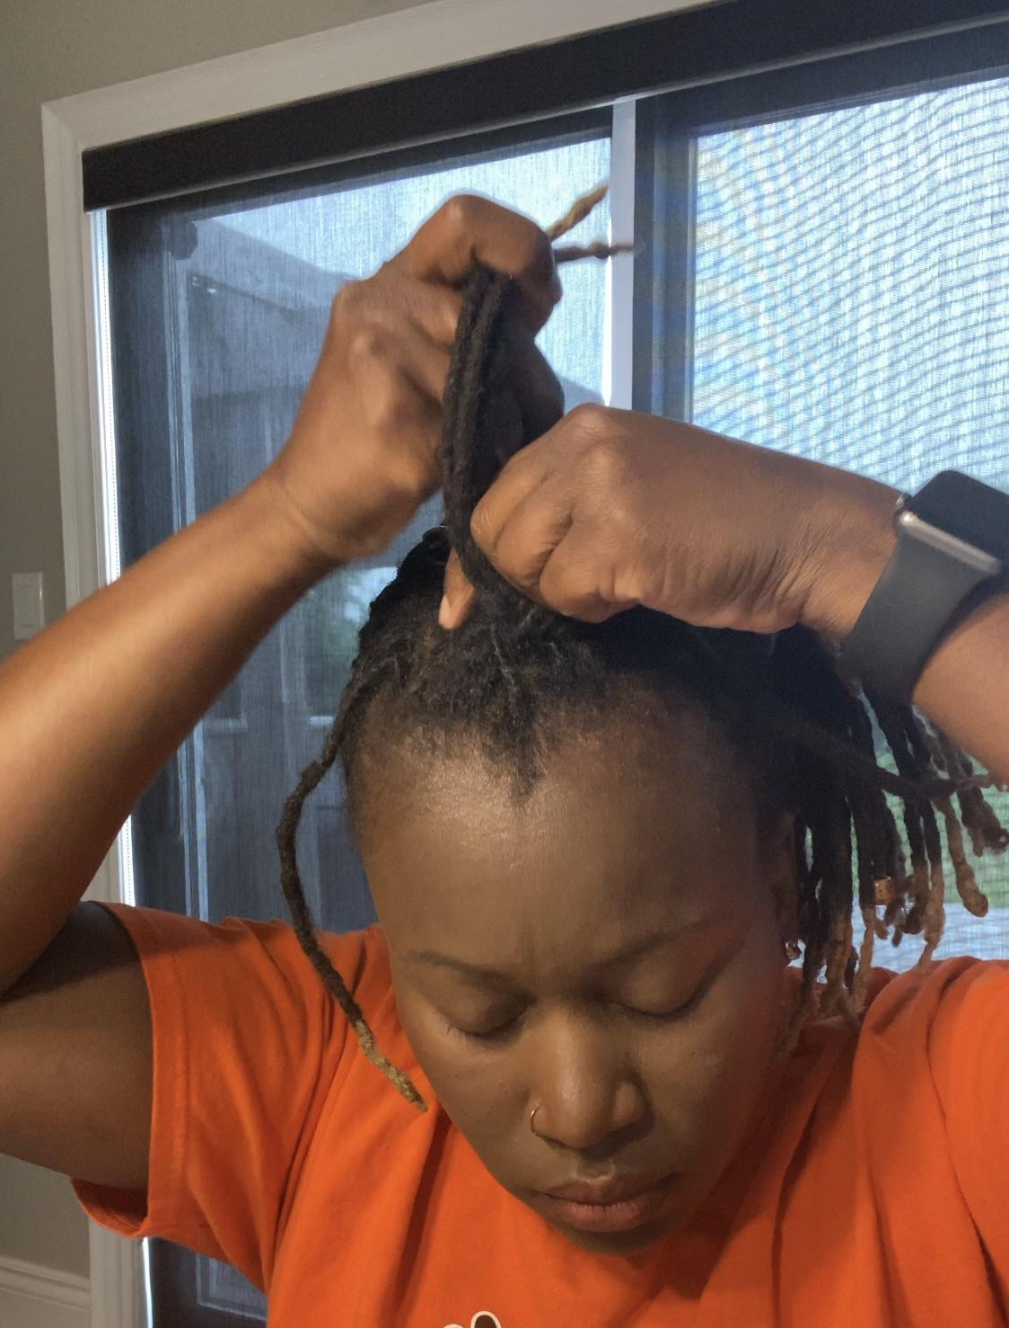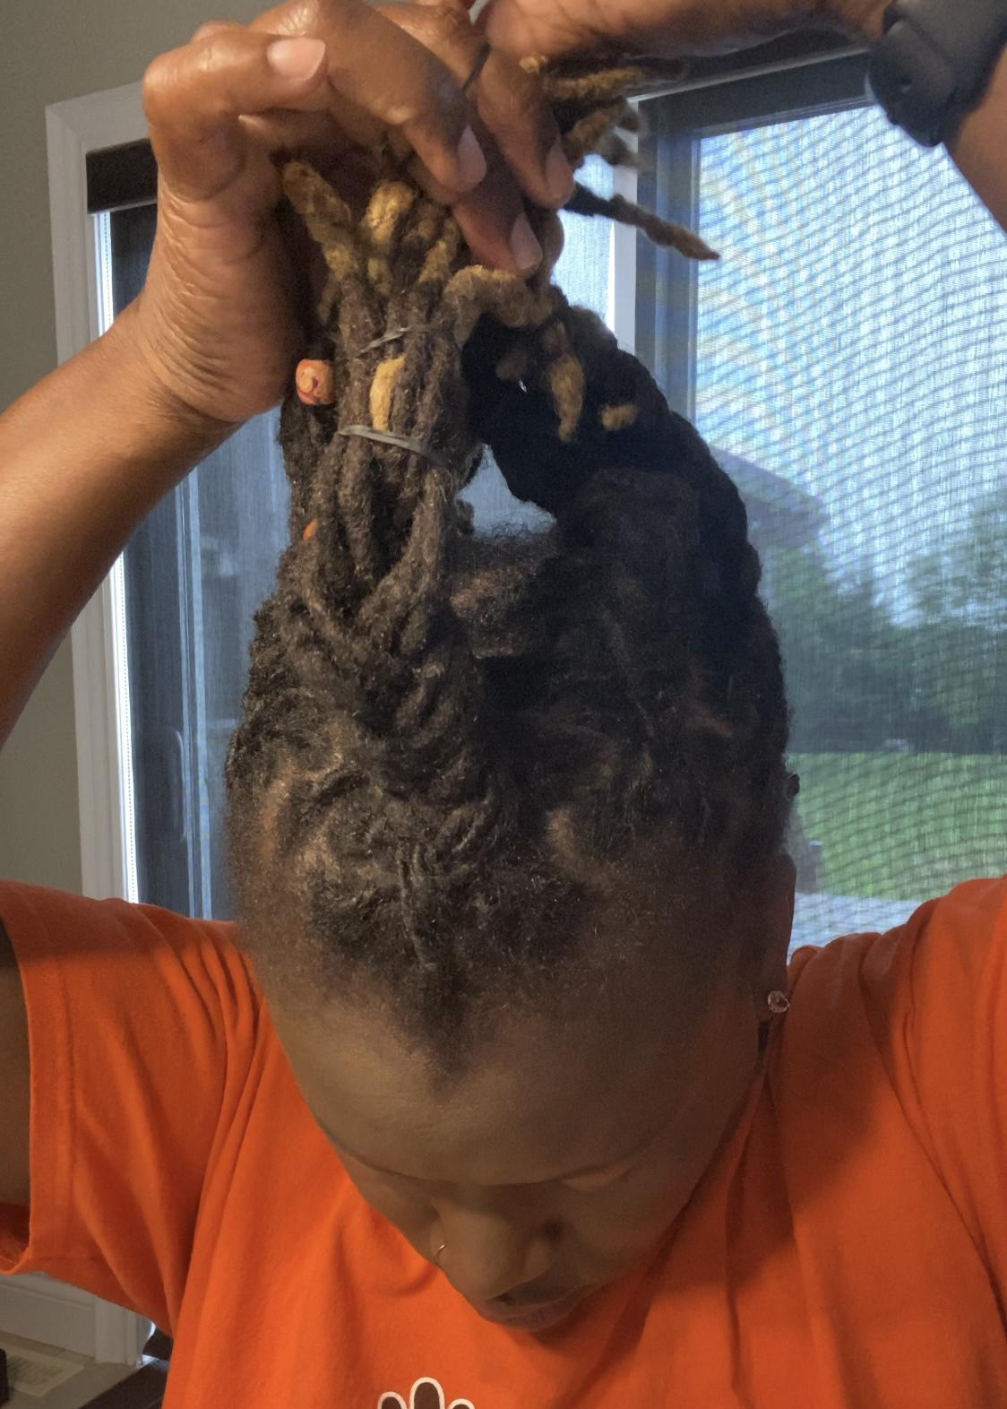

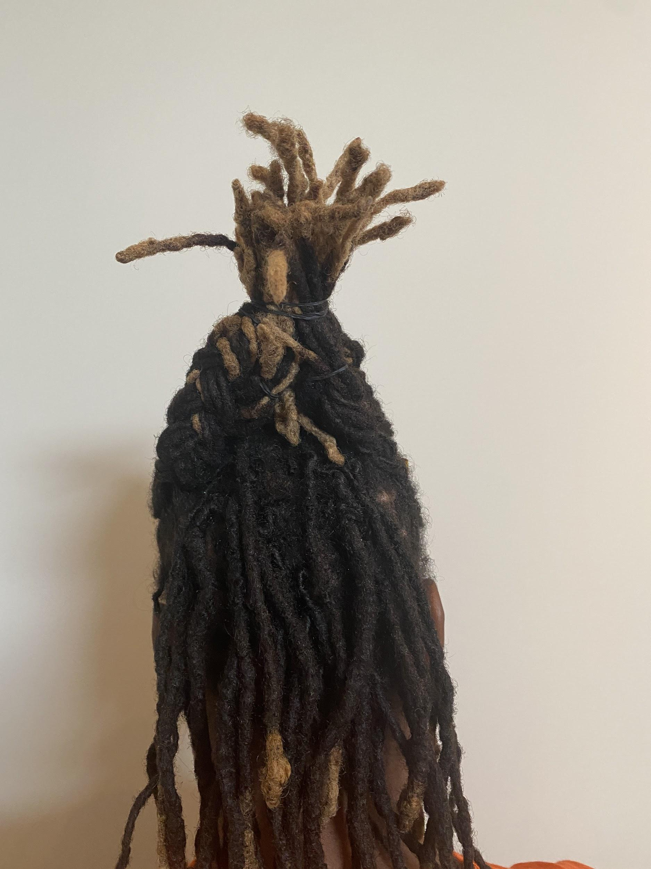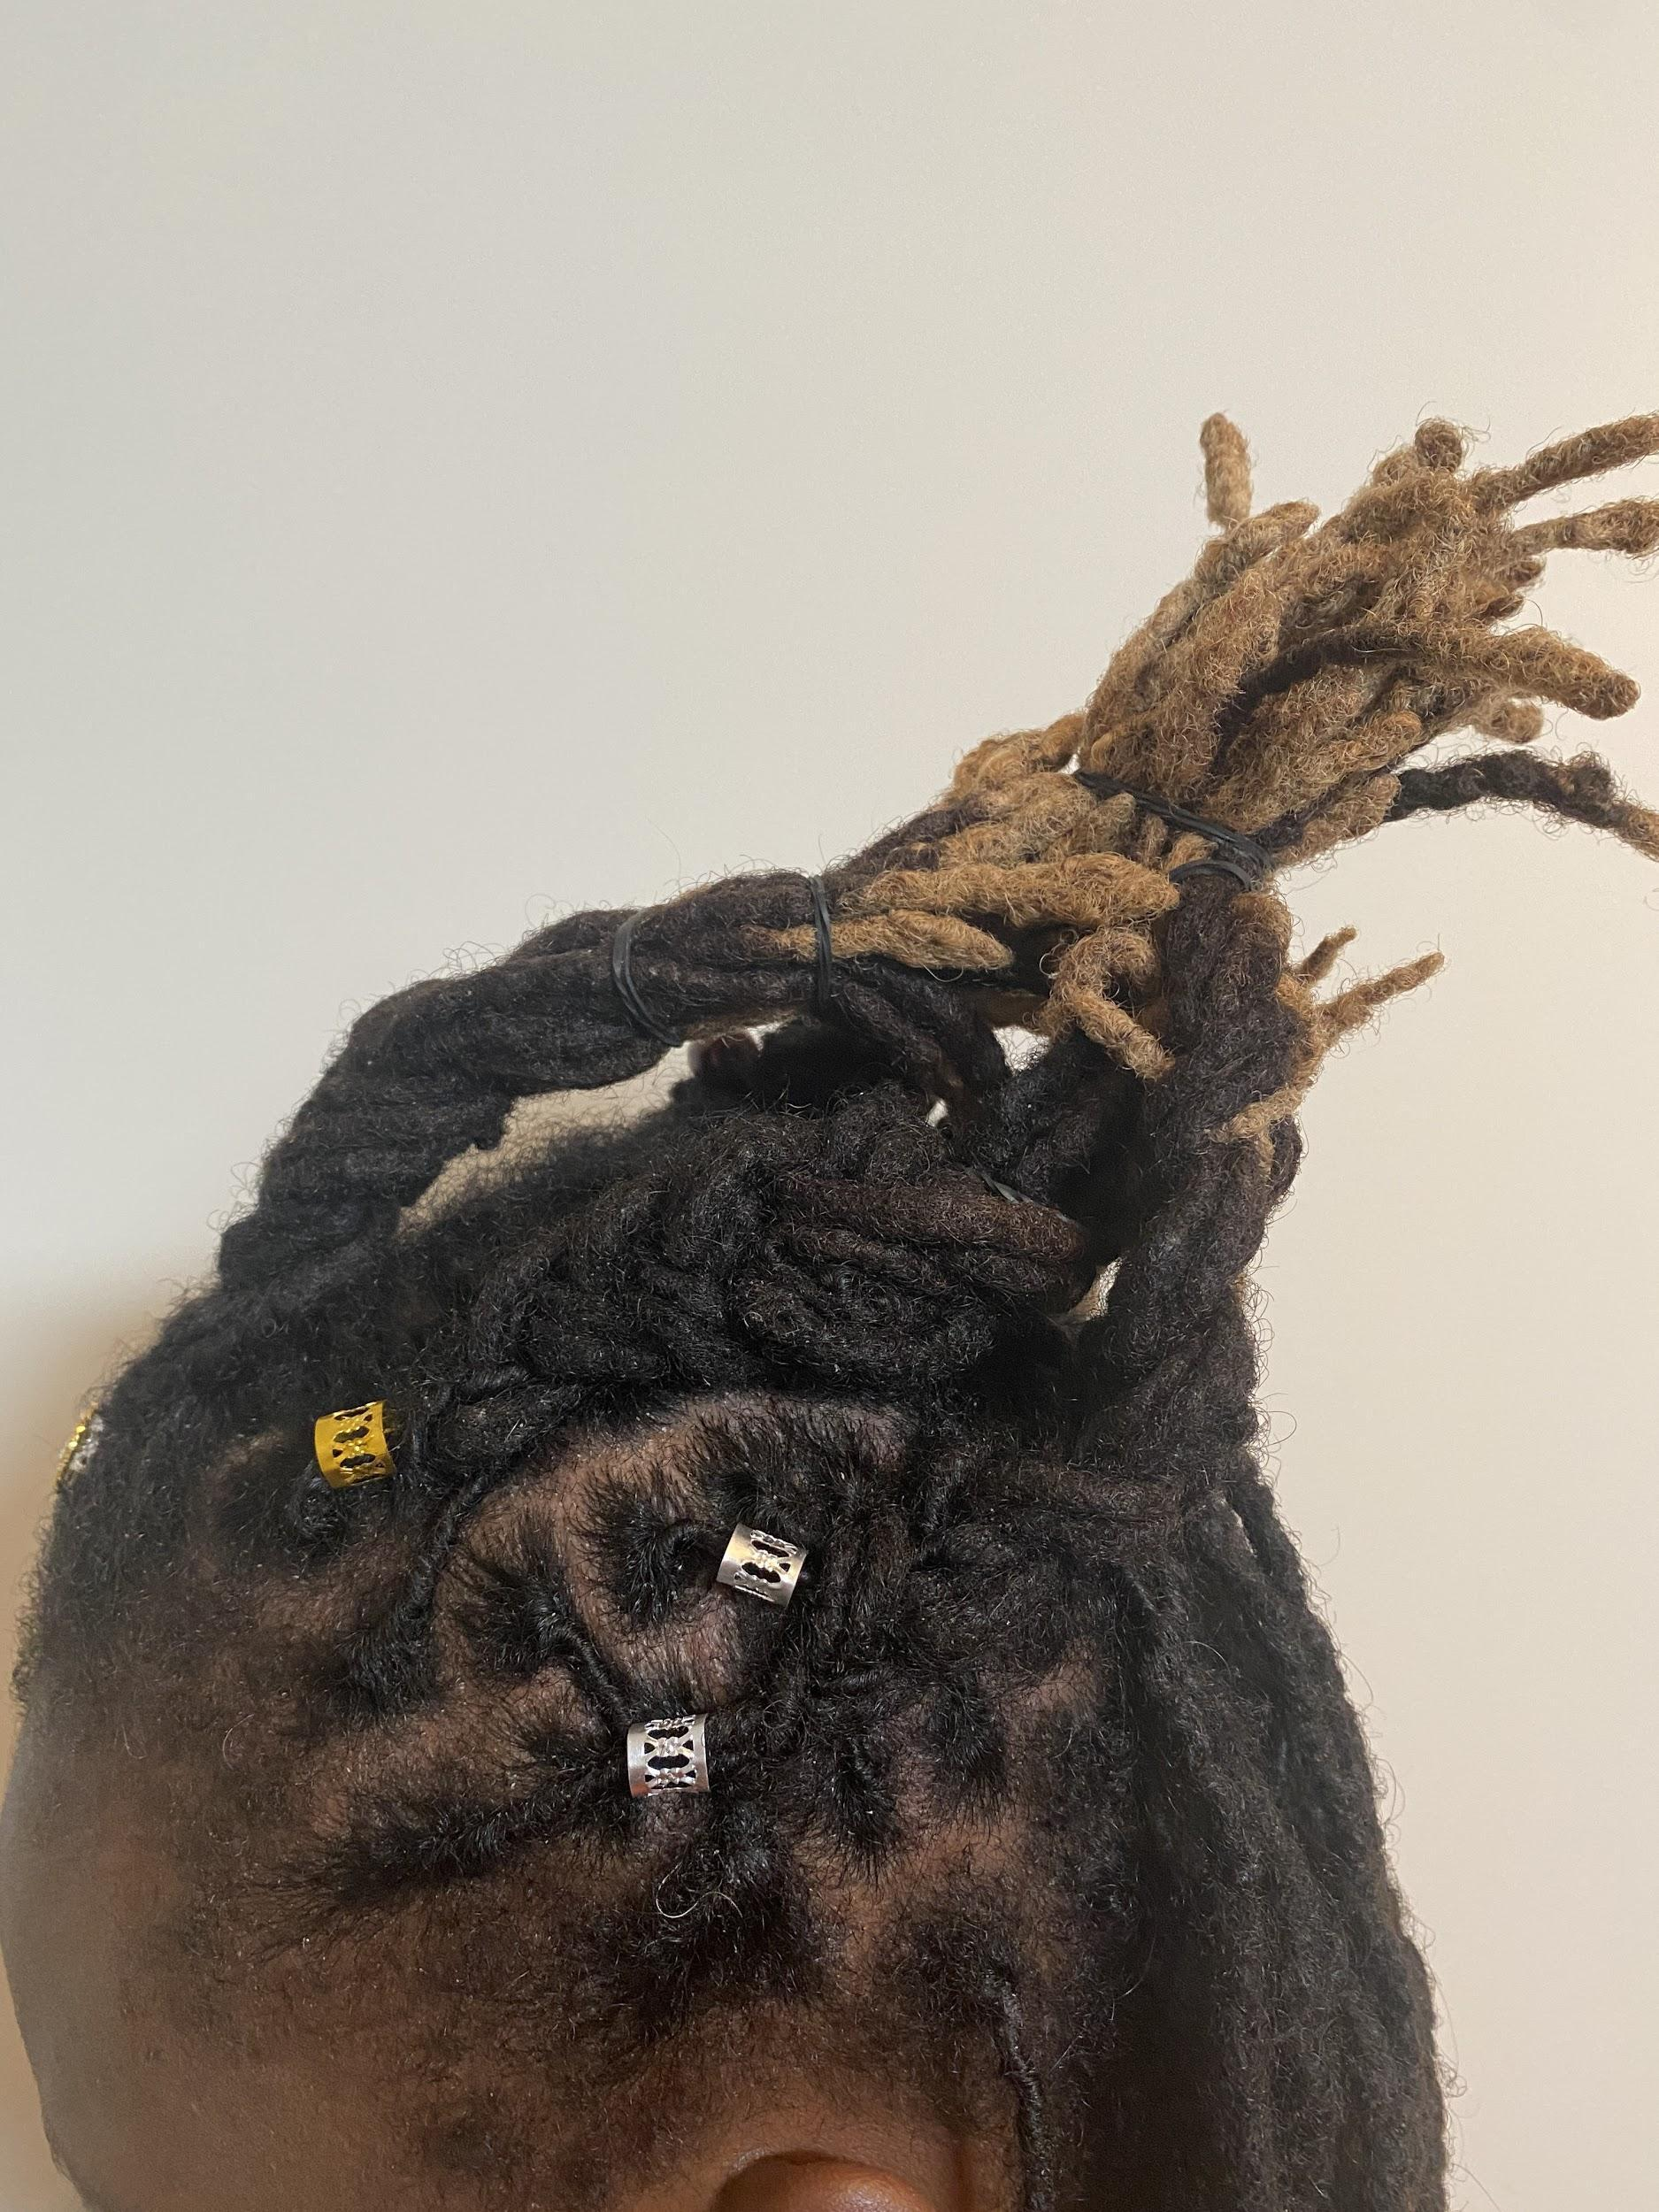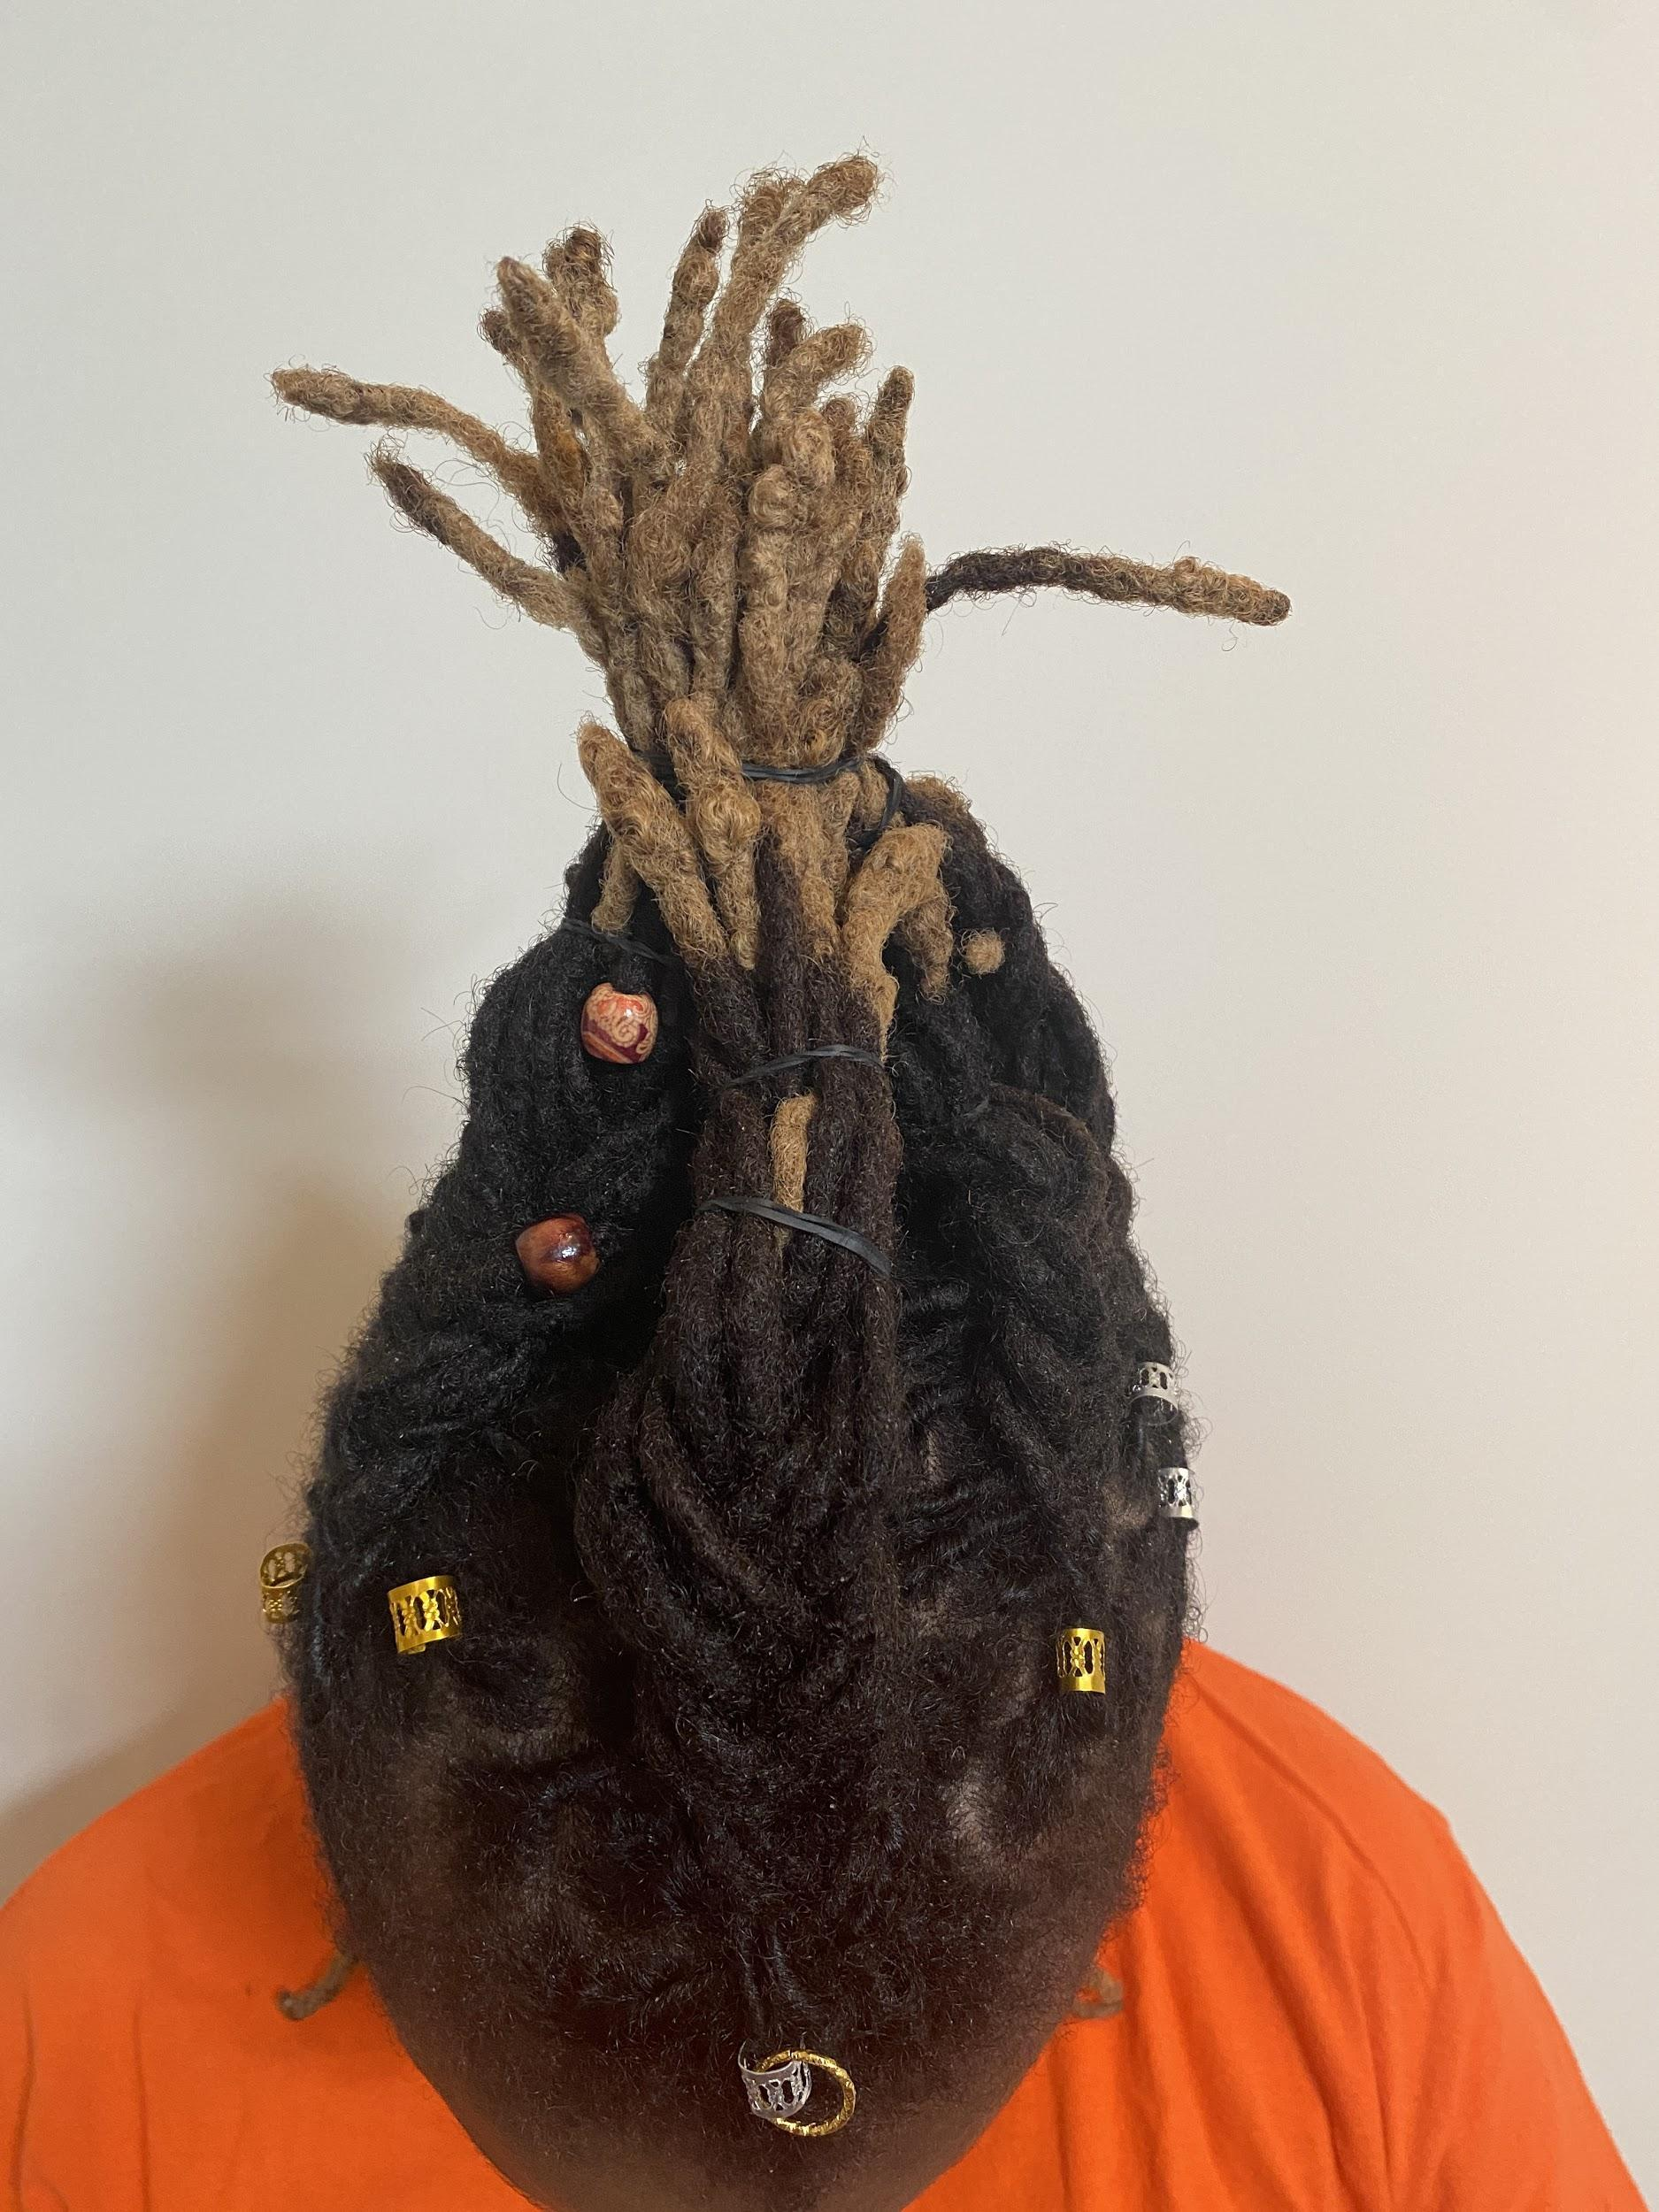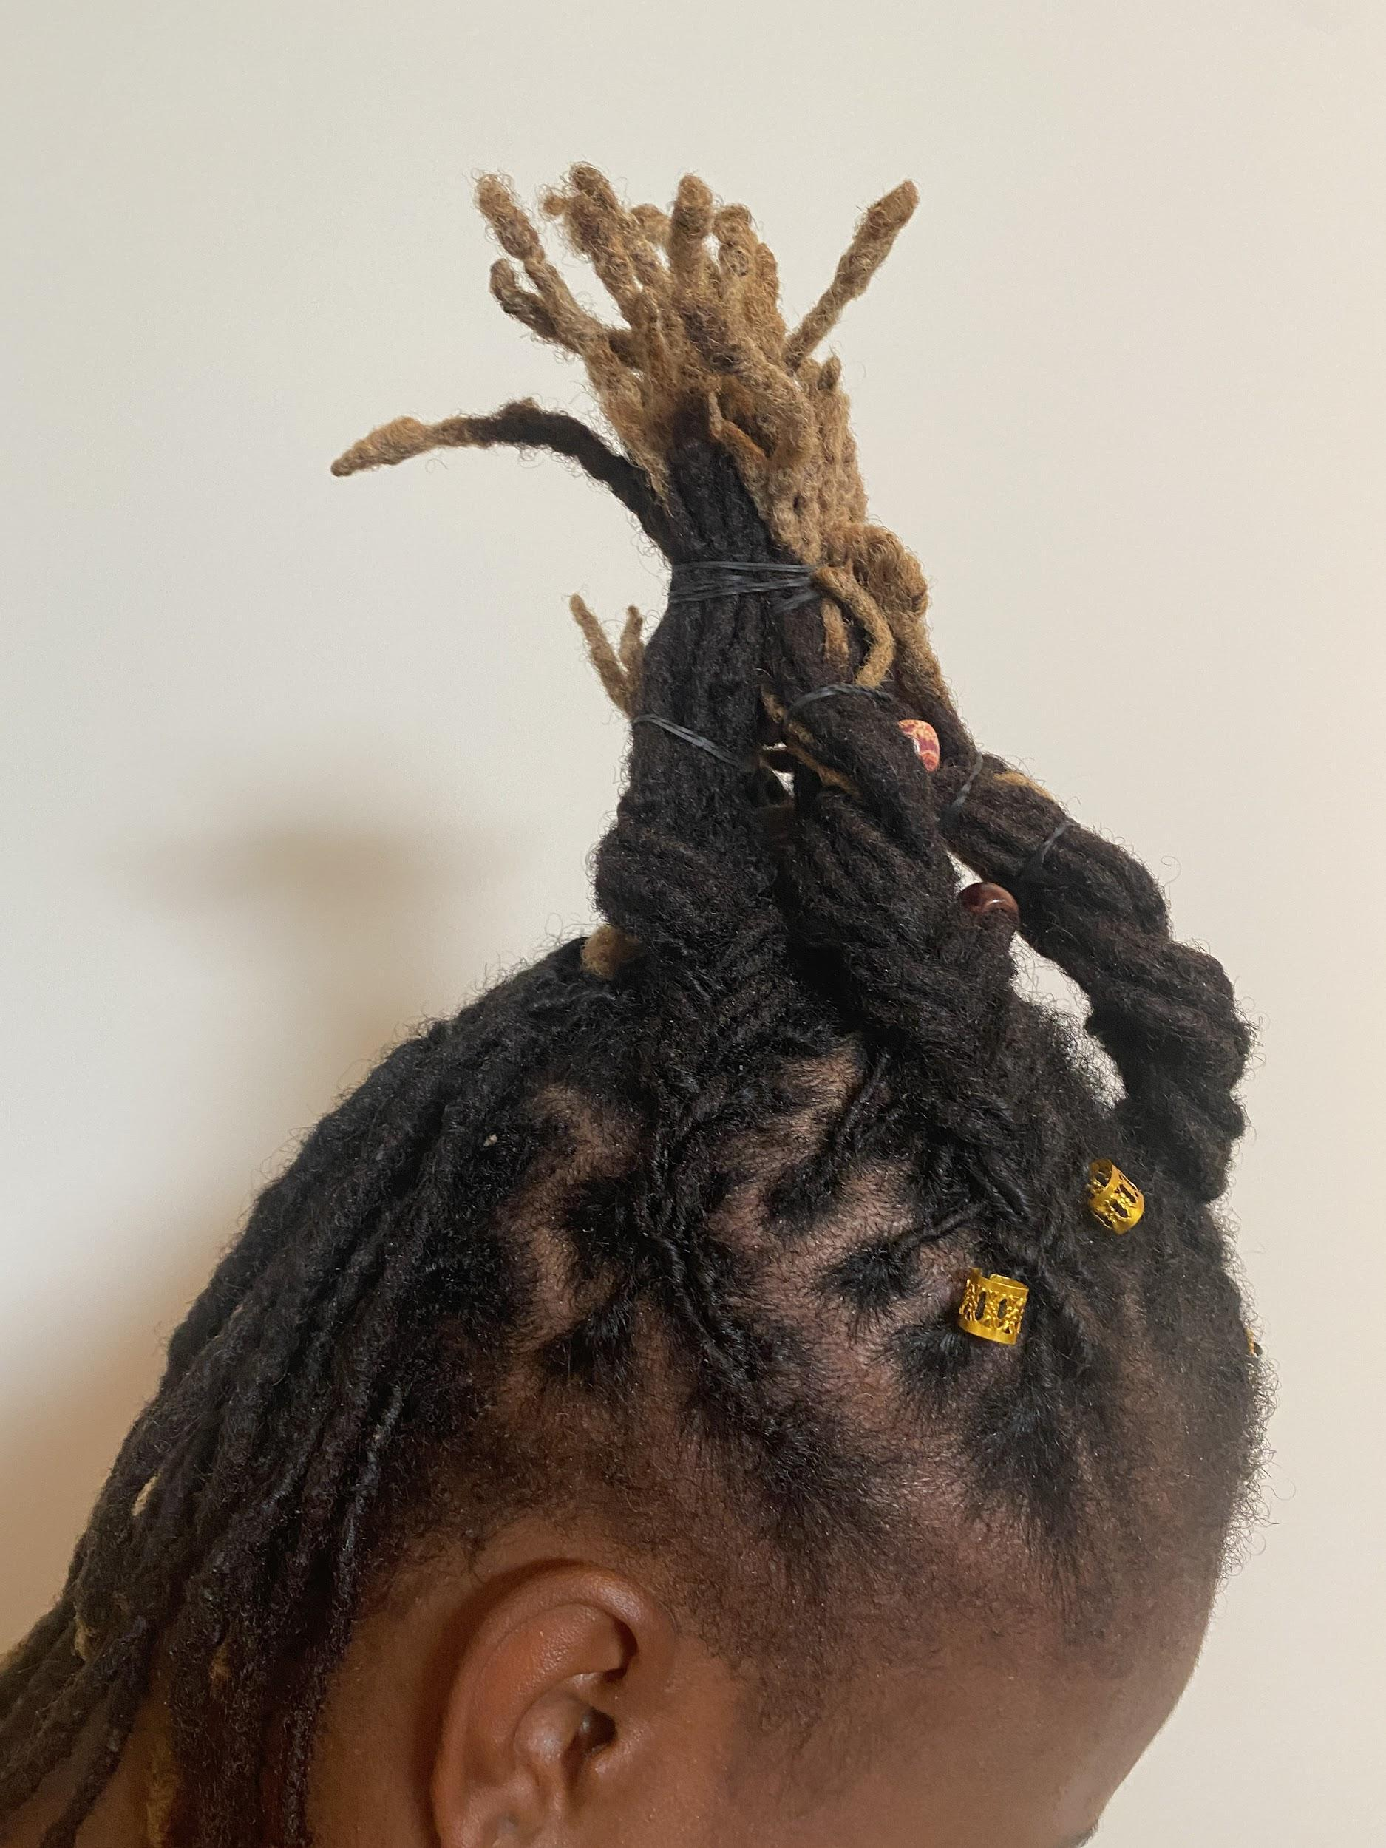
Photos of Cultural Updo

Click on the photo link below to view the video of my chosen Global Updo.
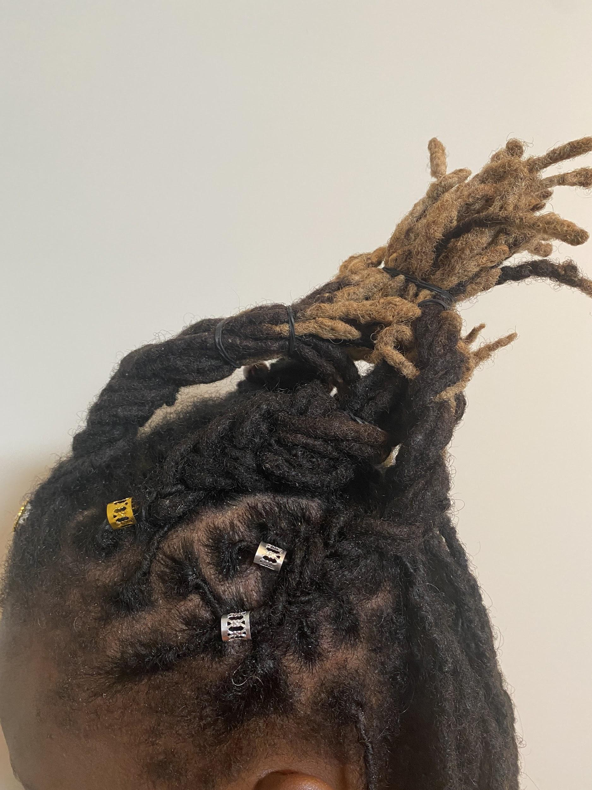
How to create the updo style
For this updo, the hair is sectioned, then braided up and elastics are used to hold the hair in place. The hair is adorn with some silver and gold ornaments. In addition, half of the hair is left down for this updo.

Braided Updo Exemplar 2
Please click on the photo link below to see exemplar 2.

Appendix B - Review and Prior Knowledge Checklist and Slip

Task | Strength | Areas of Improvement
Identify appropriate sanitation products and use them correctly
Select safe and appropriate materials, tools, and products and use them correctly to perform salon services.
Comply with workplace health and safety regulations.
Can describe the structure of the hair.
Can describe the characteristics of the hair.
Can perform a variety of hairstyling procedures using rollers, and/or thermal irons.
Twitter Slip/Instagram
Reflect on what you’ve learned and use the hashtag #Prior knowledge

If you do not have Twitter or Instagram you can write your reflection here, or you can do an oral response on what you have learned or remembered from the units covered.

Appendix C - KWL Chart
K-W-L Chart Student Name: _________________________________

Reflect on what you know before and then after learning about a particular topic. Begin by filling in the columns below with what you Know about the topic, what you Want to know, and finally, what you have Learned.

What do you Know about the topic? | What do you Want to know? | What have you Learned?

Appendix D – Safe Use of Thermal Irons

Safe Use of Thermal Irons
- Keep thermal irons clean
- Do not overheat thermal irons
- Do not use metal combs when working with irons, as they will heat up and could burn the scalp
- Test the temperature of the iron on a tissue paper or white cloth before placing it on the clients hair in order to prevent burning the hair
- Use only hard rubber or non-flammable combs when working with irons and it should be 7” long
- Place comb between iron and scalp, to prevent burning of the scalp.
- Place hot iron in a safe place to cool
- Beware of your surroundings when working with hot irons, (ex. children)
- Client hair must be clean and completely dry to ensure a good thermal curl
- Do not allow the hair ends to protrude over the iron, this causes fishhooks (hair that is bent or folded)
- When ironing lightened, tinted, or relaxed hair, always use a gentle heat setting.
- Care of Thermal (Marcel) Irons
- Before cleaning a thermal iron, be sure to check the manufacturer’s direction for care and cleaning.
- To remove dirt, oils, and product residue is to dampen a towel or rag and wipe down the barrel of the iron with a soapy solution containing a few drops of ammonia.
- Do not clean iron when it is turned on or when it is still cooling from a previous styling service.
- 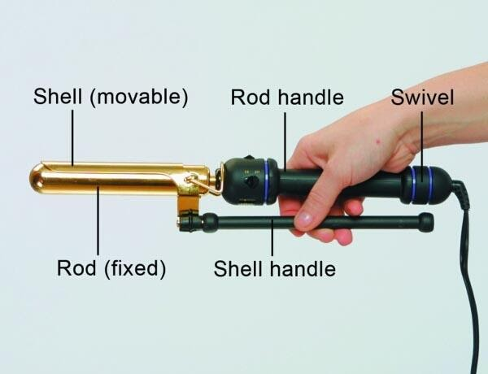
- Barrel/Rod contains the heating element
- Groove/Shell is sometimes called the tongue or clamp used to hold the hair in place while curling
- Shell/Handle used to control the tension of the groove or shell
- Rod/Handle contains the temperature controls

Appendix E - Checklist
Checklist
Success Criteria | Complete | Incomplete
Student has conducted research on culture and/or heritage updo
Student has completed write-up on selected updo
Student was sensitive to others culture and/or heritage
Student presented the name of the ancestry/ cultural heritage
Student presented their findings and updo as a video presentation, or oral presentation, or visual arts, or live presentation, or photo documentation.
Student completed Jamboard activity.
Student provided references of sites/sources for their updo
Notes:

Appendix F - Global Updo Rubric
Criteria | Level 4  (80-100%) | Level 3  (70-79%) | Level 2  (60-69%) | Level 1  (50-59%)
Knowledge/Understanding /20
Demonstrates the ability to use tools and products accurately | Demonstrates thorough ability to use tools and products accurately | Demonstrates considerable ability to use tools and products accurately | Demonstrates some ability to use tools and products accurately | Demonstrates limited ability to use tools and products accurately
Communication /20
Communicates information clearly  Describes steps accurately  Communicates information accurately | Communicates information with a high degree of clarity  Describes steps with a high degree of accuracy  Communicates information with a high level of accuracy | Communicates information with a considerable clarity  Describes steps with a considerable accuracy  Communicates information with a considerable accuracy | Communicates information with some clarity  Describes steps with some accuracy  Communicates with some accuracy | Communicates information with limited clarity  Describes steps with limited accuracy  Communicates with limited accuracy
Thinking/Inquiry /20
Demonstrates proper use of tools, techniques and safety procedures | Demonstrates proper use of tools, techniques and safety procedures | Demonstrates considerable use of tools, techniques and safety procedures | Demonstrates some use of tools, techniques and safety procedures | Demonstrates limited use of tools, techniques and safety procedures
Application /40
Demonstrates proper techniques of updo style  Demonstrates proper use of tools and products | Demonstrates a thorough technique of updo style.  Demonstrates thorough use of tools and products | Demonstrates a considerable technique of updo style.  Demonstrates considerable use of tools and products | Demonstrates some technique of updo style.  Demonstrates some use of tools and products | Demonstrates limited technique of updo style.  Demonstrates limited use of tools and products

References
21st Century Competencies: Foundation Document for Discussion. Phase 1: Towards Defining 21st Century Competencies for Ontario, Winter 2016 Edition, 2016 http://www.edugains.ca/resources21CL/About21stCentury/21CL_21stCenturyCompetencies.pdf
A Visual History of Iconic Black Hairstyles (History.com), 2019 https://www.history.com/news/black-hairstyles-visual-history-in-photos
Beautiful Young Woman With Braids (Photo), 2021 https://www.pexels.com/photo/beautiful-young-woman-with-braids-4157657/
College of Trades Training Standards https://www.collegeoftrades.ca/training-standards
Cosmetology: Roller-set PowerPoint presentation (PowerPoint), 2021 https://www.octe.ca/application/files/4316/3016/2860/TXJ2O_Roller-set_Activity_1.pptx
Curling Iron ToolSAFE Video, OCTE, 2021 https://youtu.be/DgswGaJ88Uk
Course Codes for Emphasis courses in the Revised Curriculum: Technological Education, Grades 11 and 12, 2009 http://www.edu.gov.on.ca/eng/curriculum/secondary/techedemphasiscourses.pdf
Flat Iron ToolSAFE Video, OCTE, 2021 https://youtu.be/UkzHMP0Z-R0
Global Updo (mp3 soundtrack), 2021 https://www.octe.ca/application/files/8416/3016/3121/Global_Updo.mp3
Global Updo Exemplar (YouTube video), 2021 https://www.octe.ca/application/files/7416/3321/8666/Global_Updo_Exemplar_with_copyright_free_sound.mp4
Global Updo Presentation, 2021 https://docs.google.com/presentation/d/e/2PACX-1vR-UWhs3T9NU7_XotiCUfXW9WNUrchTt8KLEf4pAAGqPUY98IHiXLDBY1uFKHZ1rqGgIqMfpbjaK9kb/pub?start=true&loop=false&delayms=30000&slide=id.p
Growing Success: Assessment, Evaluation, and Reporting in Ontario Schools, First Edition, Covering Grades 1 to 12, 2010 www.edu.gov.on.ca/eng/policyfunding/growSuccess.pdf
Hairdressing Photo (Pixabay), 2021 https://pixabay.com/photos/hair-hairdresser-barber-beauty-shop-5473204/
Learning for All – A Guide to Effective Assessment and Instruction for All Students, Kindergarten to Grade 12, 2013 http://www.edu.gov.on.ca/eng/general/elemsec/speced/LearningforAll2013.pdf
Ministry News https://news.ontario.ca/en/release/1000078/ontario-to-modernize-and-streamline-apprenticeship-training
Red SEAL – Sceau Rouge, 2018 http://www.red-seal.ca/trades/tr.1d.2s_l.3st-eng.html
Resources, Ontario College of Trades, 2020 https://www.collegeoftrades.ca/resources
Respect Our Roots: Brief History Our Braids Cultural Appropriation (Essence), 2018 https://www.essence.com/hair/respect-our-roots-brief-history-our-braids-cultural-appropriation/
Skilled Trades Identified in Ontario https://www.collegeoftrades.ca/wp-content/uploads/Sector_Brochure_One_Pager_web.pdf
Skilled Trades Ontario https://www.ontario.ca/page/skilled-trades
Stylish Black Model With Hand On Hip Indoors (Photo), 2021 https://www.pexels.com/photo/stylish-black-model-with-hand-on-hip-indoors-7275382/
The Apprenticeship Advantage, Ontario College of Trades, 2020 https://www.collegeoftrades.ca/wp-content/uploads/ApprenticeshipAdvantage_English_web.pdf
The Differentiated Instruction Scrapbook http://www.edugains.ca/resourcesDI/EducatorsPackages/DIEducatorsPackage2010/2010DIScrapbook.pdf
The Ontario Curriculum, Grades 9 and 10: Technological Education, 2009 (revised) http://www.edu.gov.on.ca/eng/curriculum/secondary/teched910curr09.pdf
The Ontario Curriculum, Grades 11 and 12: Technological Education, 2009 (revised) http://www.edu.gov.on.ca/eng/curriculum/secondary/2009teched1112curr.pdf
Thermal Hairstyling PowerPoint Presentation on Flat Irons (PowerPoint), 2021 https://www.octe.ca/application/files/2216/3016/2986/TXJ2O_Thermal_Hairstyling-Flat_Iron_Lesson_1.pptx

Set up on OCTE Website

Global Updo Exemplar 1 (video), 2021 https://www.youtube.com/watch?v=HjprPg1v_Mk
Global Updo Exemplar 2 (presentation), 2021 https://docs.google.com/presentation/d/e/2PACX-1vR-UWhs3T9NU7_XotiCUfXW9WNUrchTt8KLEf4pAAGqPUY98IHiXLDBY1uFKHZ1rqGgIqMfpbjaK9kb/pub?start=true&loop=false&delayms=30000&slide=id.ge5d49eba41_0_6

