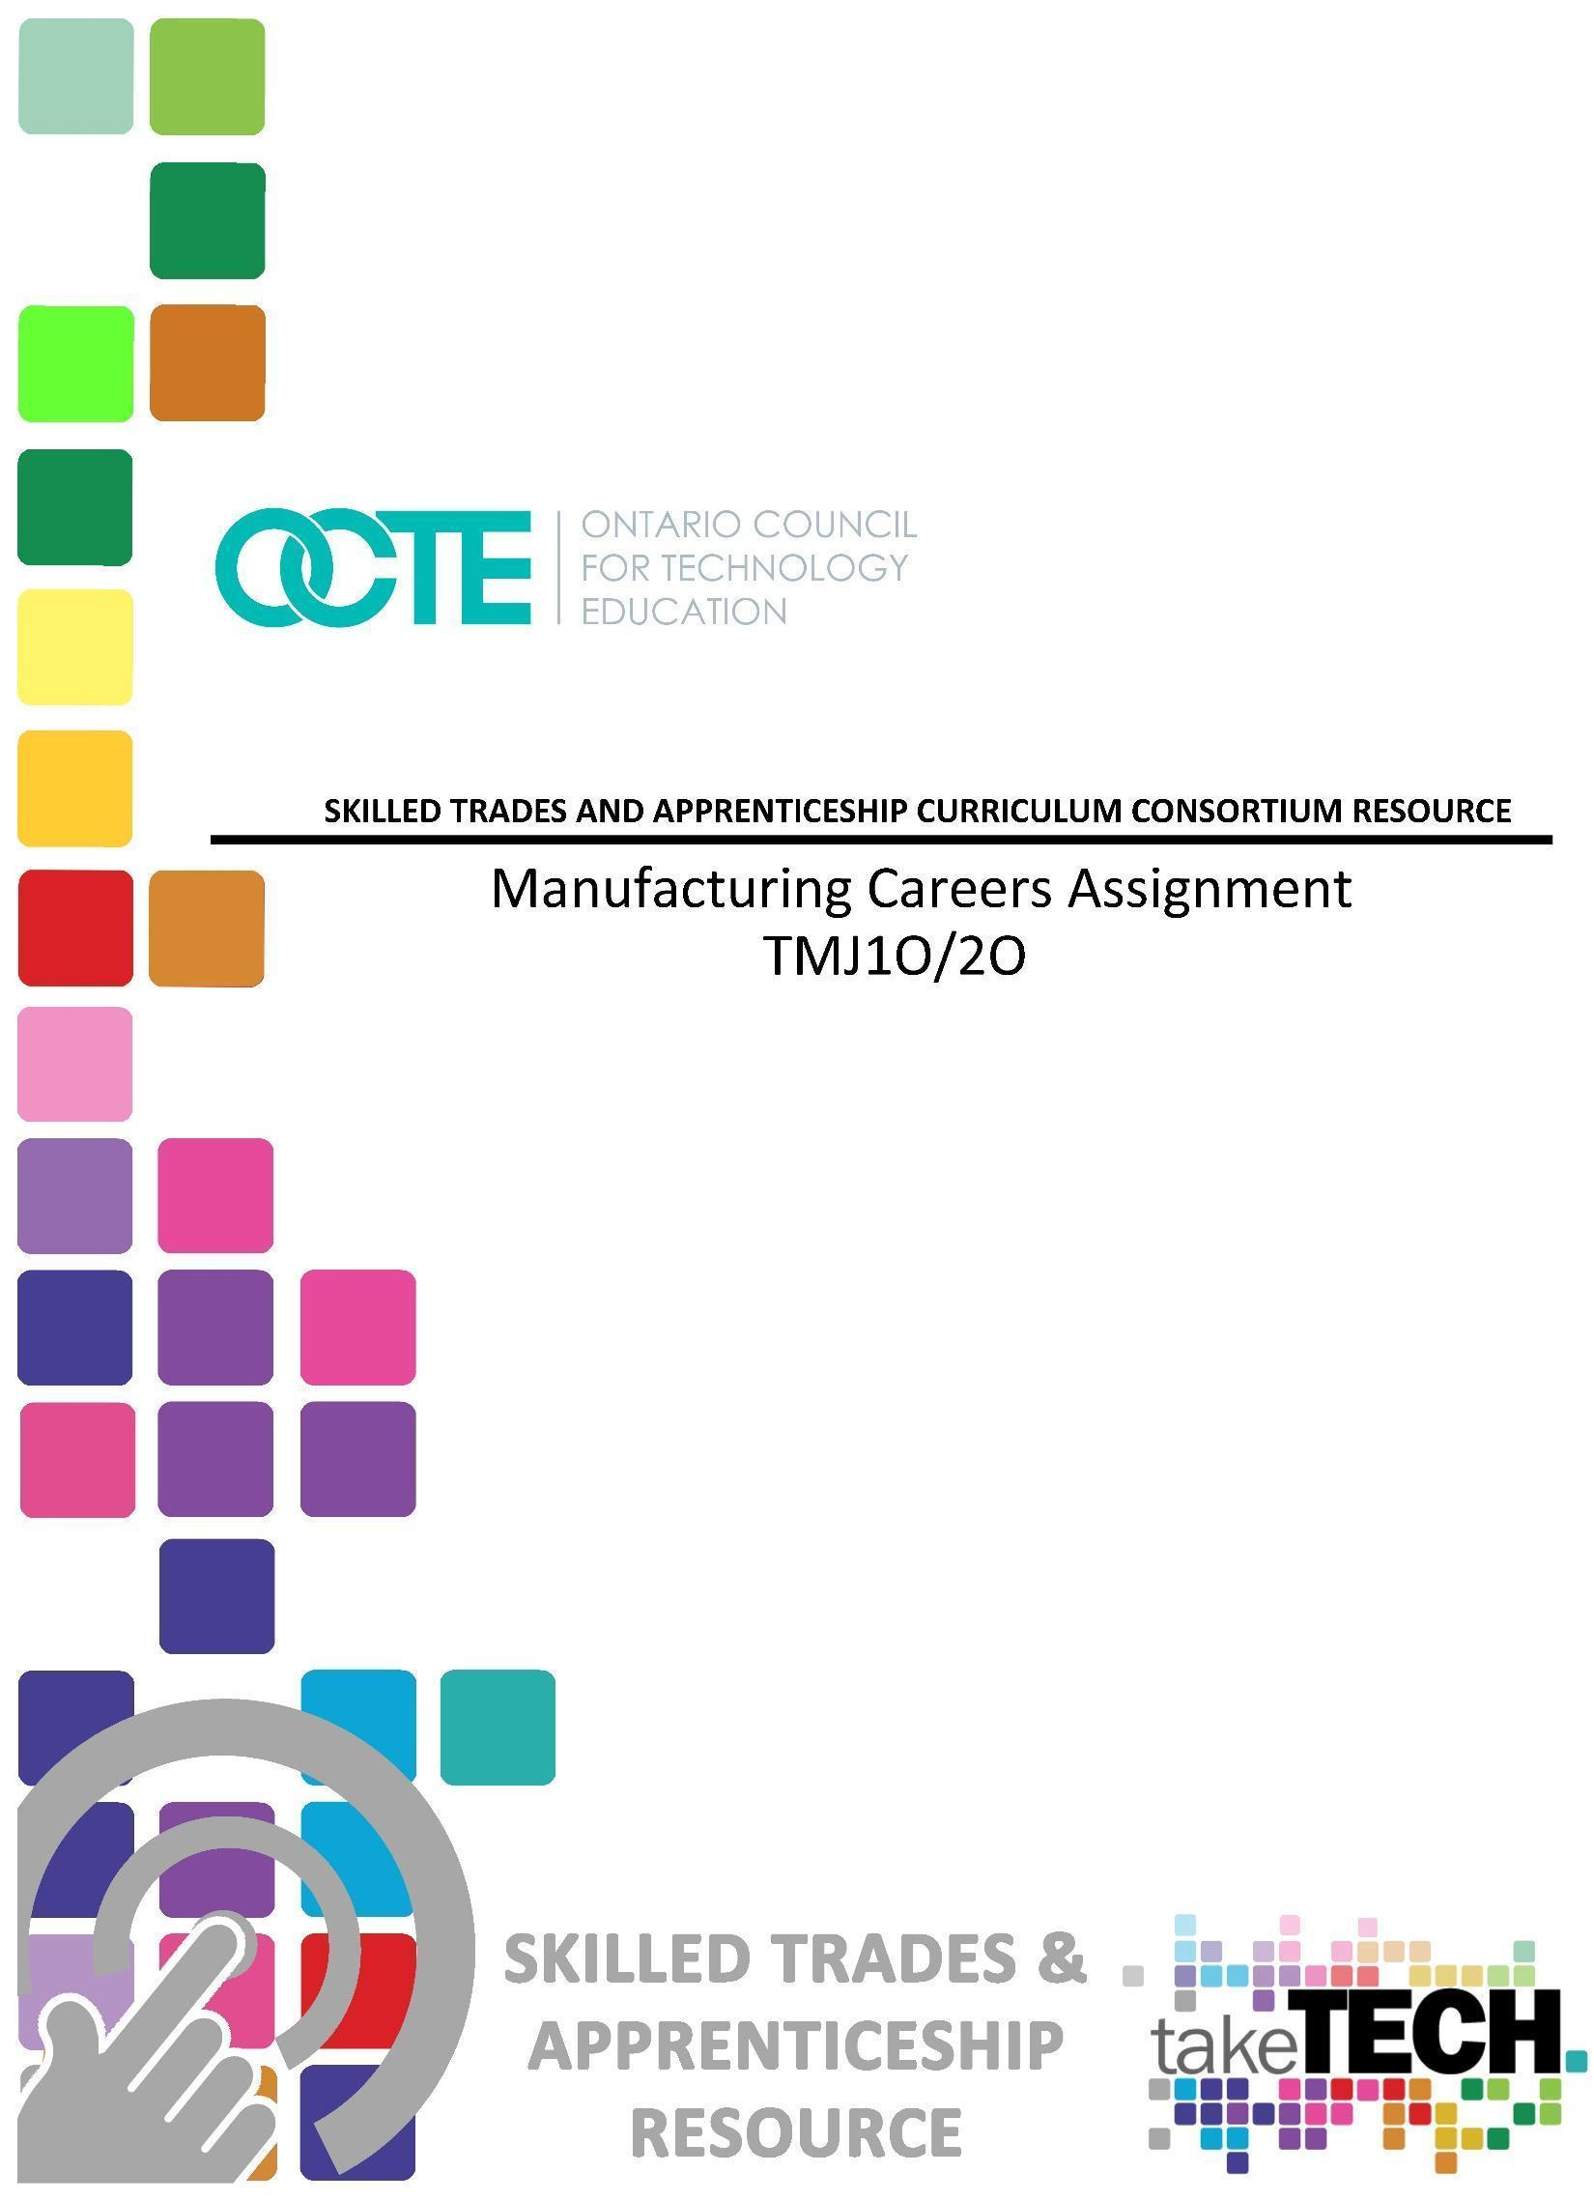

Table of Contents

Introduction 2
Project Outline 2
Prior Knowledge 2
Student Activities 2
Planning Notes 3
Skilled Trades and Apprenticeship Opportunities 3
Career and Industry Extensions 4
Continuum of Influence 5
Continuum of Skills 6
Resources 12
Files 12
Lesson Plans 12
Handouts 12
Tools/Equipment 12
Software 12
Textbooks/ Books 12
Journals/Magazines 12
Videos 13
Exemplars 13
Websites for Teachers 13
Instructional Strategies 13
The Hook / Motivational Strategies 13
Learning Goals and Success Criteria 14
Overall and Specific Expectations in Support of Ontario Curriculum Grades 9 - 12 Technological Education 14
Overall Expectations 14
Specific Expectations 14
Project Challenges 15
Differentiation of the Project / Activity 15

Assessment and Evaluation 15
Assessment As Learning 16
Assessment For Learning 16
Assessment Of Learning 16
Ethical Considerations 16
Reflection or Design Report 16
Appendix A - Continuum of Influence 17
Appendix B - Manufacturing Career Awareness Challenge Lesson Plan 18
Appendix C - Manufacturing Technology Career Awareness Assignment 21
Appendix D - Micro Lesson Plan 22
Appendix E - Essential Skills Resources 23
Appendix F - Manufacturing Example PowerPoint 24
Appendix G - Career Research Rubric 25
Appendix H - Careers in Technology Presentation Reflection Sheet 26
References 30

Introduction
Course Code: TIJ1O
Broad base Technology: Manufacturing
Destination: Open
Grade Level: Grade 9
Prerequisite (if applicable) None
Resource/Project Name: Careers Assignment

Project Outline
By the end of this project, students will have explored different careers within the manufacturing industry. Careers such as Tool & Die, Mold Maker, Machine Tool Builder Integrator, General Machinist, Welder, CNC Operator, etc. At the end, students will demonstrate an understanding of postsecondary pathways that lead to career opportunities in the manufacturing industry.

Prior Knowledge
Students should be comfortable using computers and software such as PowerPoint or Google Slides. Students should also have experience accessing online resources, creating and downloading files, and submitting electronic files to the teacher for evaluation.

Student Activities
In this assignment, students will explore careers related to manufacturing and the duties of the career they chose. Students will then create a presentation (PowerPoint, Google Slides, Poster board etc.) and present their findings to the class. The purpose of this assignment is for students to gain knowledge about the career opportunities in the manufacturing sector as well as to become more comfortable speaking in front of their peers.

Planning Notes
The following are suggestions when planning to perform this project:
- It may be beneficial for the teacher to discuss the career path that they chose and explain how it led them to a career in teaching.
- Students should have an understanding of the apprenticeship process and understand that an apprenticeship is also a college education.
- It would be beneficial for students if the teacher has guest speakers come into the classroom to discuss the trade they choose and the pathway to that career.
- Field trips to different manufacturing facilities will help students understand the wide variety of careers available in the manufacturing industry.
- Show students examples, both good and bad, of previous assignments that have been submitted so students have an understanding of the expectation (remove all student’s names from previous assignments).

Skilled Trades and Apprenticeship Opportunities
Students will demonstrate an understanding of various factors that determine a career in the manufacturing industry by the end of this project. The student-centered career exploration activity will focus on essential skills required to be successful in the industrial sector (manufacturing), problem solving skills, and details that lead to apprenticeships in many skilled trades such as:
- Tool and Die Maker (430A)  - Machine Tool Builder and Integrator (430M)  - General Machinist (Machinist) (429A)  - Millwright (433A)  - Bearings Mechanic (615A)  - Computer Numerical Control (CNC) Programmer (670C)  - Die Designer (670D)  - Draftsperson - Mechanical (614A)  - Draftsperson - Plastic Mould Design (614B)  - Draftsperson - Tool and Die Design (614C) | - Industrial Mechanic Millwright (433A)  - Machine Tool Builder and Integrator (430M)  - Metal Fabricator (Fitter) (437A)  - Mould Designer (670E)  - Mould Maker (431A)  - Mould or Die Finisher (277M)  - Pattern Maker (433A)  - Pressure Systems Welder (456P)  - Tool and Cutter Grinder (602C)  - Tool and Gauge Inspector (239B)  - Tool/Tooling Maker (630T)  - Welder (456A)

It is recommended that the instructor utilize the Canadian Apprenticeship Forum for up to date resources on that include,
- Apprentice Attitudes Towards Learning and Examinations
- The Quality of Workplace Training
- Communication and Inclusion in Apprenticeship
- Apprentice Well Being
- Career Entry, Training and Completion in the Skilled Trades
- ﻿The Impact of COVID-19 on Apprenticeship

Career and Industry Extensions
Not every classroom has four walls and this assignment has been designed to allow students the opportunity to explore unconventional careers choices in manufacturing and the industrial sector. This project can make extensions to many different careers in the industry or support the industry enabling the fabrication of products through the manufacturing process called industry 2.0. Reach ahead opportunities in SHSM programs or career and industry extensions for Careers classes can also be discussed and researched. Students can explore career connections and opportunities available in the Machine, Tool, Die, Mould & Automation (MTDMA) sectors. Some examples of this are:
- Tool and Die Maker  - Machine Tool Builder and Integrator  - General Machinist  - CNC machine operator  - Mechanical engineering  - Manufacturing Engineering Technologist  - Metal Fabricator  - Mechanical Engineer  - Custom car / motorcycle / boat builder  - Heavy Equipment / Truck and Coach Service Technician | - Bearings Mechanic  - Computer Numerical Control (CNC) Programmer  - Draftsperson - Mechanical  - Draftsperson  - Industrial Mechanic Millwright  - Metal Fabricator (Fitter)  - Mould Designer  - Mould Maker  - Pressure Systems Welder  - Tool and Cutter Grinder  - Tool and Gauge Inspector  - Welder

Continuum of Influence
We all have different moments in our lives where we are affected by an experience. This can include learning a new concept or skill, experiencing something for the first time, taking a new course, developing a talent through practice and hard work, or even calling upon a skilled tradesperson to fix, repair, design, construct, maintain, build, bake, and create innovative solutions. The continuum of influence is a graphic representation of how those experiences can lead to developing a passion and talents in areas like Machine, Tool, Die, Mould & Automation (MTDMA) sectors.
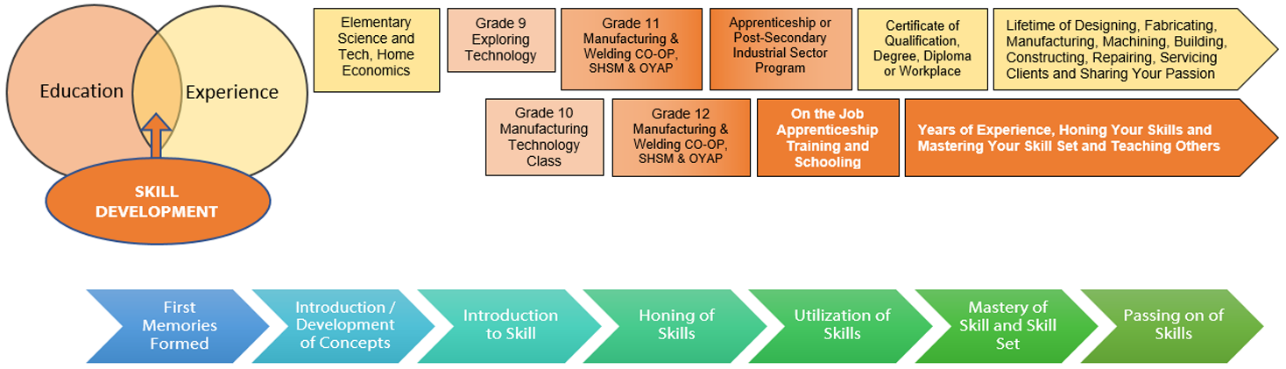

You can find the full page continuum of influence map in Appendix A.

Continuum of Skills
As students pursue their careers in the manufacturing technology industry, they will have opportunities to build their knowledge of careers offered in the Manufacturing Technology sector. The Apprenticeship Training Standards for many of these Industrial trades have a common core curriculum for level 1. These training standards are grouped as follows:
- Precision Machining and Tooling common core includes General Machinist 429A, Tool and Die Maker 430A, Mould Maker 431A, Pattern Maker 443A, Machine Tool Builder and Integrator 430M, Tool / Tooling Maker 630T
- Millwright common core includes Industrial Mechanic 433A, Construction Millwright 426A
- Welder and Metal Fabricator common core includes Welder 456A, Metal Fabricator 437A.
The curriculum expectations met during this project are related to the Level 1 Common Core Apprenticeship Training Standard for all of the previously mentioned trades as follows:

TIJ10
D2.4 Demonstrate an understanding of the Essential Skills that are important for success in the technology industries, as identified in the Ontario Skills Passport (e.g., reading text, writing, document use, computer use, oral communication, numeracy, thinking skills);
Relation to Apprenticeship Training Standards:
- Precision Machining and Tooling Common Core Apprenticeship Training Standards sections 2.1, 2.2, 2.3, 2.4, 2.5
- Millwright Common Core Apprenticeship Training Standards sections 2.1, 2.2, 2.3, 2.4, 2.5
- Welder and Metal Fabricator Common Core Apprenticeship Training Standards sections 3.1, 3.2, 3.3, 3.4, 3.5

TMJ20
D2.4 Demonstrate an understanding of the Essential Skills that are important for success in the manufacturing industry, as identified in the Ontario Skills Passport (e.g., measurement and calculation, finding information, problem solving);
Relation to Apprenticeship Training Standards:
- Precision Machining and Tooling Common Core Apprenticeship Training Standards sections 2.1, 2.2, 2.3, 2.4, 2.5
- Millwright Common Core Apprenticeship Training Standards sections 2.1, 2.2, 2.3, 2.4, 2.5
- Welder and Metal Fabricator Common Core Apprenticeship Training Standards sections 3.1, 3.2, 3.3, 3.4, 3.5

D2.5 Demonstrate an understanding of the work habits that are important for success in the manufacturing industry, as identified in the Ontario Skills Passport (e.g., working safely, teamwork, reliability);
Relation to Apprenticeship Training Standards:
- Precision Machining and Tooling Common Core Apprenticeship Training Standards sections 1.1, 1.2, 1.3
- Millwright Common Core Apprenticeship Training Standards sections 1.1.2
- Welder and Metal Fabricator Common Core Apprenticeship Training Standards sections 1.2, 1.4, 1.5, 1.6, 1.7

Career Awareness Grade 9
Learning ABOUT awareness of the variety of manufacturing careers available and begin to identify areas of interest. Students are aware of the role of postsecondary education.
Sample Student Learning Outcome:
Students understand the types of postsecondary education and training required in the career field of interest.
Experiences might include:
• Camp/Orientation
• Team Building
• “Getting to Know Yourself”
• Develop 4-year plan
• Organizational skills
• Peer Mentor/Teacher Advisor
• Project based learning
• Engineering Design Process
• Exposing students to STEM careers
• Guest speakers
• Industry tours
• Manufacturing Day
• Document and evaluation progress through electronic portfolio

Career Exploration 10th Grade
Learning ABOUT work experiences provide students with a deeper understanding of the workplace. Students explore career options to provide motivation and inform decision-making in high school and postsecondary education. Students have the opportunity to explore and refine areas of interest and prepare for higher intensity work-based learning experiences through interactions with business partners. This includes learning about the basic skills necessary for work based learning experiences such as apprenticeships.
Sample Student Learning Outcome:
Students are able to give examples of how skills and interests relate to the career fields/occupations. Experiences may include:
• Career Assessments/Interest Inventory
• Review 4-year plan
• Teambuilding
• Communication skills
• Presentation skills
• Project based learning
• Engineering Design Process
• Job shadowing
• Guest speakers
• Industry tours & STEM events
• Document and evaluate progress through electronic portfolios (Google Site)

Career Preparation 11th Grade
Learning THROUGH work experiences are designed to help students develop the basic foundation skills needed for college and career readiness. Students apply learning through practical experience and interactions with professionals from industry and the community (higher-order thinking, technical skills, academic skills and applied workplace skills). This includes learning about the basic skills necessary for work-based learning experiences such as apprenticeships.
Sample Student Learning Outcome:
Students are able to work with diverse teams and collaborate effectively with colleagues.
Experiences might include:
• Update 4-year plan and career assessments
• Experiential Learning Opportunities
• Career & College Fairs
• Critical Thinking
• Leadership skills
• Professionalism
• Informational Interviews
• Mentorships
• Networking Skills
• Social media & personal branding, create LinkedIn profiles
• Work ethics
• Resume development
• Mock Interviews
• Engineering Design Process
• Integrated projects with business partners
• Prep for apprenticeship
• Document and evaluate progress through electronic portfolios
Career Training 12th Grade
Learning FOR work training for postsecondary education and/or employment in a specific range of manufacturing occupations.
Sample Student Learning Outcome:
Students are able to demonstrate knowledge of occupations in a career and skills specific to employment in a range field.
Experiences might include:
• Resume update
• College essay
• Engineering Design Process
• Apprenticeship
• Senior Showcase Capstone project
• Experiential learning opportunities (ie: Cooperative learning)
• Culminating team experience
• Business mentors for capstone project
• Peer to Peer Mentor Program
• Planning for your future
• “Make Your Mark on the World” (ie: Leaving a legacy)
• Update electronic portfolio

Resources
Completion of this module will require the student to have the following resources:
- A computer, smart phone, or tablet
- Internet access

Files
Grade 9 Manufacturing Technology Career Awareness Assignment (see Appendix C)

Lesson Plans
Manufacturing Career Awareness Challenge Lesson Plan (see Appendix B) Micro Lesson Plan (see Appendix D)

Handouts
Career Research PowerPoint Rubric (see Appendix G)

Tools/Equipment
Computer / Tablet / Smartphone / Internet Access

Software
Google (Slides)
Microsoft (PowerPoint)
Prezi
Any other type of presentation platform available to students
Students will need training on acceptable computer use policies set by your school board

Textbooks/ Books
Technology Of Machine Tools 7th Edition, by Steve Krar, Arthur Gill, Peter Smid
(if available through your school board)
Careers in Manufacturing (Makerspace Careers) Paperback (2019) by Jessica Shaw
(if available through your school board)

Journals/Magazines
Canadian Tooling and Machining Association Membership
Canadian Manufacturing
Modern Machine Shop
American Machinist
Automation World
Machine Design

Videos
Edge Factor  https://edgefactor.com/zone/manufacturing  (multiple videos on site) | 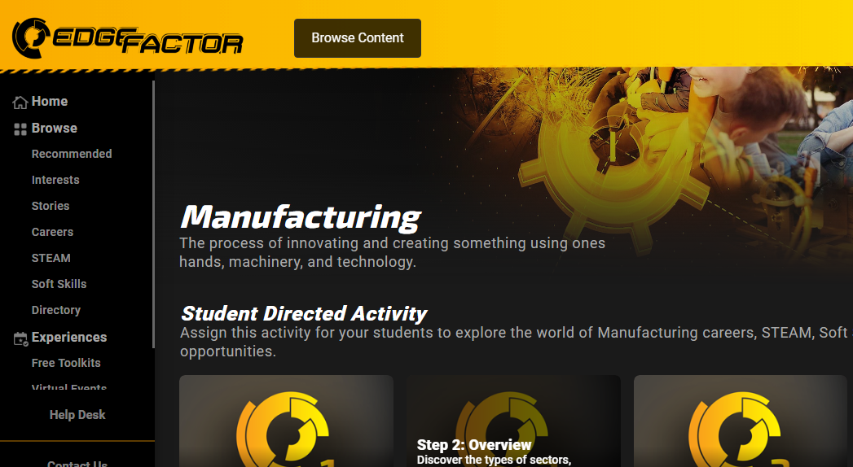

Exemplars
Manufacturing Example PowerPoint

Websites for Teachers
Canadian Tooling and Machining Association
Exploring Careers in Manufacturing
Edge Factor
Canadian Apprenticeship Forum website
Canadian Apprenticeship Forum - Apprenticeship 101 website

Instructional Strategies
Teachers may use any of the following instructional strategies; 3-Part lesson, lecture, storyboard, word wall, think-pair-share, placemat activity, rapid write, K-W-L, anticipation chart, ABC taxonomy, think aloud, analyzing text, Cornell note taking, exit ticket/ticket out the door, plus/minus/delta, etc.

The Hook / Motivational Strategies
The purpose of this activity is to help students understand their interests and how they relate to career choices. It also encourages them to look beyond preconceived ideas about careers in manufacturing and investigate alternatives they may not have considered before.

Learning Goals and Success Criteria
Learning goals and success criteria are the foundation on which students base their ability to monitor their learning and determine next steps. Applicable learning goals may include any of the following,
- Students will learn about the various career opportunities in the Manufacturing Sector.
Success criteria may include any of the following,
- I will be able to identify different careers in the manufacturing sector.
- I will be able to understand the benefits and perks of different jobs in the Manufacturing sector.
- I will be more comfortable speaking in front of my peers.

Overall and Specific Expectations in Support of Ontario Curriculum Grades 9 - 12 Technological Education

Overall Expectations
D2. Identify careers in various technological fields, and describe the educational requirements for them

Specific Expectations
D2.1 Describe secondary and postsecondary education pathways (i.e., selection of courses, programs, experiential learning opportunities, and other learning opportunities at the secondary and postsecondary levels, including apprenticeship training, certificate programs, college programs, and/or university programs) leading to a variety of careers in technological fields;
D2.2 Use various criteria to assess selected careers in technological fields (e.g., salary, job demand, working conditions, social trends);
D2.3 Identify groups and programs that are available to support students who are interested in pursuing non-traditional career choices in a technology industry (e.g., mentoring programs, virtual networking/support groups, specialized postsecondary programs, relevant trade/industry associations);
D2.4 Demonstrate an understanding of the Essential Skills that are important for success in the technology industries, as identified in the Ontario Skills Passport (e.g., reading text, writing, document use, computer use, oral communication, numeracy, thinking skills)
D2.5 Demonstrate an understanding of the work habits that are important for success in the technology industries, as identified in the Ontario Skills Passport (e.g., working safely, teamwork, reliability, organization, working independently, initiative, self-advocacy, customer service);

D2.6 Develop and/or select pieces of work and other materials that provide evidence of their skills and achievements in technology, for inclusion in a portfolio (e.g., Passport to Safety certificate, project photographs, sketches, drawings, skills checklist, work logs).

Project Challenges
Common challenges and concerns teachers may experience when using computers in the classroom could include:
- Students misusing technology.
- Keeping students safe online.
- Cost of having sufficient computers.
- Students staying focused on their task.

Differentiation of the Project / Activity
Teachers can also refer to the Differentiation Scrapbook to take into account for learner ability, multiple intelligences, exceptional students, and ESL learners.

Assessment and Evaluation
The career assignment is to reinforce the career paths open to students in manufacturing and industrial sectors. It also highlights how interested students have many options and choices on how to achieve a career goal.

Assessment As Learning
Learning ABOUT work experiences provide students with a deeper understanding of the workplace. Students explore career options to provide motivation and inform decision-making in high school and postsecondary education. Students have the opportunity to explore and refine areas of interest and prepare for higher intensity work-based learning experiences through interactions with business partners. This includes learning about the basic skills necessary for work-based learning experiences such as apprenticeships.

Assessment For Learning
Learning FOR work training for postsecondary education and/or employment in a specific range of manufacturing occupations.
Sample Student Learning Outcome:
Students are able to demonstrate knowledge of occupations in a career and skills specific to employment in a manufacturing field.

Assessment Of Learning
Learning THROUGH work experiences are designed to help students develop the basic foundation skills needed for college and career readiness. Students apply learning through practical experience and interactions with professionals from industry and the community (higher-order thinking, technical skills, academic skills and applied workplace skills). This includes learning about the basic skills necessary for work-based learning experiences such as apprenticeships.

Ethical Considerations
Manufacturing careers include creativity, caring, and collaboration, the three Cs that have been connected to motivation and engagement for many students, especially women and students of color. What kinds of students would like a career in manufacturing?

Reflection or Design Report
Teachers may wish to have the students complete a design report, reflection or create a foldable to consolidate their learning. This would be a nice way to capture the student’s understanding in a summative format and be used in preparation for their examination, entering post-secondary education or the workforce.

Appendix A - Continuum of Influence

Appendix B - Manufacturing Career Awareness Challenge Lesson Plan
 Apprenticeship Resource Lesson Plan 
Topic: Manufacturing Career Awareness Challenge

Student Activity | Curr | Content | Teacher Activity
Students should have basic knowledge of the Ontario Apprenticeship program and pathways (previous class/guest speaker)  Students will engage in discussions on careers in manufacturing sectors  (10-15 minutes)  Students gain an appreciation for your skilled trades pathway and experiences along the way. They also learn how you became a teacher (10-15 minutes)  Students listen and learn from experienced journeypersons, company owners, apprentices (75 minutes)  Students learn how to obtain research data and information properly through safe internet searches and on credible sites, journals, subscriptions databases  Students begin researching careers opportunities (150 minutes)  Students learn about essential skills and skill sets (30 minutes)  Students ask questions and confirm career topics and depth of research with teacher  (30 minutes)  Students present career assignments to class  Safety Concerns  Since this is primarily a research-based project, there is low risk. Make sure students acknowledge proper ergonomics and safe computer use/searches. | D2.1  D2.2  D2.1  D2.2  D2.3  D2.4  D2.5  D2.1  D2.3  D2.4  D2.5  D2.2  D2.3  D2.4  D2.6 | Open Discussion on  careers in Manufacturing. Skilled Trade information can be distributed at this point about programs in your board.  Careers in Manufacturing - Guest speakers, experiences, sectors  Research and critical thinking  Research  Essential Skills and work habits are introduced and discussed  Questions period  Career Presentations | Ask students the leading question about previous knowledge of careers in Manufacturing  Talk to students about your career path and what led to you becoming a trades person and now teacher.  Have guest speakers come in to discuss their career  Teachers instruct proper research techniques and credible sources. Book computer lab.  Teacher supervises and assists students  Teacher outlines skills required for success and introduces Skills Canada essential skills  Teachers check in with students to make sure they are on track with research and assignments are comprehensive  Teacher assesses student presentations, knowledge, understanding and communication skills  Note: Because this is a large ongoing assignment, timing is approximate and may vary

Expected Outcomes | Assessment of Outcomes
The student will:  - reinforce the career paths open to them in manufacturing and how they have many options and choices on how to achieve this goal  - learn career opportunities in the manufacturing sector  - learn about essential skills  - learn about benefits  - learn working hours (Flex hours, overtime)  - learn about various wages  - learn various career paths | - Students will be able to identify several careers in Manufacturing  - Careers in Technology Presentation Reflection Sheet  - Feedback  - Observation  - Participation  - Career Presentations  - Assignment

Motivation | Curriculum Expectations
Students will reinforce the career paths open to them in manufacturing and industrial sectors such as Machining, Tool, Die, Mould & Automation (MTDMA) sectors.  Students get excited to know that by taking this course they can work with machinery that performs incredible tasks with precision and accuracy.  Students learn how many options and choices they have as a career. | Overall:  D2 Describes career opportunities in the manufacturing industry and explain the importance of lifelong learning.  Specific:  D2.1 Identifies careers in the manufacturing industry and describes the education and training required for those careers.  D2.2 Explains the importance of lifelong learning for someone choosing a career in the manufacturing industry.  D2.3 Identifies groups and programs that are available to support students who are interested in pursuing non-traditional career choices in the manufacturing industry.  D2.4 Demonstrates an understanding of and applies the Essential Skills that are important for success in the manufacturing industry.  D2.5 Demonstrates an understanding of and applies the work habits that are important for success in the manufacturing industry.  D2.6 Develop and/or select pieces of work and  other materials that provide evidence of their  skills and achievements in technology, for  inclusion in a portfolio (e.g., Passport to Safety  certificate, project photographs, sketches, drawings, skills checklist, work logs).

Reflections | Instructional Materials

Equipment
- Computers, computer lab/Internet
- Overhead projector
- PowerPoint

Handouts
- Manufacturing Technology Careers Awareness Assignment
- Presentation Reflection Sheet

Exemplars
- Completed presentations

Appendix C - Manufacturing Technology Career Awareness Assignment
Task: Your task is to produce a slide presentation on a manufacturing technology related career of your choice.

Assignment Requirements:

You may use the Career Cruising or my Blueprint program or any other resources on the computer network to obtain your information.

You must use Microsoft PowerPoint, Prezi or Google slides to produce your slide presentation.

Slide Presentation Requirements:

Your slide presentation must contain a minimum of 10 slides.

All slides must have a background.

Your font style and size must be readable.

Your presentation must contain the following information:
Name of career
Job description
Salary range
Work hours
Amount of vacation time
Required qualifications
Recommended qualifications
Related subjects in high school
A sample career path (flow chart style)

Your presentation must include various graphics related to the career you have chosen. Graphics can be found in clipart or the internet.

/100

Appendix D - Micro Lesson Plan
Manufacturing Technologies

Topic: Careers in the Manufacturing
Subject Code: TMJ1O
Objective: Demonstrate an understanding of post-secondary pathways that lead to career opportunities in the manufacturing industry.

Materials: PowerPoint and Handouts

New Learning: To show and explain the various types of jobs available in the manufacturing industry.

Lesson Questions:
- Identify employment opportunities available in the manufacturing industry locally, provincially, and nationally?
- What effects does the technology have on the country and its ability to manufacture goods?

Lesson Closure: Students prepare a (Part One Summative) manufacturing career assignment worth 10% of their final mark.

Appendix E - Essential Skills Resources

Nine Essential Skills (Skills Competences Canada)  https://www.skillscompetencescanada.com/en/essential-skills/resources/  (1:40 minutes) | 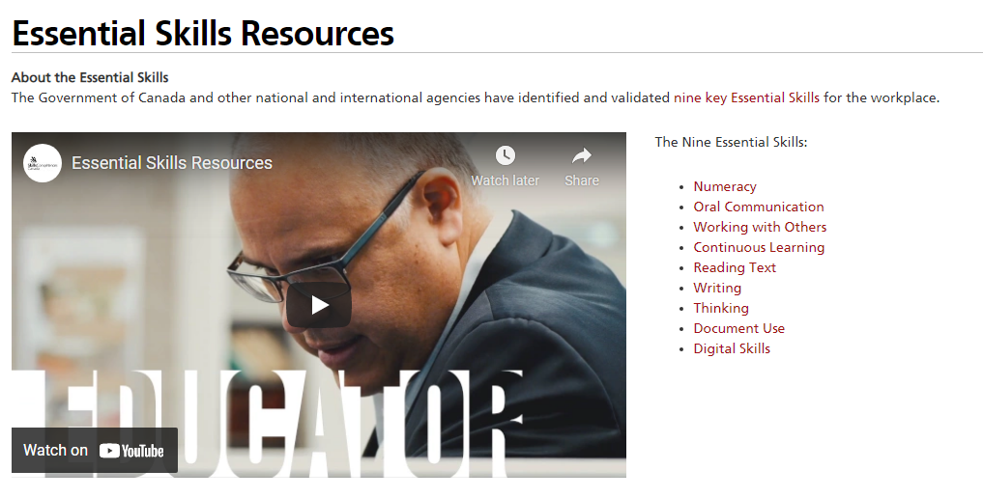
Essential Skills: Work Ready Youth Program  https://www.skillscompetencescanada.com/wp-content/uploads/2019/01/EN_SCC-Guide-Final.pdf  (PDF Doc) | 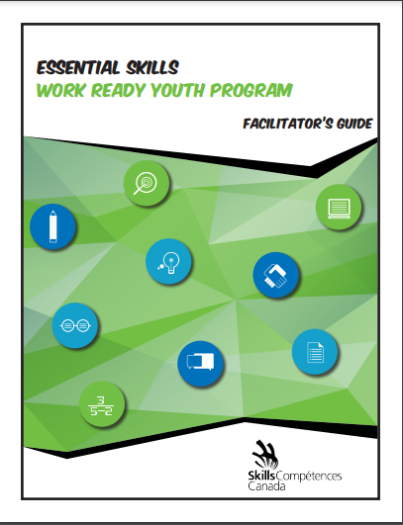

Appendix F - Manufacturing Example PowerPoint
Manufacturing Example PowerPoint

Manufacturing Example PowerPoint  https://www.octe.ca/application/files/3516/3016/0469/Sample_Manufacturing_Career_presentation_welding.pptx | 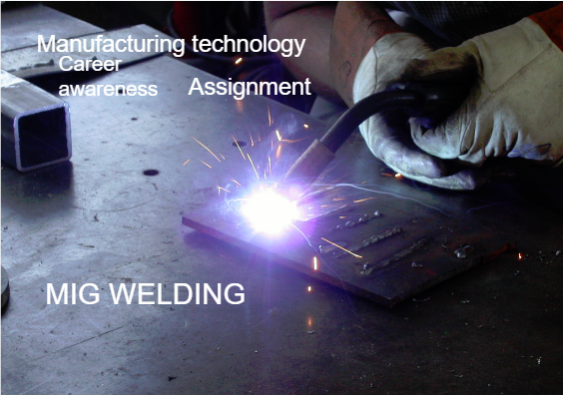

Appendix G - Career Research Rubric
Name: ____________________________ Date: ________________

Career Research Rubric
Skill | Level 4 | Level 3 | Level 2 | Level 1 | R - Remedial
Creative  Use of Technology | Innovative use of graphics, sound, slide effects, additional software, and Internet resources; superior presentation. | Several creative sounds, graphics, slide effects and links used; presentation keeps reader's attention. | Some use of interesting sounds and graphics and slide effects, predictable presentation. | Minimal evidence of independent resources; lacking in variety and interest in  presentation. | Almost no evidence of independent resources; monotonous presentation.
Content Choice | All slides fully described, information is complete and concise | Most slides are fully described. Most information included | Some slides described. Some information included | Minimal information given. Very brief descriptions | Almost no content information is not concise
Organization/ Mechanics | Flawless grammar and punctuation; layout is easy to navigate. | Very few grammar and punctuation errors; layout is easy to navigate. | Some grammar and punctuation errors; layout is sometimes confusing to navigate. | Several grammar and punctuation errors; layout is very difficult to navigate. | Numerous grammar and punctuation errors; layout is very difficult to navigate.

Expectations to assess with this rubric:
SPV.03X - Use a variety of computer software applications for research and to solve problems
ICV.04X- Identifies technology-based careers and their educational requirements
ICS.06X- Identifies computer and technology-related careers and demonstrates understanding of how technology affects selected careers

Appendix H - Careers in Technology Presentation Reflection Sheet
Careers in Technology
Presentation Reflection Sheet

Choosing a career path can be a very difficult decision, but the more people we talk to about careers, the more knowledge we will have to make good decisions. Even if we are not interested in a particular career, we can still take away several interesting points about the career being presented.

Instructions:

- Select 5 presentations that you found interesting
- Write a one-paragraph (min 5 sentences) reflection for each presenter
- Some questions to explore (you do not need to answer all of them for each speaker):
  - What are the key things you learned from the presentation?
  - What surprised you?
  - What disappointed you?
  - Were you inspired? Why/why not.
  - Could this be a career for you? Why/why not.

- Remember to elaborate. (ie: Why did that surprise you? Give reasons to support your responses)
- Make sure to take notes during the careers presentation so that you can enter all of the required information in the sections below
- All Career Presentation reflections will be written in the sections below and must be submitted by _______________________

Careers Presentation Information Template

Student Name: ______________________________

Please use this information template to record your comments and thoughts as your fellow students make their presentations. As a reminder, here are the questions for you to explore within each presentation,
  - What are the key things you learned from the presentation?
  - What surprised you?
  - What disappointed you?
  - Were you inspired? Why/why not.
  - Could this be a career for you? Why/why not.

Remember to give reasons to support and rationale to your responses.

Careers Presentation #1:

Student’s Name:

Career:

Careers Presentation #2:

Student’s Name:

Career:

Careers Presentation #3:

Student’s Name:

Career:

Careers Presentation #4:

Student’s Name:

Career:

Careers Presentation #5:

Student’s Name:

Career:

References
21st Century Competencies: Foundation Document for Discussion. Phase 1: Towards Defining 21st Century Competencies for Ontario, Winter 2016 Edition, 2016 http://www.edugains.ca/resources21CL/About21stCentury/21CL_21stCenturyCompetencies.pdf
American Machinist (website), 2021 https://www.americanmachinist.com/
Automation World (website), 2021 https://www.automationworld.com/
Canadian Apprenticeship Forum (website), 2021 http://www.apprenticesincanada.com/
Canadian Apprenticeship Forum - Apprenticeship 101 (website), 2021 https://caf-fca.org/
Canadian Manufacturing (website), 2021 https://www.canadianmanufacturing.com/
Canadian Tooling and Machining Association (website), 2021 https://www.ctma.com/
College of Trades Training Standards https://www.collegeoftrades.ca/training-standards
Course Codes for Emphasis courses in the Revised Curriculum: Technological Education, Grades 11 and 12, 2009 http://www.edu.gov.on.ca/eng/curriculum/secondary/techedemphasiscourses.pdf
Edge Factor: Engage and Prepare Students (website), 2021 https://edgefactor.com/V5/pages/zonedyn.aspx?z=76
Edge Factor: Manufacturing (website), 2021 https://edgefactor.com/zone/manufacturing
Essential Skills: Work Ready Youth Program (Skills Competences Canada), 2017 https://www.skillscompetencescanada.com/wp-content/uploads/2019/01/EN_SCC-Guide-Final.pdf
Exploring Careers in Manufacturing (PBS Learning), 2021 https://www.pbslearningmedia.org/resource/eaabc97e-d6db-457a-b2b5-6ca0f911e262/exploring-careers-in-manufacturing/
Growing Success: Assessment, Evaluation, and Reporting in Ontario Schools, First Edition, Covering Grades 1 to 12, 2010 www.edu.gov.on.ca/eng/policyfunding/growSuccess.pdf
Learning for All – A Guide to Effective Assessment and Instruction for All Students, Kindergarten to Grade 12, 2013 http://www.edu.gov.on.ca/eng/general/elemsec/speced/LearningforAll2013.pdf
Machine Design (website), 2021 https://www.machinedesign.com/﻿
Ministry News https://news.ontario.ca/en/release/1000078/ontario-to-modernize-and-streamline-apprenticeship-training
Manufacturing Example PowerPoint (PowerPoint presentation), 2021 https://www.octe.ca/application/files/3516/3016/0469/Sample_Manufacturing_Career_presentation_welding.pptx
Modern Machine Shop (website), 2021 https://www.mmsonline.com/
Nine Essential Skills (Skills Competences Canada), 2021
https://www.skillscompetencescanada.com/en/essential-skills/resources/
Resources, Ontario College of Trades, 2020 https://www.collegeoftrades.ca/resources
Red SEAL – Sceau Rouge, 2018 http://www.red-seal.ca/trades/tr.1d.2s_l.3st-eng.html
Skilled Trades Identified in Ontario https://www.collegeoftrades.ca/wp-content/uploads/Sector_Brochure_One_Pager_web.pdf
Skilled Trades Ontario https://www.ontario.ca/page/skilled-trades
The Apprenticeship Advantage, Ontario College of Trades, 2020 https://www.collegeoftrades.ca/wp-content/uploads/ApprenticeshipAdvantage_English_web.pdf
The Differentiated Instruction Scrapbook http://www.edugains.ca/resourcesDI/EducatorsPackages/DIEducatorsPackage2010/2010DIScrapbook.pdf
The Ontario Curriculum, Grades 9 and 10: Technological Education, 2009 (revised) http://www.edu.gov.on.ca/eng/curriculum/secondary/teched910curr09.pdf
The Ontario Curriculum, Grades 11 and 12: Technological Education, 2009 (revised) http://www.edu.gov.on.ca/eng/curriculum/secondary/2009teched1112curr.pdf

