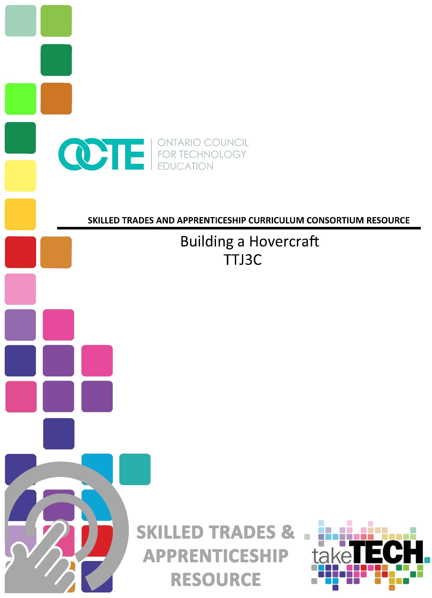

Table of Contents

Introduction 3
Project Outline 3
Prior Knowledge 3
Student Activities 4
Planning Notes 5
Skilled Trades and Apprenticeship Opportunities 5
Career and Industry Extensions 6
Continuum of Influence 6
Continuum of Skills 8
Resources 10
Tools/Equipment 10
Materials 10
Videos 11
Instructional Strategies 12
The Hook / Motivational Strategies 12
Learning Goals and Success Criteria 12
Overall and Specific Expectations in Support of Ontario Curriculum Grades 9 - 12 Technological Education 13
Overall Expectations 13
Specific Expectations 13
Safety Concerns 14
Applicable SAFEDocs and ToolSAFE videos 14
Project Challenges 14
Differentiation of the Project / Activity 15
Assessment and Evaluation 15
Assessment For Learning 15
Assessment As Learning 15
Assessment Of Learning 15
Rubric for Marking the Hovercraft 16
Ethical Considerations 19
Environmental Considerations 19
Reflection or Design Report 19
Appendix A - Lesson Plans 20
Operation of Hovercrafts 20
Understanding of Electrical Circuits 22
Safe Use of Soldering Irons 24
Constructing the Hovercraft 26
Appendix B - Pictures & Diagrams 27
Appendix C - Instructions / Handouts 29
Appendix D - Activities Classwork 33
Appendix E - Answer Key 34
References 37

Introduction
Course Code: TTJ3C
Broad base Technology: Transportation Technology
Destination: College
Grade Level: 11
Resource/Project Name: Building a Hovercraft

Project Outline
By the end of this project, students will be able to explain how hovercrafts propel forward, glide above water / ground surfaces, and how their steering is controlled. Students will be able to read and understand a basic electrical wiring diagram, and be able to create a fully functional electrical circuit. Students will be able to explain the differences between parallel and series circuits, describe the fundamental concepts and laws related to the flow of electricity, and the purposes of various electrical components. In the process of constructing a working model hovercraft, students will demonstrate their creativity and the ability to solve problems and to address a given transportation technology challenge. Students will also demonstrate the safe use of soldering tools to create a fully functional circuit.

Prior Knowledge
Students may have prior knowledge of basic electricity and basic circuits from their middle school or grade 9 Science classes. Students may also have prior knowledge of propulsion and rudder controls from their elementary Science and Technology classes. Additionally, students may have been exposed to the use of soldering tools if they have taken a grade 9 Exploring Technologies course or grade 10 Transportation Technology course. Students may also have used soldering tools with family and friends and/or, while performing individual projects. While all prior knowledge and experiences are of benefit, it will be necessary to review all necessary concepts and provide time for students to practice soldering for them to be successful.

Student Activities
- Using video footage of real hovercrafts (see suggested YouTube links under resources), the teacher introduces what a hovercraft is and how it works. Using cross section diagram of an expected finished product (included in the appendix) or a model hovercraft, teacher explains the structure of the hovercraft, the placement of all components, and the proper operation of the hovercraft – how it lifts, hovers, thrusts forward and steers right & left as needed. Students will then answer Activity #1 questions.

- Distribute instructions for the project including the circuit wiring diagram and discuss the type of circuit and the purposes of all electrical components. Discuss the characteristics of voltage and current in series and parallel circuits. Introduce and demonstrate the use of a multimeter to measure voltage and let students measure total voltage of batteries connected in series & total voltage batteries connected in parallel. Students will then answer Activity #2 questions.

- Safe use of soldering irons. Teacher demonstrates soldering techniques and let students practice soldering on small pieces of electrical wires until they have proficient skills – this step is very important to avoid the damage of motors and switches when they are working on their projects later on.

- Students will start constructing the top shell of the hovercraft using materials of their choice (Styrofoam meat tray and popsicle sticks are the best choice). At the end of this stage, students should have the top shell of the hovercraft, with structure to support the 2 thrust motors and a cup, and structure to support the centre lift motor.

- Students will receive 3 motors to mount on the structure and 6 to 8 feet long 6-wire telephone cable that needs to be soldered to the 3 motors on one end and to the control panel with the switches and batteries on the other end. At this time students should glue the motors in place, route the wires following the provided wiring diagram, and solder the ends of the wires to the 3 motors.

- Students should check that the motors are working and blowing air in the intended direction by temporarily connecting the other end of each pair of wires directly to a 9V battery or DC power supply in the shop. Students should then construct the bottom shell of the hovercraft and glue inflatable plastic sheet at the bottom.

- Students construct the controller out of wood or strong cardboard (many students find an old game controller and gut out its contents) making sure there is room to house 2 x 9V batteries and to mount the 3 switches. The 2 push-button switches that control the left and right motors must be placed conveniently to enable the usage of thumbs to control the hovercraft.

- Following the wiring diagram, students will solder the 6 wires on the other end of the telephone cable to the switches and battery straps.

- Finally, it is time to connect the batteries and test the hovercraft. If the hovercraft is built very light and is hard to control, disconnect one battery terminal and operate with a single battery.

Planning Notes
This project requires preparation of the list of materials included under resources. Teachers will be better served if they make a hovercraft ahead of time to use as a model. It will also provide the opportunity to figure out the direction of rotation of the propellers based on the polarity of the motor lugs of the specific motors purchased. Students do not have to make an identical hovercraft as the model one; even if everyone ends-up using the same concept, teachers should encourage a discussion and have students decide where they place the motors. For example, distance between the thrust motors will affect steering sensitivity, how high the motors are mounted will affect stability, etc.

Skilled Trades and Apprenticeship Opportunities
The hovercraft, an amphibious vehicle that operates on land and water, has so much in common with a propeller aircraft when it comes to its propulsion and rudder control.
The building of a hovercraft project lends an opportunity to discuss all modes of transportation covered under transportation technology and the various skilled trades that fall under the umbrella of transportation technology.
The hands-on activity focuses on problem solving skills and electrical wiring. Given the complexity of electronic systems on modern vehicles, understanding electrical wiring diagrams and learning the skills involved with the diagnosing and repairing of electrical systems are essential skills that can be applied to apprenticeships in many skilled trades such as:
- Automotive Service Technician - 310S  - Truck and Coach Technician 310T  - Heavy Duty Equipment Technician 421A  - Power Lift Truck Technician 282E  - Auto Body and Collision Damage Repairer 310B | - Small Engine Technician 435A  - Marine Engine Technician 435B  - Turf Equipment Technician 421C  - Motorcycle Technician 310G  - Agriculture Equipment Technician 425A

Career and Industry Extensions
The skills and knowledge learned by completing this project will be of great benefit to students when pursuing a career in multiple areas in the Transportation industry as well as other industries. Some additional examples of these careers are listed below:
- Parts Technician
- Automotive Electronics Accessory Technician
- Electronics Technician
- Security Systems Technician
- Robotics Technician
- Medical Instruments Repair Technician
- Electrical Engineer
- Automotive Engineer
- Home Electronics Installation

Continuum of Influence
Students who wish to begin an apprenticeship immediately should be told about OYAP, SHSM or CO-OP programs, co-op programs while in high school or steps to enter the trade directly out of high school. They should also be made aware of the process to start an apprenticeship and skilled trades careers in case they chose to at a later date.
We all have different moments in our lives where we are affected by an experience like taking a technology class. This can include learning a new concept or skill, experiencing something for the first time, taking a new course, developing a talent through practice and hard work, or even calling upon a skilled tradesperson to fix, repair, design, construct, maintain, build, bake, and create innovative solutions. A continuum of influence is a graphic representation of how those experiences can lead to developing a passion and talents in areas such as transportation trades. You can find the full size image of a Transportation continuum of influence on the next page.
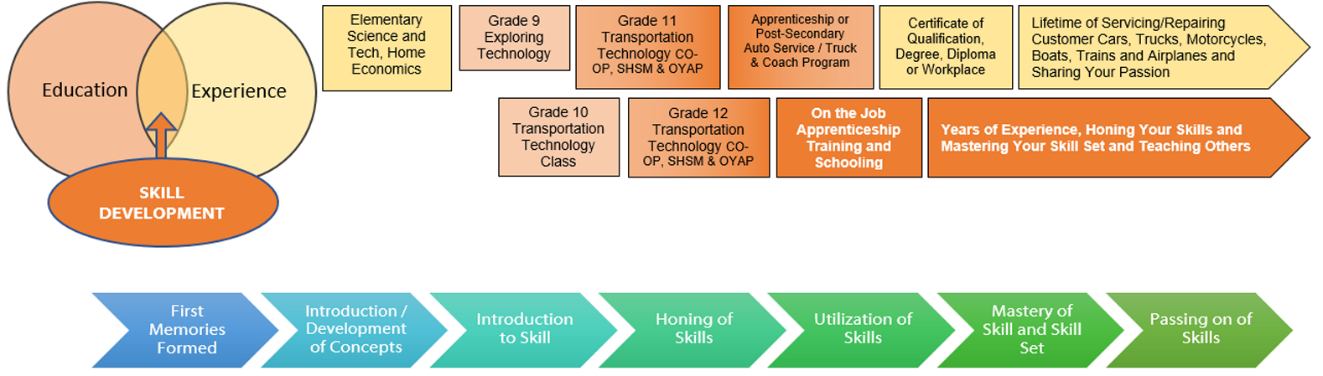

Continuum of Skills
As students pursue their careers in the transportation technology industry, they will have opportunities to build on the skills learned during this project, as the curriculum expectations met during this project are aligned with the Level 1 apprenticeship standard as follows:
A2.1 Describe the fundamental concepts and laws related to the flow of electricity (e.g., flow of electrons, magnetic fields, Ohm's law, Kirchhoff's laws) that underlie the electrical components and systems found in vehicles, craft, and powered equipment;
Alignment with Apprenticeship Training Standards:
- Aligns with section 3.1.1 Level 1 Apprenticeship in School Curriculum for 310S Automotive Service Technician
- Aligns with section 4.2.1 Level 1 Apprenticeship In School Curriculum for 310T Truck and Coach Technician, 425A Agriculture Equipment Technician, 421A Heavy Duty Equipment Technician, 282E Power Lift Truck Technician
- Aligns with section 4.1.1 Level 1 Apprenticeship in School Curriculum for 310G Motorcycle Technician
A2.4 Explain the consequences of open, short, ground, and unintentional ground circuits (e.g., electrical surges, voltage drop, voltage spike);
Alignment with Apprenticeship Training Standards:
- Aligns with section 3.6.1, 3.6.2, 3.6.3 Level 1 Apprenticeship in School Curriculum for 310S Automotive Service Technician
- Aligns with section 4.6.1 Level 1 Apprenticeship In School Curriculum for 310T Truck and Coach Technician, 425A Agriculture Equipment Technician, 421A Heavy Duty Equipment Technician, 282E Power Lift Truck Technician
- Aligns with section 3164.2.1 Level 1 Apprenticeship in School Curriculum for 310B Auto Body and Collision Damage Repairer
- Aligns with section 3.1.2 Level 1 Apprenticeship in School Curriculum for 435A Small Engine Technician, 435B Marine Engine Technician, 421C Turf Equipment Technician
- Aligns with section 4.1.1 Level 1 Apprenticeship in School Curriculum for 310G Motorcycle Technician

A2.5 Describe basic procedures involved in circuit repair (e.g., use of heat shrink, use of solder and solderless connections);
Alignment with Apprenticeship Training Standards:
- Aligns with section 3.6.4 Level 1 Apprenticeship in School Curriculum for 310S Automotive Service Technician
- Aligns with section 4.6.3, 4.6.4 Level 1 Apprenticeship In School Curriculum for 310T Truck and Coach Technician, 425A Agriculture Equipment Technician, 421A Heavy Duty Equipment Technician, 282E Power Lift Truck Technician
- Aligns with section 3.1.2 Level 1 Apprenticeship in School Curriculum for 435A Small Engine Technician, 435B Marine Engine Technician, 421C Turf Equipment Technician
- Aligns with section 4.1.5 Level 1 Apprenticeship in School Curriculum for 310G Motorcycle Technician
A3.1 Identify the function and explain the operation of the major components of various types of steering/control systems;
Alignment with Apprenticeship Training Standards:
- Aligns with section 5.2.1 Level 1 Apprenticeship in School Curriculum for 310S Automotive Service Technician
B2.1 Demonstrate a working knowledge of inspection and testing of circuits (e.g., use test lights or multimeters when required, follow correct procedures in performing a voltage drop test);
Alignment with Apprenticeship Training Standards:
- Aligns with section 3.2.1, 3.2.2, 3.2.3, 3.2.4 Level 1 Apprenticeship in School Curriculum for 310S Automotive Service Technician
- Aligns with section 4.3.1, 4.3.2 Level 1 Apprenticeship in School Curriculum for 310T Truck and Coach Technician, 425A Agriculture Equipment Technician, 421A Heavy Duty Equipment Technician, 282E Power Lift Truck Technician
- Aligns with section 3164.2.2 Level 1 Apprenticeship in School Curriculum for 310B Auto Body and Collision Damage Repairer
- Aligns with section 4.1.4 Level 1 Apprenticeship in School Curriculum for 310G Motorcycle Technician
B4.1 Demonstrate the ability to use a problem-solving process to address a given transportation technology challenge (see pp. 21–23);
Alignment with Apprenticeship Training Standards:
- Aligns with section 3.6.4 Level 1 Apprenticeship in School Curriculum for 310S Automotive Service Technician
- Aligns with section 4.6.1, 4.6.2 Level 1 Apprenticeship in School Curriculum for 310T Truck and Coach Technician, 425A Agriculture Equipment Technician, 421A Heavy Duty Equipment Technician, 282E Power Lift Truck Technician
B4.5 Demonstrate the safe and correct use of a variety of soldering, heating, cutting, and welding techniques when performing tasks related to a challenge or repair.
Alignment with Apprenticeship Training Standards:
- Aligns with section 1.4.4 Level 1 Apprenticeship in School Curriculum for 310S Automotive Service Technician
- Aligns with section 4.6.3, 4.6.4 Level 1 Apprenticeship in School Curriculum for 310T Truck and Coach Technician, 425A Agriculture Equipment Technician, 421A Heavy Duty Equipment Technician, 282E Power Lift Truck Technician
- Aligns with section 3.1.2 Level 1 Apprenticeship in School Curriculum for 435A Small Engine Technician, 435B Marine Engine Technician, 421C Turf Equipment Technician
- Aligns with section 4.1.5 Level 1 Apprenticeship in School Curriculum for 310G Motorcycle Technician

Resources
See appendices for activity lesson plans, handouts and instructions (see Appendix A)

Tools/Equipment
The tools and equipment needed to complete this project are:
- Hot glue gun
- Soldering iron
- Drill press - if students are making their control panel out of a piece of plywood and need to drill holes for the switches

Materials
Teachers must acquire the following materials from suppliers/vendors/discount/surplus stores ahead of time. The quantity on the list of materials below is what is needed for each hovercraft. Teachers should decide how many pieces to purchase based on whether the project is being assigned individually or in groups. If there is no budget constraint, it will be motivating to assign the project individually and let students keep their hovercraft; otherwise, the project could be assigned in groups of 2 or 3, and some of the components can be reused after grading

Materials needed for completion of a hovercraft (supplied by the teacher):
- 3 small toy motors
- 3 propellers
- 2 push button switches
- 1 toggle switch
- 6 to 8 feet long 6-wire telephone cable (purchase a spool from a discount store)
Consumable shop supplies:
- Hot glue sticks
- Solder
- Flux / cleaning compound
- Power supply (12V battery will do) for students to test their motors as they progress
Materials supplied by students:
(Note: teachers should consider supplying the following items to those students who struggle with remembering to bring the materials to class)
- Material of choice for body structure - styrofoam proves to be the best
- Material of choice for control panel - plywood, cardboard, gutted out game controller
- Popsicle sticks
- 2 x 9V batteries for their finished product

Videos
Teachers may access and use all or part of the following videos to help students understand how hovercrafts work,
Hovercraft - Ultimate Amphibious Machine –  https://www.youtube.com/watch?v=1sDMOa5jqHA  (52 minutes) | 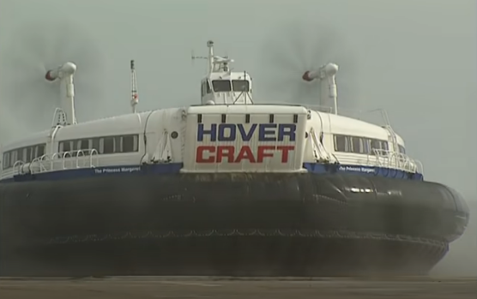
Ten Most Amazing Hovercrafts in the World  https://www.youtube.com/watch?v=6APJ-ZlmeGg  (13 minutes) | 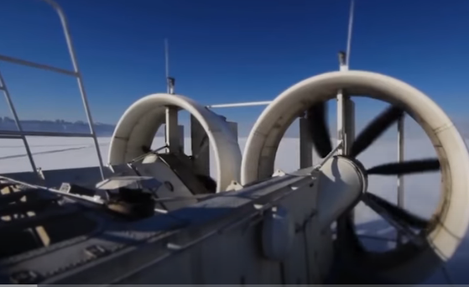

Instructional Strategies
Teachers may use any of the following instructional strategies; 3-Part lesson, lecture, storyboard, word wall, think-pair-share, placemat activity, rapid write, K-W-L, anticipation chart, ABC taxonomy, think aloud, analyzing text, Cornell note taking, exit ticket/ticket out the door, plus/minus/delta, etc.

The Hook / Motivational Strategies
When assigning this project based learning activity, there are a couple of statements that can be made to motivate and engage students
- It should be pointed out that this is a fun activity that leads to students creating a toy that they, or their younger siblings can play with. To make it more fun, teachers may setup a challenge using pylons or chairs for students to maneuver their hovercraft through a certain path
- Teachers should point out that the skills students will learn from this project, reading wiring diagrams and soldering skills, are useful skills that can be applied in many different trades, including those that don’t fall under transportation technology

Learning Goals and Success Criteria
Learning goals and success criteria are listed within each one of the lesson plans as they apply to each segment of the project. Please view the specific learning goals and success criteria in Appendix A – Lesson Plans.

Overall and Specific Expectations in Support of Ontario Curriculum Grades 9 - 12 Technological Education

Overall Expectations
A2. Demonstrate an understanding of basic electrical and electronic circuits and their components;
A3. Identify the function and explain the operation of the major systems and components of vehicles, aircraft, and/or watercraft;
B2. Demonstrate the ability to test and repair basic electrical circuits safely and correctly;
B4. Develop appropriate solutions to transportation technology challenges and/or repair problems.

Specific Expectations
A2.1 Describe the fundamental concepts and laws related to the flow of electricity (e.g., flow of electrons, magnetic fields, Ohm’s law, Kirchhoff’s laws) that underlie the electrical components and systems found in vehicles, craft, and powered equipment;
A2.4 Explain the consequences of open, short, ground, and unintentional ground circuits (e.g., electrical surges, voltage drop, voltage spike);
A2.5 Describe basic procedures involved in circuit repair (e.g., use of heat shrink, use of solder and solderless connections);
A3.1 Identify the function and explain the operation of the major components of various types of steering/control systems;
B2.1 Demonstrate a working knowledge of inspection and testing of circuits (e.g., use test lights or multimeters when required, follow correct procedures in performing a voltage drop test);
B4.1 Demonstrate the ability to use a problem solving process to address a given transportation technology challenge;
B4.5 Demonstrate the safe and correct use of a variety of soldering, heating, cutting, and welding techniques when performing tasks related to a challenge or repair.

Safety Concerns
Students are expected to wear safety goggles at all times when working in the shop. When working on this project, the main safety concern is burning yourself with the soldering iron or the tip of a hot glue gun. The other concern is breathing in soldering fumes.
Students must be adequately trained to perform the tasks safely and soldering must be done in well ventilated areas or under ventilation hoods.

Applicable SAFEDocs and ToolSAFE videos
Please refer to the OCTE SAFEDocs for Transportation Technology for safety documents in order to properly address and instruct this project.
OCTE ToolSAFE Video: Soldering  https://www.octe.ca/en/resources/resource-folder/toolsafe/toolsafe-tej-soldering  (5:40 minutes) | 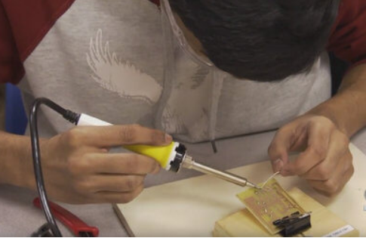

Project Challenges
This learning resource is project based on the following parameters:
- Cost: Material costs and the costs of consumables should be considered before beginning the project. Students may be put into small groups to help control expenses.
- Tool availability: Transportation classrooms may not have multiple soldering irons and hot glue guns needed to efficiently build the project.
- Student skill level: Some students may still be developing the fine motor skills and critical thinking skills needed to complete the project.

Differentiation of the Project / Activity
This project covers multiple course expectations and spans through 6 to 7 periods of 75 minutes (450 to 525 minutes in total) with an end product that needs to be handed-in for grading. Teachers must be cognizant of the fact that some students may excel in certain areas and struggle in other areas. To avoid situations that lead to some students not being able to finish the project, teachers must constantly monitor student progress and accommodate students by providing variety of ways and opportunities to tackle and solve problems.
Teachers can also refer to the Differentiation Scrapbook to take into account for learner ability, multiple intelligences, exceptional students, and ESL learners.

Assessment and Evaluation

Assessment For Learning
Teachers should pose questions to activate prior knowledge and to assess where students stand in order to improve learning by focusing on student needs. This should be done each period throughout the completion of the project, but especially on the instructional days leading to the start of the hands-on work of constructing the hovercraft.

Assessment As Learning
As students are learning how to solder and during the process of building their project, teachers should monitor student progress and give regular constructive feedback to improve student learning.

Assessment Of Learning
Upon completion of each activity and the overall project, teachers will evaluate student work and assign grades using the following assessment and evaluation rubric and answer keys for activities found under appendix E.

Rubric for Marking the Hovercraft
Categories | 50-59%  (Level 1) | 60-69%  (Level 2) | 70-79%  (Level 3) | 80-100%  (Level 4)
Knowledge and Understanding – Subject-specific content acquired in each course (knowledge), and the comprehension of its meaning and significance (understanding)
 | The student:
Knowledge of Content:  Electrical circuits and their components | demonstrates limited knowledge of content | demonstrates some knowledge of content | demonstrates considerable knowledge of content | demonstrates considerable thorough of content
Understanding of content:  Understanding wiring diagrams  Identifying and explaining the operation and steering controls of a craft | demonstrates limited knowledge of content and understanding wiring diagrams | demonstrates some knowledge of content and understanding wiring diagrams | demonstrates considerable knowledge of content and understanding wiring diagrams | demonstrates considerable thorough of content and understanding wiring diagrams

Thinking – The use of critical and creative thinking skills and/or processes
 | The student:
Use of planning skills: Use instructions to plan and build a hovercraft and control panel that meet all the outlined criteria – (inflatable bag, motor placements, control panel with switches and space for batteries) | uses planning skills, instructions and criteria with limited effectiveness | uses planning skills, instructions and criteria with some effectiveness | uses planning skills, instructions and criteria with considerable effectiveness | uses planning skills, instructions and criteria with a high degree of effectiveness
Use of processing skills: Follow the wiring diagram and make decisions on cutting wires, routing, and connections | uses processing skills with limited effectiveness | uses processing skills with some effectiveness | uses processing skills with considerable effectiveness | uses processing skills with a high degree of effectiveness
Use of critical/creative thinking processes: Student used critical/creative thinking skills during the design and construction process to ensure the hovercraft will remain level and be responsive to forward / steering controls during operation | uses critical/creative thinking process skills with limited effectiveness | uses critical/creative thinking process skills with some effectiveness | uses critical/creative thinking process skills with considerable effectiveness | uses critical/creative thinking process skills with a high degree of effectiveness

Communication – The conveying of meaning through various forms
 | The student:
Expression and organization of ideas and information:  Student was able to organize their ideas and present their information clearly in their written responses. | expresses and organizes ideas and information with limited effectiveness | expresses and organizes ideas and information with some effectiveness | expresses and organizes ideas and information with considerable effectiveness | expresses and organizes ideas and information with a high degree of effectiveness
Use of communication for different audiences in oral, visual, and written forms:  Student communicates by reading the wiring diagram and use correct technical terminology to describe the characteristics of the electrical circuit. | communicates for different audiences and purposes with limited effectiveness | communicates for different audiences and purposes with some effectiveness | communicates for different audiences and purposes with considerable effectiveness | communicates for different audiences and purposes with a high degree of effectiveness
Use of conventions vocabulary, and terminology of the discipline in oral, visual, and written forms:  Student uses technical terminology when answering questions about electrical circuits | uses conventions, vocabulary, and terminology of the discipline with limited effectiveness | uses conventions, vocabulary, and terminology of the discipline with some effectiveness | uses conventions, vocabulary, and terminology of the discipline with considerable effectiveness | uses conventions, vocabulary, and terminology of the discipline with a high degree of effectiveness

Ethical Considerations
In broad based technological studies, especially when students are engaged on hands-on projects such as this one, most of the learning happens by doing. During the construction of the hovercraft, even though it is very likely that the students come at different levels of prior knowledge and skills, and remembering collaboration amongst students should always be encouraged, it is imperative that the teacher makes sure that every student is working on their own projects with honesty and integrity. Students shouldn’t be performing soldering on their classmates’ hovercrafts. Students may help their classmates by explaining how to read the wiring diagram, but they shouldn’t be telling them which wires to connect where since they will be depriving their classmates the opportunity to learn how to read wiring diagrams and how to solder.

Environmental Considerations
Teachers should consider the environmental and health impacts of lead and purchase lead-free solder for students to use. The health risks should be communicated with students during the safety lesson so that students learn to use lead-free solder in their future endeavours.
Teachers should strive and encourage students to reduce waste. Students must plan carefully before cutting materials so that waste due to errors is minimized. Teachers should also consider reusing some of the electrical components for future classes unless the students are allowed to keep their finished project.

Reflection or Design Report
Teachers may wish to have the students complete a design report, reflection or create a foldable to consolidate their learning. This would be a nice way to capture the student’s understanding in a summative format and be used in preparation for their examination, entering post-secondary education or the workforce.
If teachers choose to assign students to write a multi-paragraph report reflecting on their experience from start to finish of the project, they may want to forgo assigning classwork in Activities 1 & 2 and indicate on the rubric of the written report that all the items in activities 1 & 2 should be addressed on the report.

Appendix A - Lesson Plans

Operation of Hovercrafts

Operation of Hovercrafts – Activity 1 - 75 minutes Grade 11 – TTJ3C1
Learning Goals | By the end of this lesson student will know and/or be able to:  - Students will explain the three modes of transportation covered under the Transportation Technology curriculum  - Students will explain the concept of thrust created by propellers and rudder controls used on aircrafts and hovercrafts  - Students will explain the concept of what makes a hovercraft hover/glide  - Terms for discussion: propulsion, thrust, hover, glide, rudder, aerodynamics | Materials:  - Video footages of real hovercrafts  - Model hovercraft if available  - Cross-section diagrams of a hovercraft  - Activity #1 classwork questions
Success Criteria | Success looks like:  Students participate in class discussions, answer questions posed during lessons, and start sharing their plans/ideas of how they will build their project  Students answer Activity #1 questions correctly and in full sentences
Activating Student Thinking  (15 min)     | Pose some questions to activate prior knowledge of propulsion and rudder controls  1. How does the propeller of an airplane thrust the airplane forward?  Expected Answer: the propeller pushes air backwards. The equal and opposite reaction force pushes the airplane forward.  2. How does a rudder control the direction of flight?  Expected Answer: air hits the deflected rudder and pushes the tail of the craft to one direction causing the front to steer to the opposite direction | Lesson Considerations  Use videos clips of a hovercraft to introduce what a hovercraft is and how it works  Explain in what situations a hovercraft is used
Developing Student Thinking  (40 min)       | Explain in detail how the expected model hovercraft works using a model hovercraft and/or diagrams.  Ask students to sketch diagrams of how they will build their hovercrafts with the emphasis of motor placements and new ideas.  Put students in small groups to share their plans, how they think the result of their plans will affect the operation of the hovercraft, and exchange ideas  Teacher to circulate from group to group and encourage richer discussions by probing questions and providing feedback | Use a model hovercraft and/or cross-section diagrams  Accommodating students with IEP  Choose student partners carefully and be mindful of their seating plans

Consolidating Student Thinking  (20 min)   | Distribute classwork – Activity #1  Students work on the classwork questions independently and hand-in their answers for marking

Icon | Opportunity identified within the lesson
 | Assessment FOR Learning
 | Assessment AS Learning
 | Assessment OF Learning
 | Opportunity for or implementation of differentiated instruction strategy
 | Audio/Visual requirement (Video, Sound, PowerPoint, SRS Activity, etc.)
 | Lesson Artifact which could be collected to support evaluation, teacher inquiry, school inquiry, etc.
 | Rationale and or research related to pedagogy; could be a hyperlink.
 | Professional Dialogue

Understanding of Electrical Circuits

Understanding Electrical Circuits – Activity 2 - 75 minutes Grade 11 – TTJ3C1
Learning Goals | By the end of this lesson student will know and/or be able to:  - Students will explain the purposes of motors and switches using technical language  - Students will explain the relationships between electrical power, voltage and current  - Students will explain the characteristics of voltage and current in series and parallel circuits  - Students will be able to use a multimeter to take voltage measurements | Materials:  - Multimeter  - 9V batteries and battery terminals  - Electrical components for the project (motor, switch, propeller)  - Wiring diagram for the project  - Activity #2 classwork questions
Success Criteria | Success looks like:  Students participate in class discussions and answer questions posed during lessons  Students use a multimeter proficiently by making the right knob selection to measure specific parameters  Students answer Activity #2 questions correctly and in full sentences
Activating Student Thinking  (10 min) | Pose some questions to activate prior knowledge of basic electricity and electrical relationships  1. What is voltage and what is its unit of measurement?  Expected Answer: voltage is electrical pressure that pushes electrons to flow and is measured in volts.  2. What is current and what is its unit of measurement?  Expected Answer: current is the directional flow of electrons and is measured in amps  3. What is the difference between series and parallel circuits?  Expected Answer: on a series circuit there is only one path for current to flow whereas on parallel circuit each load has its own path | Lesson Considerations  Demonstrate the difference in motor speeds when using a single 9V battery and 2 x 9V batteries connected in parallel
Developing Student Thinking  (40 min) | Explain the electrical circuit in detail with the emphasis of the paths for current flow and how each switch controls specific motor(s).  Demonstrate the use of multimeters by measuring battery voltage and resistance (continuity) of switches when they are open or closed  Put students in small groups and have them take resistance measurements of switches when open/closed and voltage measurements of multiple batteries connected in parallel and series and have them discuss their findings. Ex. 2 x 9V batteries in series = 18V & 2 x 9V batteries in parallel = 9V | Use the wiring diagram to explain how the circuit works  Accommodating students with IEP  Choose student partners carefully and be mindful of their seating plans

Consolidating Student Thinking  (25 min) | Explain the relationships between electrical power, voltage and current (P = I x V) in relation to the use of 2 x 9V batteries on the circuit diagram of the hovercraft  Distribute classwork – Activity #2  Students work on the classwork questions independently and hand-in their answers for marking

Safe Use of Soldering Irons

Safe Use of Soldering Irons – Activity 3 - 75 minutes Grade 11 – TTJ3C1
Learning Goals | By the end of this lesson student will know and/or be able to:  - Students will explain why it is important to solder wires when doing electrical repairs on vehicles  - Students will explain the need of using flux on electrical components or wires during soldering  - Students will explain the safety precautions they need to take when using soldering irons  - Students will learn and demonstrate their soldering skills | Materials:  - Soldering irons, flux, and solder  - Bits of wires (same as the telephone wire to be used in the project)  - Motor and switch
Success Criteria | Success looks like:  Students demonstrate safe use of soldering irons  Insulation is only stripped from the tip of the of the soldered wires (about 1mm)  The soldered wires have a good bond  The soldered wires have the right amount of solder – just enough for a solid joint, not bulky
Activating Student Thinking  (10 min) | Pose some questions to activate discussions about the need of electrical wiring repairs on vehicles and the need why soldering is a better option than just twisting wires together  1. What could cause electrical wires to result in an open circuit?  Expected Answers: wires could break accidentally or due to fatigue after repetitive movement. Wires could also corrode and break  2. How good do you think it will be if you repair wires under the hood or under the car by twisting them together and taping them?  Expected Answers: because of the exposure to weather elements, wires will corrode at the connection points and the repair will not last long  Teacher explains what corrosion build-up on wires is and how it could lead to voltage drop and/or open circuit situations. | Lesson Considerations  Necessary to review safety precautions specific to the use of soldering irons even if the students have done safety at the beginning of the course
Developing Student Learning  (50 min) | Teacher demonstrates soldering of wires to motor/switch lugs and wires that are twisted together emphasizing the importance of positioning the components so that flux & solder do not sip into the components and avoiding excessive heating that would damage the components  Students go into small groups based on the number of soldering irons available and take turns to practice soldering and learn from each other  Teacher closely watches progress and provides constructive feedback.  Teacher shuffles the size of groupings based on technical aptitude to allow more practice time to those who need it | Distribute Soldering Iron Safety Precautions handout and review it  Demonstrate soldering of multiple wires that are twisted together and single wires on motor and switch lugs

Consolidating Student Knowledge  (15 min)   | End the period by asking the following review questions and letting students share their success and struggles with the whole class:  - Why did you use flux when soldering?  - What happens when you keep the soldering iron on the motor/switch lugs for too long?  - Ask student to share their experiences in learning to solder

Constructing the Hovercraft

Constructing the Hovercraft – Activities 4 to 9 Grade 11 – TTJ3C1
225 to 300 minutes (3 to 4 working periods)
Learning Goals | By the end of this lesson student will know and/or be able to:  - demonstrate the ability to use problem solving process to address a given transportation technology challenge  - demonstrate the safe and correct use of soldering iron  - create a functional electrical circuit following a wiring diagram | Materials:  List of materials needed for the project is listed on the instruction handout
Success Criteria | Success looks like:  - students built a functional hovercraft that hovers, thrusts forward and turns right and left using the control panel  - electrical wires are routed neatly and do not interfere with the propellers  - all electrical connections are soldered and sturdy with the right amount of solder  - electrical wires are properly insulated and they don’t pose risk of short circuit
Activating Student Thinking  (5 - 10 min) each period | Each period teachers start the day by asking questions to see if any student needs help with understanding the wiring diagram or any of the processes. | Lesson Considerations  Daily review wiring diagram and soldering process as necessary
Developing Student Learning (60 min) | Provide one to one assistance as needed  Encourage student collaboration with the emphasis that students can explain but are not allowed to work on their classmate’s project | Monitor student progress and provide regular feedback
Consolidating Student Knowledge  (5-10 min) | The last minutes of each period, encourage students to unplug all soldering irons & hot glue guns, organize tools, store their projects, and clean-up work areas  Teachers should take anecdotal notes to inform proficiency of students’ learning skills

Appendix B - Pictures & Diagrams
Schematic Diagram
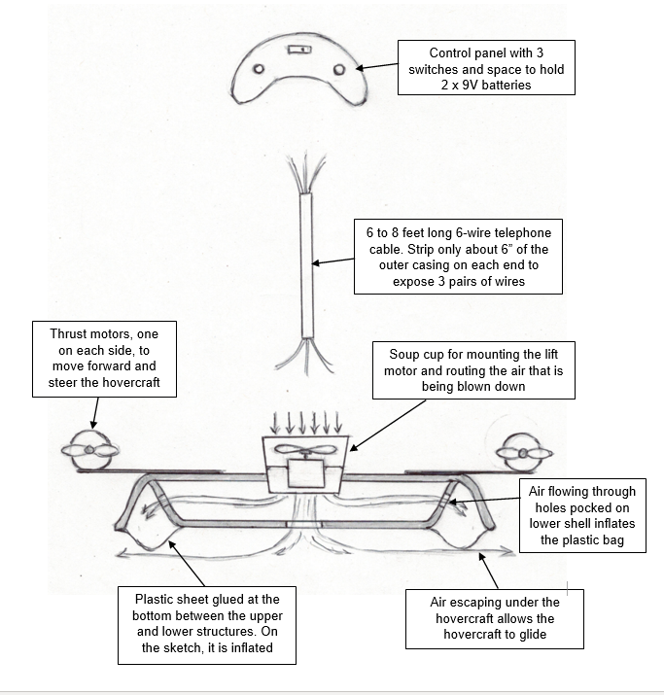

Pictures of Hovercrafts in Action
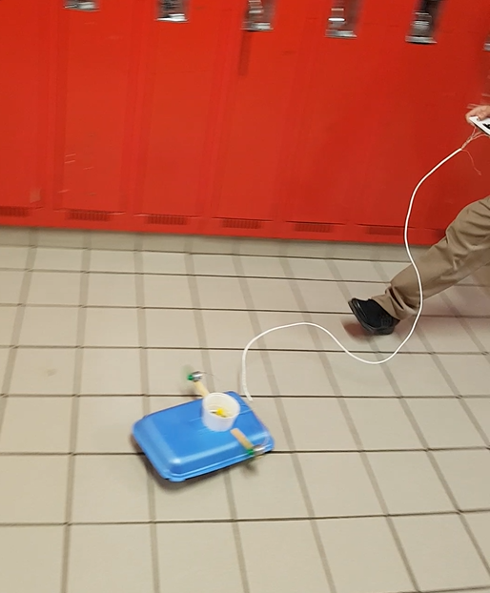
Student operating his completed hovercraft. Though the hovercraft glides forward without difficulty, the picture shows that there is more lift on the front because the motors are placed more to the back and they are weighing down the back.
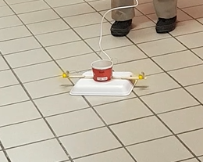
Student operating her nicely balanced hovercraft, but there is not much of a lift because the plastic sheet at the bottom did not have enough slackness to inflate.

Appendix C - Instructions / Handouts
Building a Toy Hovercraft
You are expected to build a fully functional toy hovercraft that works with 9V battery supply. A model will be shown to you in class; however, you are encouraged to build one with your own design and style.
Your teacher will provide the following items:
- Wiring diagram – see the 3rd page of this instructions
- 3 toy motors – 1 lift motor and 2 thrust motors
- 3 propellers
- 2 pressure switches
- 1 toggle switch
- All the necessary wires
- Glue, solder, and soldering gun
You should provide all the other items to suit your design/plan such as:
- Material to construct the body – cardboard, Styrofoam (from meat packaging)
- Soup cup or similar for mounting lift motor and routing air
- Popsicle sticks
- Plastic sheet
- A piece of plywood or cardboard to construct your control panel
Outcome
Upon completion of this project, students will:
- Understand thrust and propulsion
- Learn to read a basic wiring diagram
- Learn some basic electrical symbols and electrical circuits
- Learn to use a soldering gun safely and solder wires
- Create a fully functional electrical circuit
Parameters
All electrical connections should be soldered. However, before soldering make temporary connections and test the circuit for functionality. During the soldering process, be careful not to apply too much heat; you may end up damaging the switches and motors. (Normally when soldering two wires or terminals together, first you apply flux on the wires or terminals to help clean any oxidation that could prevent the solder from sticking, then you heat the end tips one at a time, enough to melt a small amount of solder on the wires and then you let the ends touch and heat them together, enough for the solder to melt and fuse. You may also twist the wires together first and solder them using the same techniques)
Expected Operation
When the toggle switch is turned on the lift motor should come on and inflate the plastic sheet to slightly lift the hovercraft so that it can easily glide on a smooth floor – if the lift motor is mounted perfectly vertical and at the centre, the hovercraft will lift but remain stationary.
The two pressure switches should turn on the thrust motors. When both thrust motors are turned on, the hovercraft should glide straight forward; releasing the right switch (turning off the right motor) should turn the hovercraft to the right and releasing the left switch (turning off the left motor) should turn the hovercraft to the left.
Evaluation - The evaluation scheme for your project will be as follows
Thinking Marks – design and construction process /20
- The structure has shape of a hovercraft with inflatable bottom
- Lift motor is located at a reasonable spot and the motor is mounted vertically
- Thrust motors are properly mounted and evenly spaced out
- All propellers spin freely without any interference
- Wires are routed neatly especially ensuring no interference with propellers
- Control panel with switches and wires assembled neatly
- Control panel has space to properly hold 2 x 9V batteries
Application Marks – Functionality of hovercraft and quality of soldering /40
- Lifting effect – when the toggle switch is turned on, the hovercraft must lift evenly by inflating the plastic bag at the bottom and should remain stationary
- Propulsion – when the two push button switches are pressed, the hovercraft should glide straight forward without difficulty
- Steering – the hovercraft should easily turn to the right and left directions when a push-button switch is released. The steering direction should match to the side of the switch being released (example – releasing right thumb → turn right)
- Soldering – all connections must be soldered with the correct amount of solder applied. All connections must be sturdy, and insulation must be removed only from the tip of the wires removing the risk of short circuits
Knowledge Marks /20
- Correct written answers to questions in Activity # 1, 2 & 3
Communication Marks /20
- Written answers must be in full sentences with correct spelling and grammar

Wiring Diagram
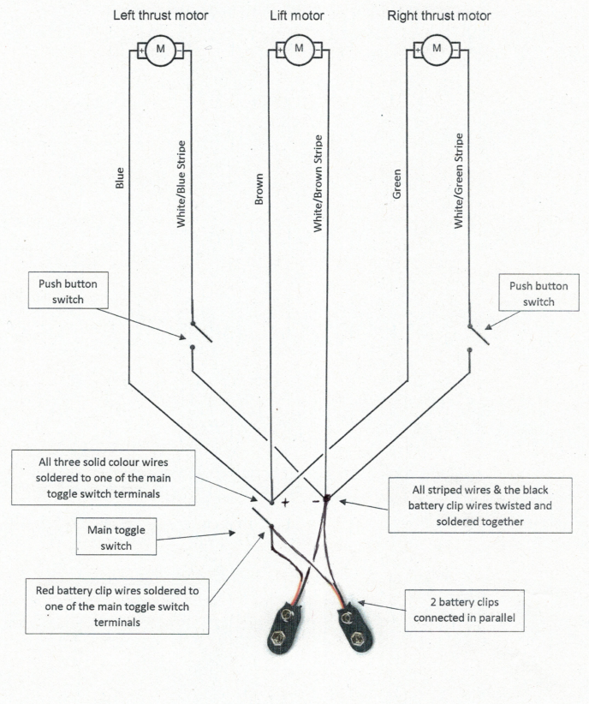

Soldering and Safety
Soldering is a joining process used to join different materials together by melting solder on the materials being joined together. In transportation technology electrical repairs, we use soldering in order to create a strong electrical and physical bond which is less affected by corrosion compared to joining wires by just twisting them together.
In order to melt the solder, we use a soldering iron or soldering gun that is heated to very high temperatures to heat the wires that are being soldered. We then melt the solder on the wires. Often, in order to ensure good bond, we need to apply flux on the wires to clean-up the wires from oxidation that would prevent the solder from sticking.
The following are some safety considerations to remember during soldering
- Wear safety glasses to prevent any spitting going into your eyes
- Soldering must be done on a fire resistant surface away from any combustible materials or vapours
- Soldering must be done in well ventilated area to reduce the risk of breathing in the fumes created during soldering
- Use lead free solder to prevent to risk of lead poisoning
- Use tweezers, pliers or clamps to hold the wires you are soldering to prevent burns
- Never touch melted solder or the tip/element of the soldering iron until they are completely cool
- Be careful not to touch the electrical cord of the soldering iron with the hot tip as it will fray the insulation and lead to a short circuit or electrocution
- Always place the soldering iron securely in/on the stand when not in use
- Unplug the soldering iron as soon as you finish using it
- When finished soldering, clean off droplets of cleaning solvent (flux) and solder from the work area

Appendix D - Activities Classwork
Activity # 1 Operation of the Hovercraft
Answer the following questions in detail and in full sentences. You will earn knowledge marks for providing correct answers and communication marks for proper sentences with correct grammar, spelling and punctuation.
- How does a spinning propeller cause the hovercraft/aircraft to move forward?
- When the lift motor is turned on, how does the hovercraft rise/lift?
- What makes the hovercraft hover / glide above the surface so easily?
- Comparing real hovercrafts you saw on the video clips and the toy hovercraft you are going to build, explain how each hovercraft steers right and left.
- What will happen if you place your lift motor far from the centre of your structure?
- What will happen if your thrust motors are not evenly spaced from the centre point of your structure? Give reasons for your answer.
- How would the length of distance between the thrust motors affect the steering of the hovercraft?
Activity # 2 Wiring Diagram
Answer the following questions in detail and in full sentences. You will earn knowledge marks for providing correct answers and communication marks for proper sentences with correct grammar, spelling and punctuation.
- On the wiring diagram provided for your project, are the motors connected in series or parallel? Give reasons for your answer.
- In technical terms, explain the purpose of a motor.
- In technical terms, explain the purpose of a switch.
- Explain how the three switches are connected in the circuit and what they control.
- What would happen if the polarity of the wires was reversed at the battery?
- What would happen if the polarity of one thrust motor was reversed?
- Are the two batteries connected in series or parallel? How does this affect the power/voltage/current output?

Appendix E - Answer Key
Activity # 1 Operation of the Hovercraft
Answer the following questions in detail and in full sentences. You will earn knowledge marks for providing correct answers and communication marks for proper sentences with correct grammar, spelling and punctuation.
- How does a spinning propeller cause the hovercraft/aircraft to move forward?
When a propeller spins, it produces force that pushes air backward. Since for every action there is an equal and opposite reaction (Newton's Law), the reaction force will push the propeller forward, consequently pushing the craft forward as the propeller is attached to the craft.
- When the lift motor is turned on, how does the hovercraft rise/lift?
When the lift motor is turned on, it pushes air downward into the bottom of the hovercraft and inflates the bag attached to the bottom of the hovercraft around its perimeter. When the bag is inflated the hovercraft lifts up sitting on a cushion of air.
- What makes the hovercraft hover / glide above the surface so easily?
The reason why the hovercraft glides so easily with minimal friction is because the film of air escaping between the inflatable bag and the ground acts as a bearing. After the lift motor inflates the bag at the bottom to create the lift, as it continues to spin, the air that is being pushed down ends up escaping between the bag and the ground.
- Comparing real hovercrafts you saw on the video clips and the toy hovercraft you are going to build, explain how each hovercraft steers right and left.
The real hovercrafts I saw on the video clips have rudders used for steering. When the rudder is deflected to a certain direction, the air pushing on the rudder will cause the tail of the hovercraft to move to one direction causing the front to steer to the opposite direction. The toy hovercraft that we are building for our project has two motors to move it forward. Every time one of the motors is turned off, the hovercraft will steer in that direction.
- What will happen if you place your lift motor far from the centre of your structure?
If the lift motor is not placed centrally, the hovercraft may not be level when it lifts. Depending on the overall weight of the hovercraft and the state of charge of the battery, the lift motor could be weighing down the area where it is located or it could be inflating that area more.
- What will happen if your thrust motors are not evenly spaced from the centre point of your structure? Give reasons for your answer.
If the two thrust motors are not spaced evenly from the centre of the structure, the hovercraft will not travel on a straight line. Since torque is (force x distance), the motor that is further from the centre will have more steering effect because of the increased torque it produces due to the increased distance.
- How would the length of distance between the thrust motors affect the steering control of the hovercraft?
If the thrust motors are spread wide, as long as the distance from the centre is equal and they are producing the same thrust force, the hovercraft will move forward stably but the steering effect when one motor is turned off will be abrupt. If the thrust motors are very close to each other, the steering effect will be less and small imperfections in construction could make it hard to get the hovercraft move straight.

Activity # 2 Wiring Diagram
Answer the following questions in detail and in full sentences. You will earn knowledge marks for providing correct answers and communication marks for proper sentences with correct grammar, spelling and punctuation.
- On the wiring diagram provided for your project, are the motors connected in series or parallel? Give reasons for your answer.
The three motors on the hovercraft wiring diagram are connected in parallel. I know this because when I trace the two wires for each motor back to the power supply, each motor has its own path for current to flow independent of the other two motors.
- In technical terms, explain the purpose of a motor.
The motor is an electromechanical device that converts the electrical energy from the battery into mechanical energy causing the propeller to spin.
- In technical terms, explain the purpose of a switch.
A switch is an electrical device that closes the circuit when it is turned on and causes an open circuit when it is on the off position.

- Explain how the three switches are connected in the circuit and what they control.
The main toggle switch is connected on the positive side of the circuit between the batteries and the three solid colour wires that supply current to the three motors. This switch controls all three motors - none of the motors will come on if this switch is turned off. The two push button switches are connected on the negative side of each thrust motor and control the corresponding motor. For a thrust motor to come on, both the main toggle switch and a push button switch must be in the on position.
- What would happen if the polarity of the wires was reversed at the battery?
If the polarity of the circuit was reversed at the battery, all motors will spin in the opposite direction causing the lift motor to suck air instead of inflating the bag and the thrust motors would move the hovercraft backwards.
- What would happen if the polarity of one thrust motor was reversed?
If the polarity of one thrust motor was reversed, that motor would spin backward. This will result in the hovercraft spinning instead of moving forward.
- Are the two batteries connected in series or parallel? How does this affect the power/voltage/current output?
The two batteries are connected in parallel. The fact that they are connected in parallel, the voltage output from the batteries will remain the same; however, there will be more power output because the two batteries can deliver more current if there is demand for it.

References
21st Century Competencies: Foundation Document for Discussion. Phase 1: Towards Defining 21st Century Competencies for Ontario, Winter 2016 Edition, 2016 http://www.edugains.ca/resources21CL/About21stCentury/21CL_21stCenturyCompetencies.pdf
College of Trades Training Standards https://www.collegeoftrades.ca/training-standards
Course Codes for Emphasis courses in the Revised Curriculum: Technological Education, Grades 11 and 12, 2009 http://www.edu.gov.on.ca/eng/curriculum/secondary/techedemphasiscourses.pdf
Growing Success: Assessment, Evaluation, and Reporting in Ontario Schools, First Edition, Covering Grades 1 to 12, 2010 www.edu.gov.on.ca/eng/policyfunding/growSuccess.pdf
Hovercraft - Ultimate Amphibious Machine, YouTube Video, 2015 https://www.youtube.com/watch?v=1sDMOa5jqHA
Learning for All – A Guide to Effective Assessment and Instruction for All Students, Kindergarten to Grade 12, 2013 http://www.edu.gov.on.ca/eng/general/elemsec/speced/LearningforAll2013.pdf
Ministry News https://news.ontario.ca/en/release/1000078/ontario-to-modernize-and-streamline-apprenticeship-training
OCTE SAFEDocs for Transportation Technology (document), 2013 https://www.octe.ca/download_file/view/4845/1201
OCTE ToolSAFE Soldering Video (video), 2017 https://www.octe.ca/en/resources/resource-folder/toolsafe/toolsafe-tej-soldering
Red SEAL – Sceau Rouge, 2018 http://www.red-seal.ca/trades/tr.1d.2s_l.3st-eng.html
Resources, Ontario College of Trades, 2020 https://www.collegeoftrades.ca/resources
Skilled Trades Identified in Ontario https://www.collegeoftrades.ca/wp-content/uploads/Sector_Brochure_One_Pager_web.pdf
Skilled Trades Ontario https://www.ontario.ca/page/skilled-trades
Ten Most Amazing Hovercrafts in the World, YouTube Video, 2020 https://www.youtube.com/watch?v=6APJ-ZlmeGg
The Apprenticeship Advantage, Ontario College of Trades, 2020 https://www.collegeoftrades.ca/wp-content/uploads/ApprenticeshipAdvantage_English_web.pdf
The Differentiated Instruction Scrapbook http://www.edugains.ca/resourcesDI/EducatorsPackages/DIEducatorsPackage2010/2010DIScrapbook.pdf
The Ontario Curriculum, Grades 9 and 10: Technological Education, 2009 (revised) http://www.edu.gov.on.ca/eng/curriculum/secondary/teched910curr09.pdf
The Ontario Curriculum, Grades 11 and 12: Technological Education, 2009 (revised) http://www.edu.gov.on.ca/eng/curriculum/secondary/2009teched1112curr.pdf

