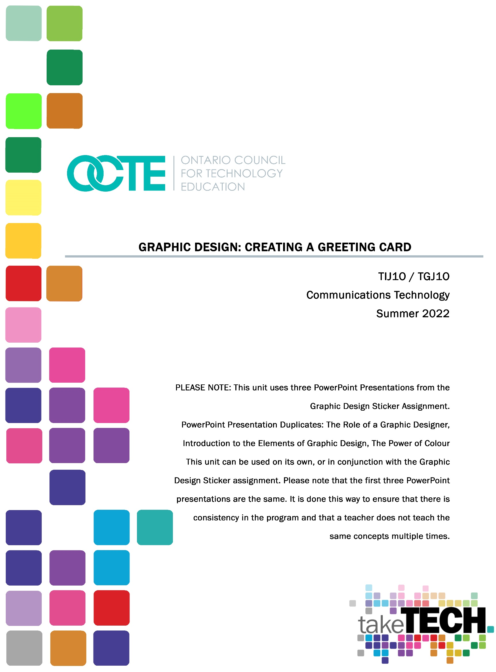

Table of Contents

Introduction 4
Project Outline 4
Prior Knowledge 5
Student Activities 5
Activity 1 – Explore the role of a Graphic Designer 5
Activity 2 – Introduction to the Elements of Graphic Design 5
Activity 3 – The Power of Colour 5
Activity 4 – History of the Greeting Card 5
Activity 5 – Think, Pair, Share - Genres of Greeting Cards 6
Activity 6 – Jigsaw - Greeting Card Slogans and Phrases 6
Activity 7 –Typography 6
Assignment – Create a Greeting Card 6
Assessments 6
Resources 6
Handouts 6
Tools/Equipment 7
Software 7
Materials 7
Journals/Magazines 7
Videos 7
Websites for Teachers 7
Planning Notes 8
Skills Continuum 8
Career and Industry Extensions 9
Instructional Strategies 9
The Hook / Motivational Strategies 10
Learning Goals and Success Criteria 10
Overall and Specific Expectations in Support of Ontario Curriculum Grades 9 - 10 Technological Education 10
Overall Expectations 10
Specific Expectations 11
Safety Concerns (including PPE if required) 11
Applicable SAFEDocs and ToolSAFE videos 11
Differentiation of the Project / Activity 12
Assessment and Evaluation 12
Assessment and Evaluation 12
Assessment As Learning 13
Assessment For Learning 13
Assessment Of Learning 13
Religious Considerations 13
Career and Industry Extensions 13
Ethical Considerations 13
Environmental Considerations 14
Reflection or Design Report 14
Graphic Design Unit - Creating a Greeting Card 15
Activity 1 – Explore the Role of a Graphic Designer 15
Activity 2 – Elements of Graphic Design 15
Activity 3 – Exploring Colour 16
Activity 4 – History of the Greeting Card 16
Activity 5 – Think, Pair, Share - Genres of Greeting Cards 17
Activity 6 – Jigsaw - Greeting Card Slogans and Phrases 19
Activity 7 –Typography PPT and Worksheet 22
Assignment – Greeting Card Assignment 25
Appendix A – TIJ1O Worksheets 26
Activity 1 – Explore the Role of a Graphic Designer 27
Activity 2 – Elements of Graphic Design 29
Activity 3 – The Role of Colour 31
Activity 5 – Think, Pair, Share - Genres of Greeting Cards 34
Activity 6 – Jigsaw - Greeting Card Slogans and Phrases 36
Appendix B – TIJ1O Graphic Design: Watch & Learn Links and Read & Learn Links 42
Appendix C - Assessments – Peer and Self Evaluations 48
References 50

Introduction
Course Code: TIJ1O / TGJ1O
Broad base Technology: Exploring Technologies and Communications Technology Destination: Open
Grade Level: 9
Online Project Name: Graphic Design – Creating a Greeting Card

Project Outline
This unit will allow students to work independently and collaboratively. Students will improve their literacy skills through research and development of greeting card slogans and phrases. Students will have the opportunity to engage collaboratively by working as a team to complete their research. This unit will also provide students with the opportunity to develop their communication skills through class presentations and open discussions.

The major goals of this unit are to increase students' understanding of graphic design and communications while creating an original product. Concepts and terms associated with colour theory, graphic design, and elements of graphic design will be explored. Students will learn the foundations of Greeting Cards and basic card layout design. Students will be exposed to the term ‘genre’ through their Greeting Card research which will later translate to other aspects of the communication technology program.

This project will allow students to understand and research Creative Commons License images and find resources that they can use in their Greeting Card assignment. Students will learn computer skills through internet research, activities, and the creation of a Greeting Card design.

This assignment can be extended to go beyond what is required through adding in details such as:
- Providing the students with hands on Greeting Cards instead of having students research them online.
- Teachers can use any software that they feel comfortable with. If teachers have access to Adobe Photoshop, Gimp, or Pixlr then students will need to be taught how to do the following:
  - Set up margins and bleeds
  - Cut out images using selection tools, clipping paths
  - Layer images
  - Use and alter text

Prior Knowledge
There is no pre-requisite or prior knowledge necessary for this unit. Students are encouraged to follow and review copyright laws in Canada prior to starting this assignment.
Students are encouraged to use websites that are royalty-free and creative commons licensed.
- StockSnap.io
- Burst (by Shopify)
- Unsplash
- The Noun Project
- Pexels
- Pixabay

Student Activities

Activity 1 – Explore the role of a Graphic Designer
- Role of a graphic designer
- Types of graphic design jobs
- Inspirational graphic designers

Activity 2 – Introduction to the Elements of Graphic Design
- Shapes and lines
- Company logos and meanings
- Use of texture in graphic design
- Understanding the role of balance in graphic design
- How elements can be used separately or together in graphic design

Activity 3 – The Power of Colour
- How colours emphasize messages
- Too many colours or conflicting colours, correction techniques
- The use of colour by Canadian companies to convey a message
- The psychology of colour

Activity 4 – History of the Greeting Card
- Origins of Greeting Cards
- Current global uses of Greeting Cards

Activity 5 – Think, Pair, Share - Genres of Greeting Cards
- Genres and uses of Greeting Cards
- Meaning of Greeting Cards
- Target Markets
- E-Cards

Activity 6 – Jigsaw - Greeting Card Slogans and Phrases
- Meaning of Slogans and Phrases in Greeting Cards
- Poetry in Greeting Cards
- Capture Audiences
- Selling e-cards

Activity 7 –Typography
- Serif, Sans-Serif, Handwriting / Script, Modern, Decorative
- Letterform, Type and Typeface terminology
- Leaning type through self-name exploration

Assignment – Create a Greeting Card
- Research ideas/ pre-plan concept through sketches
- Student Greeting Card assignment

Assessments
- Greeting Card Rubric
- Self-Evaluation
- Peer Evaluation

Resources

Lesson Plans
Please see each activity outline for instructions

Handouts
Activity 1 – Explore the Role of a Graphic Designer
Activity 2 – Elements of Graphic Design
Activity 3 – The Role of Colour
Activity 5 – Think, Pair, Share - Genres of Greeting Cards
Activity 6 – Jigsaw - Greeting Card Slogans and Phrases
Activity 7 –Typography PPT and Worksheet

Tools/Equipment
- Laptop
- Desktop
- Chromebook
- Tablet
- Mobile Device

Software
- Adobe Photoshop (paid use)
- Gimp (free)
- Pixlr (free)

Materials
Specific materials are not required; however, a teacher may want to bring in Greeting Cards as classroom examples.

Journals/Magazines
- Adobe Create Digital Magazine
- Photo News
- Communication Arts

Videos
- GCFLearnFree.org
- Adobe Creative Cloud
- Monkey’s Dream
- Adobe for Education

Websites for Teachers
- PetaPixel
- Adobe Education Exchange
- Learn Pixlr
- Learn Gimp

Planning Notes
This unit of lessons, activities and the assignment is estimated to take 2-2.5 weeks to complete. This is based on a 75min period of 10-12 class periods. Some learners may need accommodations of extra time.
These lessons, activities, and assignments have been designed to have an in-depth examination of graphic design in a Grade 9 program. This unit is a full Graphic Design unit that can be implemented into any Grade 9 tech rotation model.
- Work in this unit is scaffolded. Feedback must be provided in a timely manner.
- Materials / Worksheets can be provided all at once, or daily as per activity requirements. Worksheets may be converted to the format that is best suited for the class (.pdf, .doc, Google doc).
- It is recommended that each student have a digital drive space to submit and receive material. (e.g., Microsoft One Drive, Google Drive, Dropbox, etc.)
- Review posted source material links (handouts etc.).
- Examine software to endure familiarity. Teachers may choose to create tutorials for chosen software. Or the teacher may allow learners the opportunity to choose which software that best suits their needs.

Skills Continuum
We all have different moments in our lives where we are affected by an experience. This can include learning a new concept or skill, experiencing something for the first time, taking a new course, developing a talent through practice and hard work, or even calling upon a skilled tradesperson to fix, repair, design, construct, maintain, build, bake, and create innovative solutions. The continuum of influence is a graphic representation of how those experiences can lead to developing a passion and talents in areas of technology and skilled trades as a graphic designer, type setter, illustrator, digital artist, cinematographer, studio technician, animator, producer, communications specialist, etc.
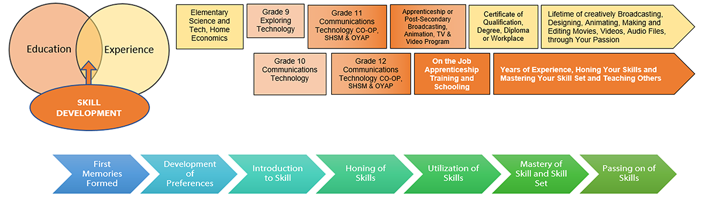

Career and Industry Extensions
There are many careers in the multimedia industry. A graphic designer can work on print, web, and digital publications. A graphic designer may also work on video and audio post productions.
Here is a general overview of multimedia career positions.
Audio Technician  Animator (2D and 3D)  Graphic Designer  Illustrator  New Media Designer  Print Publishing  Web Designer | Many jobs in film such as:  - Boom mic operator  - Cinematographer  - Director  - Gaffer  - Grip  - Producer  - Sound Engineer  - Video Editor

Instructional Strategies
- The lessons, activities, and assignment have been scaffolded.
- The lessons are formed with PPT, teacher lessons and classroom discussions.
- Activities will involve students to research and create a Google Slide / PPT presentation, a think / pair/ share activity, and a jigsaw activity.
- The lessons, activities, and assignment have been created using different forms of media and are multi-device supported.
- The learner is encouraged to revise their work using a living (collaborative) document shared with the teacher

The Hook / Motivational Strategies

Everyone has the ability to be creative. The lessons, activities, and assignments have been created to allow learners of all abilities to build on their understanding of graphic design and create a meaningful product. Understanding the conscious and subconscious impact of design and colour empowers the learner. How can they use this knowledge to influence how others perceive their work by applying these simple principles?

Learning Goals and Success Criteria
Identify how graphic design is used to convey a message
• Recognize the impact of colour on our everyday lives
• Discover the role of a graphic designer and possible career and education opportunities
• Compare different types of programs and applications choosing the best tool for their device
• Design an original work that can be used in their school or community

Overall and Specific Expectations in Support of Ontario Curriculum Grades 9 - 10 Technological Education

Overall Expectations
A1. Demonstrate an understanding of the fundamental concepts and skills required in the planning and development of a product or service, including the use of a design process and/or other problem-solving processes and techniques.
B2. Fabricate products or deliver services, using a variety of resources. (optional)
C2. Demonstrate an awareness of how various technologies affect society, as well as how society influences technological developments.
D2. Identify careers in various technological fields, and describe the educational requirements for them

Specific Expectations
A1.1 Describe a design process or other problem solving process for planning and developing products and/or services
A1.4 Incorporate appropriate technological concepts (e.g., aesthetics, control, environmental sustainability/ stewardship, ergonomics, fabrication/building/ creation, function, innovation, material, mechanism, power and energy, safety, structure, systems) in the design, fabrication or delivery, and evaluation of a product or service
B2.3 Meet all design criteria (e.g., technical requirements, type and quality of materials, appearance, ease of use, safety, timeline, client’s expectations) in creating a product or delivering a service;
C2.1 Describe some of the effects that technological innovations of the past have had on society (e.g., effects on health, on people’s ability to travel and communicate, on living standards, on education) and the economy (e.g., creation of new types of jobs, automation of factories);
D2.5 Demonstrate an understanding of the work habits that are important for success in the technology industries, as identified in the Ontario Skills Passport (e.g., working safely, teamwork, reliability, organization, working independently, initiative, self-advocacy, customer service);
D2.6 Develop and/or select pieces of work and other materials that provide evidence of their skills and achievements in technology, for inclusion in a portfolio (e.g., Passport to Safety certificate, project photographs, sketches, drawings, skills checklist, work logs).

Safety Concerns (including PPE if required)
Learners may need to practice physical distancing, and the school board adopted cleaning processes for shared tools. (e.g., shared tablets, keyboard, mice, etc.)

Applicable SAFEDocs and ToolSAFE videos
Please refer to the OCTE SAFEDocs for BBT Technology for safety documents in order to properly address and instruct this project.

Differentiation of the Project / Activity
Teachers can also refer to the Differentiation Scrapbook to take into account learner ability, multiple intelligences, exceptional students, and ESL learners.
The lessons in this document include visual, written, and video-based instruction. Some YouTube videos support Closed Captioning.
Students may choose to complete activities using the Google Read & Write Extension.
- Support for Google Read & Write
- Quick Reference Guide

Assessment and Evaluation
Examples:
- Kahoot – Colors, Colors, Colors
- Kahoot – Graphic Design

Assessment and Evaluation
Assessment: Progress of students' research stages will be examined through formative evaluations. Each phase of the unit will scaffold into the next learning section. Students will have the opportunity to explore, reflect and find ways on how to improve their performance.

Students will have the opportunity to present findings to the class thus allowing for communication skills to be formatively evaluated. After each activity, the teacher will provide formative feedback.

Final assessment will be for the Greeting Card. Students will also have the opportunity to have peer evaluations completed prior to handing in their greeting Card. After students have received their peer evaluations, they will have an opportunity to improve their design prior to handing it in. The overall quality of the card will be marked from the provided rubric.

Assessment As Learning
Teachers gauge student’s abilities through understanding student skill sets.
Teacher provides feedback from activities.

Assessment For Learning
Involve students in the learning process through formative activities.
Students monitor their own progress throughout the activities and assignment.
Students are encouraged to ask questions and practice skills.
Students use self-assessment, peer evaluations, and teacher feedback to reflect and improve learning to create a growth mindset.

Assessment Of Learning
Evidence of learning through students' goals and achievements can be demonstrated through each phase of the unit. Summative evaluation will be through the Final Greeting Card assignment.

Religious Considerations
There are many global religious holidays that can be encouraged to research. The final assignment can be geared towards blessings, spiritual words of encouragement, or specific religious holidays.

Career and Industry Extensions
Career research can be encouraged after Activity 1 - The Role of a Graphic Designer. Teachers can encourage students to research careers and post-secondary opportunities.
More information can be found here on the OCTE website.

Ethical Considerations
In Activity 3 – The Power of Colour, the teacher may add to this activity by encouraging or assigning research into how colour is perceived by different cultures

Environmental Considerations
Teachers may wish students to reflect on the process of properly recycling computers. It should be noted that computers contain heavy metals (such as lead and toxic chemicals) that can pollute the environment. Run-offs from landfills can be an issue if they are not disposed of properly.

Reflection or Design Report
Teachers may wish to have the students complete a design report, reflection or create a foldable document to consolidate their learning. This would be a nice way to capture the student’s understanding in a summative format and be used in preparation for their examination, entering post-secondary education or the workforce.

Graphic Design Unit - Creating a Greeting Card

Activity 1 – Explore the Role of a Graphic Designer

Teacher presents visual content, videos and other examples to students, using the PowerPoint presentation: 1 Graphic Design – Role of the Graphic Designer

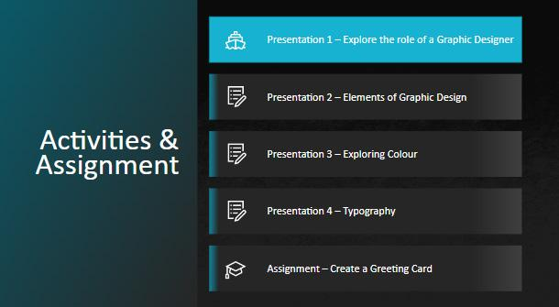

What is the definition of Graphic Design?

What is the role of a Graphic Designer?

What can a Graphic Designer create?

Worksheet in Appendix A. PowerPoint Presentation on OCTE website.

Activity 2 – Elements of Graphic Design
Teacher presents visual content, videos and other examples to students, using the PowerPoint presentation: 2 Graphic Design – Elements of Graphic Design
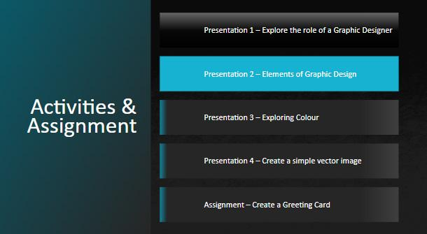
Elements of Graphic Design
- Balance, Texture, Colour, Line, Form and Shapes
Worksheet in Appendix A. PowerPoint Presentation on OCTE website.

Activity 3 – Exploring Colour
Teacher presents visual content, videos and other examples to students, using the PowerPoint presentation: 3 Graphic Design – The Power of Colour
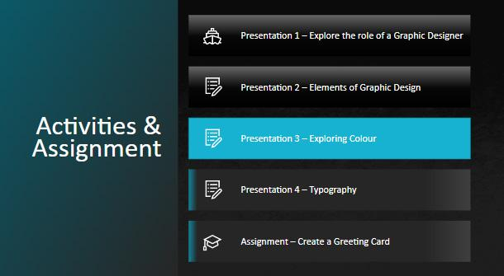
Colour Theory
- Colour Models
- Colour Psychology

Worksheet in Appendix A. PowerPoint Presentation on OCTE website.

Activity 4 – History of the Greeting Card
Objective:
- Students will have the opportunity to engage collaboratively by working as a team to complete their research. This activity will also provide students with the opportunity to develop their communication skills through class presentations and open discussions.
- Students will learn the foundations of Greeting Cards and basic card layout design.
- Group activity can reinforce and develop time management skills, communication skills, ability to plan and manage tasks, and redefine understanding through group discussions.
- Concepts and terms associated with colour theory, graphic design, and elements of graphic design will be explored.

Time: 1 x 75 Minute Period

Activity: Students in a group of 3-4 will research Greeting Cards in a chosen country and create a Google Slideshow or PPT.

Slides / Prompting Questions:
- Name of Country
- History of Greeting Cards in this Country
- What Greeting Cards (holidays or celebrations) are popular in this country?
- Find images from Google and provide 2-3 photo examples of Greeting Cards
- From previous slides - Briefly discuss the Graphic Design Elements and Colour Theory

Prior Learning:
According to GreetingCard.org, the history of greeting cards dates back to the ancient Chinese who exchanged messages of goodwill to celebrate a New Year, and to early Egyptians who used papyrus scrolls to send greetings. Key dates in greeting card history can be viewed on the website.

Activity 5 – Think, Pair, Share - Genres of Greeting Cards
Objective:
- Think, Pair, Share Activity
- Students will have the opportunity to work independently and engage collaboratively by working as a team to complete their research. This activity will also provide students with the opportunity to develop their communication skills through class presentations and open discussions.
- Students will learn the foundations of Greeting Cards and basic card layout design.
- Group activity can reinforce and develop time management skills, communication skills, ability to plan and manage tasks, and redefine understanding through group discussions.

Time: 1 x 75 Minute Period

Resources:
A white board or Chart Paper
Please see the worksheet in Appendix A

Activity:
There are many different genres of greeting cards. This activity will have the students brainstorm ideas, create team building and communication skills.

THINK - For this activity, students will first work independently. Students are to write down 5 genres of Greeting Cards and note what they are used for.

PAIR - After completing the independent part of this activity, students will then be put into groups. Each group will create a full list of the different genres of greeting cards and a note of what each greeting card consists of and when it would be used.

SHARE - As a group students will examine all of their ideas and create a top 5 list of the ones; they think are most important. Once they have created their top 5 list, students will use a whiteboard marker and put their response on the whiteboard at the front of the class. At the end there will be a list of the most popular greeting cards.
The teacher will discuss with the students the most popular greeting cards and as a class come up with reasoning why these specific cards / holidays are the most popular.

Class Question Prompts:
- Why are certain holidays more popular for Greeting cards?
- What age group do you think buys the most Greeting Cards? Why?
- Who is the target market for Greeting Cards? Why?
- Have you ever purchased a Greeting card? If so, for what occasion?
- Have you ever sent an eGreeting Card (Online Virtual Card)? If so, for what occasion?

Worksheet in Appendix A.

Activity 6 – Jigsaw - Greeting Card Slogans and Phrases
Objective:
- Jigsaw Activity
- Students will have the opportunity to work collaboratively by working as a team to complete their research. This activity will also provide students with the opportunity to develop their communication skills through team discussions.
- Students will learn the foundations of Greeting Cards through examining Slogans and Phrases, Poetry in Greening Cards, Capturing Audiences and eCards.
- Group activity can reinforce and develop time management skills, communication skills, ability to plan and manage tasks, and redefine understanding through group discussions.
- Leadership Skills are developed as each student becomes an expert in their topic and teaches others.

Time: 1 x 75 Minute Period

Resources: Please see worksheets in Appendix A.

Activity:
Part A) Students will be divided into 5 groups. Each group will have a topic that they will later share with other groups. Each person in this first main group will become a leader of their topic.

First breakout groups. All members will discuss the same topic.

Group 1
Topic 1  What is a slogan?  Can you think of some famous slogans?  Such as Nike - Just Do It!  Can Greeting Cards have popular slogans? Why or why not? | Topic 1  What is a slogan?  Can you think of some famous slogans?  Such as Nike - Just Do It!  Can Greeting Cards have popular slogans? Why or why not? | Topic 1  What is a slogan?  Can you think of some famous slogans?  Such as Nike - Just Do It!  Can Greeting Cards have popular slogans? Why or why not? | Topic 1  What is a slogan?  Can you think of some famous slogans?  Such as Nike - Just Do It!  Can Greeting Cards have popular slogans? Why or why not? | Topic 1  What is a slogan?  Can you think of some famous slogans?  Such as Nike - Just Do It!  Can Greeting Cards have popular slogans? Why or why not?

Group 2
Topic 2  Research and Discuss Poetry in Greeting Cards. | Topic 2  Research and Discuss Poetry in Greeting Cards. | Topic 2  Research and Discuss Poetry in Greeting Cards. | Topic 2  Research and Discuss Poetry in Greeting Cards. | Topic 2  Research and Discuss Poetry in Greeting Cards.

Group 3
Topic 3  How do you capture your audience when your card is sandwiched among many other greeting cards? | Topic 3  How do you capture your audience when your card is sandwiched among many other greeting cards? | Topic 3  How do you capture your audience when your card is sandwiched among many other greeting cards? | Topic 3  How do you capture your audience when your card is sandwiched among many other greeting cards? | Topic 3  How do you capture your audience when your card is sandwiched among many other greeting cards?

Group 4
Topic 4  Do eGreeting Cards need to have a different style than conventional cards? Please explain. | Topic 4  Do eGreeting Cards need to have a different style than conventional cards? Please explain. | Topic 4  Do eGreeting Cards need to have a different style than conventional cards? Please explain. | Topic 4  Do eGreeting Cards need to have a different style than conventional cards? Please explain. | Topic 4  Do eGreeting Cards need to have a different style than conventional cards? Please explain.

Part B) The next step is to mix the groups up and have one student from each topic share with a new smaller group what they have learned. There should be a new group formed that has one student from each topic group. This will provide the opportunity for students to become leaders of their topic and teach others. During this time, each student should fill out the worksheet below to record learning.

Topic 1  What is a slogan?  Can you think of some famous slogans?  Such as Nike - Just Do It!  Can Greeting Cards have popular slogans? Why or why not? | Topic 2  Research and Discuss Poetry in Greeting Cards. | Topic 3  How do you capture your audience when your card is sandwiched among many other greeting cards? | Topic 4  Do eGreeting Cards need to have a different style than conventional cards? Please explain.

Worksheet in Appendix A.

Activity 7 –Typography PPT and Worksheet

Teacher presents visual content, videos and other examples to students, using the PowerPoint presentation: 4 Graphic Design – Typography
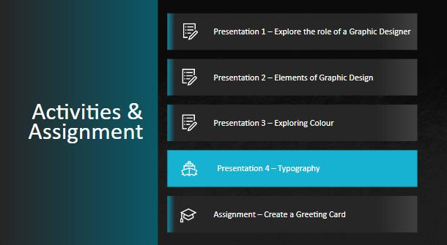
Typography:
- Serif, Sans-Serif, Handwriting / Script, Modern, Decorative
- Letterform, Type and Typeface terminology
- Leaning type through self-name exploration

Objective:
- Students will have the opportunity to work individually to complete their activity. This activity will also provide students with the opportunity to develop their communication skills through classroom demonstrations and discussions.
- Students will learn the foundations of typography through examining and exploring fonts.

Time: 1 x 75 Minute Period

Resources: Please see worksheets on Appendix A.

Activity:
Using any software, students will write their name 5 different times using different fonts / sizes / colours. Have students think of their prior typography and colour theory lessons.

Worksheet in Appendix A. PowerPoint Presentation on OCTE website.

Assignment – Create a Greeting Card

Objective:
- Students will have the opportunity to demonstrate their understanding by creating a unique Greeting Card. This assignment will be completed individually.

Time: 2 x 75 Minute Periods

Software:
- Adobe Photoshop (paid use)
- Gimp (free)
- Pixlr (free)
Students may need to reference their prior learning of software.

Materials Needed: Paper for student sketches

Activity:

Students are to demonstrate their prior knowledge of graphic design fundamentals by creating their own unique Greeting Card. The school appropriate genre of the Greeting Card will be chosen by the student.
- Students research ideas/ pre-plan concepts through creating 2 sketch designs for their Greeting Card on paper. Students will sketch out what they would like the front and back on their cards to look like. The inside of the card should have either a handwritten slogan or poem. Sketches display details and logic for each idea.
- Students will choose one of their sketch designs to create digitally. Students will then re-create the front and back of their card with their chosen software.
- Students will create a 200 word write up about their objectives, processes, and reasoning why they chose that particular genre of card.

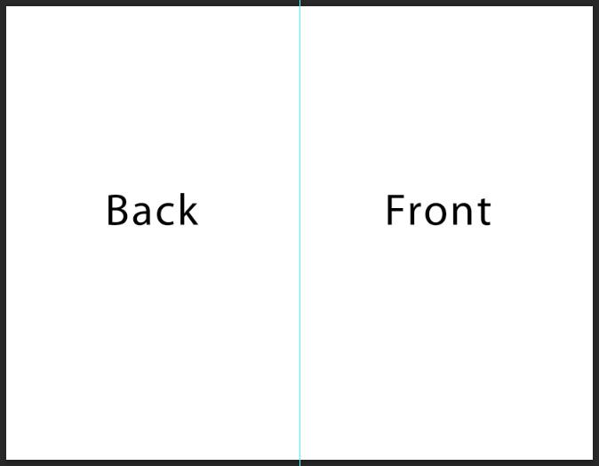
Steps for a vertical card:
- Create a landscape paper size document (8.5” x 11”)
- Using the ruler, add a vertical guide in the middle of the page
(NOTE: You may want to change your measurements to cm. It will be easier to find the center point)
- The left side of the page will be the back of the card
- The right side of the card will be the front of the card
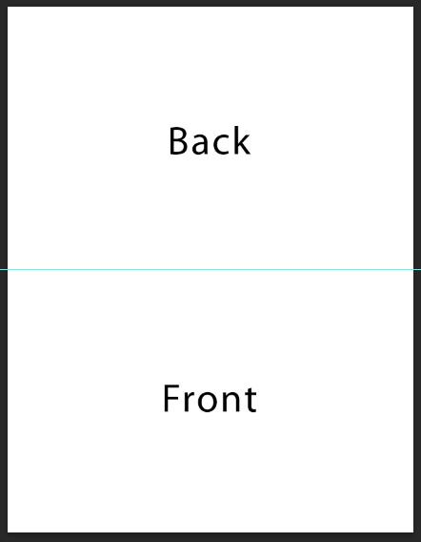
Steps for a horizontal card:
- Create a portrait paper size document (8.5” x 11”)
- Using the ruler, add a horizontal guide in the middle of the page
(NOTE: You may want to change your measurements to cm. It will be easier to find the center point)
- The top of the page will be the back of the card
- The bottom of the card will be the front

Assignment – Greeting Card Assignment

Rubric Description
- The final product is an accumulation of your design choices and skills
- Demonstrating skills developed through your process work and relating to your Inspiration Document.
- Exporting to a specific file type (.psd .pdf or .png or .jpg)
- Creative appeal needs to elicit an emotional response from the audience

Assignment 1 – Create a Greeting Card Rubric
Expectation | Level 4 | Level 3 | Level 2 | Level 1 | R
Communication: define project objectives and performance criteria precisely.
Overall Expectation: C2
Research type of Greeting Card | Defines and explains project objectives, process & reflection with profound detail. | Defines and explains project objectives process & reflection with considerable detail. | Defines and explains project objectives, process & reflection with some detail. | Did not define or explain project objectives, process & reflection. | Did not submit.
Thinking: Use a variety of planning techniques and tools when creating plans for communications technology projects.
Overall Expectation: A1
Preplanning Submitted Sketch or Design | Uses a variety of planning techniques and tools when creating plans for communications technology projects with a high degree of logic. | Uses a variety of planning techniques and tools when creating plans for communications technology projects with considerable logic. | Uses a variety of planning techniques and tools when creating plans for communications technology projects with some logic. | Uses a variety of planning techniques and tools when creating plans for communications technology projects with limited logic. | Did not submit prior to execution of Greeting Card
Application: Produce rich media products that conform to evolving industry standards and formats. Overall Expectation: C2
Completed Greeting Card | Produces rich media products that conform to evolving industry standards and formats with a high degree of fluency. | Produces rich media products that conform to evolving industry standards and formats with considerable fluency | Produces rich media products that conform to evolving industry standards and formats with some fluency. | Produces rich media products that conform to evolving industry standards and formats with limited fluency. | Does not meet the minimum requirements, please redo, and resubmit

Appendix A – TIJ1O Worksheets

TIJ1O: Activities and Assignment Worksheets

Overview:
This worksheet has been designed as a collaborative document to be shared with your teacher. As you work your way through these activities and assignment, your teacher will provide feedback that you may choose to use in revising your work. Pay careful attention to the rubric at the bottom of this sheet, and the teacher comments as you go along.
*Helpful tip, make a backup of your work

Overall Expectations:
A1. Demonstrate an understanding of the fundamental concepts and skills required in the planning and development of a product or service, including the use of a design process and/or other problem-solving processes and techniques.
B2. Fabricate products or deliver services, using a variety of resources.
C2. Demonstrate an awareness of how various technologies affect society, as well as how society influences technological developments.
D2. Identify careers in various technological fields and describe the educational requirements for them.

Activities:
When starting each activity, complete all readings and watch all videos before beginning.

Questions:
Depending on your previous experiences, some of the material that is covered may be a review, and for others, it may be brand new. It is expected that you will have questions as you work your way through this; if you do, I am here to help you. Please let me know ASAP so that you get the help you need and do not get frustrated

Resources
These FREE and Creative Commons Image Sites are a great place to find images, while respecting Copyright Laws in Canada
- StockSnap.io
- Burst (by Shopify)
- Unsplash
- The Noun Project
- Pexels
- Pixabay

Activity 1 – Explore the Role of a Graphic Designer
Name __________________________________ Date______________

Exploring the Role of a Graphic Designer
Question 1.1
Think about a logo for a company that you recognize: Microsoft, Google, Snapchat, 7 UP…
- What is the name of the company that you thought about?
- Display their logo or provide a link to their logo.
- Name the people/roles that you think would have been involved in approving the logo.
Use the table below to answer the question
Company | Logo | People Involved
e.g.  Canada Goose |  | company president, graphic designer, art manager, communications manager, focus groups, vice presidents

Question 1.2
Think about or research the types of jobs a graphic designer might work on, list six of these jobs
Graphic Designer Jobs

Question 1.3
What inspires you? When you watched the videos, you heard stories from Graphic Designers themselves. Think of Designs that have captured your attention or encouraged you to purchase something.
Research one graphic designer and answer the following questions.
- Who are they and why does the work that they have created mean something to you?
- What type of graphic design do they specialize in or are they a generalist?
- What type of education do they have?
- What or who inspires them?

Question (Optional)
Do you like to draw or sketch? Now is a great opportunity to showcase some of your favorite work. Take a photo with your mobile device and include it
Include your image or images here
Example 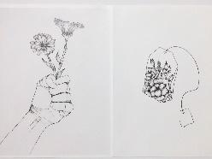

Activity 2 – Elements of Graphic Design
Name __________________________________ Date______________

Elements of Graphic Design

Question 2.1
Where was your eye drawn to in the image, why do you think that it was drawn to this area?

Question 2.2
Search and find on the internet three images where other types of lines are used (e.g. curved lines). What feelings do they convey to you? Do you think this was the intent of the creator? Place a copy of the image alongside your answer.

Question 2.3
How do the following companies use shapes to hide a hidden meaning? Look closely at the following companies’ logos. Describe what you see
Company | What Do You See
Pinterest
FedEx
Beats
Amazon
Baskin-Robbins
Hyundai
Wendy’s
Cisco

Question 2.4
Look around your house, or school, and try to find examples of books, cards, or posters that used different materials or created visual elements that demonstrate the use of texture. Use your mobile device to document and share at least two examples.
Include example 1 here
Include example 2 here

Question 2.5
Look at images on the internet, find two examples of Symmetrical and Asymmetrical photographs. Upload and share these images.
Include symmetrical image example 1 here
Include symmetrical image example 2 here
Include asymmetrical image example 1 here
Include asymmetrical image example 2 here

Question 2.6
What are three things that you learned from watching Fundamentals – Beginning Graphic Design that you didn't know before.
1.
2.
3.

Activity 3 – The Role of Colour

Name __________________________________ Date______________

The Role of Colour

Question 3.1
Choose and list three signs from your school, mall, or community center (e.g. EXIT) . What colours are used to help communicate the message? What impact do you think they would have if they were different shades of grey?
1.
2.
3.

Question 3.2
Locate and analyze an image from the internet that you think uses too many colours. Explain one or two things that the creator could have done differently to have made this image more effective.
Include a copy of the image here
Include your answer here

Question 3.3
Display five logos, or signs from different Canadian companies. Think about what you have just learned watching the videos, how do the colours that they have chosen to support their brand/message?
Logo | Message

Question 3.4
Create a Positive Colour Association and a Negative Colour Association chart for three of the following colours – Black, Purple, Brown, Grey and Magenta. Include one image that represents one of the positive or negative Colour associations that you have chosen.
Black
Positive Colour Association | Negative Colour Association
Include Image Here

Purple
Positive Colour Association | Negative Colour Association
Include Image Here

Grey
Positive Colour Association | Negative Colour Association
Include Image Here

Brown
Positive Colour Association | Negative Colour Association
Include Image Here

Magenta
Positive Colour Association | Negative Colour Association
Include Image Here

Activity 5 – Think, Pair, Share - Genres of Greeting Cards

Name __________________________________ Date______________

Think-Pair-Share Greeting Card Genre Activity

THINK
On your own, think of 5 genres of greeting cards. Try to think beyond holidays.

Genre of Card | Purpose. When would this card be used?

PAIR
With your group of 3-4 members, discuss your genres. Create a master list of all genres. Note all duplicates by adding a checkmark beside each duplicate.

Genre of Card | Purpose. When would this card be used?

SHARE
As a group you will examine all of your ideas and create a top 5 list of the ones you think are most important. Once you have created your top 5 list, you will use a whiteboard marker and put your response on the whiteboard at the front of the class.

Genre of Card | Why is this card the most important?

Activity 6 – Jigsaw - Greeting Card Slogans and Phrases

Name __________________________________ Date______________

Jigsaw Greeting Card Slogan and Phrases Activity
(Part A - Worksheet)

Topic of Discussion:

Try to come up with up to 5 discussion points about your topic that you can teach others about.
Discussion Point 1 | Discussion Point 2 | Discussion Point 3 | Discussion Point 4 | Discussion Point 5

Name __________________________________ Date______________

Jigsaw Greeting Card Slogan and Phrases Activity
(Part B - Worksheet)

Record responses on the blank fields below from what you learned by each team leader.

Topic 1  What is a slogan?  Can you think of some famous slogans?  Such as Nike - Just Do It!  Can Greeting Cards have popular slogans? Why or why not? | Topic 2  Research and Discuss Poetry in Greeting Cards. | Topic 3  How do you capture your audience when your card is sandwiched among many other greeting cards? | Topic 4  Do eGreeting Cards need to have a different style than conventional cards? Please explain.

Activity 7 –Typography PPT and Worksheet

Name __________________________________ Date______________

Typography Activity

Looking back to your Typography and Color Theory lesson, come up with 5 different ways to write your name that you feel best represents who you are.

Your Name Here | Font Name / Size / Colour | Questions:
Example:  Lorem Ipsum | Font Name:  Lobster  Size: 20pt  Colour: Rose/ Pink | 1. Why did you choose that font?  I chose this font because it was playful, and I like the decorative curves.  2. What emotion or feeling are you trying to convey?  I want to convey a playful emotion. I want people to feel happy and excited when they see this logo.  3. Why did you choose that colour?  I chose this colour because it matches my calm and outgoing personality.
1. | Font Name:  ____________________  Size:  ____________________  Colour:  ____________________ | 1. Why did you choose that font?  ____________________  ____________________  2. What emotion or feeling are you trying to convey?  ____________________  ____________________  3. Why did you choose that colour?  ____________________  ____________________
2. | Font Name:  ____________________  Size:  ____________________  Colour:  ____________________ | 1. Why did you choose that font?  ____________________  ____________________  2. What emotion or feeling are you trying to convey?  ____________________  ____________________  3. Why did you choose that colour?  ____________________  ____________________
3. | Font Name:  ____________________  Size:  ____________________  Colour:  ____________________ | 1. Why did you choose that font?  ____________________  ____________________  2. What emotion or feeling are you trying to convey?  ____________________  ____________________  3. Why did you choose that colour?  ____________________  ____________________
4. | Font Name:  ____________________  Size:  ____________________  Colour:  ____________________ | 1. Why did you choose that font?  ____________________  ____________________  2. What emotion or feeling are you trying to convey?  ____________________  ____________________  3. Why did you choose that colour?  ____________________  ____________________
5. | Font Name:  ____________________  Size:  ____________________  Colour:  ____________________ | 1. Why did you choose that font?  ____________________  ____________________  2. What emotion or feeling are you trying to convey?  ____________________  ____________________  3. Why did you choose that colour?  ____________________  ____________________

Which design do you feel is the most effective? Why?

________________________________________________________________________

________________________________________________________________________

________________________________________________________________________

________________________________________________________________________

Appendix B – TIJ1O Graphic Design: Watch & Learn Links and Read & Learn Links

Activity 1 – Explore the Role of a Graphic Designer
Watch & Learn – Role of a Graphic Designer  Adobe Creative Cloud, 2016  The Secret World of Annie Atkins, Graphic Designer for Films I Adobe Creative Cloud  https://youtu.be/flMespYYwTw  (5:29) | 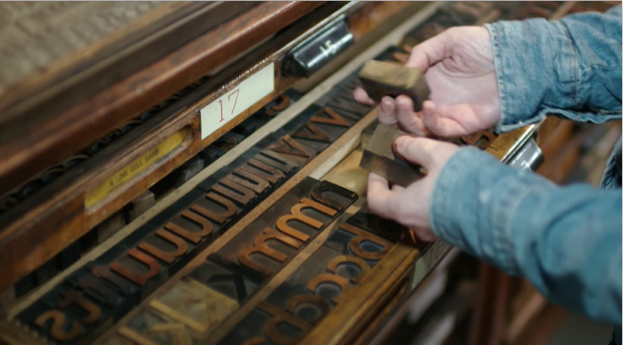
Watch & Learn – PBS Digital Studios  PBS Digital Studios, 2012  The Universal Arts of Graphic Design  https://youtu.be/sTi5SNgxE3U  (6:29) | 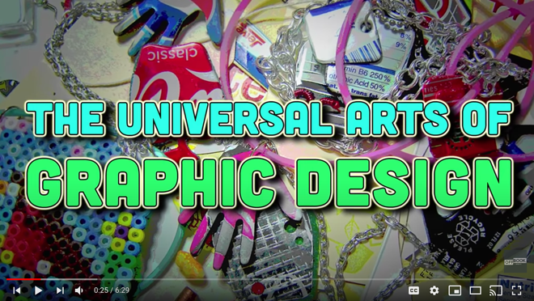
Watch & Learn – Design Careers  The Craft & Design Institute, 2015  Lexi Fontein talks Graphic Design  https://youtu.be/Ahy3EvFPJwM  (3:14) | 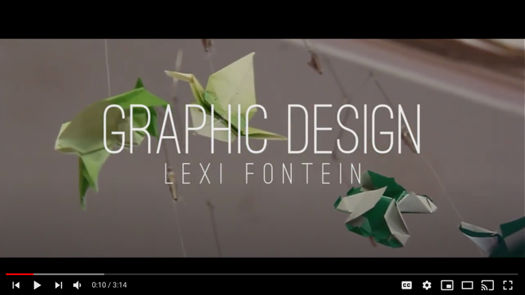
Watch & Learn – Day at Work  ConnectEd, 2013  Maurice Woods talks Graphic Design  https://youtu.be/BmBK0_vbYnY  (4:11) | 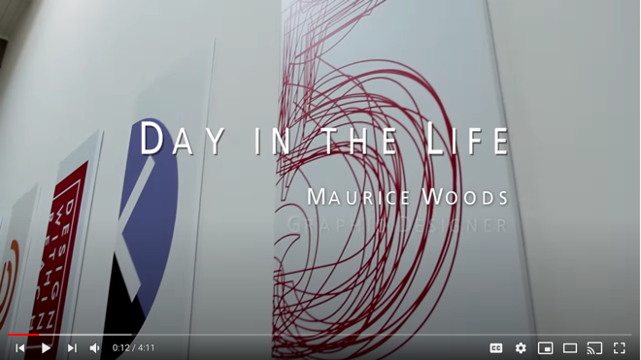
Watch & Learn – Nike Talent Presents  Nike Careers: Our Stories, 2013  Day in the Life with Nike Design  https://youtu.be/XfrK-n-ek-E  (3:53) | 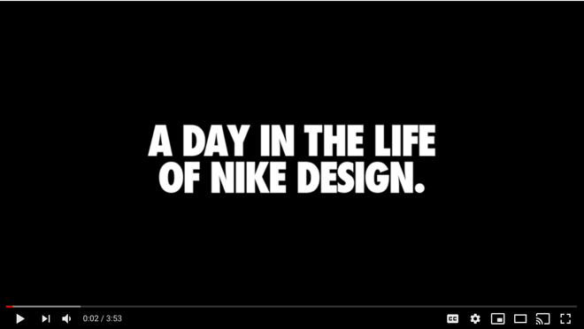

Activity 2 – Elements of Graphic Design
Watch & Learn – Fundamentals  GCFLearnFree.org, 2017  Beginning Graphic Design  https://youtu.be/YqQx75OPRa0  (6:25) | 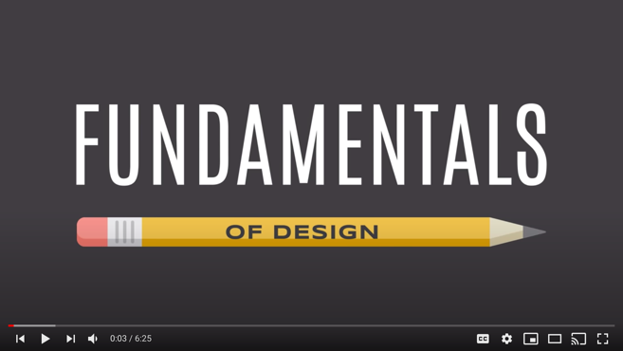
Watch & Learn – Beginning Graphic Design  GCFLearnFree.org, 2017  Images  https://youtu.be/MELKuexR3sQ  (5:46) | 
Watch & Learn –How Stamps Get Designed  AARP, 2016  Stamp Design - Antonio Alcalá  https://youtu.be/eKh3lq6SV84  (3:42) | 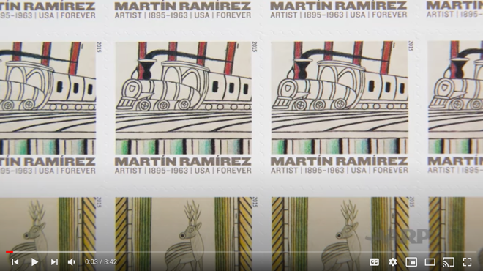
Watch & Learn –How Stamps Get Designed  D&AD – Creative Advertising, Design and Digital, 2019  2019 The Best Designs In The World  https://youtu.be/HCHzExdKeRM  (4:41) | 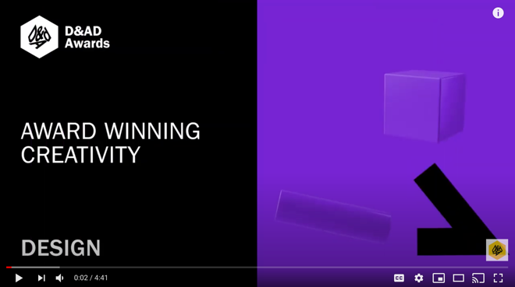

Activity 3 – The Power of Colour
Watch & Learn – Beginning Graphic Design  GCFLearnFree.org, 2016  Color  https://youtu.be/_2LLXnUdUIc  (6:32) | 
Watch & Learn – How to Use Colour  The Futur Academy, 2019  Colour Basics  https://youtu.be/QkCVrNoqcBU  (7:07) | 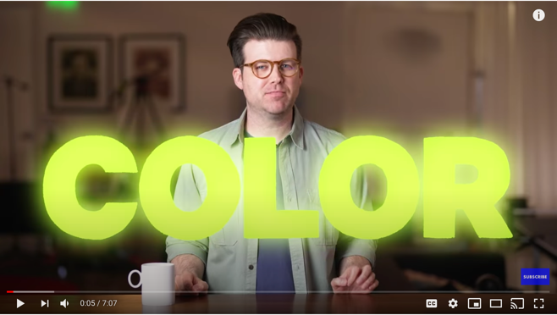
Read & Learn – Beginning Graphic Design  Goodwill Community Foundation, Inc., 2022  Colour A Closer Look  https://edu.gcfglobal.org/en/beginning-graphic-design/color/1/ | 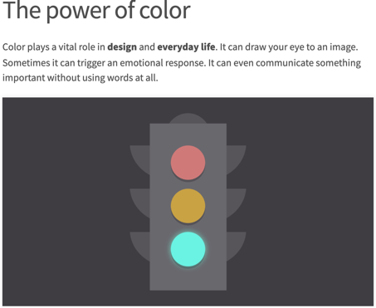
Watch & Learn – Understanding Colour Profiles  PiXimperfect, 2017  RGB vs CMYK  https://youtu.be/nkYqX1diJlo  (4:47) | 
Watch & Learn – Colour Psychology  Visme, 2019  Marketing Colour Psychology: What Do Colors Mean and How Do They Affect Consumers?  https://youtu.be/x0smq5ljlf4  (14:38) | 
Watch & Learn – Colour Beginner Guide  Flow Studio, 2017  Color Theory for Noobs  https://youtu.be/AvgCkHrcj90  (8:53) | 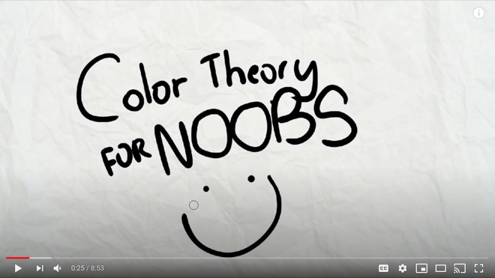
Read & Learn – Colour Psychology  Nicole Martins Ferreira, 2019  How Colour Meaning Affect Your Brand  https://www.oberlo.com/blog/color-psychology-color-meanings | 

Activity 4 – Create Vector Images
Watch & Learn – Vector Graphics  FlikliTV, 2015  What are Vector and Raster Graphics  https://youtu.be/-Fs2t6P5AjY  (1:47) | 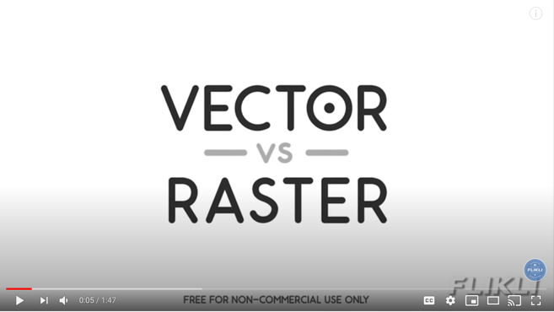
Watch & Learn – Buddy Media  Buddy Media, 2017  Raster and Vector Graphics  https://youtu.be/p2thSkOa_Xg  (2:36) | 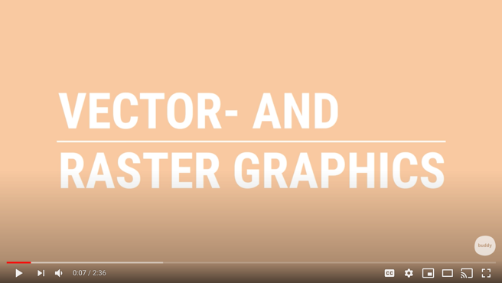
Software Tutorials – Adobe Photoshop  Watch & Learn – Photoshop  PHLEARN, 2020  How to Change the Colour of Anything  https://youtu.be/baW9jj0gs0w  (5:52) | 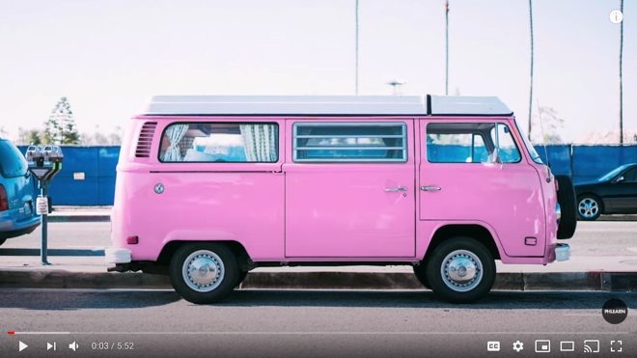
Adobe Photoshop Tutorials  Set up your Workspace Like a Pro  Adobe for Education, 2020  https://youtu.be/ewgSApe-oeU  (9:03) | 
Adobe Photoshop Tutorials
Working Smarter and Faster with Layers (Part 1)
Adobe for Education, 2020
https://youtu.be/xVM7c1HTmns
(10:09)
Adobe Photoshop Tutorials
Basic Design Rules that you Need to Know (Part 2)
Adobe for Education, 2020
https://youtu.be/7yILtiB_9H8
(10:25)

Adobe Photoshop Tutorials
The Many Possibilities of Photoshop
(Part 3)
Adobe for Education, 2020
https://youtu.be/1FyP2EGnnWU
(3:43)

Adobe Photoshop Tutorials
Simple Edits to Make Photos Stand Out
(Part 4)
Adobe for Education, 2020
https://youtu.be/L7MTU3P2uG4
(10:22)

Appendix C - Assessments – Peer and Self Evaluations
Name __________________________________ Date______________

Self-Assessment Sheet

- Describe the tasks you consider to be the best work that you were involved with during this project?
_________________________________________________________________
_________________________________________________________________
- What difficulties, if any, did you have with the activities you were involved in for this project?
_________________________________________________________________
_________________________________________________________________
- How did you overcome them (or attempt to)?
_________________________________________________________________
_________________________________________________________________
- Briefly describe what you learned during this project.
_________________________________________________________________
_________________________________________________________________
- Rate YOURSELF on a scale of 1-10 on your commitment and involvement level in this project, from conception to completion. (Consider this carefully. Your assessment and that of your teacher should be closely matched. Be prepared to defend your mark) ___________

Name __________________________________ Date______________

Peer Evaluations

List at least 1 item that you feel is great in the design and should stay. | List at least 1 item in the design that you feel needs some more work. And list a suggestion on how to change it.

References
21st Century Competencies: Foundation Document for Discussion. Phase 1: Towards Defining 21st Century Competencies for Ontario, Winter 2016 Edition, 2016 http://www.edugains.ca/resources21CL/About21stCentury/21CL_21stCenturyCompetencies.pdf
2019 The Best Designs In The World, D&AD – Creative Advertising, Design and Digital, (video) 2019 https://youtu.be/HCHzExdKeRM
Activity 1 - Exploring the Role of a Graphic Designer Worksheets, OCTE, 2022 https://docs.google.com/document/d/1y8ZEPGE4zEdsoxl_B-sm96IKlUFhqAJd4rg5byHfBiw/edit?usp=sharing
Activity 2 – Elements of Graphic Design, OCTE, 2022 https://docs.google.com/document/d/1kzfzZeZhQEK6UayEQZ51P3vxaXIcU4x-0q9n5B2POLw/edit?usp=sharing
Activity 3 – The Role of Colour, OCTE, 2022 https://docs.google.com/document/d/1TPwd7Y2IsScqPfJXz4KUpgPR78W_l66MgpEdedeIQm8/edit?usp=sharing
Activity 5 – Think, Pair, Share - Genres of Greeting Cards, OCTE, 2022 https://docs.google.com/document/d/1Fvf57ytL1f9oCddZ_C2QTWl_yKcqxFZaj5EzJtAgC5I/edit?usp=sharing
Activity 6 – Jigsaw - Greeting Card Slogans and Phrases, OCTE, 2022 https://docs.google.com/document/d/1l7LjzDl1UMTuSi91GJ_J87P8MWWi1JtgyqJeAJxLTcY/edit?usp=sharing
Adobe Creative Cloud, Adobe (website), 2022 https://helpx.adobe.com/ca/creative-cloud/tutorials-explore.html
Adobe Create Digital Magazine, Adobe (website), 2022 https://creativecloud.adobe.com/discover
Adobe Education Exchange, Adobe (website), 2022 https://edex.adobe.com/
Adobe for Education, Adobe (YouTube channel), 2022 https://www.youtube.com/channel/UCEgdeceOHkMqiGFiSGoNZEQ
Adobe Photoshop (software), 2022 https://www.adobe.com/ca/products/photoshop.html?cgen=RYGDMZR9&mv=other
Basic Design Rules that you Need to Know, Adobe for Education (video), 2020 https://youtu.be/7yILtiB_9H8
Beginning Graphic Design – Color: The Power of Color, Goodwill Community Foundation, 2022 https://edu.gcfglobal.org/en/beginning-graphic-design/color/1/
Beginning Graphic Design: Fundamentals, GCFLearnFree.org (video), 2017 https://youtu.be/YqQx75OPRa0
Burst, Shopify (website), 2022 https://burst.shopify.com/
College of Trades Training Standards https://www.collegeoftrades.ca/training-standards
Color, GCFLearnFree.org (video), 2016 https://youtu.be/_2LLXnUdUIc
Color Theory for Noobs, Flow Studio (video), 2017 https://youtu.be/AvgCkHrcj90
Colour: A Closer Look, Goodwill Community Foundation, Inc., 2022 https://edu.gcfglobal.org/en/beginning-graphic-design/color/1/
Communication Arts, Coyne & Blanchard, Inc. (website), 2022 https://www.commarts.com/
Colour Basics, The Futur Academy (video), 2019 https://youtu.be/QkCVrNoqcBU
Day in the Life with Nike Design, Nike Careers: Our Stories (video), 2013 https://youtu.be/XfrK-n-ek-E
Elements of Design, OCTE (PowerPoint presentation), 2022 https://docs.google.com/presentation/d/1zl1suVHT5Wh6u9j9kVqVlTIZnUfBGu0L/edit?usp=sharing&ouid=116677686394080626597&rtpof=true&sd=true
Exploring Colour, OCTE (PowerPoint presentation), 2022 https://docs.google.com/presentation/d/1ct93jXjje7oGrJYfeRj45bRSgP13Mims/edit?usp=sharing&ouid=116677686394080626597&rtpof=true&sd=true
GCFLearnFree.org , Goodwill Community Foundation, Inc. (website), 2022 https://edu.gcfglobal.org/en/
Gimp (software), 2022 https://www.gimp.org/
Growing Success: Assessment, Evaluation, and Reporting in Ontario Schools, First Edition, Covering Grades 1 to 12, 2010 www.edu.gov.on.ca/eng/policyfunding/growSuccess.pdf
Google Read & Write, Texthelp Ltd. (website), 2015 https://support.texthelp.com/help/readwrite-7fdf2ac
Greeting Card, Greeting Card Association (website), 2022 https://www.greetingcard.org/
How Colour Meaning Affect Your Brand, Nicole Martins Ferreira, 2019 https://www.oberlo.com/blog/color-psychology-color-meanings
How to Change the Colour of Anything, PHLEARN (video), 2020 https://youtu.be/baW9jj0gs0w
Images, GCFLearnFree.org (video), 2017 https://youtu.be/MELKuexR3sQ
Kahoot – Colors, Colors, Colors, Kylesni (Kahoot), 2016 https://create.kahoot.it/details/colors-colors-colors/8f211b37-cebd-46d8-a8db-2c531f2dbf5e
Kahoot – Graphic Design, Ashley Sullivan (Kahoot), 2014 https://create.kahoot.it/details/graphic-design/170603fa-8bbc-4aa1-9b16-0147d4caae68
Learn Gimp, Gimp (website), 2022 https://www.gimp.org/tutorials/
Learn Pixlr, Pixlr (website), 2022 https://pixlr.com/learn/
Learning for All – A Guide to Effective Assessment and Instruction for All Students, Kindergarten to Grade 12, 2013 http://www.edu.gov.on.ca/eng/general/elemsec/speced/LearningforAll2013.pdf
Lexi Fontein talks Graphic Design, The Craft & Design Institute (video), 2015 https://youtu.be/Ahy3EvFPJwM
Marketing Colour Psychology: What Do Colors Mean and How Do They Affect Consumers?, Visme (video), 2019 https://youtu.be/x0smq5ljlf4
Maurice Woods talks Graphic Design, ConnectEd (video), 2013 https://youtu.be/BmBK0_vbYnY
Monkey’s Dream (YouTube channel), 2022 https://www.youtube.com/channel/UCqUKAn0tedh4b66uOY-Y6pg
OCTE SAFEDocs for BBT Technology, OCTE (website), 2022 https://www.octe.ca/en/resources/safety/safedocs
Peer Evaluation Sheet, OCTE, 2022 https://docs.google.com/document/d/1dYwD63UwVjLeoJ3s5iIxrEJVnfCNZwqjom5PzhRNIUc/edit?usp=sharing
PetaPixel (website), 2022 https://petapixel.com/
Pexels, Pexels (website), 2022 https://www.pexels.com/
Photo News, PHOTO News Magazine (website), 2022 https://www.photonews.ca/
Pixabay, Pixabay (website), 2022 https://pixabay.com/
Pixlr (software), 2022 https://pixlr.com/
Quick Reference Guide, Texthelp (Fliphtml5), 2021 https://fliphtml5.com/anquk/npfj/basic
Resources, Ontario College of Trades, 2020 https://www.collegeoftrades.ca/resources
Raster and Vector Graphics, Buddy Media (video), 2017 https://youtu.be/p2thSkOa_Xg
Red SEAL – Sceau Rouge, 2018 http://www.red-seal.ca/trades/tr.1d.2s_l.3st-eng.html
RGB vs CMYK, PiXimperfect (video), 2017 https://youtu.be/nkYqX1diJlo
Role of a Graphic Designer, OCTE (PowerPoint presentation), 2022 https://docs.google.com/presentation/d/1gZ-ALyCx6KGCGbZmGhivcuqsLtT3gvqm/edit?usp=sharing&ouid=116677686394080626597&rtpof=true&sd=true
Self – Assessment Sheet, OCTE, 2022 https://docs.google.com/document/d/1sCNNW4BM1VQitibn4Gn9j94x5e6S8wcmfqC9y9bmrdQ/edit?usp=sharing
Set up your Workspace Like a Pro, Adobe for Education (video), 2020 https://youtu.be/ewgSApe-oeU
Simple Edits to Make Photos Stand Out, Adobe for Education (video), 2020 https://youtu.be/L7MTU3P2uG4
Skilled Trades Identified in Ontario https://www.collegeoftrades.ca/wp-content/uploads/Sector_Brochure_One_Pager_web.pdf
Skilled Trades Ontario https://www.ontario.ca/page/skilled-trades
Stamp Design - Antonio Alcalá, AARP (video), 2016 https://youtu.be/eKh3lq6SV84
StockSnap.io, StockSnap (website), 2022 https://stocksnap.io/
The Apprenticeship Advantage, Ontario College of Trades, 2020 https://www.collegeoftrades.ca/wp-content/uploads/ApprenticeshipAdvantage_English_web.pdf
The Differentiated Instruction Scrapbook http://www.edugains.ca/resourcesDI/EducatorsPackages/DIEducatorsPackage2010/2010DIScrapbook.pdf
The Many Possibilities of Photoshop, Adobe for Education (video), 2020 https://youtu.be/1FyP2EGnnWU
The Noun Project, Noun Project Inc. (website), 2022 https://thenounproject.com/
The Ontario Curriculum, Grades 9 and 10: Technological Education, 2009 (revised) http://www.edu.gov.on.ca/eng/curriculum/secondary/teched910curr09.pdf
The Secret World of Annie Atkins, Graphic Designer for Films I Adobe Creative Cloud, Adobe Creative Cloud (video), 2016 https://youtu.be/flMespYYwTw
The Universal Arts of Graphic Design, PBS Digital Studios (video), 2012 https://youtu.be/sTi5SNgxE3U
Typography, OCTE (PowerPoint presentation), 2022 https://docs.google.com/presentation/d/1POds67ZqIWZi5KvFak8h6JBoDtn5mYnP/edit?usp=sharing&ouid=116677686394080626597&rtpof=true&sd=true
Unsplash, Unsplash (website), 2022 https://unsplash.com/
What are Vector and Raster Graphics, FlikliTV (video), 2015 https://youtu.be/-Fs2t6P5AjY
Working Smarter (and Faster) with Layers, Adobe for Education (video), 2020 https://youtu.be/xVM7c1HTmns

