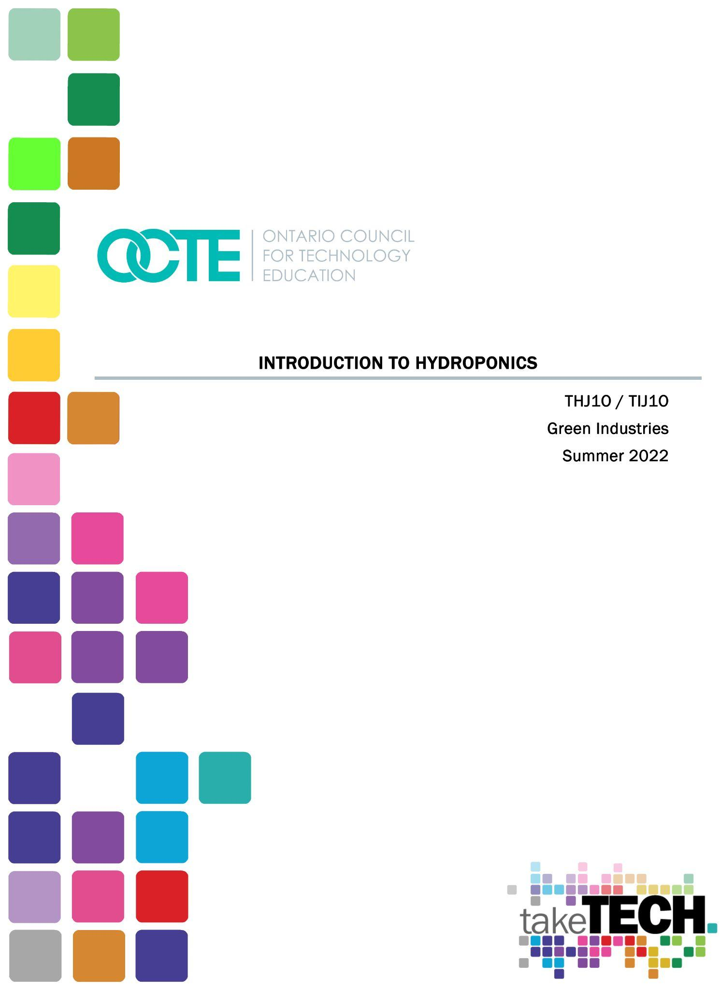

Table of Contents

Introduction 2
Project Outline 2
Prior Knowledge 2
Student Activities 2
Activity 1 – Hydroponic Research Project 2
Activity 2 – Seed Propagation 3
Activity 3 – Build a Hydroponic Water Culture System 4
Activity 4 – Hydroponic System Care and Maintenance 4
Culminating Activity – Harvesting Lettuce 5
Planning Notes 5
Skilled Trades and Apprenticeship Opportunities 5
Skills Continuum 6
Career and Industry Extensions 6
Resources 7
Files 7
Lesson Plans 7
Handouts 7
Journals/Magazines 7
Pictures/Blueprints 8
Tools/Equipment 8
Materials 9
Websites for Teachers 9
Instructional Strategies 10
The Hook / Motivational Strategies 10
Learning Goals and Success Criteria 10
Overall and Specific Expectations in Support of Ontario Curriculum Grades 9 - 10 Technological Education 11
Overall Expectations 11
Specific Expectations 11
Safety Concerns (including PPE if required) 13
Applicable SAFEDocs and ToolSAFE videos 13
Project Challenges 13
Differentiation of the Project / Activity 13
Assessment and Evaluation 14
Assessment As Learning 14
Assessment For Learning 14
Assessment Of Learning 14
Religious Considerations 14
Career and Industry Extensions 14
Ethical Considerations 15
Environmental Considerations 15
Reflection or Design Report 15
Appendix A – Hydroponic Research Project 16
Appendix B – Seed Propagation 17
Appendix C – 10 Seed-Starting Tips 20
Appendix D – Requirements for Good Plant Growth 23
Appendix E – Seed Package Assignments 29
Appendix F – Building Hydroponic Water Culture System 33
Appendix G – Hydroponic System Care and Maintenance 34
Appendix H – Culminating Activity 37
References 38

Introduction
Course Code: THJ1O / TIJ101
Broad base Technology: Green Industries
Destination: Open
Grade Level: 9
Prerequisite: None
Project Name: Introduction to Hydroponics

Project Outline
During this unit we will learn about the main parts of a plant and describe the function that they perform. We will attempt to create proper environmental conditions for plant germination as well as growing plants hydroponically.

Prior Knowledge
Prior knowledge of hydroponic systems, seed planting, hand tools, and fertilizer use is helpful but not required. Prior knowledge of volume calculations, and MS Office is also helpful but not required.

Student Activities

Activity 1 – Hydroponic Research Project
Students will be given the opportunity to explore and research different hydroponic systems that are currently used in the industry. They will gain some knowledge about different systems but may not find the correct information.
Hydroponic Research Project
Once the students have completed this worksheet begin with the Introduction to Hydroponics PowerPoint. This will provide a history of hydroponics as well as ensure the students have the correct information on each of the industry used systems.
Introduction to Hydroponics PowerPoint
Hydroponic Student Summary Graphic Organizer

Activity 2 – Seed Propagation
Students will be provided the 10 Seed Starting Tips article with questions to read and answer. This article provides a general overview of planting seeds and assists in providing the correct steps. A copy of the article has been provided for differentiated instruction. For students that have difficulties with reading and comprehension the modified copy has the question numbers in the margins to assist them in narrowing the passage that they need to review for the answers. There may also be text to speech readers that they can use to listen to the article. The Seed propagation note that you will discuss with the class to ensure that everyone knows all the factors required for good plant growth.
10 Seed Starting Tips article
Seed Propagation Note
Requirements for Good Plant Growth
Part of being able to plant seeds is knowing the correct information. Most seed packages will provide you the information you need to plant the seeds successfully.
There are two worksheets with seed package information for you to review.
Question: Why do we want to select locally produced seeds?
Answer: This is due to the climate and soil conditions in the area that you are growing in. It might not make a difference for growing hydroponically but it will have an impact on traditional growing methods.
Seed Package with Questions Worksheet – Tomato
Seed Package with Questions Worksheet - Lettuce

You will need to plant your seeds for the hydroponic system. The lettuce seeds should take about 3 to 7 days to germinate. This should give you enough time to construct the reservoir and raft to hold the seedlings. You will need to have each group plant enough seeds for their system. I would suggest each group plant 4 to 5 extra seeds as some seeds might not germinate or they may get damaged in the process.
After the seeds have germinated, they can be transplanted into the hydroponic system. Do not begin to fertilizer the seedling until they have grown their first set of true leaves. If you start too soon, you will burn the plant and it may die.

Activity 3 – Build a Hydroponic Water Culture System
1) You will be constructing your Hydroponic Water Culture reservoir from a container that you have selected or something that can be reused. This reservoir should be approximately 30L to 50L in size to be able to have enough water for the plants as well as creating a nutrient solution that will be simplified for the students.
2) ½” to 1” Styrofoam will be needed to construct the floating raft that will sit on top of your reservoir.
3) Design and layout for the holes to allow the seedlings to sit in the nutrient solution for growing. For these holes you will need to consider the size of the plants that you are growing. On the seed package it will give you the plant pacing requirements. I suggest using a leaf lettuce as they require smaller plant spacing. Providing the students with the number of plants they are required to have in the system will work the best as there is always a different understanding of the instructions. The other factor for the hole sizes will be the materials that you used to plant your seeds, Jiffy pot plugs or rockwool blocks have different sizes. You want to have a snug fit as the raft will also support your seedlings as they grow. If the holes could have a taper towards the bottom this would be best as this will keep the plug from fully falling through the raft.

Activity 4 – Hydroponic System Care and Maintenance
For the care and maintenance of the hydroponic system you will have to determine an operating level for the system. Teaching the students to calculate the total volume of the container is a start. You want to make the operating level of the system close to the top of the container as this will allow your plants the most-light for growing.
Calculating Hydroponic Reservoir Volume
You want to make sure your operating level is an easy number to use for creating your nutrient recipe. This will help the student to remember the information.
Nutrient Solution Calculations worksheet
You need to review the factors that need to be monitored when caring for a hydroponic system. This can be covered as a note or provided as a handout depending on the amount of time allowed.
Hydroponic Care and Maintenance
Hydroponic Daily Log

Culminating Activity – Harvesting Lettuce
The culminating activity is successfully creating a water culture hydroponic system and growing your plants until being able to harvest them. There will be a reflective report required to be submitted at the end of the unit.
Engineering Report

Planning Notes
Teachers will be able to work through the unit outline as it is set up in the google drive folder. Each lesson, worksheet and activity has been organized into a chronological order for you to follow.
Teachers should review materials prior to delivering the lesson/ worksheet so they can explain how to complete the student portion.
The main activities have been listed above for the students to complete; however, there is additional background information provided to you to assist the students in completion of this work.
All the electronic resources have been provided and can be linked to an online classroom platform or printed to students to complete. These resources can be either summative or formative assessments and can have due dates applied.
Students are given formative research to begin the process of hydroponic discovery. Most of the information gained by the students will be reinforced by the teacher lessons and the hands-on activity.
Teachers will need to acquire the necessary materials to have the class actively grow plants hydroponically. If it is not feasible to do this then obtaining the materials for one system could provide some hands-on experience.

Skilled Trades and Apprenticeship Opportunities
Arborist; Algonquin College, Fanshawe College, Fleming College
Heavy Equipment Operator; Cambrian College, Centennial College, Conestoga College
Horticulture Technician; Niagara College, Mohawk College

Skills Continuum
We all have different moments in our lives where we are affected by an experience. This can include learning a new concept or skill, experiencing something for the first time, taking a new course, developing a talent through practice and hard work, or calling upon a skilled tradesperson to fix, repair, design, construct, maintain, build, bake, and create innovative solutions. The continuum of influence is a graphic representation of how those experiences can lead to developing a passion and talents in areas of green industries as a landscape designer, arborist, natural resource officer, horticulturist, landscaper, botanist, greenhouse grower, farmer, nursery owner, flower shop employee, etc.

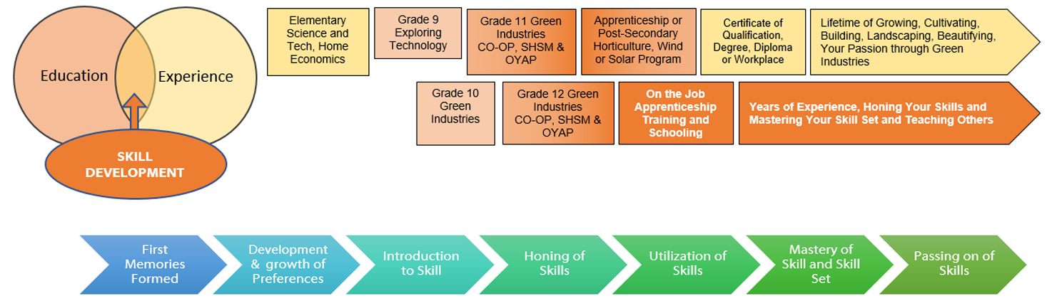

Career and Industry Extensions
There are many careers and green industry positions available. The following are some of the positions available,
- landscape designer
- arborist
- natural resource officer
- horticulturist
- horticulture technician
- landscaper
- lawn/property maintenance
- greenhouse grower
- farmer
- nursery owner
- flower shop employee

Resources

Files
Hydroponic Research Project

Lesson Plans
PPT - Introduction to Hydroponics
10 Seed Starting Tips Article with Questions
Seed Package Note
Calculating Hydroponic Reservoir Volume
Requirements for Good Plant Growth
Nutrient Solution Note

Handouts
Hydroponic Student Summary Graphic Organizer
Seed Propagation Handout
Seed Package with Questions worksheet – Tomato (F)
Seed Package with Questions worksheet – Lettuce (S)
Calculating Hydroponic Reservoir Volume - Worksheet
Hydroponic Daily Maintenance log worksheet

Journals/Magazines
https://www.finegardening.com/project-guides/gardening-basics/10-seed-starting-tips

Pictures/Blueprints

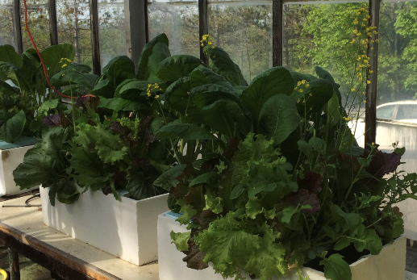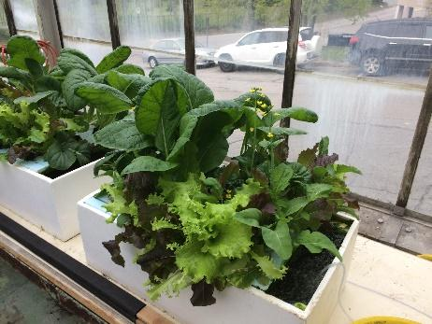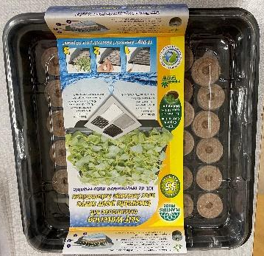
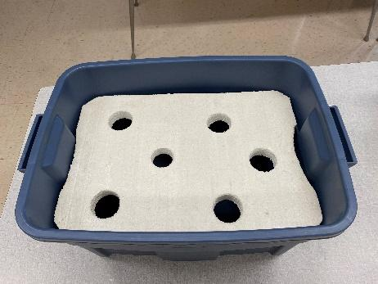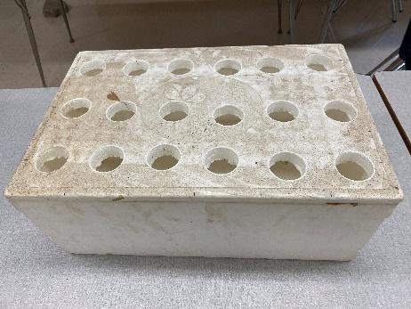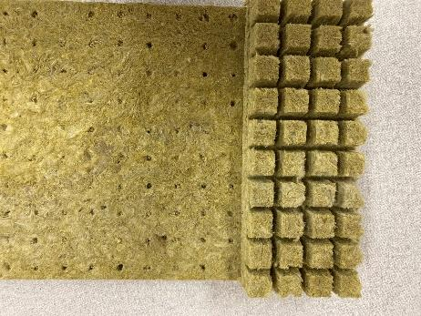

Tools/Equipment
Water holding container, approximately 30L to 50L holding capacity.
Styrofoam for floating raft to hold seedlings
Air pump to oxygenate the water
Air stone
¼” dia. Tubing to connect air pump with the air stone
Scale to weigh out fertilizer
Hole saw - to create a hole in Styrofoam to hold seedlings
Measuring tapes find the volume of the reservoir

Materials
Water holding container, approximately 30L to 50L holding capacity.
Styrofoam for floating raft to hold seedlings
Rockwool or Jiffy Pucks to start seeds.
Fertilizer to feed the plants
Toothpicks to hold seedlings in Styrofoam raft holes
Lettuce seeds – use a variety of types

Websites for Teachers
Plant Physiology: Photosynthesis, Respiration, and Transpiration
https://cmg.extension.colostate.edu/Gardennotes/141.pdf
Plant Growth Factors: Light
https://cmg.extension.colostate.edu/Gardennotes/142.pdf
Plant Growth Factors: Temperature
https://cmg.extension.colostate.edu/Gardennotes/14
Drip System Hydroponics Pros and Cons (And how to avoid them)
https://plantsheaven.com/drip-system-hydroponics-pros-and-cons/
UMass Extension Greenhouse Crops and Floriculture Program https://ag.umass.edu/greenhouse-floriculture/fact-sheets/hydroponic-systems
7 Different Types of Hydroponic Systems https://www.nosoilsolutions.com/6-different-types-hydroponic-systems/
6 Types of Hydroponic Systems Explained
https://sensorex.com/blog/2019/10/29/hydroponic-systems-explained/
Best Plants to Grow Hydroponically https://hyper-grow.com/news/best-plants-to-grow-hydroponically/
Hydroponic Systems
https://www.epicgardening.com/hydroponic-systems/

Instructional Strategies
Teachers may use any of the following instructional strategies; 3-Part lesson, lecture, storyboard, word wall, think-pair-share, placemat activity, rapid write, K-W-L, anticipation chart, ABC taxonomy, think aloud, analyzing text, Cornell note taking, exit ticket/ticket out the door, plus/minus/delta, etc.

The Hook / Motivational Strategies
Hydroponics is an exciting method of growing plants without soil. Allowing students to construct and grow their own plants can be very engaging.

Learning Goals and Success Criteria
- To identify the parts of a seed and the functions of each.
- To prepare a medium for seeds, sow seeds, and provide the proper conditions for germination.
- To water, fertilize, and harden off seedlings before transplanting.
- To transplant seedlings into flats, pods or rockwool cubes.
- To identify different hydroponic systems and their benefits.
- To learn about plant maintenance and the effect on the overall plant health.
- To learn about specific nutrient requirements for hydroponic plants.
- Students will grow their own plants
- Complete an Engineering Report

Overall and Specific Expectations in Support of Ontario Curriculum Grades 9 - 10 Technological Education

Overall Expectations
A1. Demonstrate an understanding of plant and/or animal biology and species classification as they relate to the green industries;
A2. describe the factors affecting the growth and care of plants and/or animals;
A3. Demonstrate an understanding of design and planning processes and their application to a variety of requirements in the green industries;
A4. Use mathematical, documentation, research, and communication skills as they apply to the green industries.
B1. apply effective design and production practices as they relate to a variety of green industries;
C1. Identify the impact of green industries on the environment and describe ways of minimizing harmful effects;
D1. Demonstrate an understanding of and comply with occupational health and safety standards.

Specific Expectations
A1.2 Identify the basic components of common plants and/or animals and describe their functions (e.g., leaves, flowers, bark, internal organs);
A2.1 Describe environmental factors that affect growth and post-harvest quality (e.g., light, temperature, soils, nutrients, water, wind);
A3.1 Describe the steps in a design or planning process (see pp. 22–23) and demonstrate an understanding of their application to a variety of requirements in the green industries (e.g., preparing environmental farm plans, urban forestry management plans, landscape designs; designing water gardens, mass arrangements);
A3.2 Describe common operational processes that are used in the green industries (e.g., single animal management, crop location and rotation, crop scheduling, event planning;
A3.4 Demonstrate an understanding of correct procedures for the care and handling of plants and/or animals (e.g., propagating, pruning, transporting, watering, feeding, fertilizing);
A4.1 Demonstrate an understanding of terminology used in the green industries and use it correctly in oral and written communication (e.g., hardwood, propagation, line flower, vine, topsoil);
A4.2 Use effective documentation practices to record and track important information related to green industry operations (e.g., preparing estimates, inventories, and invoices; maintaining cleaning and maintenance records, food source records, pesticide field logs, crop management records);
A4.4 Use appropriate calculations and units of measurement when completing a variety of green industry tasks (e.g., calculating fertilizer and preservative applications, yields, basal areas; surveying; calibrating sprayers; converting between metric and imperial units);
B1.1 Implement a production process or procedures according to a design or plan (e.g., harvest a crop, construct a landscape, grow and cultivate plants, make floral arrangements);
B1.4 Apply techniques relating to the maintenance, care, and handling of plants and/or animals, using environmental best practices (e.g., mulching gardens, feeding and watering, product processing, visual inspection);
C1.1 Identify ways in which green industry activities affect the environment (e.g., contamination of water by fertilizers, pesticides, and manure; emission of greenhouse gases from animals, tilled soils, and equipment; emission of air pollutants from gasoline- and diesel-powered machinery; noise pollution; high energy demand);
D1.1 Identify the personal protective clothing and equipment needed to perform various green industry tasks safely, and use as required to ensure their own and others’ safety in the work environment (e.g., eye and ear protection, hand and foot protection, head protection, sun protection, equipment guards);
D1.6 Identify sources of information about workplace hazards and how to avoid them (e.g., Workplace Hazardous Materials Information System [WHMIS], Passport to Safety);
D2.3 Identify groups and programs that are available to support students who are interested in pursuing non-traditional career choices in the green industries (e.g., mentoring programs, virtual networking/support groups, specialized postsecondary programs, relevant trade/industry associations).

Safety Concerns (including PPE if required)
Teachers should follow the manufacturer’s instructions when dealing with any chemicals and that includes fertilizer. Students and staff should wear gloves & safety glasses or goggles when handling fertilizer. If you chose to build your own planters or hydroponic system, please refer to OCTE’s SAFEdocs and ToolSAFE videos as additional personal protective equipment may be required.

Applicable SAFEDocs and ToolSAFE videos
Please refer to the OCTE SAFEDocs for BBT Technology for safety documents in order to properly address and instruct this project.
There are minimal safety concerns with this project. Using a cordless drill with a hole saw bit or a knife will be required. Review of the following documents would be beneficial.
Cordless Drill safety with hole saw bits
Utility Knife safety

Project Challenges
As a group construct a water culture hydroponic system to grow leafy greens. The system will be monitored daily, weekly until the greens are ready to be harvested. (Could have a salad bar day to eat the lettuce.)

Differentiation of the Project / Activity
Teachers can also refer to the Differentiation Scrapbook to take into account learner ability, multiple intelligences, exceptional students, and ESL learners.
Included in this Introduction to Hydroponics Unit is a graphic organizer for your applied / academic learner to have them summarize their thoughts and create questions to consolidate their learning. There is also a written note with the same information accompanied with a student handout for an SSTC or SSTW learner to have them fill in key points from the note to consolidate their learning.
Another way that differentiation can be provided is by numbering your questions in the margin of an article that students need to read and respond to questions. This helps narrow the passage that they need to scan to find the correct answer.

Assessment and Evaluation
Hydroponics Guide to Success

Assessment As Learning
This is where the students can take the information provided and make their own decisions on how to make the project successful. Being able to monitor the hydroponic systems and determine if water, nutrients or pH need adjustments for the overall health of the plants.

Assessment For Learning
This is where the students will be exposed to discovery and learning about the process. There are a few activities built into the unit to assist with this. The Hydroponic research project to allow them discovery of the different industry used systems and their advantages or disadvantages. 10 Seed Starting tips for students that have not had the opportunity to plant seeds before and to show them how to plant successfully.

Assessment Of Learning
This is the marker for the students to provide their success. Working thought the unit they will be able to demonstrate and understand key factors in being able to grow plants hydroponically. They will be able to calculate the reservoir volume to ensure that the nutrient levels are correct. They will be able to measure the fertilizer to ensure the plants are receiving enough nutrients. Observation of how well the plants are growing and their success at harvesting time.

Religious Considerations
- Due to the variable nature of student project topics, religious considerations should be assessed on a project-to-project basis.
- Some plants are used for ceremonies and celebrations, and you should be aware of their significance.

Career and Industry Extensions
This project is an introduction to Hydroponics, it is a very basic system to provide student success. This may engage students that might be looking at a Green Industries career path.

Ethical Considerations
Ethical considerations may be to discuss the difference between organic and non-organic fertilizers. This could provide a comparison between the student systems and be able to track progress.

Environmental Considerations
Reuse, Recycle and repurpose to create your hydroponic reservoirs.
Success of growing your own food, reduces transportation of food to the grocery store.
Being able to grow plants without using herbicides and pesticides.
Using Organic or Non-organic fertilizer

Reflection or Design Report
Teachers may wish to have the students complete a design report, reflection or create a foldable to consolidate their learning. This would be a nice way to capture the student’s understanding in a summative format and be used in preparation for their examination, entering post-secondary education or the workforce.
This will be part of the Culminating activity, to create an Engineering Report for the unit.

Appendix A – Hydroponic Research Project
Click to access the Hydroponic Research Project Assignment and sample answer sheet.
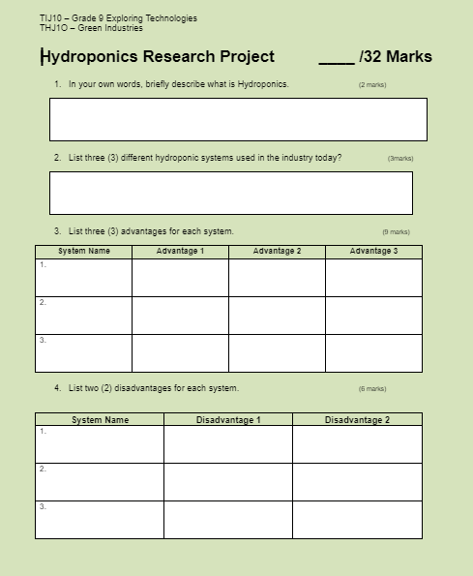
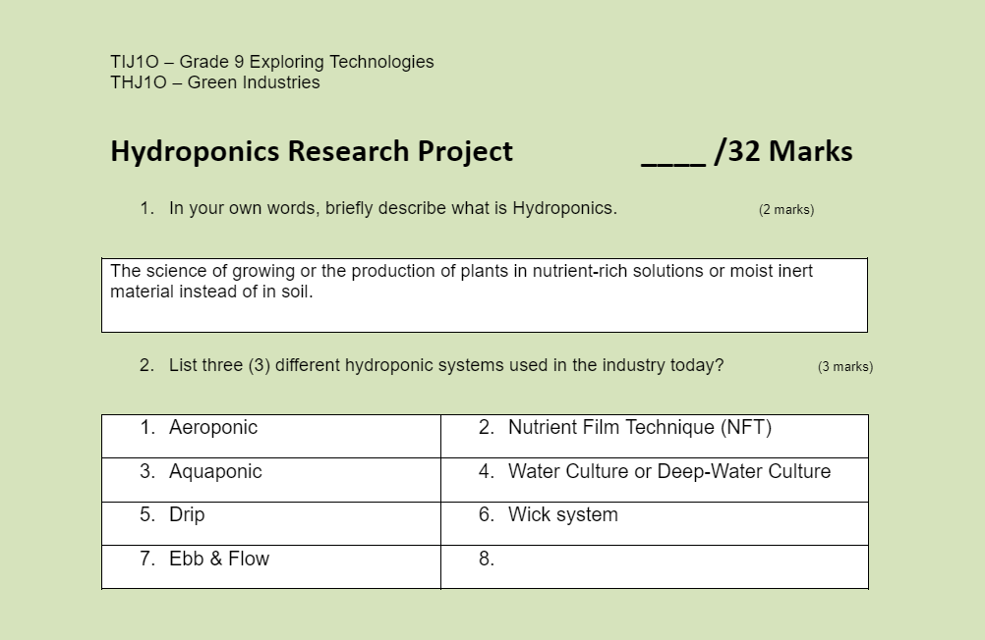

Appendix B – Seed Propagation
Excerpts from the seed propagation handout include,
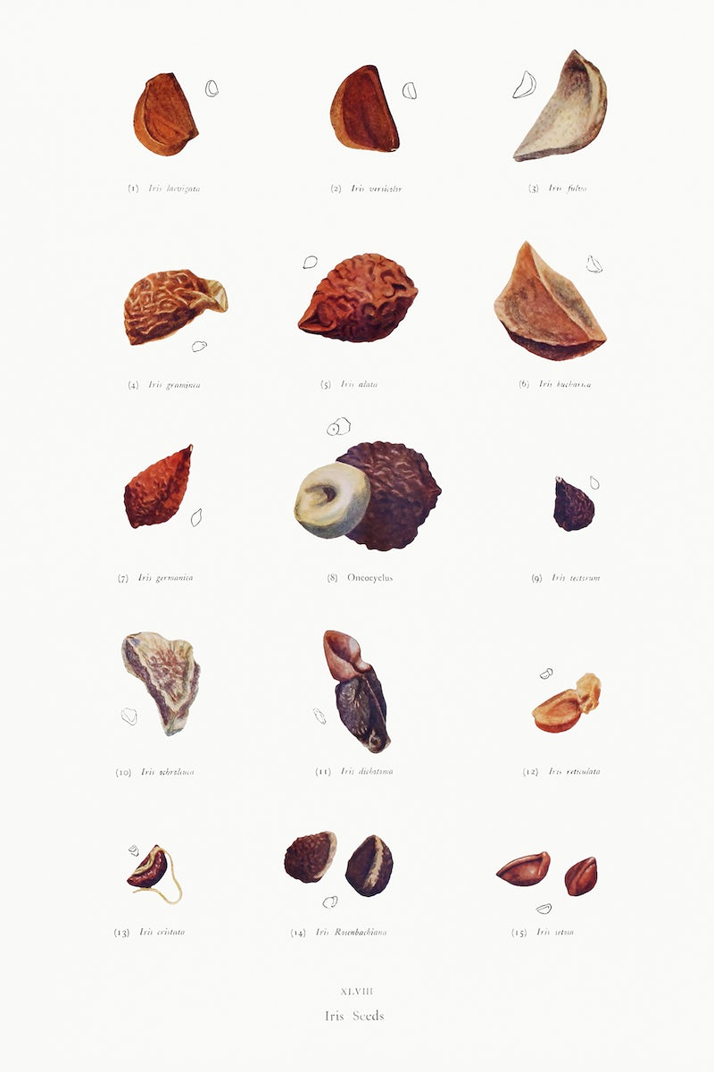
Selection of Seed

There are several important steps in the selection of seed.
- Select seeds that are grown locally.
- Select seeds that have been tested for their germination ability.
- Purchase the seeds from a reliable dealer; to assure that the germination ability is acceptable.
- Choose hybrid varieties for greater vigor, uniformity, and flowering ability.
- Select uniform heavyweight or primed seeds.

Composition of Seeds
The basic parts of a seed are the seed coat, the endosperm (stored plant food), and the embryo. The seed coat is the outside covering of the seed that protects the embryonic plant. The seed coat makes it possible for the seeds to be transported and stored for long periods of time. The endosperm is the food storage tissue that nourishes the embryonic plant during the germination (the first start of growing in a seed). The embryo is a new plant that develops because of fertilization. During germination, it extends its roots and seed leaves to form a new plant.

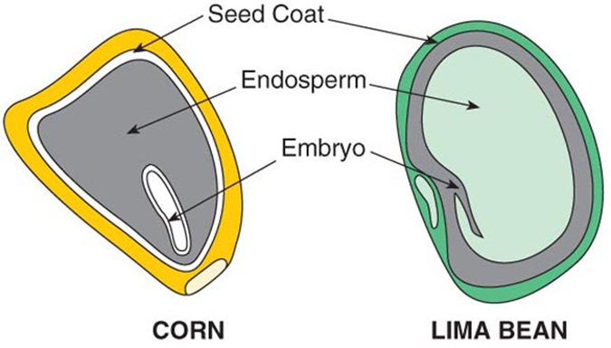

Propagation
Many annuals or vegetable plants are started from seed because it is quick and economical method. Proper conditions must be provided for successful germination: temperature, moisture, light, and medium. Annuals complete its life cycle in 1 year.

Germination Medium
The best medium for germination has a favourable pH level and adequate supply of plant nutrients. It is from Porous, uniform in texture, sterile, and free of weeds, insect, and disease organisms. A good germinating medium contains one or more of the following: Soil, Construction grade sand, Peat moss, Sphagnum moss, Horticulture grade perlite, Vermiculite.
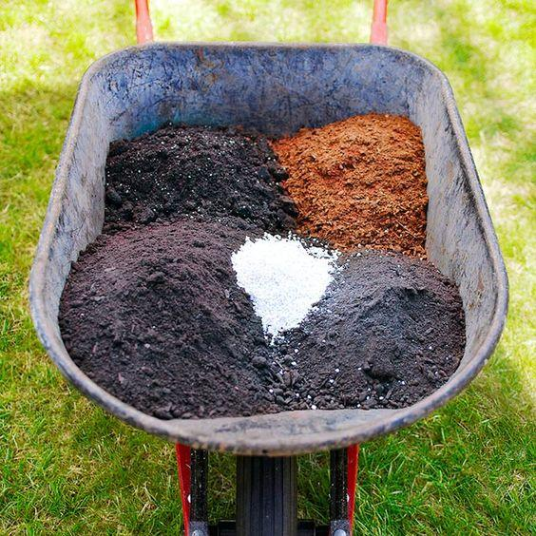

Transplanting Seedlings
After seeds germinate, they develop seed leaves or cotyledons, the first leaves to appear on the plant. The plant should be allowed to grow until the first sets of true leaves are present before transplanting. When transplanting seedlings; handle the plant by its true leaves between your thumb and index finger. Do not hold the plant by the stem; if the stem becomes bruised or damaged the seedling could die.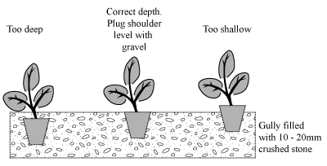

Appendix C – 10 Seed-Starting Tips
The 10 Seed-Starting Tips article from Fine Gardening written by Adrianna Vargo is accompanied by the “10 Seed-Starting Tips” activity worksheet and corresponding answer sheet
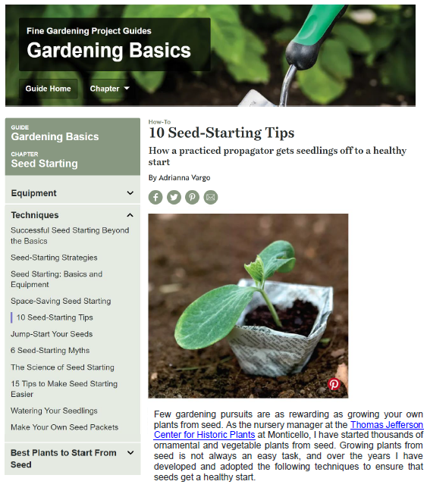

10 Seed Starting Tips Worksheet
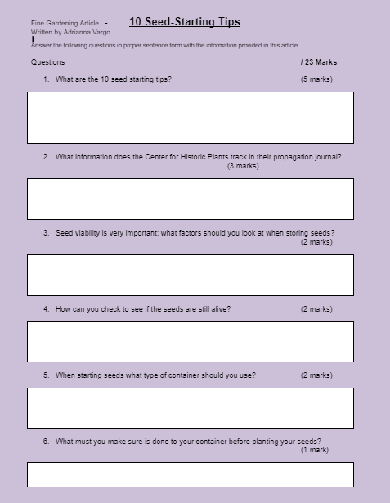

10 Seed Starting Tips Answer sheet
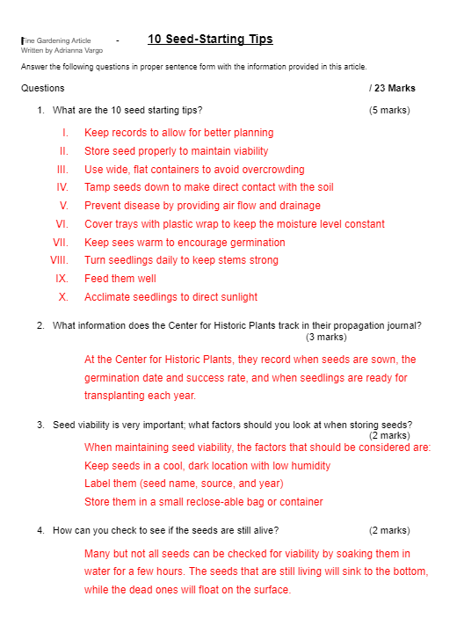

Appendix D – Requirements for Good Plant Growth
There are three parts to the Good Plant Growth assignment – the notes, worksheet and answer sheet. You can find the links to each one in this appendix.
Good Plant Growth notes

Water
Most of the water is contained in the cells. Water provides the medium for many biochemical reactions. Plant foods must be in soluble form in water before plants can use them. Chemical processes like photosynthesis could not occur without water. Water transports nutrients and manufactured food throughout the plant. Nutrients from the soil must be in a water solution before roots can absorb and transport them. Because it is clear, it allows light from the sun to penetrate plant leaves and green stems to reach the chlorophyll and powers the production of food. Inadequate water can stress plants, making the plants more susceptible to disease and insect attacks. Lack of water during dry soil conditions can slow the process of photosynthesis. Water plant to prevent heat damage.
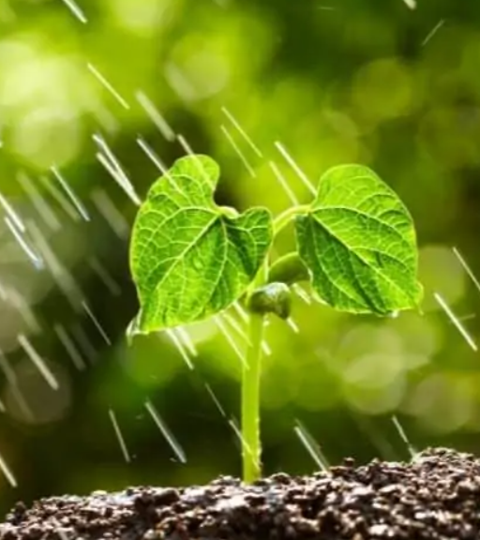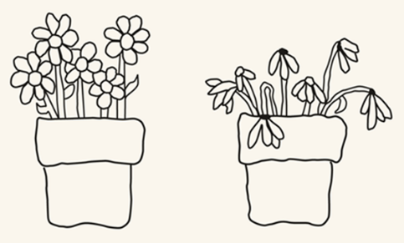

Nutrition
Nutrition is important to plant as it is to humans. Plants require at least 16 elements from the soil or from fertilizers. Good nutrition is important to plant health and growth. In loam soils, enough minor elements are available for satisfactory plant growth. In soilless mixes, minor elements may be deficient. The major elements nitrogen, phosphorus, and potassium are needed most often.
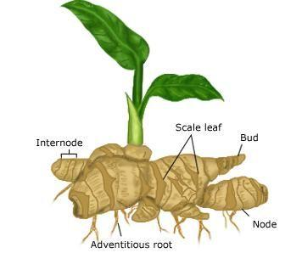
N | Nitrogen is used by plants for producing leaf growth and greener, lusher leaves.
P | Phosphorus is used by plant to increase fruit development and to produce a strong root system.
K | Potassium is used by plants for flower color and size. It is also important to the strength of the plant.
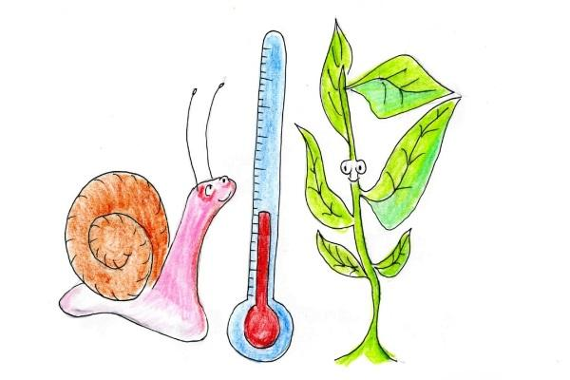

Temperature
Plant growth is greatly influenced by heat. Unlike animals, plants are unable to maintain their temperature. Plants cool themselves by the transpiration process. This process cannot maintain a constant plant temperature. Plant growth increases as temperature increases up to 86°F (31°C) for most plants. Cooling plants below their best growing temperature causes the growth to slow down.
Light 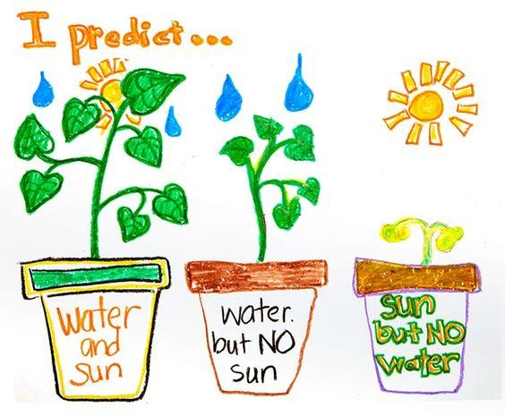
Light must be present before plants can manufacture their own food. No green plant can exist for very long without sunlight. The intensity and brightness of sunlight affects photosynthesis. Plants receiving more sunlight produce more sugars and tend to grow and flower better.

Insects and Diseases
Predatory insects attack plant roots, stems, leaves, flowers, and fruits. They also attack at any stage of growth from seedling to mature plant. There are many ways to control or reduce insect populations so that plants can be grown more efficiently. Some of the practices that can be used are rotation, beneficial insects, plant monitoring, etc.
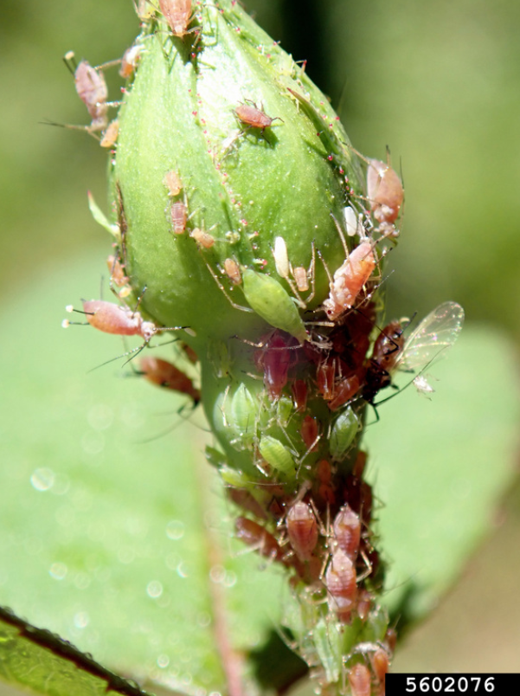

Acidity (pH)
Most plants grow best in a nutrient solution with a pH of 5.6 to 7.0 which is neutral; that is, the soil at pH 7 is neither acid nor alkaline (basic). In areas where water evaporation from the soils is more than the amount of rainfall, buildup of salts, calcium and sodium increase the pH level. Irrigation with low-salt-content water can wash the alkali-producing elements out of some of these soils.
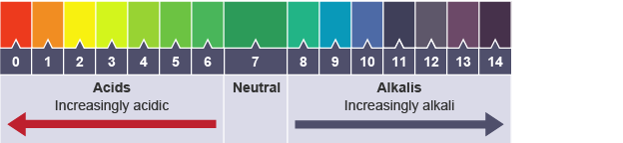

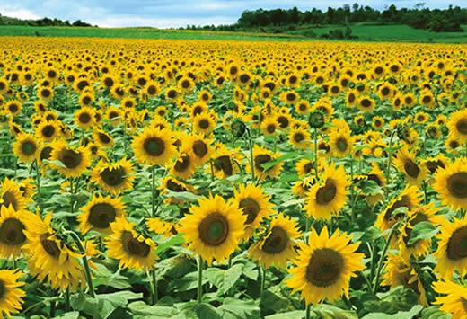

Conclusion
For successful plant growth: It is extremely important to consider the plant environment both underground and above ground. Temperature, sun, and wind exposure. Select only plants adapted to the environment they will be placed in match plant needs.

Requirements for Good Plant Growth Worksheet
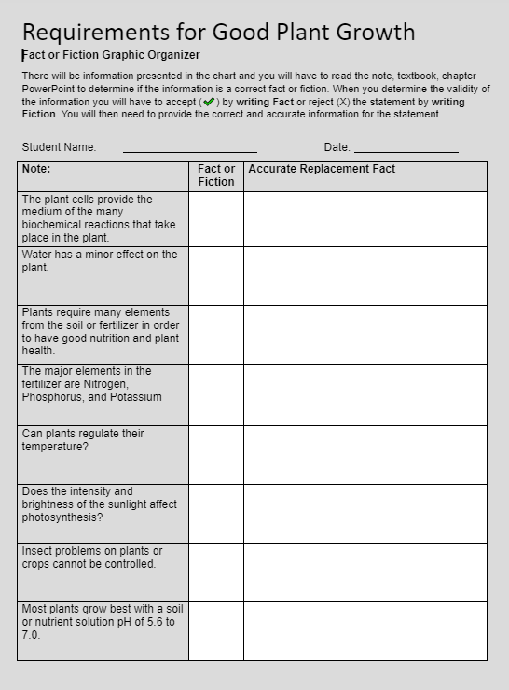

Requirements for Good Plant Growth Answers
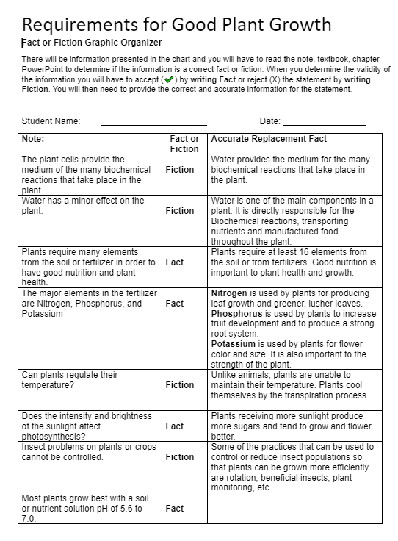

Appendix E – Seed Package Assignments
Here is the worksheet for the Seed Package assignment – Stokes Tomatoes
Seed Package Questions worksheet – Stokes Tomatoes
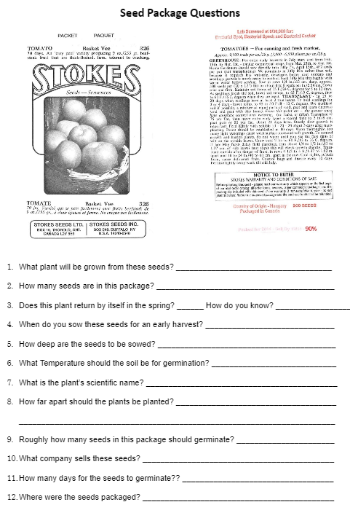
Here are the answers for the Seed package worksheet – Tomatoes
Seed Package with Questions worksheet - Tomatoes

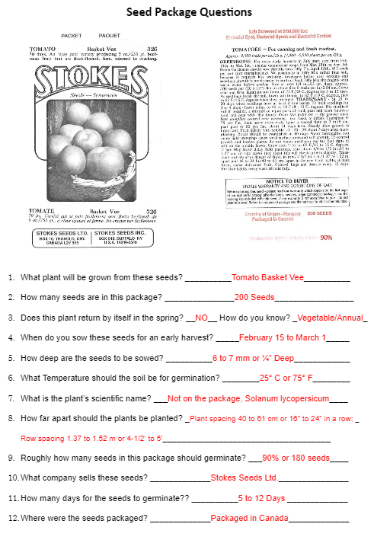
Here is the worksheet for the Seed Package assignment – Lettuce
Seed Package Worksheet - Lettuce
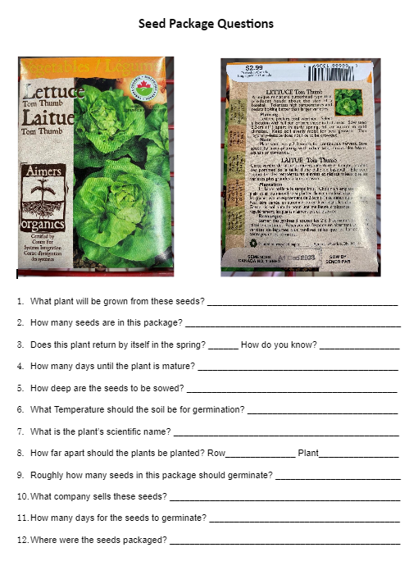

Here is the worksheet for the Seed Package assignment – Lettuce
Seed Package Answer Sheet - Lettuce
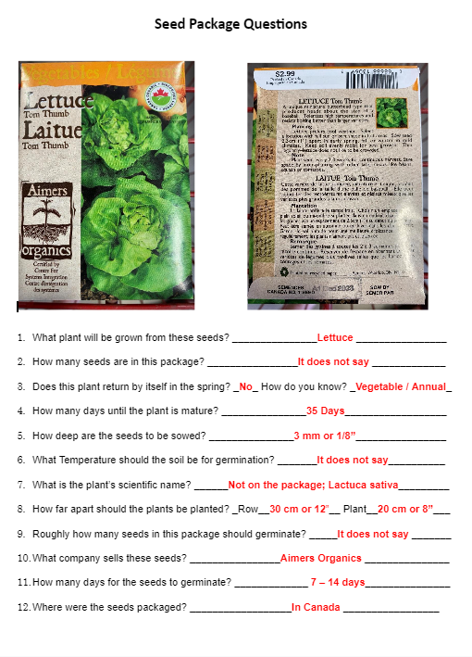

Appendix F – Building Hydroponic Water Culture System
In activity 3 you will be invited to build your own hydroponic water culture system. Teachers are to set the parameters around the system and will likely need to calculate reservoir volume. The Calculating the Hydroponic Reservoir Volume handout will assist you in performing these calculations.
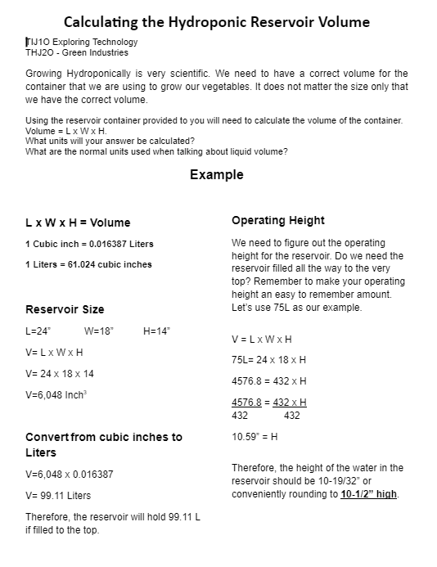

Appendix G – Hydroponic System Care and Maintenance
In activity 4 you will be taking care and maintaining your hydroponic system. You will have to learn how to/what to plant, set the water flow rate, nutrient levels and determine an operating level for the system. Teaching the students to calculate the total volume of the container is a start. You want to make the operating level of the system close to the top of the container as this will allow your plants the most-light for growing. The Calculating the Hydroponic Reservoir Volume handout in Appendix F will assist you in performing these calculations but it will also assist you by providing a worksheet.
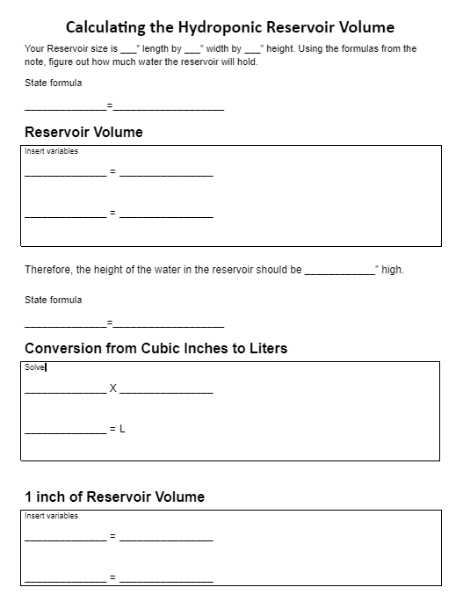
You want to make sure your operating level is an easy number to use for creating your nutrient recipe. This will help the student to remember the information.
Nutrient Solution Calculations worksheet
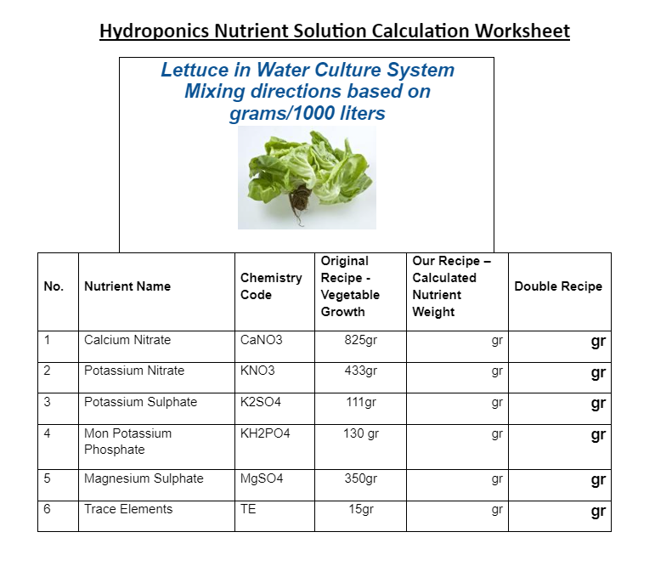
You need to review the factors that need to be monitored when caring for a hydroponic system. This can be covered as a note or provided as a handout (on the next page) depending on the amount of time allowed.

Hydroponic Care and Maintenance
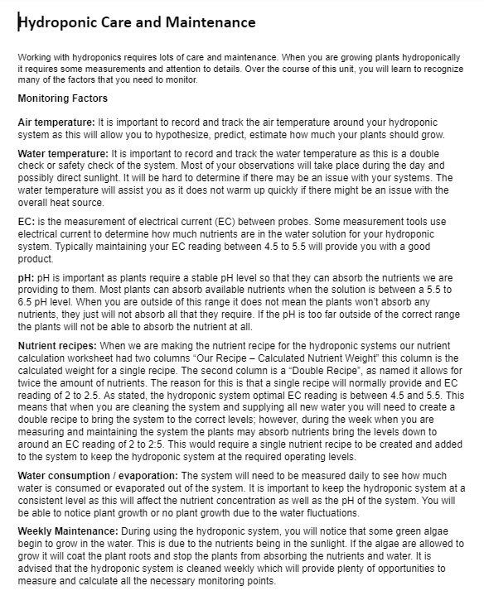

Appendix H – Culminating Activity
Harvesting your lettuce is done by pulling the plant out of the system and cutting the roots off. You will probably want to wash the lettuce before you consume it. It will taste very different from the grocery store product. Enjoy!!

Each students Engineering report should be different as they will have different experiences and engagement levels. The main part is the process for planting the seeds, building the hydroponic system, and harvesting the finished lettuce.

References
5 Hydroponic Fun Facts and Figures (poster)
6 Types of Hydroponic Systems Explained, Sensorex, 2019
https://sensorex.com/blog/2019/10/29/hydroponic-systems-explained/
7 Different Types of Hydroponic Systems, No Soil Solutions, 2022 https://www.nosoilsolutions.com/6-different-types-hydroponic-systems/
21st Century Competencies: Foundation Document for Discussion. Phase 1: Towards Defining 21st Century Competencies for Ontario, Winter 2016 Edition, 2016 http://www.edugains.ca/resources21CL/About21stCentury/21CL_21stCenturyCompetencies.pdf
A large scale ecosystem containing a lot of sunflowers, Weiming Dong, (picture), https://www.researchgate.net/figure/A-large-scale-ecosystem-containing-a-lot-of-sunflowers_fig24_279262231
Aquaponics, Ryan Somma (photo) 1980 https://www.flickr.com/photos/14405058@N08/2552598398
Best Plants to Grow Hydroponically, Hyper-Grow Fertilizer, https://hyper-grow.com/news/best-plants-to-grow-hydroponically/
Best Water for Seedlings, Flourishing Plants (picture), 2022 https://flourishingplants.com/best-water-for-seedlings/
Biotechnology and Crop Improvement of Ginger ( Zingiber officinale Rosc.), ResearchGate (image) 2022 https://www.researchgate.net/figure/Botany-of-ginger-plant-Source
Chinampa, Antropogen (image), 2011 https://anthrome.wordpress.com/2011/04/24/chinampa-raised-bed-hydrological-agriculture/
Coriander grown hydroponically in greenhouse, marsraw (Pixabay photo), 2019 https://pixabay.com/photos/hydroponics-greenhouse-coriander-4255401/
Deep Water Culture Cutaway, Simply Hydroponics (image), 2022 https://www.simplyhydroponics.com.au/page/info-hub/different-types-of-hydroponic-systems/
Drip System Hydroponics Pros and Cons (And how to avoid them), Plants Heaven, 2022 https://plantsheaven.com/drip-system-hydroponics-pros-and-cons/
Eco Grower Max, Planet Natural (image), 2022 https://www.planetnatural.com/product/ecogrower-hydroponic-system/
Good Plant Growth Notes, OCTE, 2022 https://docs.google.com/document/d/1xh8m2kgKIDXsDt7CN2_X2jbzNMCxFA1yMWGxbQLqbtU/edit?usp=sharing
Green roof, NNECAPA Photo Library (photo), 2006 https://www.flickr.com/photos/nnecapa/2830785109
Growing Success: Assessment, Evaluation, and Reporting in Ontario Schools, First Edition, Covering Grades 1 to 12, 2010 www.edu.gov.on.ca/eng/policyfunding/growSuccess.pdf
Growth Mindset for Gardeners drawing, Porter County Master Gardeners Association (image), 2020 https://extension.purdue.edu/county/porter/_docs/vol-6-issue-6---garden-thyme-nov-2020.pdf
Hair-like roots, Belding, Aaron and McBeth, Leslie (photo), 2014
Hanging Gardens of Babylon, imgur (image) 2012 https://imgur.com/ng2Az
Hanging Gardens of Babylon, White Mountain Independent (image), 2021 https://www.wmicentral.com/community_beat/religion/heads-up/article_40f8ecc0-25f2-5f21-a939-eb8b02fb3206.html
Hexagon drip planter, Belding, Aaron and McBeth, Leslie (photo), 2014 Hydroponic Systems, Epic Gardening, 2022
https://www.epicgardening.com/hydroponic-systems/
Hydroponic lattice, Belding, Aaron and McBeth, Leslie (photo), 2014
Hydroponic Research Project Assignment, OCTE (worksheet), 2022 https://docs.google.com/document/d/1LRLTUbXY-b1QdRorGn9pzwNzTixAK2YiGsDOsu-Scdk/edit?usp=sharing
Hydroponic Research Project Assignment Answer Sheet, OCTE (blackline master), 2022 https://docs.google.com/document/d/1V1NTuQi7fsiBx4Ucp8qo4udt6fWXhHUwiVC_Beo5Lxg/edit?usp=sharing
Introduction to Hydroponics PowerPoint, OCTE (PowerPoint), 2022 https://docs.google.com/presentation/d/16pKs9D01VH8QHRnL5IJfXWD9_Ndh4vJlPliaJkrma8Q/edit#slide=id.g143082bd3ff_0_36
Iris Seeds, William Rickatson Dykes, (illustration), 2003 http://aleph0.clarku.edu/~djoyce/iris/dykes/xlviiia.jpg
Learning for All – A Guide to Effective Assessment and Instruction for All Students, Kindergarten to Grade 12, https://www.dcp.edu.gov.on.ca/en/
Person on boat harvesting, Instructables (photo), 2022 https://www.instructables.com/How-to-create-a-miniature-tomato-hydroponic-rig/
pH Chart, Socratic (image), 2022 https://socratic.org/questions/calcium-oxide-is-a-base-compound-which-can-react-with-acids-such-as-nitric-acid-
Plant Growth Factors: Light, Colorado State University, 2016 https://cmg.extension.colostate.edu/Gardennotes/142.pdf
Plant Growth Factors: Temperature, Colorado State University, 2016 https://cmg.extension.colostate.edu/Gardennotes/143.pdf
Plant Physiology: Photosynthesis, Respiration, and Transpiration, Colorado State University, 2016 https://cmg.extension.colostate.edu/Gardennotes/141.pdf
Plants in a window sill, Belding, Aaron and McBeth, Leslie (photo), 2014
Planters Pride Coconut Coir Greenhouse Kit, Brantford Home Hardware, (image) 2022 https://brantfordhomehardware.ca/p/planters-pride-seed-tray-starter-kit-with-35-pellets-5121239
Potting soil mix in wheelbarrow, Lowes (picture), 2022 https://www.lowes.com/n/ideas-inspiration/square-foot-gardening
Predictions About Plants, Crayola (image), 2022 https://www.crayola.com/lesson-plans/predictions-about-plants-lesson-plan/
Red SEAL – Sceau Rouge, 2018 http://www.red-seal.ca/trades/tr.1d.2s_l.3st-eng.html
Resources, Skilled Trades Ontario https://www.skilledtradesontario.ca/about-trades/trades-information/
Rose aphid, Whitney Cranshaw (picture), 2018 https://www.insectimages.org/browse/detail.cfm?imgnum=5602076
Skilled Trades Identified in Ontario, Skilled Trades Ontario https://www.skilledtradesontario.ca/about-trades/trades-information/
Skilled Trades Ontario https://www.skilledtradesontario.ca
Start an Apprenticeship in Ontario https://www.ontario.ca/page/start-apprenticeship
Strawberries (photo), 2022 https://www.agrotv.net/hidroponska-proizvodnja-jagoda/
Temperature, Robert Krulwich (image), 2014 https://www.npr.org/sections/krulwich/2014/02/18/279189378/trees-on-the-move-as-temperature-zones-shift-3-8-feet-a-day
The Chinampa: An Ancient Mexican Sub-Irrigation System, Robles, B., Flores, J., Martínez, J. L., and Herrera, P. (image) 2019 https://doi.org/10.1002/ird.2310
The Differentiated Instruction Scrapbook http://www.edugains.ca/resourcesDI/EducatorsPackages/DIEducatorsPackage2010/2010DIScrapbook.pdf
The Ontario Curriculum, Grades 9 and 10: Technological Education, 2009 (revised) http://www.edu.gov.on.ca/eng/curriculum/secondary/teched910curr09.pdf
Transplanting planting depth of seedlings, Commercial Hydroponic Farming (image), 2020 https://www.commercial-hydroponic-farming.com/transplanting-seedlings/
UMass Extension Greenhouse Crops and Floriculture Program, Center for Agriculture, Food, and the Environment at the University of Massachusetts Amherst, 2022 https://ag.umass.edu/greenhouse-floriculture/fact-sheets/hydroponic-systems
View of Vegetables, Jatuphon Buraphon (Pexels photo), 2017 https://www.pexels.com/photo/view-of-vegetables-348689/

