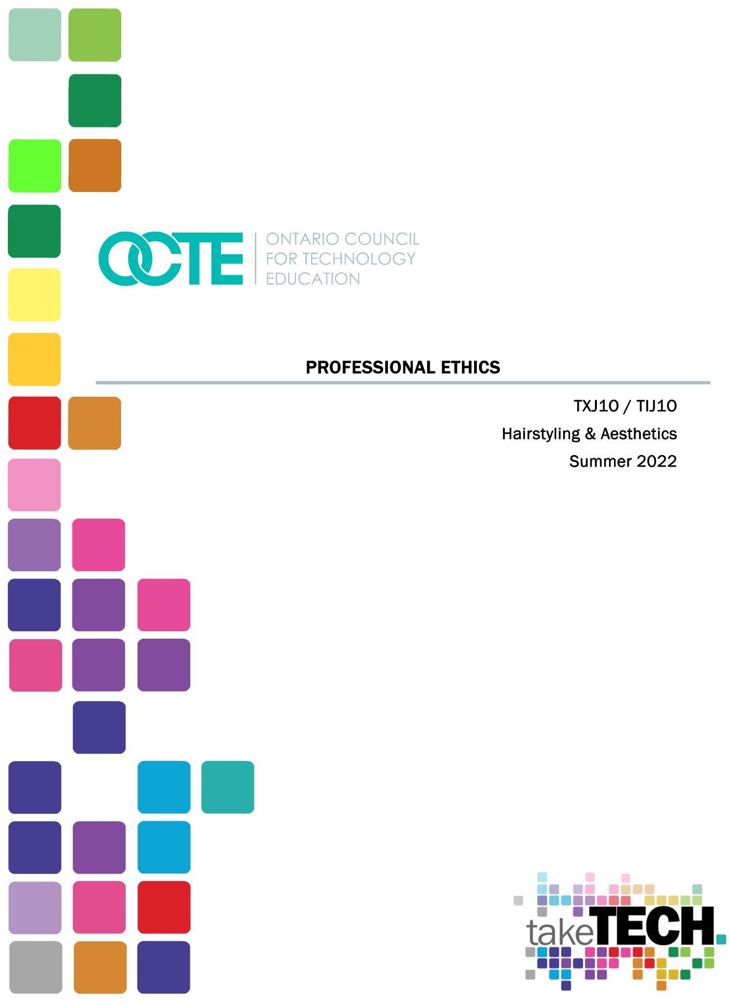
00000000000000000000000

Table of Contents

Introduction 3
Project Outline 3
Prior Knowledge 3
Student Activities 3
Activity 1 – Professional Ethics and Life Skills 4
Activity 2 – Personal Hygiene and Grooming 6
Activity 3 – Nail Art 7
Activity 4 –Role Play 8
Planning Notes 9
Skilled Trades and Apprenticeship Opportunities 9
Skills Continuum 9
Career and Industry Extensions 10
Resources 10
Handouts Error! Bookmark not defined.
Tools/Equipment 10
Materials Error! Bookmark not defined.
Textbooks/ Books - Milady 10
Journals/Magazines 10
Videos 11
Websites for Teachers 11
Instructional Strategies 11
The Hook / Motivational Strategies 11
Learning Goals and Success Criteria 11
Overall and Specific Expectations in Support of Ontario Curriculum Grades 9 - 10 Technological Education 12
Overall Expectations 12
Specific Expectations 12
Safety Concerns (including PPE if required) 12
Applicable SAFEDocs and ToolSAFE videos 13
Project Challenges 13
Differentiation of the Project / Activity 13
Assessment and Evaluation 13
Assessment As Learning Error! Bookmark not defined.
Assessment For Learning 13
Assessment Of Learning 13
Religious Considerations 14
Career and Industry Extensions 14
Ethical Considerations 14
Environmental Considerations 14
Reflection or Design Report 15
Appendix A – Assessment Rubric 16
Appendix B – Overall Personal Hygiene Rubric 18
Appendix C 19
References 20

Introduction
Course Code: TXJ10
Broad base Technology: Hairstyling and Aesthetics
Destination: Open
Grade Level: 9
Prerequisite: None
Project Name: Professional Ethics

Project Outline
Students are introduced to Professional Ethics which is a basic life skill that everyone should be taught and can be carried out throughout their entire career. Hairstyling and Aesthetics involves a lot of creativity with people of different cultures and styles. Students get a chance to embrace their culture and demonstrate differences.
This is an introductory course that presents hairstyling, make-up, and nail care techniques from a salon/spa perspective. Using materials, processes, and techniques used in the industry, students learn fundamental skills and will also consider related environmental and societal issues. They will explore secondary and postsecondary pathways leading to careers in the field of hairstyling and aesthetics.

Prior Knowledge
This is an introductory lesson no prior knowledge is required to complete the project. Note: If you are using the Milady Standard Cosmetology (13th Edition) as your textbook, there is no requirement to do so, you may find Personal Hygiene on Page 36. Life Skills, and Beauty and Wellness on pages 29 – 42 in the chapter.

Student Activities
Whether dealing with friends and family or with clients and customers, developing customer service and professional ethics, along with life skills, are important. This includes personal hygiene and grooming techniques but also working on your own values and beliefs. When dealing with the public or clients at your own salon, you need to develop the skills to listen, communicate, make people feel at home and take care of their needs. The following student activities have been established to discuss and cultivate professionalism and the skills required for customer care. Many of these topics also transfer to taking care of yourself

Activity 1 – Professional Ethics and Life Skills
Words for Professional Ethics:
appearance character honest respect
communication attendance organization cooperation
leadership demonstrate problem-solving self-esteem

Part 1 - Answer the questions correctly, then make a set of FLASH CARDS using the words from Professional Ethics.
1.The quality or condition of being fair, just and morally upright is honest.
True or False /2
2. Handles authority by appropriately handling criticism; demonstrates problem solving;
able to follow chain of command is leadership. True or False /2
3. Taking pride in your work and committing yourself to consistently doing a good job for
your clients, employer, and salon team. Choose 1 answer.
work ethics cooperation attendance leadership /2
4. Adhering to high moral principles and or professional standards.
cooperation honest character Integrity /2
5. Possesses skills in prioritizing and managing time and stress, flexible in handling change
cooperation honest character Integrity /2
6. A joint effort to work together with others in order to achieve common goals of the salon.
Self Esteem Communication Organization Cooperation /2

7-10. Click a term to match it with a definition… Select from the list below /4
7. Appropriate eye contact, body language and oral skills to exchange information
8. Willing to do what is asked or doing what is required together.
9. Displays loyalty, reality trustworthiness initiative self-discipline
10. Displays appropriate dress, grooming, and hygiene for the salon in which employed
Character communication cooperation appearance /4
Total mark /20
Part 2
Make a set of Flashcards using the words from the professional ethics list.
Write the Questions on one side and the answer on the other side.
Minimum 15 Cards
Marks /30

Activity 2 – Personal Hygiene and Grooming
Talk to students about personal hygiene and grooming, and the difference between clean and dirty. Look at pictures- sort them into clean and dirty categories.
Show pictures of people using socially appropriate and inappropriate hygiene, have students share their thoughts about these pictures. How would you feel if this person sat beside you on the bus? How would you feel if this person walked into your school or salon? Would you hire them for the job?
- Talk about hygiene routines.
- What needs to happen every day?
- What tasks do you do in the morning?
- What task do you do in the evening?
- What tasks do you do throughout the day?
- What needs to happen once a week?
- What only happens occasionally?
- Show students a sample hygiene routine - What adjustments need to be made
- As a group, develop a hygiene rating form. - Rate pictures of people based on this form to determine who has the best hygiene.
- Schedule hygiene routines into student’s daily timetables.
- Host a fancy party -give students a reason to clean up.
- Sequence pictures of the steps involved in this task.
- Sort and choose pictures of the items required to perform the task.
- Read or write a social story about the task.
- Read the steps involved in completing the task - glue a matching picture beside it.
- Posts sequences for performing these tasks.
- Students will put together a care kit and will define a care kit as it pertains to them.
(Some general items/toiletries will be available for students to use)

Activity 3 – Nail Art
Using the Cutepolish Video titled, “10 Nail Art Designs Using HOUSEHOLD ITEMS! | The Ultimate Guide #5”, have the students practice 10 different nail art designs on the printable template using household products.
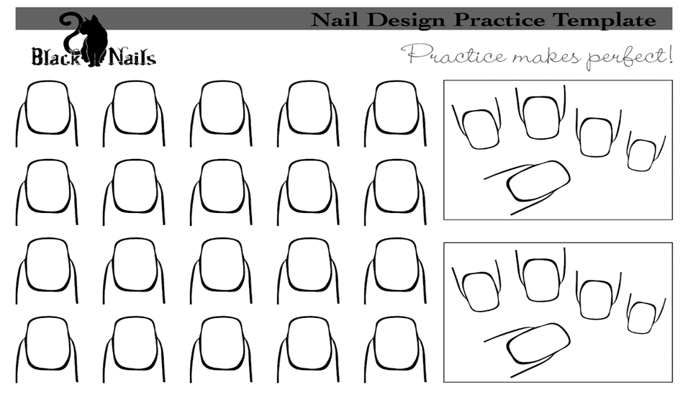
Students will demonstrate their design on the nails.
Develop a checklist of the tools they need before you start to work.
Demonstration industry standards and tools needed to perform the task
Teachers observe student work ethic, creativity and variety of designs for both in person and online (if offering virtual classes)

Activity 4 –Role Play
Students will be given a list of professions in a typical Salon. Working in groups of 2 or 3 students will choose two items from the list and role play as it pertains to the Cosmetology industry displaying good personal hygiene and professional Image.
Manicurist/Pedicurist, Shampoo Person, Receptionist, Hairstylist, Barber and apprentice
Scenario
You’re in the waiting area of a Beauty Salon. The salon attendant escorts you to the area where you will be attended to and serviced. To your dismay, however, you’re not pleased with the smell, appearance, and attitude of the individual, who has just introduced themselves as …
How can you fix this situation?
Students will be assessed based on their role playing scenario - on their ability to perform a variety of salon/spa services, using appropriate tools and products in a professional and safe manner, and applying methods for meeting the needs of the salon/spa clientele.

Activity 5 –O’Natural Spa Day
Cosmetics have been used since ancient time, however, through the years individuals have also developed sensitivities to modern day commercial products and to some of their ingredients.
Look at home in your pantry and find two or more ingredients that can be used as one of the following cosmetics products (e.g., mask, cream, body scrub, shampoo, conditioner, moisturizer, lotions, deodorant)
Create a product from the examples below using the ingredients
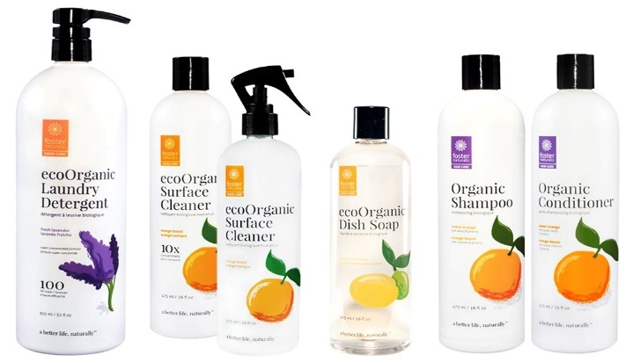
Research and explain using a Power Point Presentation the benefits of the ingredients used in your products. Present the product in a demonstration with a model.
A teacher-developed rubric can be used for assessment.

Planning Notes
Teachers may place students in groups of 2-3.
Teacher will make sure students have access to the products and accessories needed for their nail template project.
Plan to have students complete the activities in this resource within a couple of weeks. (This will all depend on how long the rotation is for your school)

Skilled Trades and Apprenticeship Opportunities
Students will explore secondary and postsecondary pathways leading to careers in the field of hairstyling and aesthetics. This includes becoming a hairstylist, barber, aesthetician, salon owner, cosmetician, cosmetology salesperson, make-up artist, pedicurist, etc.
According to Red-Seal.ca, the hairstylist is the only recognized skilled trade in this field of study, however many of the careers and jobs require specific skills sets and techniques. Students will demonstrate an understanding of the Essential Skills that are important for success in all trades, as identified in the Ontario Skills Passport (e.g., reading text, writing, document use, computer use, oral communication, numeracy, thinking skills).

Skills Continuum
We all have different moments in our lives where we are affected by an experience. This can include learning a new concept or skill, experiencing something for the first time, taking a new course, developing a talent through practice and hard work, or even calling upon a skilled tradesperson to fix, repair, design, construct, maintain, build, bake, and create innovative solutions. The continuum of influence is a graphic representation of how those experiences can lead to developing a passion and talents in areas of technology and skilled trades as a hairstylist, aesthetician , cosmetician, salon owner and entrepreneur.
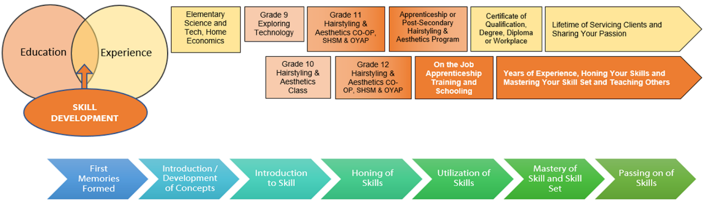

Career and Industry Extensions
Hairstyling and Aesthetics students will have opportunities to choose what area they would like to focus on in any of the industries.
- Salon Owner
- SPA Owner
- Barber
- Make-up Artist
- Hairstylist
- Aesthetician

Resources

Handouts
Activity 1 – Professional Ethics and Life Skills
Activity 2 – Personal Hygiene and Grooming
Activity 3 – Nail Art Nail Design Practice Template
Rubric – see Appendix A
Assessing Things That Help Me Learn – see Appendix C

Tools/Equipment
Practice nail, nail polish, top coat, base coat, nail jewels and sparkles.

Textbooks/ Books - Milady
Milady’s Standard Cosmetology, 1st Edition, Chapter 2 - Life Skills (if available or purchased by your school/school board, you may also utilize the link)
Milady’s Standard Cosmetology, 1st Edition, Chapter3 - Professional Image (if available or purchased by your school/school board, you may also utilize the link)

Journal/Magazine
Contessa and Salon Magazine

Videos
10 Nail Art Designs Using HOUSEHOLD ITEMS!  Cutepolish  https://www.youtube.com/watch?v=ZBwB9OKyJQM  (6:24) | 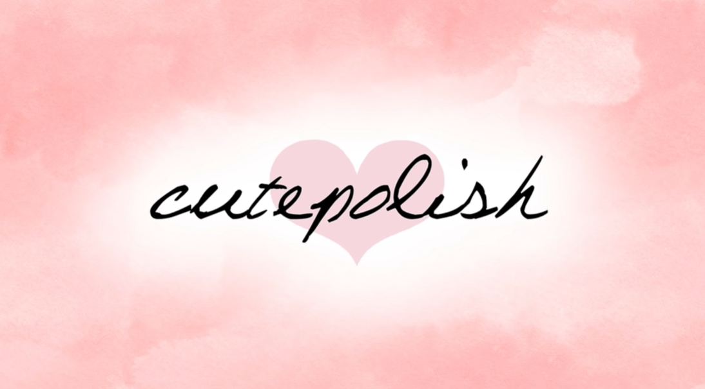

Websites for Teachers
Milady Textbook – Chapter 2 – Life Skills
Milady Textbook - Chapter 3 – Professional Image

Instructional Strategies
Teachers may use any of the following instructional strategies; 3-Part lesson, lecture, storyboard, word wall, think-pair-share, placemat activity, rapid write, K-W-L, anticipation chart, ABC taxonomy, think aloud, analyzing text, Cornell note taking, exit ticket/ticket out the door, plus+/minus/delta, etc.

The Hook / Motivational Strategies
The best tools are the one that fits the job you are doing, for example, fits in your right hand and fits the workspace, can be used and reduces the force you need to apply in a comfortable work position. Like doing an activity of the nail extension, students will get an opportunity to do the new and trendy nail and designs.

Learning Goals and Success Criteria
- Project a professional image.
- Be guided by your salon’s dress code.
- Expertly applied makeup is part of having a professional image.
- Practice meticulous personal hygiene every day.

Overall and Specific Expectations in Support of Ontario Curriculum Grades 9 - 10 Technological Education

Overall Expectations
B1. Perform a variety of salon/spa services, using appropriate tools and products in a professional and safe manner.
B2. Use knowledge of design elements and principles in the contexts of hairstyling and aesthetics services and marketing.
B3. Apply methods for meeting the needs of the salon/spa clientele.

Specific Expectations
B1.1 Select safe and appropriate materials, tools, and products and use them correctly to perform professional salon/spa services.
B1.2 Identify appropriate sterilization and sanitation products and equipment and use them correctly when providing salon/spa services (e.g., disinfectants, antiseptics, wet sanitizer, ultraviolet-ray sanitizer, autoclave)
B1.3 Comply with workplace health and safety regulations in handling salon/spa products and equipment (e.g., regulations for handling and storing chemicals, preventing harm from spills and vapour emissions, wearing personal protective equipment)
B1.4 Apply appropriate ergonomic principles in the workplace by adjusting equipment and tools properly to help maintain good posture while working (e.g., setting chairs to proper height, using a mannequin stand extension)
B3.1 Communicate and interact effectively with clients (e.g., use active listening and questioning; observe rules of conversational and professional etiquette).

Safety Concerns (including PPE if required)
Before handling any chemicals, ensure you understand the safe handling procedures as outlined on container labels, WHMIS data sheets, designated instructions or posted classroom procedures as appropriate. If you are unsure, see your instructor before proceeding.

Applicable SAFEDocs and ToolSAFE videos
Please refer to the OCTE SAFEdocs for BBT for safety documents in order to properly address and instruct this project.

Project Challenges
- Due to students' lack of confidence they may not feel comfortable doing role playing
- Students may be observed individually or in a group setting
- Some students may not have necessary ingredients at home or where they are living

Differentiation of the Project / Activity
Teachers can refer to the Differentiation Scrapbook to take into account learner ability, multiple intelligences, exceptional students, and ESL learners.
Students can role play different strengths and use products that they are familiar using.

Assessment and Evaluation
Two rubrics have been developed to assist in assessment and evaluation. You may find them as Appendix A and Appendix B.

Assessment For Learning
- Checklists for students at each step
- Self and peer assessment of collaborative group work

Assessment Of Learning
- Utilizing project rubrics for Student Activity 1 and Student Activity 2
- Directly linking assessment and evaluations to course expectations.

Religious Considerations
Students religious and or cultural preferences should be considered to support the learner and should be taken into consideration. Certain products and fragrances are used in some cultures versus other cultures. Key learning opportunities may exist according to your student population.

Career and Industry Extensions
The activities could lead to further reach ahead to support a SHSM Hairstyling and Aesthetics, as well extensions can be made to multiple career and industry employment like,
- Hairstylist
- Barber
- Aesthetician.
- Cosmetic Sales
- Make-Up Artist
- Salon Owner

Ethical Considerations
Adhering to the professional code of ethics, teachers will make students aware that ethics is at the forefront of their practice to ensure customer satisfaction. The cosmetic industry has had a long standing of testing their products on animal for a long time. This great insensitivity has impacted the cosmetic industry and customers tremendously.
As a result, both companies and clients have become aware of the practice and will not buy use, or sell, products from companies who engage in such practice.

Environmental Considerations
Beauty is an industry that gets a bad rap when it comes to sustainability. That’s because the beauty industry generates billion of units of plastics packaging per year contributing to the loss of millions of acres of forest annually.
Cosmetics affects, more than the local landfills, left with mountains of single use plastics, they also affect our oceans, our air quality, and the ecosystems that have provided the flora and fauna for thousands of years.

Species are going extinct for the sake of making skin care and eyeshadow pallets. And in addition to the ways in which wildlife is impacted by the manufacturing and disposal of the products, they are also directly harmed by the still-prevalent practice of animal testing, which occurs throughout the world.
Everyone must realize the value of being educated about what’s best for oneself, business, and the eco system.

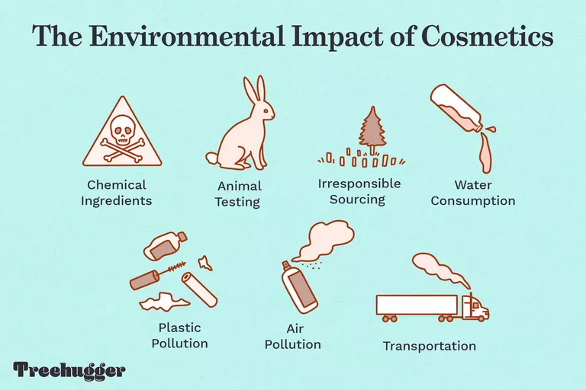

Reflection or Design Report
Teachers may wish to have the students complete a design report, reflection or create a portfolio to consolidate their learning. This would be a nice way to capture the student’s understanding in a summative format and be used in preparation for their examination, entering post-secondary education or the workforce.

Appendix A – Assessment Rubric
 | Level 4  80-100% | Level 3  70-79% | Level 2  60-69% | Level 1  50-59%
Knowledge of subject specific content and the comprehension of its meaning and its significance.  *Facts  *Equipment  *Terminology  *Processes  *Procedures  *Industry Standards | Demonstrates thorough knowledge of content  Demonstrates thorough understanding of content | Demonstrates considerable knowledge of content.  Demonstrates considerable understanding of content | Demonstrates some knowledge of content.  Demonstrates some understanding of content | Demonstrates limited knowledge of content.  Demonstrates limited understanding of content
Thinking  The use of critical and creative thinking skills and/or processes.  *Use of planning skills  *Strategize  *Problem solve  *Processing skills  *Use of creative/critical thinking processes | Expresses and organizes and information with a high degree of effectiveness  Communicates for different audiences and purposes with a high degree of effectiveness  Uses vocabulary and terminology with a high degree of effectiveness | Expresses and organizes and information with considerable effectiveness  Communicates for different audiences and purposes with considerable effectiveness  Uses vocabulary and terminology with considerable effort and effectiveness | Expresses and organizes and information with some effectiveness  Communicates for different audiences and purposes with some effectiveness  Uses vocabulary and terminology with some effectiveness | Expresses and organizes and information with limited effectiveness  Communicates for different audiences and purposes with limited effectiveness  Uses vocabulary and terminology with limited effectiveness
Communication  Expresses and organizes ideas in oral or written form.  *Terminology  *Vocabulary | Applies knowledge and skills with a high degree of effectiveness  Transfers knowledge and skills to new contexts.  Makes connections within and between various contexts with a high degree of effectiveness | Applies knowledge and skills with considerable effectiveness  Transfers knowledge and skills to new contexts.  Makes connections within and between various contexts with considerable effectiveness | Applies knowledge and skills with some effectiveness  Transfers knowledge and skills to new contexts.  Makes connections within and between various contexts with some effectiveness | Applies knowledge and skills with limited effectiveness  Transfers knowledge and skills to new contexts.  Makes connections within and between various contexts with limited effectiveness
Application of knowledge and skills  *Transfers concepts, processes, use of equipment and technology to new contexts. | Student applies and transfers knowledge and skill with a high degree of effectiveness  Makes connections between various contexts with a high degree of effectiveness | Student applies and transfers knowledge and skill with considerable effectiveness  Makes connections between various contexts with considerable effectiveness | Student applies and transfers knowledge and skill with some effectiveness  Makes connections between various contexts with some effectiveness | Student applies and transfers knowledge and skill with limited effectiveness  Makes connections between various contexts with limited effectiveness

Appendix B – Overall Personal Hygiene Rubric
OVERALL PERSONAL HYGIENE RUBRIC
Student Name:
Date:
List any adaptive equipment used for personal hygiene:
Personal Hygiene | Uses the skill at all times  in all environments | Completes  the skill as  expected | Uses the  Skill  inconsistently | Learning  the skill
Taking a shower | Proficiency / Daily practice applicable to changing environments | Considerable / Meets expectation / daily practice | Casual / Inconsistent / Not a daily occurrence | Learning / Skill not quite obtained / Once in a while
Washing hand after using the bathroom | Proficiency / Daily practice applicable to changing environments | Considerable / Meets expectation / daily practice | Casual / Inconsistent / Not a daily occurrence | Learning / Skill not quite obtained / Once in a while
Washing hands before meal time | Proficiency / Daily practice applicable to changing environments | Considerable / Meets expectation / daily practice | Casual / Inconsistent / Not a daily occurrence | Learning / Skill not quite obtained / Once in a while
Use of soap (dispenser  or bar soap) | Proficiency / Daily practice applicable to changing environments | Considerable / Meets expectation / daily practice | Casual / Inconsistent / Not a daily occurrence | Learning / Skill not quite obtained / Once in a while
Washing face | Proficiency / Daily practice applicable to changing environments | Considerable / Meets expectation / daily practice | Casual / Inconsistent / Not a daily occurrence | Learning / Skill not quite obtained / Once in a while
Taking a bath | Proficiency / Daily practice applicable to changing environments | Considerable / Meets expectation / daily practice | Casual / Inconsistent / Not a daily occurrence | Learning / Skill not quite obtained / Once in a while
Use of deodorant | Proficiency / Daily practice applicable to changing environments | Considerable / Meets expectation / daily practice | Casual / Inconsistent / Not a daily occurrence | Learning / Skill not quite obtained / Once in a while
Wiping nose | Proficiency / Daily practice applicable to changing environments | Considerable / Meets expectation / daily practice | Casual / Inconsistent / Not a daily occurrence | Learning / Skill not quite obtained / Once in a while
Blowing nose | Proficiency / Daily practice applicable to changing environments | Considerable / Meets expectation / daily practice | Casual / Inconsistent / Not a daily occurrence | Learning / Skill not quite obtained / Once in a while
Brushing teeth | Proficiency / Daily practice applicable to changing environments | Considerable / Meets expectation / daily practice | Casual / Inconsistent / Not a daily occurrence | Learning / Skill not quite obtained / Once in a while
Brushing hair | Proficiency / Daily practice applicable to changing environments | Considerable / Meets expectation / daily practice | Casual / Inconsistent / Not a daily occurrence | Learning / Skill not quite obtained / Once in a while

Appendix C – Assessing Things That Help Me Learn

Things That Help Me Learn

Use one of the phrases, “very much like me”, “quite like me”, or “a little like me” along each of the lines which best describes you.

I understand my role in the group

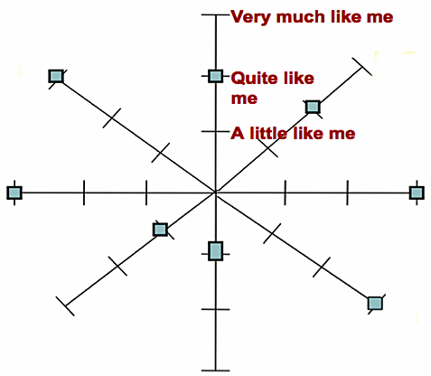
I take responsibility for my I ask questions when I choices don’t understand

I offer help before I am asked I do my best all the time

I finish what I start I treat other people with
respect
I help others in my group

References
10 Nail Art Designs Using HOUSEHOLD ITEMS!, Cutepolish (video), 2018 https://www.youtube.com/watch?v=ZBwB9OKyJQM
21st Century Competencies: Foundation Document for Discussion. Phase 1: Towards Defining 21st Century Competencies for Ontario, Winter 2016 Edition, 2016 http://www.edugains.ca/resources21CL/About21stCentury/21CL_21stCenturyCompetencies.pdf
Contessa - Salon Magazine, 2020 https://www.salonmagazine.ca/category/online-editions/
Course Codes for Emphasis courses in the Revised Curriculum: Technological Education, Grades 11 and 12, 2009 http://www.edu.gov.on.ca/eng/curriculum/secondary/techedemphasiscourses.pdf
Foster Naturals EcoOrganic Products, This West Coast Mommy (picture), 2022 https://thiswestcoastmommy.com/foster-a-greener-home-with-foster-naturals/
Growing Success: Assessment, Evaluation, and Reporting in Ontario Schools, First Edition, Covering Grades 1 to 12, 2010 www.edu.gov.on.ca/eng/policyfunding/growSuccess.pdf
Learning for All – A Guide to Effective Assessment and Instruction for All Students, Kindergarten to Grade 12, https://www.dcp.edu.gov.on.ca/en/
Milady’s Standard Cosmetology - Chapter 2, 1st Edition, (textbook). 2012 https://cpb-us-e1.wpmucdn.com/cobblearning.net/dist/8/794/files/2018/11/Milady-Textbook-Chapter-2-Life-Skills-20brelq.pdf
Milady’s Standard Cosmetology - Chapter 3, 1st Edition, (textbook). 2012 https://cpb-us-e1.wpmucdn.com/cobblearning.net/dist/8/794/files/2018/11/Milady-Textbook-Chpater-3-Professional-Image-106pjt5.pdf
Nail Art Practice Sheet, Black Cat Nails (image) https://twitter.com/blackcatnails/status/338288704202371073?lang=en
OCTE SAFEdocs for BBT, OCTE, 2022, https://www.octe.ca/en/resources/safety/safedocs
Resources, Skilled Trades Ontario, 2022 https://www.skilledtradesontario.ca/about-trades/trades-information/
Red SEAL – Sceau Rouge, 2018 http://www.red-seal.ca/trades/tr.1d.2s_l.3st-eng.html
Start an Apprenticeship in Ontario, Government of Ontario, 2022 https://www.ontario.ca/page/start-apprenticeship
Skilled Trades Identified in Ontario, Skilled Trades Ontario https://www.skilledtradesontario.ca/about-trades/trades-information/
Skilled Trades Ontario (website), 2022 https://www.skilledtradesontario.ca
The Differentiated Instruction Scrapbook http://www.edugains.ca/resourcesDI/EducatorsPackages/DIEducatorsPackage2010/2010DIScrapbook.pdf
The Environmental Impact of Cosmetics, Olivia Young (image), 2022 https://www.treehugger.com/environmental-impact-of-cosmetics-5207672
The Ontario Curriculum, Grades 9 and 10: Technological Education, 2009 (revised) http://www.edu.gov.on.ca/eng/curriculum/secondary/teched910curr09.pdf

