Router and Router Table

Video QR code
(to be inserted)

Safety Lesson Plan

Router and Router Table

Writer: | Kevin Shea
Doc version  (version Y/M/D date i.e.150630): | 160228

Specific Tool or Process: | Router and Router Table
Main Applicable Course: | Construction Technology – TCJ2O
Additional Applicable Courses: | TCJ3M/4M, TCJ3E/4E, TWE3E/4E- Cabinet Making

Safety Instruction Type (check all that apply)
Whole class demo | X | Demo at course start | X
Small group demo | X | Just in Time (JIT) demo | X
Individual demo | X | Assessment Review | X
Student presentation |  | Assessment demo | X
Students repeat demo |  | Other

This resource was produced
by the Ontario Council for Technological Education (OCTE)
It may be used in its entirety, in part, or adapted

Assessment Procedure
Student quizzes, student demonstration. This will be placed on the student’s Safety Passport as well as the wall charts (optional) that allows students to see which equipment they have met qualifications required to use safely

Associated Documents: (list all attached and reference documents)
Appendices to this lesson | Appendix A– Router Table and Router Safety Rules And Quiz (Below)  Appendix B - Router and Router Table Diagram and Quiz (Below)  Appendix C - Student Safety Record (Below)  Appendix D – Router Powerpoint Presentation (separate file)
OCTE SafeDOC | Construction July 2013  http://octelab.com/filter/%2A?field_lesson_subject_tid%5B%5D=20
OCTE SafetyNet | http://www.octelab.com/
Other Ministry | Curriculum documents - http://www.edu.gov.on.ca/eng/curriculum/secondary/teched910curr09.pdf
Other Reference Docs | Live Safe! Work Smart! Grade 9/10 and Grade 11/12  http://www.livesafeworksmart.net  Ontario School Boards Insurance Exchange  http://www.osbie.on.ca  Workplace Safety and Insurance Board  http://www.wsib.on.ca  Ontario Ministry of Labour  Web address: http://www.labour.gov.on.ca/english/  Power Tool Institute - Educational Materials  http://powertoolinstitute.com/pti_pages/educational.asp  Router Powerpoint Presentation  www6.grafton.k12.wi.us/ghs/teacher/kgain/  .

Hazard Table (check all that apply):

Standard Tool Hazards |  | Biological Hazards
Sharp objects, cuts | X | Food contamination
Knives/sharp tool procedures |  | Food temperature handling
Set up adjustments, lock procedures | X | Sharps/cutting tools handling
Machine guarding | X | Exposure to sunlight/ultraviolet light
High speed moving elements | X | Exposure to blood products
Pinch points |  | Exposure to mold, mildew
Sharp noise |  | Temperature extremes
Constant noise | X | Insect bites/plant/animal hazards
Drop hazards | X | Emergency contamination proc.
Kickback hazards | X
Heavy material hazards | X | Chemical Hazards
Use of recycled products/materials | X | WHMIS identification | X
Dust/debris hazards | X | Exposure to dangerous gases/fumes
Spill hazards | X | Exposure to dangerous liquids
Emergency stop procedures | X | Exposure to solvents
 |  | Exposure to pesticides/herbicides
 |  | Glassware handling
 |  | Emergency chemical procedures
Fire/Burn Hazards
Flammable material hazards |  | Electrical hazards
Hot processes |  | Electrical shock | X
Sparks |  | Electrical sparks
Explosion hazards |  | Electrical burns
Noxious gases/fumes |  | Short circuits
Emergency fire procedures | X | Wire/cord/cable inspection | X
 |  | Electrical connection inspection | X
 |  | Power cables/bars handling
Ergonomic hazards |  | Emergency power shutoff procedures | X
Heavy lifting
Awkward lifting | X | Site hazards
Heavy or extreme force |  | Confined spaces
Constant heavy force |  | Working from heights
Vibration |  | Slip/trip/fall hazards | X
Posture, body placement |  | Hazardous location of others
Repetitive stress injuries
Working with helpers | X
Emergency injury procedures | X
Safe disposal and Cleanup |  | Other hazards (specify)
Material scrap disposal | X | Floor Clean Up – Sawdust – Slippery | X
Chemical disposal
Biological materials disposal
Tool cleanup procedures | X

Personal Protective Equipment (check all that apply)
PPE | Required | Suggested | Details
Eye, Face, Head Protection
Safety glasses | X
Face shields
Welding helmets/goggles
Hard hats
Hearing Protection
Ear plugs | X
Ear muffs
Hand protection
Work gloves
Disposal gloves
Chemical resistant gloves
Knife shields
Respiration Protection
Dust masks | X
Surgical masks
Respirator (describe type)
Body Protection
Foot protection
Arm shields
Leg shields
Bibs | X
Coveralls
Welding jackets
Hot/Cold temperature protection
Fall Arrest
Fire protection

Lesson Preparation Procedures

Lesson Preparation
- Arrange PPE: safety glasses, bibs and/or shop coats

- Set up router and/or router table, inspect guards and/or fences

- Ensure there is a taped safety area and is clean from sawdust or debris around working piece or on both sides and front of the router table

- Have a variety of materials available for demonstration. This should include long and short pieces.

“Look Fors”:
- router work space is clean from sawdust and/or debris

- the router bit is sharp to ensure clean cut (no burn areas)

- the router bit is set to the correct height for material

- the fence is set to the correct width and is in locked position

- if on a router table, there is a proper guard over the bit

- the power chord and prongs including ground are in good shape

- location of E-stop and lock out power location (for router tables)

- non-slip mats and clamps are readily available to secure wood piece

- materials are free from nails and/or staples

Step by Step: Performing the Lesson

- Review student knowledge of material types and sizes(wood species/sizes) and safe handling procedures (demonstration)

- Review student knowledge of router components and function (prior lesson)

- Review shop rules and safety procedures (e.g., use of cell phones, no horse play, throwing objects, foot wear, etc.

- Examine work area for appropriate clean work area free from debris and sawdust

- Review rotation of router bit and what direction the router will travel – left to right (demonstration)

- Review changing bit on router – discuss colette and size, depth, tightening (demonstration)

- Review height of router bit in relation the material

- Review how to turn on/off router including how to set the router down once turned off

- Review the use of a fence (router table) depending on the type of application

Discuss and Demonstrate:
- proper use of Protective Personal Equipment (PPE)

- location and use of E-stops

- turning router on/off and setting it down on its side

- unplugging or locking out router if bit needs to be replaced

- location and use of eye wash stations

- need to notify instructor prior to use of table saw and “at all time – if in doubt – See you instructor”

- need to clean tools, floor space and hands after use

Emergencies

Before procedure, ensure students understand potential hazards and their mitigation.
Ensure all PPE is in place, eye and ear protection

Students must be trained to be aware of potential hazards, how to deal with emergencies, locations of safety equipment such as fire extinguishers, first aid kits and safety exits. Teachers must ensure safety equipment is up to date and ready.

Any injury, no matter how seemingly insignificant, must be reported to the instructor. Instructors must make reports as per Board and OSBIE requirements.

Fire
- Warn instructor & other students. Stop machine operation and hit shop E-stop as applicable. Instructor must direct students away from the danger and toward fire exit, ensuring fire alarm is activated, and use fire extinguisher if warranted.
- Burns must be treated right away, with water or preferably burn cream. Cover wound and bring student to administration.
- Any injury must be reported as per Board and OSBIE requirements.

Cuts/Scratches/Slices
- Student must stop operation, tell students close by to watch over equipment, tell instructor, then proceed to wash out the cut/scrape. Disinfectant and bandages should be brought in from the first aid kit and cut dressed.
- Inspect and assess the reason for the cut and inspect the tools and work pieces involved. Clean any blood, skin in the area with disinfectant. Instructors must approve of continuing operation and warn all students about the incident and instruct how to avoid future events.
- Any injuries must be reported as per Board and OSBIE requirements.

Electrical Shock
- Students must be trained to notice signs of electrical shock. Person undergoing shock must not be touched until power removed remotely.
- Clear the area; shut off power at fuse panel or e-stop. Unplug equipment only when power is off.
- Get someone to notify administration immediately.
- If shock is severe or prolonged:
  - Begin CPR if the person shows no signs of circulation, such as breathing, coughing or movement. Keep person warm.
- Cover any burned areas with a sterile gauze bandage.
- Leave scene as is for inspectors.
- Any injury must be reported as per Board and OSBIE requirements.

Cleanup Procedures

All students are responsible for end of class clean up. All machines are shut down seven minutes prior to the end of class to ensure the shop is clean and ready for the next class. This included but not limited to:
- projects put away in the appropriate location
- wood is either recycles or places in the storage bins
- saw dust is cleaned up
- machines are swept down
- work stations/tables are cleaned
- floors are swept
- tools put away in their proper places
- report any problems that may be associated with the equipment (e.g., unusual noises, dull bits, etc)

Assessing Safety Knowledge

Describe how students will be assessed, reporting progress, note relevant documents like tests, demonstration checklists, rubrics, signoff procedures, etc.-

Students will be assessed on their knowledge, understanding of procedures and safety concerns through the following:
- written quiz or test
- individual practical demonstration with instructor
- instructor observation of students’ ability to explain & demonstrate correct steps for equipment use and recording of results on a prepared checklist
- Quiz results will be recorded in instructor mark records.
- Database records will keep track of students that have met requirements for safe use of specified equipment.
- Wall charts will allow students to see which equipment they have met qualifications required to use safely.

Appendix A
Appendix Title – Router Table and Router SAFETY RULES and QUIZ –

Router Table

- Routers operate at high speeds and torque. Ensure all parts are tight and bits are sharp. Keep a solid two-handed grip on your work at all times, and make sure your stance is solid.

- Ensure that the clear plastic guard is in place and covering any exposed part of the router bit. Your wood should fit under the guard with only a ¼” clearance.

- When possible, use a push stick and/or feather boards to ensure that your fingers are not able to come in contact with the router bit.

- When using a router table with a fence, the work always moves from right to left.

- When routing all the edges of a board (or table top), start by routing across the grain.

- Look listen and smell! You control the feed speed. If the motor is slowing down you are trying to cut too fast. If you smell burning, you are feeding too slowly and the router bit is burning your wood.

- Ensure you are using proper depth of cut. Test cuts on scrap material. Make multiple passes for deep cuts. See the teacher if in doubt.

- Never let go of your wood during a cut.

- When bits become worn or damaged, they should be repaired or replaced immediately. Excessive burning or tearout are signs of damaged and dull bits. Bring these to the attention of the teacher.

AT ALL TIMES – IF IN DOUBT, SEE YOUR INSTRUCTOR

ROUTER TABLE QUIZ

Name:_______________________________

Date:________________

1. When using the fence, the work piece moves from __________ to ___________.

2. Never let _____________ of your wood during a cut.

3. Make a ___________ cut on a piece of scrap if you are not sure the router is set
up appropriately.

4. If you cut too ____________, you will have a rough edge. Be careful and don’t
push your wood too quickly. Let the machine _____________ properly.

5. Ensure that the _______________ ________________ is set to ¼” above your
work piece.

6. Let the work _____________ on the table. Never freehand cut.

7. Keep your ______________ away from the router bit.

8. If your work is ______________ it’s because you’re moving your wood too slowly.

WORD BANK:
Left, go, fast, right, rest, test, cut, burning, plastic guard, fingers

Router

- Routers operate at high speeds and torque. Ensure all parts are tight and bits are sharp. Keep a solid two-handed grip at all times and make sure your stance is solid.

- Routers turn clockwise (when seen from top). Always feed from left to right when making outside cuts. For inside cuts move from the right to the left.

The rule to remember is: Outside = Counter-clockwise
Inside = Clockwise

(an easy way to remember this is to match up the two longer words – Outside and Counterclockwise, and the two shorter words – Inside and Clockwise)

- When routing all the edges of a board (or table top), start by routing across the grain.

- Look listen and smell! You control the feed speed. If the motor is slowing down you are trying to cut too fast. If you smell burning, you are feeding too slowly and the router bit is burning your wood.

- Ensure you are using proper depth of cut. Test cuts on scrap material. Make multiple passes for deep cuts. See the teacher if in doubt.

- Never let go of the router until it has come to a complete stop.

- When bits become worn or damaged, they should be repaired or replaced immediately. Excessive burning or tearout are signs of damaged and dull bits. Bring these to the attention of the teacher.

- Make sure material to be routed is clamped solidly to the work bench or is on a non-slip mat/carpet.
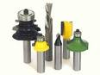

AT ALL TIMES – IF IN DOUBT, SEE YOUR INSTRUCTOR

ROUTER QUIZ

Name:_______________________________

Date:________________

1. Always use ____________ hands when using a router.

2. Don’t let go of the router until the __________ _________ has come to a
complete ____________.

3. Make a ___________ cut on a piece of scrap if you are not sure the router is set
up appropriately.

4. If you cut too ____________, you will have a rough edge. Be careful and don’t
push your wood too quickly. Let the machine _____________ properly.

5. Whenever possible start by cutting ________________ the grain.

6. Make sure your work is secure. Either on a ________________ mat, or on
______________.

7. Keep your ______________ away from the router bit.

8. If your work is ______________ it’s because you are moving your wood too
slowly.

WORD BANK:
Two, against, stop, fast, carpet, router bit, burning
test, cut, non-slip, fingers

Appendix B - Router and Router Table Diagram
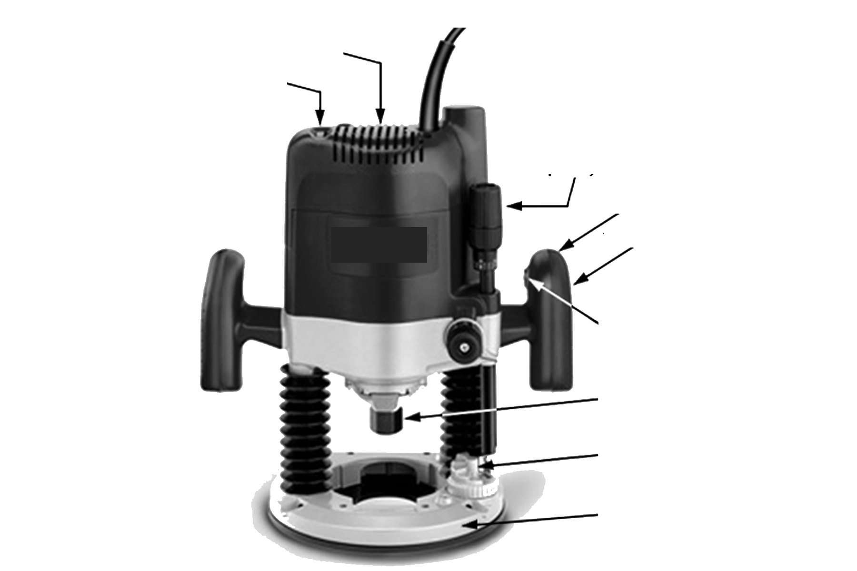Label the following components on the Router and Router Table below.
1)
3)
4)
5)
6)
7)
8)
2)

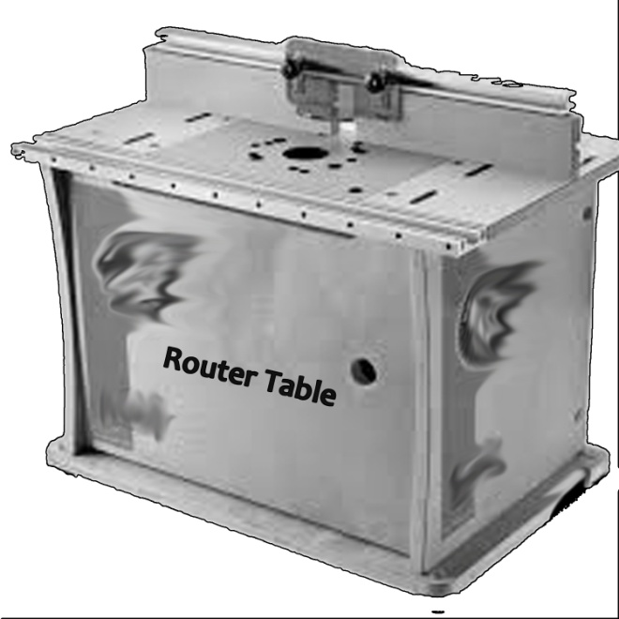
Answer Key
- Bit Safety Guard
- Fence
- Router plate
- Router Base
4)
3)
2)
1)
Answer Key
1) Variable Speed Dial, 2) Motor, 3) Depth Adjustment Guide, 4) Handle, 5) Power Switch, 6) Collet, 7) Depth Stop, 8) Base 9) Extension Table, 10) Front Rail, 11) Fence Locking Lever, 12) Mitre Gauge Slots, 13) Blade Height Adjustment Wheel, 14) Blade Angle Guide
Student Information |  |  | Levels Chart
Name:  Date :  Course: |  |  | Level 1: May set-up equipment only, Instructor must do the work.  Level 2: Use only with an Instructor’s assistance.  Level 3: Full use with an Instructor standing by to supervise.  Level 4: Full use of machine with an Instructor’s permission.  (Note: Lower levels can be upgraded to higher levels with further instruction, practice and proof of competence. All students must have Instructor’s permission before using any equipment.)
Stationary Equipment |  |  |  |  | Hand & Assembly Equipment
Equipment | Level | Sig. |  | Date | Equipment | Level | Sig. | Date
Band Saw | 1 |  |  |  | Biscuit Cutter | 1
Scroll Saw | 1 |  |  |  | Hand Drill | 1
Drill Press | 1 |  |  |  | Router | 1
Disk/Belt Sander | 1 |  |  |  | Circular Saw | 1
Lathe | 1 |  |  |  | Jig Saw | 1
Miter Saw | 1 |  |  |  | Hand Jointer | 1
Grinder | 1 |  |  |  | Finish Sander | 1
Thickness Planer | 1 |  |  |  | Orbital Sander | 1
Jointer | 1 |  |  |  | Belt Sander | 1
Table Saw | 1 |  |  |  | Chisels | 1
Router Table | 1 |  |  |  | Hand Saws | 1
(list all tools) |  |  |  |  | Hand Planes | 1
 |  |  |  |  | Files/Rasps | 1
 |  |  |  |  | Spoke Shave | 1
 |  |  |  |  | (list all tools)

Appendix C - Student Safety Record

It is the responsibility of the student to insure that prior to using any piece of equipment they have been signed off at the appropriate level.

All students in grades 9, 10, 11 and 12 are assumed to be at a level 1, they must complete a practical test before moving levels. This document is to keep in your file at the front of the class all semester.

