Printed Circuit Board

Video QR code
(to be inserted)

Safety Lesson

Writer: | Paul Lewis
Doc version  (version Y/M/D date i.e.150630): | 151002

Specific Tool or Process: | Printed Circuit Board Production
Main Applicable Course: | TEJ2O Computer Technology and TEJ3M Computer Engineering
Additional Applicable Courses: | TEI3M/TEI4M Computer Engineering Technology: Interfacing  TEL3M/TEL4M Computer Engineering Technology: Electronics  TER3M/TER4M Computer Engineering Technology: Robotics and Control System

Safety Instruction Type (check all that apply)
Whole class demo |  | Demo at course start
Small group demo |  | Just in Time (JIT) demo
Individual demo |  | Assessment Review
Student presentation |  | Assessment demo
Students repeat demo |  | Other

This resource was produced
by the Ontario Council for Technological Education (OCTE)
It may be used in its entirety, in part, or adapted

Assessment Procedure
ASSESSMENT FOR: Through the production of the sample board students will practice the safe and proper methods of making that board. Students will conference with the teacher throughout the process to discuss areas of growth. The teacher will also monitor/observe as the students work on their PCBs.
ASSESSMENT OF: Students write a test of knowledge before conducting the project. Later in the course the student will then make an individual project in which they will be assessed on the production of a PCB and production methods. Safety knowledge will be integrated into that assessment.

Associated Documents:
Appendices to this lesson | Appendix A: OCTE_toolSAFE_TEJ_PCB_ManufacturingPCB_PowerPoint.pptx (ext)  Appendix B:  OCTE_toolSAFE_TEJ_PCB_WHMIS_PowerPoint.ppt (external)  Appendix C:  OCTE_toolSAFE_WHMIS_Hazard_Symbols_PDF.pdf (external)  Appendix D:  OCTE_toolSAFE_TEJ_PCB_WHMIS_Handout_PDF.pdf (external)  Appendix E:  OCTE_toolSAFE_TEJ_PCB_FootShear_PowerPoint.pptx (external)  Appendix F:  OCTE_toolSAFE _TEJ_PCB_HotTools_PowerPoint.pptx (external)  Appendix G:  OCTE_toolSAFE_TEJ_PCB_FancyFlasherLayoutToPrint_PDF.pdf (ext)  Appendix H:  OCTE_toolSAFE_TEJ_PCB_Appendix_PracticeBoardInstructions.pdf  Appendix I: Printed Circuit Board Manufacturing Test (in doc)  Appendix J: Printed Circuit Board Manufacturing Answers (in doc)  Appendix K:  OCTE_toolSAFE_TEJ_PCB_Appendix K_MSDSFerric Chloride.pdf
OCTE SafeDOC | Computer Engineering SAFEdoc:  http://octelab.com/content/safedoc-computer-engineering  Chemical Handling Pg. 31  Electrical Hazards Pg. 34  Electrical Current Safety Pg. 35  Power Tools Pg. 47-48  Soldering Safety Pg. 52  Tool Safety Pg. 53  WHMIS Pg. 54
OCTE SafetyNet | Computer Engineering  http://octelab.com/filter/%2A?field_lesson_subject_tid%5B%5D=19
Other Ministry | Curriculum documents - http://www.edu.gov.on.ca/eng/curriculum/secondary/teched910curr09.pdf
Other Reference Docs | - Soldering http://www.ee.ryerson.ca/~jkoch/MSDS_Sheets/4900_Lead_Free_Solder.pdf  - Solder  http://www.astro.umd.edu/~harris/docs/WellerSoldering.pdf  http://naples.cc.sunysb.edu/Admin/HRSForms.nsf/pub/EHSD0348/$File/EHSD0348.pdf  - Ferric Chloride  http://www.mgchemicals.com/downloads/msds/english/sds-415-l.pdf  http://doc.ccc-group.com/msds/english/436497.pdf  http://www.indabook.org/d/Liquid-Ferric-Chloride-General-Chemical.pdf  http://www.labchem.com/tools/msds/msds/LC14380.pdf  http://blogs.eciad.ca/printmedia/files/2008/03/working-with-ferric-chloride.pdf  - Scissors  http://safety.ucanr.edu/files/3130.pdf  - Gloves  http://www.research.northwestern.edu/ors/safety/general/ppe/documents/allergic-reactions-to-gloves.pdf  - Burns  http://www.healthline.com/health/burns#Overview1  - WHMIS  http://www.hc-sc.gc.ca/ewh-semt/occup-travail/whmis-simdut/symbols-signaux-eng.php  http://www.hc-sc.gc.ca/ewh-semt/occup-travail/whmis-simdut/index-eng.php  https://www.youtube.com/watch?v=-m2IpqMpR34  - Liquid Tin  Note: DO NOT use this chemical as it has carcinogen substances in it. Read Section 11 of the MSDS.  http://www.mgchemicals.com/downloads/msds/english/sds-421-l.pdf  Live Safe! Work Smart! Grade 9/10 and Grade 11/12  http://www.livesafeworksmart.net  Ontario School Boards Insurance Exchange  http://www.osbie.on.ca  Workplace Safety and Insurance Board  http://www.wsib.on.ca  Ontario Ministry of Labour  Web address: http://www.labour.gov.on.ca/english/

Hazard Table

Standard Tool Hazards |  | Biological Hazards
Sharp objects, cuts |  | Food contamination
Knives/sharp tool procedures |  | Food temperature handling
Set up adjustments, lock procedures |  | Sharps/cutting tools handling
Machine guarding |  | Exposure to sunlight/ultraviolet light
High speed moving elements |  | Exposure to blood products
Pinch points |  | Exposure to mold, mildew
Sharp noise |  | Temperature extremes
Constant noise |  | Insect bites/plant/animal hazards
Drop hazards |  | Emergency contamination proc.
Kickback hazards
Heavy material hazards |  | Chemical Hazards
Use of recycled products/materials |  | WHMIS identification
Dust/debris hazards |  | Exposure to dangerous gases/fumes
Spill hazards |  | Exposure to dangerous liquids
Emergency stop procedures |  | Exposure to solvents
 |  | Exposure to pesticides/herbicides
 |  | Glassware handling
 |  | Emergency chemical procedures
Fire/Burn Hazards
Flammable material hazards |  | Electrical hazards
Hot processes |  | Electrical shock
Sparks |  | Electrical sparks
Explosion hazards |  | Electrical burns
Noxious gases/fumes |  | Short circuits
Emergency fire procedures |  | Wire/cord/cable inspection
 |  | Electrical connection inspection
 |  | Power cables/bars handling
Ergonomic hazards |  | Emergency power shutoff procedures
Heavy lifting
Awkward lifting |  | Site hazards
Heavy or extreme force |  | Confined spaces
Constant heavy force |  | Working from heights
Vibration |  | Slip/trip/fall hazards
Posture, body placement |  | Hazardous location of others
Repetitive stress injuries
Working with helpers
Emergency injury procedures
Safe disposal and Cleanup |  | Other hazards (specify)
Material scrap disposal
Chemical disposal
Biological materials disposal
Tool cleanup procedures

Personal Protective Equipment

PPE | Required | Suggested | Details
Eye, Face, Head Protection
Safety glasses |  |  | Drilling and Soldering
Face shields
Welding helmets/goggles
Hard hats
Hearing Protection
Ear plugs
Ear muffs
Hand protection
Work gloves
Disposal gloves
Chemical resistant gloves |  |  | Instructor - Not Students
Knife shields
Respiration Protection
Dust masks
Surgical masks
Respirator (describe type)
Body Protection
Foot protection
Arm shields
Leg shields
Bibs |  |  | Plastic, for etching tank
Coveralls
Welding jackets
Hot/Cold temperature protection
Fall Arrest
Fire protection

Lesson Preparation Procedures

- Students must come into this lesson with prior knowledge of: WHMIS, safety around hot tools, safety around drill presses, safety around foot shears, safe use of a utility knife and PPE.
- Class materials should include:
clothes irons with auto shutoff (6+) wooden boards (12” x 12” is a good size) (6+)
scissors (6+) pencil/utility knife and Kevlar glove (6+) laser overheads (box 100) printed circuit board ferric chloride (4 litre)
etchant tank with air pump (best to set up in a sink to rinse the boards)
computer, laser printer and electronic cad software (Express PCB is free)
permanent marker – fine and ultra fine (6+) drill press (2+)
#60 drill bit (20+) foot shear extra pencils
brown single fold paper towel (2+ of 250 sheets) copper scrub pads (6)
sink with running water. safety glasses for students
plastic apron, safety glasses and vinyl gloves (for the instructor when handling the ferric chloride)

- Ensure you have enough printed circuit boards for every student. Single sided is best, however double sided is more common.

- Place the ferric chloride in the etchant tank with the air pump running. Placing the etchant tank in the sink not only protects the tank from tipping but is also close to the tap for rinsing the board. A 4 litre bottle of ferric chloride will adequately fill the tank. Keep the bottle as it can be used to store the spent solution that will later be disposed of according to the school board’s disposal protocol.

- Print off about three transfers for every student. Some will take more, others less before they get a good image on their board.

- Prepare a tray of cold tap water.
- Prepare PC boards in the different stages to for your demonstration.
- Basic PC board cut to the right size.
- A good image that has been transferred to the board.
- A bad image that has been transferred to the board. It should be less than 85% with parts of the traces missing and some of the image blurry.
- An etched board that came out well.
- An etched board that has stayed in the solution too long and has missing pathways.

- Prepare photocopies of the PowerPoint “PCB Production Lesson” (Appendix A) as a handout.
- Prepare copies of the knowledge test (Appendix I, in this document)

Step by Step: Performing the Lesson

- Present and discuss the PowerPoint “OCTE toolSAFE Printed Circuit Board Production Lesson”. (Appendix A) (It is recommended to print it out as a handout.)
- Present and discuss “Hot Tools” PowerPoint (Appendix F) which includes:
  - where to place the tool when on but not in use.
  - where to place the cord so the tool does not get pulled,
  - checking the cord to see that it is in good condition.
- Present and discuss “Foot Shear” PowerPoint (Appendix E) which includes:
  - How to line up the board that you are cutting,
  - where to place hands while cutting
  - how to use the foot to shear.
- Perform a class demonstration by first cutting the transfer out from the printed laser sheet. Cut along the fine lined border. (See Appendix G)
- Take a piece of printed circuit board and trace with pencil along the edge of the transfer. The transfer should be lined up along one of the edges of the printed circuit board. Let them know that the board should not be wasted, so not cutting the image out of the middle of the board, which is also harder. Let them know that the board must be the exact size as the thin line.
- Take them over to the foot shear and demonstrate how to cut the board. Key points include:
  - Sliding the printed circuit board up against the right angle guide.
  - Lining the pencil mark with the cutting edge of the shear.
  - Show where to place the hands.
  - Show how to cut the board using the foot, making sure the other foot is out of the way.
- Clean the board with a copper scrub pad. It must be very shiny. Let them know that there should be no finger prints. The board should be handled by its edges. If it is a double sided board, clean both sides. Sometimes there is something on the board that inhibits the etching process.
- The next step is to iron on the transfer. The ironing is done on a wooden board so that the tabletop is protected. The iron is on its highest setting, which is linen.
- At this point review the safe operation of a clothes iron. Items to review include:
  - safe placement of the electrical cord so that the iron cannot be pulled,
  - placing the iron standing up when not in use and not leaving the sole plate on the surface,
  - not touching the sole plate, even when not plugged in.
- Place a single piece of brown paper towel on top of the copper board. Place the iron on top and move it around in a circular motion. This will heat the board evenly so there are no cold spots. This takes about 4 minutes.
- Pull back the paper towel and put the transfer on the copper board. When doing so, make sure the transfer is not shifted once it is down. If it does it will blur the image.
- Once the transfer is down, replace the paper towel and continue the circular motions for another 2 minutes.
- Pull off the paper towel and place the board in the tray of water. After it has cooled for 30 seconds, pull out the board and dry it off.
- Holding the board at one end with your thumb pressing down, lift the transfer from the other end and keeping it tight, lift straight up. The motion should be more like a door swinging open as opposed to pulling back bed covers. This increases the likelihood of the toner staying on the copper.

- Inspect the board. If 85% or more of the toner is on the copper board, use it. However, it is less, take the copper scrub pad and scrub off the toner and try again with that board. Sometimes there is a hint of the image still remaining after the toner has been scrubbed off. Not to worry, the board can still be used.
- Take a permanent marker and repair the areas that did not transfer. After it has dried, repeat two more times. If this is not done the etchant solution will breakdown the permanent marker and begin to eat the copper. The student should also put their initials on the copper side of the board with a permanent marker, going over it three times.
- Once the printed circuit board is ready to go into the etchant solution, put on your personal protective equipment. You should wear:
  - a plastic/vinyl apron (something that does not absorb the chemical),
  - plastic/vinyl gloves,
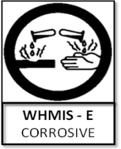
  - safety glasses
Students should be wearing safety glasses (and aprons if possible) and standing far enough away to avoid splashes or spills.

- Explain to the students that Ferric Chloride is corrosive and can damage skin but especially eyes. That is why the instructor will be putting in and taking out the printed circuit boards. Put in one of the good quality prepared copper boards to demonstrate how it will stand in the tray.
- 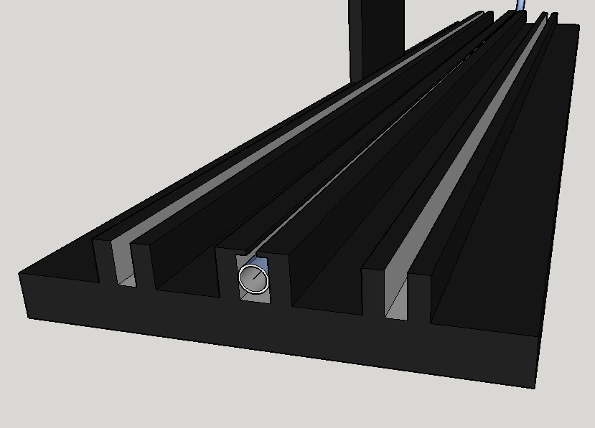Explain to the students that they will be reminding the instructor to check the boards every 10 minutes. Normally a board in new ferric chloride will take about 20 minutes. However, as you add more boards to the tank and as the etchant gets “older” because of the number of boards it has etched, the time to etch a board will become longer and longer. By checking the boards every 10 minutes provides an opportunity to turn the boards. The boards stand in a slot and that part of the board does not etch as fast as the exposed parts. By turning them allows the board to etch evenly.
SLOT
- Show the students a good etched board. Point out that a good etched board will have all the component pads, pathways and text. If it is too long, parts of the pads and paths will be gone.
- Explain that the toner and permanent marker have done its job and must now come off. Take a scrub pad and scrub it clean.
- Taking a multimeter and having it set for continuity testing, demonstrate how to check for breaks in the pathway and for shorts. Let them know that if there is a break to mark it with a permanent marker and it can be fixed during the soldering process. However, if there is a short, it can be broken using a pencil/utility knife. Remind them that they must wear a Kevlar glove on the hand that is not holding the knife. They should use short strokes when cutting through the copper.
- The next step is to mark all the holes to be drilled on the printed circuit board. This is done so that the pads stand out when drilling and no holes are missed. It becomes quite difficult to drill a hole when half of the components are already soldered in.
- The next step is to drill the holes in the pads on the printed circuit board. Remind them the safety measures that must be followed when drilling. They include:
  - wearing safety glasses when operating the drill press or within 1 meter of the drill press,
  - long hair must be tied back,
  - they must not wear loose clothing.
Students must also be reminded how to:
- start and stop the drill press
- open and tighten the chuck using the chuck key,
- raise and lower the table,
- adjust the guard that is in front of the chuck.
Remind the students that they are to use a #60 drill and because it is so small they must gently pull the drill through the printed circuit board. They should also inspect the drill bit to make sure it is not broken. Using a broken drill bit makes a ragged and a much larger hole.
- Lastly, during the drilling process small copper burs develop because the metal is so soft. They should be removed, if not they could cause a short between two pads that are close to each other.
- Once the board is complete with drill holes, all tools and work surfaces must be wiped down and cleaned of any debris. All tools and materials must be put back in their proper storage. The etching tank fluid must be disposed of as per Board and school policies (the teacher should perform this duty). See Cleanup Procedures below.

- Students complete the test of the procedures (Appendix I, enclosed) before continuing on further projects.

Emergencies

NOTE: Consult and be familiar with your school and Board procedures on accident reporting and treatments.

Specific Immediate Remedial Measures:

Before beginning any project, ensure that you have a stocked emergency first aid kit ready to treat burns, cuts, etc. Note special case of having lime or soda ash/sodium carbonate handy for neutralizing ferric chloride spills below.

In case of burns and minor injuries;
• Call your teacher for immediate attention.
• Your teacher must ensure your cut is treated and sterilized properly.
• Ensure any OSBIE and/or Board incident report is completed.

Ferric Chloride
Ferric Chloride in the etchant tank should be placed in a area where it cannot be knocked over. A deep sink is the perfect place as there is very little chance of being tipped. Also, as the board are being pulled out of the tank they need to be rinsed off, once most of the ferric chloride has been dripped off.

However, if there is a spill the MSDS sheet suggests the following:
Cleaning: Neutralize with lime (Ca(OH)2 or CaC03) or soda ash/sodium carbonate (Na2C03). Collect liquid in a plastic container. Wash spill area with soap and water to remove the last traces of residue.
Clothes Iron
After inspecting the iron before use and it is found that the cord or plug have been damaged, take a side cutting pliers and cut the cord at the plug and at the iron. Throw the iron out.
If someone is burned by an iron it is important that the burned skin is bathed in cool water. Do not use ice or apply butter. Once the pain has abated, cover the burned area in gauze to protect the area. If a blister forms do not break it as increases the chances of infection. If the burn is severe enough, medical attention should be sought immediately. Report any incidents as per Board nd school policies..

Cleanup Procedures

Cleaning up at the end of class includes the following:
- Return the scissors to the storage area.
- Return the wooden boards to the storage area.
- Return the pencil/utility knives and permanent markers to the storage area.
- Return the clothes irons to the storage area making sure the cords have been tied up and the hot (or assumed hot) sole plate is facing in.
- Empty the trays of cold water and place them in the storage area.
- Return any unused printed circuit board to the storage area.
- Brush down the drill press and return the chuck key and drill bit to the storage area.
- Pick up scrap plastic from the transfer, used paper towel and put them in the garbage.
- Sweep the floors.

Storage of Chemicals
When this unit is over and the ferric chloride is no longer required, return the chemical to the original bottle and then store it in a cool dry place that is locked.

Removal of Chemicals

When the ferric chloride is no longer useful, it is placed back in the container it came in and stored in a cool dry place that is locked. At the end of the school year inform the administration and the Health and Safety department of your school board that you have a hazardous waste to be disposed of. They will arrange for pickup so that it can safely be disposed of.
Assessing Safety Knowledge

Student will start off the course with a unit on the introduction of tools that they will use throughout the course. They will also learn how to safely use these tools as well as safety procedures related to non tool items. At the end of that unit there will be a written test.

In this unit safety procedures will be reviewed. However, during the unit the student will be assessed by demonstrating proper use of tools. This will be part of the rubric for this unit. It will also track infractions. This ongoing assessment will determine if the student needs to revisit safety procedures and protocols.

Appendix I: Printed Circuit Board Manufacturing Test

Name:_______________ Date:_______________

____
40
Part A: Knowledge [10]

- The image or transfer is glued onto the PCB.
- The PCB is cut using a foot shear.
- The clothes iron is set at the linen temperature setting.
- The plastic transfer is peeled back by rolling it back.
- A pencil is used to correct any flaws in the image on the PCB.
- Ferric Chloride is used in the etching process.
- Safety glasses, protective gloves and hearing protection are worn when working with the etchant solution.
- Your instructor is the person who will handle the etchant solution.
- Once etched, the multimeter is used to measure the resistance of the board.
- A Kevlar glove is worn to prevent burns.

K
____
10

Part B: Thinking [10]

- How do you identify the following burns.[3]
a) First degree burn -
b) Second degree burn -
c) Third degree burn -
- Identify three safety rules to observe when drilling a PCB with a drill press.[3]
-
-
-
- List three safety rules when using a clothes iron.[3]
-
-
-

- What part of the foot shear makes sure that you are cutting 90° corners?[1]
-
T
____
10

T
____
10
Part C: Communication [10]

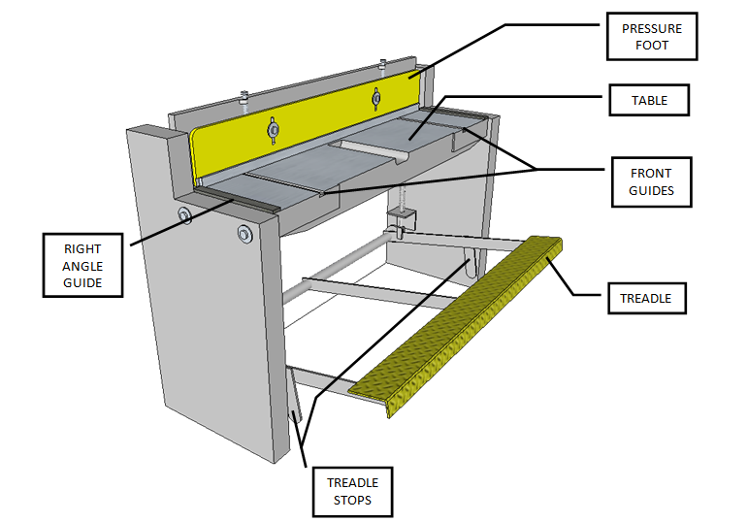
- Identify the parts of this machine.[6]
- Identify this tool and explain its purpose and why it is used.[3]
Tool:____________________
Purpose:___________________________________________________________
Why use it:_________________________________________________________
C
____
10
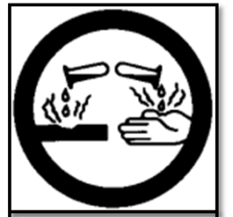
- Identify this WHMIS symbol.[1]
-
Part D: Application [10]
- List the steps in making a PCB.[1]
  - _____________________________________________________________
  - _____________________________________________________________
  - _____________________________________________________________
  - _____________________________________________________________
  - _____________________________________________________________
  - _____________________________________________________________
  - _____________________________________________________________
  - _____________________________________________________________
  - _____________________________________________________________
  - ____________________________________________________________
  - ____________________________________________________________

A
____
10

Steps to Operating a Foot Sheer

- ____________________________________________________________________________________________________________
- ____________________________________________________________________________________________________________
- ____________________________________________________________________________________________________________
- ____________________________________________________________________________________________________________
- ____________________________________________________________________________________________________________
- ____________________________________________________________________________________________________________

Appendix J

Printed Circuit Board Manufacturing Test Answers
Knowledge - True/False
- F
- T
- T
- F
- F
- T
- F
- T
- F
- F
Thinking – Short Answers
- - First Degree: Redness, minor inflammation (swelling), Pain, dry, peeling skin,
- Second Degree: blisters, extremely red and sore
- Third Degree: waxy and white, charred, dark brown, raised and leathery
Accept Any of These Answers
- - Wear safety glasses
- Make sure long hair is tied back
- Cannot wear loose clothing
- - not in use have clothes iron standing up with hot face plate facing away from
you and your classmates
- work on a wooden board
-Never touch the sole plate of the clothes iron, even when it is not plugged in.
Always assume it is hot.
- Right Angle Guide
Communication – Short Answers (Accept Any of These Answers)

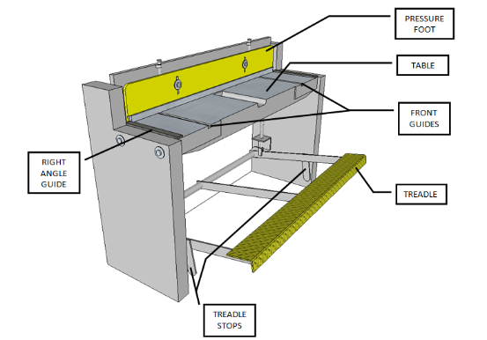

- Tool: Soldering Iron Stand
Purpose: To hold the soldering iron when not being held
Why use it: Its design is to isolate the hot tip so that no one or nothing can get
burned.
- E – Corrosive
- Manufacturing PCB Steps
- Cut out laser printed transfer
- Trace the image size onto a copper board
- Cut the copper board using the foot shear
- On a wood board heat the copper board under paper towel for 4 minutes
- Place the transfer onto the copper board and heat another 2 minutes
- Cool copper board in water and peel off plastic
- If over 85%, fill in gaps using permanent marker
- Place copper board in ferric chloride so that exposed copper is etched off
- Check every 10 minutes and when complete pull board out and rinse board
- Use continuity setting on multimeter to check for shorts and breaks
- Mark and drill pads for components using #60 drill bit

