Safety Resource
Haircutting Resource Booklet
(Please note this resource is always in progress!)
Jeff Williton/Tracey Fedy-Williton
7/15/2015

Haircutting: Identifying tools of the trade
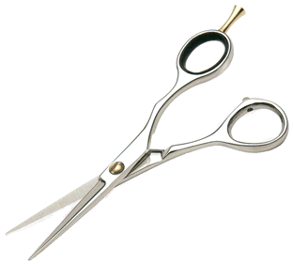
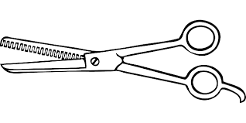
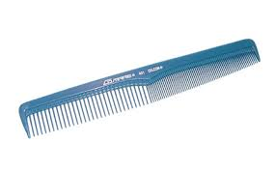
Haircutting shears Thinning shears haircutting comb

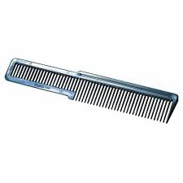
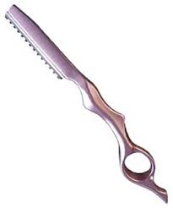
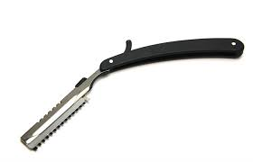
Traditional straight razor Modern straight razor Clipper cutting comb

Clippers Clipper guards Trimmers
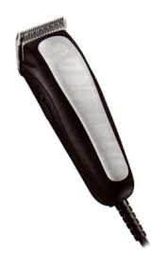
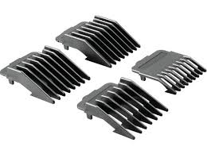
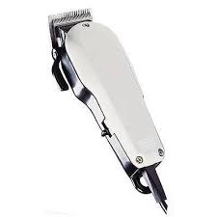

Clippers, trimmers and guards
Clippers are used for a variety of short haircuts. Clipper attachments also referred to as guards, provide the stylist control with cutting the hair very short creating consistent length with each different attachment. There are many sizes of clipper attachments/guards available.
Common guard sizes:
# 4 | 12mm or ½ inch
# 3 | 9mm or 3/8 inch
# 2 | 6mm or ¼ inch
# 1 | 3mm or 1/8 inch

How to put a guard on the clipper
-Select the guard you wish to use,
-secure the guard under the clipper blades first, then…
-secure the bottom of the guard against the bottom of the clipper until you hear it snap in place.
-to remove the guard pull up on the tab at the back.

Clippers used without a guard will remove all length down to the skin with a trace of stubble.
Trimmers (also referred to as an edger) are used to outline the hairline, trim side burns and for hair tattoo design. Some trimmers come with guards and may be used as clippers. Trimmers designed with a smaller motor and finer teeth than clippers making clippers a better choice when removing a lot of hair at one time or when working with thick or course hair.
Trimmers used without a guard will remove all length down to the skin will very little trace of stubble (a closer cut than clippers as the teeth are finer and set closer together).
SAFETY TIP: To prevent electrical shock, always inspect the cords to ensure they are free of frays and damage. If you inspect any danger, report it to your teacher.
Disinfection procedure: Clippers and guards
- Remove loose hair from the clipper blades with clipper brush (or old tint brush)
- Lightly spray the blades with an approved disinfecting spray (see teacher)
- Guards are to be put into a sink, rinsed in hot soapy water, then sprayed with disinfectant, rinsed and dried.
- Return clippers and guards to a clean, closed container

(This procedure is also found on page 7 under “Routine Disinfection Procedures for the Classroom”)
Procedure: How to respond to an accidental cut
To protect yourself and others from the unknown, use the following procedure to respond to an accidental cut or bodily fluid exposure. This procedure can also be found later in this document.


Stop service and inform the teacher

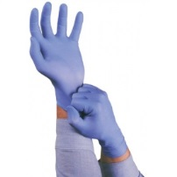
Put on disposable gloves before you touch the wound

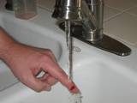
Allow the wound to bleed freely, and then wash with soap and water

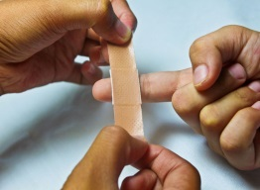
Dry with a paper towel and cover with a bandage

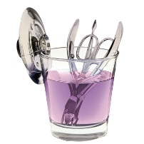

Disinfect the exposed tool(s) and surfaces, follow up this step by recording details of the incident (to be kept on file for 5 years)
Preparing and Handling Instruments and Equipment
How you use an item determines the classification and type of disinfectant needed. For example; a tool that may accidentally nick or break the skin must be disinfected with an intermediate or high level disinfectant as it has the potential to come into contact with blood and body fluids. While a comb or brush used on your clients hair needs to be disinfected with a low level disinfectant. Tables and work surfaces may also be disinfected with a low level disinfectant. (See your instructor for specific instructions)

- Hands MUST be washed before and after each client, and should be washed at both the beginning and end of class.

- All combs and brushes MUST be thoroughly cleaned, followed by disinfectant before use on a client.

- Work surfaces MUST be disinfected between each client, and before leaving class (this includes chair and mannequin stand)

- Scissors should be cleaned and disinfected with a low level disinfectant after each use. Scissors MUST be properly cleaned and disinfected in the event of an accidental cut to the skin.

- Electric clippers and their blades MUST be cleaned and disinfected with an intermediate level disinfectant after each use. (see your teacher for further instruction)

- Any instrument, when visibly contaminated with blood or body fluids, MUST cleaned and with a high level disinfectant.

- Razor blades used for haircutting MUST be disposed of in an appropriate biohazard container.

- All towels MUST be laundered and thoroughly dried in a mechanical dryer and stored in a clean and sanitary manner prior to reuse. Separate towels MUST be used for each client.

- Disposable neck strips or clean towels MUST be used under reusable capes for each client.

- The neck rest and the hair-washing bowl MUST be cleaned with a disinfectant between each client.

Hand-washing instructions
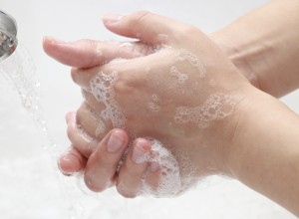
Your hands must be washed before and after each client!
- Wet hands with warm water
- Apply soap to produce lather
- Rub for 10 to 20 seconds to remove 80% of germs
- Rinse germs away
- Dry hands with a paper towel
- Turn off tap with paper towel

Public Health hand hygiene link: http://www.publichealthgreybruce.on.ca/Infectious_Diseases/Hand_Hygiene/
Photo source: http://norocore.ncsu.edu/blog/hand-hygiene-in-hospitals-2

Hair Salons and Barber Shops-Fact Sheet

Bacterial, fungal, and viral infections may result from using contaminated equipment. Infection prevention and control measures must be followed to protect both personal service workers (PSW) and clients. You do not have to see blood or body fluids on the instruments for an infection to occur

Hands must be washed before and after each client, before and after wearing gloves and in between breaks in service.

If hands are NOT visibly soiled, an alcohol based hand rub with at least 60% alcohol may be used.

Scissors and reusable razor blades for cutting hair should be cleaned after each client.
They may be disinfected using a low level disinfectant between clients.

Razors for cutting hair must have a proper guard in place. Razors are to be disposed of in an approved sharps container.

Combs and brushes should be cleaned and disinfected with a low level disinfectant after each client.

Hair clippers, trimmers, and scissors that may accidentally nick or break the skin must be cleaned and disinfected with an intermediate or high level disinfectant.

If a sharps container is required, the container must be disposed of in an appropriate manner (e.g. pharmacy).

Crochet hooks must be cleaned and disinfected with an intermediate or high level disinfectant.

Single use neck strips, or towels that are laundered after each client, must be used with reusable capes.

Hepatitis B vaccine is strongly recommended for all stylists (PSW’s).

In the event of accidental blood exposure to either client or PSW: Document the incident. Records must be kept on site for one year and on file for five years. See Procedure: How to respond to an accidental cut or bodily fluid exposure. All equipment and surfaces must be cleaned and disinfected with a high level disinfectant

Note: all items must be cleaned, with soap and water, and then dried with a clean towel prior to being disinfected.

Reference
Infection Prevention and Control Unit, Public Health Division. (January 2009)
Infection Prevention and Control Best Practices For Personal Services Settings. Ministry of Health and LongTerm Care.
Routine Disinfection Procedures for the Classroom

It is the responsibility of all students to ensure infection control procedures are strictly followed to provide a safe, healthy learning environment.

Combs
Tail combs and cutting combs are to be cleaned with soap and water after each use, and then placed into a jar with Barbicide disinfectant. The combs will remain in the Barbicide jar until needed.
When a comb is removed, it will be rinsed with water before use on the client.
Barbicide jars must be emptied at least once a week. (see your teacher for more information)

Brushes
Styling brushes must be disinfected before use on a live model.
Begin by removing all loose hair from brush into a garbage can.
Go to the sink and rinse thoroughly with hot, soapy water (use a small bit of dish soap).
Spray brush with an approved disinfectant (see your teacher).
Allow disinfectant to remain on brush for manufacturers recommended contact time.

*See your teacher for classroom procedures for brushes used on mannequins.

Tables/work surfaces and chairs
Are to be wiped down at the end of each class with an approved low level disinfectant (see teacher)

Clippers and guards
  - Remove loose hair from the clipper blades with clipper brush (or old tint brush)
  - Lightly spray the blades with an approved disinfecting spray (see teacher)
  - Guards are to be put into a sink, rinsed in hot soapy water, then sprayed with disinfectant, rinsed and dried.
  - Return clippers and guards to a clean, closed container

Towels
Are to be washed after each use, and stored in a clean area.
Separate bins will be used for both dirty and clean towels.
The lint trap in the dryer MUST be cleaned after each load.

Capes
A towel or neck strip must be used between the cape and the clients skin
Haircutting capes will be washed as needed.
Haircolour capes should be washed after each use.
All capes are to hang dry. Do not dry capes in the dryer as they will lose their shape.
Lint trap in dryer MUST be cleaned after each load.

Haircutting – Infection control procedures & safety
Haircutting shears (includes Thinning shears and specialty shears)
- Handle shears carefully at all time as they are very sharp
- Shears should be disinfected before each use.
- Using your dominant hand, use your ring finger to control the sill blade (pinky finger rests on tang) and your thumb to control the movable blade.
- Palm the shears with the tips closed while combing through the clients hair.
- Use only the tip of the shears while working close to the ears.
- To prevent cutting or nicking your fingers, never cut past your second knuckle
- In the event of an accidental cut, the shears must be disinfected immediately after caring for the wound. (see your teacher for assistance in this situation)

Haircutting Comb
Are to be cleaned and then placed into Barbicide disinfectant after each use (remove any loose hair first). Carefully remove comb from Barbicide, rinse and dry off with a clean towel before using.

Haircutting Razor
- The use of a haircutting razor will be permitted only under the direct supervision of the teacher.
- The teacher will ensure that the guard is safely in place and appropriate for use
- The teacher will personally instruct you on how to hold and safely use a razor.
- Old blades must be carefully placed into a Sharps container for safe disposal.

Clippers, Trimmers and Guards
- Students must first be trained and receive approval from the teacher prior to using these tools.
- Must be inspected before each use to ensure that they are clean and in safe working condition.
- If the clippers or trimmers are dropped, they must be inspected to make sure that the blades are not damaged. Damaged blades or missing teeth can/will cut the skin and cause bleeding.
- Clippers, trimmers and guards must be disinfected prior to use on your client. (procedure below)
-Remove loose hair from the clipper blades with clipper brush (or old tint brush)
-Lightly spray the blades with an approved disinfecting spray (see teacher)
-Guards are to be put into sink, rinsed in hot soapy water, sprayed with disinfectant. Rinse. Dry.
-Return clippers and guards to a clean, closed container

Draping
Each client who receives a haircut will be properly draped with either a neck strip or towel to prevent the cape from directly contacting the client’s skin. The towel will be laundered and/or the neck strip will be disposed of after use. Capes will be laundered regularly, and hung to dry.

Client services (live model work)
- All live model work will be done under the supervision of the teacher.
- Students must receive permission from the teacher prior to beginning any haircutting service, including a bang trim.

Blunt cut procedure

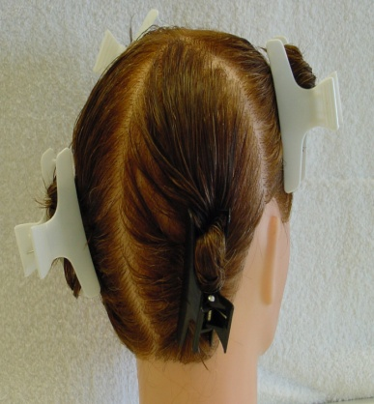
1) Section mannequin in four.
2) Begin at the back of the head. Take down a horizontal section approx. 3
fingers above the hairline on from the back 2 panels and cut a guideline to
the desired length
* The hair must be held with even tension
* Each section of hair is to be held at 0 degrees/ no elevation.

3) After cutting your guideline, bring down a ½” section and cut
this hair to match your guide using no elevation.
Check to ensure this is even.

4) Continue to bring down ½” sections, matching their length to the
guide. Check for evenness before you continue.

*remember to make sure the chin is always level with the floor
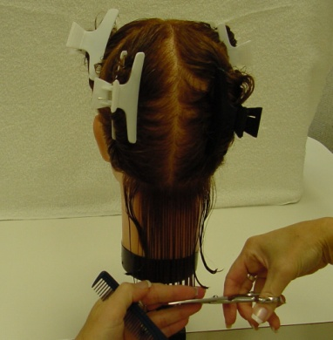
*Each section is not to elevated as this will create layered ends

5) After the back is complete, and you feel it is reasonably even,
continue onto the sides.
Bring down a section over each ear (approx. 3 fingers above the ear)

6) Cut the length guideline at each side to match the back.
*again be careful to make sure the chin is level
*Do not comb the hair down with too much tension as it will shrink (shorter)

7) After the guideline over each ear is cut and you have checked to
ensure that both sides are even, complete each side in the same
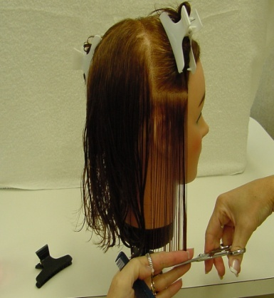
manner you did the back by bringing down ½ inch horizontal sections until
you reach the top of the head, or hair no longer reaches the guide.

8) When the cut is complete, clean up your workspace.
Clean hair from table and chair-sweep up the floor.

9) Blow dry and style.
*always dry and style your haircut as the hair will lie differently when it dries.

*Always do a final inspection and make necessary adjustments to ensure is
even and balanced.

10) See teacher for assessment.

Increase layer haircut – cutting procedure

Increase layers produce shorter layers at the top of the head to create movement and volume. The layers become longer towards the perimeter. This cut is done by creating a stationary guide at the top, and directing all hair up to this guideline. The elevation used is 180 degrees.

Procedure:
- Set up necessary tools and supplies.
- Section into 2 (front half and back half)
- Begin at the back. Cut your guideline at the top (crown area).
- The back will be divided into 3 sections-one in the center and one behind each ear.
- Start with the center section-bring ½ inch horizontal sections up to the stationary guideline at the top (the one you just cut). *Do not drop any hair as you cut.
- When the center panel is complete…continue to the panels behind each ear-bring ½ inch horizontal sections up to the original guideline.
- Cross-check the back using vertical partings elevated at 180 degrees.

Front (top and sides)
- Create a guideline from the crown to the front perimeter (bang area). This guideline should be approx ½ wide and created by using the length from the original guideline
- Using ½ inch horizontal partings, bring the hair up to your guideline to be cut. Continue to do this until all the hair, including the perimeter length is cut. (repeat this step for each side)
- Cross-check the top and sides using vertical partings elevated at 180 degrees.
- Blow-dry and style….
- Fine tune the final cut (check over cut for to make sure it is even, fine tune the layers around the face and shape bangs as required)

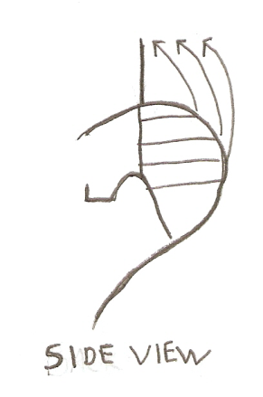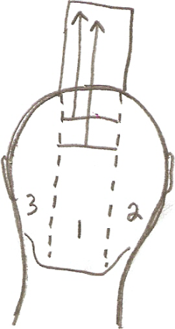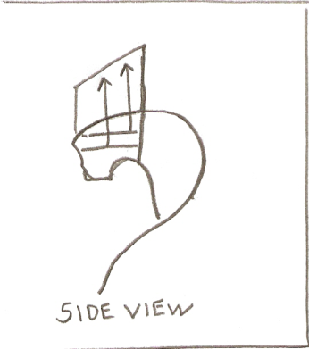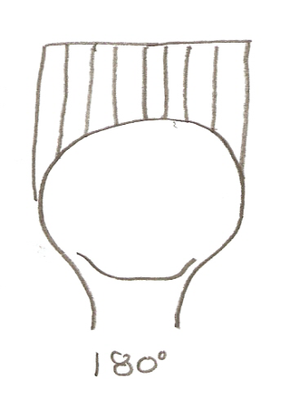

(Back half of cut) (Front half of cut)
Uniform layer haircut

Learning Goals and Expectations
- Safely and correctly use cutting tools, including palming the shears during the cut
- Demonstrate organization, using clean sectioning/partings
- Cut and follow a traveling guideline
- Demonstrate a clear understanding of cross-checking
- Final cut is even and reasonably balanced
- Effective clean up of workspace (ongoing) –this includes mannequin away, hair swept up and removed from workspace, and workspace disinfected daily!

Uniform layer cut “Short procedure”
1) Cut perimeter lengths
2) Create guideline at the top
3) Cut the top and front sides. Crosscheck your work
4) Cut the crown area using pivoted sections
5) Complete the layers at the back using vertical partings. Crosscheck your work
6) Blowdry/style and fine tune your work.
Diagram of Perimeter cut
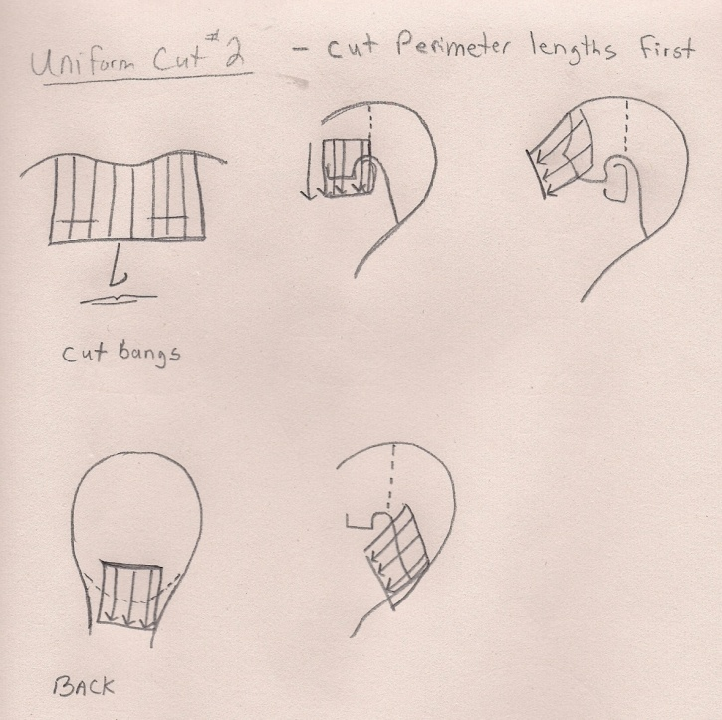

Uniform Layer Haircut Procedure
All the hair is cut to the same lengths, in layers.
Hair is held straight out from the head at 90 degrees

Basic procedure:

- Determine, and cut the perimeter lengths .(Bangs, length over ears, and length at the back).The length of the perimeter will be used as guideline for the rest of your cut

- Section the hair across the top of the head from ear to ear. Clip up the hair at the back as we will be beginning our cut in the front.

- Cut a length guideline at the top from the bangs back to the crown.

- Proceed to cut the top of the head – using small horizontal partings. (the length guideline will be in the center of your section )

- For each side; continue to use vertical partings, (about the size of your finger), to layer and connect the top down to your perimeter guideline that was cut at the ear.

- Crown area. – use the apex as your guideline to layer the crown area. Take pie-shaped (pivoted) sections, and work from the middle of the head, out to the back of your completed sides.

- To complete the layers in the back, simply continue using small, vertical partings, held at 90 degrees, and work down to match your perimeter length guideline that you established at the beginning.

- Cross-check your work. Use horizontal, roller size partings to double check your work and ensure it is even and balanced. Make sure that you hold the hair at 90 degrees.

- Blow-dry and style. Check and make any necessary adjustments. (a good time to check and adjust the bangs and perimeter)

Uniform layer cutting procdure diagrams
Final shape
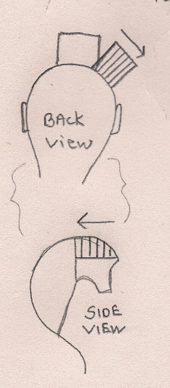
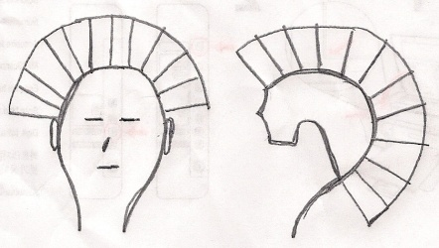
Creating guideline for the front Sectioning for layers at the front
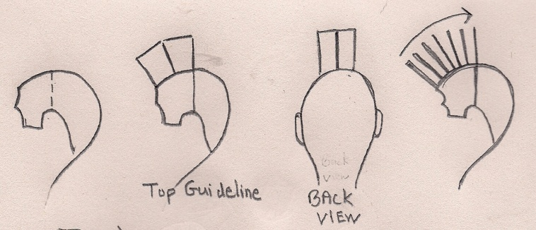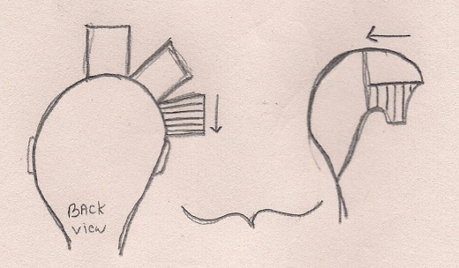

Creating guideline for the back Sectioning used to cut the crown area
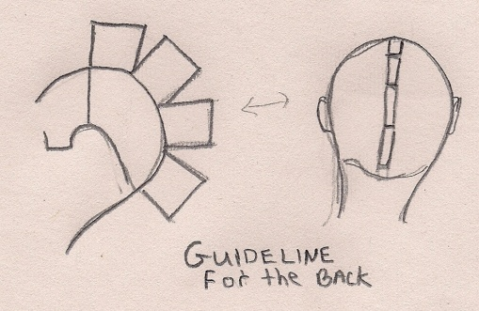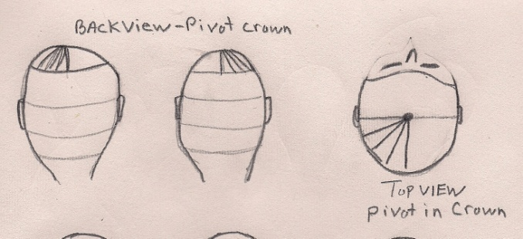

Sectioning to layer the back
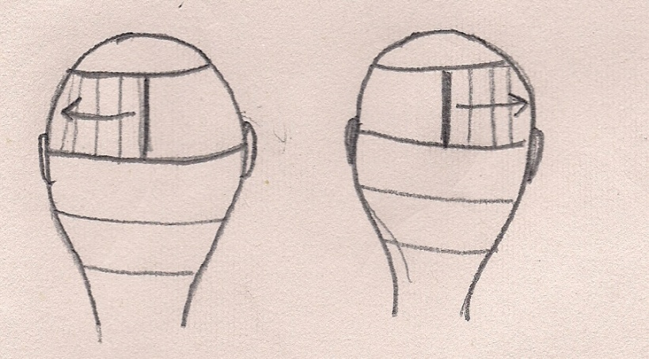

Graduated layer Haircut Procedure
*please note: The procedure below describe a traditional graduated layer cut. There are many ways to adapt this procedure to produce a variety of different shapes through the use of over-direction. This note is designed to be used for instructional reference. See your teacher for more instruction.

- Section into 4

- Begin at the back of the head, bring down a horizontal section (approx. 1 to 2 inches above the hairline) and cut your length guideline using no elevation.

- Continue to bring down ½ inch horizontal sections at a 45 degree angle, using only your previously cut section as your traveling guide.

- Work your way up to the top of the head until you run out of hair. Ensure that each section is elevated no higher than 45 degrees.

- Continue next to the sides. Bring down a section (approximately 2 to 3 inches above the hairline) down, over each ear. Cut the length guideline at each side using no elevation to match your length guideline in the back. (use the longest perimeter length as your length guide)

- Continue to complete each side by bringing down ½ inch horizontal sections at a 45 degree angle using a traveling guideline.

- When each side is complete, cross-check your cut carefully vertically to ensure that it is even and balanced.

- Style as desired, and double check for evenness and balance

- Clean up your work area.

Haircutting shears/thinning shears

Safety PASSPORT (sample)
General Conditions

Students must be trained to safely use and maintain salon haircutting tools and/or implements. This includes the following:
- haircutting shears
- thinning shears

The student must demonstrate to the teacher that they understand the procedures for safe use of each tool in order to perform a haircut (live model or mannequin) with that specific tool.
Personal Protective Equipment

- Smock (optional)
- Non-slip enclosed Shoes
Possible Risk Factor

- Accidental cuts to fingers
- Back strain due to improper posture and body positioning
- Fungal/Parasite/Bacterial/Viral Infection due to working with unclean tools
- Skin Irritation (example; from short hair clippings

- The student has been trained on the equipment listed above.
- The student understands the required personal protective equipment to operate these tools.
- The student understands the procedures for safe use of the equipment listed above
- The student is aware of the possible risk factors

Student signature ________________________________

Teachers signature ________________________________

Date of training ________________________________

Haircutting: Clippers and trimmers

Safety PASSPORT (sample)
General Conditions

Students must be trained to safely use and maintain salon haircutting tools and/or implements. This includes the following:
- Clippers (including guards)
- Trimmers
- Disinfectant specific to the cleaning and disinfection of these tools

The student must demonstrate to the teacher that they understand the procedures for safe use of each tool in order to perform a haircut (live model or mannequin) with that specific tool.
Personal Protective Equipment
- Smock (optional)
- Non-slip enclosed Shoes
- Goggles, gloves, apron (when disinfecting tools)
Possible Risk Factor

- Accidental cuts to fingers
- Back strain due to improper posture and body positioning
- Fungal/Parasite/Bacterial/Viral Infection due to working with unclean tools
- Respiratory Problems (inhalation)
- Skin Irritation
- Eye Infections and/or Damage
- The student has been trained on the equipment and materials listed above.
- The student understands the required personal protective equipment to operate these tools and how to use the required disinfectant.
- The student understands the procedures for safe use of the equipment/materials listed above
- The student is aware of the possible risk factors

Student signature ________________________________

Teachers signature ________________________________

Date of training ________________________________

