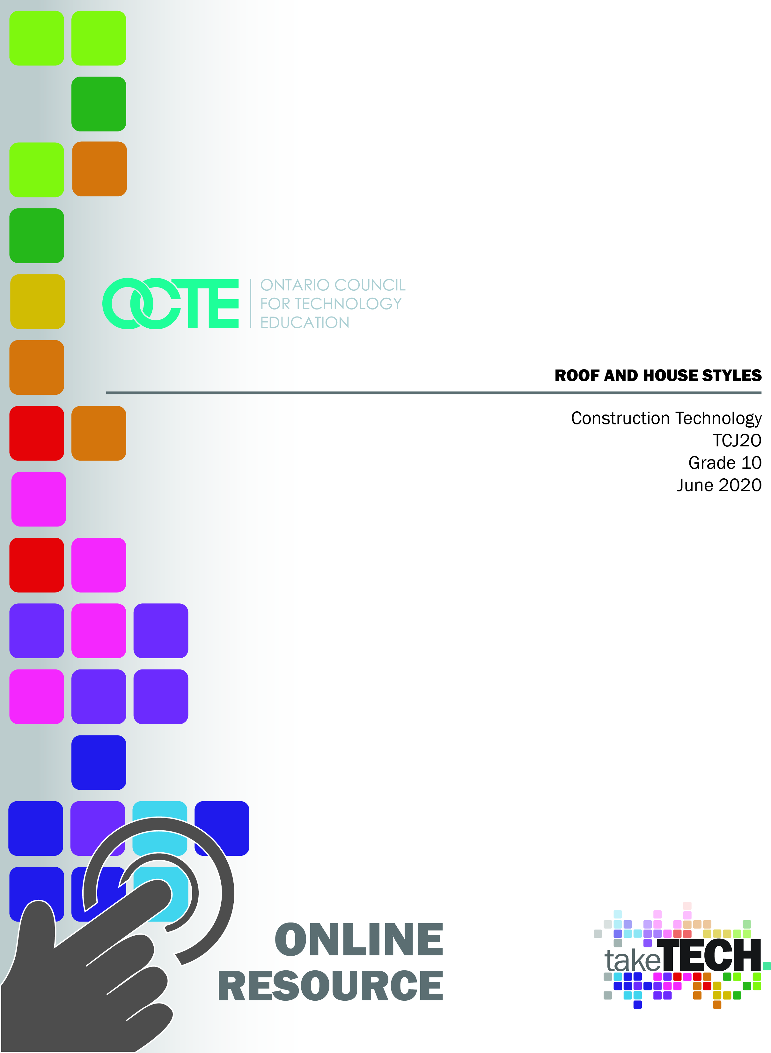

Table of Contents

Introduction 2
Project Outline 2
Prior Knowledge 2
Student Activities 2
Resources 3
Video 3
PowerPoint presentation 4
Files 4
Images/Photographs 5
Websites for Teachers 5
Planning Notes 5
Instructional Strategies 5
Motivational Strategies 6
Learning Goals and Success Criteria 6
Overall and Specific Expectations 7
Overall Expectations 7
Specific Expectations 7
Safety Concerns and Expectations 7
Differentiation of the Project / Activity 8
Career and Industry Extensions 8
Appendix A - Roof and House Styles – Digital Assignment Sheet 9
Appendix B: Roof and House Styles – Print Assignment Sheet 14
Appendix C - Roof and House Style Record Keeping Form 24
Appendix D – Roof and House Style Reference Sheet 26
Appendix E – Roof and House Style Quiz 30
Appendix F – Components of a Roofing System 34
Appendix G – Roof Truss Diagram 36
Appendix H – Roofing Terminology Questions 38
References 39

Introduction
Course Code: TCJ2O
Broad base Technology: Construction Technology
Destination: Open
Grade Level: 10
Online Project Name: Roof and House Styles

Project Outline
Students will be introduced to different roof and house styles in this project. Before potentially building a roof style on a shed, model house or actual building it is good to know and be able to identify the different roof styles, house styles and identify their characteristics.
Activities in this project include,
- Students will socially distance by going outside in their communities to seek out examples of roof and house styles
- Students will photograph and assemble a document with their findings
- Students will do additional research of house styles, provide definitions and photos
- Students will be given a quiz to see how they have retained the information

Prior Knowledge
This is a grade 10 level course with no prerequisite, therefore no prior knowledge of roof styles, roofing or building design is required. An interest in architecture and building construction along with good spatial awareness and shape identification is a benefit but is not necessary.

Student Activities
Students will be asked to perform several activities in order to complete this project. They include:
- Watch the Roof and House Styles video
- Research and photograph examples of five roof and five house styles in their community
- Assemble documentation, with locations, pictures, descriptions and submit
- Complete a Roof and House Style Quiz (Appendix E) to display student’s knowledge and understanding
- Extension Activity: Find all house and roof styles discussed
- Extension Activity: Research and find additional house styles
- Watch the Essential GAF Roofing System Components for Your Home video
- Read the article IKO Roofing What Makes Up a Roof – Your Roof Components and the article Owens Corning – The Anatomy of a Roof
- Complete the Components of a Roofing System Handout (Appendix F)
- Extension Activity: Research a style of roof and create a roof truss diagram and label it (Appendix G)
- Extension Activity: Perform the Roofing Terminology Worksheet (Appendix H)
- Extension Activity: Watch the Beginner Rafter Layout video and layout a rafter in the workshop
- Extension Activity: Watch the Training the Trades - Cutting Common Rafters video and cut a rafter in the workshop

Resources
The resources in this document can be completed online or through a blended format so that the students obtain the skill set to identify roof and house styles. The students will need to utilize a computer with internet access to view the video and research styles of houses and their characteristics. Students should follow school board computer use policies and safe internet searches when completing this assignment.
The resources in this document include an instruction video, PowerPoint presentation for in-class use and student handouts. Additional resources include: digital worksheet, printable worksheet, quiz and styles reference sheet.

Video
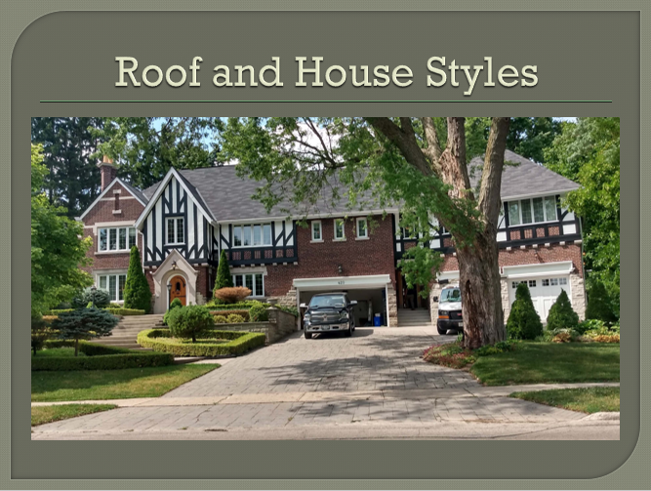 | Roof and House Styles Video  https://www.octe.ca/application/files/5415/9762/3122/Roof_and  _House_Styles_Final.mp4
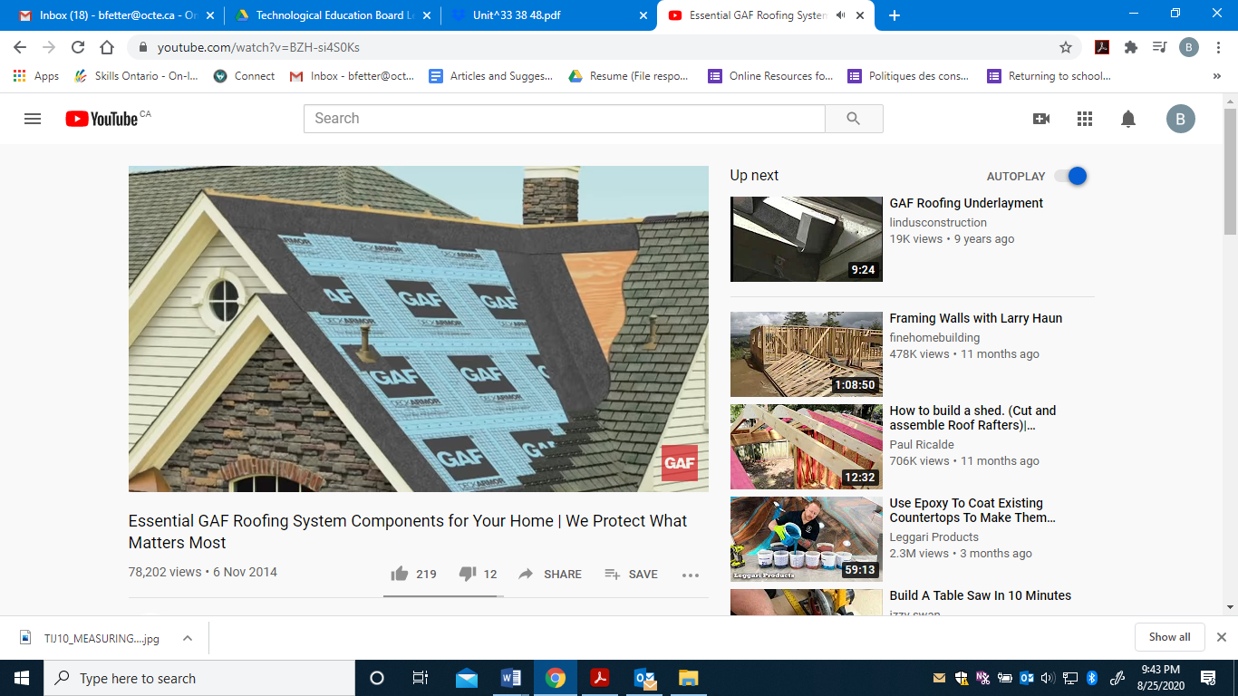 | Essential GAF Roofing System Components for Your Home  https://www.youtube.com/watch?v=BZH-si4S0Ks
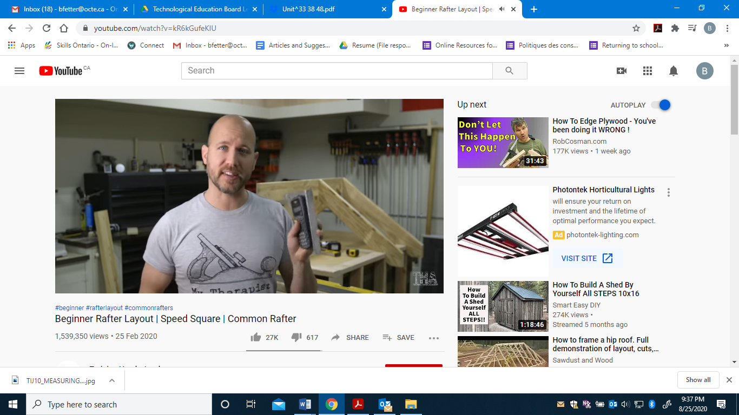 | Beginner Rafter Layout  https://www.youtube.com/watch?v=kR6kGufeKIU
 | Training the Trades - Cutting Common Rafters  https://www.youtube.com/watch?v=gz-Ej0qY1pQ

PowerPoint presentation
Roof and House Styles PowerPoint
https://www.octe.ca/application/files/3815/9762/3360/House_and_
Roof_Styles.pptx

Files
- House and Roof Styles Reference Sheet (Appendix D)
- Roof and House Record Keeping Form (Appendix C)
- Roof and House Styles Digital Assignment Sheet (Appendix A)
- Roof and House Styles Print Out Assignment Sheet (Appendix B)
- Roof and House Styles Quiz.pdf (Appendix E)
- Components of a Roofing System (Appendix F)
- Roof Truss Diagram (Appendix G)
- Roofing Terminology Worksheet (Appendix H)

Images/Photographs
All photographs have been specifically sourced in the creation of this document and are royalty free and are referenced in the References section of this document.

Websites for Teachers
Top 20 Roof Types and Pros & Cons – Roof Styles
National Roofing Contractors Association Glossary
JTC Roofing Contractors Ltd. – Roof Types
Medeek Trusses Resource

Planning Notes
It is estimated that the combination of video, internet research, and assignments will take learners 5 hours to complete. Accommodation of extra time may be required for some learners.
- Utilize your school board LMS or create a digital space for each learner to submit and receive the material (e.g., Microsoft One Drive, Google Drive, Dropbox, etc.)
- Direct students to watch Roof and House Styles video (once or twice)
- Direct students to print out House and Roof Styles reference sheet
- Provide each learner with ROOF AND HOUSE STYLES Digital and/or Print out Assignment Sheet(s)
- Post or provide the learners with the materials at timed intervals or all at once.
- Provide timely feedback to learners;
- Administer ROOF AND HOUSE STYLES Quiz in class or convert to Google doc to have them take online

Instructional Strategies
Instructional strategies for this project include,
- Independent, guided video
- Feedback on submitted assignment
- Internet research for both online and blended format

Motivational Strategies
- Students can complete the project with a camera (or Google maps) and Microsoft Word (or comparable software). This is project requires no construction tools (hand or power) to complete.
- The project can be done independently or in small groups (socially distanced) as they either ride their bikes or walk through their neighbourhood.
- Students are able to get outside.

Learning Goals and Success Criteria
By the end of this project students will be able to:
- Demonstrate the ability to communicate to the teacher through audio or live video communications.
- Describe the components and systems of buildings
- Will use keywords in an internet search.
- Will demonstrate learning skills that include Responsibility, Organization, Independent Work, Initiative, and Self-Regulation.
Success criteria to meet some of those learning goals might look like,
- I am able to identify multiple styles of roofs and houses
- I can confidently state characteristics of house styles and their features
- I can communicate through the use of correct construction terminology and can describe building components
- I can describe the components and systems of buildings

Overall and Specific Expectations in Support of Ontario Curriculum Grades 9-10 Technological Education

Overall Expectations
A1. Describe the components and systems of buildings, the properties of various building materials, and the processes in which those materials are used;
A3. Use correct terminology to describe building components and construction materials, tools, equipment, and processes.

Specific Expectations
A1.1 Identify the different components of a residential construction project (e.g., footings, foundation, joists, studs, trusses, rafters, millwork, trim, cabinetry), and outline the sequence in which these components are usually installed;
A1.2 Identify the various systems in a building (e.g., foundation, framing, electrical, plumbing, cabinetry), and describe their functions;
A1.4 Describe the processes used to produce common construction materials (e.g., cutting and milling lumber and trim, gluing together the layers of plywood);

Safety Concerns and Expectations
This project has been designed as an online or blended assignment and therefore construction tools and machinery are not required, minimizing the risk and need to address shop safety. The students however will need to utilize a computer for research and should be mindful of proper ergonomics. Additional safety concerns include,
- Students are old enough to roam or ride their bicycle through their community
- Students need to obey traffic laws and be aware of their surroundings, accessing a safe and well-known neighbourhood for their safety
- Students may or may not have their own cell phone or digital camera in order to take photographs. Students should be stopped and standing in a stable position in order to take their photographs. It is advised not to use your phone while riding your bicycle at the same time.
- Students must take photos from sidewalks and not trespass on properties
- Project should not require parental supervision however parents can assist in transporting their son or daughter to obtain the necessary photographs in order to complete the assignment.

Differentiation of the Project / Activity
There are a number of ways in which this project can be differentiated for instruction. They include,
- Teacher can use the stand alone PowerPoint presentation to introduce assignment in class and then have students do research away from in class time
- Teacher can find examples of roof and house styles in neighbourhoods, record addresses and have students visit them and determine which roof or house style is being represented
- Entire project can be presented online and done by students away from school entirely using video provided
- Teachers may allow students to work with partners.

Career and Industry Extensions
Industry extensions and career exploration for students to include:
- Structural engineer
- Architect
- Architectural Technologist
- Carpenter

Appendix A - Roof and House Styles – Digital Assignment Sheet

Roof Style #1:

Roof Style | House # | Street Name | City

Roof Style #2:

Roof Style | House # | Street Name | City

Roof Style #3:

Roof Style | House # | Street Name | City

Roof Style #4:

Roof Style | House # | Street Name | City

Roof Style #5:

Roof Style | House # | Street Name | City

House Style #1:

House Style | House # | Street Name | City

House Style #2:

House Style | House # | Street Name | City

House Style #3:

House Style | House # | Street Name | City

House Style #4:

House Style | House # | Street Name | City

House Style #5:

House Style | House # | Street Name | City

Extension Activity 1 – Bonus Roof Styles

Bonus Roof Style #1:

Roof Style | House # | Street Name | City

Bonus Roof Style #2:

Roof Style | House # | Street Name | City

Bonus Roof Style #3:

Roof Style | House # | Street Name | City

Bonus Roof Style #4: Combination Roof

Roof Style | House # | Street Name | City

Extension Activity 2:

Bonus House Style #1:

House Style | House # | Street Name | City

Bonus House Style #2:

House Style | House # | Street Name | City

Bonus House Style #3:

House Style | House # | Street Name | City

Bonus House Style #4:

House Style | House # | Street Name | City

Extension Activity 3:

Bonus House Style #5: Cape Cod

House Style | House # | Street Name | City
Cape Cod

Cape Cod Definition (two sentences):

Bonus House Style #6: Queen Anne

House Style | House # | Street Name | City
Queen Anne

Queen Anne Definition (two sentences):

Bonus House Style #6: Timber Frame

House Style | House # | Street Name | City
Timber Frame

Timber Frame Definition (two sentences):

Appendix B: Roof and House Styles – Print Assignment Sheet

Roof Style #1:

Roof Style | House # | Street Name | City

Picture or sketch | Description

Roof Style #2:

Roof Style | House # | Street Name | City

Picture or sketch | Description

Roof Style #3:

Roof Style | House # | Street Name | City

Picture or sketch | Description

Roof Style #4:

Roof Style | House # | Street Name | City

Picture or sketch | Description

Roof Style #5:

Roof Style | House # | Street Name | City

Picture or sketch | Description

House Style #1:

Roof Style | House # | Street Name | City

Picture or sketch | Description

House Style #2:

Roof Style | House # | Street Name | City

Picture or sketch | Description

House Style #3:

Roof Style | House # | Street Name | City

Picture or sketch | Description

House Style #4:

Roof Style | House # | Street Name | City

Picture or sketch | Description

House Style #5:

Roof Style | House # | Street Name | City

Picture or sketch | Description

Extension Activity 1 – Bonus Roof Styles

Bonus Roof Style #1:
Roof Style | House # | Street Name | City

Picture or sketch | Description

Bonus Roof Style #2:
Roof Style | House # | Street Name | City

Picture or sketch | Description

Bonus Roof Style #3:
Roof Style | House # | Street Name | City

Picture or sketch | Description

Bonus Roof Style #4: Combination Roof
Roof Style | House # | Street Name | City

Picture or sketch | Description

Extension Activity 2:

Bonus House Style #1:

Roof Style | House # | Street Name | City

Picture or sketch | Description

Bonus House Style #2:

Roof Style | House # | Street Name | City

Picture or sketch | Description

Bonus House Style #3:

Roof Style | House # | Street Name | City

Picture or sketch | Description

Bonus House Style #4:

Roof Style | House # | Street Name | City

Picture or sketch | Description

Extension Activity 3:

Bonus House Style #5: Cape Cod

House Style | House # | Street Name | City
Cape Cod

Cape Cod Definition (two sentences):

Bonus House Style #6: Queen Anne

House Style | House # | Street Name | City
Queen Anne

Queen Anne Definition (two sentences):

Bonus House Style #6: Timber Frame

House Style | House # | Street Name | City
Timber Frame

Timber Frame Definition (two sentences):

Appendix C - Roof and House Style Record Keeping Form

Student Name: _________________________ Date: _____________

ROOF STYLES | HOUSE # | STREET NAME | CITY
Roof #1
Roof #2
Roof #3
Roof #4
Roof #5

HOUSE STYLES | HOUSE # | STREET NAME | CITY
House #1
House #2
House #3
House #4
House #5

BONUS ROOF STYLES | HOUSE # | STREET NAME | CITY
Roof #1
Roof #2
Roof #3
Roof #4 - Combo

BONUS HOUSE STYLES | HOUSE # | STREET NAME | CITY
House #1
House #2
House #3
House #4

BONUS HOUSE STYLES | HOUSE # | STREET NAME | CITY
Cape Cod
Queen Anne
Timber Frame

Appendix D – Roof and House Style Reference Sheet

Roof Styles Reference Sheet

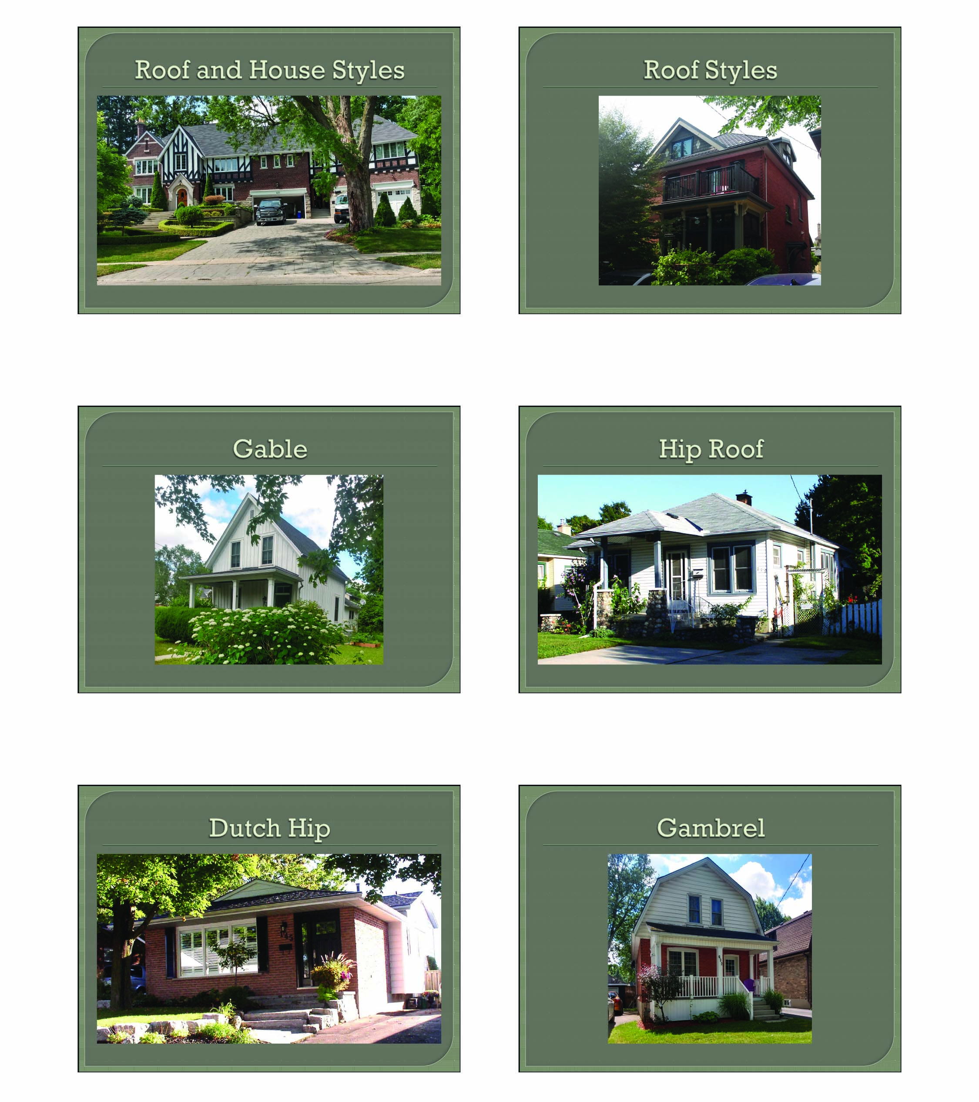

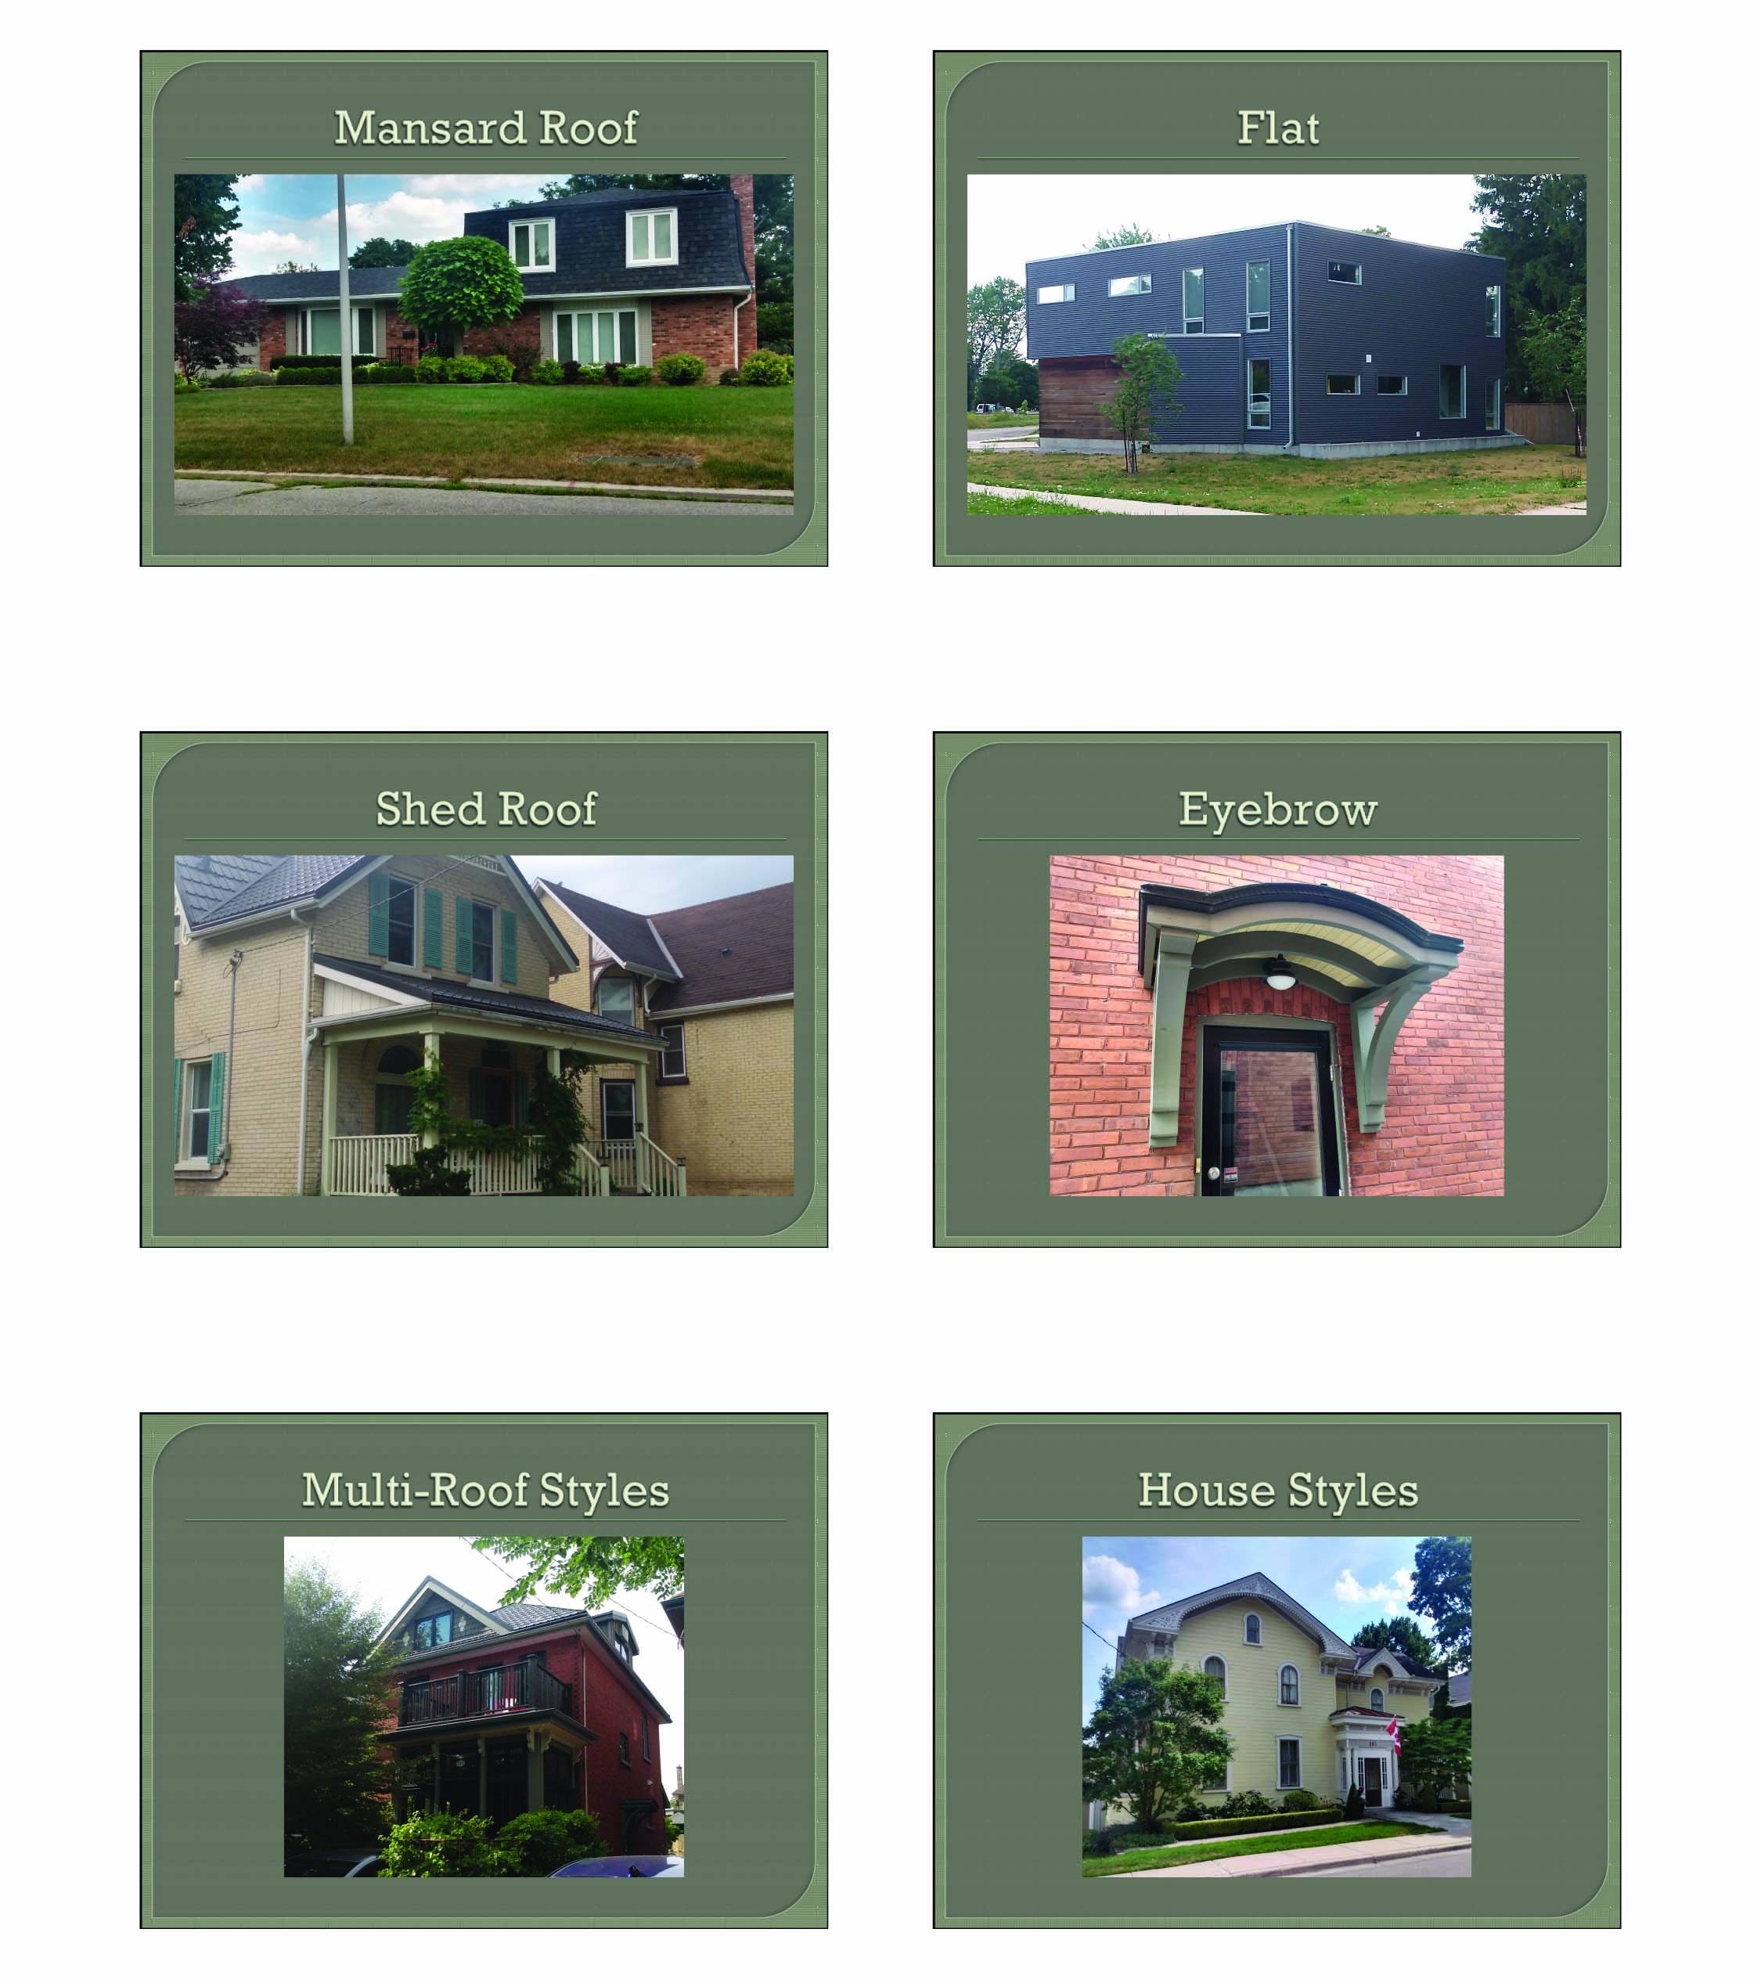

House Styles Reference Sheet
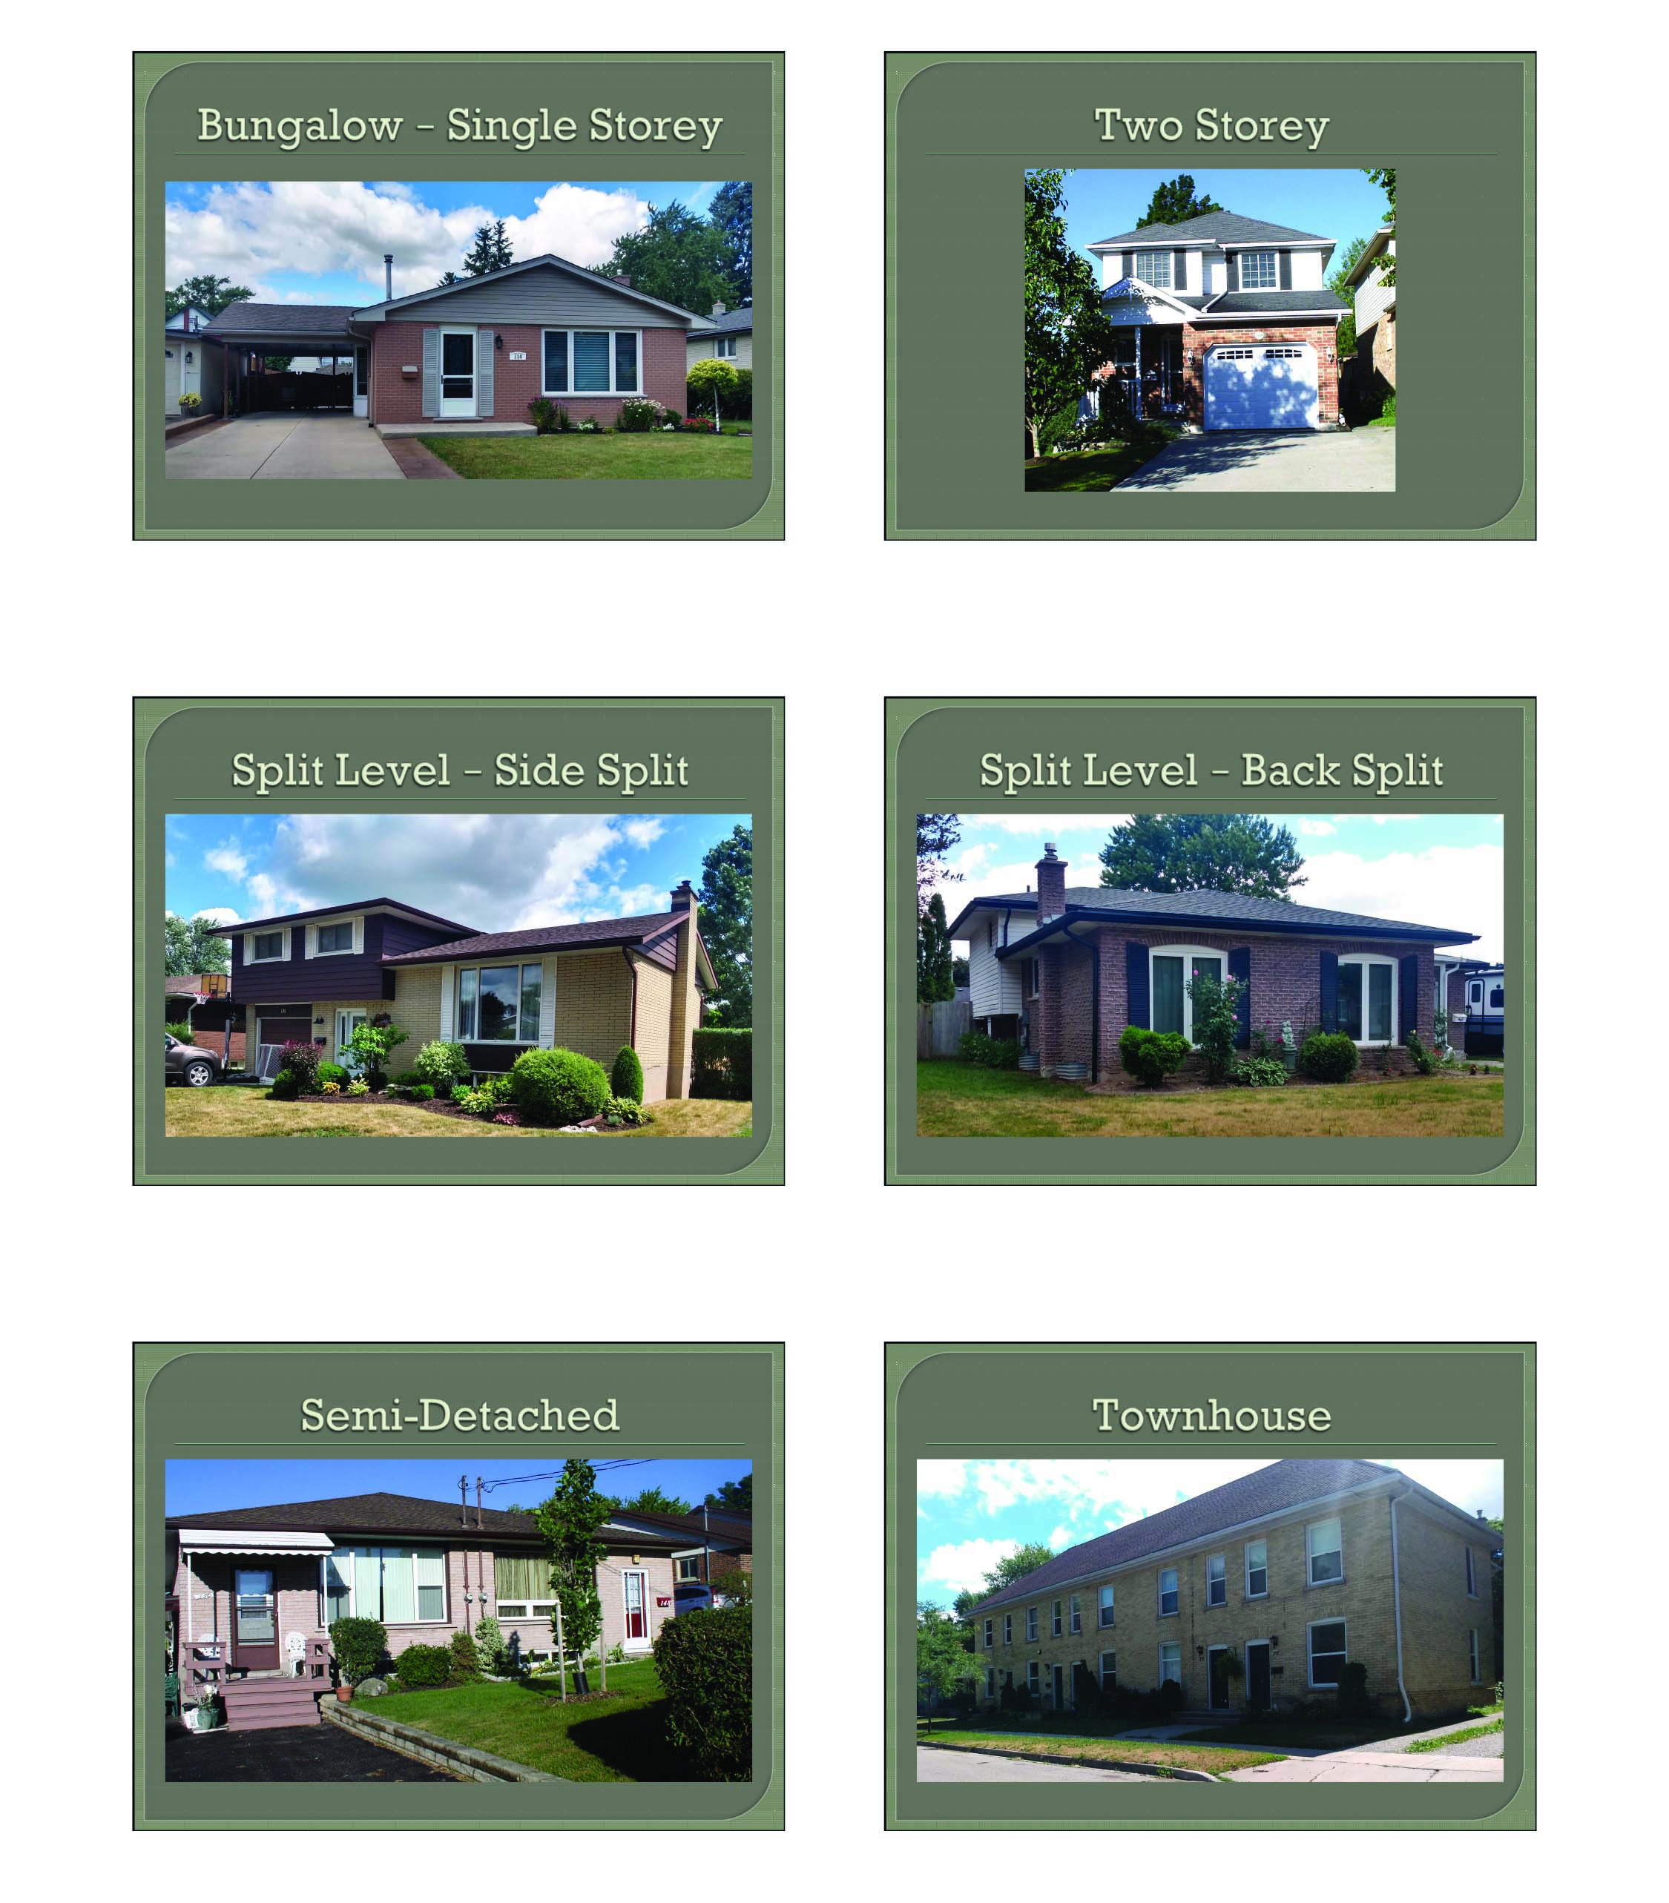

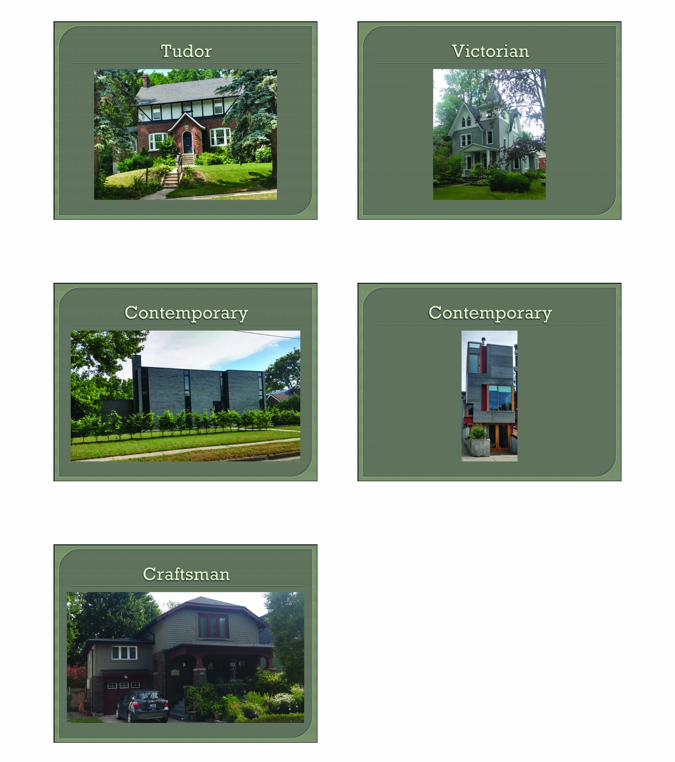

Appendix E – Roof and House Style Quiz
Using the clues below, match the appropriate house and roof style for each photo shown.

HOUSE STYLES |  | ROOF STYLES
Bungalow | Victorian | Gable | Mansard
Contemporary | Townhouse | Hip | Shed
Two Storey | Split Level | Flat | Gambrel

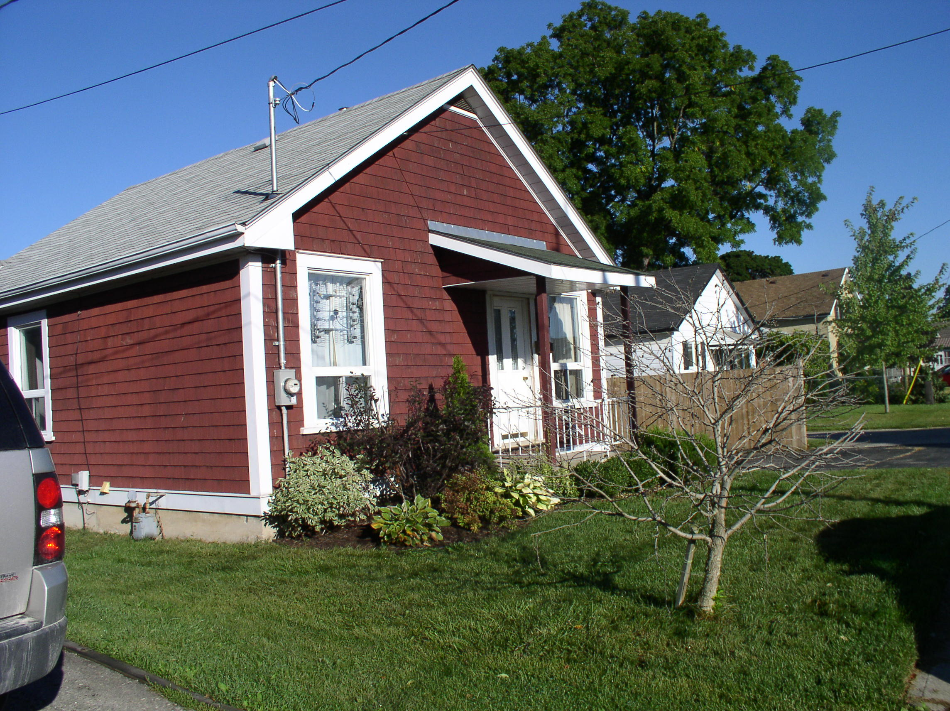

House Style | Roof Style(s)
.
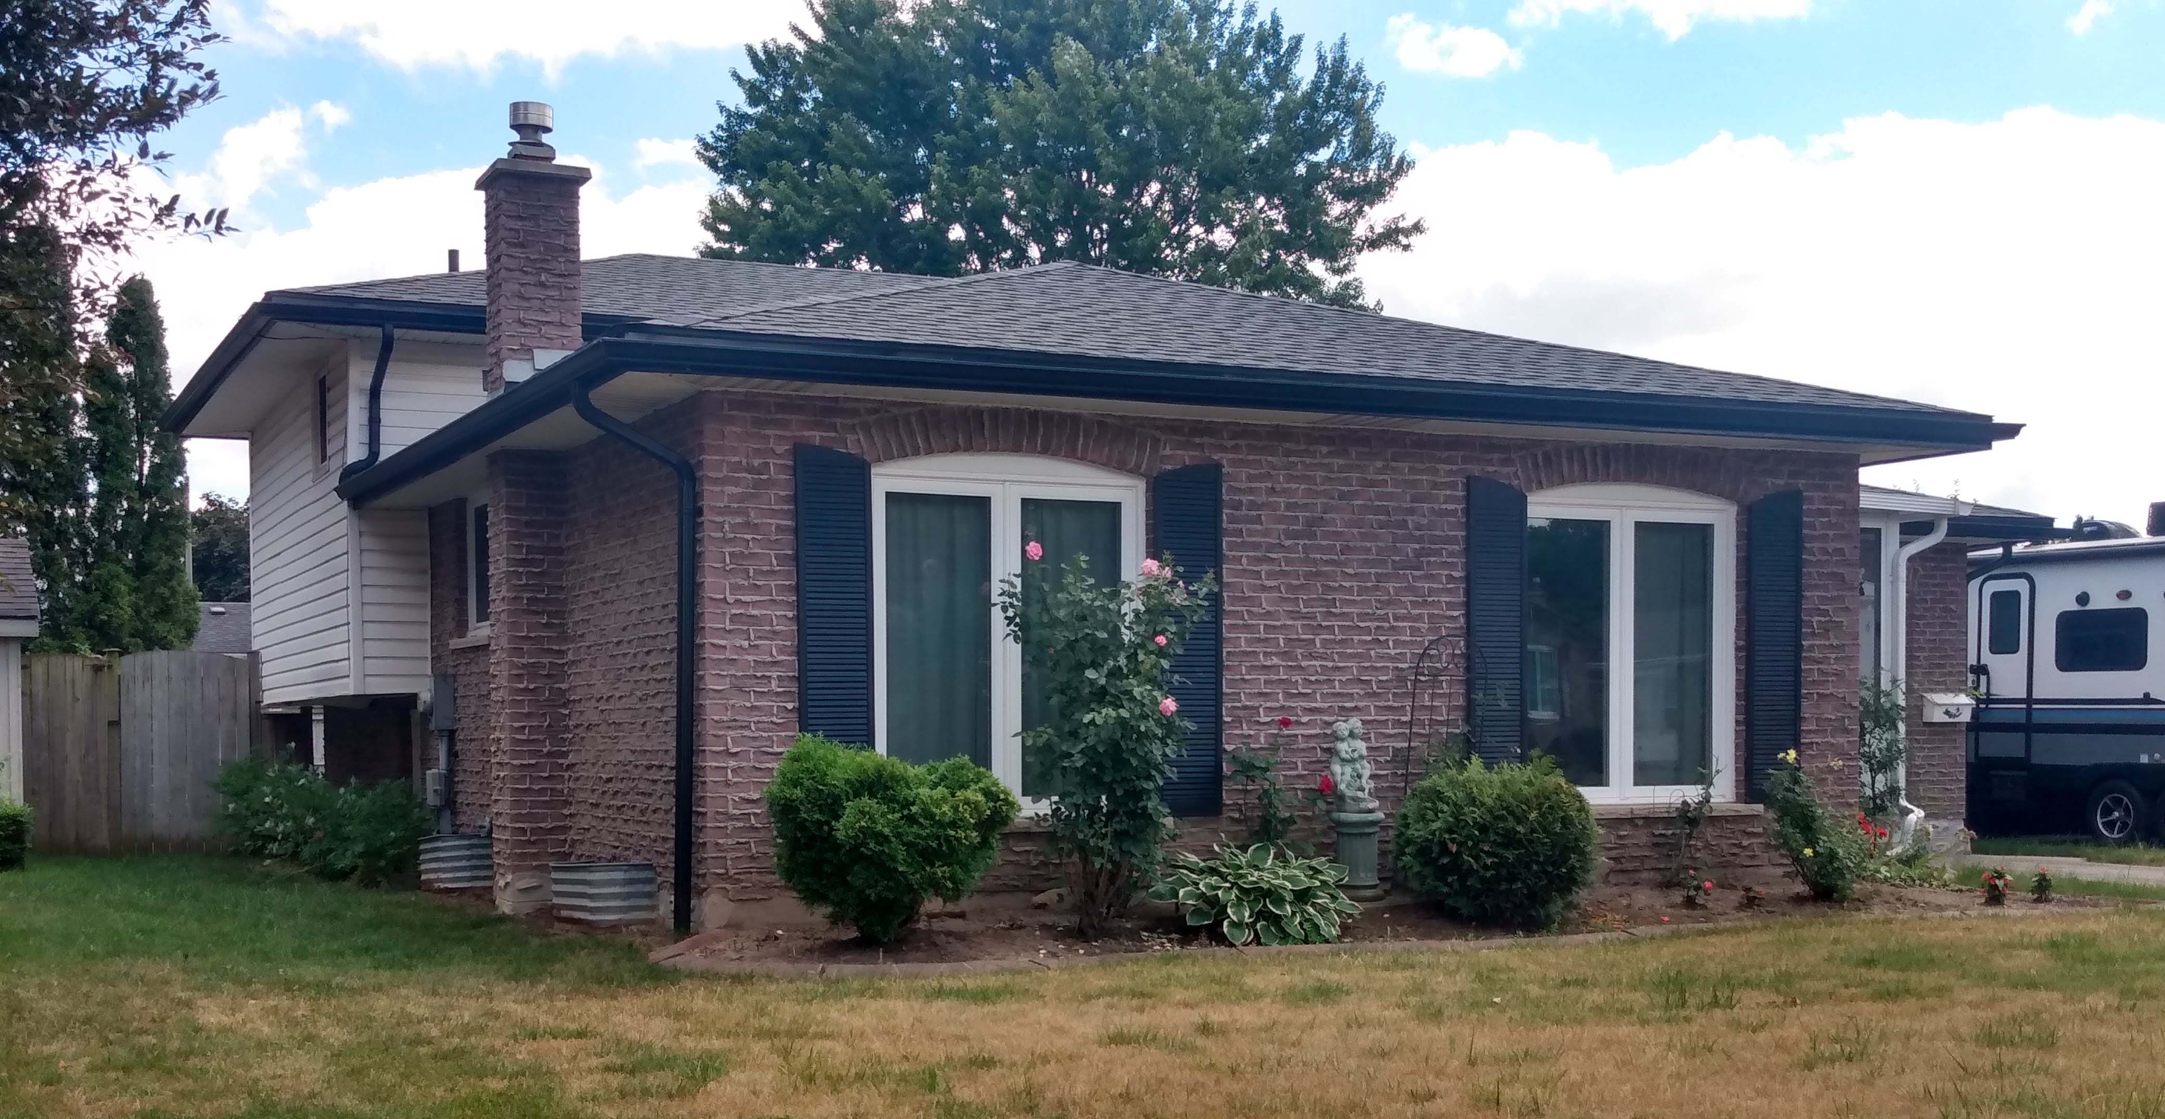
House Style | Roof Style(s)

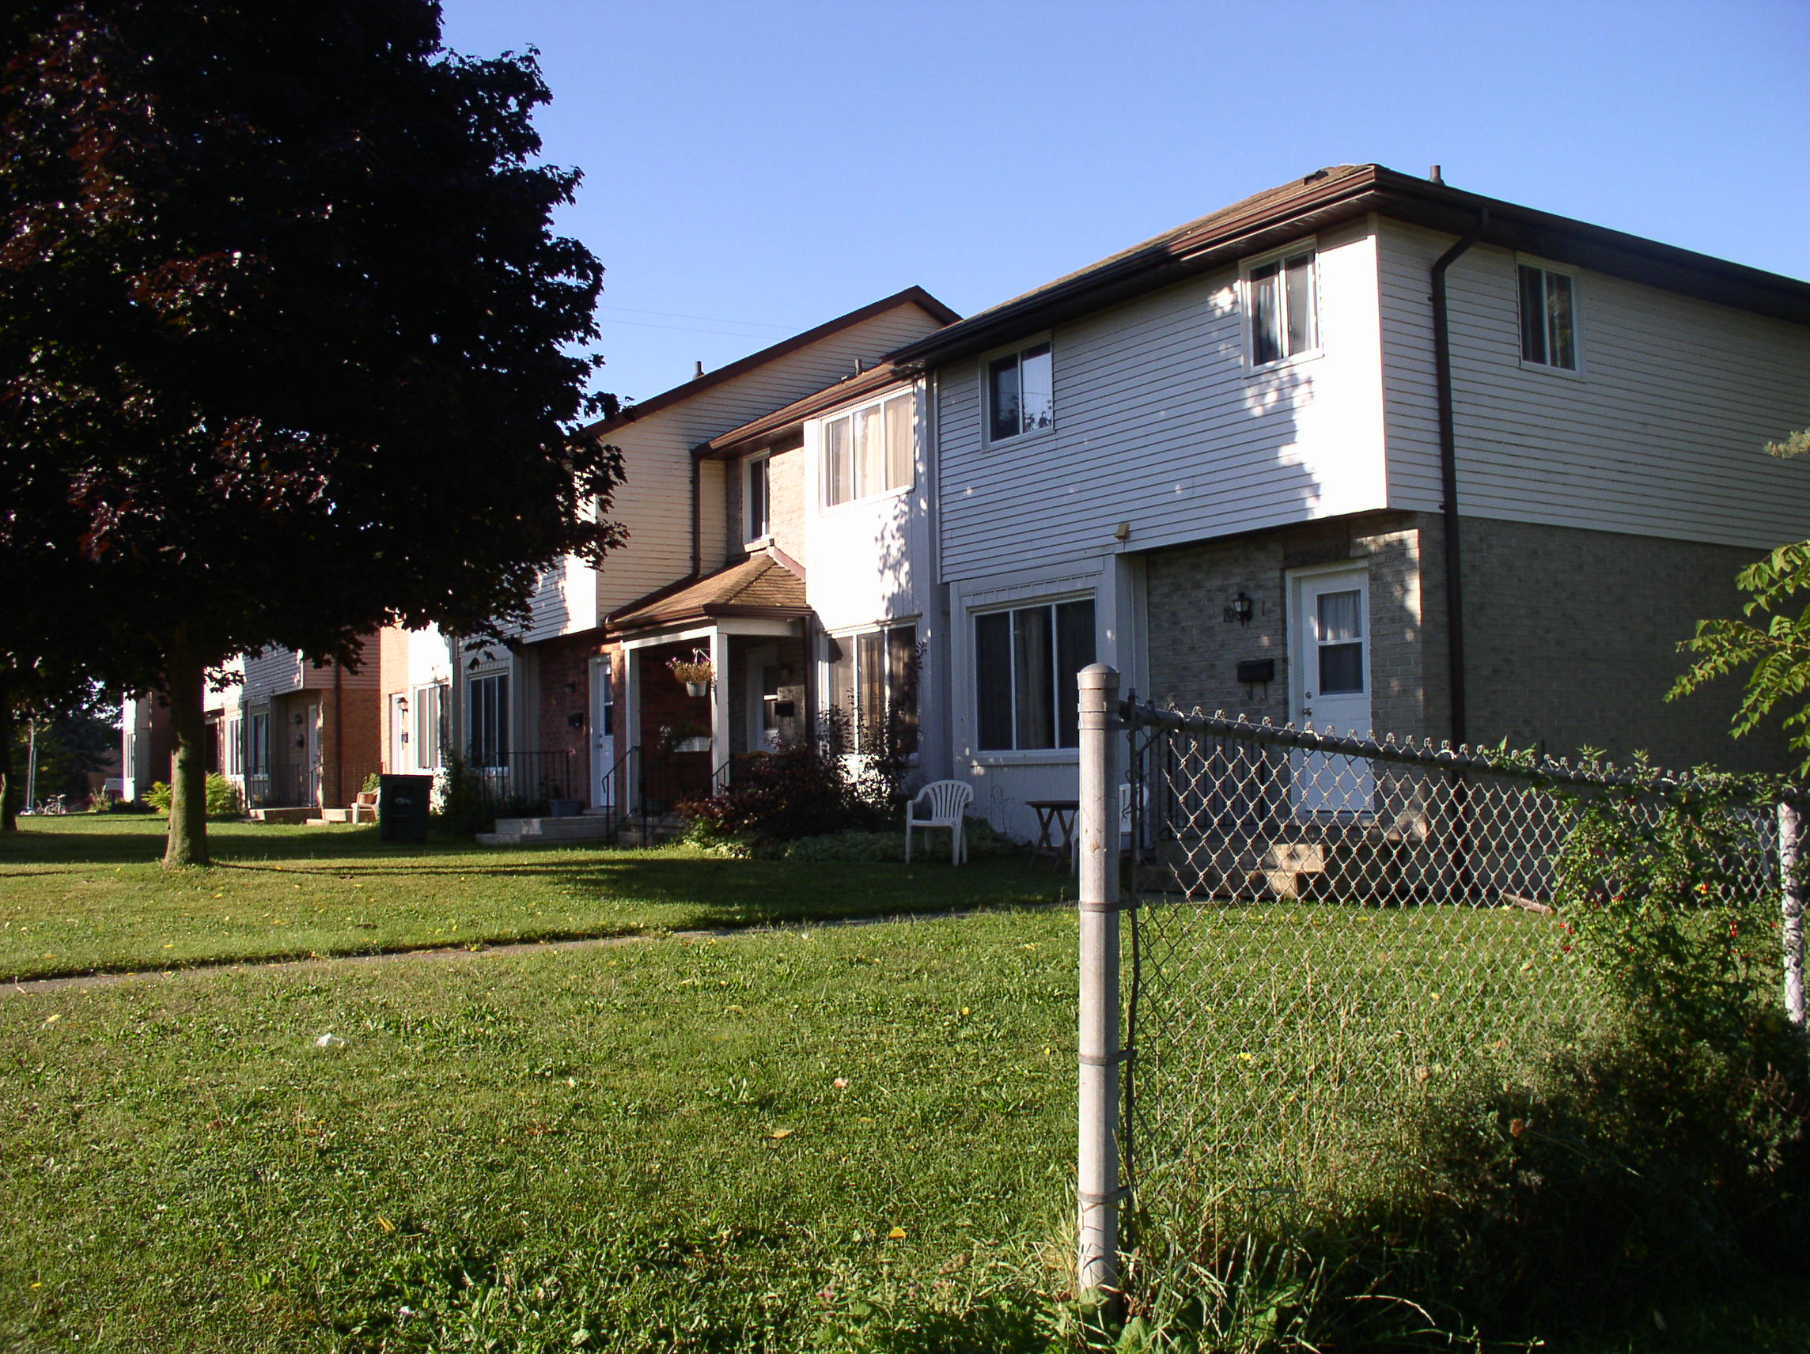

House Style | Roof Style(s)
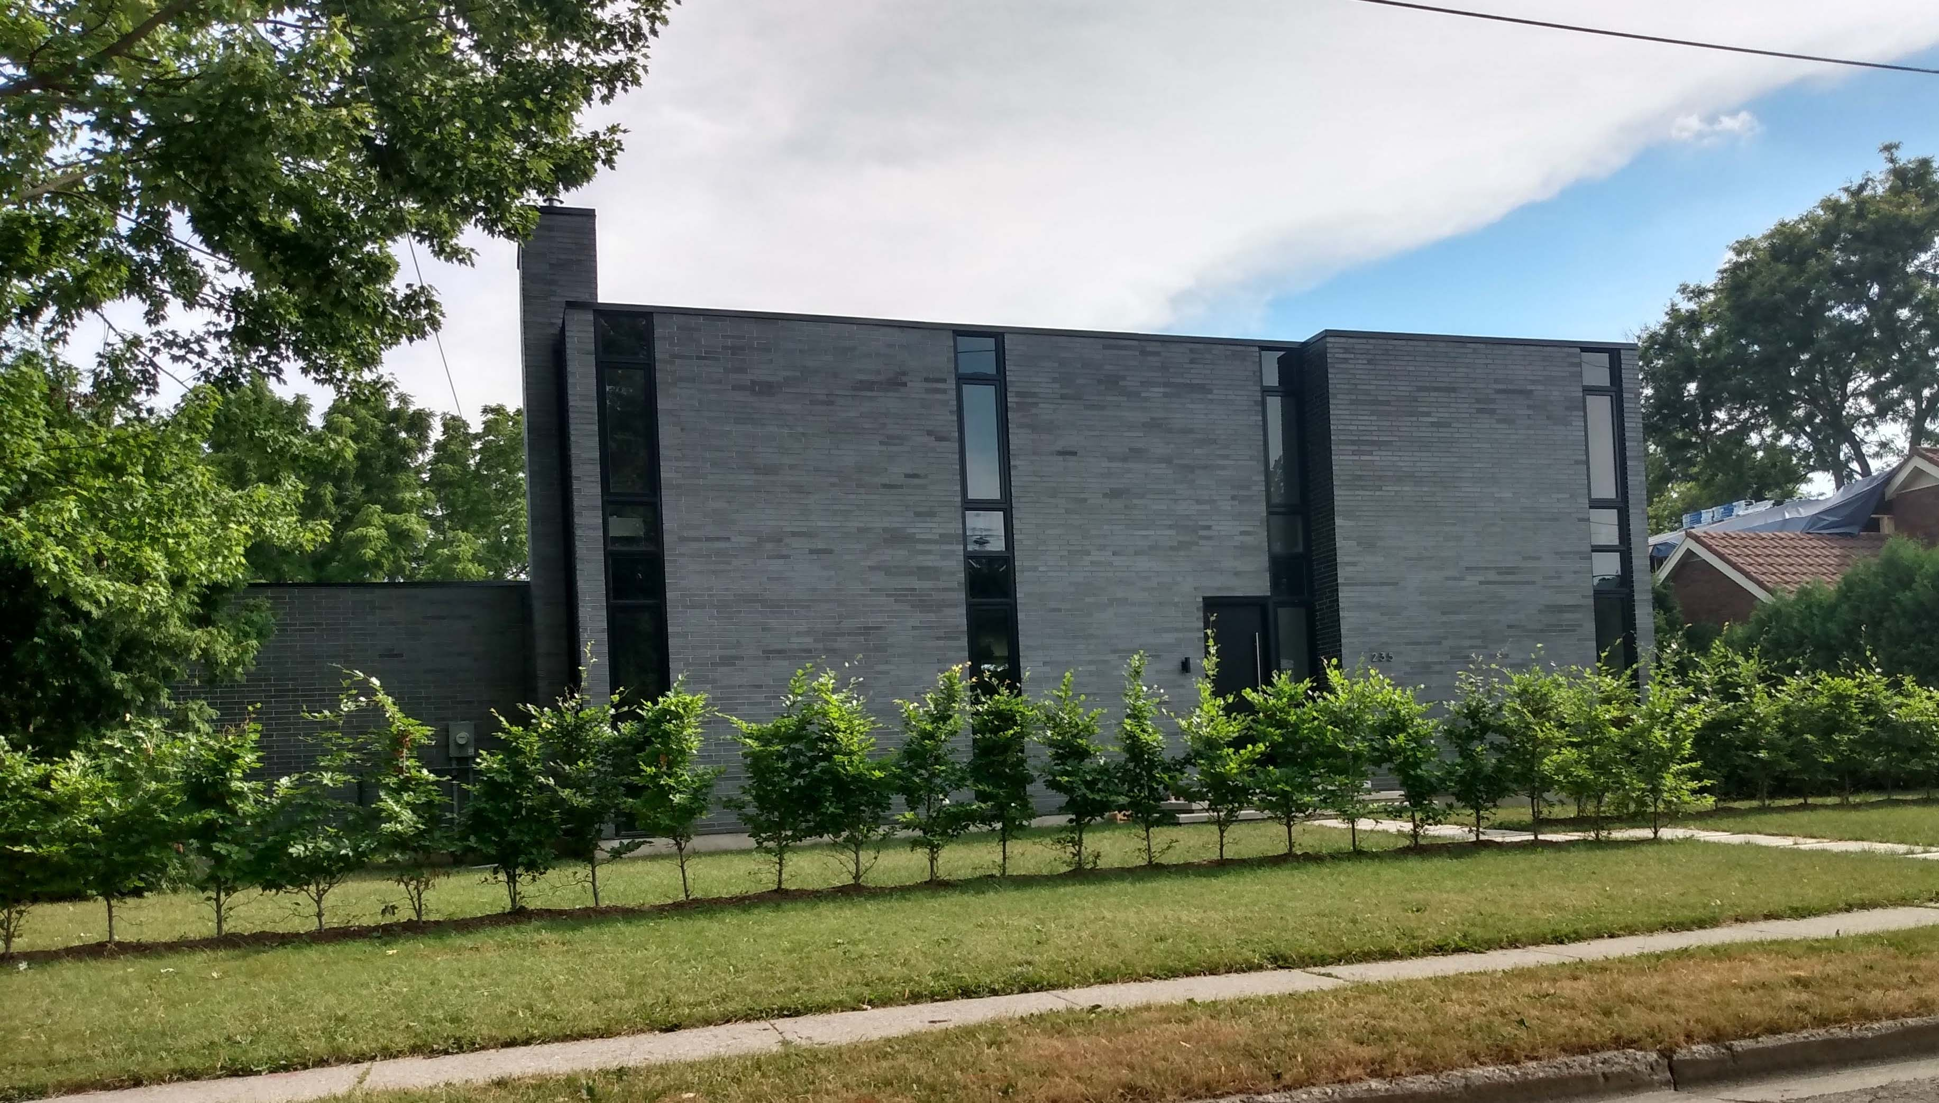
House Style | Roof Style(s)

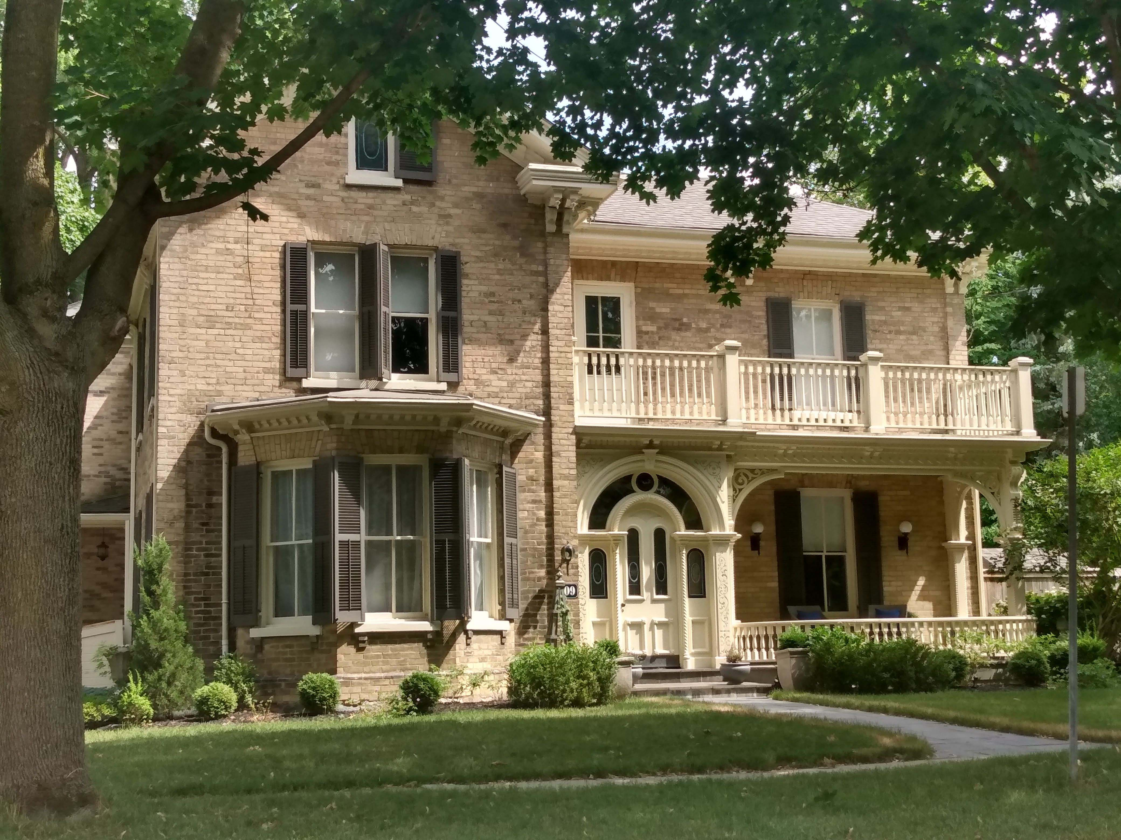
House Style | Roof Style(s)

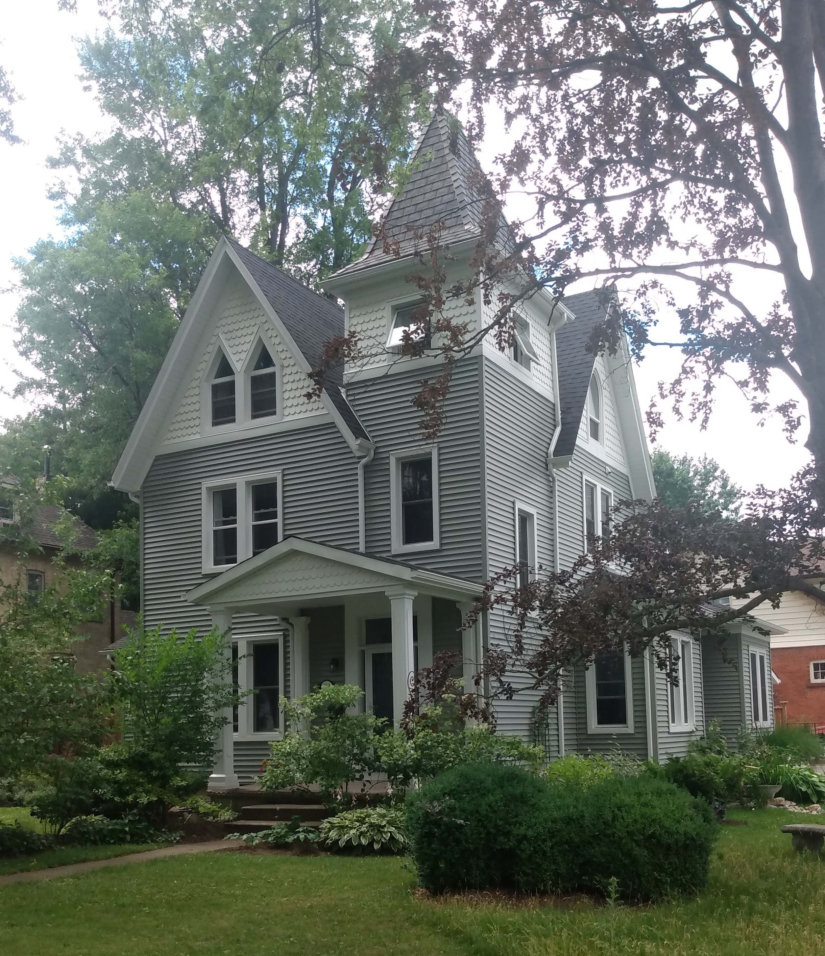

House Style | Roof Style(s)

Appendix F – Components of a Roofing System

Appendix G – Roof Truss Diagram
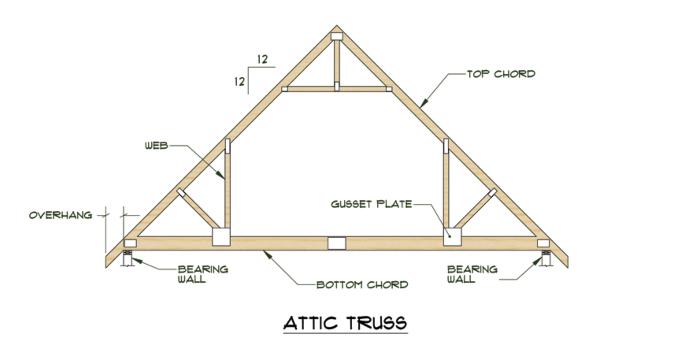
Built off job site in a Truss factory and delivered to job site.
- Lower skill level required by carpenters
- Engineered to meet load characteristics of the roof.
- Usually uses smaller dimensional lumber fastened together by gusset plates.
- Reduces amount of time on job site to build roof system.
- Trusses are very common way of construction in Canada.

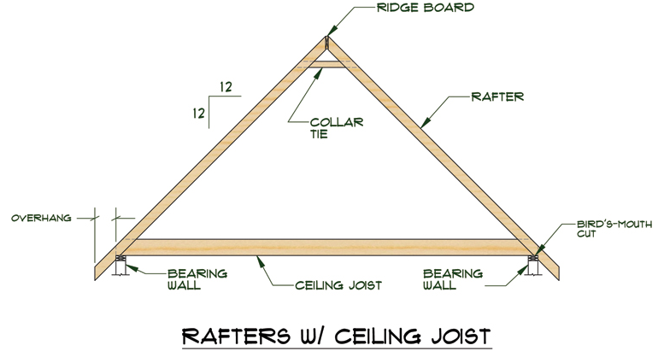
Built on the job site.
- High skill level of Carpenters to create roof system to withstand loads of roof.
- Built using standard dimensional lumber according to building code specifics.
- Rafters are very common way of construction in the US.
- 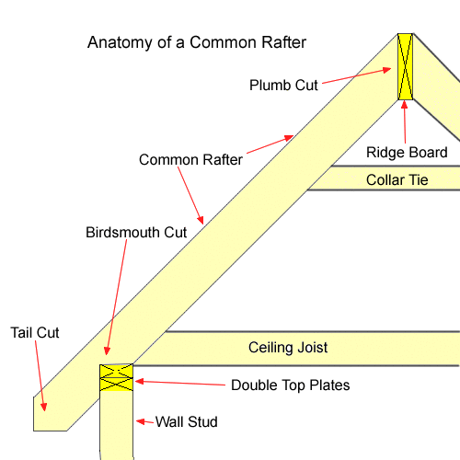

Appendix H – Roofing Terminology Questions
Using your Construction Technology textbook and the Internet, answer the following questions.
- What is the purpose of a roof?
- State three loads that are applied to a roof.
- What is the difference between a truss and rafters?
- Define the following terms,
  - Pitch
  - Span
  - 16” O.C.
  - Total Rise
  - Tail
  - Roofing square
- What is the function of a ridge board?
- What is the function of a birdsmouth cut?
- Why is ventilation important to the life span of a roof?

References
Beginner Rafter Layout (YouTube video), 2020 https://www.youtube.com/watch?v=kR6kGufeKIU
Construction Technology SAFEDocs (OCTE), 2013 https://www.octe.ca/application/files/1115/3796/3108/SAFEdoc_CON.pdf
Course Codes for Emphasis courses in the Revised Curriculum: Technological Education, Grades 11 and 12, 2009 http://www.edu.gov.on.ca/eng/curriculum/secondary/techedemphasiscourses.pdf
Essential GAF Roofing System Components for Your Home | We Protect What Matters Most (YouTube Video), 2014 https://www.youtube.com/watch?v=BZH-si4S0Ks
Exploring Technologies SAFEDocs (OCTE), 2013 https://www.octe.ca/application/files/6715/3796/3140/SAFEdoc_EXPL.pdf
Growing Success: Assessment, Evaluation, and Reporting in Ontario Schools, First Edition, Covering Grades 1 to 12, 2010
www.edu.gov.on.ca/eng/policyfunding/growSuccess.pdf
IKO Roofing What Makes Up a Roof – Your Roof Components (Article), 2020 https://www.iko.com/na/blog/roof-components-the-parts-that-make-a-roof/
JTC Roofing Contractors Ltd. – Roof Types (Website), 2020 https://www.jtcroofing.co.uk/roof-types/
Learning for All – A Guide to Effective Assessment and Instruction for All Students, Kindergarten to Grade 12, 2013 http://www.edu.gov.on.ca/eng/general/elemsec/speced/LearningforAll2013.pdf
National Roofing Contractors Association Glossary (Website), 2020 https://www.nrca.net/technical/glossary
Owens Corning – The Anatomy of a Roof (Article), 2020 https://www.owenscorning.com/en-us/roofing/tools/the-anatomy-of-a-roof
Photographs of Houses, (Images), taken by D Paul, 2020
Rafters vs Trusses (Image), 2020 https://www.roofingcalc.com/rafters-vs-trusses/anatomy-of-a-roof-rafter/
Roof and House Styles (PowerPoint presentation), 2020 https://www.octe.ca/application/files/3815/9762/3360/House_and_Roof_Styles.pptx
Roof and House Styles (Video), 2020 https://www.octe.ca/application/files/5415/9762/3122/Roof_and_House_Styles_Final.mp4
The Ontario Curriculum, Grades 9 and 10: Technological Education, 2009 (revised)
http://www.edu.gov.on.ca/eng/curriculum/secondary/teched910curr09.pdf
The Ontario Curriculum, Grades 11 and 12: Technological Education, 2009 (revised) http://www.edu.gov.on.ca/eng/curriculum/secondary/2009teched1112curr.pdf
Top 20 Roof Types and Pros & Cons – Roof Styles, Design & Architecture (Website), 2020 https://www.roofingcalc.com/top-20-roof-types/
Training the Trades - Cutting Common Rafters (YouTube video), 2020
https://www.youtube.com/watch?v=gz-Ej0qY1pQ
Trusses (Images), 2020 http://design.medeek.com/resources/trusses.html

