

TEJ2O Computer Technology
An Introduction to Arduinos

Abstract
This document was produced by the Ontario Council for Technological Education (OCTE).
It may be used in its entirety, in part, or adapted.

Disclaimer

This material was designed to assist teachers implement the Ontario Curriculum – Technological Education (revised Grade 10 -12). This material was created by members of the Ontario Council for Technology Education (OCTE) subject association and is intended as working guides for classroom, lab or shop activities. Permission is given to reproduce these materials for any purpose except profit. Teachers are encouraged to amend, revise, edit and adapt this material for educational purposes. Please acknowledge the source in all uses. Any references in this document to particular to commercial resources, materials or equipment reflect only the opinions of the writers of this material, and do not reflect any official endorsement by the Ontario Council for Technology Education, the Ontario Ministry of Education, or any other agency or government body.
All materials within these safety related documents are to be considered as suggestions and recommendations only. These are not legal documents and are not to be considered as legal requirements or as official policy. OCTE or the individual contributors makes no claim to the accuracy or the completeness of the enclosed documents and accepts no responsibility for any damages pertaining to their use. Users of this document should not assume all warnings and precautionary measures are contained herein, that additional information or measures are not required, or that local by-laws, regulations or Board policies are explicitly included.

© Ontario Council for Technology Education 2016

Table of Contents (do not edit!!!)

Project Overview
Project Challenge
Connections
Project Criteria
Examples
Project Synopsis and Timelines
Activity 1 - Getting to Know the Arduino
Minds On (Engaging Prior Knowledge)
Description
Criteria and Instructions
Prior Knowledge
Planning Notes
Action (Introduce or Extend Learning)
Instructional Strategies
Assessment and Evaluation
Accommodations
Consolidation & Connections (Provide Opportunities for Reflection)
Reflection Paper/Exit Card
Materials, Tools and Resources
Websites
Publications
Computer Software
Human Resources
Other
Appendices
Activity 2 - First Steps with the Arduino
Minds On (Engaging Prior Knowledge)
Description
Criteria and Instructions
Prior Knowledge
Planning Notes
Action (Introduce or Extend Learning)
Instructional Strategies
Assessment and Evaluation
Accommodations
Consolidation & Connections (Provide Opportunities for Reflection)
Reflection Paper/Exit Card
Materials, Tools and Resources
Websites
Publications
Computer Software
Human Resources
Other
Appendices
Activity 3 - TBD
Minds On (Engaging Prior Knowledge)
Description
Criteria and Instructions
Prior Knowledge
Planning Notes
Action (Introduce or Extend Learning)
Instructional Strategies
Assessment and Evaluation
Accommodations
Consolidation & Connections (Provide Opportunities for Reflection)
Reflection Paper/Exit Card
Materials, Tools and Resources
Websites
Publications
Computer Software
Human Resources
Other
Appendices

Project Overview
The Arduino is an exciting low-cost and open-source platform which lets students learn basic programming and electronics while making interactive projects.

In this set of activities, students will learn the basics of Arduinos by using them to wire some introductory circuits. Along the way, they will learn the fundamentals of Ohm’s Law, which defines the relationship between Voltage, Current, and Resistance.
Project Challenge | Connections
The project is broken down into three phases:  - getting introduced to the Arduino  - creating and programming some simple circuits  - reflecting on the process by documenting their learning in an ePortfolio | Science, Technology, Engineering and Mathematics (STEM)  This project supports the fundamental principles around STEM. It encompasses all aspects of STEM; material properties, engineering concepts, computer aided design, and mathematics  Differentiated Instructions (DI)  Provide an open-end approach when having students select a product. Have students choose their own product. A choice board with examples may help.

Project Criteria
Ideally, each student will have their own Arduino to complete the activities, or where DI warrants it, and Arduino can be shared with between two students. For each Arduino, there should be a set of supporting parts, including but not limited to:
- a breadboard
- 330 and 1KΩ resistors
- a 5V motor
- MORE HERE
Each student will also require access to the World Wide Web and have access to online tools such as Google Docs and Google Sites.

Troubleshooting equipment such as a multimeter would be beneficial, but is not mandatory at this level.

Examples

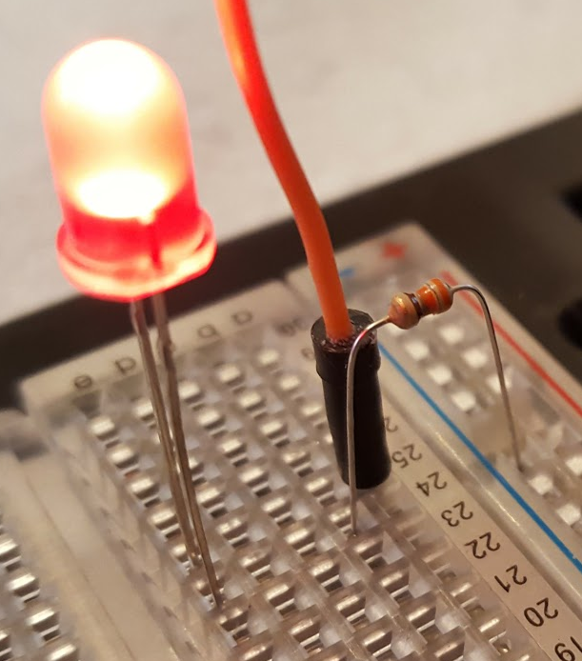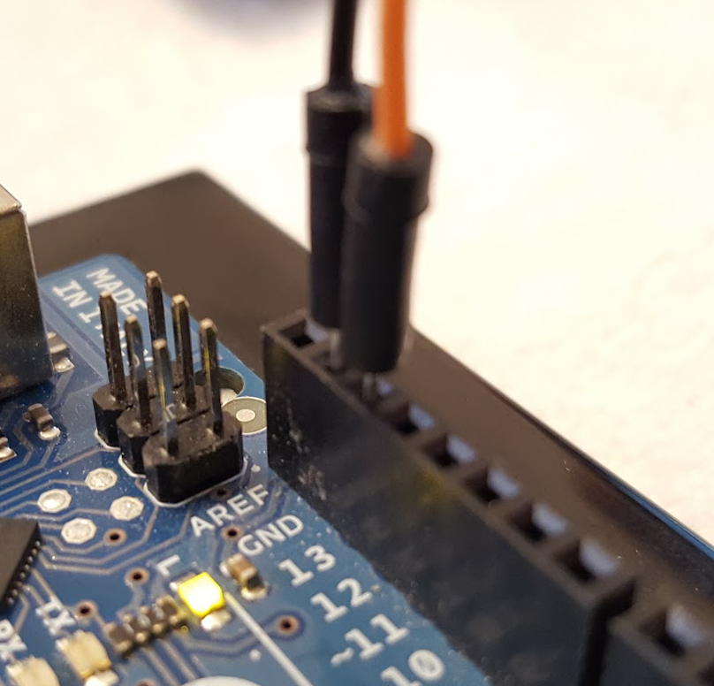

Project Synopsis and Timelines
Act # | Activity Title/Name | Time  (hrs.) | Curriculum Expectations | Assessment  & Evaluation | Connections?
1 | Getting to Know the Arduino |  | A1., A1.1, A1.2, A1.4  A3., A3.1  B2., B2.1, B2.2, B2.3, B2.5  B4. B4.2  B5., B5.1, B5.2, | - K/U  - T  - C  - A | - Ontario Curriculum  - Growing Success  - DI  - STEM  - Math Literacy  - Literacy
2 |  |  |  |  | - Ontario Curriculum  - Growing Success  - DI  - STEM  - Math Literacy  - Literacy
3 |  |  |  |  | - Ontario Curriculum  - Growing Success  - DI  - STEM  - Math Literacy  - Literacy

Activity 1 - Getting to Know the Arduino

Minds On (Engaging Prior Knowledge)

Description
It is assumed the students have no prior knowledge with Arduinos, programming, or electronics.

This series of lessons and activities will provide an overview of the Arduino. There is a slideshow that will get the students started with the theory and first few activities but then they will need to use some critical thinking skills to complete the remaining activities.

The lesson will start with motivational videos about the Arduino leading into some simple activities to get started with the programming and the basic electronics.

Criteria and Instructions
- Need something here about notes and/or questions related to the videos

Prior Knowledge | Connections
None assumed, other than basic computer experience (opening and saving files), being able to search on Google, etc. | N/A
Planning Notes | Connections
Forthcoming...

Action (Introduce or Extend Learning)
Instructional Strategies | Connections
Activities per our grade outline, https://goo.gl/PT22VI

Assessment and Evaluation | Connections
- Neatness
- Adherence to Black for ground, Red for power
- Proper operation
- More???
Accommodations | Connections

Consolidation & Connections (Provide Opportunities for Reflection)

Reflection Paper/Exit Card | Connections
- Some activity related to imagining future or real-world projects

Materials, Tools and Resources

Websites
- Getting Started with Arduino and Genuino products
https://goo.gl/BHtTY1
- Arduino Presentation
https://goo.gl/3gkY1R
- Arduino Language Reference
https://www.arduino.cc/en/Reference/HomePage

Publications
- N/A

Computer Software
- Arduino Editor
- Web Browser

Human Resources
- N/A

Other
- N/A

Appendices

Activity 2 - First Steps with the Arduino

Minds On (Engaging Prior Knowledge)

Description

Criteria and Instructions

Prior Knowledge | Connections
None assumed, other than basic computer experience (opening and saving files).
Planning Notes | Connections
Forthcoming...

Action (Introduce or Extend Learning)
Instructional Strategies | Connections
Activities per our grade outline, https://goo.gl/PT22VI
Assessment and Evaluation | Connections
Accommodations | Connections

Consolidation & Connections (Provide Opportunities for Reflection)

Reflection Paper/Exit Card | Connections
- Some activity related to imagining future or real-world projects

Materials, Tools and Resources

Websites
- Arduino Presentation https://goo.gl/frtM22

Publications
- Link to PDF of Arduino manual

Computer Software
- Arduino Editor

Human Resources

Other

Appendices

Activity 3 - TBD

Minds On (Engaging Prior Knowledge)

Description

Criteria and Instructions

Prior Knowledge | Connections
None assumed, other than basic computer experience (opening and saving files).
Planning Notes | Connections
Forthcoming...

Action (Introduce or Extend Learning)
Instructional Strategies | Connections
Activities per our grade outline, https://goo.gl/PT22VI
Assessment and Evaluation | Connections
Accommodations | Connections

Consolidation & Connections (Provide Opportunities for Reflection)

Reflection Paper/Exit Card | Connections
- Some activity related to imagining future or real-world projects

Materials, Tools and Resources

Websites
- Arduino Presentation https://goo.gl/frtM22

Publications
- Link to PDF of Arduino manual

Computer Software
- Arduino Editor

Human Resources

Other

Appendices

