

TEJ3M Computer Engineering Technology
Arduinos continued!

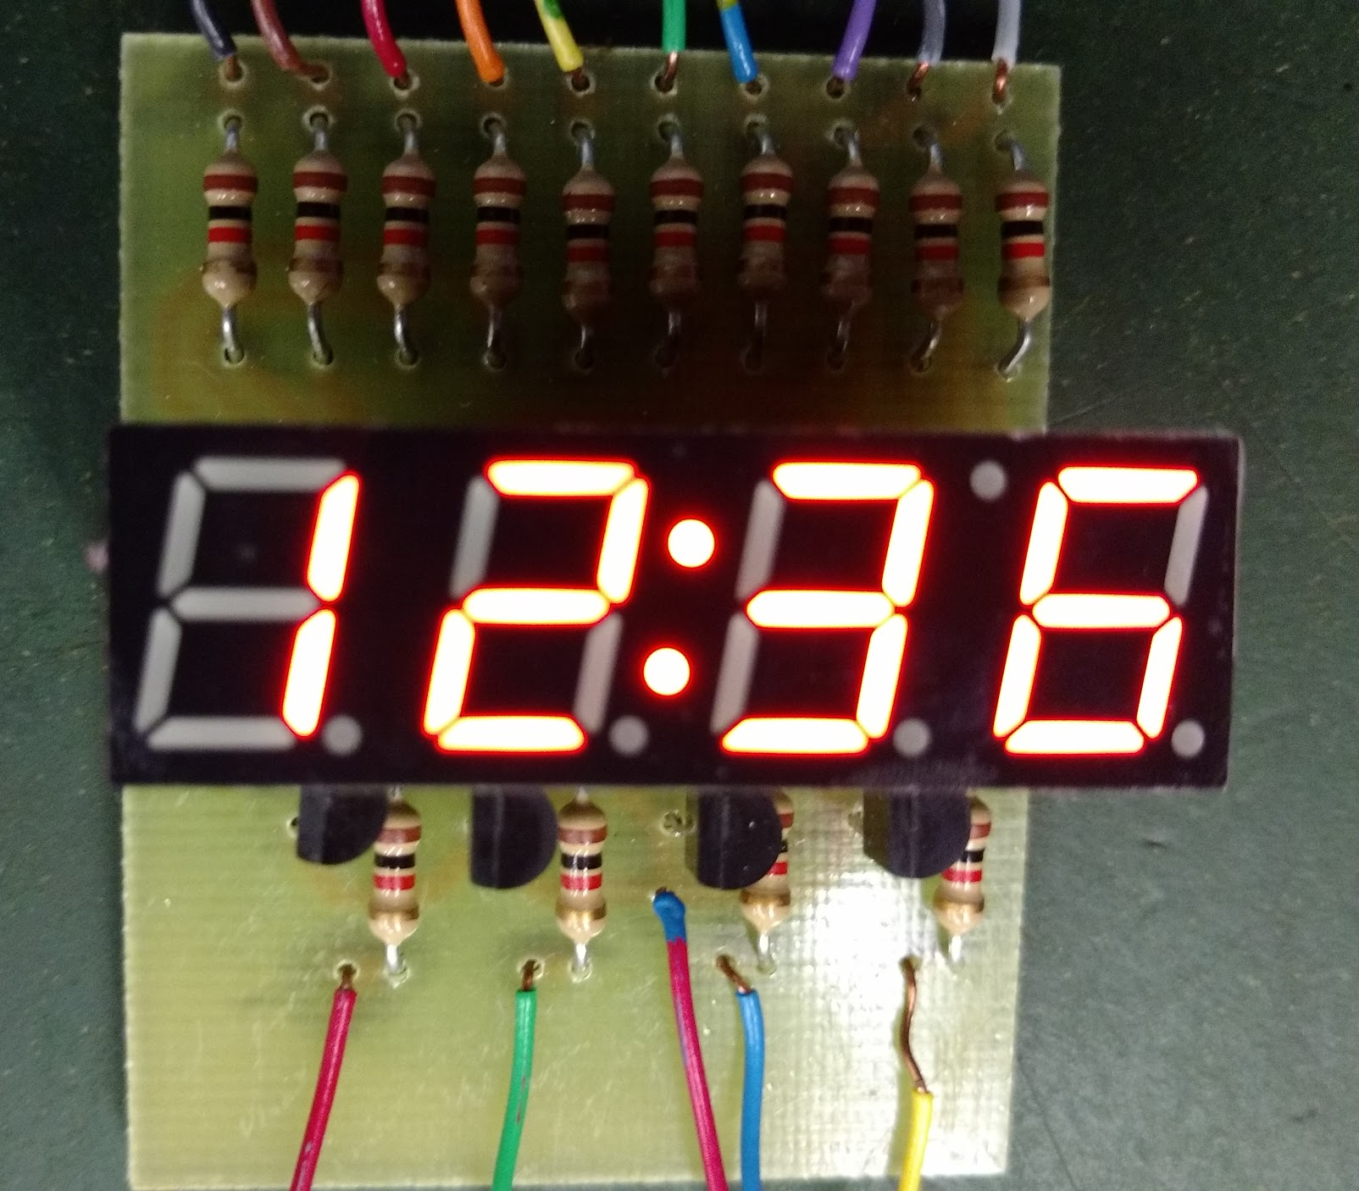

Abstract
This document was produced by the Ontario Council for Technological Education (OCTE).
It may be used in its entirety, in part, or adapted.

Disclaimer

This material was designed to assist teachers implement the Ontario Curriculum – Technological Education (revised Grade 10 -12). This material was created by members of the Ontario Council for Technology Education (OCTE) subject association and is intended as working guides for classroom, lab or shop activities. Permission is given to reproduce these materials for any purpose except profit. Teachers are encouraged to amend, revise, edit and adapt this material for educational purposes. Please acknowledge the source in all uses. Any references in this document in particular to commercial resources, materials or equipment reflect only the opinions of the writers of this material, and do not reflect any official endorsement by the Ontario Council for Technology Education, the Ontario Ministry of Education, or any other agency or government body.
All materials within these safety related documents are to be considered as suggestions and recommendations only. These are not legal documents and are not to be considered as legal requirements or as official policy. OCTE or the individual contributors makes no claim to the accuracy or the completeness of the enclosed documents and accepts no responsibility for any damages pertaining to their use. Users of this document should not assume all warnings and precautionary measures are contained herein, that additional information or measures are not required, or that local by-laws, regulations or Board policies are explicitly included.

© Ontario Council for Technology Education 2016

Table of Contents (do not edit!!!)

Project Overview
Project Challenge
Connections
Project Criteria
Examples
Project Synopsis and Timelines
Grade 11 - Digital Clock Using Arduino
Activity 1. Minds On (Engaging Prior Knowledge)
Project Research and Information Gathering
Criteria and Instructions
Prior Knowledge
Planning Notes
Activity 2. Action (Introduce or Extend Learning)
Instructional Strategies
Assessment and Evaluation
Accommodations
Activity 3. Consolidation & Connections (Provide Opportunities for Reflection)
Reflection Paper/Exit Card
Materials, Tools and Resources
Publications
Computer Software
Human Resources
Other
Appendices

Project Overview
This project covers how to use Arduinos in the Computer Technology classroom. Together, there are three units, basically designed to be used one after the other, but that is not essential (although part 1 should be done first).

Part 1 is introductory, covering how to hook up the Arduino, getting started with the editor, and some simple output programs.

Part 2 covers some introductory electronics to build a multiplexed clock using Arduino UNO. Example circuit layout using Fritzing and Arduino Sketch (for teacher reference) is given in the Appendix.

Part 3 covers a weatherstation project (including how to collect data from sensors), motor control, and how to use wi-fi with Arduinos.

This document covers Part 2 of the projects.
Project Challenge | Connections
To build a digital clock using a multiplexed seven-segment LED display and Arduino UNO. Clock should display time in hh:mm format. It can be in 12 hour or 24 hour format. Time is set in the program itself. As an additional challenge, student can write a Process code to sync the clock from PC clock. | Grade 11 computer engineering technology curriculum (TEJ3M)  - Electronic components and circuits, reading schematics, troubleshooting  - Microcontrollers  - Programming  - Writing and presentation
Project Criteria | Examples
Clock should display time in hh:mm format in 12 / 24 format.

Project Synopsis and Timelines
Grade | Activity Title/Name | Time  (min) | Curriculum Expectations | Assessment  & Evaluation | Connections
10 |  |  |  |  | - Ontario Curriculum  - Growing Success  - DI  - SEF  - STEM  - Math Literacy  - Literacy  - Equity Inclusive…  - ICE  FNMI First Nations, Metis
11 | - Project outline  - Multiplexing - presentation  - Fritzing Layout work  - Circuit Building  - Writing Sketch  - Testing / modifying  - Documentation | - 30  - 45  - 150  - 225  - 300  - 150  - 150  ( 12 to 15 classes of 75 minutes each) | Grade 11 computer engineering technology (TEJ3M) | - Rubric  - Project Report  - Layout skills  - Programming  - Breadboard / solder skills  - [optional: daily log] | - Ontario Curriculum  - Growing Success  - DI  - SEF  - STEM  - Math Literacy  - Literacy
12 |  |  |  |  | - Ontario Curriculum  - Growing Success  - DI  - SEF  - STEM  - Math Literacy  - Literacy  - Equity Inclusive…  - ICE  FNMI First Nations, Metis

Grade 11 - Digital Clock Using Arduino

Activity 1. Minds On (Engaging Prior Knowledge)

Project Research and Information Gathering
This project is best suited to be a culminating project or Rich Performance Task for TEJ3M or TEL3M (Computer Engineering Technology - Electronics focus) courses. Students will enhance their prior knowledge of Arduino by building a digital clock using a seven-segment display. This project involves hardware and software aspects of computer engineering technology. Students will learn to build a circuit of moderate complexity by soldering or by breadboarding. Software aspect is covered by writing Arduino Sketch to control the display to show time in hh:mm format. Students will also learn about Multiplexing - a common technique used in modern display systems. Arduino IDE (Integrated Development Environment) will be used to write the program called Sketch. Students who are familiar with advanced IDEs can be encouraged to use Microsoft Visual Studio (community edition) with Visual Micro plug in to program Arduino UNO board. This IDE has more features and functionalities than the Arduino IDE.

Human need to measure time dates back centuries and millenia. Knowing seasons was important in farming activities to reap a good crop. Measurement of time became essential for marine navigation in a seafaring society. Many of the long range navigational aids, including the modern day GPS measure the time differential from satellites to calculate one’s Latitude and Longitude. Sexagesimal numbering system based on 60 is still used in time and angle measurements.

Appendix A introduces the project to the students with necessary milestones. Milestones will help students to plan their work for a successful completion of the project. It will also help a teacher to monitor students’ progress and to provide descriptive feedback. Appendix B has the evaluation rubric that shows how a student’s work will be marked. Presentation in Appendix C explains the coding process in progressive steps, starting from a simple Sketch using built-in Arduino functions to register direct accessing, to interrupt-driven code.Example Sketch in Appendix E is a fully functional well documented code for teacher’s reference. This code can be easily modified for use in other types of seven-segment displays. This code can be stripped down to outline code to scaffold students’ programming efforts.

This project uses transistors (2N3904) and a multiplexed seven-segment display (Young Sun four-digit LED). Brief review lesson on these two components - especially the correct way to connect them in a circuit - is essential to prepare the students for this final project.

This is also a good starting point to review the hardware aspects of Arduino: viz, pins (digital, analog, and power), supply voltages etc. Also, outline of a Sketch, and a few Sketch samples can be taken up to highlight that initialization code goes in setup() function and the main code goes in loop() function.

This project meets the following overall and specific expectations from the Ontario Curriculum Grades 11 and 12, Technological Education, 2009. Computer Engineering Technology, Grade 11; University/College Preparation TEJ3M / TEL3M courses (Page 76).

A3.5 compare the advantages and disadvantages of interfacing using desktop computers, microcontrollers, and programmable logic controllers.

B3. design, construct, create diagrams for, and troubleshoot electronic circuits and interfaces for control systems;

B5.3 use a design process (see pp. 22–23) to write, test, and debug a computer program that controls and/or responds to the inputs from an external device (e.g., LED array, motor, relay,
infrared sensor, temperature sensor).

Fritizing software is used to layout the components on a breadboard. Based on resources available at a school and to accommodate students’ varying skill levels in electronics work, students can either breadboard the project or solder the project onto a veroboard that has the same layout as the breadboard. Example Fritzing layout uses half the breadboard / veroboard; so one board can be cut in half for two projects.

Criteria and Instructions
Project Outline in Appendix A provides the background information and also the project milestones to help students plan their work. Evaluation Rubric in Appendix B depicts four levels of achievement criterion.Refer to the following site for more info on Gantt / milestone chart: http://www.ganttchart.com/CreateGantts.html

Prior Knowledge | Connections
A priori knowledge on the following topics are expected. However, if teacher feels that majority of students need a review of these topics, one or two periods can be dedicated to cover them.  Arduino:  - pins (digital and analog), power supply, familiarity with the IDE, writing a Sketch, uploading and running a program.  - Ohm’s law  Electronic components:  - resistors, resistor colour codes  - transistors, types and their working  - seven-segment displays, types, segment names | - TEJ2O lessons that cover Arduino.  - Electronic components.  - Grade 9 Science lessons on Ohm’s Law
Planning Notes | Connections
All the components needed for the project must be obtained before the project starts. This will avoid any last minute changes to the project due to non-availability of components. This is essential for remote communities. Despite teacher’s and students’ best efforts, components will get damaged especially when soldering on the veroboard. It is suggested to order and keep 10% more components. Seven-segment displays are socketed, therefore they can be removed for reuse.

Activity 2. Action (Introduce or Extend Learning)
Instructional Strategies | Connections
Multiplexing: Students must be made familiar with this technique used extensively in modern day electronics. Primary purpose of multiplexing is to reduce:  - Pin count on microcontroller  - Power consumption  - Cost  Most of the multi-digit displays that students see everyday,e.g. on buses, elevators, school signs are all multiplexed. Principles of multiplexing and how fast the digits must be switched to avoid flickering are explained in the presentation Appendix C.  Time measurement: In this project, one second interval to keep time is derived from the Arduino itself. Also, starting time is hard coded in the program or synchronized from the PC; synchronizing the time from PC is the challenge part of the project.Either way, the Sketch has to keep the time based on the seconds elapsed. If the measurement of seconds is not accurate, time displayed will not be accurate. Students can be directed to do independent research on temperature compensated crystal oscillators and Cesium atomic clocks that provide time reference.  If soldering facilities are available, a short review lesson on soldering safety and tool safety following SAFEdoc for computer engineering must be delivered. Resource in Appendix F provides tips for good soldering in comics form; it must be emphasised to students that soldering skill is essential in any electronics work. And Appendix G has short answer questions based on the comics. | B3. design, construct, create diagrams for, and troubleshoot electronic circuits and interfaces for control systems;  B5. demonstrate an understanding of fundamental programming concepts, and develop a program that interacts with an external device.  B5.1 use constants, variables, expressions, and assignment statements correctly, taking into account the order in which operations are performed;  B5.2 use input statements, output statements, selection structures, and repetition structures in a program;  Leading Math Success - Mathematical Literacy  Grades 7–12/ 2004  OCTE safedocs for computer engineering. Soldering safety
Assessment and Evaluation | Connections
Evaluation rubric is a tool to measure assessment of learning. Anecdotal notes, and students’ daily log (if used) can be used for assessment for learning to provide descriptive feedback as explained in “Growing Success” document p31.  “Learning happens best when a learning experience pushes the learner a bit beyond his or her independence level.” L.S. Vygotsky, Mind in Society, 1978. As a step in this direction, students are challenged to synchronise the time from a PC instead of setting the time and uploading the code. This can be done by running a Process Sketch on a PC that syncs the time making the display show the system time. | GROWING SUCCESS | assessment, evaluation, and reporting in Ontario schools,  First edition, covering grades 1 to 12, 2010.  Student Success  Differentiated Instruction Educator’s Package (2010)
Accommodations | Connections
Students who are sensitive to smoke and / or who have not developed fine motor skills for soldering work can breadboard the project instead of soldering on a veroboard. Well ventilated room and table-top fume extractors will keep students’ work area free of smoke while soldering. Smoke is from the burning of flux core in the solder and not from the burning of the solder that may need much higher temperatures.  ESL students can be paired and the project can be a group project for them.  Instead of expecting students to develop complete code from scratch for the project, teacher can provide “scaffolding” code to students to expand and incorporate their logic and thinking. | Think Literacy: Cross-curricular Approaches, Grades 7-12

Activity 3. Consolidation & Connections (Provide Opportunities for Reflection)

Reflection Paper/Exit Card | Connections
Project report is a reflective report of what students did to build the project. Also, writing and documentation is an essential skill in technology careers. This report covers the steps students took to complete the project and necessary next steps to improve or add more features to their project stands out. A simple enhancement to the project could be a blinking colon for seconds. AM / PM indicator using extra dots on the display is another feature for 12 hour clock. | Think Literacy: Cross-curricular Approaches, Grades 7-12

Materials, Tools and Resources
Websites (as of July 2016)
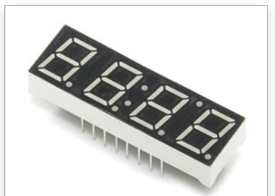
https://www.arduino.cc/en/Main/Software
http://fritzing.org/download/
Seven-segment Young Sun multiplexed display is available from ABRA Electronics. Sparkfun and other electronics retailers also carry this item. Any seven-segment multiplexed LED display can be used instead; slight modifications in the Sketch and layout will be needed. Four separate displays can also be used, but this will make the layout / soldering a bit more complex.
https://abra-electronics.com/opto-illumination/led-displays-segmented/com-09483-four-digit-7-segment-display-039-red-com-09483.html
Solderable Veroboard (can be cut in half) is available from:
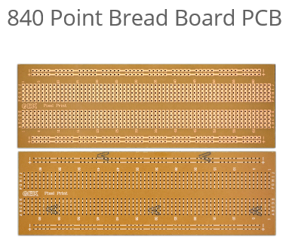
http://www.veroboard.com/veroboard-circuit-prototype/bread-board/840-point-bread-board-pcb-phenolic.
Example layout in Appendix D uses half of this board. Use a mini shear or Exacto knife to cut the board in half.

Publications
- School Effectiveness Framework
- Growing success
- Think Literacy
- Tech Curriculum docs
- Leading Math success
- Differentiated Instruction

Computer Software
Arduino IDE
Fritizing

Human Resources

Other
Refer to Appendix H for tools and components

Appendices
Appendix A – Project Outline - document
Appendix B – Evaluation Rubric - document
Appendix C – Multiplexing - presentation
Appendix D – Fritzing |Layout – Fritizing layout file
Appendix E – Arduino Sketch – Arduino sketch
Appendix F – Soldering is Easy comics – PDF document
Appendix G – Soldering Comics Questions. - document
Appendix H – Tools and components - document
Appendix I – Datasheet Young Sun multiplexed display – PDF document

Think Literacy: Cross Curricular Approaches, Grades 7-12, page 43, explains the SUM (Situation, User, Message) process in writing a report.
A “rich task” encourages students to use subject knowledge and skills in ways that are relevant in and beyond the classroom. Rich tasks require students to think in ways they will have to think in life outside school (Flewelling & Higginson, 2001).Leading Math Success - Mathematical Literacy,Grades 7–12, 2004

