

THJ3M
GREEN INDUSTRIES
Hardscaping-Paver Installation

Abstract
This document was produced by the Ontario Council for Technological Education (OCTE).
It may be used in its entirety, in part, or adapted.

Disclaimer

This material was designed to assist teachers implement the Ontario Curriculum – Technological Education (revised Grade 10 -12). This material was created by members of the Ontario Council for Technology Education (OCTE) subject association and is intended as working guides for classroom, lab or shop activities. Permission is given to reproduce these materials for any purpose except profit. Teachers are encouraged to amend, revise, edit and adapt this material for educational purposes. Please acknowledge the source in all uses. Any references in this document to particular to commercial resources, materials or equipment reflect only the opinions of the writers of this material, and do not reflect any official endorsement by the Ontario Council for Technology Education, the Ontario Ministry of Education, or any other agency or government body.
All materials within these safety related documents are to be considered as suggestions and recommendations only. These are not legal documents and are not to be considered as legal requirements or as official policy. OCTE or the individual contributors makes no claim to the accuracy or the completeness of the enclosed documents and accepts no responsibility for any damages pertaining to their use. Users of this document should not assume all warnings and precautionary measures are contained herein, that additional information or measures are not required, or that local by-laws, regulations or Board policies are explicitly included.

© Ontario Council for Technology Education 2016

Table of Contents (do not edit!!!)

Project Overview
Project Challenge
Connections
Project Criteria
Examples
Project Synopsis and Timelines
Activity 1 - Project Research and Information Gathering
Precast Concrete Paver Construction and Design
Activity 1 Project Research and Information Gathering
Activity 1 Criteria and Instructions
Minds On (Engaging Prior Knowledge)
Activity 1 Prior Knowledge
Activity 1 Planning Notes
Action (Introduce or Extend Learning)
Activity 1 Instructional Strategies
Activity 1 Assessment and Evaluation
Activity 1 Accommodations
Consolidation & Connections
(Provide Opportunities for Reflection)
Activity 1 Exit Card/Daily Log
Materials, Tools and Resources
Activity 1 Websites
Activity 1 Publications
Activity 1 Computer Software
Activity 1 Human Resources
Activity 1 Other
Activity 1 Appendices
Activity 2 - Project Development
Excavation & Installation
Activity 2 Project Development
Activity 2 Criteria and Instructions
Minds On (Engaging Prior Knowledge)
Activity 2 Prior Knowledge
Activity 2 Planning Notes
Action (Introduce or Extend Learning)
Activity 2 Instructional Strategies
Activity 2 Assessment and Evaluation
Activity 2 Accommodations
Consolidation & Connections
(Provide Opportunities for Reflection)
Activity 2 Reflection Paper/Daily Log
Materials, Tools and Resources
Activity 2 Websites
Activity 2 Publications
Activity 2 Computer Software
Activity 2 Human Resources
Activity 2 Other
Activity 2 Appendices
Activity 3 - Project Portfolio and Presentation
Activity 3 Project Portfolio and Presentation
Activity 3 Criteria and Instructions
Minds On (Engaging Prior Knowledge)
Activity 3 Prior Knowledge
Activity 3 Planning Notes
Action (Introduce or Extend Learning)
Activity 3 Instructional Strategies
Activity 3 Assessment and Evaluation
Activity 3 Accommodations
Consolidation & Connections (Provide Opportunities for Reflection)
Activity 3 Peer and Self-assessment
Materials, Tools and Resources
Activity 3 Websites
Activity 3 Publications
Activity 3 Multimedia
Activity 3 Human Resources
Activity 3 Other
Activity 3 Appendices

Project Overview
Many different materials can be used in constructing Hardscape/Landscape features. In Green Industries students use a variety of landscape materials such as precast concrete pavers, natural stone and wood to create beautiful outdoor spaces like patios, paths/walkways, retaining walls, pergolas and a variety of other landscape features.

In this landscape construction project students will learn how to correctly install precast concrete pavers. These durable, attractive and popular products are ideal for use around school grounds for walkways and paved areas.

Pavers are made by a number of different manufacturers and are availability in a variety of different shapes, sizes, colours and textures. These pavers offer a broad range of design possibilities for around the school grounds to create aesthetically pleasing hardscape features. In this project students will design and build one of the following features: a patio, a pad for school benches/picnic tables or a pathway/walkway.

Project Challenge | Connections
Students must research, design and install a hardscape feature on the school campus. This feature will be dry-laid which means you use no cement, concrete or mortar. The project will be either:  - A patio  - A pad for a bench or picnic table  - A pathway/walkway  - Paved area as part of outdoor classroom  It will be made from precast concrete pavers. It must contribute to the overall aesthetic appearance of the school and will be used by the students, staff and the local community.  It may be one phase of a larger landscaping project like an outdoor classroom. Outdoor classrooms are becoming more common around school grounds so it is conceivable that this may be one part of this larger project. | Science, Technology, Engineering and Mathematics (STEM)  This project supports the fundamental principles around STEM. It encompasses all aspects of STEM; material properties, engineering concepts, design, and mathematics  Innovative, Creativity, Entrepreneurship (ICE)  This project can be part of an ICE training initiative through collaboration with local landscaping organisations like Landscape Ontario or in conjunction with other technology program areas e.g. Construction Technology or Tech. Design.  School Effectiveness Framework (SEF) Component 2: School and Classroom Leadership  Indicator 2.2: Rich and relevant tasks advance learning, creativity and innovation.  Indicator 2.5  Staff, students, parents and school community promote and sustain student well-being and positive student behaviour in a safe, accepting, inclusive and healthy learning environment.  Component 6: Home, School and Community Partnerships  Indicator 6.3-The school and community build partnerships to enhance learning opportunities and well-being for students.  Differentiated Instruction (DI)  Engaging and interesting tasks (that address the same skills) for all learning preferences, interests and levels of readiness  Ontario’s Equity and Inclusive Education Strategy  As a strategy in applying equity and inclusion, engage community partners that reflect the diversity of the local community and work towards representation of diverse groups within this potential ICE initiative. As an example, design and install a culturally based hardscape at a local cultural centre.
Project Criteria | Examples
- students must use precast concrete pavers  - the patio, pad or walkway must be dry-laid  - it must be constructed on the school grounds and is to be used by the school community  - it must include sketches, research notes, a detailed cross sectional diagram, complete set of working drawings with all parts and a complete list of materials and quantities  - a variety of landscaping equipment will be utilized, for example, plate compactor, concrete saw, guillotine cutter, and a variety of hand tools.  - students will present their completed project  NOTE: Criteria can be adjusted to reflect the equipment available at the given school | 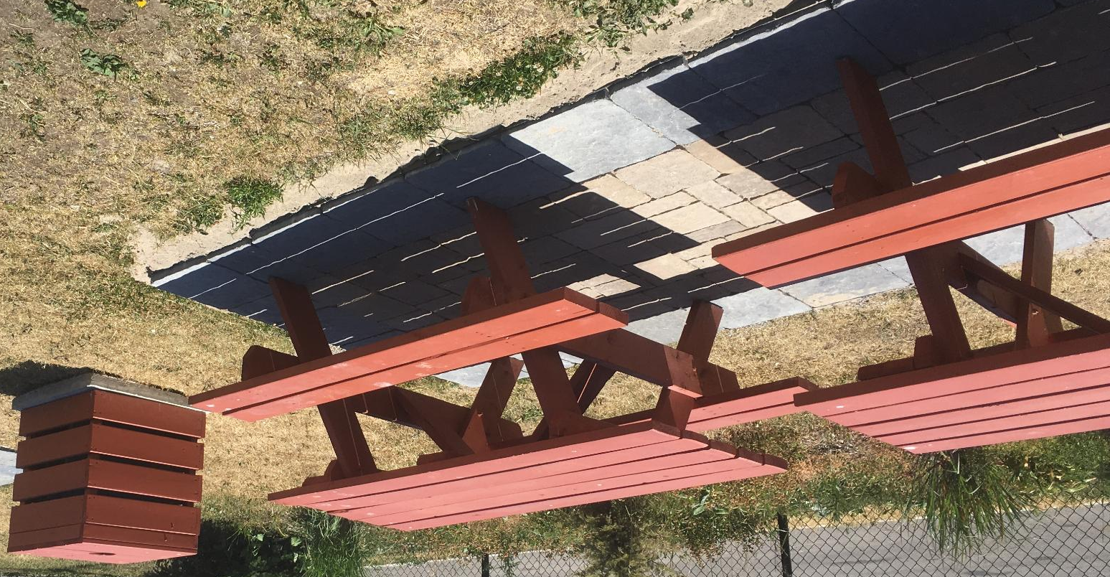  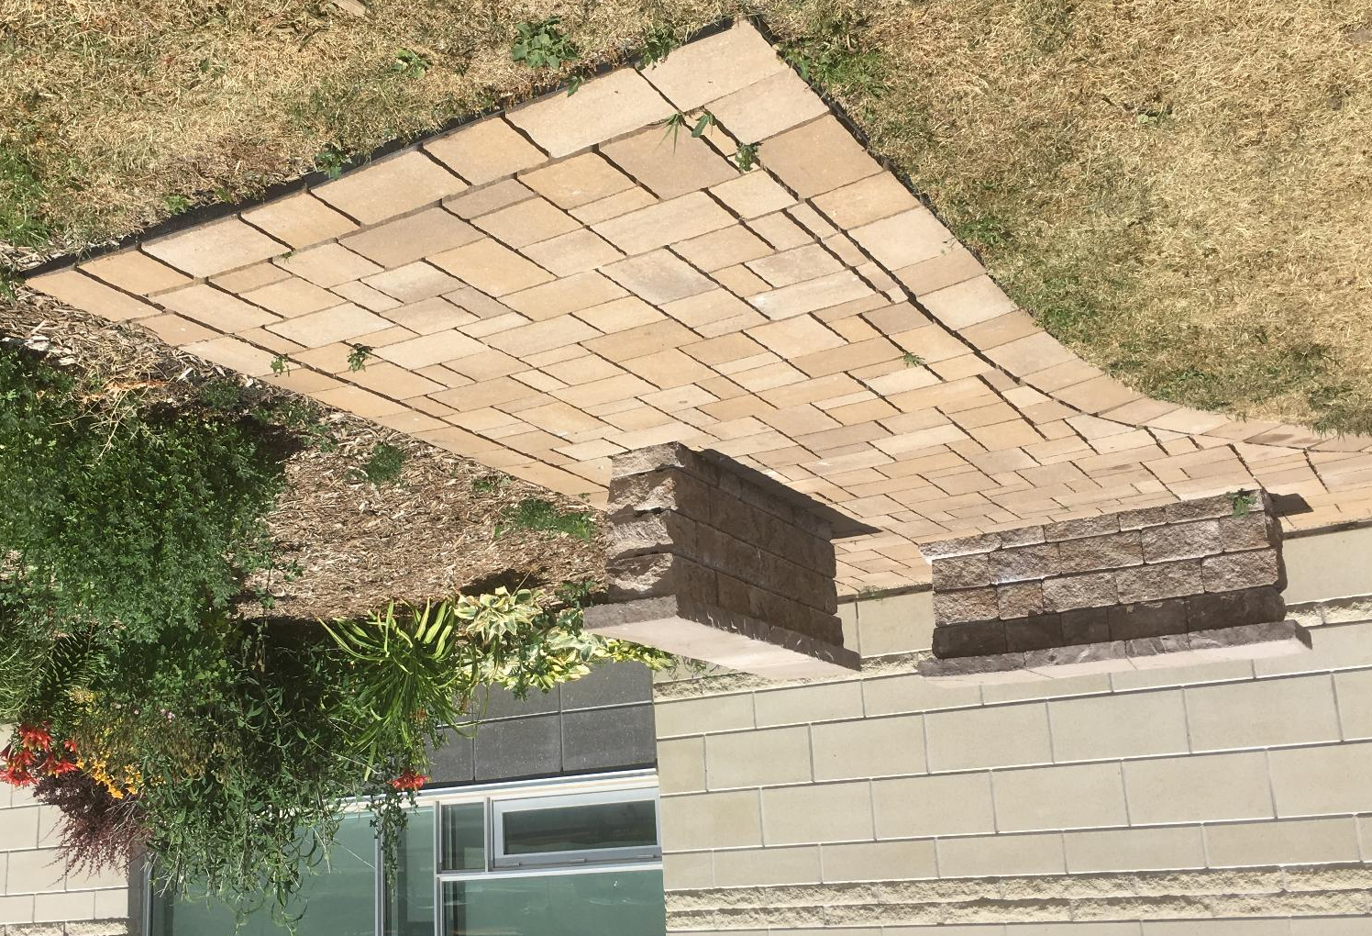  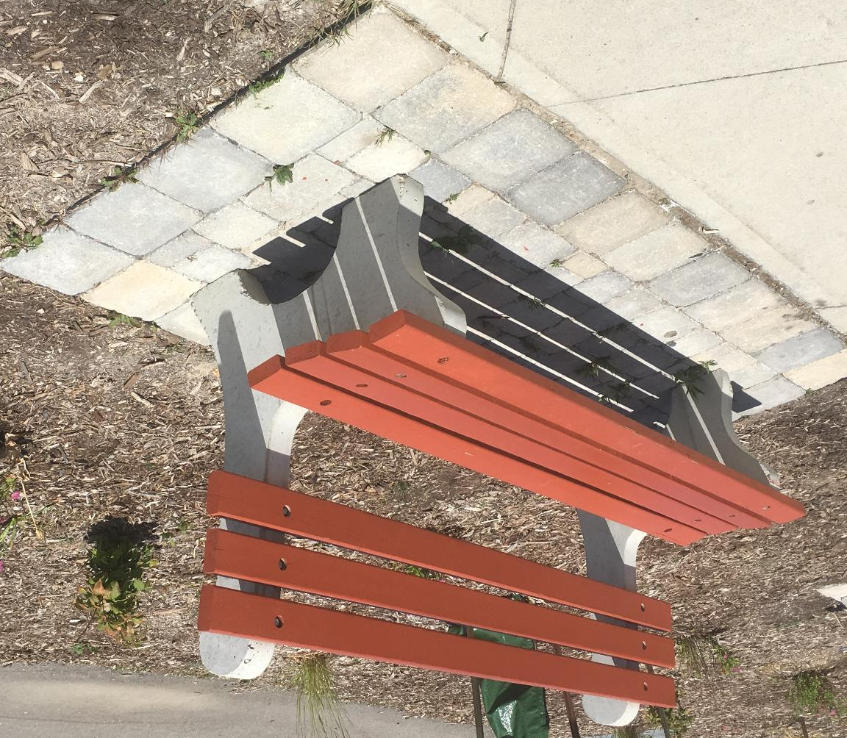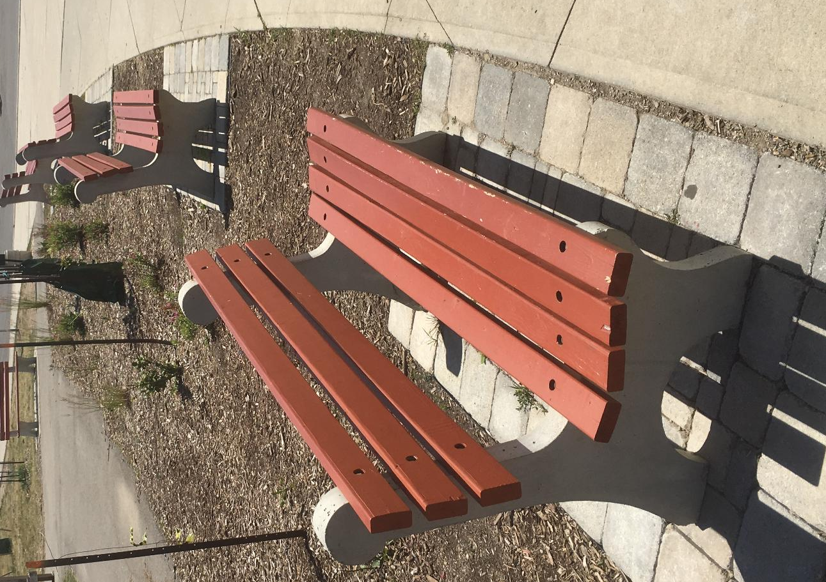

Project Synopsis and Timelines
Act # | Activity Title/Name | Time  (hrs.) | Curriculum Expectations | Assessment  & Evaluation | Connections
1 | Project Research and Information Gathering  - Research  - Hardscaping techniques  - Sketches & diagrams  - Material  - Equipment & Safety  - Report | 7.0 | A.3, A.4, D.3  A3.1, A4.4, D3.5, D3.6 | - K/U  - T/I  - C | - Ontario Curriculum  - Growing Success  - DI  - SEF  - Literacy  - ICE  - FNMI First Nations, Metis  - OCTE-SafeDocs, SafetyNet  - OSP
2 | Project Development  - Rough layout of project area  - Excavate the area  - Stake out the area  - Prepare the base  - Establishing elevations  - Screeding  - Lay the precast concrete pavers  - Install edge restraint  - Compact pavers  - Sweep in sand | 20.0 | A4, B1, B3, D1, D3  A4.4, B1.1, B3.1, B3.2, D1.1, D1.2, D1.3, D3.5, D3.6 | - K/U  - T/I  - C  - A | - Ontario Curriculum  - Growing Success  - DI  - SEF  - Math Literacy  - Literacy  - ICE  - OCTE-SafeDocs, SafetyNet  - OSP
3 | Project portfolio and presentation  - Challenge statement  - Research & information gathered  - Pictures/images  - Timelines  - Reflection/Concluding remarks  - Presentation | 3.0 | A4, D3  A4.1, A4.2  D3.6 | - K/U  - T/I  - C  - A | - Ontario Curriculum  - Growing Success  - SEF  - Math Literacy

Activity 1 - Project Research and Information Gathering

Precast Concrete Paver Construction and Design

Activity 1 Project Research and Information Gathering
Activity Description:

Precast concrete pavers offer a broad range of design possibilities. They are widely used in the landscaping sector and are popular because of their durability, attractive colours & textures and because they are easy to work with and install. They are excellent for constructing patios, pathways, driveways and many other hard landscape projects.

In this activity, students will:
- Research and describe a variety of landscape construction projects made with precast concrete pavers
- Research and detail the correct installation techniques for precast concrete pavers
- Come up with a landscape construction project that can be done on the school property
- Create a sketch and scaled landscape design for the project
- List all materials needed for the overall project
- List all tools needed to complete such a project
- Make note of safety considerations, rules and PPE required to complete the project
- Keep it simple!

Activity 1 Criteria and Instructions
Landscape Construction/Hardscaping projects
- Research and describe a variety of landscape construction projects that use precast concrete pavers. There are many different manufacturers, designs, styles, shapes & sizes. Create a presentation that includes all related information gathered.
- You must include any, notes, images, photos, illustrations.
- Take a look at other projects that have been done around the school or in the wider community. Take pictures of these different landscape construction projects. Also collect images by doing internet research (Google Images) or cut out pictures from magazines/newspapers/catalogues.
- When searching using the Internet, be sure you find designs that have detailed plans and installation guides with useful diagrams. Manufacturer’s websites will have links to their latest catalogues that include installation techniques.
Installation Techniques
- Become familiar with the correct installation techniques
- List all the different materials needed and note all the tools that are required
- Make copies of interesting designs and take detailed notes of plans and installation techniques and draw diagrams. Manufacturer’s websites will have links to their latest catalogues that include installation techniques.
Sketch/drawing
- Come up with a basic hardscaping design
- Make a sketch of the design
- Add any drawings or diagrams discovered during research (including a cross-section)
- Create a basic landscape design for the project
Materials list
- List all materials needed for the overall project
Tool/equipment list
- List all tools needed to complete such a project
Safety
- Make note of safety considerations, rules and PPE required to complete the project
Research Sources
- You must use a variety of resources when collecting your information like magazines, newspapers, manufacturer’s installation guides, landscape design books, Internet, and many other sources.
- All sources of information must be cited as proof that you used a number of different sources.
Information gathering
- Evidence of your research and design considerations must be posted in your online board collaboration system or in your personal Green Industries binder.
Report Presentation
- A report must be presented in a structured format with cover sheet, page numbers, headers and footers.
- Note that you’ll be asked to include portions of this report in your final portfolio presentation so be sure you keep all of your notes, diagrams, designs etc.
- Your final portfolio will include evidence of acquired skills and competencies and will be presented to the class at the end of the project.

Minds On (Engaging Prior Knowledge)
Activity 1 Prior Knowledge | Connections
The student will have:  - group work skills;  - research skills: ie, the ability to use a variety of resources (Internet, magazines, catalogues, etc.);  - skills in cooperative learning techniques (effective interpersonal skills) and an understanding of personal responsibilities and commitment required for group activities;  - basic skills in word processing used for journals/log entries;  - respect for the rights, responsibilities, and contributions of self and others;  - basic knowledge of hardscaping/landscape construction from Exploring Technologies class and/or Grade 10 Green Industries class  - Previously developed skills, knowledge and understanding of safe and efficient operation of landscaping equipment  - Review of related safety information and videos of key tools and equipment used to facilitate this landscaping project | Teacher Tips  It may be a good idea to review report format and specific word processing features. E.g., inserting tables, headers, footers, cover page, etc.  SEF Component 1 Assessment for, as and of Learning  Indicator 1.7: Clear learning goals and success criteria are identified, shared and clarified with students and parents.  OCTE Resources  SafeDocs, SafetyNet
Activity 1 Planning Notes | Connections
- Check all resources prior to beginning lesson and activity.  - Be sure that all computers are in working order and that Internet access is available.  - Check school WiFi for accessibility.  - Have backup sources in case of computer or WiFi accessibility issues (magazines, catalogues, landscaping books etc.)  - Review all activities and prepare all resources (handouts and materials) necessary for the delivery of content.  - Review learning goals and success criteria so that they can be identified, shared and clarified with students and parents.  - It is recommended that all resources be posted to your board collaboration system or classroom website to avoid too many handouts and to ensure full accessibility.  - Ideal activity for allowing students to use their own personal electronic devices in their research.  - Provide links to access safety information and videos | SEF Component 1 Assessment for, as and of Learning  Indicator 1.7: Clear learning goals and success criteria are identified, shared and clarified with students and parents.  SEF Component 3 Student Engagement  Indicator 3.4: Creative, innovative and diverse perspectives are encouraged and nurtured.  OCTE Resources  SafeDocs, SafetyNet

Action (Introduce or Extend Learning)
Activity 1 Instructional Strategies | Connections
TEACHER  - Introduce the project criteria & instructions (Appendix A). Be sure to clearly describe expectations. Show the students previous hardscaping/landscape construction projects to give the students visual exemplars that provide a clear vision of the final product.  - Allow students to establish design/construction crews of 3-4 members. The teacher may choose or modify the crews depending on individual strengths and weaknesses.  - Discuss best practices regarding group work.  - Clearly describe what students are expected to learn and how their learning will help with the overall project. Provide students a clear vision of where this activity will lead.  - Tell students, at the outset of instruction, what the learning goals are. Refer frequently to the learning goals.  - Show students exemplars to better help them understand activity expectations.  - As part of the research, have students analyze different cultural hardscape designs.  - Student binders- review and check for understanding, recording ideas, organization and up to date journal entries  STUDENT  - Participate in collaborative/cooperative learning through group research.  - Research list, and describe a variety of landscape construction projects made with precast concrete pavers  - Research and detail the correct installation techniques for precast concrete pavers  - Come up with a landscape construction project that can be done on the school property  - Sketch and draw a landscape design for the project  - List all materials needed for the overall project  - List all tools needed to complete such a project  - Select a paver product that best suits their needs and research the correct installation procedure by examining the manufacturer’s guide.  - List all safety considerations, rules and required PPE  - Provide evidence of ongoing progress by documenting in your personal Green Industries binder.  - Produce a report of their research and final design choice.  - Take pictures of local community and private hardscape projects/designs. By using internet research combined with real world examples, students a clear understanding of expectations through these visual references. | The Ontario Curriculum, Grade 11-12, Revised 2009  Overall Expectations: A.3, A.4, D.3  Specific Expectations: A3.1, A4.4, D3.5, D3.6  FNMI  Schools will strive to “employ instructional methods designed to enhance the learning of all First Nation, Métis, and Inuit students”, it is recommended that students research some First Nation, Métis, and Inuit natural hardscaping designs or landscape construction techniques.  Ontario Skills Passport  Literacy skills in planning and organizing.  Differentiated Instruction (DI)  Flexible Learning Groups In a differentiated classroom, students are grouped and regrouped, frequently and flexibly based on their; readiness to learn a concept; interest in a concept learning preferences in working with or thinking about a concept; or environmental or social sensitivities  SEF Component 3  Student Engagement Indicator 3.1:  Learning experiences are engaging, promote collaboration, innovation and creativity (i.e. are clear, meaningful, challenging, productive and include problem solving and critical thinking on a variety of issues). Ongoing feedback between students and teachers enables students to refine both thinking and products.  Think Literacy Reading (research) Strategy: Engaging in Reading  Working collaboratively with a partner use reading, note taking, and oral strategies to make sense of the text.  Teacher Tips  Encourage students to visit the specific locations where they can find interesting hardscaping features or take the class on a walking tour of the local community.
Activity 1 Assessment and Evaluation | Connections
Assessment strategies and tools in this activity will include opportunities in monitoring students’ achievement levels as well as learning skills.  Assessment and evaluation tools and strategies will be used throughout this project by both the teacher and the student. These tools and strategies will help to guide student learning and to inform instruction.  Knowledge and Understanding  - Assessing student knowledge and understanding of landscape construction processes, tools & equipment and safety considerations.  Thinking and Inquiry  - Assessing the students design concept  - Assessing students on their thinking skills, teachers will evaluate students’ research report based on: level of research, the use a variety of resources, clear notes, and report format.  Communication  - Assessing students ability to select and use proper vocabulary and terminology to describe landscaping processes  - Graphically communicate their ideas through sketches and landscape designs that conform to professional landscape design conventions and standards  - Assessing their research report in terms of format, content and overall appearance.  Learning Skills  Through observation and conferencing, students will be assessed formally or informally.  The teacher will document the following:  - the student’s skills pertaining to conflict management skills;  - student’s ability to work effectively as a team member;  - student’s initiative, leadership and participation in a group.  Assessment Tools:  Rubric | Growing Success  Using the achievement chart to establish rubric.  SEF  Component 1- Assessment for, as and of.  Indicator 1.2 -A variety of assessment strategies and tools that meet the needs of all students are used to improve learning and inform instructional decisions (e.g., observations, demonstrations and presentations, projects, work samples, conversations, portfolios of student work).  Indicator 1.6- Assessment of learning is based on the performance standards set out in the Achievement Chart and the content standards identified by the overall curriculum expectations and/or IEP.  Ontario Skills Passport  Numeracy skills in measurement and calculations
Activity 1 Accommodations | Connections
Teachers must be familiar with exceptional students’ Individual Education Plans (IEPs) for legislated accommodations, and consult with the appropriate staff. By doing this, teachers will be aware of and can implement prescribed modifications accommodations and/or alternative program goals.  - Teaching Strategies for students with special needs may include:  - grouping design teams with varied abilities to allow for peer support. The teacher may choose or modify the teams depending on individual strengths and weaknesses;  - providing a list of websites that will assist with finding specific research materials;  - pairing experienced students with those who are not yet familiar with the techniques;  - the use of a support staff to assist students in reaching their IEP goals. | SEF  Component 1- Assessment for, as and of.  Indicator 1.7- Clear learning goals and success criteria are identified, shared and clarified with students and parents.

Consolidation & Connections

(Provide Opportunities for Reflection)

Activity 1 Exit Card/Daily Log | Connections
Have students fill out exit cards at the end of this activity. Be sure questions are broad in nature but specific enough to measure student learning.  Prepare half-slips of paper with typed questions or write questions on the whiteboard for students to answer.  Have students complete exit cards during the last 5 minutes of the period. Often they refer directly to the content that was studied, but they can also be general in nature such as:  - List three things you learned in completing this activity.  - What questions, ideas and feelings have been raised by this lesson?  - What was your favourite part of this activity? Why? What was your least favourite part of this activity? Why?  - Evaluate your participation in class today. What did you do well? What would you like to do differently next time.  - Write a question you’d like to ask or something you’d like to know more about.  - Something that really helped me with my learning today was….  - Did working as part of a crew make your work easier or harder? Why?  A daily log sheet may also be used to measure/gauge student learning (Appendix B). | DI  The student completes an exit card to demonstrate their learning. This will provide an informal measure of how well students understood any new concepts in terms of research and information gathering. Teaching strategies may need to be changed based on student feedback.

Materials, Tools and Resources

Activity 1 Websites
Curriculum Websites

- Green Industries Curriculum Document
  - http://www.edu.gov.on.ca/eng/curriculum/secondary/teched.html
- Ontario’s Equity and Inclusive Education Strategy
  - http://www.edu.gov.on.ca/eng/policyfunding/equity.pdf
- Ontario Skills Passport
  - http://www.skills.edu.gov.on.ca/OSP2Web/EDU/DisplayEssentialSkills.xht
- Growing Success Document
  - http://www.edu.gov.on.ca/eng/policyfunding/growSuccess.pdf
- Student Success Differentiated Instructions Document
  - http://www.edugains.ca/resourcesDI/EducatorsPackages/DIEducatorsPackage2010/2010EducatorsGuide.pdf
- Student Effectiveness Framework Document
  - http://www.edu.gov.on.ca/eng/literacynumeracy/SEF2013.pdf
- Math Literacy Document
  - http://www.edu.gov.on.ca/eng/document/reports/numeracy/numeracyreport.pdf
- Think Literacy Document
  - http://www.edu.gov.on.ca/eng/studentsuccess/thinkliteracy/library.html
- First Nations, Metis, and Inuit Education Policy Framework
  - http://www.edu.gov.on.ca/eng/aboriginal/fnmiFramework.pdf

Resource Websites

- Landscape Ontario
  - http://www.horttrades.com/?utm_source=lodotcom&utm_medium=overlay&utm_name=trade
- Landscape Ontario- Landscape Guidelines
  - http://landscapeontario.com/attach/1246977850.Landscape_Guidelines.pdf
- National Association of Landscape Professionals
  - https://www.landscapeprofessionals.org
- Permacon pavers
  - http://www.permacon.ca/home
- Oaks pavers
  - http://oakspavers.com
- Unilock pavers
  - http://contractor.unilock.com
- Oregon State University- How to install pavers
  - http://extension.oregonstate.edu/marion/sites/default/files/how_to_install_pavers.pdf
- Home Depot - How to guide
  - http://www.homedepot.com/c/how_to_install_a_paver_patio_HT_PG_OD
- Lowes - How to guide
  - http://www.lowes.com/projects/porch-deck-and-patio/installing-patios-and-walkways/project
- Interlocking Concrete Paving Institute- Installation Guide
  - www.icpi.org/paving-systems/concrete-pavers/installation

Activity 1 Publications
- Landscaping magazines
- Manufacturer’s catalogues
- Outdoor Landscaping/Hardscaping Books
- PLANET- Installation guide

Activity 1 Computer Software
- Word processing
- Internet
- Dynascape
- Google Sketchup

Activity 1 Human Resources
- Guest Speakers - Industry or local community
- Special Education/Resource staff
- Library Technician

Activity 1 Other
- Board computer policies

Activity 1 Appendices
Appendix A - Project Criteria & Instructions
Appendix B - Employability Log

Activity 2 - Project Development

Excavation & Installation

Activity 2 Project Development
Activity Description:

Precast concrete pavers offer a broad range of landscaping possibilities. Their durability, attractive colours & textures are excellent for use in many construction of hardscaping projects like patios, pathways and driveways.

One key element is a well prepared sub-base and base. These steps are extremely important in any landscaping project. A stable, properly graded and compacted sub-base at the correct depth and slope are essential. Just as important is a well prepared base that usually consists of compacted aggregates like crusher or ¾” gravel topped with levelled H.P.B. or sand.

In this activity, the student will:
- Do a rough layout of project area
- Excavate the area
- Stake out the area
- Prepare the base
- Establish elevations
- Screed the H.P.B. or sand
- Lay the precast concrete pavers
- Install edge restraint
- Compact pavers/sweep in sand

Activity 2 Criteria and Instructions
Rough layout
- Following the design created in Activity 1, do a rough layout of the project area
- Use spray paint and stakes to lay out a rough outline
- A more accurate layout will be done after the excavation

Excavate the area
- Determine the finished grade and calculate the excavation depth of the base material
  - Final depth = paver thickness + 1” H.P.B. layer (2.5cm) + 8” gravel base layer (20cm)
- Excavate a minimum of 6” (15cm) beyond each side of the walkway
- Create a 2% slope away from structures
  - A 2% slope has a drop of ¼” per foot (2cm per metre)
- Using the appropriate PPE, use a plate compactor to flatten the sub-base. This will help to alleviate any unwanted settling
- A geotextile (filter fabric or weed barrier) is placed over the sub-base to prevent soil mixing with aggregates

Stake out the area
- Lay out the edges of the hardscaping/construction project with stakes and string.
- Rebar or sharpened wooden stakes would suffice.
- Set a string line to the finished grade.
- If square/90-degree corners are required, use the 3-4-5 method (Pythagoras’ Theorem)

Prepare the base
- Make sure the sub-base is at the correct depth and is properly compacted and stable
- The sub-base must extend 6” (15cm) beyond the finished dimensions
- Add 1 layer of geotextile
- Start setting the base using aggregate material like ¾” crusher or ¾” gravel
- Rake and compact the base material in 3-4” increments to the desired depth, removing any undulations
- Check the height, add more base material where needed and compact again
- Use a plate compactor or hand tamper to flatten the base
- Set grade elevations based on existing benchmarks and slope requirements. Keep the surface as flat and smooth as possible while maintaining the correct slope.

Screeding
- Using two lengths of rigid pipe with 1” outside diameter, place them on the gravel base
- Place the pipes parallel to each other on the base and use them as levelling guides or screed rails
- Shovel H.P.B. between the pipes and 2-4” on either side of the pipes
- Using a 2x4 screed bar, screed the material back and forth until smooth
- Check the height by placing a paver along the edge
- Remove pipes and fill the voids with H.P.B. Do not step on finished area

Laying the precast concrete pavers
- Start in a corner and work outwards. Use the 3-4-5 method for square or rectangular patterns
- Start in the centre and work outwards, if laying a circular pattern
- Hold each paver against the neighbouring paver and slide it straight down. Never slide pavers across the H.P.B.
- If making cuts use a chalk line, chisel & weighted mallet, guillotine cutter or stone saw
- Always wear appropriate PPE when cutting/splitting pavers

Install edge restraint
- Install L-shaped plastic edging with 12” metal spikes. The spikes penetrate the aggregate base. Cut the notches if using a curved design
- There are a variety of different materials used for edging. Installation techniques will vary depending on manufacturer and material being used. L-shaped hard plastic edging is arguably the most common and least expensive and aluminum is a good choice too.

Compact pavers
- When all pavers are in position and edge restraint is in place then make one pass over the pavers with a plate compactor
- Replace any pavers that may have broken

Sweep in sand
- Spread fine sand or other filler material (Polymeric sand) over the surface of the pavers
- Sweep the sand into the cracks until all spaces are filled
- Make one more pass with the plate compactor then sand again

Minds On (Engaging Prior Knowledge)
Activity 2 Prior Knowledge | Connections
Prior Knowledge Required  The student will have:  - group work skills;  - skills in cooperative learning techniques (effective interpersonal skills) and an understanding of personal responsibilities and commitment required for group activities;  - communication skills - verbal, written, graphic;  - respect for the rights, responsibilities and contributions of self and others;  - experience from the Grade 10 Green Industries hardscaping unit. This experience will provide students with knowledge of basic paver installation and construction techniques.  - individual technical skills in the use of a variety of landscape construction hand tools and power equipment like the plate compactor, stone saw etc.  - Basic math skills for laying out project area e.g. Pythagoras’ Theorem  - Numeracy skills in measurement and calculations (Appendix C) | Teacher Tips  It may be a good idea to create diagnostic assessment tools to determine specific prior knowledge. This could include a simple questionnaire, defining technical terms, hardscaping techniques, etc.  SEF Component 4 Curriculum Teaching and Learning  Indicator 4.2-Numeracy specific concepts are explicitly used to deepen student learning and understanding in all subjects.  Ontario Skills Passport  Numeracy skills in measurement and calculations.  OCTE Safe Docs/SafeNet/Safety Videos
Activity 2 Planning Notes | Connections
- Review workshop and outdoor safety procedures (Appendix D)  - Review all safety rules, PPE, hand tools, materials and power equipment  - Conduct safety lessons and make sure students complete safety passports for all equipment/tools  - Ensure learners feel safe and are appropriately challenged.  - Some students may be new to the Green Industries class so in order to accommodate new students, the teacher will need to spend more time with them or pair them with a peer tutor.  - Be sure all computers and WiFi are in working order for students to review safety videos  - Check all safety PPE, hand tools, materials and power equipment for defects, operating condition, attachments/accessories. Remove, replace, or lock out as needed  - Review all activities and prepare all resources (handouts, tools and materials) necessary for delivery of the content  - This activity will be split into several phases so prepare handout and related activities for each phase  - Establish an appropriate location for the project that has been approved by administration  - Ensure all materials have been delivered and are ready for the hardscaping project. Get as many materials donated as possible.  - Consult with School Admin and Business Manager to see if there are any monies available for school improvements  - Review individual and group responsibilities  - Invite local landscape contractor’s to come in and demonstrate construction techniques  - As students prepare materials, teacher should monitor equipment and tool use and check layout, depth of excavation etc.  - Have utilities checked in area to be excavated (ONTARIO1CALL) | Teacher Tips  Make connections with local suppliers and landscape contractors for free pavers, aggregates etc.  OCTE Safe Docs/SafeNet/Safety Videos  Review all related to Hardscaping/Landscape Construction resources  Ontario Council for Technology (OCTE)  Become a member of OCTE where tech teachers can network and collaborate on common challenges and resource development.  SEF Component 2 Classroom Leadership Connections  Indicator 2.1 Collaboration with other teachers will inform instructional practices to meet the needs of students. A collaborative learning culture (e.g., a commitment to continuous improvement, a collective focus on student learning for all, deprivatization of practice and reflective dialogue) is evident. Evidence-based teaching practices, modelled in professional learning, are used in classrooms. Collaborative learning, inquiry, co-planning and/or co- teaching inform instructional practices to meet the needs of students.  Professional Learning Communities  Learning teams provide teachers with opportunities to work together to identify challenges and discuss classroom strategies. Actively participating in these communities can help contextualize content. Consult with Construction Technology teachers, do cross curricular lessons with Construction classes  Growing Success  Review learning goals and success criteria so that they can be identified, shared and clarified with students and parents.

Action (Introduce or Extend Learning)
Activity 2 Instructional Strategies | Connections
TEACHER  - Introduce the project criteria and be sure to clearly identify expectations  - Discuss links with the Grade 10 Green Industries course  - Describe what students are expected to learn  - Review best practices regarding group work  - Modify teams, if needed, based on their performance in Activity 1  - Students must learn to work cooperatively  - Discuss the importance of “team work” and why it is vital in many careers in the varied Green Industry sectors  - Discussion on safety e.g. tools, injuries, first aid, fire alarms lockdowns etc.  - Have utilities checked and have discussion with students regarding this important topic  - Demonstrate how to lay out the project area correctly, techniques and tool use  - Review metric vs imperial units. Discuss measurement requirements and annotation. Review any measurement calculations based on diagnostic assessments. (Appendix E)  - Reinforce safety considerations and general housekeeping duties. Work site must be free of hazards, caution taped and clean at the end of each period  - Monitor students for safe work practices throughout the project. In the case of any safety infractions, stop the class and have classwide discussion  - Bring in guest speaker, local industry companies to work with students and to demonstrate any power equipment like skid steer loaders or Dingos.  - Have a discussion with students to ascertain their understanding of tasks, schedule of work, timekeeping, safety procedures etc.  - Continually remind students of importance of steady and consistent work practices  - Review 3-4-5 method for laying out projects  - Demonstrate all aspects of base preparation  - Discuss all the different types of materials that can be used in base preparation and the pros & cons of each  - Describe how to select materials based on landscape design criteria, costs and environmental considerations  - Introduce proper screeding techniques  - Demonstrate correct installation techniques for precast concrete pavers (Appendix F, G)  - Explain and demonstrate the use of edge restraint and proper finishing techniques for the patio, pad, walkway/path  - Be sure to provide encouragement and positive feedback along with constructive criticism for students engaged in the installation.  STUDENT  - Students will listen actively and critically to learn, understand and apply discussion etiquette when working as part of a landscaping crew  - Participate in collaborative/cooperative learning  - Plan and organize their project/work area  - Demonstrate safe work practices and identify hazardous situations in the workplace  - Students will demonstrate that they have knowledge, skills, and good habits for safe participation in the Green Industries class  - Demonstrate correct, safe and efficient tool usage and landscape construction techniques  - Demonstrate competence in the technical skills required to complete a hardscaping project  - Students will use appropriate measurements, units and calculations  - Replicate all the techniques demonstrated by the teacher like excavating, screeding, splitting pavers etc.  - Demonstrate an understanding of and apply the work habits that are important for success in the green industries  - Students will become familiar and use correct terminology in both written and oral communication  - Students will document all processes and experiences in their Green Industries binder and/or in their daily log sheets | The Ontario Curriculum, Grade 11-12, Revised 2009  Overall Expectations: A4, B1, B3, D1, D3  Specific Expectations: A4.4, B1.1, B3.1, B3.2, D1.1, D1.2, D1.3, D3.5, D3.6  Think Literacy  Oral Communications-Whole Class Discussion-Discussion Etiquette Small group discussion strategies can also apply here.  Ontario Skills Passport  Literacy skills in reading, writing, oral communications, document and computer use.  Math Literacy  Establishing A Positive Classroom Climate Valuing Mathematics Valuing mathematics implies being productively disposed towards the subject. It involves seeing mathematics as sensible, useful, and worthwhile, and seeing oneself as able to learn and use it. Teachers must create a climate whereby all students can make sense of the mathematics they are learning and gain confidence in their mathematical ability. Introduce most skills and concepts through problem solving. Building math literacy capacity is a strong component of this project.
Activity 2 Assessment and Evaluation | Connections
Assessment strategies and tools in this activity will include opportunities for monitoring students’ achievement levels as well as learning skills. (Appendix H)  Knowledge and Understanding  - Assessing student knowledge and understanding of landscape construction processes by observing student behaviour, safe use of tools & equipment and discussing their understanding of the tasks and why they are doing them  - Upon completion of their landscape construction project, students will be assessed on their knowledge and understanding through a written test containing true/false, multiple choice and fill in the blank type questions.  Thinking and Inquiry  - To assess students on their thinking and inquiry skills, teachers will evaluate students’ ability to plan out their daily work tasks and to follow through on each activity.  Communication  - Reflections: Students will be assessed on their experiences through a reflective employability log.  Application  - Students are assessed on their ability to use different tools and techniques to create a patio, pad or walkway using precast concrete pavers.  - The completed landscape construction project will be evaluated as a package using a rubric assessment tool. (Appendix I)  Learning Skills  - Through observation and conferencing, students can be assessed formally or informally. Checklists, anecdotal comments or the Learning Skills rubric will serve to help assess students.  - The teacher will document the following:  - the student’s skills pertaining to conflict management skills;  - student’s ability to work effectively as an interdependent team member;  - student’s initiative, leadership and participation in a group  Conferencing assessment can take place on a daily basis. Be sure to provide encouragement and praising effort, as tasks are complete building on a positive self-image.  Assessment Tools:  - Rubric (Appendix J)  - Written Test  - Reflection Paper | Growing Success  Using checklists allow for assessment as learning, also have conversations with the student about their progress to keep the process transparent. Final evaluations should not occur until the student has had verbal feedback along the way – assessment as learning.  SEF Component 1 Assessment for, as and of Learning Connections  Indicator 2.2- Provide explicit feedback about their engagement and learning as educators and advocate for what they need as learners  Assessments will include communications, observation, performance assessment, reflection, conferencing and tests/quizzes.  Assessment tools will include marking schemes for the activities, rubric assessments, tests, checklists and anecdotal comments.  input, through the reflection papers will help refine instruction to improve student learning
Activity 2 Accommodations | Connections
Teachers are to be familiar with exceptional students’ Individual Education Plans (IEPs) for legislated accommodations, and consult with the appropriate staff. By doing this, teachers will be aware of and can implement prescribed modifications accommodations and/or alternative program goals.  Teaching Strategies for students with special needs may include:  - grouping design teams with varied abilities to allow for peer support. The teacher may choose or modify the teams depending on individual strengths and weaknesses;  - pairing experienced students with those who are not yet familiar with the techniques. Some students have obtained knowledge of drawing techniques in previous art and/or technology courses;  - having students enhance their hardscape landscape construction projects by adding some softscaping around the area (sod, plants, mulch)  - the use of a support staff to assist students in reaching their IEP goals. | DI  Encourage students to participate in skills competition.  SEF  Component 1- Assessment for, as and of.  Indicator 1.7- Clear learning goals and success criteria are identified, shared and clarified with students and parents.

Consolidation & Connections

(Provide Opportunities for Reflection)

Activity 2 Reflection Paper/Daily Log | Connections
Students will be asked to write a Reflection Paper at the end of this activity. This paper will include a summary of the activities. The purpose of this paper is to allow students to practice the use of proper written language skills. It will also help students reflect on their experiences throughout this unit in preparation for the unit test and end of year exam. This paper should include all the key terms discussed throughout the activity.  Additionally, students can keep a daily log (Appendix B). This log will include a list of activities done each period and will also include a list of tools used and P.P.E. utilised. | SEF  Indicator 3.2- Educators and students collaborate to create a positive learning environment in the classroom and school that maximizes engagement, achievement and well-being.

Materials, Tools and Resources

Activity 2 Websites
- Landscape Ontario
  - http://www.horttrades.com/?utm_source=lodotcom&utm_medium=overlay&utm_name=trade
- Landscape Ontario- Landscape Guidelines
  - http://landscapeontario.com/attach/1246977850.Landscape_Guidelines.pdf
- National Association of Landscape Professionals
  - https://www.landscapeprofessionals.org
- Permacon pavers
  - http://www.permacon.ca/home
- Oaks pavers
  - http://oakspavers.com
- Unilock pavers
  - http://contractor.unilock.com
- Oregon State University- How to install pavers
  - http://extension.oregonstate.edu/marion/sites/default/files/how_to_install_pavers.pdf
- Home Depot - How to guide
  - http://www.homedepot.com/c/how_to_install_a_paver_patio_HT_PG_OD
- Lowes - How to guide
  - http://www.lowes.com/projects/porch-deck-and-patio/installing-patios-and-walkways/project
- Interlocking Concrete Paving Institute- Installation Guide
  - www.icpi.org/paving-systems/concrete-pavers/installation
- Ontario One Call- Utilities
  - http://www.on1call.com/

Activity 2 Publications
- Landscaping magazines
- Manufacturer’s catalogues
- Outdoor Landscaping/Hardscaping Books
- PLANET- Installation guide

Activity 2 Computer Software
Search for YouTube or other video resources for subject specific supports

Activity 2 Human Resources
- Guest Speakers - Industry or local community
- Special Education/Resource staff
- Construction Technology Teacher(s)
- Admin staff / Business manager
- ONTARIO1CALL-Utilities

Activity 2 Other
- Make connections with local landscaping companies and manufacturers to get as many of the materials donated as possible e.g. pavers, aggregates etc.
- Make connections with local landscaping firms and companies to borrow tools and equipment e.g. skid steer loader for the excavation

Activity 2 Appendices
Appendix B - Employability Log
Appendix C - Paver Calculations
Appendix D - Workshop/Class Safety Rules
Appendix E - Imperial Measurements
Appendix F - Procedures for Landscape Construction Projects
Appendix G - How to install pavers (PPT)
Appendix H -Performance Indicators Rubric
Appendix I - Landscape Construction Rubric
Appendix J - Landscape Construction Evaluation

Activity 3 - Project Portfolio and Presentation

Activity 3 Project Portfolio and Presentation
Activity Description:

Your final Landscape Construction portfolio sums up the work that you and your landscaping crew has completed. It must showcase your crew’s accomplishments throughout this hardscaping project. The portfolio must impress the viewer, demonstrating how your team collaborated on a hardscaping feature that meets or surpasses all expectations.
The portfolio may consist of graphic displays which can be used to demonstrate the scope of the students learning in this project. The goal of this activity is to provide a means whereby students can communicate what they have learned, the skills they have developed, and their depth and breadth of understanding of a professional landscape construction project.

Activity 3 Criteria and Instructions
The Landscape Construction Portfolio will include:
- A challenge statement
- Research and information gathered during Activity 1
  - describe a variety of landscape construction projects made with precast concrete pavers
  - Research and detail the correct installation techniques for precast concrete pavers
  - Installation diagrams
  - Idea development for project on the school property
  - Initial sketches and drawings
  - List all materials needed for the overall project and quantities used in final project
  - List of tools used to complete the project

- Pictures taken during and after project was completed
- Timelines of the project
- Reflection/Concluding remarks

Minds On (Engaging Prior Knowledge)
Activity 3 Prior Knowledge | Connections
The student will have:  - group work skills  - understanding of the course expectations related to this project  - skills in cooperative learning techniques (effective interpersonal skills) and an understanding of personal responsibilities and commitment required for group activities  - word processing skills used for journals/log entries  - respect for the rights, responsibilities and contributions of self and others  - knowledge of report formats based on grade 10 Green Industries course | Teacher Tips  Review report format and specific word processing features e.g. inserting tables, headers, footers, cover page, etc.
Activity 3 Planning Notes | Connections
- Check all resources prior to beginning lesson and activity.  - Set up a presentation schedule and get students to register for their presentation spot.  - Ensure all multimedia equipment is available and functional for their presentations  - Be sure that all computers are in working order and that Internet access is available.  - Check school WiFi for accessibility.  - Review all activities and prepare all resources (handouts and materials) necessary for the delivery of content.  - Review learning goals and success criteria so that they can be identified, shared and clarified with students and parents.  - It is recommended that all resources be posted to your board collaboration system or classroom website to avoid too many handouts and to ensure full accessibility.  - Ideal activity for allowing students to use their own personal devices in their research. | SEF Component 1 Assessment for, as and of Learning  Indicator 1.7: Clear learning goals and success criteria are identified, shared and clarified with students and parents.  SEF Component 3 Student Engagement  Indicator 3.4: Creative, innovative and diverse perspectives are encouraged and nurtured.  Teacher Tip  Build in opportunities for students to practice their presentations inside or outside of class. This will ensure elevated student success and raise student confidence

Action (Introduce or Extend Learning)
Activity 3 Instructional Strategies | Connections
TEACHER  - Review portfolio types  - Model the ideal presentation  - Introduce activity and criteria  - Ensure all students have reviewed the assignment (Appendix K)  - Describe what students are expected to learn  - Review all documents that students are expected to include in their presentation  - Ensure all multimedia technology is available and in working order  Student:  - Organize portfolio and prepare their presentation  - Select a time slot for your presentation  - Review all documents required for the presentation  - Upload electronic version to the board collaboration website  - Prepare a hard copy if necessary | The Ontario Curriculum, Grade 11-12, Revised 2009  Overall Expectations: A4, D3  Specific Expectations: A4.1, A4.2, D3.6
Activity 3 Assessment and Evaluation | Connections
Assessment strategies and tools in this activity will include opportunities in monitoring students’ achievement levels as well as learning skills.  Knowledge and Understanding  - Assessing student knowledge and understanding of landscape construction processes  - Assessing student knowledge and understanding of safe work practices and tool usage  Thinking and Inquiry  - To assess students on their thinking skills, teachers will evaluate students’ creativity in how they lay out their portfolios.  - To assess students ability to rationalize the overall steps taken in planning and executing the management of the project  Communication  - The portfolio will be assessed in terms of format, content and overall appearance.  - Assessing student’s ability to select and use explicit vocabulary, accurately communicating landscape construction processes using related terminology  - Graphically communicating overall project management and production of finished hardscape feature  Application  - Assessing the student’s ability to demonstrate proper techniques and to operate equipment safely and properly  - Assessing the finished product and making sure it was constructed to the correct specifications and stated criteria  - Is the final product functional and aesthetically pleasing  Learning Skills  - Through observation and conferencing, students will be assessed formally or informally.  - The teacher will document the following: - the student’ s skills pertaining to conflict management skills; - student’s ability to work effectively as a team member; - student’s initiative, leadership and participation in a group.  - Conferencing assessment can take place on a daily basis. Be sure to provide encouragement and praising effort, as tasks are complete building on a positive self-image.  Assessment Tools:  Checklist  Rubric | Growing Success  Assessment Chart  Achievement chart for explicit use of vocabulary and terminology  SEF Component 1 Assessment for, as and of Learning Connections  Indicator 2.2- Provide explicit feedback about their engagement and learning as educators and advocate for what they need as learners  Assessments will include communications, observation, performance assessment, and conferencing .
Activity 3 Accommodations | Connections
- Teachers are to be familiar with exceptional students’ Individual Education Plans (IEPs) for legislated accommodations, and consult with the appropriate staff. By doing this, teachers will be aware of and can implement prescribed modifications accommodations and/or alternative program goals..  - Teaching Strategies for students with special needs may include:  - providing choices in portfolio formats; - grouping design teams with varied abilities to allow for peer support. The teacher may choose or modify the teams depending on individual strengths and weaknesses;  - pairing experienced students with those who are not yet familiar with the techniques;  - the use of a support staff to assist students in reaching their IEP goals. | SEF Connections  Accommodations are to be made so students do not lose dignity because of disability, poverty, lack of success, linguistic diversity or race. Teachers foster a positive atmosphere accepting of individual’s uniqueness, values, and needs.

Consolidation & Connections (Provide Opportunities for Reflection)

Activity 3 Peer and Self-assessment | Connections
Assessment of Learning: the students and teacher will complete associated checklists, rubrics and engage in peer evaluations to gain evidence of demonstrated learning  ● Journal Entry and Self-Assessment - Prompt students prior to them writing in their journals by asking them to consider completing these questions:  - List three things you learned in completing this project.  - What questions, ideas and feelings have been raised by this project?  - What was your favourite part of this project? Why? What was your least favourite part of this project? Why?  - Evaluate your participation in class today. What did you do well? What would you like to do differently next time.  - Write a question you’d like to ask or something you’d like to know more about.  - Something that really helped me with my learning today was….  - Did working as part of a crew make your work easier or harder? Why?  ● Learning Skills Self-Assessment - Have students complete a Learning Skills self-assessment form. This will increase responsibility for students’ own learning as a result of more opportunities for self-reflection.  ● Overall Project Rubric – allow student to reflect and assess themselves on the same rubric the teacher will use  ● Peer to Peer Evaluation – group students into groups of four and have them collaborate to complete an evaluation for each presentation  - Project Review – teacher can have students create a Kahoot game that is used as a review tool of all the learnings of the unit. This is a great way to archive review materials that students can reference toward the summative/final assessment period. And the activity is engaging, fun and creates a passion for learning. If students are in teams/groups, they can collaborate and compete for the highest level of responses! | Growing Success  SEF Component 1  Assessment for, as and of Learning Connections  Indicator 1.5 - Students are explicitly taught and regularly use self-assessment skills to monitor, improve, and communicate their learning.  Math Literacy - TIPS4RM  Teach self-evaluation strategies and involve students in self-monitoring their own learning.

Materials, Tools and Resources

Activity 3 Websites
University of Manitoba - Effective presentations
http://umanitoba.ca/rehabsciences/ot/media/GUIDELINES_FOR_EFFECTIVE_PRESENTATIONS.pdf

Activity 3 Publications
- Landscaping magazines
- Manufacturer’s catalogues
- Outdoor Landscaping/Hardscaping Books
- PLANET- Installation guide

Activity 3 Multimedia
- Projector
- SmartBoard
- Computer access
- Internet access
- WiFi
- Computer speakers

Activity 3 Human Resources
- Peers for evaluation purposes to provide feedback
- Special Education and/or Educational Assistants
- Invite industry representatives to view presentations
- Special Education/Resource staff
- Library Technician

Activity 3 Other
- Board computer policies

Activity 3 Appendices
Appendix K -Sample Personal Portfolio Assignment

