THE DESIGN CHALLENGE

CHALLENGE #2: THE NATIVE PLANT GARDEN
Once you have researched native bees and their habitat, design a native bee landscape based on your research. This should be a garden that contains a variety of native plants, It should be designed to be attractive to many different species of native bees, durable and appropriate for placement in a garden on the school grounds. Feel free to gather additional information and see other examples of these bee shelters at the websites posted below.

Criteria:
- must be functional to attract variety of native bee species 
- must be attractive and connect with the surrounding school landscape
- must be of a sufficient size, minimum of 20 feet by 20 feet or 6 by 6 meters.
- must be placed in an appropriate area on the school grounds, approved by your teacher and principal
- must include recommended soil requirements
- must be presented as a proper landscape plan, drawn to scale with north orientation, showing features such as the location of the bee shelter, benches, pathways and any other related elements. It should also include locations for native plant species with both common and botanical names
- must provide a list of all required plants and materials, and their quantities and costs
- must provide a detailed schedule of maintenance requirements throughout the year for future students to follow

Examples:
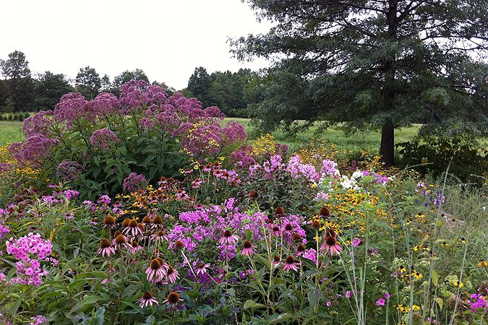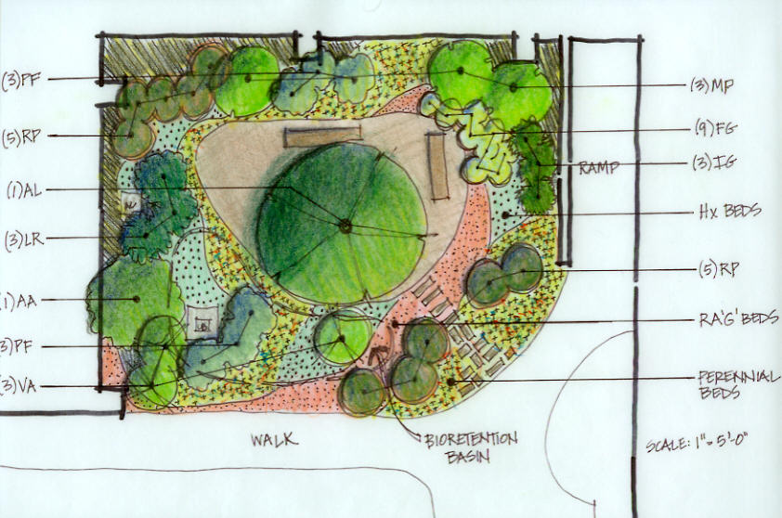

Sample Web Sites:
- https://www.crd.bc.ca/docs/default-source/Partnerships-PDF/water-in-our-community-learning-resource/design-a-native-plant-garden.pdf?sfvrsn=0
- http://www.usask.ca/education/prairiehabitatgarden/teaching/downloads/habitat-start.pdf
- http://www.nybg.org/exhibitions/2013/native-plant-garden/
- http://dyckarboretum.org/how-to-design-a-native-plant-garden/

