THE DESIGN CHALLENGE

CHALLENGE #1: THE NATIVE BEE SHELTER
Once you have researched native bees and their habitat, design a native bee shelter based on your research. This should be a structure no larger than 24 inches or 60 cm in size (unless instructed by your teacher to design a larger scale habitat). It should be designed to be attractive to many different species of native bees, durable and appropriate for placement in a garden on the school grounds. Feel free to gather additional information and see other examples of these bee shelters at the websites posted below.

Criteria:
▪ must be functional to attract variety of native bee species 
▪ must be a structure no larger than 24 inches or 60 cm in size
▪ must be made of wood, and other natural materials, and be able to withstand the outdoor elements
▪ must be placed in an appropriate area on the school grounds
▪ must include a sketch and working drawings with a parts and materials list

Examples:
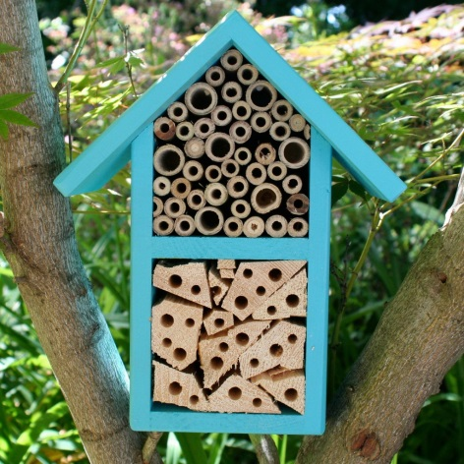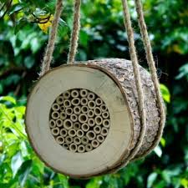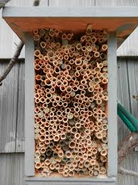

Sample Web Sites:
- http://www.xerces.org/wp-content/uploads/2008/11/nests_for_native_bees_fact_sheet_xerces_society.pdf
- http://www.seeds.ca/pollination/making-bee-nests
- http://tcpermaculture.com/site/2013/05/02/mason-bees-a-quick-overview/

