Hairstyles of the Stars

Celebrity hairstyles often cause trends that can sweep the nation. Many people will come into a hair salon looking to emulate their favorite Hollywood celebrity's hairstyle. Learning to recreate celebrity hairstyles, whether it is a particular cut, updo or style will help you become a more successful cosmetologist.

- Choose a photo of a celebrity, either from a magazine, book, internet, etc… that you will use to re-create their hairstyle on your mannequin. Keep in mind while choosing your photo that your mannequin must end up looking exactly the same as the picture (except for hair colour).

- Recreate your photo on your mannequin combining several of the techniques that we have learned in class. Blow-drying, braiding, cutting, curling, flat-ironing. . . whatever techniques desired to re-create your celebrity photo. Everyone will have access to all of the tools necessary for recreating your celebrity hairstyle, such as scissors, hot styling tools, curlers, pins, etc…

- Write a one-page summary outlining, in order, all of the techniques you will use to achieve the final look on your mannequin. Remember to also include details about any hair ornamentation that you may use as part of your re-creation.

Success Criteria:

- Choose a celebrity photo to re-create and submit it to be approved.
- Re-create the chosen celebrity hairstyle on your mannequin, trying your best to achieve an exact “look-a-like.”
- Combine several different hairstyling techniques to achieve your overall look.
- Write a one-page summary detailing the techniques you will use, in order, to create your final look.
- Treat your mannequin in a professional manner…She is your celebrity client.
- Take your time and pay attention to detail.
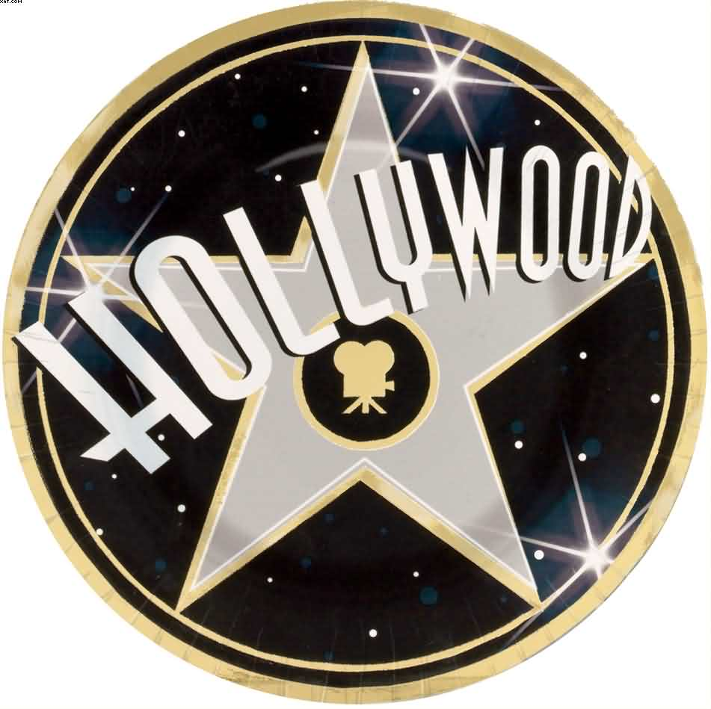
- Challenge yourself and be creative!

