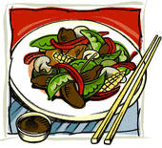
Stir Fry Dish Rubric
Student Name: __________________
/100 Planning /100 Stir Fry Dish /100 Kitchen Stir Fry Type:_________________

Stir Fry Dish | Looking for: | Level R  0-49% | Level 1  50-59% | Level 2  60-69% | Level 3  70-79% | Level 4  80-100%
Dish Preparation | Resourceful and independent preparation.
Knife Cuts | 3-5 different vegetable cuts for aesthetic value and variety.
Knife Cuts | Consistent vegetable cuts for proper cooking.
Storing | Product mise en place stored and labeled daily.
Kitchen Professionalism | Preparation is efficient and well planned. Sanitation is a priority.
Dish Service | Dish meets deadline.
Plating | Dish presentation is attractive and appetizing. Appropriate garnish is used.
Temperature | Appropriate temperature of dish served.
Sauce | Desired consistency and flavour.
Vegetable Texture | Al dente (firm), not mushy texture.

