Stir Fry Brainstorming and Research /40

Product | Recipe found at:  (Full url, or book and page number) | Two Healthy Changes  (Fat, Salt, Fibre, Sugar Nutrients, Trans fats) | How would you make this product wow to customers? list two | Use 3-5 sentences to explain the theme of your menu. Cultural, Organic, Locally Sourced, Vegan, Kosher, Fusion Cuisine, other...

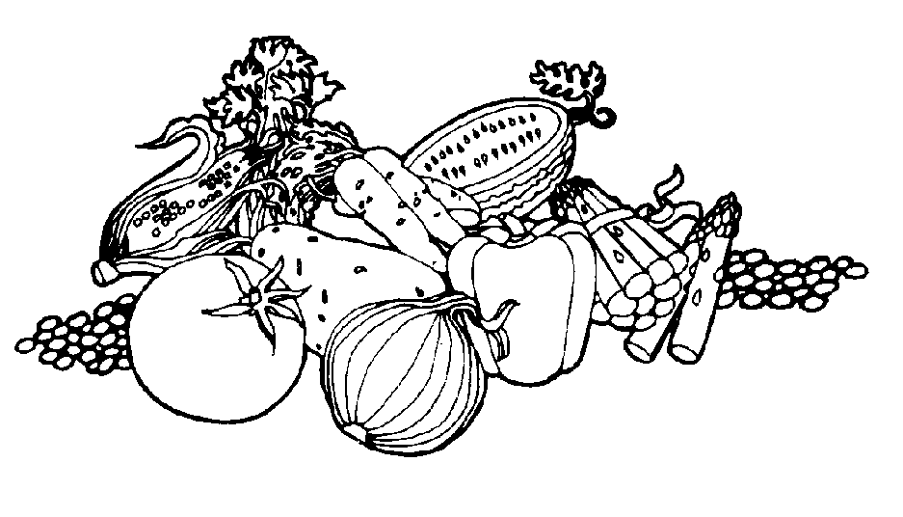
Stir Fry Planning /40

Common Table Ingredients Available (may select “other with teacher check in)

Carrots | Broccoli | Cauliflower | Snow Peas | Celery | Green Onion
Mushrooms | Red Pepper | Yellow Pepper | White Onion | Green Pepper | Water Chestnuts
Garlic | Ginger | Bok Choy | Lemon | Orange | Zucchini

Produce Needed For Stir Fry
(Minimum 3 vegetables and maximum 5)
Knife Cuts Being Used (3-5 types)

Name the vegetable cut along with a description of how to make this type of cut.

Sauce Ingredients
List all the ingredients needed for your sauce.
Kitchen Production Time Line

List what you are doing each day for preparation. You will have two days to complete your stir fry. The stir fry will be due by the end of the period on the second day.

Menu description for the Customer

How would you describe this tasty dish to your customer? Make them want to order it!

