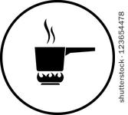
Basic Cooking Principles Name ______________
Foods are composed of

- _______________________
- _______________________
- _______________________
- _______________________
- _______________________
- _______________________
- _______________________

Carbohydrates like starch and sugars are found in
______________________________________________________________________________
A small amount is also found in ____________________ and ____________________________
Carbohydrates
Sugars Starches
Caramelization Gelatinization
___________________________________ ____________________________________

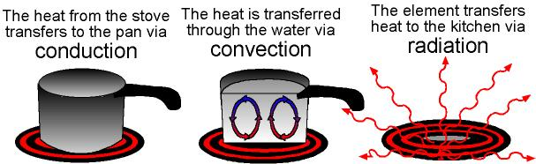
Heat Transfer Methods
Heat transfer through…. | Kitchen examples….
Heat transfer through…. | Kitchen examples….
Heat transfer through…. | Kitchen examples….

Cooking Methods
Cooking Method-Moist Heat
Moist heat example | Description of Method | A food that could be cooked this way
Poach
Simmer
Boil
Steam
Braise

Cooking Methods-Dry Heat
Dry heat example | Description of Method | A food that could be cooked this way
Roast/Bake
Broil
Salamander
Grill

Cooking Methods-Dry Heat using Fats
Dry heat using fats example | Description of Method | A food that could be cooked this way
Saute
Pan fry
Deep fry

