Vegetable Cuts

Why do the cuts matter?
- to make pieces smaller for quicker and more uniform cooking
- to remove parts that are not edible
- to make food more impressive and attractive
- to control the flavours in food

Types of Cuts
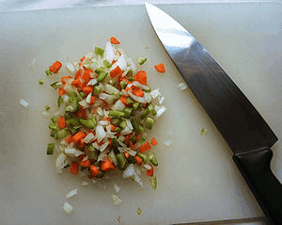  Mirepoix | A mixture of roughly-chopped vegetables used as a base for sauces or as a flavour enhancer for main dishes. The size of the chop depends on the cooking time of the food being used with the mirepoix.
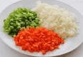  Brunoise | This is a very fine diced cube. Sized somewhere between 1 and 3 mm square. It is often used as a garnish for consomme.
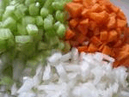  Macedoine | This is a fine diced cube. About 5mm square. Slightly larger than the brunoise.
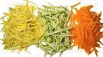  Julienne | Long thin, matchstick shaped pieces. Usually 4 or 5 cm long and 3mm thick. It is often used as a garnish or to substitute for chopped vegetables in a recipe for a different look.
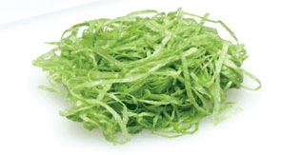  Chiffonade | Finely sliced or shredded green leafy vegetables. Used as a base, garnish or in soups. Typical cut for leafy vegetables or fresh herbs.
Paysanne  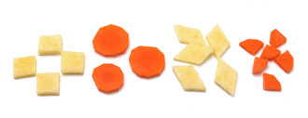 | This is a shaped cut. Typically squares, triangles, circles or half rounds. Consistency of size is important for cooking and the shape of the vegetable usually determines which shape the paysanne will be.

