Vegetable Cuts
Name _______________

Why do the cuts matter?
- ________________________________________________________________
- ________________________________________________________________
- ________________________________________________________________
- ________________________________________________________________

Types of Cuts
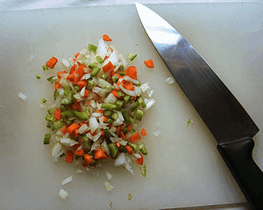 Mirepoix | ____________________________________________________________________________________________________________________________________________________
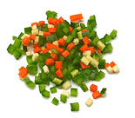 Brunoise | _______________________________________________________________________________________________________________
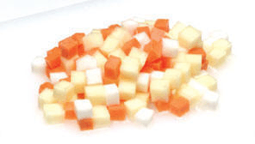 Macedoine | ____________________________________________________________________________________________________________________________________________________
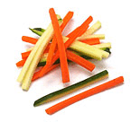 Julienne | ____________________________________________________________________________________________________________________________________________________
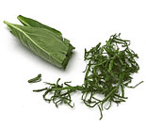 Chiffonade | _______________________________________________________________________________________________________________
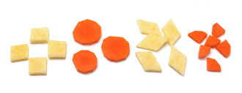  Paysanne | ____________________________________________________________________________________________________________________________________________________

