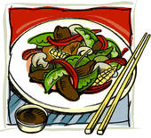
Stir Fry Self Reflection Sheet
Name ______________

Compare the professional characteristics with what was accomplished with your culminating Stir Fry product and kitchen performance:

PRODUCT | Preferred characteristics | Product Characteristics
Knife Cuts
Texture
Flavour
Appearance
Give yourself a mark out of 100 for product results |  | /100

KITCHEN  PRACTICE | Professional Characteristics | Personal Characteristics
Sanitation Before
Planning

Timing

Accuracy

Sanitation During
Sanitation After
Product Conservation
Professionalism

Give yourself a mark out of 100 for Kitchen Practices |  | /100

